REPORT FROM THE COMMISSION TO THE EUROPEAN PARLIAMENT AND THE COUNCIL
PROGRESS TOWARDS ACHIEVING THE KYOTO AND EU 2020 OBJECTIVES
(required under Article 21 of Regulation (EU) No 525/2013 of the European Parliament and of the Council of 21 May 2013 on a mechanism for monitoring and reporting greenhouse gas emissions and for reporting other information at national and Union level relevant to climate change and repealing Decision No 280/2004/EC)
Table of Contents
1. Summary 4
2. Progress towards meeting the Kyoto target 2013-2020 and the Europe 2020 target 6
2.1. Second commitment period under the Kyoto Protocol 6
2.2. Union's GHG emission reduction target by 2020 6
2.2.1. The Union's progress 6
2.2.2. Member States progress 6
3. Overachievement of the Kyoto Targets under the first commitment period (2008-2012) 8
3.1. EU-28 8
3.2. EU-15 9
3.3. Performance at Member States level 10
4. GHG emissions trends in the EU 11
4.1. GHG emissions in 2012 compared to 2011 11
4.2. Convergence in GHG emissions intensity and emissions per capita 12
4.3. Ex-post evaluation of the drivers behind CO₂ emission reductions 14
4.4. Aviation impact on the global climate 15
5. State of implementation of the Union's climate change policy 15
5.1. Reducing emissions 15
5.1.1. Preparation of the 2030 Climate and Energy framework 15
5.1.2. EU ETS 16
5.1.3. Other policies and measures 17
5.2. Adaptation to climate change 17
5.3. Climate Finance 18
5.3.1. Auctioning revenues 18
5.3.2. Mainstreaming Climate Policies into EU budget 20
6. Situation in the Union's candidate countries and potential candidates 21
6.1. EU candidate countries (Albania, Iceland, Turkey, the Former Yugoslav Republic of Macedonia, Montenegro and Serbia) 21
6.2. EU potential candidates (Bosnia and Herzegovina and Kosovo) 21

1. Summary
On track to overachieve the Kyoto targets
In 2012, emissions reached their lowest levels since 1990. Total EU greenhouse gas (GHG) emissions (without international aviation and Land Use, Land Use Change and Forestry (LULUCF)) were 19.2 % below 1990 levels and 21.6 % below Kyoto base years level. According to preliminary estimates, total emissions further decreased by 1.8 % in 2013.
Over the first commitment period (2008-2012), EU-28 Member States overachieved their targets by a total of 4.2 Gt CO₂-eq.
On average over the second commitment period (2013-2020), total emissions (excluding LULUCF and international aviation) are expected to be 23 % lower than base year levels according to Member States' projections. The EU is consequently on track to meet its Kyoto target for the second commitment period with a potential overachievement of 1.4 Gt CO₂-eq.
The total potential cumulative overachievement is estimated around 5.6 Gt CO₂ eq. for the 2008-2020 period. This amount represents more than the total EU emissions in 2012.
Figure 1: Total overachievement during the first commitment period (2008-2012) of the Kyoto Protocol and projected overachievement during the second commitment period (2013-2020) (EU-28)
Source: European Commission, EEA
On track to meet the Europe 2020 GHG target
Total EU emissions against the scope of the Climate and Energy Package (excluding LULUCF and including international aviation) were already in 2012 18 % below 1990 level and are estimated to be around 19 % below 1990 level in 2013.
According to the projections provided by Member States based on existing measures, emissions will be 21 % lower in 2020 than in 1990. The EU is thus on track to meet its GHG emission reduction target domestically.
However, 13 Member States still need to implement additional policies and measures to meet their 2020 national emission reduction target in the sectors not covered by the EU ETS. Furthermore, preliminary estimated 2013 emissions data in Germany, Luxembourg and Poland are higher than their respective 2013 targets set under Effort Sharing Decision (ESD).
Successful decoupling between economic activity and GHG emissions
During the period 1990-2012, the combined GDP of the EU grew by 45 %, while total GHG emissions (excluding LULUCF and international aviation) decreased by 19 %. As a result, the greenhouse gas emissions' intensity of the EU was reduced by almost half between 1990 and 2012. Decoupling occurred in all Member States.
Figure 2: Evolution of GDP (in real terms), GHG emissions and emission intensity (i.e. ratio of greenhouse gas emissions to GDP): Index (1990 = 100)
Source: EEA, DG ECFIN (Ameco database), Eurostat
The structural policies implemented in the field of climate and energy have contributed significantly to the EU emission reduction observed since 2005. The economic crisis contributed to less than half of the reduction observed during the 2008-2012 period. .

2. Progress towards meeting the Kyoto target 2013-2020 and the Europe 2020 target

2.1. Second commitment period under the Kyoto Protocol
For the second commitment period, the EU, its 28 Member States and Iceland have inscribed a commitment of reducing average annual emissions by 20 % during the 2013-2020 period, as compared to base year, to be fulfilled jointly.
According to the projections with existing measures (WEM) submitted by the Member States (not including LULUCF and Kyoto mechanims), total emissions excluding LULUCF and international aviation are projected to be 22 % lower in 2020 compared to 1990 and 25 % compared to base year.
As regards LULUCF, preliminary projections show that the EU as a whole could benefit from a small net sink. However, this will vary from Member State to Member State. In addition, as the technical review process goes forward with regard to the Forest Management Reference Levels, changes could still occur.

2.2. Union's GHG emission reduction target by 2020

2.2.1. The Union's progress
The Climate and Energy package adopted in 2009 sets for the Union a 20 % GHG emission reduction target by 2020 compared to 1990, which is equivalent to -14 % compared to 2005. This effort has been divided between the sectors covered by the Emission Trading System ('ETS') and non-ETS sectors under the Effort Sharing Decision (ESD). While the ETS provides an EU-wide cap, the ESD sets annual emission allocations in the non-ETS sector for each Member State.

According to Member States’ updated projections with existing measures (including international aviation), emissions are projected to be 21 % lower in 2020 than in 1990 (including ETS and non-ETS). The EU as a whole is currently on track to meet its EU 2020 target.

2.2.2. Member States progress
However, 13 Member States will need additional efforts to meet domestically their 2020 targets for the non-ETS sectors while 15 Members States are already projected to reach these commitments with existing policies and measures (see Figure 3).

Furthermore, according to approximated 2013 emission data, the non-ETS emissions in Germany, Luxembourg and Poland were higher than their respective 2013 targets set under the ESD by 0.7, 1.1 and 2.4 percentage points of their respective ESD base-year emissions. This analysis does not yet take into account the use of flexibilities provided for in the ESD, such as the use of international project credits or transfers of unused emission allowances between Member States.

Figure 3: Gap between projected 2020 emissions and targets in the non-ETS sectors (in percentage of 2005 base year emissions) and gap between the 2013 emissions and the non-ETS 2013 target. Negative and positive values respectively indicate overdelivery and shortfall
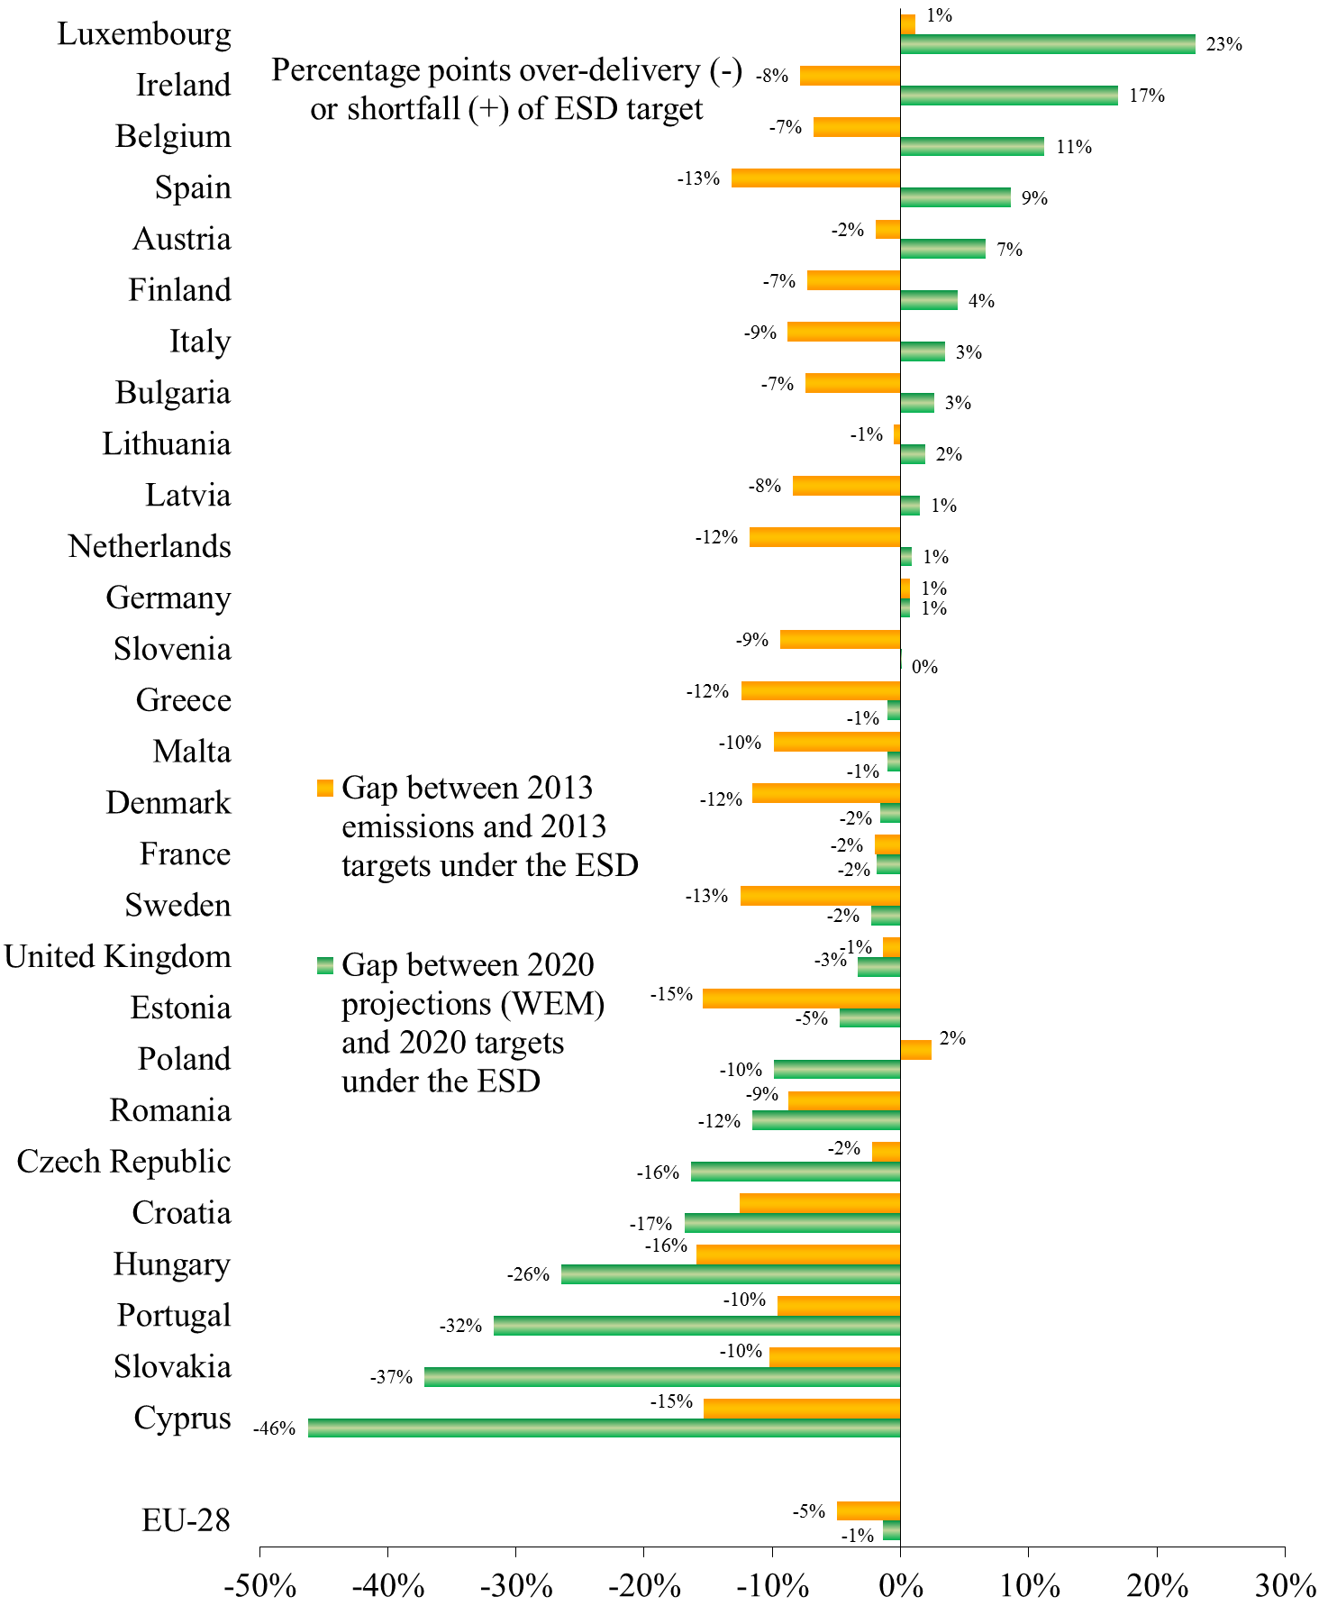
Note: The percentages represented correspond to percentage points of ESD base-year emissions. These base-year emissions are defined for each Member State so as to be consistent with both relative and absolute 2020 ESD targets.
Source: EEA, European Commission based on projections by the Member States.
As part of the European Semester 2014, the Commission carried out specific analysis based on the latest projections with existing measures provided by Member States:
- GHG emissions in Luxembourg are projected to exceed the national target by 23 percentage points. Significant GHG emission reductions could be achieved by increasing taxation on transport fuel and developing public transport. At the same time, this would lead to higher growth and to co-benefits of climate policies, such as reducing traffic congestion, which entails significant costs.
- Ireland’s GHG emissions are expected to exceed the target by 17 percentage points due to a large increase of emissions in transport and agriculture. Ireland is however currently developping a range of initiatives to reduce emissions under the Low-Carbon Development Bill.
- Emissions in Belgium are projected to fall short of the target by 11 percentage points. The analysis stressed the need for a clear division of tasks between authorities. Reducing transport emissions also needs to be combined with a reduction of road congestion.
- Five other Member States (ES, AT, FI, BG, IT) are expected to fall short of their target by a gap of 3 percentage points or more.
Other country-specific recommendations relevant to GHG emissions reduction have also been adopted. The Council recommended to shift the tax burden away from labour to taxes less detrimental to growth, including environmental taxes to several Member States (BE, CZ, FR, HU, IE, IT, LT, LV, ES). It recommended EE to strenghten environmental incentives to contribute to less resource-intensive mobility. The Council also recommended BG, CZ, EE, HU, LT, LV, PL and RO to pursue efforts to improve energy efficiency.
MT was recommended to further develop renewable energy. In 2013, DE reformed its support system for electricity from renewable sources. DE was recommended to monitor the impact of this reform. The UK developed an electricity market reform in order update its generation capacity, including in the renewable sector. The UK was recommended to increase the predictability of the planning processes as well as to provide clarity on funding commitments.

3. Overachievement of the Kyoto Targets under the first commitment period (2008-2012)
The final assessment of compliance of the EU and its Member States for the first commitment period of the Kyoto Protocol will follow the UNFCCC review of the 2014 inventory, which includes emission data up to 2012, and the additional true-up period. The EU and its Member States will be able to use Kyoto mechanisms until the end of the completion of the compliance assessment.

3.1. EU-28
During the first commitment period, total emissions in the EU-28 were significantly lower than the relevant targets:
- on average for the period 2008-2012, annual emissions (without LULUCF) were 18.9 % below base year levels (3.21 Gt CO₂ eq. overachievement as compared to the relevant targets);
- taking into account carbon sinks from LULUCF brings an additional 1.3 % emission reduction (0.38 Gt CO₂ eq.);
- A number of Member States are sellers of international credits under the Kyoto mechanisms. The combined expected sale of these international credits represent 1.6 % of base year emissions (-0.47 Gt CO₂ eq.);
- companies located in the EU offset part of their emissions with international credits under the Kyoto mechanisms (CERs and ERUs), representing an additional 3.6 % of base year emissions (1.03 Gt CO₂ eq.).
Taking into account all the above components, the total overachievement for the EU-28 as a whole is estimated at 4.2 Gt CO₂ eq. during the period, representing an average reduction of 22.1 % compared to base year levels (see Figure 1 in the summary).

3.2. EU-15
Over the first commitment period, total emissions in the EU-15 were significantly lower than the relevant target (reduction by 8 % on average during the 2008-2012 as compared to the base year):
- on average for the period 2008-2012, annual emissions (without LULUCF) were 11.8 % below base year levels (an overachievement of 0.8 Gt CO₂ eq. during the first commitment period);
- when taking into account carbon sinks from LULUCF, an additional emission reduction of 1.4 % (0.3 Gt CO₂ eq) is achieved;
- with the intended use of the Kyoto mechanisms by governments, an additional 1.5 % emission reduction can be expected (0.3 Gt CO₂ eq). However, in light of the economic downturn, Member States may adjust their intentions with regard to the use of the Kyoto mechanisms compared to their latest reported information;
- with the use of international credits by ETS operators, an additional 3.8 % emission reduction is achieved (0.8 Gt CO₂ eq. in total).
Consequently, the EU-15 reduced its emissions by 18.5 % during the first commitment period, meaning a total reduction of 2.2 Gt CO₂ eq. The EU-15 emission reduction has therefore been more than twice their target for the first commitment period (see Figure 4)
Figure 4: Total overachievement during the first commitment period (2008-2012) (EU-15)
Source: EEA, European Commission

3.3. Performance at Member States level
EU-15
Progress towards meeting the respective Member States' Kyoto targets can be evaluated on the basis of assessing the performance under the non-ETS sectors.
As shown in Figure 5, seven Member states (AT, BE, DK, ES, IT, LU, NL) have made or will need to make use of international credits under the Kyoto mechanisms. According to its latest reporting, Italy will have to purchase additional international credits before the end of the true-up period.
EU-11
Eleven other Member States have individual targets under the Kyoto Protocol's first commitment period. All of them will overachieve their targets through domestic emission reduction measures alone (i.e. without taking into account LULUCF and the use of Kyoto mechanisms), and some will do so by a wide margin. Many of them have already sold part of their unused Assigned Amount Units (AAUs). Romania, the Czech Republic and Poland are the largest sellers of AAUs with respectively 318, 125 and 120 Mt CO₂ eq. sold to other Parties.

Figure 5: Relative gaps between GHG emissions in the non-ETS sectors for the first commitment period and the respective 2008-2012 Kyoto targets (including LULUCF) with and without the intended use of Kyoto mechanisms at government level.
Source: EEA, European Commission

4. GHG emissions trends in the EU

4.1. GHG emissions in 2012 compared to 2011
In 2012, total EU emissions continued to decrease by 1.3 % compared with 2011. Emissions decreased the most in the transport and the industrial sectors (-3.6 % for both sectors). In the power generation sector, however, emissions increased by 0.8 % even if the share of renewable in total electricity production increased from 21.5 % to 23.1 % in 2012. This is due to the increase in the production of electricity from solid fuels (coal and lignite) linked to the relatively lower price of coal compared to gas. The year-on-year changes of emissions range from + 3.7 % in Malta to - 8.8 % in Finland. Emissions increased in four Member States (Malta, Germany (+ 1.1 %), Ireland (+ 1.4 %) and the UK (+ 3.2 %).

4.2. Convergence in GHG emissions intensity and emissions per capita
All Member States have experienced a reduction in GHG emissions intensity with the average annual reduction rate ranging from 0.9 % to 5.1 %. This has led to a convergence of performances between Member States (Figure 6).

Figure 6: GHG emissions intensity in the EU-28, 2012/1990. Percentages reflect annual average reduction
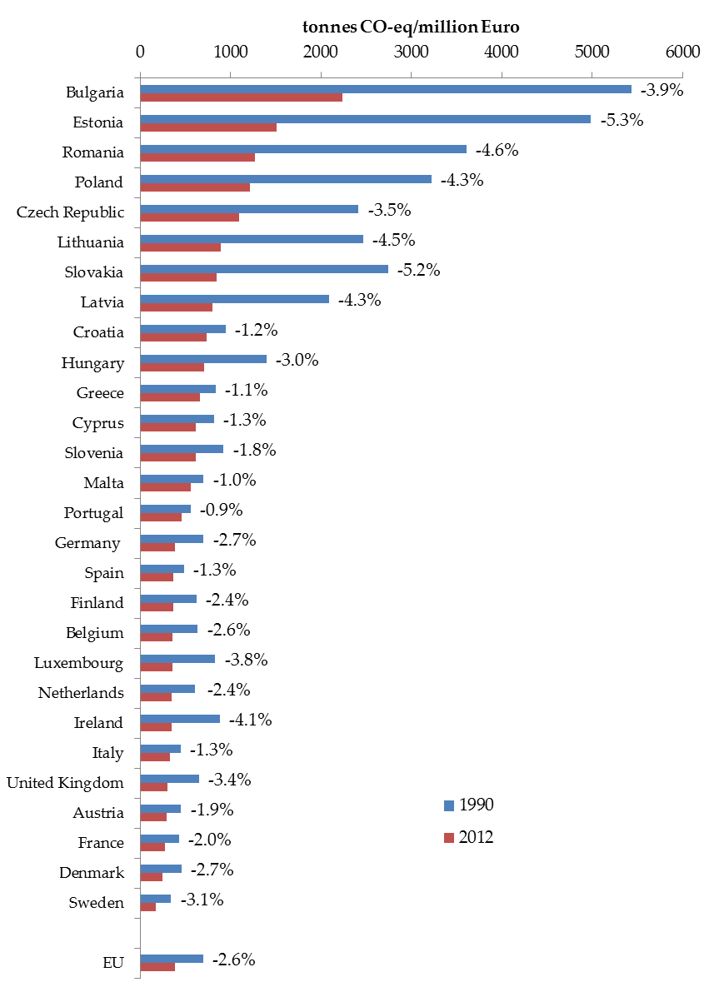
Source: Commission, EEA
In all Member States except Cyprus, Malta and Portugal, per capita emissions have been decreasing and converging since 1990.
Figure 7: GHG emissions per capita in the EU, 2012/1990. Percentages reflect annual average reduction
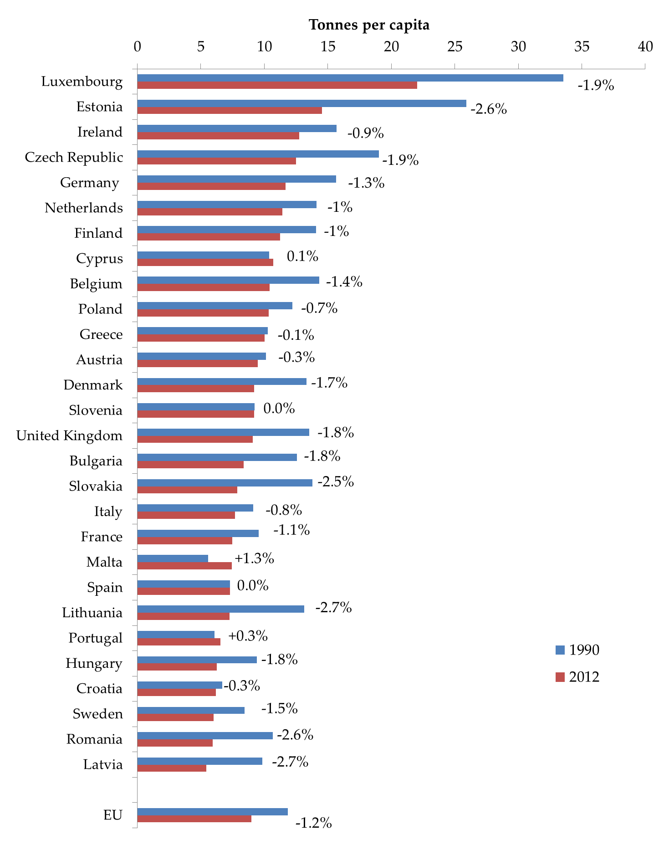
Source: Commission, EEA

4.3. Ex-post evaluation of the drivers behind CO₂ emission reductions
The European Environmental Agency has carried out an analysis of the main drivers behind emission reductions during the period 2005-2012. This analysis provides a quantification of the impact of the decomposition factors affecting CO₂ emissions, namely (i) population; (ii) GDP per capita; (iii) primary energy intensity and (iv) carbon intensity of primary energy use. The assessment, based on a decomposition analysis, covers CO₂ emissions from fossil fuel combustion which account for about 80 % of total GHG emissions.
As summarised in Figure 8, CO₂ emissions from fossil fuel decreased by respectively 3.3 % and 9.2 % during the 2005-2008 and 2008-2012 periods. This can be attributed to the three main factors:
- the 'primary energy intensity' of the EU economy decreased significantly, including through energy efficiency improvements, thus contributing to a large emission reduction for the two periods concerned;
- the carbon intensity of primary energy use decreased due to the development of renewables (nuclear production has been declining since 2005), also contributing to reducing emissions for both periods of time;
- The effect of growth was contrasted for the two periods considered. The GDP grew between 2005 and 2008 therefore mitigating the emission reductions driven by other factors. Conversely, the GDP decreased during the period 2008-2012, therefore reinforcing the emission reductions driven by factors other than the economic recession.
Figure 8: Aggregate decomposition of the change in total CO₂ emissions from fossil fuel combustion in the EU for the 2005-2008 and 2008-2012 periods.
Source: EEA
This analysis carried by the European Environment Agency and the Commission's counterfactual analysis described in the accompanying Staff Working Document (SWD) show that the economic crisis contributed to less than half of the reduction observed during the 2008-2012 period.

4.4. Aviation impact on the global climate
Domestic aviation GHG emissions in the 28 Member States have been decreasing since 2000, and were just over 16 Mt CO₂ eq. in 2012. On the contrary, the international emissions (CO₂ only) reported to the UNFCCC have increased to reach nearly 135 Mt CO₂ in 2012 (against nearly 70 Mt in 1990). Overall, total reported aviation emissions represent 3.22 % of total EU emissions reported in 2012.
Emissions of nitrogen oxides (NOx), aerosols and their precursors (soot and sulphate) and increased cloudiness in the form of persistent linear contrails and induced-cirrus cloudiness are also contributing to climate change.
Efforts have been made in the recent years to provide quantified estimates of the impacts of factors other than CO₂ on climate change despite the lack of observational data on the impacts such as contrails and induced-cirrus cloudiness. For example, a study partly financed by the EU 6th Framework Programme integrated project 'QUANTIFY’, attempted to estimate overall aviation impacts. The study concluded that aviation represents a 3.5 % share of total anthropogenic forcing in 2005 excluding aviation induced cloudiness (AIC), or a 4.9 % share including AIC.
The research project REACT4C performed in 2010-2014 investigated the potential of climate-optimised flight routing as a means of reducing the atmospheric impact of aviation. The results of this scientific research show that 25 % reduction of the climate impact can be already achieved with only small changes in the air traffic routing and economic costs increase by less than 0.5 % of operational costs.

5. State of implementation of the Union's climate change policy

5.1. Reducing emissions

5.1.1. Preparation of the 2030 Climate and Energy framework
In January 2014 the European Commission outlined a policy framework shaping the climate and energy policies after 2020. This policy framework has been completed by a Communication on energy efficiency in July 2014. It sets out the following key elements:
- a binding domestic greenhouse reduction target of 40 % in 2030 compared to 1990 to be met by an annual reduction of the cap on the EU-ETS emissions of 2.2 % after 2020 and a reduction of emissions of non-ETS sectors to be shared equitably among the Member States in the form of binding national targets;
- an EU level target of at least 27 % of renewable energy to be consumed in the EU by 2030. This commitment will be delivered through clear commitments decided by the Member States themselves, supported by strengthened EU level delivery mechanisms and indicators;
- a 30 % energy efficiency target for 2030;
- and a new governance system based on national plans for competitive, secure and sustainable energy.
In response to the current geopolitical environment and the EU´s import dependence, the Commission also adopted a Communication putting forward a new European Energy Security Strategy, inseparable from the 2030 Climate and Energy framework. Diversifying external energy supplies, upgrading energy infrastructure, completing the EU internal energy market and saving energy are among its main points.
The October 2014 European Council reached an agreement on the 2030 Climate and Energy framework based on the Commission's proposal.

5.1.2. EU ETS
Work on implementation has led to the successful start of phase 3 under the EU ETS (period 2013-2020). In terms of scope, the ETS now covers, in addition to CO₂ from most of industrial installations, nitrous oxide (N₂0) from the production of nitric and other acids and PFCs from the production of aluminium.
The EU ETS phase 3 does no longer provide an individual cap for every Member State, but a single cap for the EU, Iceland, Liechtenstein and Norway. As of 2013, around 43 % (excluding NER 300) of the emission allowances have been auctioned, and this share is expected to increase over time.
Since 2009, a growing surplus of allowances and international credits has been available on the carbon market, leading to a fall of the carbon price. To address this imbalance, the Commission proposed to postpone ('back-load') the auctioning of 900 million allowances from the early years of phase 3 of the EU ETS to the end of the trading period. The 'back-loading' was adopted by amending the Auctioning Regulation on 25 February 2014.
On 22 January 2014, the Commission furthermore adopted a legislative proposal to establish a market stability reserve at the beginning of the fourth trading period in 2021. The proposed reserve will complement the existing rules. Allowances are placed in the market stability reserve – i.e. deducted from future auction volumes – according to the "total number of allowances in circulation". The flow of allowances into and out of the reserve would occur on the basis of an automatic, fully rule-based process.
In the aviation sector, the International Civil Aviation Organization (ICAO) Assembly agreed in autumn 2013 to adopt a definitive agenda leading to a global agreement to tackle aviation emissions. Pending the possible adoption of international rules, the Council and European Parliament limited in March 2014 the coverage of the EU ETS to flights within the European Economic Area for the period from 2013 to 2016.

5.1.3. Other policies and measures
The Commission adopted a Communication setting out a strategy for progressively including GHG from maritime transport in the EU's policy for reducing its overall GHG emissions. As a first step in implementing this strategy, the Commission proposed a Regulation which would establish an EU-wide system for the monitoring, reporting and verification of CO₂ emissions from large ships starting in 2018. The draft Regulation is under consideration of the Parliament and the Council.
Implementation of the legislation setting targets for CO₂ emissions from cars to 2021 and from light commercial vehicles to 2020, is complete. The Commission has approved six eco-innovations which reduce CO₂ emissions.
A new legislation on fluorinated greenhouse gases has been adopted and will apply as from 1st January 2015. It will reduce fluorinated gases emissions by two-thirds in the period from 2015 to 2030 entailing a total cumulative savings estimated at 1.5 Gt CO₂ eq. until 2030, and 5 Gt CO₂ eq. until 2050, compared to a business-as-usual scenario.
In order to mitigate against the indirect land use change emissions from biofuel production, the Commission proposed a number of amendments to the Renewable Energy and Fuel Quality Directives ('the ILUC proposal'). The proposed text is currently discussed within the European Institutions.
Member States have begun the reporting, under legislation adopted in 2013, on their current and future LULUCF actions to limit or reduce emissions and maintain or increase removals in that sector.
A list of legal acts recently adopted is available in section 3 of the accompanying SWD.

5.2. Adaptation to climate change
On 16 April 2013, the Commission adopted the EU Strategy on Adaptation to Climate Change aiming at contributing to a more climate resilient Europe. It focuses on meeting three key objectives with the following main developments:
- Promoting action by Member States: The Commission encourages Member States to adopt comprehensive adaptation strategies and is developing an adaptation preparedness scoreboard. In March 2014, the European Commission launched the Covenant of Mayors Initiative encouraging cities to take action to adapt to climate change. Mayors Adapt aims at increasing the support for local activities, providing a platform for greater engagement and networking by cities, and raising public awareness about adaptation and the measures that are needed. The Commission also supports adaptation projects, in particular through the new LIFE Climate action sub-programme.
- Mainstreaming adaptation action into EU policies: the objective to devote at least 20 % of the budget of the Union for climate change related objectives is used as a tool for promoting adaptation.
- Promoting better informed decision-making, in particular through the Climate-ADAPT platform, which enables collecting and disseminating adaptation information in the EU. The Commission is furthermore completing a knowledge gap strategy on adaptation aiming at identifying and bridging specific sectorial knowledge gaps.

5.3. Climate Finance

5.3.1. Auctioning revenues

5.3.1.1. Use of auctioning revenues by Member States
Under the Monitoring Mechanism Regulation, Member States were requested to report for the first time by 31 July 2014 on the amounts and use of the revenues generated by the auctioning of ETS allowances in the year 2013 (see Figure 9 and in Annex as well as more detailed information in SWD). The total revenues for the EU were € 3.6 billion.
The EU ETS Directive provides that at least 50 % of auctioning revenues or the equivalent in financial value of these revenues should be used by Member States for climate and energy related purposes. All Member States have reported to have used or to plan to use 50 % or more of these revenues or the equivalent in financial value of these revenues for climate and energy related purposes (87 % on average representing approximately € 3 billion), largely to support domestic investments in climate and energy.
The reported amounts represent only a proportion of total climate and energy related spending in Member States' budgets.
Figure 9: Reported revenues from the auctioning of EU ETS allowances (millions of euros) in 2013 and share of these revenues or the equivalent in financial value used or planned to be used for climate and energy related purposes
* IT, EL: split between domestic and international use not reported. BE: no information on the use of auctionning revenues provided.
** No reporting provided.
Source: European Commission
Only some Member States reported information on the split of the use of revenues per type of action (see SWD). For instance, France, the Czech Republic and Lithuania use all their auctioning revenues in projects to improve the energy efficiency of buildings. Bulgaria, Portugal and Spain use most of their revenues to develop renewable energy. Poland uses most of its revenues that are dedicated to climate change in support of energy efficiency and renewable energy. In Germany, all auctioning revenues are used for climate and energy related purposed, with most of those revenue directed to a specific climate and energy fund, which supports a wide range of projects. Finland channels its auctioning revenues to Official Development Assistance activities, including climate finance. The UK uses around 15 % of auctioning revenues to provide financial assistance to low income households in relation to energy expenses.

5.3.1.2. NER 300
The NER 300 funding programme is mechanism in support of innovative renewable energy technology development and Carbon Capture Storage (CCS) demonstration projects. It is financed by the auctioning of 300 million allowances from the new entrants' reserve of the EU ETS. Two calls for proposals were launched under this programme.
The second call, awarded in July 2014, was funded from the sale of the remaining allowances and unused funds from the first call. 18 renewable energy and 1 CCS projects were selected and will receive €1 billion in total, which will generate private investments for a total value of almost €900 million. In total, the two calls will provide € 2.1 billion to 39 projects (38 in the field of renewable energy and 1 CCS project).

5.3.2. Mainstreaming Climate Policies into EU budget

5.3.2.1. Multiannual Financial Framework
As regards the mainstreaming of climate action into the EU budget, all Institutions have agreed that at least 20 % of the overall expenditures under the Multiannual Financial Framework (2014-2020) will be climate-related. The contribution towards climate expenditure in 2014 and in 2015 represents almost 13 % of the EU budget for each year.
A significant upward revision is expected as from the 2016 budget, when the Operational Programmes of the Member States under the European Structural and Investment Funds are adopted and the Common Agricultural Policy's new direct payment scheme, including the greening measures, is fully implemented.

5.3.2.2. Climate Research and Innovation
Climate research was one of the main research themes of the EU's 7th Framework Programme (2007-2013) and is central to Horizon 2020, the new EU programme for research and innovation 2014-2020, budgeted to € 79 billion. At least 35% of the Horizon 2020 budget is expected to be invested in climate-related objectives. This represents a significant increase compared to the estimated € 900 million that have been spent under the 7th Framework Programme.
For example, the Horizon 2020 Societal Challenge "Climate Action, Environment, Resource Efficiency and Raw Materials” (with a budget of about € 3 billion), supports mitigation research and innovation projects. These projects aim at analysing and mitigating the pressure on the environment (oceans, atmosphere, and ecosystems) and improving the understanding of climate change. In addition, research actions will focus on assessing impacts, vulnerabilities and solutions for adapting to climate change, developing strategies for disaster risk reduction and stimulating a transition to a low-carbon society and economy.
Climate change mitigation and adaptation are important drivers for programming research and innovation under all other Societal Challenges as well, notably in transport, energy, bioeconomy, and food, agriculture, and the in pillar “Industrial leadership”.

5.3.2.3. Supporting developping countries
With a share of 51 % of Official Development Assistance (ODA) for climate change from all donors reporting to OECD, the EU and its Member States have been the largest contributor to both mitigation and adaptation related ODA for the period 2010-2012.
As part of the fast-start finance commitment by developed countries of USD$30 billion, the EU and its Member States fulfilled their commitment by allocating € 7.34 billion to fast-start finance over that period. After the end of the Fast Start Finance period, the EU and its Member States have continued to provide climate finance support to developing countries in view of the developed countries goal to jointly mobilise USD$100 billion per year by 2020 from a wide variety of sources.
At the Doha Climate Change Conference in December 2012, the EU and a number of Member States announced voluntary climate finance contributions to developing countries. The total contribution is expected to exceed € 5.5 billion. An initial assessment shows that this amount was on track to be delivered in 2013.
In 2013, Member States submitted to the European Commission their first annual reports on financial and technology support provided to developing countries pursuant to Article 16 of the Monitoring Mechanism Regulation with information for the years 2011 and 2012. The total climate financial support provided to developing countries (2011-2012) by the EU and its Member States and per type of instrument is available in the tables of the SWD.

6. Situation in the Union's candidate countries and potential candidates

6.1. EU candidate countries (Albania, Iceland, Turkey, the Former Yugoslav Republic of Macedonia, Montenegro and Serbia)
Albania is a non-Annex I Party. According to its latest National Communication dated 2009, Albania's emissions have decreased by 70% between 1990 and 2000.
Iceland is an Annex I Party which met its individual target for the first commitment period. For the second commitment period, Iceland, the EU and its Member States will enter into a joint emission reduction commitment (cf. section 2.1).
Turkey’s GHG emissions (excluding LULUCF) increased by 133 % between 1990 and 2012 and 3.7 % between 2011 and 2012. While Turkey is an Annex I Party, it has no target under the first or the second commitment period of the Kyoto Protocol.
The former Yugoslav Republic of Macedonia is a non-Annex I Party. It provided its third National Communication to the UNFCCC in March 2014. According to this document, total GHG emissions decreased by 22% between 1990 and 2009. In Montenegro, which is also a non-Annex I Party to the Convention, total GHG emissions (excluding LULUCF) increased by around 4.9 % between 1990 and 2003.
No recent information is available for Serbia regarding GHG emissions inventories.

6.2. EU potential candidates (Bosnia and Herzegovina and Kosovo∗)
Bosnia and Herzegovina submitted its second National Communication in November 2013. Between 1991 and 2001, the total emission of Bosnia and Herzegovina decreased by 48 %.
No data are available for Kosovo.

According to the 2014 inventory submission providing GHG emissions data up to 2012. Unless stated otherwise, all the GHG emission data are based on the Revised 1996 IPCC guidelines calculated using the global warming potential from the IPCC 2nd Assessment Report.
For most Member States, this does not include yet the expected effects of the Energy Efficiency Directive and does not assume yet a full implementation of the Climate and Energy package.
The approximated 2013 emissions data are estimates compiled by the EEA in the approximated EU GHG inventory for 2013.
LU issued recently its own estimates according to which its ESD emissions in 2013 were 1.61% below the 2013 ESD target.
See analysis by the European Environment Agency, section 4.3 hereafter
The scope of the package differs from the scope of the Kyoto Protocol. It includes international aviation but excludes LULUCF and emissions of nitrogen trifluoride NF3.
For most MS, these are the projections submitted in 2013. The following Member States submitted on a voluntary basis updated projections in 2014: CY, IE, LT, LU, PL and RO. Member States submissions were quality-checked, gap-filled and adjusted where necessary by the EEA. An estimation of the share of non-ETS emissions had to be made for several Member States. For the gap filling and ETS/non-ETS split estimation, data from the 2013 EU climate policy "baseline with adopted measures" projection based on the PRIMES and GAINS models have been used. This projection has also been used as sensitivity analysis in the first EU Biennial Report [SWD(2014)1].
The approximated 2013 emissions data are estimates compiled by the EEA in the approximated EU GHG inventory for 2013 based on data submitted by Member States by 31 July 2014. Final emissions data will be available in 2015 using the new 2006 IPCC methodology on inventories.
Data calculated with the global warming potential from the IPCC 4th Assessment Report
ESD base-year emissions are calculated for each Member State so as to be consistent with both relative and absolute 2020 ESD targets.
MT and CY have no target under the first commitment period.
EEA 2014 - Why did GHG emissions decrease in the EU between 1990 and 2012? http://www.eea.europa.eu/publications/why-are-greenhouse-gases-decreasing
primary energy consumption per unit of GDP
CO₂ per primary energy from fossil fuels
Represented by the decomposition factor 'GDP per capita' in Figure 8
http://www.pa.op.dlr.de/quantify/
7thFP project "Reducing Emissions from Aviation by Changing Trajectories for the benefit of Climate" (2010-2014)
COM(2014) 15.
COM(2014) 520
COM(2014) 330
See conclusions of the European Council (http://www.european-council.europa.eu/council-meetings/conclusions)
See section
COM(2013) 479
Regulation (EC) n° 443/2009
Regulation (EC) n° 510/2011
Regulation (EC) n° 517/2014
Decision 529/2013/EU of the European Parliament and the Council
Certain Member States intend to use at least 50 % of auctioning revenues for climate related purposes. However; the revenues collected in 2013 have not been allocated yet and will be reported to subsequent years (for instance FI, LV and SK).
According to their submissions, auctioning revenues in AT, DK, IE, NL and UK are not earmarked in their national budget and therefore no direct attribution to specific purposes is possible. The data reported only relates to examples covering a small part of overall climate-related spending.
see http://ec.europa.eu/clima/policies/finance/documentation_en.htm. Each year, Member States submit to the European Commission information on financial and technology support provided to developing countries by 30 September.
Iceland must limit the increase of emissions below 10 % on average over the first commitment period. Emissions decreased by a 2 % average over this period.
 This designation is without prejudice to positions on status, and is in line with UNSCR 1244/1999 and the ICJ Opinion on the Kosovo declaration of independence.

