Table of Contents
Directive 2010/40/EU
A - Analysis of 2011 Reports on National Activities and Projects 1
1. Introduction 3
2. General observations 3
3. Detailed Analysis 4
3.1. Priority area 1: Optimal use of road, traffic and travel data 4
3.2. Priority Area 2: Continuity of traffic and freight management ITS services 6
3.3. Priority Area 3: ITS road safety and security applications 7
3.4. Priority Area 4: Linking the vehicle with the transport infrastructure 8
3.5. Preliminary conclusion 9
4. Possible contributions to the work on specifications 9
4.1. Examples of contributions to priority action (a): the provision of EU-wide multimodal travel information service 10
4.2. Examples of contribution to priority action (b): the provision of EU-wide real-time traffic information services 10
4.3. Examples of contribution to priority action (c): data and procedures for the provision, where possible, of road safety related minimum universal traffic information free of charge to users 11
4.4. Examples of contribution to priority action (d): the harmonised provision for an interoperable EU-wide eCall 11
4.5. Examples of contribution for priority action (e) + (f): the provision of information and reservation services for safe and secure parking places for trucks and commercial vehicles 11
5. Recommendations 12

B - Analysis of 2012 Reports on 5-year National ITS actions 14
1. Introduction 13
2. General Observations 13
3. National priority areas and related measures 16
4. Detailed Analysis 17
4.1. Transport Data 17
4.2. ITS Directive 19
4.2.1. Multimodal travel information 19
4.2.2. Real time traffic and travel information 20
4.2.3. eCall 20
4.2.4. Information services for safe and secure parking for trucks and commercial vehicles 21
4.2.5. Connectivity/connected mobility 21
4.3. Research and innovation 22
4.4. Use of funding instruments 22
4.5. ITS standards 22
4.6. City logistics 22
4.7. Coordination Platforms 22
4.8. Enforcement 23
5. Conclusion 23

A - Analysis of 2011 Reports on National Activities and Projects

Introduction
The present document summarises the analysis of the national initial reports 2011, provided by the Member States as per Article 17(1) of Directive 2010/40/EU.
The guidelines for reporting, adopted as Commission Implementing Decision of 13.7.2011 indicate that "the initial report should include (…), description of the national activities and projects in each priority area with, as appropriate and deemed relevant by the Member State, a description of the relevant initiatives, their objective, timescale, milestones, resources, lead stakeholder(s) and status. Where possible, figures should be provided in order to measure the progress better and facilitate possible future benchmarking."
This summary constitutes an overview of the national reports, based solely on their content and on the Commission’s understanding of these reports.

General observations
Twenty seven reports have been received (26 Member States and Norway), although approximately half of them did not meet the deadline of the 27 August 2011. There is one report still missing (Luxembourg).
Nine reports had to be translated in English, whereas three reports in French or German were analysed in their original language.
Most of the reports followed the Guidelines for reporting, although with various levels of accuracy, which did not facilitate the comparisons of core activities across Member States and the cross referencing with the actions of the ITS Action Plan and priority areas/actions of the ITS Directive. A number of reports included additional parts on legal framework and national ITS strategy, which provided interesting complement to understand the rationale behind the actions taken in a wider perspective.
The length of the reports was variable, from few pages to more than one hundred fifty pages, reflecting the different level of details on the one hand and the extensiveness of development and deployment of ITS, on the other hand. Eight Member States provided annexes in complement to their national reports. These annexes ranged, in length, from twenty to almost four hundred pages, often providing a more detailed view of the status of development in the different priority areas.
One or more contact person(s) were indicated in twenty two reports. In some of them, contacts were given for each priority action, each type of actions, or each project, reflecting the split of roles and responsibilities across the different entities and the multiplicity of organisational models in place. For instance, in some Member States several Ministries might share responsibilities, whereas in other cases dedicated agencies have been specifically set up for the development and implementation of ITS.
Eighteen reports provided some figures on past and future investments in ITS research and deployment (e.g. Germany), or on equipment and operating costs (e.g. Denmark), or on the number of equipment (e.g. Spain) or on project costs (e.g. Czech Republic). In the absence of a general context for those figures, it was however not always easy to interpret and compare them. In this respect, the availability of comparable performance indicators and percentages would have facilitated a benchmarking and monitoring of ITS deployment across Europe.

Detailed Analysis
In general the national reports provided a good overview of the Member States (best) practices. Unsurprisingly, almost all Member States had already taken action in the development and deployment of ITS prior to the adoption of the ITS Directive. Some countries had started their activities on this field sooner and their achievements and experience were far advanced, such as Netherlands, Germany, UK, Spain, Sweden, Norway or France (see some specific highlights in short notes in frames).
The analysis of the national reports was structured along the four priority areas of the ITS Directive. The level or intensity of activity in each of the 4 priority areas was assessed on the basis of the information contained in the reports. This assessment resulted in the production of four European colour coded maps reflecting the Member States’ level of activity in each priority area.

Priority area 1: Optimal use of road, traffic and travel data
Activities in priority area 1 are the most documented in the reports, as illustrated in figure 1. Most of the provided examples relate to traffic information, and cover topics such as traffic management measures and equipment, control centres, data format (e.g. Datex/Datex II), databases and digital maps. Several Member States appear also very active in the field of multimodal information whether in the form of (smart) ticketing services, public transport joint database, or multimodal journey planner for instance.
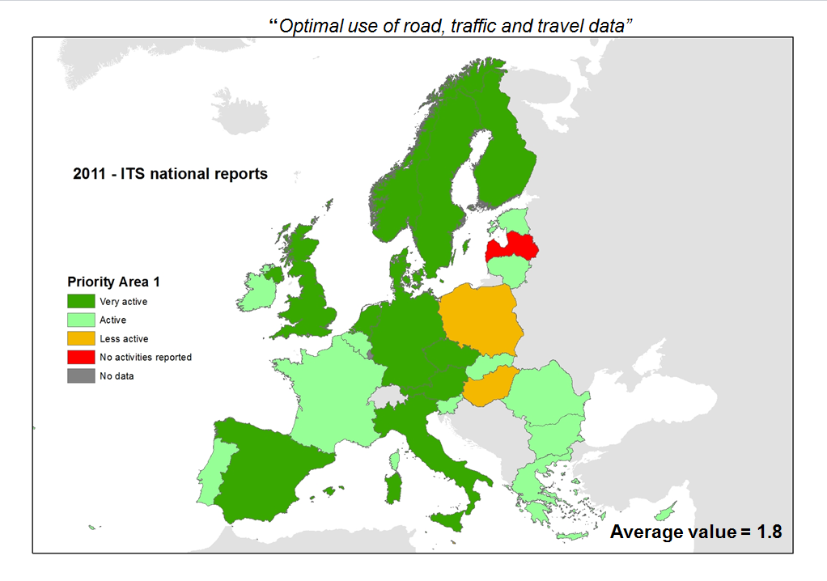
Figure 1 : Priority Area 1
In United Kingdom, Transport Direct is an operational door-to-door journey planner launched in 2004 covering more than 30 million different routes covering different modes across the UK, and is compatible with the multi-modal door-to-door journey planner from Ireland.

In Finland, an open joint database for public transport should be complete by 2012 and several national ITS databases and services are already implemented (Digitraffic, Digiroad, RDS-TMC maintenance service for position data for producers of TMC messages, real-time service on road conditions).

France has implemented the information system "Tipi" since 2010, allowing the sharing of road data at a national level. The aggregated information is disseminated to end user via public or private services. "Tipi" allows easy transmission of DATEX-formatted data to in-vehicle navigation devices.

Sweden has implemented multimodal travel information services, real-time travel information services, data for digital maps, road safety related information free of charge. Data for digital maps is maintained in a national database (NVDB) and made available through a portal. At the end of 2012, services based on ROSATTE will be available.

Priority Area 2: Continuity of traffic and freight management ITS services
Some reports provide interesting elements with respect to priority area 2 such as work undertaken on the harmonisation of traffic and travel information data or the development of architecture, standards and protocols. Any additional details on these aspects and on interoperability, data warehouse and data exchange, or cross borders traffic management would be very valuable.
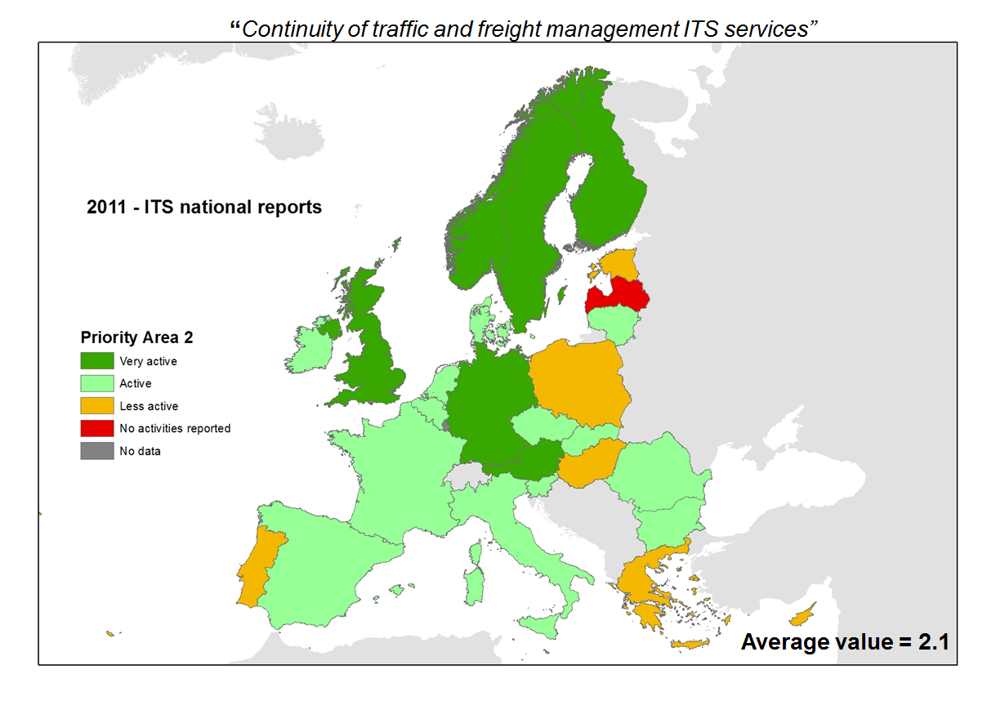
Figure 2 : Priority Area 2
Spain has developed strong real time traffic information services based on RDS-TMC. These services are implemented on specific sections of interurban network, using mostly VMS, web servers. Information exchange takes place with France and Portugal (DATEX).

Czech Republic has generalised e-ticketing in public transport, with an intention to enhance the interoperability between the systems of electronic ticketing in different regions.

United Kingdom has developed national (open) specifications (ITSO) for smart ticketing. The EU-funded Interoperable Fare Management (IFM) Project concluded that ITSO specification (United Kingdom) along with Calypso Network Association (Belgium) and VDV (Germany) are the three leading smart ticketing specifications in the EU and they could be supported on a single smart ticketing platform (e.g. smart travel card).
Norway has developed a generic multimodal ITS architecture (Arktrans).

France is implementing a national plan for speed adaptation on targeted motorways and national roads.

Priority Area 3: ITS road safety and security applications
Priority area 3 was not covered so extensively in the national reports. Typical examples of projects listed in the reports were eCall (including the HeERO deployment pilot) and activities related to intelligent or secured parking for trucks. This may be surprising but it is premature to conclude that road safety was not deemed a priority for the deployment of ITS in the Member States. In some cases, an expressed lower activity may be due to financial constraints. But this may also be due to the fact that activities falling under priority area 3 had been a priority in the past, leading to concrete implementation and measurable progress, and lesser in current activities. In some countries, on the other hand, the importance and activities in road safety for other institutional stakeholders, such as urban authorities, may have simply been overlooked.
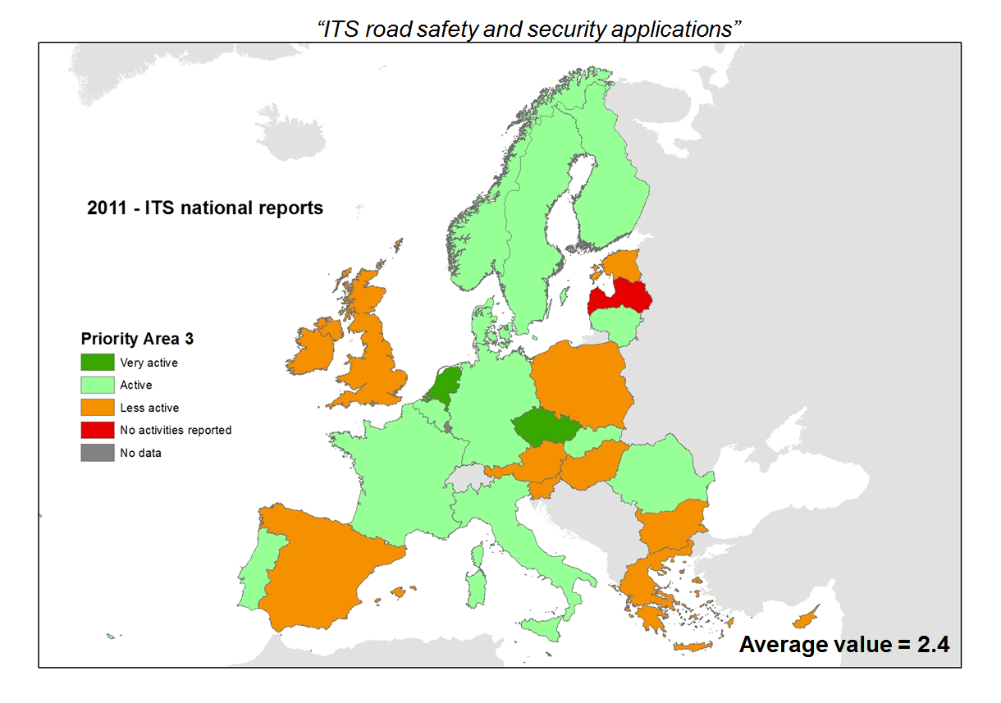
Figure 3 : Priority Area 3
Czech Republic, Germany, Finland, Greece, Italy, Netherlands, Romania and Sweden participate in the HeERO eCall deployment pilot.

Norway adopted in its national Transport Plan a main goal to use Universal Design principles for vulnerable road users both for infrastructures and for ITS services.

Finland adopted a mandatory fixture of alcohol locks on all chartered school and kindergarten transport.

In Germany, 15 intelligent truck parking pilot projects are based on the LABEL criteria.

Priority Area 4: Linking the vehicle with the transport infrastructure
Despite a true interest into connected mobility and cooperative systems as demonstrated by the number of countries involved in EU funded projects (e.g. SafeSpot, COOPERS, CVIS), activities under priority area 4 appeared in the reports somehow fragmented or marginal. One possible explanation is the fact that much of the activities in this area are still in the research domain, and sometimes involving primarily private companies, such as car manufacturers or ITS service providers; hence not (or only partially) financed or coordinated at the Member State level. In addition, topics such as Human Machine Interface, electronic toll system, open in-vehicle platform, V2I standards would need to be further explored and/or reported on, in so far they also represent cases of linking vehicle with infrastructure.
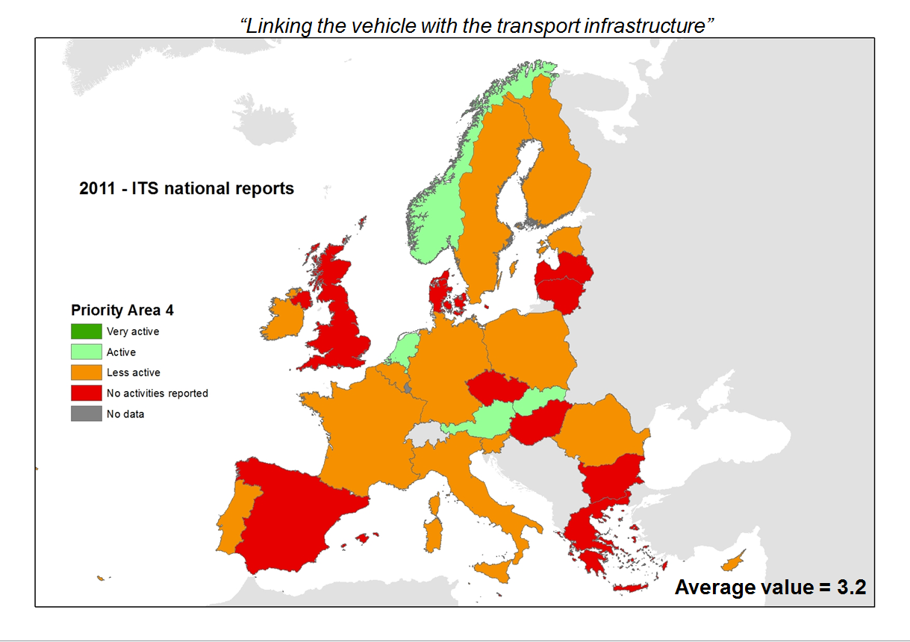
Figure 4 : Priority Area 4
In the Netherlands, the open in-vehicle platform SPITS (Strategic Platform for Intelligent Traffic Systems) focuses on three areas: traffic management, in-vehicle solutions and service download and management solutions. One of the promising applications that have been developed is Cooperative Adaptive Cruise Control. CACC provides an opportunity for congestion (and more specifically shockwaves) to be tackled and showed a potential reduction of 30% in current congestion.

Many Member States participate in EU-funded research projects on cooperative systems (e.g. Safespot, COOPERS, CVIS).

Slovakia reported on several projects by the Transport Research Institute related to linking of vehicles with the transport infrastructure (OBU for Slovakia, monitoring of dangerous goods, interoperability of electronic toll systems, driver assistance system).

Preliminary conclusion
The transmission of the initial national reports related to the ITS Directive has provided the European Commission and the Member States with a first information on the ITS implementation all over Europe. The Commission recognises the efforts of the Member States in putting their reports together and the value they offer in the context of the implementation of the ITS Directive. However, additional information would be necessary to complete the EU-wide overview of the current situation, in particular with respect to the four priority areas of the ITS Directive
In addition, the representativeness of the reports, and certainly also of the summary thematic maps, suffers from several limitations:
- Not all reports were comprehensive enough to be able to derive a good sense of effective priorities in the MS;
- Although interesting, most often provided qualitative reporting is difficult to interpret. Therefore, reports should better focus on measurable elements. For instance commonly agreed Key Performance Indicators could help to better illustrate the current situation across Europe.
- Moreover, the national reports may not always present the whole picture, and notably not the local initiatives (e.g. urban centres) or the private activities (e.g. automotive, mobile). Member States are encouraged to provide complementary information on the aforementioned topics and in particular with a view to contribute to the development of the six first specifications under the ITS Directive, notably during consultations with Member States experts.

Possible contributions to the work on specifications
This section provides an overview of how some of the activities indicated in the national reports are of direct relevance in the preparation of the specifications under ITS Directive.
Some national examples of particular relevance for given priority areas were already highlighted during the meeting of the ITS Committee of the 15 December 2011. Although the lack of details of most of these inputs did not allow a deeper analysis at the current stage, these national projects/initiatives constituted essential examples and inspirations to be further presented and discussed by Member States experts in the respective MS experts meetings in preparation of the specifications for the six priority actions.
This can be illustrated in the following sections.

Examples of contributions to priority action (a): the provision of EU-wide multimodal travel information service
A lot of preparatory work for this priority action has been achieved, notably through study work, workshop, as well as through the launch of the 1st Smart Mobility Challenge on European Multimodal Journey Planners. Although there has not been yet a meeting of MS experts to start discussing the specifications required in this priority action, the national reports have provided many examples of practical projects or institutional frameworks used at national level that are addressing some of the challenges to be overcome in this priority area.
In France, for example, a specific organisational framework for multimodal information and ticketing services (AFIMB, 2011) has been created with this mission. In Ireland, a multi-modal door-to-door journey planner has been established with compatibility with UK. In UK itself, Transport Direct has established an operational door-to-door journey planner, covering different modes across the country. Similarly, in Czech Republic, a system with generalised e-ticketing in public transport has been put in place, together with a specific legislation. Similar examples are provided in Portugal, Sweden or Norway, and constitute elements of reference when discussing further the specific provisions to be adopted for this priority area.

Examples of contribution to priority action (b): the provision of EU-wide real-time traffic information services
Preparatory work on this priority action is on-going, building on early work regarding the existing road traffic data exchanges systems based in the Member States. The discussions held with the MS in the preparation of priority action (c) on road safety related minimum universal traffic information services have also underlined a number of specific elements and possible systems in terms of road and traffic data exchange that can be of relevance for priority action (b). The first meeting of MS experts to start discussing the specifications required in this priority action will be held in 2013. However, like for priority action (a), the national reports have provided some examples of practical projects or institutional frameworks used at national level that are addressing some of the challenges to be overcome in this priority area.
In the Netherlands, for instance, the National Data Warehouse for road network and traffic Information, regrouping 15 road operators is operational. Similarly, but using another organisational model, a “road” Data Market Place has been established in Germany. Spain has also reported on traffic information exchanges with France and Portugal using DATEX format. In Finland, an Internet site has been created for information provision on traffic at borders and traffic management systems for border control points at the Russian border. Other concrete examples of systems or initiatives to provide traffic information are provided in the national reports of e.g. Belgium, Hungary, Sweden or Lithuania.

Examples of contribution to priority action (c): data and procedures for the provision, where possible, of road safety related minimum universal traffic information free of charge to users
Following the preparatory work and the meetings of MS experts held over the Summer and the Autumn 2012, the specifications for priority action (c) are almost ready for adoption. The inputs and specific contributions of the national reports in this priority action have constituted the background elements of the discussion with the MS experts in the consultation meetings.
We have learned from the reports that in Greece, experience on early incident detection exist as it is an integral part of a national ITS project on ITS for the Egnatia motorway. A specific work and study on the definition of minimum requirements for traffic information including safety related has been launched in Slovakia. The reports have also provided examples of operational implementation of road safety related traffic information: in Ireland, for instance, this is done by the National Road Authority through VMS, sms and email alerts; in Italy is under the responsibility of the CCISS (road safety information coordination centre); in Belgium, a regional implementation is done in Wallonia through the PEREX centre which provides RDS-TMC based feeds.

Examples of contribution to priority action (d): the harmonised provision for an interoperable EU-wide eCall
The delegated act for priority (d) is the first adopted under the ITS Directive. Expert meetings with MS have been held over the Summer 2012. The inputs and specific contributions of the national reports in this priority action have underlined the direct involvement of many Member States, through the HeERO eCall deployment pilot, in the actual implementation of the eCall PSAP infrastructure. Such experience in HeERO was most valuable for the drafting of the specifications for the Public Safety Answering Points.

Examples of contribution for priority action (e) + (f): the provision of information and reservation services for safe and secure parking places for trucks and commercial vehicles
Like for priority action(c), following the meetings of MS experts held over the Summer and the Autumn 2012, the specifications for priority action (e) are almost ready for adoption. The ones for priority action (f) will come later in 2013. Some of the contributions of the national reports in this priority action have constituted the background elements of the discussion with the MS experts in the consultation meetings.
We have notably learned from the reports of the Dutch project on truck parking occupancy information using Floating Car data and map matching. Similarly, the French report has informed of the 10 secured parking areas organised around the network FESTPAS. In Germany, intelligent truck parking was implemented through 15 Pilots projects based on LABEL criteria.

Recommendations
In the light of the analysis of the initial national reports, taking into account the defined limitations, it is generally recommended to the MS, in view of the follow-up reports due in 2014 and 2017 to:
- More systematically follow the structure of the Guidelines on reporting and distinguish very well the four different priority areas of Directive 2010/40/EU. Within these priority areas, a distinction between the six priority actions of the ITS Directive is also recommended.
- Share more details about current national initiatives, especially those of crucial importance with respect to the development of the ITS specifications, whether functional, technical, organisational or service related, for each of the six priority actions of the ITS Directive.
- Provide, whenever possible and available operational details on ITS activities and projects as annexes (including timeline and milestones, resources and instruments, key figures/indicators/targets, lead stakeholders, status…). These annexes can also include elements of benchmark, R&D projects, and best practices.
- Cover not only the projects and activities that the central government of Member States is implementing and/or is responsible for, but also any other initiatives that the governments are aware of and/or incentivise, such as potentially relating to priority area 4 on linking vehicles to infrastructure and projects covering urban areas and urban-interurban interfaces. This should include or be complemented by the activities carried out by the private sector.
With respect to consultations with Member States experts on drafting specifications for six priority actions, it is recommended to:
  - During consultations, further share details about current national or regional initiatives, especially those of crucial importance with respect to the development of the ITS specifications.
_____________
B - Analysis of 2012 Reports on 5-year National ITS actions

Introduction
The present document summarises the analysis of the national reports 2012 on ITS actions envisaged over the following five year period, provided by the Member States as per Article 17(2) of Directive 2010/40/EU.

After an initial reporting in 2011 describing the existing national activities, these reports describe, for the first time since the adoption of Directive 2010/40/EU, the intentions of the Member States with regard to the deployment of ITS on their territory in the coming five years.

Based on the Guidelines for reporting adopted as Commission Implementing Decision on 13 July 2011, they provide an outstanding view on notably the national approach on the development and deployment of ITS in the Member States.

The following analysis of the national reports 2012 is based solely on their content and on the Commission’s understanding of these reports.

General Observations
The Commission has received, to date, 28 national reports (27 Member States - Croatia not yet Member of the EU on 27 August 2012 - and Norway), with approximately a third of them meeting the deadline of 27 August 2012. Nine reports had to be translated in English, whereas five reports in French, German or Polish were analysed in their original language. Fifteen reports were provided in English, or both in national official language and in English.

Most of the reports followed the Guidelines for reporting, although more or less closely, enabling only partial comparisons between Member States' planned actions. Most of the reports tried to match planned national ITS activities with the actions of the ITS Action Plan and priority areas/actions of the ITS Directive. Most Member States have demonstrated a good understanding of the remit of the different priority areas/actions as laid down in the ITS Directive.

The length of the reports was variable, reflecting the different level of details, on the one hand, and the extensiveness of the national strategy and/or frameworks in place with respect to the development and deployment of ITS, on the other hand. Six Member States provided annexes, notably with lists and description of projects, in complement to their reports. Many of the reports tried to explain the rationale behind the actions taken and planned in a wider perspective.

The extent of coverage and description of the various items of the Guidelines for reporting has been analysed and colour coded accordingly. This assessment is presented in the following table.

Since the adoption of the ITS Action Plan in 2008 and of the ITS Directive in 2010, some Member States have developed a strategic document for the development and deployment of ITS. In some Member States, ITS is also often integrated or (partly) covered in other national strategic documents dealing with transport policy and infrastructure (Poland), road safety, and mobility (Spain, France, Italy), innovative technologies (Czech Republic), multimodality (Sweden), logistics (Italy), etc. Some Member States are still in the definition phase (Slovenia) or in the process of developing such a strategy or roadmap for the development and deployment of ITS (Czech Republic, Bulgaria). When an ITS strategy does exist, most of the times, it is aligned with the European framework (Germany, Netherlands) or an initial version is already updated (Finland), and builds upon existing ITS initiatives and case studies (Malta, Italy).

The transposition of the ITS Directive was often referred to by the Member States (one can assume this would be considered as a first step towards the elaboration of a national legal framework). When in place, national legal frameworks for the development and deployment of ITS are diverse across Member States, ranging from nothing more than the transposed ITS Directive (Denmark, Estonia, Portugal) to government resolution (Finland) or national primary and secondary legislation (Ireland). Some Member States have amended existing regulations in order to integrate ITS e.g. revision of the law establishing the fundamentals of transport activities (Lithuania), updated Road Traffic Act (Netherlands), updated Traffic Management Act (United Kingdom), subsidiary legislation under the Authority for Transport Act (Malta); whereas some others have taken new legal provisions e.g. Royal Decree (Spain), Ministerial Decree (Italy), new Traffic Act (Sweden), dedicated Act on ITS (Slovakia).

Although not defined as a national technical framework, several Member States have developed and implemented some elements or tools supporting the technical deployment of ITS. These elements are of different nature e.g. functional architecture (Belgium, ARTIST in Italy), procurement strategy (Finland), open data platform (Sweden) or definition of data format for data exchange (France), functional architecture for a National Road Data warehouse, based on DATEX II (Portugal), guidance on data collection (Germany) or data provision (Netherlands), multimodal ITS framework (Norway), methodology for the evaluation of impact of ITS (France). Few Member States refer to existing materials such as the Easyway Deployment Guidelines (Hungary), European standards e.g. UTMC, RDS (United Kingdom), or industrial agreement (Ireland); and others plan to further define the needed methodology, standards, open systems, principles for deployment (Czech Republic, Lithuania, Malta), and ITS architecture (Slovenia, Spain). The formal consultation of stakeholders is hardly mentioned although some consultative or expert bodies have been established to coordinate activities, raise awareness, educate, collaborate and ultimately foster the concrete deployment of ITS e.g. ITS Advisory Council (Germany), ComITS (Italy), ITS Coordination Committee (Romania), network of educational institutions (Slovenia).

Little details on the resources and milestones associated with ITS national activities have been provided in the reports. Some Member States gave figures and timelines in the context of very specific projects/actions (Denmark, Netherlands, Sweden), or budget estimates per ITS priorities (Lithuania) or ITS equipment although without clarity on potential shared resourcing between ITS services (Spain). Several reports mentioned the sources of funding of ITS e.g. private from companies or users (Finland), regional steer from master-planning (Belgium), EU funding such as Easyway, Cohesion Funds (Romania, Hungary, Portugal) or Structural Funds (Poland). A few Member States provided amounts committed or earmarked for capital and operational expenditures over the next 5 years or so (Finland, Germany, Malta, Netherlands), but these are difficult to interpret and compare due to the multiplicity of situations (i.e. broken down per measures, R&D projects, equipment, years, and for different time periods e.g. up till 2017, 2018, or 2020). A number of Member States referred to the scarcity of funding opportunities, due to the financial crisis, which has a detrimental impact on on-going and planned deployment.

In the absence of details on milestones, monitoring is even less addressed. A few Member States made reference to the setting up of monitoring authorities (Romania, Estonia) or observatories (Spain) for specific actions or topics (e.g. logistics, intermodality). Future (ex post) evaluation is foreseen and generic criteria provided (Finland), but no Key Performance Indicators. The need for further definition of monitoring methods was identified (Netherlands).

National priority areas and related measures
The type and intensity of activities in each of the 4 priority areas of the ITS Directive have been analysed and colour coded accordingly. This assessment is presented in the following table and further detailed in the next section.

It is clear from this table that most Member States have focused their efforts (as already demonstrated in their national reports 2011) and will continue to invest into priority areas I "Optimal use of road and travel data" & II "Continuity of traffic and freight management ITS services", whereas limited measures (beside eCall) are planned for priority area III "ITS road safety and security applications" and very little measures are foreseen with respect to priority area IV "Linking the vehicle with the transport infrastructure".

Main activities described in the reports include:
- traffic information and management at urban or interurban levels incl. parking management, incident detection and management, traffic monitoring based on vehicle tracking and refined measurements for traffic calculation, traffic management plans and traffic centres
- (real time) travel information at stations, stops or on-board vehicles
- access and exchange of static and/or dynamic data for traffic and travel information with reference to database, data portal, data warehouses, open data policies/platforms
- multimodal journey planner (MMJP) and smart ticketing incl. supporting standards and architecture
- users' apps for smartphones and navigators for traffic and travel information
- intelligent speed adaptation (ISA) and speed enforcement
- ITS for logistics i.e. eFreight, cross-border queue management system, freight traffic management through tolling/charging and weight control incl. weight in motion
- eCall pilots
- trials and feasibility studies on cooperative systems incl. telecommunications upgrade

Detailed Analysis
The analysis of the national reports has been structured along various themes of the ITS Action Plan and ITS Directive including re-asserted or emerging priorities for the short/medium term, as a result of the mid-term evaluation of the ITS Action Plan and reported interests by the stakeholders.

These themes are the following:
- Transport data (availability, access to and re-use)
- ITS Directive:
  - multimodal travel information
  - real time traffic and travel information
  - eCall
  - secure parking for trucks
  - connectivity/connected mobility
- Research and innovation
- Use of funding instruments (e.g. CEF, EIB, Cohesion funds)
- ITS standards
- City logistics
- Coordination platforms
- Enforcement

Each of these themes is presented in the remainder of this document with a view to highlight the commonalities and emerging trends, the good practices for roll out, and the main barriers to overcome in order to support the development and deployment of interoperable, compatible and seamless ITS.

Transport Data
Unlocking the potential of transport data could strongly contribute to a faster and more continuous ITS deployment. A number of questions with relation to transport data are mentioned in the reports: the access to transport data and its re-use, definition and monitoring of data quality and creation of the necessary platforms to share data among relevant stakeholders.
Logically the question of data cannot be disconnected from other actions, notably the first three priority actions of the ITS Directive, related to multimodal information services, real-time traffic information and safety related traffic information.
In terms of road traffic data (or its provision by public authorities to private actors, i.e. information service providers), a number of potential approaches are planned or already implemented: creation of national data marketplace (Germany), data store (Czech Republic), Public Index of information (Italy), repository (Slovakia) or warehouse (Slovenia, Portugal). Such platforms are sometimes conceived as a national observatory for transport, with aims of collecting (via a number of innovative technologies), processing and sharing data among stakeholders (Greece).
While some countries have not yet taken the decision on the form of such platform (in France it will probably be a continuation of an existing platform TIPI), they suggest that there is a need to reflect upon and devise an economic model for access to transport data (in general), because such data is a public resource, and its collection, aggregation and sharing comes at a cost to public authorities. The reasoning is based on the assumption that Open Data, free of charge, might impede further investment in data collection and quality. However, some authorities follow an open policy in this respect, e.g. Wallonia. The Netherlands are currently heading towards an Open Data policy, reaching beyond the provisions of the PSI Directive, and re-organising the National Data Warehouse's principles of data exchange with service providers. In terms of format of traffic data exchange, most of the times, DATEX is mentioned.
Other countries mention the question of providing traffic information (to users), without mentioning the provisions for the organisation of traffic database (Lithuania, Malta, United Kingdom). Finland, for that matter, mentions the use of precompetitive public procurements, in order to develop a variety of information services to the user, at a reasonable price.
The question of geographical information i.e. consolidating spatial data, is also mentioned. For Malta this question is linked to the central repository of road and traffic data. Austria created the GIP database, with a decentralised update by the different counties and the Austrian operators, and the Czech Republic plans to create a single geographical system with cartographic material. Italy will foster the use of single geographical representation based on open cartographic data.
The use of innovative technologies and devices is also mentioned as a potential option in order to capture more traffic data of high quality. Belgium (Flanders) mentions floating car data as a tool to detect abnormalities on the network; probe data is also mentioned by Cyprus.
In terms of transport data, which is often discussed separately from traffic data (but not necessarily, e.g. United Kingdom mentions an Open Data strategy for both traffic and travel data; Hungary mentions the planned establishment of a transport data portal in line with business model developed within the EasyWay II project), different models are also possible. While a number of countries advocate creation of harmonised databases, it can be either organised around Open Data principle (Ireland, Lithuania) or in a more regulated approach. The Netherlands are currently planning the development of a database for public transport (which, the same as traffic data warehouse will be organised around standard licence agreements for all users, and potential symbolic contribution for access or exchange, in order to guarantee continuity) and parking. Also Finland mentions an open joint public database for public transport. Sweden is planning to expand its platform for open data sources, which are already published. The French Agency AFIMB (Agence Française de l'Information Multimodale et de la Billettique) is looking into questions of travel data access and re-use, and planning on developing further interfaces. Greece plans to develop a national public transport database.

ITS Directive

Multimodal travel information
With respect to multimodality, its overall importance is underscored (e.g. Portugal) and a number of initiatives are mentioned by the Member States, in line with the priority actions of the ITS Directive. The accent is often put on the questions related to multimodal travel planning and information services, including ticketing. Multimodal travel information provision builds on the question of access to travel data that has been introduced, to a certain extent, in the previous section. However, aspects related to multimodal freight transport are also mentioned at a number of occasions (Netherlands, Sweden, Slovenia, Italy), with respect to testing new solutions (such as single electronic document within eFreight project, tracking vehicles and their loads through positioning systems such as GPS/EGNOS/Galileo or promoting interoperability and modal integration for freight).
A large number of Member States report on their plans to develop or improve the existing multimodal information services - MIS (Austria, Belgium: both Flanders and Wallonia, Cyprus, Czech Republic, Estonia, France, Greece, Ireland, Lithuania, Malta, Netherlands, Norway, Slovenia, Spain). Also initiatives on regional or urban level are mentioned (e.g. Poland, Greece). Sweden points to its expectation that the service providers will abide by the guidelines developed by Easyway, when it comes to the multimodal journey planner provision.
MIS are linked with the question of promoting the goal of better modal integration and proposing good and reliable travel alternatives to the use of individual car, thanks to the necessary integration of different modes, such as road, rail and air. Further questions of importance are data exchange and the definition of roles and responsibilities (Slovenia).
The need for strengthening the trans-border cooperation is mentioned by Austria or the Czech Republic. Norway mentions the planed cooperation between the Nordic countries (i.e. with Finland and Sweden) to harmonize their multimodal travel information services, for both travel planning data and real-time data. Such cooperation is not mentioned though in either of other Nordic countries' reports.
The planned activities in the domain of information services list a number of important functionalities: different search criteria for trip planning, inclusion of all transport modes and mobility services (e.g. cycling and parking, including realistic times for car journeys, with the time spent in congestion and searching for a parking space), differentiation of pre-trip and on-trip information needs, real-time information. Different options for information delivery are considered (e.g. online, phone, mobile phone).
A number of countries incorporate the reflection about fare information into the planning, and link it to ticketing (Wallonia, Czech Republic, Finland, Greece, Hungary, Ireland, Norway, Slovenia, Spain, Sweden, United Kingdom), promoting at least the development of an interoperable national solution, if not mentioning necessary compatibility with broader standards and specifications (e.g. the Interoperable Fare Management Project - IFM).
Some countries created specific institutions to advance the questions of multimodal information and ticketing, e.g. France where AFIMB was tasked with the development of interoperable smart ticketing application, in order to reduce the complexity of locally deployed systems, and also has the goal to promote multimodal information, and enhance its quality.
Nevertheless, it is difficult to assess the level of advancement of all planned activities, given that the timeline is provided only by a few Member States (e.g. Sweden).

Real time traffic and travel information
Some front runner Member States could share their experience with less advanced countries (e.g. Data Market Place, TISA standards, methodology for data collection including incidents in Germany; National Traffic Databank, safety related traffic information in the Netherlands; weather information services in Sweden; use of pervasive mobile technology, development of real time granular data capture, creation of a connected closed loop cooperative network in London).
Austria put forward plans to make traffic information services more up-to-date, enhancing the reliability of the information presented and indicating precise locations for accident and congestion reporting.
Austria and other Member States (Denmark, France) indicated that future efforts need to focus on improving the quality of the information provided.
DATEX II is already well used across Member States, but improvements are foreseen to better support data exchange (i.e. centralised database, harmonised data format, DATEX node as requested in the specifications recently adopted in the framework of the ITS Directive).
Although RDS-TMC remains a wide-spread system, the use of mobile devices/smart apps to disseminate traffic information is expanding (as offered by commercial providers or developed by the public authorities like in Ireland).
Some Member States plan to better use technology to enhance incident detection (i.e. automated detection in Malta and United Kingdom); whereas others look into expanding the network coverage of their traffic control centres (TCC) and setting interfaces between urban TCC and TCC surrounding motorways (Ireland).

eCall
Most reports mention the deployment of 112 eCall capability in the Public Safety Answering Points (PSAPs) as a priority for the near future. In addition to some front-runners: Romania, Czech Republic, where 112 eCall is already operational, many Member States are involved in HeERO I and II pilots and/or prepare national actions (e.g. national eCall Committee in Norway, pilot trial in Portugal 2013/2014, Institutional Board in Italy) to have their eCall PSAPs operational by 2015. Some Member States (Germany) reported also on the objective to have parallel implementation of private systems in addition to 112 eCall, while one Member State (United Kingdom) expressed strong opposition to the mandatory fitment of eCall to new vehicles. Reservations (France) were also expressed about the risk of driver distraction generated by additional services building on the eCall components.

Information services for safe and secure parking for trucks and commercial vehicles
Most Member States mention the necessity of optimising the use of parking places. Information services comprise indications on the location of the parking, the services available and possibly the number of spaces available (i.e. dynamic information). Some countries have already set in place dynamic information indicating the number of places available on ‘priority zones’ (Austria, France, Netherlands, Latvia, Spain). Some others plan the setting up of ’intelligent parking places’ (Czech Republic, Greece, Belgium, Hungary, Slovenia, Poland) or to ease the access to paid parking areas through parking information and booking services (Italy). Some are also considering improving the quality of existing services (United Kingdom) whereas some others do not consider this topic as a priority considering their peripheral location (Portugal).

Connectivity/connected mobility
Regarding cooperative systems or cooperative ITS (C-ITS), their potential to effectively contribute to enhancing road safety and reducing traffic congestion is generally acknowledged by Member States. However, before elaborating plans for any wide-scale deployment of these systems, most Member States are waiting for further advances in technology, standardisation and the results of future large scale demonstration projects.
It is noted that the participation of the private sector would be very much welcome in the funding of the installation of roadside equipment. At the current state of play the interest of the private sector is limited as it awaits the emergence of a clear business model for the delivery of cooperative ITS services.
One specific area where several Member States are planning deployment is interactive intelligent traffic light control and traffic management with a view to give priority to public transport vehicles (Belgium, Czech Republic, Finland, Ireland).
As regards vehicle-to-infrastructure (V2I) systems, the Netherlands, Germany and Austria have specific plans for the phased deployment of C-ITS building on the results of European projects such as EasyWay. Here the emphasis is to deploy relatively simple services in the beginning and gradually increase the complexity of services at a later stage as the penetration of vehicles equipped with the relevant ITS equipment and infrastructure coverage increase. France has also indicated its willingness to participate in these kinds of projects and signalled that EU technical coordination and financial support would be sought. Italy will look into the technical specifications applicable to support telematics link needed between vehicles and infrastructure.
Several Member States reported that they had built test sites for cooperative mobility services and indicated that road charging and toll collection activities can be covered by C-ITS.

Research and innovation
Only two countries mentioned specifically R&D strategies although many others participate in R&D projects. Austria highlighted the importance of linking R&D with pre procurement. The Netherlands participate actively in research activities through Associations.

Use of funding instruments
Various sources of funding are referred to in the reports e.g. Cohesion funds and in particular Interreg for projects in urban areas; Structural funds; Easyway for the deployment of ITS core services along the TEN-T with complementary funding from national budgets and private investments (i.e. in the framework of concession contracts); FP7 and its successor Horizon 2020 for research projects; public-private partnerships to fund transport infrastructure or innovative applications. The Connecting Europe Facility (CEF) is rightly mentioned as a future resource in many reports. Little details are provided beyond naming the various sources and highlighting the need for securing co-funding from local/national budgets. None of the reports mentioned innovative financing or the opportunities offered by the European Investment Bank (EIB) for instance.

ITS standards
DATEX II is the standard mentioned in almost all national reports. Extensive work is also going on to build up national data warehouses or marketplaces. Member States acknowledged that quality management is at stake. The use of common data formats and/or standardised interfaces is also mentioned with respect to travel data.

City logistics
Member States hardly make any references to city logistics in their reports. Therefore no common trends can be identified although some interesting examples are mentioned. Spain aims at creating a logistic observatory (which would not be limited to urban matters) and establishing a national urban mobility forum (i.e. the main cities forum). The Netherlands will integrate an information platform dedicated to logistics within their National Data Portal. Greece wants to create information systems for loading/unloading spaces and hours along urban networks. Czech Republic will include freight into their urban Traffic Management Plans. France is already working on securing the exchange of freight data between firms (incl. SMEs) all along the logistics chain (i.e. up till the last miles for urban deliveries). Sweden is also planning a pilot in the domain of city logistics, and it has established a 'Main Cities Forum' in order to monitor the situation in other MS. Italy will promote the use of ITS to optimise city logistics (e.g. automatic identification of Euro emission category, management of access restriction, booking of loading facilities).

Coordination Platforms
The Member States mentioned many of such coordination platforms e.g. national ITS associations, 'Transport Ecosystem' (part of ITS-Portugal), national ITS expert group, European standardisation organisations, consultative committee at regional level (public body), Easyway platform, specific forums (e.g. road operators, logisticians, urban mobility). In general these coordination platforms share the same goal, namely fostering the cooperation between public and private stakeholders, and promote ITS deployment. And they usually cover technical, organisational, as well as legal issues.

Enforcement
Member States use ITS for traffic enforcement measures in an extensive and varied fashion. The most frequent and successful use of ITS within "enforcement" seem to be with red-light control, weighting, truck take-over ban control and speed enforcement.
Intelligent speed adaptation systems (ISA) as well as dynamic speed limits are reported to be further developed in Member States such as Belgium, France, Germany, The Netherlands, Sweden and United Kingdom. ITS systems to sanction incorrect driving behaviours in urban areas particularly dangerous for Vulnerable Road Users will be promoted in Italy.
The level of technological development varies and is in many cases in progress through concrete projects. In Germany, speed control or advised speed is used for traffic management including congestion avoidance. The weighing technology is one example where older weighing stations are increasingly being replaced by weight-in-motion systems. Such systems either already exist or are planned to be deployed in several Member States (Belgium, Czech Republic, Cyprus, France, Latvia, Lithuania, Netherlands, Spain and United Kingdom).
For law enforcement, number plate recognition technology is increasingly used for automatic monitoring and enforcement of infringements against road regulations. Several Member States report the use of such technology for speed checks, red-light violation, commuter/bus lane control, and HGV overtaking-ban control.
Alcolock technology is increasingly used to limit road accidents. Belgium, Finland, and Sweden have either introduced initiatives that put alcolock devices in public fleets of vehicles or established a legal framework for the introduction of such devices on a larger scale.

Conclusion
For all the themes selected for detailed analysis, most Member States show active engagement at some level.
There is a clear trend towards further engagement in information services. For these purposes collection and pooling of traffic and travel data is discussed, and innovative solutions introduced, including models for the provision of these services. Multimodal information services are reported to be under development in 17 Member States demonstrating the strong interest in this topic but also highlighting the risk of further fragmentation of solutions. Projects include the integration of all transport modes, mobile ICT-solutions and in some cases integrated ticketing. Furthermore, many countries highlighted the importance of real-time information (incl. safety or weather related). Some are on the forefront with advanced infrastructure in place and could possibly share their experience and knowledge with other countries which are still at a more initial stage of development.
Deployment of eCall is in a few examples operational and otherwise in the process of becoming operational through the HeERO1 and HeERO2 pilots.
Regarding cooperative systems, deployment is in the preliminary phase (i.e. pilots), waiting for further advancements in technology and business models for the industry. A few Member States have moved ahead with the deployment of Vehicle to Infrastructure communication (V2I) for very specific applications. Several Member States and private stakeholders would welcome the introduction of a European framework/European guidance enabling them to invest further and deploy real life applications (i.e. through large scale demonstration projects first).
Member States report to be using EU-funds to a certain extent even though details are lacking.
ITS for enforcement is fairly extensively used and growing. Notable trends are the development of Intelligent Speed Adaptation (ISA) and weight-in-motion.
Overall, the national reports demonstrate a strong interest and willingness to foster the deployment of ITS throughout Europe in support to services continuity and smarter mobility. ITS applications are numerous, responding both to end users’ needs as well as operators tasks, and offering many opportunities to the market. In this context, it seems all the more important that all the stakeholders involved strive to achieve interoperability and compatibility of services and systems. Future reporting should better describe allocated resources and foreseen milestones for the deployment of ITS services, and if possible use common indicators and harmonised assessment methods. This would in particular help tailoring future calls for proposals under the Connecting Europe Facility.
_____________

OJ L 207, 6.8.2010, p. 1
OJ L 193, 23.7.2011, p.48
See the PowerPoint presentation to the ITS Committee on the 15 December 2011
http://ec.europa.eu/transport/themes/its/studies/doc/2011_09-multimodal-journey-planner.pdf
http://ec.europa.eu/transport/themes/its/studies/doc/2011_03-final-report-study-data-access-free-safety-traffic-information.pdf
OJ L 207, 6.8.2010, p.1
OJ L 193, 23.7.2011, p.48
Green means MS has well addressed the item, Orange means MS has partly addressed the item, and Red means MS has not or poorly addressed the item.
http://www.ifm-project.eu/
http://ec.europa.eu/transport/themes/its/road/action_plan/
http://www.heero-pilot.eu

