COMMISSION STAFF WORKING DOCUMENT
IMPACT ASSESSMENT
on the calculation methods and reporting requirements pursuant to Article 7a of Directive 98/70/EC of the European Parliament and of the Council relating to the quality of petrol and diesel fuels
Accompanying the document
COUNCIL DIRECTIVE ../.../EU
laying down calculation methods and reporting requirements pursuant to Directive 98/70/EC of the European Parliament and of the Council relating to the quality of petrol and diesel fuels

1. Section: Procedural issues and consultation of interested parties 5
1.1. Background 5
1.2. Organisation and timing 5
1.3. Stakeholder views 7
2. Section: Problem definition 9
2.1. Introduction 9
2.2. Scene setter 9
2.3. Underlying drivers 13
2.4. Who is affected by the implementation of greenhouse gas emissions methodology and reporting requirements? 14
2.5. What policies to regulate the GHG intensity of road transport fuels are there? 15
2.6. Baseline scenario for the assessment of options 15
2.7. The right to act 24
3. Section: Policy objectives 25
3.1. General objective 25
3.2. Specific objective 25
3.3. Operational objectives 25
4. Section: Policy options 25
Option A - No methodology to calculate greenhouse gas emissions of fossil fuels is established 25
Option B - Methodology based on the non-disaggregated average default greenhouse gas intensity values by fuel type based on an EU (B1) or Member State (B2) fuel mix (“basic reporting approach”). 25
Option C - Methodology based on disaggregated average default greenhouse gas intensity values by main feed stock types with partial disaggregation into conventional and non-conventional feed stocks (“2011 proposal”) 25
Option D – Methodology based on the GHG impact of all feedstocks used in the EU represented with EU average (D1) or conservative (D2) default greenhouse gas intensity values per fuel types, while allowing all suppliers to report alternate, actual values (“hybrid approach”) 25
Option E - Methodology based upon separate greenhouse gas intensities for individual categories of feedstocks ("complete differentiation") 25
5. Section: analysis of impacts 25
5.1 Assessment methodology 25
5.2 Option B1 - Methodology based on the average default greenhouse gas intensity values by fuel type based on an EU fuel mix level (“basic reporting approach”). 25
5.3 Option C - Methodology based on the disaggregated average default greenhouse gas intensity values by main feedstock types (“2011 proposal”) 25
5.4 Option D - Methodology based on disaggregated default greenhouse gas intensity, based on average (D1) or conservative (D2) values, while allowing suppliers to report actual values (“hybrid approach”) 25
5.5 Option E - Methodology based upon separate greenhouse gas intensities for individual categories of feedstocks ("complete differentiation") 25
6. Section: comparison of the options 25
7. Section: conclusion 25
8. Section: monitoring and evaluation 25
8.1. Core indicators of progress 25
8.2. Monitoring arrangements 25
9. Glossary 25
10. Acronyms 25
11. Annex I : Overview of the oil production process (Source: Europia) 25
12. Annex II : the EU crude oil supply chain (Source: various) 25
13. Annex III: Low Carbon Fuel Standards outside EU 25
14. Annex IV: information on industry sectors related to fuel suppliers 25
15. Annex V: EU suppliers dataset (Source: ICF) 25
16. Annex VI: EU refinery capacity (Source: Vivid Economics) 25
17. Annex VII: Average GHG intensities by Member State (gCO₂/MJ) (Source: ICF) 25
18. Annex VIII: Estimated GHG emission associated with fossil and biofuels 25
19. Annex IX: Road Energy demand and related emissions in ILUC sensitivity scenario (Source: ICF) 25
20. Annex X: Intervention logic 25
21. Annex XI: Assessment methodology 25
22. Annex XII: Carbon abatement costs and potential (Source: ICF/Vivid Economics) 25
23. Annex XIII: Monitoring, reporting and verification actions 25
24. Annex XIV: Screening of competitiveness impacts (Source: Vivid Economics) 25
25. Annex XV: Assessment of competitiveness impacts on EU refineries (Source: Vivid economics) 25
25.1. Estimation of the marginal cost curves - exit and sustainable margins 25
25.2. Construction of marginal costs of compliance options 25
25.3. Explanation of modelling method 25
25.4. Establish where compliance costs fall, that is, see whether traders or refiners bear it 25
25.5. Construct cost curves for each policy option 25
26. Annex XVI: Summary of ILUC sensitivity assessment 25
27. Annex XVII: Projected road fuel mix 2020 for each option (non-ILUC scenario) (Source: Vivid Economics) 25
28. Annex XVIII: General considerations around environmental impacts associated with fossil fuel production (Source: JRC) 25
28.1. Environmental impacts: general considerations 25
28.2. Air quality impacts 25
28.3. Pressures on biodiversity 25
28.4. Efficient use of resources: water 25
29. Annex XIX: Detailed information on administrative costs (Source: ICF) 25
30. Annex XX: Projected road fuel mix 2020 all options (ILUC scenario) (Source: Vivid Economics) 25

Executive Summary Sheet
Impact assessment on the calculation methods and reporting requirements pursuant to article 7a of directive 98/70/EC relating to the quality of petrol and diesel fuels as amended by 2009/30/EC
A. Need for action
Why? What is the problem being addressed?
Article 7(a) of Directive 98/70/EC requires the Commission to adopt inter alia an implementing measure establishing a calculation method for the GHG emissions from fuels, other than biofuels, and energy. This is so suppliers can monitor and report the GHG intensity of the fuels and energy they place on the EU market in order to achieve the mandated 6% reduction target. The different impacts associated with the options available for such a methodology for fossil fuels will be assessed
What is this initiative expected to achieve?
Establish a suitable methodology for fuel suppliers to accurately report the volumes, origin, place of purchase and the life-cycle greenhouse gas emissions of the fuels that they supply. The emissions associated with all relevant stages from extraction or cultivation, land-use changes, transport and distribution, processing and combustion, must be taken into account for the purpose of ensuring that a 6% reduction in GHG intensity of road fuels is achieved. Such a methodology should also result in a sufficiently accurate fossil fuel comparator, be as consistent as possible with that already established in the legislation for biofuels, be simple to verify and not lead to an unacceptable level of administrative burden.
What is the value added of action at the EU level?
Set into effect the obligations in FQD Art 7a by implementing a methodology to be used by suppliers for calculating and reporting on the lifecycle greenhouse gas intensity of fossil fuels. The power to adopt this through the regulatory procedure with scrutiny was specifically conferred to the Commission with the adoption of the FQD.
B. Solutions
What legislative and non-legislative policy options have been considered? Is there a preferred choice or not? Why?
The options assessed represent possible levels of disaggregation of information to be reported by fuel suppliers. These are,
Option A - No methodology to calculate greenhouse gas emissions of fossil fuels is established
Option B – Average default GHG values by fuel type (petrol/diesel) based on an EU (B1) or Member State (B2) fuel mix (“basic reporting approach”).
Option C - Disaggregated default GHG values by main feedstock types (“2011 proposal”)
Option D - Disaggregated default GHG average (D1) or conservative (D2) values, while allowing suppliers to report actual values (“hybrid approach”)
Option E - Separate GHG values for individual categories of feedstocks ("complete differentiation")
Options discarded include A (does not meet legal requirements) and B2 (internal market barriers). The remaining options allow for reporting at different levels of disaggregation by fuel type only (B1, D1, D2), by further disaggregation by feedstock type (C) or by even more detailed disaggregation by feedstock source (E), and so lead to trade-offs between the accuracy, environmental and economic impacts. In the hybrid option(s) D suppliers would need to provide their own actual GHG intensity calculation and so would need to rely on measurement or estimation methods, and while limitations on data availability exist. In conclusion, there would appear to be a series of issues that finely balance the choice between options C, D1, D2 and B1. The option B1 approach is expected to lead to the lowest administrative costs. While option E is attractive as potentially more accurate, it would be difficult to implement this option in the short term . That is why option B1 is preferred : Average default GHG values by fuel type (petrol/diesel) based on an EU fuel mix (“basic reporting approach”)
Who supports which option?
Option B1 is favoured by the sector (including oil majors, independents and traders), certain exporting oil countries and certain Member States.
Option C was the option proposed as the implementing measure submitted to the Member States in October 2011. This option is favoured by environmental NGOs and certain Member States.
Option D is favoured by environmental NGOs, and stakeholders from the bioenergy and agricultural sectors.
Option E is not favoured by any specific stakeholder group, although it is seen by some Member States and certain oil exporting third countries as the fairest approach as it is based on full differentiation of all fuels.
C. Impacts of the preferred option
What are the benefits of the preferred option (if any, otherwise main ones)?
The shortlisted options allow for reporting at different levels of disaggregation by fuel type only (B1, D1, D2) or by feedstock type (C) or feedstock source (E), and so they lead to trade-offs between accuracy, environmental and economic impacts. Options C, D1, D2, and B1 have similar economic impacts. B1 provides for the simplest implementation and verification mechanism given that it does not require any additional data collection. However B1 is the simplest way forward but also entails certain inaccuracies in terms of reporting GHG intensity at supplier level and poses some risks in reporting the EU average, as best available data presents low coverage of the market, does not cover imported products and no market information is collected by suppliers under this option. In addition, it presents a worse environmental performance due to encouraging a greater consumption of unconventional energy sources in the final EU fuel mix. This approach is expected to lead to the lowest administrative costs In contrast, options C, D1 and D2 are similar in terms of providing an accurate methodology and present positive environmental impacts, although D2 is more burdensome. While option E is attractive, it would be difficult to implement this option in the short term.
What are the costs of the preferred option (if any, otherwise main ones)?
The B1 option is expected to lead to the lowest administrative costs estimated to range between 2 to 3 million euros p.a. . Small differences in administrative and compliance costs have been found between the options, these represent very low overall costs and do not lead to different impacts on pump prices or competitiveness impacts.
How will businesses, SMEs and micro-enterprises be affected?
No significant impacts on businesses (including refineries) are expected as a result of the implementation of FQD. Expected pump price increases are very small and costs expected to be passed through. Although it has not been possible to categorise EU suppliers according to their size in a comprehensive manner, significantly lower administrative provisions for SMEs are reflected in the methodology.
Will there be significant impacts on national budgets and administrations?
No. Very small administrative costs may arise under some of the options as a result of the choice of methodology. The preferred approach B1 is expected to lead to the lowest administrative costs.
Will there be other significant impacts?
Observed variations in the fuel mix under the different options are small in the context of overall fuel demand and so should be interpreted with caution when assessing environmental, economic and social impacts. However, those options that provide differentiation at feedstock level (C and E) yield a fuel mix with a lower share of unconventional energy sources compared to option B1.
D. Follow up
When will the policy be reviewed?
The Commission will, monitor developments including based on the data provided by fuel suppliers to Member State authorities, with regards its proposed fossil fuel methodology on a) accuracy and reliability, b) its effectiveness, c) impacts on EU refinery sector and feedstocks, d) functioning and administrative burden, e) data availability and f) appropriateness of default GHG intensity values.

Section: Procedural issues and consultation of interested parties

Background
The Climate and Energy package adopted by the Council and Parliament on 22 April 2009 sought to achieve a 20% reduction in greenhouse gas emissions by 2020. It contained an amendment introducing an obligation on suppliers to reduce by 6% the lifecycle greenhouse gas intensity (emissions per unit energy) of fuel and other (electric) energy supplied in the EU for use in road vehicles (and in non-road mobile machinery) by 2020, to the Fuel Quality Directive (''FQD'').
The FQD target is expected to be met by substituting fossil fuels with a) lower GHG intensity fuels including sustainable biofuels, Liquefied Petroleum Gas (LPG) and methane (Compressed Natural Gas, Liquid Natural Gas and bio-methane), b) with electricity and hydrogen, and c) by reducing upstream emissions of fossil fuels in and outside of the EU. While the methodology for calculating the greenhouse gas emissions for biofuels was included in the FQD at the time of adoption, the methodology to be used by suppliers for calculating the lifecycle greenhouse gas intensity of fossil fuels was left to be developed through comitology.
In this context, a draft implementing measure harmonising the method for calculating greenhouse gas emissions from fossil fuels and electricity in road vehicles was submitted to the Fuel Quality Committee of the Member States on 4 October 2011. The proposal was discussed on 25 October and 2 December 2011, and the Committee vote on the implementing measure held on 23 February 2012 resulted in a "no opinion", given that a number of Member States claimed to be unable to finalise their position in the absence of an assessment of the economic impacts of the proposed measures. In accordance with the relevant comitology procedure, the Commission is now required to submit a proposal to the Council. This impact assessment supports such a proposal to be presented to the Council.

Organisation and timing
The draft implementing measure, discussed with the Committee, had been prepared following input from stakeholders and Member States. This included a public consultation launched in July 2009 which focussed on the issues to be addressed in the draft implementing measure; a follow up stakeholder meeting comprising the fossil and biofuel industries, Member States and NGOs in January 2010; and discussions on a concept paper with the Member States in March 2010. Moreover, the proposal presented in 2011 relies on a number of analytical studies including the work of the JEC and its "well to wheels" study, the Brandt study on natural bitumen, and the Brandt study on oil shale. The work of Dr Brandt was subjected to an external peer-review process whose findings were discussed with stakeholders at a public meeting on 27 May 2011.
In addition, in order to evaluate the different options for a methodology, a study of their effectiveness in terms of achieving accurate and real greenhouse gas emission reductions in transport fuels consumed in the EU was commissioned in 2012 and interim findings were discussed with stakeholders at public meetings on 20 December 2012 and 15 April 2013. In additions, a number of stakeholders i.e. the governments of Alberta and Canada, Europia, Transport and Environment, and the Government of Estonia, accepted the offer from the Commission to present their views on the options under consideration including any relevant analysis that they had conducted. An inter-service working group focusing on the preparation of the impact assessment report was established in early 2012, with meetings of this Impact Assessment Steering Committee taking place on 25 April 2012, 3 December 2012, 25 January 2013, 27 February 2013, 25 April 2013 and 3 June 2013.
The present Impact Assessment takes into account the recommendations formulated by the Impact Assessment Board on 3 July and 30 August 2013. They requested that a number of aspects of the Impact Assessment should be improved i.e. clarify the main drivers for the high greenhouse gas intensity of transport fuels and baseline scenario, including the role of high carbon conventional and unconventional oil sources; clarify the objectives of the intervention and related monitoring arrangements; improve the assessment and comparison of the options, including Member State specific impacts and impacts on relations with trade partners; and better integrate stakeholder views and explain how their concerns have been addressed.

These comments were taken into account in the resubmitted Impact Assessment as follows,

- A new section describing stakeholder views in detail has been introduced and these have been integrated throughout the report;

- The problem definition section has been shortened and the description of the baseline has been improved in a number of aspects (i.e. environmental impacts, detailed description of assumptions on biofuels and electricity, detailed description of fuel suppliers baseline, etc.);

- More information has been provided with regards to the role of conventional and unconventional oil sources;

- The policy objectives have been revised to include considerations around simplicity of implementation and verification arrangements of the different options, which are now included in the assessment of impacts chapter.

- Description of the policy options has been improved to include associated data requirements.

- Better description of Member State specific impacts have been included where appropriate, as well as impacts on trade relations and WTO compatibility issues;

- Effectiveness of the options with regards to needed accuracy has been developed to highlight the strengths and weaknesses of each approach.

- The monitoring and evaluation section has been developed to provide further detail on evaluation criteria and detailed monitoring arrangements.

- The executive summary, executive summary sheet, the comparison of the options and conclusions sections have been modified accordingly to reflect key changes.

Stakeholder views
The Commission is aware of the views of the main stakeholder on the possible options for the implementation of the FQD through the different consultation exercises conducted over the last three years.
In this context, the governments of Alberta and Canada have expressed strong concerns against any implementing measure that would assign a higher carbon intensity to Canadian natural bitumen crude and derived products compared to conventional oil sources, which in their view would be incompatible with WTO rules. Although they recognise that natural bitumen inherently presents a higher carbon intensity than most conventional crudes consumed in Europe because of the more energy intense extraction and production methods, any measure that creates a separate category for natural bitumen would in their view unfairly discriminate natural bitumen oil against the utmost polluting types of conventional oil sources. For this reason Canada has indicated that it would submit any such proposal to the WTO for review.
The Estonian Government has also expressed concerns about the potentially large economic impacts derived from any measure that would assign a differentiated higher carbon intensity value to Estonian oil shale and derived products given the important contribution of oil shale exploitation to the Estonian economy. In addition, the results from a study from the Tallinn University of Technology suggesting that the typical carbon intensity value of Estonian oil shale production is lower than that included in the 2011 implementing measure were presented to stakeholders at the meeting of 15 April 2013.
The EU and US oil industry sector (including oil majors, independents and traders) oppose any measures that would require the development and implementation of a chain of custody for crude oil and derived products, given the complexity of the global fuel supply chain as well as concerns over quality of data available and risk of fraud. They have also expressed concerns about the impacts on competitiveness among crude producers and refiners related to the disclosure of commercially sensitive information under such system. In this context, a study commissioned by Europia suggests that any methodology based on crude differentiation would lead to an increase in total compliance costs to EU refiners between $1.5 to $7 per oil barrel, as well as increasing the emissions associated with fuel transportation and leading to no global net greenhouse gas emissions savings, as higher carbon intensity crude oil and derived products would be consumed outside Europe where no such restrictions exist.
The bioenergy and agricultural sectors oppose any different methodological treatment for fossil fuels from that applied to the calculation of greenhouse gas emissions of biofuels on the grounds of fair treatment. In this context, biofuel producers already implement a chain of custody mechanism throughout the supply chain for each consignment of biofuel feedstock.
Environmental NGOs favour as disaggregated a methodology as possible in order to ensure that the carbon intensity of fuel suppliers is accurately measured and that the correct level of associated mitigation actions is undertaken. In this context, NGOs specifically favour assigning different values for unconventional oil sources, which they estimate could represent between 5.3% and 6.7% of all oil crude and transport fuels in EU by 2020, to reflect their higher carbon intensity. In addition, studies commissioned by NGOs suggest that a low administrative burden would be associated to such system being estimated at about 0.8-1.6 eurocents per barrel. Although no assessment of the compliance costs to industry was included, a separate study from NGOs suggest that when the price of unconventional oils ranges from 30–90 $/bbl, a price differential ranging between conventional and unconventional sources of $0.5 to 3 per barrel may also have an impact on investments in extraction of unconventional oils, which could result in an additional 19 Mt CO₂ savings from discontinuation or postponement of existing and planned projects.

Section: Problem definition

Introduction
The aim of Article 7a of the FQD is to reduce the lifecycle GHG associated with the production and use of fuels and electric energy used in road transport. This includes those GHG associated with the extraction of feed stocks used for their production, processing, subsequent transport and refining as well as their use in vehicles. Article 7a stipulates that:
- Fuel suppliers shall reduce the greenhouse gas emissions per unit energy of the fuels they supply by 6% by 2020 (Article 7a(2)(a)); and
- Fuel suppliers shall report annually to Member States on the greenhouse gas intensity of fuel and energy supplied by providing as a minimum,
- Total volumes of fuel types/energy supplied indicating its origin and place of purchase (Article 7a(1)(a));
- The life cycle greenhouse gas emissions per unit of energy of the fuels supplied (Article 7a(1)(b)).
The purpose of the reporting mechanism is twofold, it aims to ensure both accuracy in respect to the greenhouse gas emissions reductions that need to be achieved (Article 7a(2)(a)) as well as to the actual average GHG intensity of fossil fuels consumed in the EU (Annex IV, C, 19).
The FQD delegates authority to the Commission to establish a robust methodology for the calculation of life cycle greenhouse gas emissions from fuels other than biofuels and from energy. The FQD also invites the Commission to establish guidelines in relation to the information to be reported by fuel suppliers. The problem to be addressed in this impact assessment is the appropriateness of the options for developing such a methodology and their associated environmental, economic and social impacts. In this context, this impact assessment aims to explore in detail key concerns raised by industry and certain Member States with regards to administrative burden and compliance costs imposed on fuel suppliers.

Scene setter

Transport emission reductions in the context of EU climate goals
The EU is committed to achieving, by 2050, an 80% to 95% reduction in greenhouse gas emissions economy wide compared to 1990 levels. The "A Roadmap for moving to a competitive low-carbon economy in 2050" foresees that the transport sector needs to reduce its greenhouse gas emissions by around 60% compared to 1990 levels by 2050 to ensure a comparable cost-effective greenhouse gas emissions abatement in that sector. This objective has been confirmed in the Transport White Paper: "Roadmap to a Single European Transport Area – Towards a competitive and resource efficient transport system".
Transport emissions can be reduced through measures which affect i) the amount of transport activity, ii) the energy efficiency with which that transport is carried out and iii) the greenhouse gas intensity of the energy used to perform the transport. Moreover, efficiency gains and greenhouse gas intensity reductions in fuels play a particularly important role in decoupling the effects of economic growth on emissions. Given the overall transport greenhouse gas reduction goals, the degree to which one of the three levers to reduce emissions is not deployed, the more action will be required from the other two, including through increased fuel efficiency from vehicles.

Policies aimed at reducing the greenhouse gas intensity of the energy used in the transport sector will therefore play an important role in achieving climate goals, particularly as transport sector activity and the share of unconventional, more-energy intense, fossil fuel sources are expected to increase to 2050. While the Commission prefers a more streamlined approach over the continuation of specific targets in the transport sector in its vision for the 2030 climate and energy framework, there is a need to establish a mechanism for reporting the greenhouse gas emissions of road fuels in order to improve data collection and monitoring of such emissions. Therefore, in establishing a solid regulatory framework for reporting of such emissions through the FQD, the EU is not only ensuring a contribution towards the 2020 emission reduction objectives, but also developing a system to assess the upstream emissions from oil production that is appropriate in the context of the long term commitment to decarbonisation of the transport sector.

EU trade in crude oil
Crude oil is a worldwide commodity, although logistics, product quality and geopolitical reasons heavily influence supply sources. In total, it is estimated that around 611 million tonnes of oil, around 15% of total global consumption, were consumed in the EU in 2012. Although some domestic production of North Sea oil is available, the crude oil consumed in the EU is mostly imported from the Former Soviet Union (FSU) and Norway, followed by the Middle East, and North Africa.
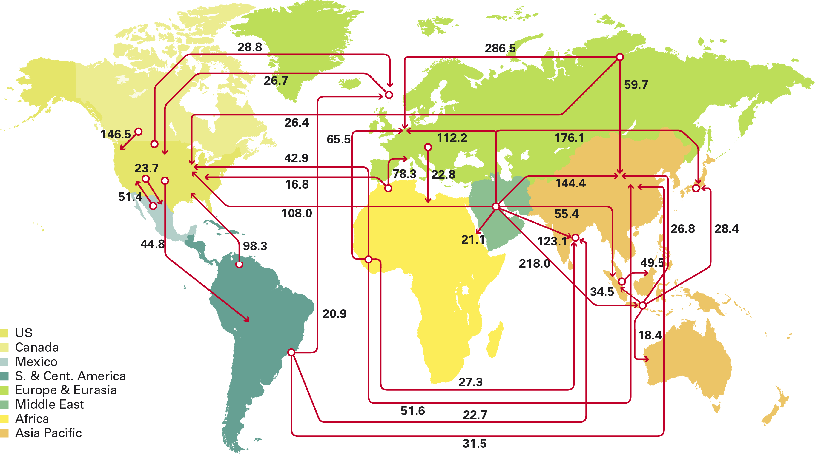
Figure 1: Major trade movements 2012 (million tonnes). Source: BP Statistical review 2013
Total EU consumption of crude oil has been decreasing slowly since 2005 and it is expected to continue decreasing to 2020, in part due to the increased share of renewable energy and implementation of energy efficiency measures. In the context of sourcing, North Sea production is expected to decline, leading to increased imports, even under such scenarios of reduced consumption. By contrast, global crude oil consumption is expected to increase during the same period of time.

EU trade in petroleum products,
The EU is the second largest producer of petroleum products in the world after the United States. The two key trade petroleum products in the EU in terms of volume are petrol and middle distillates such as diesel and gasoil (including jet fuel and heating oil). A growth in demand for middle distillates (such as diesel, jet fuel and gasoil) between 1990 and 2008 resulted in a supply/demand imbalance in the EU with regard to such products which has led it to be dependent on trade in order to balance out demand and supply. If net imports of kerosene and jet fuels are taken into account, the EU shortfall in middle distillates amounts to upwards of 35 million tonnes of net imports per year, imports of kerosene and jet fuel coming mainly from several Middle Eastern countries.
More specifically, demand for petrol in the EU in 2011 was 89 million Tonnes (Mt) whilst exports to North America, Africa and Asia comprised 18, 10 and 8 Mt respectively which made the EU a net exporter of petrol (representing c.a. 30% of domestic EU production). However, the EU is net importer of diesel/gasoil with 15 Mt, 12 Mt and 8 Mt being imported from Russia, the USA and Asia respectively to help meet a demand of 279 Mt.
For road transport, the EU is also a net importer of intermediate products such as processed oil (e.g. straight run fuel oil or vacuum gas oil) and naphtha (feedstock destined for either the petrochemical industry “ethylene manufacture” or aromatics production). Historically, significant volumes of fuel oil and vacuum gas oil have been imported from the FSU and processed in the EU to supplement high quality road diesel demand that could not have been supplied by less technologically advanced Russian refineries, which are currently being upgraded and so trade on final products will increase. With regards to naphtha, little is thought to be used for diesel production as it is unlikely to comply with legally binding lower limits of aromatics permitted in diesel.

Conventional and unconventional petroleum sources and associated greenhouse gas emissions
The GHG intensity of fossil fuels is normally expressed as the sum of the upstream emissions associated with extraction and downstream emissions associated with transport, refining and combustion in the vehicle's engine. The average greenhouse gas intensity of transport fuels consumed in the EU currently is approximately 88.3g CO₂/MJ. The largest contributor to this figure (c.a 85%) are the tail-pipe emissions whilst upstream emissions and downstream emissions contribute approximately 5 and 10% respectively.
However, upstream emissions can be much higher and vary according to the source, type of feedstock and production method. Recent modelling suggests that upstream emissions could range between 0-50 g CO₂/MJ with the overwhelming majority of EU conventional crude sources ranging between 0 and 10 g CO₂/MJ.
In most simple terms, the greenhouse gas intensity of extracting and preparing any petrol/diesel feedstock for further refining is, inter alia, directly linked to the energy needed for extraction. Consequently, the greenhouse gas intensity of such activities is related to how immobile the feedstock is, as found in-ground, prior to extraction. Natural bitumen feedstocks are generally more dense and viscous and do not flow freely under natural conditions. The further differentiation of natural bitumen feedstock from conventional crude oil is linked to the extraction methods employed,,. This also stems from its viscosity and density. Natural bitumen is extracted through mining or thermally enhanced gravity drainage where the fossil fuel deposit is heated with steam so as to lower its viscosity and where the thermal energy is mainly derived from sources other than the feedstock source itself.
It is important to note that the presence of natural bitumen is not unique to any one location. United States Geological Survey (USGS) reports the presence of natural bitumen in North and South America, Europe, Asia and Africa.

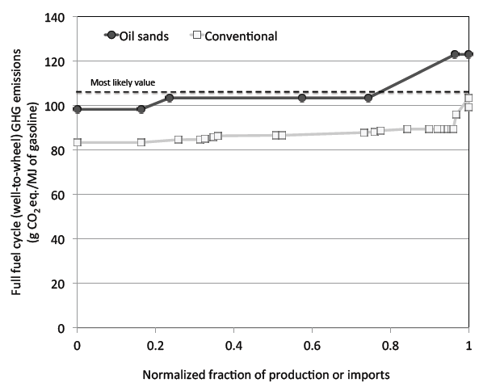
Figure 2: Typical GHG emission ranges for conventional crude oil and oil sands. Source: Brandt
It is clear from the Brandt study on oil sands that some of the worst performing conventional crude feedstocks (i.e. high flaring emissions associated with certain Nigerian oil fields) and the best performing natural bitumen feedstocks (i.e. using natural gas for their extraction) present a similar level of greenhouse gas emissions, as shown in Figure 2. It is important to note that this overlap does not normally stem from the naturally occurring differences in physical properties of the respective feedstock sources but is mostly, for example, due to the flaring and venting emissions occurring during the extraction of oil and which result from the inappropriate management of the simultaneous extraction of two separate fossil fuels, crude oil and natural gas. In this context it is worth noting that while the amount of unconventional oil sources is expected to rapidly rise in the future as the exploitation of such feedstocks increases globally, greenhouse gas emissions associated with flaring and venting of conventional crude show a downward trend worldwide.

Information about petroleum feedstocks affecting their greenhouse gas intensity
There is currently a significant amount of information that is collected by economic operators along the oil supply chain because it is either required for production purposes (i.e. the chemical composition of crude oil is needed for efficient refining) or for compliance with specific legislation. This is particularly comprehensive for imported and exported goods as information about their origin, tariff classification (i.e. including differentiation between conventional and unconventional sources), mass/volume and physical characteristics has to be recorded and reported to the competent authorities for compliance with customs legislation. Nevertheless, there are gaps in the transfer of information for "finished" and "intermediate" products such as petrochemicals in need of further refining, which represent however only around a quarter of total EU oil consumption.
With regards to the reporting of the associated greenhouse gas emissions, conventional and unconventional feedstocks are already treated differently in the legislation. For example, the greenhouse gas emissions of natural bitumen (i.e. oil sands and tar sands) and oil shales are differentiated in Commission Regulation No 601/2012 on the monitoring and reporting of greenhouse gas emissions under the European Emissions Trading System (i.e. a higher CO₂ emission factor for "oil shale and tar sands" than for conventional crude oil is stated on the basis of their energy and carbon content). Furthermore, many companies in the oil sector already voluntarily report on their greenhouse gas emissions, although no common methodology is being used.
Further detailed information on what information is currently available and where the key gaps and difficulties remain can be found in Annex II : the EU crude oil supply chain.

Underlying drivers
In the context of establishing a suitable methodology for the calculation of the lifecycle GHG emissions of fossil fuels, there are a number of underlying drivers that need to be considered. This is because the chosen method for obligated parties to calculate and report emissions of fuels derived from different crude sources, and the degree of differentiation applied to those, would play an important role in influencing the final mix and associated mitigation actions for the energy consumed in the EU.

Increasing production of unconventional oil sources and need for greater differentiation between feedstocks
Vast unconventional oil reserves are concentrated in Canada, Venezuela and a few other countries. In Europe, exploitation of unconventional sources is mainly limited to Estonian oil shale production for export (80%) and represents a significant contribution to the Estonian employment and GDP. However, although only a small fraction is used domestically in heat production in Estonia, plans for the production of transport fuels from 2016 onwards exist.
Whilst there are high costs associated with their production, exploitation remains economic with oil prices of around $65 to $75 per barrel. As such, whilst unconventional oil feedstocks such as oil sands and oil shale do not currently represent a significant share of Europe's supply, their share is expected to increase in the future with some studies predicting that over 10% of global supply is expected to come from these sources by 2020, rising up to 15% in 2035. In certain Member States where significant investments are being made by refineries to be able to process heavier crudes, the share of unconventional oil could increase very rapidly. For example, Spanish oil industry estimate that unconventional oil could represent 23% of the Spanish crude mix by 2020. Nevertheless, replacement crudes of similar quality and a lower GHG footprint are available to offset this supply.
Although there is an overlap between the greenhouse gas emissions of some of the worst performing conventional and the best performing unconventional crudes, there is a significant deviation between the average greenhouse gas emissions associated with conventional oil and the average greenhouse gas emissions of unconventional oil sources. In this context, it is also important to note that while there is significant uncertainty inherent to measurements regarding flaring and venting emissions released to the atmosphere, emissions associated with unconventional sources are related to their production methods and therefore more easily recorded.
The average production of unconventional oil generally emits more greenhouse gases per barrel than that of most types of conventional oil. In the absence of any mitigation being conducted, the foreseen amount of unconventional oil could result in significant upstream emissions amounting to around 2.8 billion metric tonnes of CO₂ per year globally. In addition, there are also some differences in the greenhouse gas intensity of similar feedstocks within the conventional category because of the differences in the way these feedstocks are produced (e.g. because of excessive flaring and venting).
As such, as much as possible differentiation between feedstocks is desirable in order to ensure that their emissions are accurately reported and monitored, and that appropriate mitigation measures are conducted. Possible mitigation measures are also applicable to reduce the emissions from unconventional oil production include more efficient extraction technologies and carbon capture and storage (CCS). For example, reducing the input of external heat to extract oil sands is possible from a technical point of view but is not widely practiced because revenues from selling the feedstock yields higher profit than optimising efficiencies.

Who is affected by the implementation of greenhouse gas emissions methodology and reporting requirements?
Regulations to estimate, report and monitor the greenhouse gas intensity of fossil fuels used in the transport sector may affect fuel suppliers, Member States, third countries exporting fuel to the EU, associated industries (i.e. biofuels) and consumers (i.e. through price impacts) in different ways according to the methodology being implemented. These impacts will be evaluated in more detail in chapter 5 in the context of the shortlisted options for implementing such methodologies. In particular, EU refiners are exposed to extra-EU competitive pressures and intra-EU greenhouse gas and environmental regulations that differ from those in the rest of the world (ROW). This is particularly important as EU refiners, to a larger extent maintain and invest in EU assets, unlike independent fuel traders who mainly import and trade petroleum products in order to balance marginal, aggregate and distribute refinery products, and are not affected by minor shifts in product movement.

What policies to regulate the GHG intensity of road transport fuels are there?
Similarly to the FQD's principles, a number of Low Carbon Fuel Standards (LCFS) have been put in place or are being developed by different jurisdictions in North America. A short description of these regimes, as well as of their methodological choices, is included in Annex III: Low Carbon Fuel Standards outside EU.

Baseline scenario for the assessment of options

Overview of related industries
There are a number of industry sectors in the EU that are directly or indirectly associated with the production and consumption of road fuels. The industry sector most directly affected by the FQD are EU fuel suppliers, whether EU producers, who process crude oil into petroleum products or those that do not have EU based refining capacity but trade finished products, and as such are the main focus of the quantitative economic impacts in chapter 5. Information on other sectors closely related to the refinery sector such as the petrochemical industry and those directly involved in the production of renewable alternatives in road transport such as biofuel producers is included in Annex IV: information on industry sectors related to fuel suppliers.

2.6.1.1. EU fuel suppliers
The FQD defines a supplier as “the entity responsible for passing fuel or energy through an excise duty point or, if no excise is due, any other relevant entity designated by a Member State”. Accordingly, this is the entity regulated by Article 7a and therefore the entity responsible for applying the required reporting/greenhouse gas emissions calculation methodology.
There are two main types of suppliers in the EU: producers who process feedstocks from within the EU or outside EU to produce fuels for the EU market, and fuel traders that do not have EU based refining capacity but trade finished products.
As there is no data at EU level on the number fuel suppliers, the Commission approached Member States in 2010 and fuel suppliers in 2012 with a questionnaire to collect key information on the sector. Extrapolation of the answers received from 12 Member States was conducted to provide a representative baseline for Member States. Further detail on the approached followed for extrapolating fuel suppliers and the results are presented in the Annex V: EU suppliers dataset (Source: ICF).
Given the limited number of responses received from Member States and the gaps in the information supplied, it was not possible to categorise EU suppliers according to their size in a comprehensive manner. In addition, subsequent attempts from the Commission to Member States and industry associations such as UPEI have failed to yield any useful information that could be used in providing a more disaggregated analysis of competitiveness impacts by company size accurately.

2.6.1.2. Current production and turnover of EU refining sector
The EU's crude refining capacity currently represents 778 million tonnes per year (or 15 million barrels per day), equivalent to 17% of total global capacity. The European refining industry consists of 101 refineries spread across 22 Member States. Turnover in 2012 was estimated to be around €419 billion with around €30 billion value added. EU demand for refined products peaked in 2006, decreasing every subsequent year.
Italy, Germany, France and the UK have the largest refining capacity in the EU, accounting for around half of the total refining capacity. The refineries of Poland, Belgium and the Netherlands are the largest, whilst those in Romania and Sweden are the smallest. ANNEX VI: EU REFINERY CAPACITY, shows in more detail the refining sector across the different Member States. The average refinery utilisation rate in OECD Europe in 2011 amounted to 77%, compared to 85% in 2008.
In terms of the evolution of the petroleum product demand mix in the EU, the share of jet fuel and kerosene has increased between 1990 and 2008 from representing 5.5% to 9.4%; the share of diesel and gasoil together from 17.7% to 31%. Meanwhile, the share of petrol has decreased from 22.7% to 16.1% and the share of heavy fuel oil from 16.3% to 6.4%. It is estimated that of the refined products produced in EU refineries, 63% are used in transport, 22% are used in industry and 15% are used for heating and power.
There are an estimated 190,000 people employed in refineries in the EU. Around €240 billion/year is collected in the EU through duties and taxes on oil fuels. The EU refinery industry invests on average €5 billion/year in refining, R&D, transport and distribution.

2.6.1.3. Outlook on EU refining sector
There are 101 refineries operating in all Member States with the exception of Cyprus, Estonia, Latvia, Luxembourg and Malta. These are typically located at sites with landing terminals for oil tankers, around key infrastructures such as major ports or pipelines, with around half of the total being situated in North West Europe (49), the largest of which is the Amsterdam-Rotterdam-Antwerp (ARA) market. Additional capacity is allocated in the Mediterranean region (37) and Central and Eastern Europe (17).
The traditional ownership structure is changing. "Oil majors" have divested towards Indian, Chinese and Russian conglomerates or smaller independent refiners or have separated refining activity from upstream exploration and production.
Overall refining capacity in the EU has been relatively stable over the last twenty years (see figure 3 below), although there have been changes in ownership. The top six refinery players in the EU account for around 50% of capacity. The main players differ between the regions. Whereas the international oil companies (e.g. Shell, Total, BP, ExxonMobil) have a strong presence in the North West Europe market, they are less prominent in the Central, Eastern and Mediterranean markets. Here national oil companies, such as Repsol and ENI, are the major players. Across the EU, there is a large number of smaller refining companies, such as Orlen, Petrom, Cepsa, Eni, Galp, MOL, Omv, Lukoil, Neste and Statoil that operate entirely on the European market.
Figure 3: Global refinery production 1970-2012. Source (IEA)
Another difference between regions is in the type of refining capacity they have – simple or complex. Complex refining, while more capital intensive and more expensive enables higher yields of more valuable and marketable products – such as diesel. North West Europe has a higher proportion of simple refining capacity than either the Mediterranean or Central and Eastern Europe. In the longer term, possible reliance on heavier crudes and a continuing shift in demand towards higher value products such as diesel and away from petrol may require additional investment to increase the capacity of complex refining units. In this context, Spanish refineries report investments of 6 billion euro over the last few years to prepare the process units to adjust to a fuel mix with a greater share of unconventional oil.
Refinery economics are determined by two global commodity markets namely that for crude and refined products market. The margin between these two determines the potential profitability of the refinery once operating costs are taken into account. Refiners therefore try to optimise the costs of the crude oil they buy in light of relevant constraints such as the technological configuration/complexity of the refinery and physical supply constraints such as access to sea ports and pipelines. Changes to the cost of particular crude supplies may adversely affect refinery profitability in the EU because of the operational dependence on particular crude sources. For example, most of the oil consumed in Latvia, Lithuania and Estonia is imported from Russia via pipelines, as these countries are important transit points for exports of Russian oil.
Overall, the commercial environment facing the EU refining industry is difficult, primarily as demand in Europe is expected to be lower in the future. This is because of:
- the on-going shift from petrol to diesel has led to an excess petrol production capacity in the EU. The excess petrol production is currently being exported to the US market but this trend is not expected to continue beyond 2020 given expected market developments;
- in addition, demand for petrol in Europe is also being reduced through the increasing use of bioethanol and energy efficiency measures in the transport sector, while the demand for middle distillates such as jet fuel, road and marine diesel is growing;
- at global level, refiners in Asia and Middle East are developing additional capacity and entering the EU market.
Due to excess capacity and low economic margins associated with production of petrol, some EU refiners will struggle to maintain their operations unless new export markets are found to absorb increasing EU petrol surplus. This may translate into a reduction in petrol production through restructuring or by shutting down entire refineries. The IEA reports that capacity equivalent to 1.5 million barrels a day have shut down or have been scheduled to shut down since 2008 Such recent developments have yielded a return to improved margins not seen since 2006 reflecting the resilience of the refinery industry to the EU-wide economic recession. To 2020, work conducted for the Commission estimates that a number of additional refinery closures, ranging between 18 and 23 depending on the total biofuel consumption, will be needed to achieve sustainable utilisation rates regardless of the chosen FQD methodology.

Overview of road fuel consumption out to 2020
Table 2 below shows the 2010 fuel consumption levels in road transport in the EU-27, as well as 2020 projections. In this context, it is expected that the on-going downward trend in consumption will continue to 2020, with an overall decrease of approximately 1841 PJ, being more pronounced for petrol than diesel as trends on increasing dieselisation of the car fleet are expected to continue to 2020. This is driven by a combination of increased energy efficiency measures and an increased consumption of renewables (i.e. biofuels and electricity).
Fuel | 2010 consumption (PJ) | 2020 consumption (PJ)
Petrol | 4002 | 2958
Diesel | 8532 | 7590
Electricity | n/a | 87
Hydrogen | 0 | 0
LPG | 219 | 208
CNG | n/a | 44
LNG | 0 | 0
TOTAL | 12753 | 10886
Table 2: EU-27 Fuel mix consumption (PJ). Source: ICF from EUROSTAT 2010 and WEO Scaled Projections for 2020
Although exact amounts are not being reported, only very limited quantities of petrol and diesel currently consumed in the EU in 2010 are believed to come from unconventional oil sources such as oil sands. These quantities mostly relate to imports of refined products, as with the exception of small volumes of Estonian oil shale used outside the transport sector, no other feedstocks from unconventional sources are currently being extracted or produced in the EU. In addition, all the crude imported from Nigeria, some of which may come from high flaring oil fields, represents a small part of total crude being consumed in the EU (4.1%).
The amount of renewable electricity in transport and biofuels consumed in 2020, as reported by the Member States in their National Renewable Energy Action Plans and adjusted to forecast total fuel consumption, is included in the table above (overall numbers for petrol and diesel include total biofuel volumes). In order to provide a more disaggregated biofuel baseline into the specific feedstocks, the 2020 biofuel mix in the EU as estimated for the preparation of a different impact assessment by the International Food Policy Research Institute (IFPRI) was used and is presented in table 3 below.
Biofuel Feedstock | Baseline 2020 (PJ)
Corn (maize) | 29
Sugar beet | 40
Sugar cane | 103
Wheat Process fuel not specified | 15
Wheat Natural gas as process fuel in CHP plant | 15
Wheat Straw as process fuel in CHP plant | 15
2G ethanol - land using | 10
2G ethanol - non-land using | 10
2G biodiesel - land using | 15
2G biodiesel - non-land using | 15
Waste 1st. Gen. diesel | 31
Palm oil | 82
Palm oil with methane capture | 82
Rapeseed | 385
Soybean | 105
Sunflower | 40
TOTAL | 991
Table 3: EU-27 2020 biofuel consumption (PJ) . Source: EC calculations based on IFPRI feedstock projections

Baseline disaggregated fuel consumption 2020, associated GHG and wider impacts
To better understand the different fossil fuel feedstocks that may be consumed in the EU in 2020 before the FQD is applied, the overall estimated demand detailed above was modelled using the WORLD linear program, through combining this information with bottom up detail in a number of areas,. Subsequently, the greenhouse gas emissions associated with the consumption of these fuels in the baseline were calculated by applying the GHG intensity values used in the 2011 proposal for the Article 7a fossil fuels' methodology. With regards to biofuels, the estimated GHG intensity values presented here take into account their expected improvements in greenhouse gas emissions performance towards 2020, based on estimates from COWI. However, those values do not take into account more recent developments (such as the ETS proposals for ammonia and nitric acid plants in EU), and do not cover improvements for all biofuel feedstocks. As such, these have been adjusted by JRC to allow for comparison across all biofuels. The results of this analysis are shown in table 4 below. Further information on the assumptions is included in Annex VIII: Estimated GHG emission associated with fossil and biofuels.
The carbon intensity for electricity is assumed to be 130gCO2e/MJ for 2010 as calculated by the JRC, and reduced by 13% based for 2020 taking into account an increase in the production of renewable energy. Adjustments to account for the increased efficiency of the powertrain by a factor of 0.4 were also made.
A number of key conclusions can be drawn from these results. Overall, that the FQD 6% greenhouse gas emission reduction target, requiring the average greenhouse gas intensity of all fuels to be reduced to 83gCO₂/MJ, would not be achieved through the increased deployment of biofuels and electric vehicles driven by the Renewable Energy Directive targets as reported by the Member States (i.e. corresponding to a 83.8gCO₂/MJ), but would need an additional 0.8 percentage point reduction (i.e. corresponding to a reduction of 7.8 Mt over a total of 913.8 Mt emissions) to come from other technologies such as reductions in upstream emissions.
With regards to the final fossil fuel mix, most of the diesel and petrol consumed in the EU in 2020 in energy terms is expected to be produced from conventional sources. All Nigerian crude, some of which may come from high flaring oil fields, continues to represent a small part of the total crude being consumed in the EU (7%). In addition, small amounts of fuel being produced from high GHG intensity unconventional crudes such as Canadian and Venezuelan natural bitumen. In this context, most of the unconventional sources will come in the form of Venezuelan natural bitumen to be refined in the EU into petrol and diesel, followed by diesel from Canadian natural bitumen refined in the United States, where most of the excess capacity for supplying and processing these types of crude exists. It also appears that small amounts of other high greenhouse gas unconventional products (e.g. oil shale, gas-to-liquid, coal-to-liquid) will also enter the market in 2020. In total, it is estimated that 345PJ, or 3% of all the energy used, would come from unconventional sources.
It is worth noting that although the energy share of high GHG intensity unconventional oil remains comparatively low at 3%, their associated greenhouse gas emissions at 3.48 gCO_{2e}/MJ are significant in terms of the 6% reduction target as they alone represent 4% of the 2010 fossil fuel GHG intensity levels and thus equivalent to more than half of the desired reduction in GHG intensity of the fuels used in the EU in 2020.
In addition to the GHG impacts, the production of fuels can have a negative impact on the environment as a result of the sum of upstream activities (extraction, including exploration and production, followed by transportation by tanker or pipeline); mid-stream activities (refining), and downstream activities (transportation by tanker, pipeline or rail to marketing terminals and bulk plants and eventually service stations and commercial accounts). These activities can lead to negative air quality impacts, biodiversity impacts and the consumption of large amounts of resources (i.e. land use, water, energy input, etc…).
These impacts are much greater when they involve the production of unconventional energy sources such as natural bitumen, as the impacts on air quality, biodiversity and land use change, energy and water requirements are greater. This is of particular importance when its production leads to significant surface disturbance that could lead to significant impacts on primary forests and wildlife, or when aquifers are affected through mining affecting downstream water supply.

Sensitivity analysis of fuel mix consumed in the baseline
In the context of mitigating against the indirect land use change impacts of biofuels, the Commission has recently proposed to limit the contribution of conventional crop based biofuels towards the Renewable Energy Directive targets to 5%.
It is not clear at this stage what would be the final measure adopted, but any of the options under consideration is likely to impact on the final fuel mix for 2020 presented in this impact assessment. In order to better understand the possible impacts of a reduced contribution from conventional biofuels to the FQD target, a sensitivity scenario, where the estimated indirect land use change emission factors are taken into account in the sustainability criteria for biofuels is included here. This is because this option would lead to the largest reduction in the consumption of conventional biofuels, and almost double that expected to result from the Commission’s proposal, and as such the final outcome will be somewhere between the business as usual scenario and this extreme sensitivity case.
Under such a scenario, it is assumed that suppliers would no longer blend those biofuel feedstocks that do not provide at least a 50% GHG reduction benefit compared to petrol or diesel, once the estimated indirect land use change emissions have been taken into account. This leads to the elimination of the least efficient wheat bioethanol pathways and all biodiesel pathways from conventional oil crops (i.e. biodiesel from rapeseed, sunflower, soy and palm oil), with the gap in demand (724PJ) being met with fossil petrol and diesel at 87.5 gCO₂/MJ and 89.1 gCO₂/MJ. The revised emissions for the fuel forecast out to 2020 after displacing the selected biodiesel pathways are shown in Annex IX: Road Energy demand and related emissions in ILUC sensitivity scenario (Source: ICF)
A number of key conclusions can be drawn from these results. Overall, that the FQD 6% greenhouse gas emission reduction target, requiring the average greenhouse gas intensity of all fuels to be reduced to 83gCO₂/MJ, would not be achieved in the baseline scenario, needing an additional 4.5 percentage point reduction (i.e. a total 951.7 Mt of emissions translate into 87.2gCO2/MJ) to come from other available tools such as reductions in upstream emissions and advanced biofuels.
Fuel | Feedstock | GHG Emissions | Energy Consumption
Fuel | Feedstock | (MMT) | (PJ)
Petrol | Conventional crude | 232.3 | 2652
Petrol | Natural bitumen  (Venezuela to EU) | 7.2 | 68
Petrol | Oil shale | 0.2 | 2
Petrol | Subtotal | 239.7 | 2722
Diesel | Conventional crude | 586.2 | 6559
Diesel | Natural bitumen  (Venezuela to EU) | 18.4 | 170
Diesel | Natural bitumen  (Canada to USGC) | 2.3 | 21
Diesel | Oil shale | 0.6 | 4
Diesel | CTL | 3.2 | 19
Diesel | GTL | 6.0 | 62
Diesel | Subtotal | 616.7 | 6835
LPG |  | 15.3 | 208
CNG |  | 3.4 | 44
Electricity | EU-average | 3.9 | 87
Ethanol | Corn (maize) | 0.9 | 29
Ethanol | Sugar beet | 1.1 | 40
Ethanol | Sugar cane | 2.1 | 103
Ethanol | Wheat Process fuel not specified | 0.7 | 15
Ethanol | Wheat Natural gas as process fuel in CHP plant | 0.7 | 15
Ethanol | Wheat Straw as process fuel in CHP plant | 0.4 | 15
Ethanol | 2G ethanol - land using | 0.2 | 10
Ethanol | 2G ethanol - non-land using | 0.1 | 10
Ethanol | Subtotal | 6.1 | 236
Biodiesel | 2G biodiesel - land using | 0.1 | 15
Biodiesel | 2G biodiesel - non-land using | 0.1 | 15
Biodiesel | Waste 1st. Gen. Diesel | 0.3 | 31
Biodiesel | Palm oil | 4.2 | 82
Biodiesel | Palm oil with methane capture | 2.4 | 82
Biodiesel | Rapeseed | 15.4 | 385
Biodiesel | Soybean | 4.9 | 105
Biodiesel | Sunflower | 1.3 | 40
Biodiesel | Subtotal | 28.7 | 756
Total |  | 913.8 | 10886
Table 4: EU-27 2020 fuel consumption (PJ) and associated GHG emissions. Source: ICF

The right to act
Following the adoption of the amendment to the FQD in April 2009, an obligation on suppliers to reduce by 6% the lifecycle greenhouse gas intensity (emissions per unit energy) of fuel and other (electric) energy supplied for use in road vehicles (and in non-road mobile machinery) by 2020 was introduced. In this context, the power to adopt a methodology to be used by suppliers for calculating the lifecycle greenhouse gas intensity of fossil fuels through the regulatory procedure with scrutiny was specifically conferred to the Commission. Establishing this methodology through an implementing act is essential in order to make the 6% target effective. Furthermore, due to the inconclusive deliberations in the Fuel Quality Committee in February 2012, according to the provisions of the comitology decision, the Commission has now an obligation to submit a proposal to the Council.

Section: Policy objectives
The Commission is evaluating a number of different options for a fossil fuel calculation methodology. To enable the assessment of the options, it is necessary to establish the general, specific and operational objectives. The relevant FQD provisions under which such methodology should be developed are described under section 2.1.

General objective
Following from the above, the general objective reflecting the importance of establishing a methodology to ensure that the FQD aims are met is,
- To ensure that the greenhouse gas intensity of road transport fuels is accurately measured and reduced by at least 6% compared to 2010.

Specific objective
In line with the specific goals of the policy intervention, the general objective can be translated into the following specific objective:
- To establish a suitable methodology for fuel suppliers to accurately estimate and report the volumes, origin, place of purchase and the life-cycle greenhouse gas emissions of the fuels that they supply.

Operational objectives
The desired characteristics of a methodology can be captured in a number of operational objectives. Primarily, the methodology needs to be as accurate as possible to allow fuel suppliers to enact their reporting obligations and for the Commission to maintain the fossil fuel comparator up to date.
- To establish a methodology for fuel suppliers to report as accurately as possible the life-cycle greenhouse gas emissions, covering all relevant stages including extraction, land-use changes, transport and distribution, processing and combustion, irrespective of where those emissions occur, of the fuel and energy other than biofuels that they supply.
- To ensure that the methodology results in as accurate as possible fossil fuel comparator.
Given that the methodology for biofuels is already included the legislation, the design of the fossil fuel methodology should be as consistent as possible with that for biofuels,
- To ensure that the reporting methodology is as consistent as possible with that already established in the legislation for biofuels.
Once the operational objectives above have been satisfied, the methodology should be kept as simple as possible as to avoid any unnecessary additional burden on industry and authorities,
- To ensure that such methodology enables Member States to verify compliance by fuel suppliers with their obligation in a way which does not lead to an unacceptable level of administrative burden for suppliers and competent authorities.
The evaluation of the effectiveness of the policy options will focus on how well these operational objectives are achieved, while considering wider environmental, economic and social impacts in line with the Commission’s impact assessment guidelines. In this context, special attention will be paid to the impacts that these options may have on the competitiveness of the domestic EU refinery sector and on the administrative burden that may result on fuel suppliers in terms of the information that they may be required to collect, store and report. The intervention logic is described in the pictogram in Annex X: Intervention logic

Section: Policy options
The Commission wishes to consider the effectiveness of a number of options for establishing a methodology for the calculation of greenhouse gas emissions from fuels and energy other than biofuels consumed in the EU, as well as for the reporting of information regarding their volumes, origin and place of purchase. In addition to the methodology proposed in the draft implementing measure submitted to Member States in October 2011, a very large number of additional options can be developed according to the different possible levels of disaggregation (e.g. product or feedstock), and whether actual calculations of greenhouse gas emissions or established default values are permitted. This impact assessment focuses on the key options that have been proposed by stakeholders. These are:

Option A - No methodology to calculate greenhouse gas emissions of fossil fuels is established
This option would assume that the Commission did not propose a methodology to give effect to Article 7a of the FQD. As a methodology is required for Member States to implement the FQD, this would mean the Commission failing to act according to its legal obligation. As such, this option is discarded without any further analysis.

Option B - Methodology based on the non-disaggregated average default greenhouse gas intensity values by fuel type based on an EU (B1) or Member State (B2) fuel mix (“basic reporting approach”).
Under this approach, a representative lifecycle greenhouse gas intensity would be established in grams CO₂ per Mega Joule ("average default greenhouse gas intensity") for each of the four main road fossil fuel types consumed in the EU (i.e. petrol, diesel/gasoil, liquefied petroleum gas and compressed natural gas). This would include upstream emissions from the exploitation of feedstocks as well as the processing, transport and combustion of feedstocks and finished fuels. Suppliers would need to determine their annual volumes and energy content of each fuel type produced or imported, information which is already being collected by suppliers. The lifecycle greenhouse gas emissions attributed to the production of these fuels would be based on default values derived from industry data on EU refined crudes. Within this overall approach, the lifecycle greenhouse gas emissions can be attributed to each fuel type based on the EU (option B1) or Member State (option B2) crude mix. The ability for fuel suppliers to provide actual values is not allowed under any of these two options.
This approach would represent the simplest methodology as it involves the least possible level of disaggregation, i.e. it does not differentiate between conventional and unconventional fossil fuel sources in the reporting of their specific carbon intensities towards achieving the 6% FQD reductions, as these are instead integrated in the EU or MS average for the respective fuel types, and it does not require suppliers to report the greenhouse gas emissions specific to each fuel consignment. Therefore, no difference between fossil fuel suppliers according to the feedstocks that are included in their fuel mix would be reported.
However, there are significant concerns specific to the potential distortions in the correct functioning of the internal market that may arise as result of the implementation of option B2. This is because the introduction of different default values at Member State level under this option would effectively impose different requirements to fuel suppliers depending on which Member State the fuel is supplied to and so it may lead to barriers to internal market trade. In this context, it is worth noting that the fundamental objective of the FQD was to establish harmonised fuel quality rules to reduce environmental impacts from vehicles and to ensure vehicles operate correctly everywhere in the EU. As the implementation of option B2 is counterproductive to the aim of the FQD, this option has been discarded and only option B1 has been further assessed in chapter 5.
Option B1 is favoured by the oil industry sector (including oil majors, independents and traders), certain exporting oil countries and certain Member States.

Option C - Methodology based on disaggregated average default greenhouse gas intensity values by main feed stock types with partial disaggregation into conventional and non-conventional feed stocks (“2011 proposal”)
This option was proposed as part of the implementing measure submitted to the Member States in October 2011. The methodology would separate non-conventional feed stocks and conventional feed stocks so that the greenhouse gas intensity of petrol and diesel made from oil (comprising a range of different crudes), natural bitumen, oil shale, coal to liquid, gaseous fuels and electric energy, etc. would be distinguished. However, petrol and diesel made from different conventional petroleum feed stocks would not be treated separately i.e. all conventional petroleum feed stocks would be treated identically with a single default greenhouse gas intensity value. The lifecycle greenhouse gas emissions attributed to the production of these fuels would be based on default values derived from public data.
This option would require fuel suppliers to report information on the feedstocks that are included in their fuel mix. This methodology would require fuel suppliers to collect information beyond their existing data collection mechanisms (i.e. suppliers already report volumes of products, and refiners' internal monitoring systems already track the crudes that are being used). Additional requirements would be needed for the refiners' tracking system to comply with this methodology and for the data on the feedstock split associated with each batch of product trade to be passed on. The ability for fuel suppliers to provide actual values is not allowed under this option
This option is favoured by environmental NGOs and certain Member States.

Option D – Methodology based on the GHG impact of all feedstocks used in the EU represented with EU average (D1) or conservative (D2) default greenhouse gas intensity values per fuel types, while allowing all suppliers to report alternate, actual values (“hybrid approach”)
As per option B1, under this option, suppliers’ compliance would be based on the GHG impact of all feedstocks used in the EU (e.g., petrol and diesel/gasoil from oil, natural bitumen, oil shale, coal to liquid, gaseous fuel and electric energy, etc.). Suppliers would report default values based on average (option D1) or conservative, higher than average, GHG intensity values (D2).. The latter one being the same approach as the one laid down in the Directive for biofuels.
These options would require suppliers to report information on the feedstocks that are included in their fuel mix. However, this information will not influence suppliers’ compliance with the reduction target. Alternatively, suppliers may wish to provide actual values. This methodology implies the same data collection and traceability requirements as option C, the compliance effort of option B1, and additional efforts for those suppliers choosing to report actual values. But it is expected that only suppliers whose fuel mix yield a lower greenhouse gas intensity than the default value would opt to provide actual values and hence, this option would lead to a significant inaccuracy or under estimation.
This option is favoured by environmental NGOs, and stakeholders from the bioenergy and agricultural sectors who asked for a coherent approach with the methodology applied to biofuels.

Option E - Methodology based upon separate greenhouse gas intensities for individual categories of feedstocks ("complete differentiation")
This option would require upstream greenhouse gas emissions estimates for individual categories of feedstocks within those types described under option C to be calculated and reported (e.g. field level, trade name, Marketable Crude Oil Name, etc.) by suppliers. In addition, similar information would need to be available in respect of intermediates and refined products which are purchased by refiners and or fuel suppliers.
As such, this option should provide the most accurate reporting of the GHG intensity of fuels consumed in the EU. This is because it would provide differentiation not only between the main feedstock categories (i.e. petrol and diesel/gasoil from oil, natural bitumen, oil shale, coal to liquid, gaseous fuels and electric energy, etc.), but also within these categories (i.e. oil based fuel with higher and lower upstream emissions). This is the option with the most complex reporting system.
In practice, suppliers would need to provide their own actual GHG intensity calculation and so would need to rely on measurement or estimation methods, while limitations on data availability exist. With regards to feedstock characterisation, data availability is high for EU and North American feedstocks and refineries but more challenging for other regions. In contrast, suppliers that need to draw on data from other companies, little data is publically available and so there may be difficulties in providing such information due to commercial sensitivity reasons. With regards to estimating the associated GHG intensity, lifecycle emission models with default data already exist but these would need to be tailored, either unilaterally, or by each supplier, in order to reflect EU specifics. In this context, the level of disaggregation required would be critical.
This option is not favoured by any specific stakeholder group, although it is seen by some Member States and certain oil exporting third countries as the fairest approach as it is based on full differentiation of all fuels.

Section: analysis of impacts

5.1 Assessment methodology

5.1.1. Introduction
The baseline estimated 2020 fuel mix, and its associated greenhouse gas emissions, are outlined in chapter 2. In the context of the evaluation of the effectiveness of the different policy options, the assessment will focus on how the accuracy of the supplier and EU level greenhouse gas intensity and the final fuel mix in 2020 may be influenced by the choice of methodology, as well as looking at potential scenarios on the mix of technologies and tools required to achieve the FQD 6% greenhouse gas emissions reduction. Any wider environmental, economic and social impacts in the categories listed below associated with that technology and tool mix will also be explored.
In so far as possible, the economic impacts that the different options may have on the competitiveness of the domestic EU refinery sector, the additional administrative burden associated with the implementation of the respected methodologies, and the overall compliance costs with the FQD reduction target, will be quantified. For the remaining cases and categories where this has not been possible, the assessment of the impacts is of a qualitative nature. Further detail can be found in Annex XI: Assessment methodology.
5.1.2. Development of scenarios
The options provide for different possible levels of disaggregation of information to be provided by fuel suppliers when reporting on the GHG intensity of the fuels under the FQD. These range from option B1 which relies on suppliers using a single EU GHG intensity average for each product, to option E under which suppliers can develop their own specific carbon intensities. The choice of methodology will influence for each fuel supplier,
- the complexity of the reporting requirements and associated administrative burden (i.e. less data intensive options require more easily available aggregated data) ; and
- the range of attractive abatement options to reduce greenhouse gas intensity of fuels supplied (and compliance costs) and their reported GHG intensity ;
Policy option |  | Additional biofuel blending | Upstream emission reductions | Crude switching |  | Product switching
 |  | Additional biofuel blending | Upstream emission reductions | EU refinery switch feedstock types | EU refinery switch among any crude feedstock | Import products refined from other feedstock types | Import products refined from any crude feedstock
Option B1 |  | ✓ | ✓
Option C |  | ✓ | ✓ | ✓ |  | ✓
Option | D1 | ✓ | ✓ |  | ✓ |  | ✓
Option | D2 | ✓ | ✓ |  | ✓ |  | ✓
Option E |  | ✓ | ✓ | ✓ | ✓ | ✓ | ✓
Table 6: Abatement choices for suppliers per option included in the assessment
In addition, the number of abatement choices available is also influenced by the type of methodology, as some tools (i.e. the possibility to switch to lower carbon fossil fuel feedstocks), would not be desirable to fuel suppliers under some of the less specific options.
Although electric vehicles as a compliance measure are available under all policy options, it has not been assessed further as a realistic option beyond levels in the projected 2020 energy demand due to the low perceived cost effectiveness compared to alternatives and associated technological constraints.
It should also be noted that options related to switching from one type of road fuel to another (e.g. CNG and LPG over diesel or petrol) are not considered because the carbon price premium needed to induce GHG reductions in a given year would not bring about such switching which generally responds to longer-term changes to vehicle fleets and/or taxation regimes.
The role of switching from low to high GHG savings biofuels may also be a way to help suppliers to comply with the FQD. Given that this would also be strongly influenced by other variables outside the scope of this study such as trade tariffs, the proximity of biofuel production facilities and technical compatibility issues, this option has not been included in the assessment. In addition, for those policy options in which the supplier is reporting actual supplier specific intensities, any measure that reduces the GHG intensity of that supplier’s product would be available to the supplier. This could include for example refinery optimisation or changes to transport/distribution efficiencies. Such measures are not considered further here because the measures listed in the table above are considered those likely to be most attractive to suppliers, and further that refinery emissions intensity reduction is already covered within the scope of the EU ETS and that transport/distribution emission reduction projects are likely to affect total lifecycle intensities only marginally. The emission intensities assumed for supplier specific emissions methods do not assume any specific refinery emission savings.

5.1.3. Assessment of effectiveness
The main measure of effectiveness of each policy option is the accuracy of the resulting greenhouse gas intensity estimate for each supplier’s fuel mix and of the overall average EU emissions of fossil fuels. Upon revisiting the descriptions of the proposed options in Chapter 4, it is self-evident that options are most accurate when the greenhouse gas values (default or actual) used in the calculation reflect as closely as possible, the supplier’s fuel mix.
In the interest of measuring the accuracy of each methodology, a comparison was made between the 2020 projected GHG intensity reported for each fuel supplier under each option against their actual emissions as calculated under option E which is expected to produce the most accurate results. The second measure of effectiveness pertains to the accuracy of the policy options to estimate actual average EU emissions from the aggregated, supplier reported values compared to that based on EU default values. In both cases, the respective per cent error was calculated and reported under each option (positive and negative per cent errors indicates overestimation and underestimation of emissions respectively).

5.1.4. Assessment of compliance costs
In order to conduct the assessment of the options described in chapter 4, the estimated available potential and corresponding pre-tax costs associated with each of the carbon abatement options have been developed for the Commission. Assuming that fuel suppliers will be mainly driven by seeking lowest cost in their choice of abatement option, the estimated changes in fuel mix, the range of options and associated costs compared to the baseline fuel mix have been calculated and are reported under each policy option as compliance costs. Moreover, the total size of the CO₂ abatement market will determine the ultimate market costs, defined as the required CO₂ abatement at the highest marginal cost. These are also reported under each option. Further information on the availability and marginal abatement costs associated with each technology can be found in Annex XII: Carbon abatement costs and potential (Source: ICF/Vivid Economics).
In this context, it is noted that the baseline fuel mix already includes the levels of renewable energy (i.e. biofuels and electricity) required to achieve the Renewable Energy Directive targets as reported by the Member States. As such, it is only the additional carbon abatement effort required above those levels that is being considered in this impact assessment.

5.1.5. Assessment of administrative costs
The FQD creates new reporting requirements for fuel suppliers in the European market. The methodological options described in chapter 4 present different levels of complexity depending on the level of data disaggregation that is required by fuel suppliers in reporting the GHG intensity of the fuels they supply on an annual basis to the relevant public authorities.
In order to evaluate these costs, the contractors have identified and analysed the potential costs associated with the monitoring, reporting and verification incurred by the different policy options. Given that a certain level of reporting requirements already exist, only the additional actions needed to fill any data gaps specific to the FQD and the associated costs are reported here. Further information on the methodology used can be found in Annex XIII: Monitoring, reporting and verification actions.

5.1.6. Assessment of competitiveness impacts
The contractors conducted the competitiveness analysis in accordance with guidance set out by the Commission. In this context, a number of sectors have been identified as possibly being affected (i.e. refining industry, fuel traders, biofuel producers, vehicle manufacturers, public transport and the petrochemical sector) by the FQD and qualitatively screened accordingly. Following from the results of this screening, only the competitiveness impacts on the refining industry have been further analysed as impacts on other sectors are not expected to be significant enough to warrant further investigation.
With regards to the refining industry, the analysis of the competitiveness proofing of the policy options under consideration has been conducted focusing on a number of key aspects and potential resulting impacts such as,
- the ability for refineries to choose lower over higher intensity crudes and products as a way to comply with the FQD reductions,
- the potential changes in the mixture of sources of finished and semi-finished diesel and gasoline imported into Europe
- the ability of industry to pass on any resulting increase of fuel prices, and estimation of impacts on pump prices (pre-tax), taking into account cost pass-through;
- closure of refineries to maintain margins in response to expected reductions in demand in Europe;
The question relevant to this impact assessment is to what extent any additional burden arising from compliance with article 7a of the FQD may impact the petroleum industry sector, and in particular EU refineries. In this context, it seems reasonable to assume that producers will be able to pass through most of the costs to consumers. Based on a literature review, it seems reasonable to assume a pass through cost rate of around 90-100% so long as they possess some degree of market power. Moreover, it is worth noting that the implementation of the FQD does not lead to significant reductions in total fuel consumption from the baseline scenario.
As explained in section 2.6.1.1, given the limitations on EU supplier data availability despite requests to Member States and relevant industry associations such as UPEI, it has not been possible to categorise EU suppliers according to their size in a comprehensive manner, although some of those classified as fuel traders in the baseline would be expected to fall under the SME definition. As such, it has not been possible to determine what proportion of the fuel suppliers in the baseline would fall under the SME category and whether they would be significant differences in terms of SME specific impacts by any of the options being considered in this impact assessment.
Nevertheless, modelling results indicate that trade volumes are only marginally impacted as reductions in trade of fossil fuel are partially offset by an increase in trade of biofuel volumes. In addition, net decreases in total fuel volumes are broadly equal for refiners and traders because these are linked to the overall reduction in demand. Since these effects are too small to produce changes in market structure and since cost is expected to be passed through almost completely, no significant differences in the cost of capital (associated with changes in margin volatility), employment (associated with plant closure or large changes in output), value added (associated with changes in margins or wages) and capacity to innovate (associated with profitability) between traders and producers are expected regardless of the implementation option considered. However, uniform government reporting requirements tend to have an over-proportionally large cost burden on smaller players.

5.1.7. ILUC sensitivity scenario
As explained in section 2.6.4, on-going discussions on a legislative proposal for mitigating against indirect land use change emissions may lead to a reduction in the consumption of biofuels in 2020 which could have significant impacts on the assessment of the options. To better understand these impacts under the most extreme option (i.e. the inclusion of the ILUC estimated emissions in the greenhouse gas emissions performance of biofuels), further analysis has been conducted and is presented in Annex XVI: Summary of ILUC sensitivity assessment.

5.2 Option B1 - Methodology based on the average default greenhouse gas intensity values by fuel type based on an EU fuel mix level (“basic reporting approach”).
Option B1 is the option with the simplest methodology as it only involves disaggregation between the main four fuel types consumed in the EU (i.e. petrol, diesel/gasoil, liquefied petroleum gas and compressed natural gas), for which an average default value would be developed. The lifecycle greenhouse gas emissions attributed to these fuels would be based on the EU feedstock mix.
With regards to the abatement options available to fuel suppliers for complying with the FQD objective, it is worth noting that this is the only approach that does not allow for switching to lower GHG intensity fuel feedstocks, or improving the GHG intensity of the fuels supplied through actions other than upstream emission reductions.
The modelled fuel mix to 2020 under this approach and corresponding abatement measures are shown in Annex XVII: Projected road fuel mix 2020 for each option (non-ILUC scenario) (Source: Vivid Economics). The key changes compared to the baseline should be interpreted with caution as these are very small in the context of the overall energy demand. These are,
- a negligible increase in the consumption of petrol (~5PJ, 0.05%) against fossil diesel, given that it has a better greenhouse gas emissions performance than fossil diesel.
- in addition, a small amount of fossil diesel (~32PJ, 0.29%) is replaced by biodiesel from waste (i.e. used cooking oil or animal fats), which provides a small contribution towards the required greenhouse gas emissions reductions (2.5Mt CO2).
- there are no changes in the feedstock mix with consumption of unconventional fuels being unaffected.
- the bulk of the abatement measures come in the form of reductions in upstream emissions (7.8Mt CO2).
- a negligible reduction in total transport fuel demand (<0.1%).

5.2.1. Effectiveness in achieving policy objective
This approach will provide for the least degree of accuracy in its reporting of the greenhouse gas intensity associated with the fuels being supplied. This is because given the simplicity of the methodology (i.e. 4 broad fuel categories), neither the variations in GHG intensity between (i.e. conventional vs. unconventional) or within (i.e. higher intensity conventional vs. lower intensity conventional) broad feedstock categories would be captured. In addition, no opportunity for suppliers to report the actual values of the fuels supplied would be allowed. This yields a percentage error ranging between -1.6 to 0.7 percentage points of the FQD target in the reporting of the GHG intensity of the fuel put in the market by suppliers compared to their actual values, a significant share in the context of the overall 6% target (a potential underestimation of emissions up to 27%). In this context, it is worth noting that the actual GHG intensity of fuels supplied in the Eastern and Northern European countries, that are expected to be lower than the EU average, would be overestimated, and that of those in the Southern European countries underestimated.
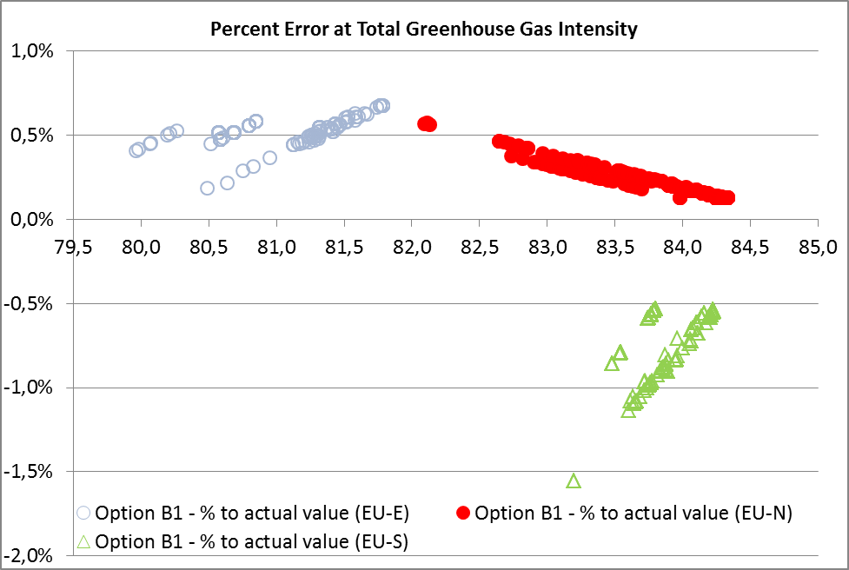
Figure 4: Assessment of option B1’s reporting accuracy at fuel supplier level
Despite the significant inaccuracies in the reporting of the GHG intensity at fuel supplier level, the reported average EU emissions may not be affected as long as the average default values used are based on robust data and capture variations in the feedstock mix in a timely manner. However, the fact that this option does not lead to the collection of real detailed market information by suppliers neither for reporting purposes nor for checking of compliance in 2020, poses a risk with regards to the accuracy of the reported average EU emissions as well as for the accuracy of the development of the fossil fuel comparator values. This is because, the best available data at EU level is based on voluntary provided data by members of the industry organization Oil and Gas Producers (OGP). Historically, the data reflected approximately a limited 30% of the crude oil refined in the EU. However, this system provides no information on imported products, which are expected to increase. In addition, the bulk of unconventional sources entering the European market are expected to be refined outside the EU and so this method will provide poor coverage, unless the reporting mechanism is significantly strengthened.
This approach is also the least consistent with the biofuels methodology, under which those suppliers blending biofuels can make use of conservative default greenhouse gas emission values disaggregated by feedstock and technological pathway, and best performing producers are given the opportunity to provide actual values over all steps of the value chain. Moreover, this option would not require fuel suppliers to put together any type of chain of custody mechanism, unlike for biofuel producers, as the GHG intensity of the fuels supplied would be based on the EU average fuel mix and not specific to the fuel consignment.
These issues around accuracy in option B1 are balanced by the fact that this methodology is least cost and would enable Member States to verify compliance by fuel suppliers with their obligation in the simplest possible way. This is because this methodology only relies on one piece of data from suppliers, quantities of product supplied, which is the most straightforward to verify. Validation of correctly applied factors (i.e. default unit GHG intensities) could also be undertaken but is straightforward and would not entail excessive administrative burden. The risk of fraud is therefore considered to be low.

5.2.2. Environmental impacts
In so far as this approach would lead to reductions in the consumption of fossil fuels, increased waste biodiesel and increased reductions in the emissions associated from flaring and venting as outlined above, it will lead to positive environmental impacts compared to the baseline scenario. In addition, as the level of mitigation effort required to achieve the 6% target is directly related to the accuracy of each methodology, there is a risk that this approach could lead to less mitigation actions being undertaken, given its lack of real monitoring of market information and that the share of imported products and unconventional sources is projected to increase.
On the other hand, the lack of differentiation between fossil fuel feedstocks neither discourages the consumption of more resource intense and more polluting unconventional sources, nor rewards those suppliers that have invested in lowering the carbon footprint associated with the production of their fuels as they would not be allowed to use actual calculations. The lack of such an incentive runs counter to the achievement of the key general objective of the Directive, i.e. the achievement of the 6% reduction target by fuel suppliers.

5.2.3. Economic impacts
With regards to additional costs for suppliers to comply with the FQD, the additional reductions required in upstream emissions and waste biodiesel result in compliance costs of 6 million euros. Given the simplicity of the methodology, and particularly the lack of a traceability mechanism needing to be implemented, this approach is expected to lead to the lowest administrative costs estimated to range between 2 to 3 million euros. While these costs reflect total administrative costs to suppliers and national authorities, the estimated burden on national authorities is negligible.
In determining the overall impacts on pump prices, it is important to consider that the market costs will be higher than those reported as compliance costs above. This is because in reality, the actual market impact will be closer to that of the marginal abatement cost under each option being applied to the whole of amount of CO₂ needed to be abated. In this context, option B1 is reported to lead to increased market costs of 79 million euros, or estimated pump price increases up to 0.03 cents per litre (0.04%). These costs are considered to be too small to lead to any significant changes in market structure, value added, capacity to innovate or competitiveness of EU refiners vis a vis international competitors.
Trade in crude oil and petroleum products would be largely unaffected compared to the baseline, with only a very small decrease of refined products being imported from the Former Soviet Union (~11PJ, 0.10%). The small increased amount of biofuel used may also lead to a decrease in the amount of products being refined in the EU (~32PJ, 0.29%). As a result, impacts on security of supply are also expected to be small, although it is worth noting that the share of imports in the final mix may increase under this option. As the ability for fuel suppliers to switch from higher to lower carbon intensity fossil fuel feedstocks is not a compliance option available to fuel suppliers, this option does not lead to any changes in the consumption or trade of unconventional fossil fuels in the EU. As such, the risk of a WTO challenge is low.

5.2.4. Social impacts
The market costs outlined above are considered to be too small to lead to any significant changes in market structure. As they are assumed to be passed almost in full to consumers, no significant differences in employment are expected.
In so far as this approach would lead to reductions in the consumption of fossil fuels, and increased reductions in the emissions associated from flaring and venting as outlined above, it will lead to positive air quality impacts compared to the baseline scenario, due to reduced emissions of particulate matter and methane), and thus positive effects on public health.

5.3 Option C - Methodology based on the disaggregated average default greenhouse gas intensity values by main feedstock types (“2011 proposal”)
Option C is the option described in the proposal submitted to the Member States in 2011. Under this option, the GHG intensity of all feedstocks used in the EU would be reported separately (i.e. petrol and diesel/gasoil from oil, natural bitumen, oil shale, coal to liquid, gaseous fuels and electricity, etc.) based on default values derived from public data.
This option would require differentiated reporting by fossil fuel suppliers of the specific fossil fuel feedstocks they supply. Therefore, differences between suppliers according to the feedstocks that are included in their fuel mix would be reported.
The modelled fuel mix to 2020 under this approach and corresponding abatement measures are shown in Annex XVII: Projected road fuel mix 2020 for each option (non-ILUC scenario) (Source: Vivid Economics). The key changes compared to the baseline should be interpreted with caution as these are very small in the context of the overall energy demand. These are,
- a negligible increase in the consumption of petrol (~7PJ, 0.06%) against fossil diesel, given that it has a better greenhouse gas emissions performance than fossil diesel.
- in addition, a small amount of fossil diesel (~32PJ, 0.29%) is replaced by biodiesel from waste (i.e. used cooking oil or animal fats), which provides a small contribution towards the required greenhouse gas emissions reductions (2.5Mt CO2).
- the bulk of the reduction in consumption of fossil diesel comes from unconventional fuel categories, mainly from natural bitumen, but also from gas to liquid and oil shale (total of~38PJ, 0.35%).
- the bulk of the abatement measures come in the form of reductions in upstream emissions (7.8Mt CO2).
- the role of crude and product switching is limited, given the technical constraints in refineries driven by fuel specifications and relatively higher carbon abatement costs compared to the other technologies available (i.e. biofuels and upstream emission reductions). As such, they only provide a small contribution (0.5 Mt CO2).
- a negligible reduction in total transport fuel demand (<0.1%).

5.3.1. Effectiveness in achieving policy objectives
This approach provides for a high degree of accuracy in its reporting of the greenhouse gas intensity associated with the fuels being supplied. This is because the variations in GHG intensity between feedstock categories (i.e. conventional versus unconventional; and between unconventional feedstocks) would be captured. In addition, the opportunity for suppliers of high intensity unconventional fuels to report on actual values would enhance the accuracy of this option and would provide for an incentive to improve production processes so as to reduce their greenhouse gas intensity. However, no differentiation within the average GHG intensity crude categories (i.e. conventional diesel high intensity and conventional diesel low intensity) would be reflected. This yields a small percentage error ranging between -0.1 to 0.2 percentage points of the FQD target with regards to reporting the GHG intensity of fuel suppliers. In addition, the collection of real detailed market information at feedstock level by suppliers for reporting purposes and for checking of compliance in 2020, helps ensuring that the reported average EU emissions as well as the fossil fuel comparator values remain accurate compared to the actual emissions.
This approach is partly consistent with the biofuels methodology, in so far that suppliers can make use of default greenhouse gas emission values disaggregated by fossil feedstock types and technological pathways, which, as is the case for biofuels now, is expected to become further disaggregated over time, although not all suppliers are given the opportunity to provide actual values if they wish to. Moreover, this option requires fuel suppliers to put together a type of traceability mechanism, likely that in place for biofuel producers, to report on the GHG intensity of the fuel consignments being supplied.
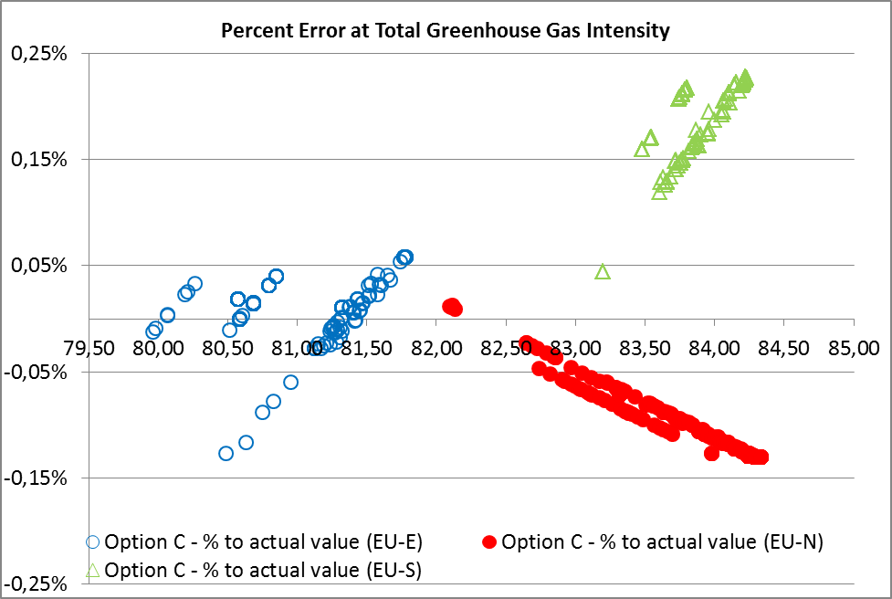
Figure 5: Assessment of option's C reporting accuracy at fuel supplier level
This methodology would require additional data collection efforts. This is because suppliers would need to split their fuels across feedstocks using feedstock mix data from the refineries of the origin of the products. In addition, refineries generally already track and report most of the required data (refineries inside and outside the EU), but do not currently apportion products in this fashion. Also, the categorisation of feedstocks in this manner is not currently undertaken, and feedstock origin details are not normally retained along supply chains of fuel market traders.
As such, Member States verification of compliance by fuel suppliers with their obligation would be of a medium complexity. The method relies on two types of data from suppliers: (i) quantities (MJ) per product, and (ii) those quantities split according to categories of feedstock. Since the quantities of products supplied also form entries in the excise duty systems of Member States, this part is already verifiable and presents a low risk of fraud. The data concerning the split of refinery feedstock categories is not readily available data: refineries know their own crudes that they are using as this information is fundamental to refinery operations, but data on the feedstock origins of products once traded are not readily available to suppliers. Therefore the current reporting practices would need bolstering in order to ensure scrutiny and verification so as to avoid fraud. Validation of correctly applied factors (default unit GHG intensities) could also be undertaken and would be straightforward.

5.3.2. Environmental impacts
Through reductions in the consumption of fossil fuels, increased waste biodiesel and increased reductions in the emissions associated from flaring and venting as outlined above, this option will lead to positive environmental impacts compared to the baseline scenario.
In addition, positive environmental impacts are enhanced by the differentiation between fossil fuel feedstocks also leading to a reduction in the consumption in the EU of more resource intense and more polluting unconventional sources, such as natural bitumen and oil shale. Suppliers of unconventional sources that have invested in lowering the carbon footprint associated with the production of their fuels could also be rewarded by being allowed to use actual calculations.

5.3.3. Economic impacts
The measures needed to be put in place by suppliers to comply with the FQD under this option, i.e. the additional reductions required in upstream emissions, waste biodiesel and product and crude switching would result in costs of around 8 million euros. In addition, the requirement for disaggregation of fuel mix into feedstock types and the need for a traceability mechanism under this approach, gives rise to moderate total additional costs to suppliers and national authorities ranging between 15 and 16 million euros annually. While these costs reflect total administrative costs to suppliers and national authorities, the estimated burden on national authorities is negligible. With regards to the impacts on pump prices, this option is reported to lead to increased market costs of 79 million euros, or pump price increases of around 0.03 cents per litre (0.04%). These costs are considered to be too small to lead to any significant changes in market structure, value added, capacity to innovate or competitiveness of EU refiners vs international competitors.
Trade in crude oil and petroleum products would not be impacted significantly compared to the baseline, although a small decrease in the level of imports of refined products from natural bitumen from North America (~22PJ, 0.20%), gas to liquid from Africa (~8PJ, 0.07%), oil shale (~6PJ, 0.06%) and conventional crude oil from Former Soviet Union (~6PJ, 0.06%) would be expected. The increased amount of biofuel used partially contributes to a small decrease in the amount of products being refined in the EU (~4PJ, 0.04%).
It is worth noting that since the consumption of unconventional sources is discouraged under this approach and the refining capacity for processing these is currently outside the EU, the overall decrease in diesel consumption has a larger impact on imports of refined products than on EU refineries. As such, overall security of supply may be slightly improved under this option. However, such measures may impact investments in certain EU countries, such as Estonia and Spain, where actions plans for upgrading refineries to be able to process unconventional sources are planned or underway. It should be noted that investments made to facilitate processing oil sands may not be impacted as oil sands are interchangeable with other heavy crudes.
In addition, Canada has raised concerns about the potential compatibility of this approach with WTO rules with regards to a discriminatory treatment of unconventional oil sources and so this methodology may be challenged at the WTO. In this context, legal analysis conducted by the Commission's legal services in 2011 provided reassurance that the methodology under this option, as regards natural bitumen feedstocks, may be defended in case of a challenge before the WTO adjudicatory bodies.

5.3.4. Social impacts
The market costs outlined above are considered to be too small to lead to any significant changes in market structure. As they are assumed to be passed almost in full to consumers, no significant differences in employment are expected.
In so far as this approach would lead to reductions in the consumption of fossil fuels, and increased reductions in the emissions associated from flaring and venting as outlined above, it will lead to positive air quality impacts compared to the baseline scenario. These are enhanced by the reduction in the consumption of more polluting unconventional sources, such as natural bitumen and oil shale.

5.4 Option D - Methodology based on disaggregated default greenhouse gas intensity, based on average (D1) or conservative (D2) values, while allowing suppliers to report actual values (“hybrid approach”)
Under this option, suppliers’ compliance would be based on the GHG impact of all feedstocks used in the EU (e.g., petrol and diesel/gasoil from oil, natural bitumen, oil shale, coal to liquid, gaseous fuel and electric energy, etc.). Suppliers would report default values based on average (option D1) or conservative, higher than average, GHG intensity values (D2). These options would require reporting of the origin of fossil fuel feedstocks. However, this information will not influence suppliers’ compliance with the reduction target. Alternatively, suppliers may wish to provide actual values. This methodology implies the same data collection and traceability requirements as option C, by default the compliance effort of option B1, and additional efforts for those suppliers choosing to report actual values.
The projected fuel mix to 2020 has only been modelled for option D1, given that the impacts of option D2 would be determined by the level of conservatism under which the default values would be set and the amount of suppliers actually opting to report actual values. Although this is unknown, the impacts of option D2 are expected to be close to option D1. In any case, the quantification of impacts for option E, where all suppliers are required to report actual values, should be seen as a very extreme case of option D2.
Any option where a supplier may choose the lowest value between a provided default value and a self-calculated actual value inherently leads to an underestimate of the EU average greenhouse gas intensity and skewed results. Hence it is only certain that the resulting impacts will fall somewhere between those presented for option C and option E. More details are shown in Annex XVII: Projected road fuel mix 2020 for each option (non-ILUC scenario) (Source: Vivid Economics).
The key changes compared to the baseline should be interpreted with caution as these are very small in the context of the overall energy demand. These are,
- a negligible increase in the consumption of petrol (~5PJ, 0.05%) against fossil diesel, given that it has a better greenhouse gas emissions performance than fossil diesel.
- in addition, a small amount of fossil diesel (~18PJ, 0.2%) is replaced by biodiesel from waste (i.e. used cooking oil or animal fats), which provides a small contribution towards the required greenhouse gas emissions reductions (1.6Mt CO2).
- the bulk of the reduction in consumption of fossil diesel comes from unconventional fuel categories including natural bitumen, gas to liquid and oil shale (~30PJ, 0.3%).
- the bulk of the abatement measures come in the form of reductions in upstream emissions (7.8Mt CO2).
- the role of crude and product switching is limited, given the technical constraints in refineries driven by fuel specifications and relatively higher carbon abatement costs compared to the other technologies available (i.e. biofuels and upstream emission reductions). As such, they only provide a small contribution (0.5 Mt CO2).
- a negligible reduction in total transport fuel demand (<0.1%).

5.4.1. Effectiveness in achieving policy objectives
This approach provides for a modest degree of accuracy in its reporting of the greenhouse gas intensity associated with the fuels being supplied at supplier level. This is because the variations in GHG intensity between feedstock categories (i.e. conventional vs unconventional; and between unconventional feedstocks) would not be captured. On the one hand, the opportunity for all suppliers to report actual values would enhance the accuracy of this option as it will encourage differentiation within the average GHG intensity crude categories (i.e. conventional diesel high intensity and conventional diesel low intensity). On the other hand, those suppliers whose fuel intensity is above such a default value would effectively be given a lower value, which poses a risk that the EU average values are underestimated unless these values are regularly updated. In this context, option D2 would be expected to provide a more accurate representation than option D1 as the amount of suppliers opting out of the use of those default values and instead using actual values should be higher.
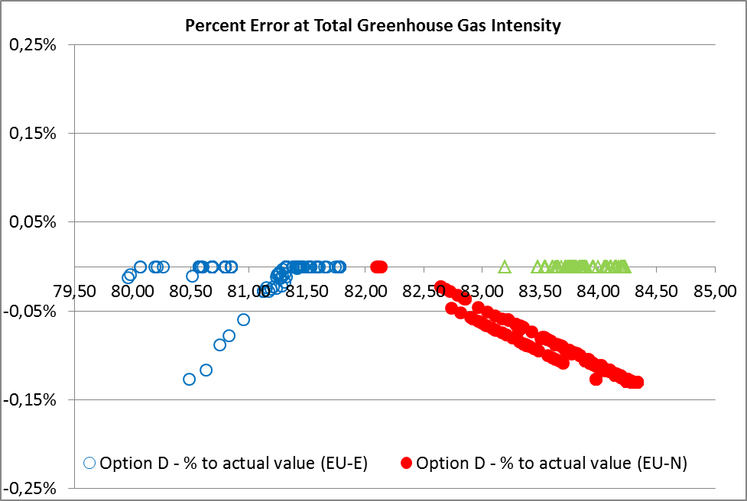
Figure 6: Assessment of option D1 reporting accuracy at fuel supplier level
This yields a percentage error ranging between 0 to -1.6 percentage points of the FQD target with regards to reporting the GHG intensity of fuel suppliers. However, the reported average EU emissions could be underestimated by an error of around -1% in the case of D1 as those suppliers with higher carbon intensities are expected to use average default values as these underestimate real emissions. This effect could be partially mitigated by either providing more frequent updates of such default values according to the actual data being reported or using conservative default values under D2. With regards to providing useful data for the purposes of the fossil fuel comparator, this option has some positive effects in so far as it increases collection of real detailed market information at feedstock level and in certain cases of actual values by suppliers. On the other hand, D1 and to a lesser extent D2 may lead to underestimation of the EU average value as explained above.
This approach is broadly consistent with the biofuels methodology in so far that suppliers can make use of default greenhouse gas emission values or provide actual values if they wish to. This is particularly relevant for option D2, which in line with the biofuel methodology as it includes conservative default values in order to incentivise more suppliers to report actual emissions. Moreover, this option requires fuel suppliers to put together a type of traceability mechanism, like that in place for biofuel producers, to report on the GHG intensity of the fuel consignments being supplied.
This methodology would require reporting of the origin of fossil fuel feed stocks. However, this information will not influence suppliers’ compliance with the reduction target. This methodology implies the same data collection and traceability requirements as option C and the compliance effort of option B1. As such, Member States verification of compliance by fuel suppliers with their obligation would be of a medium complexity for those suppliers choosing to use default values.
For suppliers that choose to provide their own actual values, verification by the Member States would be more complex. This is because verification processes would be necessary for any measured data or life cycle estimates generated by suppliers, and the level of rigour required by verification processes of these suppliers would need to be higher than that for those choosing to use default values due to the additional complexity of the calculations. The additional risk of fraud would therefore be higher.

5.4.2. Environmental impacts
Through reductions in the consumption of fossil fuels, increased waste biodiesel and increased reductions in the emissions associated from flaring and venting as outlined above, option D1, and to a greater extent option D2, would be expected to lead to positive environmental impacts compared to the baseline scenario. In addition, differentiation between fossil fuel feedstocks also leads to enhanced benefits as a result in reductions in EU consumption of more resource intense and more polluting unconventional sources, such as natural bitumen and oil shale.
In addition, the ability to provide actual values would be expected to lead to suppliers of both conventional and unconventional sources that have invested in lowering the carbon footprint associated with the production of their fuels to be rewarded by being allowed to use actual calculations. Option D2 is likely to incentivise this type of behaviour to a greater level than option D1 since more suppliers would have a lower GHG intensity than that of the default value that would be provided.

5.4.3. Economic impacts
The measures needed to be put in place by suppliers to comply with the FQD under this option, i.e. the additional reductions required in upstream emissions, waste biodiesel and product and crude switching would result in costs of around 1 million euros for option D1, and from 1 to 8 million euros for option D2. In addition, the requirement for disaggregation of fuel mix into feedstock types, the need for a traceability mechanism under this approach, and the increasing number of suppliers expected to report actual emission values, gives rise to moderate total additional costs ranging from 18 to 28 million euros under D1 and up to 31 million euros under option D2. While these costs reflect total administrative costs to suppliers and national authorities, the estimated burden on national authorities is negligible.
With regards to the impacts on pump prices, this option is reported to lead to increased market costs between 59 to 79 million euros, or pump price increases of 0.02-0.03 euro cents per litre (0.04%). These costs are considered to be too small to lead to any significant changes in market structure, value added, capacity to innovate or competitiveness of EU refiners versus international competitors.
For option D1, trade in crude oil and petroleum products would not be impacted significantly compared to the baseline, although a decrease in the level of imports of refined products from natural bitumen from North America (~18PJ, 0.16%), gas to liquid from Africa (~6PJ, 0.06%) and oil shale (~4PJ, 0.04%) would be expected. The increased amount of biofuel used partially contributes to a very small decrease in the amount of crude oil being refined in the EU (~1PJ, 0.01%). It is worth noting that since the consumption of unconventional sources is discouraged under this approach and the refining capacity for processing these is currently outside the EU, the overall decrease in diesel consumption has a larger impact on imports of refined products than EU refineries. Impacts for option D2 would be somewhere between these described here and that under option E. As such, security of supply may be slightly improved under this option. However, such measures may impacts investments in certain EU countries, and raise the same issues in relation to WTO rules as referred for option C (see 5.3.2.).

5.4.4. Social impacts
The market costs outlined above are considered to be too small to lead to any significant changes in market structure. As they are assumed to be passed almost in full to consumers, no significant differences in employment are expected.
In so far as this approach would lead to reductions in the consumption of fossil fuels, and increased reductions in the emissions associated from flaring and venting as outlined above, it will lead to positive air quality impacts compared to the baseline scenario. These are enhanced by the reduction in the consumption of more polluting unconventional sources, such as natural bitumen and oil shale.

5.5 Option E - Methodology based upon separate greenhouse gas intensities for individual categories of feedstocks ("complete differentiation")
This option would require upstream greenhouse gas emissions estimates for individual categories of feedstocks within those types described under option C to be calculated and reported (e.g. field level, trade name, MCON, etc.) by suppliers. As actual disaggregated data may not necessarily be available for all fuel types and to all suppliers at the moment, this option may be challenging in its implementation as the option to use instead default values is not available to suppliers.
The modelled fuel mix to 2020 under this approach and corresponding abatement measures are shown in Annex XVII: Projected road fuel mix 2020 for each option (non-ILUC scenario) (Source: Vivid Economics). The key changes compared to the baseline should be interpreted with caution as these are very small in the context of the overall energy demand. These are,
- a negligible increase in the consumption of petrol (~6PJ, 0.06%) against fossil diesel, given that it has a better greenhouse gas emissions performance than fossil diesel.
- in addition, a small amount of fossil diesel (~32PJ, 0.29%) is replaced by biodiesel from waste (i.e. used cooking oil or animal fats), which provides a small contribution towards the required greenhouse gas emissions reductions (2.5Mt CO2).
- the bulk of the reduction in consumption of fossil diesel comes from unconventional fuel categories including natural bitumen, gas to liquid and oil shale (~35PJ, 0.32%).
- the bulk of the abatement measures come in the form of reductions in upstream emissions (7.8Mt CO2).
- the role of crude and product switching is limited, given the technical constraints in refineries driven by fuel specifications and relatively higher carbon abatement costs compared to the other technologies available (i.e. biofuels and upstream emission reductions). As such, they only provide a small contribution (0.5 Mt CO2).
- a negligible reduction in total transport fuel demand (<0.1%).

5.5.1. Effectiveness in achieving policy objectives
This approach provides for the highest degree of accuracy in its reporting of the greenhouse gas intensity associated with the fuels being supplied as all suppliers are required to report actual values. Therefore, all differences between and within fuel feedstock categories would be captured with no error being derived from the reporting mechanism itself. In addition, the collection of real detailed market information at fuel consignment level by suppliers makes this option being the most accurate in the context of updating the fossil fuel comparator values.
This approach is inconsistent with the biofuels methodology and much more burdensome, in so far that suppliers cannot make use of default greenhouse gas emission values but must provide actual values at all times. Moreover, this option requires fuel suppliers to put together a more complex traceability mechanism than that in place for biofuel producers.
As suppliers are requested to provide their own actual values, verification by the Member States would be complex. Verification of measured data would be necessary and extensive if the data used has not been verified for other purposes. In this context, while the validation of lifecycle emission models available to EU suppliers would be possible, it would be challenging to reliably verify measured data for feedstocks originating from outside the EU or North America, which represent over three quarters of all feedstocks consumed in the EU. As such, the implementation of this option may require an interim period where further disaggregated data can be developed or gathered to ensure full coverage of all fuels. The potential for fraud with this option is higher than for other options.

5.5.2. Environmental impacts
Through reductions in the consumption of fossil fuels, increased waste biodiesel and increased reductions in the emissions associated from flaring and venting as outlined above, it will lead to positive environmental impacts compared to the baseline scenario. In addition, full differentiation between fossil fuel feedstocks also leads to a reduction in the consumption of more resource intense and more polluting unconventional sources, such as natural bitumen. All suppliers would now be required to report actual values, and so both those supplying high carbon conventional sources, who may under other options resort to a default value, and those using unconventional sources, would be very strongly incentivised to take action.

5.5.3. Economic impacts
The measures needed to be put in place by suppliers to comply with the FQD under this option, i.e. the additional reductions required in upstream emissions, waste biodiesel and product and crude switching would result in costs of around 8 million euros. In addition, the requirement for full disaggregation of fuel mix and the need for a more complex traceability mechanism under this approach, gives rise to the highest total administrative costs, with costs ranging between 21 and 42 million euros annually. While these costs reflect total administrative costs to suppliers and national authorities, the estimated burden on national authorities is much smaller.
With regards to the impacts on pump prices, this option is reported to lead to increased market costs of 79 million euros, or pump price increases of 0.04 cents per litre (0.06%). These costs are considered to be too small to lead to any significant changes in market structure, value added, capacity to innovate or competitiveness of EU refiners versus international competitors.
Trade in crude oil and petroleum products would not be impacted significantly compared to the baseline, although a decrease in the level of imports of refined products from natural bitumen from North America (~21PJ, 0.19%), gas to liquid from Africa (~8PJ, 0.07%), oil shale (~4PJ, 0.04%) and conventional crude oil from Former Soviet Union (~3PJ, 0.03%) would be expected. The increased amount of biofuel used partially contributes to a small decrease in the amount of conventional crude oil being refined in the EU (~8PJ, 0.07%). It is worth noting that since the consumption of unconventional sources is discouraged under this approach and the refining capacity for processing these is currently outside the EU, the overall decrease in diesel consumption has a larger impact on imports of refined products than EU refineries. As such, security of supply may be slightly improved under this option. However, such measures may impact investments in certain EU countries, such as Estonia and Spain, where plans for upgrading refineries to be able to process unconventional sources are planned or underway.
With regards to WTO rules, this approach is seen by some Member States and certain oil exporting third countries as the fairest approach as it is based on full differentiation of all fuels. However, it may require an interim period where further disaggregated data can be developed or gathered.

5.4.4. Social impacts
The market costs outlined above are considered to be too small to lead to any significant changes in market structure. As they are assumed to be passed almost in full to consumers, no significant differences in employment are expected.
In so far as this approach would lead to reductions in the consumption of fossil fuels, and increased reductions in the emissions associated from flaring and venting as outlined above, it will lead to positive air quality impacts compared to the baseline scenario. These are enhanced by the reduction in the consumption of more polluting unconventional sources, such as natural bitumen and oil shale.

Section: comparison of the options
The table below summarises the main issues related to the different options.
Option B1 | Effectiveness | Other
Option B1 | Least degree of accuracy for reporting GHG intensity of fuel suppliers (-1.6 to 0.7 p.p off FQD target). GHG intensity of fuels supplied in the Eastern and Northern European countries being overestimated while that of Southern European countries is underestimated.  Poses risks reported average EU emissions are less accurate as no real market information is collected by suppliers.  Least consistent with biofuel methodology.  Simplest implementation and verification process by Member States as based on existing reporting requirements. | Lowest annual administrative costs (€2-3 m). Abatement 2020 related market costs (€79m). Negligible pump price increases (0.04% or 0.03 cents per litre).  Environmental gains from increased waste biofuel use and upstream emission reductions.  Simplest reporting arrangements  Lowest level of EU refining and largest share of imports.  No significant competitiveness impacts on EU refineries.
Option C | High accuracy for reporting GHG intensity of fuel suppliers (-0.1 to 0.2 p.p. of FQD target).  Reported average EU emissions accurate.  Partly consistent with biofuel methodology.  Implementation and verification processes of medium complexity as additional information would need to be collected. | Environmental gains from increased waste biofuel use and upstream emission reductions, and largest reductions of unconventional sources consumption.  Annual administrative costs (€15-16m). Abatement 2020 related market costs (€79m). Negligible pump price increases (0.04% or 0.03 cents per litre).  No significant competitiveness impacts on EU refineries. It may impact planned or existing investments for upgrading refineries to process unconventional oil.  Incentives for downstream emission reductions only to suppliers of products from high intensity crudes.  Manageable risk of WTO challenge
Option D1-D2 | Modest accuracy for reporting GHG intensity of fuel suppliers (0 to -1.6 p.p. of FQD target).  Risk of underestimation of average EU emissions reported from D1 (-1 pp FQD) and to a lesser extent from D2. Southern European countries GHG intensity underestimated.  D2, and to a lesser extent D1, fully consistent with biofuel methodology.  Implementation and verification processes of is more complex as additional information would need to be collected on methodologies used for actual value reporting . | Environmental gains from increased waste biofuel use and upstream emission reductions, and reductions of unconventional sources consumption. Underestimation of EU average may lead to less abatement tools required (i.e. biofuels), and therefore lowest overall costs for D1.  Annual administrative costs (€18-28m). Abatement 2020 related market costs (€59-79m). Negligible pump price increases (0.04% or 0.02-0.03 cents per litre).  No significant competitiveness impacts on EU refineries. It may impact planned or existing investments for upgrading refineries to process unconventional oil.  Incentives for downstream emission reductions to all suppliers.  Manageable risk of WTO challenge
Option E | Most accurate option for reporting of both GHG intensity of fuel suppliers and EU average.  Inconsistent with biofuels methodology.  Implementation and verification processes of high complexity as significant additional information would need to be collected. High risk of fraud. | Environmental gains from increased waste biofuel use and upstream emission reductions, and reductions of unconventional sources consumption. Annual administrative costs (€21-42m). Abatement 2020 related market costs (€79m). Negligible pump price increases (0.06% or 0.04 cents per litre).  No significant competitiveness impacts on EU refineries. It may impact planned or existing investments for upgrading refineries to process unconventional oil.  Incentives for downstream emission reductions to all suppliers.

Section: conclusion
In conclusion the choice of methodology is critical in determining the accuracy of the reported carbon intensity of the fuels being supplied. Some methodologies lead to a underestimation and/or overestimation of the GHG intensity of fuels at the supplier level. Options D1 and D2 tend to also underestimate the GHG intensity of fuels at the EU level. Inaccurate reporting can partly undermine the overall ambition of the FQD and affect the way the burden is shared amongst fuel suppliers.
The options that lead to a further level of disaggregation than simply fuel type (i.e. feedstock and fuel consignment level) are more effective in encouraging consumption of lower GHG intensity and less polluting fuels. These yield positive results with regards to environmental impacts. Indirectly, this tends to lead to small reductions in imported products as crudes sourced by EU refineries tend to present lower carbon intensities.
There is little variation in terms of economic costs with regards to the different options although some differences in administrative and compliance costs have been found. As the differences between the options represent very low overall costs, they are not considered to be significant in terms of economic or competitiveness impacts for fuel suppliers, in contrast to industry claims to the contrary. Reductions in upstream emissions and increased biofuel blending deliver the bulk of the additional reductions needed to achieve the FQD target under all options. The possibility for suppliers to replace higher with lower carbon intense fuels plays a limited role in achieving the mandated greenhouse gas emission reductions under those options where this abatement option is allowed.
Where suppliers can choose between the reporting of their actual GHG intensity values or a default value being provided there is a risk that suppliers of high intensity crudes could profit from this flexibility unless such default values are set conservatively.
Theoretically it may be desirable to encourage suppliers to report the actual emissions associated with the production of their fuels as a way to promote innovation and reward investments in improving their GHG intensity beyond business as usual. However in practice, despite significant improvements in the development of data inventories worldwide, it seems that major gaps remain for the production of fuels in certain regions. As such, the implementation of option E may require more time so that further disaggregated data can be developed or gathered to ensure full coverage of all fuels.
B1 leads to the simplest implementation and verification mechanism given that it does not require any additional data collection. B1 also comes with the least administrative costs. However B1 yields certain inaccuracies in terms of reporting GHG intensity at supplier level and poses some risks in reporting the EU average, as the best available data presents a low coverage of the market, does not cover imported products and no real market information is collected by suppliers under this option. Option B1 yields a relatively worse environmental performance. In contrast, options C, D1 and D2 are slightly higher in their administrative costs and are similar in terms of providing a more accurate methodology and present positive environmental impacts, although D2 is more burdensome.
In the hybrid option(s) D suppliers would need to provide their own actual GHG intensity calculation and so would need to rely on measurement or estimation methods, and while limitations on data availability exist. In conclusion, there would appear to be a series of issues that finely balance the choice between options C, D1, D2 and B1. The option B1 approach is expected to lead to the lowest administrative costs. While option E is attractive as potentially more accurate, it would be difficult to implement this option in the short term but possible by 2020. That is why option B1 is preferred: Average default GHG values by fuel type (petrol/diesel) based on an EU fuel mix (“basic reporting approach”)

Section: monitoring and evaluation

8.1. Core indicators of progress
The core indicators of progress are linked to the evolution of the average road fuel mix in the EU and associated mitigation actions. They cover data relating to:
• fuel supplied in road transport in the EU, including volumes, origin, place of purchase and life-cycle greenhouse gas emissions;
• progress made towards achieving the required greenhouse gas emissions reduction target, and relevant mitigation actions, including shares and types of biofuels placed on the market, renewable electricity, reductions in upstream emissions associated with the production of fossil fuels, etc.

8.2. Monitoring arrangements
The Commission will, building on the data to be provided by fuel suppliers to Member State authorities in their annual fuel quality reports and gathering any additional information as necessary, monitor,
- the accuracy and reliability of the monitoring and reporting of fossil fuel greenhouse gas intensity;
- the effectiveness of the adopted fossil fuel methodology under Article 7a of Directive 98/70/EC to incentivise reductions in the greenhouse gas intensity of road fuels through increased biofuel blending and reductions in upstream emissions;
- changes in the EU refinery sector and supply of petroleum feedstocks to the EU
- the functioning of the reporting requirements associated with the adopted fossil fuel methodology and associated administrative burden on industry, including SMEs;
- developments in the methods and data available to fuel suppliers for the determination of the greenhouse gas emissions intensity of the fuels they supply at further levels of disaggregation;
- the appropriateness of the default greenhouse gas intensity values in this Directive, and update these in line with the latest technical and scientific information if necessary.
These arrangements will be reviewed as foreseen in the resulting legislation.

Glossary
Baseline = projection of fossil fuels consumption in EU in 2020. The associated greenhouse gas emissions are used as basis to understand the capacity of reaching the target of 6% reduction of greenhouse gas emission in the transport sector in 2020.
Biodiesel = oil-based biofuels typically produced from vegetable and animal fats, such as rapeseed oil and tallow, and used as a diesel additive for its use in motor vehicles.
Bioethanol = alcohol-based biofuel typically produced from starch and sugar crops such as wheat and sugar beet, and used as a petrol additive for its use in motor vehicles.
Biofuels = liquid or gaseous fuel used for transport purposes produced from biomass.
GHG intensity = amount of carbon by weight emitted per unit of energy consumed. A common measure of GHG intensity is weight of carbon (g CO2 eq.) per Mega joule of energy.
Conventional Oil = crude and unrefined oil stock extracted from underground reservoirs using the natural pressure of the wells and pumping or compression operations.
Feedstock = any bulk raw material constituting the principal input for the production or conversion into fuels.
Flaring and Venting = consequences of oil and gas production. Flaring is a controlled burning of natural gas that cannot be processed or sold and disposes of the gas while releasing emissions into the atmosphere. Venting consists in the release of unburned gases in the atmosphere, often aimed at ensuring the safety conditions in the course of the various processes and treatments. Both flaring and venting release greenhouse gases, particulate matter, sulphur dioxide (SO2) and methane into the atmosphere.
Fuel mix = result of fossil feedstock diet fed to the EU refineries in a determined period of time.
Indirect land-use change = land-use change occurring indirectly i.e. mostly referred to in the context of land-use change as a result of displaced demand previously destined for food/feed/fibre market as a result of biofuel demand.
Lifecycle greenhouse gas emissions = emissions associated with the production and use of transport fuels and electric energy. This includes emissions produced through the extraction of feedstocks used for production of transport fuels and electric energy, their processing, their subsequent transport and refining as well as their use in vehicles (referred to as their tail pipe emissions).
Methodology based on a disaggregated value = a single default GHG intensity value would be established for each type of feedstocks used to produced fuels
Methodology based on an average default value = an average default GHG intensity value would be established for the main four fuels consumed in Europe (i.e. petrol, diesel/gasoil, LPG and CNG).
Unconventional Oil = crude oil found in shale formations and sand. It is explored, developed and produced through unconventional processes. The terms “natural bitumen”, “tar sands” and “oil sands” are used indifferently throughout this document.

Acronyms
2G BD Second generation bio diesel
2G Et Ethanol
APEC Asia-Pacific Economic Cooperation
API American Petroleum Institute
APPEA Australian Petroleum Production & Exploration Association
ARA Amsterdam – Rotterdam – Antwerp
b/cd Barrels per calendar day
BP British Petroleum
CARB Californian Air Resources Board
CARB LCFS Californian Air Resources Board Low Carbon Fuel Standard
CCS Carbon Capture Storage
CDU Crude Distillation Unit
CH4 Methane
CHP Combined heat and power
CIF Cost, Insurance and Freight
CN Combined Nomenclature
CNG Compressed natural gas
CO2 Carbon dioxide
CONCAWE CONservation of Clean Air and Water in Europe
CTL Coal-to-Liquids
DG AGRI Directorate General Agriculture
DG ENER Directorate General Energy
DG ENTR Directorate General Enterprise and Industry
DG ENV Directorate General Environment
DG MOVE Directorate General for Mobility and Transport
DG TRADE Directorate General for Trade
EDD Energy Duty Directive
EEA European Environmental Agency
EMCS Excise Movement and Control System
ENS Entry Summary Declaration
EORI Economic Operation Registration and Identification
ETD Energy Taxation Directive
ETS European Emissions Trading Scheme
EU/EU-27 European Union
EUROPIA European Petroleum Industry
EUROSTAT European Statistical System
FQD Fuel Quality Directive
FSU Former Soviet Union
FT Fischer-Tropsch
g Grams
GHG Greenhouse gas
GTL Gas-to-liquids
GWP Global Warming Potential
H2S Hydrogen-sulphide
ICCT The International Council on Clean Transportation
IEA International Energy Agency
IEF International Energy Forum
IFPRI International Food Policy Research Institute
ILUC Indirect Land Use Change
IPIECA International Petroleum Industry Environmental Conservation Association
IPPC Integrated Pollution Prevention and Control
JEC Consortium of JRC, EURCAR (the European Council for Automotive R&D) and CONCAWE (the Oil Companies’ European Organisation for Environment, Health and Safety)
JODI Joint Organisation Data Initiative
JRC The Joint Research Centre of the European Commission
Kg Kilograms
LCA Life Cycle Assessment
LCFS Low Carbon Fuel Standard
LNG Liquefied Natural Gas
LP Linear Programme
LPG Liquefied Petroleum Gas
LRTAP Convention on Long-range Trans boundary Air Pollution
MACC Monitoring Atmospheric Composition and Climate
MCON Marketable Crude Oil Name
MJ Mega joule (106 joules)
MMT Million Metric Tons
MRV Monitoring, Reporting and Verification
MS Member States of the European Union
Mt Million tonnes
Mtoe Million tonnes of oil equivalent
N2O Nitrous Oxide
NCTS New Computerised Transit System
NGL Natural Gas Liquids
NGO Non-governmental Organisation
NH3 Ammonia
NMVOC Non-Methane Volatile Organic Compounds
NOx product from the reaction of nitrogen and oxygen
NRC National Research Centre
NREAPS National Renewable Energy Action Plans
OECD Organisation for Economic Co-operation and Development
OGP International Association of Oil & Gas Producers
OLADE Latin American Energy Organization
OPEC Organization of the Petroleum Exporting Countries
PM2.5 Particulate Matter
PM10 Particulate Matter
PJ Petajoule (1015 joules)
PVC Polyvinyl Chloride
RED Renewable Energy Directive
R&D Research and Development
RLCFRR British Columbia Renewable and Low Carbon Fuel Requirement Regulation
ROW Rest of the World
SMEs Small and Medium Enterprises
T&E Transport and Environment
TJ Terajoule (1012 joules)
TNK-BP Russian Oil Company
TTW Tank-to-Wheel
UER Upstream Emissions Reduction
UK United Kingdom of Great Britain and Northern Ireland
UNECE United Nations Economic Commission for Europe
UNEP-GPA United Nations Environment Programme. Global Programme of Action for the Protection of the Marine Environment from Land-based Activities
UNFCCC United Nations Framework Convention for Climate Change
UNSD United Nations Statistics Division
UPEI Union of European Petroleum Independents
US United States of America
US EPA United States Environmental Protection Agency
USGS United States Geological Survey
USLCFS United States Low Carbon Fuel Standard
VOCs Volatile Organic Compounds
WEO World Economic Outlook
WTO World Trade Organisation
WTR Well-to-Refinery
WTT Well-to-Tank
WTW Well-to-Wheel

Annex I : Overview of the oil production process (Source: Europia)
The oil industry can be divided into two major components summarised in the figure below.
The upstream oil sector is a term commonly used to refer to the searching for and the recovery and production of crude oil and is also known as the exploration and production (E&P) sector. Exploration involves the search for rock formations associated with oil deposits, and involves geophysical prospecting and/or exploratory drilling. Well development occurs after exploration has located an economically recoverable field, and involves the construction of one or more wells from the beginning (called spudding) to either abandonment if no hydrocarbons are found, or to well completion if hydrocarbons are found in sufficient quantities. Production is the process of extracting the hydrocarbons and separating the mixture of liquid hydrocarbons, gas, water, and solids, removing the constituents that are non-saleable, and selling the liquid hydrocarbons and gas. Production sites often handle crude oil from more than one well. Oil is nearly always processed at a refinery.
The downstream oil sector is a term commonly used to refer to the refining of crude oil and the selling and distribution of natural gas and products derived from crude oil. The downstream sector includes oil refineries, petrochemical plants, petroleum product distribution, retail outlets and natural gas distribution companies. The downstream industry touches consumers through thousands of products such as petrol, diesel, jet fuel, heating oil, asphalt, lubricants, synthetic rubber, plastics, fertilisers, antifreeze, pesticides, pharmaceuticals, natural gas and propane.
UPSTREAM
DOWNSTREAM
Exploration & Production
Supply
Refining
Distribution
Sales & Marketing
Figure 4: Summary of the oil production process. Source: Europia

Oil refineries play a particularly important role in the process of providing oil products for consumers. Refineries break down crude oil into its various components, which can then be selectively converted into a range of new products. The complexity of refinery operations varies from one installation to the next, but generally all refineries perform three basic steps: separation, conversion and treatment.
Refineries typically consist of a large number of processing units in which crude oil is first separated, through distillation, into a number streams of different boiling range and molecular structure. These streams are then processed further, predominantly via catalytic conversion that requires high temperature and high pressure. These conversion processes deliver oil product streams that after further treatment are suitable for a variety of applications. Demand for cleaner, high-value products, which can meet stricter specifications, means modern refineries have to use ever more complex and energy intensive processes. The refinery process is summarised in the following diagram.
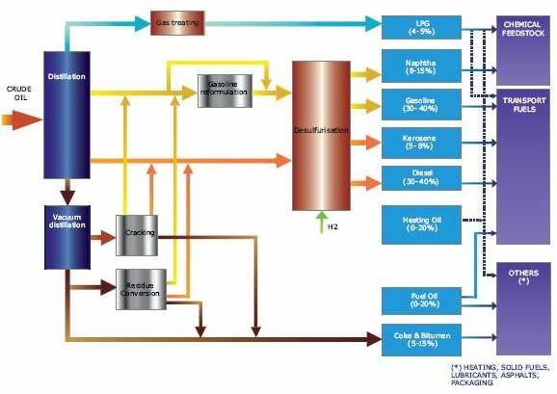
Figure 5: Overview of the oil refinery process. Source: Europia

Most refineries produce a wide range of products. These generally include:
- Gases such as LPG (liquefied petroleum gas) which can be used as feedstock for chemical processes, as fuel for heating and cooking or as transportation fuel.
- Naphtha, which is mostly used as chemical feedstock.
- Petrol, a main source for transport fuels.
- Kerosene and jet fuel, predominantly used as fuel for commercial aircraft and military transport.
- Middle distillates consisting of diesel fuel for transport (road and rail), heating oil for domestic and commercial applications and marine diesel mostly for inland and coastal shipping
- Heavy Fuel Oil for industrial installations (power generation and boilers)
- Bunker Fuels for sea-going vessels
- Speciality products including lubricants and greases for automotive and industrial applications, bitumen, mainly for road and roof surfacing, coke for specialty applications like electrodes and hydrocarbon solvents, predominantly used in speciality industrial applications.
Following processing at a refinery, and with the use of pipelines, road tankers and tankers transported by ship, transport fuel is sent to distribution centres and from these distribution centres, transport fuel is transported to local service stations, so that consumers can purchase it for their vehicles.

Annex II : the EU crude oil supply chain (Source: various)
The European oil industry and oil trade is mainly based on foreign oil exploration and production with overwhelming dependency on oil imports from Former Soviet Union, Middle East and North Africa.
In simple terms the supply chain incorporates transportation, processing, refining and distribution. Most of the oil that is imported into the EU comes in either as crude oil which has to be refined into various products or as finalised products (which have been refined outside the EU) or 'intermediate' products (petrochemicals or diesel which have been refined outside the EU and may need to be refined further). EU refineries can be used to process crude oil, feedstock and intermediates from other refineries and feedstock from chemical plants. Following processing, oil and oil products can be processed and distributed throughout the EU or outside of the EU via pipelines, road tankers and tankers transported by ship.
- Reporting in the supply chain
There is currently a significant amount of data transferred along the oil supply chain. GHG emissions are already being tracked by many major oil companies for the purposes of voluntary sustainability reporting. This reporting includes data on the GHG intensity of fuels but does not include details on the origin of products.
Refiners need to know the chemical composition of the crude they are using for efficient refining, and as such they collect information about its origin. In addition, there are also several laws and regulations in place which require information to be reported on imported products placed on the European marketplace, including origin, tariff classification, mass or volume, and physical characteristics. The EU requires importers to provide information on their imported goods for customs purposes. Much of this information is similar to that required under the FQD. Suppliers should already report the country of origin, properties of the crude, and its intended purpose at the time of importation. Overall, given the existing EU legislation and practices in place, economic operators and importers are required to provide a significant amount of information upon importation and there are additional obligations to ensure that this information is transferred through the chain of custody as a product moves about the EU.
The following table summarizes some of the information which is reported on/available (at Member State and EU level) at various stages in the supply chain at the moment and the drivers for this.

Supply Chain | Info | Driver
Import | Physical Properties  Feedstock source  Intended Purpose of the goods | Combined Nomenclature
Import | Proof of Origin | Community Customs Code
Import | General Information on source of oil | Commodity Code
Import | Destination of goods and how the goods are to be transported | Entry Summary Declaration
Import | Transport means; country of origin; product details; statistical value; gross and net mass | Single Administrative Document/ NCTS
Import | Designation of the crude oil (inc API); quantity in barrels; CIF per barrel; percentage sulphur content | Council Regulation (EC) No.2964/95
Import | Movement of Excise goods | Excise Duty Directive
Refining | Name of crude  Country of Origin, State & Province | Oil Industry / Refinery practices
Retail Sale | Details on products being used for transport fuel | Energy Taxation Directive
Other Info available | Overall GHG emissions | API/IPIECA GHG Compendium (Voluntary) guidelines for estimating GHG emissions
 | Information on Products and product Flows | Joint Organisation Data Initiative

The following diagram displays the basic supply chain for imported crude oil, intermediate products and feedstock together with the type of information available at particular stages. In practice, the supply process may involve more steps than those shown in the basic diagram below, depending on how complex the supply chain is in terms of the movement of oil streams.
Final products
Crude Oil
- More detail on drivers for and information included in current reporting
- Combined Nomenclature
The basis of all reporting is the Combined Nomenclature (CN), which provides tariff classifications for imported goods. Each year, the Commission publishes an updated version of its Annex I setting out tariff classifications—called CN codes—for all imported and exported products. CN-codes help to determine tariff duties and play an important role in trade negotiations at the WTO level, while the CN-coding system is also used for statistical purposes as records can be maintained on the number of products being exported and imported as per the classifications. The CN codes are thus used to help maintain a record of foreign trade statistics. The CN codes for petroleum oils differentiate according to physical properties (density, sulphur content, and distillation temperature) and feedstock source (such as crude or bituminous materials other than crude). The CN codes also require importers to disclose the intended purpose of the imported goods in the European Union. This includes imports for use as transport fuels and those destined to undergo specified processes at refineries. A supplier cannot determine the applicable CN code without this information.
- Customs Code
Another source for information is the Customs Code, which lays down rules and procedures applicable to goods brought into or out of the Community customs territory.
Any goods entering the European Union must be accompanied by a customs declaration and supporting documentation (including information on proof of origin) that is subject to verification by customs authorities. Goods which were produced in more than one country "shall be deemed to originate in the country or territory where they underwent their last substantial transformation.” The term “substantial transformation” has yet to be defined in the Modernised Customs Code. Import duties are based on the tariff classifications in the CN but may also be based on other nomenclature based fully or partly on the CN. The Customs Code can therefore provide a legal basis for distinguishing between petroleum oils derived from conventional crudes or synthetic crudes.
- Commodity code
The commodity code combines the customs code and CN-code, using Taric and additional codes, which, with regard to crude oil, can give general information regarding the source of the oil.
- Entry Summary Declaration
Before the entry of goods in the European Union an Entry Summary Declaration (ENS) has to be completed to provide a description of the bulk goods entering the EU as well as general information about the ship, its travel, load and crew. Where the first EU country in which a ship arrives is not the same country as that of the import of goods, it must be clear what the destination of the goods is and how the goods are to be transported (e.g. by ship, train, pipeline or truck) to the importing country. This declaration is not needed for goods which enter by pipelines or for goods from Norway.
- Single Administrative Document or New Computerised Transit System (NCTS)
A Single Administrative Document has to be filled in or an electronic declaration has to be made in the New Computerised Transit System (NCTS) for imported goods or release for free circulation. The declaration is the same in all EU countries and is standardised in the Community Customs Code. For most oil imports an electronic declaration will be used. Every importing company has to use its own EORI (Economic Operation Registration and Identification) number. The type of data that is required (if appropriate) includes: the means of transport (by a code); the country of origin of the product (by a code); the product (by a code); the statistical value (and currency); and the gross and net mass (kg).
Copies of the (electronic) document are submitted to the national statistical bureau or, in the case of transport between member states, to both statistical bureaus. The country of origin is the country where the crude oil is extracted. The customs organisation also uses the Transit system (the New Computerised Transit System, NCTS) for exporting and importing excise goods from or to third countries.
- Council Regulation (EC) No.2964/95 registration for crude oil imports and deliveries in the EU
Council Regulation (EC) No.2964/95 requires any person (economic operator) importing crude oil from third countries or receiving a crude oil delivery from another Member State to provide information on the delivery/imported product to the Member State in which they are established. Information, including the designation of the crude oil, the API gravity, the quantity in barrels, the CIF price (Cost, Insurance and Freight) paid per barrel and the percentage sulphur content, is then reported to the Commission by Member States. Results from this reporting can be found on the DG Energy website market observatory section. This data for the crude register is collected from the oil importing companies by the national statistical bureau and confidentiality provisions apply.
- Excise Duty Directive and Energy Taxation Directive
- The Excise Duty Directive (EDD) () and the Energy Taxation Directive (ETD) () stipulate the rules on the levying of indirect taxes on energy products and can be used to track the movement of goods (EDD) and obtain information on the taxation of products being used for transport fuels (ETD). The EDD lays down general arrangements for levying excise duties on the consumption of excise goods such as energy products. In principle the excise duty becomes chargeable ‘at the time, and in the Member State, of release for consumption’ of the excise goods. For those petroleum products which are energy products excise duties become chargeable upon their production (including extraction) within the EU unless the production, processing and holding take place in a tax warehouse, and in such case the goods are placed under a duty suspension arrangement. For imported goods the excise duty is normally chargeable at the moment of importation ‘unless the excise goods are placed, immediately upon importation, under a duty suspension arrangement’. Movement of excise goods under suspension of excise duty within the EU is monitored through a computerized system (Excise Movement and Control System (EMCS)). The energy products are defined with references to the codes of the CN. The EMCS is therefore a useful system through which Member States can track intra-EU movement of excise goods under suspension of excise goods. ETD lays down the EU framework for the taxation of energy products and electricity. In general the ETD requires Member States to impose taxation on any product used as a motor fuel which includes energy products destined for use as transport fuels, and in particular petroleum oils obtained from crudes and bituminous materials.Joint Organisation Data Initiative (JODI)
APEC, Eurostat, IEA/OECD, OLADE, OPEC and the UNSD formed a common data reporting exercise, called Joint Organisation Data Initiative (JODI), in June 2011. Initially this involved a questionnaire asking for month-old and two-month-old information and later became a government reporting obligation for the member countries of the six organisations, and coordinated by the IEF Secretariat. This resulted in the development of a worldwide database on monthly oil statistics. For each country the JODI database provides information on flows (production, imports/exports etc) and products (crude oil, petrol etc).
- Oil industry and refinery data
Oil source data is also monitored and tracked in the industry itself. To determine the type of oil, refineries need detailed data on the oil which they process. This applies to the crude oil that refineries process.
- Voluntary reporting of GHG emissions
Many companies in the oil sector voluntarily report their GHG emissions through the publishing of sustainability reports which are then verified through external assurance. The standard tool for this reporting is the API/ IPIECA GHG Compendium (API, 2009), developed by the American Petroleum Institute (API), the International Petroleum Industry Environmental Conservation Association (IPIECA) and the International Association of Oil & Gas Producers (OGP). The methodology is based on a standard for GHG reporting developed by the World Bank and the World Resources Institute and covers the calculation or estimation of emissions from the full range of industry operations, including exploration and production.
However reporting is not consistent between the major companies as some report emissions on an equity basis while others allocate emissions on an operational basis. There is therefore no harmonised industry standard. These existing voluntary reporting GHG activities include the GHG emissions of intermediates and products for processing under accountability of the suppliers. Reporting is limited to upstream and overall GHG emissions of the suppliers themselves with the data covering the whole range of feedstock-fuel chain, from crude oils to intermediates and imported end products (diesel). Data on the GHG intensity of crudes and oil products is therefore held by the major oil companies and could be passed through the supply chain but information on fuel origin is not necessarily tracked through the supply chain at the moment and to do so would present an additional burden.
By way of example, annual reports from BP and Exxon Mobil (Corporate Citizenship Report) for 2011 contain details of absolute GHG emissions for the companies broken down by upstream, downstream and chemical. With regard to Exxon Mobil, the net equity greenhouse gas (GHG) emissions metric includes direct and imported GHG emissions but excludes emissions from exports, including Hong Kong Power. ExxonMobil reports GHG emissions on a net equity basis for all its business operations, reflecting its percentage ownership in an asset. BP reports the direct GHG emissions for the group on a CO2-equivalent basis, including CO2 and methane. This reporting represents all consolidated entities and BP’s share of equity-accounted entities (except TNK-BP). BP also provides further details on year on year variance broken down into changes due to developments in terms of acquisitions, divestments, methodology changes, operational changes and sustainable reductions during the reporting period. BP separately reports on the indirect CO2 emissions associated with the import of electricity, heat or steam into its operations and data going back to 1998, including data by business segment, can be found using on the BP website. BP also provides an analysis of direct GHGs per unit of production – using a consistent normalization methodology so that trends in GHG intensity over time can be seen, across its major business sector (Exploration and Production, Refining and Petrochemicals).
A number of major oil companies also contribute to an annual report by OGP on the environmental performance of the exploration and production industry. The report provides details at a global and regional level on environmental indicators such as gaseous emissions, energy consumption, flaring, aqueous discharges, discharges of non-aqueous drilling fluids on cuttings and spills of oil and chemicals. The 2011 report contained data in respect of 36 companies covering around 33% of global production sales although regional coverage is uneven. Details of the aggregate CO2 and GHG emissions of all of the participating companies combined, as well as the emissions per unit of production across different regions are provided, although the report does highlight that since companies use a variety of estimation techniques, care should be taken when interpreting data.
- Information where there are gaps/difficulties in terms of reporting
In terms of the current reporting practices and level of information provided at stages in the supply chain, the main area where there are gaps or difficulties with regard to the transfer of information is in respect of ‘finished’ and ‘intermediate’ products (such as petrochemicals or diesel which still need further refining before being sold on the market), which represent 20-25% of EU oil consumption. In simple terms:
Crude oil origin and type are currently not being reported for end products (incl. petrol and diesel) and intermediates that enter the EU. Only the last country where the product or intermediate was processed (e.g. refined) is known.
Intermediates or crude oil derivatives from the chemical industry are also used as feedstock for refineries. The origin of these products is currently not being reported.
Refineries do not require suppliers to provide the origin and type of oil used to produce the intermediates and products that they process.
Data on the origin of oil is currently not tracked beyond the refineries, i.e. in the trajectory from refinery to the excise duty point. Supplier feedstock origin is not included with the other information provided along the chain.
The difficulty and complexity arises when crude oil or intermediate products are blended and processed, as it is necessary to determine the contribution of different inputs prior to transferring ownership of the output. Refineries sometimes use different crudes at the same time and intermediate products are exchanged between refineries (both within the EU and between non-EU and EU refineries) and co-fed to the refinery crude intake at relevant unit feed streams for further processing. Information on feedstock origin is known to the first refiner and other qualities of the inputs are tracked, but incomplete information management practices on feedstock may result in the information not being transferred. Difficulties arise as blending and processing can occur in different countries and streams enter the EU at different stages.
In terms of the mechanisms in place for obtaining information about imported oil and oil products there are some issues. For example, under the NCTS, the box for the region code is not always filled in as in many countries it is not obligatory to do so. Furthermore, the origin of the crude oil may disappear from the data after refining if not managed and transferred appropriately. So for refined products, in the current situation the country of origin may not always be the same as the country of extraction, as there is no need to ensure this information remains accessible. With regard to Council Regulation (EC) No.2964/95, the statistics do not cover imports of intermediates or final products such as diesel. Nonetheless, even for these types of imports, in a lot of cases the major oil companies already monitor GHG intensity for their own sustainability reports and quality controls.
The establishment of a synchronised methodology and single reporting system would enable consistent transfer of data on the GHG intensity and origin of products being supplied by oil companies.

Annex III: Low Carbon Fuel Standards outside EU
The most developed programme to date is the Californian Air Resources Board (CARB) Low Carbon Fuel Standard (LCFS), which requires fuel producers and importers to reduce the GHG intensity of their fuels by an average of 1% per year until 2020 relative to the average GHG intensity of the 2006 California crude mix.This means that fuel providers have to determine the GHG intensity of the fuels they provide, specific to a set of pathways, and to report that information to CARB, under the accepted methodologies for suppliers to report improvements in the LCA of existing fuel pathways or entirely new ones.
The CARB LCFS is a market mechanism where regulated parties may buy credits (when fuel supplied is higher than GHG intensity target for a full year) or sell them (when the fuel supplied is lower than the GHG intensity target for a full year). This way, it creates a price differential for fuels with lower GHG intensity through recognising differences in terms of their lifecycle greenhouse gas emissions based on the carbon intensities as calculated by the CARB. As a result, a price differential has already started to emerge in the Californian market, with for example corn ethanol with a GHG intensity of about 90 g CO₂/MJ fetching 2 to 3 cents more per gallon in the Californian market than corn ethanol with GHG intensity of 98 g CO₂/MJ.
Amongst the other similar Low Carbon Fuel Standards in North America, the only other one in operation is the British Columbia Renewable and Low Carbon Fuel Requirement Regulation (RLCFRR). No data on price differentials arising from this scheme are yet available. Other Low Carbon Fuel Standards at different stages of development also include programmes in the US for the Northeast and Mid-Atlantic States, the Midwestern states, Oregon and Washington. In most cases, the LCFS are proposing reduction targets of 10% in the greenhouse gas intensity of the fuels that are being supplied to be achieved over different timelines. Although they follow a similar approach to the Californian LCFS, there is currently no harmonised single methodology for calculating the different GHG intensities.

13.1 Methodological choices for reporting on GHG emissions of fossil fuels of the different Low Carbon Fuel Standards
The two LCFS in operation in California and British Columbia utilise different methodological approaches for the reporting of the GHG emissions associated with fossil fuels.
Under the latest version of the Californian LCFS, the average GHG intensity of the crude used in California is assessed on a yearly basis according to the GHG intensity of the petrol and diesel feedstocks consumed in the previous year. The individual GHG intensity values of these feedstocks are based on estimated intensities disaggregated by Marketable Crude Oil Name (MCON), and the same reporting requirements are applicable to domestic fuel suppliers and importers. As higher intensity values are allocated to unconventional feedstocks, if their use in the final fuel mix increases, the average value would also increase accordingly, requiring additional mitigation measures across all fuel suppliers without distinction to achieve the required greenhouse gas emissions reductions.
With regards to the British Columbia RLCFRR, the current systems allows fuel suppliers to report either default emission values provided or fuel specific greenhouse gas emissions calculated using an LCA model. It is worth noting that in contrast to California, the default values provided do not differentiate between conventional and unconventional sources according to their GHG intensity and so an increase of unconventional sources in the final fuel mix would not be captured by the methodology in the reported GHG intensity.

Annex IV: information on industry sectors related to fuel suppliers

14.1 Petrochemical industry
The petrochemical industry produces key chemicals from raw feedstocks such as naphtha, components of natural gas such as butane, and some of the by-products of oil refining processes, such as ethane and propane following the refining process. These chemicals are the building blocks for common products such as PVC, textile fibres, rubber and plastic manufacturing, paint, etc… Petrochemical producers depend on the refined products provided to them by the refineries ( many times petrochemical producers are even co-located with refineries; of the 58 steam crackers in existence in the EU, 41 are directly integrated refinery/steam crackers), and so they may be impacted by any changes to the composition and price of the crude delivered to Europe.

14.2 Alternative transport fuel industries
Biofuels are liquid or gaseous fuels used for transport purposes produced from biomass. Most biofuels currently consumed in the EU are typically 'first generation' or ‘conventional biofuels’, typically being produced from crops such as cereals and sugars to make bioethanol (i.e. for petrol substitution), and oil crops, waste oils and animal fats to make biodiesel (i.e. for diesel substitution) via well-developed technological processes.
In 2010, 13.3 Mtoe of biofuels were consumed in the EU, mainly biodiesel due to the larger share of diesel cars in fleet, which represented 4.5% of all fuels consumed in road transport. Imported biofuels represented 20% of the market, despite existing overcapacity in the EU (total EU installed capacity stands at 25Mtoe). Other related industries include those involved in the processing of the feedstocks, particularly oil crops into vegetable oils before they are chemically treated to produce the final biodiesel product, and those involved in cultivation of feedstocks.
In this context, the most important feedstock for biodiesel was EU rapeseed (40%) followed by imported soy and palm (40%). In addition, it is estimated that used cooking oil may make up to 10% of total consumption during the same period. For bioethanol, about 80% originated from EU sugar beet, wheat and maize.

In contrast, the production of advanced biofuel technologies, typically produced from non-food/feed feedstocks such as wastes and residues like straw, non-food crops like grasses and miscanthus, and algae, with the exception of a small commercial scale advanced bioethanol plant in Italy, remain largely at pilot or planning scale due to financial and technological barriers.

Estimated 2020 consumption figures for biofuels based on the National Renewable Energy Action Plans (NREAPS) and assuming an increase to over 29 Mtoe are also the basis for the baseline established in this Impact Assessment. In this context, there is some uncertainty regarding how much biofuel can be blended with petrol and diesel, while maintaining associated warranties from car manufacturers. Based on the biofuel volumes estimated by Member States for 2020, it seems that, in volume terms, blends beyond 10% for diesel (currently at 7%) and around 15% for petrol (currently at 10%) will be needed to achieve the Renewable Energy targets EU-wide. This is an important issue due to the long lead-times both in changing specification of car engines, the slow turnover of cars, and the long lead-time needed for changing fuel specifications, and so biofuel volumes reported in the NREAPs for 2020 may be seen close to maximum achievable blends given technological constraints.

Due to concerns around the global land use change impacts associated with increased agricultural demand for biofuel feedstocks, the Commission has recently proposed a 5% limit to the amount of conventional biofuels which may be counted towards the Renewable Energy targets. As this may have significant impacts on current biofuel projections to 2020 if adopted, it is further explored in the sensitivity section of this impact assessment.

The use of electricity in road transport remains low, with Eurostat figures reporting consumption of 0.006Mtoe of renewable electricity in road transport in 2010, or approximately 70,000 electric cars. In this context, the estimated increase in consumption to 2020 at 2.1Mtoe (i.e. 0.7Mtoe of renewable electricity) as reported in the NREAPs seems challenging.

Annex V: EU suppliers dataset (Source: ICF)

Following a request from the Commission, partial information on the volumes of petrol and diesel supplied by a list of anonymised suppliers, 51 producers and 404 traders, was provided by 12 Member States. In order to extrapolate these data for the EU27, the following steps were taken,

- For the twelve Member States, the number of refineries, based on data published by European Commission (2010), was mapped and matched to the number of producers, and from this an average ratio of producers/refineries was derived. This ratio was used to extrapolate the number of producers per Member State for the unknown Member States by using the same published data on the number of refineries.

- The supply of petrol and diesel by producers reported by Member States was assessed against the refinery capacity data published by the European Commission (2010) and used to extrapolate estimates for the petrol and diesel supplied by producers in the unknown Member States.

- The ratio of the reported supply of fuels by producers to the supply of fuels by traders was used to extrapolate the fuels supplied by traders in the unknown Member States. For those Member States without producers (i.e. without refineries), the volumes supplied by traders was instead assumed to be the average of fuels supplied by traders in the Member States.

- Volumes (on an energy basis) of all fuels across producers and traders were normalised with the baseline fuel projections to ensure consistency.

- For the producers, if more than one was identified for the Member State, the supplied volumes of fuel were split across the size categories using the information obtained. The (rounded) number of producers within each size category within each Member State was estimated from the supplied volumes of fuel per size category per Member State together with the supplier. This enabled also the quantities of fuel supplied by each producer to be estimated (if there was more than one producer in the Member State).

- For the traders, the quantity (MJ) of each fuel at Member State level was estimated to be split among size categories of suppliers within each unknown Member State. The (rounded) number of traders within each size category within each Member State was estimated from the quantity of fuel per size category per Member State together with the average size of supplier. This enabled also the quantities of fuel supplied by each trader to be estimated.

- The above steps resulting in an estimated EU27-wide dataset of suppliers with estimates for total volumes supplied per petrol and diesel which vary in the ratios between the fuel types. This consists of 90 suppliers that are producers (i.e. which are refiners operating one or more refineries) and 775 traders. Table below summarises the extrapolated EU dataset on suppliers which is subsequently used (at granular supplier level) to undertake the policy options analysis.

Member State | Number of suppliers
 | Producers | Traders | Total
Austria | 1 | 26 | 27
Belgium | 3 | 24 | 27
Bulgaria | 1 | 6 | 7
Cyprus | 0 | 6 | 6
Czech Republic | 3 | 18 | 21
Germany | 11 | 139 | 150
Denmark | 2 | 4 | 6
Estonia |  | 6 | 6
Greece | 3 | 19 | 22
Spain | 8 | 100 | 108
Finland | 1 | 20 | 21
France | 5 | 32 | 37
Hungary | 8 | 20 | 28
Ireland | 1 | 16 | 17
Italy | 14 | 61 | 75
Lithuania | 1 | 49 | 50
Luxembourg | 0 | 11 | 11
Latvia | 0 | 25 | 25
Malta | 0 | 6 | 6
Netherlands | 5 | 28 | 33
Poland | 2 | 56 | 58
Portugal | 2 | 18 | 20
Romania | 5 | 5 | 10
Sweden | 4 | 11 | 15
Slovenia | 0 | 10 | 10
Slovakia | 1 | 6 | 7
United Kingdom | 9 | 53 | 62
EU27 total | 90 | 775 | 865

Annex VI: EU refinery capacity (Source: Vivid Economics)
Country | Average  CDU capacity (b/cd) | Average complexity  (index) | Number of refineries | Total  CDU capacity (kb/cd)
Austria | 208600 | 6.5 | 1 | 209
Belgium | 239607 | 6.0 | 3 | 719
Bulgaria | 115240 | 6.1 | 1 | 115
Czech Republic | 61000 | 6.5 | 3 | 183
Denmark | 87200 | 4.5 | 2 | 174
Finland | 130288 | 10.9 | 2 | 261
France | 156255 | 7.8 | 11 | 1719
Germany | 185936 | 8.9 | 13 | 2417
Greece | 105750 | 8.3 | 4 | 423
Hungary | 161000 | 11.4 | 1 | 161
Ireland | 71000 | 5.4 | 1 | 71
Italy | 144014 | 8.4 | 16 | 2304
Lithuania | 190000 | 9.5 | 1 | 190
Netherlands | 199429 | 8.9 | 6 | 1197
Poland | 246475 | 10.8 | 2 | 493
Portugal | 152086 | 7.4 | 2 | 304
Romania | 72167 | 7.6 | 6 | 433
Slovakia | 115000 | 12.7 | 1 | 115
Slovenia | 13500 | 1.0 | 1 | 14
Spain | 141278 | 8.3 | 9 | 1272
Sweden | 87400 | 6.1 | 5 | 437
UK | 176717 | 8.8 | 10 | 1767

Annex VII: Average GHG intensities by Member State (gCO₂/MJ) (Source: ICF)
Member State | Upstream |  | Transport, refining, distribution and combustion |  | Total lifecycle
 | Petrol | Diesel | Petrol | Diesel | Petrol | Diesel
Austria | 5.2 | 6.2 | 82.4 | 83.8 | 87.6 | 90.0
Belgium | 5.2 | 6.2 | 82.4 | 83.8 | 87.6 | 90.0
Bulgaria | 5.4 | 5.5 | 82.4 | 84.1 | 87.8 | 89.6
Cyprus | 7.2 | 6.9 | 82.4 | 84.1 | 89.6 | 91.0
Czech Republic | 5.4 | 5.5 | 82.4 | 84.1 | 87.8 | 89.6
Germany | 5.2 | 6.2 | 82.4 | 83.8 | 87.6 | 90.0
Denmark | 5.2 | 6.2 | 82.4 | 83.8 | 87.6 | 90.0
Estonia | 5.4 | 5.5 | 82.4 | 84.1 | 87.8 | 89.6
Greece | 7.2 | 6.9 | 82.4 | 84.1 | 89.6 | 91.0
Spain | 7.2 | 6.9 | 82.4 | 84.1 | 89.6 | 91.0
Finland | 5.2 | 6.2 | 82.4 | 83.8 | 87.6 | 90.0
France | 5.2 | 6.2 | 82.4 | 83.8 | 87.6 | 90.0
Hungary | 5.4 | 5.5 | 82.4 | 84.1 | 87.8 | 89.6
Ireland | 5.2 | 6.2 | 82.4 | 83.8 | 87.6 | 90.0
Italy | 7.2 | 6.9 | 82.4 | 84.1 | 89.6 | 91.0
Lithuania | 5.4 | 5.5 | 82.4 | 84.1 | 87.8 | 89.6
Luxembourg | 5.2 | 6.2 | 82.4 | 83.8 | 87.6 | 90.0
Latvia | 5.4 | 5.5 | 82.4 | 84.1 | 87.8 | 89.6
Malta | 7.2 | 6.9 | 82.4 | 84.1 | 89.6 | 91.0
Netherlands | 5.2 | 6.2 | 82.4 | 83.8 | 87.6 | 90.0
Poland | 5.4 | 5.5 | 82.4 | 84.1 | 87.8 | 89.6
Portugal | 7.2 | 6.9 | 82.4 | 84.1 | 89.6 | 91.0
Romania | 5.4 | 5.5 | 82.4 | 84.1 | 87.8 | 89.6
Sweden | 5.2 | 6.2 | 82.4 | 83.8 | 87.6 | 90.0
Slovenia | 7.2 | 6.9 | 82.4 | 84.1 | 89.6 | 91.0
Slovakia | 5.4 | 5.5 | 82.4 | 84.1 | 87.8 | 89.6
United Kingdom | 5.2 | 6.2 | 82.4 | 83.8 | 87.6 | 90.0

Annex VIII: Estimated GHG emission associated with fossil and biofuels

Figure 2: Default GHG intensity of fossil fuel feedstocks (Source: EC proposal 2011)

Figure 3: GHG intensity values for biofuels (Source: EC)

Annex IX: Road Energy demand and related emissions in ILUC sensitivity scenario (Source: ICF)
Fuel | Feedstock | GHG Emissions | Energy Demand
Fuel | Feedstock | (MMT) | PJ
Petrol | Conventional crude | 234.9 | 2682
Petrol | Natural bitumen (Venezuela to EU) | 7.2 | 68
Petrol | Oil shale | 0.2 | 2
Diesel | Conventional crude | 648.3 | 7253
Diesel | Natural bitumen (Venezuela to EU) | 18.4 | 170
Diesel | Natural bitumen (Canada to USGC) | 2.3 | 21
Diesel | Oil shale | 0.6 | 4
Diesel | CTL | 3.2 | 19
Diesel | GTL | 6.0 | 62
LPG | n/a | 15.3 | 208
CNG | n/a | 3.4 | 44
Electricity | EU-average | 3.9 | 87
Ethanol | Corn (maize) | 1.2 | 29
Ethanol | Sugar beet | 1.4 | 40
Ethanol | Sugar cane | 3.6 | 103
Ethanol | Wheat (Process fuel not specified) | n/a | n/a
Ethanol | Wheat (NG as process fuel, w/ CHP) | n/a | n/a
Ethanol | Wheat (Straw as process fuel, w/ CHP) | 0.6 | 15
Ethanol | 2G ethanol - land using | 0.3 | 10
Ethanol | 2G ethanol - non-land using | 0.1 | 10
Ethanol | sub-total | 7.2 | 206
Biodiesel | 2G biodiesel - land using | 0.3 | 15
Biodiesel | 2G biodiesel - non-land using | 0.1 | 15
Biodiesel | Waste 1st. Gen Diesel (2G) | 0.3 | 31
Biodiesel | Palm oil | n/a | n/a
Biodiesel | Palm oil with methane capture | n/a | n/a
Biodiesel | Rapeseed | n/a | n/a
Biodiesel | Soybean | n/a | n/a
Biodiesel | Sunflower | n/a | n/a
Biodiesel | sub-total | 0.7 | 61
TOTAL |  | 951.7 | 10886

Annex X: Intervention logic
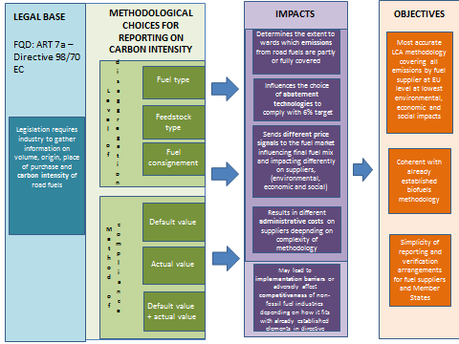

Annex XI: Assessment methodology
The assessment of the policy options described in section 4 can give raise to a range of environmental, economic, social and wider impacts. The most relevant impacts are listed in the table below.
Effectiveness | Accuracy of the methodology with regards to reporting of GHG intensity of fuels consumed in the EU at supplier and EU average level (quantified).  Coherence with biofuel methodology.  Simplicity of reporting and verification arrangements for fuel suppliers and MS.
Environmental impacts | Air quality impacts
Environmental impacts | Biodiversity
Environmental impacts | Efficient use of resources (i.e. land use, water, energy input)
Environmental impacts | Sustainable consumption (i.e. including consumption of alternative fuels)
Economic impacts | Administrative burden on industry and public authorities (quantified)
Economic impacts | Compliance costs (quantified)
Economic impacts | Market costs, pump prices and competitiveness impacts (quantified)
Economic impacts | Impacts on trade, trade relations and WTO compatibility
Economic impacts | Security of supply and supplier prices
Social impacts | Employment
Social impacts | Public health

Annex XII: Carbon abatement costs and potential (Source: ICF/Vivid Economics)
Figure 7: marginal abatement costs (euro/tonne)
Figure 4: Compliance cost curve under baseline scenario (non-ILUC) (option B1)
Figure 5: Compliance cost curve under baseline scenario (non-ILUC) (option C)

Figure 6: Compliance cost curve under baseline scenario (non-ILUC) (option D1)

Figure 7: Compliance cost curve under baseline scenario (non-ILUC) (option E)

Annex XIII: Monitoring, reporting and verification actions
To measure progress towards the target, fuel suppliers and fuel traders will have to annually report the GHG intensity of the fuel they provided during that specific year. For each methodological option ICF identified and analysed the Monitoring, Reporting and Verification (MRV) costs that suppliers and public authorities will incur. Data requirements of the different options are compared with the existing reporting practices in order to identify data gaps and estimate the associated additional costs. The majority of the MRV costs will be borne by the fuel refiners, without any difference between EU and non-EU facilities.
For each kind of compliance option, the total cost has been calculated for each actor (either a supplier or a public authority) and summed up for the entire EU, considering the total number of actors involved. As far as UER projects are concerned, the estimate for the administrative costs has been based on CDM transaction costs for suppliers. However, the responsibility, and hence the costs, to set up a mechanism to verify and validate the different projects submitted is attributed to public authorities (e.g., MS). The following Table depicts the administrative actions that suppliers would need to take under the different options.

Annex XIV: Screening of competitiveness impacts (Source: Vivid Economics)
The refining industry is the focus of this competitiveness analysis but other sectors may also affected by the FQD. These other sectors include biofuel production, vehicle manufacture, public transport and the petrochemicals sector.
After applying the Commission’s guidelines on the extent of analysis required for sectors that face competitiveness impacts from new policy proposals, only the competitiveness impacts on the refining industry have been warranted to require further analysis. Qualitative screening of the sectors uses the matrix suggested in the guidelines referred above.
Biofuels production is assessed in Table 8. The sector faces some small direct impacts due to the FQD, mainly regarding international competitiveness due to possible variation in the emissions intensity of EU and foreign biofuels. These impacts seem dependent on aspects of policy not under consideration in this study and are likely to be insignificant. As a result the competitiveness impact on biofuels is not pursued any further.
The competitiveness impact on vehicle manufacturers is considered in Table 9. The only relevant impacts are a possible decrease in demand for vehicles if fuel prices were to increase due to the FQD and a slight increase in the demand for electric vehicles. The impact of the FQD on fuel prices is likely to be low and the demand response to such a change in price is uncertain but unlikely to be large. The demand for electric vehicles before 2020 in the EU is likely to be very small relative to demand for total vehicles. As a result the competitiveness impact on vehicle manufacturers is likely to be insignificant and so the analysis is not pursued any further for this sector.
Public transport may experience an increase in demand if fuel prices were to increase due to the FQD and this is described in Table 10. As is the case for vehicle manufacturers this impact is expected to be small and so further analysis is not pursued.
Table 11 evaluates the possible competitiveness impacts on petrochemicals. This sector may suffer negative indirect impacts due to impacts on refineries. Some petrochemical producers are co-located with refineries and so if a refinery were to close due to the FQD then so would a co-located petrochemical plant. Petrochemical plants usually rely on output from complex refineries as these yield higher ratios of the most sought after petrochemical feedstocks. The FQD is only likely to negatively impact simple refineries (e.g., hydroskimming) as these exhibit the lowest margins. The FQD may also result in changes to the composition and price of crude delivered to Europe as refineries adjust their diet. As crude is a feedstock for petrochemicals these changes could also have an impact on the competitiveness of the sector. This is also unlikely as the small quantities of replaced feedstocks will not result in a noticeable carbon price premium and the quality of the replaced feedstocks yield lower proportions of the desired petrochemical inputs. Given that the impacts on petrochemicals are a function of the impacts on refineries further analysis for petrochemicals is not directly pursued but will be considered qualitatively alongside the quantitative analysis conducted for refineries.
Refineries face the greatest direct impacts from the FQD, as Table 12 describes. Furthermore, these impacts are dependent on the way in which the policy is implemented. Refineries may have to abate and the level of abatement required and the cost of abatement may vary by refinery depending on the design of the policy. International competitiveness impacts will also vary depending on how imports of refined products are treated.
Ability of refiners to select alternate crudes may influence competitiveness. Central and eastern European refineries are disproportionately constrained in their ability to choose different crudes as many of these are landlocked and dependant on pipelines delivering crude from the FSU. However, they are also not likely to be affected as the predicted change in crude uptake will affect the southern EU region. The choice of methodology will also influence to what degree they will be affected.
Cost pass-through is also expected to influence competitiveness. Demand elasticity is a key determinant of the ability of an industry to pass on price increases to consumers or other downstream purchasers, allowing the identification of where the burden of a regulatory measure or market change will lie. Where consumers have limited options to substitute for other goods or reduce their level of consumption, they are more likely to bear the price of input cost increases. Note that input cost increases that only affect EU producers will likely have a lower pass-through rate than shocks that affect all sellers into the European market. Given that the FQD obligations cover imports as well as European manufacture, it seems reasonable to consider that changes in the price of crude oil provide the more relevant comparison point. Given, that the cost-pass through rates for crude oil are more relevant, it appears that the true pass-through rate lies between 90 and 100 per cent.
Finally, no refinery closures are expected as all measures are predicted to reduce fossil fuel demand by only 0.08%.
The other major sector that will take part in compliance with the FQD is the fuel trader. However, fuel traders hold an intermediary market position, that is, they reduce the transaction costs of trading through specialisation. In contrast to refiners, traders hold no major assets affected by the FQD. Further, modelling results presented in Section 3 confirm that trade volumes are not adversely impacted. Any reduction in trade of fossil fuel volumes is largely offset by an increase in trade of biofuel volumes. Since these effects are too small to produce changes in market structure and since cost pass through is almost complete, there are no differences in the cost of capital (associated with changes in margin volatility), employment (associated with plant closure or large changes in output), value added (associated with changes in margins or wages) and capacity to innovate (associated with profitability) among traders and producers regardless of the implementation option considered. A summary of the qualitative assessment is presented in Table 13.

Competitive impacts | Direct effects | Indirect effects | Sizing (timing) of impacts | Duration of impact | Risks and uncertainty
Cost and price competitiveness | the FQD provides a market for biofuels produced for compliance with Directive 2009/28/EC. There are additional impacts due to the FQD | none applicable | 3% increase in biofuel consumption | not applicable due to no expected additionality | there could be a shortage of biofuels relative to the quantity needed for compliance with the FQD, which could increase biofuel prices
Capacity to innovate | the FQD provides an increased incentive to raise the blend wall | none applicable | likely to be small given current research program | not applicable | not applicable
International competitiveness | ILUC proposal (European Commission, 2012b) may affect competitiveness of biofuels | none applicable | the emissions intensity of biofuels from ILUC can be 30 per cent more or less than default values (European Commission, 2012c) | for the duration of the FQD | (European Commission, 2012b) ILUC proposal has yet to be accepted and current details are limited
Table 8: Biofuels production faces small direct impacts that are contingent on other policies (Source: Vivid Economics)

Competitive impacts | Direct effects | Indirect effects | Sizing (timing) of impacts | Duration of impact | Risks and uncertainty
Cost and price competitiveness | none applicable | if fuel prices increase then demand for vehicles may decline | likely to be small as the FQD does not impose significant costs to fuel production | permanent change to demand | changes in fuel prices due to the FQD are uncertain; the price elasticity of demand for vehicles is uncertain
Capacity to innovate | small increase in demand for electric vehicles; flex-fuel vehicles are currently an established technology | none applicable | small due to limited expected deployment of electric vehicles prior to 2020 | not applicable | none applicable
International competitiveness | none applicable | none applicable | none applicable | not applicable | none applicable
Table 9: Vehicle manufacturers could face small changes in demand if fuel prices increase (Source: Vivid Economics)

Competitive impacts | Direct effects | Indirect effects | Sizing (timing) of impacts | Duration of impact | Risks and uncertainty
Cost and price competitiveness | none applicable | if fuel prices increase then demand for public transport may increase | likely to be small as the FQD does not impose significant costs to fuel production | permanent change to demand | changes in fuel prices due to the FQD are uncertain; the price elasticity of demand for vehicles is uncertain
Capacity to innovate | none applicable | none applicable | none applicable | none applicable | none applicable
International competitiveness | none applicable | none applicable | none applicable | none applicable | none applicable

Table 10: Public transport could experience a small increase in demand if fuel prices increase Source: Vivid Economics)

Competitive impacts | Direct effects | Indirect effects | Sizing (timing) of impacts | Duration of impact | Risks and uncertainty
Cost and price competitiveness | none applicable | producers integrated with refineries are not likely to be exposed to impacts | input price changes are likely to be limited | No permanent change in input prices | uncertainty on the extent to which co-located refineries will be affected; some risk that input price changes could be greater than expected
Capacity to innovate | none applicable | none applicable | not applicable | not applicable | none applicable
International competitiveness | none applicable | there is an international competitiveness impact to the extent that input prices change | input price changes are likely to be limited | permanent change in input prices | some risk that input price changes could be greater than expected

Table 11: The competitiveness impacts on petrochemicals occur indirectly from the effects of policy on refineries (Source: Vivid Economics)

Competitive impacts | Direct effects | Indirect effects | Sizing (timing) of impacts | Duration of impact | Risks and uncertainty
Cost and price competitiveness | refineries will face a cost of abatement to achieve compliance and will also enjoy high cost pass-through rates; demand for refined product could be displaced by biofuels | none applicable | Approximately 0.08% reduction in fossil fuel demand | permanent cost change | the magnitude of costs depends on the extent to which other abatement options are available; the variance in costs across refineries depends on how the policy is implemented
Capacity to innovate | profits may slightly fall, with a small risk of limiting R&D from retained profits | none applicable | depends on the extent to which R&D is funded from retained profits | a permanent cost change will permanently affect profits | refineries may be able to compensate for lost part to finance R&D in other ways
International competitiveness | Impacts on international competitiveness impacts will not occur as importers and domestic producers are equally affected | none applicable |  | cost change may affect competitiveness | the impact depends on how the policy is implemented

Table 12: Refineries face the greatest direct effects to competitiveness and the nature of these effects depends on how the policy is implemented (Source: Vivid Economics)

Competitive impacts | Direct effects | Indirect effects | Sizing (timing) of impacts | Duration of impact | Risks and uncertainty
Cost and price competitiveness | traders will face a cost of abatement to achieve compliance; demand for traded refined products will be broadly displaced by biofuels; the costs will be passed through by traders | none applicable | depends on how the policy is implemented | permanent cost change which is passed through | the magnitude of costs depends on the extent to which other abatement options are available
Capacity to innovate | No effect | none applicable | none applicable | none applicable | none applicable
International competitiveness | No effect | none applicable | none applicable | none applicable | none applicable
Table 13: Traders also face direct effects but their competitiveness is largely unaffected

Annex XV: Assessment of competitiveness impacts on EU refineries (Source: Vivid economics)

Estimation of the marginal cost curves - exit and sustainable margins
The first step undertaken was to model exit of refiners under baseline conditions, to ensure realistic capacity utilisation and construct realistic baseline projections. Vivid Economics took Ensys’ demand projection for 2020 and estimates on biofuels uptake from EC data to calculate the margins and utilisations achieved in the sector, assuming all current refineries remained in operation except for the announced closures. The further step assumed the least profitable refineries in Europe to close down until the margins recovered to levels typical of refinery operations in recent years. This set of remaining refiners was the set upon which the assessment was carried out.
The first step in the data inputting, which involves estimation of exit, takes as inputs the fuel demand and price projections from the World Model, shown in the figure below.
Figure 8: Relationship between data gathering and analytical tasks. Source: ICF and Vivid Economics
The next steps in the modelling was to construct a compliance cost curve for biofuels and upstream emissions reductions, and to understand the current compositions and upstream carbon intensities of crude and diesel imported into Europe.

Construction of marginal costs of compliance options
The construction of the marginal cost curves for compliance options has four elements:
- crude switching;
- biofuel uptake;
- product switching; and
- upstream emissions reduction.

24.2.1 Crude switching
The competitiveness of crudes is defined as their value in the EU refining market. This is modelled by taking the current import shares by crude and imputing their costs to refiners, which are the combined purchase and processing costs. The cost to refiners is related to the market share through some standard, powerful economic theory. Each crude type has a distinct cost and therefore competitiveness that is in part affected determined by its GHG intensity. As the carbon price changes, or equivalently, as the value of carbon changes in the FQD compliance regime, the competitiveness of the crude alters.
The model was used to estimate the sensitivity of costs and markets shares to a change in carbon price. It showed how the competitiveness of each crude type was affected by a change in the carbon price. The output was a marginal cost curve which shows the reduction in upstream emissions associated with crude imports as the carbon price increased.
The advantage of this approach is that, in contrast to exogenous restrictions on certain crudes, a combination of cost effectiveness and GHG intensity determines imports of crudes.

24.2.2 Biofuels
The Renewable Energy Directive demands a certain use of biofuels which will be subtracted from total fuel demand. Further biofuel uptake as a result of the FQD was analysed as follows. The work constructed compliance cost curves, which show the achievable absolute emissions reduction in MtCO₂e at each unit abatement cost in €/tCO2e for each relevant abatement option under each compliance option. The abatement options include biofuels and UERs under compliance options B1 and B2 and biofuels, UERs, crude and product switching under compliance options C, D1/D2 and E.

24.2.3 Product switching (imports of finished products)
Diesel and gasoline imports have varying carbon intensities dependent on their source material, be it bitumen, conventional crude oil or gas to liquids. These imports currently command a market share in Europe which reflects their relative competitiveness. As the price of CO₂ increases, the relative competitiveness of these imports will change, resulting in gains or losses in market share. Vivid Economics’ modelling estimated the changes in product imports for a range of CO₂ prices. The combined effect of biofuels uptake and product switching on emissions was tabulated as a marginal abatement curve across this range of CO₂ prices.

24.2.4. Upstream emissions reductions
There are CO₂ cost estimates available for upstream emissions reductions and these activities have no direct effect on fuel production. The magnitude and unit cost of these opportunities, as developed by ICF, was added to the overall MACC resulting from the biofuels, product and crude switching modelling.

24.2.5. Overall marginal compliance cost curve
Once the cost estimates for each compliance measure had been assembled, it was possible to compare them against other estimates of compliance costs, such as those prepared by Wood MacKenzie for Europia, as far as those parties agreed to share their estimates with Vivid Economics.
The next step was to combine the individual curves into a single marginal compliance cost covering crude switching, biofuels uptake and flare reduction. This involved the inter-collation of the components of the individual curves into a single curve. This overall curve showed the carbon price at which the FQD target was satisfied, and an indication of the mix of abatement options that were taken in response to the FQD. Once this carbon price had been found, it was fed back into the models to generate estimates of impact for a range of metrics.

Explanation of modelling method

24.3.1. Explanation of crude switching
Crude switching is undertaken for each EU refinery and forms part of the abatement options available to each EU refinery. EU refineries can switch crudes used to produce finished products under some of the policy options. Any switch in the crudes used by EU refineries as a consequence of the FQD is based on the relative competitiveness of each crude. This competitiveness is based on the current market share and GHG intensity of each crude. The GHG intensity required for this analysis is from ‘well to refinery gate’, as provided by ICF, and not a ‘well to wheel’, lifecycle, measurement.
Vivid Economics modelled the competitiveness of crudes by taking the current import shares by crude and uses a model to impute their costs to refiners (combined purchase and processing costs). Each crude had a distinct cost and therefore competitiveness that also reflects its GHG intensity.
Vivid Economics estimated the change in crude cost under a shadow carbon price. This creates a competitiveness impact, raising the cost of importing all crudes, but raising the cost of some more than others. The model estimates the redistribution of market shares between crudes, with reductions in market share occurring for the higher carbon crudes and gains in market share for lower carbon crudes. The output is a curve showing the reductions in total upstream emissions associated with crude imports for increases in the carbon price.
The work looked at the competitiveness of crudes for the overall EU refining industry and did not match crudes to individual refineries.

24.3.2. Explanation of product switching
Product switching is defined as changing the imports of finished products outside the EU based on the underlying crudes used to produce these finished products outside the EU. Product switching is considered in the model together with biofuel blending and EU refinery production as all three involve finished products. The relative competitiveness of different sources of imports in the EU will determine the effect of the FQD on imports. This might induce product switching, that is a relative decline in the import of fuels derived from unconventional sources and a relative increase in the import of conventional crudes.
Importers were grouped similarly to crude imports, that was between conventional and unconventional and by individual carbon intensities. Importer competitiveness was treated in the same way as refinery competitiveness.

24.3.3 Pedigree of the model
The issues to be taken into account in this work and the economic relationships that are important are described in the inception report. The model used is a standard industrial organisation treatment of oligopolistic competition between firms. Information on market demand and firm output and margin levels are used to set up the model before introducing changes in costs or demand. The model is solved algebraically, rather than numerically, and is built in Excel. Vivid Economics had used similar models in other sectors such as glass and aluminium and petrochemicals.
Vivid Economics has experience using this approach in work on refinery operations:
- the modelling of crudes shows a good fit between crude market share globally and cost of crude extraction and transport;
- the distribution of refinery margins across the EU portfolio fits well the anonymised data on margins at refinery level;
- the model has been used to predict exit of refineries in US and the EU;
- the model has been used to examine refinery investment strategies.

No work has been done to corroborate the model against historic market events.

Establish where compliance costs fall, that is, see whether traders or refiners bear it
Traders have only a market intermediary position, that is, they hold, in contrast to refiners, no major assets affected by the FQD, they simply reduce the transaction costs of trading through specialisation. The compliance costs fall on traders, fuel producers, crude and imported finished product suppliers, and on consumers.
The compliance costs appear as changes in margin and changes in output for refiners, and the same metrics for crude and product suppliers. Consumers experience changes in price and changes in consumption. These changes were estimated and the magnitude of costs facing each party was set out.
Building on previous work in EU taxation and a literature survey of cost pass-through, Vivid Economics took the final cost and price increase in the fuel production market resulting from the FQD and calculated the final pump price by using cost pass through and margin estimates per Member State.

Construct cost curves for each policy option
For each of the policy options, Vivid Economics models the costs and impacts for fuel suppliers, which are EU refineries and importers of finished products, depending on the available abatement options.
In addition, individual crudes and biofuels, individual upstream emissions reductions and individual refineries will be modelled. The modelling of compliance cost curves was not carried out at supplier level, but the results of the modelling were used to estimate the take-up of compliance measures by the aggregate of suppliers under each of the compliance options.
Although impacts are modelled at an individual crude, product and refinery level, which could allow reporting (for refineries) for each Member State, there is a reason for choosing a higher level of aggregation. The modelling method and data used for this work is appropriate for estimating general market effects, levels and distributions of impact. It is not designed to give verifiable impacts at individual asset level, where special circumstances which are not picked up in the model may be important. For example, when some refineries are closed in the first step of the work, it is uncertain which refineries would be the ones to close. Since some Member States have a small number of refineries or even a single refinery, the reporting of exit of capacity for that Member State would inappropriately suggest a level of precision which the results will not carry. In addition, there would be a concern that by reporting figures for all Member States, the impacts on individual firms could be extracted in some cases. This might be market sensitive and it is not our intention to present information which can be taken up by financial market analysts and applied to individual firms. Thus the output metrics are presented at EU level and for regional groupings of Member States chosen to avoid disclosure of individual firm or asset information.

Annex XVI: Summary of ILUC sensitivity assessment
As explained in section 2.6.4, on-going discussions on a legislative proposal for mitigating against indirect land use change may lead to a reduction in the consumption of biofuels in 2020 which could have significant impacts on the analysis of the options. In order to better understand the potential magnitude of the reduced contribution under the most extreme option (i.e. the inclusion of the ILUC estimated emissions in the greenhouse gas emissions performance of biofuels) being considered in the comparison of the options presented here, this was included in the analysis conducted for the Commission.
As a result of the introduction of ILUC factors in the sustainability criteria reduced the amount of conventional biodiesel and inefficient bioethanol pathways that can be counted towards the FQD. This gap is further widened as the performance of all land using biofuels is reduced through the inclusion of the estimated indirect land use change as the performance of biofuels. This means that the total emission reductions needed to achieve the FQD increase almost fivefold from 10Mt CO₂ to 48Mt CO₂. This results in much larger contributions needed from all different available carbon abatement tools (i.e. better performing biofuels, upstream emission reductions and replacing higher intensity with lower intensity products) which increase marginal carbon abatement costs significantly due to the higher demand for abatement tools (from 6-7.7 euros per ton in the non ILUC to around 129-145 euros per ton).
The key results from such analysis highlight a number of interesting facts,
- There is little difference in overall trends in both cases (ILUC and non-ILUC). All options lead to a more accentuated trend in more petrol and less diesel being consumed driven by higher marginal abatement costs. This is due to the fact that a) petrol has slightly lower GHG intensity than diesel and b) that there is a larger share of biofuels from bioethanol from maize, as well as waste and second generation biodiesel.
- There is very little difference between options in both cases (ILUC and non-ILUC) in terms of abatement tools used. The increased abatement costs caused by moving from non-ILUC to ILUC scenario leads to a larger contribution from additional biofuel blending (10Mt CO₂), a much higher contribution from upstream emission reductions (37Mt CO₂), and accentuates the switching from unconventional to conventional sources for those options where disaggregation is possible.
- The key difference between options in both cases (ILUC and non-ILUC) seems to be in terms of the fossil fuel mix that the different options are driving. It is worth noting that disaggregated options lead to most unconventional crudes not being consumed at all, with the exception of Venezuelan natural bitumen (i.e. whose consumption is reduced only in part due to being the most cost competitive unconventional fuel). In addition, disaggregation leads to a stronger increase in EU refining of conventional diesel vs imports of Russian and North America that decrease, given that the latter group tend to have overall a higher GHG intensity.
- Administrative costs increase very slightly under the ILUC scenario for all options due to the increased amount from additional certification costs of the upstream emission projects. Nevertheless the bulk of the increase in costs comes from additional compliance measures being taken up, which increase to around 1600 million euros, which should be seen as a moderate increase (pre-tax market costs of 0.5 cents per litre) in the context of volumes of fuels being supplied. There is no significant differences between the options in terms of either administrative or compliance costs.
- As in the non-ILUC scenario, no significant difference is expected between the options according to pump price impacts under the ILUC scenario. As such, there is no difference in terms of impacts on the competitiveness of EU refineries between the options.

Annex XVII: Projected road fuel mix 2020 for each option (non-ILUC scenario) (Source: Vivid Economics)

Fuel | Feedstock | Option B1 |  | Option C |  | Option D |  | Option E
Fuel | Feedstock | PJ | Mt CO2e | PJ | Mt CO2e | PJ | Mt CO2e | PJ | Mt CO2e
Petrol | Conventional crude | 2657 | 234.1 | 2660 | 232.9 | 2658 | 232.8 | 2658 | 232.8
Petrol | Natural bitumen  (Venezuela to EU) | 68 | 6.0 | 67 | 7.2 | 67 | 7.2 | 67 | 7.2
Petrol | Oil shale | 2 | 0.2 | 0 | 0.0 | 1 | 0.1 | 1 | 0.1
Petrol | Subtotal | 2727 | 240.2 | 2727 | 240.1 | 2725 | 240.0 | 2726 | 240.1
Diesel | Conventional crude (subtotal) | 6515 | 587.9 | 6550 | 585.4 | 6558 | 586.1 | 6549 | 585.4
Diesel | Conventional crude (EU refined) | 4700 | 424.1 | 4728 | 422.5 | 4730 | 422.8 | 4724 | 422.2
Diesel | Conventional crude (import USGC) | 167 | 15.1 | 169 | 15.1 | 169 | 15.1 | 169 | 15.1
Diesel | Conventional crude (import Russia) | 1648 | 148.7 | 1653 | 147.7 | 1658 | 148.2 | 1656 | 148.0
Diesel | Natural bitumen  (Venezuela to EU) | 169 | 15.3 | 168 | 18.2 | 168 | 18.3 | 168 | 18.3
Diesel | Natural bitumen  (Canada to USGC) | 21 | 1.9 | 0 | 0.0 | 3 | 0.4 | 0 | 0.0
Diesel | Oil shale | 4 | 0.4 | 1 | 0.1 | 1 | 0.2 | 1 | 0.2
Diesel | CTL | 19 | 1.7 | 19 | 3.2 | 19 | 3.2 | 19 | 3.2
Diesel | GTL | 62 | 5.6 | 53 | 5.2 | 55 | 5.4 | 53 | 5.2
Diesel | Subtotal | 6790 | 612.8 | 6790 | 612.1 | 6805 | 613.6 | 6791 | 612.2
LPG |  | 208 | 15.3 | 208 | 15.3 | 208 | 15.3 | 208 | 15.3
CNG |  | 44 | 3.4 | 44 | 3.4 | 44 | 3.4 | 44 | 3.4
Electricity | EU-average | 87 | 3.9 | 87 | 3.9 | 87 | 3.9 | 87 | 3.9
Ethanol | Corn (maize) | 29 | 0.9 | 29 | 0.9 | 29 | 0.9 | 29 | 0.9
Ethanol | Sugar beet | 40 | 1.1 | 40 | 1.1 | 40 | 1.1 | 40 | 1.1
Ethanol | Sugar cane | 103 | 2.1 | 103 | 2.1 | 103 | 2.1 | 103 | 2.1
Ethanol | Wheat Process fuel not specified | 15 | 0.7 | 15 | 0.7 | 15 | 0.7 | 15 | 0.7
Ethanol | Wheat Natural gas as process fuel in CHP plant | 15 | 0.7 | 15 | 0.7 | 15 | 0.7 | 15 | 0.7
Ethanol | Wheat Straw as process fuel in CHP plant | 15 | 0.4 | 15 | 0.4 | 15 | 0.4 | 15 | 0.4
Ethanol | 2G ethanol - land using | 10 | 0.2 | 10 | 0.2 | 10 | 0.2 | 10 | 0.2
Ethanol | 2G ethanol - non-land using | 10 | 0.1 | 10 | 0.1 | 10 | 0.1 | 10 | 0.1
Ethanol | Subtotal | 236 | 6 | 236 | 6 | 236 | 6 | 236 | 6
Biodiesel | 2G biodiesel - land using | 15 | 0.1 | 15 | 0.1 | 15 | 0.1 | 15 | 0.1
Biodiesel | 2G biodiesel - non-land using | 15 | 0.1 | 15 | 0.1 | 15 | 0.1 | 15 | 0.1
Biodiesel | Waste 1st. Gen. Diesel | 62 | 0.6 | 62 | 0.6 | 51 | 0.5 | 62 | 0.6
Biodiesel | Palm oil | 82 | 4.2 | 82 | 4.2 | 82 | 4.2 | 82 | 4.2
Biodiesel | Palm oil with methane capture | 82 | 2.4 | 82 | 2.4 | 82 | 2.4 | 82 | 2.4
Biodiesel | Rapeseed | 385 | 15.4 | 385 | 15.4 | 385 | 15.4 | 385 | 15.4
Biodiesel | Soybean | 105 | 4.9 | 105 | 4.9 | 105 | 4.9 | 105 | 4.9
Biodiesel | Sunflower | 40 | 1.3 | 40 | 1.3 | 40 | 1.3 | 40 | 1.3
Biodiesel | Subtotal | 787 | 29 | 787 | 29 | 775 | 29 | 787 | 29
Total |  | 10879 | 910.6 | 10879 | 909.9 | 10880 | 911.1 | 10879 | 910.0

Annex XVIII: General considerations around environmental impacts associated with fossil fuel production (Source: JRC)

Environmental impacts: general considerations
The impacts of fossil fuels on the environment result from the sum of upstream activities (extraction, including exploration and production, followed by transportation by tanker or pipeline); mid-stream activities (refining), and downstream activities (transportation by tanker, pipeline or rail to marketing terminals and bulk plants and eventually service stations and commercial accounts).
The FQD objective refers to GHG intensity of fossil fuels including those produced using production methods that are energy intensive or involve practices that result in higher emissions. Therefore such fuels do include unconventional sources (e.g. tar sands, coal, oil shale), heavy oils, as well as conventional sources some of which may require additional energy for crude oil recovery or use practices that result in larger emissions (e.g. Nigerian crudes with flaring, Middle East and California thermal enhanced oil recovery).
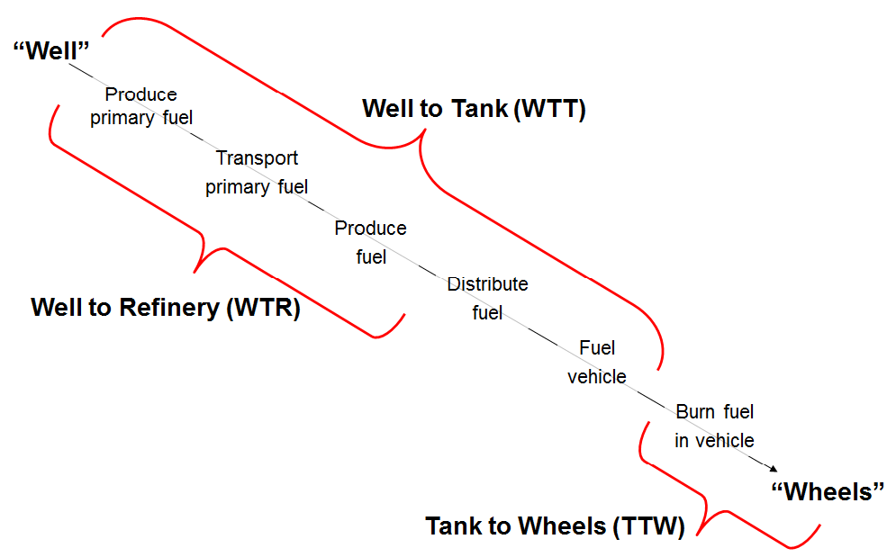
Figure 9: Crude Oil Life Cycle (Source: JEC Well-to-Wheels Study, 2011)
Environmental impacts of fossil fuels necessarily refer to lifecycle or “well-to-wheel” (WTW), i.e. those associated with oil recovery, upgrading, transport, refining, distribution, and combustion emissions. “Well-to-tank” (WTT) refers to emissions upstream of the vehicle tank while “Tank-to-wheel” (TTW) refers to the in-vehicle combustion emissions.
In view of the FQD reporting mechanism mandated by Article 7a of the FQD, the TTW segment is not relevant. For that reason throughout this annex, WTT environmental impacts are considered.
It is worth noting that the attention of researchers and governments alike is certainly focused on regulating/reducing carbon-intensity of crude oils and fossil fuels, typically expressed as CO2e per MJ. There is a considerable wealth of information on this matter despite existing differences largely due the use of different data sources, methods, lifecycle boundaries, and assumptions used, making comparisons of results a challenging issue.
It is equally worth highlighting that crude oil resources around the world vary significantly in regard to resource quality and production methods. Thus, this annex does not intend to compare across types of crudes because the results of such a comparison vary substantially in function of which crudes are used as a reference and/or which crudes are evaluated to determine a baseline. Indeed, results would be different if the terms of comparison were ‘any specific crude type’ vs. an average of all crudes consumed in the EU or ‘any specific crude type’ vs. the crudes it is most likely to displace.
Being relatively poor of resources, the EU relies on foreign resources to meet its energy needs. The environmental effects of expanding exploitation therefore fall largely outside its territory, nevertheless implying a growing global footprint for the EU. Increasing scarcity of, or other types of restrictions to use, fossil fuels may stimulate greater efforts to shift to other energy sources that can be – at least partially – found domestically, including turning to sources previously deemed uneconomic.
This may have various effects on Europe's environment, including increased land use for biofuels, disruption of ecosystems from developing additional hydropower capacity, noise and visual pollution from wind turbines. Expanding nuclear energy capacity may be expected to trigger public debate about waste storage and safety risks.
Attention dedicated, and data are available, to non-GHG concerns surrounding crude oils and fossil fuels’ production is typically focused on the assessment of developments/projects in specific contexts. This allows carrying out detailed analyses taking into account – and rightly so – the specificities of different crude types and different impacted environmental contexts.
Due to the general scope of this note, it provides an overview of the main environmental impacts of fossil fuels without providing specific assessments on any given crude type.

Air quality impacts
Air emissions associated with oil and gas production can impact air quality and impair visibility.
Air emissions generated during oil and gas production can be grouped into three categories:
- Air pollutants (ozone, carbon monoxide, sulphur dioxide, particulate matter, and their precursors, including nitrogen oxides and Volatile Organic Compounds);
- Haze precursors (including ozone, NOx, SO2, and PMs); and
- Greenhouse gases (GHGs, including CO2 and methane CH4) are generated during oil and gas development.
OGP member companies reported in 2011 that:
- Normalised CH4 emissions increased in 2011 by 6% compared with 2010;
- Normalised NOx emissions increased in 2011 by 3% compared with 2010, and;
- Normalised CO2, SO2 and NMVOC emissions remained stable compared with 2010.
Leaving aside GHG, including ozone as one of the GHGs, the emissions of primary sub-10µm particulate matter (PM10) have reduced by 26% across Europe between 1990 and 2010, driven by a 28% reduction in emissions of the fine particulate matter (PM2.5) fraction.
Emissions of particulates between 2.5 and 10 µm have reduced by 21% over the same period; the difference of this trend to that of PM 2.5 is due to significantly increased emissions in the 2.5 to 10 µm fraction from 'Road transport' and 'Agriculture' (of 50% and 15% respectively) since 1990. Of this reduction in PM 10 emissions, 39% has taken place in the 'Energy Production and Distribution' sector due to factors including the fuel-switching from coal to natural gas for electricity generation and improvements in the performance of pollution abatement equipment installed at industrial facilities.

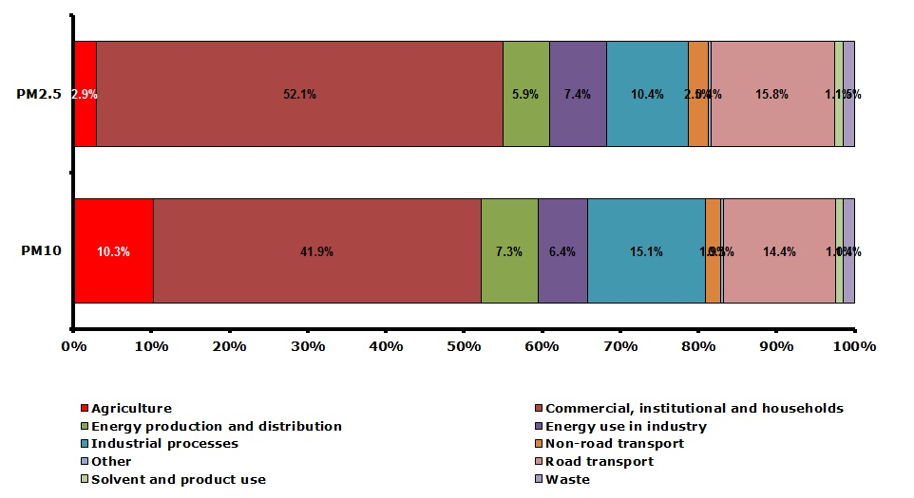
Figure 11: Contribution per sector to emissions of primary PM2.5 and PM10 in 2010.

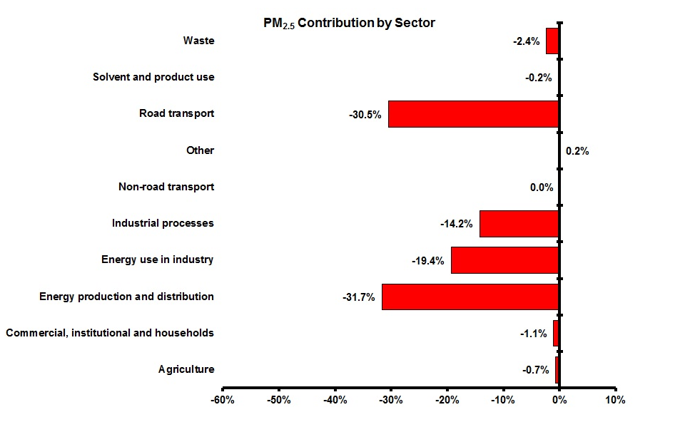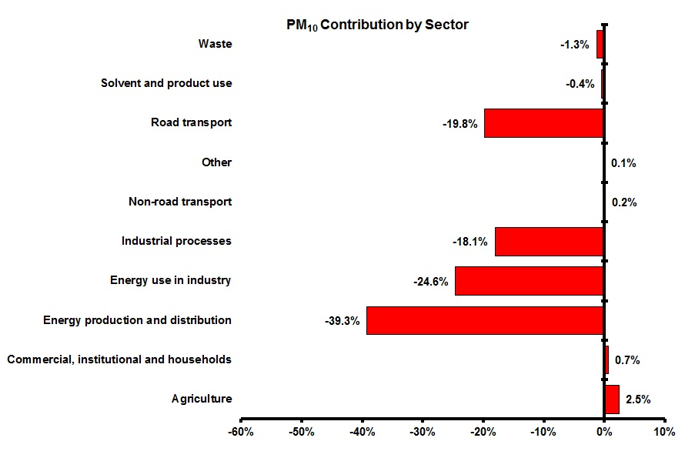
Figure 12: The contribution made by each sector to the total change in primary PM2.5 and PM10 emissions respectively between 1990 and 2010. (Source: UNECE National emissions reported to LRTAP Convention)
Beyond general information, the relevant issue here is: would these levels of emissions be influenced depending on the policy option chosen to implement the reporting mechanism mandated by FQD Art. 7a.
It seems reasonable to conclude that a marginal influence only of such reporting mechanism on air quality impacts beyond the GHG component can be expected.
In fact, despite projected overall growth of GHG emissions with energy demand offsetting the impacts of technological improvements for transportation fuels, sulphur and nitrogen emissions are expected to fall by a quarter to a third from today’s levels thus continuing last decade’s trend.
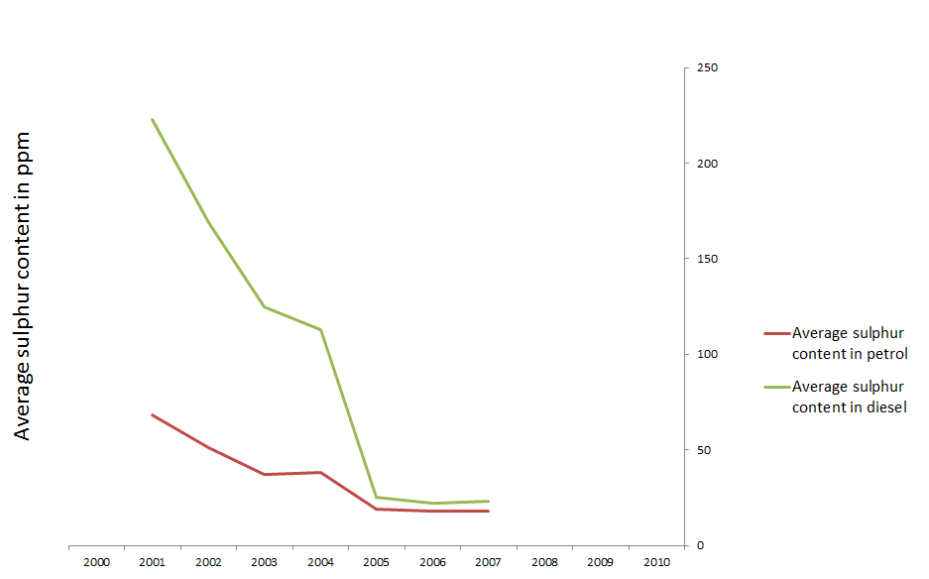
Figure 13: Time series of the average ppm of sulphur in fuels in the EU27 countries (Source: EEA)

At the midstream segment and given the progress that refineries have made in the abatement of sulphur emissions to air, the focus of technology improvement is progressively shifting towards volatile organic compounds, particulates (size and composition) and NOx, as in the environmental debate generally.
Refinery processes require a lot of energy; typically more than 60 % of refinery air emissions are related to the production of energy for the various processes.

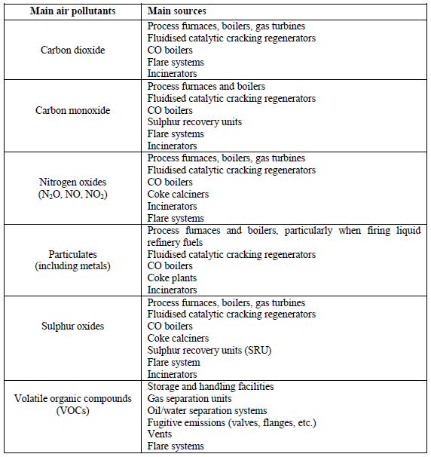
Figure 14 Main air pollutants emitted by refineries and their main sources (Source: IPPC Bureau, BREF on Mineral Oil and Gas Refining, 2003).

Very different is the situation of methane where atmospheric concentrations have been rising steadily. Despite the recognition that fossil fuel upstream and midstream emissions share the contribution to this trend with a number of other emissions’ sources, it is certainly a key contributor.

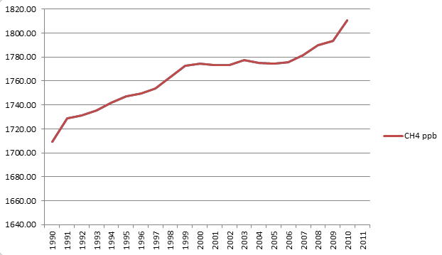
Figure 15: Time series of the average ppb atmospheric concentration of methane in the EU 27 countries (Source: EEA).
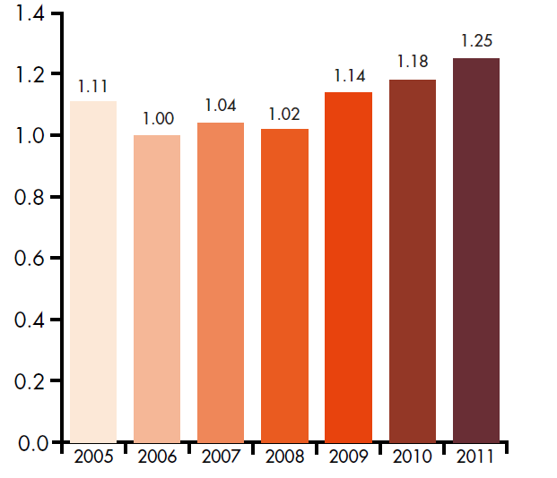

Figure 16: Methane emissions per unit of production (tonnes per thousand tonnes of hydrocarbon production) (Source: OGP, 2011).

Flaring produces predominantly carbon dioxide emissions, while venting produces predominantly methane emissions. The global warming potential (GWP) of methane is estimated to be 25 times that of CO2 when the effects are considered over one hundred years. Although methane is certainly one of the GHGs and is therefore included in the impacts analysis dedicated to GHGs in this impact assessment, it is worth highlighting in this section as well that the FQD Art.7a reporting mechanism is reasonably expected to exert its effects on fuel suppliers to reducing flaring and venting in fossil fuel production.
OGP reports that in 2011 15.7 tonnes of gas was flared every thousand tonnes of hydrocarbon produced versus 16.0 tonnes in 2010 and 17.9 in 2009. Reductions in flaring rates are predominantly driven by major infrastructure improvement projects that increase the capability to inject gas for reservoir maintenance and to deliver gas to markets.

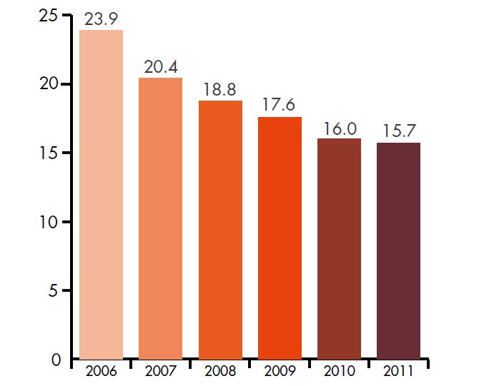

Figure 17: Flaring per unit of hydrocarbon production (tonnes per thousand tonnes) as reported by OGP member companies by region (Source: OGP 2011)

It is also worth highlighting that VOC emissions come largely from flaring and venting (together representing ¾ of total reported sources for VOCs) the remainder coming from fugitive emissions and only to a very minor extent are attributable to energy use.

Pressures on biodiversity
Within the EU territory, habitat changes — including loss, fragmentation and degradation — impose the greatest impacts on species. Grasslands and wetlands are in decline, urban sprawl and infrastructure fragment the landscape, and agro-ecosystems are characterised by agricultural intensification and land abandonment.
Relevant considerations when thinking of fossil fuel production and threats to biodiversity address mainly soil and water pollution and changing agricultural practices, including land-use change. Agricultural intensification means decreased crop diversity, simplified cropping methods, fertiliser and pesticide use, and homogenised landscapes: biofuel crops may intensify fertiliser and pesticide use, exacerbating biodiversity loss. Industrial chemicals do end up in the soil or in water and although nitrate and phosphorus pollution of rivers and lakes is declining, NOx emissions are still an outstanding issue across the EU.
Fossil fuel production and distribution therefore do not belong to the key drivers for biodiversity loss. Nevertheless, there are points of intersection. Key areas where the biodiversity issue and petroleum industry activities overlap are: access, indigenous populations, and alien invasive species.

- “Access” issues include those surrounding land in general, marine and coastal areas, and transportation routes. Bilateral agreements may also choose to enforce stringent requirements on site habitat restoration/rehabilitation once a company has moved out of an area.

Access to land for oil and gas activities is increasingly subject to regulation through multilateral or bilateral treaties, including restrictions on existing operations if the industry cannot demonstrate its ability to operate within a small footprint and minimal impacts.
Marine and coastal access is typically regulated by international agreements and mandates calling for the expansion and strengthening of coastal and marine protected areas. Initiatives such as the International Coral Reef Initiative affect the way the petroleum industry operates in the oceans and transports its products worldwide.
Transportation routes are also impacted by regulation on biodiversity through – for example – sensitivity mapping and oil spill contingency plans which are addressed in the context of conservation. This has led to tanker routes being restricted in certain areas, such as the Great Barrier Reef, Australia.

  - Many of the areas having the highest interest for the petroleum industry and at the same time the highest levels of biodiversity are in low or middle income countries where natural resources can be crucial to the livelihoods of the inhabitants. There is increasing emphasis on the impacts of petroleum industry activities on indigenous organisations by fostering a participatory approach.

  - The colonisation of new areas by species from outside the immediate environment is an important ecological process taking place naturally. Anthropogenic activities though contribute to increasing the number and rate of species introductions worldwide, enabling species to become established in areas that they would not ordinarily be able to reach. When species become established outside their natural range as a result of human activity and threaten biodiversity, they are defined as “alien invasive species”. The diversity of these species range from micro-organisms to mammals and comprise both animal and plants in all sorts of ecosystems. It has become acknowledged that alien invasive species represent a key threat to global biodiversity, including the survival of species of commercial significance (e.g. fisheries). Indirect ecological disturbance, relating mainly to habitat degradation and the direct introduction of alien invasive species often happen concurrently. The petroleum and gas industry has a potential impact on creating indirect pathways for alien invasive species, namely because it often works in remote areas with little or no previous human activity, moving specialized equipment and personnel between sites and developing large-scale linear features (e.g. pipelines). These characteristics set it apart from many other sectors and increase the likelihood and potential severity/consequences of invasion if appropriate measures are not implemented. The business case for oil and gas companies to address this aspect of biodiversity safeguarding relates mostly to legal compliance with requirements in national law systems rather than with the type/quality of the energy source and the resulting product(s).

Despite recognition of points of intersection between biodiversity and activities of the petroleum industry, quantitative data and analyses are scarce with the relevant exception of oil spills at sea. Limited information is available on infrastructure impacts and maintenance (pipelines and oil port terminals) and this is certainly not linked to the GHG intensity of any specific crude or finished fossil product via different technological options.

Efficient use of resources: water
There is growing recognition that energy and water are closely linked. Water is used in every step of fossil-fuel extraction and processing. Oil refining requires approximately 4 to 8 million m3 of water daily in the United States alone (the amount of water that two to three million U.S. households use daily). Despite growing interests for water demand by the energy industry, information on the impacts on water quality is scattered. This is partly because water is used in different ways during extraction and processing and can therefore be contaminated by different pollutants (from sediment to synthetic chemicals) but also groundwater, rivers or lakes can be contaminated by solid or liquid wastes resulting from extraction.

Aside of ordinary operations for fossil fuels extraction, accidents in the form of spills and other disasters associated with the extraction process are another source of water contamination.

Water brought to the surface through mining or drilling, called “produced water,” can contain dissolved salts, trace metals, hydrocarbons, and radionuclides. Produced water is a by-product of oil and gas production from reservoirs. Oil and gas reservoirs contain a mixture of oil, gas and water at equilibrium: a small proportion of the hydrocarbons will be dissolved in water depending on their solubility. Therefore, there is a dissolved hydrocarbon component in the produced water consisting typically of light aromatic hydrocarbons (due to their relatively high solubility) in addition to suspended oil droplets.

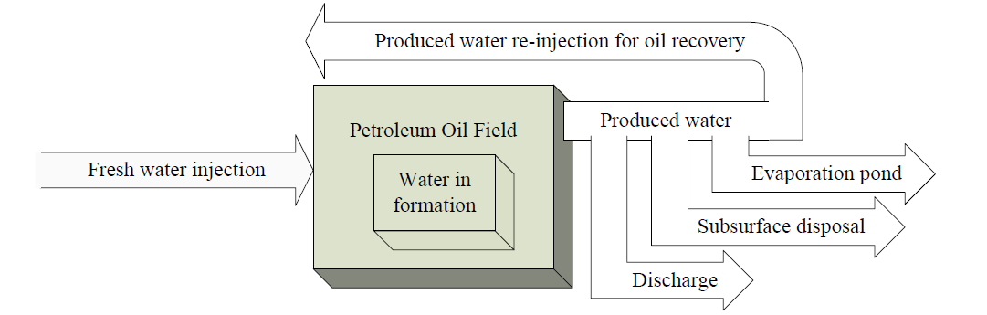
Figure 18: Water inputs and outputs for crude oil production (Source: Argonne National Laboratory, 2009).

The treatment processes for separation of oil and water before discharge of the produced water have traditionally been based on the difference in specific gravity between oil droplets and water. The oil droplets will generally float to the top of the water where they can be removed. Gravity treatment methods are not able to remove dissolved hydrocarbon components though. At wastewater treatment plants at refineries or other facilities dealing with significant quantities of hydrocarbons, biological treatment (breakdown by micro-organisms) is the best means of breaking down and removing the dissolved hydrocarbons. This option is not available at offshore oil and gas installations.

The discharge of produced water from offshore installations has been addressed by the OSPAR Commission, including setting limits to the total amount of waste water permitted to be discharged. Treatment technologies, including produced water re-injection and the types of hydrocarbons contained in produced water are monitored and regularly updated.

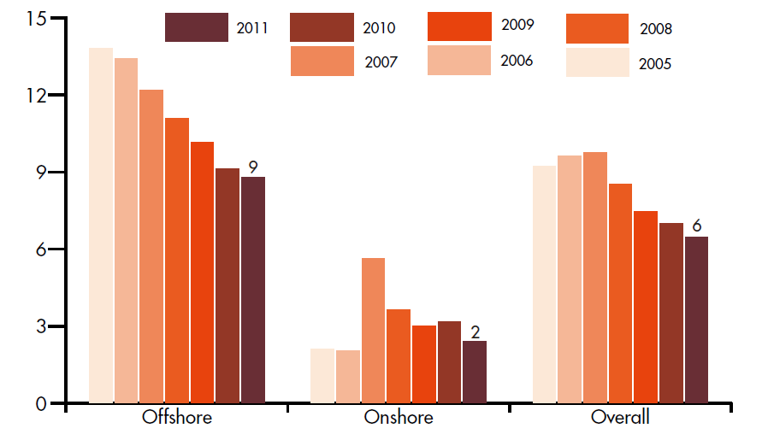
Figure 19: Oil discharged in produced water per unit of production (tonnes per million tonnes of hydrocarbon production). (Source: OGP, 2011).

ESTIMATES OF GLOBAL INPUTS OF OIL TO THE MARINE ENVIRONMENT

In a report published in 2002 by the National Research Council (NRC) of the U.S. National Academy of Sciences, the average total worldwide annual release of petroleum (oils) from all known sources to the sea has been estimated at 1.3 million tonnes. However, the range is wide, from a possible 470,000 tonnes to a possible 8.4 million tonnes per year. According to the report, the main categories of sources contribute to the total input as follows:
- natural seeps: 46%
- discharges from consumption of oils (operational discharges from ships and discharges from land-based sources): 37%
- accidental spills from ships; 12%
- extraction of oil: 3%

The Australian Petroleum Production and Exploration Association (APPEA) claims the following distribution of the inputs from different sources:
- Land-based sources (urban runoff and discharges from industry): 37%
- Natural seeps: 7%
- The oil industry - tanker accidents and offshore oil extraction: 14%
- Operational discharges from ships not within the oil industry: 33%
- Airborne hydrocarbons: 9%

(Source: UNEP GPA Clearing-House Mechanism)

During the refining phase, water is used intensively as process water and for cooling purposes. Its use contaminates the water with oil products mainly increasing the oxygen demand of the effluent.
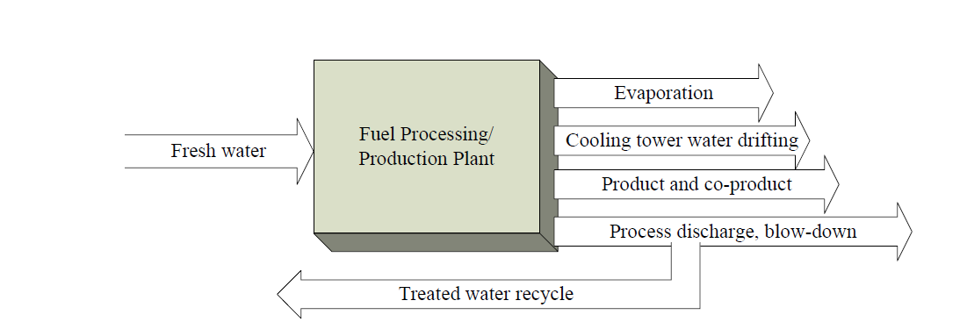

Figure 20: Water inputs and outputs for biofuel production and oil refining (Source: Argonne National Laboratory, 2009).

Refineries discharge waste water which originates from:
- Process water, steam and wash water. These waters have been in contact with the process fluids, and apart from oil, will also have taken up hydrogen sulphide (H2S), ammonia (NH3) and phenols. The more severe the conversion processes, the more H2S and NH3 are taken up by the process water. The process water is treated before discharge to the environment.
- Cooling water, once-through or circulating systems. This stream is theoretically free of oil. However, leakage
- into once-through systems, even at low concentrations, can result in significant mass losses because of the large volume of water involved.
- Rainwater from process areas. This type of water has not been in contact with the process fluids, but it comes from rainfall on surfaces which are possibly oil-polluted. It is often referred to as ‘accidentally oil-contaminated’ water and is typically treated prior to discharge to the environment.
- Rainwater from non-process areas. This stream is oil-free.

Oil and hydrocarbons are the main pollutants found in waste water generated by refineries but also other pollutants are found in waste water generated by refineries, as listed below. Refinery waste water treatment techniques are mature techniques, and emphasis has now shifted to prevention and reduction.

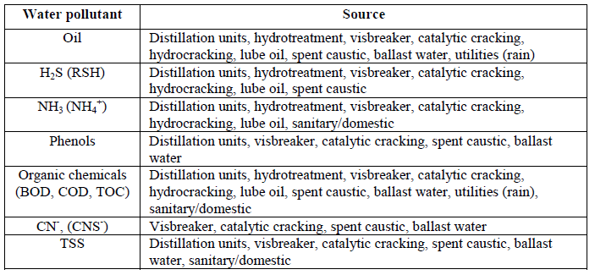
Figure 21: Main water pollutants generated by refineries and their main sources (Source: IPPC Bureau, BREF on Mineral Oil and Gas Refining, 2003, based on CONCAWE Best available techniques to reduce emissions from refineries, 1999).

References used

ANL – “Consumptive Water Use in the Production of Ethanol and Petroleum Gasoline”, 2009
EEA – “The European Environment State and Outlook (SOER) 2010”, 2011
EEA – “Biodiversity – SOER Thematic Assessment 2010”, 2011
EEA – “Emissions of primary particulate matter and secondary PM precursors, CSI 003 Assessment”, 2012
EEA – “Absolute and Relative Gaps between Average 2008–2011 non-ETS Emissions and Kyoto Target for non-ETS Sectors”, 2012
IPIECA – “Biodiversity and the Petroleum Industry”, 2000
IPIECA, OGP - “Alien Invasive Species and the Oil and Gas Industry”, 2010
JRC – “Integrated Pollution Prevention and Control (IPPC), Reference Document on Best Available Techniques for Mineral Oil and Gas Refineries”, 2003
JRC - “Unconventional Gas: Potential Energy Market Impacts in the European Union”, EUR 25305 EN, 2012
Lattanzio, R. K. - “Canadian Oil Sands: Life-Cycle Assessments of Greenhouse Gas Emissions”, US Congressional Research Service, 2013
OECD - “Environmental Outlook to 2030”, 2008
OGP - “Aromatics in Produced Water: Occurrence, Fate & Effects, and Treatment”, 2002
OGP - “Environmental Performance Indicators. 2011 data, 2012
UNEP – GPA, http://gpa.unep.org

Annex XIX: Detailed information on administrative costs (Source: ICF)
MRV Actions | Reference actor | Number of actor | Cost per actor |  |  |  |  |  | Total annual cost for the EU
MRV Actions | Reference actor | Number of actor | Assumptions | Measurement unit | Cost per measurement unit | Number of unit | Cost per actor | Annualised cost per actor | Total annual cost for the EU
Regulation Review | All suppliers | 904 | Annualised over 10 years | Hour | € 70/hour | 15 | € 1,050 | € 129 | € 117,028
Verification - development of a EU harmonised assurance standard | All EU refineries | 1 | Delegated responsibility from the MS. Part of the cost borne by the MS | / | / | / | / | / | € 2 – 3 million
UER Projects – pre-registration cost | UER projects | 4 | Once off cost per project – low estimate | / | / | / | € 31,000 | € 3,822 | € 15,288
UER Projects – pre-registration cost | UER projects | 4 | Once off cost per project – high estimate | / | / | / | € 116,500 | € 14,363 | € 57,454
UER Projects – post registration costs | UER projects | 4 | Annual cost per project – low estimate | / | / | / | € 7,750 | € 7,750 | € 31,000
UER Projects – post registration costs | UER projects | 4 | Annual cost per project – high estimate | / | / | / | € 15,500 | € 15,500 | € 62,000
Table 11: MRV costs under Option B1 for suppliers

MRV Actions | Reference actor | Number of actor | Cost per actor |  |  |  |  |  | Total annual cost for the EU
MRV Actions | Reference actor | Number of actor | Assumptions | Measurement unit | Cost per measurement unit | Number of unit | Cost per actor | Annualised cost per actor | Total annual cost for the EU
Periodical update of data required for the calculation | EC | 1 | Occur every 10 years | FTE | € 60,000 | 1/6 | € 10,000 | € 1,233 | € 1,233
UER Projects – verification and validation | EC | 1 | Costs are covered by the administrative fees | / | / | / | / | / | /
MS - Gathering and reporting data to the EC | 27 MS | / | Annual cost  Low estimates | Person-day | € 157 | 51 | € 8,007 | € 8,007 | € 8,007
MS - Gathering and reporting data to the EC | 27 MS | / | Annual cost  High estimates | Person-day | € 157 | 76 | € 11,932 | € 11,932 | € 11,932
EC – Processing and analysis of data | EC | 1 | Based on reporting costs |  |  |  |  |  | € 4,000
 |  |  |  |  |  |  |  |  | € 5,500
Table 12: MRV costs under Option B1 for public authorities

MRV Actions | Reference actor | Number of actor | Cost per actor |  |  |  |  |  | Total annual cost for the EU
MRV Actions | Reference actor | Number of actor | Assumptions | Measurement unit | Cost per measurement unit | Number of unit | Cost per actor | Annualised cost per actor | Total annual cost for the EU
Regulation Review | All suppliers | 904 | Annualised over 10 years | Hour | € 70/hour | 15 | € 1,050 | € 129 | € 117,028
Development of internal tool / spread sheet | Simple refinery | 87 | Annualised over 10 years | Hour | € 70/hour | 40 | € 2,800 | € 345 | € 30,034
 |  |  |  | Hour | € 70/hour | 80 | € 5,600 | € 690 | € 60,067
Development of internal tool / spread sheet | Complex refinery | 42 | Annualised over 10 years | Hour | € 70/hour | 80 | € 5,600 | € 690 | € 28,998
 |  |  |  | Hour | € 70/hour | 160 | € 11,200 | € 1,381 | € 57,996
Maintaining internal tool / spread sheet | Simple refinery | 87 | Annual cost  Daily / weekly activity | Hour | € 70/hour | 260 | € 18,200 | € 18,200 | € 1,583,400
Maintaining internal tool / spread sheet | Complex refinery | 42 | Annual cost  Daily / weekly activity | Hour | € 70/hour | 520 | € 36,400 | € 36,400 | €1,528,800
Verification - development of a EU harmonised assurance standard | All EU refineries | 1 | Delegated responsibility from the MS. Part of the cost borne by the MS | / | / | / | / | / | € 2 – 3 million
Internal and external verification | Simple refinery | 87 | Averaging cost of internal and external auditing | Hour | € 70/hour | 15 | € 1,050 | € 1,050 | € 91,350
Internal and external verification | Complex refinery | 42 | Averaging cost of internal and external auditing | Hour | € 70/hour | 30 | € 2,100 | € 2,100 | € 88,200
Management and transfer of data by fuel traders and verification of this process | Fuel traders active in the EU | 775 | Administrative cost of fuel traders is equivalent to 20% of the costs for EU and non-EU refineries | / | / | / | / | / | €9.1 – 9.3m
UER Projects – pre-registration cost | UER projects | 4 | Once off cost per project – low estimate | / | / | / | € 31,000 | € 3,822 | € 15,288
UER Projects – pre-registration cost | UER projects | 4 | Once off cost per project – high estimate | / | / | / | € 116,500 | € 14,363 | € 57,454
UER Projects – post registration costs | UER projects | 4 | Annual cost per project – low estimate | / | / | / | € 7,750 | € 7,750 | € 31,000
UER Projects – post registration costs | UER projects | 4 | Annual cost per project – high estimate | / | / | / | € 15,500 | € 15,500 | € 62,000
Table 13: MRV costs under Option C for suppliers

MRV Actions | Reference actor | Number of actor | Cost per actor |  |  |  |  |  | Total annual cost for the EU
MRV Actions | Reference actor | Number of actor | Assumptions | Measurement unit | Cost per measurement unit | Number of unit | Cost per actor | Annualised cost per actor | Total annual cost for the EU
Periodical update of data required for the calculation | EC | 1 | Occur every 10 years | FTE | € 60,000 | 1/6 | € 10,000 | € 1,233 | € 1,233
UER Projects – verification and validation | EC | 1 | Costs are covered by the administrative fees | / | / | / | / | / | /
MS - Gathering and reporting data to the EC | 27 MS | / | Annual cost  Low estimates | Person-day | € 157 | 51 | € 8,007 | € 8,007 | € 8,007
MS - Gathering and reporting data to the EC | 27 MS | / | Annual cost  High estimates | Person-day | € 157 | 76 | € 11,932 | € 11,932 | € 11,932
EC – Processing and analysis of data | EC | 1 | Based on reporting costs |  |  |  |  |  | € 4,000
 |  |  |  |  |  |  |  |  | € 5,500
Table 14: MRV costs under Option C for public authorities

MRV Actions | Reference actor | Number of actor | Cost per actor |  |  |  |  |  | Total annual cost for the EU
MRV Actions | Reference actor | Number of actor | Assumptions | Measurement unit | Cost per measurement unit | Number of unit | Cost per actor | Annualised cost per actor | Total annual cost for the EU
Regulation Review | Refineries, Suppliers, Traders | 904 | Annualised over 10 years | Hour | € 70/hour | 15 | € 1,050 | € 129 | € 117,028
Verification - development of a EU harmonised assurance standard | All EU refineries | 1 | Delegated responsibility from the MS. Part of the cost borne by the MS | / | / | / | / | / | € 2 – 3 million
UER Projects – pre-registration cost | UER projects | 4 | Once off cost per project – low estimate | / | / | / | € 31,000 | € 3,822 | € 15,288
UER Projects – pre-registration cost | UER projects | 4 | Once off cost per project – high estimate | / | / | / | € 116,500 | € 14,363 | € 57,454
UER Projects – post registration costs | UER projects | 4 | Annual cost per project – low estimate | / | / | / | € 7,750 | € 7,750 | € 31,000
UER Projects – post registration costs | UER projects | 4 | Annual cost per project – high estimate | / | / | / | € 15,500 | € 15,500 | € 62,000
Table 15: MRV costs under Option D for suppliers (incurred by both opted in and opted out suppliers)

MRV Actions | Reference actor | Number of actors | Cost per actor |  |  |  | Total annual cost for EU (low) | Total annual cost for EU (high)
MRV Actions | Reference actor | Number of actors | Assumptions | Cost per actor | Annualised cost per actor(low) | Annualised cost per actor (high) | Total annual cost for EU (low) | Total annual cost for EU (high)
LCA calculation – own measurement | ⅓ opting out producers | 19 | Measured data for 2 stages (extraction and refining) | € 58,000 | € 13,028 | € 30,751 | € 247,539 | € 584,276
 |  |  |  | € 100,950 | € 22,676 | € 53,523 | € 430,846 | € 1,016,943
LCA calculation – engineering estimates | ⅓ opting out producers | 19 | Estimation - Engineering | € 70,000 | € 15,724 | € 37,114 | € 298,754 | € 705,161
 |  |  |  | € 93,000 | € 20,890 | € 49,308 | € 396,916 | € 936,856
LCA calculation – existing model | ⅓ opting out producers | 19 | Estimation – Existing model (e.g. GREET) | € 11,500 | € 2,583 | € 6,097 | € 49,081 | € 115,848
 |  |  |  | € 23,300 | € 5,234 | € 12,354 | € 99,442 | € 234,718
Verification and validation cost | Opting out refineries | 56 | External validation | € 11,500 | € 2,583 | € 6,097 | € 144,660 | € 341,446
 |  |  |  | € 23,300 | € 5,234 | € 12,354 | € 293,093 | € 691,800
Development of an internal tool / spreadsheet | Simple refineries | 38 | Annualised over 10 years | € 2,800 - € 5,600 | € 345 | € 690 | € 13,118 | € 26,236
Development of an internal tool / spreadsheet | Complex refineries | 18 | Annualised over 10 years | € 5,600 - € 11,200 | € 690 | € 1381 | € 12,428 | € 24,855
Maintaining an internal tool / spreadsheet | Simple refineries | 38 | Annual cost. Daily / weekly activity | € 18,200 | € 18,200 | € 18,200 | € 691,600 | € 691,600
Maintaining an internal tool / spreadsheet | Complex refineries | 18 | Annual cost. Daily / weekly activity | € 36,400 | € 36,400 | € 36,400 | € 655,200 | € 655,200
Management and transfer of data by fuel traders, verification of this process | Opted out traders | 378 | Administrative cost of fuel traders is equal to 20% of costs for EU and non-EU refineries |  |  |  | € 6,770,308 | € 13,926,273

Table 16: Additional MRV costs under Option D for opted out suppliers
(Low Estimates based on repeated calculations every 5 years and high estimates based on re-calculations every 2 years)

MRV Actions | Reference actor | Number of actor | Cost per actor |  |  |  |  |  | Total annual cost for the EU
MRV Actions | Reference actor | Number of actor | Assumptions | Measurement unit | Cost per measurement unit | Number of unit | Cost per actor | Annualised cost per actor | Total annual cost for the EU
Development of internal tool / spread sheet | Simple refinery | 49 | Annualised over 10 years | Hour | € 70/hour | 40 | € 2,800 | € 345 | € 16,916
 |  |  |  | Hour | € 70/hour | 80 | € 5,600 | € 690 | € 33,831
Development of internal tool / spread sheet | Complex refinery | 24 | Annualised over 10 years | Hour | € 70/hour | 80 | € 5,600 | € 690 | € 16,570
 |  |  |  | Hour | € 70/hour | 160 | € 11,200 | € 1,381 | € 33,141
Maintaining internal tool / spread sheet | Simple refinery | 49 | Annual cost  Daily / weekly activity | Hour | € 70/hour | 260 | € 18,200 | € 18,200 | € 891,800
Maintaining internal tool / spread sheet | Complex refinery | 24 | Annual cost  Daily / weekly activity | Hour | € 70/hour | 520 | € 36,400 | € 36,400 | € 873,600
Internal and external verification | Simple refinery | 49 | Averaging cost of internal and external auditing | Hour | € 70/hour | 15 | € 1,050 | € 1,050 | € 51,450
Internal and external verification | Complex refinery | 24 | Averaging cost of internal and external auditing | Hour | € 70/hour | 30 | € 2,100 | € 2,100 | € 50,400
Management and transfer of data by fuel traders and verification of this process | Opted in traders | 584 | Administrative cost of fuel traders is equivalent to 20% of the costs for EU and non-EU refineries |  |  |  |  |  | €4.7m

Table 17: Additional MRV costs under Option D for opted in suppliers

MRV Actions | Reference actor | Number of actor | Cost per actor |  |  |  |  |  | Total annual cost for the EU
MRV Actions | Reference actor | Number of actor | Assumptions | Measurement unit | Cost per measurement unit | Number of unit | Cost per actor | Annualised cost per actor | Total annual cost for the EU
Periodical update of data required for the calculation | EC | 1 | Occur annually | FTE | € 60,000 | 1/6 | € 10,000 | € 10,000 | € 10,000
UER Projects – verification and validation | EC | 1 | Costs are covered by the administrative fees | / | / | / | / | / | /
MS - Gathering and reporting data to the EC | 27 MS | / | Annual cost  Low estimates | Person-day | € 157 | 51 | € 8,007 | € 8,007 | € 8,007
MS - Gathering and reporting data to the EC | 27 MS | / | Annual cost  High estimates | Person-day | € 157 | 76 | € 11,932 | € 11,932 | € 11,932
EC – Processing and analysis of data | EC | 1 | Based on reporting costs |  |  |  |  |  | € 4,000
 |  |  |  |  |  |  |  |  | € 5,500
Table 18: MRV costs under Option D for public authorities

Annex XX: Projected road fuel mix 2020 all options (ILUC scenario) (Source: Vivid Economics)

Fuel | Feedstock | Option B1 |  | Option C |  | Option D |  | Option E
Fuel | Feedstock | PJ | Mt CO2e | PJ | Mt CO2e | PJ | Mt CO2e | PJ | Mt CO2e
Petrol | Conventional crude | 2709 | 238.6 | 2717 | 238.0 | 2703 | 236.7 | 2703 | 236.7
Petrol | Natural bitumen  (Venezuela to EU) | 69 | 6.1 | 55 | 5.9 | 55 | 5.9 | 55 | 5.9
Petrol | Oil shale | 2 | 0.2 | 0 | 0.0 | 0 | 0.0 | 0 | 0.0
Petrol | Subtotal | 2780 | 244.9 | 2772 | 243.9 | 2759 | 242.7 | 2759 | 242.7
Diesel | Conventional crude (subtotal) | 7024 | 633.9 | 7154 | 639.5 | 7169 | 640.8 | 7169 | 640.8
Diesel | Conventional crude (EU refined) | 5067 | 457.3 | 5312 | 474.8 | 5276 | 471.6 | 5276 | 471.6
Diesel | Conventional crude (import USGC) | 180 | 16.3 | 110 | 9.9 | 109 | 9.8 | 109 | 9.8
Diesel | Conventional crude (import Russia) | 1777 | 160.3 | 1732 | 154.8 | 1784 | 159.4 | 1784 | 159.4
Diesel | Natural bitumen  (Venezuela to EU) | 167 | 15.1 | 139 | 15.0 | 139 | 15.0 | 139 | 15.0
Diesel | Natural bitumen  (Canada to USGC) | 21 | 1.9 | 0 | 0.0 | 0 | 0.0 | 0 | 0.0
Diesel | Oil shale | 4 | 0.4 | 0 | 0.0 | 0 | 0.0 | 0 | 0.0
Diesel | CTL | 19 | 1.7 | 19 | 3.2 | 19 | 3.2 | 19 | 3.2
Diesel | GTL | 61 | 5.5 | 0 | 0.0 | 0 | 0.0 | 0 | 0.0
Diesel | Subtotal | 7296 | 658.4 | 7312 | 657.7 | 7327 | 659.1 | 7327 | 659.1
LPG |  | 208 | 15.3 | 208 | 15.3 | 208 | 15.3 | 208 | 15.3
CNG |  | 44 | 3.4 | 44 | 3.4 | 44 | 3.4 | 44 | 3.4
Electricity | EU-average | 87 | 3.9 | 87 | 3.9 | 87 | 3.9 | 87 | 3.9
Ethanol | Corn (maize) | 58 | 2.5 | 58 | 2.5 | 58 | 2.5 | 58 | 2.5
Ethanol | Sugar beet | 40 | 1.4 | 40 | 1.4 | 40 | 1.4 | 40 | 1.4
Ethanol | Sugar cane | 103 | 3.6 | 103 | 3.6 | 103 | 3.6 | 103 | 3.6
Ethanol | Wheat Process fuel not specified | 0 | 0.0 | 0 | 0.0 | 0 | 0.0 | 0 | 0.0
Ethanol | Wheat Natural gas as process fuel in CHP plant | 0 | 0.0 | 0 | 0.0 | 0 | 0.0 | 0 | 0.0
Ethanol | Wheat Straw as process fuel in CHP plant | 15 | 0.6 | 15 | 0.6 | 15 | 0.6 | 15 | 0.6
Ethanol | 2G ethanol - land using | 10 | 0.3 | 10 | 0.3 | 10 | 0.3 | 10 | 0.3
Ethanol | 2G ethanol - non-land using | 10 | 0.1 | 10 | 0.1 | 10 | 0.1 | 10 | 0.1
Ethanol | Subtotal | 236 | 8 | 236 | 8 | 236 | 8 | 236 | 8
Biodiesel | 2G biodiesel - land using | 22 | 0.4 | 15 | 0.3 | 15 | 0.3 | 15 | 0.3
Biodiesel | 2G biodiesel - non-land using | 80 | 0.7 | 80 | 0.7 | 80 | 0.7 | 80 | 0.7
Biodiesel | Waste 1st. Gen. Diesel | 85 | 0.8 | 85 | 0.8 | 85 | 0.8 | 85 | 0.8
Biodiesel | Palm oil | 0 | 0.0 | 0 | 0.0 | 0 | 0.0 | 0 | 0.0
Biodiesel | Palm oil with methane capture | 0 | 0.0 | 0 | 0.0 | 0 | 0.0 | 0 | 0.0
Biodiesel | Rapeseed | 0 | 0.0 | 0 | 0.0 | 0 | 0.0 | 0 | 0.0
Biodiesel | Soybean | 0 | 0.0 | 0 | 0.0 | 0 | 0.0 | 0 | 0.0
Biodiesel | Sunflower | 0 | 0.0 | 0 | 0.0 | 0 | 0.0 | 0 | 0.0
Biodiesel | Subtotal | 187 | 2 | 180 | 2 | 180 | 2 | 180 | 2
Total |  | 10837 | 936.2 | 10839 | 934.5 | 10840 | 934.6 | 10840 | 943.6

Within the context of the Fuel Quality Directive, suppliers are defined as the entity that passes the fuel through the duty point.
Directive 98/70/EC.
With regards to the post-2020 climate and energy legislative framework, the Commission is of the view that sector specific sub-targets, such as the FQD, should be discontinued http://ec.europa.eu/energy/doc/2030/com_2014_15_en.pdf
Directive 2009/30/EC includes mandatory sustainability criteria aimed at preventing the conversion of land characterised by high carbon stock and high biodiversity for biofuel production, as well as requiring biofuels to achieve minimum greenhouse gas emission savings compared to fossil fuels. Biofuels need to comply with these criteria in order to be counted towards the targets and qualify for public support. These criteria are also included in the Renewable Energy Directive 2009/28/EC.
Directive 2009/30/EC, Article 7a(5).
Annex 3 and 4 of the 2011 proposal: http://ec.europa.eu/transparency/regcomitology/index.cfm?do=search.documentdetail&XOvfOQKYHt67nl0gDR9EQ0pDU4MfDGIJHglKuEmrBsRhxbx1TISJ2Mfg5DtxY23N
All analysis and policy discussions referenced in this report predate the accession of Croatia to EU Membership in July 2013.
https://circabc.europa.eu/faces/jsp/extension/wai/navigation/container.jsp for both the questions and responses
The JEC consortium comprises the JRC, EUCAR and CONCAWE. Thus the Commission, EU automobile industry and oil industry take part in this work.
https://circabc.europa.eu/w/browse/9e51b066-9394-4821-a1e2-ff611ab22a2d
https://circabc.europa.eu/w/browse/9ab55170-dc88-4dcb-b2d6-e7e7ba59d8c3
https://circabc.europa.eu/w/browse/9e51b066-9394-4821-a1e2-ff611ab22a2d
https://circabc.europa.eu/w/browse/9ee501ad-fdfe-4975-80d4-477557384644
Meetings of this group were chaired by DG CLIMA and included representatives of the Secretariat General, DG MOVE, DG ENTR, DG ENER, DG AGRI, DG TRADE, DG ENV and the Joint Research Centre.
ARES(2013)2583437 and ARES(2013)2954250
A summary of the latest report commissioned by the Canadian authorities on this matter can be found here http://www.nrcan.gc.ca/media-room/news-release/2013/13889
Note available https://circabc.europa.eu/w/browse/d627b43b-93b4-4547-a2a8-2a8c1bb8f007.
https://www.europia.eu/content/default.asp?PageID=412&DocID=37713. Given the commercially sensitive nature of the information used, only a summary of the results from this report has been published by Europia. As such, the ability to draw comparisons with other available studies remains limited.
It includes total costs. No figures have been provided specifically for the resulting administrative burden, although Europia has stated in several meetings that such costs are minimal.
However, it should be noted that refineries are technically constrained by their refining processes in terms of what feed stocks they can process as this can impact on their product yield, and adjusting their processes may incur capital expenditure at the refinery. With regards to unconventional sources of oil, very few EU refineries are able today to process unconventional oil sources although many are planning to upgrade their capacity in the near future (i.e. Spanish and Estonian refineries).
http://www.transportenvironment.org/publications/nrdc-report-increased-tar-sands-imports-europe
http://www.cedelft.eu/publicatie/oil_reporting_for_the_fqd%3Cbr%3Ean_assessment_of_effort_needed _and_cost_to_oil_companies/1245
“Economic and environmental impacts of the FQD on crude oil production from tar sands”. CE Delft 2013.
More detail in below.
The term "lifecycle greenhouse gas emissions" is defined under Article 1 as "all net emissions of CO₂, CH₄ and N₂O that can be assigned to the fuel (including any blended components) or energy supplied. This includes all relevant stages from extraction or cultivation, including land-use changes, transport and distribution, processing and combustion, irrespective of where those emissions occur".
http://eur-lex.europa.eu/LexUriServ/LexUriServ.do?uri=COM:2011:0112:FIN:en:PDF
http://eur-lex.europa.eu/LexUriServ/LexUriServ.do?uri=COM:2011:0144:FIN:en:PDF
The combustion of road fuel alone is currently responsible for around 20% of the Community’s greenhouse gas emissions.
IEA Energy Outlook 2013.
http://ec.europa.eu/energy/doc/2030/com_2014_15_en.pdf
Includes biofuels
BP 2013 statistical review available at www.bp.com/statisticalreview
Commission Staff Working Paper on Refining and the Supply of Petroleum Products in the EU [SEC(2010)1398]
Trade figures presented here reflect total demand for petroleum products for all sectors, not just that consumed in EU road transport which is the sector regulated by the Fuel Quality Directive.
EUROPIA annual report for 2012.
Commission's calculation based on JEC Well to Wheel study and UNFCCC's data.
The terms “natural bitumen”, “tar sands” and “oil sands” are used indifferently throughout this document.
''Enhanced Recovery Methods for Heavy Oil and Tar Sands'' Speight, 2009, p.23
''Enhanced Recovery Methods for Heavy Oil and Tar Sands'' Speight, 2009, p.20-22
"World Energy Outlook 2010", IEA, 2010, p.145
''Handbook of Alternative Fuel Technology'', Speight, p.198
''Upstream greenhouse gas (GHG) emissions from Canadian oil sands as a feedstock for European refineries'', 20 June 2011, Brandt
''Heavy Oil and Natural Bitumen Resources in Geological Basins of the World'' USGS, 2007, p.36
Available at: https://circabc.europa.eu/w/browse/9e51b066-9394-4821-a1e2-ff611ab22a2d
World Energy Outlook 2012.
International Association of Oil and Gas Producers, Environmental Performance Indicators, 2011 data. In addition, US National Oceanic and Atmospheric Administration satellite data indicate an 8% reduction in total worldwide flaring volumes between 2008 and 2010.
Different tariff classification exists for natural bitumen and oil shale (CN 2714 10 00) and conventional crude (CN 2707 99) under Council Regulation (EEC) N° 2658/87.
Such Union legislation includes Commission Regulation (EC) No 684/2009 of 24 July 2009 implementing Council Directive 2008/118/EC as regards the computerised procedures for the movement of excise goods under suspension of excise duty; and Commission Regulation (EEC) No 2454/93 of 2 July 1993 laying down provisions for the implementation of Council Regulation (EEC) No 2913/92 establishing the Community Customs Code.
COMMISSION REGULATION (EU) No 601/2012 of 21 June 2012 on the monitoring and reporting of greenhouse gas emissions pursuant to Directive 2003/87/EC of the European Parliament and of the Council, OJ L 181, 12.07.2012, p. 30 (and p. 93). http://eurlex.europa.eu/LexUriServ/LexUriServ.do?uri=OJ:L:2012:181:0030:0104:EN:PDF
Note available https://circabc.europa.eu/w/browse/d627b43b-93b4-4547-a2a8-2a8c1bb8f007.
IEA World Energy Outlook 2010. Oil shale projects are expected to be competitive at lower prices of $60 per barrel.
EC’s calculations from IEA World Energy Outlook 2013.
Note submitted by the Spanish Oil Industry (AOP).
Satellite observations provide total estimated flare gas volumes per hydrocarbon-producing country but do not distinguish between oil and gas production. In some countries the proportion of gas production is large and it is reasonable to expect that a certain proportion of flaring is associated with gas production. However, there is no widely recognised method for apportioning flaring emissions between all hydrocarbons produced.
ICCT report. This is equivalent to around half of all US emissions from fossil fuels in 2008.
For example, a number of pilot CCS projects are being undertaken in Canada where the Albertan government has committed $2 billion to advancing four large-scale demonstration projects in the province.
Summary on LCFS policies available at the ICCT's website. http://www.theicct.org/sites/default/files/publications/ICCTpolicyupdate12_USLCFS_2011.pdf
Article 2 (a) (ii) 8.
12 Member States representing 60% of the EU market responded to the questionnaire in 2010. Only 33 fuel suppliers responded to the questionnaire in 2012.
A total of 90 producers have been identified in the EU. Please note that this is different from the total number of EU refineries since some of these are single suppliers with multiple refineries. Please see ICF report for more information.
Eurostat 2012
Eurostat
Eurostat/EC DG Energy
Europia 2010 Annual Report. In addition, an estimated 500,000 may be employed in marketing and logistics, and 778,000 in the petrochemical sector. Source: Commission Staff Working Paper on Refining and the Supply of Petroleum Products in the EU [SEC(2010)1398]
PÖYRY ENERGY CONSULTING report to DG Energy and Transport on a Survey of the Competitive Aspects of Oil and Oil Product Markets in the EU
Note submitted to the EC by Spanish Oil Industry Association (AOP).
Tax incentives and transport structural changes have led to a petrol to diesel current ratio of 1:3, potentially increasing to 1:4 in 2020, from the inverse situation 20 years ago (petrol to diesel ratio of 2:1). Source:Europia.
Compared to 3.5 million barrels a day have shut down for the OECD as a whole over the same period. World Energy Outlook 2012.
P. 101 IEA's ''2010 Oil Mid-term Market Report" http://www.oecdilibrary.org/docserver/ download/6112281e.pdf?expires=1369141213&id=id&accname=id24042&checksum=1FE94D51815C 0718EB5C4E64FE7B7ECA
Sustainable utilisation rates are defined at 84% in order to maintain a 4% margin.
http://www.greenpeace.org.uk/media/reports/tar-sands-your-tank
Source: ICF from Eurostat and OPEC 2010.
http://ec.europa.eu/energy/renewables/action_plan_en.htm
2020 feedstock projections from IFPRI used in EC staff working document SWD (2012) 343 have been adjusted to 2020 fuel consumption figures used in this assessment. The potential impacts of a higher greenhouse gas emissions threshold at 50% under the FQD's sustainability criteria have not been taken into account for the purpose of this exercise and as such no biofuel feedstock has been excluded from this assessment. This is because although the level of GHG improvements needed can be challenging, it is theoretically possible in most cases.
Total figures in this table may include rounding error.
Information used included crude/non-crude oil breakdown (biofuels, GTL/CTL etc.), data on every refinery worldwide with aggregation into regional or sub-regional groups, multiple products and product quality detail, detailed marine, pipeline and minor modes transport representation, refining sector GHG emissions, projects, investments, etc.). Further information on the WORLD model, the data inputs and outputs resulting from this analysis, can be in the contractors' final report at https://circabc.europa.eu/w/browse/6893ba02-aaed-40a7-bf0d-f5affc85a619.
Further information on key modelling assumption and input data can be found in ICF’s report.
Values were firstly adjusted to account for the projected baseline 2020 EU crude mix changes. http://ec.europa.eu/transparency/regcomitology/index.cfm?do=search.documentdetail&XOvfOQKYHt67nl0gDR9EQ0pDU4MfDGIJHglKuEmrBsRhxbx1TISJ2Mfg5DtxY23N. The GHG intensity values for conventional fossil fuels included in this assessment were based on the most recent Well to Wheel study at the time of being conducted. Other sources emerging since then strongly suggest that upstream emission reductions have been underestimated. In this context, any increases of the carbon intensity baseline will lead to lower compliance costs to suppliers than those reported in chapter 5 as they would indirectly also proportionately lower the carbon abatement costs of mitigation measures such as biofuels.
See details on assumptions in chapter 2.2 of the report: Technical assistance for an evaluation of International schemes to promote biomass sustainability (2009) http://ec.europa.eu/energy/renewables/bioenergy/sustainability_criteria_en.htm.
Table 4. EC staff working document SWD(2012) 343 final
Further information on specific carbon intensities at Member State level are shown in Annex VII: Average GHG intensities by Member State (gCO2/MJ) (Source: ICF))
Well-to-wheels Analysis of Future Automotive Fuels and Powertrains in the European Context, Appendix 2 WTW GHG-Emissions of Externally Chargeable Electric Vehicles, CONCAWE/EUCAR/JRC, 2011.
EU Energy Trends to 2030 – Update 2009, European Commission, 2010. available online: http://ec.europa.eu/energy/observatory/trends_2030/doc/trends_to_2030_update_2009.pdf
In recognition of such higher efficiency, the energy contribution of electric vehicles towards the Renewable Energy Directive target is 2.5 of the energy consumed.
Source: ICF from Eurostat and OPEC 2010.
Should all unconventional fossil fuel sources be replaced by the conventional equivalents, the average GHG intensity of all fuels consumed would go down to 83gCO2/MJ, which would mean that the 6% FQD target would be achieved with those in place to achieve the Renewable Energy Directive targets.
Most of today's biofuels are produced from crops grown on agricultural land. When this land previously destined for the food, feed and fibre markets is diverted to the production of biofuels, the non-fuel demand will still need to be satisfied. If non-agricultural land is brought into production, land use change occurs indirectly, which could lead to substantial greenhouse gas emissions being released if high carbon stock areas are affected. This is why the Commission has proposed to limit incentives for first generation biofuels (http://ec.europa.eu/clima/policies/transport/fuel/documentation_en.htm).
Please see full IFPRI report for further information on how he estimated indirect land use change emissions from biofuels have been calculated http://trade.ec.europa.eu/doclib/docs/2011/october/tradoc_148289.pdf
In reality, it is likely that the carbon intensity of the additional fossil petrol and diesel that are being used here will be of a higher intensity as some amounts of unconventional sources are likely to be included.
The Renewable Energy Directive 10% target would not be met under this scenario either as a result of the reduced biofuel contribution. As the aim of the scenario is to focus on the impacts of the FQD, additional contributions from available renewable energy technologies (i.e. advanced biofuels, electricity in road and rail) needed to achieve this have not been considered.
Sub-totals and total figures reported in this table may include rounding error.
Directive 2009/30/EC, Article 7a(5).
While the need for accuracy of the chosen methodology is key to a successful implementation of the FQD, it does not seem possible to define such level more precisely in a non-arbitrary way.
Annex III and IV of the 2011 proposal: http://ec.europa.eu/transparency/regcomitology/index.cfm?do=search.documentdetail&XOvfOQKYHt67nl0gDR9EQ0pDU4MfDGIJHglKuEmrBsRhxbx1TISJ2Mfg5DtxY23N
For the purpose of this assessment, representative values for petrol, diesel, LPG and CNG) were derived from the "Well to Wheel" work carried out by the JEC consortium.
Allowing for actual values to be reported under this option may lead to the overall EU fuel carbon intensity being underestimated as only those suppliers with lower carbon intensity would be encouraged to report. This could be mitigated through the provision of more conservative default values.
Certain environmental NGOs have called into question the compatibility of this simplified approach given that the legal requirements on fuel suppliers seem focused in reporting specific information about the fuels they supply (i.e. origin, carbon intensity, etc).
These values were mainly derived from the "Well to Wheel" work carried out by the JEC consortium, and a number of studies conducted for the Commission for the oil sands/natural bitumen and oil shales values. More information can be found in the Commission’s 2011 proposal. http://ec.europa.eu/transparency/regcomitology/index.cfm?do=search.documentdetail&XOvfOQKYHt67nl0gDR9EQ0pDU4MfDGIJHglKuEmrBsRhxbx1TISJ2Mfg5DtxY23N.
Allowing for actual values to be reported under this option may lead to the overall EU fuel carbon intensity being underestimated as only those suppliers with lower carbon intensity would be encouraged to report. This could be mitigated through the provision of more conservative default values. In the 2011 proposal, suppliers of feedstocks from unconventional sources were given the possibility to report actual values if they wished to do so in order to demonstrate better greenhouse gas emission performance than such default value. This has not been taken into account into the assessment of the options in chapter 5.
These values were mainly derived from the "Well to Wheel" work carried out by the JEC consortium, and a number of studies conducted for the Commission for the oil sands/natural bitumen and oil shales values. More information can be found in the Commission’s 2011 proposal. http://ec.europa.eu/transparency/regcomitology/index.cfm?do=search.documentdetail&XOvfOQKYHt67nl0gDR9EQ0pDU4MfDGIJHglKuEmrBsRhxbx1TISJ2Mfg5DtxY23N.
Allowing for actual values to be reported under D1 may lead to the overall EU fuel carbon intensity being underestimated as only those suppliers with lower carbon intensity would be encouraged to report. This is evaluated further in chapter 5. This effect could be mitigated through the provision of more conservative default values, such as D2.
Such system could be simplified through the introduction of default values, further disaggregated (i.e. field level, trade name, Marketable Crude Oil Name, etc), as a method for compliance.
For example, suppliers are required to report the GHG intensity of the fuels they supply according to their MCON name to the Californian Air Resources Board under the Californian Low Carbon Fuel Standard. Significant improvements to available data inventories using the OPGEE model have been recently made in a recent report from ICCT that can be found at https://circabc.europa.eu/w/browse/49f63fd8-7e27-4cf7-8790-3410ee8d308e
The use of actual values is only permitted to all fuel suppliers under options D1, D2 and E. Under option C, only suppliers of high ghg intensity products are permitted to do so.
https://circabc.europa.eu/w/browse/6893ba02-aaed-40a7-bf0d-f5affc85a619
Other considerations, such as compatibility of different feedstocks with refinery configuration, have also been taken into account. Please see final reports from ICF and VIVID for full details.
As explained in chapter 2, the Commission has recently proposed a limit on the maximum level of conventional biofuels that can be counted towards the Renewable Energy Directive in regards to concerns about indirect land use change impacts. The possible impacts of a reduced contribution from biofuels are explored under the sensitivity section at the end of this chapter.
http://ec.europa.eu/governance/impact/key_docs/docs/sec_2012_0091_en.pdf
See Annex XIV: Screening of competitiveness impacts for further information.
https://circabc.europa.eu/w/browse/6893ba02-aaed-40a7-bf0d-f5affc85a619
Further detail on how the analysis has been conducted can be found in Annex XV: Assessment of competitiveness impacts on EU refineries
Fuel traders have a market intermediary position, that is, they reduce the transaction costs of trading through specialisation. In contrast to refiners, traders hold no major assets affected by the FQD.
It is acknowledged that SMEs may be more sensitive to any increase in administrative burden and so simplified SME specific reporting provisions may be needed depending on the final methodological choice.
The accuracy of this option would be improved significantly if suppliers were, for example, required to report on the carbon intensity of the fuels based on a more disaggregated system, as to ensure such average would be based on a large sample of reported data.
In such case, default values would need to be set at conservative level as to avoid large under-reporting.
Or between 10 to 25% of overall FQD reduction target.
Well to wheel study, JEC consortium.
Further information on the environmental impacts associated with fuel production can be found in Annex XVIII: General considerations around environmental impacts associated with fossil fuel production (Source: JRC) .
Should all unconventional fossil fuel sources not be captured by the methodology, the average GHG intensity of all fuels consumed would go down to 83gCO2/MJ, which would mean that the 6% FQD target would be achieved on paper but in reality it would constitute a 5.2% reduction.
All costs presented here are annual costs. Administrative costs associated with the chosen mechanism will apply to suppliers every year given that the reported obligation is set on an annual basis, while compliance with the FQD target, and therefore the associated compliance and market costs, does not apply until the year 2020. Full details on administrative costs can be found in Annex XIX: Detailed information on administrative costs.
Instead, compliance costs reported here only reflect the sum of the expenditure on all abatement measures.
The pump price increases reported here represent the change in cost between the baseline and the different options- the effort required to achieve the Fuel Quality Directive target once the Renewable Energy Directive target has been met. Absolute pump price increases for the 6% reduction would be around 0.3 cents per litre. Further detail can be found in ICF/VIVID report at https://circabc.europa.eu/w/browse/6893ba02-aaed-40a7-bf0d-f5affc85a619
In the context of the overall uncertainty associated with the results from the modelling, these variations should be interpreted with caution as they represent very small proportion (>1%) of the total fuel mix at 11000PJ.
Under this option, the amount of unconventional sources being consumed remains largely unaffected and so the decrease in diesel demand comes mainly from conventional sources. As most of the refineries in the EU are not able to process unconventional feedstocks, a larger decrease on consumption of conventional sources indirectly leads to a larger share of imports.
Negative impacts on employment may be limited to those related to the small reductions in EU refining throughput. Although these reductions are likely to be offset with increased biofuel production at EU level, these effects may concern different groups of workers and not occur in the same Member State.
Or between 2 to 3% of overall FQD reduction target.
Refiners report to the MS and MS to the Commission monthly summary of delivered crude quality, crude name, density, and sulphur content pursuant to Council Regulation 2904/95.
It is not possible to determine whether the level of disincentives provided by such methodology under the Fuel Quality Directive will ultimately lead to the unconventional sources not being extracted or instead these would be routed to markets outside the EU. Diverging results from stakeholder studies conducted on this topic can be found in section 1.3.
All costs presented here are annual costs. Administrative costs associated with the chosen mechanism will apply to suppliers every year given that the reported obligation is set on an annual basis, while compliance with the FQD target, and therefore the associated compliance and market costs, does not apply until the year 2020. Full details on administrative costs can be found in Annex XIX: Detailed information on administrative costs.
The pump price increases reported here represent the change in cost between the baseline and the different options- the effort required to achieve the Fuel Quality Directive target once the Renewable Energy Directive target has been met. Absolute pump price increases for the 6% reduction would be around 0.3 cents per litre. Further detail can be found in ICF/VIVID report at https://circabc.europa.eu/w/browse/6893ba02-aaed-40a7-bf0d-f5affc85a619
These results should be interpreted with caution as they represent very small variations (>1%) of the total fuel mix at 11000PJ.
It is worth noting that US imported diesel derived from natural bitumen is expected to exit the market before other unconventional sources such as oil shale and Venezuelan natural bitumen as its competitiveness inside the EU is influenced by having a lower market share than Venezuelan natural bitumen. In addition, its upstream emissions intensity and the lifecycle emissions intensity is high, almost as high as oil shale and above Venezuelan natural bitumen levels. Oil shale is slightly more competitive than North American natural bitumen as it is harder to substitute.
In our assessment, this leads to less abatement measures needed to be put in place overall under D1.
Or around 27% of overall FQD reduction target.
Or around 17% of overall FQD reduction target.
It is not possible to determine whether the level of disincentives provided by such methodology under the Fuel Quality Directive will ultimately lead to the unconventional sources not being extracted or instead these would be routed to markets outside the EU. Diverging results from stakeholder studies conducted on this topic can be found in section 1.3.
The difference in compliance costs would be determined by the level of abatement needed. This would range between the costs of 1 million for D1 (i.e. which presents low costs given its underestimation of EU emissions to 8 million euros, which equals the compliance costs for option E as it would be the most extreme variant for D2.
All costs presented here are annual costs. Administrative costs associated with the chosen mechanism will apply to suppliers every year given that the reported obligation is set on an annual basis, while compliance with the FQD target, and therefore the associated compliance and market costs, does not apply until the year 2020. Full details on administrative costs can be found in Annex XIX: Detailed information on administrative costs.
Option D1 would lead to lower costs as due to the underestimation of EU average default values less abatement tools are needed than for the other options. The costs for both D1 and D2 will ultimately lie somewhere between those of options C and E.
The pump price increases reported here represent the change in cost between the baseline and the different options- the effort required to achieve the Fuel Quality Directive target once the Renewable Energy Directive target has been met. Absolute pump price increases for the 6% reduction would be around 0.3 cents per litre. Further detail can be found in ICF/VIVID report at https://circabc.europa.eu/w/browse/6893ba02-aaed-40a7-bf0d-f5affc85a619
These results should be interpreted with caution as they represent very small variations (>1%) of the total fuel mix at 11000 PJ.
This could be mitigated through the development of default values based on data at further level of disaggregation, such as those included in the Californian Low Carbon Fuel Standard.
All costs presented here are annual costs. Administrative costs associated with the chosen mechanism will apply to suppliers every year given that the reported obligation is set on an annual basis, while compliance with the FQD target, and therefore the associated compliance and market costs, does not apply until the year 2020. Full details on administrative costs can be found in Annex XIX: Detailed information on administrative costs.
The pump price increases reported here represent the change in cost between the baseline and the different options- the effort required to achieve the Fuel Quality Directive target once the Renewable Energy Directive target has been met. Absolute pump price increases for the 6% reduction would be around 0.3 cents per litre. Further detail can be found in ICF/VIVID report at https://circabc.europa.eu/w/browse/6893ba02-aaed-40a7-bf0d-f5affc85a619
These results should be interpreted with caution as they represent very small variations (>1%) of the total fuel mix at 11000PJ.
Article 8 (3) of 98/70/EC.
Based on information provided from chapter 2 of the Delft Report March 2012: Oil reporting for the FQD: An assessment of effort needed and cost to oil companies.
Minimum Reporting Obligations in the Fuel Quality Directive, Administrative burden of tar sand classification in the Fuel Quality Directive, T&E.
Based on diagram from Delft Report March 2012: Oil reporting for the FQD: An assessment of effort needed and cost to oil companies.
Based on Chapter 2 of the Delft Report March 2012: Oil reporting for the FQD: An assessment of effort needed and cost to oil companies and Minimum Reporting Obligations in the Fuel Quality Directive, Administrative burden of tar sand classification in the Fuel Quality Directive, T&E.
Regulation (EC) No 450/2008 of the European Parliament and of the Council of 23 April 2008 laying down the Community Customs Code (Modernised Customs Code)
(?) Council Directive 2008/118/EC of 16 December 2008 concerning the general arrangements for excise duty and repealing Directive 92/12/EEC (OJ L 009, 14.1.2009, p.12).
(?) Council Directive 2003/96/EC of 27 October 2003 restructuring the Community framework for the taxation of energy products and electricity (OJ L 283, 31.10.2003, p.51).
Chapter 3 of the Delft Report March 2012: Oil reporting for the FQD: An assessment of effort needed and cost to oil companies
of 95.86 g CO2 eq./MJ for petrol and 94.71 g CO2 eq./MJ for diesel.
http://www.arb.ca.gov/fuels/lcfs/122310-new-pathways-guid.pdf
It includes the states of Connecticut, Delaware, Maine, Maryland, Massachusetts, New Hampshire, New Jersey, New York, Pennsylvania, Rhode Island and Vermont.
It includes the states of Illinois, Indiana, Iowa, Kansas, Michigan, Minnesota, Missouri, Ohio, South Dakota and Wisconsin.
Both CARB and RLCFRR methodological approaches have been revised since their entry into force. For simplicity, only the most current approach is described here.
It is worth noting that because of industry concerns around potential crude shuffling of lower crudes by companies (i.e. these being diverted into British Columbia as to benefit from RLCFRR credits), the option for reporting actual emission values is being discontinued from 2013 onwards.
Biomass = the biodegradable fraction of products, waste and residues from biological origin from agriculture (including vegetable and animal substances), forestry and related industries including fisheries and aquaculture, as well as the biodegradable fraction of industrial and municipal waste.
Ec Renewable Energy Progress report COM(2013) 175 final
This number excludes biofuels produced in the EU from imported feedstocks.
In this context, there are some 150 oil crops processing and vegetable oils and fats production facilities across Europe, for which the trade in biodiesel products will be one of their major markets.
Further detailed information on the biofuel and related agricultural industries can be found in SWD2012(343).
All the plans, in both English and original language are available here: http://ec.europa.eu/energy/renewables/transparency_platform/action_plan_en.htm
JEC Reference scenario: http://ies.jrc.ec.europa.eu/uploads/jec/JEC%20Biofuels%20Programme.pdf.
http://europa.eu/rapid/press-release_IP-12-1112_en.htm
Renewable Energy Progress report SWD(2013) 102 final
The NREAPs estimate a total of 0.7 Mtoe of renewable electricity in road vehicles by 2020. In order to convert this figure to overall electricity it has to be divided by the fraction of renewable energy in the electricity mix of 2020, assumed to be 34% for the EU in the NREAPs. This gives 2.1 Mtoe of electricity. The real figure is likely to be lower, as countries with higher than average share of renewable energy in the electricity mix, will use national values rather than the EU-average.
Reference to final report ICF/VIVID.
Detail information on the modelled fuel mix under each option is available in Annex XVII: Projected road fuel mix 2020 for each option (non-ILUC scenario) (Source: Vivid Economics).
CO2e describes for a given mixture and amount of greenhouse gas, the amount of CO2 that would have the same global warming potential (GWP), when measured over a specified timescale (generally, 100 years).
OSPAR is the mechanism by which fifteen Governments of the western coasts and catchments of Europe, together with the European Union, cooperate to protect the marine environment of the North-East Atlantic (http://www.ospar.org)

