COMMISSION STAFF WORKING DOCUMENT
IMPACT ASSESSMENT
Accompanying the document
Proposal for a Regulation of the European Parliament and of the Council
establishing a multiannual plan for the stocks of cod, herring and sprat in the Baltic Sea and the fisheries exploiting those stocks, amending Council Regulation (EC) No 2187/2005and repealing Council Regulation (EC) No 1098/2007

Lead DG: DG MARE
Other departments involved: DG ENV, DG EMPL, DG REGIO, DG ECFIN, DG TRADE and the Secretariat-General
Agenda planning/WP reference: 2009/MARE/010
Executive Summary Sheet

Impact assessment on Proposal for a REGULATION of the European Parliament and of the Council establishing a multiannual plan for the stocks of cod, herring and sprat in the Baltic Sea and the fisheries exploiting those stocks
A. Need for action
Why? What is the problem being addressed? Maximum 11 lines
The main problems with the current management regime:
- Currently the cod stocks are subject to long term management plan which does not address anymore the reality of the status of the stocks. The targets established in the plan are not coherent with the MSY approach. The plan introduced a parallel system of stock management by limiting the fishing effort which scientists lately concluded as unnecessary.
- The main management tool for pelagic stocks is a yearly catch limits established by the Council. The total allowable catches (TACs) and quotas are based on yearly political agreements in the Council and there can be large fluctuations from year to year. This makes it very difficult to ensure that fishing mortality will be consistent with MSY by 2015.
- The unpredictability in the level of future fishing opportunities makes it difficult for the industry to plan ahead, risking additional adaptation costs. Too high or exceeded TACs have contributed to fishing mortality remaining above target values, leading to reduced yields and income.
- The most important underlying driver on the main Baltic stocks is fishing. It could lead to overfishing and stock depletion. This results from a tendency to favour short-term economic gain over longer-term considerations.
What is this initiative expected to achieve? Maximum 8 lines
- Bring the management of fish stocks to the requirements of the reformed Common Fisheries Policy, i.e. introduce and further detail the regionalisation process.
- To achieve and maintain maximum sustainable yield for the stocks of cod, herring and sprat by 2015.
- To contribute to the implementation of the landing obligation and to minimize the impacts of fishing on the ecosystem.
- Socio-economic objectives, such as to provide conditions for efficient fishing activities within an economically viable and competitive fishing industry; contribute to a fair standard of living for those who depend on fishing activities; take into account the interests of consumers;
What is the value added of action at the EU level? Maximum 7 lines
Conservation of marine biological resources is exclusive competence of the Union so legislation is only possible at EU level.
B. Solutions
What legislative and non-legislative policy options have been considered? Is there a preferred choice or not? Why
Three options have been considered as follows:
1. The first option is Status quo, i.e. remaining with the current management plan for the two Baltic cod stocks, and TACs for the pelagic stocks based on annual scientific advice and negotiations with MS.
2. Cod, herring and sprat stocks under management plan approach A. This option brings all of the relevant stocks under the management plan such that the annual TAC for each stock is based on a target fishing mortality and associated biomass trigger values. Target values for these stocks have been selected from the lower end of the ranges that are consistent with achieving MSY. The stocks were evaluated individually.
3. Cod, herring and sprat stocks under management plan approach B. As with option 2, this option would bring all of the relevant stocks under management plan with clear targets. Some results from the multi-species evaluations used to investigate possible fishing mortality targets for Eastern Baltic cod, sprat and central Baltic herring suggested that it might be possible to set higher target fishing mortalities for these stocks as a result of the interactions between them. However it has associated risks of uncertainty if the underlining science is mature enough.
Who supports which option? Maximum 7 lines
Options 2 and 3 were discussed with stakeholders in Baltic Sea Advisory Council which consists of environmental NGOs and fishermen representatives and with MS administrations in the BALTFISH throughout 2012 and 2013. The consultation with stakeholders and member states gave clear support for option 2 over option 3, so option 2 is the preferred option.
C. Impacts of the preferred option
What are the benefits of the preferred option (if any, otherwise main ones)? Max 12 lines
The international obligation of the EU to ensure sustainable fisheries at MSY level by 2015 for the stocks concerned is to achieve environmental benefits. The probable reduction in the overall amount of fishing, which would also imply a reduction in emissions from vessel engines.
Bringing the herring and sprat stocks under a management plan would provide a systematic basis for setting annual TACs in a way which would provide the pelagic sector with predictability of catches which would help support business planning and stability of supply. It would also add value, as management plans are usually a prerequisite for a fishery to obtain certification from, for example, the Marine Stewardship Council (MSC). Fish caught in such certified fisheries can then attract a higher price in the market.
Lowering fishing opportunities might result in slight profit reduction for the fishermen, processing industry, and it might negatively affect the consumers in the short term, but restoring the status of stocks will ensure long-term benefits in terms of profit and sustainable fishery. Furthermore, the temporary reduction of quotas normally results in increasing the price for that stock.
The abolishment of fishing effort system and of requirement of single area fishing will simplify the legislative environment and reduce administrative burden on MS and industry.
What are the costs of the preferred option (if any, otherwise main ones)? Maximum 12 lines
None
How will businesses, SMEs and micro-enterprises be affected? Maximum 8 lines
Businesses will be positively affected by having more stable fishing opportunities once the MSY is reached. Stable catches will lead to stable fish prices which in turn will lead to more predictable and higher income. In addition, stocks subject to management plans may obtain certain certification, which attracts higher prices.
Will there be significant impacts on national budgets and administrations? Maximum 4 lines
No negative budgetary impact is foreseen as the cod stocks are already subject to management plan; and stocks of herring and sprat are subject to TAC and associated CFP rules.
The abolishment of fishing effort system and of requirement of single area fishing will simplify the legislative environment and reduce administrative burden on MS.
Will there be other significant impacts? Max 6 lines
None
D. Follow up
When will the policy be reviewed? Maximum 4 lines
The management plan will be subject to scientific review and will be linked to the stock benchmarking exercises conducted by ICES regularly. On the basis of the scientific evaluation the Commission shall evaluate the impact of the plan every six years.

Glossary
Biomass | Biomass refers to the size of the stock in unit of weight. Often, biomass refers to only one part of the stock (e.g. spawning biomass, recruited biomass or vulnerable biomass, the latter two of which are essentially equivalent).
B_{lim} | Biomass limit reference point is a minimum level of spawning biomass below which there is a higher risk that the stock reaches a level where it suffers from severely reduced productivity.
Demersal | Descriptive of a fish which lives at or near the bottom of the water column, e.g. cod or haddock.
Discards | Unwanted catches returned to the sea as a result of fishing operations.
Fishing mortality (F) | An expression of the rate at which fish are removed from the stock from fishing operations (including fish subsequently discarded). It is approximately the stock annual removal expressed in percentage.
F_{msy} | A biological reference point. It is the fishing mortality rate that, if applied constantly, would result in an average catch corresponding to the Maximum Sustainable Yield (MSY) and an average biomass corresponding to B_{msy}.
Harvest control rule | A set of rules which specify what the TAC for a given stock should be in a given year based on information about the state of that stock and its fisheries.
Maximum Sustainable Yield (MSY) | Theoretically the largest yield (or catch) that can be taken from a species' stock over an indefinite period. It is the maximum use that a renewable resource can sustain without impairing its renewability through natural growth and reproduction.
M74 mortality syndrome | A reproduction disorder of salmon in the Baltic sea. It is associated with a deficiency of the vitamin Thiamine and leads to increased mortality of salmon larvae.
Overexploitation | A situation where observed fishing mortality (or exploitation) rates exceed targets.
Pelagic | In relation to fish, the term 'pelagic' refers to fish which live in the upper layers of the water column, e.g herring, sprat and mackerel.
Precautionary approach to fisheries management | An approach to managing fisheries to ensure a high probability of avoiding undesirable outcomes. Typically this involves specifying a limit value of spawning stock biomass, then managing fisheries to make sure the stock stays above this level. A limit reference point may also be specified for fishing mortality, in which case management will aim to keep fishing mortality below this level.
Recruitment | The number of new fish added to the exploitable portion of the stock resulting from growth of juvenile fish into adults, or migration of smaller fish.
Spawning Stock Biomass | Numbers (weights) of individual fish which are old enough to reproduce. This generally corresponds to the minimum landing size and so defines the 'fishable' population.
STECF | The Scientific and Technical Committee for Fisheries
Stock | The population of a given species that forms a reproductive unit and spawns little if at all with other units. The total stock refers to both juveniles and adults while spawning stock refers to the adult population (see above).
TAC | Total allowable catch; the maximum biomass of fish that can be caught from a given stock in a given year.

1. Procedural issues and consultation of interested parties

1.1. Organisation and timing
This impact assessment concerns a proposal for a Regulation of the European Parliament and of the Council establishing a multiannual plan for the stocks of cod, herring and sprat in the Baltic Sea and the fisheries exploiting those stocks. The proposal is provided for in ‘Agenda Planning’ (2009/MARE/010) and in the 2012 Annual Management Plan of the Directorate-General for Maritime Affairs and Fisheries.
Nevertheless, the proposal could not be put forward because of two major legislative issues: the interinstitutional deadlock between the European Parliament and Council as regards paragraphs 2 and 3 of Article 43 of the Treaty and the reform of the CFP. After the adoption of Regulation 1380/2013 in December 2013 and the publication of the Final report of the Task Force on multiannual plans established by the European Parliament and Council in April 2014, the plan and the accompanying impact assessment has been updated accordingly. Since the elements of the reform laid down in regulation 1380/2013 have been duly considered from the very beginning, and considering that the baselines for the proposal have remained unaltered, the original impact assessment only needed some updating to reflect the trends of the last years in early 2014.
The intention is that this plan will replace the existing cod management plan, and will also bring the Baltic pelagic stocks under a management plan.

1.2. Consultation and expertise
DG MARE has an established procedure for the evaluation of long term management plans. The key players in this process are as follows:
The Scientific and Technical Committee for Fisheries (STECF). This commitee consists of between 30 and 35 people who are scientific experts in the fields of marine biology, marine ecology, fisheries science, nature conservation, population dynamics, statistics, fishing gear technology, aquaculture, and the economics of fisheries and aquaculture. The role of STECF is to provide scientific advice to DG MARE. With the approval of the European Commission, STECF may create specific working groups to carry out clearly defined tasks. The working groups consist of external experts but include at least two STECF members.
The International Council for the Exploration of the Sea (ICES). ICES coordinates and promotes marine research on oceanography, the marine environment, the marine ecosystem, and on living marine resources in the North Atlantic. Members of the ICES community now include all coastal states bordering the North Atlantic and the Baltic Sea. ICES cooperates with organizations and institutes on an international scale. ICES also has an institutionalised relationship with the European Commission, which is a major customer for the ICES scientific advice on fisheries management. The relationship between ICES and the European Commission is formalised through annual Memorandum of Understanding which specify the nature and scope of the scientific advice that ICES is required to deliver.
The (Regional) Advisory Councils (R)ACs). The RACs were established in order to encourage participation by the fisheries sector in the formulation and management of the common fisheries policy (CFP). Within that context, the parties concerned may make recommendations and suggestions to the Commission and the competent national authorities regarding the geographical areas covered by an RAC. The membership of the RACs consist of representatives of the fisheries sector and other interest groups affected by the CFP. In practice this includes a wide spectrum of interests. For instance, in the Baltic Sea RAC (BSRAC), fisheries sector representation includes organisations from the processing sector, from both inshore and offshore capture sectors, as well as workers' organisations. Similarly, the other interest groups represented in BSRAC are also diverse, and include environmental NGOs, recreational fishing organisations and women's groups among others. Geographical representation is also wide, with member organisations coming from all Baltic members states (MS).
The procedure for the evaluation of long term management plans involves two stages. The first stage is a retrospective evaluation, looking back at the past performance of an existing management plan. This is followed, if required, by a prospective evaluation, looking forward at possible replacement management plans and their potential impacts. Each stage involves a series of meetings of expert groups of the STECF. These meetings are organised in order to address terms of reference specified by DG MARE.
The first step of the retrospective is a scoping meeting where STECF experts and other invited experts identify and plan the work needed to address the terms of reference and evaluate the performance of the management plan. The experts will typically include fisheries scientists, but also experts from other disciplines including economics and social sciences. The scoping meeting is also open to representatives of RACs and MS who are able to provide input and raise issues they consider to be relevant. The next step is an evaluation meeting where the experts meet to complete the evaluation report by building on the work that has been done inter-sessionally. Again, this meeting is open to RAC & MS representatives who have the opportunity to raise issues and contribute to the discussion. Finally, the evaluation report is reviewed by STECF.
On the basis of the retrospective evaluation, DG MARE can decide whether it is neccesary to amend, revise or replace the management plan. If the decision is taken to replace the plan, then this leads to the second stage of the evaluation process, this time looking forward at possible options for a replacement plan and their possible impacts. While this is sometimes referred to as an impact assessment, it is probably better described as a prospective evaluation, and this terminology used here. The first step in this stage is another scoping meeting which identifies options for replacement plans and organises the work neccesary to evaluate these options. This is followed by another evaluation meeting which finalises the work neccesary for the impacts of the different options to be evaluated. As with the retrospective evaluation, the expert meetings that form the prospective evaluation process are open to Member States and RACs. Following review by STECF, the prospective evaluation is used by DG MARE to support the drafting of the impact assessment report.
The full evaluation process outlined above is the process esatblished by DG MARE for the evaluation of management plans. It is set-up so that the initial tasks and questions to be addressed are specified by DG MARE but the key inputs at all steps come from scientists and other experts, and from stakeholders who are fully involved throughout the process.
In the current context the initial intention was to establish a management plan for the Baltic stocks of pelagic species (herring and sprat), as well as to revise or replace the existing management plan for the two Baltic cod stocks. A prospective evaluation had been prepared for a management plan for the pelagic stocks, and the existing Baltic cod plan had been subject to both retrospective and prospective evaluation. In June 2011, instead of going ahead with separate cod and pelagic management plans, the decision was made to move to a multi-species plan for the Baltic stocks of cod, herring and sprat. This decision was made in consultation with the Member States and stakeholders at a meeting of the regional forum called BALTFISH. Subsequently the decision was formalised at the Fisheries Council meeting in October 2011. The context for this decision was the requirement anticipated in the reform of the CFP for management plans to cover multiple stocks where possible.
The decision to go with a multi-species plan for the Baltic stocks neccesitated the start of a new round of STECF meetings. To provide the basis for a prospective evaluation, DG MARE organised a number of meetings of experts, most of which were held jointly between STECF and ICES. All of these meetings were open to stakeholders, and members BSRAC participated in all of them.
The first meeting was a meeting of the STECF expert working group on multi-annual management plans in Edinburgh, UK over 28 November to 2 December 2011. This was intended as a scoping meeting where the intention was to identify the work that needed to be done to provide a prospective evaluation for the new management plan, identify the tools available to do that work, and provide a timeline for the work to be done. The next meeting was the ICES Workshop on Integrated/Multispecies Advice for Baltic Fisheries, which was held at Charlottenlund, Denmark over 6-8 March 2012. This was an additional meeting, over and above the basic requirements of the evaluation process, reflecting the highly technical nature of the problems to be addressed and the long-standing expertise of ICES in relation to species interactions in the Baltic. The meeting focused on scientific issues involved in the modelling work on the Baltic ecosystem. The third meeting was another meeting of the STECF expert working group on multi-annual management plans, this time in Rostock, Germany, over 26 to 30 March 2012. This meeting reviewed and finalised all the work that had been done, and prepared an evaluation report based on this work.
Following the sequence of meetings summarised above, the report of the final meeting was reviewed by STECF who then provided additional scientific advice on the content. In summary, STECF advised that a management plan based on the current, single-species MSY targets would meet the criteria of providing high long-term yield, with minimal risk to the stock. In short, such a plan would be consistent with the principles of Maximum Sustatinable Yield (MSY – see section 2.2). They also noted that a more multi-species approach might allow higher target fishing mortalities on some stocks, but that more scientific work would be required to evaluate the risks associated with such an approach. In the light of this advice, a discussion paper was prepared which presented these two options and their implications. This was discussed with MS at a Baltfish meeting, and with BSRAC, both in mid-June 2012.
The initial idea for this initiative arose through consultation, and every stage of its subsequent development has included stakeholder involvement. The close involvement of stakeholders throughout the process in this way is considered an appropriate level of consultation for such an initiative.
With the adoption of the Regulation on the Reform of the Common Fisheries Policy in 2013, furhter consultations were conducted with the stakeholders in BSRAC and with MS administrations' in BALTFISH. This took place during Mach – June 2014.

1.3. Impact Assessment Board review and opinion
An initial draft of this report was submitted to the Impact Assessment Board (IAB) in May 2012 for consideration at its meeting on 6 June 2012. The redrafted assessment was then submitted to the IAB on 24 september 2012, for which the IAB delivered its opinion in October 2012. In its opinion the Board required further work on three aspects of the assessment as follows.
First, it should provide a clearer policy context and better structure the problems by presenting further evidence on the functioning and results of the current system, and by showing how stakeholders are affected. It should also improve the baseline scenario, for instance by expolring the possible ways of how the of the economic and employment situiation for the industry would evolve.
Secondly, the options presented should be further clarified and described.
Finally, the analysis of impacts should be extended to SME’s and to the administrative or compliance costs the different options entail.
Consequently, extensive revisions were made on the present impact assessment in the light of the above listed comments made and opinion expressed by the Board. When information was available, the recommendations of the Board have been taken into account and implemented into the revised Impact Assessment report.
In the order in which they appear in this report, the revisions included: the incorporation of a glossary; a full description of DG MARE's consultation process and how it was implemented in this case; a much more detailed description of the policy context and the problem to be addressed, including full detail of the baseline scenario; and a more detailed description of how the options for consideration were identified and the basis for the choice of the preferred option. A new chapter was insrted on assessing how stakeholders are affected and how the situation would evolve in case of status quo.

2. Problem definition

2.1. Context and current management
Fish move across borders and seas, and fishing fleets have done the same for centuries. As the activities of each fishing fleet affect the opportunities of other fleets, there is a clear need for international co-ordination and co-operation in the management of marine fisheries. The EU's Common Fisheries Policy provides the basis for this for fisheries in EU waters. The policy brings together a range of measures designed to achieve a thriving and sustainable European fishing industry. With regard to marine capture fisheries, the main elements of the CFP are rules which are laid down to ensure Europe's fisheries are sustainable and do not damage the marine environment, and tools which are provided for national authorities so that they are able to enforce the conservation rules. The CFP also includes elements related e.g. to markets for fishery products, negotiation with other countries, and aquaculture.
At present, the main objective of EU fisheries management is to achieve long term sustainability of the fisheries. More technically, this objective is based on the precautionary approach and on the principle of Maximum Sustainable Yield (MSY). The precautionary approach is intended to ensure that each fish stock is kept above a minimum stock size, known as a precautionary biomass. If the stock falls below this level there is an increased risk that the stock's ability to reproduce itself will be affected. Under the precautionary approach, management can be considered to be about keeping the stock away from where we don't want it to be. This is usually defined in terms of so-called precautionary reference points, so that management is intended to keep the total weight of mature fish in the stock (the spawning stock biomass) above a defined lower limit value. In contrast, the MSY approach is more about defining where we do want the stock to be and managing accordingly. In the EU, MSY is normally defined in terms of the proportion of fish removed by fishing, which is known as fishing mortality or F. By keeping fishing mortality close to a target value (often known as F_{MSY}) it is possible to ensure that the overall average catch taken from the stock is close to the maximum that is possible without doing any harm to the stock. This is known as Maximum Sustainable Yield.
The EU is a signatory of the Johannesburg Declaration made at the World Summit on Sustainable Development in 2002. With regard to fisheries, this includes a commitment to: "Maintain or restore stocks to levels that can produce the maximum sustainable yield with the aim of achieving these goals for depleted stocks on an urgent basis and where possible not later than 2015".
For the main EU fish stocks, there is an annual cycle of scientific advice which involves ICES scientists first assessing the state of each stock. This involves using data on catches from the stock, data on the stock's biology abundance collected during research vessel surveys. These data are used to obtain estimates of population size and fishing mortality so that it is possible to see how the fish stock abundance, and the fishing pressure on the stock, has changed over time. Based on the estimates of the population in the most recent years for which data are available, the scientists will then provide advice on how the stock should be managed during the following year in order to achieve the management objectives. For instance, if the stock is fished at a level higher than that required to produce MSY, then the advice might be to reduce fishing mortality to the MSY target level. For many EU fish stocks, the main management measure is an annual total allowable catch (TAC) which is set in order to limit the amount of fish caught from that stock in a given year. For this reason, the scientific advice will normally given in terms of a proposed TAC.
The next stage in the process depends on whether or not the stock is subject to a management plan. If it isn't, then the actual TAC for the following year will be decided through a process of political negotiation so that the final TAC is typically a compromise between the level advised by scientists for stock conservation, and the higher level desired by fishing interests. Basing TACs on short-term considerations in this way can lead to large year-to-year fluctuations in TACs and delays in achieving sustainability, leading to an overall loss of yield and income.
Prior to the entry into force of the Treaty, if the stock was subject to a long-term management plan, then the plan would normally include what is known as harvest control rule for the stock concerned. This is a set of rules which determines what the TAC should be given the state of the stock. This means that the TAC would follow directly from the harvest control rule, so its effect would not be liable to be weakened through negotiation. Such plans were intended to take a longer-term approach to management, so that they could establish long-term management objectives (such as achieving MSY), then set out the actions necessary to achieve the objectives over a period of several years. This approach offerd stability for the fishing industry, particularly if the plan also incorporated rules to limit the extent to which TACs can change from year to year .
Nevertheless, after the entry into force of the Treaty, pursuant to Article 42.3 thereof, because the fishing opportunities are established by the Council, multiannual plans do not contain harvest control rules. In order to ensure a certain level of stability and long-term approach to achieving the objectives of the plan, Regulation 1380/2013 requires that multiannual plans should establish quantifiable targets in terms of fishing mortality and/or spawning biomass.
Long-term management plans, established under the CFP since 2002, have shown to be very valuable for the sustainable management of fishery resources. By establishing rules for the annual setting of the TACs and other associated management measures, they provide stability and predictability while ensuring that fish stocks are exploited within the agreed limits. As of 2014 the use of long term management plans is further confirmed in the reformed CFP rules adopted by Regulation 1380/2013. This regulation anticipates more extensive use of long-term management plans, and states that: "Multi-annual plans should where possible cover multiple stocks where those stocks are jointly exploited". Other new elements include a move to eliminate discards, and a step towards achieving "good environmental status" as required by the Marine Strategy Framework Directive (MSFD).
For TACs to be effective as a management measure requires that measures are in place to ensure that the catches do not exceed the TAC. In the specific case of Eastern Baltic cod there have been problems with catches well in excess of TACs being landed illegally. This has been addressed by improved control and compliance which has contributed to the rapid recovery of the stock. There may still be issues with adequate control of pelagic catches, not least because they are sometimes landed as a mixture of herring and sprat meaning that the total catches of both species can be uncertain.
An important issue to consider when developing management plans for Baltic fish stocks is that cod are predatory, and that they eat sprat and, to a lesser extent, herring. In addition, herring and sprat sometimes feed on the eggs of cod. This means that management of fisheries for cod can have an impact on fishing opportunities for sprat and herring, and vice versa. This could be addressed by bringing all stocks into a single management plan where the objectives and harvest control rules can be designed to take account of these interactions between the different species. This is the idea behind the current initiative.
The productivity of Baltic fish stocks, particularly cod and sprat, can be strongly influenced by environmental conditions in the Baltic. Spawning of cod in the Eastern Baltic is limited to the deep areas where salinities in the deeper water are sufficiently high to allow egg fertilisation and for the fertilised eggs to float. Limited inflow of oceanic water from the North Sea has resulted in oxygen depletion in these deep saline waters since the mid-1980s and cod reproduction has only been successful in the southern spawning areas of the Bornholm Basin and Slupsk Furrow located mainly in Sub-division 25. If there was a substantial inflow of North Sea water to the Eastern Baltic, this could lead to substantially higher recruitment of cod than has been seen in recent years.
For sprat, there is a link between recruitment and temperature, with more young fish recruiting to the stock in warmer conditions. This linkage implies that the occurrence of, for example, two successive hard winters, could have severe consequences for the sprat stock.

2.2. State of the stocks
For management purposes, the Baltic is split up into ICES Subdivisions (SD), as shown in Figure 2.2.1.
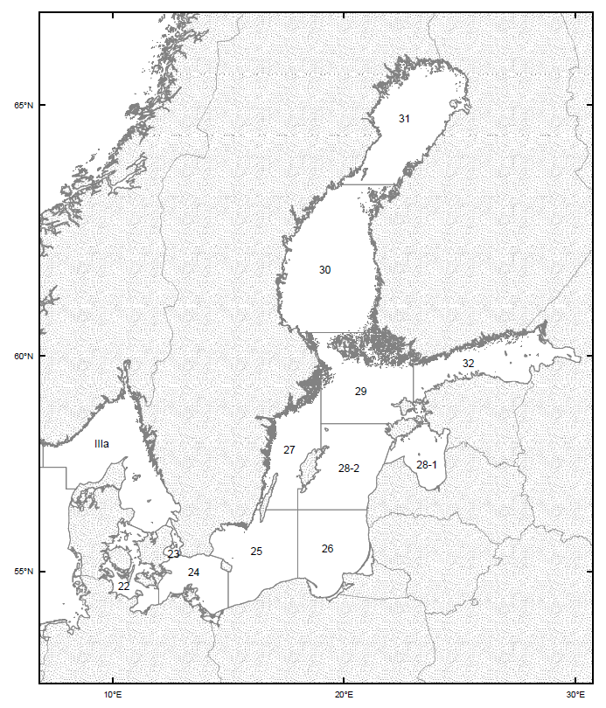
Figure 2.2.1. ICES Subdivisions in the Baltic
The main fisheries in the Baltic are for cod, herring and sprat. Cod in the Eastern Baltic (SD 25-32) and Western Baltic (SD 22-24) are considered to be two separate stocks. There are a number of different herring stocks in the Baltic, with the main stock being found in the sea's eastern basin (SD 25-29 and 32, excluding 28.1). There are smaller stocks in the Bothnian Sea (SD 30), the Bothnia Bay (SD 31) the Gulf of Riga (SD 28.1) and the Western Baltic (SD 22-24). The latter stock spawns in the western Baltic, then migrates into the Skagerrak (ICES Division IIIaN) and the Eastern North Sea in order to feed. There is one stock of sprat in the Baltic.
Every year ICES provides updated scientific advice on the state of fish stocks in European waters. The summary here is based on the advice published in 2014. For cod in the Eastern Baltic, ICES noted that significant changes taking place in stock biology. The growth of cod stocks above 30 cm has reduced considerably while no changes in growth are observed in fish below 30 cm. The Eastern cod stock tends to concentrate in subdivisions 25-26 and migrate to the subdivision of another cod stock, i.e. 24. For the Western Baltic cod stock, ICES identified that in the past the fishing mortality was underestimated and the spawning biomass – overestimated. This might have been caused by stock benchmarking as well as by changes observed in distribution of the Eastern cod stock causing uncertainties in data used for the assessment of the Western cod stock.
In 2013, the precautionary biomass level was defined for the central Baltic herring stock, and according to the latest scientific advice the spawning biomass is at above level of MSY, and fishing mortality is substantially lower than the MSY level. ICES advise that the Bothnian Sea herring stock is in a healthy state, with a high spawning stock and low fishing mortality. The spawning stock of herring in the Gulf of Riga is above the reference level, and fishing mortality has been reduced to MSY levels. The spawning biomass of western Baltic herring recovered in recent years to the reference level, while fishing mortality still remains above the MSY level. Fishing mortality on the Baltic sprat stock has been decreasing in recent years however it is still above the MSY level. The small herring stock in the Bothnian Bay is considered to be data-limited as there is not enough information to fully evaluate its status. This stock is not considered further here.
In summary, of the seven Baltic stocks considered here, only three herring stocks: Central Baltic, Gulf of Riga and Bothnian Sea are currently exploited at levels consistent with MSY.
A management plan has been in place for the two stocks of cod in the Baltic since 2007¹. The performance of this plan has been evaluated by STECF6. For the Eastern Baltic cod stock, STECF concluded that the management plan had been effective, as compliance with management rules had been improved meaning that catches had been reduced in line with the intended TACs, and fishing mortality had been reduced to below the target value. For the Western Baltic cod stock, the plan had not been effective as fishing mortality had not reached the target value, although this was partly a result of growth and reproduction by the stock being less than anticipated. STECF also noted that the current target fishing mortality for this stock is not compatible with achieving MSY. In the light of the most recent scientific advice for cod stocks, the rules of reduction fishing mortality as provided in the plan are considered no longer precautionary; however the targets of the plan as stated by ICES still remain precautionary.
The current cod management plan includes restrictions on annual fishing effort as a control measure. STECF concluded that these were not necessary provided that TACs were effective in limiting catches, although they suggested that it might be useful to include an option to limit fishing effort in case TACs did not prove to be effective in limiting fishing. The expert group also highlighted the need to address discards and recreational fisheries, and had discussed the use of the current technical measures.

2.3. Economic data and indicators
The following economic analysis was adapted from the STECF prospective evaluation¹¹ which used data from the 2011 and 2013 Annual Economic Reports on the EU Fishing Fleet. Vessels from Germany, Sweden and Denmark fish in both the North and Baltic Seas which makes it difficult to obtain cost information only for the Baltic. There have also been changes over time in how the data have been collected, which means that the data from different years are not always comparable. Reflecting these difficulties, only data on the economic performance of Baltic fleets over the period 2008–2009 have been used. In order to address these issues, in the 2013 Annual Economic Report estimates of the structure and economic performance of BS fleet segments were used. This new methodology, in turn, results in an analysis that cannot be included in the previous evaluation so the latest findings are added at the end of the section.
To simplify the task, analysis was limited to a subset of fleet segments where data were available and which are relatively important in terms of their catch volume or value. The representativeness of the selected fleets is presented in Figure 2.3.1. It can be seen that these selected fleets account for a relatively high proportion of the fishing effort and weight and value of the landings, and hence can be considered representative.

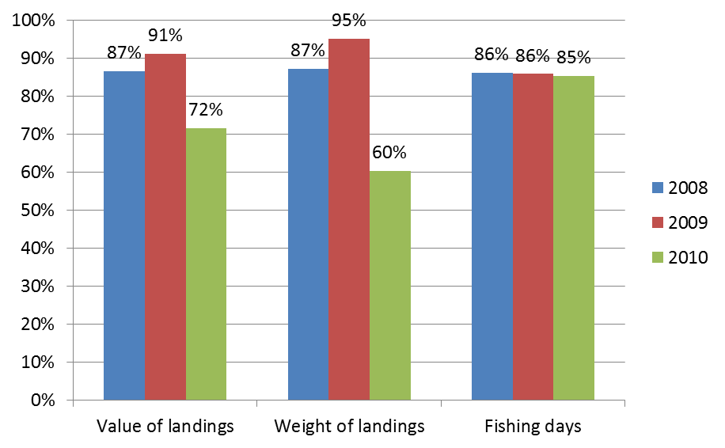
Figure 2.3.1. The representativeness of selected fleets for economic analysis compared with total Baltic Sea.

The coverage per species caught in the Baltic Sea by selected fleets varied, and is presented in Figure 2.3.2.

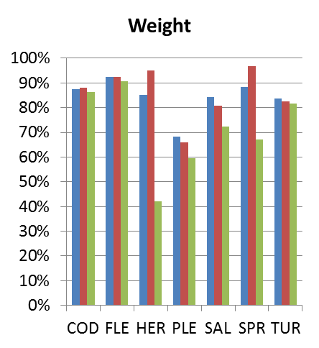
Figure 2.3.2. The economic analysis coverage per main species landed in the Baltic Sea. The species concerned are as follows: cod (COD), flounder (FLE), herring (HER), plaice (PLE), salmon (SAL), sprat (SPR) and turbot (TUR).

The dataset included a number of fleets operating in both Baltic and North Sea. To compile a pure Baltic Sea dataset, the economic data from these fleets were broken down based on the amount of fishing effort and the value of landings reported from each area.
In the analysis, the following fleet sectors were considered: fixed nets (DFN), Polyvalent Gears - coastal fishery (PG), Demersal trawlers (DTS) and Pelagic gears (TM).
The analysis shows high dependency of fixed netters as well as demersal trawlers on the cod catches, while coastal fisheries are more heterogeneous, targeting more diverse and valuable fish species (see Figure 2.3.3). The pelagic fishery mostly targets sprat and herring; however demersal fish species provide about 10% of value of landings. On the other hand, some demersal fleets catch some pelagic species, presumably during the closure of cod fishing seasons.

Figure 2.3.3. The composition of landings by species within selected fleet groups in the economic analysis. . The species concerned are as follows: cod (COD), flounder (FLE), herring (HER), plaice (PLE), salmon (SAL), sprat (SPR) and turbot (TUR).

According to the 2013 Annual Economic Report, in 2012 herring was landed in the biggest quantity (220 000 tonnes), followed by 177 000 tonnes sprat and 62 000 tonnes cod (Figure 2.3.4.) The highest value was generated by the cod landings (EUR 77 million), followed by herring (EUR 64 million), and then sprat (EUR 45 million). As a result of quota deductions of sprat from 2011 to 2012, its landed volume decreased by 26% but this only brought 11% decrease in value. As for the stocks of herring, the 5% decrease in volume brought 8% increase in value. The cod landings remained relatively stable during the same period. As it can be seen, reduction of fishing opportunities had positive effect on the price of those stocks. Smaller quantities on the market raised the value of the fish.

Figure 2.3.4. EU BS fleet volume and value of top 5 species landed: 2008-2012

2011 Annual Economic Report data: The Baltic Sea coastal fleet (see PG in Figure 2.3.5) represents about 69% of persons employed as well as 77% of vessels and 24% of kW of the selected fleets. They accounted for more than 50% of economic profit in 2009, while income and gross value added reached about 25% of the selected fleets. Profitability is highest in the fixed gear and inshore fleets, although the highest income is made by the pelagic fleet (Figure 2.3.4).
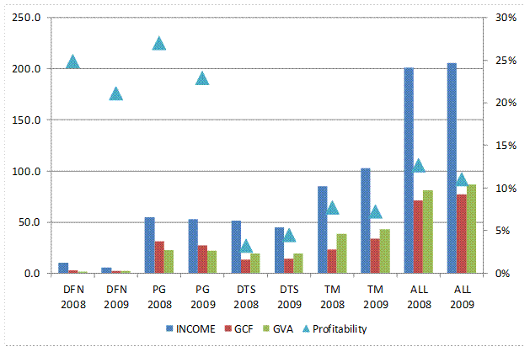
Figure 2.3.5. Economic performance of selected Baltic Sea fleets. Profitability is given as a percentage (right hand axis); all other indicators are given in million euros (left hand axis).
According to the 2013 Annual Economic Report in 2011 the main economic performance indicators at the following gear type levels was analysed: demersal trawls and seines (DT), pelagic trawls (TM) and passive gears (PGS) (see Figure 2.3.6.). While the most income was generated by the DT fleet of EUR 101 million, this was a 6% decrease from 2010. The EUR 67 million income of TM was a 5% increase from the previous year and the EUR 32 million income of PGS was a 6% decrease. Nevertheless, the profitability of the TM was the highest (10%), while DT had a -2% profitability.

 | Income (million EUR) | GVA(million EUR) | GVA per FTE (thousand EUR) | Profitability
DT | 101 | 45 | 49.2 | -2%
TM | 67 | 25 | 36.2 | 10%
PGS | 32 | 10 | 9.6 | -4%
Figure 2.3.6. Main economic performance indicators at gear type levels in the BS

Evaluation of changes in 2008-2009 (See Figure 2.3.7) shows an increase of gross value added and gross cash flow overall and in the trawl fishery, the labour productivity (value of landings per Full-time equivalent, FTE) grew as well. However capacity and overall employment in the Baltic Sea fishery decreased. The reduction of capacity through the decommissioning schemes and economic instruments, such as individual transferable quotas has been observed since 2005 in most of MS fishing in the Baltic Sea.
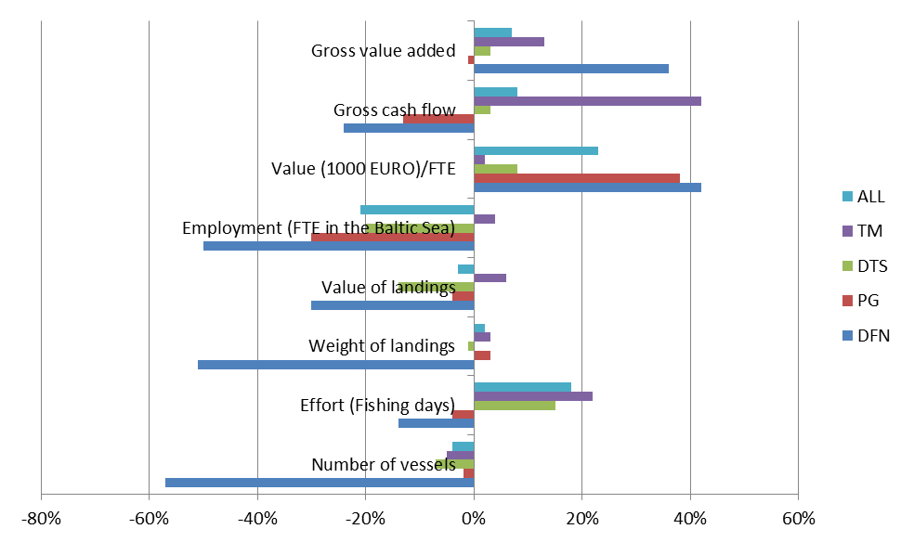
Figure 2.3.7. Changes in the performance indicators 2009 compared with 2008.

The economic performance of fleets is usually affected more by external factors, including fuel and fish prices, which are driven mostly by overall price levels and consumption. The changes in fuel prices are likely to affect the trawl fishery more than coastal or nets fishery (see Figure 2.3.8). The past experience shows a decrease of energy costs in the overall cost structure in 2009, which also affected economic profit. The overall deterioration of the economic situation in 2009 led to the decrease of crew costs in some segments.
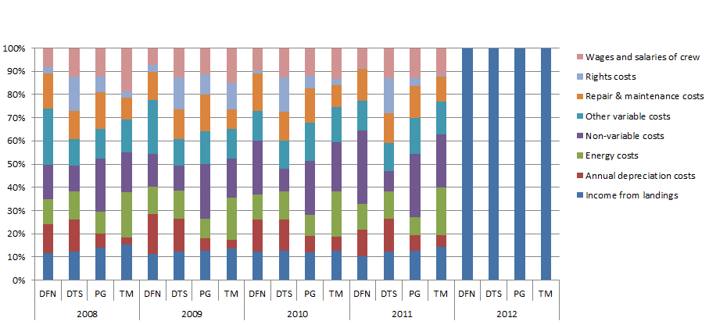
Figure. 2.3.8. Profitability and Costs structure of main Baltic Sea fleets (Costs structure for 2012 is not available).

2.4. Social indicators
The current situation for the selected Baltic fleet-segments can be described in terms of three social indicators:
engaged crew per vessel as an indicator of the level of employment provided by each segment (labour intensity),
engaged crew per full time equivalent as an indicator of the quality of the work (full time/part time)
value of landings per full time equivalent as an indicator of remuneration, given that in the Baltic the income of the crew is mainly based on crew share.
These indicators are shown for 2008-2011 in Figure 2.4.1, while the value of landings corresponds to income in Figure 2.3.5.
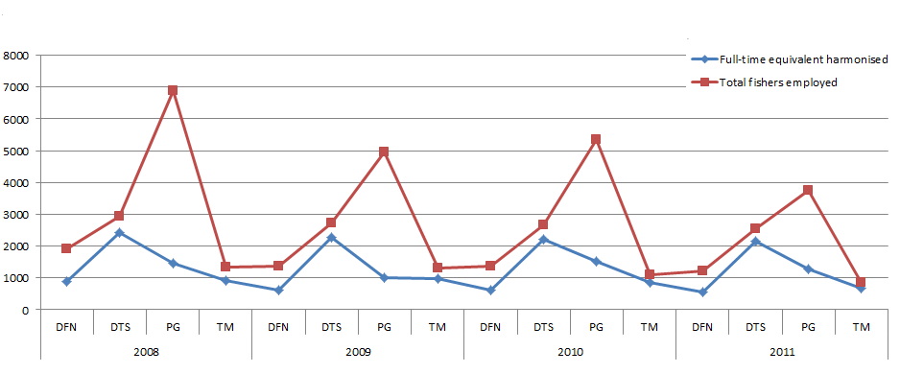
Figure. 2.4.1 Value of social indicators for main fleet segments, 2008-2011 (in numbers).

Over the two years for which data are available, the employment per vessel has increased in the netter segment and remained stable in the pelagic trawlers, but it has decreased both in the coastal fisheries segments and in the pelagic trawlers. The level of employment has thus increased or been maintained in the segments with the highest employment but it has decreased in those segments that had already a low level of employment per vessel. The value of the indicator for the coastal fisheries also reflect the fact that they are smaller vessels

2.5. The main problems
Based on the preceding descriptions, particularly Sections 2.1 and 2.2, there are two main problems with the current management regime:
- The fishing mortality consistent with MSY can often be substantially lower than the current fishing mortality on a given stock. This means that going to F_{MSY} can involve a relatively large reduction in TAC which MS and fishing industries can be reluctant to accept. This can lead to negotiations and "horse-trading" when it comes to setting the TACs each year. The TACs and quotas are based on yearly political agreements in the Council and there can be large fluctuations from year to year. This makes it very difficult to ensure that fishing mortality will be consistent with MSY by 2015. Moreover the unpredictability in the level of future fishing opportunities makes it difficult for the industry to plan ahead, risking additional adaptation costs.
- In some cases TACs have been exceeded so that catches have been much greater than intended. This has contributed to fishing mortality remaining above target values, and relatively low stock sizes, leading to reduced yields and income.

2.6. Underlying drivers
The main Baltic fish stocks are influenced by many different pressures, many of which are directly connected to human activities. However, the most important pressures are those related to fishing.

2.6.1. Fishing
As is the case for all wild fish stocks, fisheries in the Baltic Sea could lead to a race to exploit the resource, leading to overfishing and stock depletion. This results from a tendency to favour short-term economic gain over longer-term considerations, with fishers seeking to maximise their catch in a given year. For similar reasons, the negotiations over annual fishing opportunities tend to lead to TACs that are higher than would be required to acheive conservation objectives for the stock. As TACs are set in order to restrict the amount of fish caught from the stock, and thus limit fishing mortality, setting relatively high TACs which are still exceded, means that the effect of TAC management is limited, and fishing mortality tends to remain high.

2.6.2. Cod management plan
The existing cod management plan¹ means that the two cod stocks are already subject to relatively effective management, as is apparent from the reductions in fishing mortality on both stocks observed in recent years. The cod plan also has had some influence on the pelagic stocks. One impact has been that, because of the reduced cod quotas, a number of fishermen switched from targeting cod and started to target pelagic fisheries, increasing the fishing mortality of the pelagic stocks. A second impact has been that, because the cod recovery plan has been successful in rebuilding the cod stocks, there may be an increased level of predation on pelagic fish, especially sprat.

2.7. Who is affected, in what ways, and to what extent
The main effect that bringing all Baltic stocks of cod, herring and sprat under a plan would change the way annual TACs are determined for these stocks. This would have a direct impact on the relevant MS as it would restrict their abilities to negotiate the annual TACs each year. As each MS has a fixed share of the TAC for each stock, so the TAC influences how much quota they have for each stock. Depending on how MS choose to distribute these quotas across their national fishing fleets, there will also be an indirect impact on the catching and processing sectors.
While the effect on the catching and processing sectors will only be indirect, it is nonetheless useful to try and quantify the relative size of these sectors. The STECF Annual Economic Report on the EU fishing fleet1⁵gives some data on the size and nature of the Baltic Sea fishing fleet in 2009. Numbers of vessels and employment in the Baltic Sea fleet are given by country in Table 2.7.1 and by gear type in Table 2.7.2. Note that the data presented in Section 2.3 represent only a subset of these data, making it difficult to compare the two datasets. Note also, that for some countries these data include vessels which operate outside of the Baltic.

EU Member State | Fleet size (number of vessels) | Employment (FTEs)
Denmark | 498 | 1,191
Estonia | 937 | 1,872
Finland | 1,531 | 229
Germany | 1,223 | 997
Latvia | 814 | 480
Lithuania | 28 | 11
Poland | 763 | 1,307
Sweden | 1,115 | 941
Total | 6,909 | 7,027
Table 2.7.1, Numbers of vessels and employment in the EU Baltic Sea fleet in 2009 by Member State.

Gear type | Fleet size (number of vessels) | Employment (FTEs)
Pelagic trawl | 360 | 1,603
Demersal trawl/seine | 682 | 1,443
Passive gears | 4,651 | 2,930
Drift & fixed nets | 102 | 231
Passive & mobile gears (polyvalent) | 61 | 107
Passive polyvalent gears | 765 | 345
Gear using hooks | 37 | 82
Dredges | 34 | 22
Beam trawl | 217 | 264
Total | 6,909 | 7,027
Table 2.7.2, Numbers of vessels and employment in the EU Baltic Sea fleet in 2009 by gear type.

With regard to the processing sector in the Baltic, the most recent published information also dates from 2009. Figures for the numbers of enterprises and employment within the sector in each of the Baltic MS are given in Table 2.7.3. Again it should be noted that in some cases the enterprises concerned process fish caught in areas other than the Baltic.

 | Number of enterprises by size (No. of employees) |  |  |  |  | Employment  (FTEs)
No. of employees: | <= 10 | 11-49 | 50-249 | >=250 | total | Employment  (FTEs)
Denmark | 63 | 37 | 23 | - | 123 | 3,596
Estonia | 21 | 20 | 9 | 1 | 51 | 1,746
Finland | 125 | 9 | 3 | - | 137 | 742
Germany | 184 | 52 | 20 | 7 | 263 | 7,268
Latvia | 33 | 37 | 16 | 5 | 91 | 6,850
Lithuania | 3 | 12 | 15 | 5 | 35 | 3,995
Poland | 60 | 96 | 52 | 17 | 225 | 15,893
Sweden | 186 | 17 | 13 | 10 | 226 | 1,736
Total | 675 | 280 | 151 | 45 | 1,151 | 41,826
Table 2.7.3, Numbers of enterprises and employment in the processing sector of Baltic EU Member States in 2009.

2.8. How would the problem evolve, all things being equal?
Under the baseline scenario, TACs for the two Baltic cod stocks would continue to be set according to the existing management plan, and TACs for the sprat and herring stocks would continue to be set on an ad hoc, annual basis. By nature it is very difficult to predict how the fish stocks are likely to develop under any management scenario as the populations will be highly influenced by natural variation in the number of young fish entering the population each year (known as recruitment) and growth. With that caveat, some comments about the possible stock developments are given below.
The Eastern Baltic cod stock is currently exposed to the reduced growth most likely caused by environmental factors. The further application of the management plan will unlikely improve the situation, as according to scientists, additional measures are needed. Under the current plan, the fishing mortality on the Western cod stock is likely to remain close to the target level of 0.6. However, this target is not considered to be consistent with MSY. Hence it is likely that the current plan will maintain fishing mortality on the Western cod stock above sustainable levels, although the plan does allow for the target values to be revised.
It is particularly difficult to predict how the stocks of herring and sprat are likely to develop under the baseline scenario. Not only are they subject to natural variation in growth and recruitment, there are also no rules in place to establish TACs each year. As a result, the TAC which will apply to each stock is effectively unpredictable. It is possible that the annual negotiation process which currently determines TACs for these stocks may lead to TACs which will be consistent with MSY, but there is no guarantee that this will be the case, and similarly, there is no guarantee that stocks will be maintained at MSY once this is achieved. In short, for the pelagic stocks, the baseline scenario will lead to greater variability in catches and stocks, greater uncertainty in whether objectives will be achieved and less predictability and ability to plan for the fishing industry.

3. Legal frameworks
A number of legal and safe regulated frameworks influence management of the main Baltic fish stocks

3.1.1. The Common Fisheries Policy
The scope of the CFP is defined by Annex I to the Treaty. It covers fisheries products, irrespective of whether they stem from marine or fresh water. While in general the European Parliament and the Council jointly adopt fisheries legislation, pursuant to Article 43(3) the fixing and allocation of fishing opportuinities is the task of the Council. Accordingly, the multiannual plans adopted by the co-legislators are limited in this aspect.
Regulation 1380/2013 sets out the legal framework for the CFP and limits it to conservation, of ‘marine biological resources’. This basic regulation provides for the possibilty to adopt multiannual plans as a priorty, to restore and maintain fish stocks above levels capable of producing MSY (Article 9). It also states that "Multi-annual plans should, where possible, cover multiple stocks where those stocks are jointly exploited". Such plans will also be more consistent with the ecosystem approach to fishery management.

3.1.2. Baltic TAC and quota
The two Baltic cod stocks are currently the subject of a management plan which includes rules for setting annual TACs. The plan also includes restrictions on fishing effort and there are also technical measures in place for cod. The pelagic stocks are currently subject to annual TACs and quotas and technical measures, but there is no management plan. Scientific advice on annual catch limitations is given by stock, whereas the TACs are set according to management areas. This can cause some complications when the stocks overlap in certain management areas, particularly for herring stocks, because the TAC will cover the catches of more than one stock. The distribution of each of the main stocks compared with the respective TAC areas is described below.
Annual TACs and effort allocations for the fisheries on cod in the Western and Eastern Baltic are set according to the rules specified in the management planError: Reference source not found. There are some indications that, following the recovery of the Eastern stock, fish from that stock are now occurring in the eastern part of Sub-division 24, i.e. the distribution area of the Western stock
The Western Baltic herring stock moves between the Western Baltic (SD 22-24) and the Skagerrak-Kattegat (ICES Division IIIa) where it mixes with another stock, the North Sea autumn spawning herring. Since the catches in the Skagerrak are a mixture of Baltic and North Sea stocks, and the North Sea stock is shared with Norway, the TAC for IIIa must be jointly agreed with Norway. The stock of herring in the Gulf of Riga (SD 28.1) is regarded as separate from the Central Baltic stock. There is some movement of fish between the two areas which is accounted for when the TACs are set.

3.1.3. Technical measures
Technical measures for fisheries exploiting stocks in the Baltic Sea are contained in the technical measures regulation for the Baltic Sea and consist of gear specifications, minimum percentages of target species and by-catch limitations by mesh size and area. In addition the management plan for Baltic cod1 specifies seasonal closures for the two stocks, and the annual TAC and quota regulation for the Baltic Sea specifies landing limitations for unsorted catches of herring and sprat.

3.1.4. Control measures
The control provisions related to the CFP in the EU are set out in a specific Council regulation, with another regulation giving specific implementing rules. The control system set up by these regulations include rules governing access to waters and resources, control of the use of fishing opportunities from the net to plate, fleet management, technical measures and recreational fisheries. The regulations also cover the conduct of monitoring, control and surveillance activities by MS and the Commission. Financial measures and deduction and transfer of fishing opportunities further contribute to compliance. In addition to the general rules, the control regulationError: Reference source not found also establishes certain provisions applicable to multiannual plans. Nevertheless, it is recognised that different measures may be necessary and appropriate in the context of a specific multiannual plan.
Accordingly, certain area-specific control measures are established and maintained for the Baltic Sea cod fisheries in the managemnt plan regulationError: Reference source not found. Such rules are the obligation to keep a logbook for vessels of 8m overall length and more, single area fishing limitation, modified prior notification obligation. The general provisions on fishing authorisation and designated ports laid down in the control regulationError: Reference source not found.

3.2. Legal basis for the EU to act
The proposal falls in a field of EU exclusive competence as laid down in Article 3.1(d) of the Treaty on the Functioning of the European Union¹⁷, which states:
“1. The Union shall have exclusive competence in the following areas: (…)
(d) the conservation of marine biological resources under the common fisheries policy;(…)”
Given the exclusive EU competence for this legal instrument, the principle of subsidiarity does not apply in this case.
The CFP's basic regulation¹⁸ provides further legal base for the establishment of management plans for fisheries exploiting stocks within safe biological limits (Article 6).

4. Objectives

4.1. General objectives
The general objective for the EU and its MS as regards Baltic stocks is to ensure that the conservation status of all the Baltic stocks is favourable and within safe biological limits in order to provide for an environmentally sustainable fishery in the long-term and is 'managed in away that is consistent with the objectives of achieving economic, social and employment benefits, and of contribiting to the availability of food suppy'., and by applying the precautionary approach the to esnure that the exploitation levels are in line with MSY, as stated in Article 2 of the basic regulation.
The aim of the proposal is to ensure sustainable exploitation of stocks at levels that will deliver the highest possible long term yields with a low probability that the stocks will move outside of safe precautionary levels. In particular, the aim of the proposed plan will be to achieve levels of fishing mortality that are consistent with F_{MSY} by 2015.with reference points for these approaches specified for each stock within the plan. Any plans will also make allowance for stability of catches, and will be required to specify clear time frames for achieving conservation objectives. Plans should also include measures for eliminating unwanted catches and for minimising the impacts of fishing on the ecosystem.
In relation to capture fisheries, the EU's Common Fisheries Policy lists a number of socio-economic objectives, such as:
provide conditions for efficient fishing activities within an economically viable and competitive fishing industry;
contribute to a fair standard of living for those who depend on fishing activities;
take into account the interests of consumers;
The new CFP has introduced the general objective of integrating the requirements of EU environmental legislation. This is a reference to the Marine Strategy Framework Directive (MSFD) which specifies a number of objectives associated with achieving the overall goal of 'Good Environmental Status' (GES). The three descriptors of GES most relevant to the management of fisheries are the following:
Descriptor 1: maintaining biological diversity.
Descriptor 2: maintaining exploited populations within safe biological limits and with a healthy age-distribution
Descriptor 4: maintaining all elements of marine food webs at normal abundance.

4.2. Specific objectives
For each fish stock to be covered by the proposed management plan, the specific objectives will be specified in terms of a minimum spawning stock biomass and a target fishing mortality. To be consistent with the precautionary approach, management will aim to keep the stock above its minimum level where this is specified. The target fishing mortalities will be specified in order to maximise long-term, average yield from the stock, hence management will aim to keep fishing mortality on each stock close to its target level in order to be consistent with the MSY approach. In the short-term, management will also be intended to achieve these target fishing mortalities by 2015.
The minimum biomass levels and target fishing mortalities to be used will be specified for each stock within the proposed management plan. The values to be used will depend on the policy option selected.
With regard to the three descriptors of GES, of relevance to fisheries management, there is some overlap between their requirements and those of the precautionary and MSY approaches. In particular, the requirements of Descriptor 3 should be met to a large extent through the implementation of the precautionary approach (to maintain stocks within safe biological limits) and the MSY approach (which will normally imply a low fishing mortality and thus also a healthy age distribution). Descriptor 4 applies more to multiple stocks, so would require that the stocks of cod, herring and sprat considered here are all maintained above their minimum biomass levels, so that there can be no consideration of, for instance, fishing down cod in order to make more sprat available for commercial fisheries. This would follow from a combination of the precautionary approach, and MSY targets which account for the multi-species interactions. It is not immediately clear what management requirements Descriptor 1 would impose (if any) over and above the requirements of Descriptors 3 and 4.

5. Policy options
The three options considered here are the existing management regime and two candidate approaches to establishing management plans.
The scientific analyses undertaken to support the impact assessment were extensive and involved the use of a multi-species model to model the interactions between the Eastern Baltic cod stock, the sprat stock and the Central Baltic herring stock. Other stocks were subject to single-species evaluations. Full details of these, and the other analyses are given in the report of the STECF expert group on multi-species management plans for the Baltic¹¹.
A key parameter within a management plan is the target fishing mortality as this is closely linked to the major objective of the plan. If the objective is to achieve MSY, then a target fishing mortality will be one which has been shown by scientific analysis to be consistent with achieving that objective. In practice, that means a fishing mortality that would have a high probability of maximising long-term yield from the stock with minimum risk of the stock falling to a low level. As stocks will show natural variation in aspects like growth and recruitment, the analysis will normally identify a range of values for fishing mortality that are consistent with achieving MSY. For the stocks considered here, the analyses indicated that a relatively broad range of target fishing mortalities would be consistent with MSY. In part, this results from the biological interactions between the main stocks of cod, herring and sprat. Some aspects of the analyses indicated that higher fishing mortalities could lead to MSY because of these interactions. However, the scientists indicated that more work was needed to fully understand these biological interactions and thus to evaluate the risks associated with fishing at these higher levels.
Given the results of the scientific analyses, two sets of target fishing mortality values were selected to be carried forward into the impact analysis. The sets differed only in the target fishing mortalities used for the stocks where the biological interactions have been considered, i.e. Eastern Baltic cod, Central Baltic herring and Baltic sprat. One set (approach A) involves relatively low fishing mortalities, close to existing single species values, while the second set (approach B) involves slightly higher fishing mortalities, which can be considered as more consistent with a multi-species approach. The two approaches are explained in more detail below. In both cases, options 2 and 3 should be considered as initial approaches to management plans, rather than specific plans in themselves. This reflects the clear requirement from BSRAC that the plan should be adaptive so that aspects of the plan can be changed in the light of improved scientific understanding or changing environmental conditions.
As noted in Section 2.7, the direct impacts of the introduction of a management plan will be on Member States. There will then be an indirect impact on the national catching and processing sectors depending on how MS allocate their quota shares to their national fleets. In order to give an indication of the possible economic impacts of the different scenarios, projections were run using a fleet-disaggregated bio-economic model. This required the strong assumption that MS will continue to allocate quota shares in the same way as they have previously. Given the need to make this assumption, as well as difficulties in e.g. predicting fish prices and vessel costs, the results of the projections should only be taken as a broad indication of the relative changes that may occur under each scenario. In addition, the natural variation in stock size due to e.g. variation in growth and recruitment, is forecast to have a greater impact on catches and incomes than the management scenario assumed. Again, this means that the results of the projections can only be used to give relative comparisons. Full details of the models used and the projections run are given in the STECF report on Multi-species models for the Baltic¹¹.

5.1. Option 1- Continuation of existing management plan for cod, no management plan for herring or sprat.
The first option is Status quo, i.e. remaining with the current management plan for the two Baltic cod stocks, and TACs for the pelagic stocks based on annual scientific advice and negotiations with MS.

5.2. Option 2- Cod, herring and sprat stocks under management plan approach A.
This option brings all of the relevant stocks into management plans such that the annual TAC for each stock is derived from a harvest control rule based on a target fishing mortality and associated biomass trigger values. The fishing mortality targets used are given in the Table 4.2.1 below. In the case of the Eastern Baltic cod stock, the sprat stock and the Central Baltic herring stock, the impacts of the target fishing mortalities were evaluated taking into account the interactions between these three stocks. For this approach, target values for these stocks have been selected from the lower end of the ranges that are consistent with achieving MSY. All other stocks were evaluated individually, and the target fishing mortalities used for these are taken from the most recent scientific advice for each stock. In most cases the values came from ICES advice, but in the case of Western Baltic cod⁷ and Gulf of Riga Herring¹¹, the values were based on more recent analyses by STECF.

Stock | Target fishing mortality
Eastern Baltic Cod | 0.30
Western Baltic Cod | 0.33
Central Baltic Herring | 0.16
Western Baltic Herring | 0.25
Gulf of Riga Herring | 0.30
Bothnian Sea herring | 0.16
Baltic Sprat | 0.35
Table 5.2.1: Target fishing mortalities assumed in Option 2, Manangement plan approach A.

5.3. Option 3- Cod, herring and sprat stocks under management plan approach B.
As with option 2, this option would bring all of the relevant stocks under management plans so that their annual TACs are determined by harvest control rules. Some results from the multi-species evaluations used to investigate possible fishing mortality targets for Eastern Baltic cod, sprat and central Baltic herring suggested that it might be possible to set higher target fishing mortalities for these stocks as a result of the interactions between them. This option takes these results in order to illustrate the impacts of applying higher target fishing mortalities for these stocks. The values used are given in Table 4.2.2 below.

Stock | Target fishing mortality
Eastern Baltic Cod | 0.45
Western Baltic Cod | 0.33
Central Baltic Herring | 0.26
Western Baltic Herring | 0.25
Gulf of Riga Herring | 0.30
Bothnian Sea herring | 0.16
Baltic Sprat | 0.40
Table 5.2.2: Target fishing mortalities assumed in Option 3, Manangement plan approach B.

6. Analysis of impacts
The analyses of the impacts of the three options considered here are based on advice from STECF¹¹. Natural variations in the abundance and productivity of the stocks, particularly the Eastern Baltic cod stock, will have quite a large impact on potential revenue from the fishery. Viewed against this background, the impacts of other aspects of the options are relatively small.

6.1. Economic impact and impact on fisheries management

6.1.1. Option 1 - Continuation of existing management plan for cod, no management plan for herring or sprat.
For the pelagic stocks, option 1 reflects the current situation where the Commission proposes the Total Allowable Catch (TAC) and associated technical measures as today. The management does not provide the sector with predictability of catches which makes it harder for the sector to adapt its strategies to ensure profitability. The lack of management objectives creates a situation where the basis for giving scientific advice is left uncertain, and it is difficult to ensure we will respect our international commitment to achieve MSY by 2015. In addition, partly as a result of the existing cod management plan, the Eastern Baltic cod stock is currently at a high level and is subject to a low fishing mortality. Under these circumstances, predation by cod on the pelagic species could have an adverse impact on the yield of pelagic species that could otherwise have been taken by the fishery.
The management plan for cod introduced fishing effort system as an additional measure ensuring the proper stock conservation when misreportintg of catches was a persistent problem. The misreporting has been considerably reduced and according to scientists the effort system has become redundant. Thereofre the further application of fishing effort regime will cause human and financial resources being used innefectivelly in MS countries.
The requirement to fish in one area introduced in the management plan does not serve the intended purpose to have more precise catch data from diferent areas and avoid area misreporting because now cod concentrates only in one area. Thereofre the continued control of catche on the basis of area division will also contribute to human and financial resources being used innefectivelly in MS countries. Also this would continue to provide for less smart regulatory framework for the industry.
The prior-notification of 4 hours before arrival to port is disproportionate as has been demonstrated in practice and confirmed by the inspection services of the Commisison. The time is too long as the fishing grounds in the Baltic sea are nearer to the ports of landing. Such requirement is hardly implementable and creates unnecessary burden for catching sector.

6.1.2. Option 2 - Cod, herring and sprat stocks under management plan approach A.
The main change between Option 1 and Option 2 would be to bring the herring and sprat stocks under a management plan. This would provide a systematic basis for setting annual TACs in a way which would provide the pelalgic sector with predictability of catches which would help support business planning, as well as helping to ensure that the international commitment to achieve MSY by 2015 is met. Bringing the pelagic stocks under a management plan would also add value, as management plans are usually a prerequisite for a fishery to obtain certification from, for example, the Marine Stewardship Council (MSC). Fish caught in such certified fisheries can then attract a higher price in the market.
For the processing industry, stability of supply is an important issue. This is generally associated with lower fishing mortalities which lead to more stable stock sizes. As a result, stability of supply is more likely to be assured with this option than with option 3, although the differences will be small. Stable suply of fish products will lead to more predictable income, businissess wil be able to plan their acitiviteis better and reduce their costs for storage of fisheries products.
The administrative burden on Member States is reduced due to abolishment of fishing effort regime and of the catch monitoring at area level. The shortening of the time period during which the prior-notification of arival is to be submitted will lead to the rules being more enforcable and implementable.

6.1.3. Option 3 - Cod, herring and sprat stocks under management plan approach B.
As with option 2, this option would provide the benefits of predictability of catches, defined management objectives and added value through the possibility of certification that should result from implementing a management plan. The only difference between this option and option 2 comes from the slightly higher fishing mortality targets used for Eastern Baltic cod, Central Baltic herring and Baltic sprat. From the evaluations done using these values, the main differences are that the initial catch of cod will be higher (although the long term catch will be similar) and that catches of herring will be slightly higher.

6.2. Environmental impact

6.2.1. Option 1 - Continuation of existing management plan for cod, no management plan for herring or sprat.
The continuation of the current management regime would lead, in the short-term at least, to an ecosystem with a relatively high abundance of cod relative to sprat and herring. This would involve increased risk to the latter stocks, both through increase predation by cod, and through over-fishing due to less effective management. The reduction in population size of the pelagic species would also lead to increased abundance of their zooplankton prey, so there would be reduced risk of algal blooms as the zooplankton would consume more of the algae. At current high abundances, there are indications that cod are in relatively poor condition due to lack of food.

6.2.2. Option 2 - Cod, herring and sprat stocks under management plan approach A.
The introduction of a management plan covering the stocks of cod, herring and sprat would affect the ecosystem mainly through the quantities of each of these stocks removed by fishing. These quantities would be determined by the target fishing mortalities for each stock and the associated harvest rules. The quantity removed from each stock would also have implications for the relative abundance of the stock withn the Baltic ecosystem. The introduction of a management plan may also lead to a reduction in the overall amount of fishing, which would also imply a reduction in emissions from vessel engines.
Aside, from the general impacts associated with introducing a management plan, the environmental impacts of option 2 would be broadly similar to those of option 1 except the risks to the herring and sprat stocks would be reduced through more effective management of both these and the cod stock.

6.2.3. Option 3 - Cod, herring and sprat stocks under management plan approach B.
The general impacts of introducing a management plan are as described under option 2.
A situation of higher fishing mortality on cod could lead to higher biomasses of herring and sprat. This in turn could lead to increased competition for food, leading to slower growth among these species. There will also be increased consumption of zooplankton, leading to a higher risk of algal blooms and eutrophication. There is also a link between high sprat biomass and the increased incidence of M74 mortality syndrome in Baltic salmon.
The possibility that a higher target fishing mortality might be appropriate for Eastern Baltic cod arises from the fact that in some cases large cod prey on smaller cod, so increased fishing mortality is compensated by decreased cannibalism as more large cod are removed by fishing. However, this is poorly understood, and the scientific basis is weak at present, hence selecting a higher target fishing mortality for cod carries additional risks due to these uncertainties. Similar concerns arise for herring and sprat where the possibility of higher fishing mortalities depend on assumptions about density-dependent growth. This is thought to occur as the zooplankton food supply available to these stocks is limited, so the fish grow relatively slowly. By removing more herring and sprat, the remaining fish are left with more food so are able to grow faster to compensate for those fish removed by fishing. Again, this process is relatively poorly understood, so basing management on the assumption that this effect occurs again carries additional risks.

6.3. Social impact

6.3.1. Option 1 - Continuation of existing management plan for cod, no management plan for herring or sprat.
The available employment data suggest that the inshore fisheries around the Baltic are the most important in employment terms, represents about 69% of persons employed as well as 77% of vessels These are mostly dependent on species other than those considered here (see Figure 2.3.3) so the impact on employment is likely to be negligible. If the existing cod management plan was maintained and allocations of fishing effort became more restrictive, it is possible that vessels might compensate by taking more crew to sea in order to fish more intensively while at sea. This could lead to a small increase in employment, but in view of current healthy state of the Eastern Baltic cod stock, further effort reductions are unlikely in the short-term.
Under the current management regime, all vessels above 8m in length are obliged to report details of their catch, gear used etc. using logbooks for all fishing tripsError: Reference source not found.

6.3.2. Option 2 - Cod, herring and sprat stocks under management plan approach A.
As for option 1, impacts on employment are likely to be negligible although it is possible that the increased stability of catches resulting from bringing the pelagic stocks under a management plan, could have a beneficial impact on employment. No change in reporting obligations is anticipated.

6.3.3. Option 3 - Cod, herring and sprat stocks under management plan approach B.
As for option 1, impacts on employment are likely to be negligible although it is possible that the increased stability of catches resulting from bringing the pelagic stocks under a management plan, could have a beneficial impact on employment. No change in reporting obligations is anticipated.

6.4. Summary
Table 6.4.1 summarises the impacts of the three different options.

 | Option 1: No change | Option 2: Management plan A (lower Fs)) | Option 3: Management plan B, (higher Fs)
Environmental | Initial loss of yield of pelagics due to cod predation; low probability of achieving MSY by 2015 for some pelagic stocks | Consistent with EU/WSSD objectives | Greater risk of eutrophication due to high biomass of planktivores. Also M74 in salmon. Greater risk to cod stock if understanding of cannibalism incorrect. Similarly sprat stock & density dependence. Risk of higher discards of cod.  Consistent with EU/WSSD objectives
Economic: fleet | General reduction in gross value added, largely due to expected deline of cod stock form current large size. | As option 1, plus existence of a management plan for pelagic stocks adds value through allowing possibility of e.g. MSC certification | Existence of a management plan for pelagic stocks adds value through allowing possibility of e.g. MSC certification  Compared to option 2, Higher gross value added for some demersal fleets. Initial yield of cod higher, but long-term yield similar.Higher yields of herring.
Economic: processing | Variable and less predictable catches of pelagic species. | Greater predictability and stability of catches from pelagic species | Greater predictability of catches from pelagic species, though with greater variabilit of stock sizes.
Social: fleet employment | Inshore fleet is most important for employment in the Baltic, and this is not dependent upon the stocks considered here, hence any impact will be minor. | As option 1, plus possibility of increased opportunity due to increased stability of pelagic catches. | As option 1, plus possibility of increased opportunity due to increased stability of pelagic catches.
Table 6.4.1: Social, economic and environmental impact of the three different policy options

7. Comparing the options
There are clear advantages to bringing all of the relevant stocks into a management plan through the stability and predictability it would bring to catches and the increased probability of achieving the international obligation to achieve MSY by 2015. Thus, for reasons of effectiveness, options 2 and 3 are favoured over option 1. Similarly, bringing more stocks under management plans is also in line with CFP objectives, hence on grounds of coherence, options 2 and 3 are again favoured over option 1. There are no differences in resource implications between the three scenarios, so there is no basis for choosing between them on efficiency grounds.
These two options (2 and 3) were discussed with BSRAC and MS in June 2012. There was reasonable agreement between the views of MS and those of BSRAC. In both cases there was agreement that the single-species MSY targets would make a sensible starting point for a Baltic plan, provided that the scientific work could be continued in order to adapt the plan in the light of improved understanding and changing conditions. In neither case was it considered urgent to develop a plan immediately, in fact in both cases the parties expressed a preference for further consultation instead of urgent plan development. MS stressed the importance of ensuring stability by reducing year to year changes in TAC.
To compare the two management plan options, option 2 is based on single species target values, and as a result cannot really be considered to be a multi-species management plan as it does not fully address the biological interactions between the different species. However, it could be considered as the starting point for a management plan, if the targets can be adapted in the light of improved scientific understanding. In contrast, option 3 does address the biological interactions, but there is clear scientific advice that the risks with taking this approach are not yet fully understood and would need more scientific work to evaluate them. In consultation, both member states and BSRAC expressed a preference for option 2, using the single species targets as a starting point, then adapting the plan as scientific understanding improved.
In terms of their relative impacts, the differences between the two options are relatively small, although there may be a small increase in the risk of adverse environmental impacts with option 3.
Overall, On the basis of effectiveness and coherence, there are clear grounds for choosing either option 2 or option 3. However, neither these considerations nor the relative impacts give any basis for choosing between these two options. In contrast, the consultation with stakeholders and member states gave clear support for option 2 over option 3, so option 2 is the preferred option.

8. Monitoring and evaluation
Any management plan must have means to ensure the implementation of the mandatory aspects and fulfilment of the objectives. The core indicators for evaluating achievement of the objectives of the management plan for Baltic stocks are:
- catch data (both industrial and non industrial);
- sampling programs of industrial landings
- indices of stock abundance conducted by research vessels.
The indicators should be monitored by Member States and Regional Advisory Councils in order to detect any deficiencies in operation of the plan. These indicators will also contribute to ICES scientific advice on the state of the relevant stocks, which will provide an important source of information for monitoring the effectiveness of the plan. The collection of these indicators is supported by the EU's Data Collection Framework.
The management plan will be subject to review under the process outlined in Section 1.2 and will be linked to the stock benchmarking exercises conducted by ICES.
In view of the strong influence that environmental conditions can have on Baltic stocks, and also to account for any improvements in the scientific understanding of the stocks their interactions, and other aspects of the Baltic ecosystem, there will be a need to keep the targets and conservation reference points for these stocks under review in order that they can be modified where scientific advice indicates that this may be appropriate, or when significant changes in environmental conditions merit it.

Regulation (EU) No 1380/2013 of the European Parliament and of the Council of 11 December 2013 on the Common Fisheries Policy, amending Council Regulations (EC) No 1954/2003 and (EC) No 1224/2009 and repealing Council Regulations (EC) No 2371/2002 and (EC) No 639/2004 and Council Decision 2004/585/EC (OJ L 354, 28/12/2013, p. 22–61)
http://www.europarl.europa.eu/meetdocs/2009_2014/documents/pech/dv/taskfor/taskforce.pdf
Council Regulation (EC) No 1098/2007 of 18 September 2007 establishing a multiannual plan for the cod stocks in the Baltic Sea and the fisheries exploiting those stocks, amending Regulation (EEC) No 2847/93 and repealing Regulation (EC) No 779/97 (OJ L 248, 22.9.2007)
Commission Decision of 26 August 2005 establishing a Scientific, Technical and Economic Committee for Fisheries (2005/629/EC)
http://www.ices.dk/aboutus/aboutus.asp
Council Decision of 19 July 2004 establishing Regional Advisory Councils under the Common Fisheries Policy (2004/585/EC)
In accordance with Article 43 of Regulation 1380/2013 the Regional Advisory Councils are replaced by Advisory Councils applicable from 1 January 2014. Accordingly, when reference is made this Council prior to 2014, the term Regional (R) is added.
MRAG, September 2009: Economic and social impacts of the proposed scenarios for a multi-annual management plan for Baltic pelagic fisheries, FISH/2006/09 — Lot 4.
Report of the Sub Group on Management Objectives and Strategies (STECF SGMOS 10-06). Part e) Evaluation of multi-annual plan for Baltic cod
Report of the STECF expert group meeting on: Impact Assessment of Baltic cod multi-annual plans (STECF 11-05)
Council of The European Union, document 16684/11 ADD 1, http://register.consilium.europa.eu/pdf/en/11/st16/st16684-ad01.en11.pdf
Report of the STECF expert group meeting on: Scoping for Impact Assessments for Multi-Annual plans for Baltic Multispecies and cod in the Kattegat, North Sea, West of Scotland and Irish Sea. (STECF-12-05)
Report of the Workshop on Integrated/Multispecies Advice for Baltic Fisheries (WKMULTBAL) 6–8 March 2012, Charlottenlund, Denmark. ICES CM 2012/ACOM:43
Report of the STECF expert group meeting on: Multispecies management plans for the Baltic (STECF-12-06)
http://www.un-documents.net/jburgpln.htm
Council Regulation (EC) No 338/2008 of 14 April 2008 providing for the adaptation of cod fishing quotas to be allocated to Poland in the Baltic Sea (Subdivisions 25-32, EC Waters) from 2008 to 2011.
Report of the ICES Advisory Committee, 2014, ICES Advice, 2014, Book 8
The 2011 Annual Economic Report on the EU Fishing Fleet (STECF-11-16); The 2013 Annual Economic Report on the EU Fishing Fleet (STECF-13-15) http://stecf.jrc.ec.europa.eu/documents/43805/581354/2013-09_STECF+13-15+-+AER+EU+Fleet+2013_JRC84745.pdf,
It must be noted that Estonia failed to provide any related data for 2011 and is therefore excluded from the analysis.
Figure 7.2 on Page 234 of the 2013 Annual Economic Report
Report of the STECF Expert Group on: Economic Performance of the EU Fish Processing Industry Sector (STECF-OWP-12-01)
The Treaty on the functioning of the European Union
Council Regulation (EC) No 2187/2005 of 21 December 2005 for the conservation of fishery resources through technical measures in the Baltic Sea, the Belts and the Sound, amending Regulation (EC) No 1434/98 and repealing Regulation (EC) No 88/98 (OJ L 349, 31.12.2005)
For 2014: Council Regulation (EU) No 1180/2013 of 19 November 2013 fixing for 2014 the fishing opportunities for certain fish stocks and groups of fish stocks applicable in the Baltic Sea (OJ L 313, 22/11/2013, p. 4–12)
Council Regulation (EC) No 1224/2009 of 20 November 2009 establishing a Community control system for ensuring compliance with the rules of the common fisheries policy, amending Regulations (EC) No 847/96, (EC) No 2371/2002, (EC) No 811/2004, (EC) No 768/2005, (EC) No 2115/2005, (EC) No 2166/2005, (EC) No 388/2006, (EC) No 509/2007, (EC) No 676/2007, (EC) No 1098/2007, (EC) No 1300/2008, (EC) No 1342/2008 and repealing Regulations (EEC) No 2847/93, (EC) No 1627/94 and (EC) No 1966/2006 (OJ L 343, 22.12.2009)
Commission Regulation Commission Implementing Regulation (EU) No 404/2011 of 8 April 2011 laying down detailed rules for the implementation of Council Regulation (EC) No 1224/2009 establishing a Community control system for ensuring compliance with the rules of the Common Fisheries Policy (OJ L 112, 30.4.2011)
Directive 2008/56/EC of the European Parliament and of the Council
http://www.ices.dk/committe/acom/comwork/report/asp/advice.asp?titlesearch=&Region=30&Species=-1&Period=316&submit1=Submit+Query&mode=2
Commission Decision of 18 December 2009 adopting a multiannual Community programme for the collection, management and use of data in the fisheries sector for the period 2011-2013 (notified under document C(2009) 10121) (2010/93/EU)

