1. Introduction

Regulation (EU) 994/2010 was adopted following the 2009 gas crisis. It repealed and replaced Directive 2004/67/EC on measures to safeguard security of natural gas supply.
The lessons learnt from the implementation of Directive 2004/67/EC had shown that it was necessary to harmonize national measures in order to ensure that all Member States are prepared at least on a common minimum level. It was felt that, if all Member States were to comply with minimum standards, this would enhance solidarity between them in case of crisis, since no one could be seen "to take a free ride" on the efforts made by others. At the same time, the legislator considered that excessive protection of own gas consumers in some Member States could leave consumers in other Member States more exposed and/or could disproportionally restrict trade.
Against this background, Regulation 994/2010 aims to ensure that each Member State puts in place appropriate tools to prepare for and to manage the effects of a gas shortage caused by either a supply disruption or exceptionally high demand. The responsibility for security of gas supply is defined by a three-tier approach. Natural gas undertakings, based on market mechanisms, are primarily responsible to ensure gas supplies. In case the market mechanisms fail to deliver gas in a country, Member State measures kick in to ensure gas to protected customers. The European Commission provides general coordination and ensures the consistency of national measures.
Four years after the adoption of Regulation 994/2010, the issue of security of gas supply is very relevant again in light of the tensions between Ukraine and Russia. Efforts are made at national and European level to enhance the security of gas supplies for the winter of 2014/2015 and beyond.
The present report is prepared in line with the obligation on the Commission in Article 14 of the Regulation. It is aimed at feeding into the wider discussion on upcoming improvements to the security of supply framework announced in the European Energy Security Strategy.
The report is organized along the main elements of the Regulation: (1) the supply standard and protected customers, (2) the infrastructure standard including the N-1 rule and the obligation to install bi-directional capacity, (3) the Risk Assessment, Preventive Action Plan and Emergency Plan, (4) the notification of intergovernmental agreements and details of commercial agreements and (5) responsibilities and coordination in case of an emergency. For each issue, a short description of the main provisions of the Regulation is followed by a state of play on its implementation and an assessment of its impact. For some points possible improvements are suggested.

2. The identification of protected customers and the common supply standard

a.) Description
Regulation 994/2010 provides for an obligation to ensure a minimum degree of gas deliveries to a specifically identified group of "protected customers" in times of scarce gas supplies and/or exceptionally high gas demand (the "supply standard"). The Regulation also prescribes that protected customers should be supplied as long as possible and can only be curtailed last. In case of a disruption or extreme demand increase, authorities have to put in place initially market based and later non-market based measures to free up gas supplies to protected customers.
Member States have a margin of discretion to define the group of "protected customers" in their jurisdiction, but the Regulation prescribes that, as a minimum, all households must be included. In addition, Member States may include (1) SMEs and essential social services provided that they do not represent more than 20% of the final gas use in the country and/or (2) district heating installations to the extent that they deliver heating to households or other protected customers and are not able to switch to other fuels.
The supply standard foresees that uninterrupted gas supplies to protected customers is guaranteed for a minimum of 7 or 30 calendar days depending on the defined scenario, even in case of scarce gas supplies and/or exceptionally high demand.
The legislator recognized the concerns of those Member States that had in place stronger protection in their national standards than those prescribed by the Regulation. The Regulation thus foresees the possibility of an "increased" supply standard, provided that it is clearly defined and based on well-identified risks. However, Member States which have an increased supply standard are required to identify in their Preventive Action Plans and Emergency Plans how the national standard may be temporarily reduced to the default standard of Regulation 994/2010 in the event of a regional or Union emergency, in order to provide solidarity and help at regional and EU level. In other words, higher national standards should not stand in the way of regional solidarity.
The supply standard is binding in its result. As such, the Regulation does not prescribe how and through what tools it should be fulfilled. Competent Authorities must require the natural gas undertakings which they identify in a non-discriminatory way to take measures – e.g. have valid capacity and supply contracts, deposit gas in underground gas storage facilities etc. – to ensure gas supply to the protected customers. The supply standard can hence not be considered as a gas storage obligation.
The ways to enforce the supply standard (including penalties for undertakings that fail to comply) are also left for Member States to be developed. Member States should describe in their Preventive Action Plans how they intend to implement and enforce the supply standard.

b.) Implementation
Whereas the goal of the Regulation is to harmonize to a certain extent the national protection standards existing in the Member States, the first years of implementation experience show that large discrepancies continue to exist and that there are fundamentally different concepts in Member States regarding the implementation of the supply standard.
As regards the definition of protected customers, the majority of Member States go beyond the category of households and use the flexibility of the Regulation to include either or both of the possible additional categories (SMEs and social services and/or district heating).
A few Member States indicate that they encounter technical difficulties in differentiating protected from non-protected customers and in selectively curtailing the latter when they are linked to the same distribution network. As a result, the Competent Authorities concerned often include all consumption at the distribution network level as protected.
Other Member States used an annual consumption threshold to define protected customers. In one case, gas deliveries to a neighbouring market – which receives all of its gas from the country in question – is also qualified as protected.
Member States' definition of protected customers:

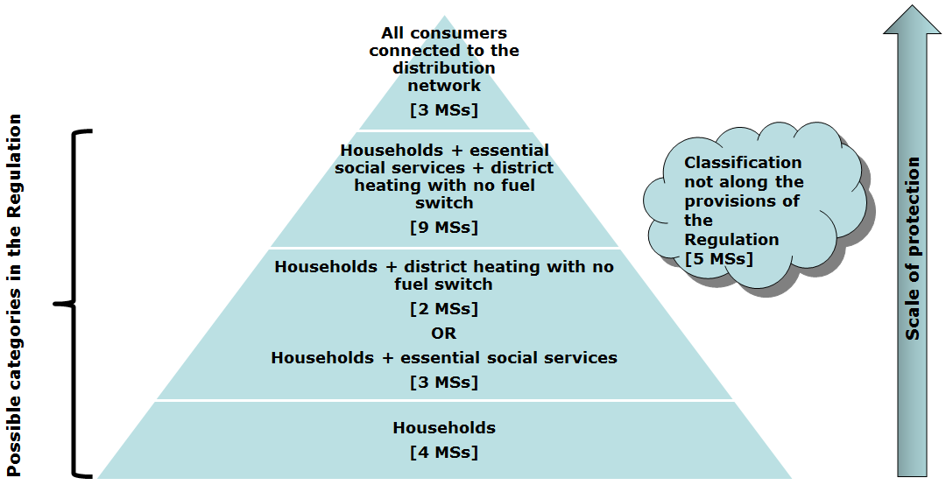
Categories of protected customers as notified by Competent Authorities. The ranking does not reflect the absolute quantity in gas consumption or the share of protected customers within national gas demand.

The tools and instruments chosen to implement the supply standard are equally diverse.
Some Member States have set up extensive ex ante monitoring systems, whereby gas supply companies must present their supply plans for the coming winter to the Competent Authority, which examines the plans and continuously monitors their implementation. Other Member States require gas supply companies to store minimum volumes in an underground gas storage, or to have booked sufficient capacities on interconnectors to bring the necessary volumes of gas to supply protected customers into the country.
Although the obligation to guarantee a minimum supply standard to protected customers is a key element of Regulation 994/2010, information about the methodology for controlling and enforcing the implementation of the supply standard is missing from several Preventive Action Plans. Some Member States consider the supply standard rather as a general obligation on the selected natural gas undertakings, without specifying any further enforcement rules. It remains unclear in these cases if concrete measures have been taken to ensure gas supply to protected customers (capacity and supply contracts, storage options or contracts, etc.) or whether governments just rely on the fact that the market is sufficiently liquid to deliver without further precautionary measures. Even where enforcement is in place, it is sometimes restricted to mere ex post penalties in case a natural gas undertaking fails to serve a protected customer.

Very often basic information to verify the fulfilment of the standard is missing – in particular the level of consumption of protected customers within the total gas demand (e.g. for SMEs, where a 20% cap applies). Information on the legal rules to implement the standard remains rudimentary. Data on the final use of gas and demand variations in different temperatures – is often absent as well.
Member States have pointed to difficulties in interpreting the supply standard as one of the reasons for the missing information.
Discussions in the Gas Coordination Group have highlighted that some Member States struggle with the practical implementation and enforcement of the supply standard. Member States have inter alia raised the following questions: How can I put obligations to individual suppliers in a "hub-based" gas world where a large number of domestic and foreign companies buy and sell gas? In what way could contracts from the spot market be taken into account? How should the ability of undertakings to supply protected customers be checked? What tools/measures could the Competent Authority accept as appropriate guarantees to fulfil the standard in the three scenarios? What happens if several undertakings count on the same batch of gas for an emergency?

c.) Assessment – contribution to solidarity and preparedness
Most Member States have clearly identified the group of protected customers under their jurisdiction and most have done so in line with the Regulation. Some Member States have explained to have technical difficulties in distinguishing protected from non-protected customers which led them to include a broader group (i.e. all customers connected to the distribution grid) to the protected customers. It is true that the possibilities to implement selective supply cuts only for the relevant customers in an integrated gas network should be taken into account when calculating the actual gas need for protected customers in a realistic manner. However, experience in many Member States has shown that in fact there are existing technical and administrative possibilities to focus the supplies on the most vulnerable customers groups in case of a crisis. The Commission services are of the view that further exchanges of best practices for the selective supply of protected customers should be developed and intend to pursue this matter further in the Gas Coordination Group, bilaterally with the Member States concerned and in a possible reform of Regulation 994/2010.
More generally problematic is the lack of information, or the lack of detail and precision thereof, on the consumption volumes and patterns (i.e. seasonality, fuel switching possibilities, etc.) of the protected customers in many Risk Assessments, Preventive Action Plans and Emergency Plans. Detailed information on the amounts of gas which is needed to protect the most vulnerable customers in an emergency is important to allow for efficient and fair cooperation between Member States in cases of gas supply problems. The information on the "protected" gas volumes is not only necessary for the assessment whether the legal limits of Regulation 994/2010 concerning protected customers are met. The recent energy stress test exercise showed that precise information on the necessary volumes in each Member States is crucial to organise cross-border cooperation and emergency supplies in a gas crisis. The Commission services therefore call upon the Member States to update the information regarding protected customers in the first revision of the Plans which need to be submitted under Regulation 994/2010 by December 2014. Member States may use the detailed information submitted on protected customers during the Energy Stress Test exercise for the update of their plans.
Some Member States apply an increased supply standard, which is possible under regulation 994/2014 under certain conditions. However, the justification for the increased standard was not always complete. Also information on how the increased national standard can be temporarily reduced in the event of a regional or Union emergency was sometimes missing. As a significantly increased supply standard in single Member States may unnecessarily limit cross-border flows and aggravate the security of supply situation in a neighbouring Member State, the information on ways to temporarily reduce the supply standard to the EU default level should be provided in the next revision of the plans.
The main weakness in the implementation of Regulation 994/2010 is in the Commission services view, however, the unclear enforcement of one of the key element of Regulation 994/2010, the supply standard. It appears that Regulation 994/2014 has failed to bring about a clear system in which the supply standard is monitored and enforced in a systematic manner. As a result thereof, it appears that customers remain unequally protected across the EU.
Who appears to be well protected on paper, may be much less so in reality in the absence of an effective monitoring and enforcement system. Where no or weak ex ante monitoring tools are in place to ensure that companies can comply with the supply standard, earlier resort may have to be taken to emergency measures in case of crises which might have negative spill over effects on neighbours, being less market-based and more costly.
The lack of harmonization in the implementation and enforcement of the supply standard implies in other words that the contribution of the supply standard to the EU's emergency preparedness is today suboptimal and may endanger solidarity. The Commission services are of the opinion that the provisions on the supply standard in Regulation 994/2010 should be reviewed with respect to the existing implementation deficits in terms of enforcement.

3. Creating an infrastructure that allows to make gas available where it is needed
During the 2009 gas supply crisis the necessary amounts of gas were available on the EU internal market but it was physically impossible to ship them to the affected Member States in Eastern Europe.
Against this background, the Regulation aims to improve cross-border capacities by pursuing the development of new infrastructure which may not necessarily be commercially feasible but is essential in terms of security of supply. The two tools chosen are the implementation of the so-called N-1 rule and the implementation of permanent bi-directional capacity (physical "reverse flows").

3.1 The N-1 rule

a.) Description
This rule – based on the example from the electricity sector – obliges those Member States who are dependent on a single import pipeline, underground storage facility or other type of essential infrastructure, to make sure that demand on extremely cold days can be covered even if the main infrastructure fails. The N-1 rule must be fulfilled from 3 December 2014 onwards.
It is also possible to fulfil the N-1 rule on a regional level if relevant Member States establish a joint Risk Assessment and a joint Preventive Action and Emergency Plan.

b.) Implementation
The number of Member States who comply with the N-1 rule has been increasing over the years and currently stands at 20. Three Member States with small and isolated gas markets – Sweden, Luxembourg and Slovenia – are exempted from the N-1 rule.

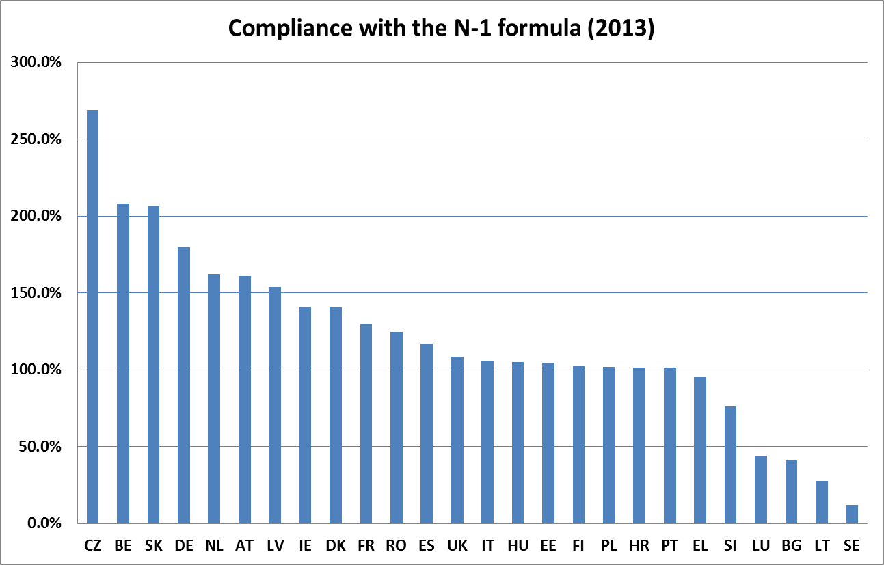
Source: European Commission

In those Member States which in 2013 did not fulfil the obligation yet – Greece, Bulgaria and Lithuania – short and mid-term investment projects are foreseen to ensure compliance with the N-1 rule. This is notably the case for Lithuania where the Klaipeida LNG terminal with a capacity of 2-3 bcm/year is foreseen to become operational in December 2014 and works on the expansion of the bi-directional capacity with Latvia have increased capacity from 1 mcm/d to 6 mcm/d. For Bulgaria, the limited 1 mcm/d reverse flow capacity on the Greece-Bulgarian interconnector alleviates the situation to some extent, but Bulgarian dependency on the Negru Voda entry point remains highly problematic. Bulgaria remains vulnerable because the difficulties in the implementation of Bulgaria-Romania interconnection delay the project, and because the Bulgaria-Greece interconnection is expected to be in place only in 2016. For Greece, the Southern Gas Corridor could provide a new gas source on the medium term, while additional LNG import and storage capacities could provide a higher level of flexibility in case of peak demand or a temporary disruption of flows.
The EU Infrastructure Regulation of 2013, which provides for a detailed process to define and implement infrastructure priority projects ("Projects of Common Interest" or "PCIs"), is an important complement to the infrastructure obligations in Regulation 994/2010. Compliance with the N-1 rule is one of the key benchmarks in the attribution of "PCI" status) under the EU Infrastructure Regulation.

c.) Assessment - contribution to enhanced security of supply
The Commission services are of the view that the N-1 infrastructure standard is a crucial indicator to test whether the entry capacities into a gas transmission system are sufficiently balanced and are not overly-concentrated on a single trunk pipeline or underground gas storage facility. The N-1 standard is a useful benchmark in the PCI selection process. It has also not become obsolete, as the identification of an "N-1" relevant PCI will not in itself ensure that the projects are actually implemented as scheduled. As the highest degree of commitment and prioritization from Member States, planning and regulatory authorities and companies involved is needed to ensure success, it appears justified to maintain the legal obligation to comply with the N-1 standard in Regulation 994/2010.
Moreover, Member States have effectively made use of the N-1 standard in their Risk Assessments to examine the resilience of their network in various disruption scenarios. The same is true for other such as ENTSOG and the International Energy Agency.
It is important to note that the N-1 standard is an evolutionary concept. Its value is subject to constant changes in light of evolving circumstances, such as additional infrastructure being developed, changes in national production and changes in peak demand. Although Regulation 994/2010 stipulates 3 December 2014 as date by which the N-1 must be complied with, it is hence important that Competent Authorities, the EU and others involved in security of gas supply continue monitoring and ensuring compliance with the standard also beyond that date.
At the same time, the N-1 standard is only one factor in testing accurately the resilience of a gas system. Compliance with the N-1 rule, when considered in isolation, can give a false impression of security if not combined with other indicators such as the flexibility value of the infrastructure (e.g. daily withdrawal rates from storages under various filling scenarios), the question whether alternative routes allow to tap into various sources of supply and the risk of congestion. The Commission services therefore intend to examine in the context of a review of the Regulation whether additional benchmarks should be included in the Risk Assessments and Plans in order to obtain a more refined and accurate picture of the individual position of Member States.

3.2 Enabling permanent bi-directional capacity

a.) Description
Physical bi-directional gas flows on existing cross-border pipelines can be an efficient and cost effective way of increasing entry capacity and potentially to have access to new sources. It can also help the shippers to rapidly and massively reroute gas deliveries within internal market and change the direction of traditionally one-way transport routes in case one of the Union's major supplies becomes unavailable. The Regulation put an initial obligation on transmission system operators to enable permanent bi-directional capacity on all relevant cross border points by 3 December 2013, and after that on Competent Authorities to regularly check the need for reverse flows when they update their risk assessments and plans. The necessity and justification for each reverse flow is determined by a procedure involving neighbouring Member States who express their need for the new capacity. Competent Authorities may grant an exemption in case the bi-directional capacity would not significantly enhance the security of supply of any Member State or region, or if the investment costs would significantly outweigh the prospective benefits for security of supply. The Commission has the power to require the amendment of the Competent Authority's decision in case there is a discrepancy with the opinions of the other Competent Authorities concerned. The procedure may be repeated on the request of a transmission system operator, a Member State or the Commission when the security of supply situation changes.
Virtual and physical reverse flows
The development of the internal energy market has brought about the need for cost-effective and flexible ways of transporting gas via the infrastructure. Virtual reverse flows – or backhaul – is a service provided by the transmission system operator whereby the actual physical gas flow is a result of collecting, summing and netting the individual transport orders (nominations) across the concerned interconnection point in both directions. If the nominations in one direction are equal to the nominations in the opposite direction, then no physical gas flow takes place. Backhaul services enable gas to contractually flow in both directions also at those interconnection points, which are physically impossible to reverse. In these cases however, the potential level of reverse flows may be only smaller or maximum equal to the prevailing forward flows.
In the case of physical reverse flows gas may transported in both directions across the interconnection point – up to the available technical capacity –, independently from the quantity of the gas coming from the prevailing forward direction. In the field of security of supply the physical possibility of transporting gas in both directions counts, and hence the permanent bi-directional capacity stands for such capacity.

b.) Implementation
The share of bi-directional cross-border interconnection points within the EU has increased from only one-quarter (24%) in 2009 to almost half (40%) of all points by 2014. This means that the gas flows via almost every second interconnection point between Member States can physically be turned around. Looking at the possibility to transport gas in both directions not on the level of interconnection points but on the level of borders between Member States, compared to 2009, four more borders (Germany-Denmark; Italy-Austria, Greece-Bulgaria and Romania-Hungary) have become bi-directional in 2014. This improvement can certainly be regarded as an important success.
The majority of this development has come from commercial projects incentivized by the market demand. Nevertheless, Regulation 994/2010 has been instrumental in putting in place or speeding up physical reverse flows on some interconnections where voluntary market developments did not bring about the necessary results on time although reverse flows are crucial for security of supply reasons, such as on the Yamal pipeline between Poland and Germany, on the interconnection between Romania and Hungary and between Greece and Bulgaria. At the same time, the Regulation did not bring about changes in other, major interconnection points such as at Obergailbach (France-Germany), Waidhaus (Czech Republic-Germany) or on the BBL pipeline (Netherlands-UK).

 | 2009 | 2014
Number of cross-border interconnection points in the EU | 49 | 53
Number of bi-directional interconnection points | 12 | 21
Number of unidirectional interconnection points | 37 | 32

The majority of interconnection points which were unidirectional in 2009 remain so. Analysis shows that exemptions requested by TSOs were granted by Competent Authorities and were not contested by other Member States in the consultation period. There was only one case where the cross-border consultation resulted in the implementation of reverse flows requested by the country which benefits from it. In the rest of the consultations Competent Authorities did not provide remarks that have substantially changed the original decision. The Commission is not aware of any Competent Authority that expressed an opinion for reversing an interconnection point other than those at its direct borders.
Several reasons have been invoked to grant exemptions from the obligation to install bi-directional capacity. In some cases, reverse flows do not make sense since the pipeline connects a Member State at the end of the supply route (cul-de-sac) and there is no gas available in the country concerned (e.g. no gas in storage) that could be shipped in the reverse direction. In other instances, the pipeline connects directly with a distribution network or connects a production field. Thirdly, the specificities of the L-gas system with few production sources that are moreover depleting, render it unnecessary to make investments for ensuring reverse flows of L-gas into areas where L-gas may be supplied by H-gas converted into L-gas. Technical barriers have also been pointed to as a reason for not implementing reverse flows in the case of different odorization practices on both sides of the border.
In other cases, even though no or little specific technical arguments were raised, Competent Authorities agreed on the two sides of the border that reverse flow investments would not enhance security of supply in the target market and that the estimated costs would outweigh the potential benefits.

c.) Assessment - contribution to enhanced security of supply
Even if the number of interconnection points with reverse flow capability has increased significantly, the Commission services are of the view that the flexibility of the EU gas grid is not fully satisfactory yet.
In particular the flexibility of the EU gas grid could still be substantially enhanced – when looked at on a wider scale than purely the flows between the two neighbouring Member States concerned – if the major trunk pipelines between France and Germany, between the UK and the Netherlands, and between Germany and the Czech Republic would become bidirectional at Obergailbach, on the BBL pipeline and at Waidhaus respectively. The stress test exercised recently carried out by the Commission in cooperation with the Member States shows that in a scenario where gas supplies from the East are disrupted, Member States from Central-Eastern Europe massively start to draw on gas from Western markets such as Germany. In such a scenario the entry capacities to Germany and to the North-West European markets, and exit capacity from these countries towards the East would need to be maximized. In this respect the physical reversal of the BBL pipeline between the UK and the Netherlands, the reversal of the interconnection between France and Germany at Obergailbach or the reversal of the Waidhaus interconnection point could be instrumental to secure the necessary supplies to Central-Eastern Europe. The absence of bi-directional flows on these points implies that gas can today not, or only to a limited extent, be physically transported from the North-West European and the French and Iberian markets to the East. The EU hence misses out on the potential for Eastern Europe to tap into the LNG sources available on the Iberian Peninsula and in France and on the full access to Norwegian deliveries in the case of a security of supply crisis.
The assessment carried out so far under Regulation 994/2010 has in the Commission's view focussed too much on the direct benefits for the neighbour only. In this regard, it is true that the Netherlands, Germany and the Czech Republic all fulfil the N-1 standard also without additional reverse flow capabilities. It is recommended that in the future more attention is paid to possible beneficial effects for security of supply along the whole transportation corridor.
The Regulation provides for a minimum frequency of reviewing the necessity for reverse flows every two years when the Risk Assessments are updated. The Commission services call upon Competent Authorities to engage actively with all those Member States along the wider potential supply routes. Various disruption scenarios – such as those included in the recent stress test exercise – identify the scope of possibly concerned Member States for each currently unidirectional interconnection point, with special regard to the ability to transport massive amounts of gas from North-West and South-West Europe to Central-Eastern and South-Eastern Europe.
The obstacle represented by different odorization practices will have to be addressed in this context and possible costs related to de-odorization techniques may have to be included in the cost-benefit analysis. Odorization issues, however, should not make reverse flows impossible per se.

4. Harmonized analysis of risks, preventive and crisis management measures

a.) Description
In order to ensure that all Member States analyse the threats and hazards to their security of supply, and draw up preventive and emergency measures in a coherent and comparable manner, each Member State has to prepare and notify to the Commission three separate documents (see the graph below). These must be updated every two years or if necessary even more frequently.

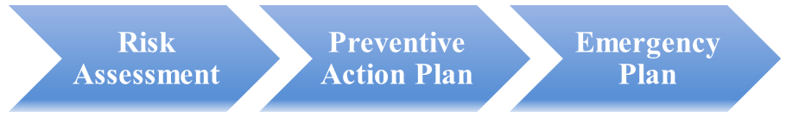
Update every 2 years

The Risk Assessment serves to analyse exceptionally high gas demand and supply disruption scenarios and to categorize the threats and hazards into high-, medium- and low-risks while taking into account national specificities. It also examines the fulfilment of the infrastructure and supply standards, and it should identify the interaction and correlation of risks with other Member States in a cross-border dimension.
The Risk Assessment is the basis for both the Preventive Actions Plan and the Emergency Plan, because the specific measures described in the latter must address the various threats and hazards identified.
The Preventive Action Plan aims to collect those measures that may help to avoid or at least reduce the probability or impact of various risks. The measures included in the Preventive Action Plan must be market-based as they cover the pre-crisis period and those situations when the market is still functioning and is able to supply customers.
The Emergency Plan focuses on those situations when the amount of gas provided by the market is not enough to cover all demand. It governs the roles and responsibilities, the information exchange schemes and the course of action to be taken by the authorities, gas supply companies, transmission system operators, consumers and other players. The Emergency Plan must be based on the three crisis levels, and it has to describe the mechanisms that are used to cooperate with other Member States at each crisis level.
The Plans must be exchanged and consulted between Member States to ensure that the national measures are not inconsistent with each other. The final Plans must also be published.
Member States have the possibility, and the Commission strongly encourages that Competent Authorities establish joint Risk Assessments and Plans on regional level. These documents focus on the region as a whole, and should identify both the common and the correlated risks which each participating Member States is facing. Joint or coordinated actions in the Plans can show the efficiencies gained by this joint approach and the potentially lower burden to reach an adequate level of security on national level. So far the Baltic States and the United Kingdom and Ireland have prepared joint Risk Assessments. The Baltic States and Finland are currently working on a joint Preventive Action Plan and an Emergency Plan.
In its function to ensure consistency on Union level and foster solidarity among Member States, the European Commission assesses the Plans, and it has the power to recommend or request changes in certain cases.

b.) Implementation
The development of the Risk Assessment and the Preventive Action Plan was a new exercise and this may explain why there is still room for improvements regarding the quality and compatibility of these analyses. The Commission's Joint Research Centre provided guidance documents and a collection of international practices, and furthermore gave recommendations on the possible elements and the structure. In the absence of a template in the Regulation, the recommendations were not always taken into account. This resulted in diverse approaches, structure and findings for the assessments and the plans.
Regarding the legal status the same diversity is visible. The plans are often regular working papers published by the Competent Authority, but some Member States chose to adopt them as a law or a decree. Occasionally, such a long administrative process was the reason why the plans were submitted to the Commission with a significant delay. In these cases, the Commission launched "EU Pilot" enquiries to the Member States about the state of play of fulfilling their obligation.
The Commission prepared and shared with the Gas Coordination Group its main findings about the Risk Assessments and the Plans in September 2013.

- Evaluation of the Risk Assessments:
The assessments represent a good overview of national circumstances. In spite of the informal guidance provided by the Joint Research Centre, the structure, the standard and the nature of the assessments considerably differ among Member States.
Some Competent Authorities established a risk assessment focusing predominantly on the transmission system and examining the probability and impact of a cut on each individual entry and exit point. Others drew up a more policy-oriented analysis with more qualitative information. While both approaches have their merits, a balanced combination of both would be ideal. A purely physical and technical approach can give exact figures both on the impact and probability but it does not look further into the potential causes that may trigger a disruption. This way, the early signs that could indicate a future supply problem will remain hidden, and it will be impossible to look into correlated and common risks shared with other Member States. The purely policy-oriented analysis concentrates more on these qualitative issues (e.g. nature of geopolitical, economic risks etc.) but it often fails to provide concrete figures on the occurrence and impact of a disruption.
The worst case scenarios in the Risk Assessments are based on events that have already occurred. The 2012 Cold Spell demonstrated that a combination of several adverse conditions (extreme high gas demand and supply problems occurring simultaneously on several entry points) is a realistic scenario. Threats related to previously unforeseen events such as strikes, cybercrime, Sun flares etc. are rarely included. The assumptions in the Risk Assessments must include more pessimistic scenarios as well as new threats.
The assessments seldom take into account the impact of risks on their exit points and thus the potential impact on gas flows from their territory into neighbouring Member States. Furthermore, Risk Assessments – unlike the Plans – are rarely exchanged between Member States. An exchange of at least parts of the assessments could contribute to identifying correlated risks, harmonizing risk scenarios, realizing additional risks.
In some cases, relevant stakeholders such as natural gas undertakings or consumer organizations were not well involved in the development of the Risk Assessment, even though their experience could provide valuable input to the exercise.
Estonia, Lithuania and Latvia in the framework of the BEMIP Focus Group on Regional Cooperation decided to set up a joint Risk Assessment, which was completed in 2012. The joint Risk Assessment of the United Kingdom and the Ireland in 2014 is another example of successful regional cooperation.

- Evaluation of the Preventive Action Plans and Emergency Plans
Almost all Competent Authorities have exchanged and consulted their draft Plans with each other and the Commission. In the Gas Platform and the Baltic region the cooperation went beyond a mere formal exercise and contributed to a better consistency among national plans. In several other instances however, the consultation was carried out in order to "tick the box" and no substantial dialogues took place among Member States. In some cases practical difficulties (language difficulties, significant time difference in the establishment of the plans) hindered the cooperation.
Consequently, there is little focus in the plans on common or coordinated actions in the preventive stage or in the case of a disruption.
The self-centered approach in the Plans also does not take into account the cross-border impact of national measures. The majority of Member States do not seem to pay attention to the consequences of their own actions on the neighbours. They equally fail to consider the impact of their neighbours' measures on them. This makes it impossible to adequately check whether there are no measures introduced that are likely to endanger seriously the gas supply situation in another Member State and whether cross-border access to infrastructure is maintained as far as possible.
The results of the Risk Assessment and the Plans are usually not linked. In most cases it is not clear which measure is supposed to neutralize a certain risk. As the impacts of neither the risks, nor the measures are quantified, it is not possible to assess the efficiency and effectiveness of certain actions.
In some cases the obligatory elements as prescribed in the Regulation, are only formally mentioned in the Plans without real analysis. The missing description of the fulfilment of the supply standard or a superfluous listing of various crisis prevention measures – such as increasing gas imports or buying gas on the spot market – considerably reduce the value of the Plans.
In particular in the Emergency Plan, roles and responsibilities and the exact measures should be clearly defined for each crisis level.
Positive examples for regional cooperation are the joint Plans of the Baltic region and Finland, which are being established. There are indications that in the course of the second iteration of the Plans, some others for instance the United Kingdom and Ireland are also planning to prepare joint Preventive Action and Emergency Plans.

c.) Assessment – contribution to enhanced security of supply
The Risk Assessments and Plans have no doubt had a positive impact on security of supply. Some Member States engaged in similar exercises already before, but this was not the case for all Member States, at least not in such a structured and visible manner. The exercise has hence raised awareness and systematized national security of supply assessments.
The depth of analysis, level of data and robustness of the Risk Assessments and Plans varies significantly. The Commission services count on this report providing guidance to Member States and are committed to continue working with the Member States on improving the quality by facilitating the exchange of best practices and to give concrete feedback on individual Assessments and Plans. In addition, in order to ensure better comparability and enable the Commission to better assess the documents and thus security of supply on a Union level, the Joint Research Centre – based on its experience of having evaluated the first iteration of the Risk Assessments and Plans – shall develop templates which could be consulted with the Gas Coordination Group. In the context of a review of the Regulation, it could be considered whether to make those templates mandatory for Member States by annexing them to the (revised) Regulation. The correlation between the gas and electricity sectors must be addressed more extensively as well.
The main weakness so far, however, has been that Risk Assessments and Plans have remained nationally focussed only and that the co-ordination between Member States has overall been poor.
As regards the Risk Assessments, they should evolve to include – in addition to the national dimension – also impacts of a threat or hazard outside the concerned Member State. Currently there is no formal obligation for Competent Authorities to exchange Risk Assessment. A certain level of consultation however, would be instrumental for all participating sides to recognize the shared and correlated risks and to identify those threats and hazards which are posed by them on each other.
In their Preventive Action Plans and Emergency Plans, Member States must pay attention to the cross-border impact of their policies and factor in the impact of neighbouring countries' measures. This can be done effectively only through real exchanges of information and consultations between Member States. In this context, Member States should actively explore the possibility of joint actions, both in preparing for emergencies and in responding to emergencies. Uncoordinated national measures to maintain a sufficient level of supply security are likely to be less effective and more expensive than exploiting the advantages or strengths of several cooperating countries and putting in place concerted measures. Furthermore, without coordination, several national policies may aim at the very same source or route of gas in a supply shortfall which could lead to overly optimistic plans and/or rivalry and political tensions between Member States in the face of a crisis.
The Commission's tools to co-ordinate actions are under the existing Regulation limited and the absence of Risk Assessments and Plans co-ordinated between Member States at regional level further complicate it overall co-ordination task at EU level significantly.
In the context of a review of the Security of Supply Regulation, the Commission services intend to explore how the regional cooperation between Member States can be fostered, for example by replacing national Risk Assessments and Plans by regional ones. The lack of exchange on the Plans so far suggests that mandatory consultations between Member States may not be sufficient in this regard.
The feasibility of carrying out risk assessments and establishing Preventive Action Plans and Emergency Plans at Union level
The establishment of Risk Assessments, Preventive Action Plans and Emergency Plans on Union level may be considered as an option for a future amendment of Regulation 994/2010. The establishment of centralised plans may indeed have the advantage to avoid information asymmetries and frictions between national plans as observed today. At the same time, the Commission would need to make sure that the information on which the plans are based is sufficiently accurate, which implies a close involvement of the national competent authorities and possibly ENSTO-G in the establishment of the plans. An alternative to EU-wide plans at Union level could be to further align the national plans in a legally binding manner (e.g. by more detailed provisions on the required content and cooperation requirements in the plans).

5. Notification of inter-governmental agreements and details of commercial contracts with Third Countries

a.) Description
Pursuant to Article 13 of the Regulation, in order to allow the Commission to assess the situation of security of supply on Union level, Competent Authorities were obliged to communicate those existing inter-governmental agreements (IGAs) with third countries, which have an impact on the development of gas infrastructures and gas supplies by December 2011. Member States are also requested to inform the Commission when concluding such IGAs.
For the sake of assessing the long-term supply outlook of the Union and the flexibility of commercial measures, natural gas undertakings were requested to notify the Competent Authorities certain details of those contracts with suppliers from third countries, which have duration of more than one year. Competent Authorities then had to notify the information in an aggregate form to the Commission by the same deadline of December 2011, and provide an update on a regular basis.

b.) Implementation
In the process of notification, 11 Member States submitted the texts of 32 IGAs, and 12 Member States indicated that they do not have any relevant IGAs with Third Countries. Those agreements which were sent in full to the Commission are published in the national official journals. Three Member States notified only the title and the existence of 9 IGAs without submitting the text of the agreements.
For the information regarding the commercial contracts, the Commission prepared and circulated a template for Competent Authorities so that the information can be collected and evaluated in an effective way. Ten Member States provided information according to the template and five Member States provided detailed information in non-aggregated manner. In 2014 the Netherlands and Germany submitted an update based on the Commission template. As the contracts are of different length, cover various volumes and the information was submitted in an aggregate form the following findings are rough estimations to give information on the main parameters of long-term contracts reported to the Commission:
- The notified quantities of average annually contracted volumes have exceeded the actual yearly demand in the last three years in cca. 10 Member States, showing that earlier expectations foresaw a steady increase in consumption.
- The share of long-term contracted gas in the annual consumption varies from as low as 10% to as high as 150%. The high share of gas contracted on long-term is a usual feature of isolated markets with low level of diversified sources and/or those who have LNG as a significant supply source. There are however also well-connected markets with access to various gas sources, where the share of long-term contracted gas is dominant in the annual supply volumes.
- Approximately 300 long-term contracts exist in the EU. Regarding the duration of these agreements, a balanced distribution is visible: 31% of them run for 1-10 years; 33% run for 10-20 years and 36% is in force for more than 20 years.
- Some Member States (6 out of 20) have very few (less than 5) long-term contracts, while others (5 out of 20) have more than 30 contracts each. Those Member States who have less long-term contracts tend to have almost their whole consumption covered by them. This could be the sign of high market concentration and exposure to a small number of external suppliers.
- Almost half of the long-term contracts currently in force, are going to expire in the coming 10 years while the other half expires within 20 years.

c.) Assessment
The obligation to communicate IGAs to the Commission pursuant to Article 13 of the Regulation became obsolete with the adoption of Decision No 994/2012/EU of the European Parliament and of the Council.
The provisions of the Decision go beyond the Regulation, and oblige Member States to submit all existing intergovernmental agreements and new IGAs following their conclusion, including annexes and amendments to those agreements which have an impact on the operation or the functioning of the internal energy market or on the security of energy supply in the Union. The Commission carries out a detailed compliance check of the IGAs with the EU acquis and follows up in the form of letters to the concerned Member States.
As concerns the requirement to submit long-term commercial supply contracts, it has to be noted that the importance of such contracts for the gas market has overall decreased in the last years. Often the information provided on the long-term contracts has given just a broad overview. Because the data is aggregated it is not possible to match the contracted quantities to the contracts expiring, and to the delivery points. Because of the possibility to resell the contracted gas on the European market and the changing portfolio of gas suppliers with decreasing share of long-term contracts within, it will be more and more difficult to assess the impact of long-term contracts on security of supply in many parts of the "hub-based western gas markets.
However, in many vulnerable Member States without supply diversification and gas hubs, long-term contracts remain an important element for security of supply. It should therefore be considered to introduce a more flexible and focused reporting obligation for long-term contracts, e.g. by exploring strengthened tools of data collection on contracts – e.g. by replacing the general reporting obligation by giving powers to the Competent Authorities to request data from natural gas undertakings already in the stages of Early Warning and Alert, and impose fines in case of refusal also outside the context of an Emergency.

6. Coordinated emergency measures

a.) Description
Emergency management represents another basic pillar of security of supply beside prevention. The Regulation developed the general coordinative activities which were in the precursor Directive and – in the spirit of enhancing solidarity – introduced new elements aiming at i.) avoiding premature declaration of emergency and imposing barriers on cross-border trade and ii.) giving stronger powers to the Commission to monitor the situation and to ensure that the national measures do not undermine security of supply in other Member States.
The definition and number of possible national "crisis levels" is now harmonized, with three different levels indicating the severity of the crisis in each Member State. The declaration of early warning and alert level before an emergency level is meant to put citizens and industry on alert, which by itself can have the effect to bring more gas to the affected market and thus prevent further deterioration of the situation. The Regulation, however, does not define precise thresholds or indicators determining when and which level of emergency can and/or must be declared.
The Commission is tasked to monitor the security of supply situation on Union level. This is done on the one hand via strategic analyses based on the input from various sources (e.g. Member State Risk Assessments and Plans, the Summer and Winter Supply Outlooks and the Ten-Year Network Development Plans prepared by ENTSOG and the information provided in the course of the PCI exercise). On the other hand, in potential pre-crisis and in crisis situations, the Commission services carry out daily monitoring of flows, underground gas storage levels and political and technical developments that affect supplies to Europe. They disseminate information on the situation, most importantly to the Gas Coordination Group.
Competent Authorities are requested to immediately inform the Commission once they declare any of the crisis levels, and provide details of the measures that they plan to take. If the Competent Authority declares emergency, it should follow the pre-defined actions as defined in its Emergency Plan and it may deviate from those only in justified cases. This is to ensure predictability and proper preparation for the affected market players. It also ensures that no arbitrary and unexpected actions are taken.
The Commission has five days at its disposal to verify whether a declaration of emergency is justified and whether the measures do not breach the relevant principles and they follow closely the actions listed in the Emergency Plan. The Commission may request the Competent Authority to lift the declaration of emergency or to amend its measures but this is not binding.
Upon the request of several Competent Authorities that face a gas crisis simultaneously, the Commission can declare a Union emergency or a regional emergency for a specifically affected geographical area. The Commission has some discretion to decide which of the two emergency levels it wishes to declare. The declaration of a Union or regional emergency triggers the possibility to use non-market based measures and confers a coordination function to the Commission. However, beyond the coordinative role and the ability to give recommendations, Regulation 994/2010 does not provide the Commission with direct powers to order Member States to take particular decisions in case of a Union or regional emergency. The Gas Coordination Group is convened in such cases without delay. The Commission has an important role to coordinate the actions of Competent Authorities and to ensure the exchange of information, the consistency and effectiveness of actions at Member State and regional levels. It also coordinates the actions with regards to third countries. In a Union or regional emergency several markets are impacted in parallel, however, it is a likely scenario that only a few Member States are in a state of national emergency (i.e. the market is not working) while the others are still in the early warning or alert phase (i.e. the market mechanisms are still operational, there are no non-market based measures in place).

b.) Implementation
Since the entry into force of the Regulation the national crisis levels have been declared on the occasion of two events (national emergency was declared only in one Member State) and for this reason experience is limited. There was no example for declaring either Union or regional emergency.
In the Cold Spell in February 2012, Greece, Italy and Poland declared "Alert" level because of peak gas demand. In the case of Italy and Greece, the exceptionally high gas demand was triggered by exceptionally high demand in electricity and was coupled with disturbances in gas supply. The deterioration of the situation led in Greece to the declaration of "Emergency" which lasted for five days.
The second instance took place in December 2013, when Greece declared an "Early Warning" because of the loss of more than 20% of gas supplied via Turkey for two consecutive days.
Measures in the "Alert" level included curtailment of interruptible customers, call for suppliers to procure additional LNG and invitation to voluntarily reduce gas demand. Poland released part of its strategic gas stocks. Greece introduced load-shedding to some of the gas-fired power generation plants in the "Emergency" stage.
No Competent Authority informed the Commission officially about actions of neighbouring Member States that were disruptive to their security of supply, however some natural gas undertakings alleged difficulties in ensuring cross-border gas flows due to public service obligations on national level.
In order to allow the Commission to carry out its assessment regarding the declaration of emergency as per Article 10(8) of the Regulation, the relevant Competent Authority submitted a detailed explanation about the supply-demand situation and the measures taken. The Commission found that the declaration of emergency was justified and informed the Competent Authority accordingly.
As neither regional, nor Union emergency has been declared by the Commission since 2010, there is no experience on how the actions of the Competent Authorities and actions towards third countries are coordinated, and how the consistency and effectiveness of measures on national, regional and Union level is ensured.

c.) Assessment
The national and Commission's capacities to monitor the development of gas supplies and demand in an emergency have developed since the 2009 gas crisis.
The high level of transparency regarding cross-border capacities and gas flows, underground gas storage levels and the information provided in the Risk Assessments and Plans (e.g. daily peak consumption) enable Member States and the Commission to identify anomalies or weaknesses in gas supply on a daily basis. The transparency platforms established by the industry (such as the ENTSOG database and GSE's AGSI – Aggregated Gas Storage Inventory) give a summarized overview of the situation in the whole Union. The input from Member States in the Energy Stress Test exercise provided valuable insight into to the national conditions and planned measures in certain scenarios. The gradually improving transparency in the Ukrainian gas sector is expected to provide a clear picture about the situation in this important gas transport corridor.
The Commission is rapidly able to contact Member States via an emergency contact list, and since 2013 a web- and audio-conferencing tool is available through which it is possible to convoke an online meeting of the Gas Coordination Group within hours. These capabilities provide an adequate platform to exchange important information on a short notice. It does not enable however true crisis management at EU level.
The implementation of the provision requiring that the Commission verifies within five days the justification of the declaration of an emergency is in practice necessarily limited to a marginal check on the evidence and arguments produced by the Competent Authority, due to the limited time available and the limited tools that the Commission has at hand to verify the information provided. Revising the timelines or providing the Commission and Member States with more sophisticated information tools and investigatory powers both within and before an emergency should therefore be considered.
It should be re-examined whether the Commission can truly ensure consistency of national measures without the power to impose binding requests on Member States in an emergency.
National emergency
The few cases when a crisis level was declared show that Competent Authorities refer to this tool as a last resort and are prudent in using it. Although the declaration of "Early Warning" or "Alert" could very well function as a signal to suppliers and traders to bring more gas to the affected market, and could send a political signal as well, it is not fully used to fulfil this function. In some Member States (such as in France of in the United Kingdom) the transmission system operators have their own alert mechanisms through which they signal to market participants if the planned consumption is not expected to be covered from the planned gas deliveries.
There is no benchmark or indicator which would show at which point a Competent Authority should activate either of the crisis levels. Further analysis of Competent Authorities' reactions is needed to gain a clear picture whether the crisis levels are used in their full role when needed.
"Emergency" was declared only in Greece, which is located at the end of the interconnected European gas system, hence the national measures did not affect gas flows to other markets – there was no "domino effect" towards other Member States. Experience with the Plans shows that most Member States do not analyse the impact of their national emergency measures on other neighbouring countries. Competent Authorities need to make it explicit in their updated Emergency Plans which are those measures which may affect security of supply in other Member States.
The declaration of the crisis levels in some Member States is carried out by the transmission system operators. The Regulation is firm that the actual declaration must be carried out by the Competent Authority, even if it is done on the basis of the TSO's input.
Only few Member States have pre-defined actions for an emergency as the nature and impact of a crisis may vary. This problem could be overcome by uniform indicators for which Member States should define concrete measures (e.g. measures in case a certain share of the demand is not covered). As regards the impact on neighbours, those concrete actions should be identified for each potential emergency situation, which would affect the security of supply of another Member State. Stronger scrutiny of the national measures from neighbouring Competent Authorities would contribute to better self-constraint if national measures harm other Member States.
Union and regional emergency
The Regulation currently foresees the possibility to declare only an emergency on regional or Union level, but not the other crisis levels notably early warning and alert. In certain situations such as the current gas dispute and political conflict between Ukraine and Russia, or when a Europe-wide cold spell takes place, the Commission – provided it is in possession of the relevant information, including where appropriate relevant commercially sensitive information, on the basis of exchanges with Member States – could formally highlight the vulnerability of certain countries while continuing to promote the use of market based measures by declaring regional or Union early warning or alert.
Apart from the political weight of such a move, this could help to send signals to the market about the potential lack of gas in certain areas. Today, infrastructure constraints in cross-border capacities and the dominance of single suppliers in some markets make it impossible for price signals to fulfil their function and attract gas to certain countries and regions, even if a potential disruption is on the horizon. This may lead to a premature introduction of non-market based measures such as curtailments, instead of taking advantage of the internal market for instance by maximizing imports from other Member States. As long as such deficiencies exist, an instrument to draw attention to weaknesses in gas supplies and to indicate more market-based remedies is important.
In order to be able to identify the proximity and probability of an immediate crisis, the Commission's monitoring capabilities and its access to certain commercially sensitive information would need to be improved. Real-time alerts about technical problems (drops in pressure, extraordinary TSO actions to balance the system etc.) or about abnormalities in the supply conditions (e.g. repeated failure of a supplier to procure the necessary amounts of gas) could enable the Commission to – in cooperation with Competent Authorities – mobilize and incentivize market players to channel gas to the regions in need.
Although there is no reference case for a regional or Union emergency, it would be important to clarify the exact allocation of responsibilities and tasks among the Commission, the Member States, the Competent Authorities and the natural gas undertakings in such a situation. It remains to be decided whether a regional or Union emergency would automatically make it possible to introduce non-market based measures – or EU solidarity mechanisms in case such are created – in those Member States where the market is still working. It also needs clarification who would have the authority to directly instruct natural gas undertakings in a regional or Union emergency. The hierarchy and priority of national vs. Union interest would need to be better defined in order to ensure smooth decision making.
Specific analysis should cover the main guidelines of allocating gas in a Union or regional emergency and how the principle of solidarity would apply in these cases. Certain questions that could be examined are inter alia:
- Is national emergency automatically triggered in each Member State when a Union emergency is declared?
- Is it a prevailing rule that supplies to protected customers should be provided in all Member States (even at the expense of other, non-protected customers)? Should one Member State curtail its non-protected customers to enable supplies to the protected customers of another Member State?
- Should there be financial compensation mechanisms?
- What should be the principle of distributing gas among the protected customers of several affected markets (pro rata, price, optimization e.g. taking into account fuel switch and concrete impact on households)?

d.) Possible next steps
The example from the Cold Spell of 2012 shows how closely peak electricity demand and gas demand are linked. A better integrated assessment of risks and measures in both sectors should ensure that correlated risks are identified in an early stage and cross-sectoral impacts of a disruption are minimized. Further work could be done, in close cooperation between the Commission, Member States and the ENTSOs to deepen the cross-sector assessments of risks and response measures.
The interdependence and the dynamics of an emergency and national measures (national actions and reactions) could be further analysed. Emergency exercises and scenario analyses could explore what happens if a Member State, which is not at the end but in the middle of the transport chain, declares emergency. Such exercises could also shed light on impact on physical gas flows of concrete disruption scenarios. Efforts are ongoing from ENTSOG and others to step up the modelling capacity but this does not include so far actual tests or exercises.
The question whether it is appropriate to set up new facilities to monitor gas flows in the EU in real time and possibly to play a role as Crisis Coordination Centre at EU level could be considered. The aim would be to provide appropriate premises with the necessary equipment to ensure:
- live monitoring of gas flows across the EU (based on the data of TSO dispatching centres)
- secure communication and information exchange channels between the Commission, Member States, TSOs and where appropriate supplier representatives
- informed advise on emergency measures in the case of crisis, possibly even going as far as the possibility to give binding instructions to TSOs;

7. Conclusions

Regulation 994/2010 has been instrumental in putting in place the basic building blocks of gas supply security on national level and thus improving the resilience of Member States in a gas crisis. It also took the first steps in creating links and consultations among Member States in order to start developing a cross-border conscious approach instead of an isolated national one, and in introducing stronger coordination on European level.
However, this Report shows that there is scope to strengthen the EU's preparedness and capacity to respond effectively to gas supply crises further. The Commission services are of the view that the lessons of recent risks to security of supply in the EU, i.e. risks caused by extreme weather conditions such as the prolonged cold spell in 2012 or geopolitical risks having an impact on EU energy security such as the 2014 crisis in Ukraine, should be pulled together in a review of possible improvements to Regulation 994/2010. In order to underline the cross-sector interaction, it is recommended that such a review exercise is undertaken in parallel with a review of the legislative framework covering security of supply in the electricity sector.

Annex I. – Map of aggregated cross-border capacity

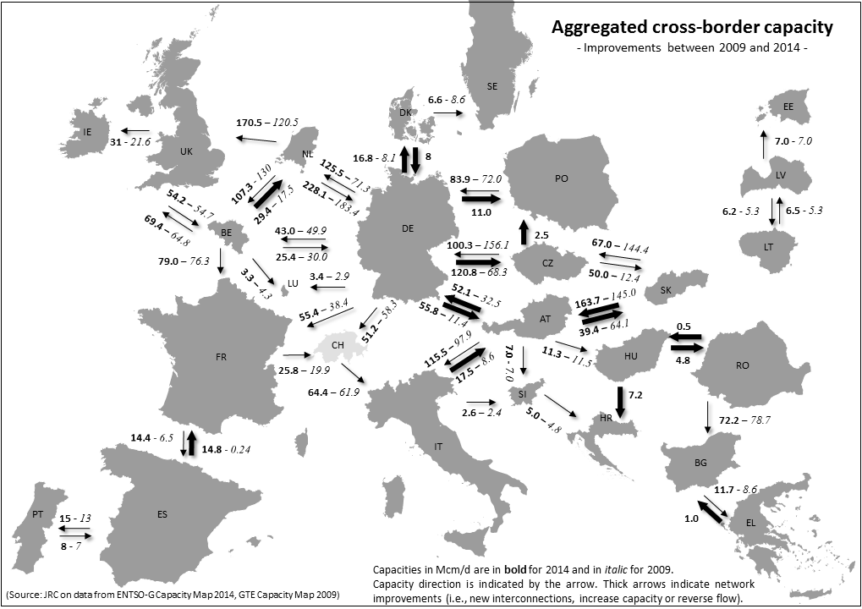

The European Council endorsed on 27 June 2014 the Commission proposal to launch a so-called stress test exercise with the purpose of assessing the robustness and the ability of Europe's energy systems to cope with a severe disruption of gas supply to the EU.
…the Commission […] after consulting the Gas Coordination Group shall: - draw conclusions as to possible means to enhance security of supply at Union level, assess the feasibility of carrying out risk assessments and establishing Preventive Action Plans and Emergency Plans at Union level and report to the European Parliament and the Council on the implementation of this Regulation, including, inter alia, the progress made on market interconnectivity; and - report to the European Parliament and the Council on the overall consistency of Member States' Preventive Action Plans and Emergency Plans as well as their contribution to solidarity and preparedness from a Union perspective.
COM(2014) 330 final
Competent Authorities require the natural gas undertakings, that they identify, to take measures to ensure gas supply to protected customers of the Member State in three scenarios (1.) extreme temperatures during a 7-day peak period occurring with a statistical probability of once in 20 years; 2.) any period of at least 30 days of exceptionally high gas demand, occurring with a statistical probability of once in 20 years; and 3.) for a period of at least 30 days in case of the disruption of the single largest gas infrastructure under average winter conditions.).
In the case of district heating facilities there is no cap defining their maximum level in the form of a percentage of the final gas use.
as opposed to the infrastructure standard
The scope of relevant undertakings is defined by the Competent Authority. It may include inter alia end-suppliers, transmission system operators, traders, suppliers of last resort or suppliers who have protected customers in their portfolio.
See Article 2(1)(a) of Regulation 994/2010.
Information on legal implementation of the supply standard is important as sometimes the domestic law provisions were not fully in line with the description in the plans.
Report on the short-term resilience of the European gas system – Preparedness for a possible disruption during the winter 2014/2015
See Article 8(2) of Regulation 994/2010.
The Regulation was one of the several instruments to promote infrastructure development. Other tools included the TEN-E Programme, the European Energy Programme for Recovery and later the Projects of Common Interest.
REGULATION (EU) No 347/2013 OF THE EUROPEAN PARLIAMENT AND OF THE COUNCIL of 17 April 2013 on guidelines for trans-European energy infrastructure
Certain points were automatically exempted from this obligation such as connections to production facilities, to LNG facilities and to distribution networks or where bi-directional capacity already existed or was under construction and no Member State asked for enhancement of the capacity.
A map with aggregated cross-border capacities and directions is available in Annex 1 of this report.
Not taking into account low-pressure pipelines which cross the border to serve local demand and which are not part of the high-pressure transmission network.
The Risk Assessments were updated in June 2014, and the Plans are to be updated by the end of 2014.
Network and gas demand characteristics with special regard to protected customers and district heating, the role of gas in the energy mix, contribution of different sources such as domestic production, storage and imports, safety and gas quality considerations
On the description of the crisis levels please see Chapter 6 on Coordinated Emergency Measures.
In case of a supply disruption or an extreme increase in demand, market players attempt to bring more gas to the affected market(s) via using their existing contracts or purchasing gas on the wholesale market. Depending on the magnitude of the disturbance, such measures may be adequate and enough, and may not impact consumers at all. When undertakings are no longer able to procure and transport enough gas to the market, the Competent Authority must declare an emergency and put in place "non-market based" measures which administratively reduce gas consumption to the level of available supply.
"where the Commission, based on these consultations: (i) assesses that a Preventive Action Plan or an Emergency Plan is not effective to mitigate the risks as identified in the risk assessment, it may recommend to the Competent Authority or Competent Authorities concerned to amend the relevant Plan; (ii) considers that a Preventive Action Plan or an Emergency Plan is inconsistent with the risk scenarios or with the Plans of another Competent Authority, or that it does not comply with the provisions of this Regulation or other provisions of Union law, it shall request that the relevant Plan be amended; (iii) considers that the Preventive Action Plan endangers the security of gas supply of other Member States or of the Union as a whole, it shall decide to require the Competent Authority to review that Preventive Action Plan and may present specific recommendations for amending it. The Commission shall give detailed reasons for its decision."
The documents are available on the European Commission's website at: http://ec.europa.eu/energy/gas_electricity/secure_supply/legislation_en.htm
For instance a disturbance in electricity production in one Member State causing a curtailment of electricity exports, could trigger a gas crisis in another Member State, because the missing electricity would need to substituted by gas.
These include i.) contract duration; ii.) contracted volumes in total, on an annual basis and the average volume per month; iii.) contracted maximal daily volumes in the event of an emergency; iv.) contracted delivery points.
Further information and IGAs have in the meantime been provided to the Commission in accordance with Decision 994/2012/EU.
Austria, Belgium, Finland, France, Greece, Italy, Lithuania, the Netherlands, Spain and UK
Bulgaria, Czech Republic, Germany, Latvia, Lithuania, Slovenia
On the basis of 2013 consumption.
Decision No 994/2012/EU of the European Parliament and of the Council of 25 October 2012 establishing an information exchange mechanism with regard to intergovernmental agreements between Member States and third countries in the field of energy
Before the Regulation, the number of national crisis levels varied between 3 and 12. Currently, Member States may declare either of the following three levels: i.) early warning level; ii.) alert level; iii.) emergency level. Non-market based measures may be applied only on emergency level. In the other two instances, the market should be still fully able to cover the demand. There is no need to gradually follow the steps – for instance in the case of a sudden, large-scale disruption, emergency may be declared immediately without declaring early warning and alert first.
For instance during the Cold Spell in 2012,in the winter of 2013/2014 and during the 2014 Ukraine-Russia conflict.
i.) no measures are introduced which unduly restrict the flow of gas within the internal market at any time; ii.)no measures are introduced that are likely to endanger seriously the gas supply situation in another Member State; and iii.)cross-border access to infrastructure in accordance with Regulation (EC) No 715/2009 is maintained as far as technically and safely possible, in accordance with the Emergency Plan.
These included technical difficulties in unloading LNG into the terminals in Italy and difficulty in procuring cargoes on a short notice in Greece. Greece also suffered from a disruption of pipelines gas supplies from Turkey.
ENTSOG updated and enriched with new functionalities its Transparency Platform in October 2014.
The existing Early Warning Mechanism with Russia and the ones in preparation with other supplier and transit countries could serve as a trigger for the declarations.

