Introduction
The purpose of the Country Reports in this Staff Working Document is to take stock of the state of play, both in quantitative and qualitative terms, of the implementation and functioning of the energy market in the 28 Member States of the European Union.
These country reports are based on the most recent information available to the Commission during the first half of 2014. In order to allow for comparability a similar structure and set-up of these reports has been chosen as the structure used in the previous reports as published together with the Internal Energy Market Communication of November 2012. There is one significant difference: for each country a new Chapter on the electricity and gas security of supply situation has been added for each country.
As to the data used, the primary source of information is Eurostat. The data used to produce the figures included in the country reports on gross inland energy consumption, gross electricity generation and electricity and gas price changes are sourced from Eurostat. Also a significant part of the information included in the table with key indicators is sourced from Eurostat. This holds for information on the number of companies, market shares, market values, and (partly) installed generation capacity. Alternatively, installed generation capacity is taken from ENTSO-E’s Yearly Statistics & Adequacy Retrospect 2012.
Information included in the table with key indicators on switching rates, regulated prices and HHIs is mostly provided by the NRAs. Typically this information is taken from the NRAs’ national reports for 2012. National Regulatory Authorities (NRAs) have been given the opportunity to comment on draft versions of the reports related to their country and all 28 NRAs have done so.
In these reports we have also strived to give a country-individual breakdown of gas and electricity retail prices, showing the composition of these prices in an energy, a network and a tax component (based on Directive 2008/92/EC, Annex I) and demonstrating the development between 2009 and 2012. This work is a follow-up of the data gathering exercise carried out in the context of the Energy Prices and Costs Communication earlier in 2014. On the basis of the data gathered we have not been able to provide meaningful graphs related to gas prices for Austria, Finland, Greece and Ireland.
The chapter in each country report on consumers contains information on consumer satisfaction from the Commission's DG SANCO’s market monitoring surveys. The number of smart meters is taken from varying national sources. The remaining information on consumer affairs included in this chapter is typically provided by NRAs.
The chapters on the regulatory framework, wholesale markets, infrastructure and security of supply contain information from a variety of (mostly national) sources. Frequently used sources are publications by Ministries, NRAs, TSOs, ACER, CEER and DG Energy. References to these sources are included in the reports.
Austria

Key issues
In the electricity sector, market coupling with Southern and Eastern neighbouring countries would be beneficial.
In gas, the number of system operators could be reduced in view of the new gas-market model. An extension of the gas network based on market demand is needed to enable injections and withdrawals on a firm basis from the gas storage capacities. The efficiency of the gas balancing regime should be improved in order to create a level playing field on the retail market.
- General overview
Energy consumption in 2012 (33.7 Mtoe) was based largely on crude oil and petroleum products (35.54%), renewables (30.05%) and natural gas (22.8%). Austria has committed to reach 34.2% of RES share in gross final energy consumption by 2020. The country is showing good progress towards its European target as the RES share in 2012 was 32.1%, well above its 2011/2012 indicative trajectory.
Figure 1: Gross inland consumption mix 2008 – 2012 (source: Eurostat)
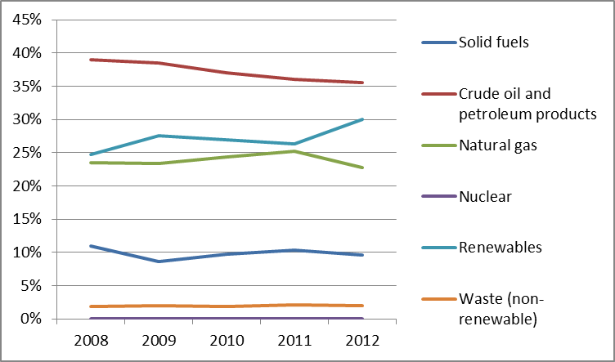
In 2011, approximately two thirds of the electricity generated (67.5%) was provided by renewables and 21.8% by natural gas.

Figure 2: Gross electricity generation mix 2008 – 2011 (source: EU Energy in Figures - Pocketbook 2012 and 2013)
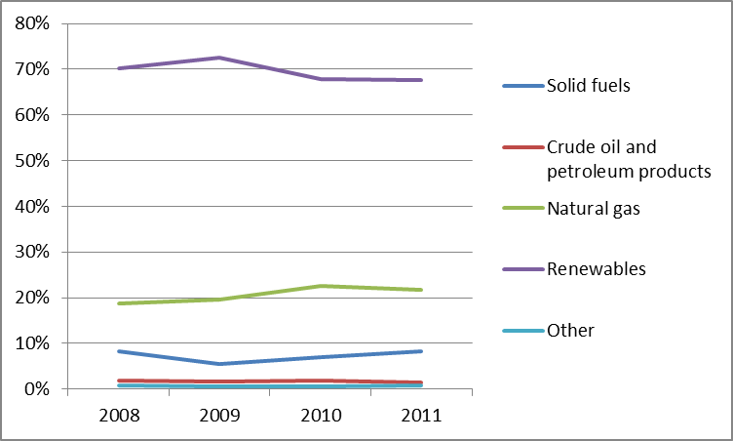
Cogeneration accounted for 15.7% of the total electricity generation in 2011, which is in line with the last few years. The relevant indicator for pump storage generation (base/peak spread) decreased by 10.5% (EUR 11.5/MWh) and the generation from hydro power stations reduced due to high tides and dry periods. Full load hours of gas fired power plants reduced by 17.9% in 2012 (1859 hours, 2011: 2265 hours).
- Regulatory framework

General
The Directives of the Third Energy Package were transposed into national law in 2010 for electricity and in 2012 for gas.
An important development has been the introduction of an entry-exit system in gas in January 2013, replacing the previous system based on contractually agreed transport paths. Austria has three market areas and entry-exit zone (East, Tirol and Voralberg). As the market areas of Tirol and Voralberg are neither connected with East or each other but supplied via the market area Net Connect Germany, they have been partly integrated in to the German market area Net Connect Germany (NCG) since October 2013. Approximately 95% of Austrian gas consumption takes place in the Eastern market area. The new regime foresees that any gas transported through the Austrian network is traded at a centralised virtual trading point (Central European Gas Hub – CEGH) both bilateral and exchange trades are possible. The new regime also foresees new balancing rules of which the efficiency is however not proven. The new market model delegates system-relevant tasks to a number of system-operators beyond the TSOs and DSOs (Distribution Area Manager, Market Area Manager, Clearing and settlement agent, Operator of the virtual trading point) which leads to administrative burden for market participants.

National Energy Regulator
In 2012 the Austrian Energy Regulator “Energie-Control Austria für die Regulierung der Elektrizitäts- und Erdgaswirtschaft” (E-Control) had an average of 113 employees and a budget of around EUR 20 million.

Unbundling
The electricity TSO Austrian Power Grid (APG) was legally unbundled in March 2012 from its shareholder Verbund AG, whose main shareholder is the Austrian Government (51%). APG was certified as an Independent Transmission Operator (ITO). The second electricity TSO in Austria, Vorarlberger Übertragungsnetz GmbH (VÜN), whose main shareholder is the federal state Vorarlberg (51%), was certified as an Ownership Unbundled TSO in June 2012. The gas TSO, Gas Connect Austria GmbH (GCA) was for the first time certified as an ITO in July 2012 and received in July 2014 an updated certification as ITO covering the operation of WAG pipeline which was until September 2014 operated by Baumgarten-Oberkappel Gasleitungsgesellschaft mbH (BOG). After the rejection of the application to be certified as ISO in March 2013 Trans Austria Gasleitung GmbH (TAG) was in July 2014 certified as ITO.
- Wholesale markets

Electricity
On the Austrian energy exchange for electricity (EXAA, Energy Exchange Austria), electricity is traded on a day-ahead basis for delivery in Austria or Germany. In the absence of congestion, the wholesale market for electricity is fully coupled with Germany and forms a single price zone. Therefore electricity can also be traded at EPEX Spot situated in Paris on an Intraday and Day-Ahead basis for the Austrian/German delivery zone. Similarly, derivatives at EEX (European Energy Exchange) situated in Leipzig, such as Phelix Futures can be traded for Austria/Germany. Hence, through Germany, Austria is indirectly coupled with the North West European electricity market. It is not yet coupled with its Eastern and Southern neighbours.
The average wholesale electricity price was EUR 51.9/MWh in 2011 but decreased in 2012, caused mainly by the low worldwide prices for coal and emission certificates, increasing generation of subsidised RES in the joint German-Austrian price zone and a bleak economic outlook. In summer 2013 Austria has introduced an obligation for electricity suppliers supplying Austrian end consumers to provide a certificate of origin of the energy supplied. It will need to be assessed further whether this new obligation restricts imports of supplies from other Member States.

Gas
The wholesale gas market in Austria was still very concentrated (Herfindahl-Hirschmann Index - HHI - of 3,371) in 2011. The wholesale gas market in particular was affected by significant price changes, which brought about major developments. On the one hand, new suppliers made use of the opportunity to enter the relatively high-priced retail gas market (including household consumers), which led to a larger spectrum of rates available. On the other hand, suppliers adapted their contracts with importers to reflect better actual market conditions, i.e. adjusting their prices to the short-term spot market.
Being dependent on gas imports, it is essential for Austria to have cross-border transport capacity available to gas traders. In the past years, new entrants wanting to trade in the Austrian gas market faced congestions in the transmission system at the border with Germany and therefore only had limited access to transport capacity. With the implementation of the European guideline on congestion management procedures and the European network code on the allocation of capacity in gas pipelines, this situation has improved significantly.
In 2012, the average price for natural gas was EUR 26/MWh, a small increase from 2011. In 2012, the price varied between EUR 25/MWh and EUR 27/MWh, except in January and February 2012 when prices of up to EUR 39.5/MWh were recorded, which is the highest price seen at CEGH. This significant increase was due to extraordinary temperatures and lower imports from Russia. Usually spot prices at CEGH are above the German NCG prices, however in the fourth quarter of 2012 this spread was reversed. At CEGH a total volume of 48.9 bcm was traded OTC in 2012, which is a significant increase compared to 38.9 bcm in 2011. The average churn rate was 3.53 in 2012 and 3.38 in 2011. On the normal exchange 3.06 TWh was traded in total.
The total Austrian gas demand was 4.391 Mtoe in 2011 of which approximately one third came from national production. In 2011, the largest share of the imported gas came from Russia (52%). Austria also exported natural gas to Germany and Italy.
- Retail markets

Electricity
The retail market can be divided into three different sections: households, small business companies and large scale consumers with special contracts. The number of active suppliers for households decreased from 143 to 139 in 2011 and for small business companies from 142 to 137 as some smaller suppliers were taken over by bigger ones. The market consists just of domestic suppliers for households and SMEs, of which 15 are operating at a national level and the remainder-wide, the others are regional suppliers. This implies that there are regionally operating suppliers. For special contract consumers the number of suppliers has not changed, giving industrial customers a chance to choose between 12 different suppliers. , which are either domestic or foreign suppliers. Normally, foreign suppliers only offer contracts if a certain amount (10-20 GWh) is supplied.
Market concentration has not changed considerably and remains at a high level given the HHI of 1,769 for household customers (2011: 1,764) and 1,685 for commercial customers (2011: 1,696). The overall market share of the three largest retailers (for households and SMEs) remained at a level of about 56% across all consumer groups. Alternative suppliers gained some market share relative to the local suppliers who still have a strong market power.
Figure 3: Electricity price change by component 2008 – 2013 (source: Eurostat, energy statistics)
The household energy price increased by 3% in 2012 (EUR 0.2224/kWh), which is higher than the average electricity price in the EU (EUR 0.2061/kWh). In 2013, household prices consisted of energy costs (41%), network costs (25%) and taxes and levies (34%). Prices for industrial customers have decreased since 2010 and in 2012 the reduction was about 4.5% for large industrial customers.
Most of the suppliers slightly reduced their prices at the beginning of 2012 mainly because the reduction of transfer prices for the mandatory acquisition of renewable energy. Following the renewal of the law in respect of renewable energy (ÖSG), the costs for renewable energy became transparent and understandable as they are determined by law. Additional price reduction due to the positive developments on the wholesale market has not been passed through to the household customers by the suppliers.
Regarding smart meters, a cost-benefit analysis came out in favour of smart meters for both electricity and gas. A Ministerial Decree mandated the roll-out of smart meters for electricity customers by the end of 2019 at the latest with a specific timetable for implementation. A modification, in 2013, to the Elektrizitätswirtschafts-und-organisationsgesetzes of 2010 makes provision for up to 5% of consumers to express the wish to their supplier not to have a smart meter installed.
Regarding switching of energy supplier the switching rate dropped from 1.5% to 1.1% in 2012. In contrast, the switching rate of specially metered customers increased by almost 50% (to 6.8%) New rules, which came into force on 1 January 2013, have probably contributed to an increase in the number of consumers who subsequently switched gas and electricity supplier. During 2013, 148,000 consumers and businesses switched supplier. This represents an increase of 68% in comparison with 2012.

Gas
The Austrian gas market is divided into two segments. Prices for small consumers (households, smaller consumers etc.) with a consumption of less than 400 MWh are published. For large customers with consumption above 400 MWh, the prices and conditions are negotiated individually. In 2012, 49% of household prices were for the energy itself, network costs accounted for 22% and VAT and energy taxes made up the remaining 29%.
Market concentration for the small consumer group is still very high (HHI: 3,726) even though it reduced by 8% in 2012. The cumulated market share of the three largest gas suppliers was 72% in 2012. The largest individual market player is EnergieAllianz Austria GmbH with a market share of 60%. EnergieAllianz Austria GmbH includes the retail companies: Wien Energie GmbH, EVN AG and Energie Burgenland AG.
In 2012, about 23,400 final customers changed their supplier (about 1.7% of all final customers in Austria). Since January 2013 the process has been further simplified, so that the switching process can be successfully completed within three weeks.
- Consumers
Overall consumer assessment of the retail electricity market is above the EU average (77.0 points compared to 72.0), corresponding to 8th place EU-wide. The market is also assessed just above the average of 31 domestic services markets (15th place). The electricity market has the second highest score in the EU on the 'overall consumer satisfaction' indicator. However, consumer assessment of the retail gas market is just below the EU average (74.0 points vs. 74.1, ranked 17th) as well as below the average of the 31 domestic services markets (ranked 21st). While the score on comparability has been increasing (although slowly) every year since 2010, it remains 4th lowest in the EU. Both electricity and gas markets have improved their performance since 2012 (respectively by 2.8 and 2.2. points).
E-Control has launched a service hotline for all gas and electricity customers where customers can find a wide range of information on electricity and gas markets. In 2012, the hotline recorded 6,373 calls, which is a reduction of 33.4% on 2011 when the price comparison tool was introduced. The main reasons for calling the hotline were related to questions on switching and energy bills. In addition, E-Control offers a wide range of online applications. About 500,000 customers used the so-called “Spritpreisrechner” calculator to identify the cheapest petrol station. Furthermore, a significant number of customers checked their opportunities for saving of energy in their households.
In 2012, the rights of vulnerable customers were strengthened. If consumers fail to pay their bills, then the supplier may only switch off supply after repeatedly sending reminders, including threatening disconnection. Moreover, suppliers are obliged to deliver natural gas or electricity to vulnerable costumers who claim their respective right, at their general terms and conditions in force and at rates for universal service to vulnerable costumers that may not exceed the rates at which most of their customers are supplied (universal service obligation).
Whilst a protection mechanism for vulnerable customers does exist in Austria, the authorities have still to make a precise definition of the concept of vulnerable customers.
New regulatory guidance (ordinance) has been put in place defining the format of consumption information by system operators towards consumers. These measures seem to have had a positive impact on the overall consumers' assessment of both electricity and gas markets between 2012 and 2013.
- Infrastructure
In accordance with the TEN-E Regulation, Austria has designated one national competent authority responsible for facilitating and coordinating the permit granting process for the Projects of Common Interest (PCIs) in gas and electricity (“one-stop-shop”).

Electricity
The Austrian energy market faces substantial challenges due to the proposed increase of electricity from renewables and the integration of European energy markets. The high capacity high-tension 380-kV ring in Austria remains to be completed and cross-border capacities to Italy, Slovenia, Switzerland and Germany enhanced. To address these mentioned challenges extensive network reinforcements and network expansion are required. Therefore Austria is involved in 13 projects of common interest (PCI) under the guidelines for trans-European energy infrastructure, including large scale projects like the new construction of the 174 km long Salzburg line (380 kV) with a capacity of 2 x 2400 MVA. Remaining PCIs include five internal lines, three interconnectors to Italy and three hydro-pump storages.

Gas
In gas, the network development needs to be closely coordinated with neighbouring countries especially with regard to the development of new gas sources from the Caspian Region.
Gas Connect Austria (in its role as Market Area Manager) established the second Coordinated Network Development Plan (KNEP) for the Austrian Market Area. Potential bottle-necks have been identified at the entry-exit points Überackern SUDA and ABG, 7 Fields, and the exit point Mosonmagyaróvár. Even though extension was requested on a non-binding basis for Penta West to offer guaranteed capacities for the use of storage and incremental capacity at the entry-exit point Überackern, no bookings were made in the course of the auction of the respective incremental capacity via Prisma in March 2014. A total of six projects of common interest in the gas sector are carried out by Austria.
- Security of Supply

Electricity
Generation capacities are expected to rise by 6.7 MW until 2020. The overall generation capacity will then be 29.6 MW, what implies that there should be no issues of generation adequacy. However, in periods when hydro generation capacities are not able to generate due to high tides or dry periods and gas fired stations are no longer running, maintaining security of supply may need complementary measures.

Gas
Given the latest survey regarding the security of gas supply Austrian suppliers fulfil the requirements of Regulation 994/2010. One important element is the storage capacities (67.8 GWh) which cover about 90% of annual gas demand (91.2 GWh).
- Key indicators
Electricity |  | Gas
Number of companies representing at least 95% of net power generation | 145 | Number of entities bringing natural gas into country | 6
Number of main power-generation companies | 4 | Number of main gas entities | 3
Market share of the largest power-generation company 2012 | 56.6% | Market share of the largest entity bringing natural gas | N/A
Number of electricity retailers | 152 | Number of retailers selling natural gas to final customers | 41
Number of main electricity retailers | 6 | Number of main natural gas retailers | N/A
Switching rates (entire electricity retail market) | 1.1 | Switching rates for gas (entire retail market) | 1.7
Regulated prices for households – electricity | No | Regulated prices for households – gas | No
Regulated prices for non-households – electricity | No | Regulated prices for non-households – gas | No
HHI in power-generation market | N/A | HHI in gas supply market | 3,371
HHI in electricity retail market | ̴1,800 | HHI in gas retail market | ̴2,200
Electricity market value (bn€) | 7.265 | Gas market value¹⁹ (bn€) | 2.658
Installed generation capacity (MW, 2011) | 22,787
Peak demand (MW) | 11,617
Number of Smart meter installed | 590

Belgium

Key issues
The level of market concentration remains high, despite a high switching rate of consumers that tend to reduce the market share of incumbent suppliers on the retail markets.
Due to changes in the generation mix and retirement of generation capacity, risks for security of supply will increase in the upcoming years. Increased cooperation with neighbouring countries and demand side response are required to tackle such risks. Efforts to further integrate the physical grid and electricity markets with neighbouring countries should be pursued. Enhanced interconnection could help to accommodate peaks in demand.
Belgium should take measures to further stimulate consumer empowerment leading to enhanced retail competition. This is necessary to ensure that when decrease in wholesale gas and electricity prices is observed, it is also passed on to the final consumers.
Belgium should also ensure that distribution charges reflect efficient costs of distribution, network operations and development. Proper regulatory oversight at federal as well as regional level is essential to ensure that all network tariffs reflect efficient costs and are incentive based.
- General overview
Gross energy consumption in 2012 (56.3 Mtoe) was based largely on crude oil and petroleum products (39.0%), natural gas (27.0%), and nuclear energy (18.5%). Solid fuels and renewable energy sources (RES) were less important in the energy mix (with shares of 5.3% and 5.9%, respectively).
Figure 1: Gross inland consumption mix 2008 – 2012 (source: Eurostat)
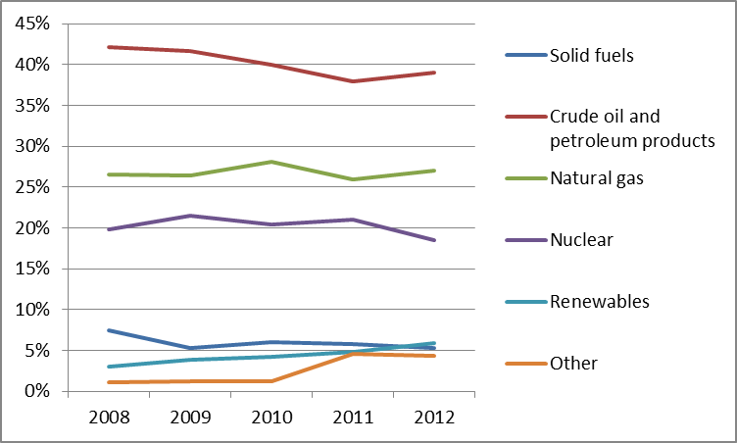
The power generation mix in 2012 (82.9 TWh) was dominated by nuclear power (with a share of 48.6%) and by gas-fired plants (30.9%). RES and solid fuels accounted for 14.2% and 0.12% respectively. Electricity demand in Belgium decreased by 2.8% in 2012 compared to the 2011 level.
Figure 2: Gross electricity generation mix 2008 – 2011 (source: EU Energy in Figures - Pocketbook 2012 and 2013)
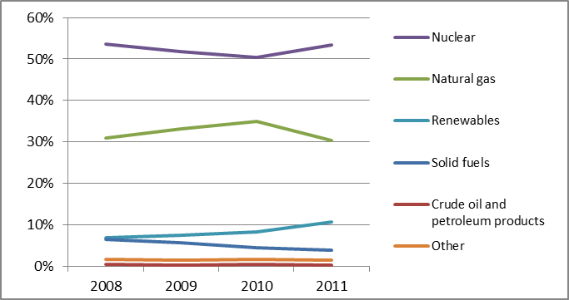
Belgium’s renewable energy target is 13 % by 2020. In 2012, the share of renewables in gross final energy consumption reached 6.8% and the country is on track to achieve its 2020 national RES target. Belgium also has plans to reduce its greenhouse gas emissions by 15%, but these have yet to be aligned with regional initiatives.
- Regulatory framework

General
The Third Energy Package was transposed into national law by a law issued on 8 January 2012. This resulted in an increase in the powers of the national regulator, while at the same time strengthening consumer protection and increasing the competence of regional authorities.
The indexation of the energy component of electricity and gas prices was capped provisionally from 1st April 2012 to 31st December 2012. The aim of the Belgian authorities was to increase transparency and price comparability in variable contracts, protecting the consumer against price increases based on opaque indices and information asymmetries. These measures and the subsequent public debate encouraged Belgian consumers to become more price-conscious and ignited their interest in changing providers.
To further increase competition and liquidity in the Belgium gas market a new entry-exit transmission model was implemented as of 1st October 2012.

National Regulatory Authority
In January 2014, the Belgian federal energy regulator, the CREG ("Commission de Régulation de l’Électricité et du Gaz") employed 64 employees (including 1 president and 3 directors) and had an annual budget of EUR 14,952,254. Its independence from the Ministry was increased by the provisions of the law of January 2012 and the decision of the Constitutional Court of 7th August 2013, which confirmed that the regulator had exclusive jurisdiction with respect to application, determination and exemption of tariffs. Since 1st July 2014, the competence for setting distribution tariffs has been transferred to the regions. Regional regulators (CWaPE in Wallonia, VREG in Flanders, BRUGEL in Brussels) are now responsible for the control of tariffs regarding public distribution of gas and electricity (low-voltage (≤ 70kV) or low-pressure networks).

Unbundling
The CREG certified S.A. Elia System Operator (Elia) as the Belgian TSO for electricity as fully ownership unbundled on 6 January 2012, along with S.A. Fluxys Belgium as TSO for natural gas on 12 October 2012 and Interconnector (UK) on 11 July 2013.
Elia has been listed on the stock exchange since 2005. Its core shareholder is the municipal holding company Publi-T (45.22%), founded in 2001 when Elia was established.
Major shareholders of S.A. Fluxys Belgium are Euronext Brussels (10,03%), Belgium State (1%) and Fluxys Holding (89,97%). Fluxys Holding, parent company of S.A. Fluxys Belgium, is owned by a municipal holding Publigas (77.7%) and Caisse de dépôt et placement du Québec (20%).
The regional governments of Flanders, Wallonia and Brussels-Capital have also transposed the DSO unbundling provisions of the Third Energy Package in their respective legislations for the 24 electricity and 18 gas DSOs. Articles 28 of Directives 2009/72/EC and 2009/73/EC, relating to Closed Distribution Systems (CDS), have been transposed into law in the Flemish and Walloon region. In the Walloon and Brussels-Capital regions, the new concept of CDSs has not (yet) been introduced, but its legislation provides for a concept of private distribution networks.
- Wholesale markets

Electricity
The Belgian electricity generation market is still highly concentrated (Herfindahl Hirschmann Index – HHI- in: 2013 of 4,770 and 7,390 in 2008) but it has been improving as the generation market share of Electrabel (2013: 67%) dropped significantly in the last 5 years. The three largest firms, Electrabel, EDF Luminus and E.ON had a market share of 89% in 2013. The average price on day-ahead wholesale market in 2013 (EUR 47.45/MWh) at the Belgian exchange market Belpex was slightly higher than in 2012 and about two euros lower than in 2011. At the same time the total trading volume increased from 12.3 TWh (2011) to 17.0 TWh (2013). The sharp increase in traded volume correlates with a reduced availability of two nuclear power plants at the end of 2012. The number of market participants on the Belpex Day-Ahead Market has increased significantly in recent years and totaled 42 at the end of 2013.

Gas
Eighteen supply companies operated in 2012 on the Belgian gas wholesale market. The largest supplier was Eni Gas & Power with a market share of 36.9% in 2012 (2011: 45.7%). GDF Suez is the second largest supplier on the market with 31.9% market share (+4.5 % in 2012). EDF Luminus also strengthened its third place (10.2% in 2012, up 1.6%). The remaining fifteen supply companies hold market shares of less than 5% each and nine of these do not even reach 1%. The level of market concentration, although still high, has improved (HHI 2013: 2,332), as pressure is exerted by emerging companies.
The total natural gas consumption was constant at 185.6 TWh (+1.2%) even though end-consumers connected to the distribution networks increased their consumption (+11.5%). However, at the same time consumption for electricity generation (possibly combined with the production of heat) dropped by 10.7% and consumption by industrial customers dropped by 3.3%. Most gas supply is provided via direct long term contracts (duration > 5 years) with natural gas producers (61.9% in 2012). However, the share of short-term contracts (< 1 year) grew from 22.3% in 2011 to 33.9% in 2012. This effect was supported by the recently set up virtual trading point ZTP(L) (Zeebrugge Trading Point) as part of the new entry-exit regime.
- Retail markets

Electricity
Despite reduction of the largest three players’ market shares, concentration was still high in 2012. The largest supplier was Electrabel Customer Service (ECS) with a market share of 45% (2011).
Figure 3: Electricity price change by component 2008 – 2013 (source: Eurostat, energy statistics)
The electricity prices for household consumers declined from EUR 0.1590/kWh in 2012 to EUR 0.1583/kWh in 2013 and for industrial consumers from EUR 0.0950/kWh to 0.0914/kWh. In 2013 the share of energy and supply costs was 38,75% of household prices, while the share of network costs was 37,25%. Taxes and other levies made up for the remaining 24%.
On 1st April 2014, a VAT reduction from 21% to 6% on electricity entered into force.

Gas
On the gas market, concentration is still high. In 2012, especially in the Flanders region, the market share of the largest three retailing companies fell from 91.26% to 76.01%. The HHI also fell in the Brussels region from 7,402 to 6,476. As in the electricity market, ECS was the largest supplier.
Figure 4: Natural gas price change by component 2008 – 2012 (source: EC, EPCR metadata)

Smart meters
Belgium formally decided, under current conditions, not to proceed until 2020 with the wide-scale roll-out of smart meters in the electricity and gas markets as the outcome of the cost-benefit analysis conducted by the regional regulators were negative.
Each of the three Belgian regions (Flanders, Wallonia and Brussels-Capital) has been in charge of their region-specific cost-benefit analysis (CBA) for the smart metering roll-out.
- Consumers
Consumers' assessment of the retail gas and electricity markets is above EU average (75.7 points vs. 74.1 and 75.6 vs. 72.0, respectively), which in both cases corresponds to the 11th position in the EU ranking. The gas market has improved by 6.7 points since 2012 and the electricity market by 7.4 (highest and 2nd highest in the EU). Both markets have the highest proportion of consumers switching tariff plan or service provider in the EU (about 3 times higher than the EU average), and choice of providers and the ease of switching are within the 5 best ratings in the EU (the latter component is assessed 3rd highest in the EU for the gas market). While the incidence of problems in both markets is below the EU average, the number of consumers complaining is higher than average (2nd highest in the case of gas services). Especially the share of complaints to third parties is 3rd highest in the EU.
The improvement of market performance from 2012 could be linked to several measures taken by the Belgian government: a modification of the energy law making it easier to switch provider; a campaign organised together with local communes informing and assisting consumers in using comparison tools for comparing energy prices; and promotion of joint energy purchases. The information campaigns that took place in 2012 were continued in 2013; at least one collective switching was organised by a consumer organisation. New regulatory guidance specified that contract termination can take place at any moment without cancelation fees (as long as the one month notification period is respected).
Customers became more price-conscious and suppliers kept their prices constant in 2013 after the end of the provisional capping. Since 2013, suppliers’ prices are more transparent and through the introduction of the safety net regulation these prices are constantly monitored by the CREG. As a result, the average price of the electricity and gas component is now moving closer to the average prices seen in neighbouring countries.
However, there is still divergence among the various regions in Belgium. A positive outlook is seen for Flanders, but not for Wallonia, as reported by regional regulators.
The number of customers benefiting from social tariffs remained stable compared to 2011 (400,000 for electricity and 230,000 for gas). The Federal Mediation Service for Energy received 8,331 complaints during 2012 (compared to 8,736 complaints in 2011). Of these complaints, 50% were considered admissible.
- Infrastructure
The Belgian authorities have establish a one-stop-shop for the permitting of Projects of Common Interest (PCIs) pursuant the TEN-E Regulation and a cooperation agreement between the Federal State and the Regions on the establishment of the Coordination Committee has been signed.

Electricity
The Belgian network forms an integral part of the European transmission network and has connections with the Netherlands, France and Luxembourg. The infrastructure at the interconnection point also includes phase shifters, which limit the impact of loop flows which originate most frequently from Germany and help to stabilize the grid in Belgium and in the region.
Several projects have been identified as PCIs in accordance with the guidelines on Trans-European energy network as they are cross border connections and improve security of supply. The “NEMO” project will create the first interconnection to the United Kingdom via the North Sea. The “ALEGro” project will also create the first direct interconnection to Germany. Finally there is another interconnection project with Luxembourg.

Gas
Belgium occupies a key position in the European gas grids and serves as an important transit country. In particular, the development of the Zeebrugge hub is attracting International trade as a collection of connection points of several pipelines and as an important LNG terminal, which contributes significantly to the security of supply in North-West Europe. In addition, Belgium is also well interconnected with its neighbours – Germany, France, The Netherlands, and Luxembourg.
Based on market consultation Fluxys Belgium will build additional interconnection lines to the LNG terminal in Dunkirk and Fluxys LNG will build a second landing stage for loading and unloading at Zeebrugge terminal which also qualified as PCI. In addition, there is another project to improve the interconnection of the Belgium gas market to Italy (reverse-flow on TENP).
In total, ten projects involving Belgium have been identified as PCIs.
- Security of Supply

Electricity
A combination of factors has led to concerns about generation adequacy in Belgium: the nuclear phase-out, delays in several new plants for fossil-based generation and in the construction of high-voltage lines. These factors have been exacerbated by unforeseen outages in major nuclear units which have reduced the generation capacity by 3 GW.
Elia, as TSO, and the Government have taken measures to address the situation which include an increased strategic reserve and industrial load reduction. An updated plan for controlled regional power cuts has been presented to avoid black-outs in a worst-case scenario.
In the medium term, in order to encourage investments, the Belgian government has launched a call for tender for the construction of new CCGT plants.

Gas
Following the transition to an entry-exit market model, the network was enforced with a new compressor station on the rTr/VTN pipeline in Winksele, which increases entry and exit capacities both in the East and the West. Moreover, Fluxys Belgium reactivated the former liquid nitrogen (LIN) storage tank in Dudzele with a new LIN blending facility in order to stabilize the flows to the UK and to fulfil gas quality conditions. Finally, the gas network towards Luxembourg will be enhanced in order to be able to comply with the anticipated growing demand for natural gas in Luxembourg.
- Key indicators
Electricity |  | Gas
Number of companies representing at least 95% of net power generation | 46 | Number of entities bringing natural gas into country | N/A
Number of main power-generation companies | 2 | Number of main gas entities | N/A
Market share of the largest power-generation company | 65.8% | Market share of the largest entity bringing natural gas | N/A
Number of electricity retailers | 33 | Number of retailers selling natural gas to final customers | 22
Number of main electricity retailers | 4 | Number of main natural gas retailers | 4
Switching rates (entire electricity retail market) | 10% | Switching rates for gas (entire retail market) | 11.2%
Regulated prices for households – electricity | No | Regulated prices for households – gas | No
Regulated prices for non-households – electricity | No | Regulated prices for non-households – gas | No
HHI in power-generation market | 4,010 | HHI in gas supply market | 4,000
HHI in electricity retail market | 3,000 | HHI in gas retail market | 3,900
Electricity market value (bn€) | 9.677 | Gas market value (bn€) | 4.505
Installed generation capacity (MW, 2012) | 20,8
Peak demand (MW) | 14,234
Number of smart meters installed | N/A

Bulgaria

Key issues
With regards to electricity, the domestic market is dominated by the Bulgarian Energy Holding and its daughter, the national electricity supply company Natsionalna Elektricheska Kompania EAD (NEK) and characterized by an overcapacity in electricity generation. To attract independent producers and traders, efforts on establishing a well-functioning balancing market including putting into place an organised independent power exchange and day-ahead market should be increased. The existing quota system for power plants in the regulated segment of the market should be phased out gradually and the current single-buyer model should also be removed. Bulgaria needs to gradually phase out regulated electricity prices also for households and small and medium-sized businesses connected at low voltage and take necessary steps towards a competitive retail market. Furthermore, an effort should be made to accelerate the implementation of electricity interconnection points and enhance the capacity to cope with disruptions.
With regards to the gas market, connection of the domestic gas transmission system and the transit system via adequate capacity level remains an outstanding issue and the delays observed in developing interconnections with neighbouring countries should be resolved and promoted. The certification process of the independent gas transmission operator should be completed.
The progressive dismantling of the Bulgarian Energy Holding conglomerate and an ownership unbundling of the transmission system operators would essentially help reducing the dominance of the incumbent company and introduce more competition on the Bulgarian electricity and gas markets.
Bulgaria should also strengthen the independence of the national regulatory authority and its administrative capacity in the energy sector.
- General overview
Gross national energy consumption in 2012 reached 18.2 Mtoe, a decrease of 4.5% compared to 2011. The country’s energy mix was largely based on solid fuels (36.3%), followed by nuclear (21.4%) and oil (20.1%). Compared to 2011, solid fuels decreased significantly.
Figure 1: Gross inland consumption mix 2008 – 2012 (source: Eurostat)
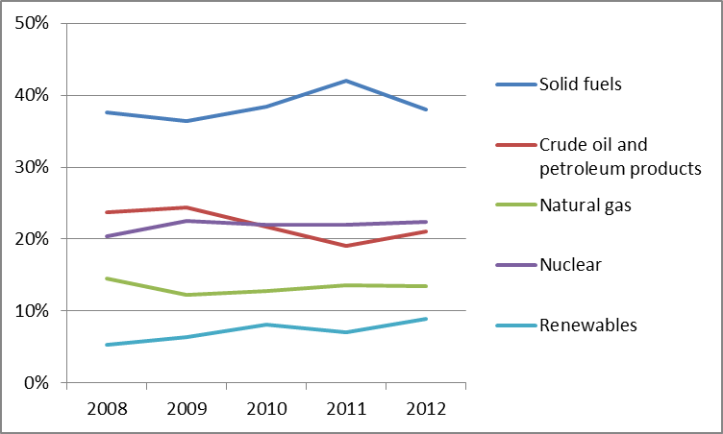
Gross electricity generation in 2011 reached 50.8 TWh, with the largest contributor being solid fuels (54.2%), followed by nuclear power (32.1%). Renewables (9.3%) and natural gas (4.1%) also had a visible presence in the electricity mix, while the contribution by oil is negligible (0.3%). Gross electricity generation in 2012 reached 47,3 TWh, with the largest contributor being solid fuels, followed by nuclear power.
Figure 2: Gross electricity generation 2008 – 2011 (source: EU Energy in Figures – Pocketbook 2012 and 2013)
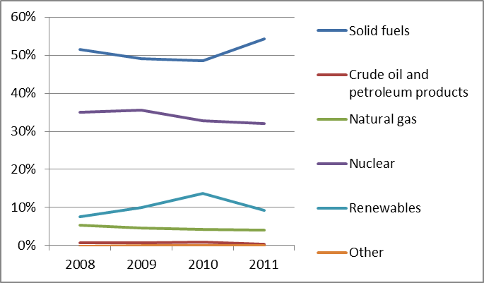
Cogeneration (with 6.7% in 2011) has been in decline since 2008, when it represented 10% of gross electricity generation. The country’s overall renewables target share for 2020 is 16%. In 2012, the renewable share in gross final energy consumption was 16.3% and Bulgaria has thus already achieved its national 2020 RES target.
- Regulatory framework

General
The Energy Act was amended in July 2012 to implement the Directives 2009/72/EC and 2009/73/EC and the Energy Efficiency Act was amended in February 2013 to implement Directive 2010/31/EC.
The Renewable Energy Act, adopted in July 2012 was amended in 2013 to abolish the “green surcharge for transit“ and introduce a fee (or tax) for solar PV and wind production. Also the limitation on the volume of electricity purchased at the feed-in tariff price was amended. Production above the cap will be purchased at the regulated retail price.

National Energy Regulator
The Bulgarian Energy Regulator is the State Energy and Water Regulatory Commission (SEWRC), established in 1999. SEWRC is an autonomous regulatory agency responsible for electricity, heat, natural gas, water and sewerage. In 2012, SEWRC employed 128 staff, with an operating budget of approximately EUR 1.86 million. Although SEWRC's budget increased by EUR 70,000 in 2013, this did not translate into a significant increase of resources and number of employees. The current budget does not allow SEWRC to build up the stable and high quality staff that is demanded to carry out its legal tasks. The fact that SEWRC's Chairpersons changed four times in the course of 2013, raises concerns about the independence, professional stability and continuity of the management of the Regulator. The selection of the Chairperson of SEWRC should take place in a more transparent manner based on transparently defined professional criteria and respecting general principles of conflict of interest.

Unbundling
In February 2014, the public provider NEK completed the last phase of its split from the Electricity System Operator (ESO). ESO is now able to start the process of its certification as an independent transmission operator, although no draft certification decision was submitted to the European Commission until September 2014. In April 2013, the gas TSO Bulgartransgaz EAD submitted an application to SEWRC for certification as an independent gas transmission operator. SEWRC's initial draft decision was withdrawn and is to be resubmitted in the autumn of 2014.
The electricity distribution network is privatized and owned by CEZ, EVN and Energo-Pro. The distribution and supply companies are legally unbundled. None of the 30 gas distribution companies are legally unbundled since they have less than 100,000 customers.
- Wholesale Markets

Electricity
The state owned Bulgarian Energy Holding EAD (BEH) and its subsidiary NEK, hold generation assets representing 45% of the installed capacity. NEK acts as a single buyer from the power generators on the high voltage grid and remains the sole electricity supplier at regulated prices for end suppliers. Moreover, NEK has the legal obligation to purchase electricity produced by CHP plants, renewables and industrial producers at regulated prices.
Dispatching of power plants takes place based on regulated quota and priority rules. As a result, NEK purchases electricity at a wide range of prices, from EUR 21/MWh up to more than EUR 350/MWh. Overall, the Bulgarian electricity market operates mainly at regulated prices, covering roughly half of the electricity transactions. The Rules on Electricity Trade were amended in May 2014; a company within the BEH group, Independent Bulgarian Energy Exchange (IBEX), has been licensed for operating an organized power exchange and day-ahead market in electricity.
About a third of the electricity market was first opened in 2012, including consumers using their right to choose a supplier and commercial exports. The open electricity market in 2012 included mainly consumers connected to high voltage network and some medium voltage consumers.
Traditionally Bulgaria is a net electricity exporter. In 2012, the share of net country exports was 20.4% of the net electricity country output. This was lower than 2011 because of decreasing demand from the Greek market and other neighbouring markets having sufficient hydro resources. In January and February 2012, the export of domestically produced electricity was curtailed twice from Bulgaria to the neighbouring markets. Following the removal of surcharges imposed on power generators electricity exports increased in 2014 compared to previous years.

Gas
Bulgaria largely depends on gas imports from Gazprom. Bulgargaz EAD, which is part of BEH, is the largest natural gas importer. In 2013, a second trader, affiliated with Gazprom, entered the gas market, which imported gas from Russia and sold gas to its distribution companies as well as end users.
The tariff model for transmission is “postage stamp” (flat fee). At present, transit flows through Bulgaria to inter alia Turkey and Greece are excluded from the regulatory oversight by SEWRC and based on historic long term transport contracts with preferential access to cross-border capacities. Bulgartransgaz EAD is expected to implement an entry-exit model, to meet the requirements of the Third Energy Package, however this system is not envisaged to include the transit.
- Retail Markets

Electricity
The retail electricity market remained highly concentrated. In 2012, 8 out of total 24 power retailers took 92% of the market.
Figure 3: Electricity price change by component 2008 – 2013 (source: Eurostat, energy statistics)
From the beginning of 2013, the market was only regulated at the low voltage level. The renewables charge makes up for 15% of the total electricity price for household consumers in Bulgaria.
Although electricity consumers are allowed to switch, no actual switching is observed. Due to the regulated prices for household consumers, there is no benefit in switching and there is no incentive for traders to enter this segment.

Gas
Overall gas demand in Bulgaria increased in 2013 by 7% compared to 2012. The traded volumes were 2854.8 mcm for non-households and 70.2 mcm for households.
Figure 4: Natural gas price change by component 2008 – 2012 (source: EC, EPCR metadata)
In 2012, Bulgaria registered an annual price decrease for natural gas close to 4%, for both household and industrial customers. Taking purchasing power into account, retail gas prices for the average consumer in Bulgaria are the highest in Europe. Natural gas prices (including taxes and levies) increased by 42.2% for residential consumers and by 49.2% for industrial users from 2008 to 2012. The main drivers behind these price rises were energy and supply costs, although VAT rises and higher distribution costs (for industrial users) were also significant factors.
Although consumers have the right to select their natural gas supplier, no actual switching is observed as DSOs operate exclusively in their licensed areas of operation.
- Consumers
The retail electricity market in Bulgaria is by far the lowest scoring in the EU (48.9 points compared to 72.0) and has seen a highest decrease in score (6.9 points) since 2012. The market is also at the very bottom of the domestic ranking of 31 services markets. In fact, it has the lowest score of all surveyed services markets in the 28 EU Member States. The market scores the lowest or second lowest on all components surveyed (comparability, trust in providers, overall consumer satisfaction, choice of providers, problems, switching and ease of switching), except for the proportion of complaints (which are just below the EU average). The gas market in Bulgaria is scoring better, although also below the EU average (72.0 points vs. 74.1, corresponding to 18th position in the EU and has seen an increase of 2.1 points since 2012. This market scores particularly low on trust (lowest place among the EU countries).
In July 2013, SEWRC concluded that the implementation of smart metering was not economically viable. The powers of the SEWRC include the review of complaints of consumers against licensees. In 2013, 2,332 complaints against electricity licensees were filed at SEWRC, and 45 complaints against gas licensees. The majority of the gas related complaints were concerned with delays in getting connected to the gas transmission network and gas disruptions. From July 2012, vulnerable customers are defined in the Energy Act.
- Infrastructure
The Bulgarian authorities should ensure a proper and timely adoption of the measures stemming from the TEN-E Regulation, including the establishment of the one-stop-shop for Projects of Common Interest (PCIs) (due by 16 November 2013), and other measures foreseen for 2014 and 2015, including the publication of the manual on the permit granting process for project promoters, and the adoption of legislative and non-legislative measures streamlining the environmental assessment procedures.

Electricity
Total installed capacity in 2012 was 13.8 MW, with the peak load of 7.8 MW observed in February 2012. There are several PCIs under the guidelines for trans-European energy infrastructure to be developed within the interconnecting lines with Greece and Romania that increase the cross-border capacity and open North-South priority corridor. Another important PCI is hydro-pumped storage in Yadenitsa.
Technical measures and rehabilitation of the electricity transmission system were approved by the Regulator in 2012. A number of reconstructions and an enlargement of the transmission network was realised and new substations and lines were constructed to satisfy the requirements from new renewable capacities in certain regions of the country.

Gas
In 2013, approximately EUR 15.7 million has been invested in the improvement of the gas distribution infrastructure, through the construction of 194 km of pipelines. Currently there is no physical congestion in the system, either national or cross-border. However, cross-border connection points suffer from heavy contractual congestion and there is minor entry capacity from neighbouring Member States into Bulgaria. Annual gas consumption is below half of the projected transmission capacity.
Progress on the interconnections, PCIs, with Romania, Serbia, Greece, and Turkey is ongoing. The interconnection with Romania – originally expected to be commissioned in June 2014 – is facing delays. Firm reverse flow capacity from Greece has been installed at the level of 1 mcm/d. However, the interconnection between Bulgaria and Turkey is delayed. The reverse flow project with Romania, entailing the connection of the domestic Romanian system to the trunk line, has been suspended.
- Security of supply

Electricity
Bulgaria is one of the largest electricity exporters in South Eastern Europe, and thus faces no particular security of supply issues. The electricity transmission network of the country has not faced any significant problems related to security of supply and congestions in the electricity system, including the cross-border capacities. Short-term congestions were rare in the interconnectors with neighbouring countries. Scheduled and non-scheduled interruptions were lower than forecasted. To increase the security of supply in the Burgas region, the construction of two new 400kV substations and three 400kV lines in the North-Eastern part of Bulgaria is envisaged, accommodating the high penetration of renewables in the region and allowing the North-South connection.

Gas
In 2014 Bulgaria remains fully dependent on a single source of gas on a single route by a single supplier. It has only limited domestic underground storage capacities that could help in balancing disruptions in high demand periods. Interconnections with the neighbouring countries are very poor and still under development. To ensure security of supply, there are possibilities for reverse physical flow of natural gas from Greece and, after eventually reaching an agreement, from Turkey. The Kula-Sidirokastro interconnector exhibits an existing capacity of 4.3 bcm annually, with the planned reverse flow capacity of 0.36 bcm. There is an underground gas storage facility, Chiren, with a capacity of 550 mcm, of which 250 mcm is reserved for emergency situations. Expansion of the Chiren capacity is envisaged.
- Key Indicators
Electricity |  | Gas
Number of companies representing at least 95% of net power generation | 20 | Number of entities bringing natural gas into country | 2
Number of main power-generation companies | 5 | Number of main gas entities | 3
Market share of the largest power-generation company | N/A | Market share of the largest entity bringing natural gas | N/A for 2012, 99.8 for 2011
Number of electricity retailers | 24 | Number of retailers selling natural gas to final customers | 30
Number of main electricity retailers | 8 | Number of main natural gas retailers | 3
Switching rates (entire electricity retail market) | 0% | Switching rates for gas (entire retail market) | 0%
Regulated prices for households – electricity | Yes | Regulated prices for households – gas | Yes
Regulated prices for non-households – electricity | Yes | Regulated prices for non-households – gas | Yes
HHI in power-generation market | N/A | HHI in gas supply market | 7,753
HHI in electricity retail market | N/A | HHI in gas retail market | Approx. 1,000
Electricity market value (bn€) | 1.706 | Gas market value³⁴ (bn€) | 0.434
Installed generation capacity (MW) | 10,236
Peak load (MW) | 7967
Number of smart meters installed | N/A

Croatia

Key Issues
Competition in Croatia’s energy market is still very limited. Market opening is needed to improve the investment climate and create incentives for new entrants.
Croatia should step up its efforts to deregulate wholesale prices and prices for end-users and complete the unbundling process. Market liberalization depends on the effective enforcement of EU law including competition and State aid rules and the removal of barriers to the export and import of gas.
Investment in LNG terminal on the Croatian island of KrK is of strategic importance to regional energy security.
- General Overview
Croatian national gross energy consumption in 2012 amounted to 8.12 Mtoe. Crude oil, petroleum products and natural gas contributed the largest shares to the energy mix.
Figure 1: Gross inland consumption mix 2008 – 2012 (source: Eurostat)
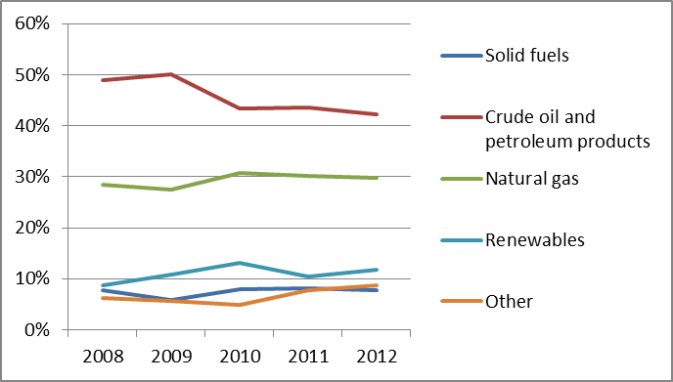
In 2012, total power generation reached 10.5 TWh (a significant decrease compared to 2010, when it was 14.1 TWh). Almost half of power generation mix comes from hydro.
Figure 2: Gross electricity generation mix 2008 – 2012 (source: Eurostat)
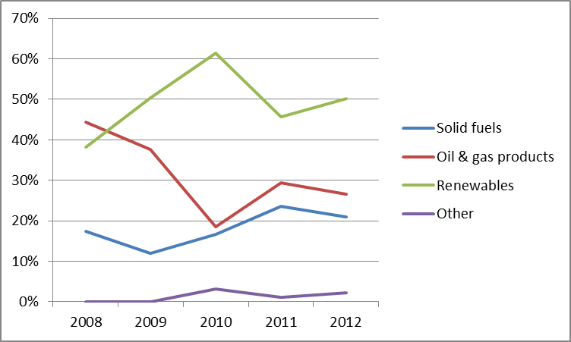
Croatia has a long tradition of gas production by which it covers over 70% of its annual domestic demand. In 2012, the domestic production of natural gas decreased. Imports increased significantly and a large amount of imported gas has been stored in underground facilities. The share of renewable energy sources in gross final energy consumption in 2012 amounted to 16.8%, above Croatia's 2011/2012 interim trajectory, and is showing good progress towards its national target of 20% by 2020.
- Regulatory framework

General
The Energy Law adopted in 2012 aims at incorporating the Third Energy Package into Croatian national legislation. Implementation has not yet taken place. In 2013, the Croatian Parliament enacted the Strategic Investments Act. It gives preferential treatment to energy projects of national interest, regardless if they are private or public.

National Energy Regulator
The Croatian Energy Regulatory Agency (HERA) was established in 2004. HERA’s annual budget of 4.5m EUR is not part of the government budget. Funds for financing the work of HERA are secured from income from its own activities (collection of one-off fees and compensations).

Unbundling
The unbundling process in Croatia is not yet completed. The HEP Group (Hrvatska Elektroprivreda) is a state owned electricity company, engaged in electricity production, transmission and distribution, supply and trade, as well as in many other supporting activities including other energy sectors such as heat and natural gas.
In mid-2013 the Croatian TSO, HEP-OPS changed its name to Croatian Transmission System Operator (HOPS). The equity capital of HOPS was increased and founding acts amended to ensure functional unbundling from the rest of HEP Group, including a different visual identity. However, unbundling certification by HERA has not been yet notified to the Commission. The HEP Group has a monopoly on the energy market but the TSO and DSOs have independent accounting, legal and management systems.
The gas grid operator Plinacro has been separated from the company INA for more than a decade, but its certification is still pending. Gas is distributed by 36 companies which operate at a local level, of which 13 have unbundled their supply and distribution operations. The remaining DSOs serve less than 100,000 customers and are exempted from the unbundling rules.
- Wholesale markets

Electricity
The power generation sector is also dominated by HEP. It was the largest electricity generator, covering 82% of the market in 2012. It owns a 50% stake in the Krsko nuclear power plant in Slovenia, near the Croatian border. HERA has so far issued 24 licenses for electricity generation, the most significant two being HEP and the independent producer TE Plomin d.o.o., co-owned by HEP and RWE Power (50:50), operating a 210 MW power plant. At the wholesale level, the market is based on bilateral contracts.
The Cross-border transmission and allocation of interconnection capacity is progressing. In 2012, HEP TSO carried out its first multilateral coordinated cross-border transmission capacity auctions with Slovenian and Hungarian operators. HOPS is striving to improve further integration with neighbouring electricity systems, including models for market coupling.

Gas
There is currently no commodity exchange or gas hub. Wholesale gas trading is based on bilateral contracts. The conditions for a de facto opening of the gas market have been met with the construction of the interconnecting gas pipeline between Croatia and Hungary which became operational on 3 August 2011. The Croatian gas market began its transition to an entry/exit model on 1 January 2014. Rather than seeking a new long-term deal (the supply contract with Italy's ENI ended last December), the Croatian oil and gas group INA-Industrija Nafte is focusing on domestic gas resources and spot markets. INA’s plan to purchase all its gas imports on the spot market has sparked interest from Slovenia and Hungary, from which shippers can import. By moving to the new model, traders will be able to book entry and exit capacity separately and shipping gas to Croatia will be easier. However, some provisions in the Gas Market Act represent a serious obstacle to cross border gas flows, by obliging domestic gas producers to offer their gas primarily to suppliers of customers in the territory of Croatia and obliging public service suppliers to primarily purchase gas from domestic producers.
Until 31 March 2014, the company Prirodni Plin (owned by INA) remained the "supplier of suppliers" under the public service obligation of gas procurement at regulated prices. From April 2014 until 2017, this function was transferred to HEP, which purchases the necessary gas from INA also at a regulated price. This marked the beginning of a three year transitional period before complete liberalisation of the market, which contradicts Croatia's commitments under the accession negotiations. During this period households prices will remain regulated.
- Retail Markets

Electricity
In June 2013, two new power retailers entered the market offering electricity to customers connected to the distribution network. The response of small customers and households at first seemed high, although the actual switching rate is unclear. This development is significant given that the price for household customers remains fully regulated. Recently the competition for customers gained momentum. Operators launched advertising campaigns, promising savings on energy bills of 30%. Though the Croatian regulator issued 15 electrical energy supply licences, the two companies leading the campaign for swapping suppliers are Slovenia’s GEN-I and Germany’s RWE. In practice, supplier switching rules are yet to be developed.
Figure 3: Electricity price change by component 2008 – 2013 (source: Eurostat, energy statistics)
Although below the EU average, Croatia's domestic electricity prices rose by 16.9% between 2008 and 2012. Industrial price rises were lower (4%), in part due to a decrease in the network costs paid by industry. In 2012, energy and supply costs accounted for 60% of domestic prices, while network costs accounted for 40% (share in price without taxes and levies). For industrial consumers, the shares were 58% and 42% respectively. In 2013, the price for industrial customers (without VAT) was EUR 91/MWh. For households, price reached a value of EUR 106/MWh (without VAT and other taxes).

Gas
Between 2008 and 2012, Croatia's gas prices rose by 45% and 94% for domestic and industrial consumers respectively. The growth was due to a VAT increase (25% for both electricity and gas), and a major rise in the natural gas shipping rate. Although permitted, there were almost no switches of supplier in 2012. The steep rise in gas prices has made helping customers a priority for the government. In 2013, industrial consumers paid 12.9 EUR/GJ on average, which is more than industry pays for gas in North West Europe. High prices negatively impact competitiveness of the Croatian economy.
Figure 4: Natural gas price change by component 2008 – 2012 (source: EC, EPCR metadata)
- Consumers
According to the law, all customers are eligible and free to choose their supplier. Protection of customers is strengthened, particularly in terms of ensuring quality of service and protection of vulnerable customers. HERA is in the process of preparing a rule which should simplify the switching procedure and ensure it takes no more than 3 weeks. It has appointed a council for customer protection, which makes recommendations and opinions to assist the ongoing transformation of the sector.
- Infrastructure

The Croatian authorities should ensure a proper and timely adoption of the measures stemming from the TEN-E Regulation, including the establishment of the one-stop-shop for Projects of Common Interest (PCIs) (due by 16 November 2013), and other measures foreseen for 2014 and 2015, including the publication of the manual on the permit granting process for project promoters, and the adoption of legislative and non-legislative measures streamlining the environmental assessment procedures.

Electricity
There are several Projects of Common Interest under the guidelines for trans-European energy infrastructure planned in Croatia, including two electricity clusters, a high voltage transmission line between Croatia and Bosnia and Herzegovina and a high voltage transmission line between Croatia, Hungary and Slovenia. Considerable investment is expected. An 800 million EUR investment in a 500 MW coal-fired power plant Plomin, is underway. The government is trying to find investors that would enable the delivery of a 500 MW gas plant in Osijek, which would help reduce imports of electricity, especially from Serbia. Investment scenarios are optimistic.

Gas
The gas pipeline Donji-Miholjac – Dravaszerdahely between Croatia and Hungary has created conditions for gas market opening. This is the second supply route for imported natural gas with an annual pipeline capacity of 6.5 bcm. The cross-border interconnector in Rogatec between Croatia and Slovenia is the supply route for Russian gas. Plinacro has finalised the implementation of its previous Network Development Plan by putting into operation the transmission pipeline Benkovac-Split.
The LNG terminal on Krk, on the list of PCIs, would open a cross European North-South corridor. To deliver the project, the government should encourage investors but for the time being contradictory signals are being conveyed. In January 2013, Gazprom and Plinarco adopted an action plan to implement the South Stream project in Croatia by 2016. A strategically important PCI (a least costly N‐1 solution for Croatia) is the Ionian-Adriatic Pipeline to Albania which creates a new energy corridor for the region.
- Security of Supply

Electricity
The Croatian power system is one of the smallest in Europe. It has 4 GW of installed generation capacity and 15.000 MVA of gross installed interconnection capacity. Due to its geographical position and location of generating plants, electricity is transported for most of the year from the south to the north and vice versa, and from the north towards the east. Croatian security of power supply is strengthened by interconnecting infrastructure with the systems of neighboring countries.

Gas
Croatian Regulation on Security of Natural Gas Supply is not fully aligned with EU Regulation 994/2010. The Preventive Action and Emergency Plan have not yet been adopted; there is no bi‐directional flow obligation; no obligation to perform the Risk Assessment and no official obligation for a N‐1 rule application. Croatia is strategically located in terms of regional security of gas supply. A recent survey revealed the existence of promising deposits of gas and oil in the central and southern Adriatic. Delivery of a PCI in LNG terminal in Krk is quickest way to improve the whole region’s natural gas supply security.
- Key Indicators
Electricity |  | Gas
Number of companies representing at least 95% of net power generation | 2 | Number of entities bringing natural gas into country | 5
Number of main power-generation companies | 2 | Number of main gas entities | 2
Market share of the largest power-generation company | 82% | Market share of the largest entity bringing natural gas | 60.8%
Total Number of electricity retailers | 9 | Number of retailers selling natural gas to final customers | 36
Number of main electricity retailers | 2 | Number of main natural gas retailers | 3
Switching rates (entire electricity retail market) | N/A | Switching rates for gas (entire retail market) | N/A
Regulated prices for households – electricity | Yes | Regulated prices for households – gas | Yes
Regulated prices for non-households – electricity | Yes | Regulated prices for non-households – gas | Yes
HHI in power-generation market | 7,738 | HHI in gas supply market | 4,833
HHI in electricity retail market | 4,516 | HHI in gas retail market | 1,588
Electricity market value (bn€) | 1.197 | Gas market value¹³ (bn€) | 0.505
Installed generation capacity (MW) | 4,000
Peak demand (MW) | 3,193
Number of smart meters installed | N/A

Cyprus

Key issues
The full liberalisation of the electricity market was formally achieved on 1st January 2014, but it is not yet implemented in practice, as EAC, a semi-public body, is currently the sole supplier. Consequently, there is no scope yet for consumer switching.
Liberalisation should be planned in detail, taking into account the EU targets for renewables, energy efficiency and GHG emissions. There is a need to create an investment-friendly framework in order to attract alternative suppliers and ensure a smooth transition for consumers.
Renewable energy could play a vital role in security of supply and should be promoted.
- General overview
The gross inland energy consumption in 2012 was 2.51 Mtoe, a drop of 6.3% from 2011. The energy mix pattern continues to be dominated by oil and petroleum products, which represent 94.9% of the gross energy consumption in 2012. The contribution of renewable energy to the gross inland energy consumption has steadily increased over recent years and the renewables share has reached 6.8% in 2012. Cyprus remained above its 2011/2012 interim trajectory and is on track to reach its national 2020 RES target of 16% by 2020.
Figure 1: Gross inland energy consumption mix 2008-2012 (source: Eurostat)
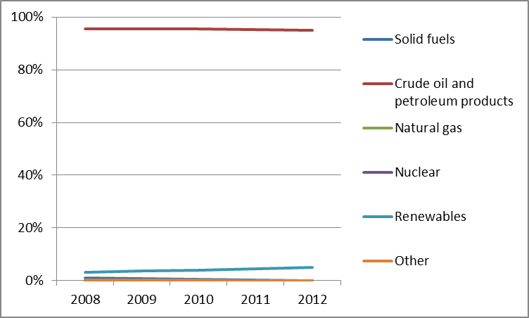
The gross electricity generation in 2012 was 4.72 TWh, a drop of 4.3% compared to 2011. Electricity in Cyprus is generated mainly by crude oil and petroleum products. Only 3.6% of electricity is generated by renewables, despite Cyprus' remarkable potential in solar and wind. However, renewables are increasing their contribution in electricity generation. In 2012, electricity generation from renewables more than tripled compared to 2010 levels, mainly due to the increase of wind power generation. The National Renewable Energy Action Plan projected that by 2018 the electricity generation capacity from renewable energy sources would reach 400 MW. In 2012, the installed renewables have reached 172 MW. The gross electricity generation is presented graphically the period 2008-2011.
Figure 2: Gross electricity generation mix 2008 – 2011 (source: EU Energy in Figures – Pocketbook 2012 and 2013)
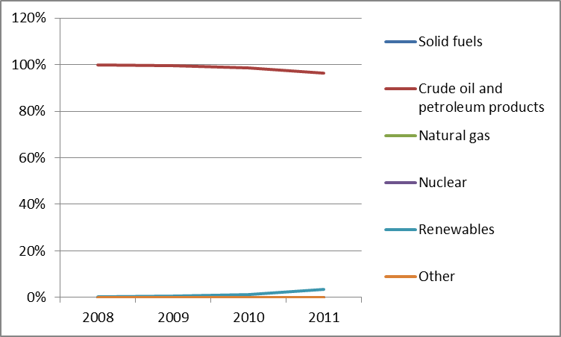
- Regulatory framework

General
An important regulatory development for 2012 was the implementing legislation of the Third Energy Package, which came into force in late 2012.

National Energy Regulator
The Cyprus Energy Regulatory Authority (CERA) was established in 2003. The objective of CERA is to regulate and monitor the Electricity and Natural Gas Markets. CERA employs 11 people. Further recruitment has been postponed as a result of government decisions for the wider public sector; CERA's lack of resources is a source of concern. The revenue of CERA for the year 2012 was EUR 1.96 million, an increase of approximately 14% from 2011. CERA closed the year with a net surplus of EUR 0.97 million.

Unbundling
The incumbent Electricity Authority of Cyprus (EAC) owns both the transmission and the distribution system. The TSO is legally but not functionally unbundled from EAC, since all its staff is seconded from EAC. The obligation of ownership unbundling of the TSO does not apply, since Cyprus has obtained a derogation from Article 9 of the 2009/72/EC Directive. The DSO is responsible for managing, operating and developing the network, safeguarding access to the distribution network and equal treatment for all users. EAC has unbundled the accounts of the DSO.
- Wholesale Markets

Electricity
Whilst full liberalisation of the market was legally achieved on 1st January 2014 when a derogation granted under the Second Energy Package pursuant to its status of small isolated system expired, Cyprus is not integrated and not interconnected with any neighbouring power systems. No wholesale market is currently operating in Cyprus; in the Memorandum of Understanding with the “Troika” (the European Commission, the International Monetary Fund and the European Central Bank) Cyprus engaged to develop open and competitive energy markets.
The installed generating capacity in 2012 was 1,546 MW, out of which 1,374 MW was thermal power stations and 172 MW was renewable capacity mainly from wind parks. The installed capacity of cogeneration of heat and power was 9.4 MW in 2012.
Based on the supply interruption data for 2012 the overall minutes lost per voltage level per year are estimated at 41 minutes for H/V, 157 minutes for M/V and 8 minutes for L/V. This represents an increase over the years for which data was available.

Gas
Currently, natural gas is not supplied to Cyprus. However in December 2011, significant gas resources were discovered within the Eastern Mediterranean Sea. The Cypriot authorities have established two National Hydrocarbons Companies whose respective tasks and functions are currently being defined: in principle EYK (formerly KRETYK) should be in charge of upstream and export issues, while DEFA should focus on the development of domestic market. Both have the legal form of private companies 100% owned by the State. In addition, an interim solution was planned for the supply of the electricity generation sector with natural gas until the indigenous natural gas reserves are made available. On 27 September 2012, DEFA and EAC issued an invitation for the Expression of Interest for the supply of natural gas to Cyprus. Seventeen applications were submitted, but none was accepted. A second invitation was issued in January 2014 with a deadline of 24 March 2014, subsequently extended to 14 April 2014.
- Retail Markets
Domestic consumers became legally eligible to switch suppliers on 1st January 2014. However, EAC is still the sole electricity supplier in Cyprus and thus switching procedures do not exist. Electricity prices are well above the EU average. The network component in households represented 15% of the total bill, while in industry it represented 11% of the end price.
Figure 3: Electricity price change by component 2010 – 2013 (source: Eurostat, energy statistics)
Electricity demand in 2012 decreased by 4.6% compared to 2011, which was the largest drop amongst all EU Member States.
According to EU law, Member States are obliged to ensure the deployment of smart metering systems, which may be subject to a cost-benefit analysis, on 80% of electricity customer premises by 2020 where positively assessed. To prepare for this medium-term goal, the EAC is implementing a pilot project of 3,000 smart meters .
- Consumers
The retail electricity market in Cyprus is performing just below the EU average (70.7 points compared to 72.0) and ranks 18th EU-wide. The proportion of consumers encountering problems in this market is the lowest in the EU. (The questions on switching, ease of switching and choice have not been asked given that the market is a monopoly).
The consumer protection measures, including those set out in Annex I of the directives 2009/72/EC and 2009/73/EC, are effective and enforced through the Laws N.211(I)/2012 and N.219(I)/2013 on Regulating the Electricity and Gas Markets, respectively. As stated earlier, from 1st January 2014 the electricity market is technically fully liberalised, but there is still only one supplier, and no scope for switching. Energy poverty, vulnerable consumers' categories and measures to protect them were defined in a Ministerial Decree, which includes measures such as reduced prices on electricity tariffs and financial incentives for participating in a Plan for setting up a Photovoltaic system at their house, with a capacity of up to 3kW with the net-metering method. In 2012, 3% of all household consumers were defined as consumers with special needs.
- Infrastructure
In accordance with the requirement in the TEN-E Regulation, Cyprus authorities have established a one stop shop for the permitting of Projects of Common Interest (PCIs).
Prior to the discovery of gas resources in the EEZ of Cyprus, the construction of an LNG regasification terminal and pipelines to the three power stations in Vasilikos, Moni and Dhekelia were planned by the Cypriot Authorities. The construction of the pipelines is supported under the European Energy Program for Recovery (EEPR) and entitled to a EUR 10 million grant.
With the recent discoveries, infrastructures are also planned for the export of gas. Pipeline and LNG projects are currently being assessed and should allow for gas export by the end of the decade. These infrastructures have been identified as PCIs under the Regulation on the Guidelines for the Trans-European Energy Network.
A future interconnection project called “Euroasia Interconnector” is in the feasibility phase. The project will have a capacity of 2,000 MW and interconnect the Cypriot, Israeli and the Greek transmission networks.
In total four projects involving Cyprus have been identified as PCIs in accordance with the guidelines for Trans-European energy infrastructure.
- Security of supply
The consequences of the energy crisis after the explosion which damaged the Vassilikos Power Station in July 2011, ended earlier than originally estimated. This was due to both the adequacy and the swift repair achieved in restoring Vassilikos Power Station and to a reduction in demand. Although the installed capacity of thermal power stations in 2012 was 1,374 MW (a decrease of 13.6% compared to 2011), including 286.6 MW of temporary generating units, the maximum generation demand was 997 MW, achieving a reserve of 38%, which was the largest reserve recorded since 2004 . All existing fossil fuel generators run on heavy fuel oil or diesel oil, and some can be converted to run on natural gas.
- Key indicators
Electricity |  | Gas
Number of companies representing at least 95% of net power generation | 1 | Number of entities bringing natural gas into country | N/A
Number of main power-generation companies | 1 | Number of main gas entities | N/A
Market share of the largest power-generation company | 100% | Market share of the largest entity bringing natural gas | N/A
Number of electricity retailers | 1 | Number of retailers selling natural gas to final customers | N/A
Number of main electricity retailers | 1 | Number of main natural gas retailers | N/A
Switching rates (entire electricity retail market) | N/A | Switching rates for gas (entire retail market) | N/A
Regulated prices for households – electricity | Yes | Regulated prices for households – gas | N/A
Regulated prices for non-households – electricity | Yes | Regulated prices for non-households – gas | N/A
HHI in power-generation market | 10000 | HHI in gas supply market | N/A
HHI in electricity retail market | 10000 | HHI in gas retail market | N/A
Electricity market value (bn€) | 1.2 | Gas market value¹⁸ (bn€) | N/A
Installed generation capacity (MW) | 1,742
Peak load (MW) | 997
Number of smart meters installed | N/A

Czech Republic

Key issues
Coupling of the day-ahead markets between the Czech Republic, Slovakia and Hungary improved price stability in the region. Market coupling with the rest of European regions remains a priority.
Further investment in cross-border interconnectors will increase market competition and energy security. Unscheduled power flows from Germany remain a big concern for the Czech Republic as they risk the safe operation of its transmission networks.
The Czech Republic should reinforce its power distribution and transmission network in order to integrate power generating facilities, including dispersed renewables.
The major concerns regarding security of supply relate to depleting lignite reserves, an ageing electricity infrastructure (including the generation portfolio) and high networks costs, which influence the electricity prices for end-users.

General Overview
Energy consumption in 2012 (42.78 Mtoe) was based largely on fossil fuels, notably coal (with a share of 40% in the energy consumption mix). The renewable energy share is increasing and has reached 11,2% in 2012, mainly due to solar and hydro contributions (8%). The Czech Republic was above its 2011/2012 interim trajectory and is on track to achieve its national 2020 RES target of 13% by 2020. The power generation mix in 2011 (87.5 TWh) was dominated by solid fuels. Cogeneration provided for 12.8% of the total electricity generation in 2011, falling slightly comparing to 2010.

Figure 1: Gross inland consumption 2008 – 2012 (source: Eurostat)
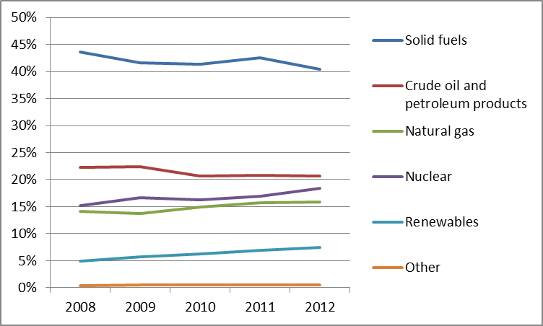

Figure 2: Gross electricity generation 2008 – 2011 (source: EU Energy in Figures – Pocketbook 2012 and 2013)
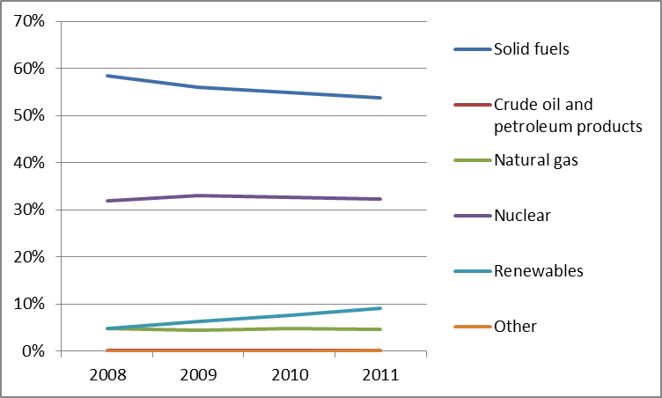
- Regulatory framework

General
The Czech Republic has introduced amendments to their incentive scheme for renewables and the support for all new installations except small hydro ceased at the end of 2013. This has slowed down the development of the sector which had increased rapidly in the previous period.

National Energy Regulator
The Energy Regulatory Office ("Energetický regulační úřad", ERO) is responsible for energy regulation in the Czech Republic. In 2012/13, ERO employed 178 staff. The 2012 budget of EUR 8 million doubled compared to 2011, due to the amendment to the Energy Act which markedly reinforced the ERO’s powers, in particular those of supervision, oversight penalisation and remedial measures in cases of violations of legal regulations and in the enforcement of sanctions.

Unbundling
In 2012, ERO certified the ownership unbundling of the electricity TSO, ČEPS. In the gas sector, at the beginning of 2013 ERO issued a certification decision concerning NET4GAS, which opted for the status of Independent Operator (ITO). Gas distribution companies are legally unbundled from the TSO, gas trading companies and gas storage operators.
- Wholesale markets

Electricity
The concentration of wholesale power generation remains very high. ČEZ is the dominant electricity generator with a market share close to 80%.
In the Czech Republic, electricity is traded at Prague-based Power Exchange Central Europe (PXE), and in spot markets (day-ahead and intraday) organised by OTE, a.s. (a joint stock company established in 2001 which acts as the Czech electricity and gas market operator). In 2012, a total of 112 TWh was traded under bilateral contracts registered in the OTE system with an additional 11 TWh traded in the organised spot markets. A total of 19,8 TWh was traded at the PXE in future energy exchange products (a market volume of EUR 944 million).
The market coupling of the Czech, Slovak and Hungarian day-ahead markets started in September 2012 and has been successful so far. The price convergence between the countries reached 76% after the launch of the market coupling. Cross-border capacity allocation for power transmission for German, Polish and Austrian borders takes place through Central Allocation Office, GmbH. Capacity allocation with Slovakia is based on long-term nominations. The average Czech day ahead wholesale price in 2012 was approximately EUR 43 /MWh for base load power (a decrease compared to 2011).

Gas
In 2012, 25 entities imported gas into the Czech Republic. The largest entities importing gas were RWE Transgas, WINGAS GmbH & Co. KG, and VNG Energie. The volume of natural gas imports reached 6.9 Mtoe in 2012. It was bought mostly from Russia and Norway under long-term contracts, but also at European energy exchanges, or from domestic resellers. The average price for gas imported from Russia was EUR 37.4/MWh in the third quarter of 2012.
Trading activity on the Czech virtual trading point increased significantly in 2012 and reached 107 TWh in bilateral contracts (compared to 0,258 TWh in 2011). The increase was due to new brokering activities of three companies: 42 Financial Services (42FS), Tradition Financial Services (TFS) and ICAP. In 2012, a bi-directional transmission between the Czech virtual trading point and Slovakia was enabled.
- Retail markets

Electricity
Market concentration remains very high, but the dominant position of three main power suppliers, ČEZ, E.ON and PRE is gradually decreasing. The three companies covered close to 70% of the market in 2012 down from 85% in 2011.
Czech power prices are fully liberalized. The supplier switching ratio in 2012 was relatively high (7.96%).
Between 2008 and 2012, power prices decreased for industrial consumers and increased for household consumers.
Figure 3: Electricity price change by component 2008 – 2013 (source: Eurostat, energy statistics)
The network component of electric energy prices for households has increased since 2010 (figure 3). The levies related to the share of renewables in electricity consumption grew from less than 2% of the total energy bill for households in 2009 to more than 9% in 2012.

Gas
Competition in the retail supply market is increasing. In 2012, there were 59 active gas suppliers in the retail market, 10 more than in 2011. Nevertheless concentration remains high. ERO reports that the retail market may saturate if the number of traders continues to grow. In 2012, gas was distributed by six regional companies.
Figure 4: Natural gas price change by component 2008 – 2012 (source: EC, EPCR metadata)
Gas prices are generally determined by long-term contracts but a growing number of suppliers offer prices reflecting spot market prices. Gas prices for industrial consumers decreased between 2008 and 2012 as network and tax related components of natural gas prices for industry decreased (figure 4). In the first part of 2013, gas prices for household consumers reached EUR 0.064/kWh. In the same period, gas prices for industrial consumers reached EUR 0.034 EUR/kWh.
In the gas sector, switching rates have remained stable in the past few years, at around 12% for both the whole retail market and households.

Smart meters
The outcome of the cost benefit analysis of smart meter deployment, undertaken by the Czech government, was negative. Consequently, a formal decision was made not to proceed with the roll-out of smart metering in both the electricity and gas sectors. In 2014 the European Commission formally requested the Czech Republic to ensure that final energy consumers are provided with individual meters.
- Consumers
Retail gas market is assessed below the EU average (72.0 points compared to 74.1) and ranks 19th EU-wide. The market is also assessed below the average of 31 domestic services markets (24th position). In particular, trust in providers is 4th lowest in the EU. However, switching rates are the second highest in the EU while the ease of switching receives the fourth highest score. Overall, this market has remained stable compared to 2012. Consumer assessment of the electricity retail market is above the EU average (72.9 points compared to 72.0), corresponding to 15th place. It increased by 3 points between 2012 and 2013, in particular with regard to overall consumer satisfaction, choice of providers, actual switching and ease of switching. The two last components have the 5th highest score in the EU.
Czech consumers no longer only switch from vertically integrated incumbents to new suppliers, but also between suppliers to obtain the lowest price. The total number of switches in the electricity sector was 472,000 in 2012 (from that 382,000 households) and in the gas sector it was 348,000 (from that 316,000 households).
Consumers can access a tool providing information on electricity suppliers on ERO’s website. Consumers may address their complaints, questions, and suggestions to the Consumer Protection Unit operating with ERO. The most frequent subject of complaints concern unfair commercial practises, switching and billing. Czech law does not define a “vulnerable customer”. The amendment of the Energy Act is currently under preparation and non-economic support should be foreseen in it.
- Infrastructure
The Czech authorities should ensure a proper and timely adoption of the measures stemming from the TEN-E Regulation, including the establishment of the one-stop-shop for Projects of Common Interest (PCIs) (due by 16 November 2013), and other measures foreseen for 2014 and 2015, including the publication of the manual on the permit granting process for project promoters, and the adoption of legislative and non-legislative measures streamlining the environmental assessment procedures.

Electricity
The increasing share of renewables in the energy mix of the Czech Republic and other countries in the region, as well as the foreseen increasing demand (up of about 200 MW per year depending on scenarios), call for an ambitious investment in the Czech energy infrastructure.
Several Projects of Common Interest (five in total) being developed in the Czech Republic aim to increase capacity at the country’s North-Western and Southern borders. Pending investments also include the upgrade of the transmission network to connect the new and modernised power plants. Improvement of distribution infrastructure is needed to enable the expansion of dispersed renewables. There is an on-going replacement and expansion project for the 400 kV grid. It is planned to be completed by 2030, but investment is slow and lead times are long.

Gas
In 2012, the GAZELLE gas pipeline was completed to connect to the OPAL and MEGAL gas pipelines that expand to the transmission system supplying Germany and France. Also, in 2012, the interconnector between the Czech and Polish gas transmission systems (the STORK project) was completed (partly financed with funds from the European Energy Programme for Recovery). The Czech-Polish interconnector plays an important role in the integration and liberalisation of the gas market in the region. Following the implementation of reverse flow projects (also co-financed by the EEPR), security of supply has substantially improved in the Czech Republic and Slovakia. A second pipeline between the Czech Republic and Poland is already planned to start operation end 2018, with two other projects with Austria planned to come online after 2020 (all these three are PCIs under the guidelines for Trans-European energy networks).
- Security of Supply

Electricity
The Czech Republic's degree of electricity dependence is one of the lowest in the EU (25.2 % in 2012). The generation mix is well diversified as the national strategy does not allow any single source of energy to provide for more than 65% of the total. Abundant domestic coal resources are gradually declining. They can be exploited until 2050. The country is a net electricity exporter. Major concerns relate to the depleting lignite reserves, ageing electricity infrastructure and high networks costs which influence the electricity prices for end-users.
The Czech Republic is interconnected with the Austrian, German, Polish and Slovak markets. The relatively high interconnection rate is generally positive for Czech security of supply, but has a downside. The Czech network suffers from unscheduled flows of power originating in Germany (loop flows).

Gas
Almost all gas consumed in the Czech Republic is imported from Russia (90%) and Norway (9%). Security of supply is relatively robust and has benefited from the new interconnectors and reverse flow capabilities on existing pipelines being put in place. The contractual gas prices are mostly linked to oil products and hard coal. This maintains stable prices, but carries financial penalties in case of early termination. In this regard, an important precedent was set in October 2012 when RWE’s Czech subsidiary succeeded in its dispute with Gazprom over gas contracts. The court ruled for the first time that a company did not have to pay fines under a "take-or-pay" clause.
- Key indicators
Electricity |  | Gas
Number of companies representing at least 95% of net power generation | 73 | Number of entities bringing natural gas into country | 25
Number of main power-generation companies | 1 | Number of main gas entities | 1
Market share of the largest power-generation company | 78% | Market share of the largest entity bringing natural gas | 82.3%
Number of electricity retailers | 360 | Number of retailers selling natural gas to final customers | 59
Number of main electricity retailers | 3 | Number of main natural gas retailers | 11
Switching rates | 7.96 | Switching rates for gas (entire retail market) | 12.03
Regulated prices for households – electricity | No | Regulated prices for households – gas | No
Regulated prices for non-households – electricity | No | Regulated prices for non-households – gas | No
HHI in power-generation market | N/A | HHI in gas supply market (domestic) | 3,358
HHI in electricity retail market (domestic) | N/A | HHI in gas retail market (domestic) | 1,632
Electricity market value (bn€) | 5.001 | Gas market value³⁰ (bn€) | 2.505
Installed generation capacity (MW) | 20,520
Peak demand (2012, MW) | 11,324
Number of smart meters installed | 50,000

Denmark

Key Issues
The energy mix will change significantly due to ambitious policy targets for renewable energy (wind power set to account for up to 50% of electricity generation by 2020). To address this interconnection capacities with neighbouring countries are being developed to maintain a high level of security of supply.
Danish household customers pay one of the highest electricity prices in EU, mainly due to a very high level of energy taxes. Compared to electricity prices for industrial consumers the price for household customers is three times higher. However, the electricity price without taxes for industrial consumers is below the EU-27 average (5% in 2012).
Annual domestic gas production was reduced by approximately 10% in 2012. Denmark now partly relies on imports through Germany to balance its gas supply and demand. Denmark's security of supply is closely linked to that of Sweden due to the fact that the latter is entirely dependent on Denmark.
Regulated end-user prices will be phased out by October 2015 (electricity) and, based on legislation yet to be proposed, by October 2016 (gas). A bill on a supplier centric model for the electricity retail market was adopted in June 2012 and will come into force by October 2015.

General overview
Gross energy consumption has decreased from 20.2 Mtoe (2008) to 18.1 Mtoe (2012). In 2012, Denmark relied on crude oil and petroleum products (39.0%), renewable energy sources (23.3%), natural gas (21.8%) and solid fuels (13.6%).
Figure 1: Gross inland consumption mix 2008 – 2012 (source: Eurostat)
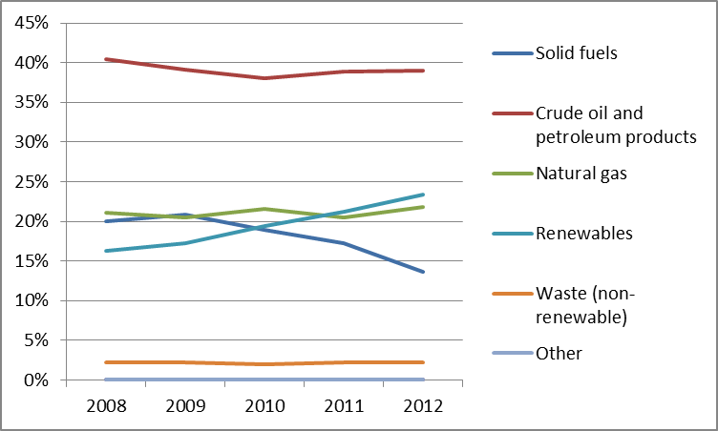
Total gross electricity generation in 2012 dropped to 30.7 TWh. In 2011, renewable energy sources provided the largest share for the first time (40.34%), whereas solid fuels were the second most important source (39.77%). Natural gas had a share of 16.48 % and crude oil of 1.42 %.
Figure 2: Gross electricity generation 2008 – 2011 (source: EU Energy in Figures - Pocketbook 2012 and 2013)
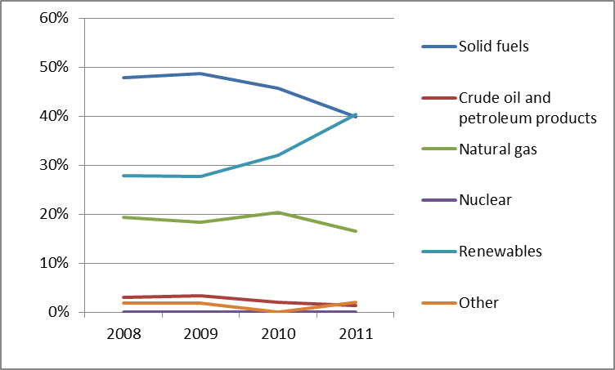
The RES share in gross final energy consumption in Denmark reached 26% in 2012 and is expected to rise to more than 35% by 2020. In spring 2011, the Danish government decided to raise the share of renewable power to 50% by 2020, thus exceeding the European targets. Cogeneration provided between 40.7% and 49.2% of the total energy generation between 2008 and 2011.

Regulatory framework

General
The Third Energy Package was implemented in national law with the adoption of Act no. 466 on 18 May 2011.

National energy regulator
The Danish Energy Regulatory Authority (DERA) was founded in 2000 and employs about 50 employees with a budget of about EUR 5.56 million in 2012. Compared with 2011 this is an increase by more than 10% in staff and budget.

Unbundling
The TSO for both gas and electricity is Energinet.dk. DERA adopted final certification decisions in February 2012 in accordance with the rules of the ownership unbundling model and making use of the provisions related to separation within the state.

Wholesale markets

Electricity
The largest electricity generators in Denmark are Dong Energy and Vattenfall who together account for about 56.7% of the total generation capacities. Denmark is part of the Nord Pool Spot, a joint energy exchange for the Scandinavian countries. More than 70% of the energy generated in the area is traded at Nord Pool Spot.
Denmark is divided into two market areas (Western Denmark DK1 and Eastern Denmark DK2). The energy is either traded day-ahead or intraday. The total volume traded day-ahead was 20.3 TWh in DK1 and 15.3 TWh in DK2 (2012), while the volume traded intraday was 0.2 TWh in DK1 and 0.2 TWh in DK2 (2012). The average price (arithmetic mean) in 2012 was EUR 36.33/MWh in DK1 and EUR 37.56/MWh in DK2.
The Danish electricity wholesale market is part of the day-ahead market coupling project which began operation in February 2014.

Gas
The annual gas production for 2012 in Denmark was 5.455 mcm, production decreased by about 10% compared with 2011. The gas consumption was at 3.696 mcm while an amount of 2.830 mcm was exported. Only a very small amount was imported from Germany. The three important export countries were Sweden (37.84 %), the Netherlands (35.19 %) and Germany (26.96%).
The Danish wholesale market is mostly based on bilateral trading (OTC trading), but volumes traded at the Danish gas exchange (Gas Point Nordic) have by 2014 reached 25%. It has been possible to trade gas on the gas exchange since 2008. The gas exchange was established in 2007. The average prices were EUR 27.98/MWh in 2013, EUR 25.16/MWh in 2012 and EUR 23.25/MWh in 2011.

Retail markets

Electricity
The electricity market was liberalised in 2003. There are currently 33 active suppliers in the retail market. DERA recognises that the level of competition needs to improve. In 2012, 6.7% of the end consumers switched supplier, which is an increase on 2011 levels (3.18%), but still low. Since 2003, all Danish electricity consumers are free to choose whether to join the regulated market with regulated prices or the liberalised market where prices are not regulated. Consumers above 100,000 kWh, covering about 50% of the retail market (in terms of consumption), are active in the market, whilst at least until the end of 2012, between 90 and 95% of electricity consumers had not exercised their right to change supplier and remained on default contracts with regulated prices. However, for most consumers, the regulated prices will cease by October 2015.
Figure 3: Electricity price change by component 2008 – 2013 (source: Eurostat, energy statistics)
The electricity prices for consumers are frequently updated by DERA and published on www.elspristavlen.dk where both fixed and variable prices are shown. The prices did not rise between the first half of 2012 and the first half of 2013, remaining constant at EUR 0.3/kWh, which is the highest electricity price within the EU and primarily caused by the highest level of taxes and levies including VAT (56.7%).
In 2013, the Danish Energy Agency issued a new regulation securing the full roll-out of smart meters in Denmark by 2020. Large scale replacement of existing meters began in 2010/2011 and currently more than 50% of consumers have smart meters. There are already 1.63 million metering points where a smart meter is installed following a voluntary roll-out led by the distribution system operators (DSOs), and the remaining 1.38 million will be also equipped following a positive cost-benefit analysis.
On 1st October 2015, the electricity retail market will change to a supplier centric system, where electricity suppliers buy grid services on a wholesale basis, and sell “delivered electricity” to consumers. By the same date, regulated prices will cease for almost all consumers. The suppliers of electricity will become the primary contact for consumers. This should make bills easier to read as there will only be one price for electricity covering both energy consumption and transmission costs. Due to this simplification consumers may be encouraged to become more active. One important initiative to boost the competitiveness of the retail market is the so-called 'datahub', a data platform developed and managed by the ownership-unbundled Danish TSO, Energinet.dk, which simplifies the extensive data traffic between the players in the Danish electricity market and makes it easier for electricity consumers to change supplier and to access their own consumption data. The datahub has been operational since March 2013.

Gas
The gas market was liberalised in 2004. In 2012, a total number of 14 retail suppliers were active in the market. On average the Danish customer is able to choose between at least 12 different suppliers. In 2012, 7.7% of end-consumers switched supplier. The retail market concentration is relatively high with a Herfindahl-Hirschman Index (HHI) of 3.648 in 2013. Customers are able to choose between regulated and unregulated prices. However, at least until the end of 2012, the vast majority of smaller gas consumers had not exercised their right to change supplier and remained on default contracts with regulated prices. For most consumers, regulated prices will cease by October 2016. The majority of small scale customers are not active in the unregulated market segment, whilst large scale consumers are. The prices for consumers are monitored by DERA and published on www.gasprisguiden.dk. The average natural gas price for households was EUR 13.82/GJ in 2013, decreasing constantly in the last two years (2011: EUR 16.47/GJ). The average price for industrial consumers was at EUR 10.74/GJ in 2013 which is an increase of 4.51% compared to the previous year.
Figure 4: Natural gas price change by component 2008 – 2012 (source: EC, EPCR metadata)
At the moment there are no plans to implement smart gas meters on a large scale.

Consumers
Danish consumers rate the performance of their retail electricity and gas market above the EU average (75.4 points compared to 72.0 and 77.0 compared to 74.1), corresponding to 12th and 9th place EU-wide, respectively. The gas market also ranks above the average of all domestic services markets (12th place out of 31), while the electricity market scores just below the average (17th place). The incidence of problems is the second lowest for electricity and lowest for gas in the EU. Both markets score high on trust in providers and overall satisfaction (2nd and 3rd highest in the EU in the case of gas market). On the other hand, comparability is amongst the lowest rated in the EU, (lowest for the gas market and 5th lowest for electricity) .
There are no specific provisions regarding vulnerable consumers in energy law; instead this issue is dealt with in social legislation.
Denmark is one of very few countries to protect energy consumers in remote areas.

Infrastructure
The Danish authorities should ensure a proper and timely adoption of the measures stemming from Regulation 347/2013 on the trans-European energy infrastructure, including the establishment of the one-stop-shop for Projects of Common Interest, PCIs (due by 16 November 2013), and other measures foreseen for 2014 and 2015, including the publication of the manual on the permit granting process for project promoters, and the adoption of legislative and non-legislative measures streamlining the environmental assessment procedures.

Electricity
The highly ambitious goals for the Danish energy policy to meet all energy demand by renewables by 2050 are a challenge to the electricity transmission system. Hence, Denmark is enhancing its electricity interconnections with neighbouring countries i.e. Germany and the Netherlands and strengthening or expanding existing interconnectors. Some of these projects are long-term with commissioning dates foreseen for years 2018 – 2022.

Gas
As a result of the gradual depletion of the Danish gas production in the North Sea, Denmark (and Sweden) require access to new gas resources.
The expansion of the gas infrastructure in the Southern part of Jutland was completed in October 2013. The expansion includes establishment of a new compressor station at Egtved and looping of the existing transmission pipeline from the German border to Egtved. Furthermore, the first phase of expansion of the transport capacity in the Northern part of Germany is completed and the next phase of the expansion is planned to come into operation in October 2015. The expansion of the cross-border connection will allow Denmark (and Sweden) to increase imports of gas from Germany in order to compensate for the decreasing Danish North Sea production. The bi-directional flow on this interconnection allows Denmark to export gas to Germany during the summer time and import gas from Germany during winter time, where gas consumption in Denmark (and Sweden) is high due to need for gas for heating purposes. The German part of the expansion of the gas system is part of the list of PCIs.

Security of Supply

Electricity
ENTSO-E predicts power imbalances from winter 2016, mainly caused by the ambitious targets for renewable energy. However ENTSO-E’s calculations do not take into account that Germany is phasing out its nuclear power plants. Nevertheless, the Danish grid has been very reliable in the past. To maintain this high level, Energinet.dk is extending its electricity infrastructure with the surrounding countries to avoid becoming dependent on the capacity of a single country. In 2013, Energinet.dk and National Grid signed a cooperation agreement to consider the feasibility of an electricity interconnector between Denmark and the UK.

Gas
Denmark implemented the requirements of the EU Regulation 994/2010 in October 2012, including an Emergency Plan for the Danish gas transmission system. The expansion of the gas transmission system towards Germany will ensure increase in import capacity from Germany in order to supplement gas supplies from the Danish North Sea as the production is foreseen to decrease in forthcoming years. However, the new Hejre gas field is expected to come on stream in 2016/2017 and will increase the production in the North Sea.

Key indicators
Electricity |  | Gas
Number of companies representing at least 95% of net power generation | ~1300 | Number of entities bringing natural gas into country | N/A
Number of main power-generation companies | 2 | Number of main gas entities | N/A
Market share of the largest power-generation company | 37% | Market share of the largest entity bringing natural gas | N/A
Number of electricity retailers | 55 | Number of retailers selling natural gas to final customers | 14
Number of main electricity retailers | N/A | Number of main natural gas retailers | N/A
Switching rates (entire electricity retail market) | 6.7% | Switching rates for gas (entire retail market) | 0.9%
Regulated prices for households – electricity | partly | Regulated prices for households – gas | partly
Regulated prices for non-households – electricity | partly | Regulated prices for non-households – gas | partly
HHI in power-generation market | N/A | HHI in gas supply market | N/A
HHI in electricity retail market | N/A | HHI in gas retail market | 3,648
Electricity market value (bn€) | 5.053 | Gas market value (bn€) | 1.514
Installed generation capacity (MW, 2011) | 13,580
National instantaneous peak load (MW) | 6,169
Number of smart meters installed | N/A

Estonia

Key issues

Following the successful establishment of the power grid connection Estlink2 − the second electricity interconnection with Finland – in March 2014, cooperation with Latvia (and Lithuania) on making available increased interconnection capacity – both through better use of existing capacity and by building a new interconnector – must now be accelerated with a view to improve electricity wholesale market functioning in the wider Baltic area.

Estonia’s gas market remains isolated from the rest of Europe. Estonia should increase efforts to diversify its gas supplies, primarily through a regional Baltic LNG terminal and the construction of the BalticConnector. Preparations should also be made to the law to legally lay down the rules applicable after the end of this isolation and the related exemption from market opening.

General overview
The Estonian national gross energy consumption in 2012 was 6.13 Mtoe. It was based largely on solid fuels (shale oil), less notable was crude oil, petroleum products and natural gas, while the share of renewables in gross final energy consumption in 2012 amounted to 25.2%. According to Eurostat, the renewables share between 2008 and 2012 grew from 19.0% to 25.2% accordingly. The Estonian renewables target for 2020 is 25%.
Figure 1: Gross inland consumption mix 2008 – 2012 (source: Eurostat)
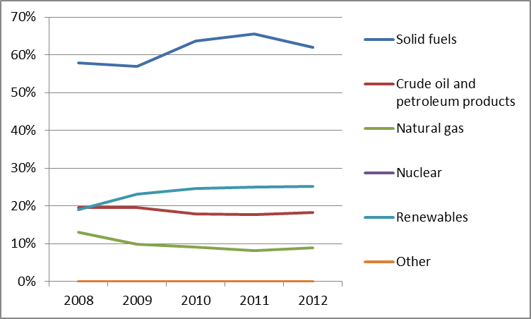
In 2012, the total power generation was 11.967 TWh, a significant part of it was derived from solid fuels (81%). Renewables and natural gas took smaller parts, respectively 12.3% and 1.0%. Renewables increased from 2.1% to 12.3% (between 2008 and 2011). In 2012, the increase in Estonia’s electricity demand was higher than in the rest of the EU countries – 8.7% (in comparison to 2011 level).
Figure 2: Gross electricity generation mix 2008 – 2011 (source: EU Energy in Figures – Pocketbook 2012 and 2013)
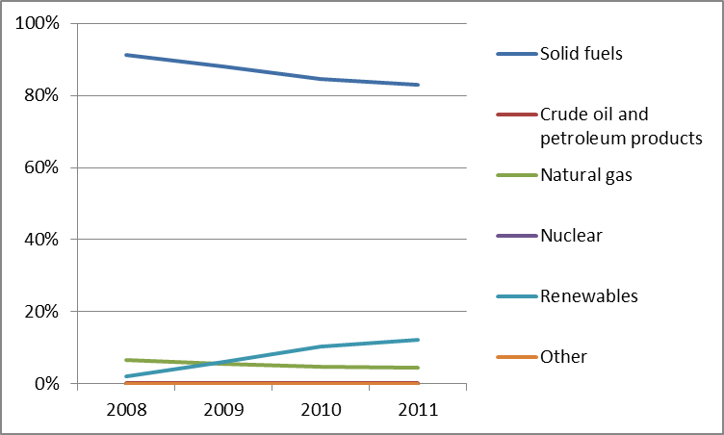
Cogeneration represented 9.75% of gross electricity generation in 2011. In 2012, the total import and consumption of natural gas in Estonia amounted to 0.545 Mtoe. Estonia has cross-border natural gas connections with Russia and Latvia only, and Russia (OAO Gazprom) is the sole supplier of gas to all three Baltic countries.

Regulatory framework

General
Estonia transposed fully the Third Energy Package Gas Directive in April 2014. In 2014, additional amendments will be enforced both in the Electricity Market Act and in the Natural Gas Market Act, which harmonise other requirements arising from the transposition of the Third Package into the Estonian legislation.

National Energy Regulator
The Estonian Competition Authority (ECA) acts as the regulator for several sectors. It employs 61 staff members (of which 21 work on energy issues) with an annual budget of almost EUR 1.83 million in 2012. The Commission questions whether the allocated human and financial resources are sufficient for ECA to carry out its regulatory tasks.

Unbundling
The electricity TSO, state-owned Elering AS, was certified by the ECA in December 2013 as compliant with the ownership unbundling rules. There is a single operator in gas, AS EG Võrguteenus, which provides transmission and distribution services and belongs to the vertically integrated gas supply company AS EestiGaas. Although art. 49 of Directive 2009/73/EC sets out an exemption for Estonia and does not require the unbundling of the transmission system, on 8 July 2012 the amendment to the Natural Gas Market Act chose not to apply the exemption in future, but selected the route of complete ownership unbundling. On 31 December 2012, the system operator EG Võrguteenus submitted to ECA the plan for the fulfilment of the requirements of the ownership unbundling that are planned to be finished by 1 January 2015.

Wholesale markets

Electricity
The 2012 load in the Estonian electricity system peaked at 1,572 MW (on 6 February 2012), while the installed capacity in the Estonian electricity system was 2,278 MW. Effective competition is limited by the dominant position of Eesti Energia AS, which accounted for 88% of the total electricity production in 2012.
There are 17 traders that operate through the Nord Pool Spot's Estonian price area and in total there are 201 eligible customers in Estonia who buy electricity either through bilateral contracts or from the power exchange. An average price in the Nord Pool Spot Estonian price area in 2012 was EUR 39.20/MWh, which is lower than the 2011 price by almost 10%. In 2012, the highest hourly price was EUR 183.48/MWh, while the lowest was EUR -7.06/MWh.
From 1 January 2013 Estonia’s electricity market was completely opened and all customers are eligible consumers. An average price in the Nord Pool Spot Estonia price area in 2013 was EUR 43.14/MWh. In 2013, the highest hourly price was EUR 210.01/MWh, while the lowest was EUR 5.08/MWh.

Gas
Estonia imports natural gas exclusively from Gazprom. During winter, the Inčukalns gas storage facility in Latvia is used by Gazprom to supply Estonia. In 2012, gas imports amounted to 679 mcm (100% of gross inland consumption). In 2012, there was only one wholesale trader on the market – AS EestiGaas. An import license has been issued to other two companies: AS Nitrofert, which obtains gas only for its own needs, and to Baltic Energy Partners OÜ, which has not made any material gas imports so far.
As there is no competition between the sellers or traders, there is no organised gas hub. According to the contract, the import price of gas is calculated using a price formula based on the previous nine months heavy and light fuel oil average prices in USD/ton proceeding to the accounting month, taking into account the USD/EUR exchange rate.

Retail markets

Electricity
In 2012, the share of eligible consumption was 2.785 TWh, which equals to 37.6% of the final consumption of electricity (total consumption without network losses – 7.407 TWh). The largest share of 82.9% of electricity sales in 2012 was held by Eesti Energia AS, followed by Imatra Elekter AS with 2.7% and VKG Elektrivõrgud OÜ with 2.6%.Elektrum Eesti AS with 13.0% and 220 Energia OÜ with 1.5%. In 2012, the number of electricity retailers to final consumers was 42.
In 2012, there were five independent suppliers, who sold electricity to eligible consumers. Non-eligible consumers were obliged to buy electricity from regulated suppliers. According to the Electricity Market Act, in 2012 ECA approved the average selling price to non-eligible customers.
Figure 3: Electricity price change by component 2008 – 2013 (source: Eurostat, energy statistics)
As non-eligible customers did not have an option to change supplier, between year 2011 and 2012 there was no supplier switching. In 2013 there were 15 suppliers, who had an opportunity to sell electricity to consumers which now can change supplier.
The roll-out of smart meters is due to be dealt with in the next Energy Sector Development Plan 2030. The Estonian grid code determines that all consumers must be provided with a “remote reading device” by 2017. No cost-benefit analysis has yet been carried out.

Gas
Similar to the wholesale market, AS Eesti Gaas also has a dominant position in the retail market. Its retail market share in 2012 was 89.0%, while the remaining 11.0% was sold by another 27 licensed gas sellers. The number of customers in the retail market is approximately 42,000, of which 41,000 are households. In 2012, 1,913 customers switched (1,810 of these were households), or 4.5% of the customers.
The import price of gas is calculated according to the changes in the average price of oil derivatives (heavy and light fuel oil), which drive the fluctuation of the gas price. End users pay the full import price, plus transportation cost and a regulated profit margin.
Figure 4: Natural gas price change by component 2008 – 2012 (source: EC, EPCR metadata)
In 2013, the average gas retail price consisted of: energy and supply costs – 51%; network costs – 22%; VAT and other taxes – 26%. No formal decision and no plan to roll-out smart meters in natural gas system had been made by 2013.

Consumers
The retail gas market is assessed fourth highest in the EU (79.3 points compared to 74.1), with the fifth highest score on the overall consumer satisfaction. The incidence of problems is second lowest in the EU, following a small but steady decrease since 2010. However, consumer assessment of the choice of providers is the lowest in the EU, and switching rates are the second lowest (and have been falling since 2010).
In contrast to the gas market, the performance of the retail electricity market is assessed below the EU average (23th position with 66.2 points compared to 72.0) and the lowest among 31 domestic services markets. The performance of this market has seen the largest decrease of all electricity markets in the EU between 2012 and 2013 and the largest decrease among domestic services markets. Trust in providers and comparability are particularly low, and the latter indicator has considerably decreased in score since 2012. On the other hand, however, the market scores high on switching (6th place out of 25).
ECA acts as an alternative dispute resolution body. Consumers can also contact the Consumer Protection Board of Estonia. In 2012, the Competition Authority received 82 complaints and inquiries concerning the electricity retail market and 19 inquiries concerning the natural gas retail market. There is no price comparison site available for the electricity and gas retail market.
In Estonia, during 2013, there was no definition of a “vulnerable consumer” in the electricity sector. Nevertheless interruption of electricity supply is very detailed regulated in the Electricity Market Act. The supply of electricity to household customers (household customer who heated residential space in full or primarily by electricity) in the winter period may be interrupted only after the consumer has been given 90 days to pay the bill. In the summer it is 15 days. As regards natural gas, the term “vulnerable consumer” is defined. The supply of natural gas to vulnerable customers (family or individual receiving subsistence benefits) may be interrupted only when the consumer has been given 45 days in the winter period to pay the bill. In the summer it is 7 days.

Infrastructure

Electricity
Estonia is interconnected to the EU electricity market through the Estlink1 and Estlink2 interconnectors with Finland and has recently joined the Nord Pool Spot by creating the Estonia price area for the day-ahead market, intraday and trading in the power exchange.
However, the limited capacity of the connection between Estonia and Latvia creates cross-border bottlenecks, which have an adverse impact on the electricity markets of Estonia and other Baltic States.

Gas
Estonia’s gas grid is connected to the Russian Federation gas system as well as to Latvia. There is no link with the rest of the EU gas market.
The BEMIP initiative is launched with a view to end the isolation of the Baltic region in general and Estonia in particular from the European market. Proposed investment projects include an interconnection between Lithuania and Poland, and a planned regional LNG terminal. The BalticConnector is a proposed natural gas pipeline between Finland and Estonia, which would connect the Baltic and Finnish gas grids.
In 2013, it was decided that a regional Baltic LNG Terminal would be best placed on either the Finnish or the Estonian side of the Finnish gulf. It is important that the Baltic States reach a final agreement on the location of the terminal in order to start construction and introduce diversification of gas supplies as soon as possible.

Security of supply

Electricity
Estonia has sufficient production capacity to cover domestic electricity demand and for export to Latvia and Lithuania. The Estlink projects enhanced security of electricity supply and Estonia's independence of Russian supplies was increased. However, the Estonian grid continues to operate in synchronous mode with the Russian and Byelorussian grids. In 2012, negotiations were launched by the European Commission with the aim to conclude an Intergovernmental Agreement. Negotiations have been suspended at the request of the Baltic States pending their analysis of a study on the de-synchronisation of the Baltic grids and a move towards synchronisation with continental European grids.

Gas
Estonia has two interconnections with the Russian natural gas network (Värska and Narva) and an interconnection with Latvia (Karksi). However, natural gas in the share of final consumption of energy in 2012 was only circa 5%. For the Estonian gas network criterion N-1 equals 104.5%, thus the coverage of infrastructural peak demand or the coverage of supply deficit is ensured. However, given that the gas from the Latvian Incukalns storage facility is contracted from the same supplier, the de facto insecurity of supply continues to exist.

Key indicators
Electricity |  | Gas
Number of companies representing at least 95% of net power generation | 6 | Number of entities bringing natural gas into country | 1
Number of main power generation companies | 1 | Number of main gas entities | 2
Market share of the largest power generation company | 87.0% | Market share of the largest entity bringing natural gas | 86.5%
Number of electricity retailers | 42 | Number of retailers selling natural gas to final customers | 27
Number of main electricity retailers | 1 | Number of main natural gas retailers | 1
Switching rates (entire electricity retail market) | 0 | Switching rates for gas (entire retail market) | 4.5
Regulated prices for households – electricity | Yes | Regulated prices for households – gas | No
Regulated prices for non-households – electricity | Yes | Regulated prices for non-households – gas | No
HHI in power-generation market | 7,748 | HHI in gas supply market | >8,500
HHI in electricity retail market | 6,869 | HHI in gas retail market | 7,943
Electricity market value (bn€) | 0.427 | Gas market value³⁸ (bn€) | 0.093
Peak load (MW, 2012) | 1,572
Installed generation capacity (MW, 2012) | 2,647
Number of smart meters installed | N/A

Finland

Key issues
Currently, Finland is reliant on electricity imports during peak demand periods. It will continue to be reliant until the 1600 MW nuclear power plant, Olkiluoto 3, is complete. It is expected that the demand for reserve and balancing power will increase in the medium term.
Finland reached 97% smart metering at the end of 2013, with hourly settlement down to domestic level. Plans are in place for greater demand response by consumers and a common electricity retail market with Sweden, Norway and Denmark.
Finland should step up the development of cross-border gas connection to diversify supply sources and continue to promote competition through better integration of the Baltic energy markets. A decision on the location of the LNG terminal and BalticConnector should be taken urgently to improve gas security of supply and improve market functioning. Currently, Finland is only connected to Russia.

General overview
Finnish national gross energy consumption in 2012 amounted to 34.1 Mtoe of which renewable sources (mostly biomass and hydropower) provided 34.3%, showing good progress towards the renewable energy target of 38% for 2020.
Figure 1: Gross inland consumption mix 2008 – 2012 (source: Eurostat)
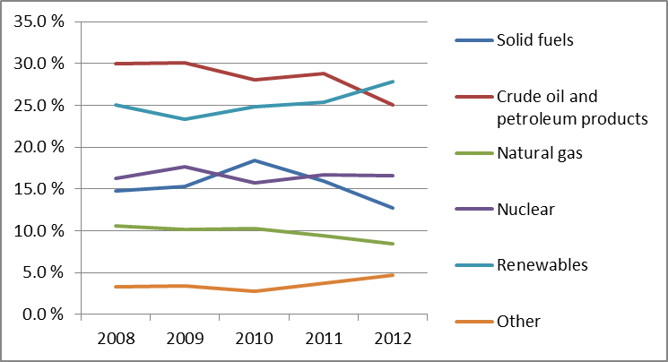
Finland’s electricity generation was 73.5 TWh in 2011, of which renewables, nuclear and fossil fuels each accounted for roughly one third. There was a significant decline of 9% in electricity generation from 2010. This was mainly due to mild weather, the waning growth of manufacturing and higher hydropower imports from Norway and Sweden. Finland has a relatively high share of combined heat and power (CHP) capacity that represented 36.2% of gross generation in 2011. The Finnish power production mix is illustrated in Figure 2.
Figure 2: Gross electricity generation mix 2008 – 2011 (source: EU Energy in Figures – Pocketbook 2012 and 2013)
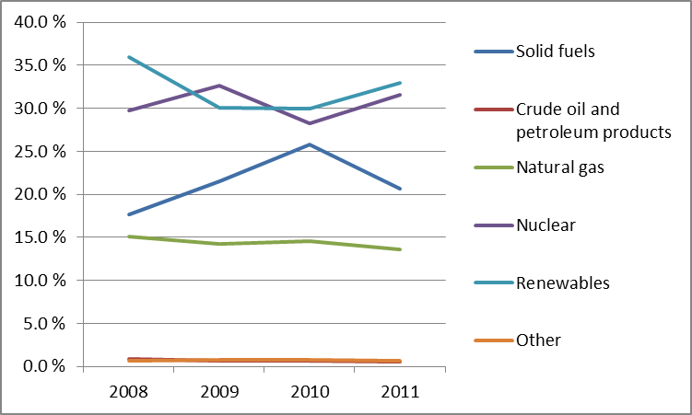
Installed electricity generation capacity in Finland was 16,947 MW at the end of 2012. The peak demand in that year was 14,433 MW and occurred in early February.

Regulatory framework

National Energy Regulator
The Energy Market Authority was renamed the Energy Authority in the beginning of 2014. This marked the introduction of new roles in promoting energy efficiency, counselling and communication, ecological design and energy labelling. By the end of 2012, the Energy Market Authority employed 66 people and had an annual budget of EUR 6.3 million.

Unbundling
The electricity transmission system operator Fingrid Oyj was certified in accordance with the model of ownership unbundling within the state in 2014 following the sale of shares by Fortum Power and Heat Oy and Pohjolan Voima Oy (PVO) to the Finnish State. 52 of the 83 DSO operators in Finland were legally declared unbundled in July 2013. Finland was granted a derogation from the obligation to liberalise its natural gas market, as long as the country only has one main supplier of natural gas and is not connected to the European gas network. This situation will change once a regional Baltic LNG Terminal becomes operational.

Wholesale markets

Electricity
The generation market is dominated by two companies: Fortum and Pohjolan Voima. Together these companies owned 50.5% of the production capacity in 2012. Apart from these companies, in 2012, there were approximately 120 companies producing electricity from 550 power plants.
Finland forms an integrated wholesale electricity market with the Nordic and Baltic countries. Physical day-ahead and intraday trading takes place in the Nord Pool Spot market. 62% of the Finnish consumption was traded through Nord Pool Spot in 2012 and the rest via bilateral agreements. Since 4 February 2014 the market is coupled to the Central Western and North Western European market.
There has been little congestion within Finland, but insufficient transmission capacities between countries have led to price differences. For example, prices between Finland and Sweden diverged 53% of the time in 2012. Average wholesale electricity price fell from EUR 49.30 in 2011 to EUR 36.64 in 2012 due to the good hydro situation and reduced consumption. Net imports accounted for 20.5% of the total electricity consumption in 2012. However, imports from Russia have decreased since 2011 when the Russian market introduced a capacity charge on the price of exported electricity.

Gas
Finland does not produce natural gas, but imports gas exclusively from Russia. Gasum Oy acts as the sole importer and transmission system operator on the basis of long term supply contracts. Gasum Oy also operates Kaasupörssi Oy, a natural gas exchange, for short term products and a bilateral secondary market where large consumers can make offers.

Retail markets

Electricity
There is no retail price regulation in Finland. Consumers can select their retail supplier freely. The annual switching rate of suppliers has settled at a level of 7-8%. There were approximately 74 retail suppliers of which 44 offered their products nation-wide in 2012. Market concentration at retail level was moderate as there were four retail suppliers with a market share above 5%. The market share of the three largest retail suppliers has been around 35-40%.
One of the strengths of the Finnish retail market is smart metering. The rate of smart metering reached 97% by the end of 2013. Balance is settled hourly down to domestic level. Implementation of supply contracts and end-user applications which encourage demand response is expected to increase in the following years.
Distribution tariffs are on the rise due to the aging electricity grid and the increased need for network investments to comply with reliability requirements. Investments in distribution networks increased in 2012 (+10% compared to 2011).
Retail prices have sustained a steady growth since 2006 with notable increases in taxes in 2011. Wholesale energy prices are reflected in the retail prices.
Figure 3: Electricity price change by component 2008 – 2013 (source: Eurostat, energy statistics)

Gas
Market concentration at the retail level was high at the end of 2012, as gas retailers in Finland have a monopoly within their own distribution network. There were 23 natural gas retail suppliers, most of whom only had a dozen customers. Natural gas retail prices for industrial users are shown in Figure 4, where it is also possible to see that the price of natural gas has increased during the last few years.

Consumers
Finnish consumers rate the performance of their retail electricity market above the EU average (77.5 points compared to 72.0), corresponding to 7th place EU-wide. The market has seen an increase of 2.8 points between 2012 and 2013. It scores better than EU average on all indicators with the exception of comparability and complaints and is assessed particularly well (3rd highest in the EU) on overall consumer satisfaction, choice of providers and trust. Results show a small but steady year on year increase in score on trust since 2010.
Electricity retail customers are satisfied with the ease by which they can switch supplier and the clarity of billing. The Energy Market Act (588/2013) specifies rules for supplier switching, information on customer bills, metering, meter reading and stipulates a standard compensation payable to customers for power outages. A price comparison tool provided by the Energy Authority has been used actively. There is no charge to change supplier and customers have rights to their own consumption data free of charge.
Social assistance is a last-resort form of income security in Finland. It is based on the client's essential expenses, which include electricity and heating bills. The Electricity Market Act (588/2013, §103) guarantees customers with a reasonable notice to allow them time with bills while waiting for social assistance for households heated by electricity during the winter.
Disputes between consumers and enterprises can either be taken to a general court of law or solved through the Consumer Disputes Board. The Board does not charge fees and its written decision is a recommendation.

Infrastructure

The Finnish authorities should ensure a proper and timely adoption of the measures stemming from the TEN-E Regulation, including the establishment of the one-stop-shop for Projects of Common Interest (PCIs) (due by 16 November 2013), and other measures foreseen for 2014 and 2015, including the publication of the manual on the permit granting process for project promoters, and the adoption of legislative and non-legislative measures streamlining the environmental assessment procedures.

Electricity
Finland is connected to Sweden, Norway, Estonia and Russia. The total import capacity of electricity at the end of 2012 was 4,650 MW, which is about 27.4% of the production capacity. On the Finnish-Russian connection currently only importing is possible, but exporting (up to 350 MW) has become technically possible during the first half of 2014.
A second submarine cable between Finland and Sweden, Fenno-Skan 2, with capacity of 800 MW was commissioned in 2011, but overall connection capacity between Finland and Sweden is 80% full. Another 100 MW, that connects mainland Finland through Åland to Sweden, is planned for 2015. Furthermore, a new 650 MW cable to Estonia, Estlink2, started operation at the beginning of 2014. The new cable triples the interconnection capacity and has improved connection with the Baltic States. The Electricity Market Act (588/2013) includes new reliability requirements. This will result in significant future investment requirements in rural areas.

Gas
The Finnish natural gas market is isolated, as it is only connected to Russia. The Baltic Energy Market Interconnection Plan (BEMIP), launched by the Commission in 2008, examines the options of diversifying gas supplies in the region. The plan points out that the most efficient option is the development of the of LNG facilities together with the necessary interconnectors.
Finland in cooperation with Estonia should make its best endeavours to develop the gas interconnector the BalticConnector which is identified as a Project of Common Interest under the guidelines for trans-European energy infrastructure.

Security of supply

Electricity
Until 2016 the available domestic production capacity will not be able to cover winter peak demand. The resulting deficit must be met by imports. A new nuclear power plant, Olkiluoto 3 by Teollisuuden Voima, with a capacity of 1,600 MW is due to be commissioned between 2016-2020 and remove most of the capacity deficit.
The Capacity Reserves Act (117/2011) is designed to ensure the balance between supply and demand. Strategic reserves which are not allowed to participate and bid on the commercial market, have been defined.

Gas
In 2012 there were no interruptions in gas supply to Finland. A substantial part of the gas consumption can be substituted with alternative fuels. The National Emergency Supply Agency acts as the responsible authority in defining measures to safeguard security of gas supply. Investments into LNG terminals in the region and the BalticConnector would help secure and diversify the gas supply.

Key indicators
Electricity |  | Gas
Number of companies representing at least 95 % of net power generation | 30 | Number of entities bringing natural gas into country | 1
Number of main power-generation companies | 4 | Number of main gas entities | 1
Market share of the largest power-generation company | 25.6% | Market share of the largest entity bringing natural gas | 100%
Number of electricity retailers | ~70 | Number of retailers selling natural gas to final customers | 23
Number of main electricity retailers | 3 | Number of main natural gas retailers | 1
Switching rates (entire electricity retail market) | 7.7% | Switching rates for gas (entire retail market) | N/A
Regulated prices for households – electricity | No | Regulated prices for households – gas | No
Regulated prices for non-households – electricity | No | Regulated prices for non-households – gas | Yes
HHI in wholesale market | 1,102 | HHI in gas supply market | N/A
HHI in electricity retail market | N/A | HHI in gas retail market | N/A
Electricity market value (bn€) | 6.979 | Gas market value¹⁵ (bn€) | N/A
Installed generation capacity (MW) | 16,947
Peak demand (MW) | 14,433
Number of smart meters installed (December 2013) | 97%
France

Key issues
Both wholesale and retail electricity and gas markets continue to be highly concentrated. Despite improvements, especially for gas, regulated tariffs continue to prevent alternative suppliers from entering the retail and wholesale markets. France would benefit from further liberalising the wholesale electricity market which remains one of the most concentrated in the EU. The renewal of hydroconcessions appears as an opportunity to foster a more competitive landscape for electricity generation in France.
Despite a good degree of market integration, limited electricity interconnection capacity with neighbouring countries (especially with Spain) continues to inhibit the development of competition and constrain the security of supply.
Gas infrastructure should also be developed to alleviate internal congestion between balancing zones and increase cross-border flows.
- General overview
The structure of the national energy mix has remained relatively stable. Nuclear energy continues to hold the highest market share (approximately 43%), followed by oil products (32%) and natural gas (14%).
Figure 1: Gross inland consumption mix 2008 – 2012 (source: Eurostat)
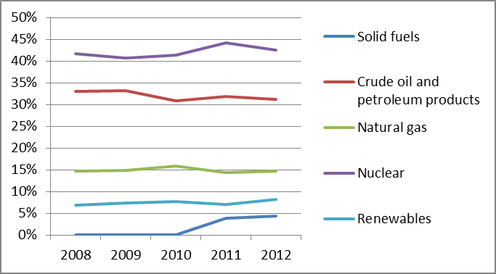
France has an obligation to reach 23% of RES share in gross final energy consumption by 2020. Despite the fact that France has stayed somewhat below its 2011/2012 interim target (12.8%), the share of renewable energy has nevertheless increased from 11.3% (2011) to 13.4% thus showing a positive trend (2012). This positive result is mainly due to contribution from the heating and cooling sector, which increased as a result of improved use of biomass.
On 18th June 2014, the French Energy Minister presented to the Council of Minister a draft law on Energy Transition. It will be debated in the French Parliament this autumn and adopted early 2015. It sets ambitious targets such as a 40% reduction in greenhouse gas emissions in 2030 and a target of 32% of renewables in the total final energy consumption by 2030, 30% reduction in fossil fuels consumption by 2030 and final energy consumption to be divided by 2 at horizon 2050. It also foresees the public tendering of hydroconcessions,
According to the electricity TSO RTE, gross electricity demand, peaked in 2010 (513 TWh) and later returned to near 2008 levels (495 TWh in 2013), with a record day consumption level registered in February 2012 (102.1 GWh). Trends show that demand is becoming more sensitive to daily temperatures, as a result of the increased use from the residential sector.
The market share of nuclear generation is stable at around 74% of market supply, whilst the contribution of renewables has progressively increased, reaching 19% in 2013 (in comparison to 14% in 2010), with a decline in oil and gas generation. However, there has been a slowdown in the growth rate of both wind and photovoltaic productions, reflecting both the financial crisis and a reduction in incentives.
Figure 2: Gross electricity generation mix 2008 – 2011 (source: EU Energy in Figures – Pocketbook 2012 and 2013)
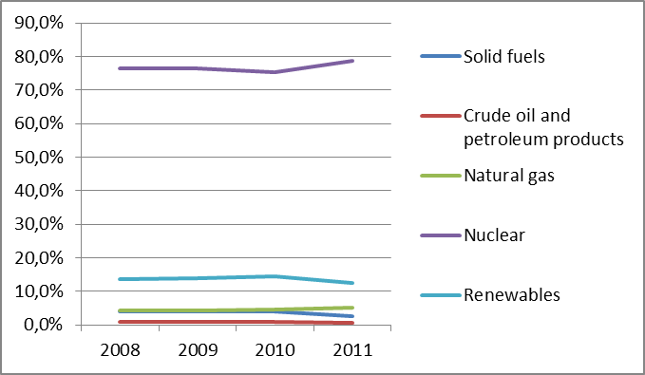
- Regulatory framework

General
France has notified full transposition of the Third Energy Package Directives.

National Energy Regulator
Despite the new duties and powers attributed to the French National Regulatory Authority (Commission de Régulation de l’énergie - CRE) with the adoption of the NOME Law in 2010 (new organisation of the electricity market) and with the adoption of the law of 15 April 2013, its resources have further decreased reaching 18.9 million euros in 2014. The staff limit will decrease in 2014 to 130, thus reinforcing the pressure on the resources of the regulator. CRE has expressed once more serious concerns about the situation as this puts at risk the fulfilment of its tasks.

Unbundling
Réseau de Transport d’Electricité (RTE) is entirely owned by EDF, the historical national utility company. RTE owns and manages the electricity transmission network. The high pressure gas network is owned by two operators. The first operator is GRTgaz, who is jointly owned by GDF SUEZ (75%) and by Caisse des Dépôts et des Consignations and CNP Assurances (25%). The second operator is TIGF, which since July 2013 is owned by a consortium of Snam (Italian utility, 45%), GIC Private Limited (Singapore utility, 35%), and EDF (20%). All three operators were certified in January 2012 as TSOs under the ITO model. Further to a change in its shareholders, TIGF has been recertified in 2014 under the full ownership unbundling model.
There are three DSOs operating in the natural gas sector that serve more than 100,000 customers. In the electricity sector, one DSO (ERDF, a 100% subsidiary of EDF) serves over 95% of French consumers. DSOs compliance with the rules of independence remains mixed. If for some DSOs the situation has improved, the NRA noticed that some of its annual requests and recommendations have remained unanswered and several breaches of DSOs independence rules were discovered in 2012 and early 2013.
- Wholesale markets

Electricity
The power generation market is highly concentrated. The HHI index as regards installed capacity is still above 8 000 for electricity generation. Next to EDF who still exploits 91.5% of installed capacity, GDF Suez exploits 5,1% of the installed capacity and E.On France 2.6%. Efforts are being made to reduce market concentration through measures such as the ARENH price, which secures access to a limited volume of nuclear generation (maximum of 100 TWh/year) under regulated tariffs for alternative suppliers, or Virtual Power Plants. These measures should be further improved to continue to promote market access for alternative suppliers. France plans to start tenders for hydroelectric concessions in the first half of next year to bring competitors into the market. The vast majority of France’s hydro plants, the nation’s biggest source of power after nuclear reactors, are run by EDF (more than 80%), the remaining being operated by GDF Suez. Under the latest plan, the government may group them by valley into concessions and adjust the expiry dates for current operating contracts. The renewal of these concessions appears as a unique opportunity to reshape the French electricity market in a more competitive way.
The wholesale market in France has low liquidity; with the majority (87% in 2012) of trading taking place over-the-counter (OTC). In February 2014 the Northwest European coupling of the day-ahead markets from the Nordic region, Great Britain and the Central Western Europe region (with which France was already coupled) went live. It was further extended to Spain and Portugal in May and should extend to Italy and Slovenia at the end of 2014. Intraday market integration of the Northwest Europe region is on-going. A project for coupling with spot markets is also under consideration.
Baseload spot price decreased by 7.8% in 2013, with respect to 2012, assuming an average value of EUR 43.24/MWh. Production costs have decreased due to low coal prices as well as low CO2 emissions prices. Furthermore, the high production of renewables in Germany influences the French wholesale prices. The decline of the day-ahead price also continued into the first quarter of 2014 with temperatures above normal.

Gas
France imports almost all its natural gas. The majority of imports (40.4%) came from Norway. LNG market share, reflecting the low competitiveness of LNG prices, decreased from 35% (2011) to 18% (2013). The market has traditionally been dominated by long-term import contracts linked to oil product prices. Despite historical dominance, these contracts decreased from 92% of overall imports (2010) to 85% (2013). In addition, renegotiation efforts of French gas importers resulted in more hub indexation within the price formula of long-term contracts.
In France there are three virtual trading points (PEG Nord, PEG Sud and PEG TIGF). The PEGAS project was launched in 2013 as a cooperation agreement between Powernext and European Energy Exchange (EEX). It combines both companies’ natural gas market activities, increasing the liquidity. PEG Nord and PEG Sud day-ahead gas price increased in 2013 by 8% and 12% respectively. PEG Nord evolution reflects the trend of the adjacent continental hubs whereas PEG Sud suffers from the physical congestion at the North-to-South link of GRTgaz’s transmission system. Despite a still sluggish industrial demand, total consumption increased by 1.4% in 2013, mainly due to the cold weather conditions during winters 2011-2012 and 2012-2013.
- Retail markets

Electricity
Market concentration at retail level remained high in 2012 as only 8% of consumers were served by alternative suppliers. Since 2007, consumers have had the choice between opting for free market prices and regulated tariffs which can only be offered by incumbents. However by the end of 2013, 92% of residential customers and 86% of non-residential customers remained under regulated tariffs.
Switching rates in the retail electricity market decreased in 2012 to 3.4 % in number of sites (a decrease of 0.3 points compared to 2011). It should be noted that there was also a registered increase in market opportunities awareness.
Regulated tariffs were raised significantly in July 2013 and are expected to increase again in 2014. This is mainly due to the financing needs of EDF and especially to the modernisation of its nuclear fleet. These increases still do not cover totally EDF costs. Nevertheless, they slightly improved the competitiveness of free market priced offers.
Figure 3: Electricity price change by component 2008 – 2013 (source: Eurostat, energy statistics)

Gas
Competition increased during the past few years. On the segment of industrial consumers, in 2013, 99% of consumption was on market offers in volume, including 51% from non-incumbents. On the other segments, similarly to electricity, concentration in gas at retail level remained high in 2012 with approximately 12% of the final consumers supplied by alternative suppliers. Consumers have the choice between opting for regulated or non-regulated prices. However in 2013, 77% of residential sites and 50% of non-residential sites, remained under regulated tariffs. The principal gas supplier, GDF-Suez, which is the exclusive provider of the regulated gas tariffs set by the government, still dominates the market for households and small businesses. Switching rates retail market increased slightly, from 3.5% in 2010 to 4.0% in 2011, and reached 5.0% in 2012.
Figure 4: Natural gas price change by component 2008 – 2012 (source: EC, EPCR metadata)
A formal decision to proceed with the roll-out of smart-meters has been taken for both the electricity and natural gas sector, after the cost-benefit analysis returned a positive outcome. There are currently two pilot projects on smart metering going ahead:
- Linky: started in 2010, the project conducted by ErDF involves 300,000 customers connected to the low-voltage grid. The project is at an early stage of intelligent network construction and aims for a final installation target of 35 million smart meters.
- Gazpar: the mass roll-out of gas smart meters was officially launched in the summer of 2013. The project is on behalf of GrDF and will start with a pilot project of 150 000 smart meters by 2016, to be extended to 11 million meters between 2017 and 2022.
- Consumers
French consumers rate the performance of their retail electricity market well above the EU average (79.2 points vs. 72.0, corresponding to 4th place) as well as above the average of all domestic services markets (12th place out of 31). The market has the third lowest percentage of complaints and second highest assessment of trust in the EU. However, switching remains low in this market. This component is in fact the only component evaluated below the EU average. The assessment of the retail gas market is above the EU average (77.6 points compared to 74.1), which corresponds to 7th place in the EU ranking. The market is evaluated above EU average for all its components except for switching, which remains low in France. The proportion of consumers complaining for having encountered a problem is the lowest in the EU, but consumers tend to complain more towards third-parties (5th highest proportion in the EU). Both markets have seen a considerable increase in score since 2012 (4 points in the case of electricity market and 4.6 points in the case of electricity).
CRE and the Energy Ombudsman (MNE) jointly manage an information website on energy issues which provides information on the opening-up of energy markets and a comparison tool for electricity and gas retail prices. In 2012, 371,000 consumers received information through the energie-info platform. An online tool for network tariff calculation is also available on CRE’s website.
Special tariffs are reserved for households with an income below or equal to a threshold of entitlement to supplementary universal health cover. These tariffs are available for both electricity and natural gas consumers. From the end of 2013, these social tariffs were further extended to cover all households with an annual reference fiscal income per unit (revenu fiscal de reference) lower than EUR 2,175. The number of households benefitting from the social tariff is expected to increase from 1.9 million to 4.2 million, equivalent to 8 million people.
- Infrastructure
The French authorities should ensure a proper and timely adoption of the measures stemming from the TEN-E Regulation, including the establishment of the one-stop-shop for Projects of Common Interest (PCIs) (due by 16 November 2013), and other measures foreseen for 2014 and 2015, including the publication of the manual on the permit granting process for project promoters, and the adoption of legislative and non-legislative measures streamlining the environmental assessment procedures.

Electricity
The French electricity network is interconnected with all neighbouring countries through export capacities totalling 12 GW and import capacities of 8 GW. This export/import percentage represents between 8% and 10% of the French maximum consumption. France is the largest exporter of electricity in the world according to the IEA (47.6 TWh in 2013). The use of import capacity from Germany reached its maximum limit during 50% of the hours in 2013. The 2013 RTE’s ten-year network development plan, foresees investments of 3 billion euros in infrastructure before 2017. The first direct current underground trans-European link should be commissioned between France and Spain in 2015, for a total investment of EUR 700 million, including EUR 225 million from the European Energy Programme for Recovery (EEPR).
In the context of the TEN-E Regulation, France has 9 PCIs that will help increase interconnection levels with the United Kingdom, Ireland, Belgium, Italy and Spain, remove bottlenecks and integrate RES to the network. Furthermore, these PCIS will contribute to reach the 10% Barcelona target by 2020 with all the neighbouring countries with the exception of Spain.

Gas
Natural gas infrastructure in France consists of 6 entry/exit points, 15 storage facilities and 3 LNG terminals. Market development has been facilitated by the implementation of a full entry-exit system. The number of market zones has progressively been reduced. However, market development is limited by a division in three market zones. The creation of a single French hub by 2018, which requires important investments to eliminate internal congestions, is under study. In this respect, the commissioning by CRE of a cost-benefit analysis to evaluate the creation of a single French hub by 2018 was an important step forward. The interconnection capacity between France and Spain (doubling the size of the Larrau interconnection) was successfully upgraded in both directions in 2013, which further reinforces the North-South interconnections. Interconnection with Belgium and the reinforcement of the French network in the North of France by GRTgaz are ongoing, while a fourth LNG terminal in Dunkirk is being developed by EDF.
- Security of supply

Electricity
System’s adequacy is measured through the capacity margin/shortfall indicator addressed in the national adequacy assessment report elaborated by RTE. RTE considers it guaranteed until 2015. However from 2016 onwards, the risk of failure of the system is expected to increase. Despite a drop in total electricity demand, the hourly peak load of France has recorded a drastic growth rate over the past few years, increasing by 18% between 2006 and 2012. At the end of 2012 a decree introducing a decentralised capacity obligation mechanism, involving both the demand and the supply side, was approved. In 2013 RTE launched a consultation on the design and rules governing this new mechanism. The Minister of Energy approved the findings in November 2013. The expected first delivery year for the capacity market is anticipated between around 2017.
In addition, the modalities of several reserve procurement mechanisms to ensure short term operational security reserves (ancillary services, replacement) were adapted to foster competition, economic efficiency and to facilitate wider involvement of balance service providers.

Gas
In terms of infrastructures, the French system has good capacity levels at entry points, LNG terminals and storages. Recent market developments have, however, led to a decrease in LNG imports, due mainly to the rerouting of cargoes towards the Asian market where prices have been much higher than in Europe. As a result, the French market has suffered from higher prices in the Southern region which is heavily dependent on LNG. At the same time, the volume of gas in storages has been tightening up, raising some concerns about security of supply in case of cold winter. Consequently, through a governmental decree adopted in March 2014, the French authorities have decided to increase the level of mandatory storage that must be booked by all gas suppliers operating on the French market.
Irrespective of levels of interconnection capacities at the borders, it should be noted that France is constrained on its internal interconnection between the North and the South of the country. This constraint has not prevented gas flows to Spain to grow significantly after the commissioning of new interconnection capacity in 2013 at Larrau. Some interoperability limitations with other countries in north-western Europe can be mentioned, affecting the potential capacity of France to contribute to the security of supply of Germany and Belgium. Two projects are under discussion which could benefit security of supply. The doubling of the Burgundy artery between the PEG North and PEG South zones of GRTgaz and the de-odorisation of natural gas and the implementation of reverse flows at the border with Germany which would allow flows from France to Germany of about 100 GWh per day.
- Key indicators
Electricity |  | Gas
Number of companies representing at least 95% of net power generation | >5 | Number of entities bringing natural gas into country | 20
Number of main power-generation companies | 1 | Number of main gas entities | 4
Market share of the largest power-generation company | 86% | Market share of the largest entity bringing natural gas | 59%
Number of electricity retailers | 183 | Number of retailers selling natural gas to final customers | 77
Number of main electricity retailers | 1 | Number of main natural gas retailers | 3
Switching rates (entire electricity retail market) | 5.7% | Switching rates for gas (entire retail market, 2011) | 4.5%
Regulated prices for households – electricity | Yes | Regulated prices for households – gas | Yes
Regulated prices for non-households – electricity | Yes | Regulated prices for non-households – gas | Yes
HHI in power-generation market | >8,500 | HHI in gas supply market | 4,000-5,300
HHI in electricity retail market | >4,500 | HHI in gas retail market | >3,000
Electricity market value (bn€) | 34.259 | Gas market value²⁸ (bn€) | 14.422
Installed generation capacity (MW, 2011) | 131,353
Peak demand (MW) | 102,098
Number of smart meters installed | 270,000

Germany

Key issues
High volumes of renewables have changed the way the electricity market in Germany operates. In 2012 direct marketing increased, in particular in onshore wind, due to a change of the Renewable Energy Sources Act (EEG). A major review of the EEG is now underway and a revised law entered into force on 1 August 2014. It is expected to have strong impact on the future costs, expansion and market integration of renewables in Germany. It is of central importance that the revised law ensures that as of certain thresholds all new beneficiaries of the RES support scheme will have to sell their electricity directly in the market and will be subject to balancing obligations.
In general, the coordination of the energy policy with neighbouring countries should further improve, also in order to keep the overall costs of transforming the energy system to a minimum, in particular by reviewing the cost-effectiveness of energy policy instruments designed to achieve the renewable energy targets and by continuing efforts to accelerate the expansion of the national and cross-border electricity and gas networks. Recent efforts of the German administration to coordinate reflections on future policy developments with neighbouring countries are very welcome.
Network development is slower than planned. Further efforts on both intra-German infrastructure and cross-border interconnections are needed to better synchronise intermittent renewables expansion with grid development and avoid congestion and unscheduled flows towards the networks of neighbouring countries.

General overview
Gross energy consumption in 2012 (319.5 Mtoe) was based largely on crude oil and petroleum products (33.9%), solid fuels (25.2%), and natural gas (21.3%). The share of renewable energy sources (RES) in overall energy consumption (10.3%) has constantly increased over the last years and surpassed the share of nuclear energy in 2011 which decreased over the same period to 8.0%.
Figure 1: Gross inland consumption mix 2008 – 2012 (source: Eurostat)
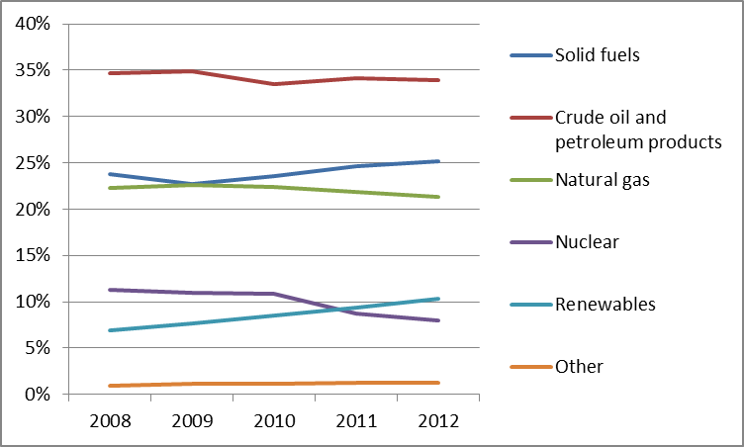
The gross electricity generation in 2011 was 608.9 TWh. The biggest share in the generation mix came from solid fuels (43.1%). RES became the second most important production technology (21.2%) followed by nuclear (17.7%) and natural gas (15.3%). In 2011 the German Parliament decided to phase-out nuclear power generation by 2022. Eight of the 17 nuclear power generation units have already been shut down, while the remaining power stations will close by 2022 in a defined order from 2015 onwards.
Figure 2: Gross electricity generation 2008 – 2011 (source: EU Energy in Figures – Pocketbook 2012 and 2013)
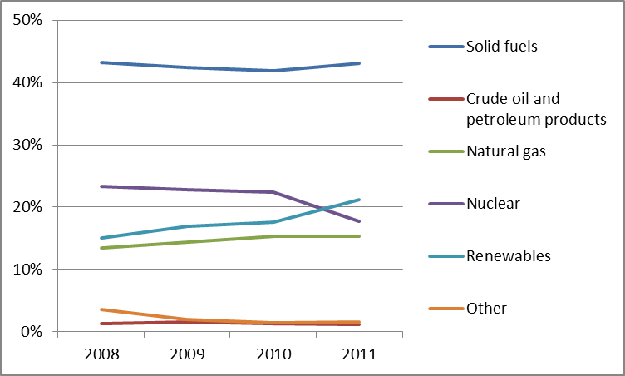
The German RES target under the Renewable Energy Directive 2009/28/EC, defined as the percentage of energy from renewable sources in total gross final consumption of energy, stands at 18% by 2020 which is 5.7 percentage points above the level of 2012. The National Renewable Energy Action Plan expects a share of 19.6% by 2020.
- Regulatory framework

General
The German energy law was amended following the nuclear moratorium in 2011 and the associated substantial changes of location of generation. Power plants must now announce their shutdown one year in advance and electricity TSOs can intervene to this shutdown in case there is a technical necessity of the particular plant in terms of network stability. TSOs are now obliged to analyse reliable available generation capacity, its development with a view to the next winter period as well as the five following years, and the potentially necessary reserve capacity.
The support schemes for renewable energies (notably solar PV, onshore and offshore wind) have been reviewed by recent legislation. One major element of the amended EEG is the gradual introduction of an obligation for all new RES producers covered by the support scheme to sell their electricity directly on the market. From 1 August 2014, this applies as of 500 kW generation capacity, which will be lowered to 100 kW on 1 January 2016. Further, the new legislation foresees planning corridors for the development of different technologies for renewable generation capacities. A further important element is the gradual introduction until 2017 of competitive tenders for renewable support, a part of which will also be open for operators established in other EU Member States.
On 18 December 2013 the Commission adopted an opening decision on the EEG to examine whether the German RES support scheme and in particular the surcharge reduction granted to energy-intensive industries is compatible with EU state aid rules. On 23 July 2014 the Commission declared the aid to be compatible, taking into account the recent amendments.

National Energy Regulator
The German Federal Network Agency for Electricity, Gas Telecommunications, Posts and Railways (Bundesnetzagentur) was set up in 1998. Bundesnetzagentur is a separate higher federal authority within the Federal Ministry of Economics and Energy. In 2012 BNetzA employed 2,324 employees (FTEs) and had a budget of EUR 181.2 million (ca. EUR 24 million thereof for energy regulation). Since 2011, the BNetzA has taken on additional duties relating to network development so as to accelerate the expansion of the extra-high voltage electricity networks, via efficient planning and approval procedures.

Unbundling
There are four onshore electricity transmission system operators (TSO) and 15 gas TSOs which have filed certification requests. Three of the four onshore electricity TSOs have received the certification while one application was rejected for the time being, due to insufficient financial resources, against the opinion of the Commission. For an offshore electricity TSO (the Baltic Cable), BNetzA opened ex officio certification procedures and, in accordance with the Commission Opinion, refused certification as no information had been provided by the TSO.
Local networks are largely still integrated on the basis of an exemption from the statutory provisions on legal and operational separation of network and retail businesses that applies to distribution system operators (DSO) with less than 100,000 connected customers. About 90% of the electricity and 95% of the gas DSOs fall under this “de minimis rule”.
- Wholesale markets

Electricity
In the generation market (electricity not eligible for payments under the Renewable Energy Sources Act) the four main power generation companies (E.ON, RWE, EnBW and Vattenfall) had a market share of 76% of installed capacity (81.4 GW) in 2012. The aggregated net generation volume of the four biggest companies (332.8 TWh) in relation to the net generation volume (426.2 TWh) that was fed into the grids of public supply resulted in a market share of 78%. In this calculation only generation capacities were taken into account that fed into the grids of public supply and that were not remunerated according to the Renewable Energy Sources Act.
There are two power exchanges in Germany: EPEX SPOT for day-ahead and intraday markets and EEX for any forward products. The volume traded (245.3 TWh) at day ahead market increased by 10% in 2012. Prices decreased for peak load by 15% (EUR 48.51/MWh) and for base load by 17% (EUR 42.6/MWh) at spot markets.
Energy directly sold from renewable sources, particularly onshore wind, increased by more than 400% (51.163 GWh) in 2012 following an amendment of the EEG allowing RES operators to choose among three forms of direct marketing: Direct marketing for the purpose of claiming a market premium, direct marketing for the purpose of an electricity supplier reducing the EEG surcharge, or other direct marketing.
The number of traders active on the different markets further increased to a total of 363 (EPEX Spot 194, and EEX 169).
As of February 2014 Germany coupled its day-ahead market with other North West European markets. Germany is also part of the market coupling project for intraday market of these markets plus Austria and Switzerland. In the market-coupled area, prices started to realign in the second quarter of 2013, after significant price divergences observed in earlier periods.
Gas
Gas production in Germany further declined in 2012 by 9.7% to 10.7 bcm and imports increased by 8.78% to 1.535 TWh in 2012. The imported volumes primarily came from Russia (about 45%), the Netherlands (26.5%), and Norway (25.9%). Exports (667.3 TWh) increased by 29.12% and were mainly directed to Czech Republic, France, the Netherlands and Switzerland.
While the German gas market was initially fragmented into more than 20 market areas, there now remain only two market areas: Net Connect Germany (NCG) and GasPool. There is one German gas exchange EGEX (European Gas Exchange GmbH). Trading activities strengthened on both OTC and exchange markets, with OTC (trading volume 2012 was 2.460 TWh) remaining the preferred market. The daily average reference price over both market areas rose by almost 10% (NCG: EUR 25.19/MWh and GasPool EUR 25.11/MWh). This increase was caused partly by temporary bottlenecks in the gas supply in February 2012, when prices increased up to EUR 40/MWh. The daily average cross border price was EUR 29/MWh (+12.6%) and the gas forward price was EUR 24.66/MWh (+4.8%) at the EEX in 2012.
While the three largest importers increased their market share by 11.4 percentage points (to 67.2%), the total share of the five largest companies fell by 11.1 percentage points (to 80.3% in 2012).
Germany has suffered from contractual congestion in the past, but booking levels have recently decreased due to the cancellation of contracts. According to ACER's Annual Report on Congestion contractual congestion remains high, mainly at Germany's border connections with the Netherlands. It therefore remains important that Germany cooperates with neighbouring countries to ensure effective implementation of congestion management regimes on its interconnection points in accordance with EU law.
- Retail markets

Electricity
With an HHI of 2,021 the German electricity market is reasonably competitive even though the four largest supply companies increased their market share by 3.3 percentage points to about 45.5% (228.1 TWh).
Despite a clear downward drift of wholesale prices on the spot and forward markets, the retail prices for households significantly increased on average (+12.3%) in 2013. Electricity retail prices in Germany rank among the highest in Europe. On the one hand, this can be attributed to the fact that the cost of expanding the share of renewable energy is borne by final consumers. On the other hand, the legislator put in place taxes and fees on energy consumption to incentivise rational use of energy and internalise externalities. Taxes (electricity and VAT) have been stable for a long time and add up to a share of 22.9% and total levies to around 26.1%.
Figure 3: Electricity price change by component 2008 – 2013 (source: Eurostat, energy statistics)
Despite some measures taken to limit the increase of the EEG-surcharge, the financing costs amounted in total to EUR 19.4 billion in 2013.
In 2012, electricity customers were able to choose among a large number of suppliers. Household customers were able to choose between 72 suppliers on average (2011: 65). In 2012, 7.8% of household customers and 11.3% of industrial customers switched supplier in terms of consumption volumes. In the entire retail market over 2.8 million customers switched their supplier, leading to a switching rate of 10.4% of the total volume.
In response to the Commission's procedure challenging the exemption by law of industrial users from network charges, Germany has adopted legislative changes to reduce the number of beneficiaries. A revised law on feed-in tariffs intends to help keeping energy prices for consumers stable in the next years.

Gas
The emitted gas volume to final consumers (including gas-fired power plants) increased by 5% in 2012 (815.4 TWh) driven by an increase in household consumption (+10%) during the very long and cold winter 2012/13. The three largest companies have a market share of only 28.5%. Diversification improved further such that in almost 86% of the network areas consumers can choose among at least 31 different gas suppliers.
However, the number of customers who switched their supplier declined, especially for small consumers. In 2012, 7.92% of household customers and 13.38% of industrial customers switched supplier in terms of consumption volumes. In terms of all final consumers, the consumption volumes-based supplier change rate was 10.68%. This is a decrease of 18% compared to 2011.
Figure 4: Natural gas price change by component 2008 – 2012 (source: EC, EPCR metadata)
- Consumers
German consumers consider their electricity and gas retail markets as above the EU average (81.4 and 77.4 points compared to 72.0 and 74.1, respectively), ranking 1st and 8th among EU countries. However, while the electricity market has seen a consistent increase in score since 2010, the gas market has slightly decreased its performance between 2012 and 2013, reversing the positive trend observed since 2010. Both markets score better than the EU average on all the components with the exception of actual switching. Electricity market scores highest among EU countries on trust in providers and and ease of switching, 2nd highest on comparability and 4th highest on choice while the incidence of complaints is second lowest in the EU. For gas services, Germany scores among the best EU countries for comparability and choice (5th place). At the same time, only around 6% of electricity and gas consumers have switched their provider or tariff with the existing provider in the past 12 months, which is in both cases around half of the EU average.
In line with the provisions of the Third Energy Package, consumer protection rights have been strengthened by the shortening of the supplier exchange process and by establishing new standards for contracts, information and financial reporting by suppliers. BNetzA has been assigned the role of central information centre for energy consumers. Energy consumers now have the right to file complaints against their supplier. In 2012 the consumer service of the BNetzA recorded a total of 22,112 incidents (electricity 19,771 and gas 2,341) of which a significant portion focused on inconsistencies in the energy bill. Furthermore a new arbitration body, the “Schlichtungsstelle Energie e.V.”, was founded to provide consumers with additional cost-free extrajudicial resolution with regard to their electricity and natural gas suppliers as well as distribution system operators.
- Infrastructure
BNetzA was designated as the “one stop shop” for permitting procedures for electricity Projects of Common Interest (PCI), while for gas the designation has not yet been communicated.

Electricity
In 2012 the four TSOs spent EUR 1.15 billion on network infrastructure which is an increase of investment volume of 36% mostly due to the energy transition. The expansion of the electricity transmission network has been advancing slower than planned. By July 2014, about 416 of 1877 kilometres (22 %) of the projects listed since 2009 in the Electricity Grid Expansion Act (EnLAG) were realised. TSOs now expect to finish 40% of the projects by 2016, 10 % less than what had been expected still in early 2014. Network development is clearly behind schedule and subject to increasing resistance, including on the level of regional governments. In 2012, BNetzA approved about 2,800 km new lines and 2,900 km of network enhancements beyond the EnLAG.
With the adoption of the Federal Requirements Plan Act (Bundesbedarfsplangesetz) in 2013, further efforts have been made to commonly agree upon and realise the most crucial and urgently needed transmission infrastructure projects. It however remains to be seen, and becomes increasingly doubtful in view of delays, whether the actual speed of network infrastructure construction is sufficient. Some projects included in the Bundesbedarfsplan are also labelled as projects of common interest as they are particularly important from the European perspective. In total 20 electricity PCIs are located in Germany. Most urgently, lines from the North to the South of Germany are needed to eliminate internal bottlenecks and help avoid unscheduled “loop flows” which are currently congesting the borders with Germany’s neighbours. Also, cross-border lines with neighbouring countries will increase interconnection capacity and ensure that electricity flows where it is most valued.

Gas
The German Energy Act requires the gas TSOs to jointly prepare a National Development Plan (NDP) Gas on an annual basis. The current NDP will lead to new pipelines with a total length of 522 km and new or extended compressors with a total capacity of 344 MW. Most of these measures are important for the transport of gas from North to South. They are also important to help to relieve critical situations in the supply of gas down to the distribution systems, especially in southern Germany. Furthermore, capacities at cross-border points will be enhanced. For the first time, the NDP Gas also focuses on decreasing L gas volumes, in particular in the Netherlands, and identifies specific grid areas for conversion to H gas.
- Security of supply

Electricity
Bundesnetzagentur has prepared a series of reports assessing security of electricity supply in order to establish the need for reserve capacity during the winter period. The aim of maintaining reserve capacity is to provide relief when critical situations arise in the transmission network as a result of the increase in energy from renewable sources and conventional plant shutdowns. Network operators contracted 2.6 MW of reserve capacities for the winter of 2012/2013. In addition to this, TSOs can use generation units nominated for decommissioning if they define these units as systemically relevant entities. The owner of such reserve capacities is then compensated for costs of keeping the unit available and generating the required power. Until now five of such nominated generation units with a total net capacity of 668 MW were defined as systemically relevant. Finally, TSOs may intervene into generation dispatch plans in order to stabilize the system. System interruption is still at a low level of 15.91 minutes in 2012.
In respect of the national balance between demand and supply, ENTSO-E calculated a negative reserve margin of -0.6% for Germany for the winter of 2012/2013 which indicates that national demand of electricity could be higher than available generation capacities. Germany may therefore need to rely on imports in certain situations.
In 2012, total electricity demand remained almost constant whilst the total volume of traded electricity across the border increased by 7.7% (79.7 TWh). The net export increased significantly, by 700% to 21.7 TWh (2011 imports: 35.5 TWh and exports 38.4 TWh), so that Germany became a net exporter of power. The cross-border trading volume of electricity increased from 74 TWh in 2011 to 79.7 TWh in 2012, of which 50.7 TWh were exported and 29 TWh imported. The biggest change occurred in the export between Germany and the Netherlands which more than doubled and the imports from France which dropped by almost one third.

Gas
The average interruption duration in gas was constantly on a low level in 2012 (1.91 minutes). During gas year 2011/2012 capacities have been shifted from entry to exit in parallel to significant sign offs of booked capacities after price increases. Given the total volume of 2.69 billion kWh transported, only 0.05% of the nominated quantities of gas were interrupted in the gas year 2011/2012.
- Key indicators
Electricity |  | Gas
Number of companies representing at least 95% of net power generation | >450 | Number of entities bringing natural gas into country | 38
Number of main power-generation companies | 4 | Number of main gas entities | 3
Market share of the largest power-generation company | N/A | Market share of the largest entity bringing natural gas into country | 30.1%
Number of electricity retailers | >1,000 | Number of retailers selling natural gas to final customers | 851
Number of main electricity retailers | 4 | Number of main natural gas retailers | 3
Switching rates (entire electricity retail market) | 10.4% | Switching rates for gas (entire retail market) | 10.68%
Regulated prices for households – electricity | No | Regulated prices for households – gas | No
Regulated prices for non-households – electricity | No | Regulated prices for non-households – gas | No
HHI in power-generation market | 2,021 | HHI in gas supply market | 1,886
HHI in electricity retail market | n/a | HHI in gas retail market | 300
Electricity market value (bn€) | 74.906 | Gas market value (bn€) | 27.511
Installed generation capacity (MW) | 171,681
National instantaneous peak load (MW) (2012) | 81,858
Number of smart meters installed | N/A

Greece

Key Issues
Electricity prices were fully liberalised in July 2013 but no effective entry into the market has taken place and the incumbent electricity company remains the dominant supplier as a result. Electricity prices should be cost-reflective and appropriate steps should be taken towards the creation of an investment-friendly framework in order to attract new potential suppliers and effectively open up the retail market to competition while ensuring a smooth transition for consumers.
In gas, the continued independent operation of gas TSO DESFA after its privatization needs to be ensured by the national regulatory authority. Greece should furthermore draw a timeline and an action plan for facilitating the transition to a more mature gas market model, fostering competition also on the retail level, ending the exclusivity rights of regional gas suppliers and thus allowing consumers to switch suppliers and reap benefits from the liberalised market.
- General overview
The gross inland energy consumption in 2012 was 27.04 Mtoe, a decrease of 2.9% compared to 2011. Crude oil and petroleum products account for 46.2%. Solid fuels represent 30.1%, natural gas represents 14.1% and renewable energies provide 9.6% of gross inland energy consumption. In 2012, the renewables share in gross final energy consumption reached 15,1%, and thus Greece is showing good progress towards achieving its 2020 RES target of 18%.
Figure 1: Gross inland energy consumption mix 2008-2012 (source: Eurostat)
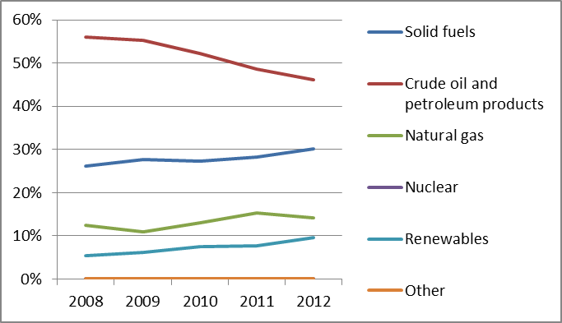
The gross electricity generation in 2011 was 59.4 TWh. Electricity is generated mainly by indigenous lignite, which represents 51% of the total electricity production, followed by natural gas (23.5%), renewable energies (14%) and crude oil and petroleum products (10%). The increase of electricity generation in 2012 came mainly from renewables, which increased its share by 23% compared to 2011 levels. This was due to the additional solar photovoltaics installed in the year.
Figure 2: Gross electricity generation mix 2008 - 2011 (source: EU Energy in Figures – Pocketbook 2012 and 2013)
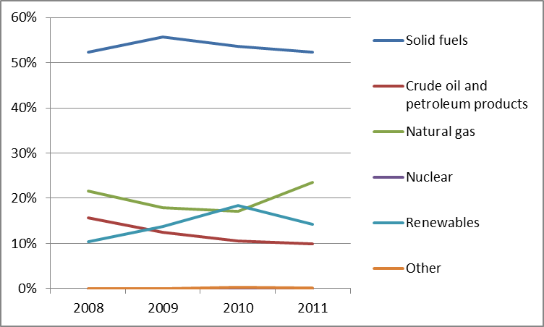
Cogeneration of heat and power represents 4.5% of gross electricity generation in 2011.
- Regulatory framework

General
The Third Energy Package was implemented in Greek legislation in August 2011. In the gas sector a decoupled entry-exit tariff model was introduced in 2013 by the Regulatory Authority.

National Energy Regulator
The Regulatory Authority for Energy (RAE), which was established in July 2000, is an independent administrative authority. The Board of Commissioners of RAE is comprised of 7 members. The budget of RAE was EUR 7.3 million in 2012, a decrease of 11% compared to 2011.
Since the transposition of the Third Energy Package, the Regulator has been influenced by severe budget and salary cuts and, most importantly, a hiring freeze, that has limited its ability to carry out the increased powers and duties assigned to it by the Third energy package.

Unbundling
Following the Energy Law 4001/2011, the Public Power Corporation (PPC), which is the state owned vertically integrated electricity company, established a 100% subsidiary, ADMIE SA, which owns and operates the transmission system, according to the Independent Transmission operator (ITO) model. In 2012, the Regulatory Authority for Energy (RAE) certified ADMIE SA as the independent power transmission system operator. The government decided to fully separate ADMIE from PPC, which should be completed still during 2014. The distribution network ownership remained with PPC, although its operation was assigned to another 100% subsidiary of PPC, DEDDIE SA.
In the gas sector, the TSO of the national grid is DESFA SA. It is currently controlled by Hellenic Petroleum ("HP", 35%) and the Hellenic Republic Assets Development Fund ("HRADF", 65%). In 2012, HP and HRADF signed an agreement with the Azeri State-owned company SOCAR for the sale of 66% of the shares in DEFSA. The certification of DESFA as controlled by SOCAR is currently pending.
- Wholesale Markets

Electricity
In May 2013, the government decided to establish a new vertically integrated electricity company, which will be formed from the transfer of approximately 30% of the assets of PPC. The new company should be fully operational in the first quarter of 2015. 17% of the PPC’s shares owned by the Hellenic Republic Assets Development Fund (HRADF) are foreseen to be sold by the first quarter of 2016.
In July 2013 RAE decided to reform aspects of the market design, which, due to the technical nature of the plant dispatch algorithm, creating stronger incentives for gas-fired power plants to follow the fluctuations of the demand curve and wholesale prices to better reflect marginal costs. Further reforms of the capacity mechanism are planned to be introduced in 2014.
The Greek electricity sector was hit in 2012 by a liquidity crisis. Several factors, such as unpaid electricity bills, liquidity tensions in the Greek banking system and structural deficiencies of the Greek energy market have tightened the cash position of PPC. In parallel, the market operator, LAGIE SA, had accumulated unsustainable debts due to the renewable energy support schemes, given the level of revenues from the market which was insufficient to cover the payments to RES generators. As a result, the main actors in the Greek electricity system have significant arrears.
The Hellenic Parliament adopted a temporary tax on revenues from renewable energy installations in 2012. Following an increase in the renewables levy in July 2013, the authorities committed to further adjustments every six months in order to eliminate the debt in the renewables account by the end of 2014.

Gas
DEPA is the incumbent natural gas importer and supplier. Pending the privatisation process of DEPA the state owns 65% of DEPA while the remaining shares are held by Hellenic Petroleum SA.
Since 2010 other companies than DEPA a total of six companies have started importing natural gas. In 2012, from the total natural gas imports 48.1 TWh in Greece, 90% were imported by DEPA SA, and ten percent (10%) by two other market players. However a sharp decline was observed in the year of 2013 in the percentage share of gas imports by the other parties. This is mainly attributable to the increased price of LNG worldwide as most of the competition in the market stemmed from third party access to the Revythoussa LNG Terminal. In March 2014, DEPA and GAZPROM EXPORT agreed to the decrease of the price of the imported natural gas by 15%, approaching the respective average EU price.
- Retail Markets

Electricity
Electricity prices for both industrial and domestic consumers increased significantly in 2012 (29% and 37.3% respectively), although in both cases they remained below the EU average. In part these increases were due to the introduction of non-recoverable tax rates, but also due to the gradual move towards cost recovery and removal of cross subsidies. Retail prices in Greece also include a public service obligation levy to recover the higher cost of power generation in the non-interconnected islands. Low-voltage end user prices have been completely liberalised since 1 July 2013.
In 2012, domestic tariffs (competitive elements only) of the incumbent (PPC) increased by around 11-34%, depending on the consumption category. The evolution of retail prices in households and industrial consumers is presented in the following figures.
Figure 3: Electricity price change by component 2008 – 2013 (source: Eurostat, energy statistics)
Electricity demand in 2012 declined by 0.2% compared to 2011. This decline was very close to the average EU27 rate. The concentration on the retail electricity market remains high. The switching rate in Greece was 3.6 % (volume-related) in 2012, mainly due to the exit of four suppliers from the market and the temporary (3-month) activation of the supplier of last resort. In 2013, electricity demand declined further by 1.9%, while the switching rate was confined to merely 0.27%.
Greece is proceeding with (and has mandated) a large-scale roll-out of smart meters to 80% of consumers by 2020. A pilot programme involving the replacement of 160,000 old electricity meters with smart metering systems was announced, and is expected to be completed in 2015.

Gas
Distribution and supply of natural gas to retail consumers is done by three companies (called EPAs) for the regions of Attica, Thessaloniki and Thessalia. DEPA supplies natural gas to these three local monopoly distributors. In general, only those customers with an annual consumption of greater than 100 GWh are eligible to select their supplier of gas in Greece. A major reform of the Greek gas retail market is envisaged that seeks to abolish the regional monopolies of the EPAs for gas supply and to progressively extend eligibility to all retail customers. A total of ten natural gas supply authorizations have been issued in the period 2010-2013.
Natural gas price in households was EUR 2.3/GJ in 2012. The total taxes were EUR 4.8/GJ (EUR 3.2/GJ for VAT and EUR 1.6/GJ for other taxes). The tariff for the industrial sector in 2012 was EUR 16.1/GJ, while the non-recoverable taxes were EUR 1.6/GJ. The Pre-Tax Total Price (PTP) for gas in Greece was the highest among EU-27.
Gas demand in 2012 decreased by 7.7% compared to 2011. DESFA forecasts that gas demand will almost double by 2019, compared to 2009 levels. This increase will mainly come from electricity generation.
- Consumers
Despite considerable improvement since 2012 (of 4.9 points), the retail electricity market is assessed fourth lowest in the EU, with a score which is almost 7 points below the EU average (65.2 compared to 72.0). In addition, the market is considered to be the worst of all 31 domestic services markets. Overall consumer satisfaction is the 2nd lowest in the EU and the incidence of consumer complaints is the 2nd highest.

The assessment is more favourable for the gas market for which Greece is more than 4 points above the EU average (78.5 vs. 74.1), which corresponds to 6th position in EU and 16th position in the ranking of 31 domestic services markets. Greek consumers show the 3rd highest level of trust in providers. However, the percentage of Greek consumers who have switched their provider or tariff plan with the existing provider in the past 12 months is the lowest in the EU (less than 1% against an average of almost 10% in the EU).

A total of 9.8% of all residential customers benefit from a social tariff, to a total of 560,126 in February 2014. In 2013, the Electricity Supply Code was published, which also includes provisions for consumer protection measures and a Ministerial decision was issued defining criteria, conditions and the procedure for a consumer to be classified as vulnerable electricity consumer and to be included in the registry.
The provisions of the definition of vulnerable gas consumers of Law 4001/2011 have not been fully adopted by the EPAs. Compliance with the categories of vulnerable groups and economic protection schemes and the Supply Code is not yet available. The distribution license of the EPAs, operating under a regime of exclusive right for both the activities of distribution and supply of gas in their areas, include some non-economic provisions for domestic customers “with special needs”.
- Infrastructure
As required by the TEN-E Regulation, Greece has established a one-stop-shop for the permitting of Projects of Common Interest (PCIs).

Electricity
In 2012, the total installed generating capacity was 18.879 MW. Thermal power plants accounted for 9.624 MW, hydroelectric power plants were 3.017 MW, wind power farms were 1.466 MW and solar photovoltaic power generating units were 1.126 MW. The electricity generation capacity of wind farms increased by 23%, while the electricity generation capacity of photovoltaic parks more than tripled, compared to 2010 levels.
The Greek network has a central position in South-East Europe with the existing and future connections to Italy, Bulgaria, Turkey and the Western Balkans. Therefore, Greece could play the role of an electricity hub in the region. Greece is investing in the connection of islands to the grid and the integration of RES.
In October 2013, two electricity interconnections were labeled PCIs by the European Commission: the AC 400kV interconnection between Maritsa East 1 (in Bulgaria) and Nea Santa (in Greece) and the DC 600kV underwater interconnection between Israel, Cyprus and Greece.

Gas
Greece has the potential to become a regional gas hub as it is located at the EU entry door of the Southern Gas Corridor, has access to LNG and gas supplies from Russia. It has therefore all the characteristics needed for the development of a liquid hub, providing price competition, security of supply and market integration in the Region.
The Trans Adriatic Pipeline (TAP) was selected by the Shah-Deniz Consortium in June 2013 as the route to transport gas from the Shah-Deniz II field in Azerbaijan to Europe. Together with the Southern Caucasus Pipeline and the Trans Anatolian Pipeline, the TAP will form part of the Southern Gas Corridor allowing for the supply of Europe with gas from Caspian sources.
The regulatory framework for the development and operation of TAP was also concluded in June 2013 following the comprehensive assessment of TAP AG’s exemption application by the regulatory authorities of two Member States (Greece and Italy) and one Contracting Party of the Energy Community (Albania) on the basis of the energy third package.
Several projects are currently planned to enhance supply opportunities and connections with its direct neighbors. This is most notably the case with the upgrade of the existing LNG terminal (Revithoussa) and the development of new ones, interconnections with Bulgaria through the reverse flow in Kula-Sidirokastron and the IGB, to Italy with the Trans-Adriatic Pipeline and, potentially, with IGI Poseidon and from Turkey with the upgrade of the compressor station in Kipi.
- Security of Supply

Electricity
Electricity demand in 2012 remained fairly stable, exhibiting a minor decline of 0.5% relatively to 2011, while electricity production increased by 3.54% compared to 2011. Exports of electricity in 2011 increased by 40.4% compared to 2010, particularly due to exports to Albania. Imports of electricity decreased by 15.7% in 2011, reaching 7,180 GWh. The main importers were Bulgaria and Turkey, accounting for 75.4% of total imports.
To enhance security of supply to the Aegean islands and facilitate further development of renewable energy, underwater interconnection of the Cyclades islands is planned by ADMIE. The first phase of the interconnection will be completed by 2016 while the second phase is planned for 2017. According to the last approved 10-year network development plan, the interconnection of Crete is planned to take place during the period 2017-2020.

Gas
The demand for natural gas in 2011 was 4.80 bcm, out of which approximately 66% was for the power generation sector. Imports of natural gas amounted to 41.8 TWh in 2013, the majority of which (66% of total imports) came from Russia. During 2012 DEPA imported gas primarily through existing long-term contracts from three different suppliers, namely Gazprom, Sonatrach (LNG) and BOTAS, while several spot cargoes were also unloaded in Revithoussa.
During 2012, there was no change regarding interconnection infrastructure of the Greek transmission system with neighboring gas systems, namely Bulgaria and Turkey.
RAE has been assigned by the Greek State as the Competent Authority for the implementation of the provisions of Regulation 994/2010/EC concerning measures to safeguard security of gas supply. During 2011-2013 the risk assessment study, the preventive action plan, the emergency action plan, and the joint reverse flow proposal of the two TSOs, of Greece and Bulgaria, for the activation of reverse flow on the border of Greece and Bulgaria have been approved by RAE.
- Key indicators
Electricity |  | Gas
Number of companies representing at least 95% of net power generation | 3 | Number of entities bringing natural gas into country | 3
Number of main power-generation companies | 1 | Number of main gas entities | 3
Market share of the largest power-generation company | 63.5% | Market share of the largest entity bringing natural gas | 88.6%
Number of electricity retailers | 11 | Number of retailers selling natural gas to final customers | 4
Number of main electricity retailers | 1 | Number of main natural gas retailers | 3
Switching rates (entire electricity retail market, by volume) | 3.6% | Switching rates for gas (entire retail market) | 0.0%
Regulated prices for households – electricity | No | Regulated prices for households – gas | Yes
Regulated prices for non-households – electricity | No | Regulated prices for non-households – gas | Yes
HHI in power-generation market | 6,183 | HHI in gas supply market | N/A
HHI in electricity retail market | >9604 | HHI in gas retail market
Electricity market value (bn€) | 4.249 | Gas market value³⁰ (bn€) | 0.753
Installed generation capacity (MW) | 16,521
Peak load (MW) | 9,894
Number of smart meters installed | N/A
Hungary

Key issues
In September 2012, the Czech-Slovak-Hungarian market coupling became operational, resulting in an increased price convergence towards regional markets. It also increased liquidity on the Hungarian power exchange, decreased price volatility and narrowed spreads on the national market. Efforts to extend market coupling to southern neighbours and successively couple with North-Western and South-Western European markets should be continued.
Key parameters for calculating network tariffs are set by the Ministry and seriously limit the NRA's ability to set network tariffs autonomously. The NRA should have effective powers to set network tariffs independently from the government. In addition, appeal procedures appear to be unsuited to ensure that regulatory decisions can be challenged effectively. The independence of the national regulatory authority should be strengthened.
Regulated energy prices were cut by 20% in 2013 and further cuts in the regulated price are occurring in 2014 for both electricity and gas. In combination with other regulatory measures (e.g. special taxes), and market interventions network operators and energy suppliers now suffer financial losses. The investment climate has deteriorated as a result of changes in the regulatory framework. As foreign utilities are selling their businesses to the Hungarian State, Hungary is on the trajectory to have a largely state owned energy sector. Overall, the country would benefit from adhering to a regulatory framework which is stable and conducive to investment and competition in the electricity and gas markets.

General overview
Gross energy consumption in 2012 amounted to 23.569 Mtoe. Consumption decreased by 12.1% compared to 2008. The primary energy mix remained largely the same as in previous years, although demand dropped further for oil (to 25.22%) and natural gas (to 35.24%).
Directive 2009/28/EC requires from Hungary a 13% renewables share within the total gross energy consumption by 2020. However, this target was raised in Hungary's National Reform Programme to 14.65%; above the binding minimum target. The level of renewables in the overall energy production remained stable in 2012 (7.52%). The share of total renewable energy in the gross final energy consumption was 9.57% in 2012. In 2012, Hungary was on track of its national action plan trajectory for overall share of renewable energy in the final energy consumption and in heating sector. However, in 2012 Hungary was behind its national action plan trajectory in the electricity and transport sectors in which the share of renewable energy decreased in 2011 and 2012 (In the electricity sector the share of renewable energy in 2012 was below 2009 level). Limited progress has been made on development of a stable, efficient and reliable legal and regulatory framework for the support for renewable energy sources.
In 2012, total power generation amounted to 34.6 TWh, significantly less than in 2008 (40.02 TWh). In parallel, net imports have been growing significantly, reaching 7.97 TWh in 2012, up from 3.90 TWh in 2008. Total gross electricity demand in 2012 was 39.95 TWh, slightly less than in 2008 (41.3 TWh).
Electricity generation from fossil fuels is decreasing. Due to market trends – and decreased profitability, natural gas constituted only 27.12% of total generation compared to around 40% prior to the economic crisis. Cogeneration represented 16.6% of gross electricity generation in 2011.
Figure 1: Gross inland consumption mix 2008-2012 (source: Eurostat)
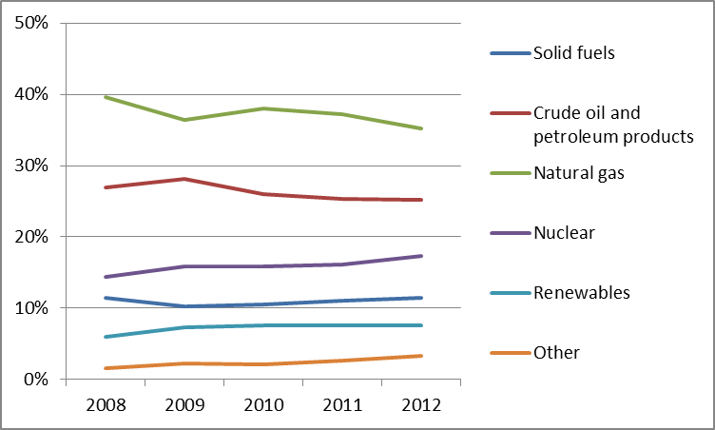
Natural gas consumption continues to sharply decrease, as it has in prior years, reaching 8.3 Mtoe in 2012. Domestic production accounted for 20.32% of total demand. E.ON Földgáz Trade (purchased by the state owned company MVM in 2013) has a long-term gas supply contract with Gazprom. In 2012 imports from the West (from Austria, HAG-pipeline) exceeded imports from the East (from Ukraine, Beregdaróc) while in 2013 imports from the East were higher again. A large share of the western entry capacity was contracted by E.ON for Russian imports. Small scale gas transit has occurred in the direction of Serbia, Romania and Croatia.

Figure 2: Gross electricity generation mix 2008 - 2011 (source: EU Energy in Figures – Pocketbook 2012 and 2013)
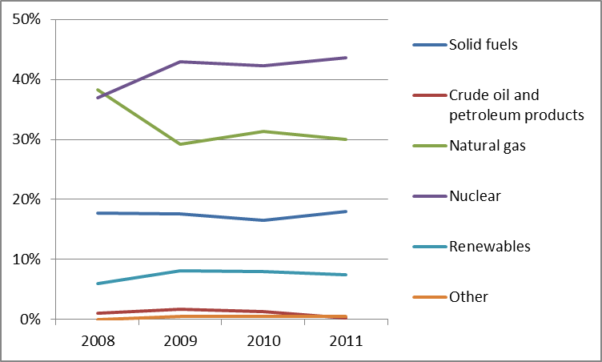

Regulatory framework

General
The political and regulatory debate during 2012 and 2013 continued to focus on the price moratorium, on special utility sector taxes and since December 2012 on price cuts for household consumers. The Minister of National Development approved a price adjustment equal to annual inflation at the beginning of 2012. Nevertheless, the price rise in gas imports created a mismatch between the level of regulated retail prices and the wholesale import price.
The energy sector is subject to an energy tax, a differentiated profit tax and a crisis tax. The crisis tax was set on (generation and supply) energy companies' taxable revenue and was due to expire in 2013. However, the government at the same time imposed a new tax on infrastructure, set by the length of transmission and distribution lines and pipelines.
In 2013, regulated prices for household consumers in the gas and electricity sector were cut by 20% and further decreases were announced for 2014 (electricity by 5.7% and gas by 6.5%).

National Energy Regulator
The Hungarian Energy and Public Utility Regulatory Authority ("Magyar Energetikai és Közmű-szabályozási Hivatal") - HEA, called until 2013 the Hungarian Energy Office, HEO - is an independent body of the administration. In 2012, HEO employed 122 staff and had a EUR 12.68 million budget. Recently its staff and budget increased due to its widening responsibilities. At the end of 2013, the HEA staff was 235.
Since 1st January 2012, HEA is obliged to calculate gas tariffs using the methodology imposed by the Ministry.
Parliament adopted a new law increasing HEA's competence in the public utility realm. This new law foresees that some of the regulatory decisions (namely decisions on connection prices and system use charges) are made in the form of HEA regulation which cannot be appealed in regular courts, but only before the Constitutional court.

Unbundling
The electricity TSO, MAVIR Zrt., is owned by the state-owned company Magyar Villamos Művek Zrt. (Hungarian Electricity Ltd., MVM), a major player both in generation and on the wholesale markets. Mavir was certified by the Regulator in March 2012 as an independent transmission system operator (ITO). The gas TSO FGSZ Zrt. is owned by MOL (Magyar Olaj-és Gázipari Nyrt, MOL Hungarian Oil and Gas Plc.), a listed company, and is also certified as an ITO.

Wholesale markets

Electricity
The generation market is relatively concentrated within the hands of state-owned MVM.
Net imports have been growing steadily reaching 19.95% of gross demand in 2012. Hungary is also an important transit country connecting markets between the Balkans and Central Europe. Imports come from Slovakia, Austria and Ukraine (76.77% share of total imports), exports are the highest towards Croatia and Serbia (73.74%).
In September 2012, the Czech-Slovak-Hungarian market coupling became operational. This resulted in an increased price convergence towards regional markets and decreased price volatility, narrowing spreads on the national market. The market coupling was an essential factor in the liquidity increase of HUPX, the Hungarian power exchange, a subsidiary of MAVIR. Day-ahead turnover was 3.78, 6.32 and 9.07 TWh, in 2011, 2012 and 2013 respectively. Prices fell from EUR 55.81/MWh in 2011 to EUR 42.33/MWh in 2013. Trade in physical futures, launched only in 2011, has also seen steady growth.

Gas
In 2012, 20.32% of gas consumption was supplied by domestic sources, the rest being mainly imported from Russia. E.ON Földgáz Trade is a major player on the wholesale market. It was purchased by state-owned MVM in October 2013.
Gas wholesale market concentration has been decreasing for a couple of years primarily due to diversified imports and their increased share in the reduced domestic demand. In 2013, MVM increased further its presence on the wholesale market, in particular in imports previously dominated by E.ON, GdF and MOL. The gas exchange market, CEEGEX, owned by MVM, became operational in early 2013.
Transit through Hungary comes from Russia via Ukraine flowing towards Serbia and Bosnia-Herzegovina, with smaller scale exports to Romania and Croatia. Negotiations about reverse flow to Ukraine were actively conducted at the end of 2012, with gas flows starting in April 2013.

Retail markets

Electricity
In 2012, 12.19 TWh of electricity was purchased under regulated prices. Almost all households remain under the regulated price regime with four companies covering 67.93% of the retail market. The switching rate for household consumers remained low i.e 1.6%, up from 0.3% in 2011. Non-household consumers had higher switching rates with 13.3% of those customers switching supplier in 2012, up from 9.7% in 2011.
Household prices were composed of electricity and supply costs for 43%, network costs for 35%. VAT and other fees and costs make up the remaining 22% of the total price. Due to a decrease in the European wholesale prices, the price moratorium in 2010 did not have significant effects until 2012. In 2013, the 20% utility rate cut led to some distortions and increased the price divergence between wholesale and retail markets.
Figure 3: Electricity price change by component 2008 – 2012 (source: Eurostat, energy statistics)

Gas
In 2012, 3.66 bcm of natural gas was purchased under regulated prices, 88% of which were sold to household consumers. Almost all households remain under the regulated prices regime. The retail market is relatively concentrated with six companies covering almost the entire retail market (83.79%). The switching rate for household consumers was 1.5%, down from 10.4% in 2011. The high figure for 2010-2011 was probably due to the liquidation of EMFESZ, a supply company with considerable retail books. Data for 2012 is likely to be much more typical for the market. Industrial consumers on the wholesale markets switch more frequently (ratios for consumers equipped with metering devices above 20 m3/h vary between 18.2% and 31.5%). Non-household prices are only regulated for consumers with gas meters below 20 m3/h.

Figure 4: Natural gas price change by component 2008 – 2012 (source: EC, EPCR metadata)

Consumers
The overall assessment of the retail electricity market in Hungary is slightly below the EU average (71.5 points compared to 72). This is also reflected in the country's position in the EU ranking (17th position) and the ranking of 31 domestic services markets (20th position). Switching, ease of switching and overall consumer satisfaction are within the 5 lowest ratings in the EU, and the incidence of consumer problems is the 5th highest in the EU. Yet, trust in providers is above the EU average. The retail gas market ranks lowest in the EU (with a score of 65.9 points compared to the EU average of 74.1) and 28th among 31 domestic service markets. It has also seen a 4.9 point decrease in its score since 2012 (highest in the EU). The market scores lowest in the EU in terms of overall consumer satisfaction, and 2nd lowest on comparability of offers while the incidence of problems is the highest in the EU.
Consumer satisfaction with electricity services was down slightly in 2012, with gas services steeply below EU27 average. Consumers can turn to both HEA and the Hungarian Authority for Consumer Protection (HACP) with their complaints. These institutions also provide dispute settlement opportunities.
Since 2008, the legislation recognises vulnerable consumers on a social and on a health-related basis. Depending on their category vulnerable consumers may benefit from deferred payment, prepayment options, individual assistance to help consumers understand their bills, consumers with disabilities whose life or health is directly jeopardized if disconnected from the electricity supply system, including any disruption in service, may not be disconnected in case of late payment or non-payment of charges, etc.

Infrastructure
Hungary has a robust infrastructure both in electricity and natural gas sectors. Due to important utility rate cuts in 2013 and extraordinary taxation on energy infrastructure, companies are dissuaded from making further investments. Investment levels within the electricity and gas sectors have decreased, and some non-essential assets have been mothballed. Development of infrastructure has been limited to state-owned actors (primarily MVM) mainly with the support from EU funds.
The Hungarian authorities should ensure a proper and timely adoption of the measures stemming from Regulation 347/2013 on the trans-European energy infrastructure, including the establishment of the one-stop-shop for Projects of Common Interest (PCIs) (due by 16 November 2013), and other measures foreseen for 2014 and 2015, including the publication of the manual on the permit granting process for project promoters, and the adoption of legislative and non-legislative measures streamlining the environmental assessment procedures.

Electricity
Hungarian electricity infrastructure is relatively strong, containing robust interconnections (equal to 30% of domestic installed capacity) with the neighbouring countries. The Hungarian network facilitates North-South transit flows between Central-Europe and the Balkans. It is involved in five PCIs under the guidelines for trans-European energy infrastructure: Two new 400kV interconnections with Slovakia are planned for 2018 and a 3rd one for 2021. Negotiations on a similar interconnection with Slovenia are under way and planned to be commissioned in 2016.

Gas
Hungary has almost finished its major interconnectivity programme launched in 2009. Interconnections with Romania and Croatia were commissioned in 2010 and 2011. It is involved in seven PCIs on the 2013 list. Negotiations about reverse flow in the former case (from Romania to Hungary, PCI), as well as on the HAG pipeline (from Hungary towards Austria) are under way. Construction of the Hungary-Slovakia pipeline is also under way (PCI) and has received funding from the European Energy Programme for Recovery from an amount of up to EUR 30 million. The Hungarian section of the South Stream pipeline is in the planning phase. Other PCIs with planned commissioning dates after 2017 (altogether five) and some minor improvements to facilitate better management of internal flows have been significantly postponed or cancelled due to the deteriorating investment climate.

Security of supply
Efforts in diversification of supply continue in both the electricity and gas sectors. Both trends rely on favourable regional economic processes and articulated policy efforts.

Electricity
Electricity imports from European markets are growing due to the phasing-out of domestic gas power generation. Cross-border capacities are adequate both for imports and North-South transit towards the Western Balkans. These achievements were fostered by the Czech-Slovak-Hungarian market coupling in autumn 2012, which resulted in increased price convergence towards regional markets and decreased price volatility on the domestic market.

Gas
Natural gas imports from Austria grew due to favourable price conditions, putting considerable pressure on Take-or-Pay clauses in the long-term contract with Gazprom. Increasing interconnectivity is one of the policy goals, reiterated by the National Energy Strategy. Romanian and Croatian interconnectors were built prior to 2012, but remained underutilised. At the same time imports from Austria were constrained by scarce pipeline capacity (4.6 bcma) in 2012. The construction of Hungarian-Slovak interconnector (max. capacity 5 bcma) in 2015 will further diversify transportation routes.

Key indicators
Electricity |  | Gas
Number of companies representing at least 95% of net power generation | 32 | Number of entities bringing natural gas into country | 20
Number of main power-generation companies | 4 | Number of main gas entities | 4
Market share of the largest power-generation company | 47.10% | Market share of the largest entity bringing natural gas | 32.91%
Number of electricity retailers | 43 | Number of retailers selling natural gas to final customers | 30
Number of main electricity retailers | 4 | Number of main natural gas retailers | 6
Switching rates (households) | 1.6% | Switching rates for gas (households) | 1.5%
Regulated prices for households – electricity | Yes | Regulated prices for households – gas | Yes
Regulated prices for non-households – electricity | Yes | Regulated prices for non-households – gas | Yes
HHI in power-generation market | 2,296.85 | HHI in gas supply market | 1,494.26
HHI in electricity retail market | 1,584.38 | HHI in gas retail market | 1,245.89
Electricity market value (bn€) | 2.758 | Gas market value¹⁵ (bn€) | 2.327
Installed generation capacity (MW) | 9,551
Peak demand (2012, MW) | 6,016
Number of smart meters installed | N/A

Ireland

Key issues
Irish authorities and their Northern Irish counterparts should continue efforts to align the SEM market design with the European target model. The TSO certification process needs to be completed to ensure compliance with the Electricity Directive.
Efforts for the diversification of its gas supplies should continue as power generation relies heavily on gas imports from the UK and both interconnectors experienced outages in winter 2012/13. The limited sourcing options have also resulted in the lack of a liquid gas wholesale market (trading is in the highly liquid UK market instead). Gas field development, greater storage and LNG capacity have all been proposed, but developments keep being delayed. A revision of the permitting process for these projects may help ensure they can be developed more rapidly.
Ireland should continue developing networks and systems to accommodate a large proportion of wind generation, which is particularly challenging in a small system.
Retail market competition in the case of gas remains below the required level for retail price deregulation while in electricity the incumbent's market shares remain high. Further efforts are required to improve competition in the retail sector and encourage customers to switch.

General overview
Energy consumption in 2012 (14.0 Mtoe) was based largely on fossil fuels, notably petroleum products, natural gas, and to a lesser extent solid fuels. The contribution from renewable energy sources was less significant in the overall energy mix at 7.2%. The 2020 renewable target for the energy sector is 16%, which is lower than the EU-27 average (20%).
Figure 1: Gross inland consumption mix 2008 – 2012 (source: Eurostat)
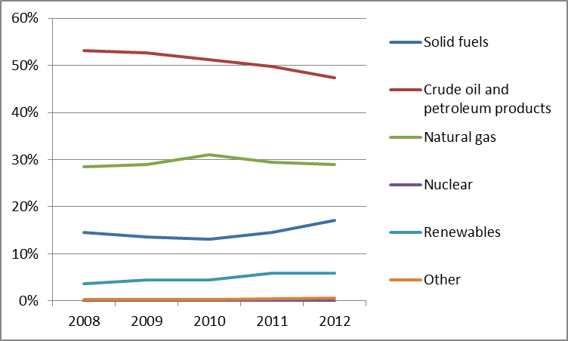
The power generation mix in 2011 (27.5 TWh) remained dominated by gas-fired power generation (with a share of 54.2%) and solid fuels (25.2%). The renewable share of power generation increased to 19.8% and cogeneration provided 7.1% of the total electricity generation in 2011. For 2012 the estimated electricity fuel production mix in Ireland is as below – gas continues to be the biggest fuel source, with renewable generation (mostly wind) now accounting for approximately 20% of the mix in Ireland.
Figure 2: Gross electricity generation mix 2008 – 2011 (source: EU Energy in Figures – Pocketbook 2012 and 2013)
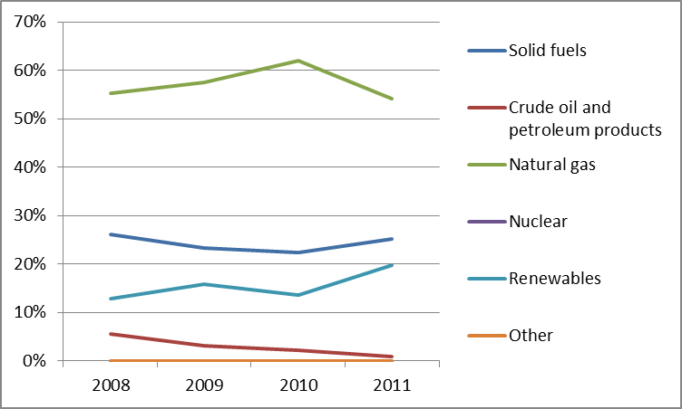

Regulatory framework

General
In January 2012, the European Commission referred Ireland to the European Court of Justice for failure to adopt EU gas market rules. This was resolved in 2012, when the access conditions to the Irish gas network at the Moffat Interconnection Point and the South-North gas pipeline were amended to include a reverse flow.
In January 2014, Ireland was referred to the European Court of Justice for failing to fully transpose the EU’s renewable energy directive. The aspects of the EU directive not yet transposed include the commitment that 10% of all transport energy would come from renewable sources by 2020, the management of grid access for renewable electricity and sustainability criteria for biofuels and bioliquids.
An infringement procedure for partial transposition of the Third Energy Package Electricity Directive is still on-going and has been referred to the Court of Justice of the EU in February 2014. Ireland had failed to adopt provisions related to unbundling of transmission system operators.

National Energy Regulator
The Commission for Energy Regulation (CER) is Ireland’s energy regulator with a range of economic, safety and customer functions. In 2014 the CER was also appointed as Ireland’s economic water regulator. The CER’s economic responsibilities in energy are to regulate the Irish electricity and natural gas sectors. As part of this role, CER jointly regulates the all-island wholesale Single Electricity Market (SEM) with its counterpart in Northern Ireland, the Utility Regulator (NIAUR) as part of the SEM Committee. The Committee consists of three NIAUR representatives, three CER representatives, an independent member and his deputy.
The number of staff at CER is currently about 90, though many of these staff works in non-energy economic areas, for example energy safety and water. The CER’s actual expenditure in 2012 was EUR 10.8 million across the range of its functions.

Unbundling
ESB owns the electricity transmission network assets and owns and operates the distribution network. EirGrid is responsible for the operation and development of the transmission system. ESB and Eirgrid are both state-owned. EirGrid has been certified as an independent transmission system operator for Ireland in 2013. The certification followed the decision of the European Commission that the arrangements in place, if effectively implemented; clearly guarantee more effective independence of the TSO than would be the case under the other unbundling options. However, to ensure their effective implementation and as set out in both the European Commission's and CER's decisions, CER now needs to monitor and assess these arrangements. CER expects to receive an application from EIL (East-West Interconnector Ltd) in due course for certification of the East-West interconnector between Ireland and Britain.
Bord Gáis Éireann is a vertically integrated state owned company, with both transmission and distribution gas infrastructure (Bord Gáis Networks) and retail supply of gas and electricity (Bord Gáis Energy), although it has no interests in production activities. The system operator Gaslink is an independent subsidiary of Bord Gáis Éireann.
In 2010, BGE confirmed its intention to adopt the “Independent Transmission Operator model” by amalgamating Gaslink and Bord Gáis Networks, to form a new independent subsidiary. In 2013, CER certified BGE as an ITO subject to the completion of outstanding work items. The Irish Government is in negotiations to sell the retail arm of the business, and in December 2013 they announced their preferred bidder: a consortium of Centrica, Brookfield Renewable Power and iCON Infrastructure. The State will retain ownership of the gas network (both transmission and distribution). Following the transaction, Bord Gáis Éireann will be fully ownership unbundled.

Wholesale markets

Electricity
Since 2007, the SEM has been the electricity market for Ireland and Northern Ireland. The SEM includes a centralised all-island gross mandatory pool market. All electricity is bought and sold through a market clearing mechanism. Generators receive the System Marginal Price (SMP), payments through a capacity mechanism and constraint payments.
SMP closely follows the gas price, since gas is the key fuel for electricity generation. In recent years, the average SMP fell from over EUR 80/MWh in October 2008 to under EUR 40/MWh for most of 2009, and then increased to over EUR 50/MWh in 2010 and EUR 60/MWh in 2011 and 2012.
To help ensure that there is no abuse of market power, the Regulatory Authorities’ Market Modelling Group has the power to require any market participant deemed able to independently influence market prices to issue “Directed Contracts”. Currently, only ESB Power Generation is required to sell Directed Contracts (2013) since they have circa 45% share of the SEM spot market. Without action the spot market would be quite highly concentrated; Directed Contracts are set to achieve a concentration level of 1.150.
The close relationship between SMP and the biggest fuel input (gas) is an indication that there has been no significant exercise of market power in SEM.
The Moyle and East-West interconnectors make capacity available through explicit long-term, daily and intraday auctions. “Use-it-or-sell-it” conditions apply to long-term capacity.
European market integration creates some unique challenges for Ireland. The EU Target Model was not designed with centralised pool markets like the SEM in mind. The more common European market design is decentralised bilateral trading with self-dispatch and the Target Model generally reflects this. Therefore the change required to implement the Target Model with SEM is substantially greater than for most other Member States. ACER and ENTSO-E therefore proposed to include for Ireland a two year transitional period in the Network Code on Capacity Allocation and Congestion Management (CACM). The SEM Committee has committed itself to implementing the Target Model by the end of 2016. This commitment is not only based on compliance with EU legal requirements. The SEM Committee views the implementation of the Target Model as a positive development that will bring significant benefits, especially in light of the developments that have occurred since the creation of the SEM in 2007. These include increased interconnection with the market in Great Britain, increased generation from renewable resources and the potential for more active involvement of the demand side in market arrangements.

Gas
Ireland currently sources most of its gas from Great Britain. Great Britain provided 91% of Ireland’s gas demand in 2012/13. There is production at the Kinsale and satellite fields, but it is declining. The Southwest Kinsale Gas Field was adapted for gas storage in October 2001.
In the 10 year forecast, the Irish gas market is expected to continue to be heavily reliant on interconnection with the UK market for the foreseeable future, and gas demand is forecast to rise by 12% over the period to 2021/22. The capacity limits of Moffat are expected to be approached in 2014/15 and any subsequent years that Corrib is delayed. Bord Gáis Networks and Gaslink have recommended reinforcements in Scotland to improve capacity, and the EU has identified this reinforcement project in the UK as a potential “Project of Common Interest” in improving supply to Ireland. To decrease Ireland's dependence on import from Britain, potential new sources of supply will include the Corrib gas field, which is currently expected to begin commercial flows in 2015, and the Shannon Liquefied Natural Gas (LNG) terminal (also a “Project of Common Interest”), which could become operational in 2017. Unfortunately development of both projects has been significantly delayed due to planning permission issues with the Corrib field and disputes over levies that Shannon LNG should pay (on this latter issue, the High Court in Ireland found in favour of the CER).
Most gas for Ireland is sourced from Great Britain's National Balancing Point (NBP) which is characterised by high levels of liquidity. Trades in Ireland can take place at a notional balancing point called the Irish Balancing Point (IBP), however the IBP is extremely illiquid. Elements of the revised guidelines on Congestion Management Procedures (CMP) were implemented on the GB-Irish interconnectors on 1 October 2013 (some other elements remain to be implemented), and the network code on Capacity Allocation Mechanisms (CAM) is required to be implemented by November 2015. Since 2008, the two regulators on the island (CER and NIAUR) have been working together to develop Common Arrangements for Gas (CAG). This would allow the gas transmission systems in Ireland and Northern Ireland to operate on an all-island basis. However, there have been challenging issues raised including physical capacity limitations to the operation of a single physical balancing regime, so implementation has been delayed.

Retail markets

Electricity
In electricity, Electric Ireland continues to be the largest supplier in terms of customers across all segments and in terms of energy supplied in the domestic (residential) and Large Energy User (LEU) markets. The domestic market share (MWh) of Electric Ireland is just under the threshold at which it was deregulated at 60%, while CMP measures introduced in 2013 will require review to ensure that they remain compatible with CAM rules when introduced in 2015.
Figure 3: Electricity price change by component 2008 – 2013 (source: Eurostat, energy statistics)

Gas
The incumbent supplier in the gas retail market is Bord Gáis Energy, who is the largest supplier. The Irish gas market has not yet been price deregulated as CER judge that Bord Gáis is still in too dominant a position (January 2014). The threshold market shares for deregulation are 60% with rebranding and the 55% without rebranding. Although the market is close to these levels, it has not yet reached that point, suggesting that retail competition is still too low in Ireland.
CER is leading the implementation of the smart meters roll-out. Phase 1 consisted of trials and cost benefit analysis carried out from 2008 to 2011. ESB Networks installed 10,000 meters and provided over 1000 in-home displays as part of the smart metering trial. In July 2012, CER announced its decision to approve the rollout of smart meters. Since then, CER has worked with stakeholders to formally initiate Phase 2. While not yet decided, the roll-out is expected between circa 2016 and 2019.

Consumers
Irish consumers assess the performance of their retail electricity and gas markets above the EU average with the difference being very small for the latter (75.1 points compared to 72.0 and 74.6 compared to 74.1), which corresponds to 13th and 14th place in the EU ranking. In addition, both markets show a score slightly above the one seen for the average of all domestic services markets (electricity is in the 14th position and gas in the 15th position out of 31 markets). While the performance of electricity market has stayed relatively stable since 2012, the gas market has decreased its score by 2.3 points. Both markets are assessed particularly well on the ease of switching (electricity 3rd and gas 5th highest in the EU) and switching gas providers/tariffs is 5th highest in the EU.
Competition continued to develop in the electricity and gas retail markets in 2012 and switching rates were above 10% in both markets. The total number of switches completed in the electricity market in 2012 was 252,056 (a decline of 25% from 2011 levels). While good by EU standards, this still means a large number of customers have never switched. To support switching, CER has set-up an accreditation process for price comparison websites.
CER's Energy Customers Team acts as single contact point providing consumers with information on electricity and gas. They also provide a free dispute resolution service. In 2012 the Energy Customers Team received 3,067 contacts from customers, an increase of almost 11% on 2011. The reasons that customers contact the ECT vary, from straightforward requests for information to complex complaints. Although complex complaints made up just 10% of the customer contacts in 2012, they made up the majority of the team’s work.
In 2012, CER set out the minimum service levels that suppliers must provide their customers with. CER has also put obligations on suppliers to ensure that disconnections are a last resort. Prior to disconnection, all suppliers are required to offer customers a free Pay-As-You-Go meter.

Infrastructure
The Planning Board has been appointed as the one-stop-shop (OSS) for the permitting of energy infrastructure Projects of Common Interest (PCI).

Electricity
The new 500 MW EirGrid East-West electricity interconnector to the UK began full commercial operation in May 2013. It received an EU funding of EUR 110 million from the TEN-E Initiative. Investment in the onshore electricity network has also been necessary, for the connection of expanding wind power as well as system security and efficient distribution.
Ireland has a grouping process or “Gate“ process for connecting the large number of renewable generators, and the next round to be developed will be connected under Gate 3 which is intended to help meet Ireland’s 20:20:20 targets from an electricity perspective – in other words to meet an Irish Government target of 40% of Ireland’s electricity consumption coming from renewable generation by 2020. The CER is commencing the process of reviewing the connection and access policy for renewable and non-renewable generators to the grid, post Gate 3.
CER authorised over a billion euros of investment in the electricity transmission system over the years 2011 to 2015. To facilitate renewables integration and improve flexibility, several PCIs are on the scope. Some PCIs regard further interconnections with UK (Northern Ireland and Great Britain), and possibly France; Hydro Storage is also addressed under PCI scheme in connection to these developments.
Another cluster of PCIs will facilitate connecting generation from renewable energy sources, both in Ireland and the UK, such as an offshore interconnected electricity grid based on renewable resources (wind, wave and tidal, connecting 3200 MW) consisting of 850 km of HVDC interconnectors with a capacity of 500-1000MW in the northern area.

Gas
To meet Third Package requirements, in 2013 Gaslink as TSO has submitted a draft Network Development Plan to the CER which was submitted to ENTSO-G. The network plan found that high pressure transmission system currently have sufficient capacity to meet forecast gas demand, although the southern part of the network is anticipated to require reinforcement in the mid-to long term.
In order to provide for more flexibility to the gas supply, a cluster of Project of Common Interest will address implementing of reverse flows between Ireland and UK -as in Moffat-, increased storage in Northern Ireland and the LNG plant in Shannon. The need for greater interconnection (through reinforcements in GB) and LNG investment is highlighted elsewhere in this report.

Security of supply
CER has a duty to monitor the security of supply of electricity and can take such measures as it considers necessary to oblige the regulated companies to take action. Given the significant reliance on natural gas, CER requires gas generators to hold fuel stocks for between 3 and 5 days.

Key indicators
Electricity |  | Gas
Number of companies representing at least 95% of net power generation | 5 | Number of entities bringing natural gas into country | 13
Number of main power-generation companies | 5 | Number of main gas entities | 5
Market share of the largest power-generation company | 55% | Market share of the largest entity bringing natural gas | 42%
Number of electricity retailers | 6 | Number of retailers selling natural gas to final customers | 8
Number of main electricity retailers | 4 | Number of main natural gas retailers | 6
Switching rates | 10%* | Switching rates for gas (entire retail market) | 10%*
Regulated prices for households – electricity | No | Regulated prices for households – gas | Yes
Regulated prices for non-households – electricity | No | Regulated prices for non-households – gas | Yes
HHI in power-generation market | 1,150 | HHI in gas supply market | N/A
HHI in electricity retail market | 4,759 | HHI in gas retail market | 4,780
Electricity market value (bn€) | 3.207 | Gas market value³¹ (bn€) | 0.800
Installed generation capacity (MW, 2011) | 8,791
Peak demand (MW) | 4,589
Number of smart meters installed | 10,000
* Domestic 10% across gas and electricity
Italy

Key issues
Competition in the electricity market has been enhanced by the development of the electricity network and the excess of supply caused by demand reduction and growth in renewables. Despite all this, power prices in Italy are generally still higher than in other EU member states.
Increasing interconnection capacity and developing congestion management rules with neighbouring markets should be encouraged to allow the secure integration of renewables and better price alignment with adjacent countries. National infrastructure capacity should be increased to tackle the North-South disparities within the country.
Competition within the gas sector has improved due to successful unbundling of the TSO and the implementation of new capacity allocation rules. Nevertheless, the spot market liquidity is still low. Security of supply at peak periods is limited due to low flexibility. Access rules to interconnection capacity should be further developed to avoid contractual congestions.

General overview
In 2012, after a 5% decrease, gross energy consumption reached 163 Mtoe. The share of oil products over the total consumption (37%) fell below the share of natural gas (38%) for the first time, while the share of solid fuel and renewables (13.5%) increased, thus moving Italy closer to achieving the 2020 renewables target of 17%.
Figure 1: Gross inland consumption mix 2008 – 2012 (source: Eurostat)
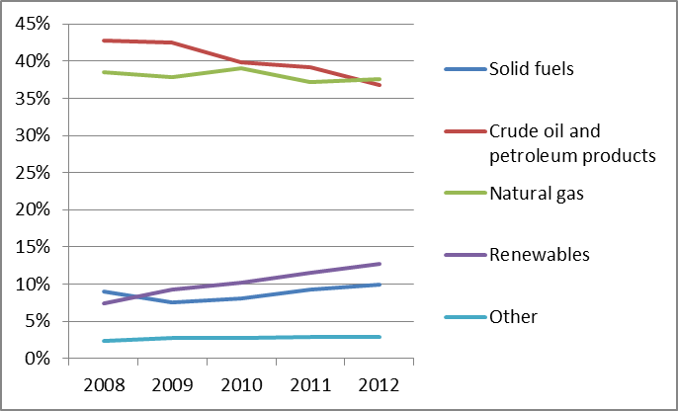
Figure 2: Gross electricity generation mix 2008 – 2011 (source: EU Energy in Figures – Pocketbook 2012 and 2013)
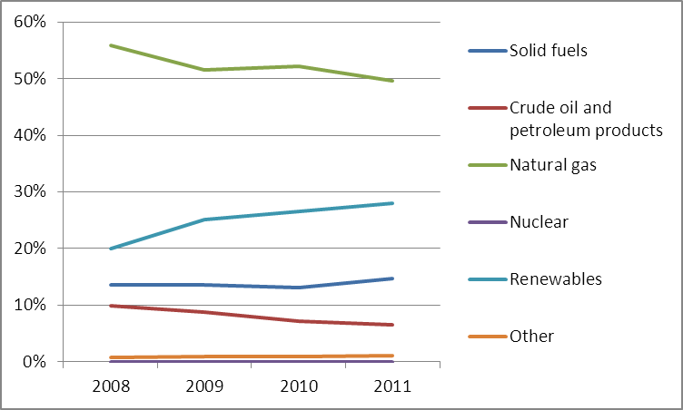
- Regulatory framework

General
A new national energy strategy (Strategia energetica nazionale, SEN) was approved at the beginning of 2013 and confirmed by the latest Italian Government. Infrastructure development, import reduction and further integration into the European single market are among the primary goals for the electricity sector. Meanwhile, the natural gas sector focused on continuous development and integration into the European gas market, with the final aim of Italy becoming the primary hub in southern Europe.
In 2012, Legislative decree 28/11 came into force, reshaping incentives for renewables: the Green Certificates mechanism was replaced by feed-in tariffs, with caps to limit overall expenditure and to incentivise capacity. Auction procedures are planned for larger plants.

National Energy Regulator
The Italian National Energy and Water Service Regulatory Authority (Autorità per l’Energia Elettrica, il Gas ed il sistema idrico), which has been in operation since 1997, working in both energy and water services regulation had 172 staff in 2012 with an annual budget of EUR 58.5 million. The Authority collects levies from energy market and water service stakeholders to cover this budget.

Unbundling
In the first half of 2013 the Italian Regulator certified Terna, the main transmission system operator, under the ownership unbundling regime. There is a total of 138 electricity distributors, 10 of which serve more than 100,000 customers each. In 2012, the market share of Enel Distribuzione, the dominant operator in distribution, remained stable at 86% of total volume distributed.
Snam Rete Gas’s unbundling process from its former parent company (Eni) has been concluded and it is now certified as an ownership unbundled TSO. In September 2013 Infrastrutture Trasporto Gas was certified as independent transmission operator. There were 232 gas distributors in 2012, of which 35 served more than 100,000 customers. In 2013, there were five distributors with market share higher than 5%, with Snam providing almost 23% of market. In the coming years, the number of gas distributors will be reduced to 177 and each concession will be auctioned.
- Wholesale markets

Electricity
Competition on the wholesale market continues to improve: the market share of the four largest operators decreased by 5%, compared to 2011 (49%). ENEL remains the main market operator holding 25% of the market (26% in 2011), followed by ENI (9%), Edison (7.2%) and E.On (4.4%). Further progress was made by small-sized operators whose collective shares rose to 30.2%. Global national electricity consumption dropped from 328.2 TWh in 2012 to 317.1 in 2013.
Congestion management rules were improved as the introduction of market coupling between Italy and Slovenia brought about tangible benefits, mainly by improving efficiency in cross-border capacity transmission rights allocation. As a result of this and a decrease in natural gas prices, a decline of the day-ahead prices was observed from the end of 2012. Even though Italy remains one of the best interconnected European countries, the average price of electricity was still above the rest of the Europe due to the generation park composition by far led by combined cycles gas fired plants (see Fig. 2).

Gas
Final gas consumption continued to decrease, reaching the lowest level since sector’s liberalisation (70 Gm³ in 2013 against 74.9 Gm³ in 2012). Net volumes of imported gas fell consequently as well, but Italy’s dependency on gas imports remains high (90%). In 2012, Russia was Italy’s main supplier (35.2%) followed by Algeria (32.2%). LNG is imported mainly from Qatar. Most imported gas is based on long-term contracts, with just 4.6% of the total import purchased on European exchanges.
Eni, Edison and Enel continued to dominate gas supply, increasing their share to a combined amount of 78.2% (74.3% in 2011) but the concentration remains low (HHI in 2012 below 500).
Despite rather low market liquidity (the churn rate of the Italian PSV remained stable at the 2011 level of 2.6) the level of competitiveness was enhanced by early introduction of congestion management rules at the North border. Prices on the OTC spot market at PSV, after a 21% increase in 2012, remained largely stable at around EUR 28/MWh with reduced spread in respect of main European hubs. Products available at the gas exchange are increasing (the organised forward market was activated in 2013).
- Retail markets

Electricity
Due to a significant downturn in power demand the size of the retail market in 2012 decreased by 4.2% compared to 2011, reaching 264 TWh. Despite the numerous active suppliers (about 140), the standard offer market remained concentrated, as 85.4% of the total supply was provided by Enel. The free market was less concentrated with a combined share of the three main operators (Enel, Edison and Eni) at 34.3%, of which the leading operator (Enel group) accounted for 20.3%. The competition on the overall retail market was at medium level (HHI just above 1800) with only two companies having a market share greater than 5%.
In Italy, consumers that do not choose a supplier remain with a default supplier, the local DSO, which provides electricity according to a ‘standard offer’. In this case, the local DSOs buy electricity from the Single Buyer at wholesale market price. Today the majority (80%) of households and SMEs are still served on the base of this ‘standard offer’. Other consumers (i.e. other than households and SMEs) are obliged to find a supplier, but if they cannot find a suitable offer, electricity is supplied by a Last Resort Supplier, selected through an open auction. Customers remained relatively active in switching suppliers: 7.6% of the total number of withdrawal points changed supplier in 2012 (compared to 7.0% in 2011). An independent data hub to support the switching process has been launched in 2013.
Figure 3: Electricity price change by component 2008 – 2012 (source: Eurostat, energy statistics)

Gas
In 2012, domestic demands in the gas sector decreased by 9% compared to 2011, with 64.2 Gcm of natural gas sold to the end market. As the share of the top three sellers (Eni, Enel and Edison) decreased slightly (from 49% in 2011 to 47.5% in 2012) the market remained concentrated.
Consumers have been able to choose their own supplier since January 2003. Nevertheless, the majority (84%) of households and SMEs are still served on the base of this ‘standard offer’. 4.7% of overall gas customers changed supplier in 2012, representing 45.2% of the total volume of gas consumption. An independent data hub to support the switching process has been launched in 2013.
In 2013 the gas retail market regulatory framework in Italy has been redefined. The new balancing market, introduced in 2011, decoupled the price from petroleum products, which led to a renegotiation of prices and quantities. This reform has incentivised the wholesale spot market and has brought prices more in line with those of other European markets. The aim was to pass on the benefits deriving from wholesale spot commodity prices to consumers through a reform of the economic terms for the "servizio di tutela gas" (standard offer for domestic consumers).
Figure 4: Natural gas price change by component 2008 – 2012 (source: EC, EPCR metadata)
- Consumers
Italy has implemented several instruments to protect consumers and promote informed choices. The NRA acts as single point of contact providing online information to consumers through the Consumers' Atlas as well as an online price comparability tool. Italy has undertaken specific institutional communication campaigns. In 2013, the NRA set up a new Energy Customer Conciliation Service parallel to the existing joint dispute resolution procedure protocols.
In 2012, the number of cases processed by the Energy Help-Desk decreased by 6% when compared with 2011 and numbering almost 36,000, submitted mostly by residential customers. The NRA has also adopted a Resolution on the transparency of billing. Other forms of protection are the presence of a last resort supplier and of social tariffs available for vulnerable customers who suffer from financial hardship or serious health conditions. The number of families who have benefited from social tariffs is 957,192 for the electricity sector and 609,301 for the gas sector.
The assessment of both retail electricity and gas markets in Italy is the 5th lowest in the EU and well below the EU average (65.7 and 71.0 points compared to 72.0 and 74.1, respectively). In addition, the score of both markets is well below the average observed for 31 domestic services markets (almost 8 points for electricity and over 2 points for gas), with 30th and 21st position in the ranking. While the performance of gas market has stayed relatively stable since 2012, the electricity market has seen a considerable (4.2) decrease in score. The electricity market scores below the EU average on all indicators (with the third lowest score on trust in providers) with the exception of switching provider or tariff plan with the existing provider (which is 4th highest in the EU). Likewise gas services are assessed below EU average on all the components with the exception of switching provider or tariff plan (with the 4th lowest EU score on overall consumer satisfaction and 4th highest incidence of complaints).
- Infrastructure
The Italian authorities should ensure a proper and timely adoption of the measures stemming from Regulation 347/2013 on the trans-European energy infrastructure, including the establishment of the one-stop-shop for Projects of Common Interest (PCIs) (due by 16 November 2013), and other measures foreseen for 2014 and 2015, including the publication of the manual on the permit granting process for project promoters, and the adoption of legislative and non-legislative measures streamlining the environmental assessment procedures.

Electricity
Various upgrades of the internal grid were completed in 2012 allowing better integration of different market zones and improving the transit of electricity throughout the critical South-Central-South section. Future investments include 19 Projects of Common Interest under the guidelines for trans-European energy infrastructure, mainly interconnecting Italy with France, Switzerland and Austria and the necessary internal reinforcements. Altogether such investments will ease the grid constraints and reduce differences between price zones. The SAPEI project doubled the existing interconnection capacity between Sardinia and the Italian mainland thus contributing to resolving congestion issues in that area. A sub-sea transmission cable between Sicily ("Sorgente-Rizziconi") and the continent is still under construction; entry into operation is expected in 2015. The Italian TSO is among a small number of entities worldwide that have decided to implement electricity storage pilot projects on a large scale to manage congestion caused by renewable generation. The electricity sector roll-out of the smart meters is almost complete, ENEL has installed over 32 million smart meters.

Gas
The new offshore LNG regasification terminal in Livorno was completed at the end of 2013. Despite the third party access exemption obtained, the terminal asked for admission to the regulated system. Another one in Porto Empedocle, Sicily, started construction activities in 2013.
Snam Rete Gas is developing a Project of Common Interest within the North-South East Corridor to allow future flows from the Southern Gas Corridor project, the construction of Trans Adriatic Pipeline transporting Azeri gas from the Turkish border to the South of Italy through Greece and Albania will start in 2015. It also has a PCI ensuring reverse flow capacity towards the north western markets and a planned pipeline for Algerian gas through Sardinia.
The AEEG has proposed updating the previously established timeframe for the mass roll-out of smart meters in the gas sector, delaying it by 2018.
- Security of supply

Electricity
The Italian system is characterised by substantial surplus of generation capacity which currently stands at over twice the peak load. The excess of available capacity has been enhanced by a very large amount of new renewable generation capacity commissioned in the last two years. A capacity market mechanism is expected to substitute the existing temporary scheme of capacity payment. According to the proposed scheme, the TSO will purchase guaranteed options from the generation companies (physically backed call options) for the amounts required to ensure system adequacy, however, implementation is still awaiting final approval.

Gas
Despite the excess of overall import capacity Italy’s reserves at peak daily demand are rather tight. Given the high (and increasing) share of residential consumption over the total demand (around 30%), the daily demand is very sensitive to temperatures. The new storage site of Bordolano (Stogit) is completed and expected to go on online in 2015, meanwhile the construction of the San Potito e Cotignola (Edison Stoccaggio) and Cornegliano (Italgas Storage) sites have been delayed and the concession for Rivara (Independent Resources plc) was cancelled. Because of the high share of gas fired generation capacity a shortage of gas may create flow problems in the electricity sector. The emergency plan for the gas system, in line with Regulation 994/2010 is based on reactivation of cold reserve oil plants and disconnection of industrial customers.
- Key indicators
Electricity |  | Gas
Number of companies representing at least 95% of net power generation | 291 | Number of entities bringing natural gas into country | 85
Number of main power-generation companies | 3 | Number of main gas entities | 3
Market share of the largest power-generation company | 25% | Market share of the largest entity bringing natural gas | 44.6%
Number of electricity retailers | 412 | Number of retailers selling natural gas to final customers | 465
Number of main electricity retailers | 2 | Number of main natural gas retailers | 4
Switching rates (entire electricity retail market) | 7.6% | Switching rates (entire retail market) | 4.7%
Regulated prices for households – electricity | No | Regulated prices for households – gas | No
Regulated prices for non-households – electricity | No | Regulated prices for non-households – gas | No
HHI in power-generation market | 884 | HHI in gas supply market | <500
HHI in electricity retail market | 1,865 | HHI in gas retail market | 1,275
Electricity market value (bn€) | 39.410 | Gas market value¹³ (bn€) | 23.110
Installed generation capacity (MW) | 124,224
Peak demand (MW) | 54,113
Number of smart meters installed | 32 mln

* AEEG updates and publishes every 3 months standard conditions for households and small enterprises based on wholesale market conditions

Latvia

Key issues
Improper functioning of the wholesale electricity market is the key issue for the power sector, along with the necessary renewal of outdated infrastructure. Electricity connections to Estonia are inadequate and challenges remain as regards smooth functioning of the regional electricity market. Active participation of Latvenergo to Nord Pool Spot market is necessary. The electricity retail market is not developing and the phasing out of regulated tariffs is one of the key measures to be implemented.
For gas, the focus needs to be on creating a functioning market. Crucial infrastructures for the diversification of supply need to be put in place. The Latvian Parliament adopted the amendments to end the emergent market derogations on 13 March 2014. However, its enforcement was postponed until 2017, meaning that the monopoly in the gas markets de facto continues. Unbundling of DSOs would support the transition as Latvia’s gas infrastructure is integrated into the Baltic and EU gas systems. Latvia should urgently develop and implement clear rules for third party access to the Incukalns storage.

General overview
Latvian national gross final energy consumption in 2012 amounted to 4.538 Mtoe. The energy consumption mix has the highest renewables share (35.8%) in all three Baltic States. The main renewable sources in Latvia are hydropower and biomass. The country’s renewables target for 2020 is 40%, which is twice as high as the EU average of 20% and Latvia is currently on track to achieve it. Natural gas, oil and petroleum products also played an important role in gross energy consumption in 2012 with a share of 30% and 27% respectively (Figure 1).
Figure 1: Gross inland consumption mix 2008 – 2012 (source: Eurostat)
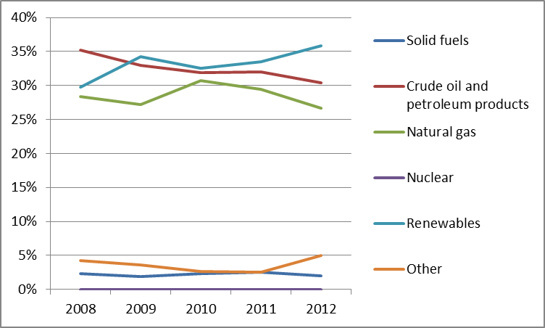
In 2012, total power generation reached 6.17 TWh with most derived from natural gas (55.1%). The remaining electricity production came from renewables. The vast majority of electricity produced from RES today comes from the Daugava hydropower plants cascade, which consists of three large HPPs and in total generated 3.63 TWh of electricity, which constitutes 53% of the total electricity output in 2012.
Figure 2: Gross electricity generation mix 2008 – 2012 (source: Eurostat)
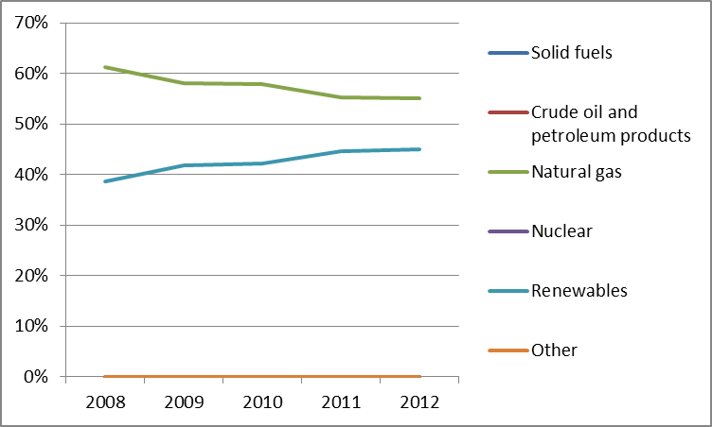

Regulatory framework

General
Latvia was granted a derogation from the Third Energy Package as an emergent gas market. In March 2014 amendments to the Energy Law were adopted in the third and final reading. The gas market in Latvia will not be opened before April 2017, but a gradual liberalisation of the gas market is implemented in several stages starting from 4 April 2014. The liberalisation of the electricity retail market envisaged for 1 April 2014 was postponed until 1 January 2015. The market for industrial users is fully liberalised since November 2012.

National Energy Regulator
The Latvian national regulator, the Public Utilities Commission (PUC), is a multi-sector regulator. PUC employed 120 staff members (21 of them responsible for energy) in 2013 and had a budget of around EUR 4.7 million.

Unbundling
The electricity TSO is Augstspriegumatīkls JSC. Legally unbundled since 2005, it became an independent company in January 2012. The PUC has certified Augstspriegumatīkls JSC as an independent transmission system operator. The main DSO is Sadalestīkls JSC and there are another ten smaller local electricity distribution companies.
The gas TSO is Latvijas Gāze with E.ON and Gazprom owning the majority of its shares. Latvia has an explicit derogation from the Gas Directive exempting it from unbundling rules (Article 49). The certification of this gas TSO has therefore not taken place yet.

Wholesale markets

Electricity
The dominant electricity producer, Latvenergo AS, produced 89% of all power in 2012 and it was the only company with market share exceeding 5%. In total there were 17 companies in 2012, representing at least 95% of electricity generated.
In 2012, the total installed capacity of power plants in Latvia was 2,576 MW. Of this total, hydropower plants had an installed capacity of 1,576 MW, while combustible fuels power plants contributed 964 MW. The peak load was 1,368 MWand electricity consumption increased by 1.6%, to 7,459 TWh.
In November 2012, the electricity market for industrial users was fully liberalised. Latvia joined the regional Scandinavian – Baltic Nord Pool Spot market for electricity contracting in June 2013. However, performance was not as good as anticipated. The interconnector with Estonia was often congested, contributing to price spikes in the Latvian/Lithuanian price area. The largest electricity producer Latvenergo AS did not participate, which resulted in low activity on the spot market.
In 2013 the majority of demand was met by domestic generation (80.3%) and the remainder was imported (19.7%).

Gas
Latvia does not have its own natural gas resources and all gas consumed is imported from the Russian Federation. Latvijas Gāze JSC is the only player in the wholesale gas market with a market share of 100%. In 2012 the average price of imported gas was EUR 31.7/MWh.
Total consumption of gas in Latvia in 2012 was 1,508 mcm, a decrease of 6%, compared to 2011. The reduction was due to lower heating demand (including cogeneration) and greater use of biomass.
Gas imported from Russia during the summer is stored at Inčukalns underground gas storage (UGS) facility. During the winter Latvia satisfies all its natural gas needs from Inčukalns UGS, which is also used to supply Estonia and to a lesser extent Lithuania.

Retail markets

Electricity
In 2012, most customers (90%) bought electricity from Latvenergo, which imports and exports electricity, and also fulfils the functions of the supplier of last resort as a public trader. Latvenergo supplied 6,708 GWh of electricity to Latvian consumers, while the other five electricity retail market participants supplied the remaining 10%.
Power prices for households and industrial consumers have been increasing in recent years, mostly due to an increase in commodity prices.
Figure 3: Electricity price change by component 2008 – 2013 (source: Eurostat, energy statistics)
It is possible to switch suppliers for industrial consumers, and in 2013 the switching rate for non-household customers was 15%. There are no legal provisions in place for smart metering and a cost-benefit analysis has not been conducted.

Gas
As in the wholesale market, Latvijas Gāze JSC is the only player in the gas retail market in Latvia. Switching supplier is therefore not an option. The price is indexed to oil derivatives.
Figure 4: Natural gas price change by component 2008 – 2012 (source: EC, EPCR metadata)
Until the end of 2013 there was no formal decision and no plan to roll-out smart meters in the natural gas system.

Consumers
Latvian consumers' assessment of the performance of their retail electricity market in 2013 is more than 3 points below the EU average (68.6 vs. 72.0), corresponding to 21th place EU-wide. The market is also around 10 points below the average for domestic services markets (second worst among 31 markets). The retail gas market is assessed somewhat above the EU average (75.4 vs. 74.1), corresponding to 13th place EU-wide, but has seen a decrease of 2.2 points since 2012. For the retail electricity market, the country scores the lowest in the EU on comparability, 2nd lowest on ease of switching and choice and 5th lowest incidence of switching (provider or tariff plan). As for gas services, the country is in the 4 last positions of the EU ranking on comparability, choice of providers, incidence of switching and ease of switching while, on the positive side, the incidence of problems is the 5th lowest in the EU and the incidence of complaints is second lowest.
According to the Law on Regulators of Public Utilities, PUC deals with customer complaints. Consumers can also approach the Consumer Rights Protection Centre for out-of-court dispute settlement. No particular actions to improve consumer access to information about the market and/or their rights have been taken recently. There is no clear definition of vulnerable consumers yet, but plans exist to introduce several measures to inform and support vulnerable consumers.

Infrastructure
The Latvian authorities should ensure a proper and timely adoption of the measures stemming from the TEN-E Regulation, including the establishment of the one-stop-shop for Projects of Common Interest (PCIs) (due by 16 November 2013), and other measures foreseen for 2014 and 2015, including the publication of the manual on the permit granting process for project promoters, and the adoption of legislative and non-legislative measures streamlining the environmental assessment procedures.

Electricity
There are currently no bottlenecks between Latvia and Lithuania. However, the interconnector between Latvia and Estonia is regularly congested. For historical reasons, the Latvian electricity system is heavily interconnected with the networks of Belarus, Russia, Estonia and Lithuania.
In March 2013, the three Baltic States’ TSOs – Litgrid (Lithuania), AugstspriegumaTīkls (Latvia) and Elering (Estonia) – signed an agreement on the principles of calculation and allocation of the cross-border capacity within the Baltic States and with third countries. The agreement contributes to a successful integration of the Baltic electricity markets.
As part of the NordBalt project, funded by the EEPR, the interconnector between Lithuania and Sweden and the transmission network in Latvia and Lithuania are reinforced, improving the supply reliability in the region. The project is expected to be completed by the end of 2018. The third interconnector between Latvia and Estonia, a Project of Common Interest under the guidelines for Trans-European infrastructure, will enhance security of supply, effectiveness of operation and competitiveness of energy markets in the entire Baltic region. The project is scheduled to be completed by 2020, but as this is the project that is expected the biggest beneficial impact on wholesale market functioning Latvia should assess ways to accelerate its construction.

Gas
Latvia is dependent on gas imports from Russia for all of its gas consumption with no alternative suppliers or supply routes. The Latvian gas market is isolated from the rest of the EU and only has interconnection with Lithuania and Estonia.
The enhancement of the Latvian-Lithuanian interconnection was realized in early 2013 by increasing cross-border capacity to more than 6 mcm/day in both directions. Moreover, a further enhancement to 12 mcm/day on a 40-kilometer section between Daugmale and Iecava is currently planned and has been granted PCI status under the guidelines for trans-European energy infrastructure. At the same time, the enhancement of the Estonia-Latvia interconnection is also part of the first PCI list.

Security of Supply

Electricity
Currently, in the event of failure of large generating units in Latvia and Lithuania, security of supply for the entire Baltic Region could be in danger. The infrastructure investments under construction will significantly increase security of supply, in particular the third interconnector to Estonia. In particular, the investments will have a positive effect on the voltage and stability level under stressed network conditions.

Gas
In 2012, the total consumption of natural gas in Latvia represented about 43% of transmission capacity, which means the natural gas delivery system is never over-loaded and can ensure a stable supply of natural gas to all consumers. According to 2012 data, the N-1 criterion equals 188.6%, implying that coverage of peak demand or supply deficit is ensured from an infrastructure perspective.
Gas supply is mainly secured by the Inčukalns UGS, where 4.47 bcm of gas can be stored (of which 2.32 bcm is active or regularly extracted). The capacity of the Inčukalns UGS can be increased to 3.2 bcm of active gas.

Key indicators
Electricity |  | Gas
Number of companies representing at least 95% of net power generation | 17 | Number of entities bringing natural gas into country | 1
Number of main power generation companies | 1 | Number of main gas entities | 1
Market share of the largest power generation company | 89% | Market share of the largest entity bringing natural gas | 100%
Number of electricity retailers | 6 | Number of retailers selling natural gas to final customers | 1
Number of main electricity retailers | 2 | Number of main natural gas retailers | 1
Switching rates (entire electricity retail market) | 0% households, 15% non-households | Switching rates for gas (entire retail market) | 0
Regulated prices for households – electricity | Yes | Regulated prices for households – gas | es
Regulated prices for non-households – electricity | No | Regulated prices for non-households – gas | no
HHI in power generation market | 7,932 | HHI in gas supply market | 10,000
HHI in electricity retail market | 8,196 | HHI in gas retail market | 10,000
Electricity market value (bn€) | 0.512 | Gas market value²⁸ (bn€) | 0.165
Peak load (MW) | 1,885
Installed generation capacity (MW, 2011) | 3,691
Number of smart meters installed | N/A

Lithuania

Key issues
Lithuania remains highly dependent on electricity imports, particularly from the Russian Federation. Interconnectors with Sweden and Poland have to be completed so as to decrease the generation deficit and foster security of supply and wholesale market functioning. Lithuania should continue to promote competition through better integration of the Baltic energy markets.
Lithuania relies on Gazprom as its single source of gas supplies. Diversification of gas supply will be introduced by an LNG terminal in Klaipeda, expected to start operating in December 2014. It is important that the planned interconnector with Poland (GIPL) is also constructed in order to further diversify gas supplies to the country and the larger Baltic region.
- General overview
The Lithuanian national gross final energy consumption in 2012 was 7.084 Mtoe. It was based largely on natural gas (37%) and oil (35%). The renewables share increased from 18.0% to 21.7% between 2008 and 2012, and the country is currently very close to reaching the 2020 national renewable energy target of 23%.
Figure 1: Gross inland consumption mix 2008 – 2012 (source: Eurostat)
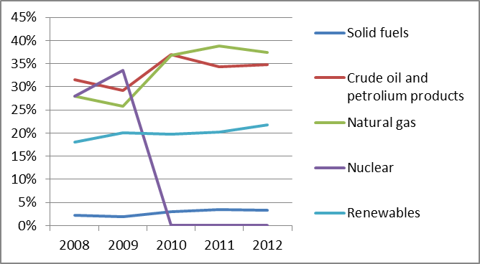
In 2012, the total power generation was 5.043 TWh, the largest part of it was derived from natural gas (63%). The major change in power generation occurred in 2010, when Ignalina Nuclear Power Plant was decommissioned and power generation in the country dropped by 63%. As a result Lithuania became dependent on electricity imports (in 2012 electricity import was 169.8% higher than gross inland production). In 2012 Lithuania’s electricity demand increased by 5.9% in comparison to the 2011 level.
Figure 2: Gross electricity generation mix 2008 – 2011 (source: EU Energy in Figures – Pocketbook 2012 and 2013)
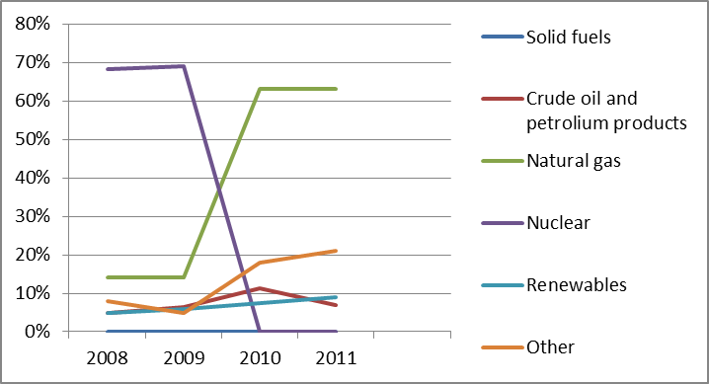
Cogeneration represented 37.5% of gross electricity generation in 2011. In 2012 gross inland consumption of natural gas in Lithuania was 2.65 Mtoe.
- Regulatory framework

General
Lithuania has by now fully transposed the provisions of the Third Energy Package.

National Energy Regulator
In 2013, the Lithuanian Regulator, the National Commission for Energy Control and Prices (NCC), employed 83 staff members and an annual budget of almost EUR 2.78 million in 2013.

Unbundling
In the electricity sector, the ownership unbundling model was chosen for unbundling the state-owned TSO Litgrid AB, making use of the possibility provided for in Article 9(6) Electricity Directive to implement the ownership unbundling model by means of separate public bodies within the State. Litgrid AB received its final certification decision by NCC in August 2013. In 2013, there was one major DSO (LESTO AB) and six other smaller electricity DSOs.
The vertically integrated gas company Lietuvos Dujos AB submitted its unbundling plan to the NCC on 31 May 2012. On 1 August 2013 a newly established, legally unbundled company, Amber Grid AB, commenced operations as a TSO. Certification is to follow after implementing full ownership unbundling which is to take place by 31 October 2014. The planned implementation of ownership unbundling has been challenged by Gazprom (co-shareholder of Lietuvos Dujos AB and Amber Grid) and the case is currently in arbitration. In 2013, in the gas distribution sector Lietuvos Dujos AB had a market share of over 99%. Five other small gas DSOs were also active in the market.
- Wholesale markets

Electricity
The closure of Ignalina NPP in 2009 created opportunities for new suppliers on the market with the bulk of the shortfall being replaced by imports from Russia . In 2013, there were six main electricity generating companies with 24 generating companies representing at least 95% of the national net electricity generation.
The total installed capacity of the power plants in 2013 increased by 1.2% up to 4,304 MW, including an increase in thermal power plants and renewables. Final electricity consumption decreased by 0.13%, from 9.659 TWh to 9.646 TWh.
The Lithuanian Power Exchange operated by Baltpool commenced operation in Lithuania in January 2010. Trade is based on the Nord Pool Spot model since June 2012 when the administration of Lithuanian Power Exchange has been transferred to the power exchange operator for Nordic and Baltic countries – Nord Pool Spot AS licensed by the Norwegian energy regulator, with bilateral exchanges between producers, importers and suppliers. In 2013, the volume of electricity traded on the Lithuanian electricity market was circa 7.983 TWh with an average price of EUR 0.0489/kWh.
Low liquidity and limited interconnection capacity in the region have caused price spikes to occur in the summer and autumn of 2013. In the short run, cooperation between the Baltic TSOs is necessary to better calculate available cross-border capacities. In the mid term the interconnector with Sweden is essential for better market functioning.

Gas
Lithuania does not have natural gas resources of its own. All its gas is imported from Russia via a single pipeline from Belarus. On the upstream gas market Gazprom is the only market player. Natural gas supply undertakings have an obligation to accumulate and store the natural gas reserves sufficient for vulnerable consumers to meet their gas demand in cases foreseen in Art. 8(1) of EU Regulation No. 994/2010. As a result, Inčukalns underground gas storage facility in Latvia stores gas reserves for Lithuanian gas supply companies amounting to 37 mcm on 1 September 2013. The new LNG terminal, which is planned to start its operation by December 2014, is intended to increase competition and security of supply. It will have an initial capacity of 2bcma which could be expanded to 4bcma. LNG supplies that are not immediately consumed are likely to be stored in Latvia as well. For the Klaipeda LNG Terminal to fully exploit its role as a regional supplier it is necessary that the transmission grid is expanded, notably on the border with Latvia.
In 2013, Lithuania imported 2,701.5 mcm of natural gas which was 18.6% less than in 2012. During 2013, the main players in the gas market remained unchanged and included Lietuvos Dujos AB, Achema AB, Haupas UAB, Kaunas CHP Plant and Dujotekana UAB (the only one that purchases gas from OAO Gazprom via Gas Stream AG LT).
In 2013, the price of the imported gas was on average 5.4% lower than in 2012 and made EUR 359.5/tcm (the average price of the imported gas in 2012 was EUR 380.2/tcm). A new gas exchange to organize secondary trade in natural gas, operated by Baltpool, was launched on 1 March 2012. In November 2012, NCC issued second gas exchange operator license for UAB GET Baltic. Trade on the UAB GET Baltic exchange since the beginning of 2013 resulted in a total traded volume in a 176 deals realized against an average price of EUR 334,91/tcm.
- Retail markets

Electricity
In 2013, the independent electricity suppliers supplied 5,646.0 GWh of electricity to customers; the public supplier AB LESTO supplied 2,582.7 GWh of electricity to the regulated customers and 478.1 GWh of electricity to the eligible customers. When 2013, is compared to 2012, the share of AB LESTO in the retail supply market decreased from 42.6% to 35.2%.
Changing electricity supplier in Lithuania was permitted but during 2013 no switches were made. A cost-benefit analysis addressing smart meters has been carried out, but no formal decision or plans about smart meters roll-out has been made so far.
Today, end-user price regulation still exists for household consumers. Full liberalization is scheduled for the beginning of 2015. For industrial consumers, price regulation was fully removed at the beginning of 2013.
Power prices for households and industrial consumers have kept increasing during the recent years, mostly due to the transmission and commodity prices, but also because of public service obligation's component during 2012-2013. This component in electricity price includes: compensation to electricity generation company “Lietuvos energijos gamyba” AB, operating as reserve capacity; support to CHPs; promotion of renewables; and financing infrastructure of strategic importance.
Figure 3: Electricity price change by component 2008 – 2013 (source: Eurostat, energy statistics)

Gas
The functioning of the natural gas retail market is determined by the situation on the wholesale market. Theoretically, the market is 100% liberalised and customers are free to choose among gas suppliers, however during 2013 only modest interest in switching was observed.
Natural gas was supplied to customers by eight supply companies and in 2013 gas sales totalled 1,430.0 mcm. As compared with 2012, the sale of natural gas decreased by 11.4%. Retail gas supply as well as the wholesale is dominated by one supplier (Lietuvos Dujos AB), which together with UAB Dujotekana holds 98.1% of natural gas supply market (Lietuvos Dujos AB - 69% and UAB Dujotekana - 29% accordingly). Other gas supply companies' joint market share is as low as 2% of the retail market. Gas prices for final consumers followed a similar trajectory to that of electricity prices.
Figure 4: Natural gas price change by component 2008 – 2012 (source: EC, EPCR metadata)

A cost-benefit analysis addressing smart meters in natural gas is being carried out by NCC, but no formal decision or plans about smart meters roll-out has been made so far.
- Consumers
The assessment of both the electricity and the gas retail markets in Lithuania is well above the EU average thus placing the country high in the EU ranking (6th and 2nd place, respectively). Both markets have considerably improved their performance since 2012 (by 4.6 points in the case of gas and 7.5 in the case of electricity, which represents the highest and 2nd highest increase EU-wide). The electricity market in the country shows the highest score in the EU as far as comparability is concerned while on the negative side the incidence of problems is the fourth highest in the EU and the scores on switching, ease of switching and choice of providers are below EU average. As far as the gas market is concerned, Lithuania has the second EU score on comparability and the 2nd highest on overall consumer satisfaction with respect to expectations.
The NCC, the State Energy Inspectorate and the State Consumer Rights Protection Authority investigate individual consumer complaints. The number of complaints per thousand inhabitants in 2012 was more than three and was almost two times higher than in 2011. It was documented by the NCC that 30 complaints concerning natural gas market were received during 2013.
The supply of natural gas is guaranteed as a matter of priority to those groups of vulnerable consumers — household customers and non-household customers — which consume less than 20,000 cm of gas per year. According to the Law on Electricity, suppliers have to conclude agreements for supply of electricity at the public electricity price to consumers who have not chosen independent electricity supplier, also to socially vulnerable customers.
- Infrastructure
The Lithuanian authorities have already established the one stop shop for Projects of Common Interest (PCI) as required by the TEN-E Regulation.

Electricity
Lithuania is not directly connected to the European grid and therefore is working in BEMIP towards the creation of the Baltic regional electricity market.
Two electricity projects are of key importance. The cross-border electricity transmission line "NordBalt" is the 700 MW capacity (400 kV) cable from Klaipeda (Lithuania) to Nybro (Sweden). This link is expected to increase possibilities for electricity trade, and by December 2015 and it will allow full integration of the Baltic and North European electricity markets.
Secondly, the cross-border electricity transmission line "LitPol Link", a PCI project, is the 500 MW capacity (400 kV) double circuit electricity transmission line from Alytus (Lithuania) to Elk (Poland). The interconnector will link the electric power systems of the Baltic States and Continental Europe and will create preconditions for electricity trade, and will enhance the security of electricity supply in Lithuania.

Gas
The Lithuanian gas network is connected to the Belarusian, Latvian and Russian Federation (Kaliningrad) gas systems. Enhancement of the Latvian-Lithuanian interconnection was successfully finalised in early 2013 by increasing the cross-border capacity to more than 6 mcm/day in both directions. Secondly, the new Klaipeda – Jurbarkas pipeline was constructed and made operational in 2013. It allows for looping the national gas transmission system and it will also ensure the efficient send-out from the LNG terminal in Klaipeda that is to become operational in December 2014.
The Lithuania-Poland gas interconnection ("GIPL") which is necessary to end pipeline-based the energy isolation of Lithuania and other Baltic States should be considered a top priority project. In 2013, its feasibility study was started and the project could be finalised by 2018. Furthermore, Lithuania should make efforts to upgrade the Klaipeda – Kursenai pipeline that is necessary to achieve the full 4bcma operation of the LNG terminal and for enhancing its interconnection with Latvia.
- Security of supply

Electricity
After the shutdown of the Ignalina NPP, Lithuania has become an importer of electricity. The abovementioned NordBalt link and LitPol Link are necessary to integrate Lithuania into a common European electricity market, thus contributing to a more reliable electricity supply, more stable prices and enhanced competition on the Lithuanian market.
At present, the Lithuanian grid is operated in synchronous mode with the Russian and Belorussian grids. In 2012, negotiations were launched by the European Commission with the aim to conclude an Intergovernmental Agreement. Negotiations have been suspended at the request of the Baltic States pending their analysis of a study on the de-synchronisation of the Baltic grids and a move towards synchronisation with continental European grids.
As regards the local supply security, the total investments into the network infrastructure were increased by 9.59% to EUR 148.1 million in 2012.

Gas
To diversify the supply of gas, as per the approved National Energy Independence Strategy of 2012, Lithuania has determined the necessity for the LNG Terminal and interconnection with the gas network of Poland to enable access to the EU-wide natural gas system.
Making the LNG Terminal operational requires investment in the outdated gas transmission line extending in the northern part of Lithuania and also connecting Latvia (Klaipeda – Kursenai). The underground storage facility in Inčukalns (Latvia) is used for the supply security for vulnerable consumers of Lithuania in case of emergency. Analysis has revealed that the present status of the Lithuanian gas network failed to fulfil the EU requirements prescribed by the EU regulation No. 994/2010. The analyses of the N-1 rule showed a result equal to 31.4% while the requirement of regulation states that N-1 must be above 100% in order to have a secure network.
- Key indicators
Electricity |  | Gas
Number of companies representing at least 95% of net power generation | 30 | Number of entities bringing natural gas into country | 5
Number of main power generation companies | 6 | Number of main gas entities | 4
Market share of the largest power generation company | 25% | Market share of the largest entity bringing natural gas | 69%
Number of electricity retailers | 27 | Number of retailers selling natural gas to final customers | 8
Number of main electricity retailers | 5 | Number of main natural gas retailers | 2
Switching rates (entire retail market) | N/A | Switching rates for gas (entire retail market) | N/A
Regulated prices for households – electricity | Yes | Regulated prices for households – gas | Yes
Regulated prices for non-households – electricity | No | Regulated prices for non-households – gas | No
HHI in power-generation market | 1162.6 | HHI in gas supply market | >5000
HHI in electricity retail market | 2124.4 | HHI in gas retail market | >5000
Electricity market value (bn€) | 0.733 | Gas market value (bn€) | 0.274
Installed generation capacity (2013, MW) | 4,304
Peak load (MW) | 1,686
Number of smart meters installed | N/A

Luxembourg

Key issues
The share of renewable energy levels remains far from the target of 11%.
To improve security of supply, further investments are required in new interconnectors with neighbouring countries, and in additional generation capacity capable of providing flexibility to the electricity system.
The natural gas sector is almost 100% dependent on imports. Reinforcing the interconnections with neighbouring countries would alleviate current concerns. Firm entry capacity in Luxembourg remains limited, and a better congestion mechanism would help to address this issue.
More should be done to encourage competition in the retail market, especially for domestic customers.

General overview
Oil products for energy production provided 63% of Luxembourgian gross inland consumption in 2012, while the share of natural gas increased to 24% (compared to 2011). The contribution of renewable sources also increased, reaching 3.1%. However, this figure continues to fall short of the 11% target for 2020. In 2011, power generation saw a decline of 20% in internal production (mainly thermal generation) from 2010 levels due to one of the combined cycles operating on reduced availability. Gas is the primary fuel for electricity generation (62% of total electricity generated), followed by renewable energy (35% with most coming from hydro power).
Figure 1: Gross inland consumption mix 2008 – 2012 (source: Eurostat)
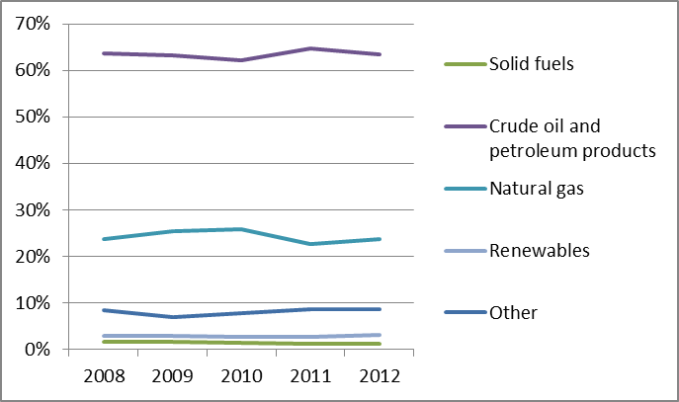
Figure 2: Gross electricity generation mix 2008 – 2011 (source: EU Energy in Figures – Pocketbook 2012 and 2013)
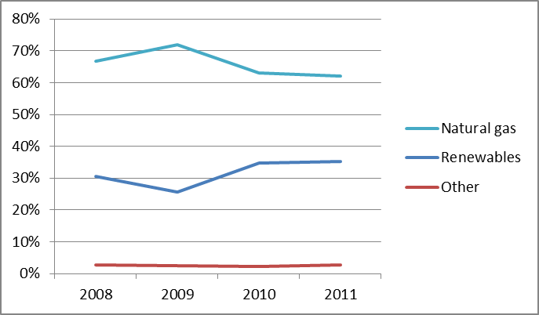
- Regulatory framework

General
Two laws came into force in August 2012 transposing Directives 2009/72/EC and 2009/73/EC, concerning common rules for the internal market in electricity and gas. An infringement procedure for incorrect transposition of the Third Energy Package Directives was launched in March 2014 and is on-going.

National Energy Regulator
In 2012, the Luxembourg national regulatory authority, the Institut Luxembourgeois de Régulation (ILR), had 51 employees and an annual budget of almost EUR 7 million. ILR is also responsible for regulating other sectors such as the telecoms and postal sectors.
To promote competition in the electricity and natural gas markets, new responsibilities were assigned to the ILR in network access and pricing, cross-border cooperation, monitoring investment plans and monitoring the function and transparency of the energy markets.

Unbundling
Luxembourg has been granted a derogation from the unbundling provisions of the Third energy package on the basis of Article 44(2) of the Electricity Directive and Article 49(6) of the Gas Directive. The legislative framework, however, guarantees a relative degree of independence of system operators through legal, functional and financial requirements. The electricity grid is jointly managed by Creos Luxembourg S.A (who has been granted transmission and distribution system operator license), five distribution system operators (DSOs) and one industrial system operator (ISO). In the gas sector Creos is the transmission and the main distribution system operator. The gas distribution grid is also managed by two other DSOs.
- Wholesale markets

Electricity
At generation level, the three largest producers (GdF Suez, Enovos, Soler) provided 89% of power generation volume.
The volume of electricity traded on the wholesale market in 2012 amounted to 6.93 TWh (17% less than the previous year). Luxembourg relies on imports from neighbouring countries, mainly Germany, for the majority of its domestic consumption (57%).
There is currently no power exchange or spot market for electricity, but the absence of congestion on interconnectors means wholesale operators can participate on other power exchanges.

Gas
The national consumption of natural gas was 13.6 TWh, slightly higher than 2011. 2012 was characterised by a particularly high peak demand due to extreme temperatures in the beginning of the year. The vast majority of gas is imported from Belgium, Germany and (to a lesser extent) France, with only a small part locally produced by biogas plants. The Luxembourg market has been is impeded by the limited availability of firm entry capacity. However, in 2013 and 2014, additional firm entry capacity has been made available which has resolved congestion issues.
There is no wholesale market in Luxembourg and the gas market has a quasi monopolistic structure. In 2012, the dominant company (Enovos) consolidated its market share despite the fact that transparent and non-discriminatory access to transmission capacity has been made available.
- Retail markets

Electricity
2012 saw 11 suppliers provide around 6.4 TWh of electricity to final consumers. The retail market was concentrated as the four biggest distributors accounted for 93% of the total amount of energy supplied. Enovos dominated the market for all three segments (residential, business and industrial) with 55% of the total consumption. The supplier switching rate in 2012 was 0.22% by customer number and 9.7% by consumption volumes, demonstrating that industrial users were more active in switching suppliers.
Figure 3: Electricity price change by component 2008 – 2012 (source: Eurostat, energy statistics)

Gas
The natural gas sector was much more concentrated than the electricity sector. In 2012, a total of eight suppliers served final consumers, with just three suppliers holding 94% of the market. Competition differs significantly within the different segments. As a result of the small number of players a monopoly within segments of industrial consumers and power producers has been created. The opening of the gas sector remained very low with supplier switching rates less than 0.1%.
Figure 4: Natural gas price change by component 2008 – 2012 (source: EC, EPCR metadata)
- Consumers
The consumers' assessment of both the electricity and gas retail markets in Luxembourg is the 3rd highest in the EU and in both cases well above the EU average (80.3 points vs. 72.0 and 79.7 vs. 74.1 respectively). The electricity market scores better than the EU average on all components (with the lowest incidence of consumer complaints in the EU) with the exception of switching (which is third lowest in the EU despite Luxembourg being 6th in the EU ranking on the ease of switching). A similar picture is seen for gas services, with all the components – except for switching – assessed above the EU average. Comparability, ease of switching and choice are within the 3 best EU ratings and the incidence of complaints is the third lowest in the EU.
Various services are now available to consumers to provide information on services and their rights. An online information point provides extensive support to customers with details on suppliers, products, switching procedures, opportunities and rights and responsibilities in the context of the non-regulated market. An automated on-line price comparison tool is now available to residential customers. Additional services include the alternative dispute resolution procedure which has been available to residential customers since 2011. In 2012, two dispute resolutions were registered under the alternative dispute resolution procedure. In addition the ILR is responsible for the electricity labelling system to provide customers with information on environmental impact depending on type of energy sources used.
All customers are de facto considered as potentially vulnerable in Luxembourg. Both the electricity and the gas legislations foresee provisions governing the situation of customers in default payment of their bill. Clear rules determine disconnection conditions in case of default payment and the installation of prepayment meters for individuals in a precarious social situation. Situations of default payment are also covered by the law of 18 December 2009 on social aid.
- Infrastructure
The Luxemburgish authorities should ensure a proper and timely adoption of the measures stemming from the TEN-E Regulation, including the establishment of the one-stop-shop for Projects of Common Interest (PCIs) (due by 16 November 2013), and other measures foreseen for 2014 and 2015, including the publication of the manual on the permit granting process for project promoters, and the adoption of legislative and non-legislative measures streamlining the environmental assessment procedures.

Electricity
The total generation capacity amounted to 1,785 MW, including the Vianden pump storage power plant (1,096 MW of capacity installed) which is directly connected to the German transmission grid. The generation assets currently available are not sufficient to provide the required electricity to cover the national demand of Luxembourg, which relies on imports from neighbouring countries.
Upgrade of the existing internal grid is underway and there are planned investments to ensure continued n-1 contingence on internal lines. Luxembourg's transmission network is connected with Germany by two interconnectors whilst the industrial grid of Sotel is connected to the Belgian transmission network.
PCIs under the guidelines for trans-European energy infrastructure have been identified in order to increase the capacity at the Belgian/Luxembourg border, also including Phase Shift Transformers for better load management.

Gas
Internal production of natural gas is only from three biogas plants being connected to the gas network in 2013. Almost all gas for consumption is imported from neighbouring countries through high pressure pipelines from Germany and Belgium and medium pressure pipelines from France. There are four entry points: two on the Belgian border, which are combined in one virtual entry point, one for the German border and one on the French border.
Luxemburg has no storage infrastructure; it relies upon the storage capacity of neighbouring countries. PCIs foresee increase of the existing interconnection with France and Belgium.
Two new Laws in August 2012 provide the opportunity for mass roll-out of smart meters. This is expected to reach 95% of electricity consumers by 2018, and 95% of natural gas consumers by 2020. Provisions for the public charging infrastructure of electric vehicles were made to promote their use.
- Security of supply

Electricity
According to the latest evaluations, the n-1 criterion is covered by existing German interconnections. The need for investment in new cross-border interconnections with Belgium and France, in new generation capacity and in upgrades of the internal grid is being analysed to improve security of supply. As there are insufficient emergency generation reserves in Luxembourg, load shedding might be the only viable emergency response tool.

Gas
In 2013 and 2014, additional firm entry capacity has been made available resolving congestion issues. Interruptible capacity and flexibility mechanisms are currently used by Creos in order to manage cases of missing firm capacity. Due to the absence of storage facilities in the country, load shedding can be used in case of emergencies. However, it has never been used till now. With about half of the gas supplied through the German entry point, Luxembourg does not comply with the N-1 rule. However, it obtained a derogation under Regulation 994/2010.
- Key indicators
Electricity |  | Gas
Number of companies representing at least 95% of net power generation | 4 | Number of entities bringing natural gas into country | 5
Number of main power-generation companies | 2 | Number of main gas entities | 1
Market share of the largest power-generation company | 82% | Market share of the largest entity bringing natural gas | N/A
Number of electricity retailers | 11 | Number of retailers selling natural gas to final customers | 8
Number of main electricity retailers | 4 | Number of main natural gas retailers | 3
Switching rates (entire electricity retail market) | 0.22% | Switching rates for gas (entire retail market) | 0.1%
Regulated prices for households – electricity | No | Regulated prices for households – gas | No
Regulated prices for non-households – electricity | No | Regulated prices for non-households – gas | No
HHI in power-generation market | 2,311 | HHI in gas supply market | High
HHI in electricity retail market | High | HHI in gas retail market | High
Electricity market value (bn€) | 0.425 | Gas market value¹⁰ (bn€) | 0.282
Installed generation capacity (MW, 2012) | 1,785
Peak demand (MW) | 1,009
Number of smart meters installed | N/A

Malta

Key issues
Given the current physical isolation of Malta’s electricity sector, the high voltage connection with Italy should be seen as a high priority project to secure electricity supply and reduce the vulnerability of the sector.
Malta should step up its efforts to diversify the energy mix and energy sources, notably by developing renewable energy and by creating access to natural gas.

Currently progress towards European targets for renewables has been slow but has improved recently thanks to the increased use of solar energy. Development of renewable energy post 2020 may be challenging due to geophysical restrictions.

General overview
Malta is almost 100% dependent on oil and petroleum products. The gross inland energy consumption in 2012 was 0.91 Mtoe, a decrease of 2.5% compared to 2011. Renewable energy accounted for only 1.1% of gross inland energy consumption. There is no supply of natural gas.
The gross electricity generation in 2012 was 2.290 TWh, an increase of 4.4% compared to 2011. Electricity generation in Malta is dominated by crude oil and petroleum products. In 2011, a small amount of electricity (8 GWh) was generated by photovoltaic systems, increasing to 13 GWh in 2012.
Malta has an obligation to reach 10% of renewable energy in the gross energy consumption by 2020. According to the present reporting data available in Eurostat, the RES share in gross final energy consumption for 2012 is below Malta's 2011-2012 indicative trajectory and the country therefore appears to lag behind its 2020 obligation. Cogeneration of heat and power remained negligible during 2012 (only 0.4%) .

Regulatory framework

General
The Third Energy Package has been transposed in 2011, it however provides for ample derogations.

National Energy Regulator
The Malta Resources Authority (MRA) was established in 2002 and is responsible for the regulation of energy, mineral and water resources. MRA is composed of seven Board members and 39 employees within the organisation. The 2012 budget for MRA was approximately EUR 2 million.

Unbundling
There is no electricity transmission system in Malta. A single distribution system serves all electricity consumers. The function of the distribution system operator (DSO) is carried out by the Enemalta PLC, a vertically integrated power utility. The requirements regarding the unbundling of transmission system operators and distribution system operators do not apply to Malta, which has derogations from Article 9 on the unbundling of TSOs, Article 26 on the unbundling of DSOs, Article 32 on third party access and Article 33 on market opening.

Wholesale Markets
Enemalta PLC enjoys legal monopoly in electricity supply and is currently the main producer of electricity in Malta. The existing independent electricity producers are small and generate electricity from renewable energy sources either for their own consumption or to sell to Enemalta PLC. In the absence of large independent electricity producers a wholesale market is not in place and the balancing between generation and demand is carried out by Enemalta PLC.

Retail Markets
Enemalta PLC has a 100% share of the electricity retail market, which is not open to competition and therefore customer switching is not possible in Malta. There were no changes in the methodologies used to determine the tariffs during 2012. All consumers of electricity are on regulated retail tariffs.
Malta's electricity prices, for industrial consumers, have been at the same level for the last four years, after an increase in 2010 due to the increase of energy and supply cost component. The electricity prices for domestic consumers have been revised downwards in 2014, whereas those for the industry are expected to be reduced during 2015. The prices for Malta’s industry were above the EU average while the retail prices for households were below EU average. Electricity generation remained dependent on heavy fuel oil and gasoil, thus making the cost of electricity in Malta highly susceptible to changes in the international market price of these two fuels. A new 215MW gas-fired Combined Cycle Gas Turbine (CCGT) plant together with a floating LNG storage and regasification unit, which would shift Malta’s electricity generation away from fuel oil and significantly increase the overall generation efficiency, is planned for 2015.
The energy component accounted for 82% of the household electricity price while for industrial consumers the energy component was 88%. The network component represented 13% and 12% of the total bill for households and industry, respectively. In Malta, a charge for the support of renewables is not included in the electricity tariff, as this support is financed through taxes in the national budget.
Figure 3: Electricity price change by component 2008 – 2013 (source: Eurostat, energy statistics)
Electricity demand in 2012 increased by 5% compared to 2011, which was the 4th largest percentage among all EU Member States. However, Malta was the only one of these four Member States which did not witness a respective GDP increase. In Malta, the increase in consumption was due to the weather conditions, since electricity is the main source for heating and air conditioning.

Consumers
The assessment of the retail electricity expressed by Maltese consumers is well above the EU average (76.1 points vs. 72.0) with the country occupying the 10th position in the EU ranking. The incidence of both problems and complaints is the 4th lowest among EU countries, and trust in providers is the 5th highest. (The questions on switching, ease of switching and choice have not been asked given that the market is a monopoly).
Vulnerable consumers, including families with low income, persons with a disability and other humanitarian cases and families on social assistance or special unemployment benefit, persons with an age pension or a career’s pension, may benefit from energy bill discounts. During 2012, 24,142 consumers received energy benefits. 12% of household consumers were defined as consumers with special needs.
The replacement of electricity meters with smart meters is underway. By the end of 2012 the number of smart meters installed was 170,346 (62%). The full replacement of the electricity meters with smart meters is expected to be completed by the end of 2014.

Infrastructure
The Maltese authorities have ensured the adoption of the measures stemming from the TEN-E Regulation, including the establishment of the one-stop-shop for Projects of Common Interest (PCIs), and other measures foreseen for 2014 and 2015, including the publication of the manual on the permit granting process for project promoters, and the adoption of legislative and non-legislative measures streamlining the environmental assessment procedures.

Electricity
In December 2012, a new generation plant came into operation and thus the nominal generation capacity of the two power stations of Malta increased to 620 MW. A 225 MW high voltage interconnection between Malta and Sicily, which is currently under construction, is expected to be completed by the end of 2014. In 2013, the government of Malta agreed to the construction, by private investors, of a new 215 MW CCGT power plant using gas supplied by an LNG Floating Storage Unit permanently berthed at Delimara. An existing 149 MW Combined Diesel Engine currently operated on heavy fuel oil will be converted to natural gas.

Gas
Natural gas is not available in Malta. For an interim period, natural gas for electricity generation will be provided by an LNG Floating Storage Unit (FSU) permanently berthed at Delimara Power Station with an onshore re-gasification unit once the infrastructure is available.
A project consisting of the FSU and a pipeline connecting it to both Delimara (Malta) (12km approximately) and Gela (Sicily) (150km approximately) for transmission of Natural Gas, entitled: Floating LNG Terminal in Malta and new interconnection Malta to Italy, was selected as a Project of Common Interest (PCI). The final design of the project will depend on the outcome of the cost-benefit and feasibility study which is currently being carried out.

Security of supply

Electricity
The installed electricity generation capacity by thermal power plants was 571 MW, in 2011. In 2012, the nominal generation capacity was increased to 620 MW. The maximum peak demand was 429 MW and was recorded on 9 August 2012. The total fossil fuel electricity generation capacity available when the peak demand occurred was 505 MW. Additional electricity generation capacity is required to ensure security of supply.

Gas
To increase the diversification of primary energy sources, Malta has submitted a project to connect Malta to the European gas grid as a project of Common European Interest (PCI).

Key indicators
Electricity |  | Gas
Number of companies representing at least 95% of net power generation | 1 | Number of entities bringing natural gas into country | N/A
Number of main power-generation companies | 1 | Number of main gas entities | N/A
Market share of the largest power-generation company | 100% | Market share of the largest entity bringing natural gas | N/A
Number of electricity retailers | 1 | Number of retailers selling natural gas to final customers | N/A
Number of main electricity retailers | 1 | Number of main natural gas retailers | n/a
Switching rates (entire electricity retail market) | N/A | Switching rates for gas (entire retail market) | N/A
Regulated prices for households – electricity | Yes | Regulated prices for households – gas | N/A
Regulated prices for non-households – electricity | Yes | Regulated prices for non-households – gas | N/A
HHI in power-generation market | 10,000 | HHI in gas supply market | N/A
HHI in electricity retail market | 10,000 | HHI in gas retail market | N/A
Electricity market value (bn€) | 0.350 | Gas market value²² (bn€) | N/A
Installed generation capacity (2012, MW) | 620
Peak load (MW) | 429
Number of smart meters installed | 244,000

Poland

Key issues
Although important improvements have been made to modernise Polish energy infrastructure, significant investments are still needed to ensure a sustainable supply of energy, reduce the share of carbon-intensive plants and increase the exploitation of renewable energy sources. Despite significant emission reductions realised over the last two decades, Poland is reluctant to support ambitious EU climate policy targets beyond 2020. This seems to be due to its concerns about energy security and its heavy reliance on coal, of which it has the biggest reserves in the EU and which is instrumental for electricity generation.
Poland should step up its efforts and extend the development of the electricity grid. Obstacles in electricity cross border exchange should be eliminated and the problems resulting from unscheduled flows properly addressed.
The gas sector in Poland has yet to complete its liberalisation process. Market conditions have improved. Progress so far includes implementation of the European Network Codes with the introduction of the virtual trading point, pilot projects with bundled capacities, capacity auctioning platform, market-based balancing, and launching of both virtual and subsequent physical reverse flow on the Yamal pipeline at Mallnow. In addition, a gas exchange (PolPx) was established and an exchange trade obligation was put in place.
However, these measures which have improved Polish chances to develop a competitive wholesale gas market have proven to be insufficient so far to boost competition on the market and change the current market structure. Although a process has been initiated, Poland still needs to phase out regulated prices in the gas sector, what would help to reinforce competition. Effort should be made to further accelerate new gas interconnections and expansion of the existing ones with neighbouring countries. Barriers to trade (including the import diversification requirements) should be revised.
Security of gas supply is expected to improve thanks to the country’s first LNG terminal to be commissioned in 2015 (to enter into commercial operation mid-2015) as well as development of new infrastructure to support the North-South gas corridor. Poland has improved considerably its interconnections with Germany (Lasow interconnection point and the introduction of physical reverse flow on Yamal at Mallnow).

General overview
Polish national gross final energy consumption in 2012 amounted to 97.97 Mtoe. It was based mostly on fossil fuels: hard coal (41%), oil (26%), gas (13%), and lignite (11%). In 2012, share of renewables in gross final energy consumption amounted to 11%, increasing from 7.8% in 2008. Poland remained above its 2011/2012 interim trajectory and is currently on track to achieve its national binding target for renewables of 15%.
In 2012, total power generation reached 162 TWh with most (88.6%) coming from fossil fuels, principally coal and lignite. Renewables accounted for 10.7%. In 2012, a rise in share of lignite was caused by decreased profitability of hard coal power generation. Poland maintained traditional export of electricity, mainly to the Czech Republic and Slovakia.
Figure 1: Gross inland consumption mix 2008 – 2012 (source: Eurostat)
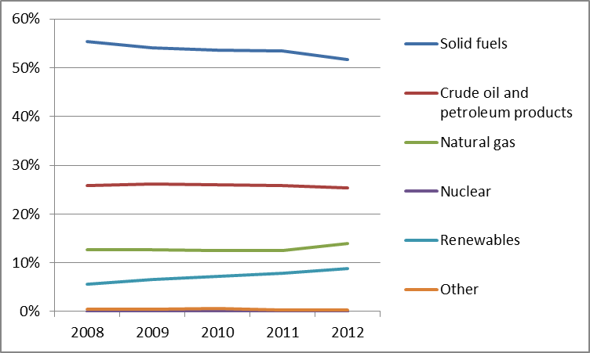
Figure 2: Gross electricity generation mix 2008 – 2011 (source: EU Energy in Figures – Pocketbook 2012 and 2013)
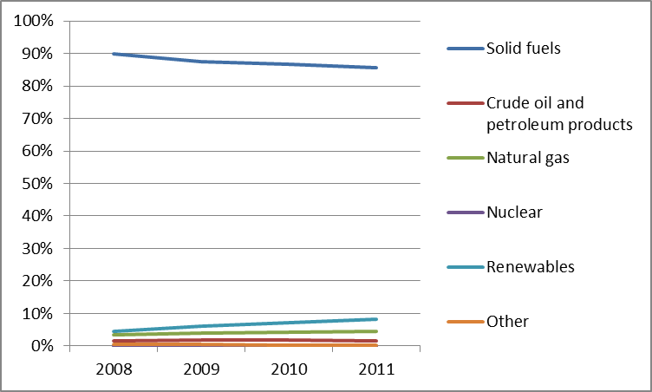

Regulatory framework

General
The Third Package Directives were transposed only in 2013 and their compliance is currently under review. An infringement procedure on regulated gas prices for non-household customers and the Third Energy Package Gas Directive is ongoing before the Court. In March 2013, the European Commission referred Poland to the Court of Justice for non-transposition of the renewables directive, which has been controversial and hampered for many years. Arguments arise mainly about the design of the support scheme for renewables.

National Energy Regulator
The President of Energy Regulatory Office (URE) is a central body for governmental administration and has been in operation since 1997. In 2012, URE employed about 300 staff. Its annual revenues totalled EUR 23.8 million while expenditures reached EUR 8.8 million. The surplus of income is part of the government budget. Amendments to Energy Law introduced a 5-year term for President of URE with a possibility of one reappointment.

Unbundling
The TSO in electricity is PSE S.A. and for gas, Gaz-System S.A. Both companies were certified as ownership unbundled TSOs (on the networks they own) in the course of 2014. The rules on certification of independent system operators were only adopted in 2013.
There were 158 electricity DSO’s at the end of 2013, but only five serve more than 100,000 customers. Each company within the “big five” is legally unbundled and 4 of them are controlled by the Polish State Treasury. In 2013 distribution of gas was performed by 40 system operators including one incumbent system operator subject to legal unbundling.

Wholesale markets

Electricity
The Polish wholesale power generation market still remains rather concentrated. However, initial data for 2013 show that HHI for electricity production dropped to less than 2000, meaning that the market shall no more be considered as highly concentrated. PGE, TAURON, and EDF remained the biggest power generators in 2012 and in 2013. The market concentration HHI index for installed capacity was 1587.9 in 2012. For the amount of power introduced to the grid this index reached 2096. The HHI index decreased further in 2013 based on the recently published data.
In 2012, the power exchange’s role became well established, following the introduction in 2010 of obligation to sell certain percentage of produced electricity by generators through the power exchange. Electricity sold through the exchange accounted for 61.8% of electricity sold by generation companies in 2012 (up from 58.8% in 2011). Bilateral contracts represented around 33% of wholesale trade in 2012. It has to be noted that the volumes traded on the exchange decreased in 2013.
According to the Polish Power Exchange (POLPX), in 2012 the annual average wholesale day-ahead power price was PLN 179.45/MWh, which is a decrease from PLN 205.19/MWh in 2011 (12% decrease). The annual traded volume in day-ahead transactions in 2012 was 19.1 TWh.
Poland participates, currently as an observer, in a five-way market coupling project known as “5M”. Poland intends to join the Czech Republic, Slovakia, and Hungary in the arrangement of capacity allocation on the common borders in implicit auctions later in the context of the CEE FBMC (Central East Europe Flow-Based Market Coupling) initiative. Poland also participates in the coupling of the North-Western European Market via the SwePol Link.

Gas
Annual natural gas inland consumption in 2012 amounted to approximately 15,9 bcm. The total imports of natural gas to Poland in 2012 amounted to 11,6 bcm, out of which imports from Russia and Central Asian countries were 9,2 bcm, corresponding to 57,6% of gross inland consumption and 79,8% of all imports. Imports from Germany amounted to 1,7 bcm and from Czech Republic 0,55 bcm. Domestic gas production in 2012 was 4,46 bcm (in terms of methane-rich natural gas) which accounted for approximately 28% of the annual demanded of all consumers.
It should be noted that imports from Germany increased thanks to physical connection via Lasow and the reverse flow via Mallnow. However, the import diversification requirement under the Polish law remains an obstacle limiting abilities of gas shippers to use the reverse flow on Yamal.
The wholesale gas market in Poland was still dominated by PGNiG in 2012 (ca 95%). The remaining 5% of total sales were supplied by other traders. Since 2013 the gas exchange obligation has provided grounds for competition in the Polish gas market, but in 2013 PGNiG failed to trade the mandatory 30% share on the exchange as there were too few buyers. The prices available under bilateral agreements were temporarily lower than prices offered on the exchange and the overall demand for gas was insufficient to drive sales up. However, in 2014, the situation changed – the volume of gas traded on the gas exchange is now increasing.
In 2012, as a result of the renegotiation of the long-term supply contract with PGNiG, Gazprom lowered the price of natural gas deliveries to Poland. The agreement ended the price dispute between PGNiG and its Russian partner. Even after the correction, Poland still pays one of the highest prices for Russian gas in the EU.
The latest legal developments are positive for natural gas market liberalisation, including already mentioned amendments of the Energy Law in 2013, an important change concerning the structure of the incumbent and the adoption and the subsequent changes in the Transmission Grid Code. The code includes provisions of the Third Energy Package as well as system operation rules for capacity allocation The code also introduced a virtual trading point for gas and allowed for early introduction of bundled capacity products between Poland and Germany which are tested until September 2014. . Subsequent changes, which entered into force in August 2014, implemented Network Code on Congestion Management Procedures (CMP), Capacity Allocation Mechanisms (CAM) and Balancing (BAL), improving the interoperability of polish gas system with those of neighbouring countries.

Retail markets

Electricity
Poland continues to regulate retail electricity prices for households. The approval of the electricity prices by the President of ERO remains for households. In 2012 the regulation of electricity prices for households applied to all consumers who did not switched to the free market. Similarly to the previous years, “incumbent” suppliers continued to detain the largest share in sale of electricity to the end-users in 2012. In 2012, 82 active suppliers were operating on the electricity market. The total number of entities licensed to trade amounted to around 360, but these were mainly the vertically integrated industrial power companies conducting sale and distribution services. In 2012 the main five retailers, which used to be part of distribution companies before the market opening, covered 80% of the market.
In 2012 four times more consumers exercised their right to switch supplier than in 2011. In total the number of non-household consumers who switched the supplier increased from 21,716 (cumulative numbers for 2007-2011) at the end of 2011 to 66,019 in 2012. The number of households supplied under the TPA rule increased from 14,341 to 77,284 consumers. This was partially caused by an increased advertising activity of the suppliers, resulting probably from the decrease in electricity demand in the business consumers segment.
Figure 3: Electricity price change by component 2008 – 2013 (source: Eurostat, energy statistics)

Gas
In 2012, gas prices for households and industry were regulated. Nevertheless, following Poland's referral to the Court of Justice on regulated gas prices for non-household customers, Poland decided to introduce some changes in the way prices for non-household customers are determined. Prices for households and small commercial consumers are expected to be deregulated at later stage.
In February 2013, the President of Energy Regulatory Office published the “Roadmap of Natural Gas Prices Liberalisation” making the deregulation of prices for commercial and household consumers a priority. This, however, did not translate into the deregulation of gas prices to non-household customers and derogations are still decided by the President of ERO. This is subject to a court case which is now pending before the Court of Justice.
The Polish gas market is still characterized by very high concentration levels with the gas incumbent, PGNiG Capital Group holding 95% of the wholesale and retail markets in 2012 in 2013. The remaining 5% of the gas market is supplied by several dozen of other entities striving for strengthening their position on the market. In 2012, the households constituted the largest group (96.9%) among all PGNiG Capital Group’s consumers. The number of gas retailers, independent from PGNiG, is growing, but their market position is highly fragmented. At the end of 2013 there were 120 gas retailers.
In 2012, 99.5% of households were supplied with gas under regulated prices (in 2011 this share was 99.9%). The number of consumers switching gas supplier has increased significantly in the past years but is still relatively low. In 2011, only a few switches were noted. In 2012 there were 210 cases and 402 by the end of September 2013.
Figure 4: Natural gas price change by component 2008 – 2012 (source: EC, EPCR metadata)

Consumers
The Information Point for Electricity and Gas Consumers, established in September 2011, received during its first year of activity first full year of functioning 2.636 questions in total. Almost a half of the cases concerned the supplier switching procedure. In case of gas consumers the most frequent problems were related to the settlements as well as to changes in gaseous fuel prices and invoicing.

To address those issues, the URE organized a nationwide campaign promoting an effective and economical management of electricity. The right to switch the supplier was a leading motive of this campaign. Information on consumers' rights and on how to switch supplier is provided in the regulator’s website. There is a special section in place (“You have a choice”). URE also offers an internet tool that compares prices (tariff calculator).
Consumers' overall assessment of retail electricity market is slightly below the EU average (70.6 points compared to 72.0, which corresponds to 19th place EU-wide) and below the average of 31 domestic services markets (24th place). Retail gas market is ranked slightly above the EU average (75.5 points compared to 74.1), ranking 12th EU-wide and among 31 domestic services markets. The market records the 3rd lowest incidence of consumer problems in the EU. Both markets have seen a considerable improvement in overall assessment since 2012, with increases of 4.4 and 2.9 points, respectively (first and second highest increase domestically). This is due to improvements in all the components (except for switching rates), in particular the ease of switching and choice.
An amendment to the Energy law was adopted in 2013 which provides consumers with new rights. In addition, new energy allowances were introduced for which consumers with financial difficulties may apply.

Infrastructure
The Polish authorities should ensure a proper and timely adoption of the measures stemming from Regulation 347/2013 on the trans-European energy infrastructure, including the establishment of the one-stop-shop for Projects of Common Interest (due by 16 November 2013), and other measures foreseen for 2014 and 2015, including the publication of the manual on the permit granting process for project promoters, and the adoption of legislative and non-legislative measures streamlining the environmental assessment procedures. However, gas infrastructure projects of major importance are now streamlined by specific a legal act, which purpose is to facilitate process on the administrative level.

Electricity
A large part of Polish energy infrastructure is ageing and in need of replacement. Significant investments in energy sector are in progress, mostly based on fossil fuels, while future investment plans include construction of two nuclear power plants, expected to be commissioned by 2025.

At distribution level, half the extensive grid replacement will take place, with half the financing coming from the EU’s Cohesion Fund. 400,000 smart meters have already been installed and are currently tested.
The interconnector between Poland and Lithuania (LitPol link) is expected to be operational in late 2015. It will connect the Baltic countries with the Western European Electricity System and increase energy security in the region.

Gas
The major on-going investment in gas infrastructure is linked to the construction of the LNG terminal in Swinolujscie. It will have a 5 bcm capacity and is scheduled to be operational in 2015. In 2012 Poland enhanced its gas interconnection with Germany (in Lasow). In 2014, the investment enabling physical reverse flow at the border with Germany (in Mallnow) was completed. Furthermore, the expansion of the existing UGS facilities (e.g. in Wierzchowice) and the construction of the new UGS facility (Kosakowo) should also be noted.
Construction of the gas interconnector between Poland and Lithuania ("GIPL") that is necessary to end the energy isolation of the Baltic countries should be considered a top priority by Poland. There are also plans to develop import capacity at the southern border with Slovakia and with the Czech Republic (as a part of North-South gas corridor). Moreover, from the security of supply point of view, one of the most significant investments was a modernisation of Polish-German interconnection point at Mallnow. The investment (completed on April 1, 2014) enabled provision of physical reverse flow of gas from Germany to Poland. In February 2014 Polish and German TSOs carried out a pilot auction on a bundled capacity at Mallnow which is the first stage of the procedure of physical reverse allocation.

Security of supply

Electricity
Polish generation capacity reserves may reach a record low in 2014. According to the Polish TSO, if the peak demand for electricity increases above 26 000 MW (in 2012 the instantaneous peak load was almost 24 000), the system will fail to deliver without support from neighbouring countries. Therefore, there is a need for enhanced demand side response. The TSO already work with large industrial users to develop system management. Poland is considering developing capacity market measures.
Limited grid connections between the North and South of Germany result in unscheduled flows to Poland limiting cross-border capacity available to market participants very often to zero MW. In 2014, Polish and German TSOs reached an agreement on the operation of phase shifting transformers to better manage the flows, but the issue requires long term solutions.

Gas
In 2013, the Ministry of Economy, responsible for the security of gas supply, adopted the Preventive Action Plan and Emergency Plan meeting the requirement set in the Regulation 994/2010 concerning measures to safeguard security of gas supply.
Heavy dependence on gas imported from Russia is balanced with domestic gas production. Further diversification is expected when the LNG terminal in Świnoujście is commissioned and if shale gas could be exploited on a sufficient scale. The gas import trend is upward, but imports from the East have fallen in favour of purchases from Germany and Czech Republic. In October 2012 the Polish TSO opened up the possibility of transporting gas to Ukraine.

Key indicators
Electricity |  | Gas
Number of companies representing at least 95% of net power generation | 32 | Number of entities bringing natural gas into country | 40
Number of main power-generation companies | 6 | Number of main gas entities | 1
Market share of the largest power-generation company | 39,3% | Market share of the largest entity bringing natural gas | 96,9%
Number of electricity retailers | 82 | Number of retailers selling natural gas to final customers | 120
Number of main electricity retailers | 5 | Number of main natural gas retailers | 1
Switching rates (entire electricity retail market) | 0,6% (0,86% for households) | Switching rates for gas (entire retail market) | 0,8%
Regulated prices for households – electricity | Yes | Regulated prices for households – gas | Yes
Regulated prices for non-households – electricity | No | Regulated prices for non-households – gas | Yes
HHI in power-generation market by volume of power fed into a grid | 2,096 | HHI in gas supply market | N/A
HHI in electricity retail market | 2,099 | HHI in gas retail market | 9,073
Electricity market value (bn€) | 9.376 | Gas market value²⁶ (bn€) | 3.658
Installed generation capacity (MW, 2011) | 34,554
Peak demand (MW) | 23,970
Number of smart meters installed | 400,000

Portugal

Key issues
Electricity and gas sectors have undergone reforms as part of the Financial Assistance Program. Regulated tariffs are being phased out gradually until 2015 and some State-controlled companies will be privatised. At present, both the wholesale and retail markets are still concentrated. However, deregulation has led to an increase in customer switching.
In the gas sector, wholesale market development is still constrained due to slow integration with the Spanish market. Integration should be promoted notably through the harmonisation of entry-exit tariffs in both transmission systems, the use of platform PRISMA to allocate capacity, the harmonization of the congestion management procedures and the creation of an Iberian Gas hub in line with the South Gas Regional Initiative and the Gas Target Model.

General overview
Portuguese energy demand decreased again in 2012 by 5.9%, to 22.2 Mtoe, following a 2.9% drop in 2011. Falling demand has reduced fossil fuel consumption, although it remains the main source of energy.
Figure 1: Gross inland consumption mix 2008 – 2012 (source: Eurostat)
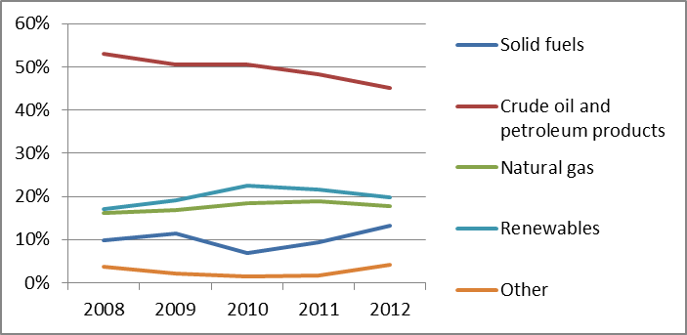
The power generation mix in 2011 (52.5 TWh) was dominated by renewables (47.0%), gas-fired power generation (28.4%) and solid fuels (18.7%). Net imports were 2.7 TWh, to a total electricity demand of 49.2 TWh. The share of gas-fired generation has however decreased considerably in the last two years.
Figure 2: Gross electricity generation mix 2008 – 2011 (source: EU Energy in Figures – Pocketbook 2012 and 2013)
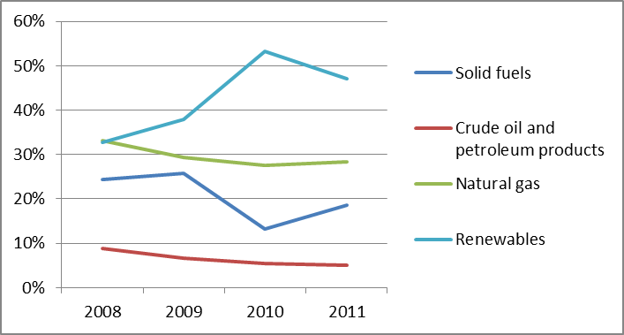
The domestic power generation mix in 2013 (47.8 TWh) was made up by 53.8% from hydro, coal and CCGT and 46.2% from renewable resources. The share of renewable energy varies yearly due to hydrological and wind conditions. Portugal’s 2020 renewables target is 31%, which is higher than the EU-27 average. According to Eurostat data, between 2008 and 2012, the renewables share in gross final energy consumption increased from 22.8% to 24.6% and the country is showing good progress towards its 2020 RES obligation.

Regulatory framework

General
The evolution of the energy sector in Portugal has been driven by reforms as part of the Financial Assistance Program. These reforms aim to reduce the energy tariff deficit. The privatisation of Redes Energéticas Nacionais SGPS and Energias de Portugal (EDP) was accelerated and regulated gas and electricity retail tariffs are being phased out. In this context, Portugal is undertaking other measures, discussed later in this report.

National Energy Regulator
The independent Portuguese Energy Services Regulatory Authority, Entidade Reguladora dos Serviços Energéticos (ERSE) has been in operation since 1997. It had a budget of almost EUR 9 million in 2012 and employed a staff force of 75 people.

Unbundling
REN (Rede Elétrica Nacional) and REN Gasodutos are the electricity and gas TSOs. Both are part of REN SGPS (Redes Energéticas Nacionais SGPS). After the re-privatisation of a 40% share capital of REN SGPS in 2012, the process continued and currently the Portuguese government does not hold shares in the capital of REN SGPS. These TSOs have both been certified in 2014 under the ownership unbundling model, after the opinion of the Commission issued in May 2014 and subject to the fulfilment of a number of conditions.
EDP is the main electricity distributor and was privatized in 2013. It holds the concession to operate the national distribution network in high and medium voltage, and most municipal concessions to operate in the low voltage distribution network. There are a few other smaller electricity distributors. The distribution of natural gas is provided by six distributors (four of them belong to GALP) that work under concession contracts and five autonomous natural gas distribution units (four of them belonging to GALP) which have a license.

Wholesale markets

Electricity
Total electricity consumption in Portugal stabilised in 2013 at 49.1 TWh after a two-year period of decline. Electricity production was 12.4% higher, driven by higher than average rainfall. Generation from hydro plants in 2013 more than doubled compared to 2012. Renewables also increased their production 16.4% when compared with 2012 data. This increase was compensated by a reduction in imports, CCGT and coal production.
Electricity generation in Portugal has an unconventional structure. While EDP, the former State-owned company, remains the largest generation entity (43% of electricity sold in 2013), a 42% share is supplied through regulated agents which are not exposed to market risks. REN Trading, which accounts for 7.6% of the domestic power generation mix, acts as a regulated market agent for the two historical PPAs. The renewable and CHP generators, which earn a feed-in-tariff, are represented in the market by a regulated single buyer. Imports account for 6% of energy supply and there is a high level of market integration and price convergence with Spain.
Changes to one of the most contentious issues, the regulated contracts for difference known as CMECs that aim to compensate for stranded costs arising from the liberalization process, are still pending. Portugal has already reduced the discount rate applied in the CMECs, but it is studying a retrospective reduction in previous years payments after the energy regulator and the antitrust authority advised of flaws in ancillary service related payments. ⁷
Portugal and Spain have been integrating their electricity markets into a single Iberian Electricity Market, MIBEL. They share a common spot market operator, OMIE, which has been operating in both countries since July 2007, and a forward market operator, OMIP, launched in July 2006. In 2013, day-ahead prices were the same in both countries. In February 2014, OMIE was coupled with the Central and Northern European markets. In 2013, 54.5 TWh were traded in the Portuguese part of OMIE day-ahead market. The average price in the day-ahead market in Portugal was EUR 43.65/MWh in 2013. Since March 2014, OMIP has auctioned FTR for the Spain-Portugal interconnection and allowed continuous trading of that product in its trading platform. In 2012 Portugal started auctioning forward contracts on energy produced by renewable and CHP plants under feed-in-tariffs. All forward contracts are settled financially, since no bilateral energy was delivered in the daily schedule in 2013. In the last two years there have been some changes in the Portuguese wholesale market. In 2012, CHP feed-in tariffs were reviewed and capacity mechanisms were reduced and limited to hydro power plants during the Financial Assistance Program. Moreover, in order to promote the sustainability of the system, 80% of the income of the CO₂ allowance auctions are used to compensate for the over-costs due to the renewable feed-in tariffs. In April 2012, ERSE approved a new system operation regulation and in June 2013 the Government approved a new measure aimed at cancelling out the effects of external events, specifically the increase in prices from new generation taxes in Spain. At the end of 2013, the Portuguese Government announced an extraordinary tax on energy production, transmission, storage and distribution activities in order to decrease the tariff deficit and promote energy efficiency measures.

Gas
Portuguese natural gas consumption dropped by 12.7% in 2012, mainly due to a 44% reduction of gas-fired power generation (all CCGT). Since Portugal does not produce natural gas, it covered its consumption in 2012 through LNG imports (23.9 TWh) and through two pipelines that connect Portugal with Spain (27.9 TWh). Portuguese supply still comes mainly from a few long term contracts held by GALP with Algeria (through Spain) and Nigeria (imported as LNG) and signed before liberalisation. At present, the Portuguese market does not have a transparent market-based natural gas price reference.
So far, Portugal´s gas market development has been constrained by its limited size and the slow progress of integration with the Spanish market, partially due to cross border entry-exit charges between both gas transmission systems. Increased integration would create the Iberian Gas Market, MIBGAS and promising developments are now ongoing. In recent years Portugal has taken steps towards market opening and integration with Spain. Portugal abolished transmission exit fees in the interconnection with Spain in June 2012 and Spain reduced the exit price (towards Portugal) in the cross border tariffs. Interconnection capacity between both countries was auctioned for the first time in 2013 and for the second time in March 2014.
As part of the review of the gas regulations finalised in 2013, the regulator allows the allocation of binding capacity rights in transmission, underground storage and LNG terminal infrastructures, for periods of up to one year.

Retail markets
In August 2012, the government announced the complete elimination of regulated tariffs. A transitory tariff (that includes an aggravation factor with a view to promoting switching) will be in place for three years. ERSE will review this tariff on a quarterly basis.

Electricity
As a consequence of the previous monopolistic supply structure and price regulation, the retail market remains concentrated. In December 2013, the HHI for domestic and industrial consumers amounted to 6,778 and 2,239 respectively. The market share of the three biggest companies in the liberalised market was 85% in 2013. In 2013 Portugal had its highest switching rate so far of household consumers: 26,8% compared to 13.2% in 2012.
Customers’ prices have increased considerably in previous years. From 2008 to 2012, final electricity prices have increased annually on average by 7.8% for domestic customers and 6.2% for industrial customers. The price increase for both domestic and industrial customers was due to an average annual increase in taxes and levies of 16% and 19%, respectively. This is influenced by a set of subsidies to ordinary producers, namely the compensation for stranded costs due to the liberalization process and the payments of feed-in tariffs for renewable and CHP.
Figure 3: Electricity price change by component 2008 – 2012 (source: Eurostat, energy statistics)

Gas
In April 2013, ERSE approved a new regulatory framework for natural gas to support the changes in commercial relationships following the removal of regulated tariffs. The modifications, which were aimed at strengthening consumer protection and enhancing competition, included extending the quality of service to all retailers, reinforcing unbundling provisions, adjustments to the supplier switching procedure and modifications in capacity allocation and pricing provisions.
The gas retail market in Portugal remains highly concentrated as liberalisation is recent and there remain some barriers to wholesale imports. At the end of 2012, GALP still supplied 68.8% of total consumption, followed by EDP with a share of 16.5% and Gas Natural with 10%. Nevertheless there are positive signs for the liberalisation process, such as the entry of new retailers and the ability for consumers to switch supplier.
Portuguese gas retail prices for household consumers (EUR 0.0836/kWh) are one of the highest in Europe, while prices for industry (EUR 0.055/kWh) are average respectively in the first part of 2013. This is partly due to the high share of network costs in the final price (in 2012, network charges for household consumers represented up to 42% in Lisbon).
Figure 4: Natural gas price change by component 2008 – 2012 (source: EC, EPCR metadata)

Consumers
Consumers' overall assessment of retail electricity market is below the EU average (22nd place and 66.3 points compared to 72.0, corresponding to 22nd place EU-wide) and second lowest among domestic services markets. However, the market has seen a considerable improvement (of 3 points) between 2012 and 2013. The incidence of consumer problems is third highest in the EU and trust in providers is fourth lowest. Retail gas market is ranked just below the EU average (74.0 points compared to 74.1, corresponding to 16th place EU-wide) and just above the average of 31 domestic services markets (14th place). However, in both markets the scores on choice, ease of switching and actual switching have improved considerably since 2012. The proportions of gas and electricity consumers who have switched their provider or tariff in the past year saw increases of over 10 percentage points (in the electricity market, this has translated to a change from 3rd lowest place in the EU in 2012 to 3rd highest in 2013).
Around 80% of complaints (7,053 in 2012) dealt with by ERSE are concerned with the electricity sector, while the remaining 20% relate to the gas sector. These complaints are mostly related to tariffs, switching of supplier and connection to the network. ERSE offers a price simulation tool on their website for electricity and natural gas customers and operates a telephone information service. A collective switching in the electricity sector took place, organised by a Portuguese consumer organisation.
Portugal maintains public service obligations through the concept of vulnerable customers, defined as those who are beneficiaries of government social support plans. They will keep the right to a regulated tariff with a limited increase established by the Government for each year. In 2012, 665,695 electricity and 17,000 natural gas consumers were eligible for this social tariff. During 2012, Portugal approved the new provisions for customers’ protection in accordance with the Third Energy Package.

Infrastructure
The Portuguese authorities should ensure a proper and timely adoption of the measures stemming from the TEN-E Regulation, including the establishment of the one-stop-shop for Projects of Common Interest (PCIs) (due by 16 November 2013), and other measures foreseen for 2014 and 2015, including the publication of the manual on the permit granting process for project promoters, and the adoption of legislative and non-legislative measures streamlining the environmental assessment procedures.

Electricity
Investments in electricity transmission have slowed down. The length of the transmission network, which had been growing in recent years, in 2013 reached 8,519 km. The Portuguese transmission network has eight interconnection lines with the Spanish Transmission Grid. In the context of the TEN-E Regulation, Portugal has 4 projects of common interest (PCI) that will help to increase interconnection level with Spain and reach the 10% Barcelona target.

Gas
The Portuguese natural gas system has three entry points: an LNG terminal at Sines (whose LNG storage capacity was expanded by 943 GWh in 2012) and two interconnections with Spain (Campo Maior and Valença do Minho). A third interconnection pipeline with Spain, aimed at increasing the integration of the Iberian Gas Market, is in the initial phase of construction. Additionally, Portugal has 2115 GWh of underground storage capacity. In 2012, Portugal commenced work on the expansion of underground storage capacity at Carriço.
In May 2013, the TSO presented a proposal investment plan for 2014-2023 that had to be analysed by ERSE that intended to expand the gas network in Northern Portugal. ERSE asked REN to review the gas investment plans for 2014-2023, worth EUR 524 million, due to the anticipated increase in consumer bills. After ERSE's opinion, the government is responsible for the final approval of the plan.
In the context of the TEN-E Regulation, Portugal has 1 project of common interest (PCI) that will increase interconnection level with Spain (and further on with France) and will help Portugal to reinforce its security of gas supply.

Security of supply

Electricity
Portugal’s dependence on imported energy has been historically high. Yet, due to an increasing amount of renewable energy in the generation mix, total energy dependence has been declining. The National Action Plan for Renewable Energy foresees a total increase of special regime generation capacity from 6,610 MW in 2012 to 8,780 MW by 2020. Addition new capacity is planned or underway as some hydro power plants are being built and the Government has granted permission to four new CCGT plants.
At the beginning of 2013, the Secretary of State announced a plan to upgrade the electricity network in the Western part of the country (worth EUR 135 million).

Gas
The LNG Terminal at Sines has allowed Portugal to diversify its supply sources, as well as to take advantage of supply diversification in the Spanish market. The expansion of gas infrastructure, including the LNG storage tank, is expected to further improve the diversification of supply sources and help meet the standard required by the European regulation of security of supply.
The entry capacity in the system (re-gasification plus interconnection capacity) is expected to remain above gas peak consumption in the next few years. In 2012, the average daily peak in consumption represented 36.5% of the entry capacity offered in SNGN.

Key indicators
Electricity |  | Gas
Number of companies representing at least 95% of net power generation | 104 | Number of entities bringing natural gas into country | 5
Number of main power-generation companies | 4 | Number of main gas entities | 1
Market share of the largest power-generation company | 44.9% | Market share of the largest entity bringing natural gas | 85.3%
Number of electricity retailers | 10 | Number of retailers selling natural gas to final customers | 20
Number of main electricity retailers | 4 | Number of main natural gas retailers | 3
Switching rates (only for electricity household consumers) | 13,2% | Switching rates for gas (entire retail market) | N/A
Regulated prices for households – electricity | No | Regulated prices for households – gas | No
Regulated prices for non-households – electricity | No | Regulated prices for non-households – gas | No
HHI in power-generation market | 3,567 | HHI in gas supply market | 3,883
HHI in electricity retail market (domestic consumers) | 6,918 | HHI in gas retail market | 4,484
HHI in electricity retail market (industrial consumers) | 2,815 | HHI in gas retail market  (industrial consumers) | 5,509
Electricity market value (bn€) | 4.856 | Gas market value²⁰ (bn€) | 0.897
Installed generation capacity (MW, 2011) | 19,938
Peak demand (MW) | 8,554
Number of smart meters installed | N/A

Romania

Key Issues
Correct and complete transposition of the Third Energy Package and its practical application needs to continue. Romania should complete the corporate governance reform of state-owned enterprises in the energy sector in line with the internal energy market legislation.
Romania's roadmap for phasing out regulated gas and electricity prices and improving retail competition and energy efficiency needs to be fully implemented. The process of electricity market coupling should be finalised following the target model.
The completion of gas interconnections and reverse flow projects, including physically linking the Romanian gas system with the transit pipelines, are necessary to strengthen security of supply and to enable increased exploitation of domestic gas resources.
Further electricity interconnection is needed to exploit the high generation capacity.
Romania is on track to meet its 2020 renewable target but upgrades to the network would help integrate more renewables.

General overview
In 2009, the economic downturn led to a decrease in consumption which has recovered slightly since 2011. In 2012, the overall renewables contribution was 22.9%, close to the 24% national target for 2020.
Figure 1: Gross inland consumption mix 2008 – 2012 (source: Eurostat)
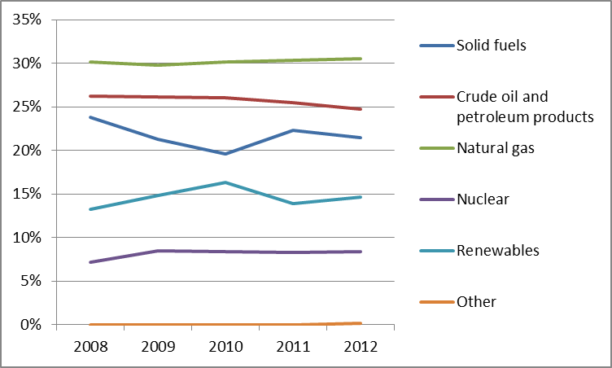

In 2012, domestic natural gas consumption amounted to 109 TWh (75.68% of total consumption) while imports were 35 TWh. In 2013, the 8.4% decrease in consumption led to a 58% reduction in import while domestic production remained at 2012 levels.
In 2013, the breakdown of electricity generation was 46.2% thermal, 25.9% hydro and 19.9% nuclear. Renewable energy sources amounted to 4.348 MW installed capacity. The renewables share in gross final energy consumption reached 22.9% in 2012 and thus Romania is almost at its national 2020 target of 24%.
Figure 2: Gross electricity generation mix 2008 – 2011 (source: EU Energy in Figures – Pocketbook 2012 and 2013)
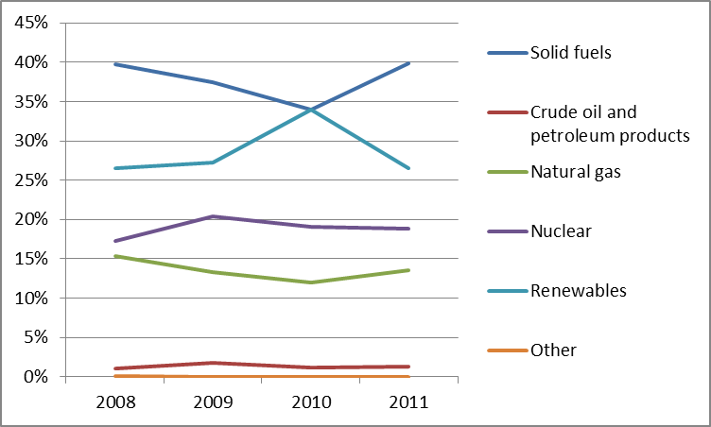

Regulatory framework

General
In September 2014 Romania adopted amendments to its energy legislation intended to ensure full transposition of the Third Energy Package Electricity and Gas Directives. An infringement procedure on restrictions on the export of gas, initiated in 2012 under the TFEU and the Gas Directive, is on-going.

National Energy Regulator
The National Energy Regulator, ANRE, was established in 1998. By law, ANRE may employ a maximum of 300 persons. Its total budget in 2013 was EUR 15.8 million.

Unbundling
Electricity sector unbundling has been ongoing since 2000 when CNTEE Transelectrica SA was appointed as the electricity TSO. SNTGN Transgaz SA Medias was appointed as the gas TSO. Both companies are state-owned and were certified as independent system operators by ANRE in 2013, subject to fulfilling certain additional requirements to be complied with. It has meanwhile been able in 2014 to issue final certification decisions after it deemed that these additional requirements were satisfied. Legal unbundling of electricity and gas distribution operators has been ongoing since 2007.

Wholesale markets

Electricity
Energy Complex Oltenia, Hidroelectrica and Nuclearelectrica are the three largest generators with a total market share of 70.01% (69.7% in 2013). The HHI in the wholesale market is 1,914 (1,759 in 2013). 2012 was a dry year, leading to very high prices in the wholesale electricity market, and a spot base load price of EUR 48.8/MWh. The spot base load price in 2013 decreased to EUR 35.3/MWh, due to lower demand, normal hydrology and a large amount of wind generation. Due to significant changes in primary legislation, transactions performed on the centralised competitive wholesale markets organised by Opcom SA (the operator of wholesale market) significantly increased. The volume sold on Opcom SA platforms is almost double than that of 2012, and represents 71% of internal consumption.
The TSO develops and administrates balancing, ancillary services and cross-border capacity markets. Bilaterally coordinated auctions for long and short term were organised as of 2012 for cross-border capacity allocation on the borders with Hungary and Bulgaria and, since December 2012, on the border with Serbia.
In July 2013, the Czech Republic, Slovakia, Hungary, Romania and Poland signed a Memorandum of Understanding to extend the existing market coupling in Central Eastern Europe by including Romania and Poland.

Gas
In 2012, demand was met by imports and six domestic producers. The two leading gas producing companies, Romgaz and OMV Petrom, provided 97.5% of domestic production. The market is highly concentrated and the sum of market shares of the three main suppliers in the wholesale market (Romgaz, OMV Petrom and OMV Petrom gas) is 78.4%.
In 2012, trading was through long term bilateral contracts and capacity allocation on a "first-come first-served" basis. In July 2013, OPCOM and the Romanian Commodity Exchange BRM were licensed by ANRE to organise gas centralised trading. The gas market development should be fostered by completion of the interconnection and reverse flow projects with neighbouring countries.

Retail markets

Electricity
The gradual phasing-out of regulated prices was completed in December 2013 for non-household consumers, whilst for households it should be completed by December 2017. The number of consumers supplied on a competitive basis (which have chosen to change suppliers) has constantly increased; in December 2013 it was close to 19,200. The switching rate in the retail electricity market is still very low (0.03% in 2012). 62 suppliers operate in the retail market while the degree of real market opening has only slightly increased from 55% in 2012 to 57% in 2013. Due to the negative or slim margins allowed by price regulation, suppliers are discouraged from making offers outside their supply areas, therefore consumer choice is in reality often very limited.
Figure 3: Electricity price change by component 2008 – 2013 (source: Eurostat, energy statistics)
To ensure universal service, five appointed suppliers of last resort are required to procure a progressively increasing share from the wholesale competitive market, with the costs transferred to end-consumers.

Gas
In 2012, gas consumption was 145 TWh of which household consumption was 20%. During the period 2010–2012, household prices including taxes and levies have remained constant, while the price for industrial users has continued to increase. However, the on-going phasing out of regulated prices will have an impact on prices for both categories.
Figure 4: Natural gas price change by component 2008 – 2012 (source: EC, EPCR metadata)
Phasing out of regulated prices for non-households will be completed in December 2014 (or end 2015 if there is a significant difference between the domestic gas price and European import price that could endanger market stability). For households, the process lasts until December 2018.

Consumers
Consumers' overall assessment of the retail electricity and gas markets is just above the EU average (72.7 points compared to 72.0 and 74.4 compared to 74.1), corresponding to 16th and 15th place EU-wide, respectively. The gas market has seen a considerable improvement (of 3.4. points) between 2012 and 2013 (second highest increase domestically). However, both markets score low on actual switching, ease of switching, choice and overall consumer satisfaction (for gas market the latter three rank among the three lowest in the EU). In addition, the incidence of consumer problems is relatively high (3rd highest in the gas market) .
Vulnerable customers are defined as household consumers with low income within the limits laid down in the Ordinance 27/2013. The road maps for phasing out regulated electricity and gas prices includes social measures for vulnerable consumers by providing direct subsidies, informing consumers about the process of market liberalisation, reviewing the process for changing suppliers and detailing electricity and gas bills. Financial aid for social protection during the cold season is in place.
Developing a price comparison tool has been debated, but the decision is pending. Independent dispute settlement commissions will be established within ANRE for both gas and electricity.
A study has concluded that implementing smart metering is feasible for electricity consumers, while for gas consumers’ installation will be optional and the decision will be left to the DSOs. The promotion of pilot projects on smart metering of electricity distribution systems is one of the measures included in "Main Commitments for the National Reform Programme 2013".

Infrastructure
The Department of Energy within the Ministry of Economy has been designated as National Competent Authority responsible for facilitating and coordinating the permit granting process for projects of common interest in accordance with the provisions of the TEN-E Regulation (“one-stop shop”).

Electricity
Transelectrica is involved in several infrastructure projects with neighbouring power systems to improve the cross-border exchange of electricity, relief congestion and improve the integration of RES. The projects are focused on enhancing interconnector capacity with Serbia, Bulgaria and Republic of Moldova. Six out of seven Projects of Common Interest (PCI) which have been identified under the guidelines for trans-European energy infrastructure on Romanian territory focus on the upgrade of the internal electricity system with new 400 kV overhead lines. Romania meets the 10% interconnectivity target set by the Barcelona Council in 2002.

Gas
Transgaz has planned the redefinition of domestic gas transmission routes in line with envisaged national and European flows, including off-shore gas reserves, the shale gas perspective and the Southern Corridor. The plan includes new high pressure pipelines and rehabilitation of existing assets.
The interconnection with Bulgaria will ensure minimum gas flow for emergency supply, with bi-directional flows expected by the end of 2016. Further development of the interconnector with Hungary, commissioned in 2010, will lead to full capacity of 4.4 bcm/year in 2016. The project provides a transmission corridor from the Black Sea and Bulgaria to the markets in Central and Eastern Europe. The development of interconnection with Moldova and Serbia will only achieve its full potential if additional investments are made on both sides of the interconnectors.
The above mentioned issues are covered through the seven gas Projects of Common Interest with Romanian participation. The construction of a LNG terminal in Constanta could help to diversify the country's supply portfolio.

Security of Supply

Electricity
A peculiarity of the Romanian electricity system is its current overcapacity in combination with limited export capacity. The existing capacity is largely meeting demand, but maintaining this capacity will require improvements in export conditions.

Gas
In the gas sector security of supply is jointly ensured by the TSO, the 41 DSOs and the two operators of underground storage. Special care is given to ensuring conditions for continuity and safety of gas supply by ensuring a minimum stock of gas in underground storage. The obligations of licensed suppliers to maintain the minimum level are set by ANRE.

Key indicators
Electricity |  | Gas
Number of companies representing at least 95% of net power generation | 11 | Number of entities bringing natural gas into country | 18
Number of main power-generation companies | 5 | Number of main gas entities | 2
Market share of the largest power-generation company | 26.7% | Market share of the largest production and import gas company | 41.7%
Number of electricity retailers | 54 | Number of retailers selling natural gas to final customers | 65
Number of main electricity retailers | 5 | Number of main natural gas retailers | 5
Switching rates (entire electricity retail market) | 0.033 | Switching rates for gas (entire retail market) | N/A
Regulated prices for households – electricity | Yes | Regulated prices for households – gas | Yes
Regulated prices for non-households – electricity | No | Regulated prices for non-households – gas | Yes
HHI in power-generation market | 1,914 | HHI in gas supply market | N/A
HHI in electricity retail market | 1,472 | HHI in gas retail market | N/A
Electricity market value (bn€) | 3.471 | Gas market value¹⁹ (bn€) | 1.786
Installed generation capacity (MW) | 18,756
Peak load (MW) | 8,627
Number of smart meters installed | N/A

Slovakia

Key issues
Slovakia should enhance the independence of national regulatory authority and ensure its accountability. Slovakia should promote a regulatory framework conducive to investment in and integration of the electricity and gas markets, including by reviewing the impact of price regulation and changes in network charges. Currently network distribution and transmission charges in Slovakia are among the highest in the EU.
Slovakia should facilitate greater regional integration and strengthen interconnections with neighbouring countries in both gas and electricity networks. Market coupling with the Hungarian and the Czech day-ahead electricity markets is a positive development and such efforts should be continued.
Slovakia should continue its efforts to diversify gas imports in order to foster security of supply and in order to address the concentration on the wholesale market.

General overview
Energy consumption in 2012 (16.7 Mtoe) was based largely on natural gas, crude oil and petroleum products. The share of renewables in gross final energy consumption was 10.4%. Slovakia remained above its 2011/2012 interim trajectory and is currently on track to achieve its 2020 renewables target of 14%.
Figure 1: Gross inland consumption mix 2008 – 2012 (source: Eurostat)
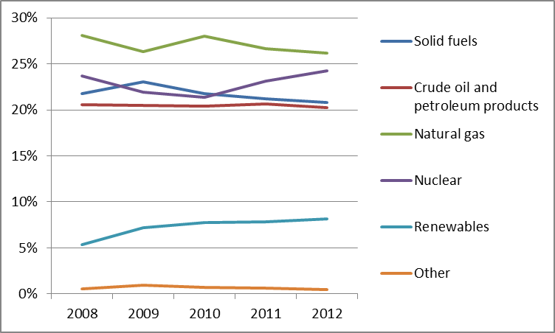
The biggest share in the power generation mix in 2011 (28.66 TWh) was nuclear (53.8%) and renewables (18.7% - mostly hydro). The share of natural gas increased in 2011 compared to 2010 while the volume of power generated from solid fuels and oil power remained unchanged.
Figure 2: Gross electricity generation mix 2008-2011 (source: EU Energy in Figures – Pocketbook 2012 and 2013)

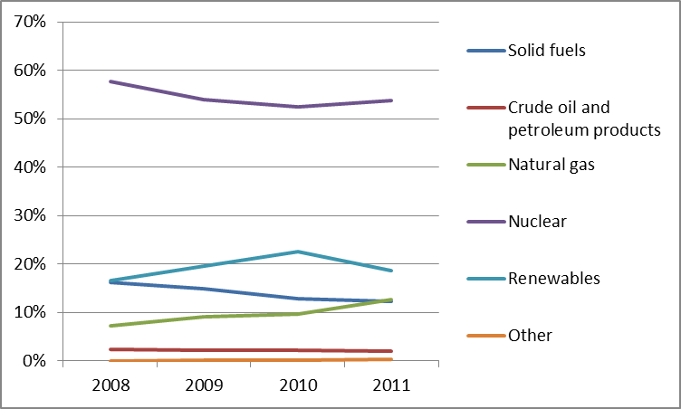
Cogeneration provided 24.5% of gross electricity generation in 2011, increasing considerably from 2010.
Final consumption of electricity in 2011 was 10.8 Mtoe and decreased compared to 2010. The consumption of natural gas by final consumers declined in 2012 to 54.2 TWh. The economic crisis boosted energy efficiency and reduced power prices in Slovakia.
- Regulatory framework

General
In July 2012, Slovakia adopted laws to transpose the Directives of the Third Energy Package into its national law. The main purpose of the adoption of that legislation was the further liberalisation and harmonisation of the rules governing the functioning of the energy market and ensuring compliance with the provisions of the third energy package. Some stakeholders have raised concerns with regard to the independence, transparency and accountability of the national regulatory authority. In particular concerns were raised that decisions to substantially change network charges have been introduced without sound consultations and proper economic analysis underpinning the decisions, in particular without analysis on the deterioration on the investment climate and the integration with neighbouring markets this decision may have. Network distribution and transmission charges in Slovakia are among the highest in the EU.

National Energy Regulator
Energy regulation in Slovakia is undertaken by the Regulatory Office for Network Industries ("Úrad pre reguláciu sieťových odvetví" - URSO) which was established in 2001. URSO employed 100 staff members in 2012 and its annual budget reached almost EUR 2.95 million. The laws transposing the Directives of the Third Energy Package do not fully ensure that URSO can take autonomous decision independently from the Ministry and the State Inspection and do not foresee that decisions taken be URSO have to be fully reasoned and justified.

Unbundling
SEPS unbundled in 2001 and as a result of unbundling, three vertically integrated companies were formed to provide electricity distribution, electricity supply and services. In 2013 SEPS, the Slovakian electricity transmission system operator, was certified under the ownership unbundling model by means of separate public bodies within the State.
Eustream the only gas transmission system operator in Slovakia was certified as Independent Transmission System Operator (ITO) in 2013. SPP-distribúcia, the only operator of the gas distribution system, was legally unbundled from SPP in 2006.
- Wholesale markets

Electricity
The power generation market is highly concentrated. The largest power generating company (Slovenské elektrárne) had a market share of almost 78% in 2011.
Trading takes place mostly through bilateral contracts. 10% of total annual power production in Slovakia has been traded on short term day-ahead exchange platforms. The main power exchange in Slovakia is Power Exchange Central Europe (PXE). Slovakia is part of the Central Eastern Europe regional market. The price convergence between Slovakia, Czech Republic, and Hungary increased from 11% to 82% after market coupling in September 2012. In 2012, liquidity of Slovakian intraday market was just 0.04 TWh, indicating poor competition on the wholesale market.
In 2013 an obligation for electricity producers to pay a network charge, so-called G-component was introduced. Furthermore for 2013 and 2014, the Ministry of Economy has imposed obligations on the electricity producer Slovenké elektrárne, on the transmission system operator and on electricity distributors and suppliers in order to ensure the production and supply of a certain amount of electricity from indigenous coal. These obligations cover 6.7% of total domestic consumption of electricity in Slovakia in 2012. The corresponding electricity price should be maintained at the level determined by the Office for the Regulation of Network Industries.

Gas
Concentration of the gas wholesale market remained very high in 2012. SPP withholds almost 70% of gas supply and it imports gas within a long-term contract with Gazprom. The contractual price SPP has to pay to Gazprom has been re-negotiated and lowered in 2014 in order to better reflect the lower prices on spot markets. 98% of gas consumed in Slovakia comes from Russia. On the Slovak wholesale gas market no major trading activity takes place however some sporadic over-the-counter deals take place on border points, the Slovak virtual trading point and the domestic points.
In 2012 transit volumes reached 56.5 bcm compared to 5.2 bcm of domestic consumption and transit capacity of 90 bcm/a. Transit volumes of natural gas from Russia to the EU through Slovakia dropped from 80% of total Russian flows to Europe a few years ago to about 54 % in 2013 due to the launch of Nord Stream. In the meantime, gas has been entering Slovakia in reverse flow from the Czech Republic via Lanzhot cross-border point. In 2013 the network charge for entering the Slovak gas transmission system from the Czech Republic increased by 300% and from Austria by 50% compared to tariffs in force in 2012.
In 2013, Slovakia, Hungary, Czech Republic and Poland adopted a “Road Map towards the regional gas market among Visegrad 4 countries”.
- Retail markets

Electricity
The number of licenced power retailers in the whole retail market has been constantly growing and it reached 407 at the end of 2012. 19 retailers provide electricity to household consumers at the end of 2012. Despite the growing number of competitors in the power supply market, prices for household consumers and small and medium companies remain regulated. Deregulation of prices for the commercial sector in 2012 was only temporary and URSO decided to revert to previous regulation due to increase in power prices for small and medium undertakings.
In 2013, electricity prices for household and industrial consumers decreased compared to 2012. Network charges are among the highest in all of the EU member states.
Figure 3: Electricity price change by component 2008 – 2013 (source: Eurostat, energy statistics)
The numbers of consumers switching power providers are increasing every year, which is a good sign for energy market liberalisation. 57,307 consumers switched in 2012 against 39,762 in 2011, but the total number of switches remains relatively low.
According to URSO, switching was not beneficial in every case, as some power suppliers failed to set prices in a transparent manner. Irregularities related mostly to invoicing issues. As a result, in 2013 URSO returned to regulating prices for small and medium commercial users.
A rollout of smart metering in Slovakia is still being discussed. Distribution system operators install smart meters on a voluntary basis, usually for energy-intensive customers.

Gas
In 2012, 74 % of all inhabitants in Slovakia had access to gas. Slovakia, after the Netherlands, is the second most gasified country of the EU. The demand for gas dropped by 5% between 2012 and 2011 due to decreasing power demand displaced by the increasing use of renewables in electricity production.
In Slovakia the distribution system is balanced separately from the transmission system which creates a potential barrier for market players to enter the retail market.
Retail market concentration is high. In 2012 there were 23 gas retailers in the entire retail market, of which the dominant supplier is Slovenský plynárenský priemysel, SPP (70% share of gas market), followed by RWE Gas Slovensko (18.7%).
Gas prices for household consumers increased between 2008 and 2012. Gas prices for industrial users decreased over the same period because their energy component decreased by almost 20%. Prices for households remained regulated.
Figure 4: Natural gas price change by component 2008 – 2012 (source: EC, EPCR metadata)
The number of household consumers who switched gas suppliers in 2012 reached over 131,000 (9.25% of all the households) and was six times bigger than in 2011. The number of switches is still relatively low.
- Consumers
Consumers' overall assessment of the retail electricity and gas markets is above the EU average (78.1 points compared to 72.0 and 79.2 compared to 74.1), corresponding in both cases to 5th place EU-wide. Both markets are also assessed above the average of 31 domestic services markets (13th and 10th place, respectively). They score better than the EU average on all indicators, with the exception of consumer complaints (which are more numerous than in other EU countries) and in the case of electricity market switching rates are also slightly lower than the EU average.
In 2012, the number of complaints submitted to URSO by the gas and electricity entities increased fourfold. In 2012, automatic compensation payments for the violation of quality standards for energy services were introduced, but were used only occasionally. Customers reported over 200 potential infringements of electricity and gas market rules and the majority of complaints related to switching. For better consumer empowerment, URSO has a power price comparison tool and energy price calculator on their website.
A definition of “vulnerable consumer” was introduced in 2012. Its scope was extended from the previous definition including only households, to a broader one also covering small businesses. Even though Slovakia has defined "vulnerable consumers" and “energy poverty”, there are no specific support measures available for vulnerable customers and consumers in energy poverty.
- Infrastructure

Electricity
An important part of energy infrastructure investment in Slovakia involves funds from BIDSF (Bohunice International Decommissioning Support Fund). Almost EUR 150 million has been made available to private companies and housing associations for implementation of energy efficiency and renewable energy projects.
Slovakia is interconnected to Czech Republic, Hungary and Poland. The Slovak transmission system is affected by the loop flows which originate most frequently from Germany and are passed through Poland into Czech Republic and Slovakia. Significant congestions also occur on the Slovak-Hungarian border. Further interconnections with Hungary are planned, three projects having been selected as Projects of Common Interest (PCIs) under the guidelines for Trans-European Energy Infrastructure. Adding to these, the reinforcement of the national grid is envisaged through the construction of two internal lines projects that also have PCI status. The importance of the PCIs implementation is reflected in the increase of the electricity interconnection level (import capacity/net generation capacity) from 37% nowadays to 54% after their implementation. Moreover, the impact is even more visible for neighbouring countries, such as Hungary, increasing from 15-30% to values above 30% on the 2020+ time horizon.
The construction of two additional units at Mochovce power plant was started in 2008.

Gas
A bi-directional high pressure gas pipeline interconnecting the gas systems of Hungary and Slovakia has been constructed and is expected to start operating very soon. The project is co-financed through the European Energy Programme for Recovery and has also acquired PCI status. The Polish–Slovak interconnection, also a PCI, is currently being developed. These projects will diversify the routes of gas supply pipelines, running across Visegrad group countries, and connect two LNG terminals in Poland and Croatia.
- Security of Supply

Electricity
Security of supply in Slovakia is expected to be strengthened considerably after the two additional units at Mochovce nuclear power plant, each of 440 MW installed capacity, are commissioned.
Slovakia suffers from unscheduled electricity loop flows from Germany, threatening the secure grid operation and cross-border wholesale trade. To mitigate the loop flows Slovakia reconfigurated its border substations. It helped to restore the N-1 security principle, but also increased losses in the transmission system. Slovakia has considered installing phase shift transformers. This problem could also be alleviated by increased interconnecting capacity.

Gas
Natural gas is currently the most significant energy source in Slovakia and roughly 98% of domestic gas consumption is covered by import under the long-term contracts between SPP and Gazprom. The gas supply disruption of 2009 was an important lesson that Slovakia needs to consider diversifying its energy portfolio. Gas storage capacities have been increased and reverse flow at the Western border interconnectors has been enabled. Ongoing investment in gas interconnecting infrastructure will open new directions for gas import to Slovakia.
- Key indicators
Electricity |  | Gas
Number of companies representing at least 95% of net power generation | 11 | Number of entities bringing natural gas into country | 8
Number of main power-generation companies | 1 | Number of main gas entities | 3
Market share of the largest power-generation company | 78.9% | Market share of the largest entity bringing natural gas | 61.8%
Number of electricity retailers | 71 | Number of retailers selling natural gas to final customers | 22
Number of main electricity retailers | 4 | Number of main natural gas retailers | 2
Switching rate | 5% | Switching rate for gas (household consumers) | 11.56%
Regulated prices for households – electricity | Yes | Regulated prices for households – gas | Yes
Regulated prices for non-households – electricity | Yes | Regulated prices for non-households – gas | Yes for SMEs
HHI in power-generation market | N/A | HHI in gas supply market (domestic) | N/A
HHI in electricity retail market (domestic) | N/A | HHI in gas retail market (domestic) | N/A
Electricity market value (bn€) | 2.662 | Gas market value²⁰ (bn€) | 1.135
Installed generation capacity (MW, 2011) | 8,056
Peak load (MW) | 4,395
Number of smart meters installed | N/A

Slovenia

Key issues
Further strengthening of the power grid is needed to ensure the reliable and safe operation of the national electricity system. Planned investments in additional cross-border capacity are needed to improve competition and integration in the internal energy market. Investments in more flexible sources with lower environmental impact would improve supply diversification and integration in the IEM. Finally, the electricity TSO ELES needs to be certified urgently.
Contractual congestion of gas interconnection capacity frequently occurs, implying the need for the reinforcement of existing capacity. Investments in new gas pipelines could help to diversify the Slovenian energy supply, but current projects (notably South Stream) tend to extend the role of current suppliers. Slovenia still has to adapt its national legislation to comply with the provisions of Regulation (EC) No. 994 on security of gas supply. Finally, more should be done to encourage competition in the generation market.

General overview
35% of gross inland energy consumption in 2012 (7.00 Mtoe) was accounted for by oil and petroleum products, followed by nuclear energy and solid fuels (20%) and renewables (15%)
In 2012, renewables increased to 20.2% of gross final energy consumption, showing good progress to the 2020 renewables target of 25%. The share of renewables increased mainly due to greater contribution (+1.9%) of heating technologies.
Figure 1: Gross inland consumption mix 2008 – 2012 (source: Eurostat)
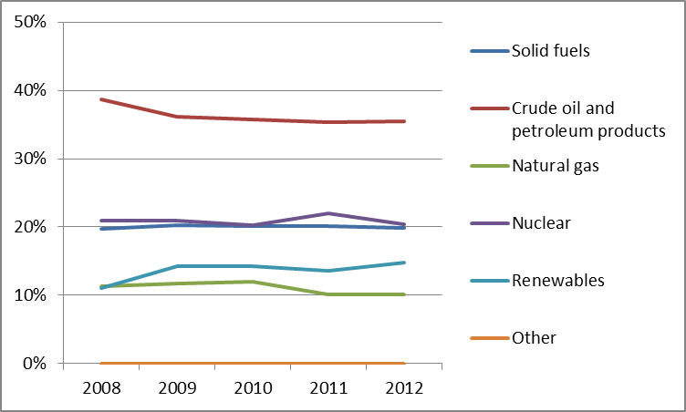
In 2012, the market share of different fuels in the electricity generation mix changed slightly compared to 2011 levels. Nuclear fuel remains the primary source of overall inland energy generation at 36%, with solid fuels accounting for 32%. Renewables rised from 25% in 2011 to 29% while the contribution of gas remained negligible at 3%.
Figure 2: Gross electricity generation mix 2008 – 2011 (source: EU Energy in Figures – Pocketbook 2012 and 2013)
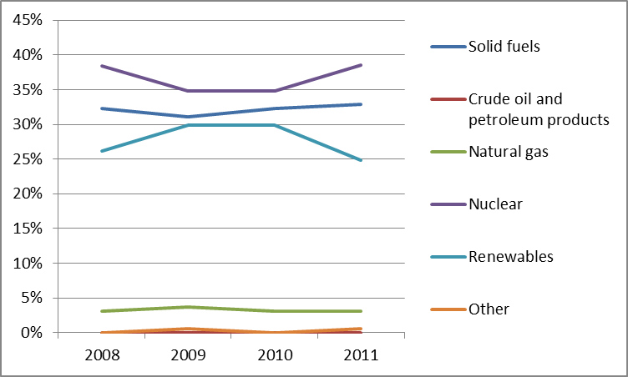

Regulatory framework

General
Slovenia's legislation transposing the Third Energy Package was approved by Parliament in February 2014.

National Energy Regulator
The Slovenian national regulator, the Energy Agency of the Republic of Slovenia (AGEN-RS) has been in operation since 2000. In 2013 it had a budget of EUR 2.8 million and 46 employees.

Unbundling
Electricity infrastructure is managed by one TSO (ELES) and one DSO (SODO), which are both state-owned. The gas TSO Plinovodi is responsible for natural gas infrastructure, together with 16 DSOs. These DSOs service less than 100,000 customers in total, and therefore no legal unbundling is required.
Plinovodi was certified as an independent transmission system operator (ITO) in 2012. ELES’s certification is pending following the recent approval of the new Energy Act.
- Wholesale markets

Electricity
The Slovenian electricity wholesale market remained highly concentrated in 2012. HSE, Gen energija and TE-TOL were the three dominant (state-owned) market players, both in terms of installed capacity (84.8% cumulative share) and production (91.4% cumulative share). The measure of market concentration (HHI) was 4,738 for generation, indicating a high level of concentration. The modest market size does not facilitate the development of many generators.
Following market coupling with Italy, Slovenia is part of a much larger market, even though cross-border capacity is still limited. Implicit auctions enabled Slovenia to improve cross-border capacity utilization and increase market liquidity.
In 2012 the day-ahead market registered 4.4 TWh of traded energy, three times larger than 2011 results. The average baseload spot price was EUR 53.15/MWh, 7% lower than 2011 figures. In October 2012, an intraday market and a balancing market were introduced.

Gas
Slovenia depends entirely on imports to meet its domestic demand for gas. Demand in 2012 declined further compared to 2011 (-4%, reaching 0.87 bcm) due to the economic crisis. 42% of gas imports supplied from Russia, 35% from Austria, 16% from Algeria, and 7% from Italy. Geoplin remained the principal importer, supplying over 90% of demand. Significant development of the secondary capacity market was observed in 2012 as the number of contracts increased together with the daily exchange capacity.
- Retail markets

Electricity
Electricity demand remained unchanged in 2012, amounting to 12.4 TWh. Eight out of thirteen active suppliers provided a share higher than 5%. The largest supplier was GEN-I, whose market share increased to 26.2% of the overall final customers. In 2012, more than five years since full market liberalisation (1 July 2007), retail competition finally increased due to a new entrant, GEN-I in the household market segment. The market share of the three largest suppliers increased slightly from 57% in 2011 to 59%. The concentration of the retail market remained at a medium level, with an HHI of 1,575. This indicator is however misleading as the retail market is supplied by many local suppliers, each of them dominant in a specific area.
The switching rate grew to 5.9% (+1.7% compared to 2011). The vast majority of switches were undertaken by household customers (48,794 consumers) who changed their supplier following the entrance of GEN-I and Petrol into the household market segment, gaining 12.5% of the final consumers.

Figure 3: Electricity price change by component 2008 – 2013 (source: Eurostat, energy statistics)

Gas
The Slovenian natural gas market is one of the smallest in the EU-28, totalling around one billion standard cubic metres per year. Most natural gas sold in the retail market is consumed by industry and other non-household consumers. The quantities of gas consumed by end customers amounted to 0.87 Gm³ in 2012. The dominant supplier, Geoplin, increased its market share to 63%, followed by EnergetikaLjubljana (7.8%) and Adriaplin (7.2%). As a result, the retail gas market was concentrated, with an HHI of 4,186. Significant improvements in opening up the retail gas market were recorded. This was confirmed by the switching rate rising from 0.07% in 2011 % to 8.6% by the end of 2012 (reflecting GEN-I entered the market) placing Slovenia at a level similar to those observed in the Netherlands and Germany. In 2013, uniform tariffs for each entry and exit point of the gas transmission network were introduced.
As a result of GEN-I’s entry in the market in 2012, natural gas prices in Slovenia started declining in the fourth quarter of 2012. GEN-I price strategy that included prices lower than existing prices by around 10 cents per cubic metre (21.7% lower than the largest player’s price before the new entry took place), lead to a fast response from incumbent suppliers, that started modifying their own offers to consumption patterns, taking into account seasonal elements and changing their marketing strategies. Since October 2012 and well into 2013, prices have been declining to less than 40 cents per cubic metre due to the continued competitive response from incumbent suppliers, as well as seasonal factors.
The percentage of network charges in the final price of gas varies between 15% and 19% for industrial customers, and between 17% and 28% for household customers (Figure 4).
Figure 4: Natural gas price change by component 2008 – 2012 (source: EC, EPCR metadata)
Slovenia is among the Member States that have not yet initiated the mass rollout of smart meters. A formal decision on the rollout, together with the establishment of a rollout percentage target has yet to be confirmed.
- Consumers
Slovenia had a very significant increase in switching during 2012 (especially in the 4th quarter of the year) due to the entry of a new player in the liberalised market. The absence of price regulation allowed the new player to enter the market with a pricing and sourcing strategy very different from that of the existing players and obliging the incumbent suppliers to modify their price strategies. The existence of the price comparability website maintained by AGEN-RS was certainly an asset in promoting energy markets’ transparency and in facilitating switching.
This situation is also reflected in consumers' overall assessment of retail gas and electricity markets which scores the highest and second highest in the EU respectively (84.4 points compared to 74.1 and 81.0 compared to 72.0). Both markets are also assessed very well in the ranking of 31 domestic services markets (2nd and 9th highest, respectively). The electricity market is assessed above the EU average on all indicators, with the exception of actual switching (which is slightly below the EU average). Comparability, ease of switching and overall consumer satisfaction rate among the 3 highest in the EU and the incidence of problems is third lowest. The assessment of the gas market has also slightly improved since 2012 (by 1.3 points). All indicators are assessed above the EU average.
- Infrastructure
Slovenia has nominated the Ministry of Infrastructure and Spatial planning as the competent authority coordinating all permit granting processes (‘one-stop shop’). The one-stop shop is responsible for facilitating and coordinating the permit granting process for Projects of Common Interest, in accordance with the Regulation on Trans-European infrastructure..

Electricity
In 2012, installed generation capacity amounted to 3.3 GW. In the medium term, significant investments in thermal (including the controversial Šoštanj lignite power plant, TEŠ) and hydro power plants are expected in accordance with the latest transmission network development plan for 2013-2022 published by ELES. This plan foresees an increase in installed generation capacity by 2.4 GW in 2022. The plan also outlines a range of different investment options, including the commissioning of a new nuclear reactor in Krško.
Since June 2012, when intraday allocation mechanism was also introduced for the Italian border, two explicit auctions are held every day. Allocation of cross-border capacity is carried out daily by implicit auctions within the market coupling mechanism of Slovenia and Italy.
In terms of infrastructure development, the interconnector with Hungary is expected to become operational in 2016. There are several electricity Projects of Common Interest under the guidelines for trans-European energy infrastructure planned in Slovenia including two electricity clusters with a high voltage transmission line between Slovenia, Croatia and Hungary and a high voltage transmission line between Slovenia and Italy. The Okroglo-Udine interconnection and HVDC line between Slovenia and Italy (PCI 3.20.1) is not expected to be completed before 2022.

Gas
The Slovenian gas transmission network is interconnected with the gas transmission networks of Austria, Italy and Croatia. Of these, the Austrian border point was the most congested and commercially attractive in 2012. Network investments in 2012 amounted to EUR 38 million (almost 50% less than in 2011), of which EUR 9 million was granted by the European Union within the European Energy Programme for Recovery (total contribution for this project amounted to EUR 37 million) for the construction of the Ceršak – Kidricevo section of the gas pipeline M1/1. Two upgrades of the transmission network, M2/1b Rogaška Slatina−Trojane and M2/1c Trojane–Vodice, were completed in 2013. Work on strengthening the Kidričevo compressor station is ongoing.
There are several gas Projects of Common Interest, which Slovenia is involved in, including the LNG terminal in Krk (HR), which is a security of supply asset for the region as well as several gas pipeline projects involving Italy, Croatia, and Hungary.
- Security of supply

Electricity
To ensure network security, the transmission grid and electricity distribution networks must adhere to the N-1 criterion. Network security is dependent on its import capacities to meet internal consumption demands.
The adequacy of Slovenia’s network varies significantly depending on seasonal peaks, with the winter period highlighted as the critical period. Summer reserve margins are expected to decrease from 10% in 2013 to 3% in 2020.

Gas
Gas supply in Slovenia is entirely dependent on its interconnections with neighbouring countries as there are no gas storage facilities. Nonetheless, in spite of extreme weather conditions at the beginning of 2012, all customer service requirements were fulfilled.
Despite efforts in implementing the provisions mentioned in Regulation 994/2010, amendments in the national legislation are needed to complete the new rules and regulations for security of gas supply.

8. Key indicators
Electricity |  | Gas
Number of companies representing at least 95% of net power generation | 3 | Number of entities bringing natural gas into country | 5
Number of main power-generation companies | 2 | Number of main gas entities | 2
Market share of the largest power-generation company | 55.2% | Market share of the largest entity bringing natural gas | 90%
Number of electricity retailers | 13 | Number of retailers selling natural gas to final customers | 21
Number of main electricity retailers | 8 | Number of main natural gas retailers | 4
Switching rates (entire electricity retail market) | 5.9% | Switching rates for gas (entire retail market) | 8.6%
Regulated prices for households – electricity | No | Regulated prices for households – gas | No
Regulated prices for non-households – electricity | No | Regulated prices for non-households – gas | No
HHI in power-generation market | 4,738 | HHI in gas supply market | 5,868
HHI in electricity retail market | 1,575 | HHI in gas retail market | 4,186
Electricity market value (bn€) | 1.161 | Gas market value¹⁸ (bn€) | 0.432
Installed generation capacity (2011, MW) | 3,268
Peak load (MW) | 2,100
Number of smart meters installed | N/A

Spain

Key issues
In 2013, Spain began an electricity market reform, with the main aim of eliminating the tariff deficit. The Parliament passed a new Electricity law in December 2013, which was followed by a range of new secondary regulations in 2014. The reform was criticized for having retrospective effects and limited consultation with stakeholders, therefore Spain should increase participation and transparency in the regulatory process to reduce perceived regulatory risks. The market reform should be completed, to reach further regulatory harmonization with the rest of Europe and reduce State intervention. Also, necessary steps should be taken to minimise impact of this reform on the renewable and cogeneration energy production to ensure that Spain is able to meet its 2020 renewable targets.
Spain should continue its efforts to complete the electricity and gas interconnections with neighbouring countries, particularly France. The creation of an Iberian Gas hub in line with the South Gas Regional Initiative and the Gas Target Model is a key challenge. Consumer satisfaction remains low. Whereas for electricity a large segment of the population is identified as vulnerable customers, for gas no vulnerable customer group has been identified.

General overview
Total gross energy consumption has continued to fall in recent years in line with economic output. In 2012 it totalled 127.3 Mtoe, 0.7% down from previous year and 10.2% down from 2008. Despite the overall decrease, consumption from renewable sources and solid fuel has grown and displaced other energy sources. In 2012, the renewables share in gross final energy consumption reached 14,3%, remaining above the country's 2011/2012 interim trajectory. Thus, Spain is currently on track to achieve its national 2020 RES target of 20%.
Figure 1: Gross inland consumption mix 2008 – 2012 (source: Eurostat)

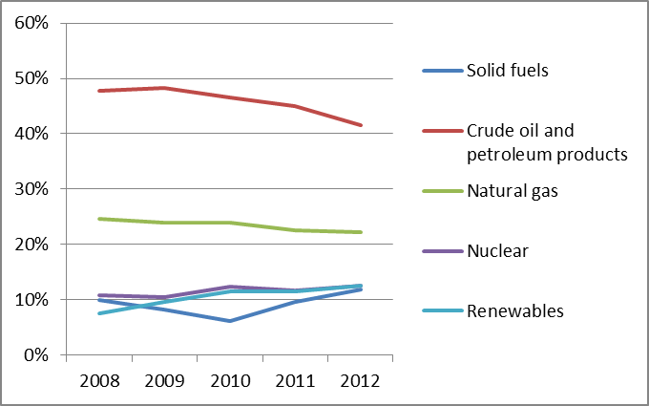
Figure 2: Gross electricity generation mix 2008 – 2011 (source: EU Energy in Figures – Pocketbook 2012 and 2013)
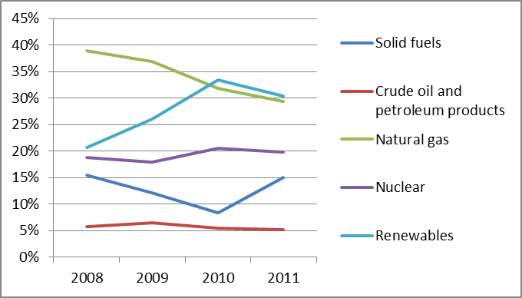

Regulatory framework

General
In December 2013, the Spanish Parliament passed a new electricity law. The law is part of an electricity market reform package which was announced in early 2013. It is mainly aimed at eliminating the tariff deficit by reducing regulated costs allocated to the system and increasing the revenue, e.g. from additional taxes. The new regulatory framework establishes that no new costs shall be introduced into the electric power system without an equivalent revenue increase or cost reduction.
The reform includes a new support scheme for existing and new renewable and CHP plants, changes in the remuneration of network activities and changes in final users’ tariffs. The changes in tariffs include a new regulated price for small customers and a new injection charge for those users with micro-generation plants, created to reflect unavoidable supply costs. The new measures have been objected to by energy producers (renewable and conventional), distribution system operators, consumer associations and political parties on different grounds. Most stakeholders complain that the reform unduly reduces their remuneration while increasing regulatory risks, and consumers criticise the increase in electricity charges.
Increased participation and transparency in the regulatory process could contribute to reduce opposition and regain the trust of stakeholders and consumers. Regulation in Spain could also benefit from greater harmonization with the rest of Europe in topics such as retail and renewable support.
A reform of the gas sector has also been announced. In particular, a new gas exchange is planned to start functioning by 1 January of 2015, in order to increase transparency for wholesale gas prices.
Spain could make use of the on-going reform to simplify the legislative framework applicable to the energy sector, to limit the number of legislative acts in force and to reduce the recourse to urgent measures, for the sake of legal certainty of the market players.

National Energy Regulator

In October 2013, the role of the National Energy Regulator was attributed to a new agency, the National Authority for Markets and Competition (Comisión Nacional de los Mercados y la Competencia, CNMC). The CNMC is the result of a merger of the previous antitrust authority with six regulatory agencies (responsible for telecom and audiovisual, electricity and natural gas markets, postal sector, airport and certain aspects of the railway sector).

The CNMC is a public law entity with its own legal personality and full public and private capacity.

The current annual budget of CNMC to carry out all of its tasks – not just energy – amounts to 52.8 million Euros and the number of staff is 519 people. It is important that CNMC retains adequate human and financial resources and that it can exercise its powers and tasks under the Third energy package effectively and independently, especially on tariff setting.

Unbundling
Currently, the entire electricity transmission network is owned and operated by Red Eléctrica de España (REE), a certified TSO. REE is independent of other companies in the sector. Enagas Transporte, S.A.U. was certified as an ownership unbundled TSO for its own network (more than 95% of gas transport pipelines) and as ISO for other companies' pipelines. The electricity and gas DSOs are legally and functionally unbundled.

Wholesale markets

Electricity
Electricity production in Spain fell in 2013 to 274 TWh – after a small recovery in the previous year – driven by the continued fall in electricity consumption and a reduction in electricity exports (which were 37.9% lower than in 2012). Production from gas fuelled CCGTs saw the biggest reduction, while production by renewable power plants increased.
In 2014, the Iberian day-ahead market, OMIE, was coupled with the Central and Northern European markets, as part of a Europe-wide market coupling process. OMIE has been the market operator for both Spain and Portugal since mid-2007. The coupling process will allow infrastructure between Spain and France to be used more efficiently, although the interconnection is already used at nearly full capacity. Conversely, congestion in the Spain-Portugal interconnection has continued decreasing in 2013, partly due to the increase in the interconnection capacity. The next step will be to focus on integrating the intraday market with the rest of Europe, which is especially relevant in terms of facilitating renewable energy integration.
Also in 2014, on March the 25th, the first joint auction of electricity interconnection capacity between Spain and Portugal took place, under a mechanism based on financial transmission rights (FTR) established in the MIBEL Council of Regulators (CR MIBEL). This auction constitutes the first European capacity allocation mechanism based on financial transmission rights (FTR).
Market concentration, which had been falling for a number of years with the increase in smaller renewable energy generating companies, has remained stable in recent years. The largest generation company in Spain in 2012 accounted for a 23.8% of the total energy sold and there were five other companies that generated more than 5%.
After a short-lived reduction in 2012, forward trading in the Spanish market recovered its growth trend. The trading volume in the period up to March 2014 (109.85 TWh) increased 42.2% compared to the same period in 2013. Furthermore, the OTC volumes cleared and settled by the Portuguese and Spanish clearing houses (i.e. OMIP clearing house (OMIClear) and by BME Clearing) measured 71.84 TWh, increasing significantly (+95.1%) in year 2013 compared to year 2012 (36.82 TWh). OTC physical trading consistently accounts for around 30% of the final energy delivered in the daily schedule. Trading in the Spanish part of the day-ahead OMIE market recovered in 2013, to 185 TWh, but is still 17% below the 2008 figure. Intraday trading volumes also dropped in 2013 to 36 TWh after a sustained increase during the previous years. Balancing energy has also been falling, even after accounting for the decrease in energy traded.
The average price in the day-ahead market was EUR 44.26/MWh in 2013, falling from 47.23 in 2012 and 49.93 in 2011.

Gas
Spain imports most of the gas it consumes, since its gas production is minimal (392,599 GWh of imports in 2012 against 393 GWh of domestic production). Natural gas consumption decreased by 8% in 2013 because of the reduction of the use of gas in power generation due to the favourable coal prices and the increase of generation by renewable sources. By contrast, industry and household demand for gas in 2013 remained constant, at 2012 level.
There are three main supplier countries: Algeria (42.4%), Nigeria (15.4%) and Qatar (11.6%), and up to eighteen companies injecting gas in the system (in 2012). In fact, Spain has one of the highest levels of gas supplier diversification in Europe. In 2012, most imports were still in the form of LNG (60.6% of the total). In 2012, Spain was the only major market in Europe which imported less gas through pipelines than through LNG terminals. However, LNG imports are decreasing (e.g. by 23% in the first quarter of 2013 compared to 2012), and in 2013 imports through pipelines surpassed LNG, due to a drop in demand, high LNG prices and the newly commissioned interconnection with Algeria. In the last few years, Spain has been re-exporting LNG.
Gas is traded bilaterally, mostly through OTC contracts. At present there are two different initiatives competing to become a Spanish gas hub. In March 2014 the two initiatives signed a MOU that may result in a merge of both projects. To date, trading can take place at eight balancing points (six LNG terminals as well as the virtual balancing point and the virtual storage point). 78.2% of trades occurred in the LNG terminals. In addition to OTC trading, the gas wholesale market is comprised of auctions at different horizons for regulated activities (for the Last Resort supply and working and cushion gas). These auctions are run by OMIE, the electricity market operator.
Due to the absence of an organised gas hub, there is no single liquid transparent gas reference price in Spain. CNMC has developed a gas import index price, reflecting the cost of long term contracts supplying the Spanish gas market. This index shows that gas import prices nearly doubled between July 2009 and December 2012 (to EUR 27.10/MWh) linked to oil price developments. During 2013 the import price is in slight decline (to EUR 26.39/MWh in December 2013).
It would appear appropriate for CNMC to review the entry-exit regime in Spain with the aim to enhance cross-border trade and allocate system costs on a non-discriminatory basis.

Retail markets

Electricity
Since 2003, all electricity consumers are eligible to choose their electricity supplier. However, most are still supplied under regulated tariffs. Customers with contracted capacity below 10 kW have the right to be supplied under the regulated regime (93.8% of all customers). At the end of 2013, 60% of those customers were supplied under the regulated mechanism while in 2011 this share was 76%.
Competition in retail supply continues to rise, with a significant and steady increase in the switching rate (from 5.2% in 2009 to 12.1% in 2012). However, most competitors focus on the commercial and industrial segments. The largest retailer at the end of 2012 was Endesa with a 37% market share of the whole free market.
Despite the competitive market conditions, final customers’ prices have increased considerably in previous years. From 2008 to 2012, final electricity prices have increased by an average 9.9% per year for domestic customers and 3% for industrial customers. The increase for domestic customers is due to an increase in network costs and taxes (26% and 14.8% annual increase respectively). In 2012 network costs accounted for 54.0% of the price without taxes and 42.5% after taxes. For industrial electricity prices, the share of network costs was 19.0% of the final price.
Figure 3: Electricity price change by component 2008 – 2012 (source: Eurostat, energy statistics)
In July 2013, the Government rebalanced the two components in the electricity tariffs, a capacity component, per kW contracted, and an energy component, per kWh of energy consumed. The change aimed to make tariffs more cost-reflective and increased the average supply cost for customers with lower than average load factors, such as holiday homes.
Since 1 April 2014, the Spanish Government has put in place a new mechanism that links the retail market electricity price to the wholesale market price. This new mechanism seeks to remove the regulation of the commodity prices in electricity bills for householders in Spain established in 2009 and in place until now. Whilst this is expected to bring positive changes with regard to competition, it should be accompanied with intensive information campaigns addressed to consumers at large.

Gas
The market concentration level of the Spanish natural gas retail sector shows moderate concentration with a HHI of 2,250 in 2012. The three largest companies still cover almost 70% of the share of natural gas supply, but there are stronger signs of new entrants' activity.
The total number of gas consumers in December 2012 was 7.4 million, with gas demand of 362 TWh. By December 2012, 69.07% of customers were supplied at a free price, while 30.93% remained under the regulated last resort tariffs. Only small customers, consisting mostly of households are eligible for this tariff that the Government sets with reference to periodic gas auctions.
Figure 4: Natural gas price change by component 2008 – 2012 (source: EC, EPCR metadata)
Customers’ switching rate, 19.32% in 2012, stabilised around the 2011 value after the previous year’s increases. 80% of the switching rate occurred within the free market and less than 20% was due to a move from the last resort supplier to the free market.

Consumers
Spanish consumers rate the performance of their retail electricity market second lowest of all EU countries (58.5 points compared to 72.0) and the assessment has further decreased (by 1.4 points) since 2012. The market also ranks 4th lowest in the ranking of 31 domestic services markets. The scores on trust in providers and overall consumer satisfaction are second and third lowest in the EU respectively while the incidence of problems is second highest. The retail gas market is ranked third lowest in the EU (69.4 points compared to 74.1), with the 3rd lowest score for trust and highest incidence of consumer complaints to third parties. Both markets score below the EU average on all indicators, with the exception of switching in the electricity market (which is slightly above the EU average).
New measures have been introduced, including the Ministry taking over responsibility for information and complaint handling, although the CNMC remains in charge of other protective functions, such as operating web-based gas and electricity price comparison tools. Suppliers need to inform clients about their rights and establish a procedure in the case of complaints. Free customer information services must be made available. Additionally, a new law adopted on 27 March 2014 has introduced new measures in switching for gas and electricity, setting up clear procedures when desisting from a switching request and procedures in case of non-requested switches.
Spain maintains public service obligations through Last Resort Suppliers. Customers whose retailers fail are supplied under the last resort tariffs until they sign a new contract. The concept of vulnerable costumers has only been defined so far for electricity customers. Vulnerable customers should fulfil at least one of the following criteria: a large family or a family where all members are unemployed; be low voltage consumers (less than 1 kV) with contracted demand lower than or equal to 3 kW; or a pensioner older than 60 years with a minimum level pension. Vulnerable customers’ electricity tariffs are reduced by means of a “social bonus”, which sets their tariffs at the July 2009 level. As of December 2012, 2,544,170 customers were defined as vulnerable.

Infrastructure
The Spanish authorities should ensure a proper and timely adoption of the measures stemming from the TEN-E Regulation, including the establishment of the one-stop-shop for Projects of Common Interest (PCIs) (due by 16 November 2013), and other measures foreseen for 2014 and 2015, including the publication of the manual on the permit granting process for project promoters, and the adoption of legislative and non-legislative measures streamlining the environmental assessment procedures.

Electricity
The reduction in electricity demand has delayed the need for new infrastructure and led to adjustments in the remuneration of networks. Conventional generation capacity has been reduced by 1,600 MW since 2010 due to the closure of some old coal, fuel-oil and diesel plants. However, renewable capacity commissioned in 2013 has decreased, following Government measures to freeze subsidy costs, although at lower rates than in previous years. In mainland Spain, 540 MW of new capacity was installed in 2013 against 2,860 in 2012.
Reinforcements to the transmission network have added 747 km of new line to the grid (1.9% of the total network length), down from 860 km in 2012. Despite these reinforcements, there has been an increase in transmission constraints in recent years, potentially due to intermittent generation.
In the context of the TEN-E Regulation, Spain has 5 Projects of Common Interest (PCI) that will help to increase interconnection level with Portugal and France and will contribute to integrate RES into the grid. However, the 10% Barcelona target will not be reached by 2020 with the selected PCIs.

Gas
Spain has six LNG terminals and a seventh regasification plant in Gijon was completed in 2012. The new plant is not in operation at the current time as the stagnated level of demand does not justify it. Spain has interconnection pipeline connections with Morocco, Portugal, France and a direct connection with Algeria. The transmission capacity with France was upgraded in 2013 providing reverse flow interconnection at Larrau which reinforced the North-South interconnections. There are four underground storage facilities covering 9.1% of the demand. An underground storage project expected to enter into operation in 2013 has been delayed after gas injection works led to intense local earthquakes. The project would have increased the underground storage capacity to around 14% of the demand. Forthcoming planned investments in gas infrastructure were revised and delayed (excluding international commitments) because of lower than expected demand.
In the context of the TEN-E Regulation, Spain has one PCI that will help increase interconnection level with France.

Security of Supply

Electricity
Spain has a comfortable generation capacity margin, due to earlier strong investments in CCGT and renewable plants and the reduction in electricity demand. No significant new capacity will be required in the coming years.
The steady increase in interconnection capacity with Portugal and France is helping Spain to manage the integration of high volumes of renewable energy. In August 2012, the Balearic Islands electricity system was connected to the Mainland system, enhancing the security of supply in the islands. However, new investments in transmission may still be required to provide better integration for those areas facing frequent congestions.

Gas
Spain has managed its dependency on imported gas by increasing the capacity of LNG terminals and diversifying its gas suppliers. In addition, it requires shippers to maintain a certain volume of stored natural gas at the beginning of the winter season.

Key indicators
Electricity |  | Gas
Number of companies representing at least 95% of net power generation | >15 | Number of entities bringing natural gas into the country | 18
Number of main power-generation companies | 5 | Number of main gas entities | 4
Market share of the largest power-generation company | 23.8% | Market share of the largest entity bringing natural gas | 48%
Number of electricity retailers | 225 | Number of retailers selling natural gas to final customers | 14
Number of main electricity retailers | 4 | Number of main natural gas retailers | 6
Switching rates (entire electricity retail market) | 12.07% | Switching rates for gas (entire retail market) | 19.32%
Regulated prices for households – electricity | Yes | Regulated prices for households – gas | Yes
Regulated prices for non-households – electricity | Yes | Regulated prices for non-households – gas | No
HHI in power-generation market | 1,329 | HHI in gas supply market | 2,399
HHI in electricity retail market | 2,240 | HHI in gas retail market | 2,264
Electricity market value (bn€) | 27.199 | Gas market value¹⁰ (bn€) | 7.414
Installed generation capacity (MW, 2011) | 102,804 | HHI for gas imports | 2,710
Peak demand (MW) | 43,527 | HHI for retail market (household/industry/electricity generation) | 2,250
Numbers of smart meters installed | 7,910,569 | HHI for households (excluding industry and electricity generation) | 3,800

Sweden

Key issues
The Swedish electricity market is integrated in the Nordic market and works well. However, congestion management and transparency provisions for cross-border exchanges give rise to some concerns. The Swedish TSO, Svenska Kraftnät, has intensified the investments in the grid to further develop the market and prepare for an increased share of renewable electricity.
Since 2009, the Swedish DSOs are obliged to provide monthly meter readings to households and hourly readings to industrial customers. This has resulted in a full roll-out of smart meters.
Diversifying gas supply sources would encourage more competition and improve Sweden’s energy security. Several new LNG-stations are therefore planned in Sweden including one of strategic importance for the Baltic market.
- General overview
In 2012, the total energy consumption reached 49.8 Mtoe and was satisfied mostly by solid fuels, nuclear, and oil products. Sweden’s target for 2020 is to have 49% of renewables in gross final energy consumption. The country has already achieved its national 2020 RES target as the renewables share improved from 42.4% in 2006 to 51.0% in 2012; this calls for a higher goal for 2020.
Figure 1: Gross inland consumption mix 2008 – 2012 (source: Eurostat)
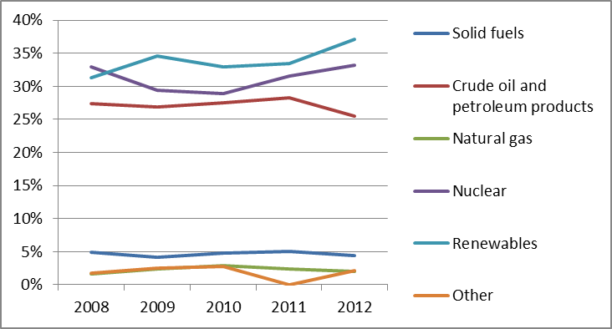
The power generation mix in 2011 (166.6 TWh) was dominated by renewable and nuclear sources. The share of cogeneration in electricity production was 10% in 2011, showing a significant increase compared to the level of 6.7% in 2005.
Figure 2: Gross electricity generation mix 2008 – 2011 (source: EU Energy in Figures – Pocketbook 2012 and 2013)
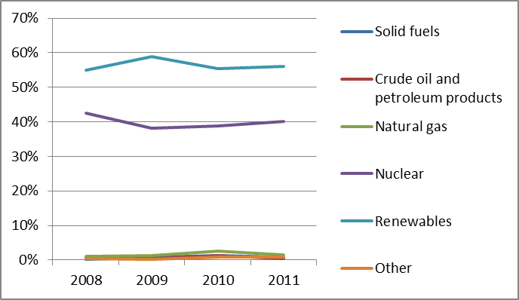
- Regulatory framework

National Energy Regulator
The Swedish regulator, Energy Market Inspectorate (Ei), has been in operation since 2008, employing 100 staff with an annual budget of around EUR 11 million. Despite being an agency administratively attached to the Ministry of Enterprise, Energy and Communication, it is an independent regulatory authority.

Unbundling
Svenska Kraftnät is the Transmission System Operator (TSO) for electricity, and Swedegas for gas. Both TSOs have been certified under the ownership unbundling model. Baltic Cable has so far not been certified. EI should cooperate with the Germany regulator Bundesnetzagentur to ensure compliance of this cable with the unbundling requirements. In electricity, 171 Distribution System Operators (DSO) are functionally unbundled, and in gas, five.
- Wholesale markets

Electricity
The Swedish wholesale power market is part of the integrated Nordic power market. In 2012, electricity production was dominated by three companies, Vattenfall, Fortum and E.ON, together controlling 79% of the generation. However, due to the connection with Nord Pool, the actual number of players active on the wholesale market is higher. The three incumbents have joint ownership of nuclear power plants, and the Swedish Competition Authority is concerned by the inherent risk of information being shared between sites, diminishing confidence in a functioning market. This problem has been addressed by the energy regulator, which forced the owners of nuclear power stations to agree on common ethical rules. However, the risks arising from links among major competing producers still remain and the Authority should continue to monitor the situation, intervening when necessary. Nord Pool Spot is the common Nordic market place with which the Swedish wholesale power market is integrated and where three-quarters of Nordic electricity is traded. New market coupling interconnections between the Continent and Nordic countries (Baltic Cable and SwePol Link) are likely to increase continental influence on the Nord Pool system price. This is seen as the first step towards Europe widemarket integration. The average wholesale price on Nord Pool Spot’s day ahead bidding market in four Sweden’s bidding areas in 2012 was around EUR 32.5/MWh. In terms of liquidity, volumes traded on Nord Pool Spot are the highest on European power exchanges. Swedish volumes reached 131 TWh, 94% of national electricity consumption.

Gas
Sweden does not produce natural gas. In 2012, it imported all of its requirements, about 1.5 bcm, through the pipeline from Denmark. Sweden has around 37,000 end-users, of whom approximately 3600 are business customers and the remainder domestic. At wholesale level, two operators are active, E.ON Sverige and Dong Energy. There is no wholesale market hub as all gas is imported. To gain access to the Swedish market, a supplier needs to acquire transmission capacity on the Danish interconnector. There is currently no congestion on the grid, either nationally or in the import link from Denmark.
- Retail markets

Electricity
The same three incumbents, Vattenfall, Fortum and E.ON, in the wholesale market hold 42% of the retail market. Unlike the wholesale power market the retail market is national in scope. In 2012, there were 121 retail electricity suppliers, though smaller players have occasionally found it difficult to enter the market. Switching of suppliers is relatively high. Around 10% of domestic customers switched their electricity supplier in 2012 and a further 27% re-negotiated their contract with their current supplier. Thus, 37% of domestic customers took an active part in the retail market during 2012. The wholesale price had a significant influence on the retail price, neither one being regulated.
Figure 3: Electricity price change by component 2008 – 2013 (source: Eurostat, energy statistics)
By 2009, Swedish DSOs were obliged to provide monthly meter readings to household customers and hourly readings to commercial and industrial customers. This resulted in practically a full roll-out of smart meters, enabling remote readings. However, some meters are not suitable for hourly readings without additional investment, preventing demand response services. Since October 2012, DSOs are obliged to provide hourly meter readings to households requesting them.

Gas
In 2012, there were six natural gas suppliers. The three largest companies, E.ON, Dong Energy and Goteborg Energi, held around 85% of the market. The Swedish gas retail market consists of around 33,400 domestic customers in South-Western Sweden. It has been a free market since 2007. During 2012, 157 of these households switched suppliers, 44% fewer than in the previous year, and about 0.5% of domestic customers. This may be due to the small size of the gas market, which does not incentivise competition. End-user prices are not regulated. Gas prices for final consumers moved in line with global gas and oil prices. Both households and industry pay high taxes, amounting to almost half the retail price.
Figure 4: Natural gas price change by component 2008 – 2012 (source: EC, EPCR metadata)
- Consumers
Consumers’ overall assessment of retail electricity market is slightly above the EU average (73.5 points compared to 72.0, corresponding to 14th place EU-wide), and equal to the average of 31 domestic services markets (18th place). The market has seen a considerable increase in score (7.4 points) since 2012 (which represents the highest and 4th highest increase domestically and EU-wide, respectively). The choice of providers records the highest EU score and switching rates are well above the average; yet the comparability of offers is assessed as poor. The incidence of problems reported in the electricity retail market is lower than the EU average but those who encounter a problem are more likely to complain.
In 2008, Ei launched an online electricity price comparison site, which enables consumers to compare prices, terms, and conditions for all Swedish suppliers. For gas, there is no single price comparison site. Electricity and natural gas consumers may report disputes with companies to the National Board for Consumer Disputes (named Allmänna reklamationsnämnden, ARN). ARN is a public authority which adjudicates in disputes between customers and companies. Since 2011, there is a definition of vulnerable consumers within the national legislation. This category of consumer is protected in the Swedish electricity and gas markets by social legislation in that the consumer has the right to receive assistance with their payment of electricity and natural gas supplies.
- Infrastructure

The Swedish Energy Markets Inspectorate has been designated as National Competent Authority responsible for facilitating and coordinating the permit granting process for projects of common interest in accordance with the provisions of the TEN-E Regulation ('one-stop shop').

Electricity
Sweden is divided into four different bidding areas. Most of the electricity production occurs in the two northern areas and most of the consumption is concentrated to the south. At times, this creates congestion within the national grid. Sweden is interconnected to Norway and eastern Denmark through AC lines and to Finland, Denmark, Germany and Poland through undersea DC cables. Svenska Kraftnät, the Swedish TSO, has an extensive plan to develop the national grid to ensure network stability and increase the capacity while increasing the amount of variable energy on the grid. This is part of the Third Energy Package. Currently, work is progressing on the Nordbalt01 project, which has received funding under the EEPR and will interconnect Sweden and Lithuania through a HVDC submarine cable. Maintaining the grid transfer capacity and ensuring the n-1 criterion for operation of the interconnection are being addressed through the construction of the new OHL between Ekhyddan and Nybro/Hemsjö on the Swedish territory (PCI 4.4.2).

Gas
Several new LNG terminals are planned, including one in Gothenburg labeled as a PCI (8.6) and planned to be commissioned in 2015 - which is of strategic importance for the Baltic energy market and would contribute to increased security of supply and flexibility for the Swedish market.
- Security of supply

Electricity
Sweden is working to ensure the power of supply both in short and long terms. Svenska Kraftnät is responsible for balancing the grid and ensuring the delivery of electricity to the customers. Local distributors are responsible for maintaining their networks to ensure that the connections between each network meet the required quality standards.
To ensure the security of supply in the longer term, Sweden is investing heavily in wind power generation. Wind power is one way of shifting the production areas to the southern parts of Sweden where the consumption is high and decreasing the congestion on the grid. Sweden introduced strategic capacity reserves in 2003 to meet peaks in demand during winter. The mechanism will be gradually reduced until 2020 when the energy only market is expected to be restored.

Gas
Since Sweden has no national production of natural gas, it is completely dependent on import. Interconnected only to Denmark, Sweden is vulnerable to gas supply disruption. One possible route for diversification was investigated through the Skanled pipeline running from Norway, but there are currently no plans to implement this pipeline. Sweden is currently exempted from the N-1 obligation set out by Regulation 994/2010 concerning measures to safeguard security of gas supply. Sweden has no significant storage facilities, and relies on storage, mainly in Denmark, to balance seasonal swings in demand.
In 2012, Ei published a National Preventative Action Plan and a National Emergency Plan, in accordance with the requirements of regulation 994/2010 on the security of natural gas. The plans include market based methods to minimise the possible negative effects on several scales and divides the responsibility for meeting the natural gas demand.
- Key indicators
Electricity |  | Gas
Number of companies representing at least 95% of net power generation | 74 | Number of entities bringing natural gas into country | 1
Number of main power-generation companies | 3 | Number of main gas entities | 1
Market share of the largest power-generation company | 44% | Market share of the largest entity bringing natural gas | 100%
Number of electricity retailers | 120 | Number of retailers selling natural gas to final customers | 7
Number of main electricity retailers | 3 | Number of main natural gas retailers | N/A
Switching rates (entire electricity retail market) | 9.9% | Switching rates for gas (entire retail market) | 1.4%
Regulated prices for households – electricity | No | Regulated prices for households – gas | No
Regulated prices for non-households – electricity | No | Regulated prices for non-households – gas | No
HHI in power-generation market | ~2,650 | HHI in gas supply market | ~5,000
HHI in electricity retail market | N/A | HHI in gas retail market | N/A
Electricity market value (bn€) | 13.349 | Gas market value¹⁷ (bn€) | 0.456
Installed generation capacity (MW) | 37,353
Peak demand (MW) | 26,200
Number of smart meters installed | 100%

The Netherlands

Key issues
For electricity, at the current pace of development, the Netherlands seems likely to miss its 2020 target for renewables. Implementing the recently established national Energy Agreement for Sustainable Growth ('Energieakkoord') should speed up the development. The problem of insufficient interconnection is seen when the price drops in Germany because of high renewables production, but the price in the Netherlands does not respond.
The increase in earthquake activity has renewed concerns about the decline in Dutch gas production. Following the recent decision to decrease production by 2016, the Netherlands needs now to determine its gas production policy from 2017 onwards.

General overview
Energy consumption in 2012 (82.0 Mtoe) was based mainly on fossil fuels, notably natural gas, crude oil and petroleum products, and to a lesser extent solid fuels. Renewable energy and nuclear energy were less important in the energy mix (with shares of 4.3% and 1.2%, respectively).
Figure 1: Gross inland consumption mix 2008 – 2012 (source: Eurostat)
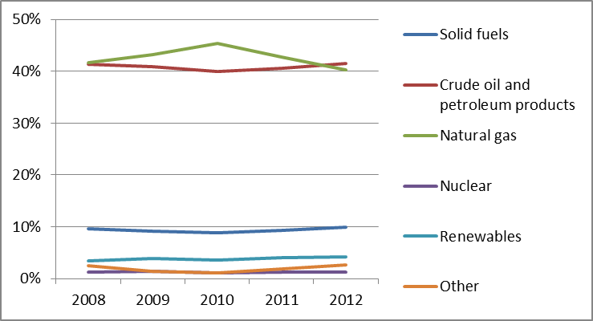
The power generation mix in 2011 (113.0 TWh) was dominated by gas-fired power generation (with a share of 63.5%) and by solid fuels (18.9%); renewables represented 10.9% and other sources such as nuclear power (3.6%) were less important.

Figure 2: Gross electricity generation mix 2008 – 2011 (source: EU Energy in Figures – Pocketbook 2012 and 2013)
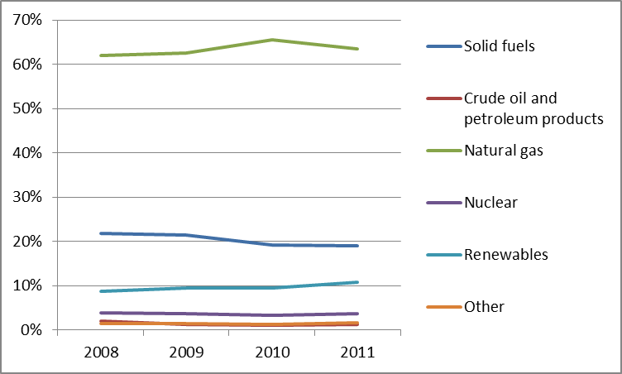
The Netherland’s 2020 renewables target is 14%, which is lower than the EU average (20%). The renewable share in gross final energy consumption grew slowly from 3.4% to 4.5% between 2008 and 2012. At this pace, the 2020 target will not be reached.
Cogeneration provided for 32.5% of the total electricity generation in 2011, and it has been at a comparable level for several years. In 2012 electricity demand in the Netherlands decreased by 1.5% in comparison to the 2011 level, this decline can be attributable to the economic recession.
- Regulatory framework

General
In September 2013 more than forty social organisations, including central, regional and local government, employers and unions, nature conservation and environmental organisations, and other civil-society organisations and financial institutions – have endorsed the Energy Agreement for Sustainable Growth. The parties to the Energy Agreement aim to achieve a saving in final energy consumption averaging 1.5% annually, and an increase in the proportion of energy generated from renewable sources to 14% in 2020, in accordance with EU arrangements (and a further increase in that proportion to 16% in 2023). It also involves the shutting down by 2016-2017 of the 5 oldest coal fired power plants from the 1980s. Beyond 2020, the Energy Agreement includes the long-term goal of an 80 to 95% reduction on greenhouse gases for the whole economy.

National Energy Regulator
The Dutch Office of Energy Regulation is part of the Netherlands Authority for Consumers & Markets (ACM). ACM was established on 1 April 2013, and is the new market authority created through the consolidation of the Netherlands Consumer Authority (CA), the Netherlands Independent Post and Telecommunication Authority (OPTA) and the Netherlands Competition Authority (NMa). In 2012, the Dutch Office of Energy Regulation employed approximately 88.5 staff and had an annual budget of EUR 8.2 million.

Unbundling
TenneT is the national TSO for the transmission of electricity and Gas Transport Services (GTS) is the TSO for gas. Both are fully owned by the Dutch state. It was announced in October 2013 that privatisation will not be considered for the time being, however the government encourages both TSOs to seek closer cooperation with certified TSOs abroad, which is a commendable approach from an internal market perspective. In December 2013, ACM certified both TSOs under the ownership unbundling model. The TSOs operating the interconnectors BritNed and BBL will also be certified. BBL was certified in August 2013 and the draft decision for BritNed, was received by the Commission in March 2014. Both interconnectors have been granted an exemption for new interconnectors.
Since the end of 2010, all but two DSOs are fully ownership unbundled from the integrated company and are mostly owned by Dutch municipalities and provinces. There are eight DSOs that distribute both gas and electricity and one that distributes gas only. Due to a court decision, part of the law on ownership unbundling of DSOs expired, which led the final two integrated companies to delay unbundling. The Ministry of Economic Affairs appealed to the Supreme Court of the Netherlands and a decision is pending. Following a request for a preliminary ruling the European Court of Justice ruled in October 2013 that the Netherlands could adopt stricter DSO unbundling measures (comparing to the Third package requirements) that constitute restrictions on the free movement of capital if such measures are justified by overriding reasons in the public interest (such as undistorted competition). The Court said it was up to the Dutch Supreme Court to decide if the government's measures passed that test taking into account the criteria that the restrictions at issue need to be appropriate to the objectives pursued and do not go beyond what is necessary to attain those objectives.
- Wholesale markets

Electricity
The Dutch power generation market is moderately concentrated. Following several successful market coupling projects in North-Western Europe, with years of increasing price convergence, 2012 and 2013 saw a decline. Increasing shares of low marginal cost renewables in Germany have led to an increase in exports to the Netherlands up to the point where the cross-border capacity between the Netherlands and Germany is no longer sufficient to absorb the price difference. Hence, the price convergence in 2012 with Germany declined to 55%, coming from 88% in 2011. In 2012, the two interconnectors BritNed (with the UK) and NorNed (with Norway) successfully implemented new allocation methods for intraday trading.
In 2013, the annual average of wholesale day-ahead power prices on the APX market was EUR 52/MWh, up from EUR 48/MWh in 2012. The annual traded volume of wholesale day-ahead power in 2013 was 47 TWh.

Gas
The production and wholesale gas markets in the Netherlands are highly concentrated due to the exploitation of the large Groningen field by a single producer, the Nederlandse Aardolie Maatschappij (NAM). The gas is produced by NAM is sold exclusively on the wholesale market by the trading company GasTerra. In 2012, the average day ahead gas price at the virtual trading point (the TTF hub) oscillated around EUR 20/MWh in spring and summer months and EUR 23/MWh in autumn and winter. The 2012 average price has been unprecedentedly convergent with average prices on the other major West European hubs. The traded volume of day-ahead gas on the TTF hub increased steeply to 1,818 TWh in 2012.
The Netherlands is the biggest natural gas producer in the EU. According to Eurostat data, the country accounted for 43.2% of EU-28 gas production in 2012. The country’s annual production was 57.4 Mtoe in 2012, down from 57.7 Mtoe in 2011. Dutch gas production is forecasted to decline significantly by 2020. In addition to this long term development, the government also decided in January 2014 to decrease production in the short term due to the increase of earthquakes in the province of Groningen. Through to 2016 production will be reduced by about 10 Mtoe a year from recent production levels. How production will develop from 2017 onwards will be determined over the next couple of years.
Following a decision by ACM in December 2013, European rules on capacity allocation and congestion management were implemented by 1 January 2014. This takes into account rules on auctioning capacity at interconnection points, the surrender of booked capacity, and capacity increase by means of an oversubscription and buy-back arrangement.
A higher utilisation of the cross-border capacity with Germany and Belgium can therefore be expected in 2014 compared to previous years.
- Retail markets

Electricity
Market concentration at retail level was high, as the three largest companies covered 83% of the retail market at the end of 2012, while the HHI index was 2,338. For both indices this implies a slight decrease compared to 2011.
Figure 3: Electricity price change by component 2008 – 2013 (source: Eurostat, energy statistics)
In 2012, 12.6% of small-scale electricity users switched supplier. This implies an increase compared to previous years and contributes to the trend of increasing annual switching rates over time.
In 2013 the two year small-scale roll-out programme for smart meters came to an end. This programme resulted in 458,182 smart meters being installed by July 2013. Following a positive cost-benefit analysis, the Netherlands are proceeding with the large deployment of smart metering – the expected diffusion rate for electricity is 100% of consumers for electricity and 80% of consumers for gas by 2020. The Netherlands have launched pilot programmes since 2012 and have mandated a large-scale smart metering roll-out to start in 2015 (exact timetable to be confirmed). Relevant legislation for smart metering is pending Parliamentary approval.

Gas
Even though the market is fully liberalised in the Netherlands, market concentration at retail level remains high, as the three largest companies covered 81% of the retail market and the HHI index was 2,258 at the end of 2012.
Figure 4: Natural gas price change by component 2008 – 2012 (source: EC, EPCR metadata)
The number of small-scale gas users that switched supplier in 2012 (12.3%) increased compared to previous years, as a part of a trend of increasing annual switching rates over time.
- Consumers
Dutch consumers rate their electricity and gas retail markets above the EU average (76.3 and 75.8 points compared to 72.0 and 74.1), which corresponds to 9th and 10th place EU-wide, respectively. The assessment of the two markets is also slightly above the average of 31 domestic services markets (13th and 15th respectively). Both markets rank well above average on choice (2nd and 1st highest score in the EU, respectively), switching rates (2nd and 3rd highest) and overall consumer satisfaction. Around 19% of electricity and gas consumers have switched their provider or tariff with existing provider in the past 12 months, almost double the EU average. Especially in the gas market, consumers face fewer problems than the EU28 average; yet virtually all who experienced a problem have complained about it to at least one party (highest percentage in the EU).
Online price comparison tools for electricity and gas are available and operated by private companies. ACM regularly monitors these tools and publishes the results on the website of the national point of contact, Consuwijzer. Consumers can direct requests for information and complaints to Consuwijzer, run by ACM. ACM also handles complaints. Vulnerable consumers – defined by law as consumers for whom being disconnected from electricity or gas would have very serious health consequences – can never be disconnected. A ‘no-disconnection period’ running from 1 October to 1 April also applies to all households. Low-income households benefit from social support schemes.
- Infrastructure
The Dutch authorities should ensure a proper and timely adoption of the measures stemming from Regulation 347/2013 on the trans-European energy infrastructure, including the establishment of the one-stop-shop for PCIs (due by 16 November 2013), and other measures foreseen for 2014 and 2015, including the publication of the manual on the permit granting process for project promoters, and the adoption of legislative and non-legislative measures streamlining the environmental assessment procedures.

Electricity
To accommodate the rise in generation capacity since 2008 (and to reduce the need for congestion management and keeping re-dispatching costs down) the 380 kV grid needs to be expanded. Expansion of the 380 kV grid in the West of the Netherlands (‘Randstad 380 kV project’) has been under development since 2002. The South ring was completed in September 2013 and the North ring is expected to be completed in 2018. Further expansion of the 380 kV grid is under construction in the North of the Netherlands (‘North-West 380 kV project’, PCI project) and planned for in the South of the Netherlands (‘South-West 380 kV project’).
As a result of previous investments and improved coordination, an additional 300 MW of interconnection capacity became available between Belgium and the Netherlands in 2012/2013. The fourth AC interconnector with Germany is planned for 2016 and will increase interconnection capacity by 1.5 GW.
Energy infrastructure investments that are judged to be of national importance are being coordinated by the Minister of Economic Affairs according to the ‘Rijkscoördinatieregeling’ regulation. Decisions on permits and exemptions are taken simultaneously in coordination between national and local governments.

Gas
The most recent “Open Season” organised by GTS in 2012, showed that no expansion investments are required to accommodate demand for transportation capacity. This experience is consistent with the converging wholesale prices observed at the Northwest European hubs and the low congestion levels.
The seasonal storage system that is being developed by TAQA is due to become operational in 2014. Seasonal storage can deliver the flexibility to meet the seasonal residential gas demand. In December 2013, ACM introduced specific entry and exit tariffs for gas storages to be applicable from January 2014 onwards. One Project of Common Interest has been identified in the gas sector.
- Security of supply

Electricity
The Dutch market has surplus available (firm) production capacity. This surplus is expected to increase to 11.7 GW in 2020. Generation adequacy therefore seems guaranteed for the coming years.

Gas
The Dutch government is preparing itself for when more imports will be necessary with a strategy to become Europe’s ‘gas roundabout’, and diversify supply sources (LNG, countries of origin). As mentioned, production from the Groningen field will be reduced but will still meet the peak demand of low-calorific gas in the Netherlands, Germany, Belgium and France.
Dutch legislation prescribes that GTS is responsible for reserving sufficient transport capacity and gas for the additional demand of gas during days with a temperature below minus 9 degrees Celsius.
- Key indicators
Electricity |  | Gas
Number of companies representing at least 95% of net power generation | 800 | Number of entities bringing natural gas into country | N/A
Number of main power-generation companies | 4 | Number of main gas entities | N/A
Market share of the largest power-generation company | N/A | Market share of the largest entity bringing natural gas | N/A
Number of electricity retailers | 35 | Number of retailers selling natural gas to final customers | 32
Number of main electricity retailers | 3 | Number of main natural gas retailers | 3
Switching rates (entire electricity retail market) | 12.6% | Switching rates for gas (entire retail market) | 12.3%
Regulated prices for households – electricity | No | Regulated prices for households – gas | No
Regulated prices for non-households – electricity | No | Regulated prices for non-households – gas | No
HHI in power-generation market | 1,492 | HHI in gas supply market | 6,455
HHI in electricity retail market | 2,338 | HHI in gas retail market | 2,258
Electricity market value (bn€) | 8.706 | Gas market value¹⁵ (bn€) | 9.474
Installed generation capacity (MW, 2011) | 28,049
Peak demand (MW) | 18,438
Number of smart meters installed (July 2013) | 458,182

The United Kingdom

Key issues
Further investment in the UK electricity network infrastructure and generation is needed for delivery of 2020 targets. In particular, greater interconnection is needed.
Successive legislative and regulatory changes are increasing the complexity of the UK market, and may be of concern given the level of investment required. There is a need to ensure that the interventions are in line with Internal Market and State Aid rules and support the integration into the wider internal energy market. Existing and future support schemes should provide a stable framework for investments whilst keeping costs of the energy transition towards a decarbonised electricity generation to a minimum.
Consumer confidence in the sector is relatively low. Further action is needed to address wholesale and retail price formation and transparency. The UK should also ensure both wholesale and retail markets are open to new entrants by removing barriers to entry. Another key issue is to ensure that support for fuel-poor and other vulnerable consumers is appropriately targeted.

General overview
Energy consumption in 2012 (202.3 Mtoe) was largely based on fossil fuels and to a lesser extent on nuclear energy. Renewable energy sources were less important in the overall energy mix than in other Member States (4.1%). The UK’s 2020 renewable target is 15%, lower than the EU average. Final consumption of electricity in 2012 was broadly unchanged on 2011. The power generation mix in 2011 (363.8 TWh) remained dominated by gas-fired power generation (with a share of 40.2%) and solid fuels (29.5%). The renewable share of generation in 2012 increased to 10.1%.
Figure 1: Gross inland consumption mix 2008 – 2012 (source: Eurostat)
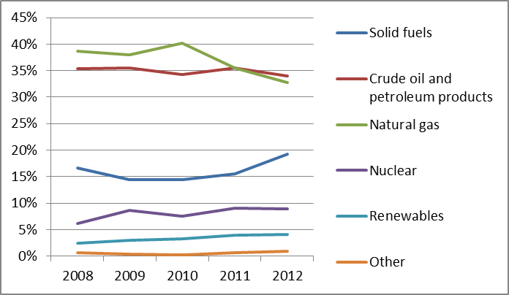

Figure 2: Gross electricity generation mix 2008 – 2011 (source: EU Energy in Figures – Pocketbook 2012 and 2013)
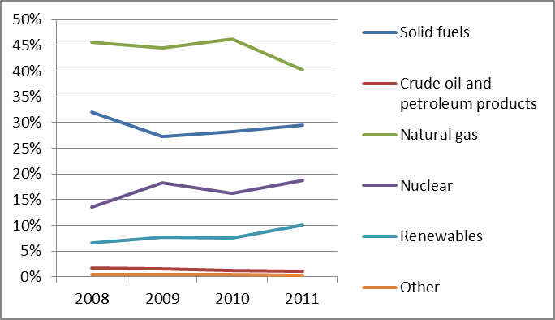
In December 2013 the UK adopted the Energy Act as part of the Electricity Market Reform (EMR) programme. The key elements include support for low carbon generation through Contracts for Difference – a form of feed in premium - , an Emissions Performance Standard set at 450g CO₂/kWh –preventing new unabated coal plants and a capacity market. The UK has also introduced a carbon price floor in addition to the existing EU Emission Trading System (ETS).
EMR is intended to deliver the first step of a transition towards a low carbon energy system by 2050. These reforms promote renewables and new nuclear through Contracts for Difference. The expected changes to the energy mix mean that the running of thermal plant would change, so a capacity market is also planned to ensure enough investment for security of supply.
The Department of Energy and Climate Change (DECC) was positive that the UK had achieved its interim target for renewables by 2012. However, some within industry have criticised a lack of certainty caused by changes to support schemes, lack of clarity about the market framework, and delays in developing grid infrastructure. Recent publication of the proposed support level for renewable technologies has improved this situation.
On 27 March 2014 Ofgem proposed to refer the market to the UK Competition and Markets Authority (CMA) to investigate whether there are further barriers to effective competition.
- Regulatory framework

General
The Third Package Directives have been transposed into national law.

National Energy Regulator
The energy regulator in Great Britain is Ofgem. The Northern Irish utility regulator is UREGNI. Ofgem regulates prices for networks, but retail tariff regulation was phased out by 2002 following the introduction of retail competition. Ofgem employed 729 staff in 2012/13. The staff number and budget has increased in recent years as it has major projects and price reviews underway.

Unbundling
National Grid Electricity Transmission (NGET) owns the onshore electricity transmission network in England and Wales and has been certified as fully ownership unbundled. In Scotland there are two onshore transmission networks which are owned by Scottish Power Transmission Limited and Scottish Hydro Electric Transmission plc. The GB onshore and offshore transmission network is operated by NGET in its role as System Operator. The Scottish TSOs have been certified under Article 9(9) of the Electricity Directive, which allows alternative arrangements to the standard unbundling models in limited circumstances. To date, Ofgem has also certified nine Offshore Transmission Owners (OFTOs) and two preferred bidders, as ownership unbundled.
The high-pressure gas transmission network in Britain is owned and operated by National Grid Gas plc, which is certified as fully ownership unbundled.
Ofgem has certified: (i) the BritNed electricity interconnector on the ground of an exemption granted in accordance with Article 22 of Directive 2003/55/EC (“Second Package Exemption”); (ii) the IUK gas interconnector (until 3 March 2015 on the ground of being in a substantially similar position to someone benefiting from a Second Package Exemption and thereafter on the ground of full ownership unbundling provided that it demonstrates that it passes the ownership unbundling tests at that time);(iii) the BBL and SNIP gas interconnectors as fully ownership unbundled; and, (iv) the Moyle and IFA electricity interconnectors as fully ownership unbundled. The interconnector between Ireland and Britain operated by EirGrid, the Irish TSO, has not yet been certified.
In Northern Ireland, as in Scotland, Article 9(9) has been applied. The electricity grid is owned by Northern Ireland Electricity (NIE) and operated by the certified TSO, SONI, with the Irish TSO, Eirgrid, under the all Island Single Electricity Market. Bord Gáis Éireann and Mutual Energy own the gas-transmission assets in Northern Ireland and have been certified as TSOs. The sale of Phoenix Supply to Airtricity in June 2012 resulted in unbundling of the gas supply company from the gas distribution company (Phoenix Natural Gas) in the Greater Belfast area.
- Wholesale markets

Electricity
There are two main power exchanges in Great Britain: APX and N2EX. UK power futures exchange traded contracts are also available on the Intercontinental Exchange (ICE). In 2012, around 85% of power was OTC traded (down from 95% in 2011) and around 15% was exchange traded (up from 5%). The average day-ahead power price on the APX market was GBP 44.54 (EUR 53.89)/MWh in 2012. The England-France Interconnector (IFA) and BritNed interconnectors are participating in the North West European project on day-ahead market coupling and intraday trading.
The power generation market is moderately concentrated. Seven companies had market shares exceeding 5% and the largest three generated almost 45% of electricity consumed in 2012. In response to concerns about liquidity, Ofgem has introduced a new licence condition from 31 March 2014. This obliges six large vertically-integrated suppliers to post prices at which they will buy and sell a range of forward power products (a market making obligation). It also requires the eight largest generating companies to follow rules when trading with small independent suppliers.
Northern Ireland is part of the all-island Single Electricity Market (SEM) with Ireland. This is discussed in more detail in the separate report covering the Republic of Ireland.

Gas
UK natural gas production is decreasing, and in 2012 was down 14% on 2011 to 452 TWh. The majority of the UK’s supplies are now imported, either from Norway, Continental Interconnection or LNG terminals. The wholesale gas market includes both OTC and exchange based trading (ICE and ICE Endex). The National Balancing Point (NBP) is the virtual trading location for UK natural gas. It is the most liquid gas trading point in Europe, with a churn rate between 10 and 20. The number of parties trading at NBP is high with a total of 222 licensed shippers, of which between 110 and 120 are usually active on a daily basis. Market concentration in is low, with the largest market share of physical and traded activity below 8%.
- Retail markets

Electricity
The retail electricity market has been open to competition since the late 1990s. At the end of 2012, there were 12 domestic and 24 non-domestic suppliers active in the market. The domestic retail market is characterised by the existence of six large, vertically integrated suppliers (the ‘Big 6’), which accounted for approx. 95% of the market in 2013, a drop of 4% since 2011. These are British Gas (Centrica), E.ON UK, EDF Energy, RWE npower, Scottish and Southern Energy (SSE), and Scottish Power. All of the Big 6 suppliers have a market share of above 10 %. Market concentration at domestic retail level remained high with an HHI of 1,720. There were 12 small suppliers active in the market in 2012, with a combined market share of just 2%, up 1% from 2011.
Figure 3: Electricity price change by component 2008 – 2013 (source: Eurostat, energy statistics)

Gas
The British retail gas market is fully liberalised. At the end of 2012, 13 domestic and 30 non-domestic gas suppliers were active in the market. The so-called ‘Big 6’ suppliers supplied approx. 95% of the 22.3 million domestic consumers in 2013. British Gas (Centrica) is still the largest party active on the domestic market, with a market share of around 40%. Market concentration at the domestic retail level remained high with an HHI of 2,373 for smaller non-domestic customers; it was 2,189 and for larger non-domestic customers 1,153. British Gas remains the leading supplier, with a market share of 40%.
Figure 4: Natural gas price change by component 2008 – 2012 (source: EC, EPCR metadata)
The British government has decided to replace all of the nation’s 53 million gas and electricity meters with smart meters. Smart metering roll-out is at an early stage, with mass roll-out planned from 2015. In both gas and electricity markets the larger suppliers are operating 89,400 domestic smart meters (0.2%) as well as 520,000 in smaller non-domestic sites.
- Consumers

Switching and trust
Consumer overall assessment of retail electricity market is slightly below the EU average (69.3 points compared to 72.0, corresponding to 20th place EU-wide) and saw a considerable decrease (of 3 points) between 2012 and 2013. The market also ranks 3rd lowest among 31 domestic services markets. The assessment of the retail gas market is 4th lowest in the EU (70.5 points compared to 74.1) and 5th lowest among domestic services markets. The overall score has slightly decreased between 2012 and 2013, continuing the downward trend observed since 2010. Both markets have particularly poor scores on trust in providers and overall consumer satisfaction, and above-average number of consumer complaints. The electricity market has the third highest share of overall consumer complaints in the EU and the highest share of complaints to third parties. At the same time, both markets have above-average scores for choice of providers and actual switching. In the gas market, choice and actual switching rank second and fourth highest in the EU.
In 2012, 12% of electricity users switched supplier and 11% of gas users switched supplier. By European standards this is high. However the capacity of consumers to understand and choose the most appropriate tariff has been a concern. Ofgem found that more than three out of five consumers (62%) claimed they have never switched, meaning they are likely to be on standard tariffs with former incumbent suppliers and typically paying above the most competitive prices in the market. The true proportion of those who have ‘never switched’ is probably lower, but it does suggest that many consumers feel they are inactive in the market.
Also, many consumers have reported being confused by the number of tariffs on offer and their differing structures. As a result, new rules have been introduced to limit the number and complexity of tariffs offered by suppliers. Online price comparability tools for electricity and gas are available. Ofgem has a Confidence Code for switching services, which many have signed up to. A recent innovation has been “collective switching” (the first was organised by Which? and 38 Degrees in 2012).

Complaints and vulnerable customers
If complaints are unresolved after eight weeks, customers can seek redress through the Ombudsman, who has the power to make a financial award of up to GBP 10,000. Domestic consumers and micro businesses can go sooner if the company says it can do no more to resolve the complaint.
Ofgem has a Consumer Vulnerability Strategy and DECC reports on fuel poverty. There are a number of measures targeted at vulnerable customers through the benefits system and fuel payment. Measures include a universal fuel benefit for older people and low-cost energy-efficiency measures through suppliers for those in receipt of certain benefits. Vulnerable customers are protected from disconnection in winter. Planned funding for energy efficiency under the Energy Company Obligation has been scaled back as a result of complaints about the impact on bills.
There is a “priority services register” managed by network companies and suppliers, which ensures the needs of vulnerable customers are met in the event of power cuts and in other situations Awareness amongst consumers of these services is low, however, and Ofgem is reviewing how take-up of services can be improved.
- Infrastructure
The recent transmission price control (RIIO-T1) authorised around GBP 22 billion of investment in the gas and electricity transmission networks in Great Britain over the period 2013-2021. Ofgem approves large infrastructure investments as they arise throughout its 8-year period through Strategic Wider Works (electricity) and incremental capacity provisions (gas).

Electricity
Existing interconnection includes the 1,000 MW BritNed interconnector with the Netherlands, the 2,000 MW IFA interconnector with France, and the 500 MW Moyle interconnector with Northern Ireland. The completion of the 500 MW EirGrid East-West Interconnector in 2012 increased interconnection between Britain and neighbouring countries from 3.5 GW to 4 GW.
However, the interconnectivity level is still low. As a result, around 10 GW of potential new interconnection projects to 6 different markets have been proposed. Under the guidelines for trans-European energy infrastructure, 17 electricity infrastructure projects of common interest were selected in the UK.
As part of its Integrated Transmission Planning and Regulation project, Ofgem is reviewing whether to move from the current developer-led approach to more centralised planning of interconnection. The DECC also published the document ‘More interconnection: improving energy security and lowering bills’ in December 2013.
A competitive tender process is used to grant licences for electricity transmission connections offshore. The regime has delivered investment of over GBP 1.4 billion to date.

Gas
The British gas system is interconnected with Belgium, the Netherlands, as well as with Northern Ireland and Ireland to the west (export only). The interconnector with Belgium (IUK) can flow gas in both directions (import 27 bcm/year and export 20.1 bcm/year). The BBL interconnector with the Netherlands has an import capacity of 19.3 bcm/year but does not allow physical reverse flow. The exit capacity at Moffat is 11.0 bcm/year. There are three LNG import terminals (Isle of Grain, South Hook and Dragon LNG) and one long range storage facility (Rough).
A number of gas projects of common interest were identified under the guidelines for trans-European energy infrastructure. These include projects to allow bidirectional flows between Great Britain, Northern Ireland and Ireland.
The UK has designated the Secretary of State for Energy and Climate Change as the National Competent Authority (so called one-stop shop for Projects of Common Interest) by a Written Ministerial Statement to the UK Parliament on 18 November 2013. The one-stop shop is responsible for facilitating and coordinating the permit granting process for projects of common interest. The UK has to ensure now that the one-stop shop is functioning without any hurdles and that other measures foreseen for 2014 and 2015, including the publication of the manual on the permit granting process for project promoters, and the adoption of legislative and non-legislative measures streamlining the environmental assessment procedures are adopted timely.
- Security of supply

Electricity
There are concerns about power generation adequacy in the mid-term. The introduction of a capacity market under Electricity Market Reform is in response to these concerns. There is a general expectation that generating margins will decrease to historically low levels in the middle of the decade. There is also an expectation that generating margins may decrease in Northern Ireland post 2020.

Gas
Under the EU Gas Security of Supply Regulation, DECC published the National Emergency Plan. DECC’s risk assessment reported that UK gas supply infrastructure is resilient to ‘all but the most unlikely combinations of severe infrastructure and supply shocks’ given the success of the market in responding to record demand and supply pressures in the winters of 2009/10 and 2010/11.
- Key indicators
Electricity |  | Gas
Number of companies representing at least 95% of net power generation | 17 | Number of entities bringing natural gas into country | 23
Number of main power-generation companies | 7 | Number of main gas entities | 6
Market share of the largest power-generation company | 25% | Market share of the largest entity bringing natural gas | 17%
Number of electricity retailers | 32 | Number of retailers selling natural gas to final customers | 36
Number of main electricity retailers | 6 | Number of main natural gas retailers | 7
Switching rates (domestic) | 12%* | Switching rates for gas (domestic) | 11%
Regulated prices for households – electricity | No | Regulated prices for households – gas | No
Regulated prices for non-households – electricity | No | Regulated prices for non-households – gas | No
HHI in power-generation market | 1,483 | HHI in gas supply market | N/A
HHI in electricity retail market | 1,720 | HHI in gas retail market | 2,373
Electricity market value (bn€) | 33.670 | Gas market value (bn€) | 20.696
Installed generation capacity (MW) | 84,900
Peak demand (MW) | 56,200
Number of smart meters installed (June 2013) | 609,400
*Domestic 12% across gas and electricity.

Eurostat.
Eurostat.
The share of electricity produced in combined heat and power plants (CHP).
Eurostat.
E-Control, Annual financial report, 2012.
By end of 2013 the former shareholders of BOG E.ON and GRT Gaz sold their shares to OMV. As of 30 September 2014 GCA will become, by way of merger, the universal legal successor to BOG.
ACER/CEER Annual Report on the Results of Monitoring the Internal Electricity and Natural Gas Markets in 2012, November 2013.
ACER/CEER Annual Report on the Results of Monitoring the Internal Electricity and Natural Gas Markets in 2012, November 2013.
Eurostat
http://ec.europa.eu/energy/gas_electricity/doc/at_energy_market_2011_en.pdf.
ACER/CEER Annual Report on the Results of Monitoring the Internal Electricity and Natural Gas Markets in 2012, November 2013.
ACER/CEER Annual Report on the Results of Monitoring the Internal Electricity and Natural Gas Markets in 2012, November 2013.
However the difference is not statistically significant.
10th Consumer Markets Scoreboard, http://ec.europa.eu/consumers/consumer_evidence/consumer_scoreboards/10_edition/index_en.htm
The hotline number is: 0810 10 25 54 (tariff EUR 0,044/minute).
www.spritpreisrechner.at
E-Control, Coordinated Network Development Plan 2014-2023, December 2013.
Market value is an estimation of the size of the retail electricity and gas markets. It is calculated using data on electricity and gas consumption in the household and non-household sectors (average bands) and annual average retail prices.
Eurostat.
http://ec.europa.eu/energy/publications/doc/2014_pocketbook.pdf
ACER/CEER Annual Report on the Results of Monitoring the Internal Electricity and Natural Gas Markets in 2012, November 2013.
National Reform Programme 2013, April 2013.
Eurostat.
CREG, Annual Report 2012, 2013.
http://www.creg.be/fr/index.html.
CEER, Status Review on the Transposition of Unbundling Requirements for DSOs and Closed Distribution System Operators, http://www.energy-regulators.eu/portal/page/portal/EER_HOME/EER_PUBLICATIONS/CEER_PAPERS/Cross-Sectoral/Tab/C12-UR-47-03_DSO-Unbundling_Status%20Review_Public.pdf.
HHI and market share based on generation capacity.
CREG National Report 2014 to the European Commission and ACER, July 2014.
CREG, Annual Report 2012, 2013.
Eurostat.
Eurostat.
Eurostat.
Ref: C13-RMF-54-05 Status Review of Regulatory aspects of Smart Metering.
Two different CBAs were realised on behalf of VREG: the first in 2008 and a second one in 2011. Among the three scenarios considered in the 2011 CBA, only the reference scenario results in a positive net present value. However the result under the reference scenario is considered to be inconclusive as it does not yield a strong positive result. Nevertheless, in the Flemish region, Eandis and Infrax (DSOs) started installing new smart gas and electricity meters as of 1 October 2012. 50,000 meters will be installed in different areas of Flanders during ten months. The CBA for the region of Brussels capital by BRUGEL results in negative net present value for all four considered scenarios. A CBA for smart metering roll-out in Wallonia has been realised in 2012 by CWAPE. The results reported are the following: the ‘Full roll-out’ is negative, while the ‘Smart Meter friendly’ scenario is positive. The Walloon region has decided, under current conditions, not to go ahead with a wide-scale roll-out until 2020.
However the difference is not statistically significant.
10th Consumer Markets Scoreboard, http://ec.europa.eu/consumers/consumer_evidence/consumer_scoreboards/10_edition/index_en.htm
Market value is an estimation of the size of the retail electricity and gas markets. It is calculated using data on electricity and gas consumption in the household and non-household sectors (average bands) and annual average retail prices.
The share of electricity produced in combined heat and power plants (CHP).
Eurostat.
Eurostat.
SEWRC, Annual report 2012, July 2013.
Ecologic, “Assessment of climate change policies in the context of the European Semester, Country Report: Bulgaria”, Report for DG Climate Action, 2013.
Ecologic, “Assessment of climate change policies in the context of the EU Semester”, Issue 03/2013, June 2013.
http://www.kpmg.com/BG/en/IssuesAndInsights/ArticlesPublications/Newsletters/Legal/Documents/2014-01-Important-amendments-to-the-Renewable-Energy-Act-effective-from-1-January-2014.htm.
http://powermarket.seenews.com/news/bulgarias-beh-says-nek-eso-split-up-completed-403143
http://www.bulgartransgaz.bg/.
http://ec.europa.eu/energy/gas_electricity/interpretative_notes/certification_en.htm.
SEWRC, Annual report 2012, July 2013.
State Gazette of Bulgaria, issue 39 of 9 May 2014
SEWRC's decision of 31 March2014
SEWRC, Annual report 2012, July 2013.
SEWRC, Annual report 2012, July 2013.
ACER/CEER Annual Report on the Results of Monitoring the Internal Electricity and Natural Gas Markets in 2012, November 2013.
ACER/CEER Annual Report on the Results of Monitoring the Internal Electricity and Natural Gas Markets in 2012, November 2013.
The EC, Energy Prices and Costs report, 2014.
However the difference is not statistically significant
However the difference is not statistically significant
10th Consumer Markets Scoreboard, http://ec.europa.eu/consumers/consumer_evidence/consumer_scoreboards/10_edition/index_en.htm
SEWRC, Annual report 2012, July 2013.
ENTSO-E, YS AR Report 2012.
SEWRC, Annual report 2012, July 2013.
SEWRC, Annual report 2012, July 2013.
SEWRC, Annual report 2012, July 2013.
ENTSO-E, Regional Investment Plan Continental South East, July 2012.
Francese, Opening the Southern Gas Corridor, Trans Adriatic Pipeline, December 2012.
Bulgartransgaz, 10 year development plan, 2013-2022.
ACER/CEER Annual Report on the Results of Monitoring the Internal Electricity and Natural Gas Markets in 2012, November 2013.
ACER/CEER Annual Report on the Results of Monitoring the Internal Electricity and Natural Gas Markets in 2012, November 2013.
Market value is an estimation of the size of the retail electricity and gas markets. It is calculated using data on electricity and gas consumption in the household and non-household sectors (average bands) and annual average retail prices.
Eurostat
The Croatian gas storage operator is Podzemo Skladiste Plina d.o.o (PSP) operating the storage facility Okoli Underground Gas Storage
Eurostat.
Official Gazette 120/12.
Official Gazette 133/1.
http://www.hera.hr/hr/html/dozvole_tab11.html.
RWE Energija objective is to gain control of 10% of the total electricity market over the next three years. RWE Energija is entering the Croatian natural gas market: the aim is to expand its electricity provision services to include gas provision.
Croatia's biggest telecom operator, T-HT (majority owned by Deutsche Telekom) announced it would start delivering electricity to local households and companies as part of a diversification plan.
Eurostat
http://www.energy-community.org/pls/portal/docs/2304177.PDF.
MVA is a measurement that also takes into account the reactive power in the power load.
In 2012, the total cross-border Electricity Exchange by Borders (GWh) was: power flows to Croatia, 1,3191; power flows from Croatia, 5,568.
Together with the Slovenian power system and the power system of Bosnia and Herzegovina, the Transmission System Operator HEP OPS constitutes the control block SLO – HR – BIH within the UCTE grid.
Market value is an estimation of the size of the retail electricity and gas markets. It is calculated using data on electricity and gas consumption in the household and non-household sectors (average bands) and annual average retail prices.
Eurostat.
CERA, 2013 National Report to the European Commission, 2013.
Eurostat.
CERA, 2013 National Report to the European Commission, 2013.
Annual Report of the Cyprus Energy Regulatory Authority for the year 2012, October 2013.
Annual Report of the Cyprus Energy Regulatory Authority for the year 2012, October 2013.
CERA, 2013 National Report to the European Commission, 2013.
Annual Report of the Cyprus Energy Regulatory Authority for the year 2012, October 2013.
Eurostat.
ACER/CEER – Annual Report on the Results of Monitoring the Internal Electricity and Natural Gas Markets in 2012, November 2013.
V. Efthimiou, “Digital Agenda for Europe & Cyprus – Smart Meter Agenda for Cyprus”, November 2011.
European Monitoring Centre on Change, European Monitoring Centre on Change, http://www.eurofound.europa.eu/emcc/.
However the difference is not statistically significant.
10th Consumer Markets Scoreboard, http://ec.europa.eu/consumers/consumer_evidence/consumer_scoreboards/10_edition/index_en.htm
Eurostat.
CERA, 2013 National Report to the European Commission, 2013.
Annual Report of the Cyprus Energy Regulatory Authority for the year 2012, October 2013.
Market value is an estimation of the size of the retail electricity and gas markets. It is calculated using data on electricity and gas consumption in the household and non-household sectors (average bands) and annual average retail prices.
Eurostat.
Eurostat.
The share of electricity produced in combined heat and power plants (CHP).
Act no. 165/2012 on promoted energy sources and amendments to certain laws.
http://www.eru.cz/dias-read_article.php?articleId=51.
Eurostat.
OTE’s own estimations.
Eurostat.
http://ec.europa.eu/energy/observatory/gas/doc/qregam_2012_quarter2_quarter3.pdf.
http://www.icis.com/resources/news/2012/12/28/9627306/year-in-review-czech-natural-gas-market/.
Overall, in 2011 there were 356 power retailers in the Czech Republic.
ACER/CEER, Annual Report on the Results of Monitoring the Internal Electricity and Natural Gas Markets in 2012, November 2013.
Eurostat.
Some of the suppliers offered their services only during a part of the year, whereas others offered their services to certain customer categories. Source: Eurostat, gas market indicators, number of retailers selling natural gas to final customers, 2003-2012.
Due to the high level of competition, motivation for newcomers may be limited.
Eurostat.
CEER database.
http://www.ceer.eu/portal/page/portal/EER_HOME/EER_PUBLICATIONS/CEER_PAPERS/Customers/2013/7-1_C13-RMF-54-05-Status_Review_of_Regulatory_Aspects_of_Smart_Metering_FOR_PUBLICATION.pdf
http://ec.europa.eu/energy/newsletter/20140205-newsletter.htm.
However the difference is not statistically significant.
However the difference is not statistically significant.
10th Consumer Markets Scoreboard, http://ec.europa.eu/consumers/consumer_evidence/consumer_scoreboards/10_edition/index_en.htm
http://kalkulator.eru.cz/.
ERO, Annual report 2012, July 2013.
Technical information on Projects of Common Interest accompanying the Commission Delegated Regulation (EU) No 1391/2013 of 14 October 2013 amending Regulation (EU) 347/2013 of the European Parliament and of the Council on guidelines for trans-European energy infrastructure as regards the Union list of projects of common interest.
Eurostat.
Eurostat.
http://ec.europa.eu/energy/observatory/gas/doc/qregam_2012_quarter2_quarter3.pdf.
ACER/CEER, Annual Report on the Results of Monitoring the Internal Electricity and Natural Gas Markets in 2012, November 2013.
Market value is an estimation of the size of the retail electricity and gas markets. It is calculated using data on electricity and gas consumption in the household and non-household sectors (average bands) and annual average retail prices.
Eurostat.
Eurostat.
The share of electricity produced in combined heat and power plants (CHP).
Eurostat.
DERA – Results and Challenges, http://energitilsynet.dk/fileadmin/Filer/Information/Resultater_og_udfordringer/Aarsrapport2011_eng/helepubl.htm#kap07.
http://energitilsynet.dk/tool-menu/english/secretariat/.
All values based on the bought quantities.
www.ens.dk/en/info/facts-figures/energy-statistics-indicators-energy-efficiency/monthly-statistics.
Eurostat.
DERA, figures for 2013 (based on volumes).
Eurostat.
However the difference is not statistically significant.
10th Consumer Markets Scoreboard, http://ec.europa.eu/consumers/consumer_evidence/consumer_scoreboards/10_edition/index_en.htm
The European Commission Vulnerable Consumer Working Group Guidance Document on Vulnerable Consumers, November 2013.
DERA, figures for 2013 (based on volumes).
Market value is an estimation of the size of the retail electricity and gas markets. It is calculated using data on electricity and gas consumption in the household and non-household sectors (average bands) and annual average retail prices.
Eurostat.
Eurostat.
Eurostat.
Eurostat.
ACER/CEER, Annual Report on the Results of Monitoring the Internal Electricity and Natural Gas Markets in 2012, November 2013.
The share of electricity produced in combined heat and power plants (CHP).
Eurostat.
Eurostat.
On 9 April 2014 Estonia notified new legislation for the transposition of the Gas Directive which is under assessment by the Commission in order to verify whether the Directive could now be considered fully transposed.
http://www.konkurentsiamet.ee/public/Aastaraamat/ECA_Annual_Report_2012.pdf.
Eurostat.
.http://www.ceer.eu/portal/page/portal/EER_HOME/EER_PUBLICATIONS/NATIONAL_REPORTS/National%20Reporting%202013/NR_En/C13_NR_Estonia-EN.pdf.
http://www.nordpoolspot.com/.
.ECA,http://www.ceer.eu/portal/page/portal/EER_HOME/EER_PUBLICATIONS/NATIONAL_REPORTS/National%20Reporting%202013/NR_En/C13_NR_Estonia-EN.pdf.
.ECA,http://www.ceer.eu/portal/page/portal/EER_HOME/EER_PUBLICATIONS/NATIONAL_REPORTS/National%20Reporting%202013/NR_En/C13_NR_Estonia-EN.pdf.
Eurostat.
ACER/CEER, Annual Report on the Results of Monitoring the Internal Electricity and Natural Gas Markets in 2012, November 2013.
http://mtr.mkm.ee/.
ACER/CEER Annual Report on the Results of Monitoring the Internal Electricity and Natural Gas Markets in 2012, November 2013.
ACER/CEER Annual Report on the Results of Monitoring the Internal Electricity and Natural Gas Markets in 2012, November 2013.
10th Consumer Markets Scoreboard, http://ec.europa.eu/consumers/consumer_evidence/consumer_scoreboards/10_edition/index_en.htm
.ECA,http://www.ceer.eu/portal/page/portal/EER_HOME/EER_PUBLICATIONS/NATIONAL_REPORTS/National%20Reporting%202013/NR_En/C13_NR_Estonia-EN.pdf.
CEER, National Indicators Database, 2013.
.http://www.ceer.eu/portal/page/portal/EER_HOME/EER_PUBLICATIONS/NATIONAL_REPORTS/National%20Reporting%202013/NR_En/C13_NR_Estonia-EN.pdf.
Market value is an estimation of the size of the retail electricity and gas markets. It is calculated using data on electricity and gas consumption in the household and non-household sectors (average bands) and annual average retail prices.
Eurostat.
http://www.nordicenergyregulators.org/wp-content/uploads/2013/02/Nordic_Market-report_2013.pdf.
http://www.tem.fi/en/energy/natural_gas_market.
Nord Pool Spot is the common power market for the Nordic and Baltic countries, http://www.nordpoolspot.com.
http://www.nordpoolspot.com/How-does-it-work/European-Integration/NWE/.
http://www.epsi-finland.org/images/stories/reports/Energy/electricity_2013_finland_press_release.pdf.
10th Consumer Markets Scoreboard, http://ec.europa.eu/consumers/consumer_evidence/consumer_scoreboards/10_edition/index_en.htm .
http://www.epsi-finland.org/images/stories/reports/Energy/electricity_2013_finland_press_release.pdf.
Energy Market Authority, National report 2013 to the Agency for the Cooperation of Energy Regulators and to the European Commission: Finland, 12 July 2013.
http://www.stm.fi/en/income_security/social_assistance.
Energy Market Authority, National report 2013 to the Agency for the Cooperation of Energy Regulators and to the European Commission: Finland, 12 July 2013.
Energy Market Authority, National report 2013 to the Agency for the Cooperation of Energy Regulators and to the European Commission: Finland, 12 July 2013.
http://www.nesa.fi/.
Market value is an estimation of the size of the retail electricity and gas markets. It is calculated using data on electricity and gas consumption in the household and non-household sectors (average bands) and annual average retail prices.
http://www.rte-france.com/uploads/Mediatheque_docs/vie_systeme/annuelles/Bilan_electrique/bilan_electrique_2013.PDF.
The new competences regard mainly four activity fields: network tariffs definition, investments in network infrastructure development, TSOs’ certification and regulation of the access to nuclear power generation of the incumbent.
Nouvelle Organisation du Marché de l’Électricité, 7 December 2010.
This law implements the REMIT regulation n°1227/2011 according to which national regulators shall ensure that the prohibitions and the obligation set out in this regulation are applied.
http://www.assemblee-nationale.fr/14/budget/plf2014/b1428-tIII-a19.asp.
CRE, Respect des codes de bonne conduite et indépendance des gestionnaires de réseaux d’électricité et de gaz naturel, September 2013.
CRE, Annual Report to the European Commission, July 2014.
Alternative suppliers are defined as non-incumbent suppliers. Incumbent suppliers are EDF, Local Distribution Companies and their subsidiaries.
CRE, Annual Report to the European Commission, July 2014.
Return to the regulated tariff is possible for consumers under certain conditions.
http://www.cre.fr/documents/publications/rapports-thematiques/le-fonctionnement-des-marches-de-detail-francais-2012-2013.
http://legifrance.gouv.fr/affichTexte.do?cidTexte=JORFTEXT000027778284&categorieLien=id.
http://www.cre.fr/operateurs/service-public-de-l-electricite-cspe/montant.
For more details, http://www.cre.fr/documents/publications/rapports-thematiques/analyse-des-couts-de-production-et-de-commercialisation-d-edf.
CRE, Annual Report to the European Commission, July 2014.
GDF is the only provider of regulated gas tariffs for customers connected to the distribution network (GrDF).
http://www.cre.fr/documents/publications/rapports-thematiques/le-fonctionnement-des-marches-de-detail-francais-2012-2013.
http://www.developpement-durable.gouv.fr/spip.php?page=article&id_article=37166.
10th Consumer Markets Scoreboard, http://ec.europa.eu/consumers/consumer_evidence/consumer_scoreboards/10_edition/index_en.htm
http://www.cre.fr/reseaux/reseaux-publics-d-electricite/calculatrices-des-tarifs.
Décret no 2013-1031 du 15 novembre 2013 portant extension à de nouveaux bénéficiaires des tarifs sociaux de l’électricité et du gaz naturel, http://www.legifrance.gouv.fr/affichTexte.do?cidTexte=JORFTEXT000028200044&dateTexte=&categorieLien=id.
Based on CRE estimations.
CRE estimates on average Net Transmission Capacities in 2012, http://www.cre.fr/documents/publications/rapports-thematiques/rapport-interconnexions-2012.
Germany is the only net exporter of electricity to France.
http://www.developpement-durable.gouv.fr/IMG/pdf/Panorama-energies-climat_E2013.pdf.
Based on RTE indications on system adequacy, http://www.rte-france.com/uploads/Mediatheque_docs/vie_systeme/annuelles/bilan_previsionnel/bilan_actualisation_2013_v2.pdf.
Table contains 2012 data unless stated otherwise. Peak demand is taken from ENTSOE, Yearly Statistics & Adequacy Retrospective 2012. HHI in power-generation market is in terms of power generation. HHI in gas supply market is in terms of gross import of natural gas.
Market value is an estimation of the size of the retail electricity and gas markets. It is calculated using data on electricity and gas consumption in the household and non-household sectors (average bands) and annual average retail prices.
Eurostat.
Eurostat.
BNetzA, Monitoring Report, 2013.
http://www.acer.europa.eu/Official_documents/Acts_of_the_Agency/Publication/ACER%20Gas%20Contractual%20Congestion%20Report%202014.pdf.
Commission Decision 2012/490/EU of 24 August 2012 regarding congestion management guidelines on amending Annex I to Regulation (EC) No 715/2009 of the European Parliament and of the Council on conditions for access to the natural gas transmission networks, OJ (2012) L 231.
A formal investigation procedure under state aid provisions was initiated on 6 March 2013. In parallel, contacts with national authorities have been established to analyse the compliance of the exemption provisions with internal energy market legislation.
BNetzA, Monitoring Report, 2013.
The electricity market increased its performance by 2.2 points while gas has seen a 1.6 decrease between 2012 and 2013.
10th Consumer Markets Scoreboard, http://ec.europa.eu/consumers/consumer_evidence/consumer_scoreboards/10_edition/index_en.htm
http://www.netzausbau.de/cln_1422/DE/Vorhaben/EnLAG-Vorhaben/EnLAGVorhaben-node.html.
http://www.bundesnetzagentur.de/cln_1912/DE/Sachgebiete/ElektrizitaetundGas/Unternehmen_Institutionen/Versorgungssicherheit/Berichte_Fallanalysen/berichte_fallanalysen-node.html#doc266870bodyText3.
In terms of volume of the entire electricity retail market 2012. The switching rate in terms of metering points was at 5.8%.
In terms of volume of the entire gas retail market 2012. The switching rate in terms of metering points stood at 7.59%.
Market value is an estimation of the size of the retail electricity and gas markets. It is calculated using data on electricity and gas consumption in the household and non-household sectors (average bands) and annual average retail prices.
Eurostat.
Greek Ministry of Environment, Energy & Climatic Change, National Renewable Energy Action Plan, http://ec.europa.eu/energy/renewables/action_plan_en.htm.
The share of electricity produced in combined heat and power plants (CHP).
Eurostat.
www.rae.gr.
RAE’s Balance Sheet 2012, http://www.rae.gr/site/file/system/docs/ActionReports/balance2012.
Greek Ministry of Environment, Energy & Climatic Change.
The EC, The Second Economic Adjustment Programme for Greece First Review, December 2012.
The EC, The Second Economic Adjustment Programme for Greece First Review, December 2012
The EC, The Second Economic Adjustment Programme for Greece Third Review, July 2013.
DEPA.
The EC, Energy Prices and Costs report, 2014.
ACER/CEER – Annual Report on the Results of Monitoring the Internal Electricity and Natural Gas Markets in 2012, November 2013.
Eurostat.
10th Consumer Markets Scoreboard, http://ec.europa.eu/consumers/consumer_evidence/consumer_scoreboards/10_edition/index_en.htm.
DEDDIE SA.
RAE, 2012 National Report to European Commission, 2014.
LAGIE, Monthly Report December 2012.
LAGIE, Monthly Report December 2012.
Greek Ministry of Environment, Energy & Climatic Change.
Eurostat.
Eurostat.
Government Gazzette B’ 556/05.03.2014.
RAE, 2012 National Report to European Commission, 2014.
Eurostat.
Market value is an estimation of the size of the retail electricity and gas markets. It is calculated using data on electricity and gas consumption in the household and non-household sectors (average bands) and annual average retail prices.
Eurostat.
HEA and MAVIR, Statistical Data of the Hungarian Power System 2012, 2012, http://www.mekh.hu/gcpdocs/86/MAVIR_MEKH_VER_statisztika_2012.pdf.
The share of electricity produced in combined heat and power plants (CHP).
FGSZ Zrt, Foldgazszallito, Energikus Csapat 21. Szazadi Teljesitmeny, 2012, http://fgsz.hu/sites/default/files/documents/fgsz_eves_jelentes_2012_magyar.pdf.
HEA, http://www.mekh.hu/statisztika/energia-statisztika/adatok-es-tablazatok/villamosenergia-ipari-tarsasagok-adatai.html.
HUPX, HUPX Year 2012 in Detail., 2012, http://www.hupx.hu/media/HUPX_Year_2012_in_detail_Final_339.pdf and HUPX, HUPXDAM Annual Report 2013, 2013. http://www.hupx.hu/media/HUPX_DAM_ANNUAL_REPORT_2013_PUBLIC_404.pdf.
MVM Csoport, MVM Csoport Eves Jelentes 2012, 2012, http://www.mvm.hu/hu/szakmai-informaciok/szakmai_kiadvanyok/eves-jelentes/Documents/MVM_EVES_2013_09_végleges.pdf. Import capacity at HAG (Austria) interconnector was reallocated in favor of MVM by the Ministry's decision in 2011.
Data is not available for this transit to Serbia and Bosnia-Herzegovina, from other documents an educated estimate would be around 2 bcma. FGSZ Zrt. “Foldgazszallito, Eves Jelentes 2012, 2012. http://fgsz.hu/sites/default/files/documents/fgsz_eves_jelentes_2012_magyar.pdf.
10th Consumer Markets Scoreboard, http://ec.europa.eu/consumers/consumer_evidence/consumer_scoreboards/10_edition/index_en.htm
Market value is an estimation of the size of the retail electricity and gas markets. It is calculated using data on electricity and gas consumption in the household and non-household sectors (average bands) and annual average retail prices.
Directive 2009/72/EC concerning common rules for the internal market in electricity and repealing Directive 2003/54/EC.
http://epp.eurostat.ec.europa.eu/cache/ITY_PUBLIC/8-10032014-AP/EN/8-10032014-AP-EN.PDF.
The share of electricity produced in combined heat and power plants (CHP).
Eurostat.
http://europa.eu/rapid/press-release_IP-14-44_en.htm.
http://europa.eu/rapid/press-release_IP-14-155_en.htm.
Pursuant Article 9(9) of the Electricity Directive.
Set out in Chapter V of the Electricity Directive.
CER/13/161, CER’s ITO Certification Decision.
There was no update on progress by 17 March 2014.
CER, 2012 Ireland National Report to the European Commission, July 2013.
http://www.allislandproject.org/en/market_decision_documents.aspx?article=2d921c38-f249-49ea-aba7-a78e04f9a99c.
http://www.allislandproject.org/en/wholesale_overview.aspx?article=d3cf03a9-b4ab-44af-8cc0-ee1b4e251d0f.
http://www.gaslink.ie/media/GaslinkNetworkDevlopmentPlan20131.pdf.
http://www.gaslink.ie/media/GaslinkNetworkDevlopmentPlan20131.pdf.
http://eur-lex.europa.eu/LexUriServ/LexUriServ.do?uri=OJ:L:2012:231:0016:0020:en:PDF.
http://eur-lex.europa.eu/LexUriServ/LexUriServ.do?uri=OJ:L:2013:273:0005:0017:EN:PDF.
http://www.gaslink.ie/media/GaslinkNetworkDevlopmentPlan20131.pdf.
http://www.niassembly.gov.uk/Documents/RaISe/Publications/2013/north_south/13213.pdf.
http://www.esb.ie/main/sustainability/smart-meters.jsp.
However the difference is not statistically significant.
10th Consumer Markets Scoreboard, http://ec.europa.eu/consumers/consumer_evidence/consumer_scoreboards/10_edition/index_en.htm
CER, 2013 Ireland National Report to the European Commission, July 2013.
http://www.cer.ie/docs/000884/cer11144.pdf.
http://www.cer.ie/customer-care.
http://www.cer.ie/docs/000451/CER13288%20ECT%20Annual%20Report%202012.pdf.
CER, 2012 Ireland National Report to the European Commission, July 2013.
http://www.ceer.eu/portal/page/portal/EER_HOME/EER_PUBLICATIONS/NATIONAL_REPORTS/National%20Reporting%202013/NR_En/C13_NR_Ireland-EN.pdf.
http://www.gaslink.ie/media/GaslinkNetworkDevlopmentPlan20131.pdf.
Market value is an estimation of the size of the retail electricity and gas markets. It is calculated using data on electricity and gas consumption in the household and non-household sectors (average bands) and annual average retail prices.
Interministerial decree of 8th March 2013, http://www.sviluppoeconomico.gov.it/ http://www.sviluppoeconomico.gov.it/images/stories/normativa/decreto-8marzo2013-sen.pdf.
AEEG, 2013 National report to the European Commission.
Assoelettrica, http://www.staffettaonline.com/articolo.aspx?ID=123738.
AEEG, 2013 National report to the European Commission.
This service is provided completely online, and provides for a third-party conciliator who is independent of the two parties with expertise in mediation and energy.
A help tool managed in collaboration with the Single Buyer (Acquirente Unico) that is conducting material, informational and fact-finding activities and ensuring the effective processing of complaints.
Resolution 02nd August 2012, 350/2012/R/eel pursuant to Ministry of Health Decree dated 13th January 2011 entitled “Identification of medical‐therapeutic equipment powered by electricity required to keep people with serious health conditions alive”, and pursuant to the provisions of Ministerial Decree dated 28th December 2007.
Resolution 72/2014/E/com of 27th February 2014 (http://www.autorita.energia.it/it/docs/14/072-14.htm).
10th Consumer Markets Scoreboard, http://ec.europa.eu/consumers/consumer_evidence/consumer_scoreboards/10_edition/index_en.htm
Resolution 575/2012/R/gas, http://www.autorita.energia.it/allegati/docs/12/575-12.pdf.
Resolution ARG/gas 155/08, http://www.autorita.energia.it/allegati/docs/08/del.ARG-gas155-08.pdf.
Table contains 2012 data unless stated otherwise. Peak demand is taken from ENTSOE, Yearly Statistics & Adequacy Retrospective 2012. For the number of smart meters installed, see http://www.enel.com/en-GB/innovation/project_technology/zero_emission_life/smart_networks/smart_meters.aspx.
Market value is an estimation of the size of the retail electricity and gas markets. It is calculated using data on electricity and gas consumption in the household and non-household sectors (average bands) and annual average retail prices.
http://www.enel.com/en-GB/innovation/project_technology/zero_emission_life/smart_networks/smart_meters.aspx.
Eurostat
Eurostat
Eurostat
Eurostat
Eurostat
http://latvenergo.lv/eng/about_us/generation/hpps/.
.Eurostat
ENTSOE, YS&AR report, 2012
Statistics Latvia, 2013.http://www.csb.gov.lv/en/notikumi/2012-export-energy-resources-has-grown-109-36464.html.
Statistics Latvia, 2013, http://www.csb.gov.lv/en/statistikas-temas/energy-key-indicators-30736.html.
.http://epp.eurostat.ec.europa.eu/statistics_explained/images/archive/1/19/20110407081503%21Number_of_main_entities_bringing_gas_into_the_country_and_their_cumulative_market_share%2C_2009.png.
EC, Quarterly Report on European Gas Markets, 2012.
Statistics Latvia, 2013, http://www.csb.gov.lv/en/notikumi/2012-export-energy-resources-has-grown-109-36464.html.
Latvenergo data, http://www.latvenergo.lv/eng/about_us/sales/.
Eurostat
ACER/CEER Annual Report on the Results of Monitoring the Internal Electricity and Natural Gas Markets in 2012, November 2013
However the difference is not statistically significant
10th Consumer Markets Scoreboard, http://ec.europa.eu/consumers/consumer_evidence/consumer_scoreboards/10_edition/index_en.htm
Market value is an estimation of the size of the retail electricity and gas markets. It is calculated using data on electricity and gas consumption in the household and non-household sectors (average bands) and annual average retail prices.
Eurostat.
Renewable Energy Directive 2009/28/EC.
Eurostat.
Statistics Lithuania, Energy Balance 2011, 2012.
ACER/CEER Annual Report on the Results of Monitoring the Internal Electricity and Natural Gas Markets in 2012, November 2013.
The share of electricity produced in combined heat and power plants (CHP).
Eurostat.
Eurostat.
.Eurostat.
ENTSOE, YS&AR report, 2012.
NCC, http://www.regula.lt/en/publications/annual-report/NCC_report_for_2012_EN.pdf.
NCC, http://www.regula.lt/en/publications/annual-report/NCC_report_for_2012_EN.pdf.
Energy in Lithuania 2012,http://www.lei.lt/_img/_up/File/atvir/leidiniai/2013/Lietuvos_energetika-2012.pdf.
NCC, http://www.regula.lt/en/publications/annual-report/NCC_report_for_2012_EN.pdf.
UAB GET Baltic, https://www.getbaltic.lt/en/news/news_1/reportoftradeonnaturalgasexchangeoffourthquarterof2013hasbeenannounced
ACER/CEER Annual Report on the Results of Monitoring the Internal Electricity and Natural Gas Markets in 2012, November 2013.
NCC data, April 2014.
Eurostat, http://epp.eurostat.ec.europa.eu/statistics_explained/index.php/Electricity_market_indicators.
ACER/CEER Annual Report on the Results of Monitoring the Internal Electricity and Natural Gas Markets in 2012, November 2013.
10th Consumer Markets Scoreboard, http://ec.europa.eu/consumers/consumer_evidence/consumer_scoreboards/10_edition/index_en.htm.
ACER/CEER Annual Report on the Results of Monitoring the Internal Electricity and Natural Gas Markets in 2012, November 2013.
NCC, 2013 data.
Market value is an estimation of the size of the retail electricity and gas markets. It is calculated using data on electricity and gas consumption in the household and non-household sectors (average bands) and annual average retail prices.
ILR, http://www.ilr.public.lu/electricite/documents_NEW/rapport/VERSION_FINALE_rapport_benchmark_2012_20130906.pdf.
Law of 7 August 2012 on electricity market, http://www.legilux.public.lu/leg/a/archives/2012/0178/a178.pdf#page=2, and Law of 7 August 2012 on natural gas market, http://www.legilux.public.lu/leg/a/archives/2012/0179/a179.pdf#page=2.
Information on the letter of formal notice issued is available at http://ec.europa.eu/eu_law/eulaw/decisions/dec_20140328.htm.
All figures on electricity and gas markets, including those of the following paragraphs, are extracted from ILR’s latest report on energy markets in 2012, unless otherwise specified, http://www.ilr.public.lu/electricite/documents_NEW/rapport/VERSION_FINALE_rapport_benchmark_2012_20130906.pdf.
10th Consumer Markets Scoreboard, http://ec.europa.eu/consumers/consumer_evidence/consumer_scoreboards/10_edition/index_en.htm.
http://www.ilr.public.lu/stroumagas/index.html or http://www.STROUMaGAS.lu.
http://www.calculix.lu/web/tk/tk.
http://www.creos-net.lu/index.php?id=556.
Market value is an estimation of the size of the retail electricity and gas markets. It is calculated using data on electricity and gas consumption in the household and non-household sectors (average bands) and annual average retail prices.
MRA, Malta’s Report to the European Commission on the Implementation of Directive 2009/72/EC, Directive 2009/73/EC and Directive 2005/89/EC, July 2013.
The share of electricity produced in combined heat and power plants (CHP).
Eurostat.
MRA, Annual Report 2012.
Eurostat.
Eurostat.
ACER/CEER, Annual Report on the Results of Monitoring the Internal Electricity and Natural Gas Markets in 2012, November 2013.
ACER/CEER, Annual Report on the Results of Monitoring the Internal Electricity and Natural Gas Markets in 2012, November 2013.
However the difference is not statistically significant.
10th Consumer Markets Scoreboard, http://ec.europa.eu/consumers/consumer_evidence/consumer_scoreboards/10_edition/index_en.htm
MRA, Malta’s Report to the European Commission on the Implementation of Directive 2009/72/EC, Directive 2009/73/EC and Directive 2005/89/EC, July 2013.
ACER/CEER, Annual Report on the Results of Monitoring the Internal Electricity and Natural Gas Markets in 2012, November 2013.
MRA, Malta’s Report to the European Commission on the Implementation of Directive 2009/72/EC, Directive 2009/73/EC and Directive 2005/89/EC, July 2013.
http://ieeexplore.ieee.org/xpl/articleDetails.jsp?arnumber=6347769.
http://ec.europa.eu/energy/infrastructure/pci/doc/2013_pci_projects_country.pdf.
Eurostat.
MRA, Malta’s Report to the European Commission on the Implementation of Directive 2009/72/EC, Directive 2009/73/EC and Directive 2005/89/EC, July 2013.
Market value is an estimation of the size of the retail electricity and gas markets. It is calculated using data on electricity and gas consumption in the household and non-household sectors (average bands) and annual average retail prices.
Gaz-System Auctions Platform
In some instance, the Regulator has released entities trading in natural gas from the obligation to submit tariffs for his approval.
Eurostat and Polish Central Statistical Office, Energy 2013, 2 September 2013.
Eurostat.
C-36/14, See IP/13/580.
C-320/13, See IP/13/259.
URE, Annual Report of the President of URE, March 2013.
URE, National Report 2013.
Mid-2013, six unbundled DSOs merged into one.
URE, National Report 2013.
URE, National Report, 2014
URE, National Report, 2014
POLPX data – Annual Summary for 2012, http://www.polpx.pl/pl/27/aktualnosci/307/podsumowanie-roku-2012-na-towarowej-gieldzie-energii.
Memorandum of Understanding w sprawie przyłączenia Polski i Rumunii do zintegrowanego mechanizmu market coupling na rynku dnia następnego, 11 July 2013.
Report on monitoring of security of supply (2012), Ministry of Economy of Poland http://www.mg.gov.pl/files/upload/8356/PL_MG_DRO_Sprawozdanie%20za%202012.pdf
Report on the result of monitoring the security of gaseous fuels supply for the period from 01 January 2012 to 31 December 2012
Transmission Network Code, President of Energy Regulatory Office Decision DRR-4322-5(9)/2013/JBu from 22 November 2013; Transmission Network Code of Polish Section of the Jamal Pipeline, President of Energy Regulatory Office Decision DRR-4322-6(5)/2-13/2-14/KG01 from 3 February 2014.
Produkt powiązany w Lasowie, http://www.gaz-system.pl/centrum-prasowe/aktualnosci/informacja/artykul/201643/.
Transmission Network Code, President of Energy Regulatory Office Decision DRR-4322-5(9)/2013/JBu from 22 November 2013; Transmission Network Code of Polish Section of the Jamal Pipeline, President of Energy Regulatory Office Decision DRR-4322-6(5)/2-13/2-14/KG01 from 3 February 2014.
Eurostat.
URE, Annual Report of the President of URE, March 2013.
URE, Annual Report of the President of URE, March 2013.
URE, MAPA DROGOWA uwolnienia cen gazu ziemnego, Warszawa, January 2013.
http://www.maszwybor.ure.gov.pl/.
10th Consumer Markets Scoreboard, http://ec.europa.eu/consumers/consumer_evidence/consumer_scoreboards/10_edition/index_en.htm
http://www.pgedystrybucja.pl.
Energa operator.
ENTSO-E, YS&AR Report, 2012.
PSE operator, press release, http://www.pse-operator.pl/index.php?dzid=32&did=1669.
Ministry of Economy, Plan Działań Zapobiegawczych, Warsaw 2013.
Ministry of Economy, Report on the results of monitoring the security of gaseous fuel supply for the period from 01 January 2012 to 31 December 2012, Warsaw 2013.
Market value is an estimation of the size of the retail electricity and gas markets. It is calculated using data on electricity and gas consumption in the household and non-household sectors (average bands) and annual average retail prices.
http://www.ren.pt/.
Share of RES in Gross Final Energy Consumption.
Employment of 80 people in 2010.
http://ec.europa.eu/energy/gas_electricity/interpretative_notes/doc/certification/certifications_decisions.pdf
http://www.erse.pt/pt/imprensa/comunicados/2014/Comunicados/CertORT%20Decisao_Comunicado_vfinal.pdf
Share over total production plus net Exchange. Source: REN, Sistema eletroprodutor. Informação mensal, Dezembro 2013.
Own estimation. OMIE quotes trading in Portugal based on purchases for Portuguese customers (i.e. it does not report sales in Portugal that are sold in Spain). Thus, it is underestimating the real market size.
OMIE has auctioned interconnection contract for difference since 2009, but it is a forward contract -it is settled against the price difference regardless the sign-, while OMIP’s FTRs is one-sided –they have value only if prices in Spain is higher, or vice versa.
Bilateral contracts in the day-ahead schedule are cancelled out though participation in the day-ahead market, so no net energy is added.
Although a new Ordinance approved in August 2012 sets an incentive to generation capacity that will apply after the end of the Financial Assistance Programme, initially in 2015.
Although a new Ordinance approved in August 2012 sets an incentive to generation capacity that will apply after the end of the Financial Assistance Programme, initially in 2015.
This regulation results from the merger of two previous regulations and includes some changes regarding balance areas, registration of market agents, an additional market for secondary reserve, settlement processes and retailers balancing responsible parties.
The proposal still has to be approved in the parliament.
Nigeria presents over 80 % of all LNG imports, while other imports are also received from Qatar, Egypt and Trinidad y Tobago.
EuroStat.
Includes concession fees, stranded costs and other taxes linked to the energy sector, RES and CHP and the compensation for isolated islands, being some of these charged in the Access Tariff.
In 2012, 6.1% of the consumers switched to Goldenergy.
Eurostat.
ACER/CEER, Annual Report on the Results of the Monitoring the Internal Electricity and Natural Gas Market in 2012, November 2013.
However the difference is not statistically significant
10th Consumer Markets Scoreboard, http://ec.europa.eu/consumers/consumer_evidence/consumer_scoreboards/10_edition/index_en.htm
These schemes are: solidarity supplement for elderly, unemployment assistance, 1st step of child benefit, social disability pension and social income supplements. Source: Diário da República, 1.ª série, N.º 189.
Market value is an estimation of the size of the retail electricity and gas markets. It is calculated using data on electricity and gas consumption in the household and non-household sectors (average bands) and annual average retail prices.
ANRE, National Report 2012, 31 August 2013.
National Institute of Statistics, Press Release no.37, 11.02.2014.
Eurostat
The Commission is examining whether the national legislation now fully transposes the Directives and will decide on the respective infringement procedures for partial transposition accordingly (Cases C-405/13 and C-406/13, IP/13/260).
http://europa.eu/rapid/press-release_MEMO-14-470_en.htm
Government Decision no. 627/13.07.2000 regarding the restructuring of the National Electricity Company.
ANRE Order no.90/11.12.2013 and ANRE Order no.3/22.01.2014, respectively.
Decisions EC 6891 /14.10.2013 and 8485/25.11.2013, respectively.
CEER data for 2012
Licence no.1798 / ANRE Decision 2120/2013.
License no.1797 / ANRE Decision 2119/2013.
10th Consumer Markets Scoreboard, http://ec.europa.eu/consumers/consumer_evidence/consumer_scoreboards/10_edition/index_en.htm
A.T. Kearney, "Smart metering in Romania", 3 September 2012.
Romania, Ministry of Foreign Affairs, "Main commitments for the National Reform Programme 2013".
ANRE, National Report 2012, 2013.
These regulated prices were totally removed since 1 January 2014.
Market value is an estimation of the size of the retail electricity and gas markets. It is calculated using data on electricity and gas consumption in the household and non-household sectors (average bands) and annual average retail prices.
Eurostat and http://ec.europa.eu/energy/publications/doc/2014_pocketbook.pdf
The share of electricity produced in combined heat and power plants (CHP).
Eurostat.
The EC, Energy prices and costs report of 17.3.2014, SWD(2014) 20 final/2.
After the European Commission has issued its opinion of 09.8.2013 pursuant to Article 3(1) of Regulation (EC) No 715/2009 and Article 10(6) of Directive 2009/73/EC.
After the European Commission has issued its opinion of 23.8.2013 pursuant to Article 3(1) of Regulation (EC) No 715/2009 and Article 10(6) of Directive 2009/73/EC.
Eurostat.
URSO, Annual report, 2013.
ACER/CEER, Annual Report. on the Results of Monitoring the Internal Electricity and Natural Gas Markets in 2012, November 2013.
URSO, Annual report, 2013.
ICIS Heren, European Gas Markets, March 2014.
Road Map towards the regional gas market among Visegrad 4 countries, June 2013
CEER database
Eurostat.
The EC, Energy Prices and Costs Report, 2014.
ACER's Market Monitoring Report
ACER's Market Monitoring Report
CEER database
The EC, Energy Prices and Costs report, 2014.
10th Consumer Markets Scoreboard, http://ec.europa.eu/consumers/consumer_evidence/consumer_scoreboards/10_edition/index_en.htm
http://www.urso.gov.sk:8088/CISRES/Agenda.nsf/KalkulackaElektrinaNewWeb.
IEA, Energy Policy Highlights, 2013.
Market value is an estimation of the size of the retail electricity and gas markets. It is calculated using data on electricity and gas consumption in the household and non-household sectors (average bands) and annual average retail prices.
http://ec.europa.eu/energy/renewables/reports/2013_en.htm
The overall installed capacity and power generation were considered in market shares’ calculation, including small producers connected to the transmission and distribution networks. Only 50% of Krško nuclear power plan has been taken into account.
Organised by BSP Regional Energy Exchange.
ACER/CEER Annual Report on the Results of Monitoring the Internal Electricity and Natural Gas Markets in 2012, November 2013.
ACER/CEER Annual Report on the Results of Monitoring the Internal Electricity and Natural Gas Markets in 2012, November 2013.
CEER, Status Review of Regulatory Aspects of Smart metering, September 2013.
However the difference is not statistically significant.
10th Consumer Markets Scoreboard, http://ec.europa.eu/consumers/consumer_evidence/consumer_scoreboards/10_edition/index_en.htm
http://www.sloveniatimes.com/thermo-plant-tes-6-showcase-of-catastrophic-corporate-governance.
Considerations based on ENTSO-E’s Adequacy forecast report 2013-2030, Scenario B. System’s adequacy is evaluated through a reserve margin indicator calculated as the ratio between Remaining Capacity, net of Adequacy Reserve Maring, and the Reliable Available Capacity. ENTSO-E, Scenario Outlook & Adequacy Forecast (SO&AF) 2013-2030,April 2013.
Market value is an estimation of the size of the retail electricity and gas markets. It is calculated using data on electricity and gas consumption in the household and non-household sectors (average bands) and annual average retail prices.
Eurostat.
Since June 2013, the Government has lifted the ban on electricity imports imposed to companies tagged as dominant players.
CNMC, Informe de supervisión del mercado peninsular mayorista al contado de electricidad, July and August 2013.
Sources: Part of the OTC physical trades is reversed in the day-ahead market. Daily schedule refers to the PBF schedule. Source: based on data from REE and OMIE.
Including all companies which produce natural gas domestically as well as abroad.
Eurostat.
However the difference is not statistically significant
10th Consumer Markets Scoreboard, http://ec.europa.eu/consumers/consumer_evidence/consumer_scoreboards/10_edition/index_en.htm
Law 3/2013, of creation of the National Markets and Competition Commission.
Market value is an estimation of the size of the retail electricity and gas markets. It is calculated using data on electricity and gas consumption in the household and non-household sectors (average bands) and annual average retail prices.
Eurostat.
http://www.energimyndigheten.se/Global/Engelska/Facts%20and%20figures/Energy_in_sweden_2012.pdf.
http://epp.eurostat.ec.europa.eu/cache/ITY_OFFPUB/KS-DK-13-001/EN/KS-DK-13-001-EN.PDF.
Eurostat.
Eurostat.
Eurostat.
ACER, http://www.acer.europa.eu/Official_documents/Acts_of_the_Agency/Publication/ACER%20Market%20Monitoring%20Report%202013.pdf.
http://ei.se/sv/nyhetsrum/nyheter/nyhetsarkiv/nyhetsarkiv-2012/extra-pengar-till-ei-i-regeringens-budget/.
Ei, National Report on the Swedish electricity and natural gas markets 2012, June 2013, http://www.ceer.eu/portal/page/portal/EER_HOME/EER_PUBLICATIONS/NATIONAL_REPORTS/National%20Reporting%202013/NR_En/C13_NR_Sweden-EN.pdf.
Ei, National Report on the Swedish electricity and natural gas markets 2012, June 2013.
Ei, National Report on The Swedisch electricity and natural gas markets 2012, June 2013.
Ei, National Report on The Swedisch electricity and natural gas markets 2012, June 2013.
However the difference is not statistically significant
10th Consumer Markets Scoreboard, http://ec.europa.eu/consumers/consumer_evidence/consumer_scoreboards/10_edition/index_en.htm
http://www.energimarknadsinspektionen.se/Documents/Publikationer/rapporter_och_pm/Rapporter%202013/Ei_R2013_10.pdf.
CREG, Study on capacity remuneration mechanisms, October 2012.
http://www.energimarknadsinspektionen.se/Documents/Publikationer/rapporter_och_pm/Rapporter%202013/Ei_R2013_10.pdf.
Market value is an estimation of the size of the retail electricity and gas markets. It is calculated using data on electricity and gas consumption in the household and non-household sectors (average bands) and annual average retail prices.
Eurostat.
The share of electricity produced in combined heat and power plants (CHP).
ACER/CEER, Annual Report on the Results of Monitoring the Internal Electricity and Natural Gas Markets in 2012, November 2013.
Ministerie van Economische Zaken, Landbouw en Innovatie, Monitoringsrapportage Leverings- en Voorzieningszekerheid Elektriciteit en Gas 2012, July 2012.
http://www.energieakkoordser.nl/.
In 2012, the energy and transport regulation was combined in one department. The provided data is the energy share of that directorate.
http://curia.europa.eu/jcms/upload/docs/application/pdf/2013-10/cp130137en.pdf.
DG Energy, Quarterly report on European Gas Markets, Market Observatory for Energy, vol. 5 issue 4, 4th quarter 2012, p. 15. For a more in-depth assessment of the liquidity on the Dutch market see ACM's Liquidity Report 2014, https://www.acm.nl/nl/download/publicatie/?id=11897.
Minister of Economic Affairs, Letter to parliament “Gaswinning in Groningen”, 17 January 2014.
ACM, National report on energy regulation in 2012, 17 September 2013.
ACM, Monitoringrapportage Kleinschalige Aanbieding Slimme Meter, 7 November 2013.
ACM, National report on energy regulation in 2012, 17 September 2013.
However the difference is not statistically significant
10th Consumer Markets Scoreboard, http://ec.europa.eu/consumers/consumer_evidence/consumer_scoreboards/10_edition/index_en.htm
Ministerie van Economische Zaken, Monitoringsrapportage Leverings- en Voorzieningszekerheid Elektriciteit en Gas 2013, July 2013.
Market value is an estimation of the size of the retail electricity and gas markets. It is calculated using data on electricity and gas consumption in the household and non-household sectors (average bands) and annual average retail prices.
On 18 December 2013 the Commission opened an in-depth investigation to examine whether UK plans to subsidise the construction and operation of a new nuclear power plant at Hinkley Point in Somerset are in line with EU state aid rules. http://ec.europa.eu/competition/elojade/isef/case_details.cfm?proc_code=3_SA_34947.
Digest of UK energy statistics (DUKES), Chapter 5.
The Carbon Price Floor is a tax on fossil fuels used to generate electricity with levels designed and adapted on a yearly basis to ensure a certain minimum effective carbon price, which came into effect on 1 April 2013.
DECC, UK Renewable Energy Roadmap: 2013 Update, 5 November 2013.
https://www.ofgem.gov.uk/press-releases/ofgem-proposes-reference-cma-investigate-energy-market.
Ofgem, 2013 Great Britain and Northern Ireland National Reports to the European Commission, 22 August 2013.
http://www.apxgroup.com/uncategorized/apx-endex-2012-volumes-up-by-12/.
https://www.gov.uk/government/uploads/system/uploads/attachment_data/file/65800/DUKES_2013_Chapter_4.pdf.
Ofgem, 2013 Great Britain and Northern Ireland National Reports to the European Commission, 22 August 2013.
Ofgem, 2013 Great Britain and Northern Ireland National Reports to the European Commission, 22 August 2013.
Smart Meters, Great Britain, Quarterly report to end June 2013.
However the difference is not statistically significant.
However the difference is not statistically significant.
10th Consumer Markets Scoreboard, http://ec.europa.eu/consumers/consumer_evidence/consumer_scoreboards/10_edition/index_en.htm
https://www.ofgem.gov.uk/ofgem-publications/74756/customer-engagement-energy-market-tracking-survey-2013.pdf.
https://www.ofgem.gov.uk/ofgem-publications/74756/customer-engagement-energy-market-tracking-survey-2013.pdf.
https://www.ofgem.gov.uk/ofgem-publications/39350/retail-market-review-final-domestic-proposals.pdf.
https://www.ofgem.gov.uk/ofgem-publications/39452/consumer-engagement-energy-market-information-needs-and-perceptions-ofgem.pdf.
https://www.ofgem.gov.uk/ofgem-publications/74615/confidence-code.pdf.
https://www.ofgem.gov.uk/ofgem-publications/75550/consumer-vulnerability-strategy.pdf.
DECC, Annual Report on Fuel Poverty Statistics 2013, May 2013.
https://www.ofgem.gov.uk/ofgem-publications/64003/pricecontrolexplainedmarch13web.pdf.
https://www.ofgem.gov.uk/electricity/transmission-networks/critical-investments/strategic-wider-works
http://ec.europa.eu/energy/infrastructure/pci/doc/2013_pci_projects_country.pdf.
Regulation (EU) No 347/2013; OJ L 115, 25.4.2013, p. 39–75.
https://www.ofgem.gov.uk/publications-and-updates/offshore-transmission-factsheet.
http://ec.europa.eu/energy/infrastructure/pci/doc/2013_pci_projects_country.pdf.
https://www.ofgem.gov.uk/ofgem-publications/75232/electricity-capacity-assessment-report-2013.pdf.
http://www.eirgrid.com/media/Generation%20Capacity%20Statement%202014.pdf.
DECC, Risk assessment for the purpose of EU Regulation 994/2010 on security of gas supply, November 2011.
Market value is an estimation of the size of the retail electricity and gas markets. It is calculated using data on electricity and gas consumption in the household and non-household sectors (average bands) and annual average retail prices.

