MERGEFORMAT
Delegations will find attached the above-mentioned document.

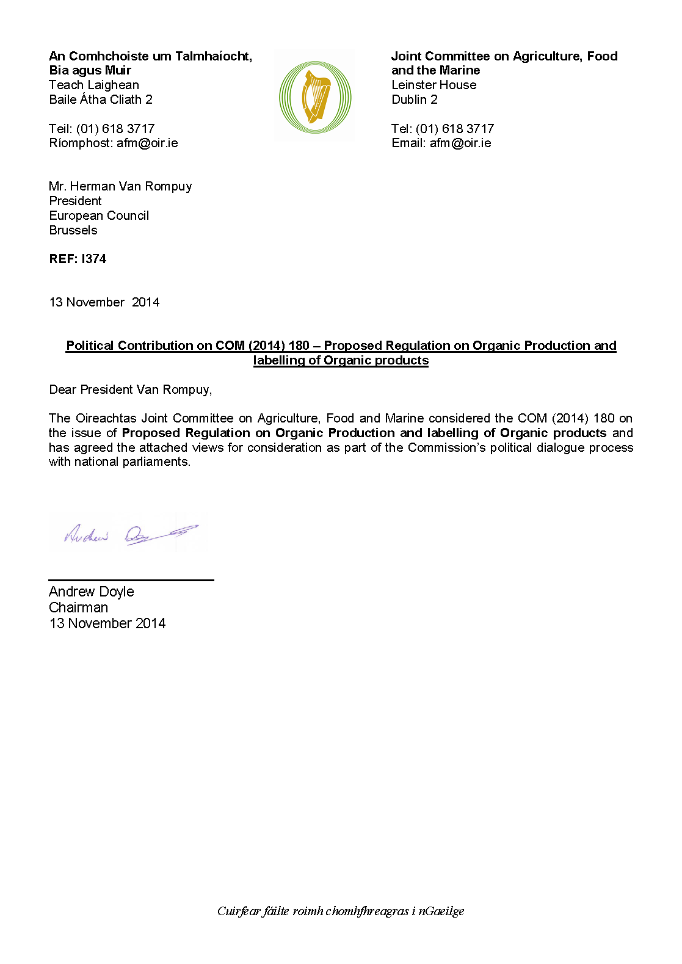
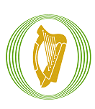

Joint Committee on Agriculture, Food and Marine
____________________________________________
Political Contribution on COM (2014) 180 – Proposed Regulation on Organic Production and labelling of Organic products

______________

An Comhchoiste um Thalmhaíocht, Bia agus Muir
_____________________________________________
An Cion Polaitiúil maidir le COM (2014) 180 –Rialacháin Beartaithe ón gComhairle maidir le Táirgeadh Orgánach agus Lipéadú Táirgí Orgánacha

November 2014

Political Contribution on COM (2014) 180 – Proposed Regulation on Organic Production and labelling of Organic products
The Joint Committee welcomes many elements of the proposal, but does harbour some concerns regarding certain provisions. It is noted that other Member States have concerns regarding aspects of the proposal and that a consensus among Member States will be difficult to achieve.
The Joint Committee:
- Is concerned about the implementation of The TFEU (Lisbon Treaty) Alignment exercise in regard to the transfer of decision making powers to the Commission via delegated Acts.

- Seeks clarity on the scope of the Proposal in terms of what organic products will be included in the regulation and what products will be left out.

- Is concerned with the transfer of organic controls to the new Officials Control Regulation. This issue is currently under discussion at EU Council.

- Is concerned about the introduction of a risk-based control system at the expense of an annual inspection requirement conducted by the Control Bodies.

- Is wary of the harmonisation of residue sampling and analysis in regard to setting a minimum threshold for pesticide residues above which the product cannot be sold as organic.

- Would like to see a greater degree of flexibility exercised for mixed holdings, where a farm can produce both organic and non-organic in the same holding.

- Regards the severe restriction in the reduction of the conversion period as a concern.

- Questions whether it is appropriate for the proposal to encompass all retailers who sell organic products.

- Advocates for the labelling of in-conversion products as organic.

- Seeks greater flexibility to allow – under very exceptional circumstances – the introduction of non-organic breeding stock, seeds and propagation material onto organic farms.

- Is concerned that the expansion of the import regime to organic farms fully in compliance with the EU organic standards could be problematic, particularly with issues pertaining to ingredients and materials.

The Joint Committee hopes its views will be taken into account and looks forward to receiving a response to its observations from the European Commission.

Andrew Doyle T.D.
Chairman
Joint Committee on Agriculture, Food, and the Marine
November 2014

