- Introduction
This report reviews the implementation by Member States of the four interrelated legislative acts establishing social rules in road transport and their enforcement regime. These legislative acts are: Regulation (EC) No 561/2006, which establishes rules on driving times, breaks and rest periods for professional drivers; Directive 2006/22/EC, which determines minimum requirements for enforcement of these rules; Council Regulation (EEC) No 3821/85 on recording equipment, i.e. main tool to control the drivers' compliance with social rules and Directive 2002/15/EC, which sets out complementary provisions on the organisation of the working time of persons performing mobile road transport activities (here-after "the Road Transport Working Time Directive).
Article 17 of Regulation (EC) No 561/2006 requires Member States to communicate every two years the necessary information to enable the Commission to draw up a report on the application of that Regulation and the developments in the fields in question. Article 13 of Directive 2002/15/EC provides that Member States should report to the Commission on the implementation of the Directive, indicating the views of the two sides of the industry. The reports on Directive 2002/15/EC and Regulation (EC) No 561/2006 can be presented in one singly document as both legislative acts cover the same two-year reporting period and establish complementary rules for professional drivers.
This report covers the 2011-2012 timeframe. It is based mainly on the national reports, for which the submission deadline expired on 30 September 2013. Its aim is to provide an overview of how Member States have implemented the above-mentioned set of legislative acts and to highlight the key challenges in enforcement and application of the rules in force. The report contains both quantitative and qualitative data on checks carried out at roadside and premises, offences detected as well as information on the implementation of Road Transport Working Time Directive. The Commission report is complemented by a Commission Staff Working Document that contains supplementary information on penalties, cooperation between Member States, comments from enforcement authorities and detailed statistical data.
The report comprises four sections that cover various aspects of implementation of social legislation. Section I summarizes the quality and timeliness of national data submissions. Section II provides for the fully fledged analysis of the national quantitative data provided on checks and offences, whereas Section III gives a descriptive outline of the Member States implementation of Directive 2002/15/EC. Section IV presents the main conclusions drawn.
Objectives and key provisions of social legislation in road transport, as well as other aspects and detailed statistics concerning the results of checks carried out, are described in the Commission Staff Working Document accompanying this report.
Data submission
The national reports on the implementation of the provisions of Directive 2002/15/EC and Regulation (EC) No 561/2006 should be submitted by means of the standard form set out in Commission Decision 2009/810/EC. This standard form combines the reporting requirements of these both legislative acts, and by means of an interactive reporting format gathers quantitative and qualitative data that constitutes a crucial input to this report.
The Commission notes that in general Member States provided national reports of better quality and timeliness then in the previous years, and would like to encourage them to continue on this path. This applies in particular to data on the implementation of Regulation (EC) No 561/2005. More in-depth description of data submission is included in the Commission Staff Working Document accompanying this report (hereafter "the accompanying document").
- Analysis of data on implementation of Regulation (EC) No 561/2006
1. Checks
According to Article 2 of Directive 2006/22/EC, the minimum number of checks in 2011 and 2012 should cover at least 3% of days worked by drivers of vehicles falling within the scope of Regulations (EC) No 561/2006 and (EEC) No 3821/85.
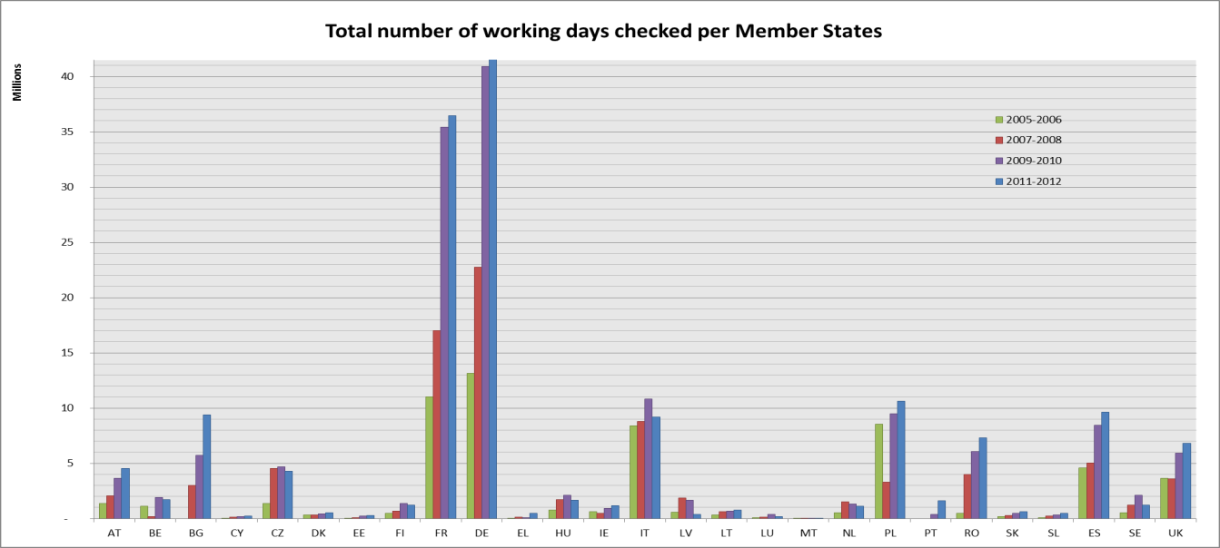
Graph 1 – Total number of working days checked per Member States
Graph 1 gives an overview of the number of working days checked in each Member State, in the current and previous reporting periods. On average the total number of working days checked in the EU noted an increase of 8.7% from almost 146 million to around 158.6 million working days checked. This rise confirms the general commitment among Member States to enhance the controls of compliance with the social rules in road transport. It is worth noting that all checks were performed by significantly lower number of enforcement officers for all Member States.
Looking closely at the number of working days effectively checked in relation to the minimum number of working days to be checked (Graph 2), it is noticeable that the majority of Member States performed more checks than required by Directive 2006/22/EC. Member States such as Greece, the Netherlands, Denmark, Italy and Latvia, who did not meet the threshold, are called upon to take appropriate corrective measures to remedy this situation. The Commission will assess the necessity of taking action in order to assure the correct application of Directive 2006/22/EC.
Detailed description of compliance with the threshold is presented in the accompanying document.
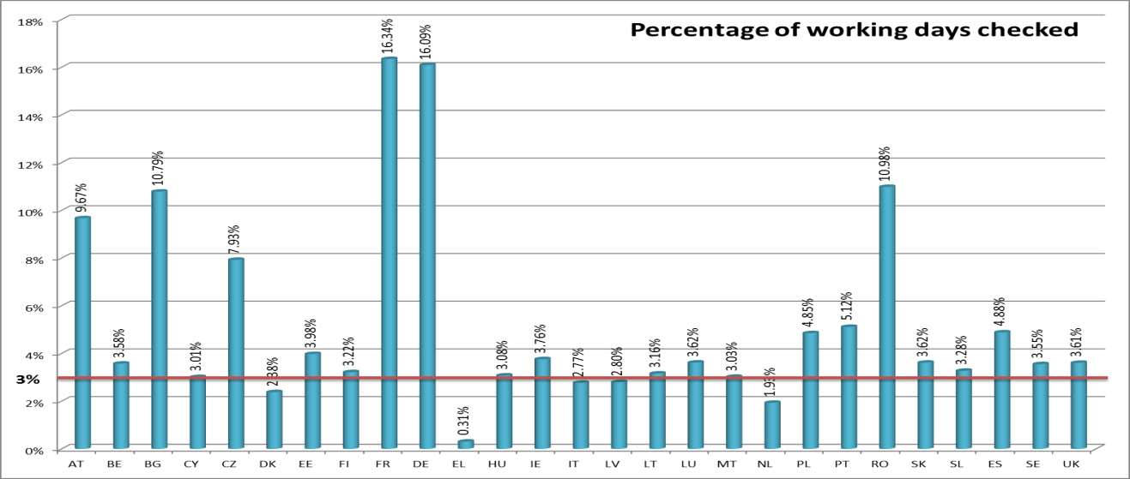
Graph 2: Percentage of working days checked per Member State
Regarding the type of controls, Article 2 of Directive 2006/22/EC sets out the ratio between the number of roadside controls (in terms of working days to be checked) and the checks at premises, which should amount to at least 30% and 50% respectively. It should be emphasised that pursuant to Article 2 of Directive 2006/22/EC the calculation of this proportion is based on the number of checks actually performed by each Member State and not on the minimum number of working days to be checked. Nevertheless, for the current reporting period most of the controls are performed at the roadside. On average 80% of all controls took place at the roadside, which shows slight improvement from 82% in the previous reporting period. Only Ireland was below the threshold for roadside checks.
1.1 Roadside checks
In total over the period of 2011 and 2012 more than 8.6 million vehicles and approximately 8.7 million drivers were controlled during checks at the roadside. These values stand for a decrease of respectively 11.3% and 19.4% in relation to the previous reporting period and are caused by corresponding increases in the checks at premises. The reason for a higher number of drivers than a number of vehicles is twofold: the double manning as well as missing data on this matter from Denmark on the number of vehicles checked at roadside.
Checks in Member States in the majority involved national vehicles and drivers and they equalled respectively 69% and 68% of all vehicles or drivers checked at roadside. Only in eight Member States, namely Austria, France, Hungary, Belgium, Lithuania, Luxembourg, Malta and Slovenia, the pattern is reversed and more non-national vehicles or drivers were subject to a control. This in some cases may be explained by the size or geographic position of these Member States. Detailed rates are incorporated in the accompanying document. As non-discrimination is one of the fundamental principles of the EU Treaties, the Commission may consider taking appropriate measures in order to ensure the equal treatment of drivers and operators in Member States where the checks are performed more frequently in regard to non-resident drivers and operators.
1.2 Checks at premises
There was a distinctive progress in the number of undertakings checked by Member States, which more than doubled in comparison with the reporting period of 2007-2008. In years 2011-2012, it amounted to 146 000 and rose by 42% as compared to 103 000 in the previous reporting period. Over 31.7 million working days were checked at premises, which signifies that the rate of growth slowed down as an increase between the reporting periods of 2007-2008 and 2009-2010 equalled to 79%, while it grew by 20% between the current and the last period. The dynamic of these developments should be seen in correlation with increases of minimum thresholds that took place during the previous reporting periods. Therefore the general increase by 8.7% in the number of working days checked both at roadside and premises and the decreases in controlled vehicles and drivers at roadside contributed jointly to the more intensified activities at premises.
2. Offences
All Member States provided data on offences detected, though with a divergent level of details. After a significant and constant growth of offences reported over the previous 6 years at the European level, which is tied with increases of minimum working days to be checked, there is a reversed tendency for the current reporting period which marked a decrease of 14% versus the last period in the number of offences detected. This number should be seen together with the increase of 8.7% in the number of working days checked. In real values it shows a decline from 4.5 million offences reported in 2009-2010 to approximately 3.9 million in the current reporting period. This change could be interpreted as an improved compliance with the provisions of social legislation thanks to well-established enforcement practices and greater awareness of social rules among drivers. This is based on an assumption that tachograph manipulation practices did not distort significantly the findings from the controls.
The table below shows that proportions between categories of infringements maintain similar levels compared with the previous reporting periods. The slight decline observed for offences on breaks in driving time and lack of records for other work is counterbalanced by increases in driving time records and recording equipment offences.

Period | Breaks | Rest periods | Driving time | Driving time records | Recording equipment | Lack/availability of records for other work
2011-2012 | 26% | 24% | 19% | 17% | 8% | 6%
2009-2010 | 29% | 23% | 18% | 15% | 5% | 8%
2007-2008 | 30% | 25% | 20% | 14% | 10% | 1%

Table 1 - Categories of infringements detected at roadside and premises

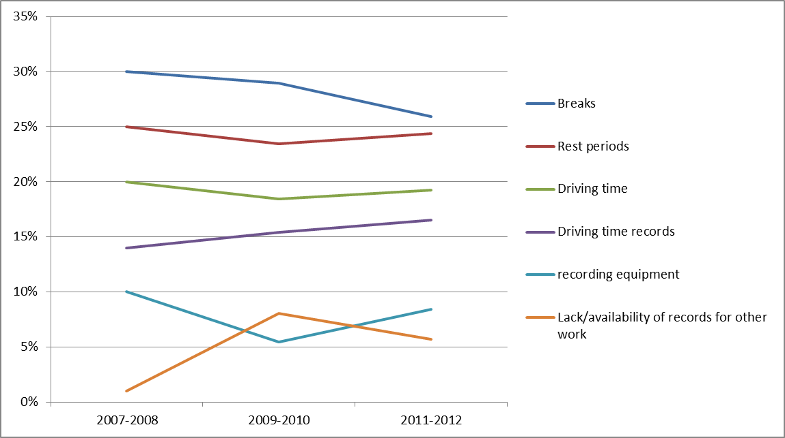
Graph 3 – Categories of infringements detected at roadside and premises
Categories of infringements detected at roadside and premises are described separately in the accompanying document.
Compared to the previous reporting period, in 2011-2012 the average rate of offences detected declined significantly by 22% and equalled to 2.43 offences per 100 working days checked. It appears that checks at premises are more effective than ad-hoc roadside controls as the detection rate at premises is 3 times higher than at roadside. It is, however, to be noted that in the previous reporting period, the detection rate at premises was 5 times higher as a detection rate at roadside. This change is due mainly to a considerable drop in detection rates at premises from 8.65 in years 2009-2010 to 5.29 in this reporting period. There are vast disparities in offence detection rates at premises per 100 days checked between Member States ranging from 0.01 in Bulgaria to 22.38 in Germany. It seems that the change in the EU average offence detection rate at premises is affected by a significant decline (by 27%) in the number of reported offences at premises in Germany, which in this reporting period still had the largest share of all offences detected at premises in Europe (53.9%).

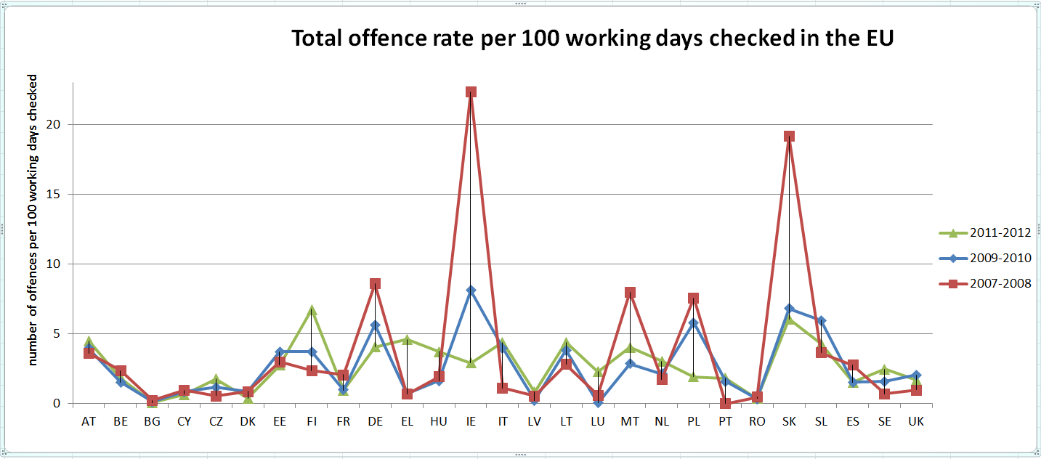
Graph 4 – Number of offences detected per 100 working days checked in 2007-2008, 2009-2010 and 2011-2012
Despite divergent fluctuations in different Member States regarding the number of offences detected per reporting period, on average there is a distinctive decrease in the number of offences reported, which is even more distinguishable when taking into account the increase in number of working days checked. Detailed description of detection rates in Member States is included in the accompanying document. These discrepancies in detection rates reveal that the European Union is far from establishing a harmonised enforcement area because of diverging enforcement resources and practices in controlling compliance with road transport legislation, as well as diverging penalty systems.
2.1 Offences detected at roadside
In the period 2011-2012, 2.2 million roadside offences were detected at European level, which constituted 58% of all detected offences both at roadside and premises. This indicates a decline in quantitative terms by almost 50 thousand, which means by 2% as compared to the previous reporting period. Per each 100 working days checked 1.74 offences have been detected compared to 1.9 in the previous reporting period.
On average 64% of offences were detected on national vehicles, which correlates with the 69% rate of national vehicles checked in Europe. However, there are Member States where the number of detected offences related to non-nationals prevails, namely Luxembourg (75%), Belgium (72%), Lithuania (59%), Sweden (57%), Bulgaria (56%), Slovenia (55%), Austria (55%), France (54%) and the United Kingdom (53%). This trend can be explained by the fact that all the above Member States performed more controls of non-national vehicles apart from Bulgaria, Sweden and the United Kingdom. In the case of these three Member States, the offences detected by non-residents are disproportionately more frequent. In particular in the case of Bulgaria where 25% of non-national vehicles checked equalled 56% of offences committed and Sweden who performed 34% controls on non-national vehicles which resulted in 57% of offences detected. The increase of offences committed by non-residents might be alarming in Sweden as the rate in comparison with the previous reporting period rose from 31% to 57%. It is worth adding that this trend continues in Member States like Belgium, Bulgaria, France, Luxembourg, Slovenia and the United Kingdom since the previous reporting period.
2.2 Offences detected at premises
During the current reporting period, Member States reported altogether over 1.6 million offences detected at premises of undertakings, constituting 42% of an overall number of offences. This marks a decrease of 26% as compared to the previous biennial period. These figures should be seen in correlation with the number of undertakings checked which augmented by 42%. Taking into consideration these two aspects, the real improvement in compliance with social rules could be noted.
In terms of frequency of offences reported per 100 working days checked, the European average marked a positive tendency and decreased from 8.65 to 5.29. When seen in parallel with the slight decrease in frequency of violations detected at roadside, it can be concluded that all the activities aiming at better compliance with social legislation in road transport start to yield results.
III. Data analysis on the implementation of the Road Transport Working Time Directive (Directive 2002/15/EC)
- Introduction
This chapter deals with the implementation by Member States in 2011-2012 of Directive 2002/15/EC, also referred to as the "Road Transport Working Time Directive". According to Article 13 of this Directive, Member States are obliged to submit a report on its implementation to the Commission every two years, indicating the views of employees and employers at national level. Descriptive parts on the transposition of this Directive in Member States, stakeholders' views on implementation and monitoring, control arrangements in Member States and enforcement issues are included in the accompanying document.
- Directive 2002/15/EC
The Directive establishes rules governing, inter alia, adequate breaks during the working period, the maximum average working week and night work. Its provisions supplement the rules on driving times, breaks and rest periods established by Regulation (EC) No 561/2006.
As this Directive lays down certain provisions concerning hours of work that are specific to the road transport sector, it is regarded as a lex specialis to the general Directive 2003/88/EC on working time, which establishes basic requirements for the organisation of working time for all workers. However, the Charter of fundamental Rights of the European Union contains provisions concerning working time and working conditions under its Article 31, which have to be respected when implementing EU law. A number of basic protection provisions of the general working time Directive, including rules on annual leave and free health assessment for night workers, are also applicable to mobile workers in road transport.
- Submission and quality of national reports
A common reporting format was established by the Commission in order to facilitate the reporting efforts of Member States, to reduce administrative burden and to prevent excessive delays in the submission of Member States reports. However, the quality of submissions varies significantly. The Netherlands did not provide any information and indicated that there were no changes as compared to the previous period. Several Member States' submissions were incomplete. The majority of national reports included information on implementation of Directive 2002/15/EC as well as on assessment of its effectiveness. Nevertheless, due to incomplete submissions, the results of this analysis cannot be considered as representative for the whole European Union.
- Implementation aspects in Member States
The overview of legislative acts transposing Directive 2002/15/EC at the national level is included in the accompanying document. During this reporting period, many Member States informed on amendments of their legislative framework in order to include self-employed drivers in its scope; namely Bulgaria, Denmark, Germany, Ireland, Luxembourg, Malta (on-going), Poland, Portugal, Sweden, the United Kingdom.
As regards collective agreements, divergent systems are observed in the European Union. They range from no collective agreements concluded (for example Malta) to established collective agreements that can provide for derogation to the working time limit (for example Italy). In Spain, a framework collective agreement in road transport was negotiated at the governmental level and 26 collective agreements were concluded at the autonomous community or province level. In Luxembourg, collective agreements were concluded for drivers of buses and additional employees of private buses enterprises as well as for the transport and logistics sector.
Portugal mentioned positive aspects of transposition thanks to clarification of availability periods and organisation of mobile workers' working time. Lithuania and Estonia assured that there were no difficulties encountered when implementing Directive 2002/15/EC as Lithuania provided training and consultation for employers and their authorised representatives.
Directive 2002/15/EC was perceived as a good set of arrangements that helped to deal with definition of working time and its limits. However, Greece pointed out that certain provisions of this Directive overlap with those of Regulation (EC) No 561/2006, which is a source of problems for businesses and workers. Spain identified issues when implementing rules on calculating periods of availability of drivers. The same matter was referred to by the Czech Republic. There is a confusion regarding the application of the working time provision, in particular when drivers spend time waiting between two runs and these times are known in advance.
In general, to facilitate practical implementation of Directive 2002/15/EC, Ireland and Sweden developed and distributed guidance material for operators on how to comply with the provisions of this Directive.
  - Offences against working time rules
Only a few Member States provided statistics on offences detected, which is not sufficient for any global conclusions to be drawn. As in comparison with the previous reporting period the same number of Member States provided data on infringements. All Member States are invited to include this information in the next reports.
5. Stakeholders' views on implementation of Directive 2002/15/EC
Sixteen Member States confirmed that stakeholders had been consulted, as required by Directive 2002/15/EC, which marks an improvement as compared to the reporting period of 2007-2008, when only nine Member States indicated the fulfilment of this obligation.
In general, there was a consensus among employers and employees that Directive 2002/15/EC contributed to health and safety protection of drivers. In Ireland, the employers expressed an opinion that limitations on working time improved the attractiveness of the driving profession. Some national social partners voiced their concerns as to the lack of consistency of enforcement and application of the rules in force and expressed the need for clarification of some specific aspects, such as compensation for night work. More detailed views of the consulted parties are included in the accompanying document.
IV. Conclusions
This report analyses implementation and enforcement developments over a 2011-2012 period in all Member States, in the context of compliance with the EU social rules.
The scope of this document is set out by Directive 2006/22/EC and Commission Decision 2009/810/EC that define standard data on Regulation (EC) No 561/2006 and Directive 2002/15/EC to be submitted; mainly number and type of controls carried out and number and types of offences detected. In this reporting period, the quality and timeliness of submissions improved, which enabled the Commission to draw more reliable conclusions on the application of social rules at European level.
The report shows that certain improvements in the enforcement and implementation of the legislation on social rules have been observed. On average, the total number of working days checked in the EU increased by 8.7% from almost 146 million to around 158.6 million working days checked while the minimum threshold of controls of 3% remained unchanged. It is worth noting that all checks were performed by a significantly lower number of enforcement officers for all Member States. This rise confirms the general commitment among Member States to enhance the controls of compliance with the social rules in road transport. However, like in the last two reports, most Member States failed to reach the threshold of having at least 50% of the total working days checked at premises and the vast majority of checks took place at the roadside. The Commission will monitor developments in this field. Should there be no improvements observed in the next reporting period 2013-2014 in respective Member States the Commission will launch an official enquiry with those Member States failing to comply with the requirement for checks at premises.
According to Article 2 of Directive 2006/22/EC, the threshold of minimum checks of number of days worked by drivers of vehicles will be raised to 4% once 90% of all vehicles checked are equipped with a digital tachograph. In this reporting period 56% vehicles checked at roadside were equipped with the digital tachograph. Hence, there is no base for raising the minimum threshold of checks to 4% of days worked by drivers.
It is important for the national authorities to guarantee that checks are being performed without discrimination on the basis of nationality of drivers/Member State of registration of vehicles. Member States should thoroughly examine their data and instruct control authorities accordingly in order to avoid the unequal treatment of non-nationals.
After a significant and constant growth of offences reported over the previous 6 years at European level, which is tied with increases of minimum working days to be checked, there is a reversed tendency for the current reporting period which marked a decrease versus the last period in the number of offences detected. This change seen together with the increase of the number of working days checked could be interpreted as an improved compliance with the provisions of social legislation thanks to well-established enforcement practices and greater awareness of social rules among drivers. To this end, the efforts of Member States and the Commission, such as guidance notes, trainings for enforcers etc. start to yield results.
The analysis of detection rates at roadside and at premises indicates that checks at premises remain more efficient than ad-hoc roadside controls. Discrepancies in detection rates between Member States reveal that the European Union is far from establishing a harmonised enforcement area because of diverging enforcement resources and practices in controlling compliance with road transport legislation.
Almost all Members States provided information on concerted checks which shows an improvement in comparison with the previous period not only in terms of reporting quality but as well in the amount of cooperation initiatives undertaken. Cooperation takes place mostly between neighbouring Member States and is complemented by actions within the framework of Euro Contrôle Route (ECR), which puts in place collaboration on a bigger scale.
The national reports on implementation of Directive 2002/15/EC, due to their incompleteness do not allow for in-depth analysis of impacts of this legislative act on health and safety of drivers or on road safety. Many Member States included self-employed drivers in the scope of their legislative frameworks even though this is sometimes perceived as causing enforcement issues.
The majority of Member States confirmed that stakeholders had been consulted. In general, social partners recognised that appropriate enforcement of Directive 2002/15/EC is a precondition to assure adequate working conditions and undistorted competition.
To assess other important aspects of the implementation of the road transport social rules, including application of the European Court of Justice jurisprudence, implementation of exceptions and penalties in the light of the Charter of Fundamental Rights of the European Union, the Commission will launch a comprehensive evaluation of the functioning of the social legislation in road transport.

Regulation (EC) No 561/2006 of the European Parliament and of the Council of 15 March 2006 on the harmonisation of certain social legislation relating to road transport and amending Council Regulations (EEC) No 3821/85 and (EC) No 2135/98 and repealing Council Regulation (EEC) No 3820/85 (OJ L 102, 11.4.2006, p. 1)
Directive 2006/22/EC of the European Parliament and of the Council of 15 March 2006 on minimum conditions for the implementation of Council Regulations (EEC) No 3820/85 and (EEC) No 3821/85 concerning social legislation relating to road transport activities and repealing Council Directive 88/599/EEC (OJ L 102, 11.4.2006, p. 36)
Council Regulation (EEC) No 3821/85 of 20 December 1985 on recording equipment in road transport (OJ L 370, 31.12.1985, p. 8), repealed by Regulation (EU) No 165/2014 of the European Parliament and of the Council of 4 February 2014 on tachographs in road transport, repealing Council Regulation (EEC) No 3821/85 on recording equipment in road transport and amending Regulation (EC) No 561/2006 of the European Parliament and of the Council on the harmonisation of certain social legislation relating to road transport (OJ L 60, 28.2.2014, p. 1)
Directive 2002/15/EC of the European Parliament and of the Council of 11 March 2002 on the organisation of the working time of persons performing mobile road transport activities (OJ L 80, 23.3.2002, p. 35)
Commission Decision 2009/810 of 22 September 2008 drawing up the standard reporting form referred to in Article 17 of Regulation (EC) No 561/2006 of the European Parliament and of the Council (OJ L 289, 5.11.2009, p.9)
The minimum rate is calculated separately for each Member State, based on the total number of days worked per driver during the two-year period and the total number of vehicles subject to these Regulations. These two factors are multiplied, which equals to a total number of days worked by drivers of vehicles falling within the scope of these Regulations and out of this amount a 3% is determined that constitutes the minimum number of checks that should be performed in each Member State.
Denmark failed to provide the number of vehicles checked at roadside
Finland did not provide data on the number of undertakings checked at premises for 2011-2012 reporting period. For the period 2009-2010 Finland, Luxembourg, Spain and Sweden did not provide data on the number of undertakings checked.
In 2008 the threshold rose from 1% to 2% and in 2010 it grew to 3% whereas no changes in the threshold were done in the current reporting period.
Detailed information on changes in particular Member States is included in the accompanying document.
In Denmark, the number of detected offences related to non-nationals amounted to 90%. However, this result is not representative due to a substantial amount of missing data on which this calculation was based. To this end the number was not counted in the European average.
See footnote 12
Directive 2003/88/EC of the European Parliament and of the Council of 4 November 2003 concerning certain aspects of the organisation of working time (OJ L 299, 18.11.2003, p.9)
Belgium, Cyprus, Hungary, Latvia, the Netherlands, Romania and Sweden
Article 3 (a) of Directive 2002/15/EC defines the ‘working time’ as "the time from the beginning to the end of work, during which the mobile worker is at his workstation, at the disposal of the employer and exercising his functions or activities, that is to say: the time devoted to all road transport activities and the times during which he cannot dispose freely of his time and is required to be at his workstation, ready to take up normal work, with certain tasks associated with being on duty, in particular during periods awaiting loading or unloading where their anticipated duration is not known in advance".
Austria, Bulgaria, Cyprus, Czech Republic, Greece, Poland, Spain
Bulgaria, Czech Republic, Germany, Denmark, Estonia, Greece, Spain Finland, France, Ireland, Lithuania, Malta, Poland, Slovakia, Slovenia, United Kingdom

