COMMUNICATION FROM THE COMMISSION TO THE EUROPEAN PARLIAMENT, THE COUNCIL, THE EUROPEAN CENTRAL BANK, THE EUROPEAN ECONOMIC AND SOCIAL COMMITTEE, THE COMMITTEE OF THE REGIONS AND THE EUROPEAN INVESTMENT BANK
An Investment Plan for Europe

"My first priority as Commission President will be to strengthen Europe's competitiveness and to stimulate investment for the purpose of job creation."

"We need smarter investment, more focus, less regulation and more flexibility when it comes to the use of public funds [available at EU level]."

"This should allow us to mobilise up to EUR 300 billion in additional public and private investment in the real economy over the next three years."

"The focus of this additional investment should be in the areas of infrastructure, notably broadband and energy networks, as well as transport infrastructure in industrial centres; education, research and innovation; and renewable energy and energy efficiency.
A significant amount should be channelled towards projects that can help the younger generation back to work."

(Political Guidelines of Jean-Claude Juncker, President of the European Commission, presented in the European Parliament on 15 July 2014)

- An Investment Plan for Europe

Europe urgently needs an Investment Plan. As a consequence of the economic and financial crisis, the level of investment in the EU has dropped significantly since its peak in 2007,
by about 15%. This level is also well below its historical trend. Only a partial rebound is projected over the coming years. Economic recovery, job creation, long-term growth and competitiveness are being hampered as a result.

There is no simple or single answer. General uncertainty about the economic situation, high levels of public and private debt in parts of the EU economy and their impact on credit risk limit our room for manoeuvre. However, at the same time, there are significant levels of savings and – in contrast to some years ago – high levels of financial liquidity that can be mobilised. Moreover, Europe has plenty of investment needs and economically viable projects in search of funding. The challenge is to put savings and financial liquidity to productive use in order to support sustainable jobs and growth in Europe.

Action is required on several fronts at the same time, addressing both the supply and demand sides of the economy. What we need is confidence in the overall economic environment; predictability and clarity in policy-making and the regulatory framework; effective use of scarce public resources; trust in the economic potential of investment projects under development; and sufficient risk-bearing capacity to encourage project promoters, unlock investment and entice private investors. These issues need to be tackled by public authorities at all levels.

Member States, as well as regional authorities, have a clear role to play in pursuing the necessary structural reforms, exercising fiscal responsibility, providing regulatory certainty and boosting investment in support of jobs and growth. Member States with fiscal room for manoeuvre should invest more. Member States with more limited fiscal space should prioritise investment and growth-related expenditure in their budgets, make better use of EU Funds and create an environment that is more conducive to investment by private actors.
A lot can be achieved at national and regional level. The Commission, together with the other Institutions and Member States, will steer and monitor progress in the context of the European Semester of economic policy coordination.

This Investment Plan will complement these efforts. It will be based on three mutually reinforcing strands. First, the mobilisation of at least EUR 315 billion in additional investment over the next three years, maximising the impact of public resources and unlocking private investment. Second, targeted initiatives to make sure that this extra investment meets
the needs of the real economy. And third, measures to provide greater regulatory predictability and to remove barriers to investment, making Europe more attractive and thereby multiplying the impact of the Plan.

For the first two strands, the Investment Plan for Europe is being launched jointly by the Commission and the European Investment Bank (EIB), as strategic partners, with the clear aim of rallying stakeholders at all levels. For the third strand, the Commission will propose action in its upcoming Work Programme, as well as together with the other EU Institutions and the Member States in the context of the European Semester.
Graph 1. An Investment Plan for Europe

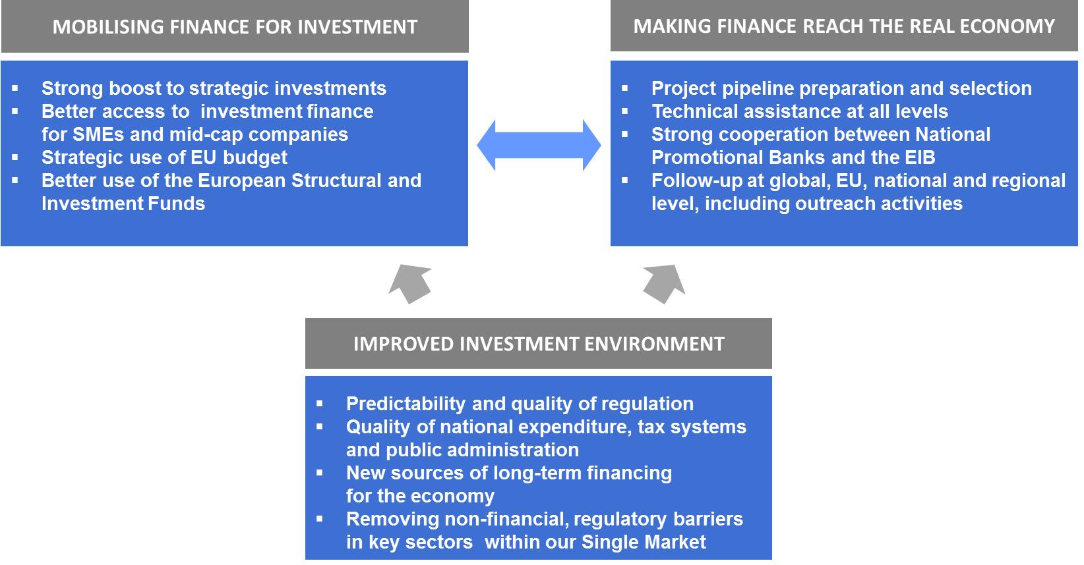

The impact of the Plan will multiply as more stakeholders join in: Member States, National Promotional Banks (NPBs), regional authorities and private investors. All have a necessary role to play. The Commission is particularly welcoming of the momentum building up around the Plan, as evidenced by the positive announcements made at European and global level in support of the Plan over the last weeks.

Between now and end 2017, the ambition is to mobilise at least EUR 315 billion in additional public and private investment into the real economy. The Investment Plan comes on top of existing measures and will make the most of every public euro mobilised through both new and existing instruments. By acting swiftly, on each aspect of the Plan, we can achieve collectively much more than we would by acting in an uncoordinated way and harness even more than the EUR 315 billion.

Ultimately, the Plan will serve three related policy objectives:
- reverse downward investment trends and help boost job creation and economic recovery, without weighing on national public finances or creating new debt;
- take a decisive step towards meeting the long-term needs of our economy and increase our competitiveness;
- strengthen the European dimension of our human capital, productive capacity, knowledge and physical infrastructure, with a special focus on the interconnections vital to our Single Market.

We have to move fast to ensure rapid results that can be sustained over time. The European Parliament will be closely involved in the deployment of the Investment Plan and
the European Council is invited to endorse the overall approach, at its meeting of
18-19 December 2014.

The Commission and the EIB will engage with stakeholders at all levels in early 2015. Rigorous follow-up will ensure that the public risk-bearing capacity is well deployed and managed soundly and that targeted projects trigger job creation, economic growth and increases Europe's competitiveness.

- Mobilising at least EUR 315 billion additional investments at EU level

The first strand of the Plan is the mobilisation of at least EUR 315 bn of additional investment over the next three years. What is presented here is based on action solely at the EU level:
the Commission calls on Member States and other economic actors to join in and complement this initiative. In order to ensure a fast delivery, the proposed action can be financed within the current Multi-Annual Financial Framework for the EU budget for 2014-2020.

For this to happen, parts of the EU budget should be used differently, at both EU and national level. The main idea is to provide greater risk-bearing capacity through public money in order to encourage project promoters and attract private finance to viable investment projects which would not have happened otherwise. This will make the best use of EU public resources.

At EU level, this will be done by establishing a new European Fund for Strategic Investments to provide risk support for long-term investments and ensure increased access to risk-financing for SMEs and mid-cap companies. At national level, a more strategic use of the European Structural and Investment Funds can make a significant difference.

The European Council is invited to endorse the setting up of the European Fund for Strategic Investments, and commit to a more effective use of the European Structural and Investment Funds, notably through an overall doubling of the use of financial instruments. The legal proposal necessary for the European Fund for Strategic Investments should be dealt with in fast-track procedure by the European Parliament and the Council, as the EU legislator, to be in force by June 2015.

2.1. A new European Fund for Strategic Investments

A new European Fund for Strategic Investments (EFSI) will be set up in partnership between the Commission and the EIB in order to benefit from the well-established expertise of the EIB and its proven ability to deliver (see Graph 2). The Fund will be set up within the EIB-Group.
Compared to existing structures, the Fund will have a different risk profile, provide additional sources of risk-bearing capacity and will target projects delivering higher societal and economic value, complementing the projects currently financed through the EIB or existing EU programmes. The range of possible products will be open-ended in order to adapt to evolving market needs.
To establish the European Fund for Strategic Investments, a guarantee, of EUR 16 bn, will be created under the EU budget to support the Fund. The EIB will commit EUR 5 bn. The Fund will thus start with significant firepower but it will also be able to expand its activities further over time. Member States, directly or through their NPBs or similar bodies, will have the opportunity to contribute to the Fund in the form of capital. Importantly, in the context of the assessment of public finances under the Stability and Growth Pact, the Commission will take a favourable position towards such capital contributions to the Fund. Private investors can also join at the level of the Fund.

Graph 2. The new European Fund for Strategic Investments – initial construction (EU alone)

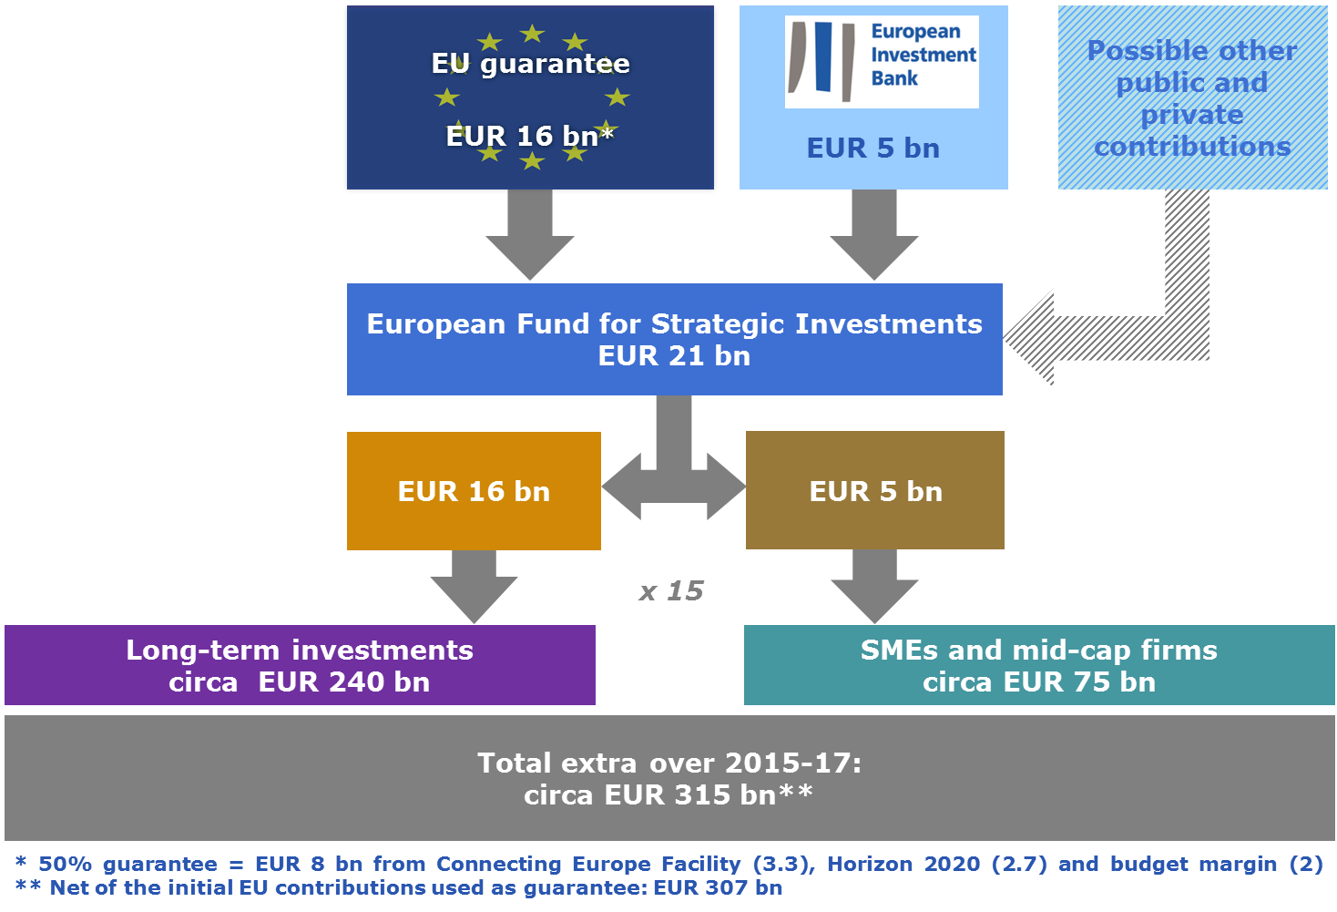

The EU guarantee will be backed by existing EU funds from the margin of flexibility which exists within the EU budget, the Connecting Europe Facility and the Horizon 2020 programme. Thanks to the new Fund, the impact of these existing EU funds on the real economy will be multiplied, compared to what they would have achieved otherwise. All interventions by the European Fund for Strategic Investments will be covered by established state-aid clearance procedures.
The role of the Fund is to ensure enhanced risk-bearing capacity and mobilise extra investment, essentially from private sources, but also public sources, in specific sectors and areas. These areas are described below.

We estimate that the Fund could reach an overall multiplier effect of 1:15 in real investment in the economy. This is because the Fund will offer an initial risk bearing capacity that will allow it to provide extra financing and attract more investors to join, as indicated in Graph 3. This means that one euro of risk protection by the Fund can generate, on average, 15 euro of investment in the real economy that would not have happened otherwise. This 1:15 multiplier effect is a prudent average, based on historical experience from EU programmes and the EIB. The final multiplier effect will naturally depend on the mix of activities and the specific features of each project.

Graph 3. The multiplier effect of the Fund (averaged based on experience)

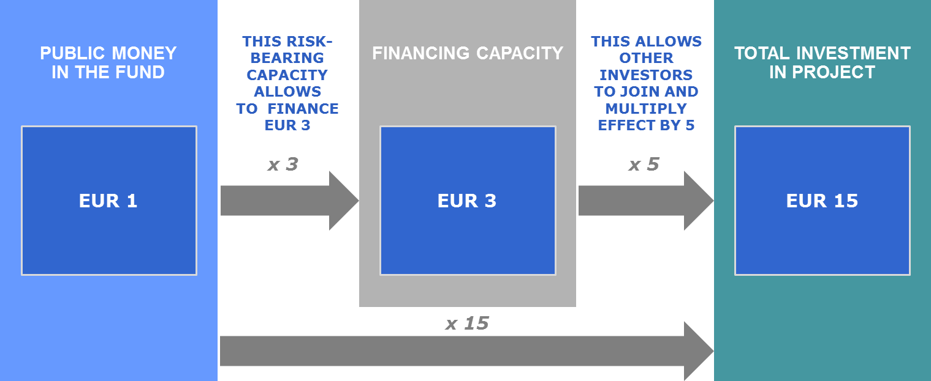

As a reference, the capital increase of the EIB in 2012 had an estimated multiplier effect of 1:18 and is materialising as foreseen. Likewise, under the current Loan Guarantee Facility for SMEs under the COSME programme, every EUR 1 bn of funding results in at least
EUR 20 bn capital for SMEs, the equivalent of a multiplier effect of 1:20.

The Fund will have its own governance structure. It will be managed in accordance with agreed investment guidelines. Its management body will ensure that the investment guidelines are adhered to and that the priorities and activities of the Fund reflect these guidelines. Concrete projects will be validated by an independent Investment Committee based on their viability and making sure that public support does not exclude or crowd out private investment. Project promoters and investors will be able to rely on the professional advice, experience and support of the EIB-Group. The EIB-Group will also contribute with dedicated staff in areas such as product development, pipeline origination and structuring, technical assistance, funding capacity, treasury management, asset-liability management, guarantees, portfolio management, accounting and reporting.

Overall, if the Fund is set up rapidly with an initial contribution of EUR 21 bn at EU level,
it has the potential to yield approximately EUR 315 bn of additional finance over three years. The impact will obviously be higher as Member States and National Promotional Banks join.

2.2. The new Fund will support long-term investment projects

The European Fund for Strategic Investments will support strategic investments of European significance in infrastructure, notably broadband and energy networks, as well as transport infrastructure, particularly in industrial centres; education, research and innovation; and renewable energy and energy efficiency. There should be no thematic or geographic pre-allocations, in order to guarantee that projects are chosen on their merits and maximise the added value of the Fund. The Fund will be flexible since different regions have different needs in order to jump-start investments.

The activities of the Fund in these fields will be complementary to the more traditional scope of EIB activities and to ongoing EU programmes such as the Connecting Europe Facility
(for infrastructure investment) and Horizon 2020 (for innovation and R&D). Typically,
the European Fund for Strategic Investments will provide greater risk coverage of the different projects, thus considerably facilitating private investment in safer tranches of the projects. It should be noted that, while the European Fund for Strategic Investments is being set up, important sources of funding exist in already approved work programmes under the Connecting Europe Facility and Horizon 2020 and will become available in 2015 for funding of projects.

In addition, the EIB-Group will start activities using its own resources as of early 2015, hereby giving the Plan a flying start.

Among the areas of interventions being considered, the European Fund for Strategic Investments should have the possibility to finance not only individual projects but also support private fund structures such as European Long-Term Investment Funds (ELTIF), set up by private investors and/or NPBs. This will create an additional multiplier effect and maximise the impact on the ground.

As suggested in Graph 2, it is envisaged to use three quarters of the resources of the European Fund for Strategic Investments for these kinds of activities (leading to investments of approximately EUR 240 bn).

2.3. The new Fund will also support investment by SMEs and mid-cap companies

In addition, the European Fund for Strategic Investments will support risk finance for SMEs and mid-cap companies across Europe, relying on the European Investment Fund (EIF, part of the EIB-Group) for the operational implementation. This should help them overcome capital shortages by providing higher amounts of direct equity, as well as additional guarantees for high-quality securitisation of SME loans. This is an effective way to kick-start job creation and growth, including the recruitment of young people.

The EIF is highly experienced in these kinds of activities. The European Fund for Strategic Investments should thus serve to scale up the activities of the EIF and, in doing so, create new channels for NPBs to develop their own activities in this area. This will come on top of existing activities for SMEs initiated by programmes such as COSME and Horizon 2020, which will notably already provide significant sources of funding in 2015.

As suggested in Graph 2, one quarter of the European Fund for Strategic Investments resources will be used for these kinds of activities (leading to investments of approximately EUR 75 bn).

2.4. In addition to the EUR 315 bn mobilised by the European Fund for Strategic Investments, the impact of the European Structural and Investment Funds can be boosted further

From 2014 to 2020, EUR 450 bn (EUR 630 bn including national co-financing) will become available for investment as part of the European Structural and Investment Funds. It is essential that Member States and regional authorities get the maximum impact from EU funds by focusing on key areas and capitalising on every euro invested.

A particularly effective way to increase the impact of the Funds is to use financial instruments in the form of loans, equity and guarantees, instead of traditional grants. These instruments are relatively new to many public authorities, but they have a great potential and proven ability to deliver where they exist. In the context of this Plan, Member States should commit to increase significantly their use of innovative financial instruments in key investment areas such as SME-support, energy efficiency, Information and Communication Technology, transport and R&D support. This would achieve at least an overall doubling in the use of financial instruments under the European Structural and Investment Funds for the programming period from 2014 to 2020.

The funds made available by these instruments, combined with resources catalysed from other investors and beneficiaries, will result in additional investments in the economy, through the multiplier effect. The final multiplier effect in the economy will depend on the actual projects and instruments used. In addition to the recent SME-Initiative, additional EU-level financial instruments as well as readily available, so-called off-the-shelf instruments, may be deployed in order to facilitate the use of financial instruments by the managing authorities. The Commission will discuss with each Member State the practical steps to be taken and provide guidance to this end. A dedicated monitoring system will be put in place to track results.

Over the whole programming period, 2014 to 2020, this new approach would result in close to EUR 30 bn committed to innovative financial instruments with a direct leverage effect generating additional investments between EUR 40 and 70 bn and with an even larger multiplier effect in the real economy. A conservative estimate of this additional investment that could be mobilised in the period 2015-2017 would be EUR 20 bn.

In addition to this, Member States and regions can also increase the multiplier effect of EU funds by increasing national co-financing beyond the minimum legal requirement. As national public funds are limited, private funds could be the source of this increase, which is already the case in certain Member States.

Third, Member States are invited to use EU funds still available under the 2007-2013 programming period to best effect and ensure that they are fully used in support of this Investment Plan. The Commission will assist with support and guidance to this end.

Finally, since the EIB will deploy new lending in parallel to the implementation of the Investment Plan, Member States are also encouraged to work with the EIB to leverage existing national resources.

- Making investment finance reach the real economy

The second strand of the Plan is to take targeted initiatives to make sure that the extra investment finance generated meets the needs of the real economy. This means channelling extra public and private money to viable projects with a real added value for the European social market economy. This holds true for the new European Fund for Strategic Investments and the European Structural and Investment Funds, but this is a broader challenge for Europe as a whole.

The main purpose of this strand is to bring about a fundamentally new approach to the identification and preparation of investment projects across Europe, by improving the way in which private investors and public authorities approach and access information on investment projects. This is closely linked to, but goes well beyond, the issue of identifying EUR 300 bn worth of projects that could potentially benefit from the additional sources of funding discussed in the first strand of this Plan.

The European Council is invited to endorse the proposal to set up a pipeline of projects
at EU level and to strengthen technical assistance through an investment advisory "Hub",
to be in place by June 2015.

3.1. A pipeline of projects will be established at EU level

For a number of stakeholders, the main concern is not a lack of finance, but a perceived absence of viable projects. However, as the initial work of the "Investment Task Force" (jointly being carried out by the EIB and the Commission, together with the Member States, expected to publish its Report before the end of the year), suggests, there is a significant number of potentially viable projects that are ripe for investment at EU level. That said, private investors are often unaware of the potential of these projects and are reluctant to invest alone given their intrinsically complex nature and lack of information to properly evaluate risk. This is notably the case for large-scale, long-term investment projects in infrastructure.

For investment to happen, there is a strong need for independent and transparent assessments that can confirm whether a project is economically viable and in particular whether it satisfies all relevant regulatory and administrative requirements. Greater transparency and understanding of the risks will help to attract and unlock private investment.

Together with the Member States, the "Investment Task Force" is carrying out a first screening exercise of potentially viable projects with European significance. The Commission considers that this work should continue on a more permanent basis at EU level, to help identify and unlock key investment projects of European significance, as well as to inform investors on a regular basis of the state of preparedness of the various projects. NPBs could usefully contribute to this work.

In this context, a pipeline of investable projects of European significance could be established. The list of projects would be dynamic and based on a number of simple and recognised economic criteria. Projects would be continuously added and removed over time. This does not mean that every project in the European pipeline should or will be financed under the Plan or through the new Fund, but it will allow public and private investors to access relevant and transparent information. The list of assessed and non-assessed projects should be made publicly available on a website, which in turn could be connected to similar lists at national and regional level.

Over time, this work could lead to a system of European certification for viable investment projects that fulfil certain criteria. Such certification could subsequently be used by the EIB and NPBs to attract private investors. This would be useful in order to provide a clear "credibility label" for European investment projects. This is also in line with the efforts at global level in the context of the G20 to share best practices for investment projects.

3.2. A single-entry investment advisory "Hub" will be set up to bring together sources of expertise and strengthen technical assistance at all levels

Many projects and project promoters in Europe are still looking for the most appropriate sources of funding, adapted to their needs. There is also often a need of guidance on how to meet regulatory requirements. A priority of the Investment Plan will be to provide strengthened support for project development across the EU, by building on the expertise of the Commission, the EIB, NPBs and the managing authorities of the European Structural and Investment Funds.

This notably includes technical assistance for project structuring, the use of innovative financial instruments at national and European level, and the use of public-
private partnerships. To this end, a one-stop-shop will be established for all questions regarding technical assistance. This will take the form of an investment advisory "Hub" with
three audiences in mind: project promoters, investors and public managing authorities.
The Hub will provide guidance on the most appropriate advisory support for a specific investor, whether it is delivered by the EIB-Group, NPBs or other international financial institutions.

This new Hub will build on successful, already available instruments such as the JASPERS programme, which will be upgraded and expanded, and the new advisory platform for the use of innovative financial instruments (Fi-Compass). It will be developed by the EIB-Group in close cooperation with the NPBs and similar entities across Europe and allow these entities to increasingly work together in a network.

3.3. Engaging with stakeholders at European, national and regional level

With the support of national and regional authorities, the Commission and the EIB will engage with investors, project promoters and institutional stakeholders to facilitate key investment projects and make sure the right projects access appropriate sources of funding. "Investing in Europe" workshops will also be organised at national, transnational and regional level to address specific challenges jointly with the EIB. The focus will be on attracting private and public project promoters, as well as private investors, raising awareness about EU financial instruments, the additional risk-bearing capacity of the European Fund for Strategic Investments, and on maximising synergies between national and EU schemes.

- Improving the investment environment

The third strand of the Plan consists of providing greater regulatory predictability, removing barriers to investment across Europe and further reinforcing the Single Market by creating the optimal framework conditions for investment in Europe. The Single Market is Europe's greatest structural reform achievement.

Much can be done at national level. The Commission, together with the other EU Institutions, will steer and follow progress in the context of the European Semester for economic policy coordination. At EU level, the Commission will shortly present its priority initiatives in its 2015 Work Programme, with first actions to be initiated in the coming weeks.

The European Council is invited to endorse the overall approach and the European Parliament and the Council, as the EU legislator, should ensure swift adoption of the forthcoming legislative measures that are necessary to improve the regulatory environment for investment.

4.1. Simpler, better and more predictable regulation at all levels

Optimal framework conditions for business across the Single Market are essential to unlock the full potential of investment in Europe. The regulatory framework, at national as well as European level, needs to be simple, clear, predictable and stable to incentivise investments with a longer term horizon. Efforts to reduce administrative burdens and simplify regulations remain slow and uneven, despite significant efforts by the Union and its Member States. This is particularly problematic for SMEs, the job creators and backbone of Europe's economy. Improving the conditions for growth is therefore essential to ensure that investment projects can prosper and that money spent on strategic investments under this Plan – and beyond – is put to effective use.
Better regulation is a joint responsibility of the Member States and of the European institutions. This is not about de-regulation but about smart regulation to benefit citizens and businesses alike. This includes reducing unnecessary regulatory burdens and improving business conditions, in particular for SMEs, to ensure that any necessary regulation is simple, clear and fit for purpose. This also means improving the effectiveness of national expenditure, the efficiency of tax systems and the quality of public administration at all levels. Member States are also responsible for the timely and full application of EU law. They need to ensure that transposition measures are as simple, clear and light as possible, avoiding creating additional burdens or so-called 'gold-plating' when transposing EU law into national law.

The Commission has made better regulation one of the main priorities of this mandate. This will already be reflected in the Commission Work Programme for 2015. The Commission will further strengthen its overall approach of better regulation in 2015 and give it fresh impetus. Regulation should remove obstacles to growth, allow new opportunities to flourish, minimise costs and guarantee social and environmental sustainability. The Commission will in particular step up its efforts under the “Regulatory Fitness and Performance Programme” (REFIT), and will work with the EU legislator to ensure that any proposed simplification of laws is effectively delivered in practice.

4.2. New sources for long-term financing, including steps towards a Capital Markets Union

Recent reforms of the EU's financial regulation framework and the completion of the Banking Union will help develop a transparent, safe, responsible and resilient financial sector contributing to stability and confidence. But investment remains heavily reliant on bank intermediation; long term finance for infrastructure remains constrained. Many SMEs still have limited access to finance and the free movement of capital across the EU remains a work in progress.

Over time, the creation of a Capital Markets Union (CMU) will reduce fragmentation in the EU's financial markets. This will also help bring about a more diverse supply of finance to SMEs and long-term projects by complementing bank financing with deeper, more developed capital markets. A genuine single capital market will help to reduce the cost of funding for the rest of the economy. The Capital Markets Union is therefore an important medium to long-term component of this Plan.

A broad consultation at the beginning of 2015 will help to develop further and prioritise the main areas for action to remove obstacles to investment financing and progress towards a Capital Markets Union.

The main areas for action in the short term include:
- Adoption before the end of 2014 of the proposed Regulation on European Long-term Investment Funds (ELTIF). The goal is to have ELTIFs operational by mid-2015 as useful vehicles for investments in long-term projects. ELTIFs could also play a role in providing a complementary vehicle for delivering public or private/public investments in the rest of the economy.
- Reviving high quality securitisation markets, without repeating mistakes made before the crisis. The Commission will reflect on the best ways to present criteria
for simple, transparent and consistent securitisation, building on recent measures
in the insurance and banking sectors and international work in this area. Reviving this asset class will help developing a deep and liquid secondary market, attract a broader investor base and improve the allocation of finance to where it is most needed.
- Examining how to address the current lack of standardised credit information on SMEs, building on work already initiated in this area, as well as improving information on the planning of infrastructure projects as well as on their credit history.
- Exploring with the private sector the best ways of more widely replicating across the EU the success of Private Placement regimes in some European markets
- Reviewing existing measures such as the Prospectus Directive to lighten the administrative burden on SMEs, making it easier for them to fulfil listing obligations.

4.3. Reinforcing the level-playing field and eliminating barriers to investment in the Single Market

To make the most of the Single Market and make it an effective launch pad for companies, determined efforts are needed. While some measures may be more long-term than others, improving the framework conditions for jobs, growth and investment is an inherent dimension of this Plan. Areas particularly relevant in the short- and medium term include the following:
- The energy and transport sectors are important dimensions of the Single Market and the implementation of recent reforms needs to be accelerated. The European Energy Union will be instrumental in this context. The full implementation of the Third Energy Package must be ensured. Rules for energy-cross-border trade still remain highly fragmented. Market-distorting retail price regulation continues in some Member States and needs to be addressed. The Commission will also take the necessary action to follow up on recent decisions concerning the 2030 climate and energy framework.
- Structural reforms to resolve barriers to investment in transport infrastructure and systems, notably with a cross-border dimension, also need to be implemented swiftly. To reap the full benefits of the Single Market, the European Single Sky objectives should be ensured, as well as the rapid adoption and subsequent implementation of the Fourth Railway Package.
- Europe needs to develop a truly connected Digital Single Market, including through swift and ambitious legislative steps in the areas of data protection, telecoms regulation and by modernising and simplifying copyright and consumer rules for online and digital purchases. The digital single market should deliver trust and security in online transactions, interoperability of different technological solutions and access to digital resources and infrastructures (in particular spectrum licencing policies). The Single Market should be open to new business models, while ensuring that essential public interest objectives are met. Consumers should be given unhindered access to online content and services across Europe without discrimination based on their nationality or their place of residence.
- Services and product markets are increasingly intertwined. Stepping up reforms is required to address disproportionate legal form, shareholding and authorisation requirements and to improve mutual recognition in particular for sectors and professions with high cross-border trade potential. Efficient application of public procurement rules should be ensured at all levels, as well as the promotion of
e-procurement tools.
- To boost research and innovation, EU competitiveness would benefit from fewer barriers to knowledge transfer, open access to scientific research and greater mobility of researchers.

- Engagement with our international partners will help to promote open investment flows. The internationalisation of European firms improves their competitiveness. Investors from countries outside the EU can play an important role in supporting the European economy.

- Next steps

This Investment Plan is not a one-off measure, but an investment offensive that will unfold over the three years to come. This is a Plan that will fundamentally change public policy and the financing tools underpinning investment in Europe, to achieve the highest economic and societal return for every euro spent.

The Plan presented today is the first step in a new direction. Member States are invited to join this initiative, including by providing further funding to the European Fund for Strategic Investments, deepening the Plan's impact on the real economy. Actions must be swiftly and effectively deployed at all levels so that tangible effects are already seen in 2015.

The Commission invites the European Council of 18-19 December 2014 to endorse the Plan, with all its strands. It calls on the European Parliament and the Council, as the EU legislator, to fast-track the necessary legislative measure to ensure that the European Fund for Strategic Investments becomes operational by June 2015, and to follow up swiftly on
the other aspects of the Plan.

Regular stock-taking in the European Parliament, in meetings of Heads of State and Government, in the relevant Council formations, and together with the European Economic and Social Committee and the Committee of the Regions will give the political ownership necessary to make sure these initiatives produce results. The Commission and the EIB will approach key stakeholders at national and regional level to organise dedicated follow-up activities in order to discuss and develop specific solutions.

This Plan is based on the assumption that no changes will be made to the Multi-Annual Financial Framework or to the capital of the EIB at this point in time. Depending on progress, additional actions will be considered by mid-2016, which will also coincide with preparation of the mid-term review of the Multi-Annual Financial Framework.

ANNEX 1. WHAT IS THE LIKELY IMPACT OF THE INVESTMENT PLAN?

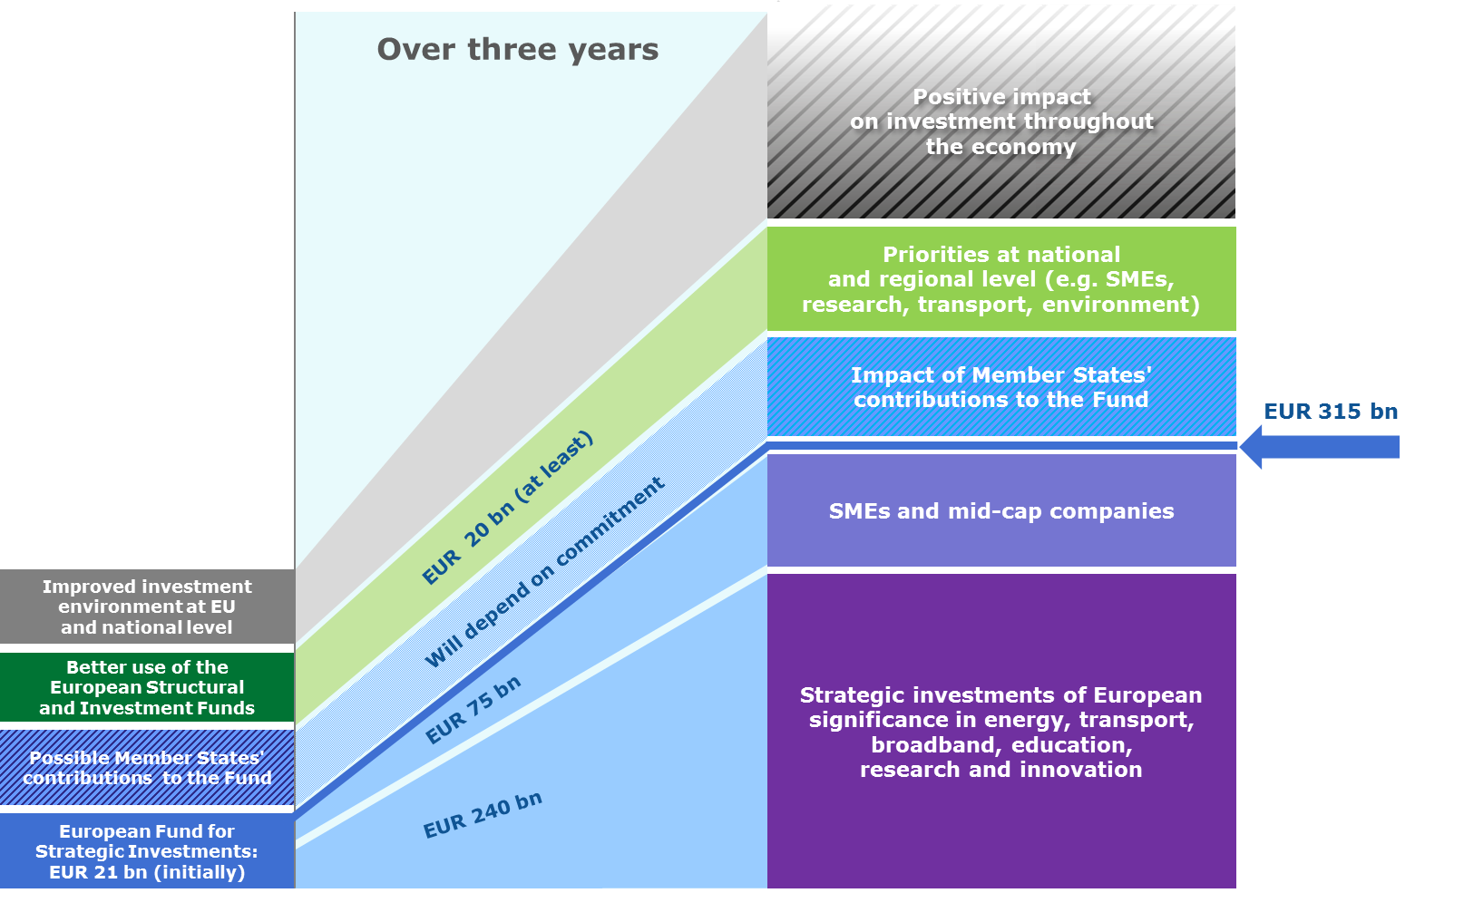
ANNEX 2. HOW WILL THE NEW FUND WORK IN THE CASE OF LONG-TERM INVESTMENTS?
EIB = European Investment Bank

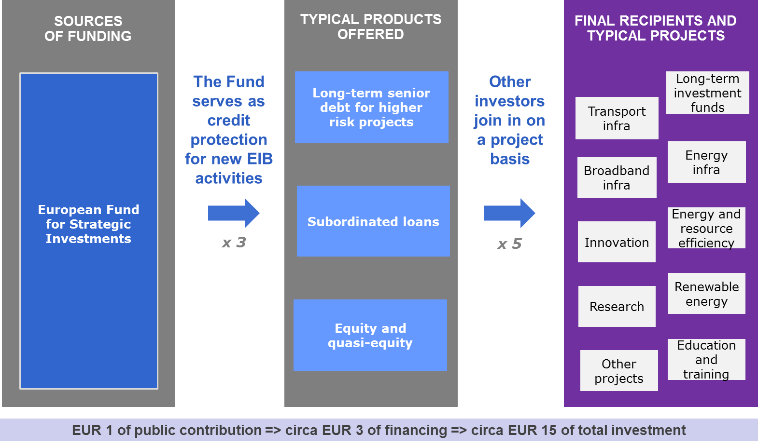
ANNEX 3. HOW WILL THE NEW FUND WORK IN SUPPORT OF SMEs AND MID-CAP COMPANIES?
EIF = European Investment Fund

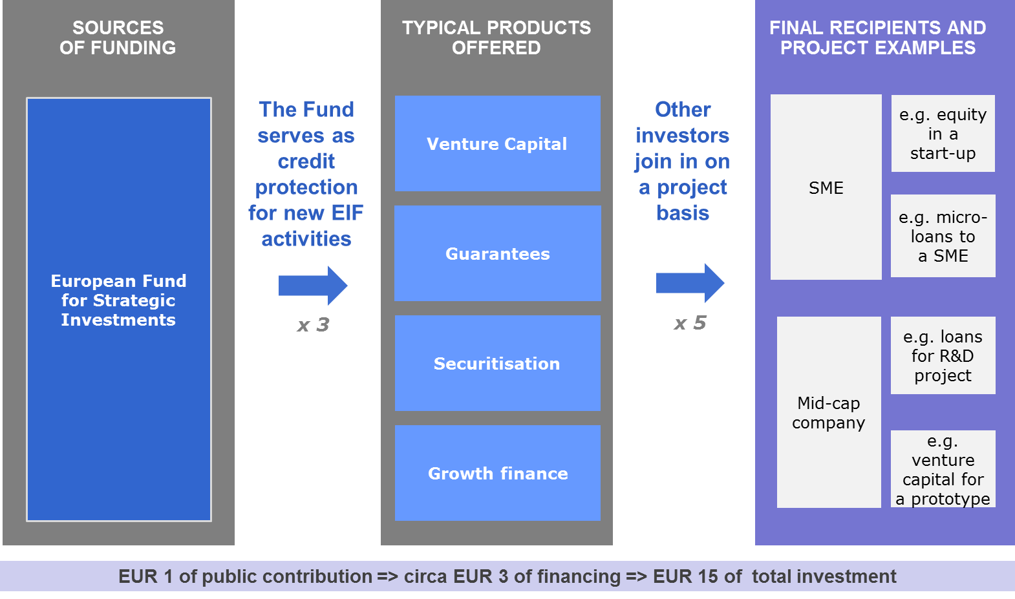

ANNEX 4. TIMELINE AND MILESTONES

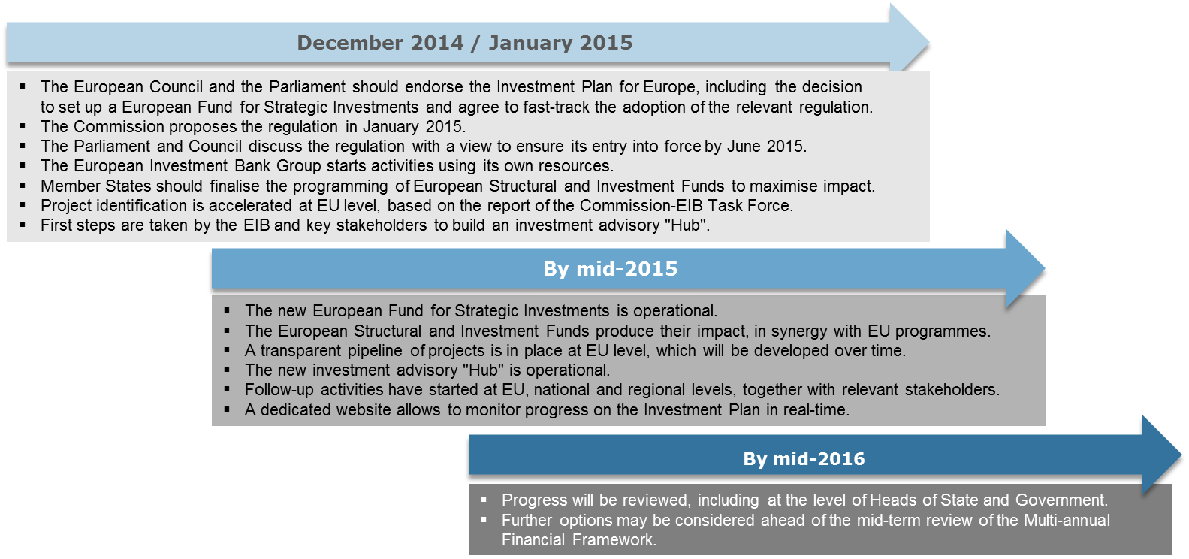

In some Member States, that dip is even more dramatic. This is notably the case for Italy (-25%), Portugal (-36%), Spain (-38%), Ireland (-39%), and Greece (-64%).
As developed by ECB President Mario Draghi in his speech in Jackson Hole on 22 August 2014. See: http://www.ecb.europa.eu/press/key/date/2014/html/sp140822.en.html
Conclusions of the European Council of 23-24 October 2014, p. 8: “The European Council supports the incoming Commission's intention to launch an initiative mobilising 300 billion euro of additional investment from public and private sources over the period 2015-2017” and the G20 Brisbane Action plan, published on 16 November 2014: “Additionally, the European Union in October announced a major initiative mobilising additional public and private investment over 2015-17. We call for swift implementation of [these] packages”. See also speech by ECB President Mario Draghi in Jackson Hole on 22 August 2014, referred to in footnote 2.
In the context of this Plan, companies between 250 and 3000 employees are considered mid-cap companies.
The legal instrument is likely to be a Regulation based on Articles 172, 182, 175(3) and possibly 173 TFEU.
The Commission and the EIB agree that the Fund should be set up within the EIB as a dedicated trust-fund. This will ensure a swift set-up and the Fund will benefit from the funding and expertise in lending and risk management from the EIB's existing structures.
To ensure that infrastructure and project investments supported under this initiative are consistent with state aid rules, projects should address unmet needs (e.g. not duplicate existing infrastructure), crowd in private financing to the maximum extent possible and avoid crowding out privately financed projects. Supported projects should generally be open to all users, including competing operators, on fair, reasonable and appropriate conditions so as to avoid the creation of entry barriers to entry. To maximise the impact of such investments, the Commission will formulate a set of core principles, for the purpose of state-aid assessments, which a project will have to meet to be eligible for support under the European Fund for Strategic Investments. If a project meets these criteria and receives support from the Fund, any national complementary support will be assessed under a simplified and accelerated State Aid assessment whereby the only additional issue to be verified by the Commission will be the proportionality of public support (absence of overcompensation).
COM(2013) 462 final, currently in so-called trilogue negotiations between the European Parliament, the Council and the Commission. Once in force, the Regulation will provide a common EU regulatory framework to enable funds specialising in long term investments, for example in infrastructure projects or SMEs, to operate throughout the EU, with the intention of attracting investors with a longer term investment horizon.
This support shall be compliant with the Commission's State Aid Guidelines on Risk Finance or shall be priced on market terms.
In order to achieve this, Member States are recommended to deliver through innovative financial instruments a specific percentage of the allocations made in their Partnership Agreements to each of the key investment areas as follows: 50% in the field of SME support, 20% in the field of CO2 reduction measures, 10% in the field of Information and Communication Technology, 10% in the field of sustainable transport, 5% in the field of support for Research Development and Innovation and 5% in the field of environmental and resource efficiency. The use of micro-finance facilities to provide preferential loans could also help to promote self-employment, entrepreneurship and develop micro-enterprises.
The SME-Initiative is a financial instrument that pools resources from the Structural and Investment Funds, the COSME and Horizon 2020 programmes, the EIF and the EIB. It provides for two types of products to improve SME-financing: uncapped guarantees to financial intermediaries and securitisation of existing loans portfolios.
Based on what can be done without disrupting the ongoing programming of the Funds, it can be estimated that another EUR 26 bn of additional investment funding could become available over the programming period 2014-2020. This comes in addition to the doubling of the use of financial instruments and is not taken into account in Annex 1.
The European Council of 23-24 October 2014 "welcomed the establishment of a Task Force, led by the Commission and the EIB, with a view to identifying concrete actions to boost investment, including a pipeline of potentially viable projects of European relevance to be realised in the short and medium term."
Securitisation is a financial practice, often used by banks, consisting of pooling and repackaging of various types of contractual debt, as for example residential mortgages. It can be used as a way to fund assets or a means of transferring and diversifying risk.

