Delegations will find attached for information a copy of the above opinion.
__________________________

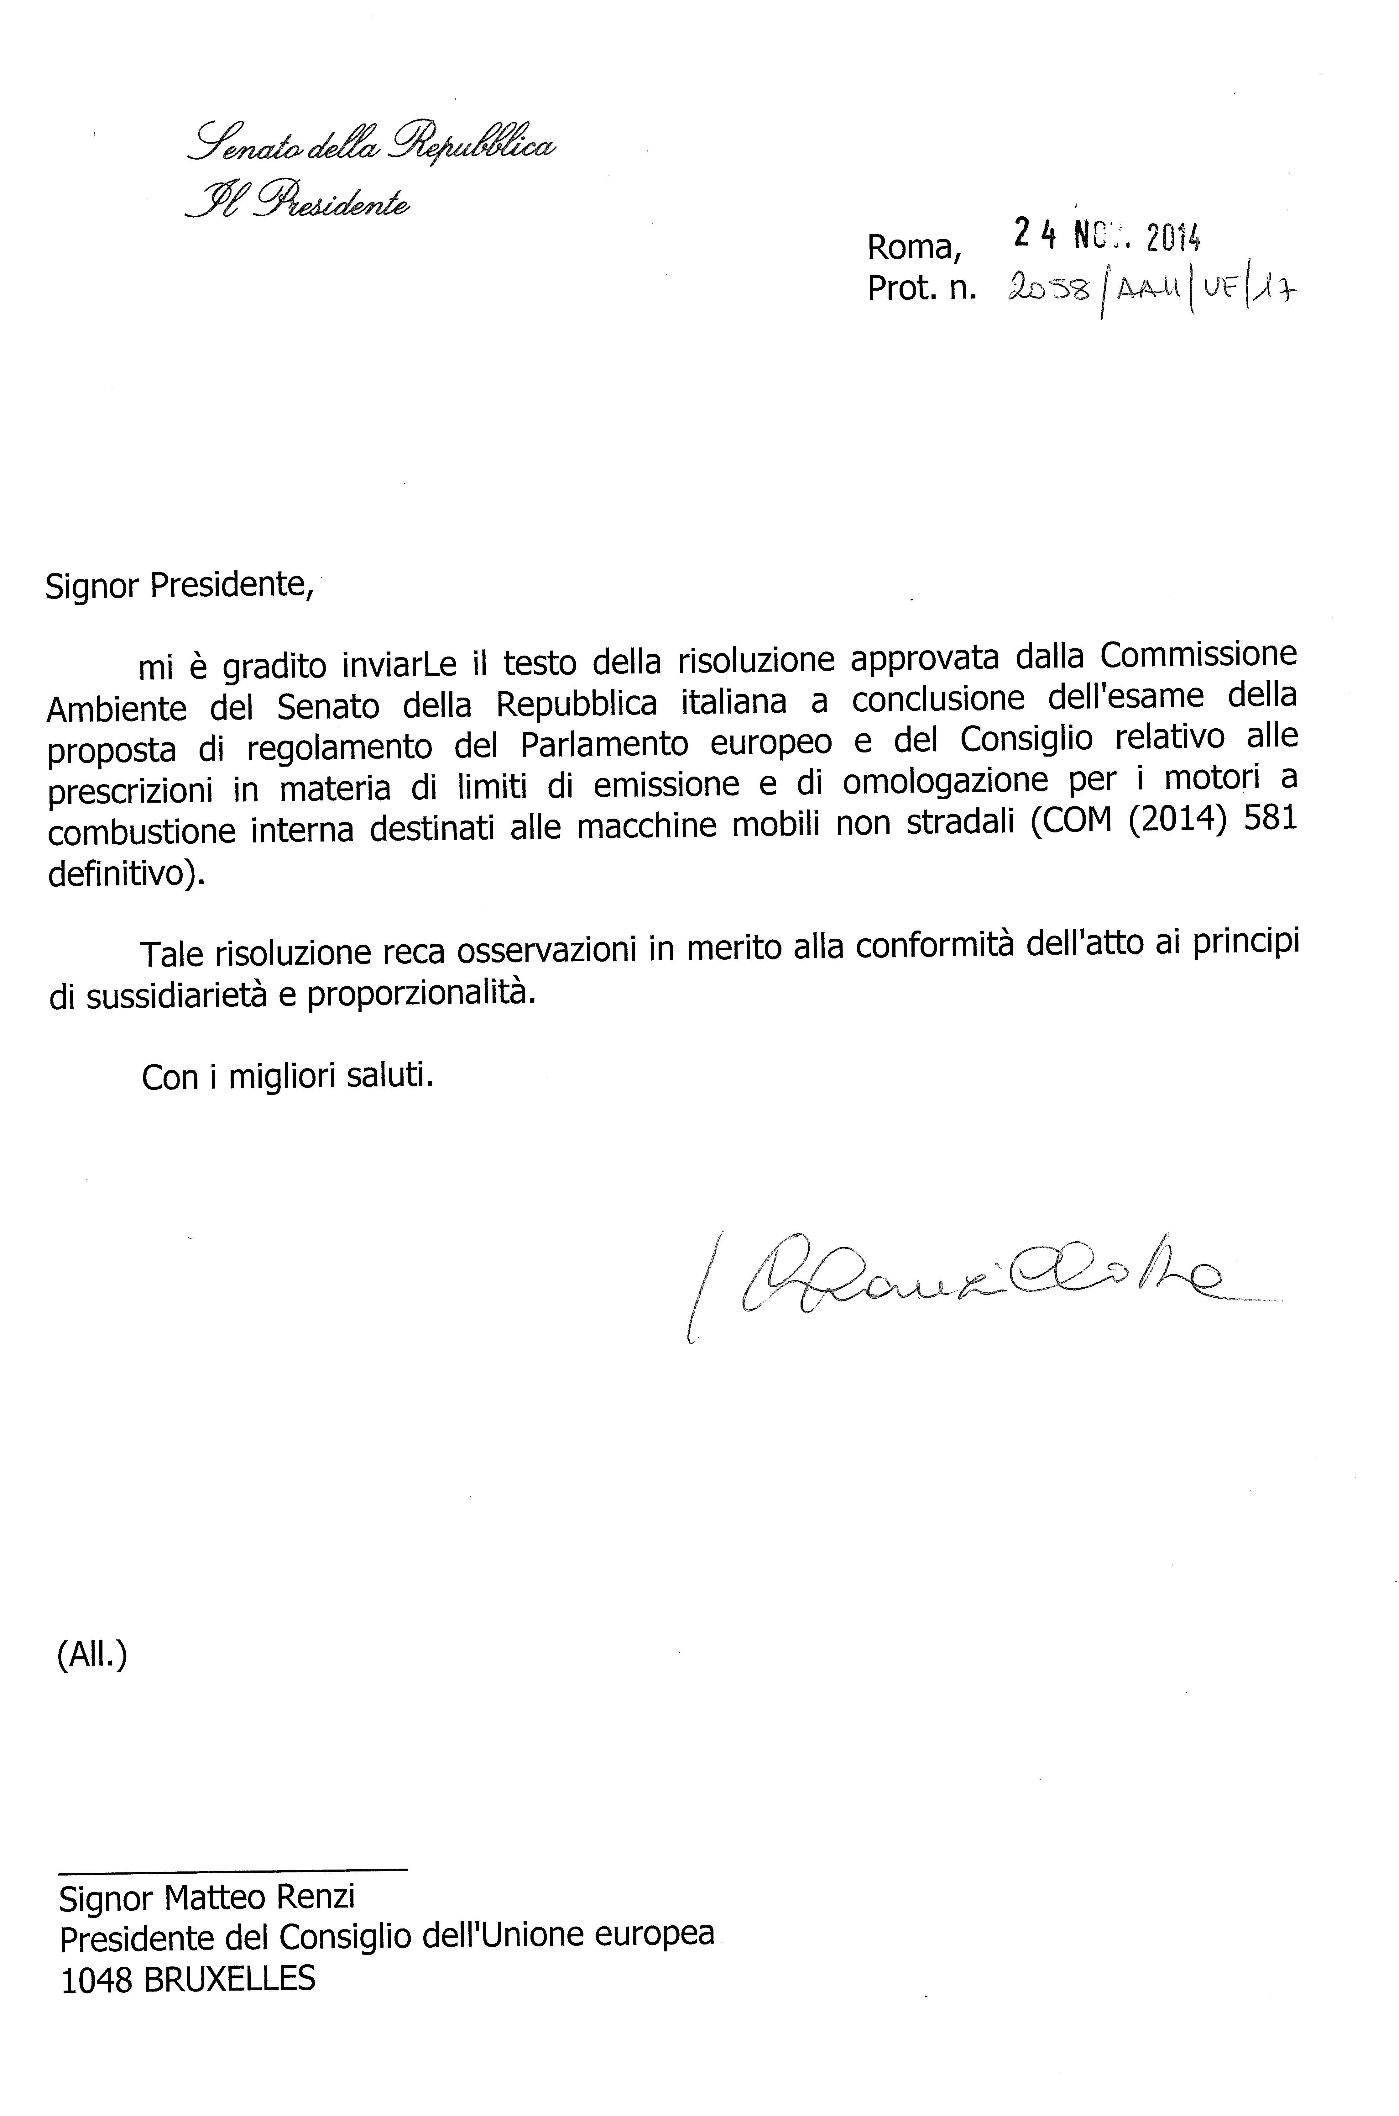

Translation(s) of the opinion may be available on the Interparliamentary EU Information Exchange site IPEX at the following address: http://www.ipex.eu/IPEXL-WEB/search.do

