 | Council of the  European Union
Brussels, 6 November 2014
(OR. en, it)
Interinstitutional File:  2013/0014 (COD)  2013/0015 (COD)  2013/0016 (COD)  2013/0028 (COD)  2013/0029 (COD) |  |  |  | 15076/14  TRANS 506  CODEC 2164  INST 541  PARLNAT 275

COVER NOTE
from: | Italian Senate
Date of receipt: | 4 November 2014
to: | General Secretariat of the Council of the European Union
Subject: | Proposal for a REGULATION OF THE EUROPEAN PARLIAMENT AND OF THE COUNCIL repealing Regulation (EEC) No 1192/69 of the Council on common rules for the normalisation of the accounts of railway undertakings  [doc. 6015/13 - COM (2013) 26 final]  Proposal for a REGULATION OF THE EUROPEAN PARLIAMENT AND OF THE COUNCIL on the European Union Agency for Railways and repealing Regulation (EC) No 881/2004  [doc. 6012/13 - COM (2013) 27 final]  Proposal for a REGULATION OF THE EUROPEAN PARLIAMENT AND OF THE COUNCIL amending Regulation (EC) No 1370/2007 concerning the opening of the market for domestic passenger transport services by rail  [doc. 5960/13 - COM (2013) 28 final]  Proposal for a DIRECTIVE OF THE EUROPEAN PARLIAMENT AND OF THE COUNCIL amending Directive 2012/34/EU of the European Parliament and of the Council of 21 November 2012 establishing a single European railway area, as regards the opening of the market for domestic passenger transport services by rail and the governance of the railway infrastructure  [doc. 5985/13 - COM (2013) 29 final]  Proposal for a DIRECTIVE OF THE EUROPEAN PARLIAMENT AND OF THE COUNCIL on the interoperability of the rail system within the European Union (Recast).  [doc. 6013/13 - COM (2013) 30 final]  Proposal for a DIRECTIVE OF THE EUROPEAN PARLIAMENT AND OF THE COUNCIL on railway safety (Recast).  [doc. 6014/13 - COM (2013) 31 final]  - Opinion on the application of the Principles of Subsidiarity and Proportionality

Delegations will find attached a copy of the above-mentioned opinion.

________________________
ANNEX
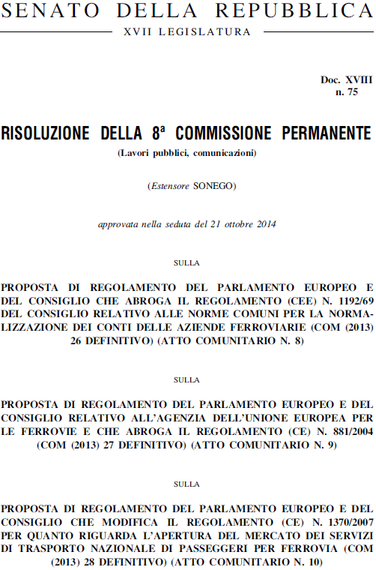
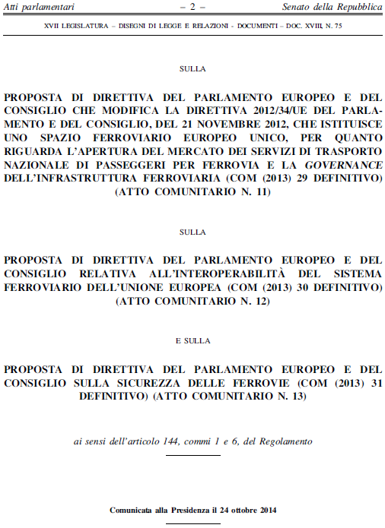

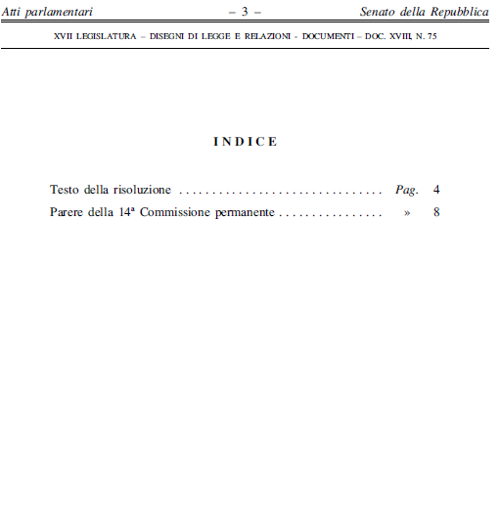

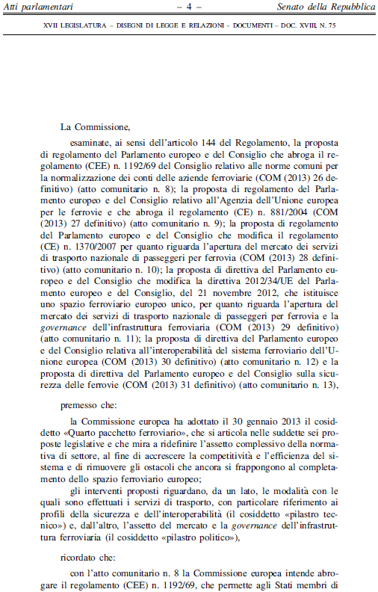
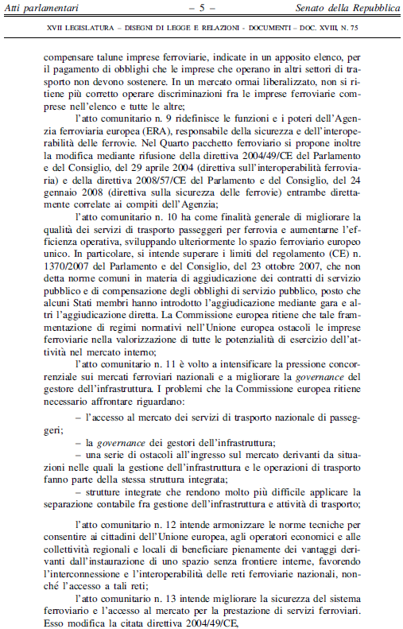
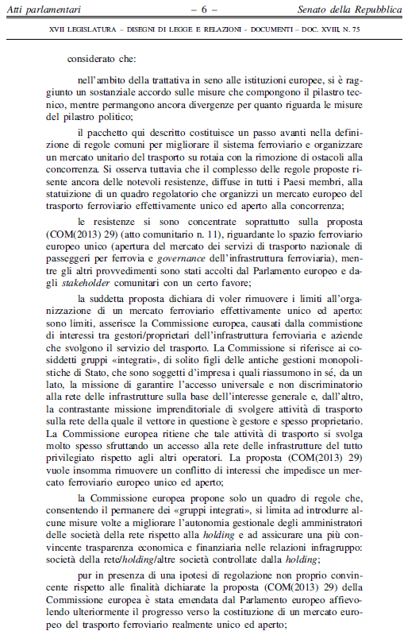
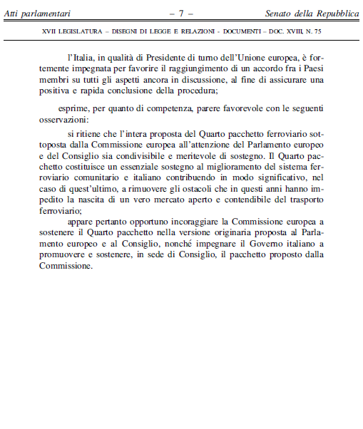
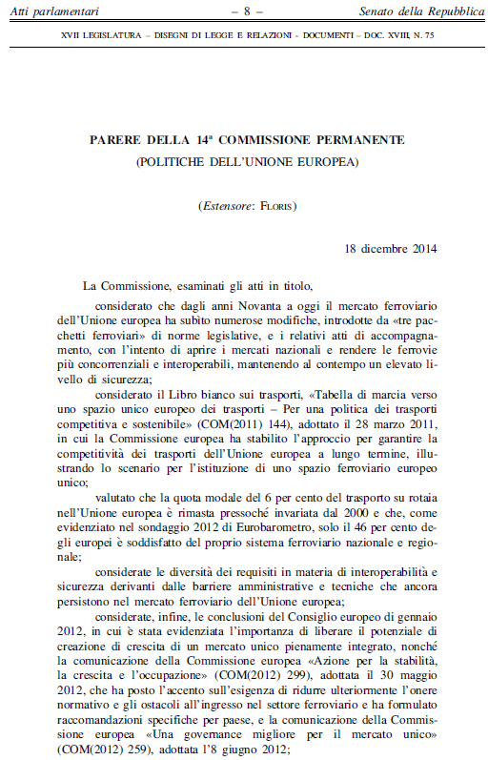
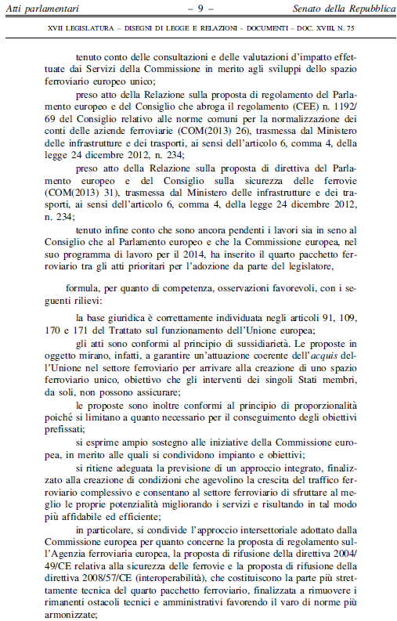
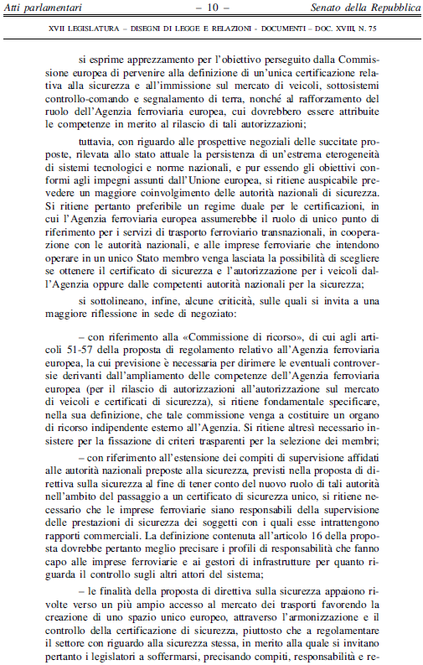
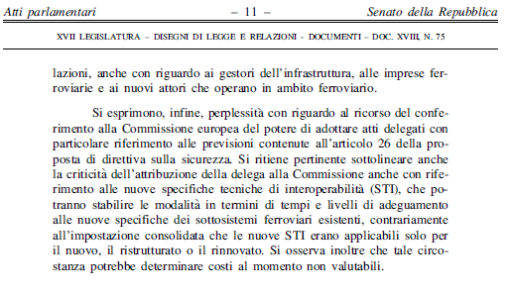

__________________________

Translation(s) of the opinion may be available at the Interparliamentary EU information exchange site IPEX at the following address: http://www.ipex.eu/IPEXL-WEB/search.do

