The draft Joint Employment Report (JER), mandated by Article 148 TFEU, is part of the Annual Growth Survey (AGS) package to launch the 2015 European Semester. As key input to strengthened economic guidance, the JER underpins the key employment messages contained in the AGS. The analysis it contains is based upon employment and social developments in Europe; the implementation of the Employment Guidelines; the examination of the National Reform Programmes (NRP) that led to the Country Specific Recommendations (CSRs) adopted by the Council on 8 July 2014 and on the assessment of their implementation so far.

Employment and social situation continues to cause concern
The Autumn economic forecasts by the Commission are marked by slow growth and high but relatively stable unemployment (24.6 million people). Divergences across countries, particularly in the euro zone, remain high. Even in economies which perform comparatively well unemployment is becoming structural as evidenced by the increasing number of long-term unemployed.
Reforms supporting well-functioning labour markets must continue
Several Member States have pursued reforms, in line with their Country Specific Recommendations. Positive effects from reform are visible for instance in increasing activity rates. However, more investments are needed to stimulate growth and create a positive environment for the creation of decent jobs.

As to combatting youth unemployment, Member States have progressed in the implementation of Youth Guarantees. Further efforts are required, with specific attention for public employment services, tailored active labour market interventions and vocational education and training. Member States should ensure a favourable environment for companies to offer apprenticeships, thus facilitating the transition from education to employment.

Investing in human capital through education and training will increase productivity
Member States have worked to introduce measures aimed at improving skills supply and promoting adult learning. A number of countries took measures to improve their primary, secondary and tertiary education system, while others addressed the overall education strategy. Member States need to continue to reform their VET systems to increase productivity of workers in the light of rapidly changing skills requirements.

Tax and benefits systems should support job creation
Unemployment benefits schemes should be better linked to activation and support measures and further action is needed to increase the integration of long term unemployed into the labour market. Member States should continue, or in some cases step up, measures addressing the challenge of segmented labour markets by simplifying labour law.
Some reforms of tax systems have been initiated so as to reduce disincentives to take on jobs and –at the same time- decrease labour taxation to allow companies (re)hire young and long-term unemployed. Several Member States have addressed wage-setting mechanisms to promote the alignment of wage developments to productivity and to support households’ disposable income, with a particular focus on minimum wages. A few Member States have looked at avenues for job creation through (temporary) hiring, wage or social contribution subsidies targeted to new hires.
Modernisation of social protection systems
Policy reforms of the social protection systems have been introduced. The pensionable age is being raised and gender disparities in pensionable age are being reduced. Member States are opening routes for people to prolong their working lives and improve pension entitlements by deferring retirement. Social protection systems activate those that are able to access the labour market, protect those most excluded from the labour market and shelter individuals from risks in their lifecycles.
Member States are increasing efforts to better target those at higher risk of poverty, in particular for children and the elderly.
In addition, reviews of health care expenditure are promoting ways to increase effectiveness for citizens and improve value for money.

1. LABOUR MARKET AND SOCIAL TRENDS AND CHALLENGES IN THE EUROPEAN UNION

Unemployment is slowly decreasing but remains at high levels in the EU-28. While the unemployment rate decreased by over 2 percentage points between 2004 and 2008, the financial and economic crisis has caused a severe deterioration (Figure 1). Between 2008 and 2013 the (seasonally adjusted) unemployment rate in the EU-28 increased from 7.0% to 10.8%. More recent Eurostat figures show that since then, the unemployment rate has fallen again, to a level of 10.1% in September 2014 (11.5% in the EA-18). This is the lowest level since February 2012 and it is stable compared to August 2014. This rate is equivalent to an absolute number of 24.6 million unemployed, down from 26.4 million on a year before. Looking at developments over time for different groups on the labour market, it can be seen that the youth unemployment rate is structurally above the average rate, and also more responsive to the business cycle. Unemployment rates for the low-skilled are also structurally higher. Older workers have rather low unemployment rates, however for older workers it is generally more difficult to regain employment once unemployed. Unemployment rates for men and women have been almost similar since 2009.
Figure 1: Development of unemployment rates between 2004 and 2013 in the EU-28 (annual data), total, youth, older workers, low-skilled and women
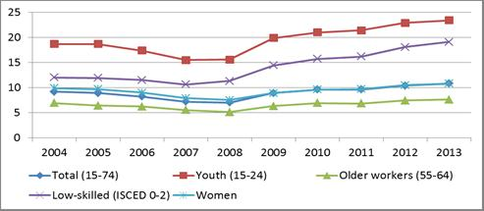
Source: Eurostat
Developments in unemployment across the EU still vary widely, but have stopped diverging further. In September 2014 unemployment rates ranged from 5.0% in Germany and 5.1% in Austria at the one extreme to 24.0% in Spain and 26.4% (July figure) in Greece at the other. Over the last year unemployment decreased in 21 Member States while it remained the same in one country and rose in six. The largest decreases were registered in Spain, Croatia, Hungary and Portugal. There was a further increase in six Member States (France, Italy, Lithuania, Luxembourg, Austria and Finland).
Long-term unemployment is still rising. Between 2010 and 2013 the long-term unemployment rate in the EU-28 has increased from 3.9% to 5.1%. Developments have been particularly negative in Greece and Spain and to a somewhat lesser extent in Cyprus, while significant improvements have been recorded in the three Baltic States. Over the last year long-term unemployment as a share of total unemployment increased further from 45.3% to 48.7% in the EU-28 (47.5% and 51.5% for the EA-18).
Long-term unemployment affects men, young people and low-skilled workers more than other groups on the labour market, and especially hits those that work in declining occupations and sectors. The overall state of the economy remains an important factor in determining changes in the levels and flows to and from long-term unemployment, but there are also strong country-specific effects with some Member States (such as Finland, the Netherlands and Sweden) ensuring high transition rates back to employment in contrast to others, for instance Bulgaria, Greece and Slovakia. In general, one in five of the long-term unemployed in the EU has never worked, and three out of four are young people below the age of 35, creating risks of marginalisation.
Figure 2: Long-term unemployment rates in % of the active population, EU-28 and Member States, 2010 and 2013
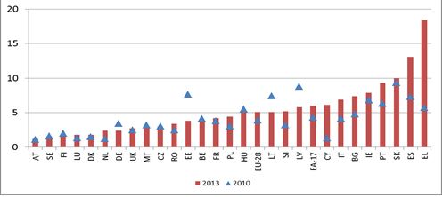
Source: Eurostat

Youth unemployment remains at very high levels, but is showing signs of improvement. In September 2014 the youth unemployment rate (15-24 years) in the EU-28 stood at 21.6%, down by 1.9 percentage points on the year before. There is a wide dispersion between Member States, with figures ranging from 7.6% in Germany and 9.1% in Austria to 50.7 (July 2014) % in Greece and 53.7% in Spain. Meanwhile the divergence has stopped growing, but it remains large.
The proportion of young people (15-24) not in employment, education or training (NEET) has remained high, even though nearly 70% of young people in the EU were in education in the first quarter of 2014. In many Member States NEET rates are considerably above the lowest levels recorded since 2008 and still close to the upper bounds. This is particularly true for some Member States with the highest rates such as Bulgaria, Cyprus, Greece, Spain, Croatia, Italy and Romania.. Rather low – and improving – rates can be found in Austria, Germany, Denmark, Luxembourg, the Netherlands and Sweden. In 2013 the levels remained above 10% in a great majority of Member States. NEET rates are somewhat higher for females than for males: in 2013 the rates were 13.2% and 12.7% respectively (total 13.0%). The NEET phenomenon is primarily due to an increase in youth unemployment, but also to non-education linked inactivity. In some Member States (Bulgaria, Romania and Italy) inactive NEET rates exceed 10%.
Early school leaving levels are gradually going down, making progress towards the target of less than 10% school drop-outs by 2020. Early school-leaving (ESL) stood at 12.0% in 2013, down from 12.7% a year earlier, with males (13.6%) being more affected than females (10.2%). ESL remains a serious problem though, as it concerns about 5 million people, over 40% of whom are unemployed. In 2013 in 18 Member States the rate was lower than the Europe 2020 target of 10%. ESL was highest in Spain and Malta with rates over 20%.
Europe is making good progress towards the target of achieving a tertiary or equivalent attainment rate of at least 40% by 2020. In 2013 tertiary education attainment stood at 36.9%, which is 1.2 percentage points higher than a year earlier. The highest rates (above 50%) can be found in Ireland, Lithuania and Luxembourg. Across the EU, more women (39.9%) than men (31.5%) finish tertiary education.
Figure 3: NEET rates for the EU-28 and Member States in the second quarter of 2014 and the highest and lowest values since 2008
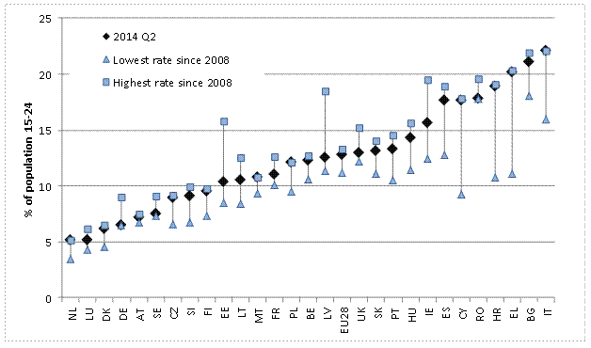
Source: Eurostat (LFS; data non-seasonally adjusted, average of 4 quarters to 2014Q2, DG EMPL calculations)
Activity rates have withstood the crisis years well in most Member States, mainly because of increasing activity rates among older workers (aged 55-64) and women. Between 2008 (Q1) and 2014 (Q1) the EU-28 activity rate for the population aged 15-64 went up from 70.3% to 72.0%, although there was considerable cross-country variation. Activity rates increased most strongly in the Czech Republic, Hungary, Lithuania, Luxembourg, Malta and Poland, while the largest decreases were witnessed in Denmark (but from a very high level) and Ireland. Although female activity rates have improved over time there is still a considerable gap as compared with those for men: 11.7 percentage points in the first quarter of 2014 (the corresponding rates for men and women were 77.9% and 66.2% respectively). Gender gaps in activity rates are particularly high in Greece and Italy. Some other countries such as Austria, Germany and the Netherlands show high female activity rates and they are characterised by widespread part-time employment for women.
The EU employment rate continues to show a negative trend and a strong reversal would be needed to reach the Europe 2020 headline target of 75% for men and women aged 20-64. Since the onset of the crisis the employment rate in the EU-28 has gone down by almost 1.5 percentage points, from a peak in 2008 to 68.4% in the first quarter of 2014. Developments across Member States have been quite different (Figure 4). Between the first quarters of 2008 and 2013, employment growth was particularly negative in several Southern European countries, the Baltic states, Bulgaria and Ireland. Strong increases have been recorded in Luxembourg and Malta and to a lesser extent in Germany. Over the last year developments have been more moderate, with employment increasing also in several countries that performed badly in the years before.
Developments in employment have not been evenly distributed. While employment rates for men (20-64) have decreased by more than 3 percentage points between the first quarters of 2008 and 2014 (from 77.4% to 74.0%), female employment went down only marginally and has even increased somewhat over the last year (by 0.8%). Increases have been quite substantial for older workers (6.2 percentage points since the first quarter of 2008 to reach 50.9% at the beginning of 2014, with sizeable increases in Belgium, Germany, France, Hungary, Italy, Luxembourg, the Netherlands and Poland), in particular older women (8.4 percentage points). As for education levels, decreases in employment have been largest for the lower-skilled and more or less similar for medium and high-skilled individuals. The employment rate of third-country nationals (20-64) in the EU-28 declined from 62.4% to 55.4% between the first quarters of 2008 and 2014. As far as employment trends by sector are concerned, the share of the services sector continues to increase, at the expense of employment in both industry and agriculture. Currently the shares are roughly 72.5%, 22.5% and 5%. Although the crisis years have been detrimental for permanent employment, the greatest burden of adjustment fell mainly on temporary jobs (non-renewal). Finally, full-time employment has decreased by roughly 8.1 million between the first quarters of 2008 and 2014. Conversely, there has been steady growth in part time jobs in recent years, with 4 million more since the first quarter of 2008.

Figure 4: Employment growth (number of persons employed, aged 20-64) since 2008q1, by Member State
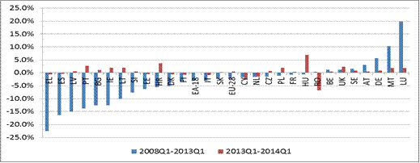
Source: Eurostat, DG EMPL calculations

Employment is likely to improve slightly in the future, mainly as a result of projected GDP growth. Over the medium term, several trends will lead to further jobs growth, in particular in certain areas. Technological progress will create jobs in the ICT sector (900,000 unfilled ICT practitioners' vacancies are expected by 2015), while ageing, despite present and future constraints on public healthcare budgets, is likely to increase the demand for health workers and health-related services in the medium term. Furthermore, the greening of the economy may lead to an increase in green jobs. Other high-tech-reliant sectors such as the transport industry will also require substantial hiring of medium- to high-skilled workers, to accommodate the growth recorded in aviation and passenger transport and the high percentage of older staff expected to leave the transport sector by 2020.
Small- and medium-sized enterprises are traditionally seen as the engine of employment growth, with some research showing that between 2002 and 2010, 85% of new jobs in the EU were created by SMEs. By contrast, between 2010 and 2013, employment in SMEs in the EU fell by 0.5%. When excluding the construction sector, which employed one in seven SME workers in 2008, this turns into a slight increase of 0.3%, but this is dwarfed by a 2% rise among large firms.
To date and in many Member States, credit availability to the non-financial sector remains weak, due to both supply and demand factors including sector restructuring and deleveraging that followed the financial crisis. Moreover, bank lending interest rates in the vulnerable Member States remain high despite recent ECB actions, mainly affecting SMEs. Limited access to finance is also likely to curb the number of start-ups which is of concern given the evidence that, among SMEs, young firms account for a major share of net job growth. The lack of dynamism in the employment record of SMEs since 2010 shows the potential employment impact of appropriate solutions to financial sector problems. Policies supportive of business start-ups also come with a significant employment impact.
Segmentation on the labour market continues to be considerable in several Member States. Youth employment is characterised by high shares of both temporary and part-time employment, at 42.4% and 31.9% (of total employment) respectively in the first quarter of 2014. In comparison, in the total working population the share of temporary and part-time employment was much lower, at around 13% and 19% respectively. Women are overrepresented in part-time work. In the first quarter of 2014 the incidence of part-time work for women was 32%, as compared with 8.3% for men, with Austria, Belgium, Germany, the Netherlands and the United Kingdom all having shares of more than 40% of women working part-time. In the current macroeconomic context temporary and part-time jobs, involuntary to some extent, may contribute to job creation and in the medium to long run they may act as a stepping stone to permanent and/or full-time contracts (e.g. for youth). Segmentation can also be seen from persistent gender pay gaps and low transition rates from less to more protected contractual forms of work.
Labour market matching has worsened in several Member States. While the number of vacancies has remained relatively stable over the last few years on average, unemployment has increased, hinting at a deterioration in labour market matching. The Beveridge curve (Figure 5) suggests that structural unemployment has been rising since around mid-2011. Looking at developments across Member States, labour market matching has deteriorated in the majority of Member States, with the notable exception of Germany in particular. The overall negative development is driven mainly by negative labour demand shocks as well as growing skills mismatch, indicating that the lack of labour market opportunities associated with the economic crisis is producing hysteresis effects which need to be counteracted by investments in human capital and more effective matching.
Figure 5: Beveridge curve, EU-28, 2008q1-2014q1
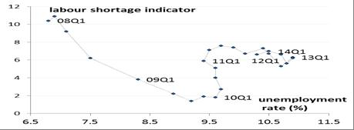
Source: Eurostat; Note: LSI (vertical axis) stands for "labour shortage indicator", derived from EU business survey results (% of manufacturing firms pointing to labour shortage as a factor limiting production); UR stands for "unemployment rate".

The growing number of unemployed during the crisis, the increasing share of long-term unemployed and the resulting decrease in matching efficiency pose serious challenges to active labour market policies (ALMPs) and public employment services (PES).
Intra-EU labour mobility remains limited, especially in proportion of the overall size of the EU labour market. While one out of four EU citizens say they would consider working in another EU country in the next ten years, until 2013 only 3.3% of the EU economically active population resided in another Member State. Cross-country differences are quite sizeable though (Figure 6). Due to substantial differences in unemployment rates between EU Member States, the rising number of persons wanting to move has partly materialised in increased mobility since 2011 but only to a limited extent and not as much as would be needed to have a real equilibrating role against the huge imbalances across EU labour markets.
Figure 6: Mobility rate by Member State by years of residence, 2013
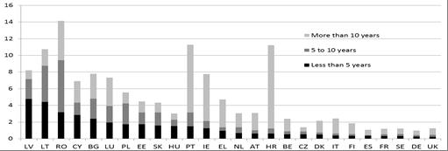
Source: "Key Features", DG EMPL; Notes: The mobility rate is the number of working-age citizens living in another Member State in 2013, as a percentage of the working-age population of the country of citizenship. Figures for MT and SI are too small to be reliable. Figures for CY, DK, EE, FI, LU and SE are not reliable due to the small size of the sample.

The supply of skills needs to be further improved. Several trends, in particular globalisation and (skill-biased) technological change, have led to gradual changes in the relative demand for different skill levels. In addition, there has been a change in the relative importance of different skill types, with both ICT-related skills and 'soft skills' such as communication skills becoming more important for a large number of occupations.
Even though over time average education levels have increased, the skills that workers possess have not kept pace with skills demand. As a result of these changes in the relative demand for and supply of skills, employment opportunities for the high-skilled are better than for the medium- and low-skilled. Labour market forecasts confirm this trend for the coming years.
Europe's growth potential is threatened by structural weaknesses in its skills base. Recent data show that about 20% of the working-age population have only very low skills, and in some countries (Spain, Italy) this proportion is even higher. Only a few countries (Estonia, Finland, the Netherlands and Sweden) have a high proportion of people with very good skills and most European countries do not come near the top-performing countries outside Europe (such as Japan or Australia). The data on government spending confirm an increasing risk of investment gaps in human capital. Europe is not investing effectively in education and skills, which poses a threat to its competitive position in the medium term and to the employability of its labour force. Nineteen Member States have reduced education expenditure in real terms and 14 Member States have reduced the relative share of GDP that they invest in education.
Wage developments have started to accommodate rebalancing needs. In the run up to the crisis several Member States witnessed sizeable increases in their nominal unit labour costs, notably Latvia, Romania and to a lesser extent Estonia, Lithuania, Bulgaria and Ireland (Figure 7). In response to the crisis nominal unit labour cost developments in these countries have been much more moderate since 2009, with the exception of Bulgaria, and have in fact turned negative in Ireland, Lithuania and Latvia, and just above zero in Romania. Also in Greece and Spain nominal unit labour costs have decreased after the crisis, following increases in the years before. Germany shows a different pattern as it is the only Member State where nominal unit labour costs decreased (albeit slightly) before the crisis, to increase in more recent years. Moderate nominal unit labour cost developments (more strongly before the crisis) were also seen in Belgium, Sweden, the Netherlands, Austria and Finland in particular. The trend reversals in "troubled" Member States on the one hand and "surplus countries" on the other have been supportive of external rebalancing, which was needed in particular within the Euro Area. It is important that wage developments continue to be consistent with the need to adjust external imbalances and reduce unemployment and in the long run match productivity gains. If sustained, recent wage increases in surplus countries may strengthen overall deficient aggregate demand.
Figure 7: Nominal unit labour cost developments in the EU-28, average year-on-year changes, 2003-2008 and 2009-2013
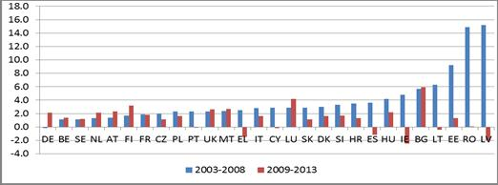
Source: Eurostat, DG EMPL calculations
Unit labour cost reductions and wage moderation have fed only slowly and incompletely into lower prices. Partly, this incomplete pass-through can be explained by simultaneous hikes of indirect taxes and administered prices due to fiscal consolidation. Nominal unit labour cost reductions in the face of sticky prices have led to decreases in labour income shares in several Member States, in particular Greece, Spain, Ireland and Portugal. The resulting increase in profit margins has not (yet) been fully accompanied by an increase in investments.
The tax wedge remains high in many Member States. A high and in some cases increasing tax wedge, especially for low-wage and second-income earners, remains an important issue in a considerable number of Member States. To illustrate, in the case of low-wage earners (67% of the average wage), a fall in the tax wedge between 2008 and 2010 in most countries was followed by an increase in the three subsequent years in nearly all Member States. The 2013 levels ranged from 20% or less in MT (2012) and IE to more than 45% in Belgium, Germany, France and Hungary.
Changes in the total tax wedge have been driven mainly by personal income tax (PIT), where increases can be seen for 15 out of 21 Member States (Figure 8). Increases in PIT (at least for this particular type of household and at 67% of the average wage) have been particularly large in Portugal and Hungary, while it has decreased quite substantially in the United Kingdom and Greece. Taking PIT and employees' social security contributions together, the burden on employees has increased in 10 Member States, while this is less true for employers (3 countries with increases in the tax burden). Overall the level of employers' social security contributions has remained more or less stable in most Member States, with a few exceptions; there were relatively strong increases in Poland and Slovakia, while at the same time the level decreased quite considerably in France.
Figure 8: Change between 2011 and 2013 of the total tax wedge by components (67% of the average wage, single person, no child)
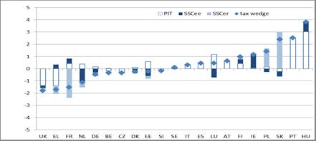
Source: EC-OECD tax and benefits database; Note: Data for non-OECD countries (BG, CY, HR, LV, LT, MT and RO) are not available.

Fighting undeclared work is a challenge in some Member States. Undeclared work covers a variety of activities ranging from undeclared work in a formal enterprise to clandestine work by own account workers, but excludes those involving illegal goods or services. Undeclared work has several negative implications. From a macroeconomic perspective, it decreases tax revenues (income tax and VAT) and undermines the financing of social security systems. From a microeconomic perspective, undeclared work and other atypical forms of employment such as bogus self-employment tend to distort fair competition among firms, paving the way for social dumping inhibiting the creation of regular employment with full social protection. It also causes productive inefficiencies, as informal businesses typically avoid access to formal services and inputs (e.g. credit) and do not grow. Although fully reliable figures on the extent of the shadow economy and undeclared work are not readily available, rough data do indicate that the issue poses a challenge in some Member States. Moreover, the scope of undeclared work might be growing because of several socioeconomic trends such as sectorial reallocation and internationalization of the economy, reduction in standard forms of work, and social distress in some MS.

While economic developments generally affect different sections of the population in different ways, the levels of inequality increased in many Member States. While the S80/S20 ratio remained stable between 2008 and 2013 in the EU on average, there is a wide dispersion and growing divergence in inequality between Member States (Figure 9). The inequality has grown in most of the Southern Member States (Spain, Greece, Italy and Cyprus) as well as in Croatia, Estonia, Denmark and Hungary and slightly in Ireland and Austria. Despite recent improvements, inequality also remains a particular concern in Bulgaria, Greece, Latvia, Romania, Spain and Lithuania (see also Figure V in Chapter 3).
Figure 9: Inequality of income distribution (S80/S20; income quintile ratio), 2008-2012
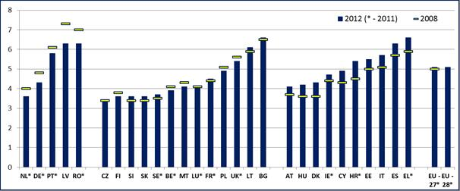Source: Eurostat, EU-SILC 2013; referring to the income year 2012. Note: * - 2011 data (data for 2012 are not available yet for BE, DE, IE, EL, FR, HR, LU, NL, PT, RO, SE, UK).

The at-risk-of-poverty and social exclusion (AROPE) rate increased significantly, with growing divergences between Member States. Between the beginning of the crisis in 2008 and 2012, the number of Europeans at-risk-of-poverty or social exclusion increased by a worrying 8.7 million (excluding Croatia), to 25.1% of the EU-28 population in 2012 (Figure 10)).
Figure 10: Developments in the at-risk-of-poverty or social exclusion rates (AROPE), 2008-2012
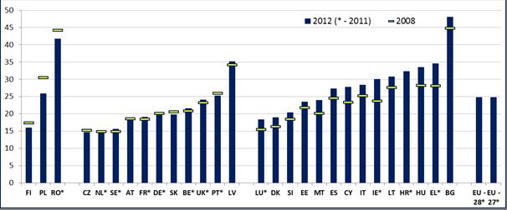
Source: Eurostat, EU-SILC 2013; referring to the income year 2012. Note: * - 2011 data (data for 2012 are not available for BE, DE, IE, EL, FR, HR, LU, NL, PT, RO, SE, UK).

The developments in poverty levels vary substantially depeneding between age cohorts. Overall, the working age population has been most affected by the crisis (Figure 11; also Figure IV in Chapter 3),mainly due to increasing levels of unemployment or low work intensity households and in-work poverty. In 2012, approximately 50 million people of working age lived on less than 60% of the national equalised median income in the EU-28, and 31.8 million (31,5 million in 2013) suffered from severe material deprivation. 10.9% of the population aged 18-59 lived in a jobless household in 2012.
Figure 11: Development of at-risk-of-poverty or social exclusion rates (AROPE) since 2005 in the EU-28, total, children, working-age population and elderly
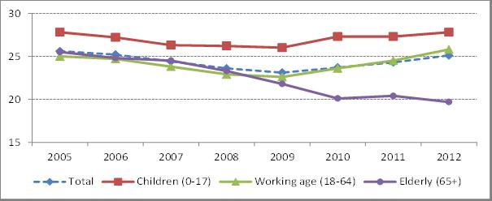Source: Eurostat, EU-SILC. Note. EU-27 average for 2005-2009; EU-28 average for 2010-2012. 2103 SILC-Data not available yet.

Older people (65+) have been relatively less affected as their risk of poverty or social exclusion has declined in most Member States with women still more affected by old-age poverty than men. However, these relative improvements do not necessarily reflect a change in the real income situation of the elderly, but result primarily from the fact that pensions being largely unchanged while income levels for the working age population have stagnated or dropped.
Children have been experiencing an increasing risk of poverty or social exclusion since 2008 as the situation of their (mostly working-age) parents worsened. It has been the case in more than 20 Member States as compared to 2008, with single parent households facing a risk of poverty and social exclusion (EU-28: 47.8% in 2012) that is more than twice as high as for families with two adults (24.4%). The substantially higher risk of poverty among single parent households is found across all Member States ranging from 35% in Slovenia, Finland and Denmark to 78% in Bulgaria. Similarly, families with three or more children face considerably higher risks of poverty or social exclusion (EU-28: 30.9%) than the population as a whole. Working-age men have been more directly hit by the deterioration of labour market conditions in the crisis. However women still face a higher risk of (persistent) poverty or exclusion than men due to care related periods of inactivity and (voluntary or involuntary) part-time work.
The risk of poverty and social exclusion in 2012 was much higher (48.9%) for third-country nationals (aged 18-64) than for the nationals (24.3%); an increase of over 3 pps between 2012 and 2013.
On average in the EU, growth in the gross disposable household income (GDHI) had improved in real terms by the end of 2013, after nearly four years of continuous declines (see also Chapter 3 for a more discussion on the developments in gross household disposable income). This was due to an increase in market incomes (compensation of employees, compensation of self-employed and property incomes), supported by an increase in social benefits transferred to the households. It remains to be seen if the 2013 improvement will be sustained, as jobs creation is still modest, the impact of tax-benefit systems remains weak and the very latest data from 2014 show another decline (Figure 12) .
Figure 12: Contributions of components to the growth of gross disposable income of households (GHDI)
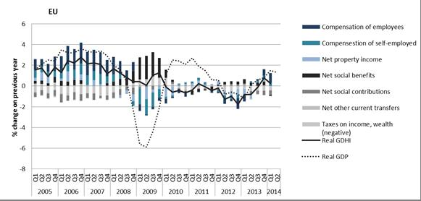
Source: Eurostat – Sectoral accounts

The distributional impacts of changes in tax and benefit systems over latest years varied substantially across countries Depending on their design, changes in tax and benefit systems impacted differently on high and low-income households. In a few countries regressive impacts put an additional strain on the living standards of low-income households in particular. Other Member States, through more careful attention to the distributional profile of their changes in tax and benefit systems, managed to avoid disproportionate effect on low income households. Such differences in distributional impacts occurred independently of the differences in the overall size of the adjustments.
Overall, after a peak in 2009, social expenditure growth rates have been negative since 2011. In the early phase of the crisis (until 2009), the rise in social expenditure was driven mainly by unemployment expenditure, but also, to a lesser extent, by other functions (notably pensions and health). Social expenditure growth weakened in 2010, reflecting a combination of fiscal stimulus measures expiring and the standard path of phasing out automatic stabilisation in countries experiencing recovery. Since 2011, social expenditure in particular on in-kind benefits and services declined, despite the further deterioration of the economic and social conditions (Figure 13)..
Figure 13: Contributions to growth in real public social expenditure in EU of cash and in-kind benefits (2001 – 2012)
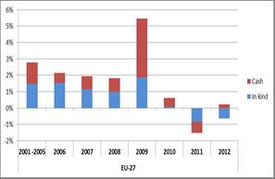
Source: National accounts, DG EMPL calculations;

The structure of social protection spending has also been altered by the crisis. Between 2007 and 2011, (real) social protection expenditure per inhabitant has increased by 8 per cent in the EU-27 (Figure 14). The strongest contributions to the increases have occurred in the areas of pensions (increasing old age & survivors benefits accounted for 44% of the total increase) and health and disability (32%). The differences across Member States are thereby substantial, as between 2007-2011 the rise in total social protection spending per inhabitant was below 5% in four Member States, while increases amounted to more than 15% in seven Member States.
Figure 14: Changes in social protection expenditure per inhabitant between 2007-2011; by social protection function
Note: contributions by function to the overall growth of social expenditure (per inhabitant at constant 2005 prices); Source: ESSPROS

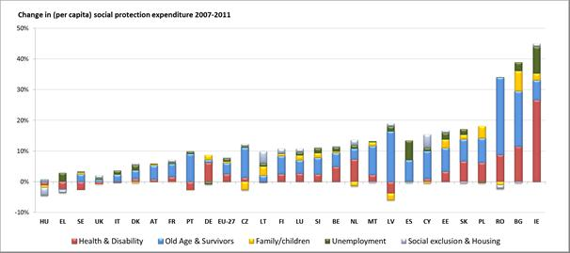
In some Member States, people in vulnarable situations and with low-income continued to experience difficulties in access to healthcare. While from 2008 to 2012 for the EU-27 as a whole the proportion of people in the poorest income cohort who reported unmet needs for health-care increased only moderately, significant increases were registered in countries such as Finland, Portugal and Greece (see Figure 15). The highest level of unmet needs for health-care in 2012 was reported in Latvia, Bulgaria and Romania. While the highest decrease was in Bulgaria (by -11.4 pp from 2008 to 2012), the proportion of people with unmet need for health-care in 2012 remained significant (16,9%).
Figure 15: Unmet need for health-care, poorest income quintile, 2008-2012
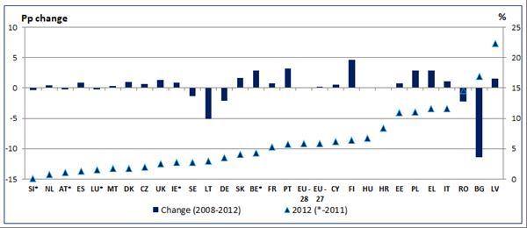
Source: Eurostat EU-SILC 2012. Note: Unmet need for health-care: too expensive, too far to travel or waiting list. * - 2011 data (data for 2012 are not available for BE, IE, LU and AT; data for 2008 are not available for HR and EU-28).
2. IMPLEMENTING THE EMPLOYMENT GUIDELINES: EMPLOYMENT AND SOCIAL POLICY REFORMS

This section presents an overview of reforms and measures introduced by Member States in the past 12 months. The Employment Guidelines offer stable policy guidance to Member States on how to respond to employment and social challenges against the background of current trends and with a view to reaching the Europe 2020 objectives (as presented in Section 1). The 2014 Annual Growth Survey set out the priorities and policy guidance for Member States submitting their National Reform Programmes in the framework of the 2014 European Semester. The National Reform Programmes were reviewed accordingly and the Council, on the basis of the Commission's proposals, issued country-specific recommendations. The Employment and Social Protection Committees review the Member States' performance and progress in responding to relevant challenges through the application of the Employment Performance Monitor (EPM) and the Social Protection Performance Monitor (SPPM). The subsequent policy reforms will be assessed in the context of the 2015 European Semester.

The European Social Fund supports efforts to achieve the Europe 2020 objectives through actions to fight unemployment, with a special focus on youth, offering traineeships and apprenticeships for re-skilling and up-skilling and supporting education actions to fight poverty and social exclusion, as well as promotion of administrative capacity building. For the 2014-20 programming period the close alignment of the ESF and other European Structural and Investment Funds to the policy priorities of the Europe 2020 Strategy together with the Funds' results -oriented focus will reinforce their role as financial pillars of the Strategy.

Reforms have been undertaken in all the areas described in the following sections. However, the degree of progress varies across policy areas and between Member States. Further efforts are thus needed, even though in many cases the full effects of the reforms are not yet visible as they typically take time to materialise. Also the 'value' of reforms cannot typically be judged in isolation as several reforms may be undertaken at the same time. Member States should therefore take relevant trade-offs into account when designing policies and reforms.

The box below presents an overview of prevailing gender gaps on the labour market and reforms that can support progress towards gender equality and that are further explained under each respective guideline.
Gender equality: Labour market is still marked by significant inequalities
While progress has been made, wide gender gaps are still prevailing. The employment rate for women remains well below that of men (62.8% versus 74% at the beginning of 2014). The gap in full-time equivalent employment is even wider (18.3 pp in 2013). Moreover, women are paid 16% less per hour of work. The gender gaps in employment, in number of hours worked and in pay add up and lead to a wide gender total earnings gap (37% across the EU). As pensions reflect earnings throughout life, the gender gap in pensions is also wide (39% on average). The at-risk of poverty or social exclusion for those over 55 is higher for women in all Member States
Access to affordable and quality childcare services, long-term care services and out-of school care, flexible working arrangements as well as adequate leave policies continue to play a crucial role in sustaining women's employment and helping men and women to reconcile work and family life. While a majority of Member States made progress towards the Barcelona targets on childcare provision since 2005, only nine Member States met the objective of 33% coverage rate for children under three years of age in 2012 and eleven met the objective of 90% coverage rate as regards children between three years old and the mandatory school age. Tax benefit systems in some countries continue to discourage women to take up work or work more, in particular by providing disincentives for second earners to work full-time.
Labour market segregation and gender stereotypes can impede men and women to realise their full potential and lead to suboptimal matching of skills and jobs. Women now outnumber men in education and training but remain overrepresented in fields of study that are linked to traditional roles, such as health and welfare, humanities and teaching, whereas areas such as science, technology, engineering and mathematics (STEM) are still male-dominated.
Action was undertaken to foster female employment rates and to reconcile work and family life, however differing in scope and ambition across the EU. The measures taken by Member States aim e.g. at (continuing to) increase the availability of childcare facilities, and/or amending the parental leave regulations or flexible working time arrangements. Fewer initiatives were registered aimed at reducing the gender pay gap or reducing fiscal disincentives for women to stay/enter the labour market. Some Member States took measures to combat child poverty or adapt the benefit system with a view to supporting (low-income) families/parents. While in many countries a (gradual) equalisation of pensionable ages between men and women is foreseen, in some cases, steps have also been taken with regard to foster older women's participation on the labour market or adapting accumulation of pension entitlements.

2.1 Employment Guideline 7: Increasing labour market participation and reducing structural unemployment

The process of modernization of employment protection legislation continued in a number of ways in Member States to promote employment dynamism and combat segmentation. Croatia adopted the second stage of its labour law reform through a new Labour Act facilitating the use of flexible types of work contracts, including part-time, seasonal and temporary agency work, relaxing legislation on working time and simplification of dismissal procedures. Following the comprehensive social partners’ agreement, the Netherlands is in the process of implementing the simplification of dismissal procedures, capping the amount of severance pay with a linkage to seniority rather than age, while tightening rules on temporary work to prevent labour market segmentation and reforming the unemployment benefit system. Spain simplified contract templates for firms, clarified collective dismissal procedures and promoted part-time work through contributory incentives and increased flexibility in using complementary hours. Italy relaxed the conditions for companies to use fixed-term and apprenticeship contracts, while a further comprehensive reform to employment protection legislation and ALMP is in its legislative stage in the parliament. Slovakia limited the duration of work performed outside a core employment relationship to one year, so called work agreements.,
The ability of MS to significantly increase the employment rate of women depends to a large extent on the availability of high quality and affordable childcare. OECD evidence confirms that childcare is a key driver for women's labour market participation. Several countries continued measures implemented in previous years and/or made additional funding for childcare available (Austria, Germany, Ireland, Malta, Poland), whereas others recently prepared steps to put in place new legislation or projects (the Czech Republic, Slovakia). Malta started as of April 2014 a free and universal childcare offered to families where both parents are working. Childcare is available during the parent/s work hours as well as an extra hour a day for commuting. Furthermore, the 2014 Budget envisaged a free-of charge service for children in kindergarten and state primary schools that will be offered during school days to employed parents who wish to take their children to school an hour before school starts. In the Czech Republic, the law on child groups, that has been delayed for several years and aims at easing the creation of child care centres outside of the public kindergarten network, has been approved by parliament.
In a number of countries measures have been taken to make working arrangements more flexible or amend the parental leave regulations (the United Kingdom, Spain, Poland, Germany and Finland). In the United Kingdom the right to request flexible working was extended to all employees as from 2014. As part of the amendment of the act on employment promotion and labour market institutions, as from 2 May 2014 in Poland a grant for teleworking – for the employment of unemployed parents returning to the labour market (bringing up at least one child under 6) or those who resigned from work to care for other dependants – was introduced. In Italy, as part of the currently discussed "Jobs Act" measures have been proposed on amending maternity leave. In Germany, the reform on the parenting benefit that will come into force in January 2015 incentives both parents to share childcare and work.
In a fewer number of cases initiatives addressed reducing the gender pay gap. In Austria equal pay reports are compulsory for companies with more than 250 employees since 2013 and with more than 150 employees since 2014.
Measures in the field of taxation were proposed in the framework of the Italy "Jobs Act" and in Malta with an extension of the tax credit for parents sending their children to private childcare centres was introduced (from EUR 1,300 to EUR 2,000). In the united Kingdom a tax-free childcare scheme for working families will be in place from 2015, replacing the current system of vouchers and directly contracted childcare. Eligible families will receive 20% of their yearly childcare costs on fees of up to GBP 10,000 per child.
A number of Member States have addressed wage-setting mechanisms to promote the alignment of wage developments to productivity. Other Member States have sought to support households’ disposable income with a particular focus on minimum wages. In Germany, a general hourly minimum wage of EUR 8.50 will be introduced starting from 1 January 2015 with a transition period allowing for some exceptions until end 2016. Estonia, Romania and Slovakia increased the level of their national minimum wage floor to combat in-work poverty, while the United Kingdom sharpened sanctions for employers who do not apply the requirements of the National Minimum Wage. Austria extended the obligation to indicate the collectively agreed minimum wage in job advertisements to all employers in industries for which there is no collective agreement. In turn, Portugal – within wide-ranging reforms - implemented reductions in the remuneration of high-earners among workers in public services.
Some measures were taken to reduce the tax wedge on labour, especially for disadvantaged individuals, and stimulate labour demand and consumptions. Belgium intervened to lower the social insurance contributions paid by low-wage workers, exempted employers from paying social contributions on pay for overtime hours in selected sectors, and extended the scope of the exemption of the withholding tax for employees. Italy lowered personal income tax for low-income earners for the year 2014 and applied a permanent reduction of 10% in the regional tax economic activities due by employers. The Spain government approved a proposal for a tax reform including a reduction from seven to five tax rates, a slight reduction of the marginal rates and an increase of the exempt amount, which will phase in between 2015 and 2016. Slovakia increased the earnings threshold for students to be exempted from social security contributions, while Estonia will increase the income tax allowance as of 1 January 2015. In the context of a wide-ranging budgetary package, Latvia alleviated the tax burden especially on families with dependents by increasing targeted non-taxable thresholds for personal income tax and social contributions. France implemented for the first year a wage-based tax credit for companies to be completed in 2015 by a decrease on employer's social security contributions and measures to reduce income tax on median and low wage earners were also decided.
Some Member States stepped up efforts against undeclared work. In Slovenia, amendments to the Prevention of Undeclared Work and Employment Act introduced a voucher system for personal supplementary work, involved the customs service in controlling illegal work practices, and increased sanctions, especially for tinkering. In August 2014, Croatia established a Commission to combat undeclared work tasked with evaluating existing measures, monitoring their implementation and proposing new measures or necessary amendments.
The implementation of the Council Recommendation on Establishing a Youth Guarantee lent impetus to implement a bold structural reform involving many facets of active labour market policies in the Member States. In 2014, all Member States presented their Youth Guarantee Implementation Plans and discussed them with the Commission. Implementation will be key, but promising first steps have already been taken.
Some Member States dedicated efforts at upgrading public employment services' support to young people. In Belgium, the public employment service in the Brussels region, Actiris, set up a dedicated YG service, whose role is to provide specific support in finding jobs and internships to young people officially registered as jobseekers. Romania has launched two Youth Guarantee pilot schemes leading to the creation of 27 youth guarantee centres (currently supported by the European Social Fund) which aim at identifying the young NEETs and offering them integrated packages of personalized services. In ES an activation and employment strategy 2014-2016 was adopted as a main coordination policy instrument to operate a shift towards a results-based approach to ALMPs. In Italy, the set-up of integrated e-Portals allows people to register directly on-line and be connected to a national register to facilitate automatic verification of fulfilment of requirements, and transmission of offers.
Targeted hiring incentives and start-up subsidies have been means to promote the activation of young jobseekers in some Member States. The Netherlands adopted a tax rebate for employers hiring young people who receive unemployment benefits or social assistance for a period up to two years, whereas Poland introduced exemptions from social insurance contributions for under-30-year olds. Other Member States have adopted new hiring incentives to stimulate job creation for other groups among the long-term unemployed. General hiring incentives have been introduced or reinforced in Portugal, Malta, Greece, Spain and Cyprus. For example, Malta offers a wage subsidy to employers for new hires up to half of the basic wage and of social contributions for a period up to one year, whereas Spain approved a flat social contribution rate for firms hiring new workers with open-ended contracts, including part-time contracts, for a period up to two years (three for small firms) as well as special allocations for Youth Guarantee beneficiaries hired on open-ended contracts.. In turn, Malta targeted a specific subsidy on older workers, including a tax deduction covering the costs of training.
Also related to the implementation of Youth Guarantee, the reform of public employment services has continued in a number of Member States to improve service standards and coordination throughout regional levels. Within the framework of a comprehensive Activation Strategy for the period 2014-2016, Spain has drafted a common catalogue of employment services, consisting of a homogeneous battery of measures to be implemented by all Spanish regions with the objectives of securing equal right of access by jobseekers, individualized treatment, efficiency, transparency, result-orientation and integration between administrative layers. Finland will scale-up the requirement to accept job offers provided by the Labour Market Service Centres at municipal level, within three hours journey per day, and enhance employment plans for long-term unemployed offering active measures within 3 months of unemployment.
Start-up incentive schemes have widely developed across Europe, as no less than nine Member States (Malta, Croatia, Spain, Lithuania, Greece, Poland, France, Portugal and Ireland) adopted incentives to support the unemployed to take up an entrepreneurial activity. In its encompassing Action Plan for Jobs, Ireland envisaged the set-up of local enterprise offices in coordination with a the Centre of Excellence in Enterprise, a new youth entrepreneurship fund to support entrepreneurial activity and expansion; and a simplification of tax supports for entrepreneurs. In Portugal, Investe Jovem is a new programme that offers financial support to young people to become self-employed or create their own micro-enterprise.

2.2 Employment Guideline 8: Developing a skilled workforce, responding to labour market needs and promoting lifelong learning

The need to improve skills supply and to promote adult learning resulted in policy action in several Member States. Member States introduced measures aimed at improving skills supply and promoting adult learning frequently in conjunction with vocational training reform.

In Denmark, as part of a broad political agreement on a ‘growth’ package, initiatives resulting from a tri-partite agreement between the government and the social partners will support the skills development of the unskilled and enable more skilled workers to take training at tertiary level. The agreement to strengthen the unskilled and skilled workers opportunities to participate in vocational training will reach an additional 160.000 people over the 2014-2020 period. In Greece a roadmap on vocational education and training, which is part of the Memorandum of Understanding under the economic adjustment programme, is intended to increase the number and the quality of apprenticeships and the provision of vocational training. In Lithuania the law on non-formal adult education and continuous training was amended and the new version (adopted on 10 July 2014) enters into force on 1 January 2015. The law provides (among other) for improving the coordination of adult education on national and local levels, for new models of funding for adult education to be implemented and for granting of leaves to employees for non-formal education. Over the reporting period, the government also signed agreements with employers’ organisations representing different sectors aiming to improve the balance between qualified labour supply and demand. In Cyprus, public universities have reached agreement to broaden the scope and breadth of programmes offered through distance education. The New Modern Apprenticeship Programme has been introduced and includes two levels: preparatory (for youth not having completed secondary education) and core (through which a 'skilled craftsperson' qualification is awarded). In Malta the government launched a 2014-2019 strategy to tackle the problem of illiteracy.

In Poland a new law that entered into force on 1 October 2014 allows for intercollegiate studies, dual studies conducted with employers and a three month apprenticeship in colleges with an applied profile and regulates the monitoring of graduates’ paths, it also supports quality in higher education. Universities will be able to recognise knowledge and skills acquired in training and or professional work and take them into account towards graduation. Thus, the new legislative framework opens up the way to study for those who work, who want to change careers or supplement education. In France, a law reforming the Vocational training system has been enacted, introducing a personal training account and changing the financing of vocational training system to enable more adequacy and access of employees and jobseekers to vocational training.

A fair number of Member States introduced measures that facilitate school to work transitions; this will equally contribute to a comprehensive Youth Guarantee.

In France a programme for re-launching the apprenticeship system was decided. The system is to become more oriented towards skills shortages and includes incentives to employers when recruiting an apprentice, and for young people the possibility of open-ended contracts following a period of apprenticeship. The decreed reform is set to become operational as of 2015. In Ireland, a ‘Skills to Work’ campaign offers jobseekers online information on what education, re-skilling or work experience options are available to them in areas of new and emerging employment opportunities. In Latvia a new student summer employment programme of one month’s paid work in businesses and local authorities for secondary school students provides for initial work experience and an introduction to a variety of skills needed for employment.

Women now outnumber men in education and training but remain overrepresented in fields of study that are linked to traditional roles, such as health and welfare, humanities and teaching, whereas areas such as science, technology, engineering and mathematics (STEM) are still male-dominated. In Germany for example, an ESF-co-financed programme aims to get more people, mainly men into childcare.

2.3 Employment Guideline 9: Improving quality of education and training systems at all levels and increasing participation in tertiary education

All Member States submitted comprehensive Youth Guarantee Implementation Plans, in compliance with the deadlines set by the European Council.
Most Member States took measures to improve their vocational education and training systems (VET) to better reflect the needs of the labour market (Belgium, the Czech Republic, Denmark, Estonia, Spain, France, Hungary, Ireland, Italy, Latvia, Lithuania, the Netherlands, Poland, Portugal, Romania, Slovakia, Sweden and the United Kingdom, in general linked to their Youth Guarantee scheme and commitments taken under the European Alliance for Apprenticeships. Several countries introduced legislative revisions of their VET systems (Denmark, Greece, Spain, Greece, Spain, France, Hungary, Ireland, Portugal, Slovakia and Belgian regions).
Belgian regions have intensified cooperation between education and training and employment policies and actors to make VET training more relevant to market needs. Spain has launched a reform to introduce a dual VET system and adapt it to labour market needs. In France, the new law on lifelong learning and VET increases support for apprenticeships for those with fewer qualifications. Romania launched new legislation to provide subsidized professional stages for higher education graduates. Sweden has adopted measures to facilitate the transition from school to work via apprenticeships, and help young people get work experience. In Estonia additional funding was allocated to adult VET courses. In Portugal, the curricular pattern of vocational education and training was adapted and Portugal created a vocational centres network and new vocational courses at basic (age 14) and secondary (ages 15 to 17) education. In Denmark the reform of vocational education and training was adopted in June 2014 and is to take effect from the school year 2015/16. The reform is to contribute to ensuring that more young people complete a VET programme, and contribute to ensuring education guarantee in Denmark for all young people who want basic vocational education and training.
Member States put less emphasis on implementation of qualification frameworks. AT set up a contact point for recognition of foreign qualifications improving opportunities for migrants and avoiding occupational mismatch. Croatia set up the Croatian qualifications framework to regulate the system of qualifications, as well as improve the educational programmes through their harmonization with labour market needs.
Some Member States introduced reforms to their tertiary education systems. Reforms of the higher education system have been introduced in Austria, Germany, Estonia, Greece, Lithuania, Luxembourg, Poland and the United Kingdom. A number of reforms often including increased financial support for groups with special needs (Austria, Germany, Estonia, Luxembourg and the United Kingdom).
Austria will increase financial assistance to students with own children, employed students or married students. Germany will increase threshold limits and to provide additional financial support, especially for young people whose parents have a low income (from 2016 on). Luxembourg modified the eligibility criteria for financial support to take into account social aspects. In the United Kingdom special funding is being made available to increase the supply of engineers and to encourage more women into the sector.
A number of Member States took measures to improve their primary and secondary education system (Austria, Estonia, Greece, Spain, Hungary, Ireland, Malta, Slovakia and the United Kingdom), while others addressed the overall education strategy (Croatia, Lithuania).
A few Member States (Austria, the Netherlands, Estonia, Ireland and Sweden) improved teachers' working conditions, salaries or increased the number of available teachers. Estonia increased the minimum wage for teachers to increase the attractiveness of teaching profession, and is implementing general upper secondary school and vocational education and training reform. Ireland has budgeted for additional 1400 teachers, as well as maintaining existing levels of resource teachers for children with special needs. Spain anticipated the choice of educational paths to the 3rd and 4th grade of secondary education (15 and 16 years old) and introduced new evaluations in the 3rd and 6th level of primary school (9 and 12 years old). Denmark government reached an agreement on a reform of state provided compulsory education (primary and lower secondary school), which will take effect in the school year 2014-15. The Portuguese government is implementing a programme for teachers training and schools with autonomy agreements are now allowed to enjoy greater curricular flexibility.
2.4 Employment Guideline 10: Promoting social inclusion and combating poverty

Many policy reforms in this area have focused on ensuring that social protection systems can:
- effectively activate and enable those who can participate in the labour market,
- protect those (temporarily) excluded from the labour markets and/or unable to participate in it,
- prepare individuals for potential risks in their lifecycles, by investing in human capital.
A. Member States are increasing efforts to strengthen ALMPs, reforming social assistance and/or unemployment systems, while introducing targeted measures for those at higher risk of poverty. A number of Member States are introducing or strengthening activating measures as part of their policy to better address adult poverty (Austria, Belgium, Bulgaria, Cyprus, Denmark, Spain, Ireland, Italy, Latvia, the Netherlands and Slovakia). Reforms of the social assistance and/or unemployment system are in progress in a number of Member States (Belgium, Greece, Cyprus, Ireland, Croatia, Italy, Lithuania, Luxemburg, Poland, Portugal, Romania and the United Kingdom). In Belgium a reform of the unemployment benefit system aims to ensure an appropriate balance between the benefit and effective job search assistance and training opportunities As part of its reform of the welfare system, Cyprus has introduced a guaranteed minimum income scheme (GMI) (replacing the old public assistance scheme). Some Member States (Belgium, Estonia, Spain, Malta and the United Kingdom) have taken specific measures targeted to the population with higher risk of poverty notably youth, families with children or people with disabilities (Austria, Belgium, Cyprus, Finland, Ireland, Latvia, Sweden and the United Kingdom). Some Member States (France, Sweden) also reported on measures to ensure equal opportunities between women and men.
B. In parallel, Member States have introduced reforms aimed at protecting those who are temporarily not participating or are unable to participate in labour markets. To that end some Member States have enhanced their social policies aiming at safeguarding well-being of children and elderly, improved benefits while others have introduced specific policies to address child poverty. In response to growing concerns about the effects of increasing numbers of children affected by poverty, measures to address child poverty have been stepped up in some Member States (Bulgaria, Estonia, Spain, Ireland, Italy, Lithuania, Latvia and Romania). In Bulgaria, the most significant measures reported in relation to the implementation of the National Strategy for Reducing Poverty and Promoting Social Inclusion 2020 include: the increase of monthly benefits for a second child and for twin, for children with permanent disabilities as well as financial support to cover the heating costs for elderly and children. Ireland launched a new evidence-based area based childhood programme designed to tackle child poverty through the expansion of prevention and early intervention services which were assessed to be successful during a pilot phase. Italy introduced a support scheme for families with children, which provides passive measures along with activation measures and services. In Latvia, there has been a significant progress in addressing the child poverty, such as increases in child-related benefits and in the support for single-parent families as of 1 January 2014. Moreover, the Latvian government also increased the Personal Income Tax non-taxable threshold for dependants. In Estonia the government decided (in June 2014) to substantially raise the universal child allowance as well as the needs-based child benefit and child’s subsistence level as from January 2015.
Member States have taken an investment approach to social policies by improving access to early childhood education and care. Some Member States (Austria, Bulgaria, the Czech Republic, Germany, Estonia, France, Hungary, Lithuania, Latvia, Poland and the United Kingdom) took initiatives aimed at extending child enrolment in early childhood care and education as part of their strategies to improve opportunities for children. Germany has made some progress in further increasing the availability of fulltime childcare facilities but only limited progress in increasing the availability of all-day schools. In France, the multiannual plan against poverty and social exclusion also contains measures targeting families with dependent children, such as improving access to school canteens and providing extra childcare places (with 10% reserved for children from low-income households). Ireland has introduced subsidised afterschool child care places to support low-income and unemployed persons to return to the workforce, and created childcare places for unemployed persons who participate in community employment schemes which provide training and experience to support activation into employment. In Malta, a new scheme offers free early childhood education and care in public and private facilities to households in which parents are in employment and/or education.
Rebalancing time in work and retirement is a key theme in pension initiatives as almost everywhere the retirement age is being raised and gender equalised. Responding to the demographic challenges for pension provision, Member States increasingly recognise the need to ensure longer working lives to offset the impact of increasing longevity and enable people to compensate declining replacement rates through longer contributory careers. Over the past years, various Member States adopted (e.g. Cyprus, Spain, France, Ireland, Hungary and Latvia) or already implemented (e.g. Denmark, the United Kingdom) an increase of the pensionable age for women and/or men. In total, 25 of 28 Member States have now legislated current or future increases of the retirement age. In many cases, the increase is accompanied by a (gradual) equalisation of retirement ages for men and women (the Czech Republic, Estonia, Greece, Croatia, Italy, Lithuania, Malta, Poland, Romania, Slovenia, Slovakia and the United Kingdom). With its extension of pension entitlements ("mutter rente") to parents who had children before 1992 Germany aimed to address some of the impact of career interruptions and part-time work. However, in many Member States more efforts are warranted to tackle these other key drivers of the gender gap in pension entitlements.
Further countries are linking the retirement age to longevity growth. The United Kingdom and Portugal are now following the growing number of countries (Cyprus, Denmark, Greece, Italy, the Netherlands and Slovakia), which after first raising the retirement age to cover earlier increases in longevity have opted to introduce an explicit link between the pensionable age and future gains in life expectancy. Yet some Member States still have serious reservations about this idea.
In order to raise effective retirement ages, more Member States have taken steps to restrict access to early retirement. The main reform measures involve stricter eligibility conditions for early pension take-up (higher minimum age, longer contribution record and benefit level reductions) and stronger focus on activation measures (Belgium, Cyprus, Spain, Croatia, Portugal and Slovenia). Some countries are also restricting access to widely-used alternative pathways to early retirement such as prolonged unemployment benefits (e.g. Spain) or invalidity benefits (e.g. Austria, Denmark). Yet in several countries (e.g. Austria, Belgium, Bulgaria, Croatia, Luxemburg, Malta and Romania) including some of those engaged in recent reforms early retirement options still tend to undermine the adequacy and sustainability of pensions. Other countries have facilitated access to early retirement options for individuals with long contributory careers and taxing workloads. In Latvia and Portugal this happened in response to increasing employment problems for certain groups of older workers. In Denmark the aim has been to offset imbalances in prior reforms that reduced early retirement options. In Germany the goal was to raise equity for persons that started work at an early age, while in Bulgaria the easing was primarily targeted at people, who have performed arduous work.
More Member States are opening routes for people to prolong their working lives and improve pension entitlements by deferring retirement. In France the age at which private employers can send a worker into retirement without his/her consent has been raised from 65 to 70. Many pension systems include incentives for working beyond pensionable age, such as higher pension accrual rates or a pension bonus in the event of delayed retirement (e.g. Denmark, Finland, France). More countries are relaxing rules to allow pension benefits to be combined with work-related income (Belgium, the Netherlands and Slovenia). Importantly, some countries are increasingly underpinning pension reforms with active ageing measures in work places and labour markets (e.g. Belgium, France, Slovenia). But in this area efforts in many Member States are still far too limited and uncoordinated.
As part of fiscal consolidation efforts the indexation of pensions in payment has been changed or temporarily frozen in a number of Member States. This is for example the case in Cyprus, France, Italy and Portugal. In others indexation, possibly in a revised form, is being re-established after a period where it has not been applied (e.g. the Czech Republic, Bulgaria and Latvia).
C. In response to fiscal pressures, countries are reviewing healthcare expenditure and seeking ways to improve value for money and effective outcomes while better instruments for cost containment are introduced. Several Member States have undertaken or launched structural reforms of their healthcare systems (Austria, Bulgaria, Cyprus, Greece, Spain, Finland, Croatia, Ireland, Romania, Slovakia and the United Kingdom). Finland has agreed a reform of the social and healthcare services whereby the responsibility for service delivery will be allocated to five social and welfare and health care regions. The new Care Act will bring major changes to the National Health Service in the United Kingdom (England) creating the legal framework for the Better Care Fund which will provide important financial incentive for local authorities to integrate health and social care services. A number of Member States introduced measures to contain the rising costs of health expenditure (Austria, Bulgaria, Belgium, Cyprus, Germany, Spain, France, Croatia, Ireland, the Netherlands, Portugal, Slovenia and the United Kingdom). Austria, Belgium and France focused on capping the overall level of healthcare expenditure growth. France introduced new measures to contain pharmaceutical expenditure by better price setting and encouraging the use of generics. A variety of measures have been taken to improve health service delivery, many of them further developing e-Health (Austria, Belgium, Bulgaria, Cyprus, Denmark, Spain, France, Lithuania, Latvia, Malta, Poland, Portugal, Sweden, Slovenia, Slovakia and the United Kingdom). Cyprus is introducing the main reforms related to the implementation of the new National Health Service and its IT infrastructure as well as reforms relating to public hospitals and other health facilities and the organisation and management of the Ministry of Health. Belgium voted an e-Health Action Plan with the aim of generalising the electronic exchange of patient information and patient files by 2018.
It remains necessary to find new ways of tackling staff shortages and securing access to healthcare for all calls for further measures. Some Member States are substantially investing in the healthcare workforce (Germany, Hungary, Latvia, Malta and Slovakia). Latvia decided to increase the minimum remuneration for health care professionals by 10-12,5%. Enhancing access to healthcare services remained a priority for several Member States (Bulgaria, Denmark, Greece, Finland, France, Ireland, Luxembourg, Latvia and Portugal). In Greece all uninsured persons are now formally entitled to access to medicine and hospital care, subject to medical need.
Against the background of ageing populations many Member States take steps for meeting the fast-growing demand for effective, responsive and good-quality long-term care. Bulgaria adopted a national strategy based on an integrated approach and enhancing the provision of quality social services, including long-term care. The Netherlands will implement from January 2015 a major structural reform of its LTC system which consists of transferring some responsibilities from the current system to municipalities and health insurance companies. In several Member States the lack of formal LTC services remains a major impediment to an adequate protection against the financial risks related to long-term care needs and to female employment.
Member States introduced special inclusion programmes for people in situations of particular disadvantages and for people affected by homelessness and housing exclusion. In Bulgaria there are positive examples of targeted support measures facilitating the access of Roma to employment. However, overall there are still few systematic measures put in place at national level. Two-year obligatory preschool introduced in Bulgaria and obligatory pre-school from the age of three being introduced by Hungary are promising for the primary education of Roma children. A few countries (Ireland, Finland and Latvia) have adopted policy measures on housing- and homelessness-related benefits, while the Czech Republic, Lithuania, the Netherlands, Slovenia are introducing policies or legislation on social housing. Some Member States (Spain, Latvia) have adopted housing-market related measures to ease the pressure on household indebtedness. In Belgium, five local authorities have launched the "Housing First" pilot project with the guiding principle of providing roof over one's head.
3. SCOREBOARD OF KEY EMPLOYMENT AND SOCIAL INDICATORS

Institutional set-up of the scoreboard of key employment and social indicators
The purpose of the scoreboard, proposed in the Communication on Strengthening the Social Dimension of the Economic and Monetary Union (EMU) and presented in the draft 2014 Joint Employment Report, has been better anticipation through the identification of major employment and social problems or developments at an early stage. The scoreboard, as an analytical instrument, focuses on employment and social trends that would threaten the stability and good functioning of the EU and the EMU by undermining employment, social cohesion and human capital, and therefore the competitiveness and sustainable growth and its purpose is to allow a broader understanding of social developments. The scoreboard was approved in December 2013 and adopted in March 2014 (as part of the Joint Employment Report) by the EPSCO Council. Following the mandate of the European Council, the scoreboard was used for the first time in the 2014 European Semester. Subsequently, the Commission drew on the results of the scoreboard when drafting the 2014 Staff Working Documents and reflecting on draft Country Specific Recommendations with the aim of better underpinning challenges and policy advice. The reading of the scoreboard was supplemented by the additional information derived from the Employment Performance Monitor (EPM) and the Social Protection Performance Monitor (SPPM) and the assessment of policy measures undertaken by the Member States. The scoreboard succeeded in highlighting key employment and social challenges in the context of the European Semester and feeding into debates on the institutional level.
In parallel, the Employment Committee (EMCO) and the Social Protection Committee (SPC) commenced a discussion on the operationalization of the scoreboard beyond the 2014 European Semester. The Committees elaborated in particular on the choice of indicators, on reading of the scoreboard in conjunction with EPM and SPPM and methodology for defining what constitutes the most problematic employment and social developments. The current edition of the Joint Employment Report includes several tabled proposals, among others, strengthening the gender and age dimensions in the data analysis and the consideration of changes in the levels of an indicator beyond the most recent period.
3.1 Findings from the comprehensive reading of the scoreboard on the EU and the Eurozone level
What follows is an overview of recent divergent socio-economic trends identifying the most noteworthy developments in the EU and individual countries across the board of the scoreboard and per each of the five indicators. Finally, tables are provided in Annex with an overview of the situation per indicator in all EU Member States as well as an overview of the key employment challenges as identified in the EPM and the social trends to watch from the SPPM.
Potentially worrying key employment and social developments and levels leading to divergences across the EU and warranting further analysis and possibly stronger policy response could be detected along three dimensions:
- For each Member State, the change in the indicator in a certain year as compared with earlier periods in time (historical trend);
- For each Member State, the difference from the EU and the euro zone average rates in the same year (providing a snapshot of existing employment and social disparities);
- The change in the indicator between two consecutive years in each Member State relative to the change at the EU and euro zone levels (indicative of the dynamics of socio-economic convergence/divergence).

In general, when looked across the board, the scoreboard's findings indicate persistent, yet not growing to the extent similar to the last year, socio-economic divergences. The divergences remain visible in the rates of unemployment, of youth unemployment and of young people who are neither in employment nor in education or training; declines in household income and increases in inequalities and increased poverty rates are evident in most Southern European Member States of the Euro zone. At this stage, in particular for the unemployment related indicators, the divergences are not becoming more profound yet the scale of reversal of the previous trends remains to be seen.
The data derived from the scoreboard is analysed also with a gender breakdown taken into consideration (for all the indicators where it is possible). In several Member States, the burden of increases in unemployment for both the working age population and the youth was unproportionally heavy for women while in other countries, these were the male workers that were hit stronger by the effects of the crisis.
When analysed on the country level, the scoreboard points at several Member States experiencing serious employment and social challenges while looking at historical developments and distances to the EU average. The most problematic situation across both employment and social indicators can be observed in Italy and Romania. These are the Member States which experienced negative developments across the board from already problematic starting points. Employment indicators in Greece, Spain and Portugal show either improvements or a stable situation while the social indicators still indicate growing and already high poverty rates and inequalities as well as decline in household incomes in real terms. In Cyprus and Croatia, (youth) unemployment rates show some improvements or no further deterioration while NEETs rate continue to increase from the already high levels. In the former Member State, negative labour market developments translated in the further worsening of the social conditions. While Lithuania continued to improve its labour market situation (already for the two reporting periods in row), social indicators point at growing concerns regarding poverty and inequality increases from already above the EU average levels. Finally, there are two Member States that until now managed to shelter their societies from the effects of the crisis yet some worrying signals are evident in the scoreboard: The Netherlands experienced increases in (youth) unemployment and NEETs rates and the poverty indicator while Finland had some worrying developments regarding the unemployment and NEETs rates.
Levels | Changes | Employment indicators |  |  | Social indicators
Levels | Changes | UR | YUR | NEETs | GHDI | AROP | Inequality
☹ | ☹ | Italy | Belgium, Italy, Romania | Croatia, Italy, Cyprus, Hungary, Romania | The highest declines: Greece, Spain, Italy, Cyprus, Hungary, Slovenia | Greece, Lithuania, Portugal, Romania | Greece, Bulgaria, Italy, Lithuania, Romania, Portugal
☹ | - | Greece, Croatia, Cyprus | - | Bulgaria, Greece, Spain |  | Italy
☹ | ☺ | Spain, Portugal, Slovakia | Spain, Greece, Croatia, Cyprus, Portugal, Slovakia | - |  | Latvia | Latvia
☺ | ☹ | Luxembourg, the Netherlands, Finland | The Netherlands, Austria | Belgium, the Netherlands, Austria, Finland |  | Denmark, Luxemburg, Cyprus, Malta, the Netherlands, Slovenia, Sweden | Cyprus, Germany, Hungary, Malta, Slovenia
Table: Summary of the reading of the scoreboard of key employment and social indicators
The challenges identified through the scoreboard of key employment and social indicators will need to be considered in the context of the European semester, in particular the Commission's work on the Staff Working Documents underpinning the draft Country Specific Recommendations and the multilateral surveillance conducted in EMCO and SPC. The battery of indicators included in the EPM and the SPPM will be fully integrated in to order to complement the country-specific analysis.
3.2 Findings from the reading of the scoreboard per indicator
3.2.1 Unemployment rate – change and level
In general across the European Union, dramatic increases in the unemployment rate as reported in the previous edition of the scoreboard have been halted. The rate among EU28 decreased of 0,5 pp giving indications of a slight recovery on the labour market. The improvements in the Eurozone were more marginal (decrease of 0,3 pp). Yet cross-country divergences that have mounted throughout the years of the crisis remain high and show no signs of improvements. The gap between two best and two worst performers remains more than 20 pps. The unemployment rate for women remains higher than among man (respectively of 0,2 pp in the EU28 and 0,4 pp in the Eurozone in the first half of 2014)
Figure I: Unemployment rates – 1st semester 2014 and changes 1st semesters 2012-13 and 1st semesters 2013-14 by country (age group 15-74)
Source: Eurostat (LFS), DG EMPL calculations; sorted by level at the first half of 2014
As seen from figures in the scoreboard, there are six Member States (Greece, Spain, Croatia, Cyprus, Portugal, Slovakia, Italy) where the unemployment rates are still alarmingly high (comparing to the EU average). While three of these states (Spain, Portugal, Slovakia) have witnessed some positive changes, the situation in Italy is becoming even more worrying as the unemployment rate deteriorated even further (i.e. an increase of 0,5 pp over a one-year period). On top of the Southern European countries, a new group of states facing growing unemployment is emerging. Luxembourg, the Netherlands and Finland have all still quite low unemployment levels, however the scoreboard shows some problematic developments of the unemployment rate for the countries that have so far managed to shelter relatively well their labour force throughout the crisis. The comparison with the first scoreboard edition shows that it is not a completely new phenomenon indicating these developments may turn into longer-term trends that may require attention. Regarding the gender dimension of the unemployment phenomenon, in the Southern European countries (Spain, Greece, Italy), the female unemployment rate remains higher than the male one; the situation is reversed in Sweden, Finland, Ireland or the Baltic States
3.2.2 Youth unemployment rate and NEETs rate
In the current reporting period, there has some positive developments regarding the youth unemployment rate with the averages declining both in the EU (decline of 1,2 pp) and the Eurozone (0,5 pp). While the situation in the worst performing countries has improved, the differences in Member States' performances still remain large. Regarding the NEETs rate, the EU and the Eurozone averages decreased only slightly leaving the European Union diverged with the high levels of NEETs rates (mostly in the Southern European countries) that have accumulated thought the crisis years.
Figure IIa: Youth unemployment rates - 1st semester 2014, 1st semesters 2012-13 and 1st semesters 2013-14 by country (age group 15-24)
Source: Eurostat (LFS), DG EMPL calculations; sorted by level at the first half of 2014
Figure IIb: NEET rates 2013 level and changes 2011 – 2012 and 2012 - 2013 (age group 15-24)
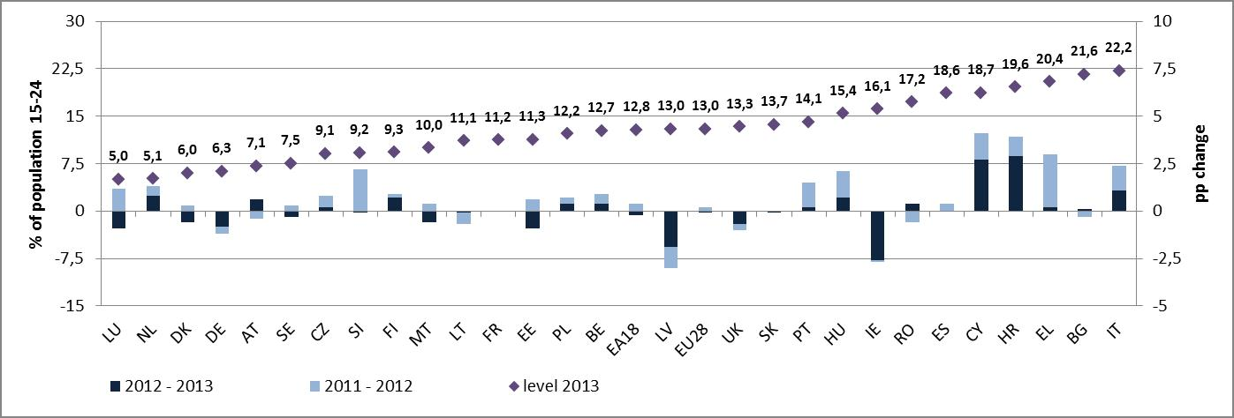
Source: Eurostat (LFS), DG EMPL calculations; sorted by level at the first half of 2014; Note: FR 2013 break in series, so no changes available
The situation of young people on the labour market remains dramatic in many Member States; in not less than seven countries (Greece, Spain, Croatia, Italy, Portugal, Cyprus, Slovakia), the unemployment rate remains 9 pps higher than the EU average. On a more positive side, most of these countries managed to improve the situation of youth with a notable exception of IT where the rate continued to raise (i.e. 4,1 pps). In addition, Belgium and Romania witnessed increases in the unemployment rate among young people with levels already relatively high. Similarly to the analysis of developments regarding the unemployment rate, also in the case of this indicator, there is a group of countries (the Netherlands, Austria, Finland) that shows signs of deterioration from still a comparatively good starting point.
While the levels of the youth unemployment rate have not risen drastically across the board, the share of young people not in education, employment or training (NEETs) increased significantly in nearly half of the Member States. From the already high levels, Croatia, Italy, Cyprus, Hungary and Romania experienced a rise of the NEETs rate between 2,7 pps and 0,4 pp. Here again, the situation of NEETs in Italy is most dramatic as the country with the highest levels of NEETs has experienced the third highest increase in the NEETs rates. On a more positive note, the negative trends in Greece were brought to a halt (at least in this reporting period): while the levels of NEETs rate are still high they have not continued to increase. Comparably to other employment-related indictors, several Eurozone Member States (Belgium, the Netherlands, Austria, Finland) have been experiencing downturn of their labour markets with the recent increases in the NEETs rates from levels still below the EU average. The NEETs rates among young women are most dramatic in the Czech Republic, Croatia, Cyprus, Lithuania and Hungary while high male NEETs rates are evident in Greece, Croatia, Cyprus and Finland.
3.2.3 Real changes in gross disposal income of households
Household incomes continued to stagnate in real terms or decline strongly after 2011 in the countries most impacted by the further deterioration of economic conditions. Household incomes have primarily been affected by the reduction of market incomes and the weakening of the impact of social transfers over time. In addition, fiscal tightening in some Member States has affected employment and changes to the tax and benefits systems and cuts in public sector wages have led to significant reductions in the level of real household incomes. This may have contributed to the widening divergence within the euro area.
Figure III: Real change in gross disposable household income (GDHI): growth in 2012 and 2011
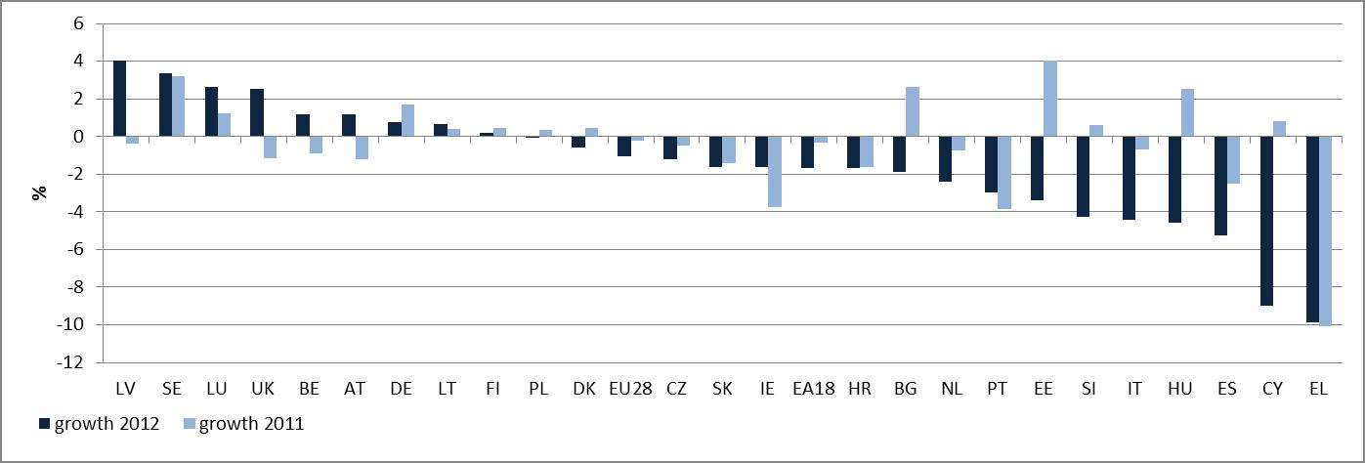Source: Eurostat, National accounts, DG EMPL calculations; sorted by total 2012 growth
There is both a wide dispersion and growing divergence between Member States in the evolution of gross household disposable income in real terms. Looking at the situation in 2012 data no less than 16 Member States experienced significant negative developments in gross household disposable incomes: Greece has experienced a year-on-year decrease of nearly 10% and Cyprus one of 9%. The declines in the former country as well as in Spain and Italy came on top of the already detectable deterioration under the previous reporting period. On the other hand, there is now a group of countries emerging whereby until 2011 wages continued to growth and it was 2012 that brought some negative developments: Cyprus, Hungary, Slovenia, Estonia and Bulgaria.
3.2.4 At-risk-of-poverty rate of working age population – change and level
At-risk of poverty rates for the working age population are on the rise in many Member States (see Figure IV). In many countries the increase comes on top of already high poverty risk levels, often compounded by drops in the level of the poverty threshold over the period.
Figure IV: At-risk-of-poverty rates in working age, 2013 level and changes 2011 – 2012 and 2012 - 2013 (age group 18-64)
Source: Eurostat, EU-SILC (DG EMPL calculations); referring to the income year 2012. Note: ES 2013 break in series, no changes available; AT UK break in series in 2012, no change 2011-2012 available, 2012 (change 2011-2012 and 2010-2011) for IE.
The Member States with the highest increase in the at-risk-of-poverty rate of the working age population between 2012 and 2013 include Greece, Cyprus, Lithuania, Luxembourg, Malta, Portugal and Romania, while the highest increases between 2011 and 2012 were observed in Greece, Portugal, Croatia and Spain. In most of these countries, the extended period of negative or close to zero GDP growth, rising long-term unemployment and the weakening over time of the impact of social transfers have given rise to poverty risks.
3.2.5 Inequalities (S80/S20 ratio) – change and level
Income inequality is growing across and within Member States, particularly in the Member States that witnessed the largest increases in unemployment (see Figure V). In many countries, the crisis has intensified the long-term trends of wage polarisation and labour market segmentation, which together with less redistributive tax and benefit systems have fuelled rising inequalities. The significant increases in inequalities can be related to high levels of unemployment (with the largest increases at the bottom of the labour market). In some cases the impact of fiscal consolidation has been also a factor.
Figure V: Inequality (S80/S20 measure) 2013 (*2012) level and changes 2011-2012 and 2012 – 2013
Source: Eurostat, EU-SILC (DG EMPL calculations); Note: ES 2013 break in series, no changes available; AT, UK break in series in 2012, no change 2011-2012 available, 2012 (change 2011-2012 and 2010-2011) for IE
There is a wide dispersion and growing divergence in inequality (S80/S20 ratio) between Member States. The recent data for the income year 2012 (which are available for a number of Member States) show increases in income inequality (as measured by the S80/S20 indicator) by 0.5 or more between 2012 and 2013 in Lithuania and Bulgaria and some notables increases in Italy, Romania, Portugal, Cyprus, Germany, Hungary, Malta and Slovenia. Income inequality remained particularly high in Bulgaria, Greece, Spain, Lithuania, Latvia, Portugal and Romania in 2013, with the income share of the top 20% being at least six times higher than that of the bottom 20%.

Official Journal L308/46, 24.11.2010, “Council Decision of 21 October 2010 on guidelines for the employment policies of the Member States (2010/707/EU)”
This is also true for third-country nationals and people with disabilities. The unemployment rate for third-country nationals was 21.7% in 2013 (14.3% in 2008), while for people with disabilities the unemployment rate is almost double the rate for people without disabilities.
See "Key Features" from DG EMPL for further analysis (forthcoming).
See Commission staff working document: Exploiting the employment potential of ICTs, 18.4.2012, SWD(2012) 96; Commission staff working document on an action plan for the EU healthcare workforce, 18.4.2012, SWD(2012) 93 and Commission staff working document: Exploiting the employment potential of green growth, 18.4.2012, SWD(2012) 92
See also Commission communication Green Employment Initiative: Tapping into the job creation potential of the green economy, 2.7.2014, COM(2014) 446.
For example, involuntary part-time employment (as a percentage of total part-time employment) in the EU-28 was 29.6% in 2013, up from 25.3% in 2008.
A Beveridge curve, or UV-curve, is a graphical representation of the relationship between unemployment and the job vacancy rate (the number of unfilled jobs expressed as a proportion of the labour force). It slopes downwards as a higher rate of unemployment normally occurs with a lower rate of vacancies. If it moves outwards over time, then a given level of vacancies would be associated with higher and higher levels of unemployment, which would imply decreasing matching efficiency in the labour market.
"Labour Market Developments in Europe, 2013", European Commission.
For further analysis, see "Key Features", DG EMPL.
For instance "Future Skills Supply and Demand in Europe", Cedefop.
In October 2013, the OECD and Commission released the outcome of a new "Survey on Adult Skills (PIAAC)", European Commission, OECD.
See e.g. "Is Aggregate Demand Wage-Led or Profit-Led? National and Global Effects", International Labour Office, Conditions of Work and Employment Series No. 40, Geneva, 2012.
See "Quarterly Report on the Euro Area", European Commission, Volume 12, No. 3, 2013.
See e.g. Eurofound (2013), "Tackling Undeclared Work in 27 European Union Member States and Norway: Approaches and Measures Since 2008", Eurofound, Dublin; Hazans, M. (2011), "Informal Workers Across Europe", Research Paper 5912, World Bank, Washington DC.
The income quintile share ratio or the S80/S20 ratio is a measure of the inequality of income distribution. It is calculated as the ratio of total income received by the 20 % of the population with the highest income (the top quintile) to that received by the 20 % of the population with the lowest income (the bottom quintile). All incomes are compiled as equivalised disposable incomes.
See more details in EU Employment and Social Situation, Quarterly Review, June 2014.
EU Employment and Social Situation - Quarterly Review - March 2014 - Supplement on trends in social expenditure (2014)
See EU Employment and social situation, Quarterly Review March 2013. Analysis shows that the downwards adjustment of social expenditure observed since 2011 appears more pronounced in comparison to similar episodes of recession over the past three decades.
This section gives an update of the situation as presented in the previous Joint Employment Report and due to space limitations, is not exhaustive and does not aim to report on all reforms and policy measures. As a rule, measures that have been only announced but have not been submitted to Parliament for adoption or to a collective bargaining with social partners are not covered in the Report.
Council Decision 2010/707/EU of 21 October 2012 on guidelines for the employment policies of the Member States.
Note that the Commission's annual report on progress on equality between women and men provides a detailed analysis
Latest data available; published in spring 2014
For a more complete overview of developments covering guidelines 8 and 9 see Education and training Report 2014.
COM(2013) 690, 2.10.2013. See in particular pp. 6-7 " The Commission proposes to create a scoreboard of key indicators to be used in its draft Joint Employment Report to follow employment and social developments. It should serve as an analytical tool allowing better and earlier identification of major employment and social problems, especially any that risk generating effects beyond national borders. (…) It would be incorporated into the draft Joint Employment Report in order to provide a more focused basis for reinforced multilateral surveillance of employment and social policies, helping to identify developments that warrant stronger employment and social policy responses. (…) The employment and social indicators for the scoreboard should capture the key phenomena for each country and identify the most serious problems and developments at an early stage and before the country diverges too strongly from its past performance or from the rest of the EU."
COM(2013) 801 final, 13.11.2013
European Council Conclusions, 19/20 December 2013, par. 39
7476/14, Brussels, 12 March 2014
European Council Conclusions, 19/20 December 2013 "38. The European Council reiterates the importance of employment and social developments within the European Semester. On the basis of work undertaken by the Council, the European Council confirms the relevance of the use of a scoreboard of key employment and social indicators as described in the Joint Employment Report"
Joint SPC/EMCO opinion the scoreboard of key employment and social indicators for the June EPSCO Council. In addition, SPC tabled the document on" Key employment and social indicators' scoreboard: operationalization – Report from the Social Protection Committee Indicators' Subgroup"
This three-fold dimension analysis follows the 2014 Joint Employment Report as agreed between the Commission and the Council. As stated in the Key Messages to the 2014 Joint Employment Report: “The impact of the crisis has also translated to a growing divergence between Member States' employment and social situations, particularly in the euro zone, as this Joint Employment Report and its new scoreboard of key employment and social indicators illustrate. This divergence is visible across all of the five key indicators within this scoreboard.” 7476/14, Brussels, 12 March 2014, p. 3. In addition, as it was agreed in the 2014 Joint Employment Report, the scoreboard covers all EU Member States and comparisons are thus made with the EU average. In some cases, statistical deviations from the EA average might also be relevant. 7476/14, Brussels, 12 March 2014, p. 49
The table represents an overview of employment and social developments across the Member States whereby levels or trends in key indicators could be considered problematic.
The ratio between the incomes of the 20% of the population with the highest incomes and the incomes of the 20% with lowest incomes.
See EUROMOD Working Paper 2/13.

