Executive summary
This Communication summarises the Commission's assessment of the 2015 Draft Budgetary Plans (DBPs) submitted by 15 October by the sixteen euro area Member States not under a macroeconomic adjustment programme (EA-16). In line with Regulation (EU) No 473/2013, the Commission has assessed these plans and the overall budgetary situation and fiscal stance in the euro area as a whole, at a time when there are also major structural reforms underway.
The overall assessment of the 2015 Draft Budgetary Plans (DBPs) and the aggregate fiscal stance can be summarised as follows:
- The Member States' plans imply a continuing decrease in the aggregate headline budget deficit in the euro area: after returning below 3% of GDP in 2013 for the first time since 2008, the deficit is expected to fall further to 2.6% of GDP in 2014 and 2.2% of GDP in 2015. Based on the DBPs, the aggregate debt ratio in 2015 is planned to remain virtually unchanged from the value estimated for the current year at around 92.5% of GDP.
- Compared to the medium-term plans formulated in the spring 2014 Stability Programmes, the planned deficit reduction is significantly lower. This reflects both a lower growth outlook and a reduced fiscal effort. After coming to a halt in 2014, fiscal consolidation is not planned to resume in 2015, according to the aggregate of the EA-16's Draft Budgetary Plans.
- The picture emerging from the DBPs is broadly confirmed by the Commission's 2014 autumn forecast. Although starting from an identical headline deficit estimate for 2014 (2.6% of GDP), the Commission forecasts a smaller reduction in headline deficits than Member States in 2015 (by only 0.2 percentage points instead of 0.4). This reflects a smaller expected fiscal effort in 2015. Higher deficits and lower growth account for an aggregate debt-to-GDP ratio that the Commission projects will increase from 91.7% of GDP in 2013 to 93.1% in 2014 and 93.6% in 2015, against the stabilisation projected in the DBPs.
- The Commission's forecast also indicates a broadly neutral fiscal stance (neither tightening nor loosening) in 2015 in the euro area, following a halt in consolidation in 2014. This appears to strike an appropriate balance between fiscal sustainability requirements, underscored by high and increasing government debt ratios, and cyclical stabilisation concerns, highlighted by significant and persistent negative output gaps which are projected to diminish only slowly in the coming years. At the same time, the assessment of the plans confirms that several Member States are currently not expected to meet their obligations under the Stability and Growth Pact (SGP).
- There is a need to closely monitor both the overall fiscal stance of the euro area and its distribution across Member States in relation to the room available under the SGP. In particular, maintaining a neutral aggregate fiscal stance, while some Member States are called to increase their efforts in order to comply with the SGP implies a degree of fiscal support coming from the exploitation of the fiscal space available elsewhere. This also strongly underlines the case for the ambitious Investment Plan for Europe presented by the Commission on 26 November.
- This avenue for supporting euro area growth is relevant when examining the composition of public finances. While the recent moves to reduce the tax burden on labour go in the right direction, the composition of expenditure shows little if any progress towards being more growth–friendly. This underscores the necessity of a better alignment of Member States' policies with the priorities of the Jobs, Growth and Investment Package presented by the Commission.
- The Commission assessment of individual Member States can be summarised as follows:
No DBP for 2015 has been found in particularly serious non-compliance with the requirements of the SGP. In several cases, however, the Commission finds that the planned fiscal adjustments fall short, or risk doing so, of what is required by the SGP. Specifically:
For five countries (Germany, Ireland, Luxembourg, the Netherlands and Slovakia), the DBPs are found to be compliant with the SGP provisions.
For four countries (Estonia, Latvia, Slovenia and Finland), the DBPs are found to be broadly compliant with the SGP provisions. For Estonia, Latvia and Finland, the plans might result in some deviation from the adjustment paths towards each country's medium-term budgetary objective (MTO). In the case of Slovenia, while the headline deficit might be brought below 3% of GDP by the deadline set under the Excessive Deficit Procedure, a shortfall in the fiscal effort puts at risk the correction of the excessive deficit in a timely and sustainable manner. The Commission invites the authorities to take the necessary measures within the national budgetary process to ensure that the 2015 budget will be compliant with the SGP.
For seven countries (Belgium, Spain, France, Italy, Malta, Austria and Portugal), the DBPs pose a risk of non-compliance. For Austria, the plans might result in a significant deviation from the adjustment paths towards the MTO, which would be also the case for Malta if it moved to the preventive arm. The DBPs of Spain, France, Malta and Portugal contain risks as regards compliance with the Excessive Deficit Procedure requirements. For France in particular, the information available indicates that the country has not taken effective action in 2014 at this stage and is at risk of non-compliance in 2015. Belgium and Italy, currently under the preventive arm of the SGP, are at risk of non-compliance with the debt rule. The Commission invites the authorities to take the necessary measures within the national budgetary process to ensure that the 2015 budget will be compliant with the SGP.
- In some cases, the risk of non-compliance has implications for possible steps under the Excessive Deficit Procedure. In the cases of France, Italy and Belgium, the Commission will examine in early March 2015 its position vis-à-vis their obligations under the SGP in the light of the finalisation of the budget laws and the expected specification of the structural reform programmes announced by the authorities in their letters of 21 November. These three Member States have committed at the highest level of government to adopt and implement growth-enhancing structural reforms by early 2015 that are expected to have an impact on the sustainability of public finances over the medium term.
Table of Contents
1. Introduction 5
2. Main findings for the euro area 6
3. Overview of individual Draft Budgetary Plans 12
ANNEX 1: Country-specific assessment of DBPs 18
ANNEX 2: The methodology and assumptions underpinning the Commission's 2014 autumn forecast 23
ANNEX 3: Sensitivity analysis 25
ANNEX 4: The implementation of structural reforms: addressing macroeconomic imbalances and reducing the tax wedge 28
ANNEX 5: Graphs and tables 31

1. Introduction

To improve economic policy coordination in the Economic and Monetary Union, EU legislation foresees that euro area Member States submit Draft Budgetary Plans (DBPs) for the following year to the Commission by 15 October. These plans summarise the draft budgets that governments submit to national parliaments. On each plan, the Commission provides an Opinion, assessing whether it is consistent with the country's obligations under the Stability and Growth Pact (SGP). It also provides an overall assessment of the budgetary situation and prospects for the euro area as a whole.
Sixteen euro area Member States sent their 2015 DBPs to the Commission by 15 October, in line with the provisions of the so-called Two-Pack. Belgium and Latvia initially submitted DBPs on a no-policy change basis, reflecting the absence of agreed governmental budgetary policy resulting from recent national elections, with Belgium submitting a full programme one week later.
While respecting Member States' budgetary autonomy, the Commission's Opinions provide independent policy advice, in particular for national governments and parliaments, to facilitate the assessment of the draft budgets' compliance with EU fiscal rules. The Two-Pack provides for a comprehensive toolbox to treat economic and budgetary policy as a matter of common concern, as intended by the Treaty.
In addition, in July 2014, the Council invited the Eurogroup to monitor and coordinate euro area Member States' fiscal policies and the aggregate fiscal stance for the euro area to ensure a growth-friendly and differentiated fiscal policy. The Council recommended that euro area Member States take action, individually and collectively over 2014‐15 to "coordinate fiscal policies of the euro area Member States, in close cooperation with the Commission, in particular when assessing Draft Budgetary Plans to ensure a coherent and growth‐friendly fiscal stance across the euro area. Improve the quality and sustainability of public finances by prioritising material and immaterial investment at national and EU levels. Ensure that national fiscal frameworks, including national fiscal councils, are strong." This recommendation is an anchor for the Commission's assessment.
The objective of this Communication is twofold. Firstly, it gives an aggregate picture of budgetary policy at euro area level, building on a horizontal assessment of the DBPs. This exercise mirrors the horizontal assessment of Stability Programmes taking place in the spring, but with a focus on the forthcoming year rather than on medium-term fiscal plans. Secondly, it provides an overview of the DBPs at country level, explaining the Commission approach in assessing them. This approach boils down to assessing compliance with the requirements of the SGP.

2. Main findings for the euro area

Overall findings
This year's DBPs confirm the slowdown of GDP growth compared to the Commission's spring 2014 forecast, published in May. According to the macroeconomic assumptions provided in the plans, GDP is now projected to grow by 1.0% in 2014 in the sixteen euro area Member States concerned (EA-16), below the 1.3% expected at the time of the Stability Programmes (SPs) in April 2014 (Table 1). For 2015, the forecast pick-up in EA-16 GDP growth to 1.5% is below the 1.7% projected in the SPs. The downward revision is relatively widespread, with only Spain, Ireland, Malta and Slovenia reporting upward revisions to their growth forecasts, while the majority of other countries show significant reductions.
The inflation outlook has also been revised down due to falling energy and food prices but also reflecting the substantial slack in the economy. According to the DBPs, this year's inflation rate of 0.8% in the EA-16 will mark the trough, followed by a slightly higher rate in 2015 (1.2%).
After returning below 3% of GDP in 2013 for the first time since 2008, the aggregate headline budget deficit for the EA-16 is expected to fall to 2.6% of GDP in 2014, according to the DBPs, though this is higher than the 2.4% deficit projected in the SPs. A slowdown in deficit reduction is also evident in 2015, with the aggregate headline deficit falling by 0.4 percentage points to 2.2% of GDP, compared to a fall of 0.6 percentage points projected in the spring. This higher deficit projection is linked to the worsening growth outlook for 2014-15, but is also driven by a reduction in the fiscal effort (see hereafter).
At 92.5% of GDP in 2015, the aggregate debt ratio is planned to remain virtually unchanged from this year. This contrasts with the SPs which had projected that debt would start declining next year. The aggregate ratio masks a wide range of national figures, from 133% of GDP in Italy to just below 10% of GDP in Estonia. In terms of levels, the downward revisions to debt ratios from the SPs reflect the implementation of the new ESA 2010 system of national accounting, which more than compensates for the worsening growth and inflation outlook and reduced fiscal consolidation effort.
Examining the planned fiscal effort in more detail, the DBPs do not provide evidence of consolidation at the aggregate level, as measured by a positive change in the structural balance, in 2014 and 2015. For both years, an improvement of 0.3% of GDP had been anticipated by Member States in their SPs. Given that six of the EA-16 Member States remain in Excessive Deficit Procedure in 2014 and that only two of the Member States in the preventive arm are expected to be at or above their MTOs in 2014-15, this appears to point to a shortfall with respect to the requirements of the SGP. However, the aggregate structural adjustment can only be viewed as illustrative in this respect, as it fails to capture the important differences across Member States vis-à-vis the requirements of the SGP, which are the subject of the Commission's country-specific assessments. In addition, any conclusion on the overall consolidation effort based on the change in structural balance should be qualified, as the structural balance may not always give an accurate picture of the underlying fiscal effort due, for example, to an unusual response of revenue to economic growth. However, the lack of fiscal consolidation at the aggregate level is confirmed by using an alternative measurement of fiscal effort, which suggests an adjustment of just 0.2% of GDP in both 2014 and 2015.

Table 1: Overview of economic and budgetary aggregates (EA-16) for 2014-15
 | 2014 |  |  | 2015
 | 2014 Stability Programmes (April) | Draft Budgetary Plans (October) | Commission 2014 autumn forecast (November) | 2014 Stability Programmes (April) | Draft Budgetary Plans (October) | Commission 2014 autumn forecast (November)
Real GDP growth (% change) | 1.3 | 1.0 | 0.8 | 1.7 | 1.5 | 1.1
HICP inflation  (% change) | 1.1 | 0.8 | 0.6 | 1.4 | 1.2 | 0.9
Headline deficit  (% GDP) | -2.4 | -2.6 | -2.6 | -1.8 | -2.2 | -2.4
Change in structural balance  (p.p. GDP) | 0.3 | 0.0 | 0.1 | 0.3 | 0.1 | 0.0
Debt (% GDP) | 94.3 | 92.7 | 93.1 | 93.1 | 92.5 | 93.6
Cyclically-adjusted expenditure ratio (% potential GDP) | 47.8 | 47.9 | 48.0 | 47.5 | 47.7 | 48.0
Cyclically-adjusted revenue ratio  (% potential GDP) | 46.9 | 46.7 | 46.8 | 46.7 | 46.5 | 46.8

Composition of public finances
For the euro area as a whole, the DBPs foresee only limited changes in the composition of public finances in 2014-15 (Table A5.5). The cyclically adjusted expenditure ratio is expected to recede very slightly in 2015 (by 0.2 percentage points), offsetting the effects of a similarly limited increase in 2014. Most expenditure categories are expected to fall, including the public sector wage bill and interest expenditures in particular (Graph A5.2), with the exception of social transfers.
The taxation measures presented in the DBPs, though moving in a more growth-friendly direction, would only moderately affect tax composition in 2015. The impact of a 0.1 percentage point decrease in revenue from social contributions is offset by a 0.1 percentage point increase in direct tax revenues (Graph A5.3). The share of indirect taxes is expected to remain stable in relation to GDP.
Many DBPs refer to measures to address the tax burden on labour, known as the tax wedge. The staff working documents accompanying the Commission's Opinions on the DBPs contain a dedicated box on "addressing the tax wedge" for those Member States that were issued a country-specific recommendation (CSR) in this area and/or that have announced a relevant reform in their DBPs. Annex IV of this Communication contains further information on this issue.
Overall, the DBPs show a clear awareness in euro area Member States of the benefits of addressing high taxes on labour. First, whereas the tax wedge has steadily increased in most euro area Member States over the past few years, the DBPs only include very few measures that would increase it further. By contrast, many Member States are planning or implementing measures to reduce the tax wedge. Second, measures to lower the tax wedge are not foreseen only by Member States with a relatively high tax wedge but also by those with a relatively low tax wedge. Third, many measures are targeted at lower income categories, by increasing the tax free allowance or by reducing taxes at low income levels or social contributions for low-wage earners. However, most tax wedge reforms remain relatively modest compared with the challenges. This reflects both the lack of fiscal space in many countries and the difficulty in finding compensating measures, either by cutting public spending or raising taxes that are less detrimental to growth, such as consumption, property or environmental taxes.
Differences in forecasts
An innovation of the Two-Pack is intended to mitigate the potential for divergence between Member States' and the Commission's forecasts, namely the introduction of a requirement for greater oversight of the forecast process by fiscal councils. Box 1 on page 10 shows how Member States have applied the requirement that draft budgets be based on independent macroeconomic forecasts.
In terms of the overall fiscal outlook, the aggregate EA-16 headline deficit emerging from the DBPs for 2015 is 0.2 percentage points of GDP lower than in the Commission's forecast. Firstly, the DBPs assume a larger fiscal effort (0.2% of GDP versus -0.1% of GDP in the Commission's forecast as measured using the alternative indicator referred to above; see Table A5.7). Secondly, the plans forecast higher GDP growth for 2015 (1.5% against 1.1% in the Commission's forecast, with Germany accounting for a significant part of the difference). However, the macroeconomic assumptions are not the main explanation for the difference in the deficit forecasts for 2015. This is because Member States in the aggregate, while having a higher GDP growth projection, also forecast a lower reaction of revenues to growth than in the Commission's forecast. This lower projected elasticity broadly offsets the impact of higher expected GDP growth. Most of the difference between the Commission's deficit forecast and the DBPs actually comes from a different evaluation of the effort on the expenditure side.
Differences between individual DBPs' and the Commission's headline deficit forecast can be relatively large, for reasons varying from one country to another. The Commission forecasts the deficit to be higher in Belgium, Spain, Malta, Portugal and Slovakia compared to the respective DBPs, with the largest differential in the case of Malta (Table A5.1 and Graph A5.4). The remaining forecast differentials are all within a 0.2 percentage point range and the Commission's forecast is for a lower deficit figure in the Netherlands and Austria.
Similar to the aggregate headline deficit projections, the Commission forecasts higher aggregate debt than projected by Member States. The Commission forecasts that debt will continue to rise moderately in 2015, to over 93% of GDP, versus a virtually unchanged level in the DBPs. The main reasons behind this difference are higher headline deficits and lower nominal GDP growth projected by the Commission. Here again, differences between the DBPs and the Commission's forecast can be larger at Member State level, for reasons varying from one country to another. The larger differentials relate to Belgium, Germany, Latvia and Malta, where the DBPs project debt to be around 2% of GDP lower than in the Commission's forecast (Table A5.3 and Graph A5.5). In most cases, the forecast differentials range between zero and 1% of GDP. The Commission's forecasts a lower deficit only in the case of Slovenia. In terms of composition, the Commission's forecast projects that even the limited decline in the cyclically adjusted expenditure ratio foreseen in the DBPs is at risk of not materialising (Table A5.5). Within expenditures, the Commission's forecast confirms that public wages, interest payments and possibly public investment could see their weights reduced, while the share of social payments may increase further (Graph A5.2). On the revenue side, the Commission's forecasts are aligned with the DBPs (Graph A5.3).
Size and composition of adjustment
Regarding the size of structural budgetary adjustment, the Commission's forecast gives the same message as the DBPs; after three years of sustained fiscal consolidation the aggregate fiscal stance in the euro area is neutral in 2014 and is anticipated to remain so in 2015. At the aggregate level, the absence of fiscal tightening appears a broadly acceptable balance between sustainability requirements, underscored by high and increasing debt ratios, and the cyclical conditions, which point to significant and persistent negative output gaps, projected to diminish only slowly in the coming years. At the same time, the assessments of the plans confirm that several Member States are currently not expected to meet their current obligations under the SGP. Taken together these considerations suggest the need to closely monitor both the overall fiscal stance of the euro area and its distribution across Member States in relation to the room available under the rules of the SGP. In principle, it would be possible to achieve a re-alignment of fiscal policies across countries that would ensure compliance with the SGP in all Member States while avoiding an unwarranted fiscal tightening. This would imply exploiting the fiscal space available under the rules in some countries.
The above considerations also strongly underline the case for an ambitious Investment Plan at the EU level to boost aggregate demand and lessen supply side constraints, and hence support the stimulus being provided by accommodative monetary policy.
This avenue for supporting growth across the euro area is relevant when examining the composition of the adjustment of public finances. While the observed move away from taxes on labour – and the number of policy actions taken to reduce the tax burden on labour – are steps in the right direction, the composition of expenditure shows little if any progress towards being more growth-friendly. This underscores the need for a better alignment of Member States' policies with the priorities of the Jobs, Growth and Investment package, including by making use of the flexibility available under the rules.

Box 1: The contribution of independent fiscal institutions to the DBPs for 2015
Articles 1, 4 and 5 of the Two-Pack Regulation (EU) No 473/2013 refer to the concept of independent bodies. The Regulation represents a further specification and extension of previous requirements laid down in EU and intergovernmental legislation empowering independent bodies with various fiscal-related tasks. Two supplementary fields are earmarked: (i) monitoring of compliance with fiscal rules and (ii) macroeconomic forecasts. Implementing provisions with a view to providing guidance to Member States have been defined in the Code of Conduct on the Two-Pack in relation to the forecasting process. Supplementing these provisions, the Council on 8 July 2014 called for euro area Member States "to ensure that national fiscal frameworks, including national fiscal councils, are strong".
Specifically, according to Article 4(4) of the Regulation, draft budgets "shall be based on independent macroeconomic forecasts", which means according to Article 2(1b) that they must be "produced or endorsed by independent bodies". Many of the DBPs submitted in October 2014 contain references to the Two-Pack requirements, with Member States opting for either the independent production or endorsement of the underlying macroeconomic forecasts.
According to the DBPs, forecasts have been produced by separate entities in five Member States: Austria (Österreichisches Institut für Wirtschaftsforschung, WIFO), Belgium (Bureau Fédéral du Plan, FPB), Luxembourg (STATEC), the Netherlands (Centraal Planbureau, CPB) and Slovenia (Urad Rs Za Makroekonomske Analize in Razvoj, UMAR-IMAD). The Ministry of Economics still produces Germany's forecasts, but on the basis of the Joint Economic Forecast (JEF) elaborated by research institutes. The independent Council of Economic Advisors in November reviews their plausibility. The DBP forecast is based on the spring issues of the JEF and the government's forecast and does not factor in the autumn issues of the JEF and the government's macroeconomic projections. In Finland, the Ministry of Finance produces the macroeconomic forecasts internally but acknowledges the need for measures to ensure the formal independence of the producing team.
The DBPs of Estonia, Spain, Ireland, Italy and Slovakia referred to the opinions on the macroeconomic forecasts delivered by separate bodies (Eelarvenõukogu, Autoridad Independiente de Responsabilidad Fiscal (AIReF), Irish Fiscal Advisory Council (IFAC), Ufficio Parlamentare di Bilancio (UPB) and the Slovakian Macroeconomic Forecasting Committee respectively). In France, Malta and Portugal, although an opinion has been delivered by a separate body (the HCFP (Haut Conseil des Finances Publiques), the National Audit Office of Malta and the CFP (Conselho das Finanças Públicas) respectively), there is no reference to it in the DBP. For France and Portugal the opinion was eventually included in the budgetary documents. In Latvia, the released no-policy change budget document does not qualify as a DBP, so does not formally trigger the need for an opinion of a separate body. For Estonia, Spain, Ireland, Italy, Malta, Portugal and Slovakia, the forecasts were largely endorsed by the above-mentioned bodies while a number of risks were highlighted. For France, the macroeconomic scenario for 2015 was deemed optimistic by the HCFP. Downward risks arising from external developments, potentially materialising in lower than expected export growth, were referred to in Estonia, Spain, France, Ireland, Malta, and Portugal. Uncertainties in relation to domestic demand (France), consumption (Spain) or investment (Malta) were also mentioned.

3. Overview of individual Draft Budgetary Plans

The Commission's Opinions on the Draft Budgetary Plans focus on compliance with the Stability and Growth Pact (SGP) and recommendations issued on this basis. For Member States in Excessive Deficit Procedure (EDP), the Commission's Opinions take stock of progress in correcting the excessive deficits, with respect to both headline and structural deficit targets. For euro area Member States in the preventive arm of the Pact, i.e. not in EDP, the progress towards the Medium-Term Budgetary Objectives (MTOs) is assessed to see whether it is in line with the SGP and the fiscal Country Specific Recommendations (CSRs) addressed to Member States by the Council in July.
The assessment of plans is based on the Commission's autumn 2014 forecast.
The Commission, after having carried out consultations with certain Member States to request further information or to highlight some initial concerns related to the DBPs they submitted, did not find by the end of October any DBP to be in "particularly serious non-compliance" as referred to in Article 7(2) of Regulation (EU) No 473/2013. Still, several of the submitted plans give rise to concerns about risks of non-compliance. Tables 2a and 2b summarise the assessments of individual countries' DBPs as per the Commission Opinions adopted on 28 November together with the assessment of progress with fiscal-structural reforms. In order to facilitate comparison, the assessment of the Draft Budgetary Plans is summarised in three broad categories:
- Compliant: According to the Commission's forecast, there is no need to adapt the budgetary plans within the national budgetary procedure to ensure compliance with the SGP rules. However, in cases where the Commission's assessment of the DBP is subject to particular risks, the Commission invites the Member States concerned to react as needed.
- Broadly compliant: The Commission invites the authorities to take the necessary measures within the national budgetary process to ensure that the 2015 budget will be compliant with the SGP based on the following reasoning:
For Member States in EDP: while the Commission's forecast projects that the headline deficit will be brought below the 3% of GDP Treaty reference value by the EDP deadline, there is a noticeable shortfall in fiscal effort that puts at risk the correction of the excessive deficit in a timely and sustainable manner.
For Member States under the preventive arm of the SGP: according to the Commission's forecast, the required structural adjustment towards the MTO is not expected to be delivered in 2015, but the shortfall relative to the requirement would not represent a significant deviation from the required adjustment towards the MTO. Should this situation persist over the years, it might however lead to a significant deviation from the required adjustment. These Member States are compliant with the debt reduction benchmark where applicable.
- Risk of non-compliance: According to the Commission's forecast, the DBP is not expected to ensure compliance with the SGP requirements. The Commission therefore invites the authorities to take the necessary measures within the national budgetary process to ensure that the 2015 budget will be compliant with the SGP based on the following reasoning:
For Member States in EDP: the Commission's forecast for 2015, if confirmed ex post, could lead to the stepping up of the EDP as the fiscal effort is not projected to be delivered and the headline target is expected to be missed.
For Member States under the preventive arm of the SGP: the Commission's forecast projects a significant deviation from the required adjustment path towards the MTO in 2015 and/or non-compliance with the debt reduction benchmark if applicable (whichever is more binding).
The impact of the changeover to the ESA2010 standard of national accounts and other statistical revisions on both deficit and debt figures have been taken into account in the assessment of plans (the impact of the switch to ESA2010 was most significant in the case of France, Ireland, Italy, Portugal and Finland). In particular, statistical revisions have been dealt with in qualitative terms and, where feasible, also in quantitative terms in the staff working documents accompanying the Commission's Opinions, whenever their impact affected the main variables used for the assessment of compliance with the SGP. Other statistical changes have been explicitly mentioned for Estonia, Latvia and Slovenia. In other cases, the impact was not significant and/or would not change the assessment.
Moreover, the Commission has assessed the degree of overall compliance with the fiscal-structural reforms outlined in the 2014 CSRs. The assessment of the DBPs is summarised in five broad categories. These are:
- No progress: The Member State has neither announced nor adopted any measures to address the relevant CSR.
- Limited progress: The Member State has announced some measures to address the relevant CSR, but these measures appear insufficient and/or their adoption/implementation is at risk.
- Some progress: The Member State has announced or adopted measures to address the relevant CSR. These measures are promising, but not all of them have been implemented yet and implementation is not certain in all cases.
- Substantial progress: The Member State has adopted measures, most of which have been implemented. These measures go a long way to addressing the relevant CSR.
- Fully addressed: The Member State has adopted and implemented measures that address the relevant CSR appropriately.
Table 2a: Overview of individual Commission Opinions on the Draft Budgetary Plans – Member States under the preventive arm of the SGP
Country | Overall compliance of Draft Budgetary Plan with Stability and Growth Pact (SGP) |  | Overall compliance with the fiscal-structural reforms suggested in 2014 Country Specific Recommendations (CSRs)
Country | Overall conclusion based on the Commission's 2014 autumn Forecast | Compliance with the preventive arm requirements in 2014-15 | Overall conclusion on progress towards fiscal-structural reforms | Main measures in DBP to address tax wedge CSRs
BE | Risk of non-compliance | 2014: some deviation from the adjustment path towards the MTO; compliance with the debt benchmark at risk  2015: some deviation from the adjustment path towards the MTO; compliance with the debt benchmark at risk | Some progress | 'Tax wedge' CSR  Increase in personal income tax deduction. Reductions of employer social security contributions
DE | Compliant | 2014: MTO overachieved; compliance with the debt benchmark  2015: MTO overachieved; compliance with the debt benchmark | Limited progress | 'Tax wedge' CSR  As of 2014, increase in personal income tax allowance and non-implementation of initially planned reduction in pension contribution rate to finance additional pension benefits. As of 2015, increase in long-term care contribution rate and reform of financing of healthcare insurance
EE | Broadly compliant | 2014: some deviation from the adjustment path towards the MTO 2015: some deviation from the adjustment path towards the MTO | No progress | 'Tax wedge' CSR  Reduction of personal income tax rate and unemployment insurance contributions. Increase of basic allowance

IT | Risk of non-compliance | 2014: allowed to deviate from the adjustment path towards the MTO due to exceptionally severe economic conditions; compliance with the debt benchmark at risk  2015: significant deviation from the adjustment path towards the MTO; compliance with the debt benchmark at risk | Some progress | 'Tax wedge' CSR  Exemption of labour costs from the taxable base of the regional tax on businesses. Permanent tax credit (recorded as social transfer in ESA2010) to low-wage employees, currently only financed for 2014. Exemption of employer social security contributions for three years for new hirings under open-ended contracts during 2015
LV | Broadly compliant | 2014: no deviation from the adjustment path towards the MTO  2015: some deviation from the adjustment path towards the MTO based on no-policy change DBP | Limited progress | 'Tax wedge' CSR  No measures in DBP submitted by outgoing government. However, the Tax Policy Strategy for 2015-17 includes plans to increase minimum wage and untaxed minimum income
LU | Compliant | 2014: MTO overachieved  2015: no deviation from the MTO | Some progress | No 'tax wedge' CSR
MT | Risk of non-compliance | 2014: in EDP  2015: significant deviation from the adjustment path towards the MTO; compliance with the debt benchmark | Some progress | No 'tax wedge' CSR
NL | Compliant | 2014: no deviation from the MTO; compliance with the debt benchmark  2015: no deviation from the MTO; compliance with the debt benchmark | Some progress | 'Tax wedge' CSR  Reform of employee tax credit, reducing burden on lower and middle incomes. Reduction of the personal income tax rate in the lowest tax bracket

AT | Risk of non-compliance | 2014: some deviation from the adjustment path towards the MTO; compliance with the debt benchmark  2015: significant deviation from the adjustment path towards the MTO; compliance with the debt benchmark | Limited progress | 'Tax wedge' CSR  General announcement of reform to reduce the tax wedge to be decided in March 2015
SK | Compliant | 2014: no deviation from the adjustment path towards the MTO  2015: no deviation from the adjustment path towards the MTO | Limited progress | No 'tax wedge' CSR
FI | Broadly compliant | 2014: some deviation from the MTO  2015: some deviation from the adjustment path towards the MTO | Some progress | No 'tax wedge' CSR

Table 2b: Overview of individual Commission Opinions on the Draft Budgetary Plans – Member States under the corrective arm of the SGP
Country | Overall compliance of Draft Budgetary Plan with Stability and Growth Pact |  | Overall compliance with the fiscal-structural reforms suggested in 2014 CSRs
Country | Overall conclusion based on the Commission's 2014 autumn Forecast | Compliance with the Excessive Deficit Procedure in 2014-15 | Overall conclusion on progress towards fiscal-structural reforms | Main measures in DBP to address the tax wedge
ES | Risk of non-compliance | 2014: headline target met  2015: in the absence of additional measures compliance not ensured | Some progress | 'Tax wedge' CSR  Reduction of personal income tax rates. Temporary reduction in social contributions on new contracts signed in 2014
FR | Risk of non-compliance | 2014: risk of no effective action  2015: in the absence of additional measures compliance not ensured | Limited progress | 'Tax wedge' CSR  As of 2014, new tax credit for wages of up to 2.5 times the minimum wage. Reduction in employer social security contributions. Reduction in personal income tax for low wage earners

IE | Compliant | 2014: effective action  2015: timely correction expected | Some progress | No 'tax wedge' CSR
PT | Risk of non-compliance | 2014: risk of no effective action  2015: in the absence of additional measures compliance not ensured | Limited progress | No 'tax wedge' CSR
SI | Broadly compliant | 2014: risk of no effective action  2015: timely correction expected | Limited progress | No 'tax wedge' CSR

ANNEX 1: Country-specific assessment of DBPs

Member States under the preventive arm of the Stability and Growth Pact (SGP)
Plans compliant with the country's obligations
The Commission is of the opinion that the Draft Budgetary Plan of Germany, which is currently under the preventive arm of the SGP and subject to the transitional debt rule, is compliant with the provisions of the SGP. However, the sizeable fiscal space, the investment needs and the very low interest rates, which imply that the social returns largely outweigh the borrowing costs, leave scope to boost public investment. Furthermore, it is necessary that Germany ensures that an independent body in charge of producing or endorsing macroeconomic forecasts is in place. The Commission is also of the opinion that Germany has made limited progress with regard to the structural part of the fiscal recommendations issued by the Council in the context of the 2014 European Semester and thus invites the authorities to accelerate implementation.
The Commission is of the opinion that the Draft Budgetary Plan of Luxembourg, which is currently under the preventive arm, is compliant with the provisions of the SGP. In particular, in 2015 Luxembourg plans to make use of its buffer with respect to the MTO as the structural surplus is set to deteriorate, while still respecting the country-specific MTO. The reduction in the structural surplus is mostly related to the decrease in VAT revenues linked to the change in e-commerce legislation (around 1½% of GDP), which is only partially compensated by the new measures planned in the Draft Budgetary Plan. However, the VAT revenues losses could turn out to be larger than expected. The Commission therefore invites the authorities to stand ready to take additional measures in case these risks should materialise. The Commission is also of the opinion that Luxembourg made some progress with regard to the structural part of the fiscal recommendations issued by the Council in the context of the 2014 European Semester and invites the authorities to make further progress.
The Commission is of the opinion that the Draft Budgetary Plan of the Netherlands, which is currently under the preventive arm and subject to the transitional debt rule, is compliant with the provisions of the SGP. The Commission invites the authorities to rigorously implement the 2015 budget. The Commission is also of the opinion that the Netherlands has made some progress with regard to the structural part of the fiscal recommendations issued by the Council in the context of the 2014 European Semester and invites the authorities to make further progress.
The Commission is of the opinion that the Draft Budgetary Plan of Slovakia, which is currently under the preventive arm, is compliant with the provisions of the SGP. In particular, based on the currently available information, the general government deficit would not exceed the Treaty reference value, although there are some uncertainties with respect to the deficit developments in 2014. Slovakia was found to be eligible to the investment clause in 2014, which allows for a temporary deviation from the required adjustment path towards the MTO in that year. In 2015, when this temporary deviation has to be compensated for, Slovakia is projected to make sufficient progress towards the MTO. In light of the above, and taking into account that the national debt brake, underpinning the Draft Budgetary Plan, is no longer expected to apply, the Commission invites the authorities to stand ready to take the necessary measures within the national budgetary process to ensure that the 2015 budget will remain compliant with the SGP. The Commission is also of the opinion that Slovakia has made limited progress with regard to the structural part of the fiscal recommendations issued by the Council in the context of the 2014 European Semester and thus invites the authorities to accelerate implementation.
Plans broadly compliant
The Commission is of the opinion that the Draft Budgetary Plan of Estonia, which is currently under the preventive arm, is broadly compliant with the provisions of the SGP. In particular, based on the Commission's forecast, some deviation from the adjustment path towards the MTO is to be expected in 2015. The Commission invites the authorities to take the necessary measures within the national budgetary process to ensure that the 2015 budget will be compliant with the SGP. The Commission is also of the opinion that Estonia has made no progress with regard to the structural part of the fiscal recommendations issued by the Council in the context of the 2014 European Semester and thus invites the authorities to accelerate implementation.
Latvia submitted on 15 October a Draft Budgetary Plan based on a no-policy change basis. The Commission is of the opinion that the Draft Budgetary Plan of Latvia, which is currently under the preventive arm, is broadly compliant with the provisions of the SGP. The Commission invites the authorities to take the necessary measures in the 2015 budget in order to be compliant with the SGP. The Commission is also of the opinion that Latvia has made limited progress with regard to the structural part of the fiscal recommendations issued by the Council in the context of the 2014 European Semester and thus invites the authorities to accelerate implementation. Following the submission of an updated Draft Budgetary Plan on 22 November 2014 by the new government, the Commission aims to adopt an Opinion on the updated Draft Budgetary Plan before the draft budget law is planned to be adopted by the national parliament.
The Commission is of the opinion that the Draft Budgetary Plan of Finland, which is currently under the preventive arm, is broadly compliant with the provisions of the SGP. The Commission invites the authorities to take the necessary measures within the national budgetary process to ensure that the 2015 budget will be compliant with the SGP. Furthermore, Finland should put in place the appropriate legal framework to guarantee that the macroeconomic forecasts underlying the draft budget are independently endorsed or produced. The Commission is also of the opinion that Finland has made some progress with regard to the structural part of the fiscal recommendations issued by the Council in the context of the 2014 European Semester and invites the authorities to make further progress.
Plans at risk of non-compliance
The Commission is of the opinion that the Draft Budgetary Plan of Belgium, which is currently under the preventive arm of the SGP and subject to the debt rule, is at risk of non-compliance with the provisions of the SGP. The Commission therefore invites the authorities to take the necessary measures within the national budgetary process to ensure that the 2015 budget will be compliant with the SGP. The Commission is also of the opinion that Belgium has made some progress with regard to the structural part of the fiscal recommendations issued by the Council in the context of the 2014 European Semester and invites the authorities to make further progress. The Commission will examine in early March 2015 its position vis-à-vis Belgium's obligations under the SGP in light of the finalisation of the budget law and of the expected specification of the structural reform programme announced by the authorities in the letter of 21 November signed by Prime Minister Michel, Minister van Overtveldt and Minister Jamar.
The Commission is of the opinion that the updated Draft Budgetary Plan of Italy, which is currently under the preventive arm and subject to the debt rule, is at risk of non-compliance with the requirements of the SGP. The Commission therefore invites the authorities to take the necessary measures within the national budgetary process to ensure that the 2015 budget will be compliant with the SGP. The Commission is also of the opinion that Italy has made some progress with regard to the structural part of the fiscal recommendations issued by the Council in the context of the 2014 European Semester, but invites the authorities to make further progress. In this context, policies fostering growth prospects, keeping current primary expenditure under strict control while increasing the overall efficiency of public spending, as well as the planned privatisations, would contribute to bring the debt-to-GDP ratio on a declining path consistent with the debt rule over the coming years. The Commission will examine in early March 2015 its position vis-à-vis Italy's obligations under the SGP in light of the finalisation of the budget law and of the expected specification of the structural reform programme announced by the authorities in the letter of 21 November signed by Minister Padoan.
The Commission is of the opinion that the Draft Budgetary Plan of Malta is at risk of non-compliance with the provisions of the SGP. Malta is currently under the corrective arm, but could become subject to the preventive arm from 2015 in case a timely and sustainable correction is achieved. According to the Commission's forecast, the structural effort in 2014 is far from what was recommended by the Council in the EDP recommendation, highlighting the risk that the correction of the excessive deficit may not be achieved, owing to the apparent lack of a sufficient effort to support it. Also, based on the Commission's forecast, compliance with the debt rule falls slightly short in 2014. Finally, a significant deviation from the adjustment path towards the MTO is to be expected in 2015 based on the Commission's forecast, according to both the structural balance and the expenditure benchmark, unlike in the Draft Budgetary Plan. The Commission therefore invites the authorities to take the necessary measures within the national budgetary process to ensure that the 2015 budget will be compliant with the SGP. The Commission acknowledges that Malta has made some progress with regard to the structural part of the fiscal recommendations issued by the Council in the context of the 2014 European Semester. However, it invites the authorities to accelerate progress on the planned efforts to improve the financial sustainability of the healthcare system, to ensure that further pension reform measures are put in place and to ensure that the efforts to improve tax compliance and fight tax evasion yield the expected results.
The Commission is of the opinion that the Draft Budgetary Plan of Austria, which is currently under the preventive arm and subject to the transitional debt rule, is at risk of non-compliance with the provisions of the SGP. In particular, the Commission is of the opinion that the Draft Budgetary Plan for 2015, after taking into account the measures announced in October, implies a significant deviation from the adjustment path towards the MTO over 2014-15 based on both the structural balance and the expenditure benchmark pillar. The Commission therefore invites the authorities to take the necessary measures within the national budgetary process to ensure that the 2015 budget will be compliant with the SGP. The Commission is also of the opinion that Austria has made limited progress with regard to the structural part of the fiscal recommendations issued by the Council in the context of the 2014 European Semester and thus invites the authorities to accelerate their implementation efforts.
Member States under the corrective arm of the Stability and Growth Pact (SGP)
Plans compliant with the country's obligations
The Commission is of the opinion that the Draft Budgetary Plan of Ireland, which is currently under the corrective arm, is compliant with the provisions of the SGP. However, the Commission invites Ireland to use the better-than-expected economic recovery to accelerate the reduction of the debt-to-GDP ratio. While current forecasts are consistent with a timely correction of the excessive deficit, more ambitious deficit targets for 2015 and 2016 would help to firmly bring the very high government debt-to-GDP ratio on a downward path. Finally, the Commission invites Ireland to stand ready, if needed, to take the necessary measures to ensure the timely correction of the excessive deficit in 2015. The Commission is also of the opinion that Ireland has made some progress with regard to the structural part of the fiscal recommendations issued by the Council in the context of the 2014 European Semester and thus invites the authorities to make further progress.
Plans broadly compliant
The Commission is of the opinion that the Draft Budgetary Plan of Slovenia, which is currently under the corrective arm, is broadly compliant with the provisions of the SGP. While the Draft Budgetary Plan envisages a timely correction of the excessive deficit as the headline balance is projected to be brought below 3% of GDP in 2015, the recommended fiscal effort in structural terms is not expected to be met. The Commission invites the authorities to stand ready to take the necessary measures within the national budgetary process in order to ensure that the 2015 budget will be compliant with the SGP. The Commission is also of the opinion that Slovenia has made limited progress with regards to the structural part of the fiscal recommendations issued by the Council in the context of the 2014 European Semester and thus invites the authorities to accelerate implementation.
Plans at risk of non-compliance
The Commission is of the opinion that the Draft Budgetary Plan of Spain, which is currently under the corrective arm, is at risk of non-compliance with the provisions of the SGP. In particular, the Draft Budgetary Plan is not expected to ensure compliance with the budgetary targets set in the EDP recommendation. The Commission therefore invites the authorities to take the necessary measures within the national budgetary process to ensure that the 2015 budget will be compliant with the SGP. The Commission is also of the opinion that Spain has made some progress towards compliance with regard to the structural part of the fiscal recommendations issued by the Council in the context of the 2014 European Semester and invites the authorities to make further progress.
The Commission is of the opinion that the Draft Budgetary Plan of France, which is currently under the corrective arm, is at risk of non-compliance with the provisions of the SGP. Taking into account the additional package presented on 27 October, the adjustment in the structural balance is expected to be 0.3% of GDP, compared to the 0.8% of GDP recommended by the Council in 2013. The Commission therefore invites the authorities to take the necessary measures within the national budgetary process to ensure that the 2015 budget will be compliant with the SGP. The Commission is also of the opinion that France has made limited progress with regard to the structural part of the fiscal recommendations issued by the Council in the context of the 2014 European Semester and thus invites the authorities to accelerate implementation. Overall, the information available so far indicates that France has not taken effective action for 2014 at this stage. The Commission will examine in early March 2015 its position vis-à-vis France's obligations under the SGP in light of the finalisation of the budget law and of the expected specification of the structural reform programme announced by the authorities in the letter of 21 November signed by Prime Minister Valls.
The Commission is of the opinion that the Draft Budgetary Plan of Portugal, which is currently under the corrective arm, is at risk of non-compliance with the provisions of the SGP. In particular, there is a risk that the Draft Budgetary Plan will not fulfil the Council recommendation of correcting the excessive deficit by 2015. This risk mainly arises from favourable assumptions of the impact on the budget of macroeconomic developments and from the lack of structural measures underpinning the Plan. The fiscal effort falls clearly short of the recommendation and thus indicates the need for sizeable additional structural consolidation measures for 2015 to underpin a credible and sustainable correction of the excessive deficit. The Commission therefore invites the authorities to take the necessary measures within the national budgetary process to ensure that the 2015 budget will be compliant with the SGP. The Commission is also of the opinion that Portugal has made limited progress with regard to the structural part of the recommendations issued by the Council in the context of the 2014 European Semester and thus invites the authorities to accelerate implementation.

ANNEX 2: The methodology and assumptions underpinning the Commission's 2014 autumn forecast

According to Article 7(4) of Regulation (EU) No 473/2013, "the methodology and assumptions of the most recent economic forecasts of the Commission services for each Member State, including estimates of the impact of aggregated budgetary measures on economic growth, shall be annexed to the overall assessment." The assumptions underlying the Commission's 2014 autumn forecast, which is produced independently by Commission staff, are explained in the forecast document itself.
Budgetary data up to 2013 are based on data notified by Member States to the Commission before 1 October 2014 and validated by Eurostat on 21 October. Eurostat has withdrawn the reservation on the quality of the government deficit data reported by the Netherlands, which had been expressed in Eurostat's news release of 23 April 2014, due to uncertainties on the statistical impact of the government interventions relating to the nationalisation and restructuring of SNS Reaal in 2013, as the size of the impact has been clarified with the Dutch statistical authorities. Eurostat has made no amendments to the data reported by Member States during the autumn 2014 notification round.
For the forecast, measures in support of financial stability have been recorded in line with the Eurostat Decision of 15 July 2009. Unless reported otherwise by the Member State concerned, capital injections known in sufficient detail have been included in the forecast as financial transactions, i.e. increasing the debt, but not the deficit. State guarantees on bank liabilities and deposits are not included as government expenditure, unless there is evidence that they have been called on at the time the forecast was finalised. Note, however, that loans granted to banks by the government, or by other entities classified in the government sector, usually add to government debt.
For 2015, budgets adopted or presented to national parliaments and all other measures known in sufficient detail are taken into consideration. In particular, all the information included in the DBPs submitted by mid-October is reflected in this forecast. For 2016, the 'no-policy change' assumption used in the forecasts implies the extrapolation of revenue and expenditure trends and the inclusion of measures that are known in sufficient detail.
European aggregates for general government debt in the forecast years 2014-16 are published on a non-consolidated basis (i.e. not corrected for intergovernmental loans). To ensure consistency in the time series, historical data are also published on the same basis. For 2013, this implies a debt-to-GDP ratio in the euro area which is 2.2 percentage points (1.7 percentage points in the EU) higher than the consolidated general government debt ratio published by Eurostat in its news release 158/2014 of 21 October 2014. General government debt projections for individual Member States in 2014-16 include the impact of guarantees to the EFSF, bilateral loans to other Member States, and the participation in the capital of the ESM as planned on the cut-off date of the forecast.
According to the Commission's 2014 autumn forecast, the aggregate budgetary measures in the DBPs for 2015 amount to around 0.2% of GDP. Expenditure savings are estimated at 0.25% of GDP, while revenue measures, in the aggregate, have a slight deficit-increasing effect. Overall, the mechanical impact on growth in the short-term would be around 0.15 percentage points.
It is important to be prudent in interpreting this estimate:
- Not acting on fiscal imbalances could heighten financial-asset fragility and lead to higher spreads and lending rates, with a negative impact on growth.
- The Regulation aims at evaluating the effect of the measures taken in the DBPs. So measures taken and having entered into force before the DBP are not included in the assessment (even if they can affect the forecast).
- Measures taken with effect in 2015 can also compensate for existing measures having a one-off impact in 2014 and for the trend increase in expenditure. At the EA-16 aggregate level, the Commission evaluates one-offs in 2014 0.0% of GDP and the trend increase in expenditures (as measured by the change in the cyclically-adjusted expenditure ratio) in absence of policy measures at 0.25% of GDP.

ANNEX 3: Sensitivity analysis

According to Article 7 of Regulation (EU) No 473/2013, "the overall assessment shall include sensitivity analyses that provide an indication of the risks to public finance sustainability in the event of adverse economic, financial or budgetary developments". This Annex therefore presents a sensitivity analysis of public debt developments to possible macroeconomic shocks (to growth and interest rates), relying on results from stochastic debt projections. The analysis allows gauging the possible impact of downside and upside risks to nominal GDP growth on public debt dynamics (also accounting for their impact on the cyclical component of the budget balance, through the functioning of the automatic stabilisers), as well as the effects of positive/negative developments on financial markets, translating into lower/higher borrowing costs for governments.
With stochastic projections the uncertainty in future macroeconomic conditions is featured in the analysis of public debt dynamics around a 'central' debt projection scenario, which corresponds respectively to the Commission's autumn 2014 forecast scenario and the DBPs' forecast scenario in the two panels of the graph below, reporting results for the EA-16 (in both cases the usual no-fiscal policy change assumption is made beyond the forecast horizon). Shocks are applied to the macroeconomic conditions (short-term and long-term interest rates on government bonds; growth rate) assumed in the central scenario to obtain the 'cone' (distribution) of possible debt paths presented in the graph below. The cone corresponds to a wide set of possible underlying macroeconomic conditions, with as many as 2000 shocks simulated on growth and interest rates. The size and correlation of the shocks reflect the variables' historical behaviour. This implies that the methodology does not capture real-time uncertainty, which at the present juncture may be higher especially for the output gap. Simulated debt dynamics account for the fact that shocks to growth feed back into 'budgetary shocks', in that the cyclical component of the budget balance is affected through the operation of the automatic stabilisers. The resulting fan charts in the graph below therefore provide probabilistic information on debt dynamics for the EA-16, taking into account the possible occurrence of shocks to growth and interest rates of a magnitude and correlation mirroring those observed in the past.
The fan charts report the projected debt path under the central scenario (around which macroeconomic shocks are applied) as a dashed line, and the debt projection trajectory that divides into two halves the whole set of possible trajectories obtained by applying the shocks (the median) as a solid black line at the centre of the cone. The cone itself covers 80% of all possible debt paths obtained by simulating the 2000 shocks to growth and interest rates (as the lower and upper lines delimiting the cone represent respectively the 10th and the 90th percentiles of the distribution), thus excluding from the shaded area simulated debt paths (20% of the whole) that result from more extreme (less likely) shocks, or 'tail events'. The differently shaded areas within the cone represent different portions of the overall distribution of possible debt paths. The dark blue area (delimited by the 40th and 60th percentiles) includes the 20% of all possible debt paths that are closer to the central scenario.
Graph A3.1: Fan charts from stochastic public debt projections around the Commission's forecast scenario and the Draft Budgetary Plans' (DBP) forecast scenario
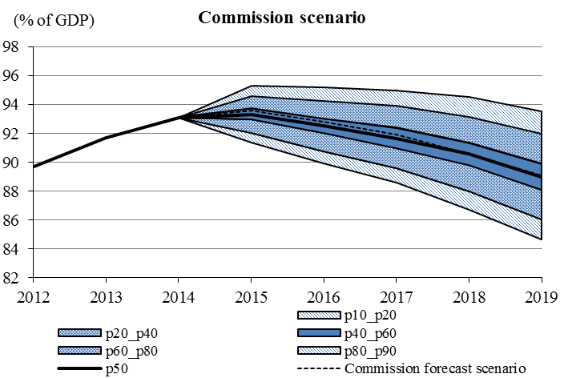

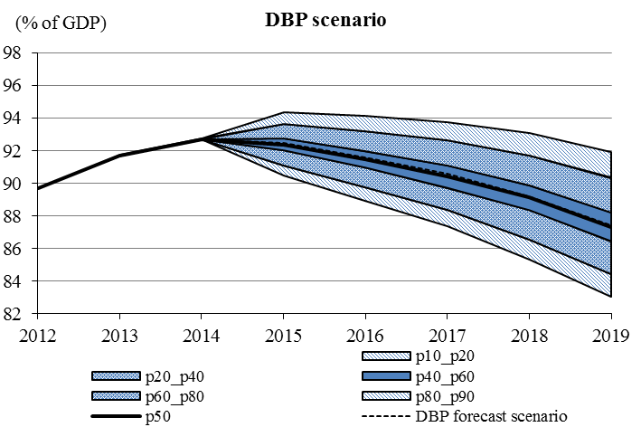

For the Commission and DBP forecast scenarios respectively, the fan charts highlight probabilities of about 40% and 50% of a worse than forecasted debt-to-GDP ratio for the EA-16 in 2015, due to the occurrence of adverse macroeconomic shocks. Accounting for both downside and upside risks to growth and financial market conditions in the two scenarios leads to a EA-16 debt in 2015 lying between 90-91% and 94-95% of GDP with an 80% probability (as the cone represents 80% of all possible simulated debt paths). Lower and upper bounds of the debt ratio interval in 2015 would be higher for the Commission scenario compared to the DBP scenario, due to a 1 percentage point difference between the respective central forecasts to which shocks apply (a debt ratio of around 93.5% in the Commission scenario versus 92.5% in the DBP scenario).
Beyond 2015, the horizon of the current DBPs, simulation results show a widening of the difference in projected debt ratios under shocks between the Commission and the DBP scenarios. At the end of the projection horizon considered in the fan charts (2019), there would be a 50% probability of a debt ratio higher than 89% of GDP in the Commission scenario, and a 50% probability of a debt ratio higher than 87% of GDP in the DBP scenario. The difference is mainly due to the structural primary balance kept constant at higher last forecasted surplus in the DBP scenario compared to the Commission scenario, leading to a stronger decrease in simulated debt ratios after 2015 in the DBP scenario.
Note that since the size and correlation of the shocks reflect the variables' historical behaviour, the methodology does not capture real-time uncertainty, such as may exist in particular for assessing the output gap. Bearing in mind the past experience of significant revisions of output gap estimates, often in the direction of lower potential output than thought in real time, this suggests an additional source of risks on future debt paths that is not reflected in the previous analysis.

ANNEX 4: The implementation of structural reforms: addressing macroeconomic imbalances and reducing the tax wedge

Structural reforms are crucial to encourage growth and jobs in Europe by fostering an efficient reallocation of resources, improving productivity and competitiveness prospects. Other than the vulnerable euro area Member States, which have been implementing an economic adjustment programme supported by financial assistance, the reform needs are the largest in countries experiencing excessive imbalances in the sense of the MIP (Italy and Slovenia) or imbalances requiring decisive policy action (France, Ireland and Spain). In response to the Council recommendations to the euro area, the Commission has put in motion a specific monitoring of policy implementation in these Member States.
For a detailed assessment of the impact of concrete structural policies on economic activity, see "Market Reforms at Work", European Economy, 2014(5). It shows that the potential impact of a selection of such market reforms in four of Europe's most vulnerable economies: Italy, Greece, Portugal and Spain can be significant, and that the reform efforts in these countries appear to be starting to have a positive effect. Both reform efforts and their effectiveness seem to vary across the four countries, with Spain showing the strongest signs that the reforms are starting to pay off, followed by Portugal, while Italy and Greece seem to lag behind.
Reducing the tax wedge
The tax burden on labour in the euro area is relatively high, which weighs on economic activity and employment. In 2014, the Council addressed country-specific recommendations (CSRs) to several euro area Member States to address this issue. In addition, the euro area as a whole was issued a Recommendation to "…regularly hold thematic discussions on structural reforms in the labour and product markets with potentially large spillovers, focussing on reducing the high tax wedge on labour and reforming services markets".
Following up on the Recommendation, the Eurogroup discussed the high tax wedge on labour in the euro area in July and in September of this year. It expressed its commitment to effectively reduce the tax burden on labour in the euro area and adopted a number of common principles for reforms in this field, related in particular to their design, their financing, the broader policy context and the political and societal support. It underlined the importance of further work in this area, including through the exchange of best practices.
A high tax wedge on labour, on its own or in interaction with the benefit system, may create unemployment or inactivity traps. By increasing the gap between labour costs and take-home pay, high taxes on labour reduce the demand for labour and depress labour supply. These effects may be particularly significant for low-skilled and low-income earners, and could interact with other labour market features such as the minimum wage. Shifting the tax burden away from labour would stimulate labour supply by reducing disincentives to work and would raise labour demand by reducing firms' labour costs. Lower labour taxation also contributes to firms' profitability, which in turn improves the return on capital and the incentives to invest. For several euro area Member States, the need to reduce non-wage labour costs is also related to the need to improve cost competitiveness, while avoiding a reduction in take-home pay.
In the years prior to the crisis, several Member States implemented structural reforms to address the high tax wedge on labour. In the context of the crisis, however, these efforts faded away and many Member States raised personal income taxes or social contributions to contribute to consolidation. This trend is visualised in Graph A4.1. Within the euro area, there are large differences between Member States in terms of the size of the tax wedge and its composition as illustrated in Graph A4.2 for a single worker at the average wage.
The DBPs show a clear awareness in euro area Member States of the benefits of addressing high taxes on labour. Reforms are underway across the euro area. To give three examples:
- France, which received a CSR to "take action to further lower employer social security contributions" and to "reduce the tax burden on labour" recalled in its DBP that, as part of the responsibility and solidarity pact, a number of measures, mainly targeted at low income earners, had been announced. As of 2014, the tax credit on competitiveness and employment will reduce the cost of labour for wages of up to 2.5 times the minimum wage. The budgetary cost of this measure will amount to EUR 20 billion when in full effect. In addition, the government has announced a EUR 10 billion reduction in social security contributions paid by employers by 2016. Finally, the DBP includes a measure reducing personal income tax for the low earning households by EUR 2.7 billion.
- Estonia, which received a CSR to "improve incentives to work through measures targeted at low income earners", included in its DBP several measures to reduce the tax wedge on labour across the board: the personal income tax rate will be lowered by 1 percentage point to 20%, the unemployment insurance contribution will be reduced to 2.4% from the current 3% and the tax-exempted income or basic allowance will be increased by 7%.
- The Netherlands, which received a CSR to "reduce tax disincentives on labour", included in its DBP measures to further increase the employee tax credit. In addition to this, the employee tax credit will be refocused to improve incentives to work for lower and middle incomes. This approach limits the budgetary costs of the measure (EUR 500 million) while keeping the significant positive effect that the credit has on labour supply of household with lower and middle incomes. Moreover, the increase in the tax rate of the first income tax bracket (after a temporary reduction in 2014) will be lower than foreseen in the coalition agreement to a budgetary cost of EUR 475 million.

Graph A4.1: Euro area tax wedge single worker, average wage
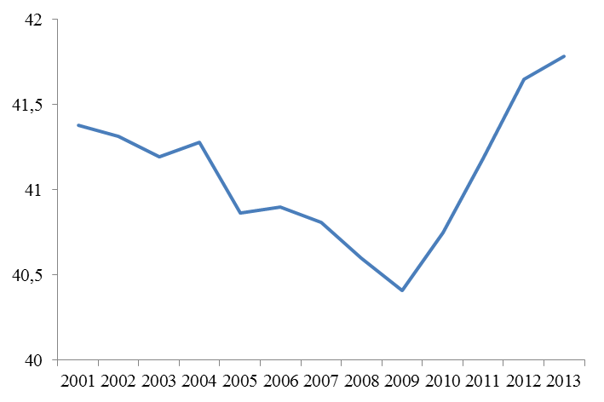
Source: OECD and Commission services.
Note: The euro area average presented is a simple arithmetic average; recent data for Cyprus is not available; data from 2012 were used for Latvia and Malta.

Graph A4.2: Tax wedge single worker, average wage (2013)
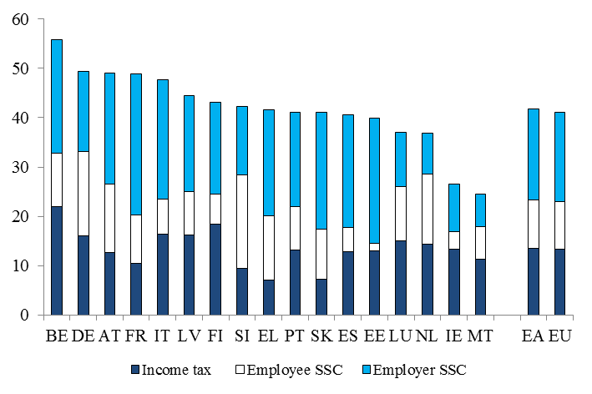
Source: OECD and Commission services. SSC = social security charges.
Note: The EU and euro area averages presented are simple arithmetic averages; recent data for Cyprus and Croatia are not available; data from 2012 were used for Bulgaria, Latvia, Lithuania, Malta and Romania.

ANNEX 5: Graphs and tables

Table A5.1: Headline deficit targets (% of GDP) for the EA-16 according to the Stability Programmes (SP), the Draft Budgetary Plans (DBP) and the Commission's 2014 autumn forecast (COM)
 | 2014 |  |  | 2015
Country | SP | DBP | COM | SP | DBP | COM
BE | -2.1 | -2.9 | -3.0 | -1.4 | -2.1 | -2.8
DE | 0.1 | 0.2 | 0.2 | 0.1 | 0.2 | 0.0
EE | -0.7 | -0.3 | -0.4 | -0.5 | -0.5 | -0.6
ES | -5.5 | -5.5 | -5.6 | -4.2 | -4.2 | -4.6
FR | -3.8 | -4.4 | -4.4 | -3.0 | -4.3 | -4.5
IE | -4.8 | -3.7 | -3.7 | -3.0 | -2.7 | -2.9
IT | -2.6 | -3.0 | -3.0 | -1.8 | -2.6 | -2.7
LV | -1.0 | -1.5 | -1.1 | -0.8 | -1.0 | -1.2
LU | 0.1 | 0.2 | 0.2 | -0.5 | -0.2 | -0.4
MT | -2.1 | -2.1 | -2.5 | -1.6 | -1.6 | -2.6
NL | -2.9 | -2.9 | -2.5 | -2.1 | -2.2 | -2.1
AT | -2.7 | -2.8 | -2.9 | -1.4 | -1.9 | -1.8
PT | -4.0 | -4.8 | -4.9 | -2.5 | -2.7 | -3.3
SI | -4.1 | -4.4 | -4.4 | -2.4 | -2.8 | -2.9
SK | -2.8 | -2.9 | -3.0 | -2.8 | -2.0 | -2.6
FI | -2.0 | -2.7 | -2.9 | -1.1 | -2.4 | -2.6
EA-16 | -2.4 | -2.6 | -2.6 | -1.8 | -2.2 | -2.4

Table A5.2: Changes in structural balance (% of GDP) for the EA-16 according to the Stability Programmes (SP), the Draft Budgetary Plans (DBP) and the Commission's 2014 autumn forecast (COM)
 | 2014 |  |  | 2015
Country | SP | DBP | COM | SP | DBP | COM
BE | 0.4 | 0.3 | 0.1 | 0.6 | 0.7 | 0.4
DE | 0.0 | -0.1 | 0.1 | -0.2 | -0.2 | -0.1
EE | 0.0 | 0.9 | 0.4 | 0.3 | 0.1 | 0.1
ES | 0.6 | 0.4 | 0.2 | 0.1 | -0.1 | -0.2
FR | 0.7 | 0.2 | 0.3 | 0.6 | 0.1 | 0.1
IE | 1.5 | 0.3 | 1.0 | 2.0 | 1.0 | 0.4
IT | 0.2 | -0.3 | -0.1 | 0.4 | 0.3 | 0.1
LV | -0.5 | -0.5 | -0.4 | 0.0 | 0.1 | -0.2
LU | -0.5 | -0.8 | -0.9 | -1.2 | -0.7 | -0.7
MT | 0.4 | 0.4 | 0.0 | 0.5 | 0.1 | -0.2
NL | -0.1 | -0.3 | 0.1 | 0.3 | 0.1 | -0.3
AT | 0.0 | 0.3 | 0.2 | 0.2 | -0.1 | 0.1
PT | 0.5 | 0.8 | 0.6 | 0.8 | 0.1 | -0.3
SI | 0.8 | -0.4 | -0.7 | 0.6 | 0.2 | 0.3
SK | -0.4 | -0.6 | -0.7 | 0.3 | 1.3 | 0.8
FI | -0.3 | -0.4 | -0.4 | 0.4 | -0.2 | 0.0
EA-16 | 0.3 | 0.0 | 0.1 | 0.3 | 0.1 | 0.0

Table A5.3: Debt-to-GDP ratio (% of GDP) for the EA-16 according to the Stability Programmes (SP), the Draft Budgetary Plans (DBP) and the Commission's 2014 autumn forecast (COM)
 | 2014 |  |  | 2015
Country | SP | DBP | COM | SP | DBP | COM
BE | 101.2 | 105.6 | 105.8 | 99.4 | 105.1 | 107.3
DE | 75.8 | 73.8 | 74.5 | 72.6 | 70.7 | 72.4
EE | 9.8 | 9.8 | 9.9 | 9.3 | 9.3 | 9.6
ES | 99.5 | 97.6 | 98.1 | 101.7 | 100.3 | 101.2
FR | 95.6 | 95.3 | 95.5 | 95.6 | 97.2 | 98.1
IE | 121.4 | 110.5 | 110.5 | 120.0 | 108.5 | 109.4
IT | 134.9 | 131.6 | 132.2 | 133.3 | 133.1 | 133.8
LV | 38.8 | 39.7 | 40.3 | 32.9 | 34.6 | 36.3
LU | 23.3 | 23.0 | 23.0 | 24.0 | 24.1 | 24.3
MT | 69.4 | 70.1 | 71.0 | 68.5 | 69.0 | 71.0
NL | 74.6 | 69.8 | 69.7 | 74.7 | 70.0 | 70.3
AT | 79.2 | 86.5 | 87.0 | 77.6 | 85.6 | 86.1
PT | 130.2 | 127.2 | 127.7 | 128.7 | 123.7 | 125.1
SI | 80.9 | 82.2 | 82.2 | 81.1 | 83.2 | 82.9
SK | 55.2 | 54.1 | 54.1 | 56.2 | 54.4 | 54.9
FI | 59.8 | 59.6 | 59.8 | 61.0 | 61.2 | 61.7
EA-16 | 94.3 | 92.7 | 93.1 | 93.1 | 92.5 | 93.6

Table A5.4: Real GDP growth (%) for the EA-16 according to the Stability Programmes (SP), the Draft Budgetary Plans (DBP) and the Commission's 2014 autumn forecast (COM)
 | 2014 |  |  | 2015
Country | SP | DBP | COM | SP | DBP | COM
BE | 1.4 | 1.1 | 0.9 | 1.8 | 1.5 | 0.9
DE | 1.8 | 1.8 | 1.3 | 2.0 | 2.0 | 1.1
EE | 2.0 | 1.5 | 1.9 | 3.5 | 2.5 | 2.0
ES | 1.2 | 1.3 | 1.2 | 1.8 | 2.0 | 1.7
FR | 1.0 | 0.4 | 0.3 | 1.7 | 1.0 | 0.7
IE | 2.1 | 4.7 | 4.6 | 2.7 | 3.9 | 3.6
IT | 0.8 | -0.3 | -0.4 | 1.3 | 0.6 | 0.6
LV | 4.0 | 2.9 | 2.6 | 4.0 | 2.8 | 2.9
LU | 3.2 | 2.8 | 3.0 | 3.2 | 2.7 | 2.4
MT | 2.3 | 3.0 | 3.0 | 2.1 | 3.5 | 2.9
NL | 0.8 | 0.7 | 0.9 | 1.3 | 1.3 | 1.4
AT | 1.7 | 0.8 | 0.7 | 1.7 | 1.2 | 1.2
PT | 1.2 | 1.0 | 0.9 | 1.5 | 1.5 | 1.3
SI | 0.5 | 2.0 | 2.4 | 0.7 | 1.6 | 1.7
SK | 2.3 | 2.4 | 2.4 | 3.0 | 2.6 | 2.5
FI | 0.5 | 0.0 | -0.4 | 1.4 | 1.2 | 0.6
EA-16 | 1.3 | 1.0 | 0.8 | 1.7 | 1.5 | 1.1

Table A5.5: Composition of fiscal consolidation in 2014 and 2015 for the EA-16 according to the Stability Programmes (SP), the Draft Budgetary Plans (DBP) and the Commission's 2014 autumn forecast (COM)
% potential GDP unless otherwise specified | 2014 |  |  | 2015
% potential GDP unless otherwise specified | SP | DBP | COM | SP | DBP | COM
Cyclically-adjusted revenue ratio | 46.9 | 46.7 | 46.8 | 46.7 | 46.5 | 46.8
p.p. change with respect to previous year | 0.0 | 0.1 | 0.2 | -0.1 | -0.1 | 0.0
Cyclically-adjusted expenditure ratio | 47.8 | 47.9 | 48.0 | 47.5 | 47.7 | 48.0
p.p. change with respect to previous year | -0.3 | 0.1 | 0.2 | -0.3 | -0.2 | 0.0
Change in structural balance | 0.3 | 0.0 | 0.1 | 0.3 | 0.1 | 0.0

Table A5.6: Short-term elasticities underlying revenue projections for 2015 in EA-16: Draft Budgetary Plans (DBP) versus Commission's 2014 autumn forecast (COM) and OECD
Country | DBP | COM | OECD
BE | 0.7 | 1.0 | 1.0
DE | 0.8 | 1.0 | 1.0
EE | 1.2 | 1.4 | 1.1
ES | 0.1 | 1.1 | 1.0
FR | 1.0 | 1.1 | 1.0
IE | 0.7 | 0.4 | 1.1
IT | 1.5 | 1.5 | 1.1
LV | 0.1 | 1.0 | 0.9
LU | 0.2 | 1.0 | 1.0
MT | 0.7 | 1.2 | 1.0
NL | 0.7 | 1.3 | 1.1
AT | 0.9 | 1.1 | 1.0
PT | 1.5 | 0.6 | 1.0
SI | -1.5 | 0.1 | 1.0
SK | -0.1 | 1.0 | 1.0
FI | 0.7 | 0.8 | 0.9
EA-16 | 0.8 | 1.0 | 1.0
Note: the comparison between the elasticities derived from the DBPs and the Commission's forecast, on the one hand, and the OECD's elasticities, on the other, should be made with care. While the first two are net elasticities to GDP growth, the latter are, strictly speaking, computed with respect to the output gap. Differences are in general minor.

Table A5.7: Fiscal effort measured as the sum of discretionary revenue measures net of the change in cyclically-adjusted expenditure ratio: Draft Budgetary Plans (DBP) versus Commission's 2014 autumn forecast (COM) and Stability Programmes (SP)
 | 2014 |  |  | 2015
Country | SP | DBP | COM | SP | DBP | COM
BE | 1.5 | 0.8 | 0.5 | 0.5 | 0.8 | 0.2
DE | 0.5 | 0.2 | 0.2 | 0.2 | 0.2 | -0.1
EE | 0.3 | 0.3 | 0.0 | -0.2 | -0.7 | -0.5
ES | 1.1 | 0.6 | 0.1 | 0.2 | 0.1 | -0.1
FR | 0.8 | -0.1 | 0.1 | 0.4 | -0.1 | 0.0
IE | 2.3 | 1.1 | 1.3 | 2.0 | 1.1 | 1.2
IT | 0.1 | 0.1 | 0.0 | 0.1 | -0.1 | -0.5
LV | 0.8 | -0.7 | -0.1 | 1.7 | 2.0 | -0.2
LU | 0.6 | -0.3 | -0.6 | 0.4 | -0.1 | -0.7
MT | -0.3 | -0.2 | -0.8 | 0.3 | -0.1 | -0.6
NL | 0.8 | 0.6 | -0.1 | 0.4 | 0.5 | -0.6
AT | -1.1 | -1.4 | -1.4 | 1.5 | 0.9 | 0.8
PT | 0.7 | 0.2 | -0.5 | 0.5 | 1.1 | 1.3
SI | 10.4 | 10.0 | 9.8 | 2.9 | 2.2 | 1.7
SK | 1.1 | 1.7 | 0.5 | 1.1 | 1.9 | 0.4
FI | -0.2 | -0.1 | -0.5 | 0.6 | -0.1 | 0.2
EA-16 | 0.6 | 0.2 | 0.1 | 0.4 | 0.2 | -0.1

Graph A5.1a: Projected changes in expenditure ratios for 2015 in EA-16: Draft Budgetary Plans (DBP) versus Commission's 2014 autumn forecast (COM)
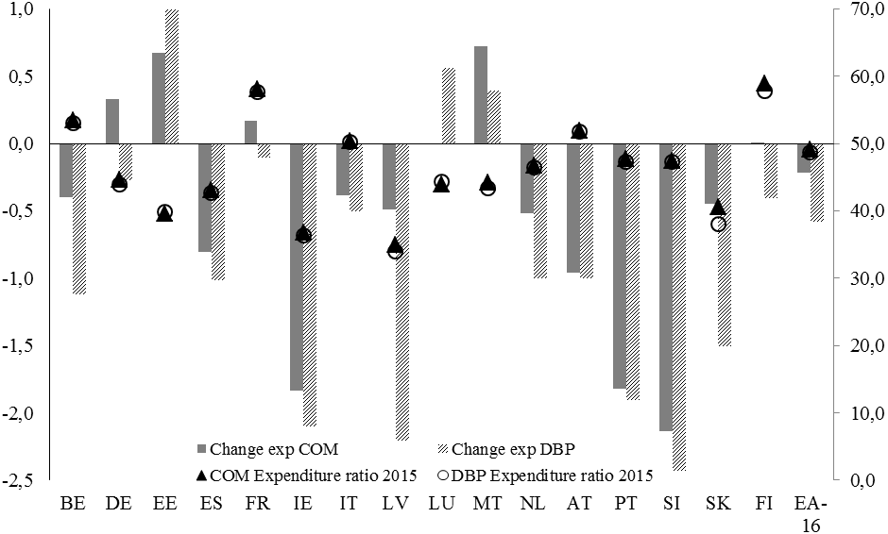
The graph shows the changes in expenditure ratios (lhs) between 2014 and 2015 and the ratios in 2015 (rhs).

Graph A5.1b: Projected changes in revenue ratios for 2015 in EA-16: Draft Budgetary Plans (DBP) versus Commission's 2014 autumn forecast (COM)
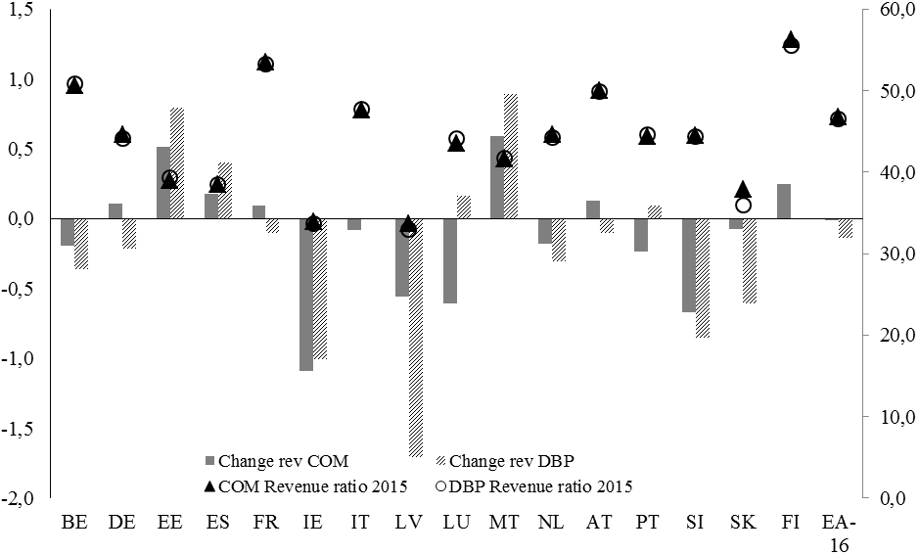
The graph shows the changes in revenue ratios (lhs) between 2014 and 2015 and the ratios in 2015 (rhs).

Graph A5.2: Projected changes in main types of expenditure (% of GDP) for 2015 in EA-16: Draft Budgetary Plans (DBP) versus Commission's 2014 autumn forecast (COM)
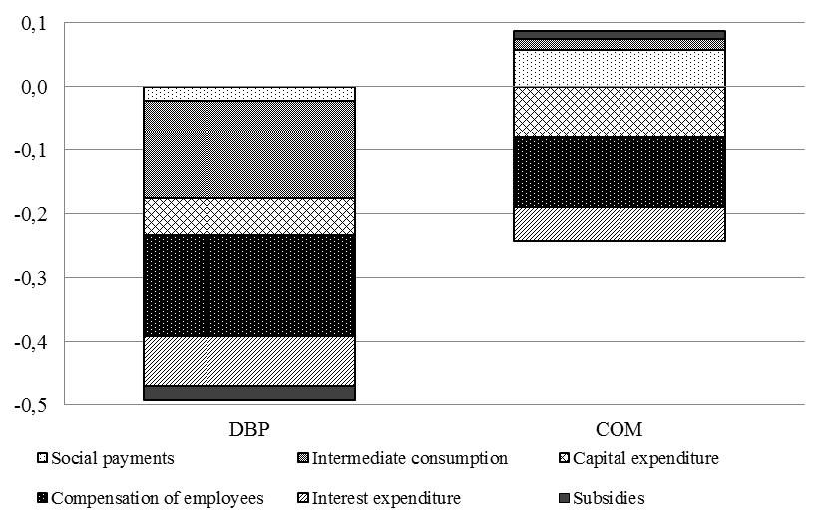
The graph shows the contributions from the main components of expenditure to the projected changes in expenditure-to-GDP ratios.

Graph A5.3: Projected changes in main types of tax revenue (% of GDP) for 2015 in EA-16: Draft Budgetary Plans (DBP) versus Commission's 2014 autumn forecast (COM)
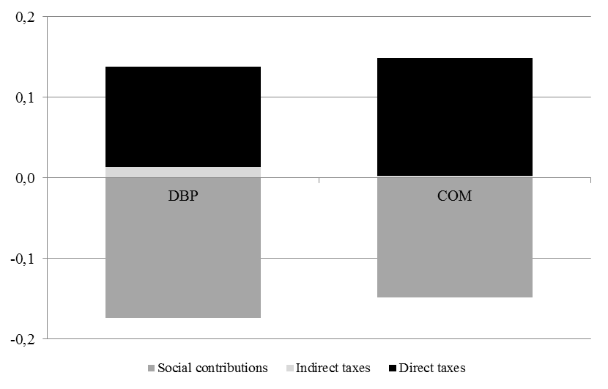
The graph shows the contributions from the main components of revenue to the projected changes in revenue-to-GDP ratios.

Graph A5.4: Comparison of headline government balance (% of GDP) as projected for 2015 by the Commission's 2014 autumn forecast (COM) and by the Draft Budgetary Plans (DBP)
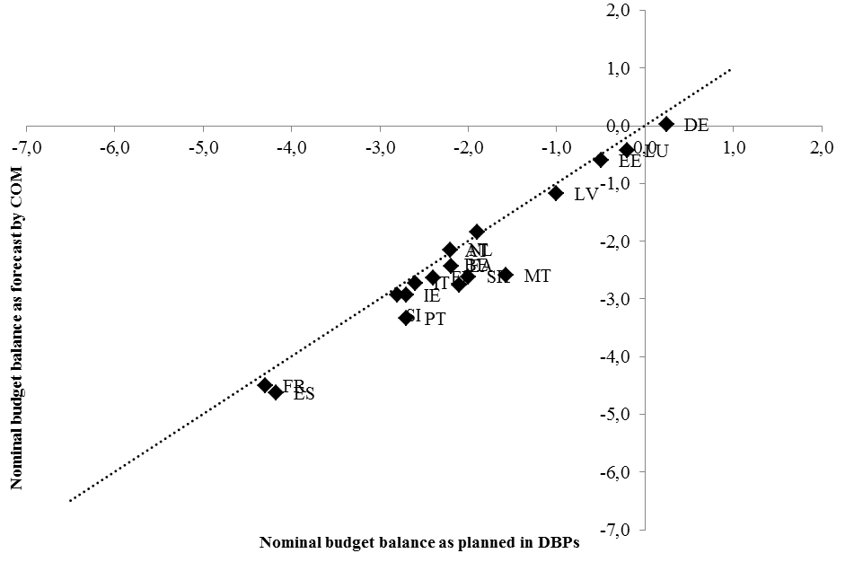
The graph plots the 2015 nominal budget balances from the Commission's forecast (horizontal axis) against those planned in the DBPs (vertical axis). Member States above (below) the bi-sector line are those where the Commission forecasts a higher (lower) nominal balance than the DBPs.

Graph A5.5: Decomposition of the difference in debt targets (% of GDP) for 2015 between the Commission's 2014 autumn forecast and the Draft Budgetary Plans
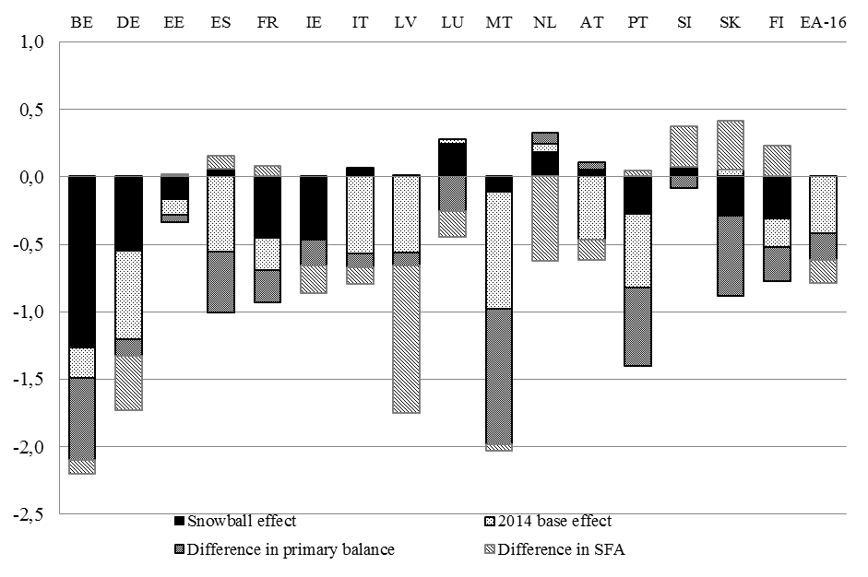
The graph breaks the projected differences in debt-to-GDP ratios down into differences in base effects, primary balances, stock-flow adjustments and snowball effects. The snowball effect represents the difference between projected growth rates and interest rates.

As set out in Regulation (EU) No 473/2013 on common provisions for monitoring and assessing Draft Budgetary Plans and ensuring the correction of excessive deficits of the Member States in the euro area. It is one of the two Regulations in the so-called Two-Pack which entered into force in May 2013.
Greece and Cyprus, the remaining euro area countries under a macroeconomic adjustment programme, are not obliged to submit a plan, as the programme already provides for close fiscal monitoring.
Latvia is invited to re-submit an updated plan in time to allow the Commission to adopt an informed Opinion on the DBP and the Eurogroup to hold a proper discussion before the budget law is planned to be adopted by the national parliament.
Council Recommendation of 8 July 2014 on the implementation of the broad guidelines for the economic policies of the Member States whose currency is the euro (OJ C 247, 29.7.2014, p. 143).
France, Ireland, Malta, Portugal, Slovenia, Spain.
An alternative measure of the fiscal effort in the DBPs can be obtained by considering the amount of discretionary revenue measures net of the change in cyclically-adjusted expenditure ratio (Table A5.7). This suggests a fiscal adjustment of 0.2% of GDP both in 2014 and 2015 for the EA-16. While these estimates are slightly higher than the changes in the structural balance (0.0% and 0.1% of GDP, respectively, in the two years), the downward revisions compared to the spring are of the same order of magnitude for both measures of effort. This confirms that the aggregate fiscal effort derived from the DBPs is smaller than what was projected in the SPs in spring.
The non-cyclically adjusted ratio would fall more significantly in 2015, by about 0.6 percentage points, given positive 'denominator effects' linked to a narrowing output gap.
OJ C 247, 29.7.2014, pp. 1-140.
The macroeconomic scenario underlying the Draft Budgetary Plan is based on the spring issue of the German Federal Government's forecast published in April. However, given that further official statistics and worsened business cycle indicators became available after its publication, it describes a significantly more optimistic outlook for economic activity in 2014 and 2015 than the Commission's 2014 autumn forecast. The German Government has updated its own forecast since the submission of the Draft Budgetary Plan.
The so-called 'net elasticity' of revenues, i.e. the percentage change in revenues, net of the effect of discretionary measures, for a one per cent change in GDP. The aggregate elasticity of revenues in 2015 arising from the plans is lower than that underpinning the Commission's forecast (0.8 and 1.0, respectively; see Table A5.6).
Structural reforms with a direct budgetary impact.
For a Member State that has not reached its MTO, the deviation will be considered significant if: (i) the deviation of the structural balance from the appropriate adjustment path is at least 0.5% of GDP in one single year or at least 0.25% of GDP on average per year in two consecutive years; and (ii) an excess of the rate of growth of expenditure net of discretionary revenue measures over the appropriate adjustment path defined in relation to the reference medium-term rate of growth has had a negative impact on the government balance of at least 0.5 of a percentage point of GDP in one single year, or cumulatively in two consecutive years. A deviation may also be considered significant if only one of the two conditions (i) and (ii) is verified and the overall assessment shows that this condition is the most appropriate for gauging the underlying fiscal effort.
Malta is currently under the corrective arm, but could move to the preventive arm from 2015 if a timely and sustainable correction is achieved.
Methodological assumptions underlying the Commission's 2014 autumn forecast, available at: http://ec.europa.eu/economy_finance/publications/european_economy/forecasts/index_en.htm).
Available at: http://epp.eurostat.ec.europa.eu/cache/ITY_PUBLIC/2-15072009-BP/EN/2-15072009-BP-EN.PDF.
Available at: http://epp.eurostat.ec.europa.eu/cache/ITY_PUBLIC/2-21102014-AP/EN/2-21102014-AP-EN.PDF.
In line with the Eurostat decision of 27 January 2011 on the statistical recording of operations undertaken by the EFSF, available at: http://epp.eurostat.ec.europa.eu/cache/ITY_PUBLIC/2-27012011-AP/EN/2-27012011-AP-EN.PDF.
The methodology for stochastic public debt projections used here is presented in the European Commission's Fiscal Sustainability Report 2012, Section 3.3.3, and in Berti K. (2013), "Stochastic public debt projections using the historical variance-covariance matrix approach for EU countries", European Economy Economic Paper No. 480.
This entails that the EA-16 structural primary balance is assumed to remain constant at the last forecasted value – a 1.4% surplus in 2015 in the DBP scenario, against a 1.2% surplus in 2016 in the Commission scenario – over the rest of the projection horizon.
The assumption is made that shocks follow a joint normal distribution.
In 2015, the dashed line representing forecasts for the central scenario in the two fan charts corresponds, in the DBP and Commission scenarios respectively, with the line indicating the 50th and the 60th distribution percentile (meaning that respectively 50% and 40% of all possible values for the debt-to-GDP ratio in 2015 would lie above the forecasted value).
For synthetic indicators on compliance with policy recommendation, see Deroose, S. and J. Griesse, "Implementing Economic Reforms – Are EU Member States Responding to European Semester Recommendations?", ECFIN Economic Brief, 2014(37).
Outside the euro area, the Commission has also identified Croatia as experiencing excessive imbalances.
Outside the euro area, the Commission has also identified Hungary as experiencing imbalances requiring decisive policy action.
For estimates of the potential impact of a selection of market reforms in selected economies, see "Market Reforms at Work", European Economy, 2014(5). For more detailed assessments of sectorial reforms see Turrini A. et al. "A Decade of Labour Market Reforms in the EU", European Economy-Economic Papers, 522; Lorenzani, D. and J. Varga, "The Economic Impact of Digital Structural Reforms", European Economy-Economic Papers, 529; Lorenzani, D and F. Lucidi, "The Economic Impact of Civil Justice Reforms", European Economy-Economic Papers, 530; Connell, W. "Economic Impact of Late Payments", European Economy-Economic Papers, 531; Ciriaci, D. "Business Dynamics and Red Tape Barriers", European Economy-Economic Papers, 532, and Canton E. et al. "The Economic Impact of Professional Services Liberalisation", European Economy-Economic Papers, 533.
Unemployment and inactivity traps refer to financial disincentives to take up a job from either unemployment or inactivity, caused by the combined effects of tax and benefit systems.

