REPORT FROM THE COMMISSION TO THE EUROPEAN PARLIAMENT AND THE COUNCIL
Annual Report on the Implementation of the EU-Colombia/Peru Trade Agreement
- Introduction
On 26 June 2012, the EU signed a Trade Agreement (hereafter the Agreement) with Colombia and Peru. The Agreement has been provisionally applied since 1 March 2013 for Peru and 1 August 2013 for Colombia.

Since the start of the Agreement's application, the Commission provided to the Parliament and the Council information regarding its implementation, in particular during meetings of the dedicated monitoring group set up by the European Parliament's International Trade Committee. In accordance with the Regulation (EU) No 19/2013 the Commission committed to submit an annual report to the European Parliament and the Council on the application, implementation and fulfilment of obligations of the Agreement and the Regulation.

This is the first such Report. In line with Article 13(1) of the Regulation, it is structured in three parts:
- an overall assessment of trade flows;
- information on the activities of various bodies implementing the Agreement;
- information on the monitoring activities referred in the Regulation.

- OVERALL ASSESSMENT: EVOLUTION OF TRADE

2.1. Methodology
The analysis of bilateral trade flows is based on data for the first year of implementation of the Agreement. In the case of Peru, data used was for the calendar year 2013, while for Colombia the data pertains to the first five months of provisional implementation of the Agreement (August 2013 to December 2013). In either case, the period was compared with the same one the previous year.

The fact that the implementation of the Agreement is still in its early stages and that certain data and figures are lacking, limits the possibility to draw conclusions about the impact of the Agreement. Indeed it can take some time before economic operators adapt so as to fully benefit from the additional trading opportunities offered by the trade agreement. Moreover, it is difficult to attribute changes in trade flows solely to the Agreement as other factors influence these figures, such as fluctuations in demand and global prices for commodities, which make up an important part of Peruvian and Colombian exports.

In general, there has been an upward trend in trade for specific goods. This has acted as a mild counterbalance to an overall decline in trade flows spurred by the global negative trends in commodity prices and EU demand. While it is premature to fully extrapolate conclusions, the figures suggest that businesses in specific sectors are increasingly making use of the Agreement.

2.2. Evolution of trade flows with Peru
In comparison with the year preceding the Agreement, the value of EU imports of goods from Peru in 2013, decreased by 15.9% (EUR 995 m), mostly because of the fall in international prices for commodities.

In 2012, the value of EU imports from Peru was EUR 6.3 bn (17.5% of Peruvian exports). In 2013, the figure was EUR 5.3 bn (16.5% of Peruvian exports), reflecting the aforementioned development.

The main EU imports were raw materials (copper and zinc accounted for 29.9% of all imports) whose value suffered a significant contraction in comparison with 2012 (-15.7%). The second group of products (food and live animals, accounting for 36.8% of all imports from Peru) saw a 10.4 % decrease in value compared to the previous year. However, some of the non-traditional exports from Peru (mainly in the agro-food sector and with a higher added value) increased by almost 6%. Chemicals and fisheries also experienced notable increases (24.9% and 4% respectively).

The value of EU exports remained constant (increasing by 0.16% or EUR 5.7 m). The EU is Peru's third largest origin for imports (accounting for some 13% of all imports in 2013).

The main products exported by the EU were machinery and transport equipment (55.5% of total). Exports of these products remained relatively stable (0.16% increase).

In 2013, the EU's trade balance with Peru reached a deficit of EUR 1,778 m (in 2012 the deficit was EUR 2,779 m). The reduction is consistent with the trend from 2009 to 2013, as the annual average growth rate was 13.5% for EU imports and 23.7% for EU exports.

2.3. Evolution of trade flows with Colombia
The analysis of trade flows with Colombia is affected by the fact that the Agreement has only been applied since 1 August 2013. In comparison with the period before the Agreement was provisionally applied (August – December 2012), the overall value of trade flows remained at similar levels.

In terms of value of trade, Colombia remains the EU's first partner in the Andean Community and the fifth in Latin America.

The value of EU imports increased by 4.2% in comparison with the previous period, totalling EUR 3,596 m. In 2012, the total value of Colombian goods exported to the EU represented 15.2% of Colombian exports (EUR 7,098.8 m out of EUR 46,720.1 m). In 2013 this figure reached EUR 7,223.2 m (15.8% of Colombian total exports).

Colombian exports remain concentrated in commodities and agricultural goods. Four types of products account for 87.2% of total exports to the EU (petroleum oils, coal, bananas and coffee).

The value of EU exports decreased by 4% compared to the same period the previous year, totalling EUR 2.328 m.

In 2012, the EU was Colombia's third largest partner in terms of imports (with 12.6% of all goods imported in 2012, or EUR 5,657.9 m out of EUR 45,025.8 m). In 2013, this figure increased to EUR 6,171.8 m (13.4% of Colombian total imports).

EU exports are characterised by a diversification of manufactured goods, consisting mainly of machinery and mechanical appliances (19% of all exports, down by 4.1%), pharmaceutical products (11.5%, up by 8.5%), aircrafts and parts (11.8%, up by 33.2%), electrical machinery and equipment (7.4%, up by 9.8%), vehicles (7.6%, up by 9.8%), and optical, photo, technical and medical apparatus (5.8%, up by 10.6%).

In 2013, the trade balance with Colombia reached a deficit of EUR 1,782 m (in 2012 the deficit was EUR 3,064 m). This needs to be weighed against the fact that during 2009-2013 the annual average growth rate was 17.8% for EU imports and 15.4% for EU exports. On the other hand, in 2013, compared to 2012, EU imports fell by 11.2%, whereas EU exports increased by 5.7%.

2.4. Evolution of trade in specific goods
A closer look at the evolution of trade flows in specific goods between the EU and the two Andean countries suggests that some sectors have begun to profit from the Agreement.

As regards Peru, notable variations were registered from 2012 to 2013 for:

- Fresh bananas: total imports rose from EUR 61 m to EUR 85 m (+39.3%);
- Edible fruits and nuts: EUR 408 m to EUR 527 m (+29.2%)
- Sugar and sugar confectionery: EUR 0.8 m to EUR 2.3 m (+187.5%);
- Beverages and spirits: EUR 44 m to EUR 71 m € (+61.4%).

Conversely, notable variations in EU exports were recorded for:

- Cereals: EUR 0.1 m to EUR 12.6 m
- Vehicles for transport of persons and goods: EUR 308 m to EUR 351 m (+14%)
- Pharmaceutical products: EUR 104 m to EUR 140 m € (+34.6%).

Given that the Agreement with Colombia has not been applied for as long as with Peru, there is less data available. The following analysis draws upon data from August to December 2013 (compared to the same period in 2012).

In terms of EU imports, notable variations were registered in 2013 for:

- Cane sugar: imports increased from EUR 1.4 m to EUR 3.4 m (+147.5%);
- Tabacco: EUR 4.6 m to EUR 15.4 m (+247.6%);
- Prepared or preserved tuna: EUR 2.5 m to EUR 2.8 m (+9.2%)
- Cut flowers: EUR 5.1 m to EUR 5.4 m (+4.4%).

Conversely, notable variations in EU exports were recorded for:

- Dairy products: exports increased from EUR 0.7 m to EUR 1.7 m (+136.5%);
- Chassis fitted with engines for vehicles: EUR 0.8 m to EUR 4.5 m (+467.4%);
- Vehicles, with compression-ignition internal combustion piston engine (diesel or semi-diesel) of a cylinder capacity exceeding 1,500 cm³ but not exceeding 2,500 cm³: EUR 2.6 m to EUR 4.3 m (+64.7%).

2.5. Use of tariff rate quotas (TRQs)
The Agreement provides for several TRQs on both sides. The preliminary analysis of quota utilisation suggests that there is still significant margin for an increase of EU exports under these advantageous TRQs.

Customs data collected through the Peruvian authorities indicate that in 2013, only two classes of products subject to TRQs registered significant trade flows (ice cream products and products with a high content of sugar), although remaining significantly below the allotted TRQs.

Similar deductions can be done for Colombia where, according to data referring to January to June 2014, only two groups of products registered any significant exports from the EU (vegetables and fruits, and malt extracts). In this case too, the utilisation of TRQs was significantly below the allotted tonnage. Groups of products such as whey and milk products, and sugar preparations registered minimal trade flows, while others (e.g. sugar, milk and cream, buttermilk, and ice-cream preparations) registered a negligible or inexistent use of available TRQs.

On the other hand, the EU opened a number of important TRQs for Peru and Colombia. In the case of Peru, the main TRQs are spread between the following groups of products: sweetcorn, maize, cane sugar, products with high sugar content, cocoa powder, rum, rice, and meat of bovine animals, among others.

According to 2013 EU customs data, only TRQs for cane sugar (full quota exhaustion, 18,334 tonnes), products with a high sugar content (2 out of 10,000 available tonnes) and for maize (58 out of 8,334 available tonnes) were taken advantage of between March 2013 and February 2014. Data for March to May 2014 indicates that TRQs were used for four groups (maize, sweetcorn, cane sugar, and products with high sugar content). Out of these, the quota for cane sugar (22,660 tonnes) was already depleted by Peru by 6 May 2014. However, all remaining products registered minimal trade flows (1 tonne for the TRQ for products with high sugar content).

As regards Colombia, the EU has opened a number of TRQs for products such as sweetcorn, maize, cane sugar, yoghurt, rum, milk and cream, and products containing high sugar content.

According to EU customs data, no use of TRQs was made in 2013. Data for 2014 indicates that TRQs were used for two broad categories (cane sugar and sugar confectionery). Out of the allotted 63,860 tonnes for cane sugar products, 23,383 tonnes had been imported by 8 July 2014. For sugar confectionery products, out of 20,600 tonnes only 105 tonnes were imported by 8 July 2014.

Overall, the modest utilisation of TRQs indicates that a disturbance in the respective internal markets for these sensitive products as a consequence of the Agreement is unlikely.

2.6. Services
Services trade data is produced with a severe time lag and presented in aggregated terms, making it unrealistic to make the same partial analysis as for trade in goods. This aspect will thus be covered in the annual implementation report once sufficient data is available.

3. Activities of the implementation bodies
The institutional provisions of the Agreement envisage the establishment of a Trade Committee and eight specialised bodies. The annual EU-Colombia/Peru ministerial level Trade Committee plays a supervisory role and ensures that the Agreement operates properly. The first meetings of these bodies were held in 2014 in Lima, Peru (see below).

Sub-Committee on Agriculture – 5 February

Participants discussed the evolution of trade and the usage of TRQs (namely aspects related to internal procedures). The stabilisation mechanism for bananas was also discussed due to the increase of Peruvian exports. Other topics included the taxation of spirits (Peru and Colombia), and a cooperation agreement for dairy products (Colombia).

Sub-Committee on Technical Barriers to Trade – 5 February

The Parties exchanged information on their quality infrastructure systems. The EU presented a number of concerns to Colombia (technical regulations for the automotive sector, conformity assessment procedures, labelling of textiles, technical regulations on alcoholic drinks, and biofuels policy) and Peru (Law for the Promotion of Healthy Eating, delays in the registration of pharmaceutical products and dietary supplements). Colombia and Peru voiced concerns about the EU requirement for origin certificates for fish exports and the restriction of the use of palm oil in some Member States.

Sub-Committee on Trade and Sustainable Development – 6 February

The Parties agreed on the list of experts that could be convened to examine matters that have not been satisfactorily addressed through governmental consultations, and shared their experiences on domestic mechanisms to promote the participation of civil society and groups committed to the implementation of the Trade and Sustainable Development provisions of the Agreement (see also point 4 below).

Sub-Committee on Intellectual Property – 11 February

The meeting discussed Geographical Indications (GIs), with the EU expressing its interest for simplified recognition procedures. Colombia presented a full set of certificates of protection of EU GIs under the Agreement and submitted a list of 18 new GIs, nine of them referring to agricultural products, which the EU will evaluate in accordance with the Agreement. For the remaining non-agricultural GIs, the EU clarified how their protection might be achieved.

Peru submitted a list of four new GIs for agricultural products. Other topics included the Party's respective enforcement systems, the liability of intermediary service providers, Paragraph 6 System of the TRIPS Agreement, the adhesion of Peru and Colombia to the Madrid Protocol, protection for performers, and pharmaceutical sector patents (Colombia).

Sub-Committee on Public Procurement – 31 March

The Parties discussed bilateral issues, with Peru and Colombia updating the EU on the list of government entities. The Parties agreed to exchange information on the participation of SMEs in foreign procurement markets.

Sub-Committee on Sanitary and Phytosanitary Measures – 1 April

Topics discussed included import requirements, verifications, measures linked to animal and plant health, equivalence, and technical assistance.

Sub-Committee on Customs Procedures, Trade Facilitation, and Rules of Origin – 28-29 April

The Parties presented recent developments in their customs legislation. The EU emphasised the importance of creating a paperless customs environment. The Parties exchanged their experience on Authorised Economic Operators and Mutual Recognition Agreements. On rules of origin, the Parties addressed the certification and verification of preferential origin, and the issue of direct transport.

Sub-Committee on Market Access – 15 May

The Parties exchanged information on the evolution of trade flows, noting the lack of reliable statistics over a prolonged period of time. The parties discussed bilateral issues such as GSP+ (Peru), and domestic policies on biofuels and truck scrapping (both Colombia).

Trade Committee – 16 May

The Committee reviewed the activities of the specialised bodies and discussed topics related to trade in services. The EU expressed concerns about deadlines for the issuance of work visas in Peru which could negatively affect Peru's commitments under the trade in services part of the Agreement. The Parties also discussed topics pertaining to the WTO and the Trade Facilitation Agreement, exchanging information on their current respective negotiations with other countries or regions.

4. Fulfilment of obligations on trade and sustainable development

Sub-Committee on Trade and Sustainable Development

The first meeting of the Sub-Committee was held back-to-back with an open session with civil society on 7 February attended mainly by members of Peruvian civil society and the EU’s domestic advisory group. Discussions included labour and environment related topics of importance to the implementation of Title IX of the Agreement, where potential areas for follow-up were discussed.
The Parties expressed their commitment to effectively implement Title IX of the Agreement. Colombia and Peru reported on the applicable organisational aspects of their labour and environment ministries, as well as progress made in relation to freedom of association, rights to collective bargaining, and the elimination of forced labour, which was also relevant in the context of the various measures included by Colombia and Peru in their Roadmaps presented to the European Parliament in 2012.
The Parties discussed the following issues.

4.1. Implementation of labour-related provisions
The EU reported on policy and measures taken at EU level to promote freedom of association, the right to collective bargaining, and to protect the rights of children (including the prevention of child labour). The EU also informed on the progress made by the Member States to ratify International Labour Organisation (ILO) conventions, in particular the Maritime Labour Convention. It also informed on the EU Council Decisions of 28 January 2014 authorising the Member States to ratify the ILO Chemicals and Domestic Workers conventions.

Peru reported on the implementation of its obligations under Title IX of the Agreement and provided an update on the following areas:
- Reinforcement of the Collective Relation System, including the strengthening of the inspection system, the creation of the National Superintendency for Labour Inspection; and the increase of the scale of applied fines;
- Promotion of fundamental rights, as established by the ILO, through special regulations for the registry of labour unions in the construction sector, regulation of optional arbitration, action plans and strategies against child and forced labour, and the approval of regulations for the equality of opportunities for persons with disabilities;
- Actions and increased inspections for the protection of labour rights; and
- Ratification of ILO conventions.

Colombia provided information on the implementation of Title IX of the Agreement, focusing on the following areas:
- The new structure of the Ministry of Labour and its achievements;
- The existing channels and mechanisms for social dialogue;
- The implementation of freedom of association;
- The strengths of the existing surveillance systems;
- Legislation adopted to combat illegal intermediation;
- The situation as regards the implementation of the ILO Conventions.

The Parties agreed to further the implementation of labour-related provisions of Title IX, including the ratification and implementation of ILO conventions (i.e., the Domestic Workers Convention of 2011, later ratified by Colombia on 9 May 2014). The Parties agreed to continue exchanging information, in particular with respect to measures against child and forced labour, and the promotion of freedom of association and collective bargaining.

The meeting afforded an opportunity to meet representatives of the regional office of the ILO and to discuss matters such as the negotiation and implementation of EU trade agreements in general.

4.2. Implementation of environment-related provisions
The Parties reported on the progress of the implementation of the environmental provisions in Title IX. Peru reported on the Legal and Political Framework for Environmental Issues, the Strategic Axis of Environmental Management in Peru, the National Agenda, and the National System for Environmental Action. Peru also reported on the National System for Environmental Impact Evaluation and the National Service of Environmental Certification for Sustainable Investments (SENACE).

Colombia reported on the Environment National System, the main achievements and policies from the Ministry of Environment and Sustainable Development, and the implementation of multilateral environmental agreements such as the Basel Convention, the Convention on International Trade in Endangered Species (CITES), the Montreal Protocol, the Convention on Biological Diversity, the Cartagena Protocol, and the United Nations Framework Convention on Climate Change (UNFCCC).

The EU addressed the liberalisation of environmental goods, highlighting the green goods initiative through which the EU and 13 other WTO members pledged to work towards liberalising trade in green goods. The EU encouraged Colombia and Peru to join the initiative, in particular in the context of Peru’s upcoming hosting of the UNFCCC Conference of Parties in Lima in November 2014, noting that it could have the potential for better and cheaper access to goods and technologies that protect the environment.

The EU outlined its resource efficiency roadmap and environmental footprint methodologies, with 17 products selected for pilot testing from November 2013. Any stakeholders, including businesses in Colombia and Peru, can sign up to follow and contribute to these pilots. Companies exporting to the EU should find participation in this exercise useful.

4.3. Domestic consultation and Sub-Committee sessions with civil society
During the Sub-Committee meeting, Parties discussed Article 281 (Domestic Mechanisms) and its implementation. The EU said its domestic advisory group mechanism would be similar to other EU Agreements and Peru and Colombia said they would use existing domestic advisory bodies. The Parties agreed guidelines for the open sessions to be held with the civil society.
In the open session with civil society, the EU domestic advisory group members, together with members of Peruvian civil society, stressed the importance of institutionalised civil society structures under the Agreement. The participants also stressed the need for civil society to be able to work with their counterparts between sessions so as to enable more productive discussions in open sessions.

4.4. Potential areas for follow-up work
The Parties agreed to continue engaging in the implementation of labour-related provisions of Title IX, including the ratification and implementation of ILO conventions. The Parties also agreed to continue to exchange information, in particular on measures against child and forced labour, and the promotion of freedom of association and collective bargaining.

On biodiversity, the Sub-Committee discussed the provisions within Title IX and future work. It was stressed that initiatives to combat illegal logging and associated trade, such as the recent EU Timber Regulation, may potentially represent increased trade opportunities in sustainable timber and timber products.

Colombia highlighted the importance of considering social and environmental mechanisms in the gold market, in particular in the fight against illegal mining. Horizontal issues such as impact assessments, and corporate social responsibility were also highlighted as potential areas for future discussion.

5. IMPLEMENTATION OF REGULATION (EU) NO 19/2013 OF THE EUROPEAN PARLIAMENT AND OF THE COUNCIL IMPLEMENTING THE BILATERAL SAFEGUARD CLAUSE AND THE STABILISATION MECHANISM FOR BANANAS

The Regulation provides for the possibility to initiate a safeguard investigation or introduce prior surveillance measures under certain conditions set out in the Regulation. In accordance with Articles 3 and 13 of the Regulation, the Commission has been monitoring the evolution of imports of bananas from Colombia and Peru. During the first year of implementation of the Agreement, the Commission neither initiated nor received any requests to initiate a safeguard investigation or introducing prior surveillance measures.

5.1. Evolution of Colombian and Peruvian banana exports
The results of monitoring during the first year of implementation of the Agreement are summarised below.

In 2013 imports of bananas from Peru increased by 39.3% in value when compared to 2012 (from EUR 61 m to EUR 85 m). In quantity, the increase was of 39.7% (80,696 tonnes in 2012 to 112,750 tonnes in 2013). This increase was greatest in November and December 2013, falling back to the usual levels of trade in the following months (January to April 2014).

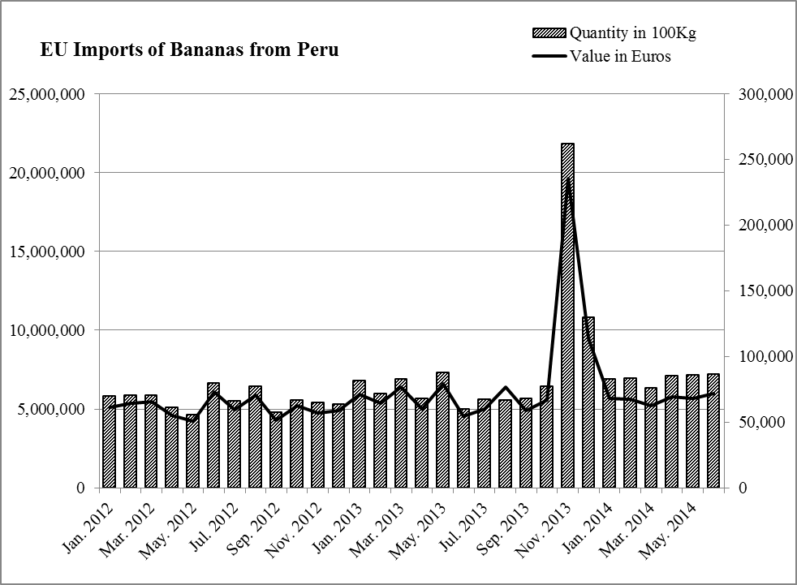

In 2013, imports of bananas from Colombia decreased by 0.6% in value when compared to the 2012 (EUR 759 m in 2012 to EUR 754 m in 2013). Total imported tonnage increased by 2.1% (1,134,567 tonnes in 2012 to 1,158,755 tonnes in 2013). Trade levels remained relatively constant (in value and quantities) for the early months of 2014.

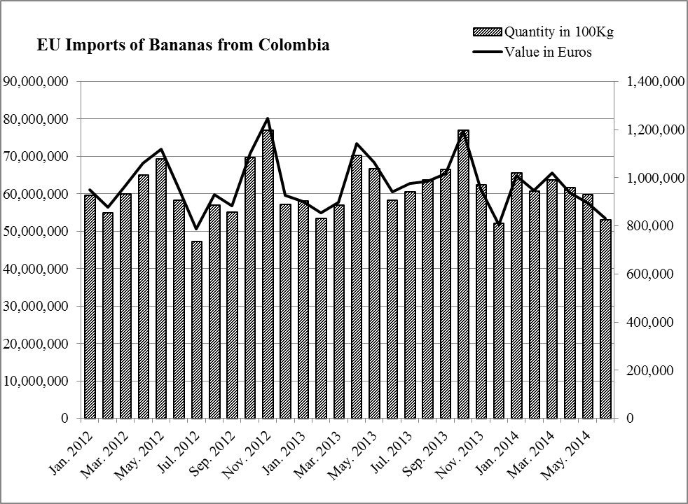
In the case of Peru, imports of bananas reached the threshold level of 78,750 tonnes in November 2013. In line with the provisions of the Banana Stabilisation Mechanism (notably Article 15(2) and 15(3) of the Regulation), the Commission examined the impact of these imports on the situation of the market for bananas in the EU. Imports from Peru represented only 1.8% of the total imports of fresh bananas to the EU, and the imports from other major banana exporters to the EU remained in line with expected trends. Moreover, the average wholesale trade of fresh bananas on the EU market did not register notable changes and there were no indications that the stability or situation of EU producers had been impacted by this increase of Peruvian exports. On the basis of this examination, the Commission concluded that the suspension of preferential customs duties on imports of bananas originating in Peru was inappropriate.

6. Conclusion
Based on about one year of implementation, it is still early to make any conclusive assessment of the results of the Agreement on trade and investment flows. While the overall level of trade seems to have decreased in relation to Peru, there were some notable increases in non-traditional trade. The reduction of trade value was probably due to reasons which are not directly linked to the Agreement itself but rather to the decrease in global commodities prices in 2013. Meanwhile, some specific sectors such as wine, vehicles, tobacco, and sugar-cane products saw important increases. On the other hand, the few months of available data for Colombia indicate little change in trade flows with some notable positive exceptions as described in the report. A greater utilisation of the available TRQs represents an important unused opportunity of this Agreement.

With regard to bananas, imports from the Andean countries remained overall stable, which made it unnecessary to initiate any suspension of preferential customs duties.

The focus thus remains on ensuring the proper implementation of the Agreement so that business can enjoy the trade opportunities arising from it. Some implementation issues persist, notably in the area of animal and plant health and hygiene (SPS) measures. Discussions on these issues will continue in the context and follow-up of the meetings of the various Sub-Committees, with a view to finding mutually acceptable and workable solutions. It is in this context that the first year of implementation overall has brought about a satisfactory set-up and functioning of the institutional framework of the Agreement.

The Agreement is provisionally applied in the EU until all Member States have ratified it. The status of the ratification is posted on the Council's website: http://www.consilium.europa.eu/policies/agreements/search-the-agreements-database?command=details&lang=en&aid=2011057&doclang=EN
Regulation (EU) No 19/2013 of the European Parliament (EP) and of the Council of 15 January 2013 implementing the bilateral safeguard clause and the stabilisation mechanism for bananas of the Trade Agreement between the European Union and its Member States, of the one part, and Colombia and Peru, of the other part.
Total annual quota proportionally adjusted for the 10 months of application of the TA in 2013.
Once two thirds of WTO membership have accepted it, this paragraph will amend the TRIPS Agreement to allow WTO members with insufficient capacities in the pharmaceutical sector for the product in question to import patented drugs made under compulsory licensing. http://www.wto.org/english/tratop_e/trips_e/public_health_e.htm
An international system for registering trademarks simultaneously in many countries http://www.wipo.int/madrid/en/
Authorised Economic Operators are economic operators that have been approved by or on behalf of customs authorities as complying with a set of requirements (e.g. compliance, solvency, security etc.) and thus benefit from various simplifications and/or facilitations specifically provided for under the respective customs legislations of the EU, Peru and Colombia.
Regulation (EU) No 995/2010.

