Table of Contents
List of acronyms 3
1. Additional figures and charts 4
2. Case studies 7
2.1: Summary of the European Initiative for Agricultural Research for Development (EIARD) Case Study 7
2.2: EU support to the ECOWAP to improve food production and security in the Economic Community of West African States 10
2.3: Summary of the Scaling Up Nutrition through EU Collaboration case study 13
2.4: Summary of a 3Cs Case Study on Ethiopia 16
3. Additional charts and examples per priority 19
4. Methodology for national report and programmes spreadsheet database 21
5. Links to the Member States’ project spreadsheet databases 26

List of acronyms
3Cs | Coordination, complementarity and coherence
AGIR | Alliance Globale pour l’Initiative Résilience
AR4D | Agriculture Research for Development
CAADP | Comprehensive Africa Agriculture Development Programme
CFS | Committee on World Food Security
CGIAR | formerly Consultative Group on International Agricultural Research
CORAF/WECARD | West and Central African Council for Agricultural Research and Development
EC | European Commission
ECOWAP | Agricultural Policy of the Economic Community of West African States
ECOWAS | Economic Community of West African States
EIARD | European Initiative for Agricultural Research for Development
EU | European Union
FAO | Food and Agriculture Organisation
ICN2 | Second International Conference on Nutrition
IFAD | International Fund for Agricultural Development
INGO | International Non-Governmental Organisation
MS | Member States
NEPAD | New Partnership for Africa’s Development
NGO | Non-Governmental Organisation
OECD/DAC | Organisation for Economic Cooperation and Development / Development Assistance Committee
PCD | Policy Coherence for Development
SHARE | Supporting the Horn of Africa’s Resilience
SUN | Scaling-Up Nutrition
UN-SCN | United Nations Standing Committee on Nutrition
USAID | United States Agency for International Development
VGGT | Voluntary Guidelines on the Responsible Governance of Tenure of Land, Fisheries and Forests
WFP | World Food Programme
WHA | World Health Assembly

The European Union (EU) and its Member States adopted an EU-wide policy framework for food security in 2010 (COM(2010) 127). Further EU development policy commitments placing additional emphasis on these priorities have been adopted in the following years. A plan for implementing the food and nutrition security commitments, as requested by the Council, was produced in 2013 (SWD (2013) 104 final) and the Council, in its conclusions on food and nutrition security in external assistance of 28 May 2013, invited the Commission and the Member States to produce a consolidated biennial progress report and to publish the first such report in 2014.
This staff working document (SWD) accompanies the first of these reports, coordinated by the Commission and jointly prepared with data provided by Austria, Belgium, Finland, France, Germany, Ireland, Italy, the Netherlands, the United Kingdom and the Commission. The SWD provides additional information and case studies supporting the analysis and findings of the first biennial report on ‘Implementing EU food and nutrition policy commitments’.

1. Additional figures and charts

 | Country | Regional | Global | Total
1: Improve smallholder resilience and rural livelihoods | 62 % | 5 % | 34 % | 100 %
2: Support effective governance | 63 % | 13 % | 25 % | 100 %
3: Support regional agriculture and food and nutrition security policies | 7 % | 51 % | 42 % | 100 %
4: Strengthen social protection mechanisms for food and nutrition security, particularly for vulnerable population groups | 96 % | 0 % | 4 % | 100 %
5: Enhance nutrition, in particular for mothers, infants and children | 80 % | 3 % | 17 % | 100 %
6: Enhance coordination between development and humanitarian actors to build resilience and promote sustainable food and nutrition security | 75 % | 1 % | 23 % | 100 %
Total | 64 % | 7 % | 28 % | 100 %
Table 1: Level of implementation per priority
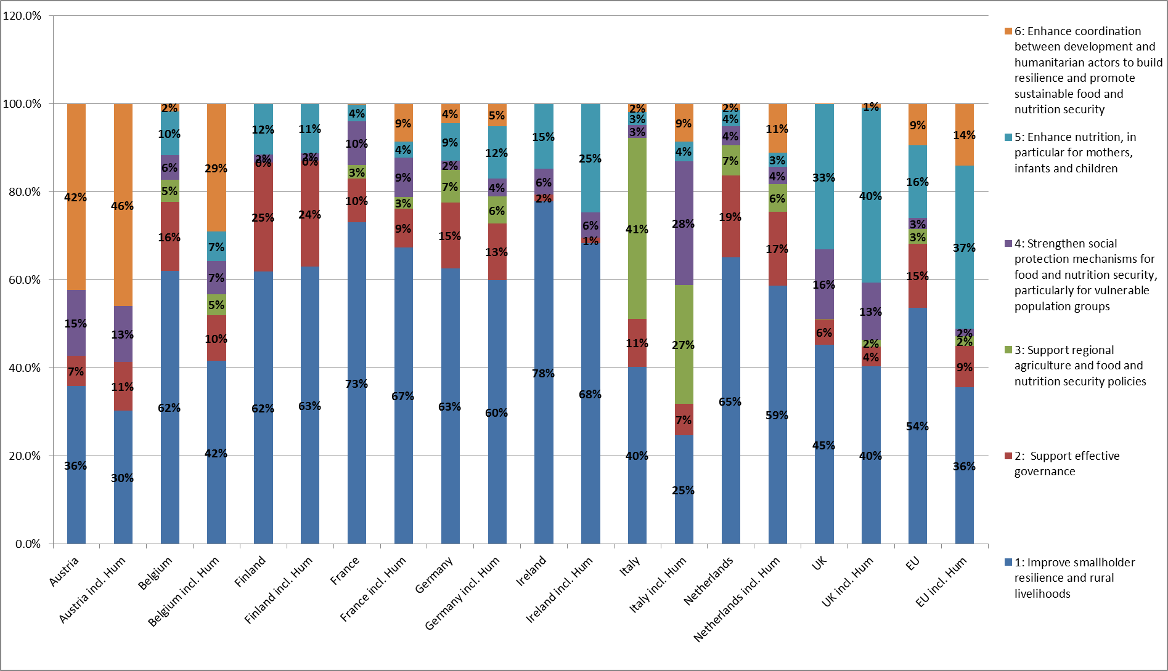
Fig. 1: Impact of humanitarian assistance on the share of each priority: percentage of support per priority for each Member State for development interventions (left bar for each Member State) and development plus humanitarian interventions (right bar for each Member State).
The separation of humanitarian programmes from the development ones is based on DAC codes: programmes with ‘Humanitarian aid’ DAC codes (72010- Material relief assistance and services; 72040- Emergency food aid; 72050- Relief coordination; protection and support services; 73010- Reconstruction relief and rehabilitation; 74010- Disaster prevention and preparedness), as well as food assistance from France with DAC code 52010 ‘Food aid/Food security programmes’, have been separated. Humanitarian assistance falls mostly under priority 5: Enhance nutrition, in particular for mothers, infants and children, and priority 6: Enhance coordination between development and humanitarian actors to build resilience and promote sustainable food and nutrition security. For some donors, humanitarian assistance is mostly one or the other (for example, Ireland’s humanitarian assistance is mostly related to priority 5 while it is mostly related to priority 6 for Belgium).

Table 2: The EU and Member States’ support to partner countries. The table is sorted by the donor average amount (total amount received for each partner country divided by the number of donors supporting the country).

2. Case studies

2.1: Summary of the European Initiative for Agricultural Research for Development (EIARD) Case Study
The case study revealed that EIARD has been very effective in terms of building coherence, coordination and complementarity.

Some suggestions emerged on how to further strengthen the 3Cs.

1. On coherence, EIARD should have a system to monitor regularly the effectiveness and impact of its work on policies, networking, advocacy and funding. This would require an open dialogue with EIARD stakeholders and beneficiaries, and a more regular interaction with other coordination mechanisms and policy platforms.
2. On coordination, EIARD should enlarge its constituency to other Member States. The EIARD mandate should be renewed at EU level, to take into consideration the new policy frameworks (on development, on research and innovation, etc.), bearing in mind the post-2015 agenda, and the building-up of a renewed global partnership for development. EIARD should liaise systematically with other coordination mechanisms/platforms.
3. EIARD should promote better complementarity of funding on agricultural knowledge and capacity development throughout interventions at different levels, so that action at the global level does add value to action at the national and local levels.
EIARD is implemented by a European Coordination Group with representatives from Austria, Belgium, Cyprus, Denmark, the EC, Finland, France, Germany, Hungary, Ireland, Italy, Luxembourg, Netherlands, Norway, Portugal, Spain, Sweden, Switzerland, the United Kingdom
This case study has been carried out through document review and semi-structured interviews with EIARD members and stakeholders. It focuses on how EU donors, Norway and Switzerland are working together in the EIARD to facilitate the coordination of European policy and investments for agricultural research for development (ARD).
Context
EIARD is a permanent informal ARD policy coordination platform for EU donors, Switzerland and Norway. It was initiated in 1995 and recognised by the Council and European Parliament in 1997. EIARD has no own financial resources and members’ activities are funded by their own agencies and ministries.
The EIARD Secretariat is hosted and supported by the European Commission. In exchange, the Commission occupies the permanent vice chairmanship of EIARD, presently held by DG DEVCO. The secretariat is managed by a seconded national expert from one of the EIARD member countries to the Commission. Since January 2014, Norway has held the chairmanship of EIARD.
EIARD’s goal is to ‘reduce poverty, to promote economic growth, food and nutrition security, sustainable management of natural resources in Africa, Latin America and Asia through effective and harmonised European investments and policies in ARD, promotion of international partnerships and support to capacity development’ (EIARD Strategy 2014-2018).
The coordination of European support to CGIAR, a global agriculture research partnership, is at the top of the EIARD agenda and it is the main area of interest for some members. EIARD is also an active member of the European Forum on Agricultural Research for Development (EFARD) which includes multiple stakeholders. A joint strategic working group with the Standing Committee on Agricultural Research (SCAR), whose mandate is agricultural research in Europe, was established to improve coherence between European agricultural research and agricultural research for development.
Facts and Figures:
Europe is a key funder of the CGIAR. In 2012, EIARD members including the EC provided USD 231 million to the CGIAR Fund (45 % of the total) and USD 321 million to the CGIAR in total (32 % of the total).
European efforts to promote coherence, complementarity and coordination through the EIARD
EIARD is considered a positive mechanism with a number of examples of coherence, coordination and complementarity but it nevertheless faces some challenges to further strengthen the 3Cs.
Strengths:
- The EIARD strategy and policy positions show a strong coherence with the EU Policy Framework for Food Security;
- EIARD members have adopted a coherent common approach on CGIAR, in particular regarding its reform and governance, and consequently Europe has one of the strongest voices in the Fund Council of CGIAR;
- EIARD is considered by its members as very effective in coordination, particularly in relation to CGIAR, including coordination of policy positions at meetings, comments of research proposals and participation in working groups. Coordination within EIARD favours the emergence of joint policies and strategies at the European level;
- EIARD acts as an information and knowledge-sharing platform and to a certain extent fosters greater complementarity of activities. This is evident in CGIAR matters, where division of labour is common practice based on shared views and mutual trust.
Challenges:
Challenges for coherence:
- To keep internal cohesion and solidarity, while broadening the agenda beyond CGIAR;
- To address the intersections with other policy areas (agriculture, trade, research, education, health, and energy) and contribute to the Policy Coherence for Development (PCD) agenda;
- To ensure effective and coherent implementation of the EIARD strategy along the research to development continuum.
Challenges for coordination:
- To include more EU countries (e.g. Eastern European countries) and have more active participation by current members, while keeping the mechanism informal and cohesive;
- To coordinate more effectively with other coordination mechanisms working on food and nutrition security.
Challenges for complementarity:
- To strengthen complementarity and division of labour on the ground with the partner countries, respecting the principles of the Paris agenda and of subsidiarity;
- To strengthen local, national and regional ARD systems and platforms.
Impact of collaboration through EIARD
The main lesson learned through EIARD is that when there is a solid basis of common views among European members, it is not difficult to build consensus and accept differences on specific topics. Effective coordination, coherence and complementarity can be achieved when there are a number of ingredients in the mix, including funding, motivation, clear objectives, flexible mechanisms, informality, and realism.
Collaboration through EIARD has been effective in a number of ways:
- ARD policies of the EU and Member States have been influenced by EIARD, through its activities, thematic studies, and coordinated work.
- EIARD had a prominent role in creating the Joint SCAR /EIARD Strategic Working Group ARCH (European Agricultural Research towards greater impact on global Challenges) in 2013 in order to improve linkages between AR and ARD aiming at identifying and working towards ways to increase the contribution of European Agricultural Research investments to solving global challenges.
- EIARD has facilitated opportunities for enhanced participation of civil society organisations in ARD activities and processes.
- EIARD has influenced the transformation of CGIAR governance and strategy, results based management, and the formulation of the CGIAR Research Programmes in terms of approaches and thematic content: development impact orientation, smallholder focus, partnership engagement, gender orientation, geographical focus, and climate change. EIARD has also contributed to a more substantive alignment of the CGIAR agenda to CAADP.
- EIARD has played an important role in ensuring that the Sub-Saharan Africa- Challenge Programme (SSA-CP) was accepted as a CGIAR programme and is sufficiently funded.

2.2: EU support to the ECOWAP to improve food production and security in the Economic Community of West African States
ECOWAP is the agricultural policy adopted by the Economic Community of West African States (ECOWAS). The European Union (EU) and Member States (MS) provide regional support for ECOWAP implementation.
Examples of EU support to ECOWAP/CAADP include the following
- EU support to the ECOWAS Agricultural Regional Information System (ECOAGRIS).
- EU support to CILSS (Comité permanent Inter-Etats de Lutte contre la Sécheresse dans le Sahel).
- Capacity development support by France and Spain for the ECOWAS Department of Agriculture and Rural Development (DARD) and the Regional Agency for Agriculture and Food (RAAF).
- Support from the Netherlands to improve farmers’ access to agro-inputs in West Africa.
- UK support to strengthen the functioning of regional food markets.
- Funding from the EU, France and Spain to help establish a regional food reserves system.
- The CAADP Multi-Donor Trust Fund (MDTF) managed by the World Bank and financed by the EU, France, Ireland, the Netherlands, the UK and the US, which should contribute to ECOWAP monitoring and evaluation efforts.

ECOWAP implementation is supported by the EU, France (AFD), Spain, the Netherlands, the United Kingdom (DfID) and Germany (GIZ). Support is also provided indirectly through organisations that are active in the region such as FAO, IFAD, the African Development Bank, the World Bank, and other international organisations.
The Agricultural Policy of the Economic Community of West African States is known as ECOWAP. It is implemented through fifteen agricultural investment plans at the national level (NAIP) and one at the regional level (RAIP), signed in 2010. Coordinated action by EU donors has provided support for ECOWAP food and nutrition security initiatives.
Context:
In 2001, the ECOWAS Ministerial Commission on Agriculture and Food adopted a framework of guidelines for the creation of a regional agricultural policy for West Africa. In 2002, the region’s Heads of State gave the ECOWAS Secretariat (now the ECOWAS Commission) a mandate to coordinate and monitor the implementation of the AU’s New Partnership for Africa’s Development (NEPAD) in the region. The development of the ECOWAP thus coincided with increasing momentum for the Comprehensive Africa Agricultural Development Programme (CAADP), the agricultural component of NEPAD.
ECOWAP was adopted in 2005. The policy’s general objective is to ‘contribute in a sustainable manner to satisfying the food needs of the population, to economic and social development and to poverty reduction in Member States as well as to address inequalities between territories, areas, and countries’ (ECOWAS, 2005).
European efforts to promote coherence, complementarity and coordination for food production and security through the ECOWAP/CAADP
The European Union and some of its Member States provide considerable regional support in the area of agricultural development and food and nutrition security in West Africa, particularly since the 2007 food crisis. The most prominent European actors in recent years are the EU, France, Spain, the Netherlands, the United Kingdom and Germany. European official development assistance (ODA) is also indirectly channelled through international organisations active in the region, such as FAO, IFAD, the African Development Bank (AfDB) and the World Bank. Key non-European bilateral development partners include the United States, Switzerland, Canada and Japan.
The EU’s support fits within the scope of one of the six policy priorities of the implementation plan for EU assistance related to food and nutrition security (European Commission, 2013), i.e. ‘supporting regional agriculture and food and nutrition security policies.’ Many of the interventions also cover one or more of the other policy priorities related to areas such as smallholder resilience, governance, social protection mechanisms and nutrition.
Agriculture constitutes a determining component of the economies of West African countries. Representing over 35 % of the regional GDP, the sector is the main source of employment in the region. Yet, production figures remain low and the region faces food security challenges. (ECOWAS 2011)
This collaboration at EU level illustrates the potential strengths and challenges of coherence, coordination and cooperation at a global level:
Strengths:
- The ECOWAP Group is a coordination mechanism for development partners, with regular meetings and participation of the ECOWAS Commission. The ECOWAP Group is recognised as unique on the continent and recently inspired a similar initiative to establish a regional CAADP coordination structure for the COMESA region.
- The success of the ECOWAP Group is partly attributable to the active role of Spain, which has worked in close cooperation with the ECOWAS Commission and has been the chair and de facto secretariat of the Group.
- There are some examples where EU actors have engaged in joint interventions under the auspices of ECOWAP. For example the EU, France and Spain are supporting the regional food reserves system. The EU and France have supported ECOWAS in combating fruit flies. France, Spain and the US have provided coordinated support to the Regional Agency for Agriculture and Food (RAAF).
Challenges:
- Many development partners provide direct support also to regional technical institutions such as CILLS (Permanent Interstates Committee for Drought Control in the Sahel) and CORAF/WECARD (West and Central African Council for Agricultural Research and Development) but overall coordination is lacking.
- Some development partners, such as the United Kingdom and the Netherlands and, until recently, the European Commission, have not participated in the ECOWAP Group meetings. Non-traditional donors, such as China, have also preferred not to participate in the group. Some representatives to the ECOWAP Group have not had sufficient instruction or lack knowledge about regional ECOWAP matters.
- ECOWAP operates in a complex policy environment with numerous regional and national actors and donors with sometimes overlapping mandates.
- International initiatives, in particular AGIR, should build coordination, complementarity and coherence with ECOWAP and not divert attention away from it.
- The functioning of the ECOWAP Group requires consolidation through chairmanship, secretariat, and monitoring arrangements.
Collaboration through ECOWAP:
ECOWAP is generally acknowledged as a first of its kind on the African continent serving to implement the regional dimension of CAADP. There also seems to be widespread consensus among national stakeholders about the importance of ECOWAP as a framework to guide strategic regional investments tackling cross-border issues. ECOWAP has become a widely accepted reference framework, also because of its potential to complement and add value to CAADP processes at the national level. The fact that the ECOWAS Member States have agreed to dedicate part of ECOWAS’s own resources to the implementation of the Regional Agricultural Investment Plan has been a contributing factor.
ECOWAP has been instrumental in convincing development partners that many West African stakeholders, including civil society organisations, have contributed to the formulation of the ECOWAP/CAADP and express continuous support for its vision and objectives.
References
ECOWAS. 2005. Twenty-eighth session of the Authority of Heads of State and Government. Decision A/Dec. 11/01/05 Adopting an Agricultural Policy for the Economic Community of West African States – ECOWAP. Accra. http://www.westafricagateway.org/files/3ECOWAS_EN.pdf
ECOWAS. 2011. Strategic and Operational Plan of the ECOWAS Commission for Governance, Coordination and Monitoring and Evaluation of the Regional Agricultural Policy of ECOWAS – (ECOWAP/CAADP) 2011-2015. Abuja: ECOWAS Commission.

2.3: Summary of the Scaling Up Nutrition through EU Collaboration case study
The SUN Movement aims to help national leaders to prioritise efforts to address under-nutrition. SUN countries are increasingly putting the right policies in place and 50 of them are working with multi-stakeholder partners to implement programmes with shared nutrition goals and mobilising resources to effectively scale up nutrition.
SUN Movement Secretariat Result Areas:
- The SUN Movement Lead Group is exercising stewardship over the Movement, keeping the political focus on under-nutrition and increasing investments in direct nutrition interventions and nutrition-sensitive development.
- Each SUN country is bringing together national stakeholders for implementation of effective actions to scale up nutrition, learning how best to do this from experiences of other SUN countries and accessing appropriate external support for achieving its objectives.
- Stakeholders from self-governing and mutually accountable SUN Networks are responding to the needs of SUN countries in a timely and effective way and contributing to responsive and aligned assistance to those countries.

The SUN Movement Secretariat was fully funded in 2013 with generous financial support from Canada, the European Union, France, Germany, Ireland, the Netherlands, the United Kingdom and the Micronutrient Initiative. Human resource capacity, reporting directly to the SUN Movement Coordinator, has been made available by France and Unilever. The Secretariat is raising additional resources to cover the estimated budget until 2015.

The Scaling Up Nutrition Movement is based on the principle that all people have a right to food and good nutrition. The 50 countries that have joined the Movement are home to over half of the children in the world who are affected by chronic malnutrition (stunting).
Coordinated action by France, Germany, Ireland, the Netherlands, the United Kingdom and the European Commission, through the SUN Movement Secretariat, has helped to accelerate political action on nutrition and long-term investment.
Context
In 2008, The Lancet’s ‘Maternal and Child Undernutrition’ Series and the Copenhagen Consensus made a compelling case for scaling up investment in nutrition using available, affordable and effective solutions. The Scaling Up Nutrition (SUN) Movement was founded in 2010 to respond to this call for action on nutrition and to address fragmented and dysfunctional governance of the international nutrition system(1). SUN unites governments, civil society, the United Nations, donors and businesses in a collective effort to improve nutrition.
The SUN Movement Secretariat was set up in 2012 as a small and flexible coordination team providing overall support to the SUN Movement. The Secretariat supports a network of more than 50 SUN countries, a 27-member SUN Lead Group, four SUN networks (donors, business, civil society, UN) and four Communities of Practice.
The Secretariat has no operational role, but links together countries and networks in the SUN Movement to ensure that support requested to intensify actions and achieve nutrition-related objectives is received in a coordinated and coherent way.
European efforts to promote coherence, complementarity and coordination through the SUN Movement Secretariat
Maternal and child malnutrition is responsible for up to 45 % of preventable child deaths. Good nutrition in the 1000 days from pregnancy to age two is a highly effective investment and can have lifelong consequences for a child’s physical and cognitive development
Within the EU, France, Germany, Ireland, the Netherlands, the United Kingdom and the European Commission are providing core funding to the SUN Movement Secretariat. This collaboration at EU level illustrates the potential strengths and challenges of coherence, coordination and cooperation at a global level:
Strengths:
- Joint donor collaboration paves the way for one plan, one budget, one report and one joint donor review of progress. Having one agreed framework leaves the SUN Movement Secretariat with more time for effectively responding to SUN countries’ unique and diverse requirements.
- Predictable multi-annual funding from EU donors provides the Secretariat with a secure resource base for strategic planning and flexibility.
- Coordinated advocacy efforts by Member States and the EU are strengthening leadership for nutrition globally and increasing investment from both public and private sources, through the Lead Group and Donor Network.
Challenges:
- Collaboration among EU donors to the Secretariat needs to be balanced with coordination with non-EU donors and with the membership of the broader SUN Movement.
- Although all donors are committed to harmonised reporting and planning, the different administrative requirements of donors have posed a challenge to the SUN Movement Secretariat in the first year. It is hoped to address this over time.
- Routine SUN Movement progress reports do not necessarily capture the results of donor funding to the SUN Movement Secretariat. Capacity to undertake additional reporting in the Secretariat is limited.
- The Movement is constantly evolving and donor expectations of the Secretariat need to be realigned and communicated on a regular basis.
- The coordination of the advocacy efforts among EU donors at country level must be strengthened to emulate the success achieved to date at a global level.
Facts and Figures:
The SUN Movement Secretariat’s budget for the period 2013-2015 is EUR 14.4 million (USD 19.1 million). Three quarters of committed funds are from EU donors, 45 % of which comes from the Commission.

Impact of collaboration through SUN
The SUN Movement Secretariat is exceeding the ambitions set out by the Lead Group in the 2012 Strategy. Countries participating in the SUN Movement are actively accelerating efforts to scale up nutrition and are putting in place systems to demonstrate results.
The SUN Movement Secretariat has been instrumental in helping countries to scale up nutrition. The Movement has grown from 30 countries in September 2012 to 50 countries in April 2014. Urgent requests for help continue to come from almost all SUN countries seeking to strengthen their capacity for further action. Thanks to the flexible and coordinated funding provided by EU donors and others, the Secretariat continues to adapt to this rapidly evolving and increasing body of requests.

References
Annual Narrative Report (1 October 2012 – 30 September 2013) & Provisional Financial Report (1 January 2013 – 31 December 2013)
SUN synthesis report April 2014
SUN newsletters and website
http://scalingupnutrition.org/the-sun-network/sun-movement-secretariat
Lancet Medical Journal 2008 and 2013 http://www.thelancet.com/series/maternal-and-child-undernutrition and http://www.thelancet.com/series/maternal-and-child-nutrition
Scaling Up Nutrition A Framework for Action September 2010
See comments from Lancet 2008 http://www.thelancet.com/series/maternal-and-child-undernutrition ‘Fragmentation, lack of an evidence base for prioritised action, institutional inertia, and failure to join up with promising developments in parallel sectors are recurrent themes’.

2.4: Summary of a 3Cs Case Study on Ethiopia
Food and Nutrition Security in Ethiopia
The main strategic coordination body in Ethiopia is the Rural Economic Development and Food Security (RED&FS) sector working group. It is the Government and Donors thematic platform for agriculture, food security and nutrition of the Development Assistance Group. It was established in 2001 to foster information sharing, policy dialogue and harmonised donor support to Ethiopia.
Under the 11th EDF Ethiopia is the first example of the EU not preparing a Country Strategy Paper but declaring that its action is fully aligned with the National Development Strategy.

The Policy and Investment Framework (PIF) provides the strategic foundation for investments to drive agricultural growth in Ethiopia. It is designed to implement the Comprehensive African Agricultural Development Programme (CAADP) Compact and has four strategic objectives:
1) To achieve a sustainable increase in agricultural productivity and production
2) To accelerate agricultural commercialisation and agro industrial development
3) To reduce degradation and improve productivity of natural resources
4) To achieve universal food security and protect vulnerable households from natural disasters

On the basis of the interviews carried out during the mission, the main EU policy focus in Ethiopia is on smallholder resilience and rural livelihoods (priority 1) and on strengthening social protection mechanisms for food and nutrition security (priority 4).
In order to evaluate the EU’s commitment in implementing its food and nutrition security (F&NS) policy, a five-day mission was fielded in Ethiopia in April 2014. The main purpose of the study, carried out in collaboration with the NGO Confederation Concord, was to analyse the European efforts to enhance coordination, complementarity and coherence (the 3Cs) of EU and its Member States external assistance programmes. The 3Cs were evaluated from the perspective of Ethiopia’s main needs, the national sector strategy, and interventions, as perceived by the main Ethiopian and international partners.
With the support of the EU Delegation to Ethiopia and the Italian Development Cooperation Office in Addis Ababa, meetings were conducted with Ethiopian authorities, Member States, other donors, NGOs, and national and international organisations.
Context
Ethiopia is one of the fastest growing non-oil dependent countries in Africa. World Bank analyses have shown that, in 2012, Ethiopia was the 12th fastest growing economy in the world. Its growth averaged 10.7 % per year from 2004 to 2012, compared with a regional average of 5.4 %. Nevertheless, over one third of Ethiopians live below the country’s poverty line. Out of a total population of around 90 million, between seven and eight million chronically food insecure people are assisted through the national social protection programme while up to two million persons receive aid during humanitarian crises.
Agriculture and food and nutrition security is a priority for Ethiopian development. More than 80 % of the population lives in rural areas and its main source of income is agriculture. The agricultural sector accounts for approximately 45 % of gross domestic product, almost 90 % of exports, and 75 % of employment. The sector is characterised by structurally low productivity, and is dominated by vulnerable small-scale subsistence farming and rain-fed agriculture. Smallholder farmers account for 95 % of production. Livestock are an essential component of local food systems. The Government invests 15 % of its budget in agriculture and Ethiopia is one of the seven African countries fulfilling the Maputo Declaration.
The IFPRI Global Hunger Index for Ethiopia (which combines three weighted indicators: undernourishment, child underweight and child mortality) stood at 25.7 % in 2013. The prevalence of low weight at birth in Ethiopia (20 %) is one of the highest in the world, and accounts for over half of child mortality.
With regard to official development assistance (ODA), OECD data show the importance of the overall European contribution, including that of Norway and Switzerland. The 2011-2012 average was EUR 867 million, which represented half of the bilateral aid and over two thirds of the total ODA to Ethiopia.
The top European donors are the United Kingdom, EU institutions, and Germany, followed by the Netherlands and Ireland. About 8 % of the assistance is given to agriculture and food security. Major non-European bilateral donors active in Ethiopia include the United States, Canada and Japan.
European efforts to promote coherence, complementarity and coordination in Ethiopia
EU donors promote food security and resilience as priority issues and are key players in assisting Ethiopia to reach the first MDG goal of halving the number of people suffering from hunger by 2015.
In 2013, the European Commission, along with 20 Member States and Norway, endorsed the EU + Joint Cooperation Strategy to ensure a cohesive response to Ethiopia’s development challenges. This process is expected to lead to the development of a framework for joint programming in the country. The EU+ partners have also agreed to establish donor mapping and cooperation databases, and to launch a pilot joint action on nutrition, a priority issue of common interest. A EU+ Road Map for nutrition is being developed and it will offer a practical example of joint analysis and planning, prioritisation, division of responsibilities and coordination.
EU donors are active in the executive and technical committees of the main strategic coordination body, RED&FS. Regular meetings of European Heads of Cooperation and sector coordinators are also held. The coordination in international fora takes place through the joint programming exercise and the RED&FS platform.
Flagship programmes — notably the Productive Safety Net and the Sustainable Land Management Programmes — are excellent instruments for channelling the European contribution to effective policy dialogue and coordination and for reinforcing coherence and complementarity. Harmonised multi-donor interventions allow each donor to concentrate on different components in line with the national policy.
Strengths:
- The EU Delegation and several Member States have played a strong role in joint programming and this can serve as an example for EU interventions elsewhere. The EU+ Joint Cooperation Strategy for Ethiopia 2011-15 is the first ACP joint document.
- Despite a complex working environment, the clear vision, ownership and leadership of Ethiopian partners and the framework provided by the RED&FS help enhance donor coordination and avoid overlapping with non-EU actors.
- Large, national flagship programmes, which are clearly country-led, provide channels for both structured dialogue and financial contributions.
- The EU, supported by Member States, plays a pivotal role in promoting new dimensions of F&NS such as resilience, linking relief to development and incorporating nutrition and social development into agriculture interventions. Particular attention is given to small-scale farmers and pastoralists.
Challenges:
- EU donors could, in order to strengthen internal coordination, work towards a bolder and more effective division of labour (based on each partner’s areas of competence, investments in various sub-sectors, available resources and potential to create added value) and delegation of competences.
- EU donors should apply a more decentralised approach to fund administration and programme implementation. They could also look into more systematic ways of blending aid instruments and financial mechanisms to explore alternative but complementary methods of increasing impact and value for money.
- The progress made under joint programming should be used to ensure higher aid predictability and counteract the negative effect of the present international financial crisis.
- EU donors should focus on producing a few selected EU communications and conclusions while ensuring a deeper and wider discussion on their content and practical implications as well as how to monitor progress on the ground, involving local communities and civil society organisations (CSOs).
Impact of collaboration for Food and Nutrition Security in Ethiopia
It is the right time to promote F&NS in Ethiopia. The concerted efforts by donors coincide with a positive national environment where the main stakeholders and public opinion are supportive and aware of the importance of F&NS. For example, new phases of many national flagship programmes as well new bilateral agricultural programmes will include significant nutrition components with solid monitoring systems. CSOs’ involvement in the process will be instrumental. Other donors, international organisations, NGOs and Ethiopian CSOs, generally speaking, appreciate the fairly high degree of European policy coherence and complementarity. They also appreciate the efforts of the EU, supported by individual Member States, in promoting nutrition as an integral part of food security and in increasingly emphasising the importance of addressing pastoral and livestock issues.

3. Additional charts
Priority 1: Improve smallholder resilience and rural livelihoods
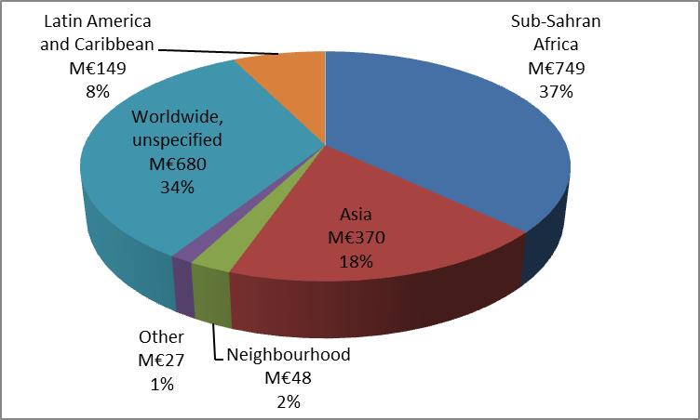 | 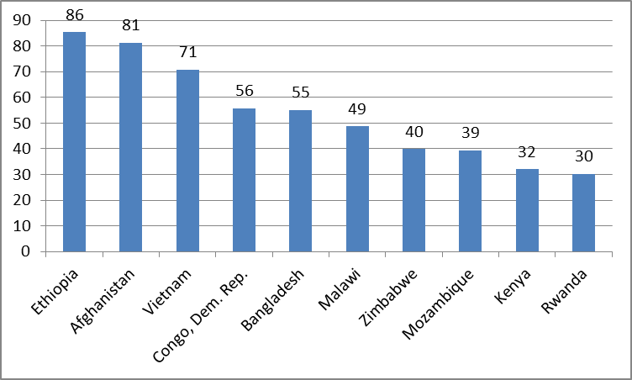
Figure 1: Pie chart (left): amount and percentage of support per continent. Graph (right): ten countries receiving the most support (EUR million)
Priority 2: Support effective governance
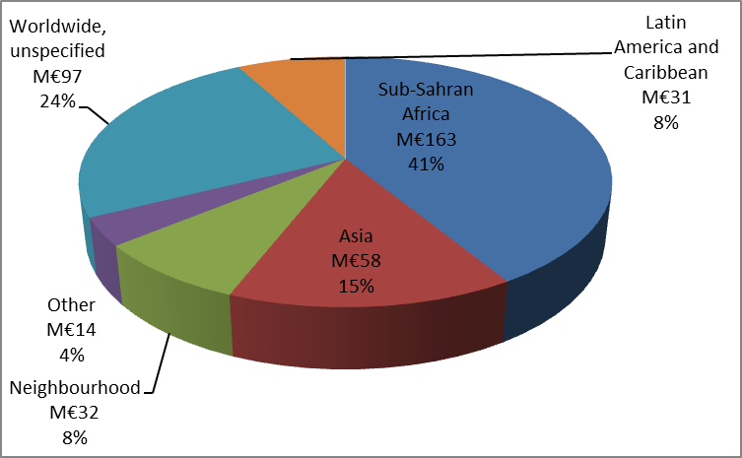 | 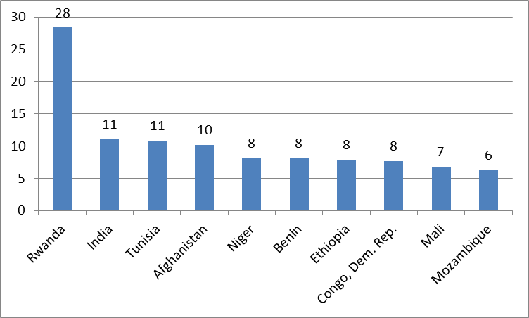
Figure 2: Pie chart (left): amount and percentage of support per continent. Graph (right): ten countries receiving the biggest support (EUR million)

Priority 3: Support regional agriculture and food and nutrition security policies
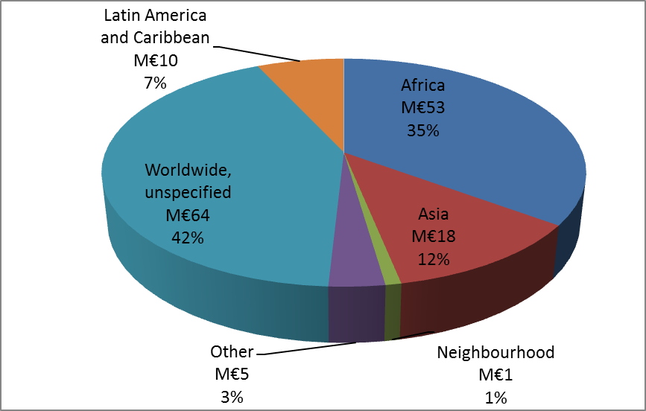
Figure 3: The pie chart above shows the amount and percentage of support per continent. Since Priority 3 concerned regional policies, very few programmes under this priority were implemented at country level (7 %), and the countries receiving the biggest support were not presented.

Priority 4: Strengthen social protection mechanisms for food and nutrition security, particularly for vulnerable population groups
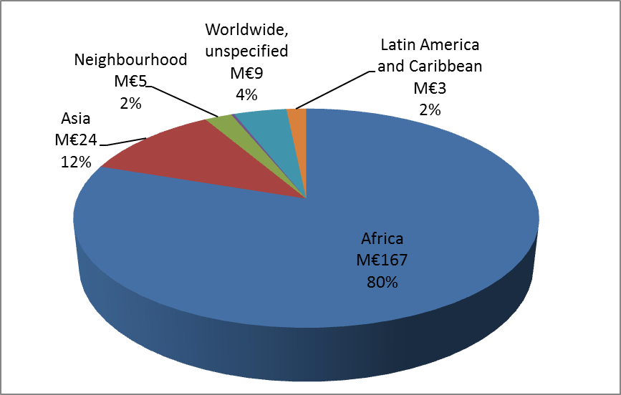 | 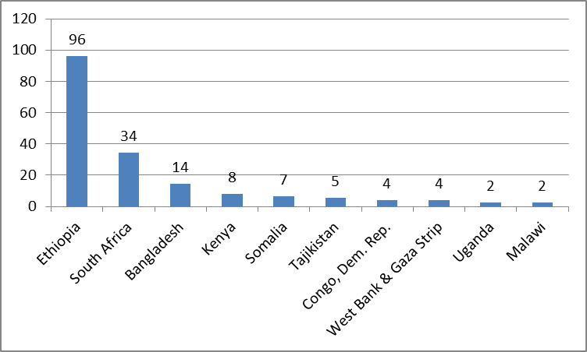
Figure 4: Pie chart (left): amount and percentage of support per continent; Graph (right): ten countries receiving the most support (EUR million)
Priority 5 Enhance nutrition, in particular for mothers, infants and children
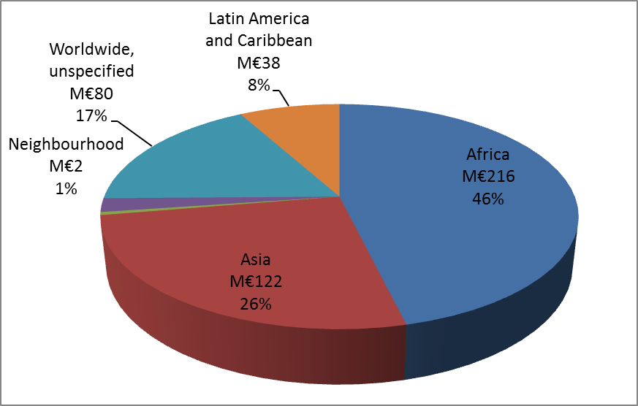 | 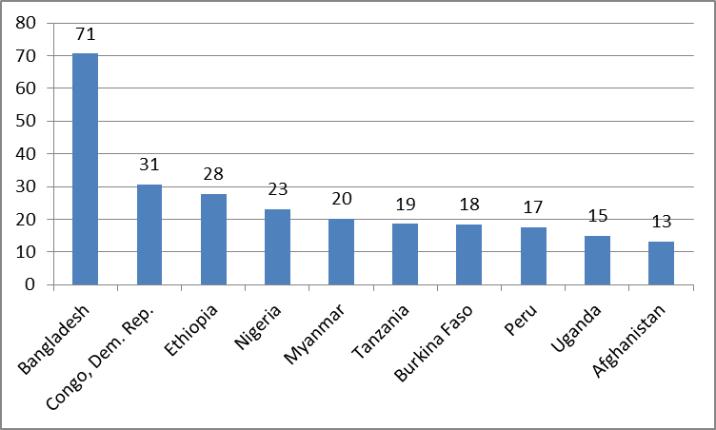
Figure 5: Pie chart (left): amount and percentage of support per continent; Graph (right): ten countries receiving the most support (EUR million)
Priority 6: Enhance coordination between development and humanitarian actors to build resilience and promote sustainable food and nutrition security
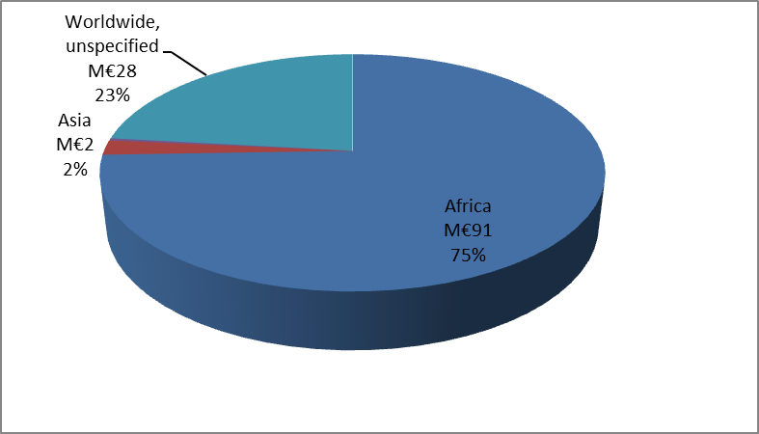 | 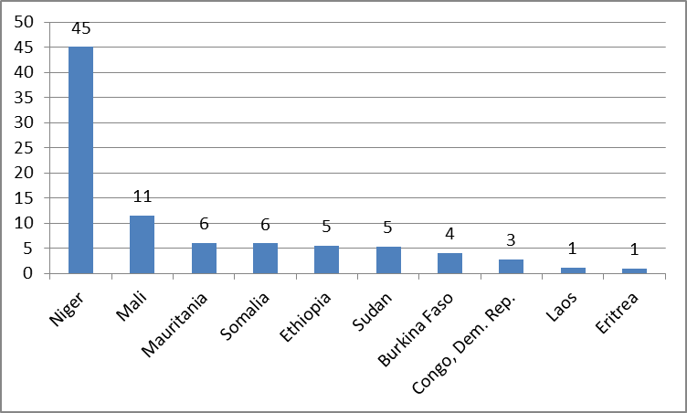
Figure 6: Pie chart (left): amount and percentage of support per continent; Graph (right): ten countries receiving the most support (EUR million)

4. Methodology for national report and programmes spreadsheet database

National Report on implementing EU food and nutrition security policy commitments
Inputs for the EU consolidated report

I) BACKGROUND AND CONTEXT
In 2010, the EU adopted a policy framework for food security built around the four pillars of food security, which was endorsed by the Council.
In its Conclusions, the Council re-emphasised and highlighted certain priorities for the EU and its Member States, and underlined
‘[…] the need for coordination within the EU and its Member States regarding different food security and nutrition initiatives, including the operationalisation of this policy framework, and invites the Commission to propose an implementation plan’.
Finalised in March 2013, the implementation plan was coordinated by the Commission, in close consultation with experts from the Member States. It defined the operational response with regard to recent policy commitments on food and nutrition security. [It is worth noting that, since 2010, there have been further EU development policy commitments which complement and re-emphasise these priorities, and which have been taken into account in this plan.]
In May 2013, the Council endorsed this plan
‘The Council supports its objective of defining an EU operational response, over the period from 2014 to 2020, to deliver on the commitments set out in the 2010 EU Food Security Policy, the Nutrition Communication, and other relevant EU policy documents. In this regard the Council emphasises the need to enhance coordination, complementarity and coherence within and between EU and Member States’ external assistance programmes.’
Furthermore,
‘The Council endorses the interventions proposed in the Implementation Plan as well as the proposal that the Commission and Member States issue biennial progress reports on the interventions they are undertaking. The Council also encourages Member States to share lessons learnt from these interventions. The Council invites the Commission to coordinate, in close collaboration with Member States, a consolidated EU biennial progress report and to publish the first such report in 2014.’
The first EU report provides an overview of EU and Member States’ efforts — undertaken in 2012 — to address food and nutrition security across six policy priorities set out in the Implementation Plan. It also provides an assessment of the EU and Member States’ efforts to address food and nutrition security, in accordance with the principles of coherence, complementarity and coordination.
The nature of the information reported will illustrate how the EU and Member States are delivering on agreed policy priority commitments, providing a quantitative assessment of food and nutrition security interventions based on an analysis of the distribution of the total investments as well as a qualitative assessment of how well we are working together at national, regional and global levels.
The next reports due in 2016, 2018 and 2020 should help demonstrate transparency and incremental progress in delivering commitments over this period, including recommendations for further improvements to be followed up and demonstrated in subsequent reports.
The effect of this plan will be to instigate a process designed to provide reliable, regular information on the interventions of the EU and its Member States, ensure accountability in regard to agreed EU policy commitments and further advance the aid effectiveness agenda in concrete terms.
II) GUIDANCE ON COMPLETING THE NATIONAL REPORT
The national report is to be no more than 10 pages long and should consist of 3 to 4 sections:
Section 1 will provide an overview of your Member State’s expenditure on projects and programmes relevant to food and nutrition security across the six policy priorities;
Section 2 will present an analysis of this expenditure across policy priorities and levels (global, regional and national);
Section 3 will present your assessment of coordination and complementarity; and
Section 4 (optional) will present a maximum of three case studies highlighting any innovative programmes or interventions, best practice or approaches that involve joint work between your Member State and other EU Member States, the European Commission, or other non-EU donors and stakeholders.
Section 1: Distribution of Investments
This first section provides a summary of the main findings from the disbursements/commitments you have entered in the spreadsheet. The completed spreadsheet will serve as the main supporting Annex to this report. (See guidance below on how to complete the spreadsheet.)
Based on the data you enter in the spreadsheet, and in order to provide a visual overview of the distribution of investments your Member State made in 2012, we have developed a graphics facility. Once you have entered all the data in the spreadsheet, press the refresh button. This will automatically create a chart showing the distribution of disbursements broken down among the six priority areas as well as a chart showing the distribution of disbursements across geographical areas. These graphs will help you outline the basic characteristics of the portfolio’s distribution.

Section 2: The Analysis of Investment Distribution
This section of the report will provide a qualitative analysis of main findings provided in Section 1. It provides you with an opportunity to explain your Member State’s strategic priorities that direct and guide the volume and value of the investments and their distribution among the six priority areas and their location as defined by the three levels of intervention. This section also provides you with the opportunity to highlight different ways you approach implementation not adequately captured in Section 1 and/or which cut across specific interventions. For example, the significance of your Member State’s support to food insecure countries; your Member State’s work on policy dialogue including, for example: Voluntary Guidelines on Land Tenure; negotiations on Responsible Agriculture Investments; joint programmes and joint programming and other dimensions of aid effectiveness; and adherence to principles such as those relating to fragile states and Linking Relief, Reconstruction and Development (LRRD).

Section 3: Your assessment of coordination and complementarity
Please provide a brief assessment, drawing on particular examples, regarding coordination and complementarity between your Member State and other Member States/the Commission at country, regional or global level, by answering the following three questions:
- What steps have you taken, individually or jointly, to improve coordination: a) at policy and decision-making level (ie: joint priorities, alignment to the partner’s priorities); b) on the ground (ie: shared/joint implementation/programmes, joint programming, joint actions, consultation and sharing of information); and c) in international fora (ie: preparation of joint positions);
- What steps have you taken, individually or jointly, to improve complementarity and division of labour within the food and nutrition security sector to avoid any duplication/inefficiencies? Examples could include joint diagnosis of a problem or situation, the establishment of clear responsibilities for lead and coordinating donors, joint decisions on sharing tasks within sectors of cooperation or within countries, examples of joint programming; and
- With your responses to 1 and 2 in mind, what are the objectives your Member State has set for itself over the next two years regarding complementarity?

Section 4: Optional — Select Case Studies/best practices
This is an optional section of the report. It provides your Member State with an opportunity to provide details about a maximum of two or three activities, providing an explanation of the approach used and lessons learnt. This is also an opportunity to showcase successful joint work on improving coordination and complementarity among the EU and its Member States on various food and nutrition security-related initiatives, as was requested in the Council Conclusions on the EU food security policy of 2010. These case studies should — in this report — specifically relate to initiatives focusing on nutrition and/or land in order to address the same specific themes. However, any case studies in other areas which you may wish to report on are also welcome.

III) GUIDANCE ON COMPLETING THE SPREADSHEET

For the purpose of the exercise, please include only programmes/projects:

A. which have a particular focus on food and nutrition security (FNS) (by being specifically designed to improve FNS, or by having specific FNS objectives or activities) and/or

B. which clearly fall within one or more of the four pillars of food security — food availability, access to food, utilisation of food, and stability, and/or

C. which clearly fall within the agreed definition of ‘food and nutrition security’: ‘Food and nutrition security exists when all people at all times have physical, social and economic access to food, which is consumed in sufficient quantity and quality to meet their dietary needs and food preferences, and is supported by an environment of adequate sanitation, health services and care, allowing for a healthy and active life.’
Core contributions at multilateral level to a range of UN agencies, funds and programmes, such as UNICEF and UNDP should be excluded as it would be difficult to allocate a proportion of this funding to food and nutrition security. You should include only those contributions to these agencies that specifically target food and nutrition security as stated above (points A, B and C). With regard to the Rome-based agencies, please report in the same way as for DAC reporting.
Administrative and overhead costs including salaries and travel-related costs are part of the projects and should be reported on.
Please bear in mind that all data you report on must be official 2012 DAC data, which means the financial disbursements/commitments you reported to the OECD DAC in 2012.

Filling in the spreadsheet step by step:
Please remember to enter the name of your Member State , the date of completion, the contact person and the reporting system (by disbursement) on the top left of the excel sheet.
- Column A: List your relevant food and nutrition security projects and programmes in the first column ‘projects or programmes’.
- Column B: Select the relevant CRS code corresponding to the project entered. If you do not use euros, please enter the equivalent amount in euros using the April 2012 OECD exchange rate available here: http://stats.oecd.org/Index.aspx?QueryId=169#
- Column C: In case no CRS code is applicable to your project, please explain in a few words what your project entails.
- Column D: Enter the financial amount disbursed for that activity in 2012.
- Column E: Enter the financial amount committed for that activity in 2012 (Optional)
- Column F: Specify for each project or programme the corresponding policy priority using the scroll down menu. There are six to choose from. (Tip: You will need to print out and read the summary description of all projects or programmes to help you complete the rest of the columns).
- Column G: Choose the relevant level of intervention: national, regional or global using the scroll down menu.
- Column H: Choose the relevant region or country using the scroll down menu
- Column I: This column will be filled in automatically based on your choices in column G and H. This column will serve to create a chart showing the distribution of disbursement across geographical areas.
- Column J: will enable you to make any additional comments or remarks you may have.

5. Links to the Member States’ project spreadsheet databases

Austria
Belgium
Finland
France
Germany
Ireland
Italy
The Netherlands
The United Kingdom
EU

COM(2010) 127, An EU policy framework to assist developing countries in addressing food security challenges, http://ec.europa.eu/development/icenter/repository/COMM_PDF_COM_2010_0127_EN.PDF
Council Conclusions on an EU policy framework to assist developing countries in addressing food security challenges, 10 May 2010, http://www.consilium.europa.eu/uedocs/cms_data/docs/pressdata/EN/foraff/114357.pdf
SWD(2013) 104, Boosting food and nutrition security through EU action: implementing our commitments, http://ec.europa.eu/europeaid/sites/devco/files/working-paper-food-nutrition-security-swd2013104-20130327_en_5.pdf
This includes the 2010 food security policy (COM(2010) 127), the 2011 Agenda for Change (COM(2011) 637), the 2012 resilience approach (COM(2012) 586), the 2012 Communication (COM(2012) 446) and Council Conclusions on social protection, and the 2013 nutrition policy (COM(2013) 141).
Council Conclusions on Food and Nutrition Security in external assistance, 28 May 2013, http://www.consilium.europa.eu/uedocs/cms_Data/docs/pressdata/EN/foraff/137318.pdf
‘A firm obligation expressed in writing and backed by the necessary funds, undertaken by an official donor to provide specified assistance to a recipient country or a multilateral organisation’: http://stats.oecd.org/glossary/detail.asp?ID=385

