COMMUNICATION FROM THE COMMISSION TO THE COUNCIL AND THE EUROPEAN PARLIAMENT
on a progress report on the implementation of the Railway Safety Directive

INTRODUCTION
Article 31 of Directive 2004/49/EC of the European Parliament and of the Council of 29 April 2004 on safety of the Community's railways (Railway Safety Directive) requires the Commission to submit to the European Parliament and to the Council every five years a report on the implementation of this Directive.
This Communication sets out the progress that has been made in implementing the Railway Safety Directive on the European rail system since the Commission adopted its second report in September 2009.
Chapter 1 presents the past five years’ developments as regards legislation based on the Railway Safety Directive and Chapter 2 focuses on its implementation and enforcement. More detail can be found in the accompanying Commission Staff Working Document "Progress report on the implementation of the Railway Safety Directive (Directive 2004/49/EC)".

DEVELOPMENT OF THE LEGAL FRAMEWORK
A common regulatory framework for railway safety is essential for achieving a Single European Rail Area. In this regard Directive 2004/49/EC represented a great step towards the achievement of this goal. Indeed it established a framework for harmonising national safety rules, safety certification of railway undertakings, the tasks and roles of the national safety authorities and the investigation of accidents. The Member States had as a consequence to abstain from developing their own safety rules and standards on the basis of disparate technical and operational approaches.

Recent developments in the legal framework for railway safety
Since the adoption of the previous progress report in 2009, secondary legislation in the railway safety sector has been developed and the implementing acts required by the Railway Safety Directive have entered into force (see Annex). The European Railway Agency (ERA) has made a major contribution in drafting legislation and providing the Commission with its recommendations.
The Commission will examine below the most important developments achieved in the field of railway safety during the period under consideration.

Common safety indicators
The main purpose of the common safety indicators (CSIs) is to measure safety performance and facilitate assessment of the economic impact of the common safety targets (CSTs).
In accordance with Article 5(2) of the Railway Safety Directive, Annex I was revised to include common definitions of the CSIs and methods for calculating the costs of accidents.

Common safety methods
Common principles underpinning the management, regulation and supervision of railway safety, including harmonised criteria for issuing and supervising safety certification, are essential to achieving a Single European Rail Area.
These principles, usually referred to as common safety methods or CSMs (see Article 6 of the Railway Safety Directive), also determine how safety levels and the achievement of safety targets are to be assessed.

Common safety targets
The common safety targets or CSTs (see Article 7 of the Directive) define safety levels in terms of society’s acceptance of risk. Risk levels are expressed as the number of fatalities and serious injuries per train-km. There are risk categories for passengers, employees, level-crossing users, unauthorised persons on railway premises, other individuals and society as a whole.
The CSTs facilitate the monitoring of railway safety performance by providing a quantified measure of whether safety in the Member States is at least maintained at the same levels.

Certification of the entities in charge of maintenance for freight wagons (Article 14a of the Railway Safety Directive)
A new system for the certification of the entities in charge of maintenance (ECMs) for freight wagons was another important achievement in the past five years. Its purpose is to provide evidence across the Union that an ECM has established its maintenance system. An ECM’s ability to ensure that any freight wagon for which it is responsible will run safely can be assessed using the harmonised framework provided for by Regulation (EU) No 445/2011.

National safety rules
Because of the lack of transparency they engender, national safety rules (NSRs) are one of the major obstacles to the development of an internal market for rail. Although introduced for legitimate reasons, most NSRs are a legacy of old regulatory arrangements and are redundant in the safety system established by the Railway Safety Directive.
Member States should keep their national rules up to date, delete obsolete provisions and keep the Commission and ERA informed of any amendment to such rules. Several years on, however, limited progress had been made in amending redundant NSRs. In December 2010, therefore, the Railway Interoperability and Safety Committee decided to set up a specific Task Force on National Safety Rules (2011-12) whose tasks were to clarify some areas of uncertainty about NSRs and foster best practices.
The conclusions of the Task Force’s report included recommendations for the dissemination of best practices and rationalising the national rules of the Member States, procedures for improving transparency, and proposals for the future legal framework. The Commission and ERA have followed these recommendations in their respective areas of competence:
a) Dissemination and cleaning-up of the national safety rules
There are still a number of redundant, repetitive, contradictory and unnecessary NSRs which are not in line with the European framework.
The Task Force entrusted ERA with launching a dissemination campaign, which included customised information and dialogues, evaluation of the NSRs and identifying specific priorities in each Member State it visited.
The Task Force developed a ‘rule management tool’ to provide guidance on the existing legislative framework and ERA addresses to the Member States a proposal for cleaning-up obsolete rules at least once a year.
b) Promoting transparency
Notif-IT is the informatics tool for notifying new NSRs. Since April 2014, a ‘draft safety rules’ module has been implemented for improving transparency and preventing the adoption of rules not in line with the EU legislative framework. The database will be transferred from the Commission to ERA in 2015.
ERA assists the Commission in the evaluation/pre-evaluation of notified NSRs. It also drew up a methodology for monitoring progress on transparency using the Transparency Barometer for the railway sector and the Transparency Survey addressed to the national safety authorities (NSAs) and Member States.
c) Proposals for the future legal framework
In the framework of the 4th Railway Package (see Section 2.4.2), the Commission proposed a recast of the Directives on railway safety and interoperability.
As recommended by the Task Force, NSRs and national technical rules are now referred to as ‘national rules’ (i.e. irrespective of their justification). The procedures for establishing and notifying new ‘national rules’ have been harmonised although separate legal bases are still used for their adoption.

MONITORING IMPLEMENTATION AND SAFETY PERFORMANCE

Member States’ transposition of the Railway Safety Directive
If the Directive is transposed incorrectly, safety measures cannot be developed or improved in line with the development of a Single European Rail Area.
The Commission, assisted by ERA, analysed the legislative measures notified by the Member States to check whether they correctly transposed the provisions of the Railway Safety Directive.
The Commission requested information from the Member States on their transposition of the Directive (‘EU-Pilot’ questionnaires) and launched infringement procedures where explanations of a lack of, or incorrect, transposition were not satisfactory.
A total of 26 EU-Pilot cases have been handled, of which one was closed at pre-infringement stage. Infringement procedures were initiated in 19 cases, of which five were already closed following corrective action taken by the Member States concerned. One case has been referred to the European Court of Justice. At present, there are still six procedures at EU-Pilot stage and 14 infringement cases ongoing (October 2014).

Managing and monitoring safety
While transposition is an important first step, legislation may formally be well transposed without being correctly implemented. If safety measures are not correctly implemented, they cannot ensure consistently high safety levels for EU citizens. The legal framework established by the Railway Safety Directive includes methods for monitoring safety levels and the achievement of targets.

Managing safety
Railway safety in Europe is managed at operator, Member State and EU level.
The legal framework created by the Railway Safety Directive is based on the responsibilities of the major actors, i.e. the railway undertakings and the infrastructure managers, to assess all risks relating to the safe operation of trains and establish a safety management system (SMS) in accordance with Article 9 of the Directive.
At Member State level, the national safety authorities (NSAs) evaluate the quality of the SMS when issuing to the railway undertakings and infrastructure managers the safety certificate or safety authorisation required for performing their activity. The NSAs are responsible for supervising the activities of the railway undertakings and infrastructure managers during the certificate’s/authorisation’s period of validity.
At EU level, monitoring safety performance is one of the key tasks of ERA, which conducts an annual assessment of the achievement of CSTs and ‘national reference values’ in line with the common safety method in Commission Decision 2009/460/EC (see Article 4 in particular). The assessment covers the 26 Member States that have a railway system, plus Norway. In 2014, for the first time, it covered Croatia, which had joined the EU the year before.
The results of the 2014 assessment show that safety performance remains acceptable in the majority of Member States, with possible deterioration identified in a few. These Member States will receive particular attention from the Commission and ERA and are expected to send the Commission an explanation of the likely causes of the results, in line with Article 5 of Decision 2009/460/EC.

Safety overview
The NSAs and national investigation bodies (NIBs) are legally obliged (according to Articles 18 and 23 of the Railway Safety Directive) to report to ERA a set of specific information that can be used to assess the development of railway safety in the EU.
Since 2006, ERA has published a report every two years, providing stakeholders with a thorough overview of the development of railway safety in the EU.
Over the last six years available railway safety has continued to improve across the EU, with accident figures falling considerably and casualty numbers seeing slight reductions (see Figures 1 and 2). More than 2 000 significant accidents occur each year on the Member States’ railways. Accidents to persons caused by rolling stock in motion and level-crossing accidents constitute more than three quarters of all railway accidents, excluding suicides. In these accidents, around 1 200 people are killed and a similar number seriously injured each year.
Safety levels vary greatly across Member States and risk levels in several are significantly above the EU average (see Figure 3). A systematic approach to safety performance improvements in these Member States would be a major step towards genuine EU-wide safety targets in the future.
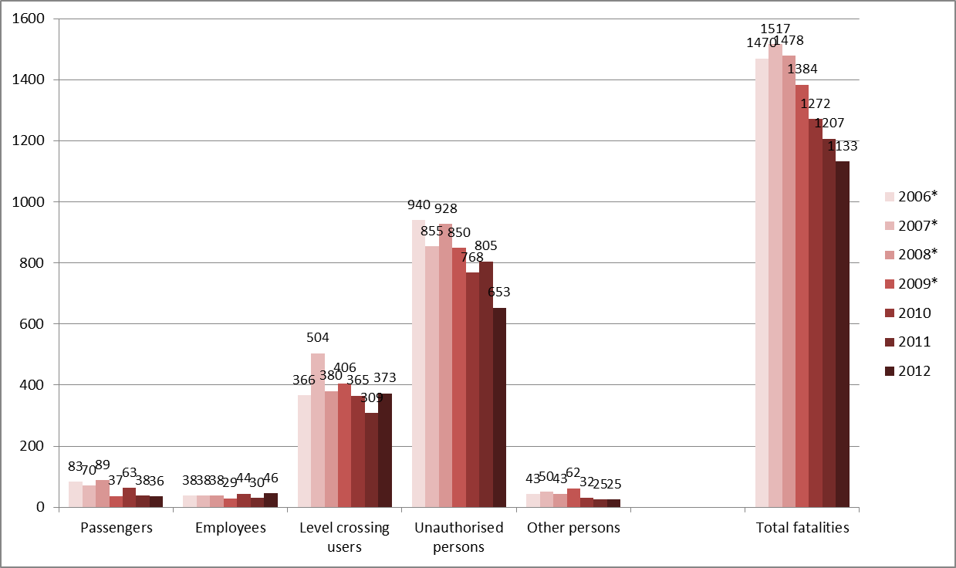
Figure 1: Number of fatalities per victim category (EU-28: 2006–12)
* Data not available for Croatia for 2006-09
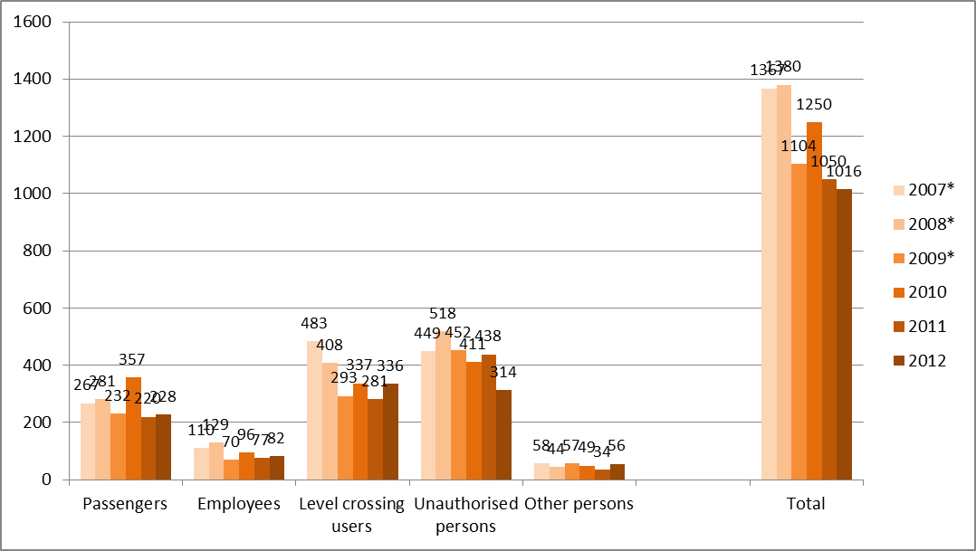
Figure 2: Seriously injured persons per victim category (EU-28: 2007-12)
* Data not available for Croatia for 2007-09
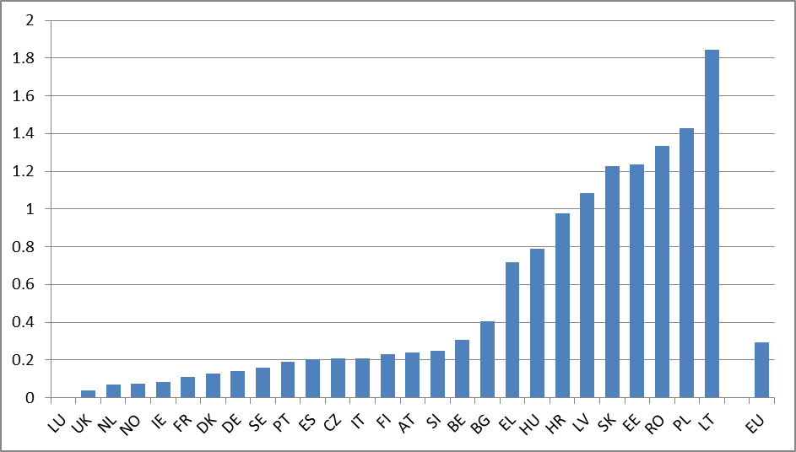
Figure 3: Fatality risk – railway fatalities and weighted serious injuries per million train-km (2007-12)

Occurrences investigated by the national investigation bodies
The number of serious railway accidents investigated by NIBs has been stable since 2007, at around 40 per year. In recent years, however, more and more NIBs have opened investigations into accidents not categorised as serious under the Directive.
For each occurrence investigated by the NIBs, ERA receives notification of the opening of the investigation and the final report.
Cooperation among NIBs is important: the results of investigations can be discussed at EU level to allow all operators to learn from accidents and improve their safety management. ERA works with the NIBs on accident investigation methods, reporting, recommendations and exchange of good practice. With ERA support, the NSAs and NIBs have developed joint guidance on safety recommendations.
ERA has also developed a safety information system for sharing urgent and important safety-relevant information, thus helping railway undertakings and infrastructure managers to take the measures most appropriate to their particular risk profile.

Monitoring activities supported by ERA
In addition to its legal reporting obligations, ERA monitors the activities of the major institutional bodies on a voluntary basis, by means of:
- the NSA cross-audit programme, aimed at evaluating NSAs’ performance of the three main activities required of them under the Safety and Interoperability Directives (safety certification and authorisation, supervision and authorisation for the placing in service of vehicles) and to share best practices. The cross-auditing system was piloted between 2011 and 2013 and the first full audit cycle (2013-18) is now under way, with performance evaluation, support for the harmonisation of processes and the identifying of possible problems to be addressed in future legislation; and
- NIB voluntary assessments, supporting NIBs by assessing their current performance in accident investigation, sharing good practices and identifying practical ways in which their work can be improved.

Certification of the entities in charge of maintenance
The certification system under Regulation (EU) No 445/2011 provides EU-wide evidence that an ECM has established its maintenance system and can meet the harmonised requirements. Since the Regulation entered into force in May 2011, the following results have been achieved:
- the number of certified entities increased from 10 to 248 between May 2012 and March 2014; and
- the number of maintenance workshops certified in accordance with the voluntary system of certification established under the Regulation increased from 1 to 169 over the same period.
In order to harmonise the ECM certification bodies’ assessments, ERA organises support activities to foster cooperation, guidance and dissemination of best practices.

Further developments

Monitoring safety performance processes
ERA developed a ‘regulatory monitoring matrix’ which can provide a systematic overview of the situation at ministry, NSA and NIB level in the individual Member States. The aim is to see how the framework is functioning at Member State level and so improve understanding of the mechanisms behind systemic problems, but also of best practice in the application of the regulatory framework that can be shared between Member States.
First results were reported to Railway Interoperability and Safety Committee in June 2014. The Commission and ERA proposed that the matrix be used for a general assessment of railway safety performance in the Member States, starting with a number of priority Member States with risk levels significantly above the EU average (placed at the right side in Figure 3).

The 4th Railway Package and the recast of the Railway Safety Directive
The 4th Railway Package, adopted by the Commission on 30 January 2013, aims to improve service quality and efficiency to make rail a more attractive choice for passengers.
The Package includes the recast of the Railway Safety Directive, involving principally a revision of safety certification arrangements and migration to a single safety certificate. Instead of the current two-part system, a single safety certificate, valid in all Member States in which the railway undertaking operates, is to be granted on the basis of a single application. This is consistent with the general objective of the 4th Package: to eliminate administrative and technical barriers so as to enhance the competitiveness of rail versus other modes of transport.
In addition, ERA would have a greater role and become an EU-wide authority as regards safety certification.
NSAs will continue to act as principal supervisors for railway undertakings and to issue safety authorisations for infrastructure managers. To ensure that they do so according to similar criteria and procedures, ERA would be authorised to monitor their activity, performance and organisation.

A Platform for European Rail Infrastructure Managers (PRIME)
In January 2014, the Commission launched a High-Level Platform for European Rail Infrastructure Managers; this should improve cooperation among infrastructure managers and inter alia ensure better implementation of the common safety approach in the EU.
The first meeting on 28 January 2014 saw a useful exchange of views on recent rail accidents on which preventive measures should be considered.

CONCLUSIONS
Over the past five years, the legislative acts foreseen by the Railway Safety Directive have been adopted. The Railway Interoperability and Safety Committee held approximately 20 meetings, advising the Commission, through its comitology procedures, on appropriate measures. This was on the basis of input from the European Railway Agency in the form of numerous recommendations on interoperability and safety issues.
Common safety indicators, methods and targets have been developed since the 2009 progress report. The national safety authorities are now able to issue safety certificates/authorisations and perform supervision according to a harmonised methodology. A harmonised system has been established for the certification of entities in charge of maintenance for freight wagons. The overall safety legislative framework is therefore operational.
Some issues, however, remain problematic:
- Several Member States have transposed the provisions of the Railway Safety Directive incorrectly or unclearly. This could lead to inconsistent application of safety requirements across the European rail system and unequal conditions for railway undertakings. Following infringement procedures, the Member States concerned are expected to adapt their national legislations so they are compliant with the provisions of the Railway Safety Directive;
- The lack of transparency associated with national safety rules may be an obstacle to the internal market. Although introduced for legitimate reasons, most NSRs are a legacy of old regulatory arrangements and are becoming redundant with the development of EU legislation. Member States are expected to withdraw obsolete rules accordingly. New NSRs should be limited in scope and be no more prescriptive than is necessary to meet the safety objectives. Moreover, the national safety authorities should abstain from imposing prescriptive safety rules and rather oblige infrastructure managers and railway undertakings fully to shoulder their responsibilities for the safety of the system; and
- Railways’ safety performance is in general satisfactory and better than that of the other land transport modes, but it varies widely across Member States. Article 4(1) of the Railway Safety Directive provides that ‘Member States shall ensure that railway safety is generally maintained and, where reasonably practicable, continuously improved’. It seems ‘reasonable’ that efforts be made to improve the situation in those Member States where the risk level is significantly higher than the EU average.
On the last point, ERA has prepared a tool for the general assessment of railway safety in each Member State. In the coming years, with some Member States coming under greater scrutiny, more balanced results can be expected, with an overall rise in safety levels.
Also, recent Commission initiatives such as the technical pillar of the 4th Railway Package and the development of a Platform for Infrastructure Managers in Europe (PRIME) have real potential to bring further safety improvements.

Annex:
Measures adopted by the Commission since 2009
in application of Directive 2004/49/EC.

Common safety indicators (Article 5 of the Railway Safety Directive)
- Commission Directive 2009/149/EC of 27 November 2009 amending Directive 2004/49/EC of the European Parliament and of the Council as regards Common Safety Indicators and common methods to calculate accident costs (OJ L 313, 28.11.2009, p. 65)
- Commission Directive 2014/88/EU of 9 July 2014 amending Directive 2004/49/EC of the European Parliament and of the Council as regards common safety indicators and common methods of calculating accident costs (OJ L 201, 10.7.2014, p. 9)
Common safety methods (Article 6 of the Railway Safety Directive)
a) Risk evaluation and assessment methods
- Commission Implementing Regulation (EU) No 402/2013 of 30 April 2013 on the common safety method for risk evaluation and assessment and repealing Regulation (EC) No 352/2009 (OJ L 121, 3.5.2013, p. 8)
b) Methods for assessing compliance with requirements in safety certificates and authorisations
- Commission Regulation (EU) No 1158/2010 of 9 December 2010 on a common safety method for assessing conformity with the requirements for obtaining railway safety certificates (OJ L 326, 10.12.2010, p. 11)
- Commission Regulation (EU) No 1169/2010 of 10 December 2010 on a common safety method for assessing conformity with the requirements for obtaining a railway safety authorisation (OJ L 327, 11.12.2010, p. 13)
c) Methods for checking operation and maintenance
- Commission Regulation (EU) No 1077/2012 of 16 November 2012 on a common safety method for supervision by national safety authorities after issuing a safety certificate or safety authorisation (OJ L 320, 17.11.2012, p. 3)
- Commission Regulation (EU) No 1078/2012 of 16 November 2012 on a common safety method for monitoring to be applied by railway undertakings, infrastructure managers after receiving a safety certificate or safety authorisation and by entities in charge of maintenance (OJ L 320, 17.11.2012, p. 8)
Common safety targets (Article 7 of the Railway Safety Directive)
- Commission Decision 2010/409/EU of 19 July 2010 on Common Safety Targets as referred to in Article 7 of Directive 2004/49/EC (OJ L189, 22.7.2010, p. 19)
- Commission Decision 2012/226/EU of 23 April 2012 on the second set of common safety targets as regards the rail system (OJ L 115, 27.4.2012, p. 27)
- Commission Implementing Decision 2013/753/EU of 11 December 2013 amending Commission Decision 2012/226/EU on the second set of common safety targets for the rail system (OJ L 334, 13.12.2013, p. 37)
Certification of the entities in charge of maintenance for freight wagons (Article 14a of the Railway Safety Directive)
- Commission Regulation (EU) No 445/2011 of 10 May 2011 on a system of certification of the entity in charge of maintenance for freight wagons and amending Regulation (EC) No 653/2007 (OJ L 122, 11.5.2011, p. 22)

Directive 2004/49/EC of 29 April 2004 of the European Parliament and of the Council on safety of the Community’s railways and amending Council Directive 95/18/EC on the licensing of railway undertakings and Directive 2001/14/EC on the allocation of railway infrastructure capacity and the levying of charges for the use of railway infrastructure and safety certification (Railway safety Directive). OJ L 164, 30.4.2004 p. 44.
Communication from the Commission to the Council and European Parliament on a Progress Report on the implementation of the Railway Safety Directive and of the Railway Interoperability Directives (COM(2009) 464 final).
OJ L 122, 11.5.11, p. 22.
Commission Decision 2009/460/EC of 5 June 2009 on the adoption of a common safety method for assessment of achievement of safety targets, as referred to in Article 6 of Directive 2004/49/EC of the European Parliament and of the Council, OJ L 150, 13.6.2009, p. 11.
Source of the information and figures: Railway Safety Performance in the European Union 2014, available on ERA web site: http://www.era.europa.eu/Document-Register/Documents/SPR2014.pdf
Guide available on ERA web site: http://www.era.europa.eu/Document-Register/Pages/guidance-on-safety-recommendations-Safety-Directive-Art-25.aspx
Commission Implementing Decisions on a mandate to ERA are not included in the list.

