ANNEX
DECISION OF THE EEA JOINT COMMITTEE
No .../2014
replacing Protocol 4 to the Agreement on the European Economic Area, on rules of origin, by a new Protocol which is aligned to the Regional Convention on pan-Euro-Mediterranean rules of origin
THE EEA JOINT COMMITTEE,
Having regard to the Agreement on the European Economic Area (“the EEA Agreement”), and in particular Article 98 thereof,
Whereas:
- Article 9 of the EEA Agreement refers to Protocol 4 which lays down the rules of origin and provides for cumulation of origin between the Union, Switzerland (including Liechtenstein), Iceland, Norway, Turkey, the Faroe Islands and the participants in the Barcelona Process.
- The Regional Convention on pan-Euro-Mediterranean preferential rules of origin (“the Convention”) lays down provisions on the origin of goods traded under relevant Agreements concluded between the Contracting Parties.
- The EU, Norway and Liechtenstein signed the Convention on 15 June 2011 and Iceland signed the Convention on 30 June 2011.
- The EU, Norway, Iceland and Liechtenstein deposited their instrument of acceptance with the depositary of the Convention on 26 March 2012, 9 November 2011, 12 March 2012 and 28 November 2011, respectively. As a consequence, in application of its Article 10(3), the Convention entered into force in relation to the EU and Iceland on 1 May 2012 and in relation to Norway and Liechtenstein on 1 January 2012.
- The Convention includes the participants in the Stabilisation and Association Process in the pan-Euro-Mediterranean zone of cumulation of origin.
- Where the transition towards the Convention is not simultaneous for all Contracting Parties thereto within the pan-Euro Mediterranean cumulation zone, it should not lead to a situation which is less favourable than what would have been the case under the previous version of Protocol 4.
- Article 6 of the Convention provides that each Contracting Party shall take appropriate measures to ensure that the Convention is effectively applied. As a consequence, in the Agreement, Protocol 4 concerning the rules of origin should be replaced by a new Protocol which is aligned to the Convention.
- Decision No XX/XX of the EEA Joint Committee provided for transitional rules for Croatia concerning the application of the rules of origin laid down in Protocol 4. Those rules should remain applicable until the transitional period expires.
HAS ADOPTED THIS DECISION:
Article 1
1. Protocol 4 to the Agreement shall be replaced by the text set out in the Annex to this Decision.

2. Notwithstanding paragraph 1 of this Article, Article 41 of Protocol 4, as amended by Decision of the EEA Joint Committee No XX/XX, shall continue to apply until 1 January 2017.
Article 2
This Decision shall enter into force on […], provided that all the notifications under Article 103(1) of the Agreement have been made to the EEA Joint Committee.
It shall apply from 1 April 2014.
Article 3
This Decision shall be published in the EEA Section of, and in the EEA Supplement to, the Official Journal of the European Union.
Done at Brussels, […].
For the EEA Joint Committee
The President
The Secretaries
to the EEA Joint Committee

ANNEX
to Decision of the EEA Joint Committee No […]
‘PROTOCOL 4
ON RULES OF ORIGIN
TABLE OF CONTENTS

TITLE I

GENERAL PROVISIONS
Article 1 Definitions
TITLE II

DEFINITION OF THE CONCEPT OF “ORIGINATING PRODUCTS”
Article 2 General requirements
Article 3 Diagonal cumulation of origin
Article 4 Wholly obtained products
Article 5 Sufficiently worked or processed products
Article 6 Insufficient working or processing
Article 7 Unit of qualification
Article 8 Accessories, spare parts and tools
Article 9 Sets
Article 10 Neutral elements
TITLE III
TERRITORIAL REQUIREMENTS
Article 11 Principle of territoriality
Article 12 Direct transport
Article 13 Exhibitions
TITLE IV
DRAWBACK OR EXEMPTION
Article 14 Prohibition of drawback of, or exemption from, customs duties
TITLE V
PROOF OF ORIGIN
Article 15 General requirements
Article 16 Procedure for the issue of a movement certificate EUR.1 or EUR-MED
Article 17 Movement certificates EUR.1 or EUR-MED issued retrospectively
Article 18 Issue of a duplicate movement certificate EUR.1 or EUR-MED
Article 19 Issue of movement certificates EUR.1 or EUR-MED on the basis of a proof of origin issued or made out previously
Article 20 Accounting segregation
Article 21 Conditions for making out an invoice declaration or an invoice declaration EUR-MED
Article 22 Approved exporter
Article 23 Validity of proof of origin
Article 24 Submission of proof of origin
Article 25 Importation by instalments
Article 26 Exemptions from proof of origin
Article 27 Supplier’s declarations
Article 28 Supporting documents
Article 29 Preservation of proof of origin, supplier’s declarations and supporting documents
Article 30 Discrepancies and formal errors
Article 31 Amounts expressed in euro
TITLE VI
ARRANGEMENTS FOR ADMINISTRATIVE COOPERATION
Article 32 Administrative cooperation
Article 33 Verification of proofs of origin
Article 34 Verification of supplier's declarations
Article 35 Dispute settlement
Article 36 Penalties
Article 37 Free zones
TITLE VII
CEUTA AND MELILLA
Article 38 Application of the Protocol
Article 39 Special conditions
TITLE VIII
FINAL PROVISIONS
Article 40 Transitional provisions for goods in transit or storage
LIST OF ANNEXES
Annex I: Introductory notes to the list in Annex II
Annex II: List of working or processing required to be carried out on non-originating materials in order for the product manufactured to obtain originating status
Annex IIIa: Specimens of movement certificate EUR.1 and application for a movement certificate EUR.1
Annex IIIb: Specimens of movement certificate EUR-MED and application for a movement certificate EUR-MED
Annex IVa: Text of the invoice declaration
Annex IVb: Text of the invoice declaration EUR-MED
Annex V: Specimen of the supplier’s declaration
Annex VI: Specimen of the long-term supplier’s declaration
JOINT DECLARATIONS
Joint declaration concerning the acceptance of proofs of origin issued within the framework of the agreements referred to in Article 3 of Protocol 4 for products originating in the European Union, Iceland or Norway
Joint declaration concerning the Principality of Andorra
Joint declaration concerning the Republic of San Marino
Joint declaration concerning the withdrawal of a Contracting Party from the Regional Convention on pan-Euro-Mediterranean rules of origin
TITLE I
GENERAL PROVISIONS
Article 1
Definitions
For the purposes of this Protocol:
(a) “manufacture” means any kind of working or processing including assembly or specific operations;
(b) “material” means any ingredient, raw material, component or part, etc., used in the manufacture of the product;
(c) “product” means the product being manufactured, even if it is intended for later use in another manufacturing operation;
(d) “goods” means both materials and products,
(e) “customs value” means the value as determined in accordance with the 1994 Agreement on implementation of Article VII of the General Agreement on Tariffs and Trade (WTO Agreement on customs valuation);
(f) “ex-works price” means the price paid for the product ex works to the manufacturer in the EEA in whose undertaking the last working or processing is carried out, provided the price includes the value of all the materials used, minus any internal taxes which are, or may be, repaid when the product obtained is exported;
(g) “value of materials” means the customs value at the time of importation of the non-originating materials used, or, if this is not known and cannot be ascertained, the first ascertainable price paid for the materials in the EEA;
(h) “value of originating materials” means the value of such materials as defined in (g) applied mutatis mutandis;
(i) “value added” shall be taken to be the ex-works price minus the customs value of each of the materials incorporated which originate in the other countries referred to in Article 3 with which cumulation is applicable or, where the customs value is not known or cannot be ascertained, the first ascertainable price paid for the materials in the EEA;
(j) “chapters” and “headings” mean the chapters and the headings (four-digit codes) used in the nomenclature which makes up the Harmonised Commodity Description and Coding System, referred to in this Protocol as “the Harmonised System” or “HS”;
(k) “classified” refers to the classification of a product or material under a particular heading;
(l) “consignment” means products which are either sent simultaneously from one exporter to one consignee or covered by a single transport document covering their shipment from the exporter to the consignee or, in the absence of such a document, by a single invoice;
(m) “territories” includes territorial waters.

TITLE II
DEFINITION OF THE CONCEPT OF “ORIGINATING PRODUCTS”
Article 2
General requirements
1. For the purpose of implementing the Agreement, the following products shall be considered as originating in the EEA:
(a) products wholly obtained in the EEA within the meaning of Article 4;
(b) products obtained in the EEA incorporating materials which have not been wholly obtained there, provided that such materials have undergone sufficient working or processing in the EEA within the meaning of Article 5.
For this purpose, the territories of the Contracting Parties to which the Agreement applies, shall be considered as a single territory.
2. Notwithstanding paragraph 1, the territory of the Principality of Liechtenstein shall be excluded from that of the EEA, for the purpose of determining the origin of the products referred to in Tables I and II of Protocol 3 and such products shall be considered to be originating in the EEA only if they have been either wholly obtained or sufficiently worked or processed in the territories of the other Contracting Parties.
Article 3
Diagonal cumulation of origin
1. Without prejudice to the provisions of Article 2, products shall be considered as originating in the EEA if they are obtained there, incorporating materials originating in Switzerland (including Liechtenstein), Iceland, Norway, the Faroe Islands, Turkey, the European Union or in any country which is a participant in the European Union’s Stabilisation and Association Process, provided that the working or processing carried out in the EEA goes beyond the operations referred to in Article 6. It shall not be necessary for such materials to have undergone sufficient working or processing.
2. Without prejudice to the provisions of Article 2, products shall be considered as originating in the EEA if they are obtained there, incorporating materials originating in any country which is a participant in the Euro-Mediterranean partnership, based on the Barcelona Declaration adopted at the Euro-Mediterranean Conference held on 27 and 28 November 1995, other than Turkey, provided that the working or processing carried out in the EEA goes beyond the operations referred to in Article 6. It shall not be necessary for such materials to have undergone sufficient working or processing.
3. Where the working or processing carried out in the EEA does not go beyond the operations referred to in Article 6, the product obtained shall be considered as originating in the EEA only where the value added there is greater than the value of the materials used originating in any one of the countries referred to in paragraphs 1 and 2. If this is not so, the product obtained shall be considered as originating in the country which accounts for the highest value of originating materials used in the manufacture in the EEA.
4. Products, originating in one of the countries referred to in paragraphs 1 and 2, which do not undergo any working or processing in the EEA shall retain their origin if exported into one of these countries.
5. The cumulation provided for in this Article may be applied only provided that:
(a) a preferential trade agreement in accordance with Article XXIV of the General Agreement on Tariffs and Trade (GATT) is applicable between the countries involved in the acquisition of the originating status and the country of destination;
(b) materials and products have acquired originating status by the application of rules of origin identical to those given in this Protocol;
and
(c) notices indicating the fulfilment of the necessary requirements to apply cumulation have been published in the Official Journal of the European Union (C series) and in the other Contracting Parties according to their own procedures.
The cumulation provided for in this Article shall apply from the date indicated in the notice published in the Official Journal of the European Union (C series).
The European Union shall provide the other Contracting Parties, through the European Commission, with details of the Agreements, including their dates of entry into force, and their corresponding rules of origin, which are applied with the other countries referred to in paragraphs 1 and 2.
Article 4
Wholly obtained products
1. The following shall be considered as wholly obtained in the EEA:
(a) mineral products extracted from their soil or from their seabed;
(b) vegetable products harvested there;
(c) live animals born and raised there;
(d) products from live animals raised there;
(e) products obtained by hunting or fishing conducted there;
(f) products of sea fishing and other products taken from the sea outside the territorial waters of the Contracting Parties by their vessels;
(g) products made aboard their factory ships exclusively from products referred to in (f);
(h) used articles collected there fit only for the recovery of raw materials, including used tyres fit only for retreading or for use as waste;
(i) waste and scrap resulting from manufacturing operations conducted there;
(j) products extracted from marine soil or subsoil outside their territorial waters provided that they have sole rights to work that soil or subsoil;
(k) goods produced there exclusively from the products specified in (a) to (j).
2. The terms “their vessels” and “their factory ships” in paragraph 1(f) and (g) shall apply only to vessels and factory ships:
(a) which are registered or recorded in a Member State of the European Union or in an EFTA State;
(b) which sail under the flag of a Member State of the European Union or of an EFTA State;
(c) which are owned to an extent of at least 50 % by nationals of a Member State of the European Union or of an EFTA State, or by a company with its head office in one of these States, of which the manager or managers, Chairman of the Board of Directors or the Supervisory Board, and the majority of the members of such boards are nationals of a Member State of the European Union or of an EFTA State and of which, in addition, in the case of partnerships or limited companies, at least half the capital belongs to those States or to public bodies or nationals of the said States;
(d) of which the master and officers are nationals of a Member State of the European Union or of an EFTA State;
and
(e) of which at least 75 % of the crew are nationals of a Member State of the European Union or of an EFTA State.
Article 5
Sufficiently worked or processed products
- For the purposes of Article 2, products which are not wholly obtained shall considered to be sufficiently worked or processed when the conditions set out in the list in Annex II are fulfilled.
The conditions referred to above indicate, for all products covered by the Agreement, the working or processing which must be carried out on non-originating materials used in manufacturing and apply only in relation to such materials. It follows that if a product which has acquired originating status by fulfilling the conditions set out in the list is used in the manufacture of another product, the conditions applicable to the product in which it is incorporated do not apply to it, and no account shall be taken of the non-originating materials which may have been used in its manufacture.
2. Notwithstanding paragraph 1, non-originating materials which, according to the conditions set out in the list in Annex II, should not be used in the manufacture of a product may nevertheless be used, provided that:
(a) their total value does not exceed 10 % of the ex-works price of the product;
(b) any of the percentages given in the list for the maximum value of non-originating materials are not exceeded by virtue of this paragraph.
This paragraph shall not apply to products falling within Chapters 50 to 63 of the Harmonised System.
3. Paragraphs 1 and 2 shall apply subject to the provisions of Article 6.
Article 6
Insufficient working or processing
1. Without prejudice to paragraph 2, the following operations shall be considered as insufficient working or processing to confer the status of originating products, whether or not the requirements of Article 5 are satisfied:
(a) preserving operations to ensure that the products remain in good condition during transport and storage;
(b) breaking-up and assembly of packages;
(c) washing, cleaning; removal of dust, oxide, oil, paint or other coverings;
(d) ironing or pressing of textiles;
(e) simple painting and polishing operations;
(f) husking, partial or total bleaching, polishing, and glazing of cereals and rice;
(g) operations to colour sugar or form sugar lumps;
(h) peeling, stoning and shelling, of fruits, nuts and vegetables;
(i) sharpening, simple grinding or simple cutting;
(j) sifting, screening, sorting, classifying, grading, matching; (including the making-up of sets of articles);
(k) simple placing in bottles, cans, flasks, bags, cases, boxes, fixing on cards or boards and all other simple packaging operations;
(l) affixing or printing marks, labels, logos and other like distinguishing signs on products or their packaging;
(m) simple mixing of products, whether or not of different kinds;
(n) mixing of sugar with any material;
(o) simple assembly of parts of articles to constitute a complete article or disassembly of products into parts;
(p) a combination of two or more operations specified in (a) to (o);
(q) slaughter of animals.
2. All operations carried out in the EEA on a given product shall be considered together when determining whether the working or processing undergone by that product is to be regarded as insufficient within the meaning of paragraph 1.
Article 7
Unit of qualification
- The unit of qualification for the application of the provisions of this Protocol shall be the particular product which is considered as the basic unit when determining classification using the nomenclature of the Harmonised System.
It follows that:
(a) when a product composed of a group or assembly of articles is classified under the terms of the Harmonised System in a single heading, the whole constitutes the unit of qualification;
(b) when a consignment consists of a number of identical products classified under the same heading of the Harmonised System, each product must be taken individually when applying the provisions of this Protocol.
2. Where, under General Rule 5 of the Harmonised System, packaging is included with the product for classification purposes, it shall be included for the purposes of determining origin.
Article 8
Accessories, spare parts and tools
Accessories, spare parts and tools dispatched with a piece of equipment, machine, apparatus or vehicle, which are part of the normal equipment and included in the price thereof or which are not separately invoiced, shall be regarded as one with the piece of equipment, machine, apparatus or vehicle in question.
Article 9
Sets
Sets, as defined in General Rule 3 of the Harmonised System, shall be regarded as originating when all component products are originating. Nevertheless, when a set is composed of originating and non-originating products, the set as a whole shall be regarded as originating, provided that the value of the non-originating products does not exceed 15 % of the ex-works price of the set.
Article 10
Neutral elements
In order to determine whether a product is an originating product, it shall not be necessary to determine the origin of the following which might be used in its manufacture:
(a) energy and fuel;
(b) plant and equipment;
(c) machines and tools;
(d) goods which neither enter into the final composition of the product nor are intended to do so.
TITLE III
TERRITORIAL REQUIREMENTS
Article 11
Principle of territoriality
1. Except as provided for in Article 3 and paragraph 3 of this Article, the conditions for acquiring originating status set out in Title II must be fulfilled without interruption in the EEA.
2. Except as provided for in Article 3, where originating goods exported from the EEA to another country return, they must be considered as non-originating, unless it can be demonstrated to the satisfaction of the customs authorities that:
(a) the returning goods are the same as those exported;
and
(b) they have not undergone any operation beyond that necessary to preserve them in good condition while in that country or while being exported.
3. The acquisition of originating status in accordance with the conditions set out in Title II shall not be affected by working or processing done outside the EEA on materials exported from the EEA and subsequently reimported there, provided:
(a) the said materials are wholly obtained in the EEA or have undergone working or processing beyond the operations referred to in Article 6 prior to being exported;
and
(b) it can be demonstrated to the satisfaction of the customs authorities that:
(i) the reimported goods have been obtained by working or processing the exported materials;
and
(ii) the total added value acquired outside the EEA by applying the provisions of this Article does not exceed 10 % of the ex-works price of the end product for which originating status is claimed.
4. For the purposes of paragraph 3, the conditions for acquiring originating status set out in Title II shall not apply to working or processing done outside the EEA. However, where, in the list in Annex II, a rule setting a maximum value for all the non-originating materials incorporated is applied in determining the originating status of the end product, the total value of the non-originating materials incorporated in the territory of the party concerned, taken together with the total added value acquired outside the EEA by applying the provisions of this Article, shall not exceed the stated percentage.
5. For the purposes of applying the provisions of paragraphs 3 and 4, “total added value” shall be taken to mean all costs arising outside the EEA, including the value of the materials incorporated there.
6. The provisions of paragraphs 3 and 4 shall not apply to products which do not fulfil the conditions set out in the list in Annex II or which can be considered sufficiently worked or processed only if the general tolerance fixed in Article 5(2) is applied.
7. The provisions of paragraphs 3 and 4 shall not apply to products of Chapters 50 to 63 of the Harmonised System.
8. Any working or processing of the kind covered by this Article and done outside the EEA shall be done under the outward processing arrangements, or similar arrangements.
Article 12
Direct transport
- The preferential treatment provided for under the Agreement applies only to products, satisfying the requirements of this Protocol, which are transported directly within the EEA or through the territories of the countries referred to in Article 3 with which cumulation is applicable. However, products constituting one single consignment may be transported through other territories with, should the occasion arise, trans-shipment or temporary warehousing in such territories, provided that they remain under the surveillance of the customs authorities in the country of transit or warehousing and do not undergo operations other than unloading, reloading or any operation designed to preserve them in good condition.
Originating products may be transported by pipeline across territory other than that of the EEA.
2. Evidence that the conditions set out in paragraph 1 have been fulfilled shall be supplied to the customs authorities of the importing country by the production of:
(a) a single transport document covering the passage from the exporting country through the country of transit; or
(b) a certificate issued by the customs authorities of the country of transit:
(i) giving an exact description of the products;
(ii) stating the dates of unloading and reloading of the products and, where applicable, the names of the ships, or the other means of transport used;
and
(iii) certifying the conditions under which the products remained in the transit country; or
(c) failing these, any substantiating documents.
Article 13
Exhibitions
1. Originating products, sent for exhibition in a country other than those referred to in Article 3 with which cumulation is applicable and sold after the exhibition for importation in the EEA shall benefit on importation from the provisions of the Agreement provided it is shown to the satisfaction of the customs authorities that:
(a) an exporter has consigned these products from one of the Contracting Parties to the country in which the exhibition is held and has exhibited them there;
(b) the products have been sold or otherwise disposed of by that exporter to a person in another Contracting Party;
(c) the products have been consigned during the exhibition or immediately thereafter in the state in which they were sent for exhibition;
and
(d) the products have not, since they were consigned for exhibition, been used for any purpose other than demonstration at the exhibition.
2. A proof of origin shall be issued or made out in accordance with the provisions of Title V and submitted to the customs authorities of the importing country in the normal manner. The name and address of the exhibition shall be indicated thereon. Where necessary, additional documentary evidence of the conditions under which the products have been exhibited may be required.
3. Paragraph 1 shall apply to any trade, industrial, agricultural or crafts exhibition, fair or similar public show or display which is not organised for private purposes in shops or business premises with a view to the sale of foreign products, and during which the products remain under customs control.
TITLE IV
DRAWBACK OR EXEMPTION
Article 14
Prohibition of drawback of, or exemption from, customs duties
1. Non-originating materials used in the manufacture of products originating in the EEA or in one of the countries referred to in Article 3 for which a proof of origin is issued or made out in accordance with the provisions of Title V shall not be subject in any of the Contracting Parties to drawback of, or exemption from, customs duties of whatever kind.
2. The prohibition in paragraph 1 shall apply to any arrangement for refund, remission or non-payment, partial or complete, of customs duties or charges having an equivalent effect, applicable in any of the Contracting Parties to materials used in the manufacture, where such refund, remission or non-payment applies, expressly or in effect, when products obtained from the said materials are exported and not when they are retained for home use there.
3. The exporter of products covered by a proof of origin shall be prepared to submit at any time, upon request from the customs authorities, all appropriate documents proving that no drawback has been obtained in respect of the non-originating materials used in the manufacture of the products concerned and that all customs duties or charges having equivalent effect applicable to such materials have actually been paid.
4. The provisions of paragraphs 1 to 3 shall also apply in respect of packaging within the meaning of Article 7(2), accessories, spare parts and tools within the meaning of Article 8 and products in a set within the meaning of Article 9 when such items are non-originating.
5. The provisions of paragraphs 1 to 4 shall apply only in respect of materials which are of the kind to which the Agreement applies. Furthermore, they shall not preclude the application of an export refund system for agricultural products, applicable upon export in accordance with the provisions of the Agreement.
TITLE V
PROOF OF ORIGIN
Article 15
General requirements
1. Originating products shall, on importation into one of the Contracting Parties, benefit from the provisions of the Agreement upon submission of one of the following proofs of origin:
(a) a movement certificate EUR.1, a specimen of which appears in Annex IIIa;
(b) a movement certificate EUR-MED, a specimen of which appears in Annex IIIb;
(c) in the cases specified in Article 21(1), a declaration, subsequently referred to as the “invoice declaration” or the “invoice declaration EUR-MED”, given by the exporter on an invoice, a delivery note or any other commercial document which describes the products concerned in sufficient detail to enable them to be identified; the texts of the invoice declarations appear in Annexes IVa and b.
2. Notwithstanding paragraph 1, originating products within the meaning of this Protocol shall, in the cases specified in Article 26, benefit from the provisions of the Agreement without it being necessary to submit any of the proofs of origin referred to in paragraph 1.
Article 16
Procedure for the issue of a movement certificate EUR.1 or EUR-MED
1. A movement certificate EUR.1 or EUR-MED shall be issued by the customs authorities of the exporting country on application having been made in writing by the exporter or, under the exporter's responsibility, by his authorised representative.
2. For this purpose, the exporter or his authorised representative shall fill in both the movement certificate EUR.1 or EUR-MED and the application form, specimens of which appear in the Annexes IIIa and b. These forms shall be completed in one of the languages in which the Agreement is drawn up and in accordance with the provisions of the national law of the exporting country. If the forms are handwritten, they shall be completed in ink in printed characters. The description of the products shall be given in the box reserved for this purpose without leaving any blank lines. Where the box is not completely filled, a horizontal line shall be drawn below the last line of the description, the empty space being crossed through.
3. The exporter applying for the issue of a movement certificate EUR.1 or EUR-MED shall be prepared to submit at any time, at the request of the customs authorities of the exporting country where the movement certificate EUR.1 or EUR-MED is issued, all appropriate documents proving the originating status of the products concerned as well as the fulfilment of the other requirements of this Protocol.
4. Without prejudice to paragraph 5, a movement certificate EUR.1 shall be issued by the customs authorities of a Contracting Party in the following cases:
- if the products concerned can be considered as products originating in the EEA or in one of the countries referred to in Article 3(1) with which cumulation is applicable, without application of cumulation with materials originating in one of the countries referred to in Article 3(2), and fulfil the other requirements of this Protocol,
- if the products concerned can be considered as products originating in one of the countries referred to in Article 3(2) with which cumulation is applicable, without application of cumulation with materials originating in one of the countries referred to in Article 3 and fulfil the other requirements of this Protocol, provided a certificate EUR-MED or an invoice declaration EUR-MED has been issued in the country of origin.
5. A movement certificate EUR-MED shall be issued by the customs authorities of a Contracting Party, if the products concerned can be considered as products originating in the EEA or in one of the countries referred to in Article 3 with which cumulation is applicable, fulfil the requirements of this Protocol and:
- cumulation was applied with materials originating in one of the countries referred to in Article 3(2), or
- the products may be used as materials in the context of cumulation for the manufacture of products for export to one of the countries referred to in Article 3(2), or
- the products may be re-exported from the country of destination to one of the countries referred to in Article 3(2).
6. A movement certificate EUR-MED shall contain one of the following statements in English in box 7:
- if origin has been obtained by application of cumulation with materials originating in one or more of the countries referred to in Article 3:
“CUMULATION APPLIED WITH ………” (name of the country/countries)
- if origin has been obtained without the application of cumulation with materials originating in one or more of the countries referred to in Article 3:
“NO CUMULATION APPLIED”
7. The customs authorities issuing movement certificates EUR.1 or EUR-MED shall take any steps necessary to verify the originating status of the products and the fulfilment of the other requirements of this Protocol. For this purpose, they shall have the right to call for any evidence and to carry out any inspection of the exporter’s accounts or any other check considered appropriate. They shall also ensure that the forms referred to in paragraph 2 are duly completed. In particular, they shall check whether the space reserved for the description of the products has been completed in such a manner as to exclude all possibility of fraudulent additions.
8. The date of issue of the movement certificate EUR.1 or EUR-MED shall be indicated in Box 11 of the certificate.
9. A movement certificate EUR.1 or EUR-MED shall be issued by the customs authorities and made available to the exporter as soon as actual exportation has been effected or ensured.
Article 17
Movement certificates EUR.1 or EUR-MED issued retrospectively
1. Notwithstanding Article 16(9), a movement certificate EUR.1 or EUR-MED may exceptionally be issued after exportation of the products to which it relates if:
(a) it was not issued at the time of exportation because of errors or involuntary omissions or special circumstances;
or
(b) it is demonstrated to the satisfaction of the customs authorities that a movement certificate EUR.1 or EUR-MED was issued but was not accepted at importation for technical reasons.
2. Notwithstanding Article 16(9), a movement certificate EUR-MED may be issued after exportation of the products to which it relates and for which a movement certificate EUR.1 was issued at the time of exportation, provided that it is demonstrated to the satisfaction of the customs authorities that the conditions referred to in Article 16(5) are satisfied.
3. For the implementation of paragraphs 1 and 2, the exporter must indicate in his application the place and date of exportation of the products to which the movement certificate EUR.1 or EUR-MED relates, and state the reasons for his request.
4. The customs authorities may issue a movement certificate EUR.1 or EUR-MED retrospectively only after verifying that the information supplied in the exporter's application complies with that in the corresponding file.
5. Movement certificates EUR.1 or EUR-MED issued retrospectively shall be endorsed with the following phrase in English:
“ISSUED RETROSPECTIVELY”
Movement certificates EUR-MED issued retrospectively by application of paragraph 2 shall be endorsed with the following phrase in English:
ISSUED RETROSPECTIVELY (Original EUR.1 No ……… (date and place of issue)
6. The endorsement referred to in paragraph 5 shall be inserted in box 7 of the movement certificate EUR.1 or EUR-MED.
Article 18
Issue of a duplicate movement certificate EUR.1 or EUR-MED
1. In the event of theft, loss or destruction of a movement certificate EUR.1 or EUR-MED, the exporter may apply to the customs authorities which issued it for a duplicate made out on the basis of the export documents in their possession.
2. The duplicate issued in this way shall be endorsed with the following word in English:
“DUPLICATE”
3. The endorsement referred to in paragraph 2 shall be inserted in box 7 of the duplicate movement certificate EUR.1 or EUR-MED.
4. The duplicate, which shall bear the date of issue of the original movement certificate EUR.1 or EUR-MED, shall take effect as from that date.
Article 19
Issue of movement certificates EUR.1 or EUR-MED on the basis of a proof of origin issued or made out previously
When originating products are placed under the control of a customs office in the Contracting Parties, it shall be possible to replace the original proof of origin by one or more movement certificates EUR.1 or EUR-MED for the purpose of sending all or some of these products elsewhere within the EEA. The replacement movement certificate(s) EUR.1 or EUR-MED shall be issued by the customs office under whose control the products are placed.
Article 20
Accounting segregation
1. Where considerable cost or material difficulties arise in keeping separate stocks of originating and non-originating materials which are identical and interchangeable, the customs authorities may, at the written request of those concerned, authorise the so-called “accounting segregation” method (hereinafter referred to as the “method”) to be used for managing such stocks.
2. The method must be able to ensure that, for a specific reference period, the number of products obtained which could be considered as “originating” is the same as that which would have been obtained had there been physical segregation of the stocks.
3. The customs authorities may make the grant of authorisation referred to in paragraph 1, subject to any conditions deemed appropriate.
4. The method shall be applied and on the application thereof shall be recorded on the basis of the general accounting principles applicable in the country where the product was manufactured.
5. The beneficiary of the method may make out or apply for proofs of origin, as the case may be, for the quantity of products which may be considered as originating. At the request of the customs authorities, the beneficiary shall provide a statement of how the quantities have been managed.
6. The customs authorities shall monitor the use made of the authorisation and may withdraw it whenever the beneficiary makes improper use of the authorisation in any manner whatsoever or fails to fulfil any of the other conditions laid down in this Protocol.
Article 21
Conditions for making out an invoice declaration or an invoice declaration EUR-MED
1. An invoice declaration or an invoice declaration EUR-MED as referred to in Article 15(1)(c) may be made out:
(a) by an approved exporter within the meaning of Article 22;
or
(b) by any exporter for any consignment consisting of one or more packages containing originating products whose total value does not exceed EUR 6000.
2. Without prejudice to paragraph 3, an invoice declaration may be made out in the following cases:
- if the products concerned may be considered as products originating in the EEA or in one of the countries referred to in Article 3(1) with which cumulation is applicable, without application of cumulation with materials originating in one of the countries referred to in Article 3(2), and fulfil the other requirements of this Protocol;
- if the products concerned may be considered as products originating in one of the countries referred to in Article 3(2) with which cumulation is applicable, without application of cumulation with materials originating in one of the countries referred to in Article 3 and fulfil the other requirements of this Protocol, provided a certificate EUR-MED or an invoice declaration EUR-MED has been issued in the country of origin.
3. An invoice declaration EUR-MED may be made out if the products concerned may be considered as products originating in the EEA or in one of the countries referred to in Article 3 with which cumulation is applicable, fulfil the requirements of this Protocol and:
- cumulation was applied with materials originating in one of the countries referred to in Article 3(2), or
- the products may be used as materials in the context of cumulation for the manufacture of products for export to one of the countries referred to in Article 3(2),
or
- the products may be re-exported from the country of destination to one of the countries referred to in Article 3(2).
4. An invoice declaration EUR-MED shall contain one of the following statements in English:
- if origin has been obtained by application of cumulation with materials originating in one or more of the countries referred to in Article 3:
“CUMULATION APPLIED WITH ………” (name of the country/countries)
- if origin has been obtained without application of cumulation with materials originating in one or more of the countries referred to in Article 3:
“NO CUMULATION APPLIED”.
5. The exporter making out an invoice declaration or an invoice declaration EUR-MED shall be prepared to submit at any time, at the request of the customs authorities of the exporting country, all appropriate documents proving the originating status of the products concerned as well as the fulfilment of the other requirements of this Protocol.
6. An invoice declaration or an invoice declaration EUR-MED shall be made out by the exporter by typing, stamping or printing on the invoice, the delivery note or another commercial document, the declaration, the texts of which appear in Annexes IVa and b, using one of the linguistic versions set out in these Annexes and in accordance with the provisions of the national law of the exporting country. If the declaration is handwritten, it shall be written in ink in printed characters.
7. Invoice declarations and invoice declarations EUR-MED shall bear the original signature of the exporter in manuscript. However, an approved exporter within the meaning of Article 22 shall not be required to sign such declarations provided that he gives the customs authorities of the exporting country a written undertaking that he accepts full responsibility for any invoice declaration which identifies him as if it had been signed in manuscript by him.
8. An invoice declaration or an invoice declaration EUR-MED may be made out by the exporter when the products to which it relates are exported, or after exportation on condition that it is presented in the importing country at the latest two years after the importation of the products to which it relates.
Article 22
Approved exporter
1. The customs authorities of the exporting country may authorise any exporter (hereinafter referred to as “approved exporter”) who makes frequent shipments of products under the Agreement to make out invoice declarations or invoice declarations EUR-MED irrespective of the value of the products concerned. An exporter seeking such authorisation shall offer to the satisfaction of the customs authorities all guarantees necessary to verify the originating status of the products as well as the fulfilment of the other requirements of this Protocol.
2. The customs authorities may grant the status of approved exporter subject to any conditions which they consider appropriate.
3. The customs authorities shall grant to the approved exporter a customs authorisation number which shall appear on the invoice declaration or on the invoice declaration EUR-MED.
4. The customs authorities shall monitor the use of the authorisation by the approved exporter.
5. The customs authorities may withdraw the authorisation at any time. They shall do so where the approved exporter no longer offers the guarantees referred to in paragraph 1, no longer fulfils the conditions referred to in paragraph 2 or otherwise makes an incorrect use of the authorisation.
Article 23
Validity of proof of origin
1. A proof of origin shall be valid for four months from the date of issue in the exporting country and shall be submitted within the said period to the customs authorities of the importing country.
2. Proofs of origin which are submitted to the customs authorities of the importing country after the final date for presentation specified in paragraph 1 may be accepted for the purpose of applying preferential treatment, where the failure to submit these documents by the final date set is due to exceptional circumstances.
3. In other cases of belated presentation, the customs authorities of the importing country may accept the proofs of origin where the products have been submitted before the said final date.
Article 24
Submission of proof of origin
Proofs of origin shall be submitted to the customs authorities of the importing country in accordance with the procedures applicable in that country. The said authorities may require a translation of a proof of origin and may also require the import declaration to be accompanied by a statement from the importer to the effect that the products meet the conditions required for the implementation of the Agreement.
Article 25
Importation by instalments
Where, at the request of the importer and on the conditions laid down by the customs authorities of the importing country, dismantled or non-assembled products within the meaning of General Rule 2(a) of the Harmonised System falling within sections XVI and XVII or headings 7308 and 9406 of the Harmonised System are imported by instalments, a single proof of origin for such products shall be submitted to the customs authorities upon importation of the first instalment.
Article 26
Exemptions from proof of origin
1. Products sent as small packages from private persons to private persons or forming part of travellers’ personal luggage shall be admitted as originating products without requiring the submission of a proof of origin, provided that such products are not imported by way of trade and have been declared as meeting the requirements of this Protocol and where there is no doubt as to the veracity of such a declaration. In the case of products sent by post, this declaration can be made on customs declaration CN22/CN23 or on a sheet of paper annexed to that document.
2. Imports which are occasional and consist solely of products for the personal use of the recipients or travellers or their families shall not be considered as imports by way of trade if it is evident from the nature and quantity of the products that no commercial purpose is in view.
3. Furthermore, the total value of these products shall not exceed EUR 500 in the case of small packages or EUR 1200 in the case of products forming part of travellers’ personal luggage.
Article 27
Supplier’s declaration
1. When a movement certificate EUR.1 is issued, or an invoice declaration is made out, in one of the Contracting Parties for originating products, in the manufacture of which goods coming from other Contracting Parties which have undergone working or processing in the EEA without having obtained preferential originating status have been used, account shall be taken of the supplier’s declaration given for these goods in accordance with this Article.
2. The supplier’s declaration referred to in paragraph 1 shall serve as evidence of the working or processing undergone in the EEA by the goods concerned for the purpose of determining whether the products in the manufacture of which these goods are used, may be considered as products originating in the EEA and fulfil the other requirements of this Protocol.
3. A separate supplier’s declaration shall, except in cases provided in paragraph 4, be made out by the supplier for each consignment of goods in the form prescribed in Annex V on a sheet of paper annexed to the invoice, the delivery note or any other commercial document describing the goods concerned in sufficient detail to enable them to be identified.
4. Where a supplier regularly supplies a particular customer with goods for which the working or processing undergone in the EEA is expected to remain constant for considerable periods of time, he may provide a single supplier's declaration to cover subsequent consignments of those goods, hereinafter referred to as a “long-term supplier’s declaration”.
A long-term supplier’s declaration may normally be valid for a period of up to one year from the date of making out the declaration. The customs authorities of the country where the declaration is made out lay down the conditions under which longer periods may be used.
The long term supplier’s declaration shall be made out by the supplier in the form prescribed in Annex VI and shall describe the goods concerned in sufficient detail to enable them to be identified. It shall be provided to the customer concerned before he is supplied with the first consignment of goods covered by this declaration or together with his first consignment.
The supplier shall inform his customer immediately if the long-term supplier’s declaration is no longer applicable to the goods supplied.
5. The supplier’s declaration referred to in paragraphs 3 and 4 shall be typed or printed using one of the languages in which the Agreement is drawn up, in accordance with the provisions of the national law of the country where it is made out, and shall bear the original signature of the supplier in manuscript. The declaration may also be hand-written; in such a case, it shall be written in ink in printed characters.
6. The supplier making out a declaration must be prepared to submit at any time, at the request of the customs authorities of the country where the declaration is made out, all appropriate documents proving that the information given on this declaration is correct.
Article 28
Supporting documents
The documents referred to in Articles 16(3), 21(5) and 27(6) used for the purpose of proving that products covered by a movement certificate EUR.1 or EUR-MED or an invoice declaration or invoice declaration EUR-MED may be considered as products originating in the EEA or in one of the countries referred to in Article 3 and fulfil the other requirements of this Protocol and that the information given in a supplier's declaration is correct, may consist inter alia of the following:
(a) direct evidence of the processes carried out by the exporter or supplier to obtain the goods concerned, contained for example in his accounts or internal book keeping;
(b) documents proving the originating status of materials used, issued or made out in the Contracting Party where these documents are used in accordance with national law;
(c) documents proving the working or processing of materials in the EEA, issued or made out in the Contracting Party where these documents are used in accordance with national law;
(d) movement certificates EUR.1 or EUR-MED or invoice declarations or invoice declarations EUR-MED proving the originating status of materials used, issued or made out in the Contracting Parties in accordance with this Protocol, or in one of the countries referred to in Article 3, in accordance with rules of origin which are identical to the rules in this Protocol.
(e) supplier’s declarations proving the working or processing undergone in the EEA by materials used, made out in the Contracting Parties in accordance with this Protocol;
(f) appropriate evidence concerning working or processing undergone outside the EEA by application of Article 11, proving that the requirements of that Article have been satisfied.
Article 29
Preservation of proof of origin, supplier’s declarations and supporting documents
1. The exporter applying for the issue of a movement certificate EUR.1 or EUR-MED shall keep for at least three years the documents referred to in Article 16(3).
2. The exporter making out an invoice declaration or invoice declaration EUR-MED shall keep for at least three years a copy of this invoice declaration as well as the documents referred to in Article 21(5).
3. The supplier making out a supplier’s declaration shall keep for at least three years copies of the declaration and of the invoice, delivery notes or other commercial document to which this declaration is annexed as well as the documents referred to in Article 27(6).
The supplier making out a long-term supplier’s declaration shall keep for at least three years copies of the declaration and of all the invoices, delivery notes or other commercial documents concerning goods covered by that declaration sent to the customer concerned, as well as the documents referred to in Article 27(6). This period shall begin from the date of expiry of validity of the long-term supplier’s declaration.
4. The customs authorities of the exporting country issuing a movement certificate EUR.1 or EUR-MED shall keep, for at least three years, the application form referred to in Article 16(2).
5. The customs authorities of the importing country shall keep for at least three years the movement certificates EUR.1 and EUR-MED and the invoice declarations and invoice declarations EUR-MED submitted to them.
Article 30
Discrepancies and formal errors
1. The discovery of slight discrepancies between the statements made in the proof of origin and those made in the documents submitted to the customs office for the purpose of carrying out the formalities for importing the products shall not ipso facto render the proof of origin null and void if it is duly established that this document does correspond to the products submitted.
2. Obvious formal errors such as typing errors on a proof of origin should not cause this document to be rejected if these errors are not such as to create doubts concerning the correctness of the statements made in this document.
Article 31
Amounts expressed in euro
1. For the application of the provisions of Article 21(1)(b) and Article 26(3) in cases where products are invoiced in a currency other than euro, amounts in the national currencies of the Member States of the European Union and of the countries referred to in Article 3 equivalent to the amounts expressed in euro shall be fixed annually by each of the countries concerned.
2. A consignment shall benefit from the provisions of Article 21(1)(b) or Article 26(3) by reference to the currency in which the invoice is drawn up, according to the amount fixed by the country concerned.
3. The amounts to be used in any given national currency shall be the equivalent in that currency of the amounts expressed in euro as at the first working day of October each year. The amounts shall be communicated to the European Commission by 15 October and shall apply from 1 January the following year. The European Commission shall notify all countries concerned of the relevant amounts.
4. A country may round up or down the amount resulting from the conversion into its national currency of an amount expressed in euro. The rounded-off amount may not differ from the amount resulting from the conversion by more than 5 %. A country may retain unchanged its national currency equivalent of an amount expressed in euro if, at the time of the annual adjustment provided for in paragraph 3, the conversion of that amount, prior to any rounding-off, results in an increase of less than 15 % cent in the national currency equivalent. The national currency equivalent may be retained unchanged if the conversion were to result in a decrease in that equivalent value.
5. The amounts expressed in euro shall be reviewed by the EEA Joint Committee at the request of the Contracting Parties. When carrying out this review, the EEA Joint Committee shall consider the desirability of preserving the effects of the limits concerned in real terms. For this purpose, it may decide to modify the amounts expressed in euro.
TITLE VI
ARRANGEMENTS FOR ADMINISTRATIVE COOPERATION
Article 32
Administrative cooperation
1. The customs authorities of the Contracting Parties shall provide each other, through the European Commission, with specimen impressions of stamps used in their customs offices for the issue of movement certificates EUR.1 and EUR-MED, and with the addresses of the customs authorities responsible for verifying those certificates, invoice declarations and invoice declarations EUR-MED or suppliers’ declarations.
2. In order to ensure the proper application of this Protocol, the Contracting Parties shall assist each other, through the competent customs administrations, in checking the authenticity of the movement certificates EUR.1 and EUR-MED, the invoice declarations and the invoice declarations EUR-MED or the suppliers’ declarations and the correctness of the information given in these documents.
Article 33
Verification of proofs of origin
1. Subsequent verifications of proofs of origin shall be carried out at random or whenever the customs authorities of the importing country have reasonable doubts as to the authenticity of such documents, the originating status of the products concerned or the fulfilment of the other requirements of this Protocol.
2. For the purposes of implementing paragraph 1, the customs authorities of the importing country shall return the movement certificate EUR.1 or EUR-MED and the invoice, if it has been submitted, the invoice declaration or the invoice declaration EUR-MED, or a copy of these documents, to the customs authorities of the exporting country giving, where appropriate, the reasons for the request for verification. Any documents and information obtained suggesting that the information given on the proof of origin is incorrect shall be forwarded in support of the request for verification.
3. The verification shall be carried out by the customs authorities of the exporting country. For this purpose, they shall have the right to call for any evidence and to carry out any inspection of the exporter’s accounts or any other check considered appropriate.
4. If the customs authorities of the importing country decide to suspend the granting of preferential treatment to the products concerned while awaiting the results of the verification, release of the products shall be offered to the importer subject to any precautionary measures judged necessary.
5. The customs authorities requesting the verification shall be informed of the results thereof as soon as possible. These results shall indicate clearly whether the documents are authentic and whether the products concerned may be considered as products originating in the EEA or in one of the countries referred to in Article 3and fulfil the other requirements of this Protocol.
6. If in cases of reasonable doubt there is no reply within 10 months of the date of the verification request or if the reply does not contain sufficient information to determine the authenticity of the document in question or the real origin of the products, the requesting customs authorities shall, except in exceptional circumstances, refuse entitlement to the preferences.
Article 34
Verification of supplier’s declarations
1. Subsequent verifications of suppliers’ declarations or long-term suppliers’ declarations may be carried out at random or whenever the customs authorities of the country, where such declarations have been taken into account to issue a movement certificate EUR. 1 or EUR-MED or to make out an invoice declaration or invoice declaration EUR-MED, have reasonable doubts as to the authenticity of the document or the correctness of the information given in this document.
2. For the purposes of implementing paragraph 1, the customs authorities of the country referred to in paragraph 1 shall return the supplier’s declaration and invoice(s), delivery note(s) or other commercial documents concerning goods covered by this declaration, to the customs authorities of the country where the declaration was made out, giving, where appropriate, the reasons of substance or form for the request for verification.
They shall forward, in support of the request for subsequent verification, any documents and information that have been obtained suggesting that the information given in the supplier's declaration is incorrect.
3. The verification shall be carried out by the customs authorities of the country where the supplier’s declaration was made out. For this purpose, they shall have the right to call for any evidence and carry out any inspection of the supplier's accounts or any other check which they consider appropriate.
4. The customs authorities requesting the verification shall be informed of the results thereof as soon as possible. These results shall indicate clearly whether the information given in the supplier’s declaration is correct and make it possible for them to determine whether and to what extent this supplier’s declaration could be taken into account for issuing a movement certificate EUR.1 or EUR-MED or for making out an invoice declaration or invoice declaration EUR-MED.
Article 35
Dispute settlement
Where disputes arise in relation to the verification procedures of Articles 33 and 34 which cannot be settled between the customs authorities requesting a verification and the customs authorities responsible for carrying out this verification or where they raise a question as to the interpretation of this Protocol, they shall be submitted to the EEA Joint Committee.
In all cases the settlement of disputes between the importer and the customs authorities of the importing country shall take place under the legislation of that country.
Article 36
Penalties
Penalties shall be imposed on any person who draws up, or causes to be drawn up, a document which contains incorrect information for the purpose of obtaining a preferential treatment for products.
Article 37
Free zones
1. The Contracting Parties shall take all necessary steps to ensure that products traded under cover of a proof of origin which in the course of transport use a free zone situated in their territory, are not substituted by other goods and do not undergo handling other than normal operations designed to prevent their deterioration.
2. By way of derogation from paragraph 1, when products originating in the EEA are imported into a free zone under cover of a proof of origin and undergo treatment or processing, the authorities concerned shall issue a new movement certificate EUR.1 or EUR-MED at the exporter’s request, if the treatment or processing undergone complies with the provisions of this Protocol.
TITLE VII
CEUTA AND MELILLA
Article 38
Application of the Protocol
1. The term “EEA” used in this protocol does not cover Ceuta and Melilla. The term “products originating in the EEA” does not cover products originating in Ceuta and Melilla.
2. For the purpose of applying Protocol 49 concerning products originating in Ceuta and Melilla, this Protocol shall apply, mutatis mutandis, subject to the special conditions set out in Article 39.
Article 39
Special conditions
1. Providing they have been transported directly in accordance with Article 12, the following shall be considered as:
(1) products originating in Ceuta and Melilla:
(a) products wholly obtained in Ceuta and Melilla;
(b) products obtained in Ceuta and Melilla in the manufacture of which products other than those referred to in (a) are used, provided that:
(i) the said products have undergone sufficient working or processing within the meaning of Article 5;
or that
(ii) those products originate in the EEA, provided that they have been submitted to working or processing which goes beyond the operations referred to in Article 6.
(2) products originating in the EEA:
(a) products wholly obtained in the EEA;
(b) products obtained in the EEA, in the manufacture of which products other than those referred to in (a) are used, provided that:
(i) the said products have undergone sufficient working or processing within the meaning of Article 5;
or that
(ii) those products originate in Ceuta and Melilla or in the EEA, provided that they have been submitted to working or processing which goes beyond the operations referred to in Article 6.
2. Ceuta and Melilla shall be considered as a single territory.
3. The exporter or his authorised representative shall enter “EEA” and “Ceuta and Melilla” in box 2 of movement certificates EUR.1 or EUR-MED or on invoice declarations or on invoice declarations EUR-MED. In addition, in the case of products originating in Ceuta and Melilla, this shall be indicated in box 4 of movement certificates EUR.1 or EUR-MED or on invoice declarations or on the invoice declarations EUR-MED.
4. The Spanish customs authorities shall be responsible for the application of this Protocol in Ceuta and Melilla.
TITLE VIII
FINAL PROVISIONS
Article 40
Transitional measures
Notwithstanding Article 3 of this Protocol the rules on cumulation provided for in Article 3 of Protocol 4 to this Agreement, as replaced by Decision of the EEA Joint Committee No 136/2005 , shall continue to apply between the Contracting Parties until the Regional Convention on pan-Euro-Mediterranean rules of origin is applicable to all the countries listed in Article 3 of Protocol 4 to this Agreement.
___________________

Annex I
Introductory notes to the list in Annex II
See Annex I to Appendix I to the Regional Convention on pan-Euro-Mediterranean rules of origin

Any reference to 'this Appendix' in Note 1 and 3.1. of Annex I to Appendix I to the Regional Convention on pan-Euro-Mediterranean rules of origin should be read as a references to 'this Protocol'
Annex II
List of working or processing required to be carried out on non-originating materials in order for the product manufactured to obtain originating status
See Annex II to Appendix I to the Regional Convention on pan-Euro-Mediterranean rules of origin
Annex IIIa
Specimens of movement certificate EUR.1 and application for a movement certificate EUR.1
See Annex IIIa to Appendix I to the Regional Convention on pan-Euro-Mediterranean rules of origin
Annex IIIb
Specimens of movement certificate EUR-MED and application for a movement certificate EUR-MED
See Annex IIIb to Appendix I to the Regional Convention on pan-Euro-Mediterranean rules of origin
Annex IVa
Text of the invoice declaration
See Annex IVa to Appendix I to the Regional Convention on pan-Euro-Mediterranean rules of origin
Annex IVb
Text of the invoice declaration EUR-MED
See Annex IVb to Appendix I to the Regional Convention on pan-Euro-Mediterranean rules of origin
Annex V
Supplier's declaration
The supplier's declaration, the text of which is given below, must be made out in accordance with the footnotes. However, the footnotes do not have to be reproduced.
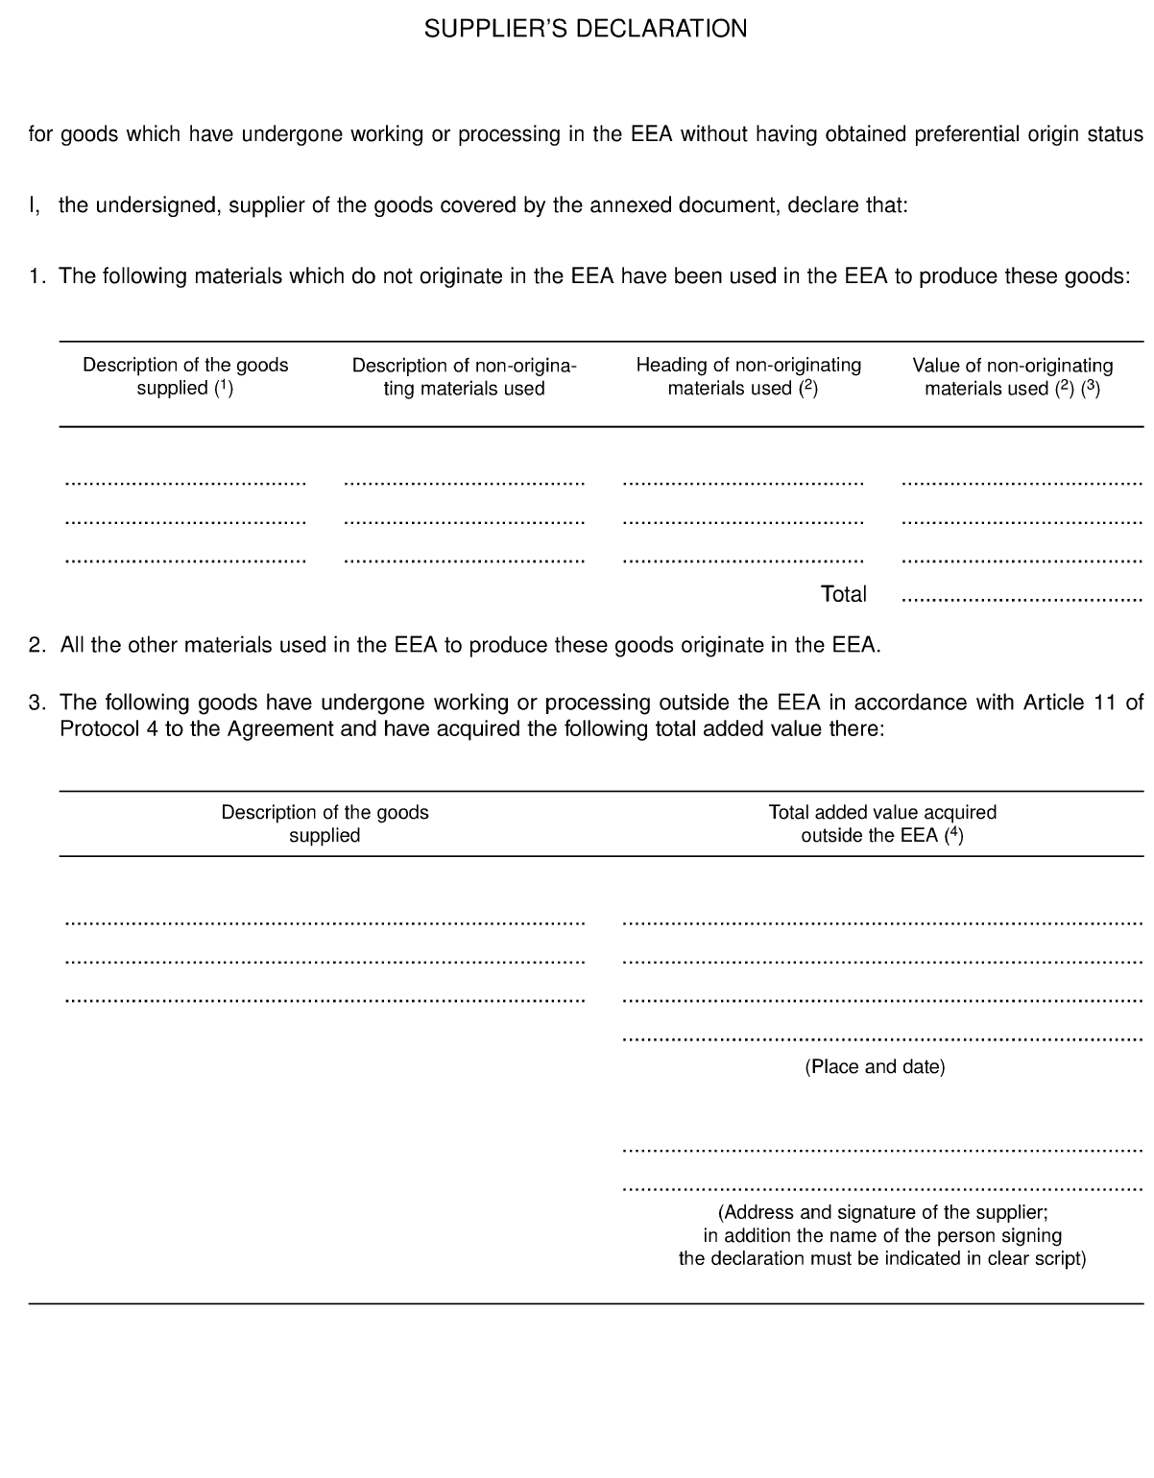
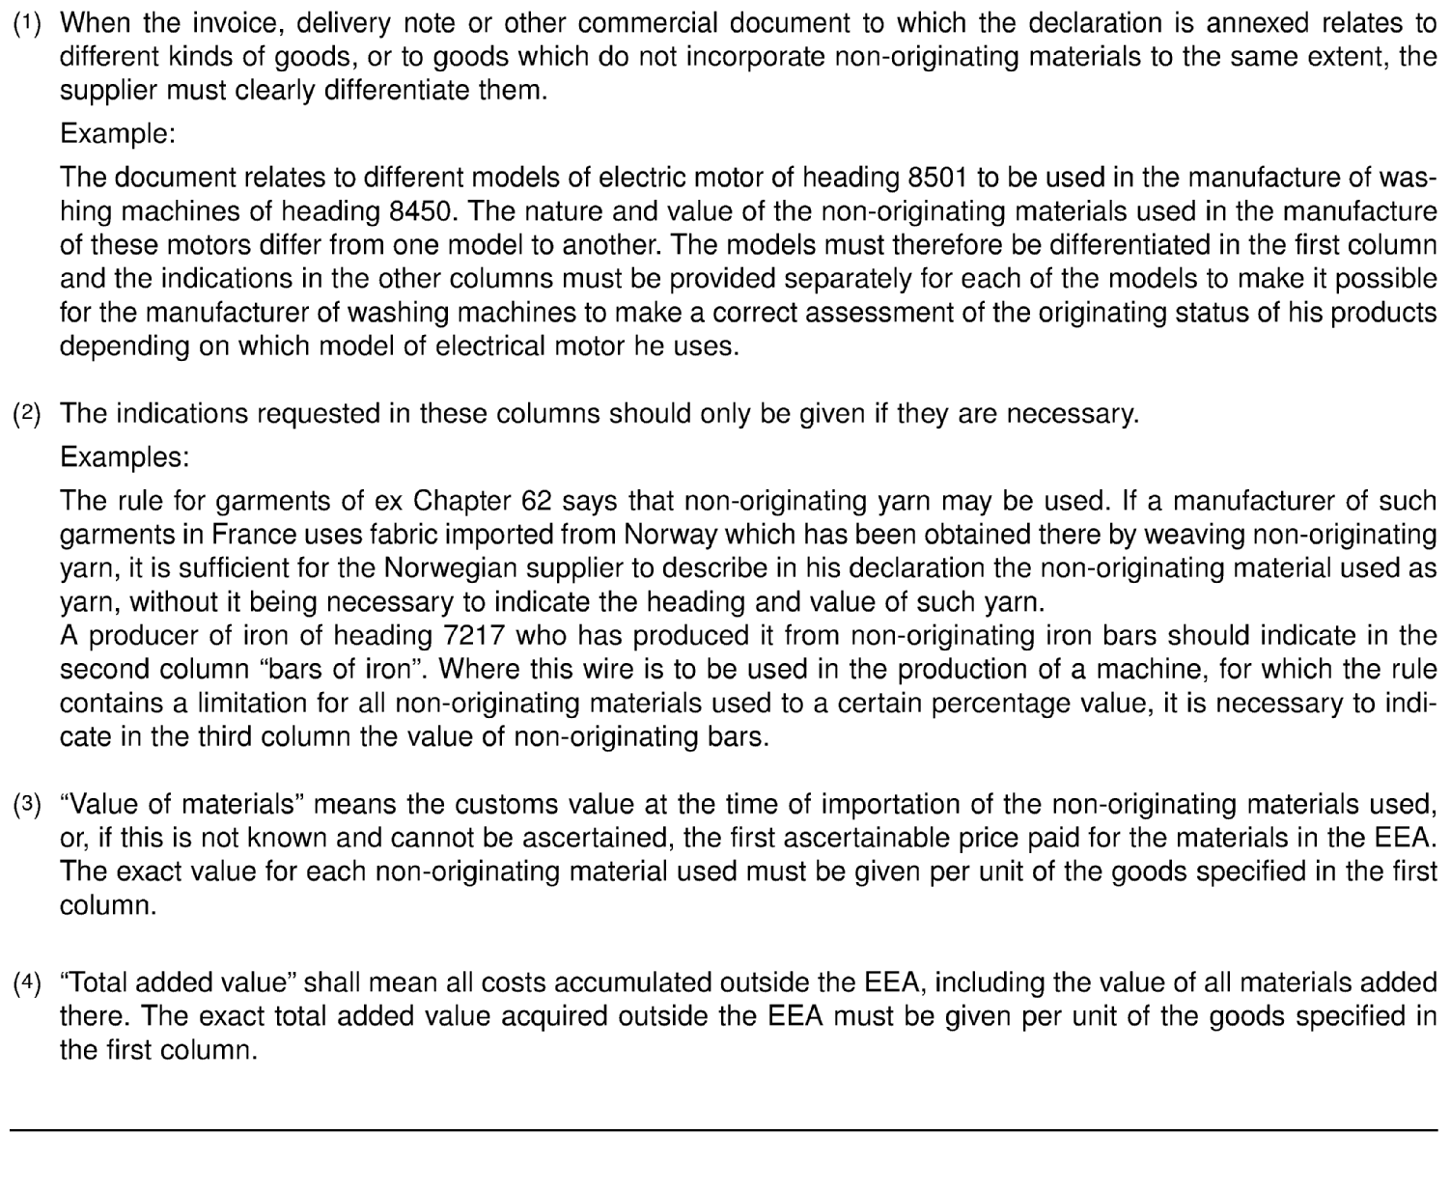
Annex VI
Long-term supplier's declaration
The long-term supplier's declaration, the text of which is given below, must be made out in accordance with the footnotes. However, the footnotes do not have to be reproduced.

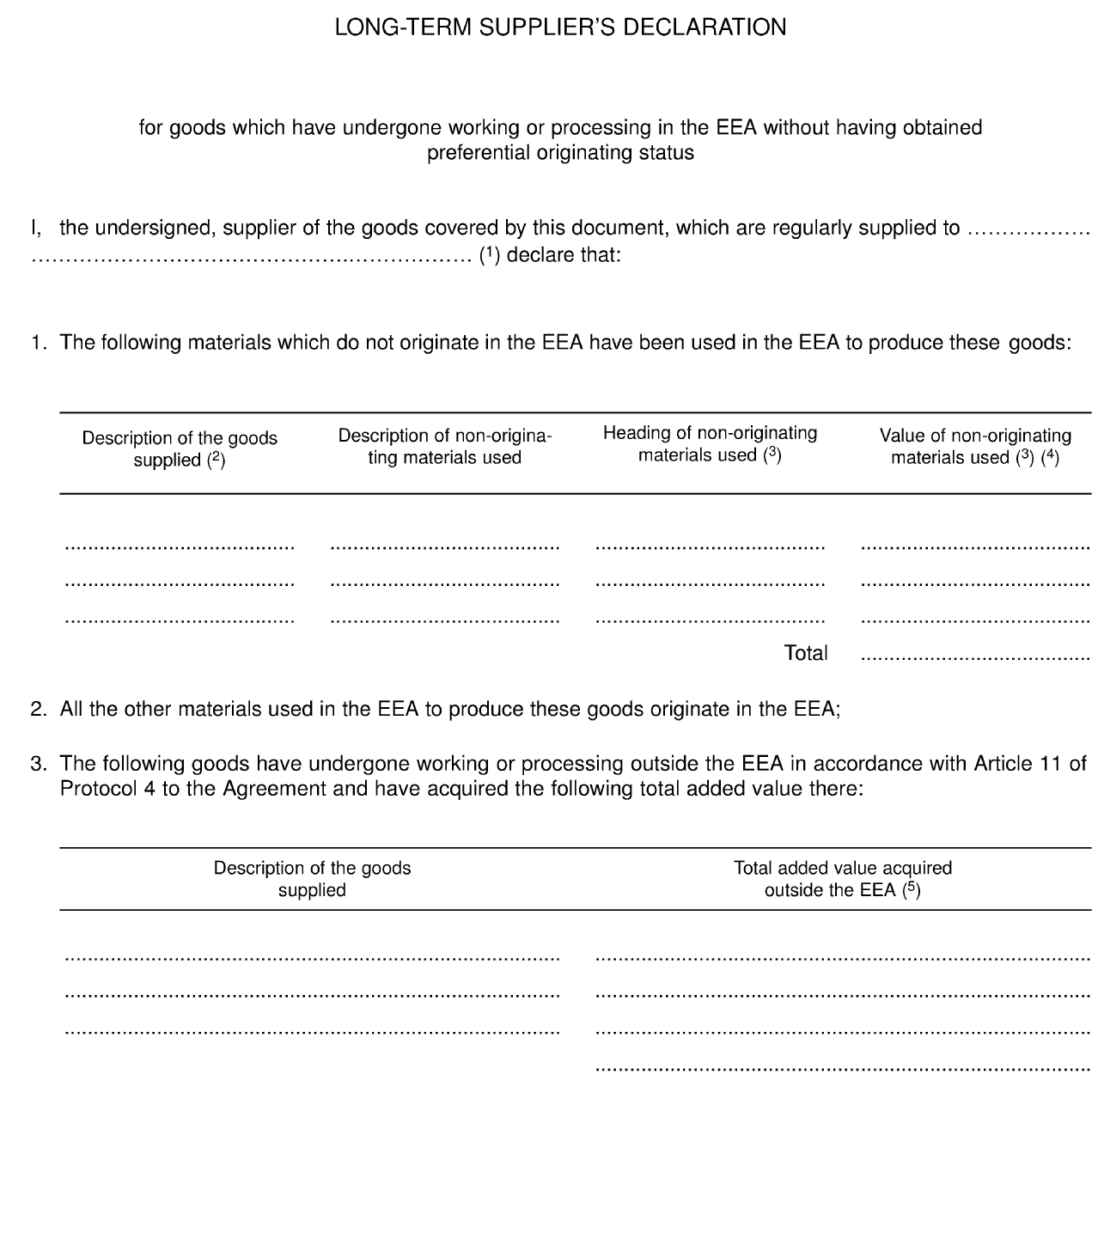
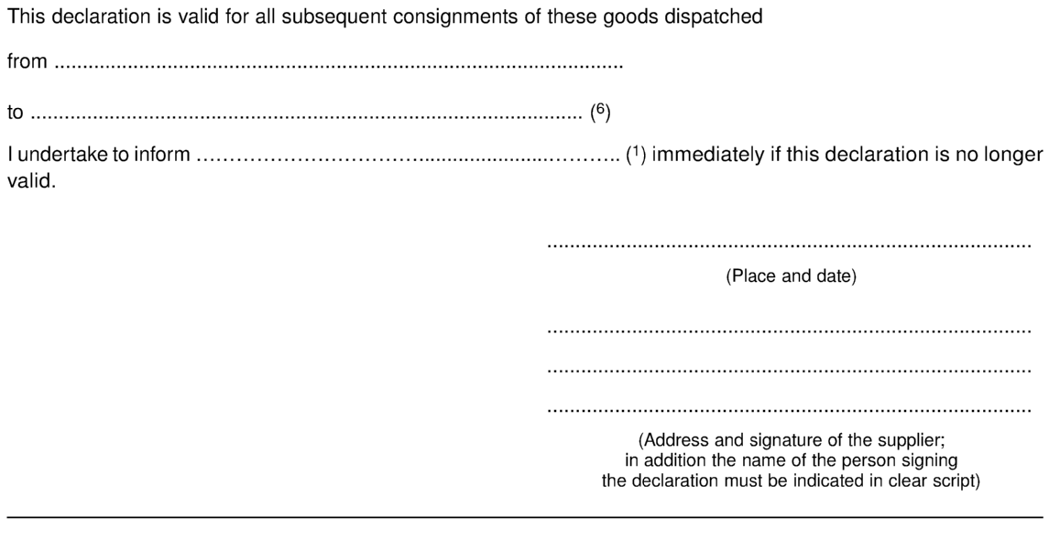
(¹) Name and address of the customer.

(²) When the invoice, delivery note or other commercial document to which the declaration is annexed relates to different kinds of goods, or to goods which do not incorporate non-originating materials to the same extent, the supplier must clearly differentiate them.

Example:
The document relates to different models of electric motor of heading 8501 to be used in the manufacture of washing machines of heading 8450. The nature and value of the non-originating materials used in the manufacture of these motors differ from one model to another. The models must therefore be differentiated in the first column and the indications in the other columns must be provided separately for each of the models to make it possible for the manufacturer of washing machines to make a correct assessment of the originating status of his products depending on which model of electrical motor he uses.

(³) The indications requested in these columns should only be given if they are necessary.

Examples:
The rule for garments of ex Chapter 62 says that non-originating yarn may be used. If a manufacturer of such garments in France uses fabric imported from Norway which has been obtained there by weaving non-originating yarn, it is sufficient for the European Union supplier to describe in his declaration the non-originating material used as yarn, without it being necessary to indicate the heading and value of such yarn.
A producer of iron of heading 7217 who has produced it from non-originating iron bars should indicate in the second column 'bars of iron'. Where this wire is to be used in the production of a machine, for which the rule contains a limitation for all non-originating materials used to a certain percentage value, it is necessary to indicate in the third column the value of non-originating bars.
(⁴) "Value of materials" means the customs value at the time of importation of the non-originating materials used, or, if this is not known and cannot be ascertained, the first ascertainable price paid for the materials in the EEA. The exact value for each non-originating material used must be given per unit of the goods specified in the first column.
(⁵) "Total added value" shall mean all costs accumulated outside the EEA, including the value of all materials added there. The exact total added value acquired outside the EEA must be given per unit of the goods specified in the first column.
(⁶) Insert dates. The period of validity of the long term supplier’s declaration should not normally exceed 12 months, subject to the conditions laid down by the customs authorities of the country where the long term supplier’s declaration is made out.
JOINT DECLARATION
concerning the acceptance of proofs of origin issued within the framework of the agreements referred to in Article 3 of Protocol 4 for products originating in the European Union, Iceland or Norway
1. Proofs of origin issued within the framework of the agreements referred to in Article 3 of Protocol 4 for products originating in the European Union, Iceland or Norway shall be accepted for the purpose of granting preferential tariff treatment provided for by the EEA Agreement.
2. Such products shall be considered as materials originating in the EEA when incorporated into a product obtained there. It shall not be necessary for such materials to have undergone sufficient working or processing.
3. Furthermore, in so far as such products are covered by the EEA Agreement they shall be considered as originating in the EEA when re-exported to another EEA Contracting Party.

JOINT DECLARATION
concerning the Principality of Andorra
1. Products originating in the Principality of Andorra falling within Chapters 25 to 97 of the Harmonised System shall be accepted by Iceland, Liechtenstein and Norway as originating in the European Union within the meaning of the Agreement.
2. Protocol 4 shall apply, mutatis mutandis, for the purpose of defining the originating status of the abovementioned products.

JOINT DECLARATION
concerning the Republic of San Marino
1. Products originating in the Republic of San Marino shall be accepted by Iceland, Liechtenstein and Norway as originating in the European Union within the meaning of the Agreement.
2. Protocol 4 shall apply, mutatis mutandis for the purpose of defining the originating status of the abovementioned products.
JOINT DECLARATION
concerning the withdrawal of a Contracting Party from the Regional Convention on pan-Euro-Mediterranean rules of origin
1. Should a Contracting Party to the EEA give notice in writing to the depositary of the Regional Convention on pan-Euro-Mediterranean rules of origin of their intention to withdraw from the Convention according to its Article 9, the withdrawing Contracting Party shall immediately enter into negotiations on rules of origin with all other EEA Contracting Parties for the purpose of implementing this Agreement.
2. Until the entry into force of such newly negotiated rules of origin, the rules of origin contained in Appendix I and, where appropriate, the relevant provisions of Appendix II to the Regional Convention on pan-Euro-Mediterranean rules of origin, applicable at the moment of withdrawal, shall apply mutatis mutandis between the withdrawing Contracting Party and the other EEA Contracting Parties. However, as of the moment of withdrawal, the rules of origin contained in Appendix I and, where appropriate, the relevant provisions of Appendix II to the Convention shall be construed so as to allow bilateral cumulation between the withdrawing Contracting Party and the other EEA Contracting Parties only.’

_______________________

Algeria, Egypt, Israel, Jordan, Lebanon, Morocco, Palestine, Syria and Tunisia.
OJ L 54, 26.2.2013, p. 4
OJ L XX, X.X.XXXX, p. X. and EEA Supplement No X, X.X.XXXX p. X)
[No constitutional requirements indicated.] [Constitutional requirements indicated.]
The Principality of Liechtenstein has a customs union with Switzerland, and is a Contracting Party to the Agreement of the European Economic Area.
Albania, Bosnia and Herzegovina, the former Yugoslav Republic of Macedonia, Montenegro, Serbia and Kosovo under UNSC Resolution 1244/99.
, Egypt, Israel, Jordan, Lebanon, Morocco, Syria, Tunisia, Palestine (*This designation shall not be construed as recognition of a State of Palestine and is without prejudice to the individual positions of the Member States on this issue).
OJ L 321, 8.12.2005, p. 1. and EEA Supplement No 63, 8.12.2005 p. 1

