Table of contents

INTRODUCTION 3
AGRICULTURE AND RURAL DEVELOPMENT 4
FINANCIAL PROGRAMMING AND BUDGET 9
CLIMATE ACTION 10
COMMUNICATION NETWORKS, CONTENT AND TECHNOLOGY 14
COMPETITION 19
EDUCATION AND CULTURE 20
ENLARGEMENT 21
EMPLOYMENT, SOCIAL AFFAIRS AND INCLUSION 22
ENERGY 27
ENTREPRISE AND INDUSTRY 32
ENVIRONMENT 37
HOME AFFAIRS 43
JUSTICE 48
MARITIME AFFAIRS AND FISHERIES 53
INTERNAL MARKET AND SERVICES 54
MOBILITY AND TRANSPORT 60
REGIONAL POLICY 65
HEALTH AND CONSUMERS 67
TAXATION AND CUSTOMS UNION 72
METHODOLOGY AND EXPLANATIONS 78

INTRODUCTION

As noted in the 31st Annual Report on monitoring the application of the EU law (COM(2014) 612 final page 2, footnote 2), this Staff Working Document contains detailed information in relation to complaints handling, EU Pilot files, infringement procedures and certain judgments of the Court of Justice of the European Union (the "Court") across each EU policy area.

AGRICULTURE AND RURAL DEVELOPMENT

I. General statistics
This chart is an excerpt from the pie chart under point 3 of the 31st Annual Report on monitoring the application of EU law (p. 12.) The pie chart contains the full ranking of the EU policy areas according to the number of open infringement cases.
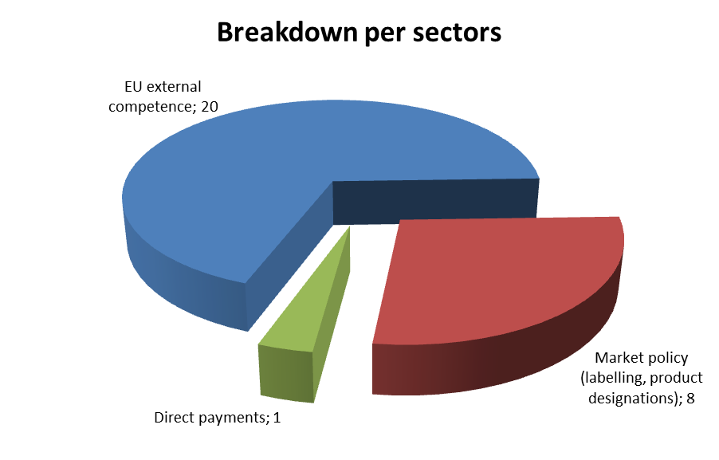
Six new infringement cases were launched in 2013. In particular, a procedure was launched against:
- Italy, due to the slow recovery of milk quota levies.
Cases referred to the Court under Article 258 TFEU:
- none in 2013
Cases referred to the Court under Article 260(2) TFEU:
- none in 2013

II. Transposition of directives
New infringement cases for the late transposition of directives (2010-2013) (between 1 January and 31 December of the given year)
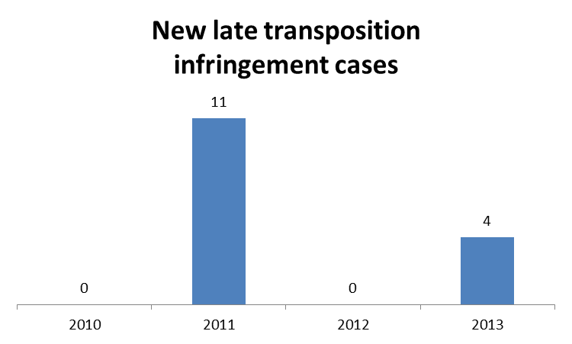

All four infringement cases had to be launched due to the late transposition of:
- the Fruit Juices Directive, which sets out new labelling rules for fruit juices and fruit nectars (the Member States concerned were Belgium, Italy, Cyprus and France).
One AGRI directive with a transposition deadline in 2013

III. Complaints
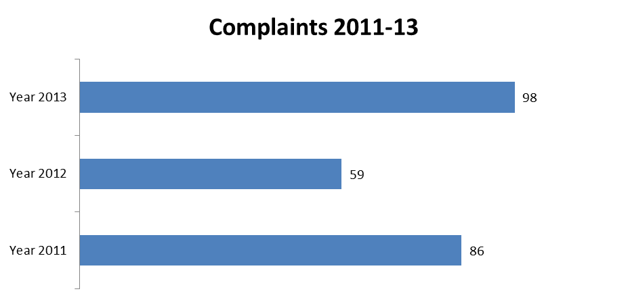

AGRI TOTAL | 98
Direct payments | 21
Rural Development | 27
Organic | 26
CMO rules | 15
Others | 9

There were 92 complaints processed in the area of agriculture and rural development in 2013. The Commission opened EU Pilot investigations in 14 cases.

One EU Pilot file was opened in response to a European Parliament question on organic farming.

IV. EU Pilot
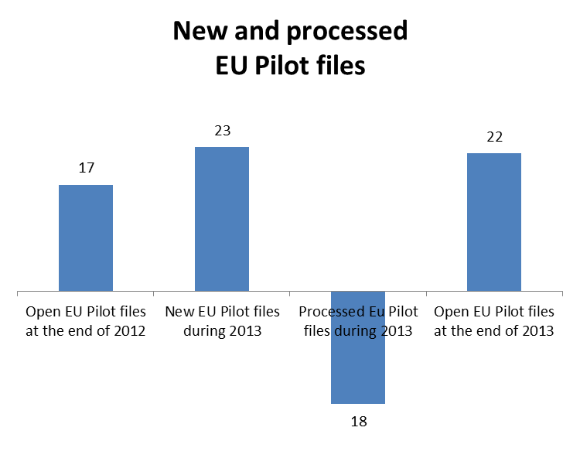
The Member States’ combined resolution rate for files in EU Pilot in the area of agriculture and rural development was 89 %.

V. Own initiative cases
Own initiative cases were opened in the following areas:
- wine (compulsory language use in labelling);
- quality, for non-compliance with rules on the protected designation of origin/the protected geographical indication.

VI. Early resolution of infringement cases
The cases closed without a Court judgment in 2013 related to:
- a case against France, imposing a tax on milk producers who exceeded their individual milk quotas even though the national quota had not been exceeded. The tax significantly interfered with the functioning of the system of milk quotas and surplus levies, as established by the Single Common Market Organisation;
- a case against France concerning the ‘Eaux-de-vie de vin’ (rules concerning the production and marketing of certain products obtained by distilling lees and marcs).

VII. Important judgments
In preliminary rulings, the Court ruled that:
- EU law, in particular the principles of equivalence and effectiveness and Article 47 of the Charter of Fundamental Rights, does not preclude a national rule of jurisdiction. For this, actions intended to safeguard the rights individuals derive from EU law must not be carried out in less advantageous conditions than those stipulated for actions intended to protect the rights derived from any aid schemes for farmers set up under national law;
- Early retirement support in the agricultural sector is an instrument of the Common Agricultural Policy which is designed to ensure the viability of agricultural holdings, and not a social security benefit. In the context of early retirement support for elderly farmers, Member States are required to ensure equal treatment between women and men, and therefore, to prohibit any discrimination on the ground of gender. Defining the ‘normal retirement age’ (in the context of the regulation on support for rural development) differently depending on gender and number of children is incompatible with the principles of equal treatment and non-discrimination for the purposes of the early retirement measure.
- There are important indications for the reform of the Common Agriculture Policy, following a request made during proceedings in Greece concerning additional payments in the tobacco sector, in particular to give Member States flexibility in implementing the Common Agriculture Policy and the limitations relating to such flexibility.

FINANCIAL PROGRAMMING AND BUDGET

I. Own initiative cases
There were six infringement cases open in the area of financial programming and budget at the end of 2013. Letters of formal notice were sent to the Netherlands and the United Kingdom requesting the compensation for loss of traditional own resources that had occurred as a result of export certificates issued by their overseas countries and territories.

II. Early resolution of infringement cases
The Commission detected 102 anomalies in the area of traditional own resources in 2013 (compared to 138 in 2012) and set 32 Value Added Tax (VAT) and 56 Gross National Income (GNI) reservations. In connection with these, it launched 421 accounting actions for traditional own resources (compared to 680 in 2012) and 285 for VAT and GNI cases (465 in 2012) with a view to requesting corrective payments (principal amounts and belated interest) from Member States. Most of the newly detected anomalies were solved at an early stage, either through bilateral discussions with Member States or in the Advisory Committee on Own Resources.

CLIMATE ACTION

I. General statistics
This chart is an excerpt from the pie chart under point 3 of the 31st Annual Report on monitoring the application of EU law (p. 12.) The pie chart contains the full ranking of the EU policy areas according to the number of open infringement cases.

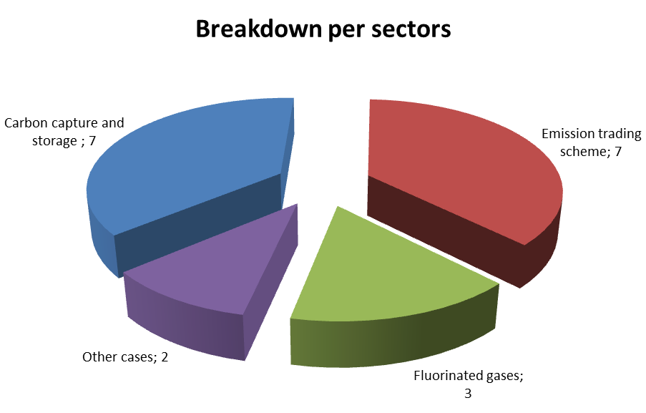
13 new infringement cases were launched in 2013. They relate to:
- Germany: omitting to include the production of polypropylene and other polymers in national measures implementing the directive on greenhouse gas emission trading;
- France: notifying the Commission of the certification and attestation bodies designated for companies and personnel recovering certain fluorinated greenhouse gas-based solvents
- Portugal: notifying the Commission of the rules applicable in Portugal on penalties for infringing the provisions of the Regulation on substances that deplete the ozone layer.
Cases referred to the Court under Article 258 TFEU:
- none in 2013
Cases referred to the Court under Article 260(2) TFEU:
- none in 2013

II. Transposition of directives
New infringement cases for the late transposition of directives (2010-2013) (between 1 January and 31 December of the given year)
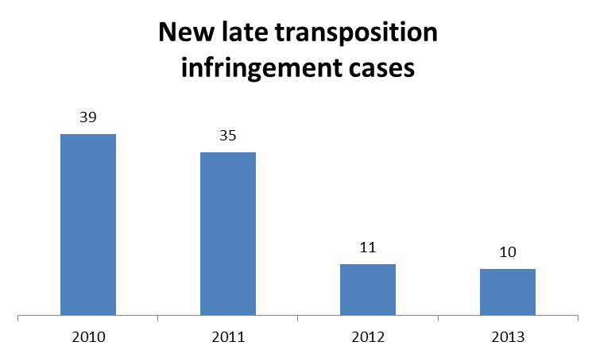

No CLIMA directives with a transposition deadline in 2013
All infringement cases had to be launched due to the late transposition of:
- the directive improving and extending the EU's greenhouse gas emission allowance trading scheme (ten Member States).
Cases referred to the Court under Articles 258/260(3) TFEU:
- none in 2013

III. Complaints
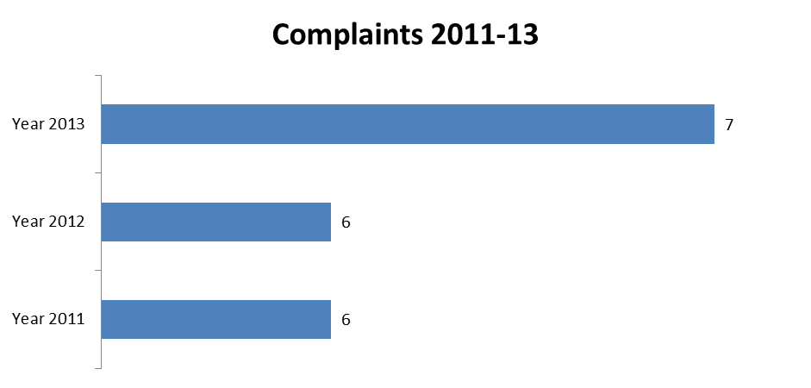

CLIMA TOTAL | 7
Fuel Quality Directive | 2
Other | 5

There were 7 complaints processed in the area of climate action in 2013. The Commission opened EU Pilot investigations in 2 cases.

IV. EU Pilot
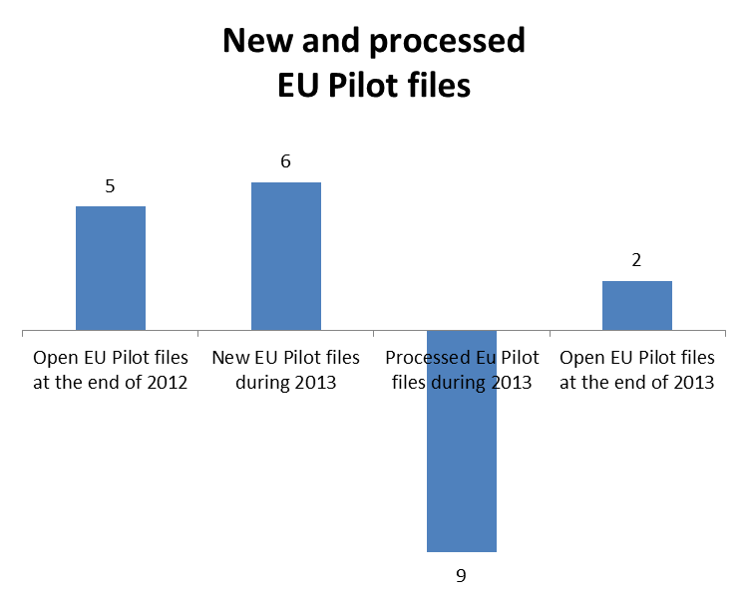
The Member States' combined resolution rate for files in EU Pilot in the area of climate action was 22%.

V. Own initiative cases
No own initiative cases were opened in 2013.

VI. Early resolution of infringement cases
The cases closed without a Court judgement in 2013 related to:
- measures to transpose the directive on geological storage of carbon dioxide into national legislation (notifications were made by Belgium, Bulgaria, the Czech Republic, Estonia, Finland, Germany, Greece, Latvia, Luxemburg and the United Kingdom).

VII. Important judgments
- There were no major judgements in the area of climate action in 2013.

COMMUNICATION NETWORKS, CONTENT AND TECHNOLOGY

I. General statistics
This chart is an excerpt from the pie chart under point 3 of the 31st Annual Report on monitoring the application of EU law (p. 12.) The pie chart contains the full ranking of the EU policy areas according to the number of open infringement cases.
12 new infringement cases were launched in 2013. They relate to:
- Belgium: the independence of the telecoms regulator;
- Luxembourg: unjustified delays on the part of the national authorities in complying with their obligations under the Electronic Communications Framework Directive;
- Slovakia: establishment requirements concerning the provision of electronic communication services;
- Luxembourg, Malta, the United Kingdom and Belgium: the incorrect transposition of a number of provisions of the Audiovisual Media Services Directive (AVMSD).
One infringement case was referred to the Court under Article 258 TFEU. It relates to:
- Estonia: failure to prevent the national telecoms regulator from owning or running telecoms companies.
One infringement case was referred to the Court under Article 260(2) TFEU. It relates to:
- Portugal: failure to designate a universal provider of basic telecoms services.

II. Transposition of directives
No infringement cases had to be launched due to the late transposition of directives in the area of communication networks, content and technology.
No communication technologies directive with a transposition deadline in 2013
Cases referred to the Court under Articles 258/260(3) TFEU:
- none in 2013

III. Complaints
There were four complaints processed in the area of communication networks, content and technology in 2013. The Commission opened EU Pilot investigations in all four cases.

CNECT TOTAL | 32
Electronic communications (authorisations and establishments requirements) | 5
Audio-visual and media services (public service broadcasting and financing of public service broadcasting) | 4
Other | 23

IV. EU Pilot
The Member States' combined resolution rate for files in EU Pilot in the area of communication networks, content and technology was 52%.

V. Own Initiative cases
A number of files have been opened in EU Pilot in the electronic communication sector. These mainly relate to Member States not meeting the requirements of the multiannual Radio Spectrum Policy Programme within the time allowed. In particular, they missed the deadline for allocating frequencies to wireless broadband services across all EU harmonised bands.

VI. Early resolution of infringement cases
The cases closed without a Court judgement in 2013 related to:
- the late transposition of the EU telecoms framework, specifically the Directives on citizens' rights relating to electronic communications networks and services (Belgium, Poland and Slovenia) and the common regulatory framework for electronic communications networks and services (Poland and Slovenia).
- the late transposition of directives on audio-visual media services (Belgium and Poland) and the re-use of public sector information (Estonia and Slovakia);
- retail prices for high-speed access being set without first carrying out a market survey (Poland);
- the awarding of 'must-carry' status to content broadcast in the Brussels region (Belgium).

VII. Important judgments
The Court ruled that:
- a special charge imposed by France on electronic telecoms operators (such as mobile phone networks) complied with the Authorisation Directive. Although this directive stipulates how "administrative charge" should be calculated, the Court found that the charge in question was not an "administrative charge" as it did not relate to the general authorisation procedure for accessing the electronic telecoms market or the allocation of numbers or radio frequencies, and was borne by the end users;
- under the Audiovisual Media Services Directive, Member States are entitled to determine the events they consider to be of 'major importance'. The Commission may only monitor whether the Member States complied with Union law in exercising their discretion. Accordingly, the appeals of the UEFA and FIFA against the Commission were rejected in cases relating to the qualification of the matches in the final stages of UEFA and FIFA tournaments as 'events of major importance'.
In preliminary rulings, the Court ruled that:
- the supply of a package of primarily television programmes via cable for which the price paid by the consumers transmission costs, broadcasters' fees and royalties, constitutes an 'electronic communications service' as defined under the Framework Directive for electronic communications and other directives establishing the EU's new regulatory framework in this area. Thus, only the national regulatory authority can be directly involved in the setting of retail tariffs, even if another body was granted the right to do so in an agreement concluded prior to the adoption of the EU's new regulatory framework;
- the limitation of costs for broadcasting short news events of high interest to the public such as football matches, is valid. The Charter of Fundamental Rights does not preclude the compensation which holders of exclusive broadcasting rights may seek from other channels for short news reports from being limited to technical costs.

COMPETITION

I. General statistics
Two new infringement cases were launched in 2013. They relate to:
- Hungary: the limitation of the sanctioning powers of the national competition authority;
- Denmark: a requirement imposed by local authorities that property owners become paying subscribers of a particular local cable TV provider.

One infringement case was referred to the Court under Article 258 TFEU. It relates to:
- Bulgaria: the procedure followed in assigning digital broadcast spectrum, which excluded potential candidates due to the disproportionately restrictive conditions imposed.
One infringement case was referred to the Court under Article 260(2) TFEU. It relates to:
- Italy: failure to recover illegal and incompatible state aid.

II. Complaints
There were 40 complaints processed in the competition area in 2013. The Commission opened EU Pilot investigations in three cases.

III. EU Pilot
Four new EU Pilot competition-related were opened in 2013. Of the ten EU Pilot files processed in 2013, the Commission opened formal infringement procedures in two cases.

EDUCATION AND CULTURE

I. General statistics

No new infringement cases were launched in 2013.
The Commission referred one case to the Court under Article 258 TFEU. It relates to:
- the Netherlands: refusal to allow Erasmus students and students from other Member States who are not economically active in the Netherlands or have not obtained a permanent right of residence to benefit from the reduced transport fares granted to Dutch students.

II. Complaints
There were 52 complaints processed in the area of culture and education in 2013. The Commission opened EU Pilot investigations in 11 cases..

III. Early resolution of infringement cases
The cases closed without a Court judgment in 2013 related to:
- Austria: discriminatory public transport fare reductions (which mostly benefited Austrian students).

IV. Important judgments
In preliminary rulings, the Court ruled that:
- Luxembourgish legislation excluding children of frontier workers from entitlement to financial aid for higher education studies goes beyond what is necessary in order to achieve the objective pursued, of increasing the proportion of residents with a higher education degree;
- Germany cannot make the receipt of a grant for a course of studies in another Member State subject to the sole condition of three years of uninterrupted residence in Germany.

ENLARGEMENT

I. General statistics
One new infringement case was launched in 2013. It relates to:
- Austria: the compatibility of Austrian establishment and residence law with the rights of Turkish nationals under the EU-Turkey Association Agreement.

II. Complaints
The Commission opened EU Pilot investigations in two cases both based on complaints received.

III. Important judgments
In a preliminary ruling, the Court ruled that:
- Turkish nationals' personal scope of application of the freedom to provide services does not imply the right to visit a Member State in order to obtain services.

EMPLOYMENT, SOCIAL AFFAIRS AND INCLUSION

I. General statistics
This chart is an excerpt from the pie chart under point 3 of the 31st Annual Report on monitoring the application of EU law (p. 12.) The pie chart contains the full ranking of the EU policy areas according to the number of open infringement cases.
33 new infringement cases were launched in 2013. They all relate to the coordination of social security systems, and more specifically to:
- Belgium: the binding effect of Portable Document A1 and E101 forms issued by the authorities of other Member States to individuals paying into their social security system while working in Belgium;
- Ireland: failure to pay long-term care benefits to residents abroad;
- The Netherlands: amendments to legislation reducing the benefits paid to residents of Turkey.
11 infringement cases were referred to the Court under Article 258 TFEU. They relate to:
- Coordination of social security systems
- United Kingdom: use of the ’right to reside’ test, instead of the ‘habitual residence’ test set out in EU law, in determining entitlement to social security benefits;
- the Working Time Directive
- Spain: failure to adopt adequate measures to ensure the protection of the health and safety of staff of the Civil Guard (referral to the Court has been decided but not yet executed in this case);
- Greece: working conditions for hospital doctors;
- Ireland: working conditions for trainee doctors.
Cases referred to the Court under Article 260(2) TFEU:
- none in 2013

II. Transposition of directives
New infringement cases for the late transposition of directives (2010-2013) (between 1 January and 31 December of the given year)
One EMPL directive with a transposition deadline in 2013
Most of the 13 infringement cases had to be launched due to the late transposition of:
- the directive implementing the Framework Agreement on preventing sharp injuries in the hospital and healthcare sector concluded by HOSPEEM (European Hospital & Healthcare Employers’ Association) and EPSU (European Federation of Public Services Unions).
Cases referred to the Court under Articles 258/260(3) TFEU:
- none in 2013

III. Complaints
EMPL TOTAL | 470
Free movement of workers (e.g. employment in the public sector, study grants and mutual recognition of professional qualifications and experience) | 178
Social security (e.g. determining the applicable laws and levying of social security contributions in cross-border situations, entitlement and calculation of pensions) | 60
Other (labour law and health and safety at work Directives) | 232

There were 376 complaints processed in the area of employment, social affairs and inclusion in 2013. The Commission opened EU Pilot investigations in 60 cases.

IV. EU Pilot
The Member States’ combined resolution rate for files in EU Pilot in the area of employment, social affairs and inclusion was 59 %.

V. Own initiative cases
No own initiative cases were opened in 2013.

VI. Early resolution of infringement cases
The cases closed without a Court judgement in 2013 related to:
- Spain: recognition of the European Health Insurance Card (EHIC), equal treatment and the cost of prescription medicines. The Spanish authorities agreed to introduce a simple system of self-certification, allowing EU pensioners using the EHIC to obtain prescriptions on the same terms as Spanish pensioners;
- Slovenia: the conditions of the ‘ad futura’ scholarships. It will no longer be a requirement that graduates awarded the scholarship are obliged to return to employment in Slovenia at the end of the programme;
- Greece: the adoption of legislation on fire safety;
- Ireland: the adoption of legislation necessary to comply with the Construction Site Directive;
- Austria: the adoption of legislation extending the scope of application to the education sector of the implementation measures relating to two directives on health and safety at work..

VII. Important judgments
The Court ruled on:
- the implications of the directive on cross-border mergers.
In preliminary rulings, the Court ruled:
- on Austria’s use of the concept of habitual residence for determining EU citizens’ entitlement to a supplementary pension payment;
- that Luxembourgish legislation excluding children of frontier workers from entitlement to financial aid for higher education studies goes beyond what is necessary in order to achieve the objective pursued, of increasing the proportion of residents with a higher education degree;
- on unemployment benefits paid to frontier workers under the regulation on the coordination of social security systems in the light of the Miethe ruling;
- on the application of a bilateral social security agreement;
- on the calculation of old-age pensions payable to migrant workers and the application of overlapping national provisions;
- on the obligatory use of Dutch in employment contracts;
- on fixed term work;
- on the implications of insolvency;
- on the posting of workers.

ENERGY

I. General statistics
This chart is an excerpt from the pie chart under point 3 of the 31st Annual Report on monitoring the application of EU law (p. 12.) The pie chart contains the full ranking of the EU policy areas according to the number of open infringement cases.

40 new infringement cases were launched in 2013. They relate to:
- Spain: restrictions imposed on the import of electricity, which is incompatible with the Electricity Regulation;
- Bulgaria, the Czech Republic and Lithuania: breach of the Energy Efficiency and Services Directive;
- The Czech Republic: a case concerning conditions for getting access to the electricity distribution system, incompatible with the Renewable Energy Directive and the Electricity Directive;
- Romania: failure to fulfil notification obligations under security of the Gas Supply Regulation;
- The UK: a case concerning the issue of energy performance certificates for holiday lets, based on the directive on energy performance of buildings.
One infringement case was referred to the Court under Article 258 TFEU. It relates to:
- Poland: the Polish system of regulated gas prices for business customers, which impeded the new gas suppliers from entering the gas market.
Cases referred to the Court under Article 260(2) TFEU:
- none in 2013

II. Transposition of directives
New infringement cases for the late transposition of directives (2010-2013) (between 1 January and 31 December of the given year)
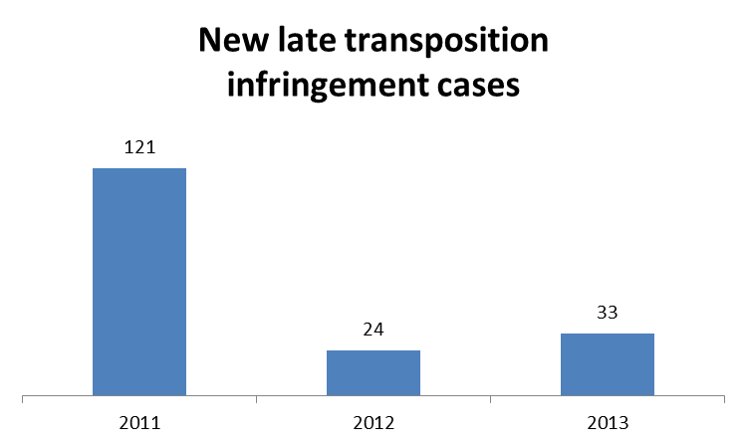
Two ENER directives with a transposition deadline in 2013
Most of the infringement cases had to be launched due to the late transposition of:
- the Oil Stocks Directive (17 Member States);
- the Spent Fuel and Radioactive Waste Directive (13 Member States).
12 infringement cases were referred to the Court under Articles 258 and 260(3) TFEU. They relate to:
- Bulgaria, Estonia, the UK and Romania: partial transposition of the two directives in the Third Energy Electricity and Gas Package;
- Poland, Cyprus and Austria: failure to transpose or to fully transpose the Renewable Energy Directive;
- Portugal: non-transposition of the directive on the energy performance of buildings.

III. Complaints
ENER TOTAL | 72
Internal market for electricity and gas (such as the rights of the national regulatory authority, tariff provisions and consumer protection) | 32
Renewable energy (especially support schemes for wind and solar energy) | 15
Legislation on energy efficiency | 14
Other (incl. exploration of hydrocarbons oil stocks and nuclear energy) | 11

There were 72 complaints processed in the energy area in 2013. The Commission opened EU Pilot investigations in 10 cases.

IV. EU Pilot
The Member States' combined resolution rate for files in EU Pilot in the area of energy was 90%.

V. Own Initiative cases
The Commission launched most energy infringement cases and referred others to the Court on its own initiative (see the 'General statistics' section above).
In 2013, the Commission also took the next procedural steps (reasoned opinion, referral to the Court or closure) in a number of ongoing own initiative cases concerning the non-transposition of the Electricity and Gas Directives, the Renewable Energy Directive, the Building Energy Performance Directive and the Energy Labelling Directive.

VI. Early resolution of infringement cases
The cases closed without a Court judgment in 2013 related to:
- the fulfilment of the obligations relating to the internal energy market in gas and electricity (Spain abolished electricity import restrictions, Poland, Finland, Bulgaria, and the UK passed legislation fully transposing the Electricity and Gas Directives; Ireland and the UK passed legislation complying with obligations under the Electricity and Gas Regulations).

VII. Important judgments
The Court ruled that:
- Italy failed to fulfil its obligations under the directive on energy performance of buildings. When buildings are constructed, sold or rented out, the owner or prospective buyer or tenant are given energy performance certificates. Italian law did not fulfil this requirement for all buildings. The Italian authorities also failed to inform the Commission of any implementing measures regarding inspections of air-conditioning systems;
- Poland failed to ensure non-discriminatory access to activities relating to the prospection, exploration and extraction of hydrocarbons, and by not following the procedure that must precede the granting of authorisations for these activities.
In preliminary rulings, the Court ruled that:
- when transposing the unbundling requirements for distribution system operators in the EU energy law , national law could impose stricter rules than at EU level;
- a standard term in consumer contracts allowing a gas supplier to unilaterally alter the price remains subject to review by national courts for lack of transparency as regards the reasons for adjusting the costs of the supply of gas and the method of doing so;
- Member States are implementing EU law in the sense of Article 51 (1) of the Charter of Fundamental Rights when setting up support schemes. However, they have a broad margin of discretion when deciding which energy sources to support;
- the French feed in system for the support of renewable energy constitutes state aid.

ENTREPRISE AND INDUSTRY

I. General statistics
This chart is an excerpt from the pie chart under point 3 of the 31st Annual Report on monitoring the application of EU law (p. 12.) The pie chart contains the full ranking of the EU policy areas according to the number of open infringement cases.

48 new infringement cases were launched in 2013. They relate to:
- France: national legislation restricting the registration of vehicles;
- Germany: imposition of national pricing rules on pharmacies in other Member States issuing prescription medicines to customers in Germany;
- Lithuania: national legislation on precious metal imported from other Member States that requires imports to be re-checked and stamped again on entry;
- Poland: failure to notify the Commission on the projects in the field of technical regulations, as required under the directive on technical standards and regulations.
Cases referred to the Court under Article 258 TFEU:
- none in 2013
Cases referred to the Court under Article 260(2) TFEU:
- none in 2013

II. Transposition of directives
New infringement cases for the late transposition of directives (2010-2013) (between 1 January and 31 December of the given year)
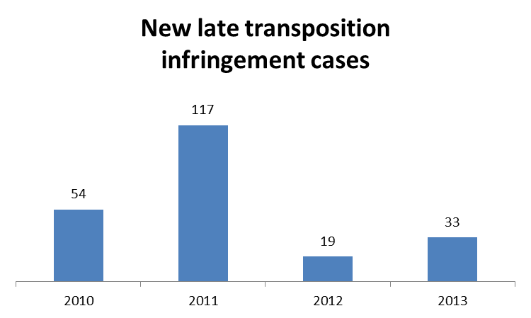
Most of these infringement cases had to be launched due to the late transposition of:
- the directive adapting certain directives in the field of the free movement of goods, by reason of the accession of the Republic of Croatia (nine Member States);
- the directive on the list of defence-related products (five Member States).
Seven ENTR directives with a transposition deadline in 2013
Cases referred to the Court under Articles 258/260(3) TFEU:
- none in 2013

III. Complaints
ENTR TOTAL | 174
Free movement of goods (in particular, vehicles' registration) | 84
Rules governing the automotive sector | 31
Other (e.g. the new Late Payment Directive and failures to notify technical rules, which might qualify as barriers to the free movement of goods) | 59

There were 128 complaints processed in the area of enterprise and industry processed in 2013. The Commission opened EU Pilot investigations in 50 cases.

IV. EU Pilot
The Member States' combined resolution rate for files in EU in the area of enterprise and industry was 72%.

V. Own Initiative cases
Member States were required to transpose the new Late Payment Directive by 16 March 2013. The Commission considered the full and correct application of this directive to be a priority, as it is included in the ‘key legislative acts’ listed in the Communication on Better Governance for the single market.Tackling late payment has therefore been one of the main areas where own initiative investigations have been launched. The Commission’s analysis of Member States’ national measures transposing the Late Payment Directive highlighted issues in the case of 25 Member States. The Commission has therefore contacted these Member States regarding their implementation of this directive through the EU Pilot system. In addition, it has also launched an own initiative investigation into the application of the directive on mobile air conditioning in Germany.

VI. Early resolution of infringement cases
The cases closed without a Court judgment in 2013 relate to:
- Austria: the ban on distant sales of contact lenses;
- Greece: the procedure for fixing the price of parallel imported pharmaceuticals which created obstacles to their import;
- Italy: legislation on pyrotechnics articles that imposed additional requirements beyond the requirements set out in the directive on pyrotechnic articles;
- France: refusal to award subsidies incentivising the purchase of environmentally friendly cars to imported demonstration motor vehicles in breach of the principle of the free movement of goods.

VII. Important judgments
The Court ruled that:
- French national laws restricting the import of tobacco products were contrary to the provisions of the directive on the general arrangements for products subject to excise duty. The Court highlighted that, where a topic has been the subject of exhaustive harmonisation at EU level, any national measure in this area must be assessed in the light of the provisions of the harmonising measure and not those of the Treaty.
In preliminary rulings, the Court ruled that:
- Member States may subject the manufacture, placing on the market or use of a substance referred to in Annex XVII to the REACH Regulation to conditions stricter than those laid down by this Regulation, only in order to respond to a situation where urgent action is necessary to protect human health or the environment, or on the basis of new scientific evidence relevant specifically to that Member State;
- Member States are not required to notify the Commission of a draft national legislation if they had already notified the Commission of a draft version, as required under the directive laying down a procedure for the provision of information in the field of technical standards and regulations and of the rules on Information Society services, and had then amended the draft to take account of the Commission’s observations on it and sent the amended draft to the Commission.

ENVIRONMENT

I. General statistics

This chart is an excerpt from the pie chart under point 3 of the 31st Annual Report on monitoring the application of EU law (p. 12.) The pie chart contains the full ranking of the EU policy areas according to the number of open infringement cases.
223 new infringement cases were launched in 2013. They relate to:
- The Czech Republic and Slovakia: inadequate transposition of the Environmental Impact Assessment Directive;
- Greece, Spain and Austria: failure to ensure adequate protection of species and/or habitats. Austria has not fulfilled its obligations to propose an exhaustive list of sites to be included in the Natura 2000 network); Greece has failed to take adequate measures to combat the use of poison baits; and Spain has engaged in a project to upgrade the maritime access to the port of Seville involving dredging of the Guadalquivir River, which may have implications on Natura 2000 sites;
- Italy: the operation of the ILVA steel plant in Taranto, in breach of the Integrated Pollution Prevention and Control Directive (IPPC Directive). The claims are based on the Industrial Emissions Directive, which replaced the IPPC Directive;
- Austria: the planned construction of a hydro-power plant on the Schwarze Sulm river, which threatens to cause serious deterioration in the quality of the river;
- Slovakia: application of EU legislation determining which projects are subject to an environmental impact assessment.
Eight cases were referred to the Court under Article 258 TFEU. They relate to:
- Italy: inadequate treatment of waste at Malagrotta and other Lazio landfills sites;
- Greece: operation of the landfill site in Peloponnese in breach of EU waste legislation;
- Belgium: inadequate urban waste water treatment in a number of small agglomerations;
- Bulgaria: failure to protect unique habitats and endangered species in the Kaliakra region;
- Germany: inadequate transposition of EU legislation on access to justice in environmental matters (including the scope of national provisions and the burden of proof).
Four cases were referred to the Court under Article 260(2) TFEU. They relate to:
- Greece: the operation of several landfill sites which do not comply with EU law;
- Italy: inadequate waste management in Campania;
- Greece: inadequate urban waste water treatment in several agglomerations;
- Sweden: industrial installations operating without permits.

II. Transposition of directives
New infringement cases for the late transposition of directives (2010-2013) (between 1 January and 31 December of the given year)
Ten ENVI directives with a transposition deadline in 2013
Most of these infringement cases had to be launched due to the late transposition of:
- the Industrial Emissions Directive (20 Member States);
- the directive on the restriction of hazardous substances (15 Member States).
Cases referred to the Court under Articles 258/260(3) TFEU:
- none in 2013

III. Complaints
ENV TOTAL | 520
Nature protection | 149
Waste management | 75
Water protection and management | 35
Other | 261

There were 400 complaints processed in the environment area in 2013. The Commission opened EU Pilot investigations in 82 cases.
Following petitions and questions received from the European Parliament, the Commission opened two infringements cases and 18 files in EU Pilot in 2013. The infringement cases were both opened against Italy, for, respectively, the non-compliance of the ILVA steel plant with EU environmental standards and the incorrect transposition of the Environmental Impact Assessment Directive. The files opened in EU Pilot mainly related to waste management, water management and nature protection.

IV. EU Pilot

The Member States’ combined resolution rate for files in EU Pilot in the environment area was 74%.

V. Own initiative cases
The Commission opened a number of own initiative cases in 2013:
- It launched infringement procedures against Ireland and the United Kingdom as part of a horizontal action addressing the inadequate application of the Urban Waste Water Treatment Directive;
- EU Pilot files were initiated with 13 Member States in connection with the designation of Special Areas of Conservation under the Habitats Directive;
- It continued infringement proceedings against 17 Member States that had exceeded the PM₁₀ limit values laid down in the Air Quality Directive.

VI. Early resolution of infringement cases
The cases closed without a Court judgment in 2013 related to:
- Belgium: incorrect application of the Environmental Impact Assessment Directive (in relation to the exception covering projects adopted by a specific national act);
- Hungary: inadequate transposition of the Environmental Impact Assessment Directive (in particular in relation to its scope);
- Denmark, Latvia and Austria: incorrect transposition of certain provisions contained in the Birds Directive and/or of the Habitats Directive;
- Germany, Estonia, Italy and Latvia: inappropriate transposition of various provisions contained in the Floods Directive;
- Latvia: inadequate transposition of the Groundwater Directive;
- The Czech Republic, Germany, Estonia, Greece and Spain: failure to notify the Commission of measures to transpose the Industrial Emissions Directive.

VII. Important judgments
The Court ruled that:
- France had failed to fulfil its obligations under the Urban Waste Water Treatment Directive, as it had not ensured the collection and the treatment of urban wastewaters in several agglomerations;
- Greece had violated both the Urban Waste Water Treatment Directive and the Habitats Directive in failing to protect Lake Koroneia, an important wetland and part of the Natura 2000 network;
- France had not fully met the requirements of the Nitrates Directive in relation to the designation of zones vulnerable to nitrates;
- Ireland had not ensured that all existing pig-rearing and poultry-rearing facilities were operating in accordance with the Integrated Pollution Prevention and Control Directive;
- Belgium and Luxembourg had failed to take the measures necessary to ensure compliance with earlier Court judgments on urban wastewaters treatment, and financial sanctions were therefore imposed.
In preliminary rulings, the Court clarified the interpretation of EU law provisions on:
- waste, environmental impact assessment, strategic environmental assessment, nature protection and access to justice in environmental matters.

HOME AFFAIRS

I. General statistics

This chart is an excerpt from the pie chart under point 3 of the 31st Annual Report on monitoring the application of EU law (p. 12.) The pie chart contains the full ranking of the EU policy areas according to the number of open infringement cases.

37 new infringement cases were launched in 2013. They relate to:
- migration cases:
- Germany: on the requirement to pass a language test abroad before being admitted to the country for family reunification;
- Italy: breach of the principle of equal treatment between Italian and third country nationals in relation to access to welfare benefits; and
- Malta: on the conditions to be fulfilled by third country nationals when applying for long-term residence permits;
- non-compliance with the Asylum directives:
- France: minimum standards for the reception of asylum seekers;
- Hungary: the processing of asylum applications and the poor treatment of asylum applicants during that process;
- implementation of the right to appeal against a visa refusal, annulment or revocation (six cases were opened against the Czech Republic, Estonia, Hungary, Poland, Slovakia and Finland; the case against Hungary has now been closed).
Cases referred to the Court under Article 258 TFEU:
• none in 2013
Cases referred to the Court under Article 260(2) TFEU:
• none in 2013

II. Transposition of directives
New infringement cases for the late transposition of directives (2010-2013) (between 1 January and 31 December of the given year)
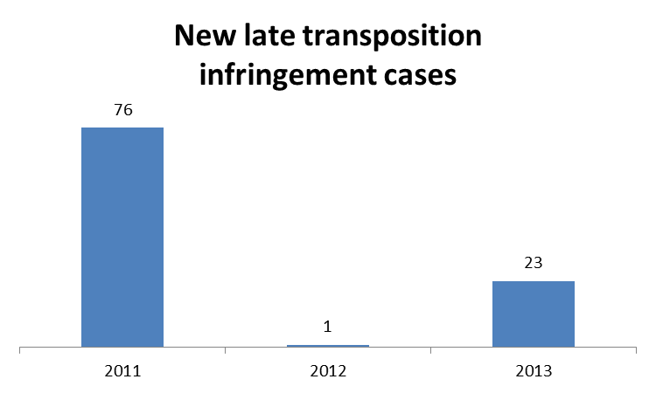
Five HOME directives with a transposition deadline in 2013
Most of the 23 infringement cases had to be launched due to the late transposition of:
- the directive on preventing and combating trafficking in human beings (13 Member States);
- the directive extending the long-term residents directive to beneficiaries of international protection (10 Member States);

Cases referred to the Court under Articles 258/260(3) TFEU:
- none in 2013

III. Complaints

HOME TOTAL | 120
Asylum | 28
Convention on the prevention of corruption | 21
Schengen | 16
Other | 55

There were 107 complaints processed in the area of home affairs in 2013. The Commission opened EU Pilot investigations in nine cases.

IV. EU Pilot
The Member States' combined resolution rate for files in EU Pilot files in the area of home affairs was 60%.

V. Own Initiative cases
Own initiative cases have mainly concerned the area of migration and local border traffic regulation.

VI. Early resolution of infringement cases
The cases closed without a Court judgment in 2013 related to:
- an Italian law that discriminated against long term residents in determining access to public housing;
- failure to inform the Commission of national measures taken to transpose the directive concerning sanctions against employers of illegally staying third-country nationals and the EU Blue Card Directive.

VII. Important judgments
The Court ruled that:
- Sweden had failed to transpose the Data Retention Directive into national law, despite a first judgment of 2010 in which the Court had already found that Sweden failed to transpose the Directive within the prescribed period.
In preliminary rulings, the Court ruled that:
- the limitation of stays in the Schengen area to a maximum of three months within a six-month period for foreign nationals who are not subject to visa requirements does not apply to those who benefit from the local border traffic regime;
- asylum seekers may, on the basis of national law, be imprisoned for the purposes of removal on the grounds of illegal stay if the application for asylum has been made with the sole aim of delaying or jeopardising enforcement of the return decision;
- Turkish nationals do not have the right to enter the territory of an EU Member State without a visa in order to obtain services (i.e. in order to be the passive beneficiaries of the freedom to provide services);
- homosexual asylum applicants can be considered to constitute a particular social group who may be subject to persecution on account of their sexual orientation;
- A Schengen Visa may be refused only on the grounds expressly provided for in the EU Visa Code Regulation. However, Member States authorities have a wide discretion for determining whether one of those grounds for refusal can be applied to the applicant.

JUSTICE

I. General statistics
This chart is an excerpt from the pie chart under point 3 of the 31st Annual Report on monitoring the application of EU law (p. 12.) The pie chart contains the full ranking of the EU policy areas according to the number of open infringement cases.

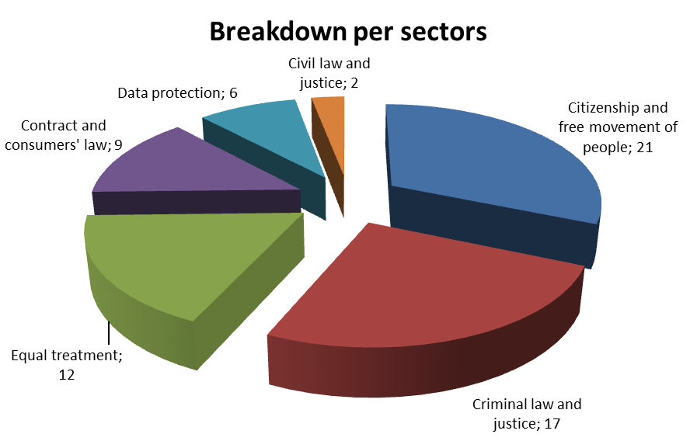
35 new infringement cases were launched in 2013. They relate to:
- five cases (Poland, Greece, Spain, Lithuania, Latvia and Slovakia) relating to EU citizens' rights to participate in elections under the same conditions as nationals of that Member State;
- two cases in the area of consumer rights:
- Cyprus: the purchase of immovable property;
- Slovakia: a lack of effective consumer protection against unfair contract terms and other violations of consumer law;
- two cases regarding equality issues:
- Italy: different conditions for men and women with regard to early retirement pensions;
- Finland: deficiencies in the powers granted to the national race equality body, which provides assistance to victims of discrimination.
One infringement case was referred to the Court under Article 258 TFEU. It relates to:
- The Netherlands: failure to adequately protect rights relating to the return to work for employees on maternity, adoption or parental leave.
Cases referred to the Court under Article 260(2) TFEU:
- none in 2013

II. Transposition of directives
New infringement cases for the late transposition of directives (2010-2013) (between 1 January and 31 December of the given year)
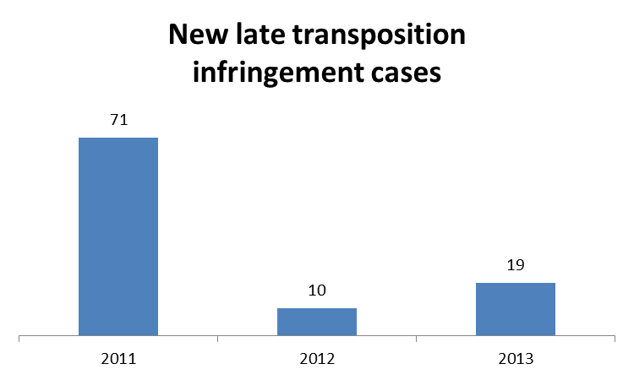
Four JUST directives with a transposition deadline in 2013
Many of the 19 infringement cases had to be launched due to the late transposition of:
- the directive on the right to interpretation and translation in criminal proceedings (16 Member States), which is the very first directive adopted in the field of procedural criminal law.

Cases referred to the Court under Articles 258/260(3) TFEU:
- none in 2013

III. Complaints
JUST TOTAL | 590
Free movement of persons | 72
Protection of personal data | 68
Consumer law and business-to-business marketing | 53
Other (including complaints invoking rights in the Charter of Fundamental Rights) | 397

There were 518 complaints processed in the area of justice in 2013. The Commission opened EU Pilot investigations in 32 cases.
A parliamentary question in the area of justice led to an EU Pilot case being opened relating to the prohibition of discrimination on grounds of religion in the context of employment and occupation.

IV. EU Pilot
The Member States' combined resolution rate for files in EU Pilot in the area of justice was 64%.

V. Own Initiative cases
Own initiative cases in the area of justice mostly relate to consumers protection law, the free movement of people and equality.

VI. Early resolution of infringement cases
The cases closed without a Court judgment in 2013 related to:
- Bulgaria: the additional requirement imposed on every non-Bulgarian EU citizen wishing to vote or stand as a candidate in European Parliament or municipal elections;
- Sweden, Slovakia, Czech Republic and Austria: cases relating to the incomplete ratification of the Convention on Civil Liability for Bunker Oil Pollution Damage.

VII. Important judgments
The Court ruled that:
- Italy had failed to require all employers to adopt practical and effective measures to support all people with disabilities.
In preliminary rulings, the Court ruled that:
- the public announcements made by the owner of a football club in Romania that he would never employ a homosexual player were in breach of the Employment Equality Framework Directive;
- a refusal to provide a pension supplement for an economically inactive EU citizen from another Member State can only be justified if granting of such a benefit is likely to place an unreasonable burden on the social assistance system in the host Member State. However, a social benefit cannot be refused automatically (without examining the burden to the national social assistance system and the personal circumstances);
- EU law does not prevent Member States from making provisions for an appeal to suspend execution of a decision that extends the effects of a European arrest warrant.

MARITIME AFFAIRS AND FISHERIES

I. General statistics and key infringement cases
During 2013, more than 70 cases (infringements, EU Pilot files and complaints taken together) were dealt with in the fisheries field. 8 new formal infringement proceedings were launched in 2013, all on the Commission's own initiative. In particular, they relate to: Greece because of its failure to submit the data necessary for the Commission in order to monitor the proper conservation and management of fisheries stocks; and Romania due to the bad application of the equal access principle as regards access to waters. In addition, 21 new EU Pilot files and 13 complaints were registered during 2013.
The Commission continued the monitoring of the implementation of the Court's judgment against Italy in relation to the lack of control of the illegal use of driftnets. Upon the receipt of Italy's proposed measures in its response to the letter of formal notice under Article 260 TFEU, the Commission carried out an extensive verification work, including inspections on the spot. Although the inspections did not detect illegal driftnets activities, some deficiencies had still been identified in the fisheries control system. To tackle these remaining problems, an action plan has been agreed with Italy.

II. Complaints
There were 13 new complaints processed in the area of fisheries matters in 2013. In total 16 complaints were treated. The Commission opened EU Pilot investigations in 14 cases.

III. EU Pilot
In 2013, the Commission opened 21 new EU Pilot files on matters of relevance for the Common Fisheries Policy (CFP), bringing the number of EU Pilot cases in this field to 48. Out of the 48 dossiers treated in EU Pilot during 2013, 25 were closed. 17 files were assessed positively. The Member States' combined resolution rate for files in EU Pilot in the field of fisheries was 68%.

IV. Early resolution of infringement cases
The cases closed without a Court judgment in 2013 related to the issue of non-compliance by Greece with the Fisheries Data collection obligations. Following the letter of formal notice mentioned above in section I, Greece has put in place the necessary administrative measures to ensure compliance with data collection obligations in the future and the case has been therefore closed in October 2013.

INTERNAL MARKET AND SERVICES

I. General statistics
This chart is an excerpt from the pie chart under point 3 of the 31st Annual Report on monitoring the application of EU law (p. 12.) The pie chart contains the full ranking of the EU policy areas according to the number of open infringement cases.

68 new infringement cases were launched in 2013. They relate to:
- Hungary: national legislation allowing natural persons to take out mortgage loans in foreign currency only if their income exceeds fifteen times the minimum wage;
- Austria: national legislation restricting the use and establishment of holiday homes on grounds of nationality;
- Belgium, the Czech Republic, Cyprus, Lithuania, Poland and Romania: national legislation restricting the supply of gambling services;
- Germany: discriminatory requirements in waste management contracts;
- Italy: restrictions on lawyers from other Member States exercising the legal profession in Italy;
- Sweden: the lack of means of legal redress in respect of the awarding of contracts for catering concessions;
- Spain: national legislation restricting the access of non-Spanish nationals to the profession of technical designer.
Two infringement cases were referred to the Court under Article 258 TFEU. They relate to:
- Poland: national legislation specifying grounds for exclusion from tenders that are not provided for by the Public Procurement Directive. Firms that have previously been awarded a contract and have failed to perform that contract correctly, or have had the contract terminated due to circumstances for which they were responsible;
- the restrictive issuing conditions of meal and holiday vouchers under the new Hungarian legal framework.
Cases referred to the Court under Article 260(2) TFEU:
- none in 2013

II. Transposition of directives
New infringement cases for the late transposition of directives (2010-2013) (between 1 January and 31 December of the given year)
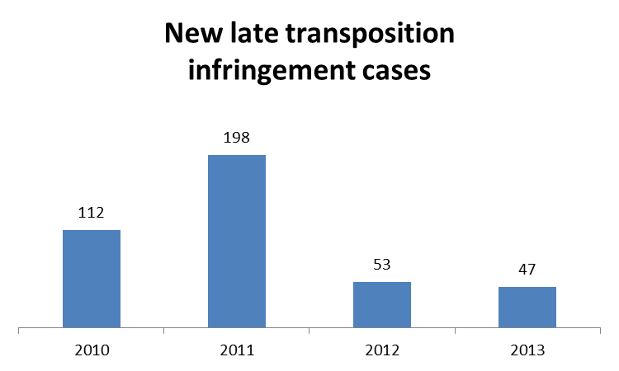
Ten MARKT directives with a transposition deadline in 2013

Most of these infringement cases had to be launched due to the late transposition of:
- the directive adapting certain directives in the field of the right of establishment and freedom to provide services, following the accession of the Republic of Croatia (19 Member States);
- the Directive on Alternative Investment Fund Managers (16 Member States).

Cases referred to the Court under Articles 258/260(3) TFEU:
- none in 2013

III. Complaints
MARKT TOTAL | 494
Free movement of capital (in relation to e.g. energy, financial services and agricultural land) | 151
Public procurement (e.g. non-discrimination, equal treatment, and transparency, wrong definition of award criteria and choice of the wrong procurement regime) | 71
Cross-border e-commerce | 18
Other (including gambling services and regulated professions) | 254

There were 458 complaints processed in the area of internal market and services in 2013. The Commission opened EU Pilot investigations in 70 cases.

IV. EU Pilot
The Member States' combined resolution rate for files in EU Pilot in the area of internal market and services was 75%.

V. Own Initiative cases
Own initiative cases have mainly been launched in the area of regulated professions.

VI. Early resolution of infringement cases
The cases closed without a Court judgment in 2013 related to:
- Portugal: failure to implement the provisions contained in the directive on award procedures of public contracts in the fields of defence and security;
- Finland: national legislation that created a monopoly right for the provision of gambling services;
- Greece: refusal to recognise qualifications awarded by educational establishments operating under franchise arrangements with universities in other Member States;
- Poland: requirement that notaries are of Polish nationality;
- Luxembourg: the linguistic requirements for lawyers wishing to practise under the Luxembourg professional title after practicing for three years under the professional title of the Member State in which they qualified.

VII. Important judgments
The Court ruled that:
- by repealing both the provisions of the Volkswagen Law relating to the appointment of members of the supervisory board and those relating to the cap on voting rights, Germany fulfilled the obligations resulting from the Court's 2007 judgment. The Court therefore dismissed the action brought by the Commission seeking to impose financial penalties for non-compliance;
- the Czech Republic was obliged to pay a lump sum of EUR 250, 000 for non-compliance with the Court's initial judgment relating to incomplete transposition of the directive on the activity and supervision of institutions for occupational retirement provision. The Commission had withdrawn its request to ask for a daily penalty.
In preliminary rulings, the Court ruled that:
- the Agreement on Trade-Related Aspects of Intellectual Property falls within the exclusive competence of the European Union;
- a Member State may rely on the provisions of a directive which has not been transposed into national law when taking a case against a body holding a public service concession;
- a contract in which one public entity assigns to another a task in return for financial compensation intended to cover the costs incurred in the performance of the task in public contract at least when:
(a) it does not establish a cooperation in carrying out a task they both have to perform;
(b) the public entity assigning the task keeps the power to supervise its proper execution, and
(c) the entity to whom the tasks is assigned is authorised to use third parties that might be capable of competing on the market for the accomplishment of that task.
- the exclusion from partial access (i.e. authorisation to carry out some of the activities in a professional field) to the physiotherapy profession in Greece constitutes an obstacle to the freedom of establishment.

MOBILITY AND TRANSPORT

I. General statistics
This chart is an excerpt from the pie chart under point 3 of the 31st Annual Report on monitoring the application of EU law (p. 12.) The pie chart contains the full ranking of the EU policy areas according to the number of open infringement cases.

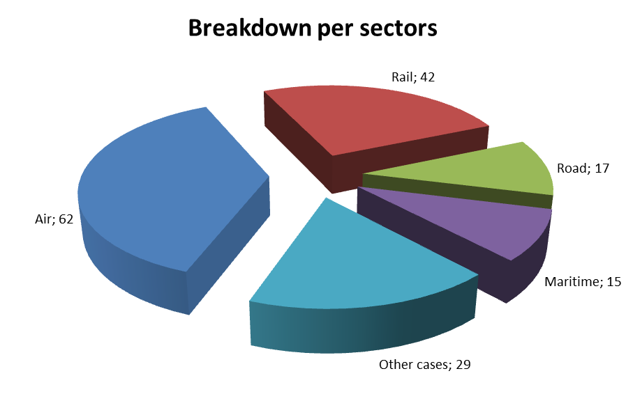
94 new infringement cases were launched in 2013. They relate to:
- Spain, Italy, Latvia, Austria and Spain: failure to comply with the requirement to keep separate financial accounts for railway undertakings and for railway infrastructure managers;
- France and Latvia: failure to implement the principle of free provision of port services;
- Belgium, Greece, Italy and Cyprus: failure to put in place the legal structure for establishing functional airspace blocks, as required under the Single European Sky legislation;
- Greece and Italy: discriminatory airport charges;
- Belgium, Denmark, France, Italy, Luxembourg, Malta, the Netherlands, Austria and Portugal: breach of passenger rights in relation to various modes of transport.
Nine infringement cases have been referred to the Court under Article 258 TFEU. They relate to:
- Austria, Poland and Finland: failure to apply EU working time rules to self-employed drivers;
- Portugal: incorrect application of the rules on airport ground handling at Lisbon, Porto and Faro airports;
- Spain: restrictive rules on the recruitment of port workers;
- Germany: failure to comply with EU rules on financial transparency in the rail sector, by allowing public funds intended for services provided under public service obligations to be used to cross subsidise passenger and freight train services open to competition;
- Portugal: failure to guarantee independence of airport slot coordinators;
- Slovenia: failure to apply the directive on the operability of the rail system within the Community;
- Belgium: failing to apply the directive on inland transport of dangerous goods to scientific and technical progress.
Cases referred to the Court under Article 260(2) TFEU:
- none in 2013

II. Transposition of directives
New infringement cases for the late transposition of directives (2010-2013) (between 1 January and 31 December of the given year)
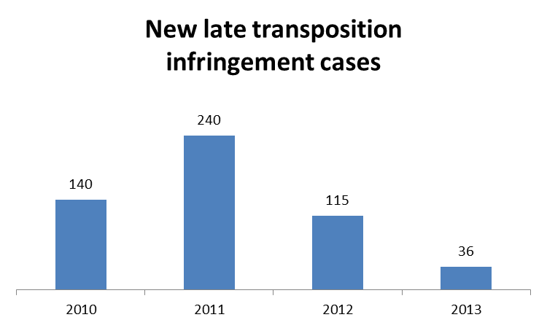
Eight MOVE directives with a transposition deadline in 2013
Most of these infringement cases had to be launched due to the late transposition of:
- the directive adapting certain directives in the field of transport policy, by reason of the accession of the Republic of Croatia (12 Member States);
- the directive adapting for the second time the annexes to Directive 2008/68/EC on the inland transport of dangerous goods to scientific and technical progress (ten Member States).
Two infringement cases have been referred to the Court under Articles 258/260(3) TFEU. They relate to:
- Belgium: failure to implement the directive on intelligent transport systems and failure to fully implement the directive on the investigation of maritime accidents.

III. Complaints
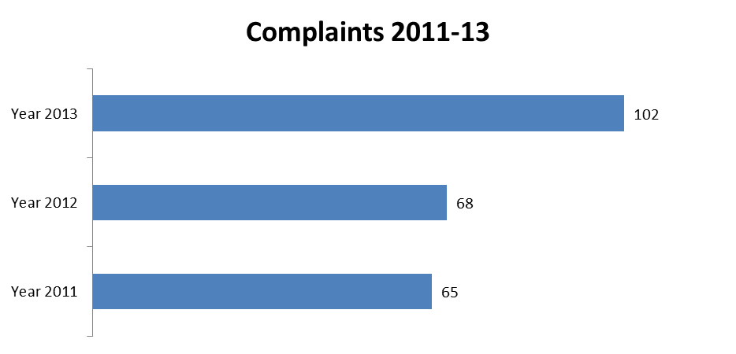
MOVE TOTAL | 102
Passenger rights, in particular air and rail and discriminatory bus fares; | 12
Road safety, in particular issues on driving licenses; | 15
Discriminatory airport charges | 15
Other | 60

There were 92 complaints processed in the area of mobility and transport in 2013. The Commission opened EU Pilot investigations in 31 cases.

IV. EU Pilot
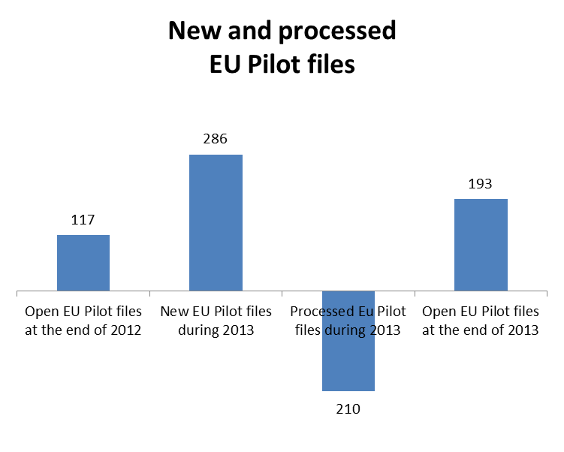
The Member States' combined resolution rate for files in EU Pilot in the area of transport was 62%.

V. Own Initiative cases
The own initiative infringement cases opened by the Commission mainly relate to the railway sector (e.g. the separation of accounts of railway undertakings, and railway infrastructure managers and railway safety and interoperability), the air sector (implementation of the Single European Sky legislation, in particular the requirement to establish functional airspace blocks) and breaches of passengers rights (e.g. designation and operation of national bodies, responsible for handling passenger complaints, in particular as relates to travel by sea and inland waterways, by bus and by-coach passengers).

VI. Early resolution of infringement cases
The cases closed without Court a judgment in 2013 related to:
- Estonia and Romania: implementation of the First Railway Package;
- The Czech Republic, Spain, Austria and Poland: failure to apply EU working time rules to self-employed drivers;
- Portugal: discriminatory charging of heavy goods vehicles for the use of certain parts of transport infrastructure.

VII. Important judgments
The Court ruled that:
- Germany, Luxembourg and Austria have complied with the obligations set out in the First Railway Package concerning the independence of infrastructure managers vis-à-vis other rail operators;
- The Czech Republic, Spain, France, Italy, Hungary, Poland and Slovenia have failed to correctly implement the First Railway Package. The shortcomings in their implementation measures mainly relate to: the lack of independence of the infrastructure manager vis-à-vis railway undertakings; insufficient implementation of the provisions of the directive on track access charging, e.g. the absence of a ‘performance scheme’ to incentivise railway undertakings and the infrastructure manager to improve the performance of the railway network; the lack of incentives for the infrastructure manager to reduce costs and charges and the fact that systems for setting tariffs do not take into account of the direct costs of rail services.

REGIONAL POLICY

I. Legal framework
Although the Commission is entitled to launch infringement proceedings against Member States in the area of regional policy, it instead employs the financial corrections procedure provided for under the regulations governing the Structural Funds. This procedure, which may be initiated by either a Member State or the Commission, allows the recovery of all or part of the EU contribution to a particular project or programme.

II. Complaints
Complaints are typically related to the rejection of applications to the EU's co-financing programmes for funding projects or to non-compliance of individual projects with the provisions on public procurement and the rules set out in EU law. An increasing number of complaints invoke violations of the Charter of Fundamental Rights. In 2013, the Commission opened EU Pilot investigations in three cases as a result of complaints.

III. EU Pilot
The Member States' combined resolution rate for files in EU Pilot in the area of regional policy was 82%.

IV. Important judgments
The Court ruled that:
- the Commission had lawfully suspended interim payments from the European Regional Development Fund (ERDF) to the regional operational programme in Campania for the 2000-06 programming period. The suspension was the result of an infringement procedure launched by the Commission against Italy in particular in response to Italy's failure to establish a proper network of waste disposal facilities in Campania and the subsequent inadequate implementation of the Court's judgment;
- France's appeal against an earlier judgment should be rejected as the Commission had lawfully cancelled the payment due to be made from the European Regional Development Fund for developing the infrastructure of ClubMed in Martinique. The Court therefore confirmed the Commission's view that France had interpreted the notion of 'subsidised contract' as referred to in the Public Procurement Directive too broadly.

HEALTH AND CONSUMERS

I. General statistics
This chart is an excerpt from the pie chart under point 3 of the 31st Annual Report on monitoring the application of EU law (p. 12.) The pie chart contains the full ranking of the EU policy areas according to the number of open infringement cases.

60 new infringement cases were launched in 2013. They relate to:
- failure to ensure that pregnant sows are kept in groups (nine Member States).
Five infringement cases were referred to the Court under Article 258 TFEU. They relate to:
- Greece and Italy: failure to take the necessary measures to ensure that laying hens are kept in "enriched cages";
- Poland: incomplete transposition of EU laws on the quality and safety of human tissues and cells used in healthcare. The provisions made in Polish law are such that three categories of tissues and cells - reproductive cells, embryonic tissues and foetal tissues – are not made subject to quality and safety rules.
Cases referred to the Court under Article 260(2) TFEU:
- none in 2013

II. Transposition of directives
New infringement cases for the late transposition of directives (2010-2013) (between 1 January and 31 December of the given year)
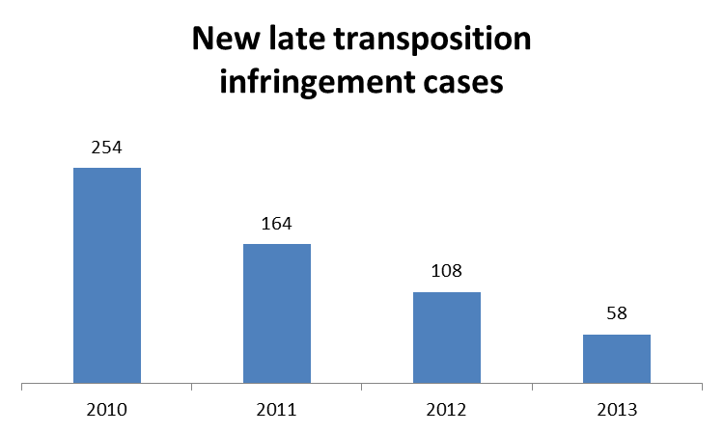
Nine SANCO directives with a transposition deadline in 2013
Most of the 58 infringement cases had to be launched due to the late transposition of:
- the directive on falsified medicinal products (16 Member States);
- the Pharmacovigilance Directive (eleven Member States)

Cases referred to the Court under Articles 258/260(3) TFEU:
- none in 2013

III. Complaints
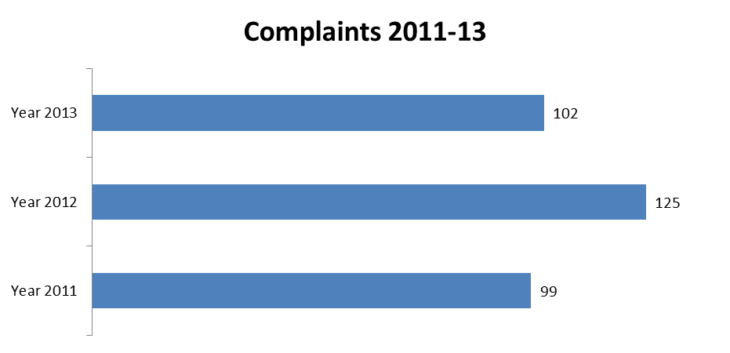
SANCO TOTAL | 102
Health protection (including medicinal products and medical devices) | 32
Consumer protection | 23
Food and plant safety (including GMOs) | 12
Animal welfare | 10
Other (e.g. zootechnics) | 25

There were 106 complaints processed in the area of health and consumers in 2013. The Commission opened EU Pilot investigations in 23 cases.
Petitions from the European Parliament revealed potential infringements of EU law in the cosmetic products, animal welfare and food safety sectors.

IV. EU Pilot
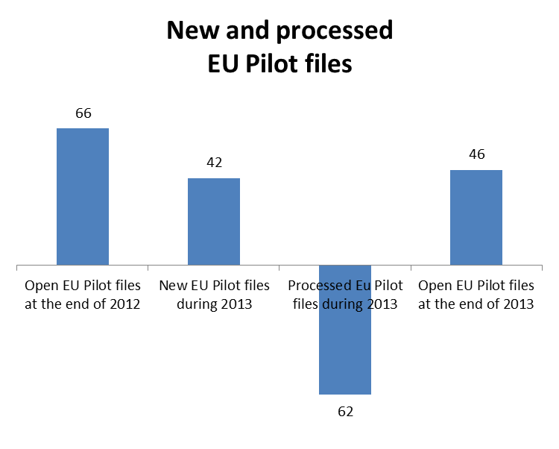
The Member States' combined resolution rate for files in EU Pilot in the area of health and consumers was 71%.

V. Own Initiative cases
The Commission has carried out a detailed assessment of the measures taken by Member States to transpose the Consumer Credit Directive.
The Commission urged Member States to implement EU legislation on the quality and safety of blood and blood components more effectively.

VII. Early resolution of infringement cases
The cases closed in 2013 without a Court judgment related to:
- Spain, Cyprus and Poland: the requirement to keep laying hens in enriched cages;
- Spain: the protection of animals in slaughterhouses;
- France: laws preventing the national equestrian institute having a monopoly in the issuing of identification documents for horses;
- Slovakia: the compliance of the national definition of "genetically modified micro-organism" with EU law.

VIII. Important judgments
The Court ruled that:
- France failed to respect Article 288 TFEU (according to which a decision is binding in its entirety and to whom it is addressed) and Article 4(3) TEU (the principle of sincere cooperation) by failing to implement the Commission Decision ordering it to suspend (until a judgment is made in an on-going Court case) certain measures it has taken in order to prohibit the import of milk and milk products intended for human consumption from holdings where a case of classical scrapie has been confirmed.

TAXATION AND CUSTOMS UNION

I. General statistics
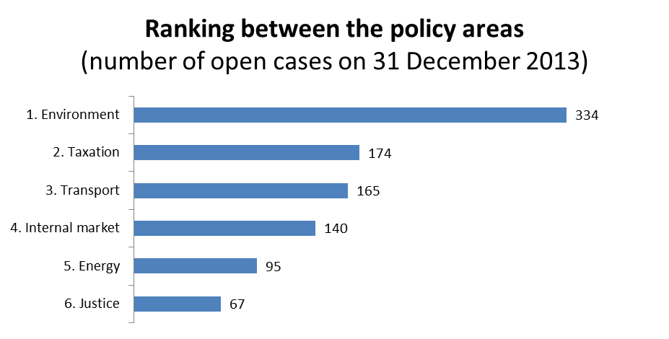
This chart is an excerpt from the pie chart under point 3 of the 31st Annual Report on monitoring the application of EU law (p. 12.) The pie chart contains the full ranking of the EU policy areas according to the number of open infringement cases.

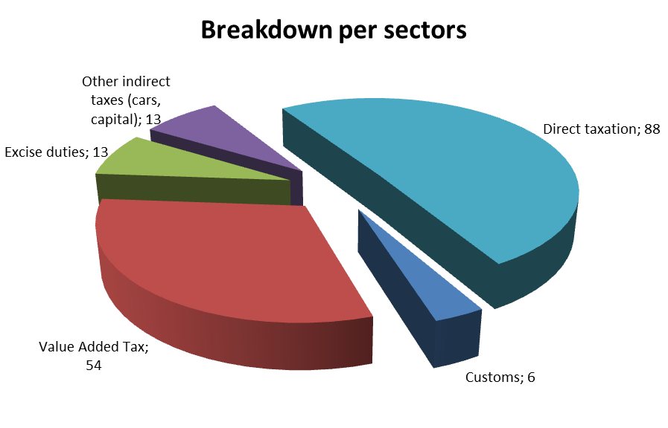
67 new infringement cases were launched in 2013. They relate to:
- Italy: rules on VAT refunds that appear to be disproportionately strict, and delays in paying refunds;
- Cyprus: failure to transpose the new, simpler and more modern EU rules on VAT invoicing;
- France: the reduced VAT rate applied to some agricultural products seems to go beyond the scope of the VAT Directive;
- Italy: rules governing inheritance tax benefits that appear to discriminate against non-Italian public securities and foreign non-profit organisations based in Member States that do not have reciprocity agreements with Italy;
- Germany: exempting foreign non-profit entities from inheritance tax only if equivalent benefits are granted to German non-profit organisations and maintenance allowances paid to the spouse and children of deceased people being conditional on that person having been resident in Germany.
15 infringement cases were referred to the Court under Article 258 TFEU. They relate to:
- Bulgaria: the duty and tax relief given to certain imports from the US under a technical assistance agreement between the two countries go beyond what is allowed under EU law, as they do not meet the conditions under which Member States are allowed to give duty relief, e.g. to commodities imported by organisations set up under international law or in connection with cultural, scientific or technical cooperation agreements concluded with non-EU countries;
- France and Luxembourg: a VAT reduction granted for e-book downloads;
- Hungary: tax exemptions for distillates (pálinka) produced for personal use (maximum of 50 litres per annum);
- France: tax laws that appear to discriminate against rented properties located outside France by allowing faster depreciation for comparable properties located in France, thereby easing the tax burden on investments in France compared to elsewhere;
- Spain: tax laws allowing only residents to benefit from the tax exemption granted for capital gains realised from the sale of a permanent residence and being reinvested into another permanent residence.
Cases referred to the Court under Article 260(2) TFEU:
- none in 2013

II. Transposition of directives
New infringement cases for the late transposition of directives (2010-2013) (between 1 January and 31 December of the given year)
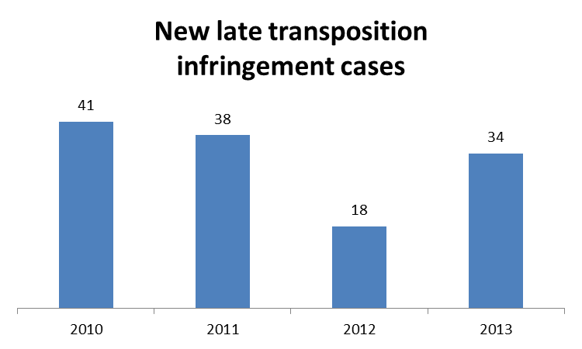
Two taxation directives with a transposition deadline in 2013
Most of the 34 infringement cases had to be launched due to the late transposition of:
- the directive on administrative cooperation in the field of taxation (13 Member States);
- the directive adapting certain directives in the field of taxation, by reason of the accession of the Republic of Croatia (nine Member States).
Cases referred to the Court under Articles 258/260(3) TFEU:
- none in 2013

III. Complaints
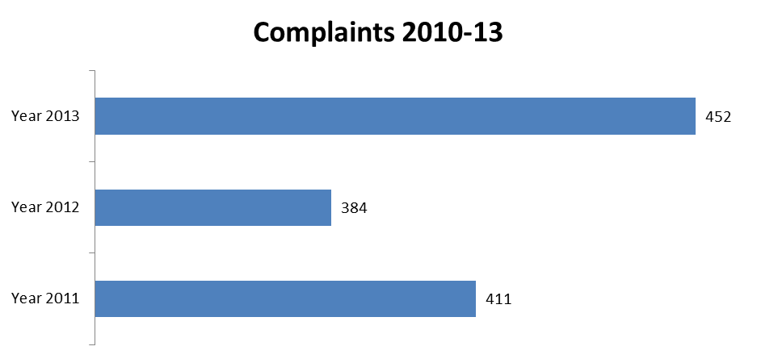

TAXUD TOTAL | 452
Indirect taxation (including VAT) | 237
Direct taxation | 180
Other (e.g. customs) | 35

There were 378 complaints processed in the area of taxation and customs union in 2013. The Commission opened EU Pilot investigations in 77 cases.
In response to petitions from the European Parliament, the Commission opened EU Pilot investigations in relation to tax rules applied to mobile workers.

IV. EU Pilot
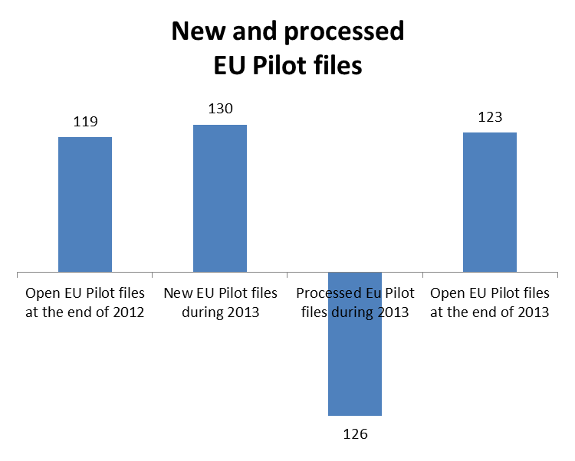
The Member States’ combined resolution rate for files in EU Pilot in the area of taxation and customs union was 60 %.

V. Own initiative cases
The Commission opened own initiative cases in 2013 in relation to:
- customs fees and duties, specifically the simplified customs procedure and customs guarantees;
- rules that might create obstacles to awarding VAT refunds to taxable individuals not established in the EU;
- procedures for verifying the validity of tax markings on tobacco products and the restricted access to excise duty warehouses in some Member States;
- national tax legislation relating to cross-border workers and cross-border inheritance.

VI. Early resolution of infringement cases
The cases closed without a Court judgment in 2013 related to:
- Cyprus: discriminatory taxation of cars imported from other Member States;
- France: less advantageous tax treatment of remuneration paid in respect of overtime for cross-border workers;
- Romania: legislation prohibiting the consolidation of losses and profits of foreign companies’ permanent local establishments, whilst allowing this for Romanian companies.

VII. Important judgments
The Court ruled that:
- France had not respected the provisions of the VAT Directive, as it had not made the awarding of VAT exemptions to vessels subject to the condition stipulated in EU law that these vessels navigate in the high seas;
- Ireland had failed to comply with the VAT Directive, as it had applied a reduced VAT rate to the sale of greyhounds and horses, to the hire of horses and to certain insemination services;
- Ireland had failed to comply with the Energy Taxation Directive, as it had granted duty-free fuel for disabled people’s motor vehicles after the transition period;
- Spain had failed to respect the VAT Directive, as it had excluded the sale of travel services sold by a retail agent in its own name but organised by a wholesale agent from the travel agents’ special VAT scheme.
In preliminary rulings, the Court ruled that:
- under the Community Customs Code, imported goods in temporary storage cannot be deemed as ready for transport within the Community transport solely on the basis of the fact that the customs declaration has been accepted. For goods to be given this status, the consignment must be considered as ‘released’ as defined in the Code, which implies the fulfilment of certain other conditions;
- the Bulgarian integrated customs information system was considered adequate for the purposes of charging retroactively an anti-dumping duty on steel fasteners of Chinese origin. Consequently, the Bulgarian authorities did not violate EU law by not creating a specific registration system for this purpose;
- when recovering of a tax levied in breach of Union law, if the UK rules allow taxpayers to choose between two possible causes of action and one of those benefits from a longer limitation period, national rules cannot curtail this period retroactively and without notice;
- Finnish income tax rules allowing the deduction of losses resulting from the sale of real estate in Finland, but not those resulting from the sale of real estate in another country, from the gains earned on the sale of securities are compatible with the TFEU;
- spouses with German nationality and subject to German income tax rules cannot be refused the benefit of joint taxation through the ‘splitting method’ solely on the basis that they reside in Switzerland.

METHODOLOGY AND EXPLANATIONS
Annex I – Directorates General∗

GENERAL STATISTICS
First chart: Open infringement cases The figures for the years 2010-13 include all procedures that the Commission initiated in the policy area by sending a letter of formal notice under Article 258 TFEU in the reporting year or before and that the Commission has not yet closed by a formal decision, irrespective of the actual procedural phase. Accordingly, this number includes all cases that, on 31 December of the above years:

(i) are in the pre-litigation phase (letter of formal notice, reasoned opinion or decision on referral to the Court under Article 258 TFEU),
(ii) are pending before the Court under Article 258 TFEU or Article 260(3) TFEU,
(iii) the Court had ruled on but the Commission could not yet confirm that the Member State has implemented the judgment correctly,
(iv) are in the second pre-litigation procedure (letter of formal notice or referral decision under Article 260(2) TFEU)
(v) are pending before the Court due to a second referral and
(vi) the Court had ruled on for the second time but the Commission could not yet confirm that the Member State has implemented the second judgment correctly.

This figure does not include, for example, open EU Pilot files in the policy area or EU Pilot files where the Commission already rejected a Member State’s response in EU Pilot but has not yet sent the letter of formal notice under Article 258 TFEU.

Second chart: Ranking between the policy areas The Commission's policy areas are ranked according to the number of open infringements they had on 31 December in the reporting year. In case two or more DGs have equal number of open infringements their ranking will be the same i.e., there is no secondary ranking criteria. The full ranking may be found in Annual Report which these Staff Working Documents follow.

Third chart: Break-down per sectors The chart indicates the main sectors within the policy areas and the number of infringements open on 31 December in the reporting year. The number of sectors varies according to the portfolio of each policy area.

List of new infringement cases: This item contains the number of new infringement procedures launched in the policy area during reporting year and lists the most important new procedures under Article 258 TFEU.

List of first referrals: This list contains the most important referral decisions (or all, if there were not many) that the Commission made under solely Article 258 TFEU in the policy area during the reporting year (or a negative confirmation). To be noted that referrals made under Article 258 and 260(3) TFEU are discussed in the "Transposition of directives" section (see below). To be noted also that the referral decision does not necessarily mean in all cases that the Commission had already submitted its claim to the Court by 31 December of the reporting year. Even if there is a negative confirmation, there might be open cases with referral decisions or on-going proceedings before the Court under this Article due to earlier Commission decisions.

List of second referrals: The third part includes all referral decisions that the Commission made under Article 260(2) TFEU in the policy area during the reporting year (or a negative confirmation). This does not mean in all cases that the Commission had already submitted its claim to the Court by 31 December of the reporting year. Even if there is a negative confirmation, there might be on-going proceedings (cases with referral decisions or pending before the Court) under this Article due to earlier Commission decisions.

TRANSPOSITION OF DIRECTIVES
Chart: New late transposition infringement cases This figure shows the number of letters of formal notice sent to all Member States in the given policy area under Article 258 TFEU due to missing or partial notifications of directives' national transposition measures. This figure is already included into the total number of new infringement cases initiated in the policy area during the reporting year. (So it should not be added to the figure shown in the first chart of the general statistics section.) To be noted that not all of these new late transposition infringement cases were necessarily open on 31 December of the reporting year. For example, if the Commission had opened a late transposition infringement procedure in March 2013 by sending a letter of formal notice it will be added to the new infringement cases even if the case was closed in October 2013 due to the Member State's full notification. The figure for the reporting year is further broken down in a list next to the chart. This list contains those directive(s) in the given policy field where the Commission had to launch infringement procedures against a relatively high number of Member States. It is also mentioned how many directives' transposition deadline expired in the given policy area during the reporting year.

Referrals against the Member State under Articles 258 / 260(3) TFEU: This item is a list of decisions to refer late transposition cases to the Court, with the indication of Member States involved and the directive(s) that they failed to transpose on time (or a negative statement). This does not mean in all cases that the Commission had already submitted its claim to the Court by 31 December of the reporting year. In addition to these referrals, there might be other cases pending before the Court based on earlier Commission decisions. Even if there is a negative statement, there might be on-going proceedings under these Articles against the Member State due to earlier Commission decisions.

COMPLAINTS
This section analyses the number of complaints that the Commission received in relation to the given policy field during the past years. The figure on the number of incoming complaints for the current reporting year is broken down according to sectors. The number of sectors identified varies according to the portfolio of each policy area.

It is also indicated how many complaints had been processed during the reporting year and how many out of these processed complaints had resulted in the Commission's opening of investigations in EU Pilot.

In case the Commission launched EU Pilot investigations or formal infringement procedures at the initiative of the European Parliament, the subject-matters of such cases are mentioned in a blue text box (not applicable for all the policy areas).

EU PILOT
Chart: New and processed EU Pilot files This chart starts from the policy area's "balance" of EU Pilot files at the end of the previous reporting year (first column). The second column indicates the number of new EU Pilot files received during the reporting year. The third column shows the number of processed EU Pilot files. This column is further broken down according to whether the Member States' responses in EU Pilot were accepted or rejected by the Commission. From the ratio of the accepted Member State responses and the total processed files the Member States' combined resolution rate in the given policy field is calculated as a percentage. Finally, the fourth column indicates the "balance" of the policy area's EU Pilot files at the end of the reporting year (i.e. first figure plus the second less the third shall be equal to the fourth figure).

OWN INITIATIVE CASES
This section contains a list of the most important infringement procedures that the Commission had launched or moved forward in the given policy area during the reporting year. The list should not be considered exhaustive.

EARLY RESOLUTION OF INFRINGEMENTS
This section contains a list of the most important infringement procedures that the Commission had closed in the given policy area during the reporting year. The list should not be considered exhaustive.

IMPORTANT JUDGMENTS
This section contains two lists; the first contains the most important judgments of the Court in the given policy area. These judgments are almost exclusively passed under Article 258 or Articles 260(2) TFEU. The second list refers to the most important preliminary rulings that the Court has issued to the Member State's judiciary in the given policy area. These lists are not necessarily exhaustive.

Directive 2012/12/EU
IP/12/179
Agrokonsulting-04, C-93/12
Regulation (EC) No 1999/1257
Soukupová, C-401/11 and Court press release No 41/13
Panellinios Syndesmos Viomichanion Metapoiisis Kapnou, C-373/11
Council Regulation (EEC, Euratom) No 1553/89 and Council Regulation (EC, Euratom) 1150/2000
The two above-mentioned Regulations establish a conciliation mechanism, whose function is similar to that of EU Pilot.
Directive 2003/87/EC
Regulation (EC) No 1005/2009
Directive 2009/29/EC
Directive 2009/31/EC
Directive 2002/21/EC
Directive 2007/65/EC
IP/13/480
IP/13/44
Decision No 243/2012/EU
Directive 2009/136/EC
Directive 2009/140/EC
Directive 2007/65/EC
Directive 2003/98/EC
Commission v Poland, C-545/08
Commission v Belgium, C-134/10
Directive 2002/20/EC
Commission v France, C-485/11. The Court took essentially the same line in Vodafone Malta and Mobisle Communications, C-71/12.
Directive 2010/13/EU
FIFA v Commission and UEFA v Commission, C-205/11 P, C-204/11 P, C-201/11 P
Directive 2002/21/EC
UPC Nederland, C-518/11
Sky Österreich, C-283/11
The case was, however, closed as Denmark complied with EU legislation in February 2014.
In breach of Directive 2002/77/EC on competition in the markets for electronic communications networks and services, the Authorisation Directive 2002/20/EC and directive 2002/21/EC on a common regulatory framework for electronic communications networks and service.
IP/13/1103
IP/13/574
Commission v Austria, C-75/11
Giersch and Others, C-20/12 and Court press release No 74/13
Prinz and Seeberger, C-523/11 and Court press release No 94/13
Demirkan, C-221/11 and Court press release No 114/13
IP/13/475
IP/13/963
IP/13/1108
IP/13/1109
Directive 2010/32/EU
Directive 92/57/EEC
Directives 89/391/EEC and 89/654/EEC
Commission v the Netherlands, C-635/11
Brey, C-140/12
Giersch and Others, C-20/12
Regulation (EC) No 883/2004
Jeltes and Others, C-443/11
Wencel, C-589/10
Mulders, C-548/11
Las, C-202/11
Papalia, C-50/13
Gomes Viana Novo and Others, C-309/12; Hogan and Others, C-398/11
Isbir, C-522/12
Regulation (EC) No 714/2009
Directive 2006/32/EC
Directive 2009/28/EC
Directive 2009/72/EC
Regulation (EU) No 994/2010
Directive 2010/31/EU
IP/13/580; Commission v Poland, C-55/13
Directive 2009/119/EC
Directive 2011/70/EURATOM
IP/13/42
Directives 2009/72/EC and 2009/73/EC; Commission v Romania, C-405/13 and C-406/13
IP/13/259
IP/13/1113
Directive 2009/28/EC
IP/13/579
Directive 2010/31/EU
Directives 2009/72/EC; 2009/73/EC; 2009/28/EC, 2010/31/EU and 2010/30/EU
Directive 2009/72/EC and Directive 2009/73/EC
Regulation (EC) No 714/2009
Commission v Italy, C-345/12
Commission v Poland, C-569/10
Essent and Others, C-105/12
RWE Vertrieb, C-92/11 and Court press release No 36/13
IBV & Cie, C-195/12
Vent de Colère and Others, C-262/12
Directive 98/34/EC
Directive 2013/15/EU
Directive 2012/47/EU
COM/2012/259 final
MEMO/14/50
Directive 2007/23/EC
Directive 92/12/EEC
Commission v France, C-216/11
Lapin luonnonsuojelupiiri, C-358/11
Belgische Petroleum Unie and others, C-26/11
Directive 2011/92/EU
Directive 2009/147/EC
Directive 92/43/EEC
Directive 2008/1/EC, IP/13/866
Directive 2011/92/EU
IP/13/250
IP/13/483
IP/13/251
IP/13/966
IP/13/967
IP/13/143
IP/13/575
IP/13/1102
IP/13/145
Directive 2010/75/EU
Directive 2011/65/EU
Directive 91/271/EEC
Directive 92/43/EEC
PM₁₀ is 'an air pollutant consisting of small particles with an aerodynamic diameter less than or equal to a nominal 10 micrometer. Their small size allows them to make their way to the air passages deep within the lungs where they may be deposited and result in adverse health effects' (Source: the European Environmental Agency).
Directive 2008/50/EC
Directive 2009/147/EC
Directive 2007/60/EC
Directive 2006/118/EC
Commission v France, C-23/13
Commission v Greece, C-517/11
Commission v France, C-193/12 and Directive 91/676/EEC
Commission v Ireland, C-158/12
Commission v Belgium, C-533/11; Commission v Luxembourg, C-576/11
Brady, C-113/12; Ragn-Sells, C-292/12; Leth, C-420/11; Salzburger Flughafen, C-244/12; L, C-463/11; Sweetman and others, C-258/11; Edwards and Pallikaropoulos, C-260/11; Gemeinde Altrip and others, C-72/12
Directive 2005/85/EC and Directive 2003/9/EC
Directive 2011/36/EU
Directive 2011/51/EU
Directive 2009/52/EC
Directive 2009/50/EC
Directive 2006/24/EC
Commission v Sweden, C-185/09. As the Data Retention Directive was declared invalid by the Court later on (Digital Rights Ireland and Seitlinger and Others, joined cases C-293/12 and C-594/12), this is expected to have consequences on the payment of the lump sum paid by Sweden as a result of the previous judgment.
Commission v Sweden, C-270/11 and Court press release No 66/13
Shomodi, C-254/11 and Court press release No 35/11
Arslan, C-534/11
Demirkan, C-221/11 and Court press release No 114/13
X and others, joined cases C-199/12, C-200/12 and C-201/12, and Court press release No 145/13
Koushkaki, C-84/12 and Court press release No 162/13
MEMO/13/1005
Directive 2006/54/EC and IP/13/45
Directive 2010/64/EU
Directive 2000/78/EC
IP/13/874
Commission v Italy, C-312/11 and Court press release No 82/13
Asociaţia Accept, C-81/12, Court press release No 52/13 and Directive 2000/78/EC
Brey, C-140/12
PPU - F., C-168/13 and Court press release No 69/13
Commission v Italy, C-249/08
IP/13/1101
Directive 2004/18/EC
IP/13/965
Directive 2013/25/EU
Directive 2011/61/EU
Directive 2009/81/EC
IP/13/1101
Commission v Germany, C-95/12 and Court press release No 138/13
Commission v Czech Republic, C-241/11
Daiichi Sankyo and Sanofi-Aventis Deutschland, C-414/11 and Court press release No 95/13
Portgás, C-425/12
Piepenbrock, C-386/11
Nasiopoulos, C-575/11 and Court press release No 79/13
Directive 91/440/EEC
Regulation (EEC) No 3577/92
Article 56 TFEU
IP/13/860
IP/13/142
IP/13/255
IP/13/559
IP/13/1097
IP/13/1100
IP/13/141
IP/13/256
Directive 2013/22/EU
Directive 2012/45/EU
IP/13/561
IP/13/560
Commission v Austria, C-555/10; Commission v Germany, C-556/10 and Commission v Luxembourg, C-412/11 (with Court press release No 88/13)
Commission v Czech Republic, C-545/10; Commission v France, C-625/10; Commission v Hungary, C-473/10; Commission v Italy, C-369/11; Commission v Poland, C-512/10; Commission v Spain, C-483/10 and Commission v Slovenia, C-627/10
Italy v Commission, joined cases T-99/09 and T-308/09 (the case concerning waste disposal is Commission v Italy, C-297/08)
Directive 93/37/EC
France v Commission, C-115/12 P
IP/13/135
IP/13/366
Directive 2004/23/EC and IP/13/873. It is national legislation, rather than this directive, that determines whether or not the tissues and cells may be used for transplantation.
Directive 2011/62/EU
Directive 2012/26/EU
Directive 2008/48/EC
Directives 2002/98/EC, 2004/33/EC and 2005/61/EC)
Directive 2009/41/EC
Commission Decision 2009/726/EC
France v Commission, T-257/07
Commission v France, C-520/11
Directive 2010/45/EU
IP/13/573
Directive 2006/112/EC and IP/13/137
IP/13/138
IP/13/473
IP/13/365
Directive 2011/16/EU
Directive 2013/13/EU
This EU-wide initiative examines the tax treatment of cross-border workers and was broadened to tackle tax discrimination against both economically active and non-active individuals including workers, self-employed and retired persons (IP/12/340 and IP/14/31)
Directive 2006/112/EC
Commission v France, C-197/12
Commission v Ireland, C-108/11
Directive 2003/96/EC
Commission v Ireland, C-55/12
Commission v Spain, C-189/11
Codirex Expeditie, C-542/11
Paltrade, C-667/11
Test Claimants in the Franked Investment Income Group Litigation, C-362/12
K, C-322/11
Ettwein, C-425/11
 Depending on the infringement workload of the Commission's various policy areas, a full review (detailed statistics and case summaries) was prepared for certain fields. By contrast, only case summaries were prepared for other policy areas, where the preparation of statistical parts would be less useful due to the limited number of procedures.

