Table of contents
INTRODUCTION 3
AUSTRIA 4
BELGIUM 11
BULGARIA 18
CROATIA 25
CYPRUS 26
CZECH REPUBLIC 33
DENMARK 40
ESTONIA 46
FINLAND 52

INTRODUCTION

As noted in the 31st Annual Report on monitoring the application of the EU law (COM(2014) 612 final page 2, footnote 2), this Staff Working Document contains detailed information in relation to complaints handling, EU Pilot files, infringement procedures and certain judgments of the Court of Justice of the European Union (the "Court") across each EU Member State

AUSTRIA

I. General statistics
1. Open infringement cases against Austria (2009-13, on 31December 2013)

2. Ranking in the EU-28 and reference group

3. 49 infringement cases against Austria
4. Referrals to the Court and key infringement cases
(a) There were 31 new infringement procedures launched against Austria in 2013. They and other major ongoing infringement cases relate to:
- limited access for non-Austrian residents to certain courses of higher education in medicine (the procedure has been suspended until the end of 2016 to allow Austria to prove that the restrictive measures are necessary and proportionate to protect the Austrian healthcare system);
- Austrian residency law and its compatibility with the rights of Turkish nationals and their families under the EU–Turkey association agreement and its standstill clauses;
- measures transposing the directive on preventing sharp injuries in the hospital and healthcare sector;
- failure to comply with the Working Time Directive as regards the working conditions of hospital doctors;
- failure to notify the Commission in good time of measures transposing the directive on combating human trafficking and the directive on alternative investment fund managers;
- toll charges on the Felbertauern crossing, which are based on the place of registration of the vehicles using the tunnel.

(b) One case was referred to the Court under Article 258 TFEU. It relates to:
- Austria's failure to apply EU working time rules to self-employed drivers.

(c) Cases referred to the Court under Article 260(2) TFEU:
- none in 2013

II. Transposition of directives

1. New late transposition infringement cases

2. Ranking in the EU-28 and reference group

3. Policy areas in which most new late transposition infringement cases were opened
19 late transposition cases against Austria
Environment 7
Energy 3
Other 9

4. Court referrals under Article 260(3) TFEU:
- partial transposition of the Renewable Energy Directive, which had to be transposed by 5 December 2010.
III. Complaints

Complaints made against Austria
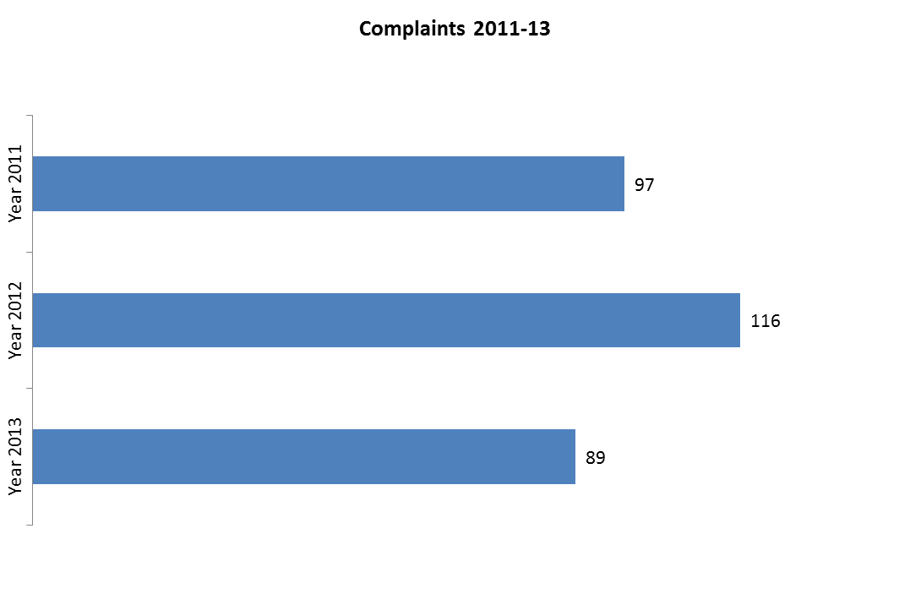
Main complaint areas
 | AUSTRIA Total | 89
Internal market | (free provision of services, free movement of professionals and public procurement) | 23
Environment | (nature protection, environmental impact assessment, access to justice) | 17
Taxation | (customs tariff classification) | 10
Other | (Schengen Borders Code, data protection and free movement of people, free movement of workers in public service, distance sale of tobacco products and discriminatory road tolls) | 39

IV. EU Pilot

1. Progress of files relating to Austria open in EU Pilot

54 New EU Pilot files during 2013
Transport 12
Environment 10
Internal market 7
Other 25
Average EU Pilot response
65 | days in 2013
62 | days in 2012
77 | days in 2011
V. Early resolution of infringement cases
The cases closed without a Court judgment in 2013 related to:
- differences in the payment frequency of family benefit top-up for EU workers residing in another Member States compared to the payment of national family benefits;
- the transposition of the directive on occupational exposure limit values for certain chemical agents;
- parts of the education sector that were excluded from the scope of national measures implementing two directives on health and safety at work;
- the construction of an emergency escape route for the Pitztaler Gletscher ski resort without environmental impact assessment;
- Austria's failure to ratify the 2001 International Convention on Civil Liability for Bunker Oil Pollution Damage.

VI. Important judgments
In a case concerning the First Railway Package, the Court ruled that:
- Austria complied with existing rail legislation as regards the level of independence required for an infrastructure manager in a holding company structure.

In preliminary rulings addressed to the Austrian judiciary, the Court ruled that:
- the free movement of workers prohibits employee promotion rules that take full account of service periods completed with the promoting organisation, but only partial account of the service periods complete elsewhere;
- asylum applications should be handled by the Member State through which the asylum seeker first enters the EU, as provided for in the Dublin II Regulation, except where systemic flaws in asylum procedures and the reception conditions in that Member State would put the applicant at real risk of inhuman or degrading treatment, as defined in the Charter of Fundamental Rights;
- national legislation cannot automatically bar (i.e. without examining the burden to the national social assistance system and the claimant's personal circumstances) the granting of a social benefit to a national of another Member State, even if this person is not economically active and not legally entitled to reside in the host Member State owing their claim for that social benefit;
- the indiscriminate collection of a private copying levy on the first sale of recording media (such as blank CDs) may be compatible with the Copyright Directive provided that, where the end use does not justify such a levy, the refund procedure is effective and not overly complex;
- the environmental impact assessment (EIA) does not assess the effects of a project on material assets, but does financial damage, does fall within the EIA Directive's protection remit if it is the direct result of the project's environmental effects. While failure to carry out an EIA does not give an individual the right to claim financial damages based on a decrease in value of property, , a national court can still establish a link between the failure and the damage, making a claim possible under EU compensation law;
- Member States' discretion is limited when defining whether certain projects should be subject to an EIA. Thus, even if overly high national thresholds mean that certain projects are effectively exempt from the EIA, national authorities must still ensure it is carried out as certain provisions in the EIA Directive have direct effect in all Member States.

BELGIUM

I. General statistics
1. Open infringement cases against Belgium (2009–13, on 31 December 2013)

2. Ranking in the EU-28 and reference group
3. 75 infringement cases against Belgium
4. Referrals to the Court and key infringement cases
(a) There were 40 new infringement procedures launched against Belgium in 2013. They and other major ongoing infringement cases relate to:
- the independence of the national regulatory authority under the Framework Directive on Electronic Communications;
- limited access for non-Belgian residents to certain courses of higher education in medicine (the procedure has been suspended until the end of 2016 to allow Belgium to prove that the restrictive measures are necessary and proportionate to protect the Belgian healthcare system);
- the non-respect of EU air quality (Particulate Matter₁₀) limit values in several zones and agglomerations;
- the issue of visas and residence cards for non-EU family members of EU citizens and safeguards against the expulsion of EU citizens;
- the lack of transparency of the Belgian legal framework for gambling, especially the restrictions on the provision of online gambling (e.g. requiring a physical presence);
- deficiencies in implementing the directive on protecting pigs, which requires keeping sows in groups during part of their pregnancy;
- the tax reduction for loans from residents of Flanders to businesses established in the region (not available to non-residents who receive their income in Belgium).

(b) Six cases were referred to the Court under Article 258 TFEU. They relate to:
- the lack of adequate urban waste water treatment in small agglomerations;
- failure to bring Belgian law into line with EU rules on customs opening hours and administrative fees;
- discriminatory inheritance tax provisions in Walloon law (discouraging Belgian residents from investing in foreign shares because their inheritance might be more heavily taxed);
- proof of language knowledge for access to employment in local administration: only certificates issued by the Belgian government recruitment service are accepted as proof of language knowledge;
- higher taxation of interests paid to foreign investment funds;
- refusal by Belgium to apply tax exemptions granted to Union institutions.

(c) Cases referred to the Court under Article 260(2) TFEU

- none in 2013

II. Transposition of directives
1. New late transposition infringement cases
2. Ranking in the EU-28 and reference group

3. Policy areas in which most new late transposition infringement cases were opened
23 late transposition cases against Belgium
Energy | 4
Environment | 4
Other | 15

4. Court referrals under Articles 258/260(3) TFEU
- partial transposition of the directive on investigating maritime accidents, which had to be transposed by 17 June 2011;
- failure to transpose the directive on intelligent transport systems, which had to be transposed by 27 February 2012;
- failure to transpose the directive adapting the legislation on inland transport of dangerous goods to scientific and technical progress, which had to be transposed by 30 June 2014;

III. Complaints
1. Complaints made against Belgium
Main complaint areas
BELGIUM Total |  | 89
Taxation | (customs representation) | 26
Justice | (free movement of persons) | 21
Enterprise and industry | (especially car registration) | 10
Other | (airport charges, posting of workers, waste management, nitrates' pollution) | 32

IV. EU Pilot
1. Progress of files relating to Belgium open in EU Pilot

61 New EU Pilot files during 2013
Transport 11
Justice 10
Employment 7
Internal market 7
Other 26
Average EU Pilot response
65 days in 2013
75 days in 2012
71 days in 2011

V. Early resolution of infringement cases

The cases closed without a Court judgment in 2013 related to:
- the partial transposition of the directives on transferring defence products, minimum sanctions and measures against employers of illegally staying third-country nationals, transporting dangerous goods, investigating maritime accidents and state control of ports;
- bad application of the Environmental Impact Assessment Directive;
- the non-ratification by Belgium of the EU-Western Balkans Aviation Agreement.

VI. Important judgments
The Court ruled that:
- Belgium failed to comply with a previous judgment that Belgium had infringed several provisions of the Urban Waste Water Treatment Directive. It has ordered Belgium to pay a lump sum of € 10 million and a penalty payment of € 4 722 euro per day .
In preliminary rulings addressed to the Belgian judiciary, the Court ruled that:
- EU rules on the free movement of workers preclude the obligatory use of Dutch in cross-border employment contracts;under the Data Protection Directive, Member States are not obliged to transpose into national law one or more of the exceptions the directive makes to the obligation to inform data subjects of the use of their personal data. They can do so if they wish however.

BULGARIA

I. General statistics
1. Open infringement cases against Bulgaria (2009-13)
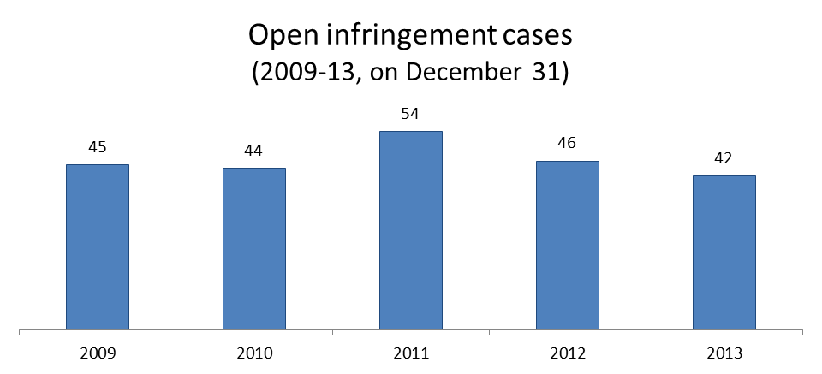

2. Ranking in the EU-28 and reference group
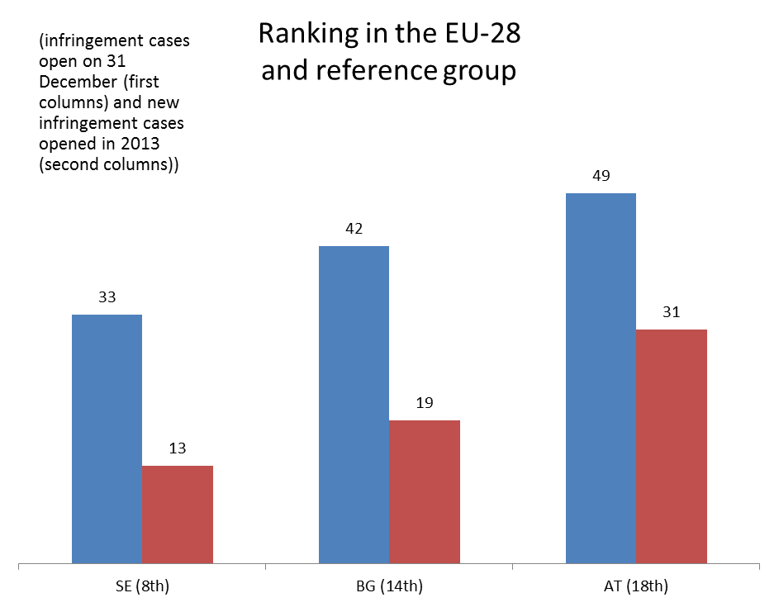

3. 42 infringement cases against Bulgaria
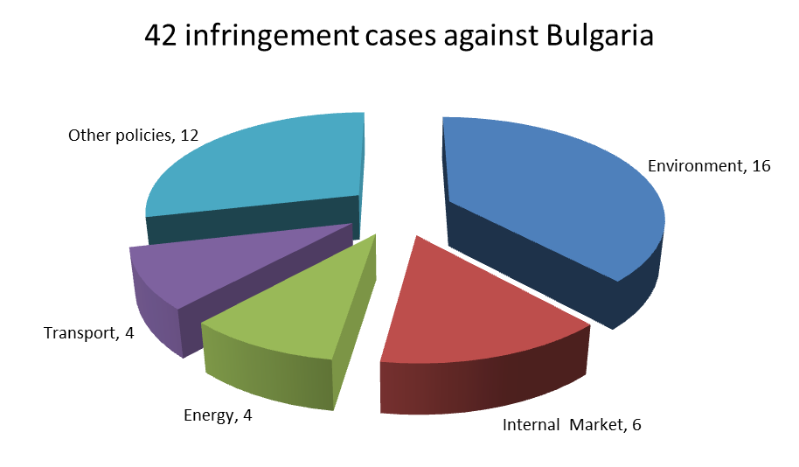
4. Referrals to the Court and key infringement cases
(a) 19 new infringement procedures were launched against Bulgaria in 2013. They and other major ongoing infringement cases relate to:
- the compatibility of the working conditions of employees at the Ministry of the Interior with the Working Time Directive;
- Bulgaria’s failure to notify the Commission of measures to transpose the directive on alternative investment fund managers;
- values for the PM₁₀ exceeding the limit in certain zones and agglomerations (air quality);
- transposition of the Railway Safety Directive, including the definition of ‘railway undertaking’, the rules relating to the safety authority and safety management systems.
(b) Three cases were referred to the Court under Article 258 TFEU. They relate to:
- the assignment of digital terrestrial broadcast spectrum. The Commission argues that in Bulgaria the reallocation of radio spectrums in the transition from analogue to digital broadcasting was disproportionately restrictive;
- the insufficient designation of a large part of the Important Bird Area 'Kaliakra' as a special protection area under the Birds Directive. Numerous economic projects (including wind turbines and golf courses) were authorized in the Kaliakra region which has allowed the destruction or deterioration of priority natural habitat (Habitats Directive) and endangered bird species under the Birds Directive (the region being an important migratory route and resting, feeding and nesting place for those species), without adequate assessments of their cumulative environmental effects (the Environmental Impact Assessment Directive);
- a technical assistance agreement between Bulgaria and the US which goes beyond the permissible privileges that may be afforded to commodities imported by organisations that are set up in the framework of international cultural, scientific or technical cooperation agreements with third countries.
(c) Cases referred to the Court under Article 260(2) TFEU:
- none in 2013

II. Transposition of directives

1. New late transposition infringement cases
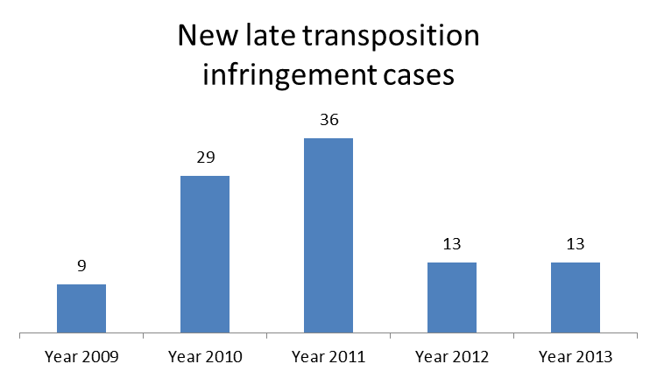

2. Ranking in the EU-28 and reference group
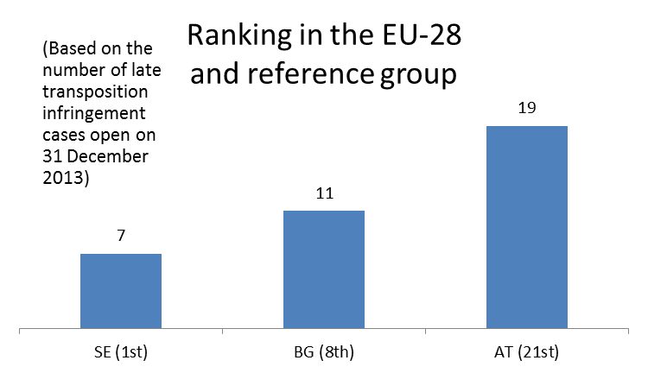

3. Policy areas in which most new late transposition infringement cases were opened

11 late transposition cases against Bulgaria
Energy 2
Environment 2
Internal market 2
Health & consumers 2
Other 3

4. Court referrals under Articles 258/260(3) TFEU:
- Bulgaria’s s failure to fully transpose the EU internal energy market rules. Bulgaria has only partially transposed the Electricity and Gas Directives. The Commission asked the Court to impose a daily penalty in respect of each partially transposed directive.

III. Complaints
1. Complaints made against Bulgaria
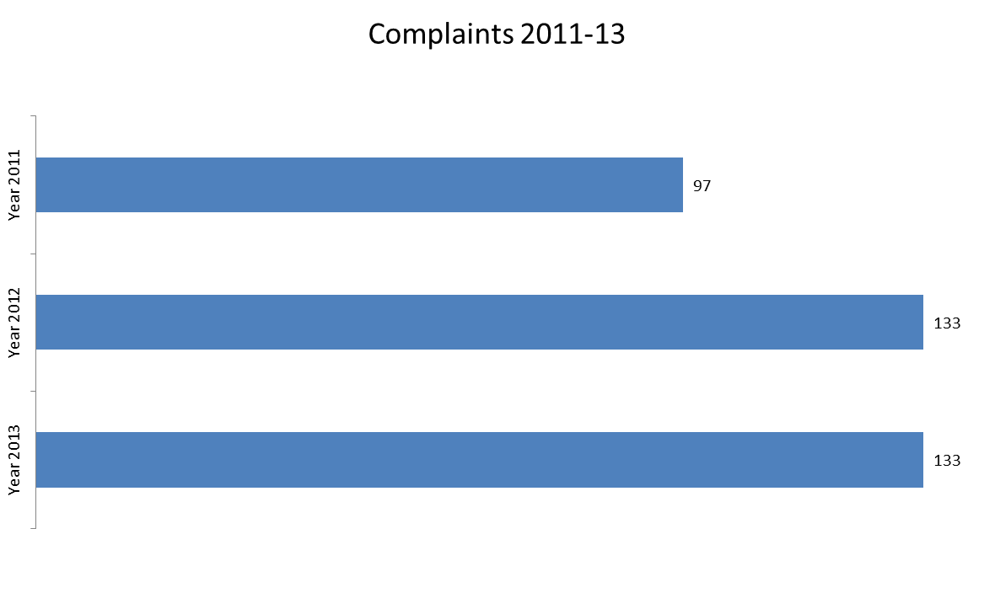
Main complaint areas
BULGARIA Total 133
Internal market | (online gambling, public procurement and free movement of services) | 24
Justice | (free movement of people and fundamental rights) | 21
Taxation | (deduction of value added tax) | 17
Other | (rural development, renewable energy, energy metering and billing, asylum and food safety) | 71

IV. EU Pilot

1. Progress of files relating to Bulgaria open in EU Pilot
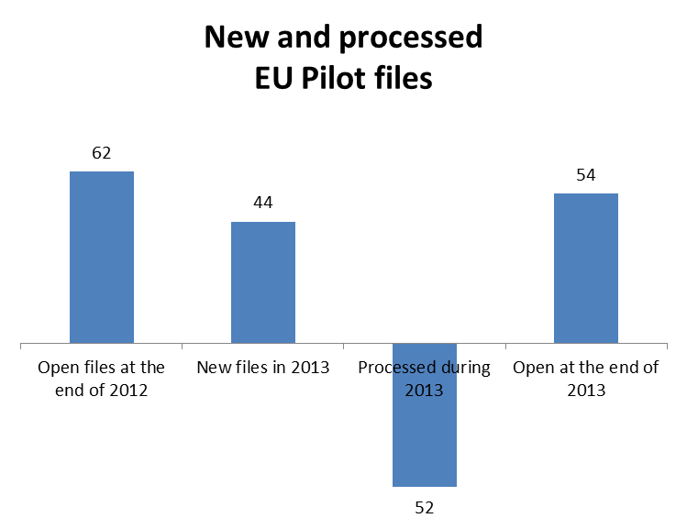
44 New EU Pilot files during 2013
Transport 12
Environment 10
Internal market 7
Other 25
Average EU Pilot response
59 days in 2013
68 days in 2012
67 days in 2011

V. Early resolution of infringement cases

The cases closed without a Court judgment in 2013 related to:
- EU rules governing citizens’ participation (as voters or candidates) in the European Parliament or municipal elections;
- full transposition of the Electricity and Gas Directives;
- the mandatory customs declaration requirement for jewels, precious stones and metals;
- the marketing rules for hearing devices;
- manufacturing practices for medicinal products for veterinary use.

VI. Important judgment

In preliminary rulings addressed to the Bulgarian judiciary concerning rural development , the Court ruled that:
- there is no contradiction with EU law if all disputes arising from decisions made by the national authority dealing with agricultural support under the Common Agricultural Policy are heard by a single court, and if the procedures that safeguard individuals’ rights under EU law are conducted at least under the same conditions as those available under national aid schemes, and that such procedural rules do not make exercising these rights under EU law excessively difficult;
- the national court must assess if a project can objectively achieve one of the aims of the European Agricultural Fund for Rural Development (EAFRD) and if artificially creating conditions exclusively for the purposes of receiving payment from the EAFRD would compromise the achievement of this goal. However, an applicant cannot be rejected merely on the grounds that applicants for an investment project are not functionally independent from each other or that they are legally linked.

CROATIA

I. General statistics

There were four infringement procedures launched against Croatia in 2013, all of them for late transposition of directives relating to:
- the management of spent nuclear fuel and radioactive waste;
- the restriction on using certain hazardous substances in electrical and electronic equipment;
- the lead and cadmium content of electrical and electronic equipment.

II. Complaints

Complaints made against Croatia in 2013 related to alleged discrimination on grounds of residence as regards access to recreational fisheries.

III. EU Pilot

At the end of 2013, the Commission and Croatia were working on 13 open files in EU Pilot (18 new EU Pilot files were opened since 1 July 2013). The Commission processed five EU Pilot files on Croatian issues in 2013. Croatia’s average response time (61 days) met the 10-week target.

CYPRUS

I. General statistics
1. Open infringement cases against Cyprus (2009-13, on 31December 2013)

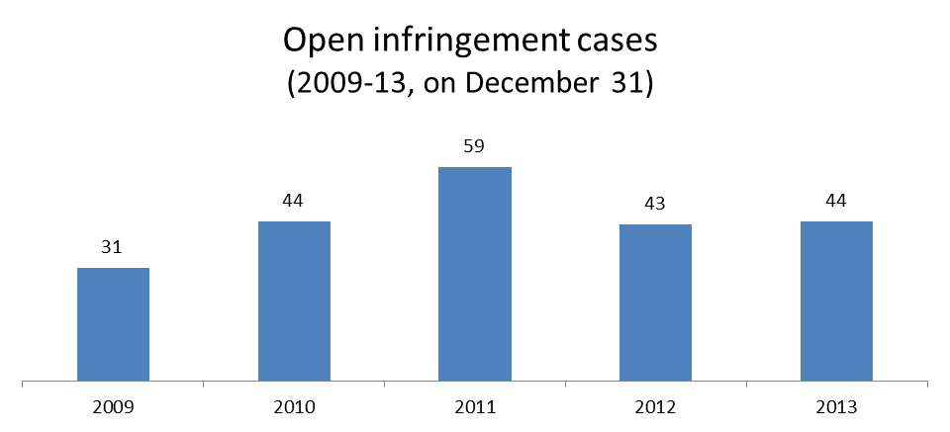

2. Ranking in the EU-28 and reference group

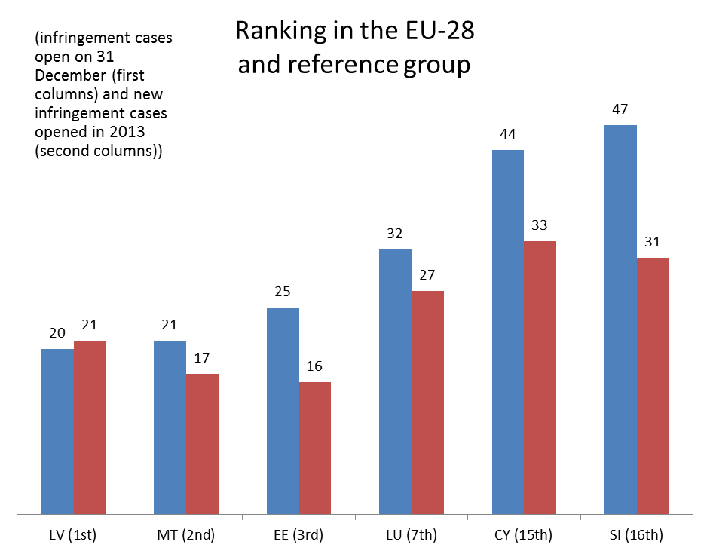

3. 44 infringement cases against Cyprus
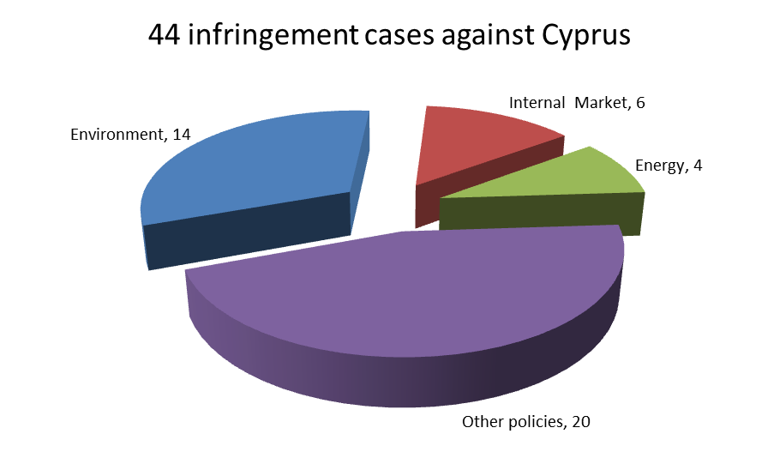
4. Referrals to the Court and key infringement cases
(a) 33 new infringement procedures were launched against Cyprus in 2013. These and other major ongoing infringement cases relate to:
- Cyprus’ failure to notify the Commission of measures to transpose: three directives in the automotive sector; the directive on preventing trafficking in human beings; and the Postal Services Directive;
- the incorrect application of the Unfair Commercial Practices Directive and the directive on unfair terms in consumer contracts in relation to the purchase of immovable property;
- restrictions on the provision of online gambling services (which were made subject to physical presence in the recipient Member State) and the failure to ensure equal treatment of gambling service providers;
- non-compliance with the Single European Sky provisions that require full implementation of Functional Airspace Blocks (FABs);
- the incorrect implementation of EU legislation concerning the welfare of animals, which requires that sows are kept in groups during part of their pregnancy;
- delays in VAT refunding;
- the refusal to take into account periods that Cypriot teachers spent working in Greece when calculating and granting pension entitlements, and the refusal to grant partial pensions to teachers who have worked in Greece and Cyprus;
- the insufficient designation of special protection areas for birds;
- the violation of the rules on free movement of persons as regards registration of EU citizens, fees for obtaining permanent residence certificates, and deadlines for issuing residence cards for third-country family members of EU citizens.

(b) One case was referred to the Court under Article 258 TFEU. It relates to:
- the application of discriminatory conditions to the pension rights and unpaid leave rights of Cypriot civil servants working in another Member State – this is in breach of EU rules on the free movement of workers.

(c) Cases referred to the Court under Article 260(2) TFEU:
- none in 2013

II. Transposition of directives

1. New late transposition infringement cases

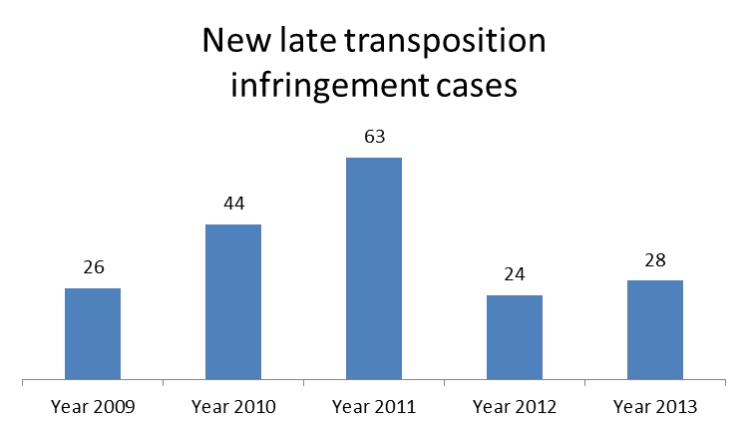
2. Ranking in the EU-28 and reference group

3. Policy areas in which most new late transposition infringement cases were opened

27 late transposition cases against Cyprus
Environment 8
Internal market 5
Other 14

4. Court referrals under Articles 258/260(3) TFEU
- failure to transpose the Renewable Energy Directive, which had to be transposed by 5 December 2010.

III. Complaints

1. Complaints made against Cyprus

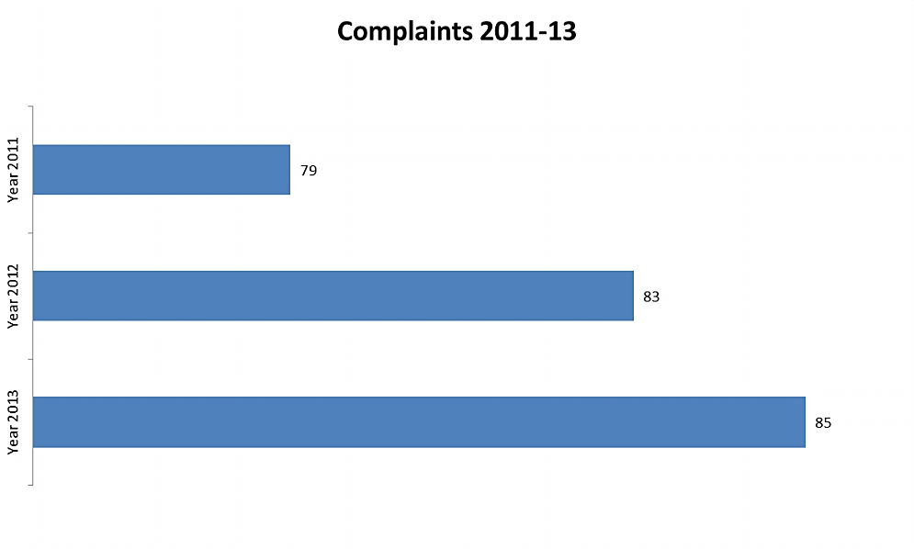

Main complaint areas

CYPRUS Total 85
Justice | (free movement of people) | 26
Internal market | (professional qualifications, public procurement, gambling and patents & industrial property) | 14
Environment | (nature protection, environmental impact assessment and waste management) | 13
Other | (residence requirement for jobseekers, fees for long-term residence permits, asylum and car taxation) | 32

IV. EU Pilot

1. Progress of files relating to Cyprus open in EU Pilot

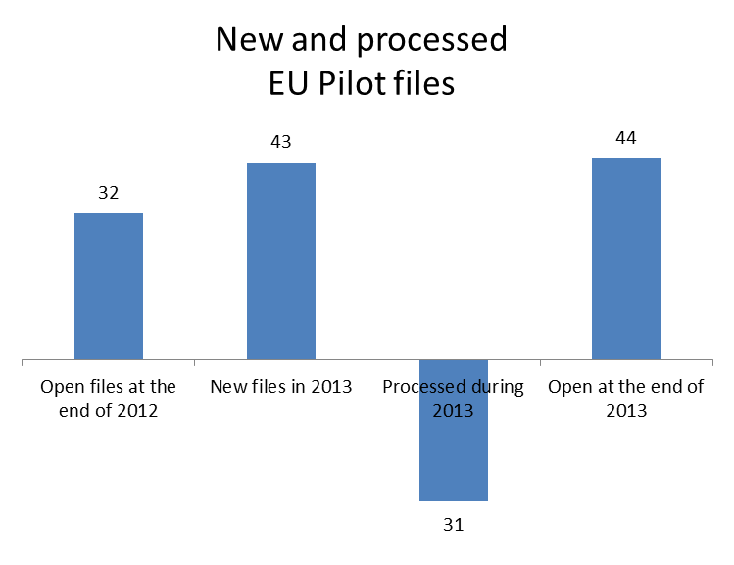

43 New EU Pilot files during 2013
Transport 11
Environment 9
Internal market 5
Other 18
Average EU Pilot response
66 days in 2013
60 days in 2012
70 days in 2011

V. Early resolution of infringement cases

The cases closed without a Court judgment in 2013 related to:
- Cyprus’ failure to notify the Commission of measures to transpose the directives on road intelligent transport systems and driving licences;
- the incorrect transposition of the directive on public participation in the drawing up of certain plans and programmes relating to the environment (national legislation restricts access to justice for certain NGOs);
- failure to implement the ban on using unenriched cages for laying hens;
- discriminatory taxation rules applied to the registration of second-hand cars brought into Cyprus from other EU Member States.

VI. Important judgments
The Court ruled that:
- Cyprus failed to fulfil its obligations under the Landfill Directive. Not all sites of uncontrolled landfill of waste operating on its territory have been decommissioned or rendered compliant with the directive’s requirements.

CZECH REPUBLIC

I. General statistics
1. Open infringement cases against the Czech Republic (2009-13, on 31December 2013)

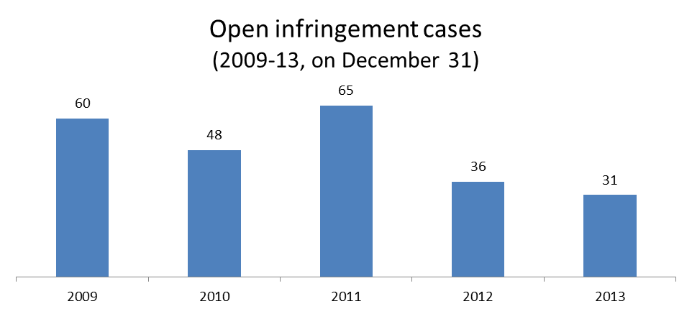

2. Ranking in the EU-28 and reference group

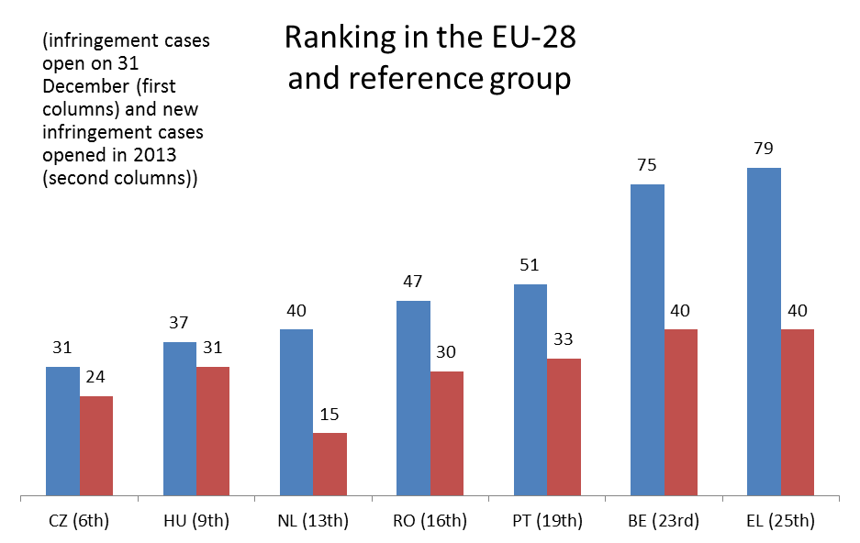

3. 31 infringement cases against the Czech Republic
II. Referrals to the Court and key infringement cases
(a) 24 new infringement procedures were launched against the Czech Republic in 2013. They and other major ongoing infringements relate to:
- the requirement that bottles of wine produced for domestic consumption be labelled with a list of ingredients in Czech;
- the Czech Republic's failure to apply the mutual recognition of hallmarks issued in other Member States;
- the Environmental Impact Assessment Directive and the limit values for PM₁₀ laid down in EU air quality legislation;
- the extension of air carriers' liability relating to intra-Schengen flights;
- the right to appeal against a decision taken on the refusal, annulment and revocation under the Visa Code;
- online gambling services;
- aviation security.

(b) Cases referred to the Court under Article 258 TFEU:
- none in 2013

(c) Cases referred to the Court under Article 260(2) TFEU:
- none in 2013

III. Transposition of directives

1. New late transposition infringement cases
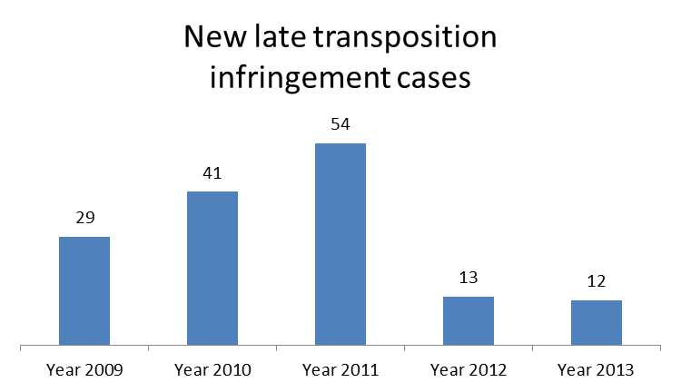

2. Ranking in the EU-28 and reference group
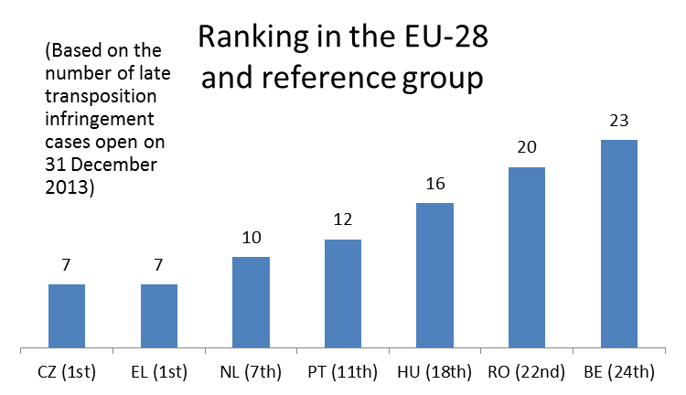

3. Policy areas in which most new late transposition infringement cases were opened
7 late transposition cases against Czech Republic
Energy 3
Environment 2
Other 2

4. Court referrals under Articles 258/260(3) TFEU:
- none in 2013

IV. Complaints

1. Complaints made against the Czech Republic
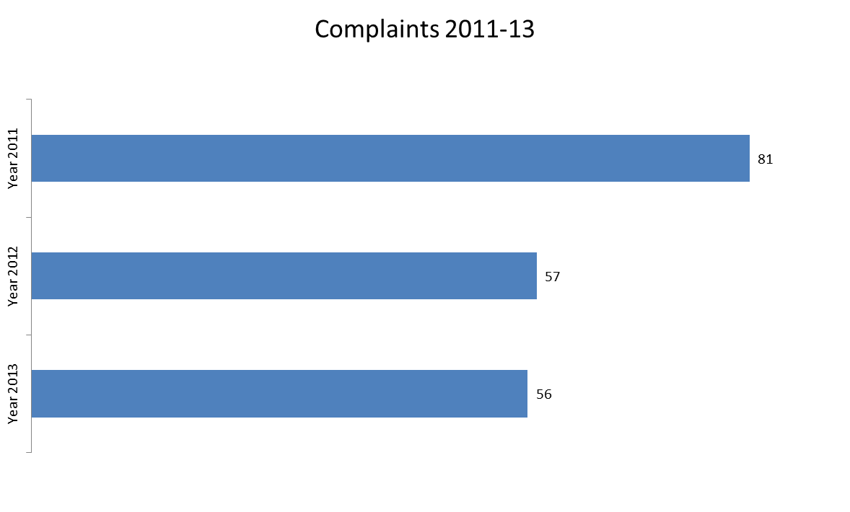
Main complaint areas
CZECH REPUBLIC Total |  | 56
Justice | (fundamental rights) | 14
Environment | (environmental impact assessment and waste management) | 12
Regional policy | (cohesion policy) | 9
Other | (wines' product labelling, authorisations and establishment requirements in electronic communications, support schemes for renewable energy, carriers' liability on intra-Schengen flights) | 21

V. EU Pilot

1. Progress of files relating to the Czech Republic open in EU Pilot

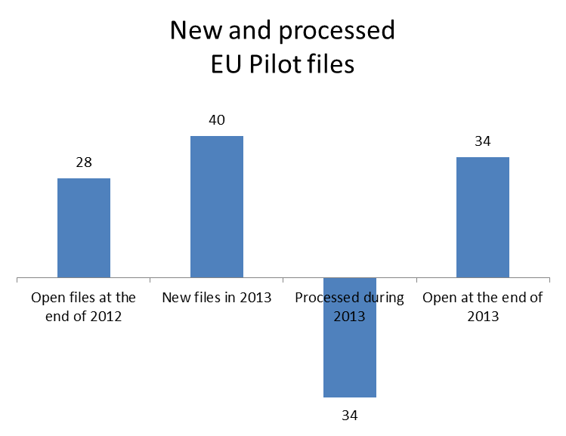

40 New EU Pilot files during 2013
Transport 11
Environment 9
Justice 8
Other 12
Average EU Pilot response
75 days in 2013
71 days in 2012
72 days in 2011

VI. Early resolution of infringement cases

The cases closed without a Court judgment in 2013 related to:
- the directive on preventing sharp injuries in the hospital and healthcare sector;
- the directive on combating late payment in commercial transactions;
- Sumava National Park's visitor code (it is a Natura 2000 site);
- the Czech Republic's failure to ratify the 2001 International Convention on Civil Liability for Bunker Oil Pollution Damage;
- the Czech Republic's failure to apply the Drivers' Working Time Directive to self-employed drivers.

VII. Important judgments
Court rulings made against the Czech Republic related to:
- the Czech Republic's failure to comply with the Court's earlier judgement on transposing the directive on the institutions for occupational retirement, where a lump sum payment of € 250,000 was ordered;
- the incorrect implementation of one of the directive in the EU's First Railway Package. The Czech Republic restricted the independence of the railway infrastructure manager; continued to operate a funding system that does not provide an incentive to the reduce infrastructure costs and access charges; and put in place incoherent and non-transparent rules that do not encourage fewer disruptions and better performance.

In preliminary rulings to the Czech judiciary, the Court ruled that:
- Czech national rules were incompatible with EU law in defining "normal retirement age" for receiving support from the EAGGF, as the Czech retirement age differs depending on gender and, for women, on the number children raised;
- asylum seekers cannot be considered as staying illegally in the territory of a Member State so they should benefit from the right to move freely. However, their detention may be maintained if the asylum application was made solely in order to delay or jeopardise an earlier decision to return that person to a third country.

DENMARK

I. General statistics
1. Open infringement cases against Denmark (2009-13, on 31December 2013)

2. Ranking in the EU-28 and reference group

3. 30 infringement cases against Denmark

4. Referrals to the Court and key infringement cases
(a) 21 new infringement procedures were launched against Denmark in 2013. They and other major ongoing infringement cases relate to:
- the compatibility of Danish national law with the directive on competition in the markets for electronic communications, networks and services; Denmark had introduced mandatory membership for households to local Danish cable associations;
- the incompatibility of the National Holiday Act with the Working Time Directive; the National Holiday Act makes it possible to defer annual leave by one year;
- Denmark’s failure to correctly implement the regulation concerning the rights of bus and coach passengers;
- Denmark’s incorrect application of the directive laying down minimum standards for the protection of pigs, which requires that sows are kept in groups during a part of their pregnancy;
- a case in which public school teachers working part-time were excluded from a number of benefits that full-time employees received. The directive on part-time work requires the equal treatment of part-time staff and permanent staff doing similar work;
- Denmark’s lack of river basin management plans, which are required under the Water Framework Directive;
- the compatibility of Danish taxation rules for foreign investment funds with the freedom to provide services and the free movement of capital as set out in the EU Treaties. In Denmark, dividends distributed to funds registered as ‘investment institutes with minimum taxation’ are exempt from tax, but only if the institute is Danish. The Danish tax rules discriminate against ‘investment institutes with minimum taxation’ from other Member States.
(b) Cases referred to the Court under Article 258 TFEU:
- none in 2013
(c) Cases referred to the Court under Article 260(2) TFEU:
- none in 2013

II. Transposition of directives

1. New late transposition infringement cases
2. Ranking in the EU and reference group
3. Policy areas in which most new late transposition infringement cases were opened
9 late transposition cases against Denmark
Environment 3
Internal market 3
Other 3

4. Court referrals under Articles 258/260(3) TFEU:
- none in 2013

III. Complaints
1. Complaints made against Denmark
Main complaint areas
DENMARK Total 57
Taxation | (charges having an equivalent effect to customs, discriminatory taxation of self-employed businesses registered in other Member States) | 12
Employment | (social security coverage, posted workers and family benefits to migrant workers) | 11
Environment | (water protection and nature protection) | 9
Other | (transport fares for students and access to education) | 25

IV. EU Pilot

1. Progress of files relating to Denmark in EU Pilot

47 New EU Pilot files during 2013
Transport 17
Taxation 6
Justice 5
Other 19
Average EU Pilot response
69 days in 2013
70 days in 2012
81 days in 2011

V. Early resolution of infringement cases

The cases closed without a Court judgment in 2013 covered:
- the incorrect transposition of the Habitats Directive;
- the incorrect transposition of the Bathing Water Directive.

VI. Important judgments

In preliminary rulings addressed to the Danish judiciary, the Court ruled that:
- an EU citizen working while studying in a Member State is entitled to receive the same amount of financial aid for studies that is granted to the nationals of that Member State;
- in certain circumstances, a disability can include incurable or curable long-term illnesses caused by a psychical, mental or psychological limitation. In such cases, the employer must offer a reduction in working hours to enable the person with a disability to work.

ESTONIA

I. General statistics
1. Open infringement cases against Estonia (2009-13, on 31December 2013)

2. Ranking in the EU-28 and reference group
3. 25 infringement cases against Estonia
4. Referrals to the Court and key infringement cases
(a) 16 new infringement procedures were launched against Estonia in 2013. They and other major ongoing infringement cases relate to:
- the incorrect transposition of the INSPIRE Directive;
- failure to correctly implement the right to appeal against a visa refusal, annulment or revocation in accordance with the provisions of the Visa Code;
- failure to transpose the Directive on Alternative Investment Fund Managers within the timeframe allowed;
- incorrect transposition of the Railway Safety Directive;
- failure to grant tax-exempt allowances in respect of the pension income of non-residents with very low worldwide total taxable income.
(b) One case was referred to the Court under Article 258 TFEU. It relates to:
- the independence of the national telecoms regulator. Estonian law is not in line with EU legislation on telecoms, which stipulates that national authorities acting as regulators cannot at the same time be involved in the ownership or control of telecoms companies.
(c) Cases referred to the Court under Article 260(2) TFEU:
  - none in 2013
II. Transposition of directives

1. New late transposition infringement cases
2. Ranking in the EU-28 and reference group

3. Policy areas in which most new late transposition infringement cases were opened
14 late transposition cases against Estonia
Energy 4
Environment 4
Other 6

4. Court referrals under Articles 258/260(3) TFEU:
- Estonia’s failure to fully transpose the EU internal energy market rules. Estonia has only partially transposed the Electricity and Gas Directives. Some provisions, for example relating to consumer protection and the independence of the regulatory authority, have not been transposed. The Commission asked the Court to impose daily penalties in respect of each partially transposed directive.

III. Complaints

1. Complaints made against Estonia
Main complaint areas
ESTONIA Total 14
Taxation | (rules on VAT and property taxation) | 3
Health and consumers | (e.g. stud-books for horses) | 2
Home affairs | (Schengen Borders Code) | 2
Other | (waste management, end-of-life vehicles and packaging) | 7

IV. EU Pilot

1. Progress of files relating to Estonia open in EU Pilot

27 New EU Pilot files during 2013
Transport 7
Environment 4
Justice 4
Other 12
Average EU Pilot response
68 days in 2013
67 days in 2012
72 days in 2011

V. Early resolution of infringement cases
The cases closed without a Court judgment in 2013 related to:
- the incorrect transposition of the Batteries Directive and of the directives in the First Railway Package.
VI. Important judgments
In preliminary rulings addressed to the Estonian judiciary, the Court ruled that:
- the concept of proximity and self-sufficiency in relation to the management of municipal waste. A local authority can require the authority responsible for the collection of waste on its territory to transport mixed municipal waste collected from private households to the nearest appropriate treatment facility. The local authority cannot however impose similar obligations on the authority in respect of industrial and building waste if the producers of that waste are themselves required to deliver the waste either to the authority or directly to the facility.

FINLAND

I. General statistics
1. Open infringement cases against Finland (2009-13, on 31December 2013)

2. Ranking in the EU-28 and reference group

3. 39 infringement cases against Finland

4. Referrals to the Court and key infringement cases
(a) 23 new infringement procedures were launched against Finland in 2013. They and other major ongoing infringement cases relate to:
- the conditions for receiving unemployment benefits in Finland;
- the protection of pensions financed through book reserves in case of the insolvency of the employer;
- the lack of timely transposition of the Laboratory Animals Directive within the allowed timeframe;
- the lack of timely transposition of the Industrial Emissions Directive within the allowed timeframe;
- the national equality body, which provides assistance to victims of discrimination. This body has not been designated as competent for all of the tasks set out in the Racial Equility Directive;
- the lack of timely transposition of the Directive on Alternative Investment Fund Managers which expired on 22 July 2013.

(b) Two cases were referred to the Court under Article 258 TFEU. They relate to:
- the discriminatory conditions applied in determining unemployment benefits;
- transposition of requirements relating to maximum working hours for self-employed drivers.

(c) Cases referred to the Court under Article 260(2) TFEU:
- none in 2013

II. Transposition of directives

1. New late transposition infringement cases

2. Ranking in the EU-28 and reference group

3. Policy areas in which most new late transposition infringement cases were opened
17 late transposition cases against Finland
Environment 7
Other 10

4. Court referrals under Articles 258/260(3) TFEU:
- none in 2013

III. Complaints

1. Complaints made against Finland

Main complaint areas
FINLAND Total 66
Taxation | (e.g. access household tax credit) | 15
Internal market | (professional qualifications, free movement of capital) | 12
Environment | (nature protection and waste management) | 11
Other | (marketing of spirits, language of instruction in education institutions) | 28

IV. EU Pilot

1. Progress of files relating to Finland open in EU Pilot

Average EU Pilot response
65 days in 2013
66 days in 2012
80 days in 2011
38 New EU Pilot files during 2013
Transport 8
Taxation 8
Justice | 5
Other | 17

V. Early resolution of infringement cases

The cases closed without a Court judgement in 2013 related to:
- gambling services and the compliance with Union law of the national provisions establishing exclusive rights to provide gambling services;
- failure to transpose the directives on road intelligent transport systems, on organisation of the working time of self-employed drivers, on roadworthiness tests for motor vehicles, on insurance of ship-owners and on maritime traffic monitoring and on minimum standards on sanctions and measures against employers of illegally staying third-country nationals;
- full transposition of the Electricity and Gas Directives.

VI. Important judgments

The Court ruled that:
- Finland had restricted the free movement of capital in a case concerning capital gains arising from the sale of real estate. Finnish law does not allow losses made from the sale of real estate in another Member State to be offset against gains taxable in Finland. Nonetheless, this restriction was deemed to be justified, in particular in order to ensure a balanced allocation of taxing rights between Member States.

In preliminary rulings addressed to the Finnish judiciary, the Court ruled that:
- in the area of chemical substances, Member States cannot, in principle, subject the manufacture, placing on the market or use of a substance referred to in Annex XVII to the REACH Regulation to conditions other than those laid down by the this regulation. If a Member State intends to impose stricter conditions for a substance restricted in Annex XVII to REACH, it may do so only in order to respond to an urgent situation to protect human health or the environment in accordance with the relevant safeguarded clause given in Article 129 of the REACH Regulation, or on the basis of new scientific evidence in accordance with Article 114(5) of the TFEU.

IP/12/1388
Directive 2010/32/EU
Directive 2011/36/EU
Directive 2011/61/EU
Directive 2002/15/EC
IP/13/142. The case had been subsequently withdrawn from the Court due to Austria's compliance.
Directive 2009/28/EC; IP/13/1113 and Commission v Austria, C-663/13
Directive 2009/161/EU
Directives 89/391/EEC and 89/654/EEC
A brief description may be found here.
Directive 91/440/EEC, Commission v Austria, C-555/10 and IP/13/176
Zentralbetriebsrat der gemeinnützigen Salzburger Landeskliniken Betriebs GmbH, C-514/12
Regulation (EC) No 343/2003, repealed by Regulation (EU) No 604/2013
Abdullahi, C-394/12
Brey, C-140/12
Directive 2001/29/EC
Amazon.com International Sales and Others, C-521/11
Directive 2011/92/EU
Leth, C-420/11
Salzburger Flughafen, C-244/12
Directive 2002/21/EC
IP/12/1388
IP/13/47
MEMO/13/122
IP/13/1101
Directive 2008/120/EC
IP/13/135
MEMO/13/122
IP/13/251
IP/13/1104
IP/13/871, IP/12/408
IP/13/868
IP/13/1105
IP/13/952
Directive 2009/18/EC, IP/13/560
Directive 2010/40/EU, IP/13/561
Directive 2008/68/EC
IP/13/256
Directive 2009/43/EC
Directive 2009/52/EC
Directive 2010/61/EU
Directive 2009/18/EC
Directive 2009/16/EC
Directive 95/377/ECC as amended, now codified in Directive 2011/92/EU
Commission v Belgium, C-27/03
Commission v Belgium, C-533/11 and Court press release No 133/13
Las, C-202/11
Directive 95/046/EC
IPI, C-473/12
Directive 2003/88/EC
Directive 2011/61/EU
PM₁₀ is 'an air pollutant consisting of small particles with an aerodynamic diameter less than or equal to a nominal 10 micrometer. Their small size allows them to make their way to the air passages deep within the lungs where they may be deposited and result in adverse health effects' (Source: the European Environmental Agency).
IP/13/47
Directive 2004/49/EC
IP/13/46
Directive 2009/147/EC
Directive 92/43/EEC
Directive 2011/92/EC
IP/13/966
IP/13/573
Directive 2009/72/EC and Directive 2009/73/EC
IP/13/42. The Commission withdrew the Court application in 2013, following Bulgaria’s compliance with the directives’ requirements.
IP/13/874
Directive 2009/72/EC and Directive 2009/73/EC
Agrokonsulting-04, C-93/12
Slancheva sila, C-434/12
Directive 2011/70/EURATOM
Directive 2011/65/EU
Directives 2012/50/EU (on lead) and 2012/51/EU (on cadmium), both amending Directive 2011/65/EU. These two cases were closed in 2013 following Croatia's transposition.
Directives 2011/87/EU, 2012/24/EU and 2013/15/EU
Directive 2011/36/EU and MEMO/13/1005
Directive 2008/6/EC
Directive 2005/29/EC
Directive 93/13/EEC
IP/13/1101
IP/13/860
Directive 2008/120/EC and IP/13/135
MEMO/13/375
MEMO/13/122
MEMO/13/583
IP/13/869
Directive 2009/28/EC and IP/13/259. Subsequently Cyprus achieved full transposition and the Commission withdrew the Court application.
Directive 2010/40/EU
Directive 2006/126/EC
Directive 2003/35/EC and MEMO/13/375
In accordance with Directive 1999/74/EC
Directive 1999/31/EC
Commission v Cyprus, C-412/12
MEMO/13/470
Directive 2011/92/EU
PM₁₀ is 'an air pollutant consisting of small particles with an aerodynamic diameter less than or equal to a nominal 10 micrometer. Their small size allows them to make their way to the air passages deep within the lungs where they may be deposited and result in adverse health effects' (Source: the European Environmental Agency).
IP/13/47
Regulation (EC) No 810/2009
IP/13/1101
Directive 2010/32/EU
Directive 2011/7/EU
Directive 2002/15/EC
Commission v Czech Republic, C-343/08; the Court ordered only a lump sum payment as the Czech Republic complied with the first judgment during the second Court procedure.
Directive 2003/41/EC
Commission v Czech Republic, C-241/11
Directive 2001/14/EC
Commission v Czech Republic, C-545/10
The European Agricultural Guidance and Guarantee Fund
Soukupová, C-401/11
Arslan, C-534/11
Directive 2002/77/EC
Regulation (EU) No 181/2011
Directive 2008/120/EC
IP/13/135
MEMO/13/583
Directive 97/81/EC
MEMO/13/907
MEMO/13/375
Directive 92/43/EEC
Directive 2006/7/EC
N., C-46/12
HK Denmark, C-335/11 and C-337/11
Directive 2007/2/EC
Regulation (EC) No 810/2009
Directive 2011/61/EU
Directive 2004/49/EC
IP/09/1636; IP/08/1532
IP/13/480
Directive 2009/72/EC and Directive 2009/73/EC
IP/13/42. Subsequently, Estionia achieved full transposition and the Commission withdrew the Court applications.
Directive 2006/66/EC
Directive 91/440/EEC, amended by Directives 1995/18/EC and 2001/14/EC
Ragn-Sells, C-292/12
MEMO/13/470
MEMO/13/820
Directive 2010/75/EU and MEMO/13/907
Directive 2000/43/EC and MEMO 13/1005
IP/13/1107
IP/13/142
Directive 2009/52/EC and IP/13/1101
Directive 2009/72/EC and Directive 2009/73/EC
K, C-322/11
Lapin luonnonsuojelupiiri, C-358/11

