Table of Contents
LITHUANIA 103
MALTA 114
THE NETHERLANDS 120
POLAND 126
PORTUGAL 133
ROMANIA 140
SLOVAKIA 147
SLOVENIA 153
SPAIN 159
SWEDEN 167
UNITED KINGDOM 173
METHODOLOGY AND EXPLANATIONS 180

LITHUANIA

I. General statistics
1. Open infringement cases against Lithuania (2009-13, on 31December 2013)

2. Ranking in the EU-28 and reference group

3. 25 infringement cases against Lithuania
4. Referrals to the Court and key infringement cases
(a) 19 new infringement procedures were launched against Lithuania in 2013. They and other major ongoing infringement cases relate to:
- obstructions created by Lithuanian legislation impeding the sale of precious metals imported from other Member States. Hallmarks granted by other Member States are not recognised and the goods therefore have to be re-checked and stamped again in Lithuania;
- failure to transpose the Industrial Emissions Directive and the Directive on Alternative Investment Fund Managers within the timeframes allowed;
- violation of EU citizens’ right to stand as candidates in local and European elections in their Member State of residence, this being prevented by restrictions placed on their involvement in political parties;
- failure to implement the provisions contained in the Postal Services Directive;
- restrictions placed on the supply of gambling services. National law obliges businesses providing online gambling services in Lithuania to establish a physical presence in the country and prescribes a specific legal form for them;

- a breach of EU rules on the free movement of persons, specifically in relation to the safeguards preventing expulsion of EU citizens and their families;
- the incompatibility with EU law of national legislation that continues to favour incumbent cargo-handling operators by giving them a ‘priority right’ when issuing new contracts.
(b) Cases referred to the Court under Article 258 TFEU:
- none in 2013
(c) Cases referred to the Court under Article 260(2) TFEU:
- none in 2013

II. Transposition of directives
1. New late transposition infringement cases
2. Ranking in the EU-28 and reference group
3. Policy areas in which most new late transposition infringement cases were opened
14 late transposition cases against Lithuania
Energy 5
Internal market 3
Other 6

4. Court referrals under Articles 258/260(3) TFEU:
- none in 2013

III. Complaints

1. Complaints made against Lithuania
Main complaint areas
 | LITHUANIA Total | 28
Internal market | (public procurement and regulated professions) | 7
Justice | (residence permits) | 4
Electronic communications | (implementation of EU rules on emergency number 112) | 4
Other | (alcohol law, nature protection, provision of port services in Klaipėda) | 13

IV. EU Pilot
1. Progress of files relating to Lithuania open in EU Pilot
35 New EU Pilot files during 2013
Transport 8
Environment 5
Justice 4
Other 18
Average EU Pilot response
63 | days in 2013
63 | days in 2012
62 | days in 2011

V. Early resolution of infringement cases
The cases closed without a Court judgment in 2013 related to:
- directives providing minimum standards on sanctions and measures against employers of illegal third-country nationals, on the conditions of entry and residence of third-country nationals for the purposes of highly qualified employment, on driving licences and on roadworthiness tests for motor vehicles.

VI. Important judgments
There were no cases involving Lithuania in which the Court issued major judgments.
LUXEMBOURG

I. General statistics
1. Open infringement cases against Luxembourg (2009-13, on 31December 2013)

2. Ranking in the EU-28

3. 32 infringement cases against Luxembourg
4. Referrals to the Court and key infringement cases
(a) 27 new infringement procedures were launched against Luxembourg in 2013. They and other major ongoing infringement cases relate to:
- the incompatibility of Luxembourg’s Labour Code with the Fixed Term Work Directive: staff at the University of Luxembourg and in the entertainment sector are not directly informed by their employer when permanent vacancies are made available;
- the National Regulatory Authority’s failure to notify the Commission of the results of its market analysis carried out over the last five to seven year period, which is in breach of the Framework Directive on Electronic Communications Networks and Services;
- the late transposition of the Industrial Emissions Directive and of the directive preventing and combating trafficking in human beings;
- the incorrect transposition of the Railway Interoperability Directive.

(b) One case was referred to the Court under Article 258 TFEU. It relates to:
- failure to comply with the VAT Directive, by applying reduced VAT rates to e-books. The reduced rate seriously distorts competition, to the detriment of traders from other EU Member States.

(c) Cases referred to the Court under Article 260(2) TFEU:
- none in 2013

II. Transposition of directives

1. New late transposition infringement cases
2. Ranking in the EU-28 and reference group

3. Policy areas in which most new late transposition infringement cases were opened
12 late transposition cases against Luxembourg
Environment 3
Energy 2
Other 7

4. Court referrals under Articles 258/260(3) TFEU:
- none in 2013

III. Complaints

1. Complaints made against Luxembourg
Main complaint areas
 | LUXEMBOURG Total | 16
Taxation | (financial advantages to highly qualified employees and dividends paid between parent and subsidiary companies) | 5
Employment | (family benefit designed to support children of non-resident workers) | 3
Justice | (discrimination on the basis of religion, right to access to justice) | 3
Other | (discriminatory rules in sport and protection of Natura 2000 sites) | 5

IV. EU Pilot

1. Progress of files relating to Luxembourg open in EU Pilot

46 New EU Pilot files during 2013
Environment 11
Transport 9
Justice 7
Other 19
Average EU Pilot response
69 | days in 2013
67 | days in 2012
* | days in 2011
* No data for Luxembourg for 2011 as it was not yet EU Pilot member

V. Early resolution of infringement cases

The cases closed without a Court judgment in 2013 related to:
- the requirement that lawyers must have working knowledge of German and Luxembourgish to establish themselves in Luxembourg;
- late transposition of the directive providing minimum standards on sanctions and measures against the employers of illegally staying third-country nationals.

VI. Important judgments
The Court ruled that:
- under Article 260(2) TFEU, Luxembourg had to pay financial penalties for failing to comply with the Court’s judgment of 2006, which stated that Luxembourg had infringed the Urban Waste Water Directive (due to inadequate urban wastewater treatment);
- Luxembourg complied with existing rail legislation as regards the level of independence required for an infrastructure manager in a holding company structure.

In preliminary rulings addressed to the Luxembourgish judiciary, the Court ruled that:
- the system excluding the children of frontier workers from financial aid for higher education pursues a legitimate objective, that is increasing the number of people in the Luxembourg population with a higher education degree, but it goes beyond what is necessary to attain that objective;
- an air carrier must provide care to passengers whose flight has been cancelled due to extraordinary circumstances, such as the closure of airspace following the eruption of the Eyjafjallajökull volcano.

MALTA

I. General statistics
1. Open infringement cases against Malta (2009-13, on 31December 2013)

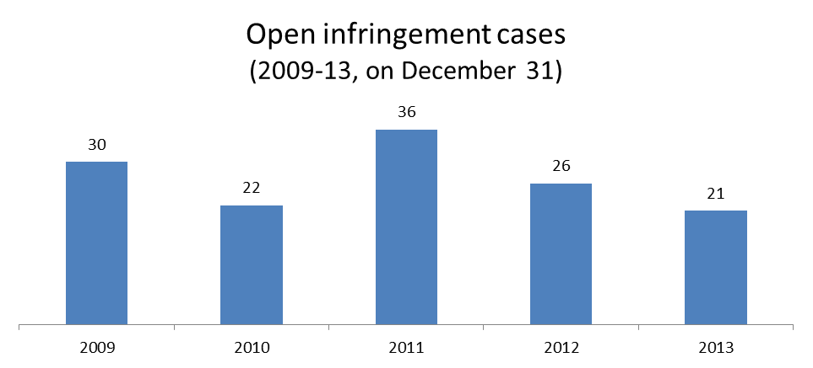

2. Ranking in the EU-28 and reference group

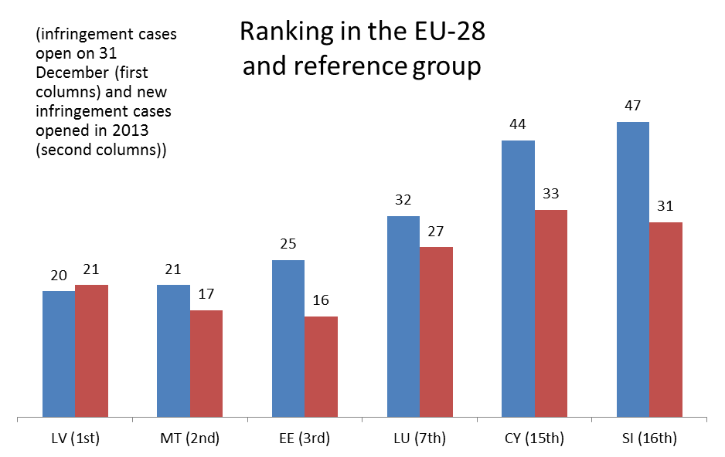
3. 21 infringement cases against Malta
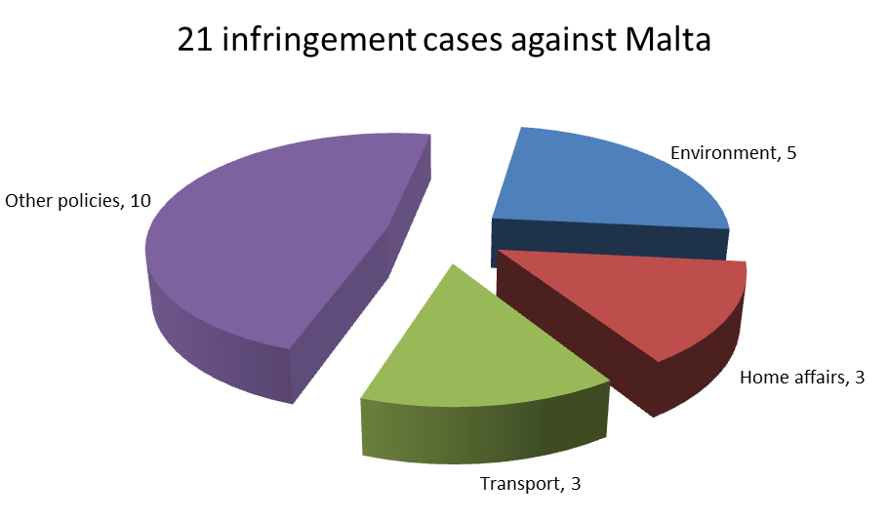

4. Referrals to the Court and key infringement cases
(a) 17 new infringement procedures were launched against Malta in 2013. They and other major ongoing infringement cases relate to:
- the inadequate transposition and implementation of EU rules on access to justice in environmental matters;
- non-compliance with the directive on long term residents in relation to the conditions a third-country national must fulfil when applying for an EU long-term residence permit;
- the failure to notify the Commission of measures to transpose the directive on preventing trafficking in human beings and the directive extending the scope of the Long-term Residents Directive to cover beneficiaries of international protection;
- discriminatory bus fares for non-residents compared to those for residents.

(b) One case was referred to the Court under Article 258 TFEU. It relates to:
- the reduction of the Maltese old-age pension if the beneficiary receives a pension from another Member State from having worked in the public service of that State.
(c) Cases referred to the Court under Article 260(2) TFEU:
- none in 2013

II. Transposition of directives

1. New late transposition infringement cases
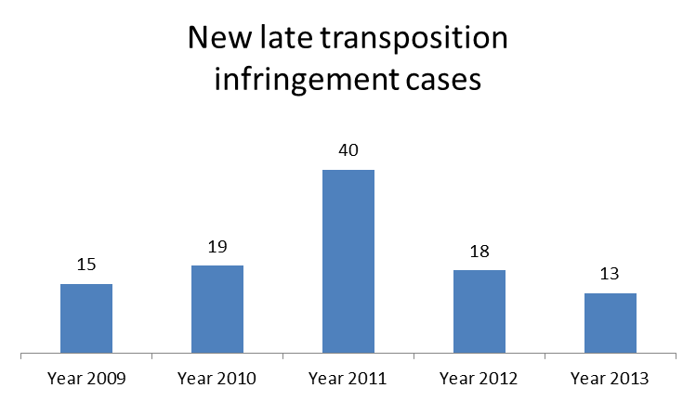

2. Ranking in the EU-28 and reference group

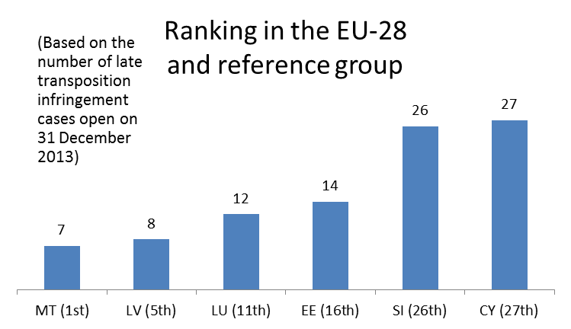

3. Policy areas in which most new late transposition infringement cases were opened
7 late transposition cases against Malta
Energy 2
Home affairs 2
Internal market 2
Justice 1

4. Court referrals under Articles 258/260(3) TFEU:
- none in 2013

III. Complaints

1. Complaints made against Malta
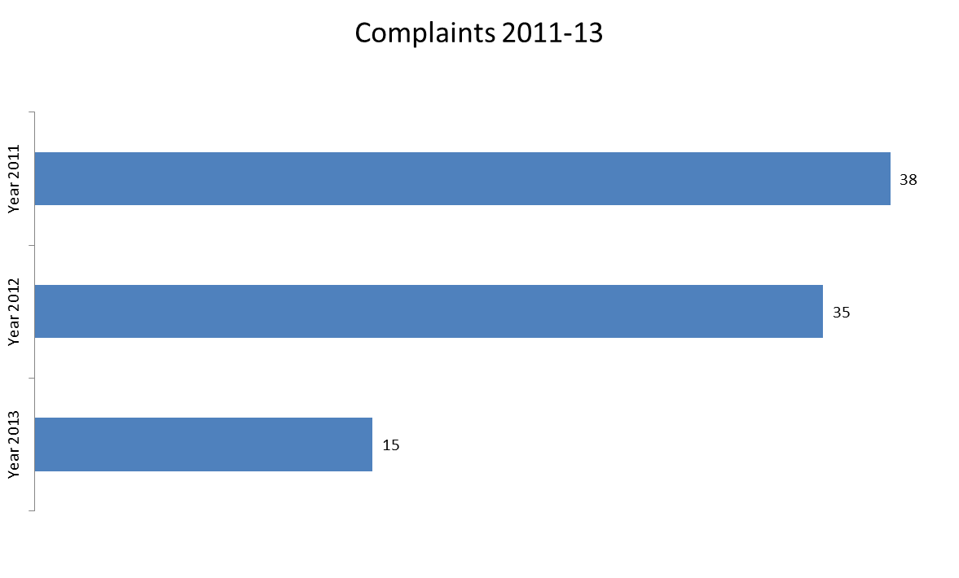
Main complaint areas
 | MALTA Total | 15
Justice | (free movement of people, especially in relation to water and energy tariffs) | 8
Employment | (refusal to grant invalidity pension to non-Maltese citizen, refusal to issue employment certificate to request pension in other Member State) | 2
Other | (tuition fees in adult education and training, birds hunting and trapping, discriminatory bus fees and car taxation) | 5

IV. EU Pilot

1. Progress of files relating to Malta open in EU Pilot
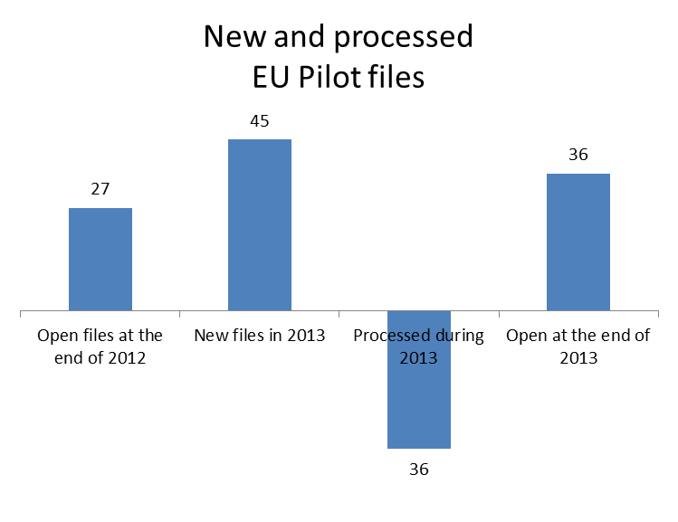

45 New EU Pilot files during 2013
Justice 9
Transport 8
Environment 6
Other 22
Average EU Pilot response
57 | days in 2013
87 | days in 2012
* | days in 2011
* No data for Malta for 2011 as it was not yet EU Pilot member

V. Early resolution of infringement cases

The cases closed without a Court judgment in 2013 related to:
- the failure to transpose certain provisions of the directive on public access to environmental information;
- the incorrect transposition of the Packaging and Packaging Waste Directive;
- the non-conformity of Maltese legislation with the Free Movement Directive, with regard to the entry and residence of the partner with whom the EU citizen has a duly attested stable relationship.

VI. Important judgments

- none in 2013

THE NETHERLANDS

I. General statistics
1. Open infringement cases against the Netherlands (2009-13, on 31December 2013)

2. Ranking in the EU-28 and reference group
3. 40 infringement cases against the Netherlands

4. Referrals to the Court and key infringement cases
(a) 15 new infringement procedures were launched against the Netherlands in 2013. They and other major ongoing infringement cases relate to:
- the Framework Directive, which established a common regulatory framework for electronic communications networks and services. In the Netherlands, access to broadcasting transmission networks — a means of regulating the market in specific situations — is granted by law, rather than via independent market-analysis procedures;
- violation of the Toy Safety Directive – Dutch legislation gives too broad a definition of the category of toy guns to which the ban applies;
- incorrect implementation of the requirements for issuing Energy Performance Certificates;
- discriminatory taxation of outbound dividends received by insurance companies. Only dividends paid on shares held by Dutch insurance companies are actually tax exempt;
- late transposition of the directive on protecting animals used for scientific purposes and of the directive on preventing and combatting trafficking in human beings and protecting its victims.

(b) Three cases were referred to the Court under Article 258 TFEU. They relate to:
- discount fares on public transport being restricted to Dutch students, with students from other EU countries not considered eligible;
- discrimination against pensioners who live abroad in the payment of an allowance for elderly taxpayers;
- the breach of the Gender Equality Directive. Dutch legislation does not include express provisions to protect employees returning from maternity, paternity or adoption leave (such as entitlement to return to their job or to an equivalent post).
(c) Cases referred to the Court under Article 260(2) TFEU:
- none in 2013

II. Transposition of directives

1. New late transposition infringement cases

2. Ranking in the EU-28 and reference group
3. Policy areas in which most new late transposition infringement cases were opened
10 late transposition cases against Netherlands
Energy 3
Other 7

4. Court referrals under Articles 258/260(3) TFEU:
- none in 2013

III. Complaints
1. Complaints made against the Netherlands
Main complaint areas
 | NETHERLANDS Total | 90
Internal market | (public procurement and recognition of professional qualifications) | 20
Environment | (protection of Natura 2000 sites) | 16
Taxation | (VAT exemption for medical services, discriminatory treatment of investment funds and dividend taxation) | 14
Other | (students' transport fares, asylum, calculation of health care contributions and the application of the EU-Turkey Association Agreement) | 40

IV. EU Pilot

1. Progress of files relating to the Netherlands open in EU Pilot

51 New EU Pilot files during 2013
Transport 12
Environment 10
Taxation 8
Other 21
Average EU Pilot response
67 | days in 2013
64 | days in 2012
67 | days in 2011

V. Early resolution of infringement cases

The cases closed without a Court judgment in 2013 related to:
- the non-conformity of national legislation with the directive on employment equality.

VI. Important judgments

The Court ruled that:
- the Netherlands failed to fulfil its obligations under the directive on cross-border mergers of limited liability companies. Employees employed in the Netherlands enjoy broader participation rights than employees of establishments in other countries set up by companies formed through cross-border mergers whose registered offices are in the Netherlands.

In preliminary rulings addressed to the Dutch judiciary, the Court ruled that:
- the protection of consumers by maintaining undistorted competition in the field of energy supply may justify restrictions on the free movement of capital;
- under the Asylum Qualification Directive, homosexual asylum applicants can constitute a particular social group who may be persecuted on account of their sexual orientation;
- under the Return Directive, a violation of the right to defence in the case of a decision extending detention does not automatically bring about the lifting of the detention;
- the Data Protection Directive does not preclude the levying of fees in respect of the communication of personal data by a public authority, but the level of those fees must not exceed the cost of communicating such data;
- the Member State in which a person was last employed can refuse to grant unemployment benefit to a wholly unemployed frontier worker whose prospects of reintegration into working life are best in that Member State, on the grounds that he does not reside in its territory.

POLAND

I. General statistics
1. Open infringement cases against Poland (2009-13, on 31December 2013)

2. Ranking in the EU-28 and reference group

3. 68 infringement cases against Poland
4. Referrals to the Court and key infringement cases
(a) 28 new infringement procedures were launched against Poland in 2013. They and other major ongoing infringement cases relate to:
- certain provisions of the Polish Gambling Act which raise concerns as to their compatibility with the Single Market freedoms enshrined in the Treaties, as well as the lack of notification of technical regulations contained in this Act, prior to their adoption;
- the limit values of PM₁₀ being exceeded in certain areas and agglomerations (air quality) and the alleged lack of impact assessment for the Upper Vistula flood prevention scheme;
- the Polish authorities' request made based on a bilateral agreement, that holders of local border traffic permits must present proof of travel medical insurance;
- the potentially incorrect implementation of the EU Visa Code as regards the right to appeal against decisions on visa refusal, annulment and revocation;
- the possible incompatibility of election rules with the TFEU by restricting the founding of membership in political parties to Polish nationals;
- the requirement for online gambling service providers to have a physical presence in Poland, and for, prior approval of changes to their shareholder structure;
- the rules governing the mandatory collective management of broadcasting firms' cable transmission rights;
- the correct implementation of animal welfare rule concerning pregnant sows;
- the discriminatory nature of Polish rules granting tax deductions only for pension contributions paid to Polish financial institutions.

(b) Nine cases have been referred to the Court under Article 258 TFEU. They relate to:
- the incompatibility with the Gas Directive of the Polish system of regulated gas prices for non-household consumers;
- Poland's alleged failure to designate sufficient nitrate vulnerable zones and shortcomings in its water legislation;
- the discriminatory nature of a number of exclusion criteria in public procurement rules;
- the non-application of EU quality and safety rules to reproductive cells, embryonic tissues and foetal tissues;
- GMO cultivation notifications;
- VAT exemption granted to a broader scope of medical equipment than provided for in the VAT Directive; and VAT exemption on fire-fighting protection goods.
(c) Cases referred to the Court under Article 260(2) TFEU:
- none in 2013
II. Transposition of directives

1. New late transposition infringement cases
2. Ranking in the EU-28 and reference group

3. Policy areas in which most new late transposition infringement cases were opened
20 late transposition cases against Poland
Environment 5
Energy 4
Other 11

4. Court referrals under Articles 258/260(3) TFEU:
- the non-transposition of the Renewable Energy Directive, which had to be transposed by the Member States by 5 December 2010.

III. Complaints

1. Complaints made against Poland
Main complaint areas
 | POLAND Total | 209
Regional policy | (cohesion policy) | 33
Agriculture | (direct payments, rural development and organic farming) | 31
Justice | (equal treatment and civil justice) | 28
Environment | (water protection and management, nature protection, environmental impact assessment and landfills' waste management) | 28
Other | (students' train fares, equal treatment in education, gambling services, requirements beyond those in Local Border Traffic Regulation and excise duties) | 89

IV. EU Pilot

1. Progress of files relating to Poland open in EU Pilot

57 New EU Pilot files during 2013
Transport 11
Environment 9
Internal market 6
Other 31
Average EU Pilot response
71 | days in 2013
69 | days in 2012
65 | days in 2011

V. Early resolution of infringement cases

The cases closed without a Court judgment in 2013 related to:
- the late transposition of the Energy and Gas Directives, the Marine Strategy Directive and the Waste Framework Directive;
- non-residents' obligation to appoint a resident proxy to receive documents in civil and commercial proceedings and the rule that only the date of a court document is delivered to the Polish postal service operator can serve as the document's date of service;
- the nationality requirement for public notaries;
- the narrow scope of the rules transposing the Drivers' Working Time Directive was not extended to self-employed drivers;
- the practice of keeping laying hens in non-enriched cages;
- the discriminatory corporate tax of foreign pension and investment funds compared to the exemption of similar Polish funds.

VI. Important judgments

The Court ruled that:
- Poland failed to comply with the Hydrocarbons Licensing Directive by maintaining discriminatory conditions with regard to the access to the prospection, exploration and extraction of hydrocarbons and by not following the procedure that must precede the granting of authorisations for these activities;
- imbalances between the income and expenditure accounts of the railway infrastructure manager do not violate EU railway laws as long as the necessary measures to balance out these accounts put in place, under normal business conditions and over a reasonable period of time. However, Poland failed to adopt incentive measures to reduce infrastructure costs and access charges;
- Poland failed to lay down transparent and non-discriminatory procedures for allocating air traffic rights in certain cases;
- some of the Polish rules implementing the directive on the contained use of genetically modified micro-organisms (GMMs) are incorrect.

Among the preliminary rulings addressed to the Polish judiciary, the Court ruled that:
- working time records (the beginning and end of working hours and breaks) are considered to be ‘personal data’ for the purposes of the Data Protection Directive; however, national legislation obliging employers to make such records available to the authorities that monitor working conditions is not contrary to this directive.

PORTUGAL

I. General statistics
1. Open infringement cases against Portugal (2009-13, on 31December 2013)

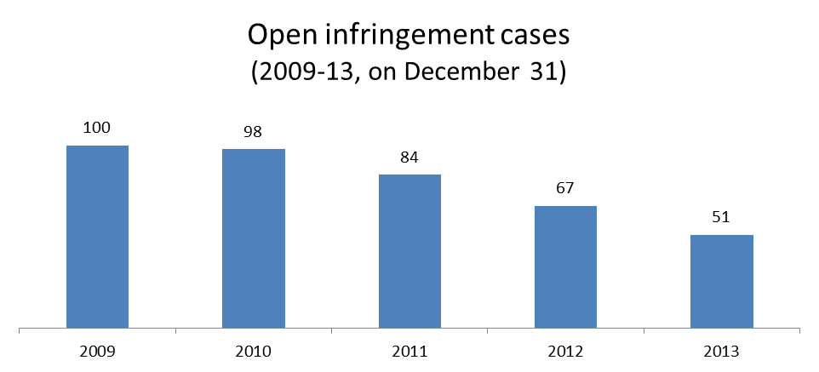

2. Ranking in the EU-28 and reference group

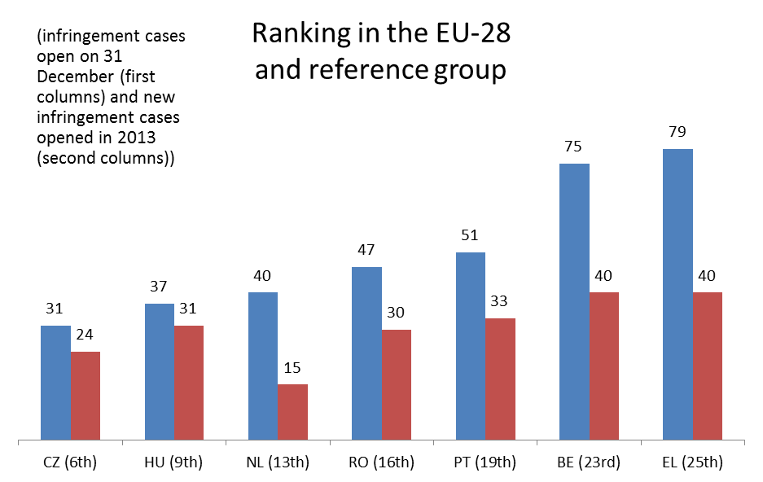

3. 51 infringement cases against Portugal
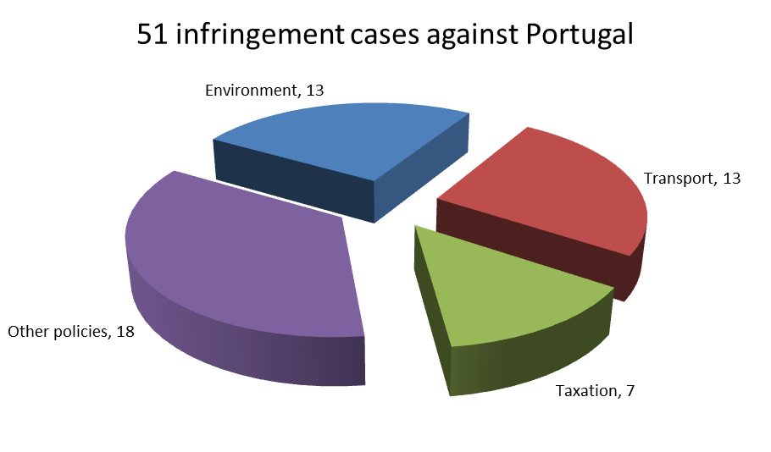

4. Referrals to the Court and key infringement cases
(a) 33 new infringement procedures were launched against Portugal in 2013. They and other major ongoing infringement cases relate to:
- the non-respect of EU air quality standards (PM₁₀ limit values) in several zones and agglomerations;
- the late transposition of the directives on preventing trafficking in human beings and alternative investment fund managers;
- the incorrect implementation of EU legislation on the welfare of animals, which requires that sows are kept in groups during part of their pregnancy;
- Portugal’s failure to fully apply the framework directive on health and safety at work to workers in the public sector;
- the discriminatory treatment of teachers employed in public schools on fixed-term contracts, which is in breach of the Fixed-Term Work Directive;
- the illegal dumping of hazardous waste in the decommissioned mines of São Pedro da Cova in Gondomar;
- Portugal’s failure to comply with Court judgments on the lack of river basin management plans required under the Water Framework Directive and the incorrect transposition of the directives in the First Railway Package.
(b) Two cases were referred to the Court under Article 258 TFEU. They relate to:
- Portugal’s failure to guarantee functional and financial independence of airport slot coordinator, as required by EU rules on allocating slots at Community airports;
- incorrect application of the rules on airport ground handling (baggage handling, ramp handling and freight-and-mail handling) at Lisbon, Porto and Faro airports.
(c) One case was referred to the Court under Article 260(2) TFEU:
- Portugal’s non-respect of the Universal Service Directive with regard to the designation of a universal service provider.

II. Transposition of directives

1. New late transposition infringement cases
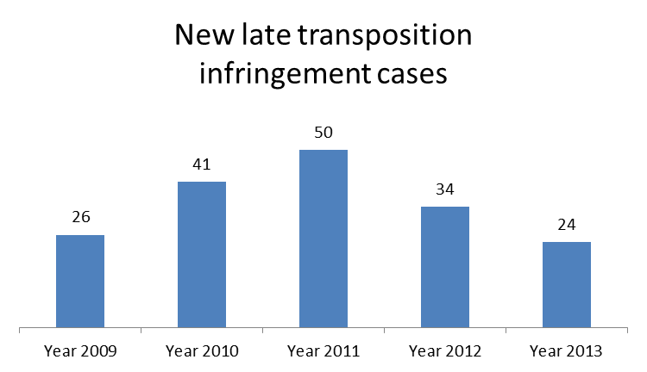

2. Ranking in the EU-28 and reference group

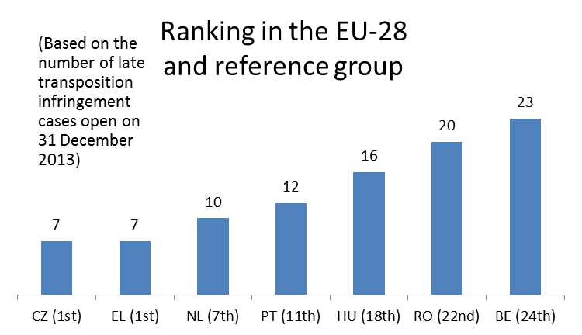

3. Policy areas in which most new late transposition infringement cases were opened
12 late transposition cases against Portugal
Internal market 5
Transport 3
Other 4

4. Court referrals under Articles 258/260(3) TFEU:
- Portugal’s failure to transpose the Energy Efficiency of Buildings Directive, which had to be transposed by 9 July 2012.

III. Complaints

1. Complaints made against Portugal

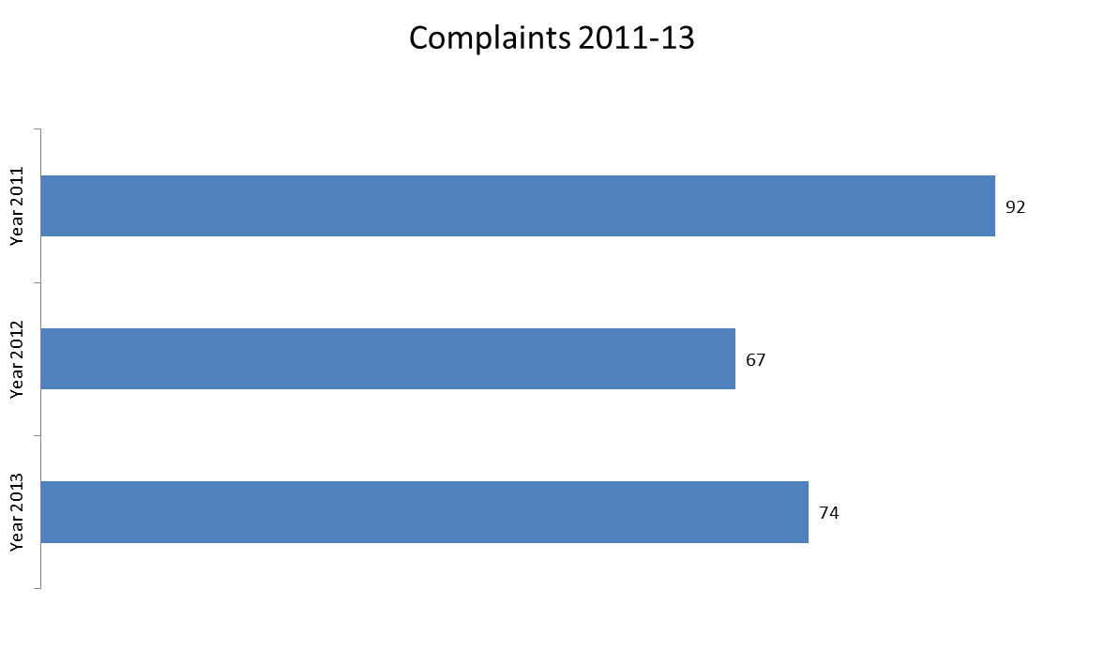
Main complaint areas
 | PORTUGAL Total | 74
Employment | (recognition of professional experience acquired abroad, workers' exposure to asbestos and Fixed Term Work Directive) | 17
Taxation | (vehicles' taxation, VAT refunds and direct taxation) | 15
Environment | (nature protection, environmental impact assessment and waste management) | 11
Other | (authorisation requirements for electronic communication, access to scholarships, Late Payment Directive, heavy goods vehicles' toll and airport ground handling services) | 31

IV. EU Pilot

1. Progress of files relating to Portugal open in EU Pilot

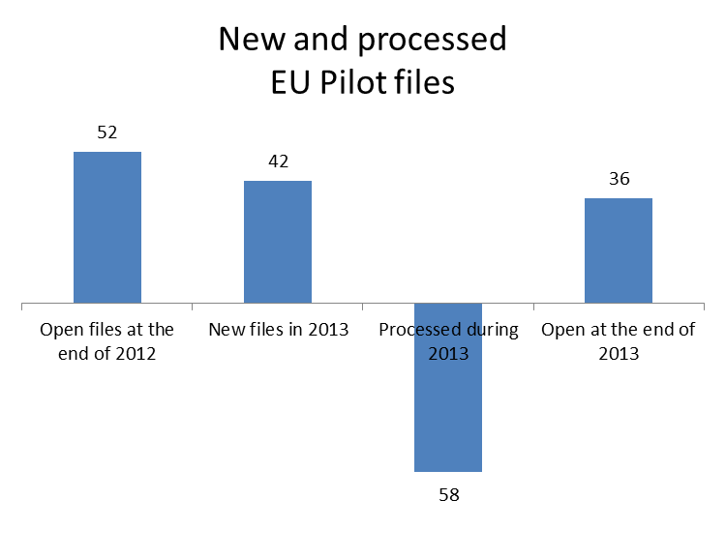

42 New EU Pilot files during 2013
Transport 11
Environment 10
Justice 7
Other 14
Average EU Pilot response
72 | days in 2013
68 | days in 2012
60 | days in 2011

V. Early resolution of infringement cases

The cases closed without a Court judgment in 2013 related to:
- late transposition of the directives on implementing the Framework Agreement on preventing sharp injuries in the hospital and healthcare sector and on defence procurement;
- non-compliance with EU rules on charging heavy goods vehicles — the Eurovignette Directive (the Portuguese legislation contained a provision leaving concession toll systems entirely outside of the directive’s scope and, moreover, Portugal did not communicate to the Commission information on calculating the tolls for newly introduced tolling arrangements).

VI. Important judgments

In preliminary rulings addressed to the Portuguese judiciary, the Court ruled that:
- EU law does not prevent national legislation from limiting the guarantee of wage claims to the period of six months before the commencement of an action that seeks a declaration of insolvency for an employer. This applies even if workers initiated legal proceedings against their employer prior to the start of that period, with a view to obtaining a determination of the amount of those claims and an enforcement order to recover these amounts.

ROMANIA

I. General statistics
1. Open infringement cases against Romania (2009-13, on 31December 2013)

2. Ranking in the EU-28 and reference group
3. 47 infringement cases against Romania
4. Referrals to the Court and key infringement cases
(a) 30 new infringement procedures were launched against Romania in 2013. They and other major ongoing infringement cases relate to:
- Romania’s failure to align national law on annual leave for government employees with the Working Time Directive;
- non-compliance with the principle of equal access to EU waters and resources as laid down in the Common Fisheries Policy;
- restrictions placed on the supply of gambling services. National law obliges businesses providing online gambling services in Romania to establish a physical presence in the country and prescribes a specific legal form for them;
- failure to notify the Commission of measures taken to transpose the Directive on Alternative Investment Fund Managers, the third Postal Services Directive and the Industrial Emissions Directive;
- incorrect implementation of the directive on the allocation of railway infrastructure capacity and the levying of charges for the use of railway infrastructure and safety certification;
- national legislation on the valuation of purchased debt claims for accounting purposes, which stipulates that transferred debt claims should be reported at their nominal value in the transferee’s accounts and financial records. EU law does not provide for any derogation permitting the use of the nominal value of purchased debt claims for accounting purposes;
- unreasonable delays in refunding VAT, in breach of EU legislation on VAT, which specifies that VAT should be refunded swiftly so that taxpayers are not bearing the burden for an unreasonably long period of time;
- restrictions placed on the importing of salt from non-EU countries such as Ukraine and Belarus. Imports of salt from these countries are subject to systematic physical checks (on 100 % of imports) and require a certificate of analysis on radioactivity contamination levels (confirming that radioactivity is within certain limits). No risk assessment has been carried out to justify this level of controls;
- the refusal to pay pensions to Greek nationals who have worked in Romania.
(b) Cases referred to the Court under Article 258 TFEU:
- none in 2013
(c) Cases referred to the Court under Article 260(2) TFEU:
- none in 2013

II. Transposition of directives

1. New late transposition infringement cases

2. Ranking in the EU-28 and reference group
3. Policy areas in which most new late transposition infringement cases were opened
20 late transposition cases against Romania
Energy 5
Environment 5
Other 10

4. Court referrals under Articles 258/260(3) TFEU:
- Romania’s failure to fully transpose EU internal energy market rules. In particular, national legislation has not been aligned with the provisions relating to the protection of consumers and to certain of the energy regulator’s duties. The Commission asked the Court to impose a daily penalty in respect of each of the partially transposed directives.

III. Complaints

1. Complaints made against Romania
Main complaint areas
 | ROMANIA Total | 154
Environment | (environmental impact assessment, nature protection and industrial emissions) | 32
Justice | (protection of personal data and rights of persons with disability) | 25
Taxation | (excise duties and customs representation) | 20
Other | (direct payments, rural development and organic farming, administrative obstacles in universities and animal welfare) | 77

IV. EU Pilot
1. Progress of files relating to Romania open in EU Pilot
53 New EU Pilot files during 2013
Environment 10
Internal market 9
Transport 7
Other 27
Average EU Pilot response
77 | days in 2013
77 | days in 2012
67 | days in 2011

V. Early resolution of infringement cases

The cases closed without a Court judgment in 2013 related to:
- late transposition of the directive on transfer of defence products. Romania informed the Commission of the measures taken to implement this directive;
- failure to correctly apply the sulphur dioxide limit values specified in EU legislation on air quality;
- incorrect transposition of the directives in the First Railway Package;
- restrictions placed on access to excise warehouses. In Romania, licences to run excise warehouses for storage of energy products are only granted to warehouse keepers authorised to produce energy products in Romania and who own equipment and machines for petroleum refining and processing. This requirement is contrary to EU law;
- the tax treatment of the profits or losses of a foreign legal entity that has several permanent establishments in Romania. These establishments are not allowed to combine (i.e. to consolidate or offset) their profits and losses.

VI. Important judgments

In preliminary rulings addressed to the Romanian judiciary, the Court ruled that:
- the judicial authorities cannot refuse to execute a European arrest warrant for a criminal prosecution on the grounds that the requested person had not been tried in the Member State issuing the warrant before that arrest warrant was issued;
- homophobic statements made by the owner of a professional football club may shift the burden of proof on to the club to prove that it does not have a discriminatory recruitment policy. The modified burden of proof laid down in the Equal Treatment Directive would not require evidence that is impossible to provide without infringing on the right to privacy. The appearance of discrimination on grounds of sexual orientation may be refuted by the club on the basis of consistent evidence to the contrary. This may involve, in particular, distancing itself from discriminatory public statements and making sure that there are provisions in its recruitment policy expressly designed to ensure compliance with the principle of equal treatment.

SLOVAKIA

I. General statistics
1. Open infringement cases against Slovakia (2009-13, on 31December 2013)

2. Ranking in the EU-28 and reference group

3. 38 infringement cases against Slovakia
4. Referrals to the Court and key infringement cases
(a) 25 new infringement procedures were launched against Slovakia in 2013. They and other major ongoing infringements cases relate to:
- Employees working in areas deemed not dangerous by the authorities being denied their right to health checks. This may constitute a breach of the directive on health and safety at work;
- Application of EU legislation determining which projects are subject to an environmental impact assessment and breaches of the maximum allowed level of PM₁₀ particles (a measure of air quality) in certain areas and agglomerations;
- individuals being denied the right to appeal against decisions taken on the refusal, annulment and revocation under the Visa Code;
- inadequate protection offered against unfair contract terms in consumer contracts; weak legislation on the use of injunctions allowing consumer law to be circumvented; and limited scope for arbitration in consumer disputes;
- national legislation that gives only Slovak nationals the right to become a member of a political party.

(b) Two cases were referred to the Court under Article 258 TFEU.. They relate to:
- welfare benefits for disabled people which should be available to all those insured under Slovak laws irrespective of whether they are resident in Slovakia or in another Member State;
- state benefit for retired people whose statutory pension is below 60 % of the average wage is only paid to pensioners resident in Slovakia.

(c) Cases referred to the Court under Article 260(2) TFEU
- none in 2013

II. Transposition of directives
1. New late transposition infringement cases
2. Ranking in the EU-28 and reference group
3. Policy areas in which most new late transposition infringement cases were opened
11 late transposition cases against Slovakia
Environment 5
Transport 2
Other 4

4. Court referrals under Articles 258/260(3) TFEU:
- none in 2013

III. Complaints

1. Complaints made against Slovakia
Main complaint areas
 | SLOVAKIA Total | 47
Employment | (posting of workers, workers' exposure to asbestos) | 9
Environment | (water and waste management) | 8
Justice | (unfair terms and practices in consumer contracts, protection of personal data and discrimination based on ethnical origin) | 7
Other | (authorisation requirements for electronic communication, public procurement, railway contracts, car registration and air transport) | 23

IV. EU Pilot

1. Progress of files relating to Slovakia open in EU Pilot
32 New EU Pilot files during 2013
Environment 6
Justice 6
Transport 5
Other 15
Average EU Pilot response
55 | days in 2013
51 | days in 2012
57 | days in 2011

V. Early resolution of infringement cases

The cases closed before a Court judgment in 2013 related to:
- failure to fully transpose the directive on preventing sharp injuries in the hospital and healthcare sector;
- national legislation that required dangerous waste to be treated primarily at Slovak locations. Such waste could only be exported to other Member States if it was impossible to treat it in Slovakia;
- failure to ratify the International Convention on Civil Liability for Bunker Oil Pollution Damage;
- definition of the term "genetically modified micro-organism" used in transposing the directive on the contained use of genetically modified micro-organisms.

VI. Important judgments

The Court ruled that :
- Slovakia had breached the Landfill Directive in the case relating to the use of the landfill site Zilina – Povazsky Chlmec. The landfille site did not meet the requirements of this directive and, in particular, Sloviakia had failed to submit to the authorities a conditioning plan addressing environmental concerns (such as water control, leachate management, protection of soil and water, gas control and hazards). In addition, it had not indicated the corrective measures that would need to be taken in order to comply with the directive.

In preliminary rulings addressed to the Slovak judiciary, the Court ruled that:
- the directive concerning integrated pollution prevention and control should be interpreted as granting the public access to an urban planning decision from the start of the project's authorisation procedure. This right to access cannot be denied on the basis of commercial or industrial confidentiality, even if a legitimate economic interest needs to be protected. If a request for access to the planning decision is refused without justification during the administrative procedure, it should be possible to rectify this decision at a second instance in the administrative procedure (and not only in the court procedure), providing that such rectification will still allow the public to effectively influence the outcome of the decision-making.

SLOVENIA

I. General statistics
1. Open infringement cases against Slovenia (2009-13, on 31December 2013)

2. Ranking in the EU-28 and reference group

3. 47 infringement cases against Slovenia
4. Referrals to the Court and key infringement cases
(a) 31 new infringement procedures were launched against Slovenia in 2013. They and other major important ongoing infringement cases relate to:
- the waste management practices for a landfill site close to the centre of Celje, where soil heavily polluted by heavy metals has been illegally dumped;
- the lack of special administrative rules governing the operation of higher education institutions from other Member States (such as for the establishment of a university branch or a subsidiary, or for franchise agreements);
- the accounts of the Slovenske Železnice group (the national railway company), which do not seem to be sufficiently detailed for the purposes of tracing financial flows between the group's subsidiaries.

(b) One case was referred to the Court under Article 258 TFEU. It relates to:
- Slovenia's failure to notify the Commission of its transposing measures for the directive modifying the Railway Interoperability Directive.

(c) Cases referred to the Court under Article 260(2) TFEU:
- none in 2013
II. Transposition of directives

1. New late transposition infringement cases
2. Ranking in the EU-28 and reference group

3. Policy areas in which most new late transposition infringement cases were opened
26 late transposition cases against Slovenia
Environment 5
Energy 4
Health & consumers 4
Other 13

4. Cases referrals under Articles 258/260(3) TFEU:
- none in 2013

III. Complaints

1. Complaints made against Slovenia
Main complaint areas
 | SLOVENIA Total | 35
Environment | (environmental impact assessment and waste management) | 11
Enterprise and industry | (ban on fur farming, conformity certificate of new equipment and registration of second hand vehicles) | 5
Internal market | (recognition of professional qualifications and public procurement) | 4
Justice | (judicial cooperation in civil matters) | 4
Other | (access to scholarships, Schengen Borders Code, real estate taxation, air passengers' rights and nationality condition to access energy & gas market jobs) | 11

IV. EU Pilot

1. Progress of files relating to Slovenia open in EU Pilot

37 New EU Pilot files during 2013
Transport 8
Justice 7
Environment 6
Other 16
Average EU Pilot response
66 | days in 2013
64 | days in 2012
67 | days in 2011

V. Early resolution of infringement cases

The cases closed without a Court judgment in 2013 related to:
- the public financing of postgraduate studies abroad in return for working in Slovenia for a period equal to the duration of the scholarship, a possibility that was initially only available to Slovene nationals;
- the incomplete notification of national measures transposing the Employers' Sanctions Directive;
- the lack of transposition measures for the directive on preventing sharp injuries in the hospital and healthcare sector.

VI. Important judgments

The Court ruled against Slovenia because:
- decisions on the allocation of train tracks for railway undertakings were made by the national railway company, whereas the Railway Directive requires that they are made by entities not involved in rail transport. Other claims included: no incentives to reduce infrastructure costs and access charges, no performance scheme for railway companies and the infrastructure manager, and the incorrect calculation method of minimum access charges. However, the Slovene authorities resolved these issues by the time the judgment was delivered.

SPAIN

I. General statistics
1. Open infringement cases against Spain (2009-13, on 31December 2013)

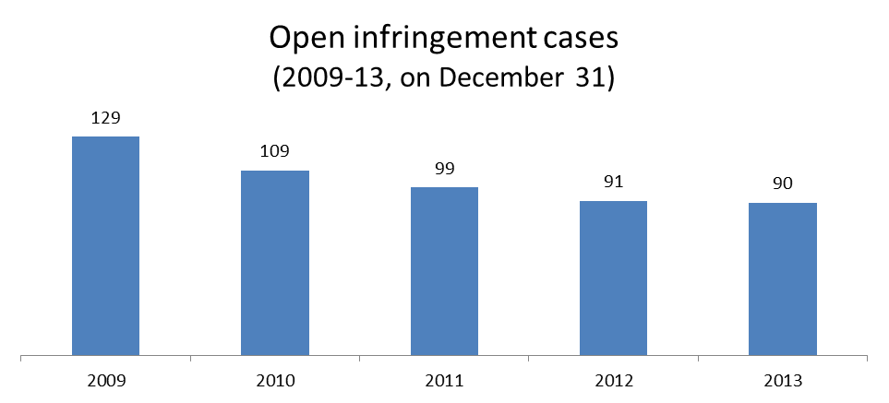

2. Ranking in the EU-28 and reference group

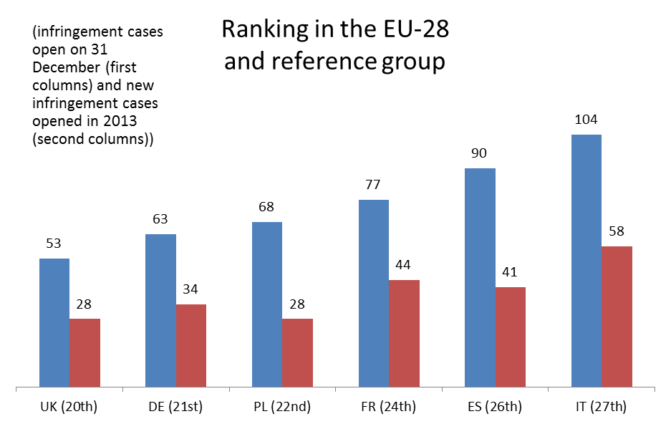

3. 90 infringement cases against Spain
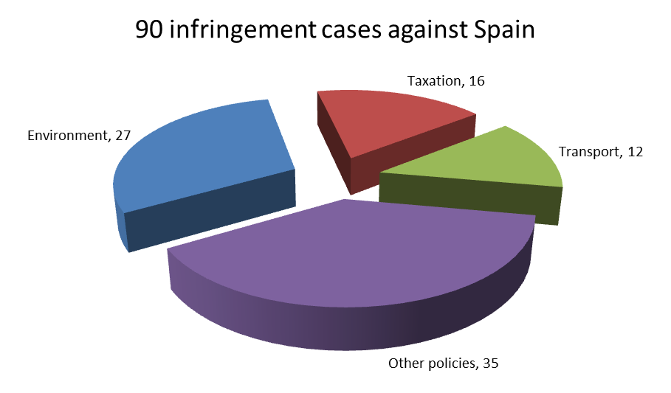

4. Referrals to the Court and key infringement cases
(a) 41 new infringement procedures were launched against Spain in 2013. They and other major ongoing infringement cases relate to:
- Spanish public hospitals refusing to recognise the European Health Insurance Card;
- violation of the framework directive on health and safety at work by the Regional Administration of Andalucía;
- violation of EU citizens’ right to stand as candidates in local and European elections in their Member State of residence, this being prevented by restrictions placed on their involvement in political parties;
- failure to correctly implement the Regulation on public passenger transport services by rail and by road;
- incorrect implementation of the directive on airport charges, specifically in relation to the obligation to consult airport users;
- failure to notify the Commission of measures adopted to transpose the Directive on Alternative Investment Fund Managers and the directive on preventing trafficking in human beings;
- discriminatory taxation of foreign dividends;
- the operation of sub-standard landfills sites, in breach of the Landfill Directive;
- Spain's failure to comply with Court judgments on the lack of river basin management plans required under the Water Framework Directive, and the inadequate urban wastewater treatment in certain areas.
(b) Three cases were referred to the Court under Article 258 TFEU. They relate to:
- failure to implement correctly the provisions of the Framework Directive on health and safety at work in respect of workers of the Civil Guard;
- the restrictive nature of Spanish rules governing the recruitment of port workers (dockers), which could discourage cargo-handling companies from other Member States from establishing themselves in Spanish ports;
- the discriminatory taxation of non-residents on their reinvesting of capital gains in the acquisition of a new permanent residence.
(c) Cases referred to the Court under Article 260(2) TFEU:
- none in 2013

II. Transposition of directives

1. New late transposition infringement cases
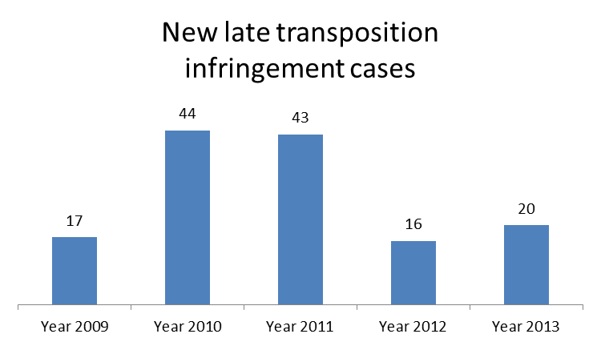

2. Ranking in the EU-28 and reference group

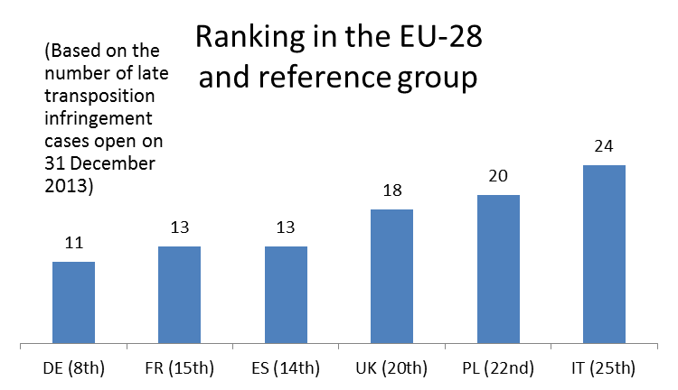

3. Policy areas in which most new late transposition infringement cases were opened
13 late transposition cases against Spain
Energy 4
Environment 3
Internal market 3
Other 3

4. Court referrals under Articles 258/260(3) TFEU
- none in 2013

III. Complaints

1. Complaints made against Spain
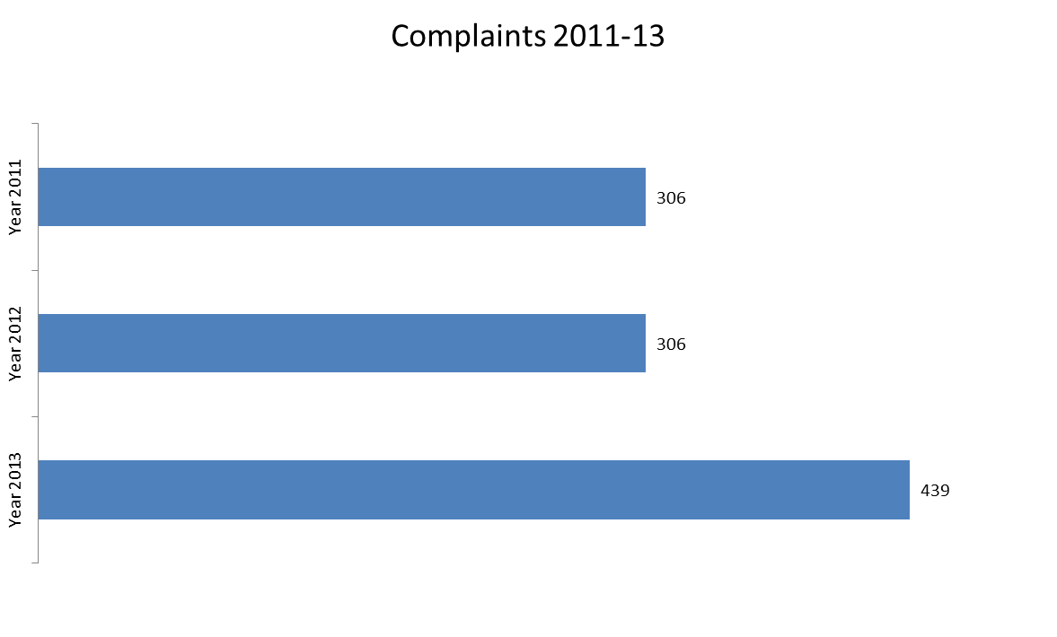

Main complaint areas
 | SPAIN Total | 439
Employment | (issuing of the European Health Insurance Card to some categories of citizens, transitional arrangements for workers from new Member States and restrictions on free movement of frontier workers at the border between Spain and Gibraltar) | 100
Justice | (free movement of people and fundamental rights) | 65
Environment | (environmental impact assessment, nature protection, waste management and water protection) | 65
Other | (access to education, exploration of hydrocarbons, support schemes for renewable energy, Late Payment Directive, Schengen Borders Code, GMOs and regulated professions) | 209

IV. EU Pilot

1. Progress of files relating to Spain open in EU Pilot
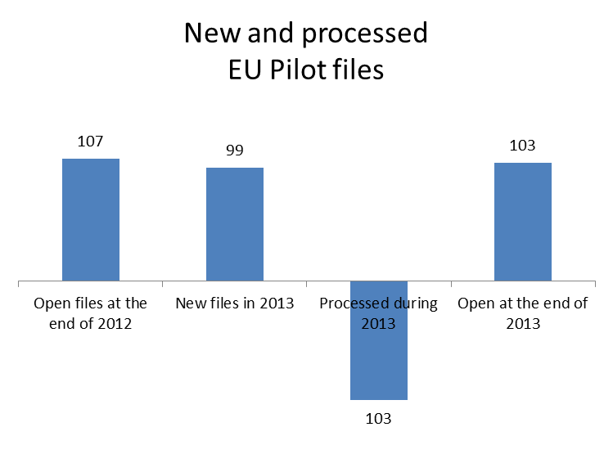
99 New EU Pilot files during 2013
Environment 28
Transport 12
Enterprise & industry 10
Other 49
Average EU Pilot response
72 | days in 2013
74 | days in 2012
82 | days in 2011

V. Early resolution of infringement cases

The cases closed without a Court judgment in 2013 related to:
- discrimination of pensioners from other EU countries, by refusing them access to free medication during a temporary stay in Spain;
- transposition of the directive on minimum safety and health requirements for work on board fishing vessels, which did not conform with EU requirements (due to the definition of the term ‘owner’ in relation to a fishing vessel);
- non-conformity of Spain's provisions on protective and preventive services with the framework directive on health and safety at work;
- failure to notify the Commission of the measures adopted to transpose the directive implementing the Framework Agreement on preventing sharp injuries in the hospital and healthcare sector;
- restrictions placed on importing electricity into the Iberian electricity market;
- failure to notify the Commission of a new programme for the renovation of tyres, a breach of Member States' obligations in respect of technical regulations;
- failure to take the measures needed to apply the provisions of the Drivers’ Working Time Directive to self-employed drivers;
- failure to implement the ban on using unenriched cages for laying hens;
- deficiencies in the implementation of EU legislation on the welfare of animals at the time of slaughter.

VI. Important judgments

The Court ruled that Spain:
- failed to transpose a number of provisions contained in the Water Framework Directive in the intra-communal river basins outside Catalonia and in Catalonia;
- has not complied with the provisions contained in the First Railway Package, in so far as: it has reserved the right to determine the charge to be paid for use of the rail network; it has not satisfied the requirement to set up a performance scheme to minimise disruption and improve the performance of the railway network; it has given public authorities the right to establish allocation priorities for the different types of service on each line; it has used the criterion of actual use of the network as a criterion for the allocation of infrastructure capacity;
- failed to correctly implement the provisions of the VAT Directive for travel agents;
- restricted the freedom of establishment by applying immediate taxation of unrealised capital gains on the transfer of the place of residence or of the assets of a company established in Spain to another Member State.
In preliminary rulings addressed to the Spanish judiciary, the Court ruled that:
- a national legislation on the method of calculating retirement pensions is not in line with EU law, if this method does not take sufficient account of the applicant’s work history in another Member State;
- the surrender of a person to the judicial authorities of another Member State following the issue of a European arrest warrant cannot be made conditional upon the conviction rendered in absentia being open to review in the Member State issuing the arrest warrant;
- the court which has jurisdiction to declare a unfair term in a loan agreement relating to immovable property must be allowed to adopt interim measures, in particular the staying of the enforcement proceedings, where they are necessary in order to guarantee the full effectiveness of its final decision.

SWEDEN

I. General statistics
1. Open infringement cases against Sweden (2009-13, on 31December 2013)

2. Ranking in the EU-28 and reference group
3. 33 infringement cases against Sweden
4. Referrals to the Court and key infringement cases
(a) 13 new infringement procedures were launched against Sweden in 2013. They and other major ongoing infringement cases relate to:
- the non-respect of EU air quality standards (maximum PM₁₀ values ) in several zones and agglomerations;
- the delay in transposing the provisions of the directive amending the directive on the status of third-country nationals who are long-term residents, to extend its scope to the beneficiaries of international protection;
- failure to timely notify measures to transpose the directives on alternative investment fund managers; the conditions of entry and residence of third-country nationals for highly qualified employment; and minimum standards on sanctions and measures against employers of illegally staying third-country nationals;
- the Fixed-Term Work Directive in national law: there is no provision for protection against abusive successive fixed-term employment contracts;
- the inconsistent application of restrictions on the cross-border provision of online sports betting services and online poker services and not subjecting the holder of the exclusive right to strict state control;
- failure to comply with EU law on the proper treatment of urban wastewater in large agglomerations.
(b) Two cases were referred to the Court under Article 258 TFEU. They relate to:
- failure to correctly implement the directive on animal health problems affecting intra-EU trade in bovine animals and swine. The uniform animal health conditions for trade in bovine animals set out in the directive do not include any health requirements for paratuberculosis. Sweden has continued testing bovine animals imported from other Member States for this disease;
- VAT postal exemption: the EU VAT Directive states that services supplied by ‘public postal services’, and the sale of stamps, should be exempt from VAT. Supplies of services for which the terms have been individually negotiated are not allowed to benefit from the VAT exemption.
(c) One case was referred to the Court under Article 260(2) TFEU. It relates to:
- failure to license industrial plants operating without permits. Under the Integrated Pollution Prevention and Control Directive, industrial and agricultural activities with a high pollution potential must be licensed. Permits can only be issued if certain environmental conditions are met, making the companies themselves responsible for preventing and reducing any pollution they may cause. Despite an earlier Court judgment on this matter, Sweden has still not licensed two major industrial plants.

II. Transposition of directives

1. New late transposition infringement cases
2. Ranking in the EU-28 and reference group
3. Policy areas in which most new late transposition infringement cases were opened
7 late transposition cases against Sweden
Energy 2
Other 5

4. Court referrals under Articles 258/260(3) TFEU:
- none in 2013

III. Complaints
1. Complaints made against Sweden
Main complaint areas
 | SWEDEN Total | 101
Taxation | (excise duties and VAT exemptions) | 25
Justice | (free movement of persons) | 22
Employment | (obstacles to register with healthcare institution, posting of workers and classification of a family benefit as sickness benefit) | 13
Other | (access to education, environmental impact assessment, long-term resident permits and marketing of medical devices) | 41

IV. EU Pilot

1. Progress of files relating to Sweden open in EU Pilot

53 New EU Pilot files during 2013
Transport 14
Employment 5
Justice 5
Taxation 5
Other 24
Average EU Pilot response
73 | days in 2013
61 | days in 2012
81 | days in 2011

V. Early resolution of infringement cases

The cases closed without a Court judgment in 2013 related to:
- the total ban on the use of metal detectors in breach of the free movement of goods principle. Sweden changed its legislation to allow the conditional use of such devices;
- the incorrect transposition of the Waste Electrical and Electronic Equipment Directive and the Strategic Environmental Assessment Directive;
- failure to ratify the Convention on Civil Liability for Bunker Oil Pollution;
- restrictions on imports of syringes and hypodermic needles from another Member State. Veterinary surgeons, medical practitioners and dentists who import such products for their own practice must apply for a permit to do so and pay a fee. Sweden changed its legislation on this matter;
- the incorrect application of the definition of an economic activity. Sweden’s definition of ‘economic activity’ does not fulfil the criteria under the VAT Directive, but to those under national income tax law.

VI. Important judgments

There were no major judgments in 2013.

UNITED KINGDOM

I. General statistics
1. Open infringement cases against the United Kingdom (2009-13, on 31December 2013)
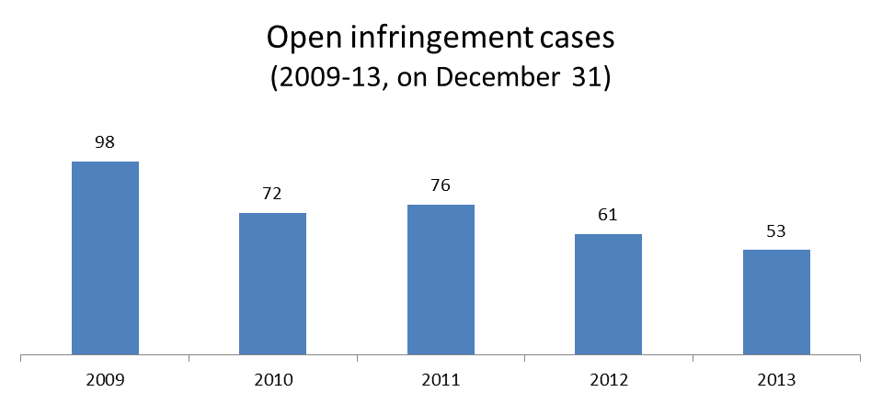

2. Ranking in the EU-28 and reference group
3. 53 infringement cases against the United Kingdom
4. Referrals to the Court and key infringement cases
(a) 28 infringement procedures were launched against the United Kingdom in 2013. They and other major ongoing infringement cases relate to:
- the Working Time Directive, regarding annual leave entitlements for low-hour contracts;
- the refusal to pay sickness benefits in cash to UK pensioners resident abroad (to benefit, pensioners have to be in the UK for 26 weeks out of 52 before the date of the claim);
- the incorrect implementation of the First Railway Package: the UK failed to comply with EU rules on excessive track access charges for passenger and freight trains using the Channel Tunnel;
- failure to correctly apply waste legislation with regard to waste oils and end-of-waste criteria (i.e. the criteria that specify when certain waste ceases to be waste and becomes a product or a secondary raw material);
- the breach of EU rules on fiscal marking for fuels: private pleasure boat users, such as those of luxury yachts, can no longer buy lower taxed fuel intended for fishing boats.

(b) Two cases were referred to the Court under Article 258 TFEU. They relate to:
- the application of a discriminatory ’right to reside’ condition for EU nationals to be granted social security benefits (such as child benefit or a state pension credit);
- the application of VAT-reduced rate for supplies of enery-efficient products in houses, as there is no provision on the VAT Directive to allow a reduce VAT rate on these products.

(c) Cases referred to the Court under Article 260(2) TFEU:
- none in 2013

II. Transposition of directives

1. New late transposition infringement cases

2. Ranking in the EU-28 and reference group

3. Policy areas in which most new late transposition infringement cases were opened
18 late transposition cases against United Kingdom
Enterprise & industry 4
Environment 4
Internal market 4
Other 6

4. Court referrals under Articles 258/260(3) TFEU:
- the UK’s failure to fully transpose the EU internal energy market rules. The Commission asked the Court to impose daily penalties in respect of each partially transposed directive.

III. Complaints
1. Complaints made against the United Kingdom
Main complaint areas
 | UNITED KINGDOM Total | 224
Justice | (free movement of persons and protection of personal data) | 99
Environment | (nature protection, air quality, waste and water management) | 28
Employment | (fees required for European Health Insurance Card by private entities, recognition of child raising periods spent abroad for pension calculation and discriminatory child benefits) | 25
Other | (organic farming, tuition fees in education, minimum alcohol pricing, very long asylum procedures and marketing of medicinal products) | 72

IV. EU Pilot
1. Progress of files relating to the United Kingdom open in EU Pilot

60 New EU Pilot files during 2013
Justice 11
Transport 11
Employment 6
Taxation 6
Other 26
Average EU Pilot response
72 | days in 2013
70 | days in 2012
66 | days in 2011

V. Early resolution of infringement cases

The cases closed without a Court judgment in 2013 related to:
- transparency of conditions for getting access to the natural gas transmission networks;
- the putting into service of CE-marked gas appliances (hot water boilers) in line with the requirements of the directive on gas appliances and the directive on the approximation of Member State laws on pressure equipment;
- the late transposition of directives on reporting formalities for ships entering or leaving Member State ports; roadworthiness tests for motor vehicles; railway safety indicators; railway interoperability; passenger ships; driving licences, maritime traffic monitoring and the Electricity and Gas Directives.

VI. Important judgments

In preliminary rulings addressed to the judiciary of the United Kingdom, the Court ruled that:
- the Member State responsible for considering an asylum application that an unaccompanied minor has made in more than one Member State is that in which the minor is present after lodging an application there;
- the term ‘not prohibitively expensive’ in relation to access to justice in environmental matters means that the financial burden of access to justice should not prevent the people concerned from making or pursuing a claim or seeking a review by the courts;
- if, under national law, taxpayers can choose between two possible courses of action to recover tax levied in breach of EU law, one of which has a longer limitation period, national law cannot curtail that limitation period without notice and retroactively.

METHODOLOGY AND EXPLANATIONS

Annex I – Member States

GENERAL STATISTICS
First chart: open infringement cases The figures for the years 2009-13 include all procedures that the Commission initiated against the Member State by sending a letter of formal notice under Article 258 TFEU in the reporting year or before and that the Commission has not yet closed by a formal decision, irrespective of the actual procedural phase. Accordingly, this number includes all cases that, on 31 December of the above years:

(i) are in the pre-litigation phase (letter of formal notice, reasoned opinion or decision on referral to the Court under Article 258 TFEU),
(ii) are pending before the Court under Article 258 TFEU or Article 260(3) TFEU,
(iii) the Court had ruled on but the Commission could not yet confirm that the Member State has implemented the judgment correctly,
(iv) are in the second pre-litigation procedure (letter of formal notice or referral decision under Article 260(2) TFEU)
(v) are pending before the Court due to a second referral and
(vi) the Court had ruled on for the second time but the Commission could not yet confirm that the Member State has implemented the second judgment correctly.

This figure does not include, for example, open EU Pilot files or EU Pilot files where the Commission already rejected the Member State’s response in EU Pilot but has not yet sent the letter of formal notice under Article 258 TFEU.

Second chart: ranking in the EU-28 and reference group Each Member State belongs to a particular reference group. On the basis of the Member States' voting weights in the Council, the following reference groups were created:

(i) Germany, United Kingdom, France, Italy, Spain and Poland
(ii) Romania, the Netherlands, Greece, Czech Republic, Belgium, Hungary and Portugal
(iii) Sweden, Austria and Bulgaria
(iv) Slovakia, Denmark, Finland, Lithuania and Ireland
(v) Latvia, Slovenia, Estonia, Cyprus, Luxembourg, and Malta.

Three sets of data are shown for each Member State in a given reference group:
- The first is the number of infringements that stood open against these Member States on 31 December in the reporting year (first columns).
- The second is their ranking position in the EU-28 (without Croatia). In case two or more Member States have equal number of open infringements their ranking will be the same i.e., there is no secondary ranking criteria.
- The third set is the number of letters of formal notice addressed by the Commission to the Member State under Article 258 TFEU (letters of formal notice under Article 260(2) TFEU are not included) from 1 January until 31 December of the reporting year. To be noted that not all of these new infringement cases were necessarily open on 31 December of the reporting year. For example, if the Commission had opened a late transposition infringement in March 2013 by sending a letter of formal notice, the case will be added to the new infringement cases irrespective of the fact that the case was closed in October 2013 due to the Member State's full notification.

Third chart: Breakdown according to policy areas As a principal rule, this chart indicates the three policy areas where the most infringements were open on 31 December in the reporting year. Four (or more) policies are mentioned, if two (or more) policies have the third highest number of open infringements. Only two policies are highlighted, if there are too many policies with the third highest number or if this would make the chart very fragmented (might occur in Member States with relatively few infringements).

REFERRALS TO THE COURT AND KEY INFRINGEMENT CASES
This section has three parts:
- The first part starts with the number of new infringement procedures in the reporting year and lists the most important new and on-going procedures in the stage of letter of formal notice or reasoned opinion (under Article 258 TFEU).
- The second part list contains the referral decisions that the Commission made under solely Article 258 TFEU against the Member State in the reporting year (or a negative confirmation). To be noted that referrals made under Article 258 and 260(3) TFEU are discussed in the "Transposition of directives" section (see below). To be noted also that the referral decision does not necessarily mean in all cases that the Commission had already submitted its claim to the Court by 31 December of the reporting year. Even if there is a negative confirmation, there might be on-going proceedings against the Member State under this Article due to earlier Commission decisions.
- The third part includes all referral decisions that the Commission made under Article 260(2) TFEU against the Member State in the reporting year (or a negative confirmation). This does not mean in all cases that the Commission had already submitted its claim to the Court by 31 December of the reporting year. Even if there is a negative confirmation, there might be on-going proceedings against the Member State under this Article due to earlier Commission decisions.

TRANSPOSITION OF DIRECTIVES
First chart: New late transposition infringement cases This figure shows the number of letters of formal notice addressed to the Member State under Article 258 TFEU due to missing or partial notifications of directives' national transposition measures. This figure is already included into the total number of new infringement cases initiated against the Member State in the reporting year. (So it should not be added to the figure shown in the first chart of the general statistics section.) To be noted that not all of these new late transposition infringement cases were necessarily open on 31 December of the reporting year. For example, if the Commission had opened a late transposition infringement procedure in March 2013 by sending a letter of formal notice it will be added to the new infringement cases even if the case was closed in October 2013 due to the Member State's full notification. The figure for the current reporting year is further broken down according to policy areas. Generally, this break-down indicates the two policy areas where the most late transposition procedures were launched during the reporting year. Three (or more) policies are mentioned, if two (or more) policies have the second highest number of open infringements. Only one policy is highlighted, if there are too many policies with the second highest number or if this would make the chart very fragmented (might occur in Member States with relatively few infringements).

Second chart: ranking in the EU-28 and reference group Two sets of data are shown for each Member State in a given reference group:
- The first is the number of late transposition infringements that were launched against the Member State during the years 2009-13.
- The second is their ranking position in the EU-28 (without Croatia). The ranking is based upon the number of open late transposition cases on 31 December of the reporting year. In case two or more Member States have equal number of open infringements their ranking will be the same i.e., there is no secondary ranking criteria.

Referrals against the Member State under Articles 258 / 260(3) TFEU: The directive(s) that the Member State failed to transpose on time is mentioned (or a negative statement). This does not mean in all cases that the Commission had already submitted its claim to the Court by 31 December of the reporting year. In addition to these referrals, there might be other cases pending before the Court based on earlier Commission decisions. Even if there is a negative statement, there might be on-going proceedings under these Articles against the Member State due to earlier Commission decisions.

COMPLAINTS
This section analyses the number of complaints that the Commission received in relation to the Member State. The figure on the number of incoming complaints for the current reporting year is broken down according to policy areas and sectors. Generally, this break-down indicates the three policy areas (as well as their most targeted sectors) where the most complaints were received during the reporting year.

EU PILOT
First chart: Average response time in EU Pilot The pie chart indicates how the Member State's average response time in EU Pilot has changed over the past three years.

Second chart: New and processed EU Pilot files This chart starts from the Member State's "balance" of EU Pilot files at the end of the previous reporting year (first column). The second column indicates the number of new EU Pilot files received during the reporting year. This column is further broken down according to policy areas, which indicates the three policy areas where the most EU Pilot files were addressed to the Member State. Similarly to the previous break-downs, more or less policies might be mentioned, depending on the actual nuber of new EU Pilot files. The third column that shows the number of processed EU Pilot files indicates the number of dossiers where the Commission decided on the Member State's responses in EU Pilot. Finally, the fourth column indicates the "balance" of the Member State's EU Pilot files at the end of the reporting year (i.e. first figure plus the second less the third shall be equal to the fourth figure).

EARLY RESOLUTION OF INFRINGEMENTS
This section contains a list of the most important infringement procedures that the Commission had closed during the reporting year. The list should not be considered exhaustive.

IMPORTANT JUDGMENTS
This section contains two lists; the first contains the most important judgments of the Court against Member States. These judgments are almost exclusively passed under Article 258 or Articles 260(2) TFEU. The second list refers to the most important preliminary rulings that the Court has issued to the Member State's judiciary. These lists are not necessarily exhaustive.

Directive 2010/75/EU
Directive 2011/61/EU
Directive 2008/6/EC
IP/13/1101
MEMO 13/470
MEMO/13/375
Directive 2009/52/EC
Directive 2009/50/EC
Directive 2006/126/EC
Directive 2010/48/EU
Directive 1990/70/EC
Directive 2002/21/EC
Directive 2010/75/EU
Directive 2011/36/EU
Directive 2004/49/EC
Directive 2006/112/EC
IP/13/137
Directive 2009/52/EC
Commission v Luxembourg, C-576/11, Court press release No 152/13
Directive 91/440/EC, Commission v Luxembourg, C-412/11
Giersch and Others, C-20/12, Court press release No 74/13
McDonagh, C-12/11
Directive 2003/35/EC
Directive 2003/109/EC
Directive 2011/36/EU
Directive 2011/51/EU
IP/13/249
Directive 2003/4/EC
Directive 94/62/EC
Directive 2004/38/EC
Directive 2002/21/EC
Directive 2009/48/EC
Directive 2010/31/EU, MEMO/13/1005
Directive 2010/63/EU, MEMO/13/583
Directive 2011/36/EU
IP/13/574
IP/13/140
Directive 2006/54/EC
IP/13/45
Directive 2000/78/EC
Directive 2005/56/EC
Commission v Netherlands, C-635/11
Essent and Others, C-105/12, C-106/12 and C-107/12, Court press release No 137/13
Directive 2004/83/EC
X and Others, C-199/12, C-200/12, C-201/12, Court press release No 145/13
Directive 2008/115/EC
G. and R., C-383/13, Court press release No 100/13
X, C-486/12
Jeltes and Others, C-443/11
Directive 98/34/EC allows the Commission to raise objections against such rules if they restrict the free movement of goods.
PM₁₀ is 'an air pollutant consisting of small particles with an aerodynamic diameter less than or equal to a nominal 10 micrometer. Their small size allows them to make their way to the air passages deep within the lungs where they may be deposited and result in adverse health effects' (Source: the European Environmental Agency).
IP/13/47
MEMO/13/375
Regulation (EC) No 1931/2006
Regulation (EC) No 810/2009
IP/13/1101
IP/13/135
Directive 2009/73/EC
IP/13/580
IP/13/48
IP/13/144
IP/13/965
Directive 2004/23/CE
IP/13/873
IP/13/571
Directive 2006/112/EC and IP/13/870
Directive 2009/28/EC
IP/13/259
Directive 2009/72/EC and Directive 2009/73/EC
Directive 2008/56/EC
Directive 2008/98/EC
Directive 2002/15/EC and IP/13/142 on the earlier referral decision
Directive 94/22/EC
Commission v Poland, C-569/10
Directive 91/440/EEC
Commission v Poland, C-512/10 and Court press release No 64/13
Commission v Poland, C-90/12
Directive 2009/41/EC
Commission v Poland, C-281/11
Directive 95/46/EC
Worten, C-342/12
PM₁₀ is 'an air pollutant consisting of small particles with an aerodynamic diameter less than or equal to a nominal 10 micrometer. Their small size allows them to make their way to the air passages deep within the lungs where they may be deposited and result in adverse health effects' (Source: the European Environmental Agency).
Directive 2011/36/EU
Directive 2011/61/EU
Directive 2008/120/EC and IP/13/135
Directive 89/391/EEC and MEMO/13/1005
Directive 99/70/EC and MEMO/13/1005
MEMO/13/1005
Commission v Portugal, cases C-223/11 and C-557/10
Directive 2000/60/EC and IP/11/438 on the earlier referral decision under Article 258 TFEU
Directives 91/440/EEC and 2001/14/EU
Regulation (EEC) No 95/93 and IP/13/1100
Directive 96/67/EC and IP/13/255
IP/13/44 and Commission v Portugal, C-154/09
Directive 2010/31/EU and IP/13/579. The case was subsequently closed, following Portugal’s compliance.
Directive 2010/32/EU
Directive 2009/81/EC
Directive 1999/62/EC
Gomes Viana Novo and others, C-309/12
Directive 2003/88/EC
IP/13/1101
Directive 2011/61/EU
Directive 2008/6/EC
MEMO/13/820
Directive 2001/14/EC
MEMO/13/820
MEMO/13/820
MEMO/13/1005
Directive 2009/72/EC and 2009/73/EC
IP/13/260. Subsequently, Romania achieved full transposition and the Commission withdrew the Court applications
Directive 2009/43/EC
Directive 1999/30/EC and Directive 96/62/EC
Directive 91/440/EEC, amended by Directives 95/18/EC and 2001/14/EC
Directive 2008/118/EC
Radu, C-396/11
Asociatia Accept, C-81/12
Directive 89/391/EEC
Directive 2011/92/EU
IP/13/47
Regulation (EC) No 810/2009
The carer's allowance (peňažný príspevok na opatrovanie), the disability allowance (peňažný príspevok na osobnú asistenciu) and the cash allowance for compensation of increased costs for severely disabled persons (peňažný príspevok na kompenzáciu zvýšených výdavkov).
IP/13/476
The 'Christmas allowance' ('vianočný príspevok')
IP/13/364
Directive 2010/32/EU
Directive 2009/41/EC
Directive 1999/31/EC
Commission v Slovakia, C-331/11
Directive 96/61/EC
Križan and Others, C-416/10
MEMO/13/583
MEMO/13/583
Directive 2011/18/EU
Directive 2008/57/EC and IP/13/141. As Directive 2011/18/EU was not adopted in a legislative procedure the Commission was not entitled to propose a financial penalty to the Court under Article 260(3) TFEU. Finally, the case has been withdrawn from the Court later in 2013 due to Slovenia's compliance.
Directive 2009/52/EC
Directive 2010/32/EU
Directive 91/440/EEC (repealed by Directive 2012/34/EU)
Commission v Slovenia, C-627/10 and Court press release No 88/13
IP/13/474
Directive 89/391/EEC
Regulation (EC) No 1370/2007
Directive 2009/12/EC
Directive 2011/61/EU
Directive 2011/36/EU and MEMO/13/1005
MEMO/13/583
Directive 1999/31/EC and MEMO/13/22
Commission v Spain, cases C-403/11 and C-343/10
Directive 2000/60/EC
IP/10/528 on earlier referral decision under Article 258 TFEU
IP/13/963
IP/13/559
IP/13/365
Directive 93/103/EC
Directive 2010/32/EU
Directive 98/34/EC
Directive 2002/15/EC
In accordance with Directive 1999/74/EC
Directive 93/119/EC and Regulation (EC) No 882/2004
Commission v Spain, C-151/12
Directive 2001/14/EC
Commission v Spain, C-483/10; and Court press release No 20/13
Commission v Spain, C-189/11
Commission v Spain, C-64/11; and Court press release No 53/13
Salgado González, C-282/11; and Court press release No 15/13
Melloni, C-399/11; and Court press release No 17/13
Aziz, C-415/11; and Court press release No 30/13
IP/13/47
Directive 2003/109/EC
Directive 2011/61/EU
Directive 2009/50/EC
Directive 2009/52/EC
MEMO/13/122
IP/13/1101
Commission v Sweden, C-438/07, IP/06/1769
Directive 64/432/EEC
IP/13/570
IP/13/1111
IP/13/145
Directive 2008/1/EC
Directive 2012/19/EU
Directive 2001/42/EC
Directive 2003/88/EC
Regulation (EC) No 1408/71 and Regulation (EC) No 883/2004
First Railway Package (Directives 91/440/EEC and 2001/14/EC, replaced by the Rail Recast Directive 2012/34/EU)
IP/13/557
MEMO/13/375
Directive 95/60/EC
MEMO/13/470
IP/13/475
Directive 2006/112/EC
IP/13/139
Directive 2009/72/EC and Directive 2009/73/EC
IP/13/42. In September 2013, however, the UK fully transposed the directives, and both cases were closed.
Directive 2009/142/EC
Directive 97/23/EC
Directive 2010/65/EU
Directive 2010/48/EU and Directive 2010/47/EU
Directive 2009/149/EC
Directive 2008/57/EC
Directive 2010/36/EU
Directive 2006/126/EC
Directive 2009/17/EC
Directive 2009/72/EC and Directive 2009/73/EC
MA and Others, C-648/11, Court press release No 71/13
Directive 2003/35/EC
Edwards and Pallikarapoulos, C-260/11
Test Claimants in the Franked Investment Income Group Litigation, C-362/12
This categorisation may change in future Annual Reports.

