COMMISSION STAFF WORKING DOCUMENT
Progress report on the implementation of the Railway Safety Directive
Accompanying the document
Communication from the Commission to the Council and the European Parliament
on a progress report on the implementation of the Railway Safety Directive
Table of Contents

1. INTRODUCTION 3
1.1. Institutional set-up of the railway safety 3
2. DEVELOPMENT OF THE LEGAL FRAMEWORK 5
2.1. EU policy developments in the railway field and in rail safety in particular 5
2.2. Last development of the legal framework for rail safety 7
2.2.1. Common safety indicators (Article 5 of the Railway Safety Directive) 7
2.2.2. Common safety methods (Article 6 of the Railway Safety Directive) 7
2.2.3. Common safety targets (Article 7 of the Railway Safety Directive) 10
2.2.4. Certification of the entities in charge of maintenance for freight wagons (Article 14a of the Railway Safety Directive) 12
2.3. National safety rules 12
2.3.1. The Task Force on national safety rules and the rule management tool 12
2.3.2. Notif-IT: database of national safety and national technical rules 13
2.3.3. Follow-up of the recommendations of the Task Force 13
2.4. The 4th Railway package and the recast of the Railway Safety Directive 15
2.4.1. Revision of the Safety Certification and migration towards a single safety certificate 15
2.4.2. A moving environment for safety 17
2.4.3. Recast of the Railway Safety Directive: inter-institutional dialogue 18
3. MONITORING THE IMPLEMENTATION AND THE SAFETY PERFORMANCE 19
3.1. Measures notified by the Member States for transposition of Directive 2004/49/EC 19
3.2. Managing and monitoring safety 20
3.2.1. Managing safety 20
3.2.2. Safety certification and Safety authorisation 22
3.2.3. Safety overview 23
3.2.4. Occurrences investigated by NIBs 26
3.2.5. Monitoring activities supported by ERA 27
3.3. Certification of the entities in charge of maintenance: overview 28
3.3.1. Status of different schemas (ART 10.1 of the Regulation (EU) 445/2011) in EU and non EU Contracting States. 28
3.3.2. State of play of ECM certification 29
3.3.3. ERA supporting activities 30
3.4. Further developments 30
3.4.1. Monitoring safety performance processes 30
3.4.2. A Platform for European Rail Infrastructure Managers (PRIME) 33
CONCLUSIONS 34

1. INTRODUCTION
This report is an update of the state of play of the implementation of the Railway Safety Directive (Directive 2004/49/EC) since the last report SEC (2009) 1157 issued on 8 September 2009. This update is required every 5 years in accordance with Article 31 of the aforementioned directive.
After a short introduction devoted to the authorities and institutional bodies created for the implementation of the Railway Safety Directive, Chapter 2 will present the developments of the legislation built on the Railway Safety Directive during the last five years, while
Chapter 3 will focus on its implementation and enforcement.
Most of the legal documents referred in the progress report are published on the Official Journal of the European Unions. All reports related to railway safety are publicly available on the web site of the European Railway Agency: http://www.era.europa.eu/Pages/Home.aspx. Internal notes related to the correspondence with the Member States in matter of legislative procedures and transposition into the national legal framework cannot be disclosed.
The European Railway Agency is credited for all figures in this report.

1.1. Institutional set-up of the railway safety
In 2009 the authorities and institutional bodies most relevant to the implementation of the Railway Safety Directive were already in place:
- The Railway Interoperability and Safety Committee (RISC) where Member States are represented. It was established under Article 21 of Directive 96/48/EC. The competences of the Committee have been extended three times: in 2001 with the conventional rail interoperability directive, in 2004 with the railway safety directive, and in 2007 with the train driver certification directive (Directive 2007/59/EC).
The Committee is chaired by the Commission and has held its 70th meeting in June 2014. The agenda is prepared by the Commission and includes, as standard parts: items submitted for vote under comitology procedures, items for discussion and items to agree on the Community position for meetings organised by international organisations such as OTIF and OSJD. Since the Agency was established, it has reported regularly on the state of play of its work leading to Commission measures.
- The European Railway Agency (ERA) was established in 2005 to help the integration of the railway area by reinforcing safety and interoperability. Its objective is to contribute, on technical matters, to the implementation of Community legislation aimed at improving the competitive position of the railway sector. Its work involves producing recommendations intended to become Commission decisions or regulations and issuing opinions on matters relating to Interoperability and safety. All recommendations must be accompanied by an economic analysis.
- National safety authorities (NSAs) assure safety performance whilst taking care that safety regulation does not hinder market opening opportunities during the development of interoperability. The NSAs are responsible for inspecting and supervising the activities of the railway undertakings and infrastructure managers during the period of validity of the safety certificate or safety authorisation.
- National investigation bodies (NIBs) are charged with investigating serious accidents and – at their discretion – other accidents and incidents on the railway. Supported by ERA, they are obliged to exchange views and experiences with each other in order to develop common investigation methods, principles for following up safety recommendations in safety reports and to adapt investigations to the latest technical and scientific progress.
To complete this institutional framework, new institutional bodies have been introduced for specific tasks during the last five years:
- The bodies issuing a certificate for the entities in charge of maintenance. These may be bodies either accredited or recognised by the Member States. Also the NSA can issue such certificate, in particular when maintenance is performed by the railway undertakings themselves. Although these bodies was required in Article 14a of the Railway Safety Directive, they became operational after the Regulation (EU) No 445/2011 on a system of certification of the entity in charge of maintenance for freight wagons entered into force in 2011;
- The bodies able to carry out an independent assessment on the application of the risk management process according to Commission Regulation (EC) No 352/2009 of 24 April 2009 on the common safety method for risk evaluation and assessment. Their competencies were further developed with the Commission Regulation (EU) No 402/2013 of 30 April 2013 on the common safety method for risk evaluation and assessment, which will be applied from May 2015.
2. DEVELOPMENT OF THE LEGAL FRAMEWORK

2.1. EU policy developments in the railway field and in rail safety in particular
In its White Paper ‘Roadmap to a Single European Transport Area - Towards a competitive and resource efficient transport system’, adopted on 28 March 2011, the Commission announced its vision to establish a Single European Railway Area and clarified that this objective implies creating the internal railway market where European railway undertakings can provide services without unnecessary technical and administrative barriers.
Additionally, the European Council conclusions of January 2012 highlighted the importance of releasing the growth-creating potential of a fully integrated Single Market, including as regards network industries. Furthermore, the Commission Communication on Action for Stability, Growth and Jobs adopted on 30 May 2012 stresses the importance of reducing further the regulatory burden and barriers to entry in the rail sector making country specific recommendations in that direction. In the same vein, the Commission adopted on 6 June 2012 the Communication on strengthening the governance of the single market, which likewise stresses the importance of the transport sector.
A common regulatory framework for railway safety was a necessary cornerstone for a single market for rail transport services. Member States have until now developed their safety rules and standards mainly on national lines, based on national technical and operational concepts. Simultaneously, differences in principles, approach and culture have made it difficult to break through the technical barriers and to establish international transport operations.
The 'Railway Safety Directive' 2004/49/EC, represented a great improvement towards the establishment of a common regulatory framework for railway safety. The Directive established a framework for harmonising the content of safety rules, safety certification of railway undertakings, the tasks and roles of the safety authorities and the investigation of accidents, to discourage Member States from continuing to develop their safety rules and standards based on national technical and operational concepts.
Directive 2004/49/EC was amended by Directive 2008/57/EC of the European Parliament and of the Council of 17 June 2008 and Directive 2008/110/EC of the European Parliament and of the Council of 16 December 2008. The last one introduced the concept of 'entity in charge of maintenance' (ECM) and the new article 14a set the obligation for each vehicle to have an ECM assigned to it.
The legal framework created by the Railway Safety Directive is based on the principle of role and responsibility sitting with the two major operational actors of the railway chain: the railway undertakings and the infrastructure managers.
These actors have the best opportunity to know and manage the risks related to their operations. Therefore, they are responsible for assessing all the risks related to the safe operation of the trains and establishing a safety management system (SMS) according to Article 9 of the Directive. The SMS is the main tool for managing safety. It demonstrates the maturity and competences of the railway undertaking and infrastructure managers and actually their capability in addressing risks.
After having evaluated the quality of the respective SMS, the NSAs issue safety certificates to the railway undertakings and safety authorisation to the infrastructure managers. Through the certification or authorisation systems these two main players should demonstrate that they have in place an effective system to manage safety and they are able to satisfy the requirements for the safe operation on the railway network.
The picture provided by the safety certificates and authorisations may be good but only partial: supervision, consisting of ongoing verification that SMSs are correctly implemented, is also an essential part of the certification process. NSAs have an essential role in issuing safety certificates and in performing supervision activities.
The SMS should also include the process for improving and taking the appropriate lessons after an occurrence (accident or incident). This consists of an efficient system of internal reporting, investigation and analysis for taking the necessary preventive measures. To achieve this goal, railway undertakings and infrastructure managers should establish, within their safety culture, a "just culture" to actively encourage personnel to report safety-related accidents, incidents and near misses without being subject to punishment or discrimination. A fair, not blaming culture enables the railway industry to learn lessons from accidents and incidents and thereby improve safety for workers and for passengers.
The recommendations provided by the NIBs are another tool to take lessons from the accidents. The railway undertakings and the infrastructure managers should take preventive measures the most appropriate to their particular risk profile. The NSAs should abstain from setting new safety rules after an accident reducing their margin of manoeuvre unnecessarily. They should show leadership in best proactive benchmarking, assuring that the railway undertakings and the infrastructure managers take their responsibilities, and supervise that appropriate preventive measures are taken, according to the SMS provisions.
To conclude, safe and successful railway transport operations, is a common goal of the railway undertakings, the infrastructure managers, the NSAs and the NIBs.
Railway undertakings are not rewarded by doing short-cuts in matter of safety: persistent poor safety records may lead to poor competitiveness and to the revocation of their safety certificate. On their side, the major obligations of the NSAs are related to certification, authorisation and supervision, and they should avoid taking the responsibilities that sit with the railway undertaking and the infrastructure managers.
2.2. Last development of the legal framework for rail safety
Since the adoption of the last progress report in 2009, the secondary legislation in railway safety has been developed and the implementing acts required by the Railway Safety Directive entered into force.

2.2.1. Common safety indicators (Article 5 of the Railway Safety Directive)
Information on common safety indicators (CSIs) is necessary to assess the achievements of the common safety targets (CSTs) and to provide for the monitoring of the general development of railway safety in the EU. In accordance with Article 5(2) of Directive 2004/49/EC, Annex I to that Directive had to be revised to include common definitions of the CSIs and methods to calculate accident costs. The revision of Annex I was carried out according to the regulatory procedure with scrutiny.
The amendment of Annex I was provided the first time in Commission Directive 149/2009/EC of 27 November 2009 amending Directive 2004/49/EC of the European Parliament and of the Council as regards Common Safety Indicators and common methods to calculate accident costs.
This directive was based on Recommendation ERA/REC/SAF/02-2008 delivered by the European Railway Agency on 29 September 2008, and on an in-depth analysis of the current Annex I carried out by ERA.
After five years of practical experience with reporting and with the use of the indicators, ERA suggested some further amendments to improve consistency in reporting of common safety indicators across the Union. On 10 December 2013, ERA delivered the new Recommendation ERA/REC/08/2013 on the amendment of Annex I of Directive 2004/49/EC. The new Commission Directive 2014/88/EU amending Directive 2004/49/EC of the European Parliament and of the Council as regards common safety indicators and common methods of calculating accident costswas adopted on 9 July 2014.

2.2.2. Common safety methods (Article 6 of the Railway Safety Directive)
One of the purposes of Directive 2004/49/EC is to improve access to the market for rail transport services by defining common principles for the management, regulation and supervision of railway safety. The Directive also provides a framework for equal conditions for all infrastructure managers, as the same safety authorisation requirements apply across the European Union.
These common principles are usually referred to as 'common safety methods' (CSM). The CSMs shall describe how safety levels as well as the achievement of safety targets and compliance with other safety requirements are assessed by elaborating and defining:
- risk evaluation and assessment methods,
- methods for assessing conformity with requirements for the award of safety certificates and safety authorisations issued in accordance with Articles 10 and 11 2004/49/EC, and
- methods to check that the structural subsystems of the railway system are operated and maintained in accordance with the relevant essential requirements, as far as they are not yet covered by the technical specifications for interoperability.

a) Risk evaluation and assessment methods
On 11 July 2012, ERA addressed the Recommendation ERA/REC/02-2012/SAF for the revision of the Regulation (EC) No 352/2009 on the common safety method (CSM) on risk evaluation and assessment. Under Article 6(4) of the Directive, CSMs must be revised at regular intervals, taking into account the experience gained from their application and the global development of railway safety and the obligations on Member States.
The revision was based on an Agency report which analysed the experience gained with the CSM and its overall effectiveness. In addition, it covered further developments on the roles and the responsibilities of the assessment body referred to in Article 6 of Regulation (EC) No 352/2009. On this basis the Commission adopted the Commission Implementing Regulation (EU) No 402/2013 of 30 April 2013 on the common safety method for risk evaluation and assessment and repealing Regulation (EC) No 352/2009.
The risk acceptance criteria used to evaluate the acceptability of a risk during explicit risk estimation and evaluation could not be included because of lack of common agreement between the sector and the authorities. ERA has continued developments in order to address a recommendation by 2015.

b) Methods for assessing conformity with requirements for the award of safety certificates and safety authorisations
In accordance with Article 17(4) of the Railway Safety Directive, CSMs should provide a framework for national safety authorities (NSAs) to harmonise their assessment and decision-making criteria across the EU and the procedure to follow.
More specifically:
- Commission Regulation (EU) No 1158/2010 of 9 December 2010 on a common safety method for assessing conformity with the requirements for obtaining railway safety certificate provides to NSAs a methodology for assessing a railway undertaking’s ability to comply with all the requirements necessary to operate in general and on the specific network for which it is seeking a certificate by assessing its safety management system.
- Commission Regulation (EU) No 1169/2010 of 10 December 2010 on a common safety method for assessing conformity with the requirements for obtaining a railway safety authorisation provides to NSAs a methodology for assessing an infrastructure manager’s ability to comply with all the requirements required to operate the specific network for which it is seeking authorisation by assessing its safety management system.
Both Regulations were based on the Recommendation ERA/REC/SAF/09-2009 of the European Railway Agency of 18 September 2009.

c) Methods to check operation and maintenance.
The purpose of certification and authorisation is not achieved by issuing the certificate or the authorisation alone. NSA supervision activities are the cornerstone of maintaining and improving safety performance across the EU. Each NSA needs to put in place arrangements to examine whether the processes outlined in the application for a safety certificate or a safety authorisation are being delivered in operation after the award of the certificate or the authorisation.
This post-award supervision regime should have a common methodology, as described in the Commission Regulation (EU) No 1077/2012 of 16 November 2012 on a common safety method for supervision by national safety authorities after issuing a safety certificate or safety authorisation.
At the same time and in line with a system-based management approach, it was recognised that a proactive self-monitoring by railway undertakings, infrastructure managers and by entities in charge of maintenance was essential for effective safety risk management and continuous improvement. A common methodology is provided by Commission Regulation (EU) No 1078/2012 of 16 November 2012 on a common safety method for monitoring to be applied by railway undertakings, infrastructure managers after receiving a safety certificate or safety authorisation and by entities in charge of maintenance.
These two Regulations were based on Recommendation ERA/REC/SAF/01-2011 of the European Railway Agency of 16 December 2011.

d) Revision of the common safety methods
After a few years of application of the CSMs for assessing conformity and for supervision, ERA has come to a conclusion that further harmonisation can only be achieved through the revision of the respective regulations.
On this basis, the European Commission addressed to ERA the Commission Implementing Decision C(2014) 1649 of 14 March 2014 on a mandate to the European Railway Agency for the revision of the common safety methods for conformity assessment and the common safety methods for supervision.
The Decision aims at a recommendation on the revision of CSMs no later than mid-July 2016 identifying the necessary changes for a more detailed description of the standard processes to be applied for safety certification (both the assessment before issuing the certification and the post award supervision) to ensure the establishment of a well-controlled SMS-based certification regime and a more consistent approach across NSAs.
This revision of the CSMs will be a major step in the achievement of a Single Safety Certificate regime. It will be made consistent with the provisions of the recast of the Railway Safety Directive as part of the 4th Railway Package (see Section 2.4).

2.2.3. Common safety targets (Article 7 of the Railway Safety Directive)
Common safety targets (CSTs) are quantitative measures of risk allowing assessment of whether the current safety levels of the railways in the Member States are at least maintained. In the long term, they could also help to reduce the current differences in railway safety performance and the related barriers to market opening. Railway transport is the only mode of transport for which safety targets have been prescribed by European legislation. The CSTs are EU-wide maximum risk values, the national reference values (NRVs) are the maximum risk levels set for individual Member States. The risk level is measured in terms of the number of weighted fatalities and serious injuries per train-km. There are risk categories for passengers, employees, level-crossing users, unauthorised persons on railway premises, others and those applied to society as a whole. The Directive prescribes a progressive approach consisting of several steps:

a) First set of draft common safety targets
Article 7 of the Railway Safety Directive requires, among others, (a) that draft common safety targets should be drawn up by the European Railway Agency under mandates, (b) that the first set of draft common safety targets should be based on an examination of existing targets and safety performance in the Member states and should ensure that the current safety performance of the rail system is not reduced in any Member State.
On this basis, the Commission Decision 2010/409/EU of 19 July 2010 on common safety targets as referred to in Article 7 of Directive 2004/49/EC () has been adopted, following the Recommendation ERA/REC/03-2009/SAF of the European Railway Agency of 18 September 2009 on Common Safety Targets.
The first set of common safety targets was understood as a first step of a process which will ensure that existing safety levels are maintained and, where reasonably practicable, continuously improved. With this first step, a transparent framework was put in place for monitoring the global safety performance of railways across the European Union.

b) Second set of draft common safety targets
As a second step, the Decision was updated by making use of 6-year instead of 4-year time series of statistical data on railway accidents and related consequences. This was intended to enable the Commission to take further decisions based on data of a better quality.
The second set of common safety targets, required by Article 7(3) of the Railway Safety Directive, builds on the experience gained from the first set of common safety targets and their implementation. Although safety levels are already adequate all over the European railway systems, this will allow steering the national railway systems of the Member States with a lower safety performance closer to the best "safety performers".
The Commission Decision 2012/226/EU of 23 April 2012 on the second set of common safety targets as regards the rail system was based on ERA’s recommendation ERA/REC/05-2011/SAF of 26 August 2011.
The decision was later amended by the Commission Implementing Decision 2013/753/EU of 11 December 2013 amending Commission Decision 2012/226/EU on the second set of common safety targets for the rail system, following the annual assessment of ERA. This last Decision was based on ERA’s recommendation ERA/REC/06-2013/SAF of 16 July 2013.

c) Third set of common safety targets
According to Article 7 (5), the common safety targets will be revised at regular intervals, taking into account the global development of railway safety. To this aim, the Commission adopted a Commission Implementing Decision C(2011)5158 on a mandate to the European Railway Agency for the revision of common safety targets and the related common safety method for the period 2011-2015. According to this Mandate, ERA should deliver its recommendation for the amendment of the common safety method and including the third set of safety targets by June 2015.

2.2.4. Certification of the entities in charge of maintenance for freight wagons
(Article 14a of the Railway Safety Directive)
After the tragic rail accident occurred in Viareggio, Italy, on 29 June 2009, due to the derailment of a freight wagon and the explosion of its content, leading to more than 30 fatalities, the European Commission and ERA decided to accelerate the establishment of a system of certification for the ECM as required by article 14a of the Railway Safety Directive.
The Commission Regulation (EU) No 445/2011 of 10 May 2011 on a system of certification of the entity in charge of maintenance for freight wagons and amending Regulation (EC) No 653/2007 provided a framework for the harmonisation of requirements and methods to assess the ability of entities in charge of maintenance to ensure the safe state of running of any freight wagon for which it is in charge.
The purpose of the certification system is to provide evidence across the Union that an entity in charge of maintenance has established its maintenance system and can meet the harmonised requirements laid down in this Regulation. Without prejudice to the responsibility of railway undertakings and infrastructure managers for the safe operation of the train, the ECM should ensure that the freight wagons for which it is in charge of maintenance are in a safe state of running by means of a system of maintenance.
This Decision was based on the Recommendation ERA/REC/06-2010/SAF of the European Railway Agency of 8 July 2010 on a System of Certification for Entities in Charge of Maintenance.

2.3. National safety rules
Since the European Union took efforts to revitalize the railway market, complex and unnecessary national safety rules (NSR) were seen as one of the major obstacles to achieve the goal of a single European rail area, as well as having the potential to create unnecessary safety risks. The Railway Safety Directive introduced measures in 2004 that gradually harmonised and reduced the need for NSR, improving overall transparency. Therefore, Member States should keep their system of national rules updated, deleting obsolete rules. After several years, limited progress has been made in Member States in cleaning up NSR made redundant by the present EU safety system. Therefore in December 2010, the RISC decided to set up a Task Force on NSR in order to clarify some uncertainties about NSR and foster best practices.

2.3.1. The Task Force on national safety rules and the rule management tool
The activity of the Task Force on NSR (2011-2012) covered four major topics: the definition of NSR and overlaps with other rules, the procedures for improving transparency of the rule systems, procedures to clean-up the rule systems and proposals for the future legal framework. To identify the scope for NSR, the Task Force developed a ‘rule management tool’ providing an overview of the existing European railway legislation: where requirements are already covered by EU legislation, the Member States may not impose any NSR, while, where there are exceptions, there is room for NSR.
The European Railway Agency will continuously improve the rule management tool with the aim to provide guidance for the Member States. An updated version of the rule management tool is available on ERA website together with the Final Report on the Task Force:
http://www.era.europa.eu/Document-Register/Pages/Report-NSR-TF.aspx
ERA is preparing a proposal to give a legal basis for the application of the rule management tool.

2.3.2. Notif-IT: database of national safety and national technical rules
Notif-IT is the main informatics application for dealing with the notification of new NSRs. ERA assists the Commission in the setting up, operation, administration and management of the databases, in the maintenance and improvement of Notif-IT and provides assistance to the users.
Early review of draft national rules is considered as a key development to improve the transparency and to prevent the adoption of rules by the Member States that are not in line with the EU legislative framework. To this end the Commission supported by ERA developed a new module of Notif-IT allowing the notification of draft rules, at an early stage. With this module stakeholders will be given the opportunity to comment on draft rules and the comments will be taken into account in the evaluation by the Commission, assisted by ERA. The purpose is to prevent introduction of rules which may have a discriminatory effect, or constitute a disguised restriction on rail transport operations between the Member States and / or infringe EU law. The new module is operational since April 2014.

2.3.3. Follow-up of the recommendations of the Task Force
The conclusions of the report on the activity of the Task Force included recommendations for the dissemination of best practices and cleaning-up the rule systems of the Member States, procedures for improving transparency of the rule systems, and proposals for the future legal framework. These recommendations have been followed by the Commission and by ERA according to their respective competences:

a) Dissemination activities
The Task Force on NSRs entailed ERA launching a dissemination campaign. ERA enhanced the bilateral and multilateral cooperation and coordination, especially through the Network of contact persons for NSR notification and through the RISC.
In 2013 ERA carried out dissemination workshops in Hungary, Austria, Portugal and Denmark. This included customized information and dialogues, evaluation of the system of national safety rules and identification of specific priorities in each visited Member State with a particular focus on the application and update of the rule management tool, on the improvement of Notif-IT and on monitoring of the progress in cleaning up the rule systems.

b) Procedures to clean up the national safety rule systems in Member States
The Task Force recommended using the rule management tool for cleaning up the Member States rule systems. Member States should revise, clarify and/or reduce these rules as appropriate. Notifications should be updated accordingly.
Reducing NSR and ensure that the key actors recognises and consistently fulfils their safety responsibilities may be a deep cultural change in some Member States. Rule cleaning means first of all the understanding of the purpose for each rule, placing it at the right level and integrating them into the safety management system. NSR should be strictly limited to a defined safety objective. Unfortunately, the experience shows that some draft NSRs are too prescriptive, providing for detailed obligations that instead should be adapted to the specificity of each railway undertaking. In doing this, Member States may introduce discriminations, giving an advantage to the domestic railway undertakings in comparison to the others. The correct way to ensure the fulfilment by railway undertakings and infrastructure managers is ensuring that the objective of the rules is taken in consideration in their respective safety management system.
ERA continued to support the Commission and the Member States in their efforts to improve both transparency and gradual reduction of national safety rules. By 2016 ERA will have implemented the action plan identified in the final report of the Task Force on NSRs.

c) Procedures for improving and promoting transparency
Early identification of draft rules is crucial for improving the transparency and to prevent at an early stage the adoption of rules which were not in line with the EU legislative framework. When there is a justified need for NSR, the Railway Safety Directive imposes a number of principles, responsibilities and tasks of the Member States and NSA that apply on different stages of NSR development. The Task Force analysed legal requirements and discovered best practice for their establishment and enforcement, including wide consultation in the Member State, and publication of adopted rules. Member States should verify their existing practice accordingly and make relevant steps for improvement of NSR transparency.
The Task Force clarified that it is not a good practice to introduce rules in an urgent manner. Nevertheless for some “urgent” rules it was recognized, that there might be safety reasons to adopt them, before the Commission has completed their evaluation as a draft rule. The adoption of any rule will not stop their evaluation. The Commission will also check if there were grounds for urgency.
Moreover, ERA defined a method to monitor progress with transparency and reduction of national safety rules and to steer improvements in Member States. This method is composed of the Transparency Barometer addressed to the railway sector and Transparency Survey addressed to the national safety authorities and Member States.

d) Proposals for the future legal framework
Following the analysis of existing practices, the Task Force suggested some changes to the legal framework aimed to simplify the NSR system and to help its consistent evolution pursuing the objectives of the Railway Safety Directive. Notably, the Task Force proposed to merge the NSR and the national technical rules adopted according to the Interoperability Directive.
In the framework of the 4th Railway Package (Cf. Section 2.4) the Commission proposed a review of both the Directives on railway safety and interoperability. The legal base for the adoption of new rules still remains separate, although the former NSR and national technical rules were both designated as 'national rules' irrespective from the safety or technical justification. The procedure is harmonised in both directives.
Taking into account the progress with the harmonized European legislation, room for 'national rules' remains limited. The Task Force proposed to clarify the rationale for remaining rules and to delete Annex II from the revised Railway Safety Directive.

2.4. The 4th Railway Package and the recast of the Railway Safety Directive
In the last decade, the EU railway market has seen massive changes, gradually introduced by three legislative ‘railway packages’ (with some accompanying acts) intended to open up the national markets and make railways more competitive and interoperable at the EU level, while maintaining a high level of safety. However, despite the considerable development of the ‘EU acquis’ establishing an internal market for rail transport services, the modal share of rail in intra-EU transport has remained modest. Therefore the Commission has planned to come forward with the 4th Railway Package in order to enhance the quality and efficiency of rail services by removing the remaining market obstacles.
In particular, the Railway Safety Directive has been reviewed focussing on the removal of administrative and technical barriers, in particular by establishing a common approach to safety and progressive technical harmonisation. This proposal for a deep review ("recast") has been included in the 4th Railway Package. The elimination of barriers may increase economies of scale for railway undertakings active across the EU, decreasing administrative costs and accelerating administrative procedures, as well as avoiding disguised discrimination and thus contributing to the competitiveness of rail sector versus other modes of transport. The "recast" of the Railway Safety Directive is therefore fully consistent with the objectives of the 4th Railway Package.

2.4.1. Revision of the Safety Certification and migration towards a single safety certificate
The simplification of the process of granting safety certificates to the railway undertakings (RU) was the main driver for the recast of the Railway Safety Directive.
The current certification system requires several applications for the RU intending to operate in more than one Member State:
- Safety certificate “Part A”, granted only once in the Member State where the RU is first established. It is valid through the whole EU;
- Safety certificate “Part B”, granted in each Member State where the RU intends to operate.
The purpose of the recast is migrating from the current two parts system towards a single safety certificate valid across the EU. Therefore, it will no longer be necessary for a RU to apply for a Part B certificate separately.
The migration towards a single certificate principle was already established in the Railway Safety Directive in force: Article 10 (7) of Directive 2004/49/EC prescribes that ‘Before 30 April 2009 ERA shall evaluate the development of safety certification and submit a report to the Commission with recommendations on a strategy for migration towards a single Community safety certificate’ replacing the current two part system (Part A/B). Single EU safety certificate development and implementation has always been a long term objective. It was never a question of 'if' but rather of 'when' it would be introduced.
In its interim report of 2009, the European Railway Agency explained that it was too early to make a recommendation and that more information was needed in order to ensure an informed debate. Three years later, on 7 March 2012, ERA held a workshop with stakeholders. Finally, ERA submitted a report to the European Commission in July 2012 with Recommendation ERA/REC/10/2011 on the migration to a single EU safety certificate proposing a strategy for the migration through the revision of the current regulatory framework.
The migration was an opportunity to revise the role of the national safety authorities (NSAs) and to reallocate the responsibilities between them and ERA.
To prepare and monitor the way towards a single safety certificate regime, a task force under the auspices of the Rail and Interoperability Committee has been set up.
When the new Railway Safety Directive will be adopted by the Council and by the European Parliament, the regulatory framework (in particular Regulations 653/2007, 1158/2010, and 1077/2012) need to be adapted to make the Single Safety Certificate effective. The issues that were identified as “preconditions” by ERA in its report on the development of a migration strategy towards a single safety certificate will continue to be considered as part of ERA Work Programme, while the programme plan for the Single Safety Certificate Task Force is focused on the activities needed to accelerate the achievement of a single safety certificate.
The introduction of new roles and responsibilities for ERA needs to be prepared as well inside this framework: ERA Recommendation to the Commission on the migration to a single EU safety certificate did not cover the scenario in which the task of assessing an applicant’s safety management system and consequently granting a single safety certificate is performed by ERA.
Since several workstreams of the Safety Unit of ERA are linked to the achievement of the single safety certificate, a Programme Management approach is needed to ensure the right momentum. A task force constituted of members of the Railway Interoperability and Safety Committee (RISC) has been appointed to drive the programme towards its successful delivery. The Taskforce will be provided with the information collected from the various related projects of ERA and will contribute to monitoring the efficiency of the overall programme. The reasons for having a TF under the auspice of the RISC are:
- To ensure the right level of Commitment : the development and delivery of harmonised approaches for assessment and supervision initiated at the level of the National safety authorities (including the NSA Task Force on Assessment & Supervision) is not delivering results according to a time plan compatible with the expectations of the Commission's proposal for the 4th Railway Package; it must be enlarged to the related stakeholders including Member States representatives as well as Sector representatives to get the right level of involvement and commitment;
- To provide the necessary Mandate: having a Task Force at RISC level for driving this programme (which is also paving the way for the Commission’s proposal of recast of Directive 2004/49/EC as part of the 4th Railway Package) will provide the necessary basis for modifying the current regulatory framework which is not (yet) part of the current mandate of ERA;
The programme plan of the Task Force has been agreed at RISC in January 2014. The kick-off meeting was held on 10 June 2014 and was mainly devoted to organisational issues and to some constructive exchanges of views. 12 Member States, Switzerland, Norway and three sector associations (CER, EIM, and ERFA) were represented.

2.4.2. A moving environment for safety
The revision of the Railway Safety Directive is also an opportunity to adapt the text to the evolution of the railway market where new professional actors or entities have been created. The lessons from severe railway accidents show that these actors may assume important responsibilities with regards to safety.
All actors involved in the safety operations should implement the necessary risk control measures (ECM, consignor, manufacturer …) and are responsible for the transmission of relevant information about safety. However, the main principle set up in the Commission proposal remained unchanged: the responsibility for the safe operation of the rail system and the control of the associated risks is laid upon the infrastructure managers and railway undertakings. These actors, together with entities in charge of maintenance will ensure that their contractors implement the appropriate risk control measures.

2.4.3. Recast of the Railway Safety Directive: inter-institutional dialogue
- Proposal of the Commission: adopted on 30.1.2013
- Opinion of European Committee of Regions: provided on 8.10.2013
- Opinion of European Economic and Social Committee: provided on 22.8.2013
- TTE Council general approach: agreed on 10.10.2013
- EP position in first reading adopted on 26.2.2014
- TTE Council political agreement: agreed on 5.6.2014
Trialogues started under Italian Presidency in October 2014.

3. MONITORING THE IMPLEMENTATION AND THE SAFETY PERFORMANCE

3.1. Measures notified by the Member States for transposition of Directive 2004/49/EC
The Commission, assisted by the European Railway Agency (ERA), analysed the legislative measures notified by the Member States for national transposition of Directive 2004/49/EC (Railway Safety Directive) checking if the transposition into the national legal framework had been made according to the aim of its provisions.
If the Railway Safety Directive is transposed incorrectly, common safety measures cannot be effectively applied within the European railway system and the rail safety framework as a whole may not operate as intended. Deviations from the system set up by the directive may have serious consequences, such as:
- Incorrect or unclear transposition of the scope of the Directive (Article 2) could lead to a fragmented safety systems and to different levels of safety across Europe;
- Failing to allocate the responsibility for safe operations, risk management and risk control to railway undertakings and infrastructure managers (Article 4) may lead to unreliable railway sectors where safety responsibilities are confused and risks left uncontrolled;
- Failing to ensure full independence to the NSAs (Article 16) may undermine the achievement of the transparent, and non-discriminatory common railway safety system;
- Failing to ensure full independence and appropriate resources to the NIBs (Articles 20 and 21) may undermine the possibilities of the NIBs to carry out their tasks and to ensure effective independent investigation.
On the basis of questionnaires ('EU-Pilot') as an initial request of information from the Member States regarding transposition of Railway Safety Directive and in the cases where the Member States failed to explain the missing or incorrect transposition, the Commission has launched the procedures of infringement.
Enforcement of a Directive follows a 3-phase process:
- A formal notice is sent to the Member State informing of the short-comings of its legislative measures.
- If the problem persists, the Commission would address a reasoned opinion to the Member State warning of possible court action if it cannot amend or justify the short-comings mentioned above.
- Finally the Member State may be referred to the Court of Justice.
Only a few procedures arrive at the last stage: it is preferable for all parties to avoid this resource-consuming step and address the pending issues at the early phases of the process through dialogue and clarification or corrective actions.
Concerning the measures notified by the Member States for transposition of Directive 2004/49/EC, 26 'EU-Pilot' cases have been handled, of which one case was closed at pre-infringement stage.
19 infringement cases have been opened, of which 5 were closed following corrective actions taken by the Member State. One Member State has been referred to the Court. At present, there are still six procedures at EU-Pilot stage and 14 infringement cases ongoing (October 2014).

3.2. Managing and monitoring safety

3.2.1. Managing safety
Railway safety in the European context is managed at three different levels; at the level of operators, Member States and the EU.
The legal framework created by Directive 2004/49/EC is based on the principle of responsibilities of the major actors of the railway chain: the railway undertakings and the infrastructure managers. They are responsible for assessing all risks relating to the safe operation of trains and establishing a safety management system (SMS) in accordance with Article 9 of the Directive. They are also responsible for self-monitoring their activities and for taking the necessary corrective measures.
At the Member State level, the quality of the SMS is evaluated by the national safety authorities (NSAs) when issuing to the railway undertakings and to the infrastructure managers the safety certificate or safety authorisation required for performing their activity. The NSAs are responsible for supervising the activities of the railway undertakings and infrastructure managers during the period of validity of the safety certificate or safety authorisation. Supervision is assured at the national level with two main instruments defined in the Railway Safety Directive as audits and inspections. While the safety audits are typically the result of longer-term planning and follow a well-established comprehensive procedure, inspections are carried out as irregular checks of the specific procedures or operations of a railway undertaking. The NSAs should take a leadership in benchmarking, assuring that the railway undertakings and the infrastructure managers take their responsibilities, and supervise that appropriate preventive measures are taken, according to the SMS provisions.
At the European level, ERA supports the Commission in monitoring safety. On an annual basis ERA assess the achievement of the common safety targets (CSTs) and national reference values (NRVs) in accordance with the common safety method (CSM) defined in the Commission Decision 2009/460/EC, and in particular in its Article 4. The assessment concerns 26 of 28 EU Member States that have a railway system, plus Norway. For the first time, in 2014 the assessment was carried out for Croatia, which joined the EU in 2013.
In accordance with the common safety method, a second set of CSTs/NRVs were applied for the third assessment carried out in 2012. The second set of CSTs/NRVs was adjusted in 2013 following the fourth annual assessment carried out by ERA. In general, the second set contains reference values that are slightly stricter compared to the values estimated in the first set (Figure 1).
The NRVs and the second set of CSTs were established using Eurostat data for the years 2004-2009 and published as Commission Decision 2012/226/EU in 2012, which was later amended by the Commission Implementing Decision 2013/753/EU.
The assessment carried out in 2014 used the risk values estimated for the period between 2008-2012 and for the single year 2012 and compared them with the national reference values of the second set (risk estimated for the period between 2004-2009).
For all railway user categories, the respective national reference value (NRV) was lower than the corresponding CST; the NRVs represented the maximum tolerable level of the risk to which it refers for this assessment. As with the assessments carried out in the past, NRVs represented the safety targets that were subject to the assessment of achievements as described in the CSM.
In general, the results of the annual assessment of achievements of the CSTs/NRVs indicated that railway safety performance remains acceptable at the EU level for all the categories of railway users. The past assessments of achievements of the CSTs/NRVs rarely resulted in possible or probable deterioration of safety performance for individual Member States (and never for the Union). In these instances, the Member States should provide a satisfactory explanation for the result achieved.
The 2014 Report on the Assessment of achievement of Safety Targets may be found at the link: http://www.era.europa.eu/Document-Register/Pages/2014-Assessment-CSTs.aspx

Figure 1: Overview of the annual assessments of achievements of the CSTs/NRVs carried out by ERA ().
Source: Railway Safety Performance in the European Union 2014
http://www.era.europa.eu/Document-Register/Documents/SPR2014.pdf

3.2.2. Safety certification and Safety authorisation
The Railway Safety Directive requires the railway undertakings (RUs) to hold a safety certificate issued by the national safety authority (NSA) to access the railway infrastructure. Similarly, Infrastructure managers (IMs) must obtain a safety authorisation from the NSA to manage and operate a rail infrastructure in a Member State. The NSA assesses the Safety Management System (SMS) of RUs and IMs applying for safety certificates or safety authorisations against the requirements set out in the Directive and the common safety methods. For the RUs, they are awarded a Part A safety certificate, which is valid throughout the EU. RUs also need to obtain Part B certificates for each Member State in which they operate, relating to the specific requirements for safe operation on the relevant network, including the authorisation of the vehicles used by the RU.
There were a total of 1 088 valid safety certificates in EU-27 countries, Norway and Switzerland (548 part A and 540 part B certificates) issued in accordance with the Railway Safety Directive and valid on 1 January 2014. Figure 2 shows the repartition of the Safety Certificates among the Member States.
Figure 3 provides more details on the number of safety certificates per type of service, valid on 1st January 2014 and registered in the ERADIS database. It shows that a relatively small number of RUs provide cross-border train operations in Europe. The international part B safety certificates remain rather rare for RUs operating passenger train services; they are more common for RUs operating freight transport services.
European IMs are typically state-owned entities with national coverage; a small number of IMs that are privately owned manage small infrastructure networks, typically at ports. Detailed information about IMs with safety authorisation is currently not available at EU level.

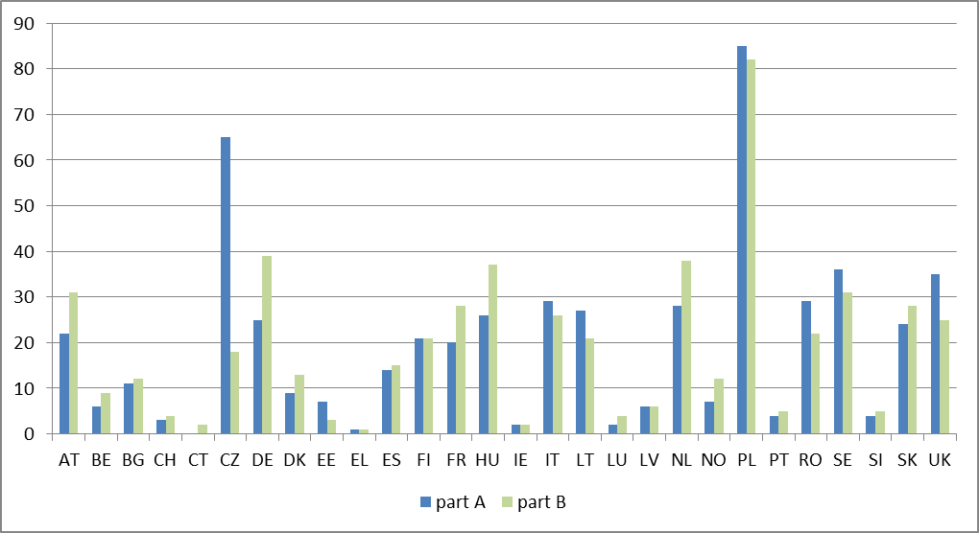
Figure 2: Number of valid Safety Certificates — Part A and B per Member State
(1 January 2014)
Source: Railway Safety Performance in the European Union 2014
http://www.era.europa.eu/Document-Register/Documents/SPR2014.pdf
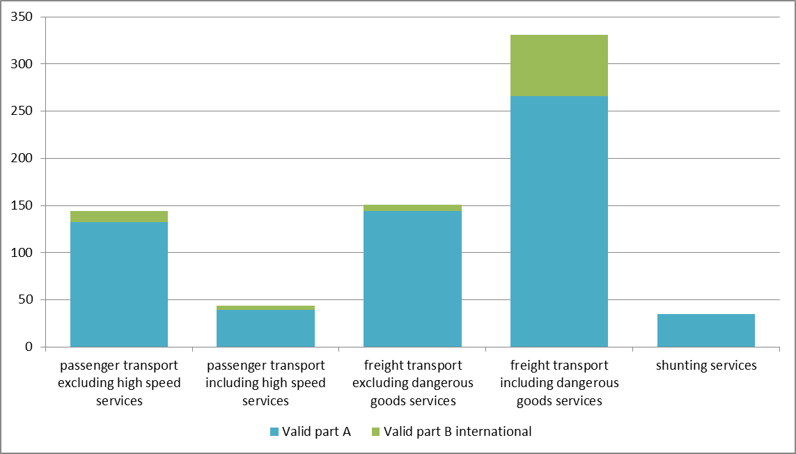
Figure 3: Number of valid Safety Certificates — Part A and B, international operations only, per type of service
Source: Railway Safety Performance in the European Union 2014
http://www.era.europa.eu/Document-Register/Documents/SPR2014.pdf

3.2.3. Safety overview
Monitoring safety performance is one of the key tasks of the European Railway Agency. ERA collects, processes and analyses different sets of data in order to support recommendations on actions to be taken. In this way, ERA facilitates evidence-based policy-making at the EU level. By continuously monitoring and analysing safety performance, ERA provides assurance that the objective of maintaining and improving safety where reasonably practicable is achieved.
In accordance with Article 9(2) of ERA Regulation, ERA publishes a report on a biennial basis since 2006. This report is one of the visible results of ERA’s activities in monitoring safety performance. It is also part of ERA’s effort to provide to its stakeholders a thorough overview of the development of railway safety in the European Union.
The basis for this report is information provided by the national safety authorities and national investigation bodies. According to Articles 18 and 23 of the Railway Safety Directive, these bodies have a legal obligation to report to ERA a set of defined information that can be used to assess the development of railway safety in the EU. Notably, the national safety authorities gather common safety indicators, defined in legislation, from the railway undertakings and infrastructure managers which provide a footprint for safety performance in Member States and the Union. Although this report is largely based on this data, it also includes additional information gathered from other sources (notably other European Commission services), as well as its own data derived from its oversight activities.
In 2012, railway safety continued to improve across the EU, with 2 068 significant accidents resulting in 1 133 fatalities and 1 016 seriously injured persons in the 28 countries. Accident figures have been decreasing considerably over the last six years; the casualty totals have seen slight, close to uniform, reductions over the same period (Figures 4a and 4b).
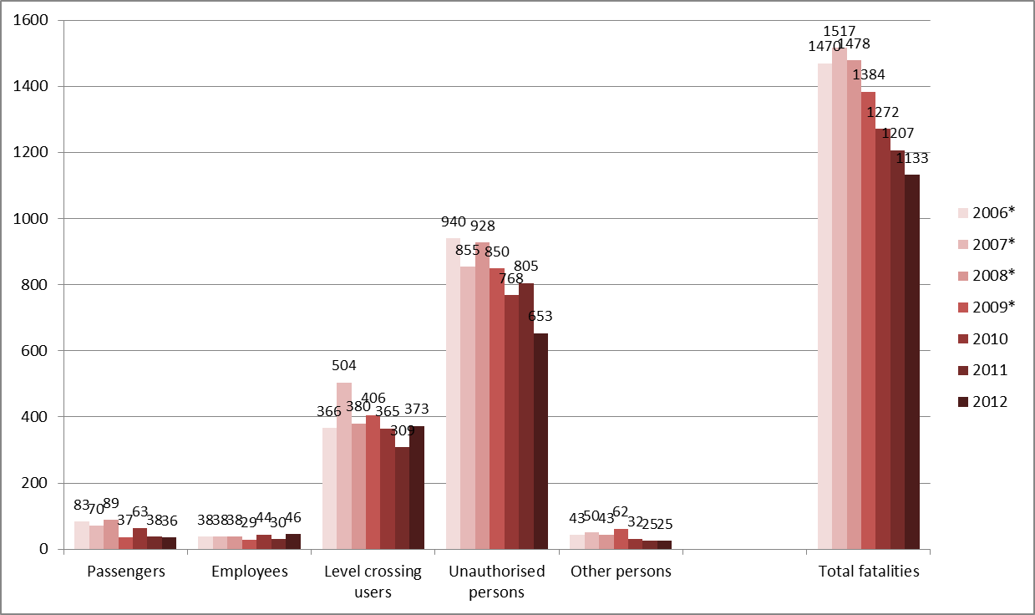
Figure 4a: Number of fatalities per victim category (EU-28: 2006–2012)
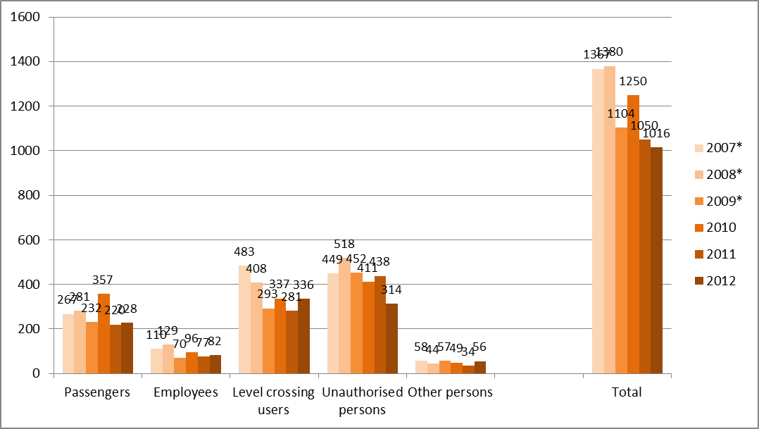
Figure 4b: Seriously injured persons per victim category (EU-28: 2007-2012)
* Data not available for Croatia in the period 2006-2009
Source: Railway Safety Performance in the European Union 2014
http://www.era.europa.eu/Document-Register/Documents/SPR2014.pdf
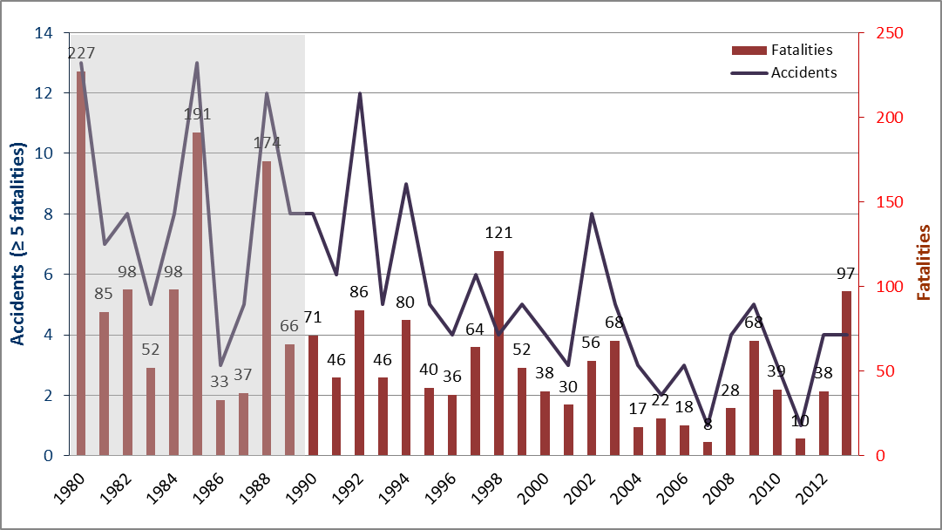
Figure 5: Railway accidents with five or more fatalities (EU-28, 1980-2013)
Source: Railway Safety Performance in the European Union 2014
http://www.era.europa.eu/Document-Register/Documents/SPR2014.pdf

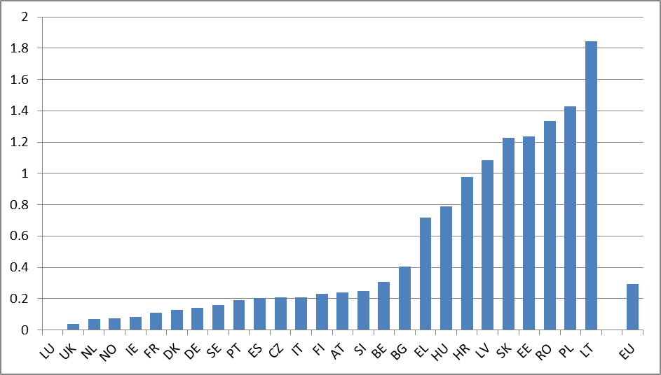
Figure 6: Fatality risk: Railway fatalities and weighted serious injuries per million train-km (2007-2012).
Source: Railway Safety Performance in the European Union 2014
http://www.era.europa.eu/Document-Register/Documents/SPR2014.pdf
According to the figures published in the 2014 report, more than 2 000 significant accidents occur each year on the Member States railways. Accidents to persons caused by rolling stock in motion and level-crossing accidents constitute more than three quarters of railway accidents, excluding suicides. In these accidents, around 1 200 people are killed and a similar number seriously injured each year.
Available historical data on fatal railway accidents shows a solid gradual improvement in railway safety over the past three decades, which has however slowed down since the mid-1990s and further since the mid-2000s. This ‘softening’ of the trend is observable when analysing both absolute and relative figures for fatal train collisions and derailments in Europe. The recording of significant accidents has only been fully harmonised in the EU since 2010. Since then the trend in significant accidents has been aligned with the trend in casualty numbers.
Accident risk, expressed in the number of outcomes per exposure, is probably the best measure of a safety level. The framework for the evaluation of CSTs/NRVs also uses it as a basis for the assessment of safety levels at the level of Member States and the Union. Considering all railway fatalities (excluding suicides), the fatality risk (system risk) per million train-kilometres (train-km) in the period 2010-2012 was 0.3 killed per million train-km in the EU. Similarly, one can estimate the fatality risk of railway passengers (passenger risk). This was 0.15 passengers killed per billion train-km in the period 2010-2012 (Figure 5). Comparison of fatality risks for travelling passengers reveals that rail is the safest mode of land transport in Europe.
Estimating risk levels for different Member States allows us to produce a benchmark highlighting the best and worst performing countries. It appears that safety levels vary greatly among Member States. One third of them have a significantly higher risk than others; the variations in risk within that group of Member States are also significant (Figure 6). It is particularly remarkable that nine Member States have significantly higher risk than the others. A systematic approach to the safety performance improvements of these countries would mean a major step towards genuine EU-wide safety targets in the future.

3.2.4. Occurrences investigated by NIBs
According to the provision of the Railway Safety Directive, the NIBs have to investigate all serious accidents that occur in their territory and may in addition investigate other accidents and incidents. The occurrences investigated by the NIBs are subject to mandatory reporting to ERA. Each accident is reported to ERA twice: as a notification of the opening of an investigation and when the final report is sent to ERA. Both records are available in ERA’s database ERAIL.
Every year, more than 200 accidents and incidents are investigated in the Member States. This number has been slightly increasing over recent years, since more and more NIBs have decided to open an investigation into accidents not categorised as serious according to the Railway Safety Directive. The number of serious railway accidents investigated by NIBs has been stable since 2007 at around 40 per year.
While the majority of serious accidents in the EU are investigated by the NIBs, the share of other similar accidents and other accidents and incidents investigated vary greatly among countries. NIBs carried out nine investigations per year on average in the period 2010-2012.
The approach and methods to accident investigation vary between Member States. One of the tasks of ERA is to facilitate a common understanding of the approach of the Safety Directive within the European Union. Current projects include work on accident causation, safety recommendations and investigator training.
The investigations should not be limited to the identification of the direct causes. This may lead to the risk that systemic factors in the SMS of a RU or IM or even in the regulatory framework remain undetected and safety recommendations may just address the symptoms of a safety problem but not its causes.
ERA works with the NIBs on accident investigation methods, reporting, recommendations and exchange of good practice. With ERA support, the NSAs and NIBs have developed joint guidance on safety recommendations.

3.2.5. Monitoring activities supported by ERA
a) NSA cross-audit programme
Supported by ERA, the NSAs agreed to a programme of audits, to share best practice as well as evaluate the performance of their three main activities required by the Safety and Interoperability Directives: safety certification and safety authorisation, supervision and authorisation for placing in service of vehicles.
From 2011 to 2013 the NSA Network carried out a series of Cross Audits of each other through a pilot phase of 6 audits. A Programme Manual was adopted to ensure the audits would be conducted using a consistent methodology, and Audit Protocols, against which NSAs were audited. ERA trained around 30 NSA and ERA staff to be auditors for the purposes of the Cross Audits.
Following a successful pilot phase, the NSA Cross-Audit Programme has launched its 1st full Audit Cycle (2013-2018), in which all the NSAs will be audited once. During the first year, the NSAs of Channel Tunnel, Sweden, Romania and Austria have been audited.
The programme was set up in order to:
- Evaluate performance of the NSA duties and responsibilities under the Safety Directive;
- support harmonization of their processes and decision making principles; and
- identify any problems related to implementation of the EU legislation.
At this stage, the audit programme focuses on the quality of NSA processes, and does not look critically at the decision-making or risk assessment applied as part of those processes. Early indications are that, while all NSAs appear committed to continuous improvement, many of them are at an early stage in terms of developing and implementing quality processes. Nevertheless, the programme has proven successful at driving improvement within those NSAs audited and those providing auditors. In addition, the audits provide a structured and consistent way to understand how well these key elements of national regulatory frameworks are functioning. Within the agreed boundaries of the programme (the audit findings are not public), this information can also help ERA by complementing the statistics and other information available to develop a fuller picture.
The current cycle is scheduled to end in 2018, by which time the changes brought by the 4th Railway Package are likely to shape the revision of the programme.

b) NIB voluntary assessments
The first NIB assessment programme was launched by ERA in 2013. The objective of these voluntary assessments is to support NIBs, who have a leading role in rail accident investigation in their own Member States, to share good practices and to identify practical improvements to their work, by assessing their current performance. The assessments are made on request, reflecting the individual commitments of NIBs to continuously improve their organisations in this structured and systematic way.
The voluntary assessment relies on the method developed by the NIBs in cooperation with ERA. After a successful pilot assessment of the Hungarian NIB in 2012, two assessments started in 2013. At the same time, two audits were carried out at the request of the European Commission and the National Parliamentary Committee of one Member State in 2013. The assessments were conducted by ERA staff and showed that the two NIBs manage their performance: they deliver good investigation reports including recommendations with the intention to prevent reoccurrence and at the same time seek to continuously improve the investigation process by developing and applying defined processes.
These assessments also showed that while all assessed NIBs have effectively carried out investigation into past accidents, the approaches vary greatly between countries. In some instances, the transposition and the implementation of the legal framework created difficulties for the NIB to work effectively and independently. In some others, the amount of available resources had a great impact on the extent and quality of the work of the organisation.

3.3. Certification of the entities in charge of maintenance: overview

3.3.1. Status of different schemas (ART 10.1 of the Regulation (EU) 445/2011) in EU and non EU Contracting States.
According to the article 10.1 of the Commission Regulation (EU) n° 445/2011 of 10 May 2011, the Member States have to choose between accreditation or recognition of the national certification bodies or shall nominate the NSA as certification body. The situation in 2014 is the following:
- “Accreditation” means that the certification body is accredited by a national accreditation body. Four Member States have chosen the accreditation scheme (Austria, Belgium, Denmark, France) + Norway, Switzerland;
- “Recognition” means that the certification body is a body recognized by the Member State. Three Member States who has chosen recognition (Italy, Portugal, Slovak Republic);
- “NSA as certification body” means that the NSA was designated by the Member state as certification body. 15 NSAs acting are acting as certification body (Bulgaria, Croatia, Czech Republic, Estonia, Germany, Greece, Hungary, Ireland, Latvia, Lithuania, Poland, Romania, Slovenia, Spain, The Netherlands);
- Four Member states have chosen both accreditation and NSA: Finland, Sweden, Luxembourg (with the NSA for the RU and the IM when they act as ECM and accreditation for all the others) and, temporarily, United Kingdom (to be reviewed after two years).
Within this certification scheme, each MS put at disposal of the domestic ECM at less one type of certification.
However, the ECMs are always free to choose between the bodies put at disposal at national level and any accredited or recognized body in another European country. 20 ECMs out of the 248 certified ones have preferred this option.

3.3.2. State of play of ECM certification
Regulation (EU) No 445/2011 of 10 May 2011 on a system of certification of the entity in charge of maintenance for freight wagons entered into force on 31 May 2011. Since then, the system delivered successful results. The number of ECMs certified in accordance with the new system of certification increased from 10 to 248 from May 2012 to March 2014 (Figures 7 and 8).
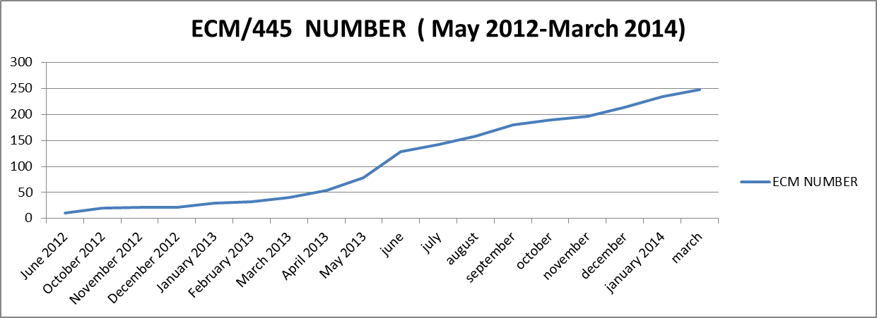
Figure 7: evolution of the number of ECM Certificates issued in accordance with the Regulation (EU) 445/2011
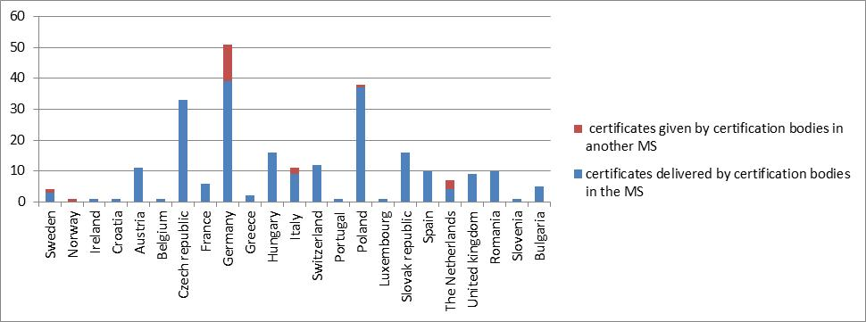
Figure 8: Distribution of the number of ECM certificates in accordance with the regulation 445/2011 by Member States (248 certificates in March 2014).

A similar trend was observed for the number of maintenance workshops certified according with the system of certification set in Regulation (EU) 445/2011. Although the system set up in the regulation is voluntary, the number increased from 1 to 169 during the same period (Figure 9).
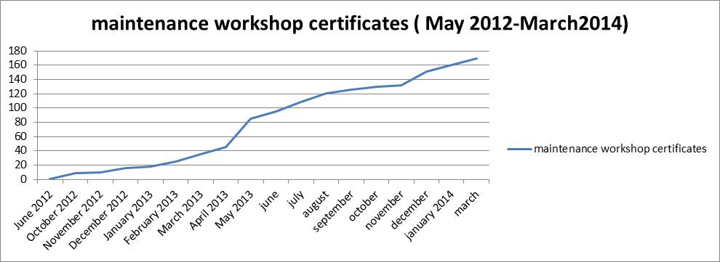
Figure 9: evolution of the number of the certificates for maintenance workshops issued in accordance with the Regulation (EU) 445/2011
During a transitory period the Regulation provides for the acceptance and recognition of certificates issued according to certain systems used before its entry into force:
- The certificates issued by a certification body no later than 31 May 2012 on the basis of principles and criteria equivalent to those of Memorandum of Understanding signed by Member States on 14 May 2009, will be recognized as being equivalent to ECM certificates for their original validity period until at the latest 31 May 2015. At March 2014, there are 26 MoU certificates dispatched in 6 countries (Figure 10).
- The certificates for the workshops based on national laws (ES, NL, RO).

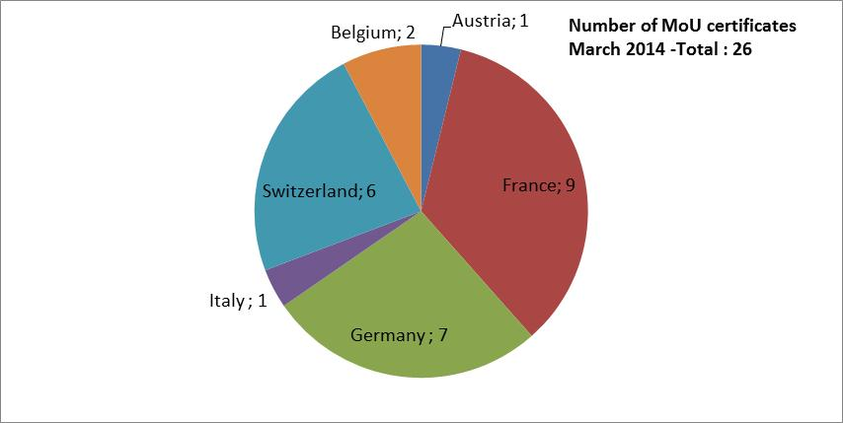
Figure 10: statistics on the ECM certificates issued in accordance with Memorandum of Understanding, recognized under Regulation (EU) 445/2011

3.3.3. ERA supporting activities
a) Cooperation activities of the certification bodies
Accordingly to the article 6(4) of the ECM regulation 445/2011, in order to harmonise their assessment approach, the ECM certification bodies should cooperate with each other both within the Member states and across the Union.
To this aim, ERA organises meetings that are the occasion for all certification bodies to address their needs and feedback on the implementation of the regulation 445/2011 and for developing common solutions to their needs.
In 2013, 3 plenary meetings have been organized and two task forces (on the analysis of gap and on drafting templates for the “release to service” and “return to operation”). A seminar on “ECM an overview” was organized by ERA in November 2013 with more than 120 participants. (ECMs, keepers, maintenance workshops, RUs, IMs, ECM certification bodies).
b) Guidance and dissemination
A new version of the Guide for the application of the Art 14 (a) of the Safety Directive and Commission Regulation (EU) No 445/2011 on a system of certification of entities in charge of maintenance for freight wagons was published in September 2013.
Form April 2012 to December 2013, there were 16 dissemination workshops on ECM organized, the attendance per workshop was approximately between 60 and 120 people.

3.4. Further developments

3.4.1. Monitoring safety performance processes
There are certain limitations to the current EU railway safety monitoring approach. It relies exclusively on outcome indicators, such as the number of accidents and resulting casualties. There is a long-term downward trend for these indicators, with zero values becoming more common in some categories at country level. Relying on these very rare occurrences alone can lead to regulatory planning that is too reactive and fails to capture the available and important information about underlying safety issues. ERA has therefore started to develop new methods for monitoring and evaluating the safety of the railway system at EU level.
The aim of this approach is to create an overview of how the framework is functioning on a Member State level in order to get a better understanding of the mechanisms behind systemic problems but also of where there exists best practice in the application of the regulatory framework to be shared between Member States. For this purpose ERA developed a model, the 'regulatory monitoring matrix', which can provide a systematic overview of the situation in the different Member States concerning Ministry, NSA and NIB-level issues.
The matrix uses information that is already available to ERA within its different work streams and presents it in a structured and accessible way. Further information is gathered through interviews. The expected outcomes of the approach are more focused support to the Member States, more informed advice to the European Commission and better prioritization of ERA’s work. The approach was presented to RISC in June 2013 and a pilot (from December 2013 until June 2014) was carried out with six voluntary Member States to develop a methodology and evaluate the model (BE, DK, IE, UK, NL, SE, June 2014).
The matrix consists of elements of the Railway Safety Directive and brings an understanding on the capability of a Member State to deliver its main requirements. Essentially, the matrix is a tool for a structured discussion with Member States and their authorities, as well as for prioritising the activities of ERA.
The 'regulatory monitoring matrix' covers five areas of effective management (steering, organising, staffing, performing and evaluating), which are further articulated into 26 sub-elements. For each of the sub-elements, an evaluation scheme was defined with five levels of performance. The results can be analysed both on a Member State level (Figure 11) or aggregated (Figure 12).
The pilot results were reported to the RISC in June 2014. The European Commission and ERA proposed to use this tool for a general assessment of the effectiveness of safety management of the Member States, starting from a number of priority countries having significantly higher risk above the EU average (at the right in figure 6).
The experience from the pilot is currently being used by ERA to update the matrix. Evaluations using the updated version are expected to start in September 2014.
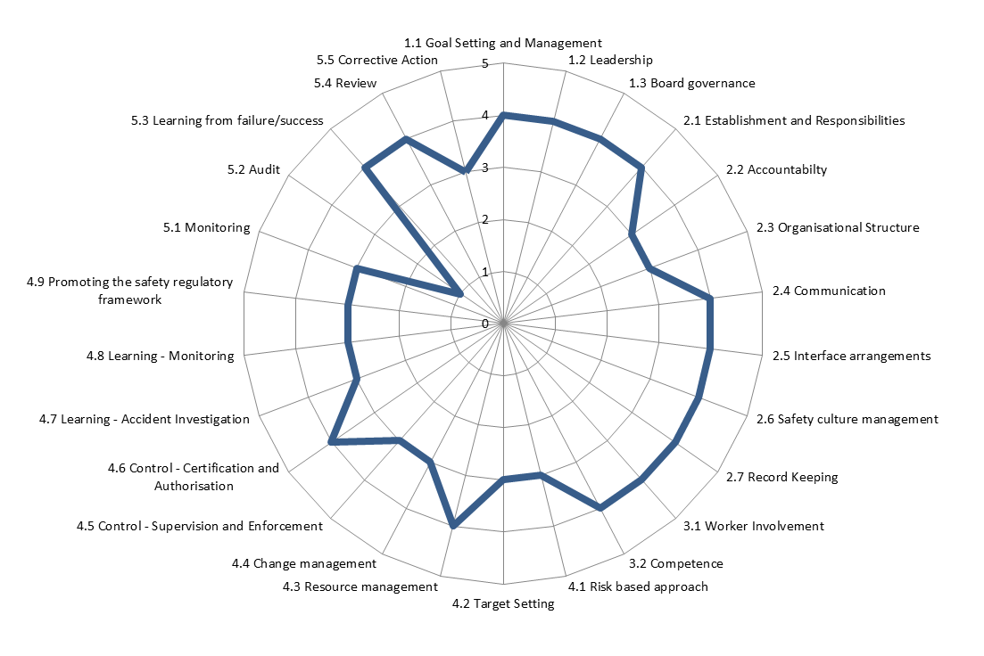
Figure 11: matrix assessment results for a hypothetic Member State in a spider-web diagram, showing poor performance related to the item "Audit" and sufficient or good performance for the other items (level 3 or above).
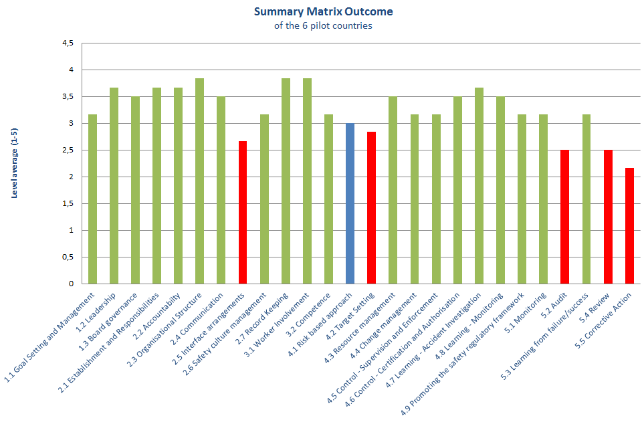
Figure 12: preliminary results for the matrix pilot phase (6 Member States).
(3 = sufficient level of implementation)

3.4.2. A Platform for European Rail Infrastructure Managers (PRIME)
A High Level European Rail Infrastructure Managers’ Platform was launched in January 2014 by the European Commission; it should help to enhance the cooperation among the infrastructure managers and, among other objective, assure better implementation of the common safety approach in the EU.
The first meeting on 28 January 2014 allowed a profitable exchange of views on recent rail accidents and on which preventive measures should be considered.

CONCLUSIONS
Over the past 5 years, the essential legislative targets have been met. The Railway Interoperability and Safety Committee (RISC) held approximately 20 meetings, advising on the measures proposed by the Commission. The overall legislative framework is therefore operational despite some delays or some incorrect transposition in most Member States.
Common safety indicators, methods and targets have been developed since the 2009 progress report. These facilitate collection of information, definition of risk evaluation / assessment methods and instil common safety levels between Member States, providing a framework aimed to harmonise the requirements across Europe for safety certification and authorisation. A harmonised system of certification of entities in charge of maintenance for freight wagons has been also established.
Member States were required to transpose the Railway Safety Directive into their national legal framework. Without doing so, safety measures cannot be consistently applied, developed or improved within the European railway system.
However, transposition provides only one part of the picture: most essential is how the Railway Safety Directive is implemented, in particular with the appropriate allocation of responsibilities to the main actors. Member States should restrain from diluting the responsibility of the operators, e.g. adopting new national safety rules instead of encouraging the railway undertakings to take risk prevention measures adapted to their own specific situation. Finally, Member States should ensure a system-based approach, which includes granting NSAs and NIBs sufficient legal powers, duties and resources to correctly supervise and enforce the roles and responsibilities set out in the Railway Safety Directive.
In general, the results of the assessment indicate that the railway safety performance remains acceptable at the EU level for all categories of railway users under consideration, although it is important that some Member States are watched more closely. Over the coming years, by dedicating more attention to these members, more balanced and improved overall results can be expected.
Taken benefit from its ten-year experience, ERA developed a complementary framework for the collection, process, analysis and publication of data on safety performance related to the process. The European Commission and ERA proposed to use the tool developed by ERA for a general assessment of the railway safety in the Member States, starting from a number of countries having significantly higher risk above the EU average.
Recent initiatives from the Commission in the framework of the 4th Railway Package and the development of a platform for Infrastructure managers in Europe (PRIME) have real potential to bring further safety improvements.

Directive 2004/49/EC of the European Parliament and of the Council of 29 April 2004 on safety on the Community’s railways and amending Council Directive 95/18/EC on the licensing of railway undertakings and Directive 2001/14/EC on the allocation of railway infrastructure capacity and the levying of charges for the use of railway infrastructure and safety certification (OJ L 164, 30.4.2004, p. 44 and Corrigendum, OJ L 220, 21.6.2004, p. 16.
Directive 2007/59/EC of the European Parliament and of the Council of 23 October 2007 on the certification of train drivers operating locomotives and trains on the railway system in the Community, OJ L315 of 3 December 2007, p. 51.
OJ L 122 of 11.5.11, p. 22
OJ L 108 of 29.4.09, p. 4
OJ L 121 of 3.5.13, p. 8
http://www.consilium.europa.eu/uedocs/cms_data/docs/pressdata/en/ec/127599.pdf.
COM (2012) 299 final.
COM(2012) 259 final.
OJ L 164, 30.4.2004, p. 44.
OJ L 191, 18.7.2008, p. 1
OJ L 345, 23.12.2008, p. 62
OJ L313 of 28.11.09, p. 65
OJ L201 of 10.7.2014, p.9
OJ L 108, 29.4.2009, p. 4
OJ L 121 of 3.5.13, p. 8
OJ L326 of 10.12.2010, p.11
OJ L327 of 11.12.2010, p.13
OJ L 320 of 17.11.2012, p.3
OJ L 320 of 17.11.2012, p. 8
Weighted fatalities and serious injuries (FWSI) are the normalised measure of railway safety outcome. One seriously injured person is considered as 0.1 fatalities and added to the number of fatalities in the given year.
OJ L189 of 22.7.2010, p. 19
OJ L189 of 22.7.2010, p. 19
OJ L 334 of 13.12.13, p. 37
OJ L 122 of 11.5.11, p. 22
To the specific purpose of addressing urgent matter (e.g.; after an accident) ERA is currently working for establishing a Quick Response Procedure.
Directive 2008/57/EC of the European Parliament and of the Council of 17 June 2008 on the interoperability of the rail system within the Community (OJ L 191, 18.7.2008, p. 1).
Commission Regulation (EC) No 653/2007 on the use of a common European format for safety certificates and application documents in accordance with Article 10 of Directive 2004/49/EC of the European Parliament and of the Council and on the validity of safety certificates delivered under Directive 2001/14/EC (OJ L 153, 14.6.2007, p. 9) Commission Regulation (EU) No 1158/2010 on a common safety method for assessing conformity with the requirements for obtaining railway safety certificates (OJ L 326, 10.12.2010, p. 11) Commission Regulation (EU) No 1077/2012 on a common safety method for supervision by national safety authorities after issuing a safety certificate or safety authorisation (OJ L 320, 17.11.2012, p. 3)
Commission Decision 2009/460/EC of 5 June 2009 on the adoption of a common safety method for assessment of achievement of safety targets, as referred to in Article 6 of Directive 2004/49/EC of the European Parliament and of the Council, OJ L 150, 13.6.2009, p. 11.
(?) MWA=Moving weighted average, OSP=Observed safety performance.
Regulation (EC) No 881/2004 of the European Parliament and of the Council of 29 April 2004 establishing a European railway agency (Agency Regulation, OJ L 164 of 30.4.2004, p. 1)
All EU countries, Norway and Switzerland, excluding Romania and Croatia for the period 1980–1989. Accidents on railway lines not covered by the Railway Safety Directive are also included.
Guide available on ERA web site: http://www.era.europa.eu/Document-Register/Pages/guidance-on-safety-recommendations-Safety-Directive-Art-25.aspx

