ê 562/2006
ANNEX I
Supporting documents to verify the fulfilment of entry conditions
The documentary evidence referred to in Article 6(3) may include the following:
(a) for business trips:
(i) an invitation from a firm or an authority to attend meetings, conferences or events connected with trade, industry or work;
(ii) other documents which show the existence of trade relations or relations for work purposes;
(iii) entry tickets for fairs and congresses if attending one;
(b) for journeys undertaken for the purposes of study or other types of training:
(i) a certificate of enrolment at a teaching institute for the purposes of attending vocational or theoretical courses in the framework of basic and further training;
(ii) student cards or certificates for the courses attended;
(c) for journeys undertaken for the purposes of tourism or for private reasons:
(i) supporting documents as regards lodging:
- an invitation from the host if staying with one;
- a supporting document from the establishment providing lodging or any other appropriate document indicating the accommodation envisaged;
(ii) supporting documents as regards the itinerary:
confirmation of the booking of an organised trip or any other appropriate document indicating the envisaged travel plans;
(iii) supporting documents as regards return:
a return or round-trip ticket;
(d) for journeys undertaken for political, scientific, cultural, sports or religious events or other reasons:
invitations, entry tickets, enrolments or programmes stating wherever possible the name of the host organisation and the length of stay or any other appropriate document indicating the purpose of the visit.
_____________
ANNEX II
Registration of information
At all border crossing points, all service information and any other particularly important information shall be registered manually or electronically. The information to be registered shall include in particular:
(a) the names of the border guard responsible locally for border checks and of the other officers in each team;
(b) relaxation of checks on persons applied in accordance with Article 9 ;
(c) the issuing, at the border, of documents in place of passports and of visas;
(d) persons apprehended and complaints (criminal offences and administrative breaches);
(e) persons refused entry in accordance with Article 14 (grounds for refusal and nationalities);
(f) the security codes of entry and exit stamps, the identity of border guards to whom a given stamp is assigned at any given time or shift and the information relating to lost and stolen stamps;
(g) complaints from persons subject to checks;
(h) other particularly important police or judicial measures;
(i) particular occurrences.
_____________
ANNEX III
Model signs indicating lanes at border crossing points

PART A


ê 610/2013 Art. 1.21 and Annex I.1(a)

PART B1: ‘visa not required’;
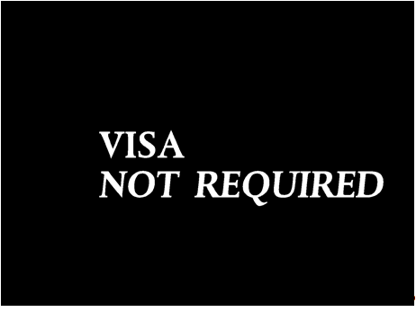

PART B2: ‘all passports’.
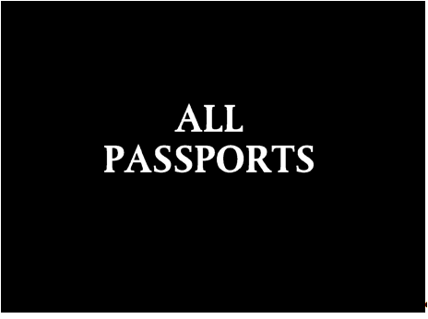

ê 562/2006

PART C
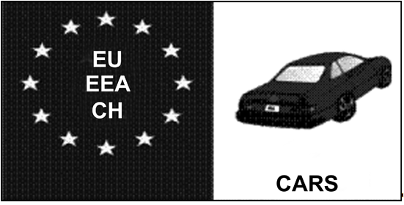
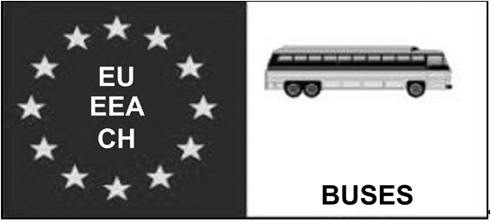
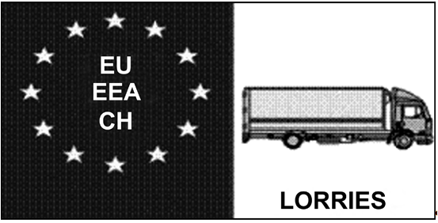

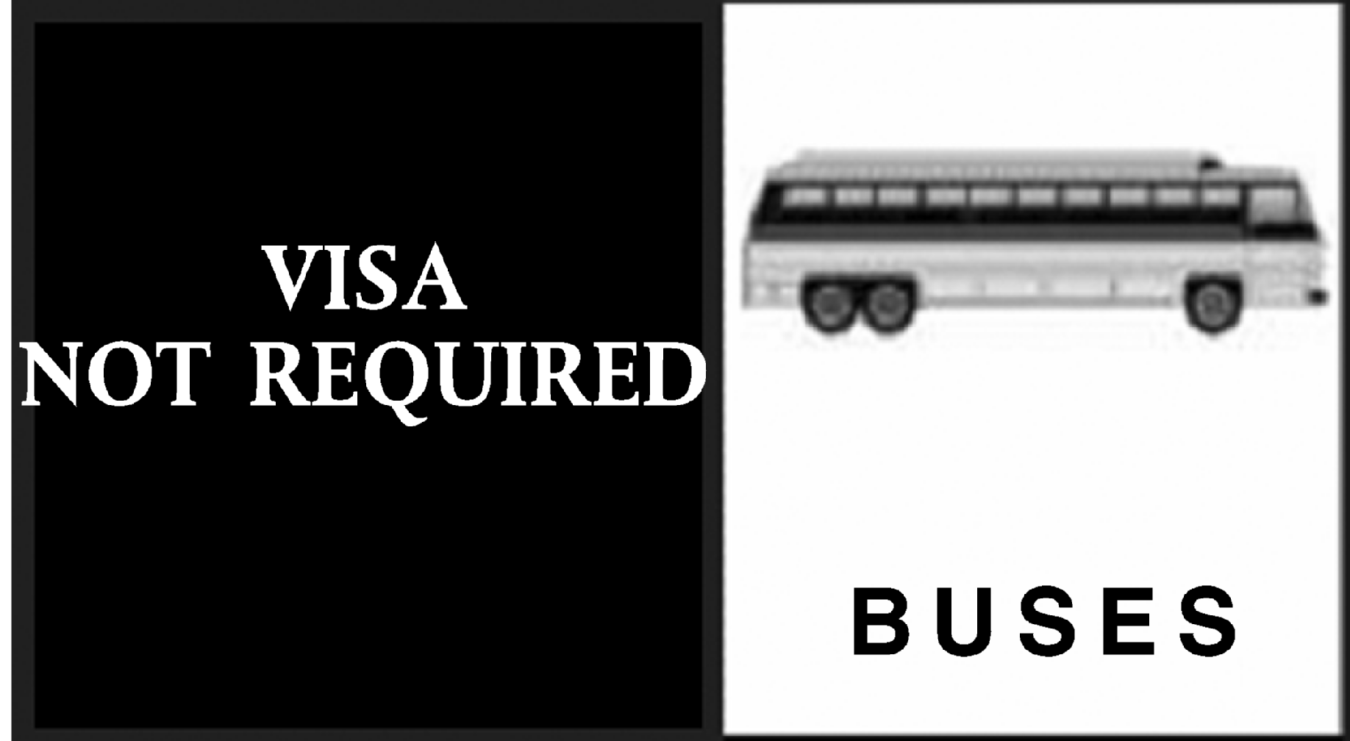
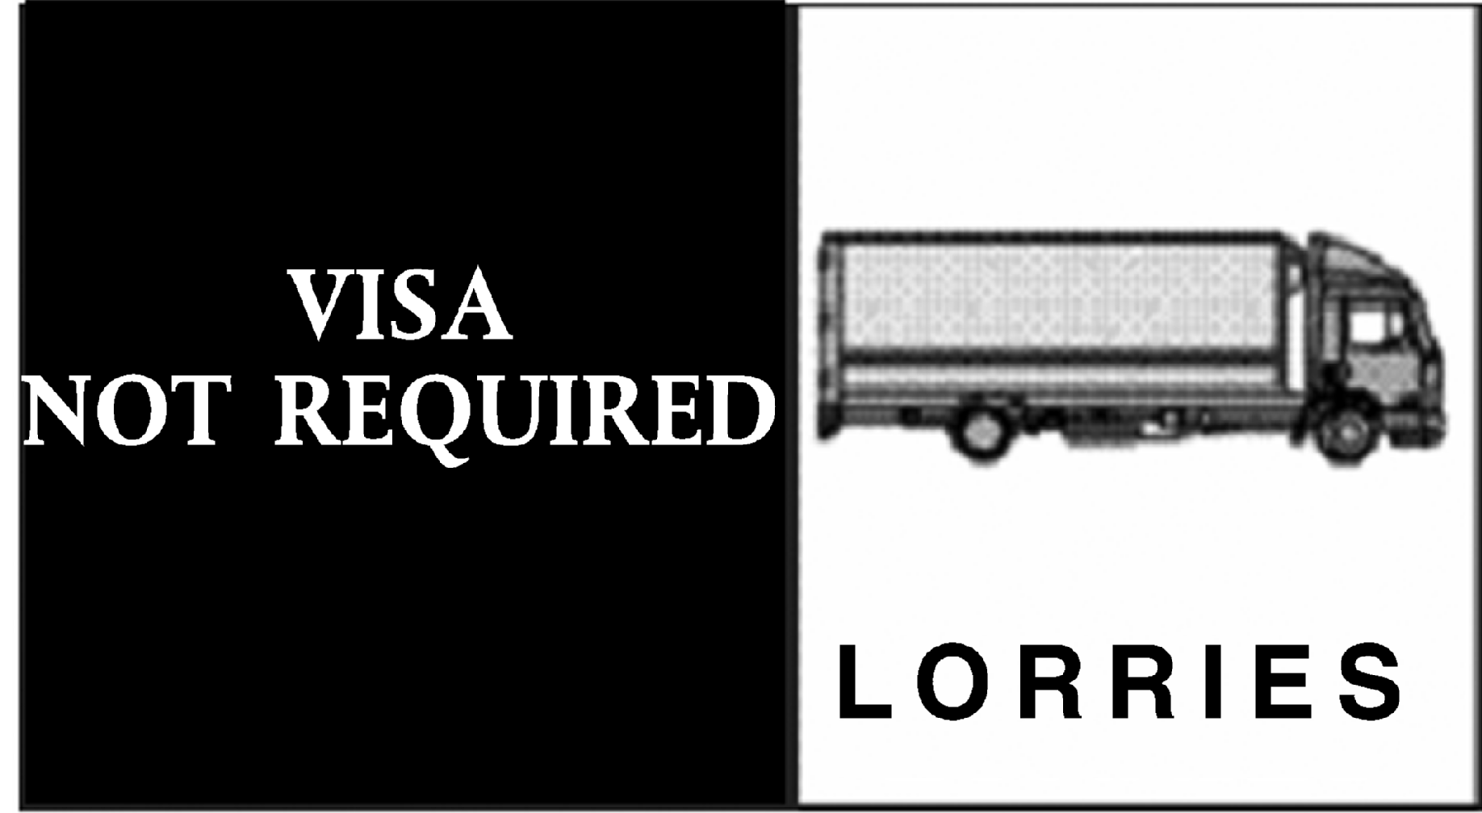
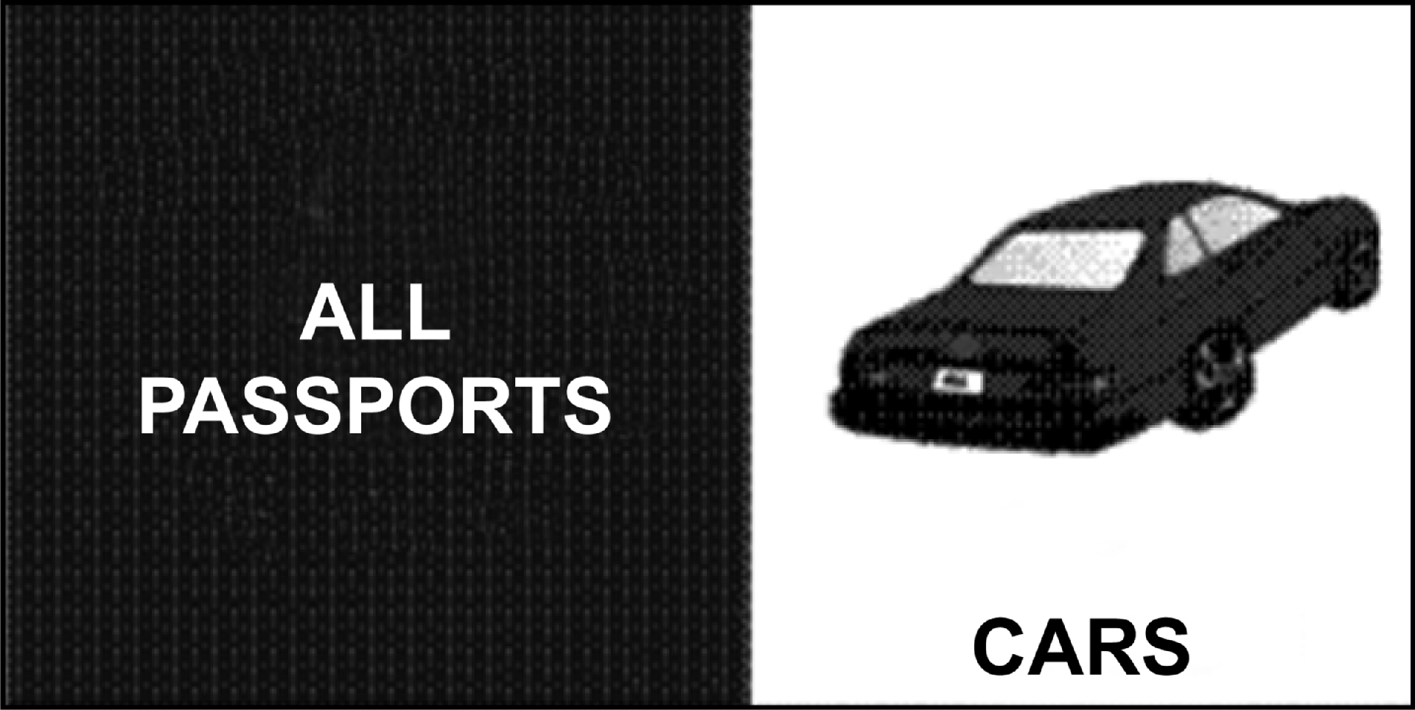
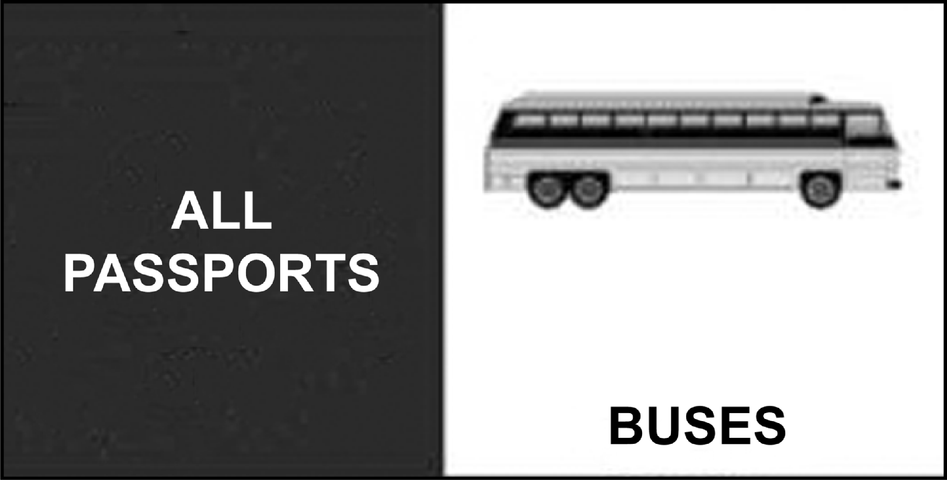
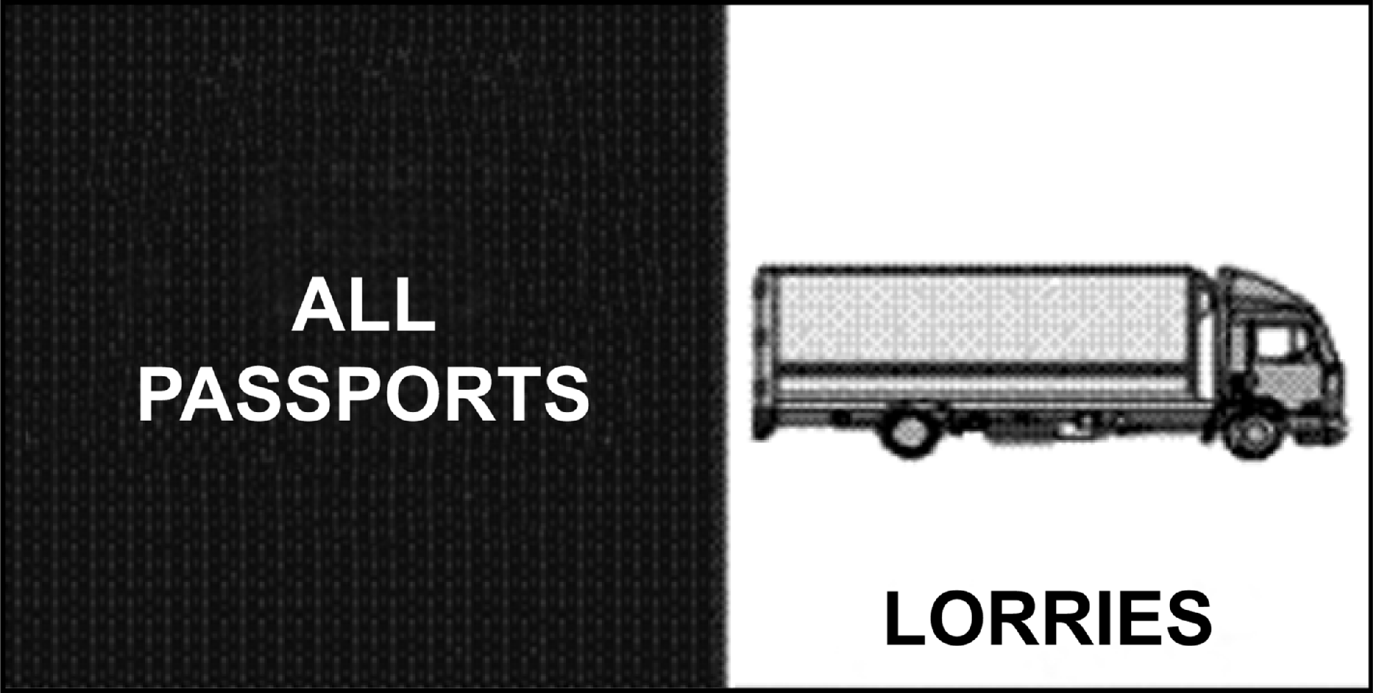
_____________
ANNEX IV
Affixing stamps
1. The travel documents of third-country nationals shall be systematically stamped on entry and exit, in accordance with Article 11 . The specifications of those stamps are laid down in the Schengen Executive Committee Decision SCH/COM-EX (94) 16 rev and SCH/Gem-Handb (93) 15 (CONFIDENTIAL).
2. The security codes on the stamps shall be changed at regular intervals not exceeding one month.

ê 610/2013 Art. 1.21 and Annex I.2
3. On the entry and exit of third-country nationals subject to the visa obligation, the stamp shall, as a general rule, be affixed on the page facing the one on which the visa is affixed.

ê 562/2006
If that page cannot be used, the stamp shall be entered on the following page. The machine readable zone shall not be stamped.
4. Member States shall designate national contact points responsible for exchanging information on the security codes of the entry and exit stamps used at border crossing points and shall inform the other Member States, the General Secretariat of the Council and the Commission thereof. Those contact points shall have access without delay to information regarding common entry and exit stamps used at the external border of the Member State concerned, and in particular to information on the following:
(a) the border crossing point to which a given stamp is assigned;
(b) the identity of the border guard to whom a given stamp is assigned at any given time;
(c) the security code of a given stamp at any given time.
Any inquiries regarding common entry and exit stamps shall be made through the abovementioned national contact points.
The national contact points shall also forward immediately to the other contact points, the General Secretariat of the Council and the Commission information regarding a change in the contact points as well as lost and stolen stamps.
_____________
ANNEX V

PART A

Procedures for refusing entry at the border
1. When refusing entry, the competent border guard shall:
(a) fill in the standard form for refusing entry, as shown in Part B. The third-country national concerned shall sign the form and shall be given a copy of the signed form. Where the third-country national refuses to sign, the border guard shall indicate this refusal in the form under the section ‘comments’;
(b) affix an entry stamp on the passport, cancelled by a cross in indelible black ink, and write opposite it on the right-hand side, also in indelible ink, the letter(s) corresponding to the reason(s) for refusing entry, the list of which is given on the abovementioned standard form for refusing entry;

ê 810/2009 Art. 55.a
(c) annul or revoke the visas, as appropriate, in accordance with the conditions laid down in Article 34 of Regulation (EC) No 810/2009;

ê 562/2006
è1 610/2013 Art. 1.21 and Annex I.3
(d) record every refusal of entry in a register or on a list stating the identity and nationality of the third-country national concerned, the references of the document authorising the third-country national to cross the border and the reason for, and date of, refusal of entry.
2. If a third-country national who has been refused entry is brought to the border by a carrier, the authority responsible locally shall:
(a) order the carrier to take charge of the third-country national and transport him or her without delay to the third country from which he or she was brought, to the third country which issued the document authorising him or her to cross the border, or to any other third country where he or she is guaranteed admittance, or to find means of onward transportation in accordance with Article 26 of the Schengen Convention and Council Directive 2001/51/EC;
(b) pending onward transportation, take appropriate measures, in compliance with national law and having regard to local circumstances, to prevent third-country nationals who have been refused entry from entering illegally.
3. If there are grounds both for refusing entry to a third-country national and arresting him or her, the border guard shall contact the authorities responsible to decide on the action to be taken in accordance with national law.

PART B

Standard form for refusal of entry at the border
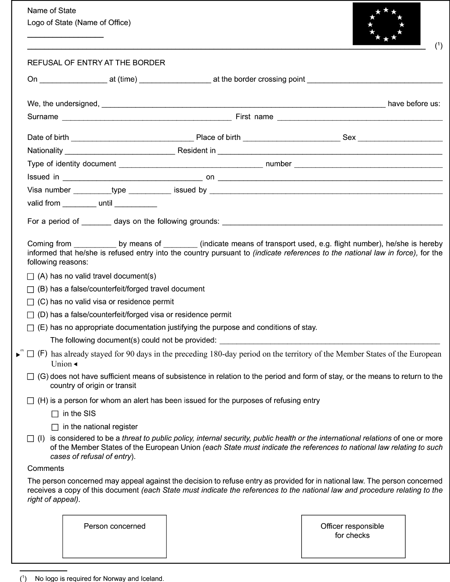
è1 ç
_____________
ANNEX VI
Specific rules for the various types of border and the various means of transport used for crossing the Member States' external borders

1. Land borders

1.1. Checks on road traffic
1.1.1. To ensure effective checks on persons, while ensuring the safety and smooth flow of road traffic, movements at border crossing points shall be regulated in an appropriate manner. Where necessary, Member States may conclude bilateral agreements to channel and block traffic. They shall inform the Commission thereof pursuant to Article 42 .
1.1.2. At land borders, Member States may, where they deem appropriate and if circumstances allow, install or operate separate lanes at certain border crossing points, in accordance with Article 10 .
Separate lanes may be dispensed with at any time by the Member States' competent authorities, in exceptional circumstances and where traffic and infrastructure conditions so require.
Member States may cooperate with neighbouring countries with a view to the installation of separate lanes at external border crossing points.
1.1.3. As a general rule, persons travelling in vehicles may remain inside them during checks. However, if circumstances so require, persons may be requested to alight from their vehicles. Thorough checks will be carried out, if local circumstances allow, in areas designated for that purpose. In the interests of staff safety, checks will be carried out, where possible, by two border guards.

ê 610/2013 Art. 1.21 and Annex I.4(a) (adapted)

1.1.4. Shared border crossing points
1.1.4.1. Member States may conclude or maintain bilateral agreements with neighbouring third countries concerning the establishment of shared border crossing points, at which Member State border guards and third-country border guards carry out exit and entry checks one after another in accordance with their national law on the territory of the other party. Shared border crossing points may be located either on the territory of a Member State territory or on the territory of a third country.
1.1.4.2. Shared border crossing points located on Member State territory: bilateral agreements establishing shared border crossing points located on Member State territory shall contain an authorisation for third-country border guards to exercise their tasks in the Member State, respecting the following principles:
(a) International protection: a third-country national asking for international protection on Member State territory shall be given access to relevant Member State procedures in accordance with the Union asylum acquis.
(b) Arrest of a person or seizure of property: if third-country border guards become aware of facts justifying the arrest or placing under protection of a person or seizure of property, they shall inform Member State authorities of those facts and Member State authorities shall ensure an appropriate follow-up in accordance with national, Union and international law, independently of the nationality of the concerned person.
(c) Persons enjoying the right of free movement under Union law entering Union territory: third-country border guards shall not prevent persons enjoying the right of free movement under Union law from entering Union territory. If there are reasons justifying refusal of exit from the third country concerned, third-country border guards shall inform Member State authorities of those reasons and Member State authorities shall ensure an appropriate follow-up in accordance with national, Union and international law.
1.1.4.3. Shared border crossing points located on third-country territory: bilateral agreements establishing shared border crossing points located on third-country territory shall contain an authorisation for Member State border guards to perform their tasks in the third country. For the purpose of this Regulation, any check carried out by Member State border guards in a shared border crossing point located on the territory of a third country shall be deemed to be carried out on the territory of the Member State concerned. Member State border guards shall exercise their tasks in accordance with Ö this Õ Regulation and respecting the following principles:
(a) International protection: a third-country national who has passed exit control by third-country border guards and subsequently asks Member State border guards present in the third country for international protection, shall be given access to relevant Member State procedures in accordance with Union asylum acquis. Third-country authorities shall accept the transfer of the person concerned into Member State territory.
(b) Arrest of a person or seizure of property: if Member State border guards become aware of facts justifying the arrest or placing under protection of a person or seizure of property, they shall act in accordance with national, Union and international law. Third-country authorities shall accept a transfer of the person or object concerned into Member State territory.
(c) Access to IT systems: Member State border guards shall be able to use information systems processing personal data in accordance with Article 8. Member States shall be allowed to establish the technical and organisational security measures required by Union law to protect personal data against accidental or unlawful destruction or accidental loss, alteration, unauthorised disclosure or access, including access by third-country authorities.
1.1.4.4. Before concluding or amending any bilateral agreement on shared border crossing points with a neighbouring third country, the Member State concerned shall consult the Commission as to the compatibility of the agreement with Union law. Pre-existing bilateral agreements shall be notified to the Commission by 20 January 2014.
If the Commission considers the agreement to be incompatible with Union law, it shall notify the Member State concerned. The Member State shall take all appropriate steps to amend the agreement within a reasonable period in such a way as to eliminate the incompatibilities established.

ê 562/2006

1.2. Checks on rail traffic

ê 610/2013 Art. 1.21 and Annex I.4(a)
1.2.1. Checks shall be carried out both on train passengers and on railway staff on trains crossing external borders, including those on goods trains or empty trains. Member States may conclude bilateral or multilateral agreements on how to conduct those checks respecting the principles set out in point 1.1.4. Those checks shall be carried out in one of the following ways:
- in the first station of arrival or last station of departure on the territory of a Member State;
- on board the train, during transit between the last station of departure in a third country and the first station of arrival on the territory of a Member State or vice versa;
- in the last station of departure or the first station of arrival on the territory of a third country.
1.2.2. In addition, in order to facilitate rail traffic flows of high-speed passenger trains, the Member States on the itinerary of these trains from third countries may also decide, by common agreement with third countries concerned respecting the principles set out in point 1.1.4., to carry out entry checks on persons on trains from third countries in either one of the following ways:
- in the stations in a third country where persons board the train;
- in the stations where persons disembark within the territory of the Member States;
- on board the train during transit between stations on the territory of a third country and stations on the territory of the Member States, provided that the persons stay on board the train.

ê 562/2006
1.2.3. With respect to high-speed trains from third countries making several stops in the territory of the Member States, if the rail transport carrier is in a position to board passengers exclusively for the remaining part of the journey within the territory of the Member States, such passengers shall be subject to entry checks either on the train or at the station of destination except where checks have been carried out pursuant to points 1.2.1 or 1.2.2 first indent.
Persons who wish to take the train exclusively for the remaining part of the journey within the territory of the Member States shall receive clear notification prior to the train's departure that they will be subject to entry checks during the journey or at the station of destination.
1.2.4. When travelling in the opposite direction, the persons on board the train shall be subject to exit checks under similar arrangements.
1.2.5. The border guard may order the cavities of carriages to be inspected if necessary with the assistance of the train inspector, to ensure that persons or objects subject to border checks are not concealed in them.
1.2.6. Where there are reasons to believe that persons who have been reported or are suspected of having committed an offence, or third-country nationals intending to enter illegally, are hiding on a train, the border guard, if he or she cannot act in accordance with his national provisions, shall notify the Member States towards or within whose territory the train is moving.

2. Air borders

2.1. Procedures for checks at international airports
2.1.1. The competent authorities of the Member States shall ensure that the airport operator takes the requisite measures to physically separate the flows of passengers on internal flights from the flows of passengers on other flights. Appropriate infrastructures shall be set in place at all international airports to that end.
2.1.2. The place where border checks are carried out shall be determined in accordance with the following procedure:
(a) passengers on a flight from a third country who board an internal flight shall be subject to an entry check at the airport of arrival of the flight from a third country. Passengers on an internal flight who board a flight for a third country (transfer passengers) shall be subject to an exit check at the airport of departure of the latter flight;
(b) for flights from or to third countries with no transfer passengers and flights making more than one stop-over at the airports of the Member States where there is no change of aircraft:
(i) passengers on flights from or to third countries where there is no prior or subsequent transfer within the territory of the Member States shall be subject to an entry check at the airport of entry and an exit check at the airport of exit;
(ii) passengers on flights from or to third countries with more than one stop-over on the territory of the Member States where there is no change of aircraft (transit passengers), and provided that passengers cannot board the aircraft for the leg situated within the territory of the Member States, shall be subject to an entry check at the airport of arrival and an exit check at the airport of departure;
(iii) where an airline may, for flights from third countries with more than one stop-over within the territory of the Member States, board passengers only for the remaining leg within that territory, passengers shall be subject to an exit check at the airport of departure and an entry check at the airport of arrival.
Checks on passengers who, during those stop-overs, are already on board the aircraft and have not boarded in the territory of the Member States shall be carried out in accordance with point (ii). The reverse procedure shall apply to that category of flights where the country of destination is a third country.
2.1.3. Border checks will normally not be carried out on the aircraft or at the gate, unless it is justified on the basis of an assessment of the risks related to internal security and illegal immigration. In order to ensure that, at the airports designated as border crossing points, persons are checked in accordance with the rules set out in Articles 7 to 14, Member States shall ensure that the airport authorities take the requisite measures to channel passenger traffic to facilities reserved for checks.
Member States shall ensure that the airport operator takes the necessary measures to prevent unauthorised persons entering and leaving the reserved areas, for example the transit area. Checks will normally not be carried out in the transit area, unless it is justified on the basis of an assessment of the risks related to internal security and illegal immigration; in particular checks in this area may be carried out on persons subject to an airport transit visa in order to check that they are in possession of such a visa.
2.1.4. Where, in cases of force majeure or imminent danger or on the instructions of the authorities, an aircraft on a flight from a third country has to land on a landing ground which is not a border crossing point, that aircraft may continue its flight only after authorisation from the border guards and from customs. The same shall apply where an aircraft on a flight from a third country lands without permission. In any event, Articles 7 to 14 shall apply to checks on persons on those aircraft.

2.2. Procedures for checks in aerodromes
2.2.1. It shall be ensured that persons are also checked, in accordance with Articles 7 to 14, in airports which do not hold the status of international airport under the relevant national law (aerodromes) but through which the routing of flights from or to third countries is authorised.
2.2.2. By way of derogation from point 2.1.1 it shall not be necessary to make appropriate arrangements in aerodromes to ensure that inflows of passengers from internal and other flights are physically separated, without prejudice to Regulation (EC) No 300/2008 of the European Parliament and of the Council. In addition, when the volume of traffic is low, the border guards need not be present at all times, provided that there is a guarantee that the necessary personnel can be deployed in good time.
2.2.3. When the presence of the border guards is not assured at all times in the aerodrome, the manager of the aerodrome shall give adequate notice to the border guards about the arrival and the departure of aircrafts on flights from or to third countries.

2.3. Checks on persons on private flights
2.3.1. In the case of private flights from or to third countries the captain shall transmit to the border guards of the Member State of destination and, where appropriate, of the Member State of first entry, prior to take-off, a general declaration comprising inter alia a flight plan in accordance with Annex 2 to the Convention on International Civil Aviation and information concerning the passengers' identity.
2.3.2. Where private flights coming from a third country and bound for a Member State make stop-overs in the territory of other Member States, the competent authorities of the Member State of entry shall carry out border checks and affix an entry stamp to the general declaration referred to in point 2.3.1.
2.3.3. Where uncertainty exists whether a flight is exclusively coming from, or solely bound for, the territories of the Member States without stop-over on the territory of a third country, the competent authorities shall carry out checks on persons in airports and aerodromes in accordance with points 2.1 to 2.2.
2.3.4. The arrangements for the entry and exit of gliders, micro-light aircraft, helicopters, small-scale aircraft capable of flying short distances only and airships shall be laid down by national law and, where applicable, by bilateral agreements.

3. Sea borders

ê 610/2013 Art. 1.21 and Annex I.4(b) (adapted)

3.1. General checking procedures on maritime traffic
3.1.1. Checks on ships shall be carried out at the port of arrival or departure, or in an area set aside for that purpose, located in the immediate vicinity of the vessel or on board ship in the territorial waters as defined by the United Nations Convention on the Law of the Sea. Member States may conclude agreements according to which checks may also be carried out during crossings or, upon the ship's arrival or departure, on the territory of a third country, respecting the principles set out in point 1.1.4.
3.1.2. The master, the ship's agent or some other person duly authorised by the master or authenticated in a manner acceptable to the public authority concerned (in both cases ‘the master’), shall draw up a list of the crew and any passengers containing the information required in the forms 5 (crew list) and 6 (passenger list) of the Convention on Facilitation of International Maritime Traffic (FAL Convention) as well as, where applicable, the visa or residence permit numbers:
- at the latest twenty-four hours before arriving in the port, or
- at the latest at the time the ship leaves the previous port, if the voyage time is less than twenty-four hours, or
- if the port of call is not known or it is changed during the voyage, as soon as this information is available.
The master shall communicate the list(s) to the border guards or, if national law so provides, to other relevant authorities which shall forward the list(s) without delay to the border guards.
3.1.3. A confirmation of receipt (signed copy of the list(s) or an electronic receipt confirmation) shall be returned to the master by the border guards or by the authorities referred to in point 3.1.2., who shall produce it on request when the ship is in port.
3.1.4. The master shall promptly report to the competent authority any changes to the composition of the crew or the number of passengers.
In addition, the master shall notify the competent authorities promptly, and within the time-limit set out in point 3.1.2., of the presence on board of stowaways. Stowaways, however, remain under the responsibility of the master.
By way of derogation from Articles 5 and 8, no systematic border checks shall be carried out on persons staying aboard. Nevertheless a search of the ship and checks on the persons staying aboard shall be carried out by border guards only when this is justified on the basis of an assessment of the risks related to internal security and illegal immigration.
3.1.5. The master shall notify the competent authority of the ship's departure in due time and in accordance with the rules in force in the port concerned.

ê 562/2006

3.2. Specific check procedures for certain types of shipping

Cruise ships

ê 610/2013 Art. 1.21 and Annex I.4(c)
3.2.1. The cruise ship's master shall transmit to the competent authority the itinerary and the programme of the cruise, as soon as they have been established and no later than within the time-limit set out in point 3.1.2.

ê 562/2006
3.2.2. If the itinerary of a cruise ship comprises exclusively ports situated in the territory of the Member States, by way of derogation from Articles 5 and 8, no border checks shall be carried out and the cruise ship may dock at ports which are not border crossing points.

ê 610/2013 Art. 1.21 and Annex I.4(c)
Nevertheless, checks shall be carried out on the crew and passengers of those ships only when this is justified on the basis of an assessment of the risks related to internal security and illegal immigration.

ê 562/2006
è1 610/2013 Art. 1.21 and Annex I.4(c)
3.2.3. If the itinerary of a cruise ship comprises both ports situated in the territory of the Member States and ports situated in third countries, by way of derogation from Article 8, border checks shall be carried out as follows:
(a) where the cruise ship comes from a port situated in a third country and calls for the first time at a port situated in the territory of a Member State, crew and passengers shall be subject to entry checks on the basis of the nominal lists of crew and passengers, as referred to in è1 point 3.1.2 ç.
Passengers going ashore shall be subject to entry checks in accordance with Article 8 unless an assessment of the risks related to internal security and illegal immigration shows that there is no need to carry out such checks;
(b) where the cruise ship comes from a port situated in a third country and calls again at a port situated in the territory of a Member State, crew and passengers shall be subject to entry checks on the basis of the nominal lists of crew and passengers as referred to in è1 point 3.1.2. ç to the extent that those lists have been modified since the cruise ship called at the previous port situated in the territory of a Member State.
Passengers going ashore shall be subject to entry checks in accordance with Article 8 unless an assessment of the risks related to internal security and illegal immigration shows that there is no need to carry out such checks;
(c) where the cruise ship comes from a port situated in a Member State and calls at such a port, passengers going ashore shall be subject to entry checks in accordance with Article 8 if an assessment of the risks related to internal security and illegal immigration so requires;
(d) where a cruise ship departs from a port situated in a Member State to a port in a third country, crew and passengers shall be subject to exit checks on the basis of the nominal lists of crew and passengers.
If an assessment of the risks related to internal security and illegal immigration so requires, passengers going on board shall be subject to exit checks in accordance with Article 8;
(e) where a cruise ship departs from a port situated in a Member State to such a port, no exit checks shall be carried out.

ê 610/2013 Art. 1.21 and Annex I.4(c)
Nevertheless, checks shall be carried out on the crew and passengers of those ships only when this is justified on the basis of an assessment of the risks related to internal security and illegal immigration.

ê 562/2006

Pleasure boating
3.2.4. By way of derogation from Articles 5 and 8, persons on board a pleasure boat coming from or departing to a port situated in a Member State shall not be subject to border checks and may enter a port which is not a border crossing point.
However, according to the assessment of the risks of illegal immigration, and in particular where the coastline of a third country is located in the immediate vicinity of the territory of the Member State concerned, checks on those persons and/or a physical search of the pleasure boat shall be carried out.
3.2.5. By way of derogation from Article 5, a pleasure boat coming from a third country may, exceptionally, enter a port which is not a border crossing point. In that case, the persons on board shall notify the port authorities in order to be authorised to enter that port. The port authorities shall contact the authorities in the nearest port designated as a border crossing point in order to report the vessel's arrival. The declaration regarding passengers shall be made by lodging the list of persons on board with the port authorities. That list shall be made available to the border guards, at the latest upon arrival.
Likewise, if for reasons of force majeure the pleasure boat coming from a third country has to dock in a port other than a border crossing point, the port authorities shall contact the authorities in the nearest port designated as a border crossing point in order to report the vessel's presence.
3.2.6. During those checks, a document containing all the technical characteristics of the vessel and the names of the persons on board shall be handed in. A copy of that document shall be given to the authorities in the ports of entry and departure. As long as the vessel remains in the territorial waters of one of the Member States, a copy of that document shall be included amongst the ship's papers.

Coastal fishing
3.2.7. By way of derogation from Articles 5 and 8, the crews of coastal fisheries vessels which return every day or within 36 hours to the port of registration or to any other port situated in the territory of the Member States without docking in a port situated in the territory of a third country shall not be systematically checked. Nevertheless, the assessment of the risks of illegal immigration, in particular where the coastline of a third country is located in the immediate vicinity of the territory of the Member State concerned, shall be taken into account in order to determine the frequency of the checks to be carried out. According to those risks, checks on persons and/or a physical search of the vessel shall be carried out.
3.2.8. The crews of coastal fisheries vessels not registered in a port situated in the territory of a Member State shall be checked in accordance with the provisions relating to seamen.

Ferry connections
3.2.9. Checks shall be carried out on persons on board ferry connections with ports situated in third countries. The following rules shall apply:
(a) where possible, Member States shall provide separate lanes, in accordance with Article 10;
(b) checks on foot passengers shall be carried out individually;
(c) checks on vehicle occupants shall be carried out while they are at the vehicle;
(d) ferry passengers travelling by coach shall be considered as foot passengers. Those passengers shall alight from the coach for the checks;
(e) checks on drivers of heavy goods vehicles and any accompanying persons shall be conducted while the occupants are at the vehicle. Those checks will in principle be organised separately from checks on the other passengers;
(f) to ensure that checks are carried out quickly, there shall be an adequate number of gates;
(g) so as to detect illegal immigrants in particular, random searches shall be made on the means of transport used by the passengers, and where applicable on the loads and other goods stowed in the means of transport;
(h) ferry crew members shall be dealt with in the same way as commercial ship crew members;

ê 610/2013 Art. 1.21 and Annex I.4(c)
(i) point 3.1.2. (obligation to submit passenger and crew lists) does not apply. If a list of the persons on board has to be drawn up in accordance with Council Directive 98/41/EC, a copy of that list shall be transmitted not later than thirty minutes after departure from a third-country port by the master to the competent authority of the port of arrival on the territory of the Member States.
3.2.10. Where a ferry coming from a third country with more than one stop within the territory of the Member States takes passengers on board only for the remaining leg within that territory, those passengers shall be subject to an exit check at the port of departure and an entry check at the port of arrival.
Checks on persons who, during those stop-overs, are already on board the ferry and have not boarded in the territory of the Member States shall be carried out at the port of arrival. The reverse procedure shall apply where the country of destination is a third country.

Cargo connections between Member States
3.2.11. By way of derogation from Article 8, no border checks shall be carried out on cargo connections between the same two or more ports situated on the territory of the Member States, not calling at any ports outside the territory of the Member States and consisting of the transport of goods.
Nevertheless, checks shall be carried out on the crew and passengers of those ships only when they are justified on the basis of an assessment of the risks relating to internal security and illegal immigration.

ê 562/2006

4. Inland waterways shipping
4.1. ‘Inland waterways shipping involving the crossing of an external border’ covers the use, for business or pleasure purposes, of all types of boat and floating vessels on rivers, canals and lakes.
4.2. As regards boats used for business purposes, the captain and the persons employed on board who appear on the crew list and members of the families of those persons who live on board shall be regarded as crew members or equivalent.
4.3. The relevant provisions of points 3.1 to 3.2 shall apply mutatis mutandis to checks on inland waterways shipping.
_____________
ANNEX VII
Special rules for certain categories of persons

1. Heads of State
By way of derogation from Article 6 and Articles 8 to 14, Heads of State and the members of their delegation, whose arrival and departure have been officially announced through diplomatic channels to the border guards, may not be subject to border checks.

2. Pilots of aircraft and other crew members
2.1. By way of derogation from Article 6 the holders of a pilot's licence or a crew member certificate as provided for in Annex 9 to the Civil Aviation Convention of 7 December 1944 may, in the course of their duties and on the basis of those documents:
(a) embark and disembark in the stop-over airport or the airport of arrival situated in the territory of a Member State;
(b) enter the territory of the municipality of the stop-over airport or the airport of arrival situated in the territory of a Member State;
(c) go, by any means of transport, to an airport situated in the territory of a Member State in order to embark on an aircraft departing from that same airport.
In all other cases, the requirements provided for by Article 6(1) shall be fulfilled.
2.2. Articles 7 to 14 shall apply to checks on aircraft crew members. Wherever possible, priority will be given to checks on aircraft crews. Specifically, they will be checked either before passengers or at special locations set aside for the purpose. By way of derogation from Article 8, crews known to staff responsible for border controls in the performance of their duties may be subject to random checks only.

3. Seamen

ê 610/2013 Art. 1.21 and Annex I.5(a)
By way of derogation from Articles 5 and 8, Member States may authorise seamen holding a seafarer's identity document issued in accordance with the International Labour Organization (ILO) Seafarers' Identity Documents Convention No 108 (1958) or No 185 (2003), the Convention on Facilitation of International Maritime Traffic (FAL Convention) and the relevant national law, to enter the territory of the Member States by going ashore to stay in the area of the port where their ships call or in the adjacent municipalities, or exit the territory of the Member States by returning to their ships, without presenting themselves at a border crossing point, on condition that they appear on the crew list, which has previously been submitted for checking by the competent authorities, of the ship to which they belong.
However, on the basis of an assessment of the risks of internal security and illegal immigration, seamen shall be subject to a check in accordance with Article 8 by the border guards before they go ashore.

ê 562/2006 (adapted)

4. Holders of diplomatic, official or service passports and members of international organisations
4.1. In view of the special privileges or immunities they enjoy, the holders of diplomatic, official or service passports issued by third countries or their Governments recognised by the Member States, as well as the holders of documents issued by the international organisations listed in point 4.4 who are travelling in the course of their duties, may be given priority over other travellers at border crossing points even though they remain, where applicable, subject to the requirement for a visa.
By way of derogation from Article 6(1)(c), persons holding those documents shall not be required to prove that they have sufficient means of subsistence.
4.2. If a person presenting himself or herself at the external border invokes privileges, immunities and exemptions, the border guard may require him or her to provide evidence of his or her status by producing the appropriate documents, in particular certificates issued by the accrediting State or a diplomatic passport or other means. If he or she has doubts, the border guard may, in case of urgent need, apply direct to the Ministry of Foreign Affairs.
4.3. Accredited members of diplomatic missions and of consular representations and their families may enter the territory of the Member States on presentation of the card referred to in Article 20(2) and of the document authorising them to cross the border. Moreover, by way of derogation from Article 14 border guards may not refuse the holders of diplomatic, official or service passports entry to the territory of the Member States without first consulting the appropriate national authorities. This shall also apply where an alert has been entered in the SIS for such persons.
4.4. The documents issued by the international organisations for the purposes specified in point 4.1 are in particular the following:
- United Nations laissez-passer issued to staff of the United Nations and subordinate agencies under the Convention on Privileges and Immunities of Specialised Agencies adopted by the United Nations General Assembly on 21 November 1947 in New York,
- European Ö Union (EU) Õ laissez-passer,
- European Atomic Energy Community (Euratom) laissez-passer,
- legitimacy certificate issued by the Secretary-General of the Council of Europe,
- documents issued pursuant to paragraph 2 of Article III of the Agreement between the Parties to the North Atlantic Treaty regarding the Status of their Force (military ID cards accompanied by a travel order, travel warrant, or an individual or collective movement order) as well as documents issued in the framework of the Partnership for Peace.

5. Cross-border workers
5.1. The procedures for checking cross-border workers are governed by the general rules on border control, in particular Articles 8 and 14.
5.2. By way of derogation from Article 8, cross-border workers who are well known to the border guards owing to their frequent crossing of the border at the same border crossing point and who have not been revealed by an initial check to be the subject of an alert in the SIS or in a national data file shall be subject only to random checks to ensure that they hold a valid document authorising them to cross the border and fulfil the necessary entry conditions. Thorough checks shall be carried out on those persons from time to time, without warning and at irregular intervals.
5.3. The provisions of point 5.2 may be extended to other categories of regular cross-border commuters.

6. Minors
6.1. Border guards shall pay particular attention to minors, whether travelling accompanied or unaccompanied. Minors crossing an external border shall be subject to the same checks on entry and exit as adults, as provided for in this Regulation.
6.2. In the case of accompanied minors, the border guard shall check that the persons accompanying minors have parental care over them, especially where minors are accompanied by only one adult and there are serious grounds for suspecting that they may have been unlawfully removed from the custody of the person(s) legally exercising parental care over them. In the latter case, the border guard shall carry out a further investigation in order to detect any inconsistencies or contradictions in the information given.
6.3. In the case of minors travelling unaccompanied, border guards shall ensure, by means of thorough checks on travel documents and supporting documents, that the minors do not leave the territory against the wishes of the person(s) having parental care over them.

ê 610/2013 Art. 1.21 and Annex I.5(b)
6.4. Member States shall nominate national contact points for consultation on minors and inform the Commission thereof. A list of these national contact points shall be made available to the Member States by the Commission.
6.5. Where there is doubt as to any of the circumstances set out in points 6.1., 6.2. and 6.3., border guards shall make use of the list of national contact points for consultation on minors.

ê 610/2013 Art. 1.21 and Annex I.5(c) (adapted)

7. Rescue services, police, fire brigades and border guards
The arrangements for the entry and exit of members of rescue services, police, fire brigades acting in emergency situations as well as border guards crossing the border in exercise of their professional tasks shall be laid down by national law. Member States may conclude bilateral agreements with third countries on the entry and exit of those categories of persons. These arrangements and bilateral agreements may provide for derogations from Articles 5, 6 and 8.

8. Offshore workers
By way of derogation from Articles 5 and 8, offshore workers who regularly return by sea or air to the territory of the Member States without having stayed on the territory of a third country shall not be systematically checked.
Nevertheless, an assessment of the risks of illegal immigration, in particular where the coastline of a third country is located in the immediate vicinity of an offshore site, shall be taken into account in order to determine the frequency of the checks to be carried out.
_____________

ê 562/2006
è1 610/2013 Art. 1.21 and Annex I.6(a)
è2 610/2013 Art. 1.21 and Annex I.6(b)
ANNEX VIII
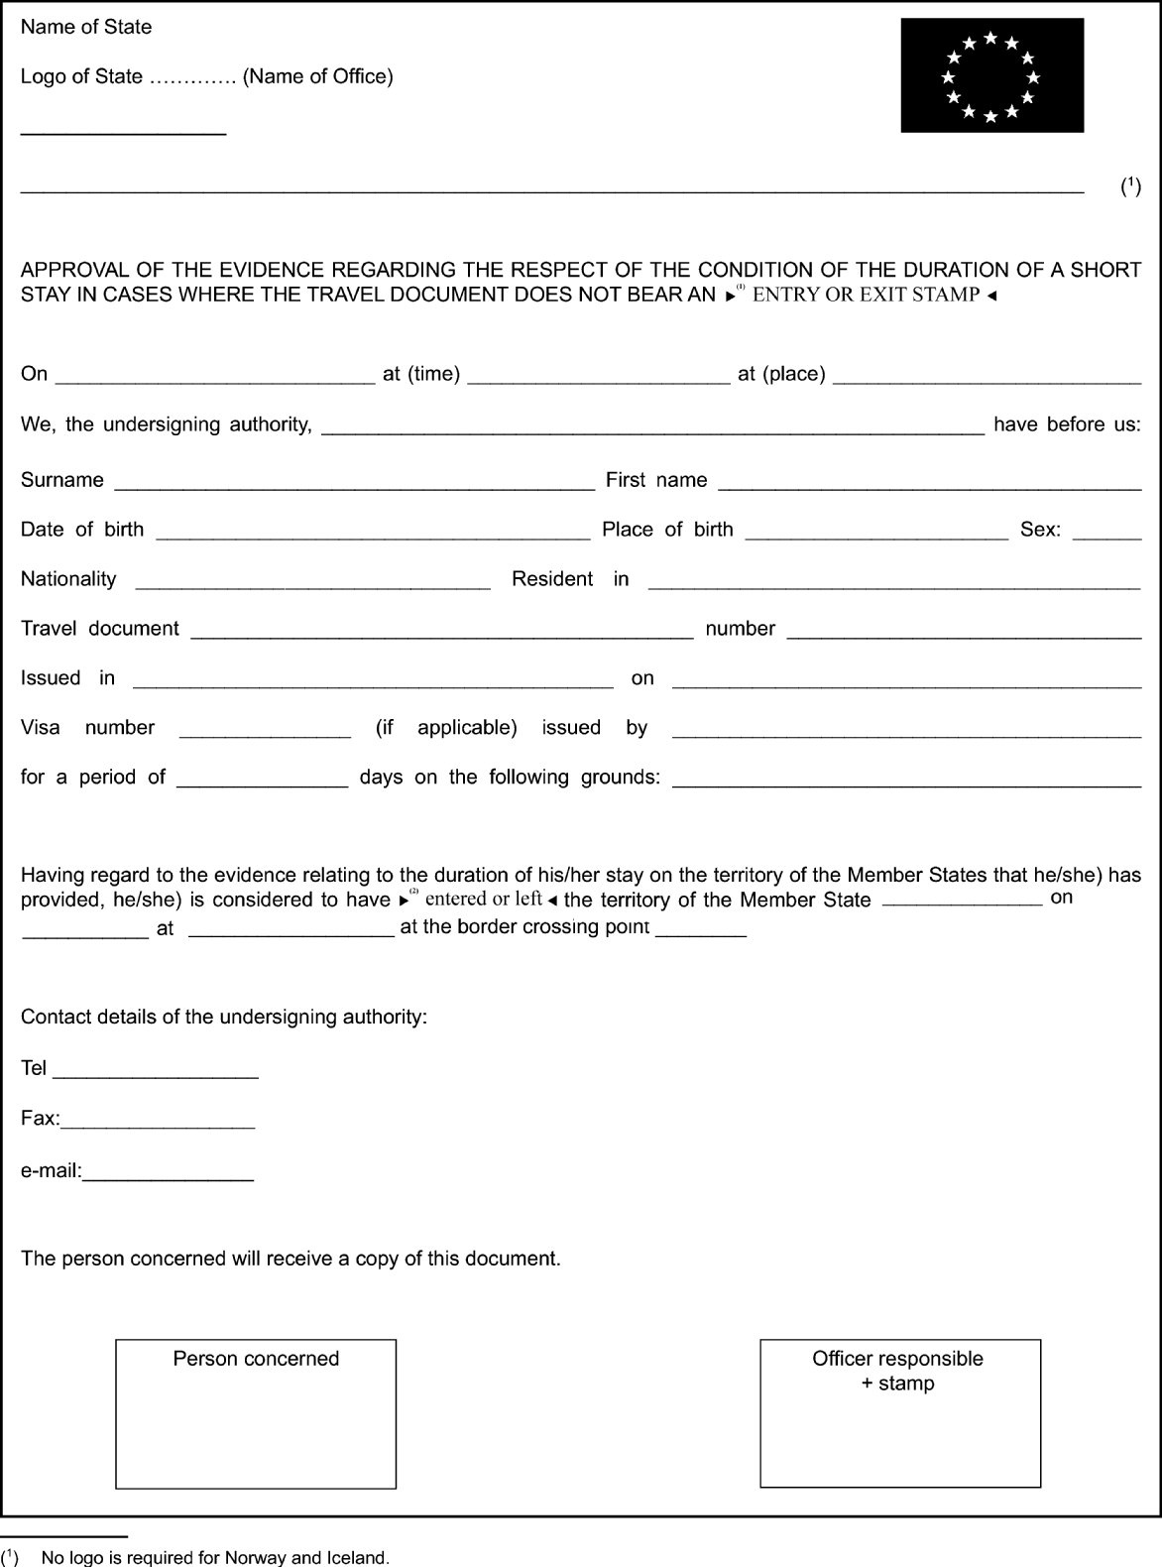
è1 ç
è2 ç
_____________

é
ANNEX IX
Repealed Regulation with list of its successive amendments
Regulation (EC) No 562/2006 of the European Parliament and of the Council
(OJ L 105, 13.4.2006, p. 1)
Regulation (EC) No 296/2008 of the European Parliament and of the Council
(OJ L 97, 9.4.2008, p. 60)
Regulation (EC) No 81/2009 of the European Parliament and of the Council
(OJ L 35, 4.2.2009, p. 56)
 | Regulation (EC) No 810/2009 of the European Parliament and of the Council  (OJ L 243, 15.9.2009, p. 1) |  | Only Article 55
 | Regulation (EU) No 265/2010 of the European Parliament and of the Council  (OJ L 85, 31.3.2010, p. 1) |  | Only Article 2
 | Regulation (EU) No 610/2013 of the European Parliament and of the Council  (OJ L 182, 29.6.2013, p. 1) |  | Only Article 1
Regulation (EU) No 1051/2013 of the European Parliament and of the Council
(OJ L 295, 6.11.2013, p. 1)
_____________
ANNEX X

Correlation Table
Regulation (EC) No 562/2006 | This Regulation
Article 1 | Article 1
Article 2, introductory wording | Article 2, introductory wording
Article 2, points (1) to (8) | Article 2, points (1) to (8)
Article 2, point (8a) | Article 2, point 9
Article 2, point 9 | Article 2, point 10
Article 2, point 10 | Article 2, point 11
Article 2, point 11 | Article 2, point 12
Article 2, point 12 | Article 2, point 13
Article 2, point 13 | Article 2, point 14
Article 2, point 14 | Article 2, point 15
Article 2, point 15 | Article 2, point 16
Article 2, point 16 | Article 2, point 17
Article 2, point 17 | Article 2, point 18
Article 2, point 18 | Article 2, point 19
Article 2, point 18a | Article 2, point 20
Article 2, point 19 | Article 2, point 21
Article 3 | Article 3
Article 3a | Article 4
Article 4 | Article 5
Article 5(1) | Article 6(1)
Article 5(1a) | Article 6(2)
Article 5(2) | Article 6(3)
Article 5(3) | Article 6(4)
Article 5(4) | Article 6(5)
Article 6 | Article 7
Article 7(1) and (2) | Article 8(1) and (2)
Article 7(3)(a) | Article 8(3)(a)
Article 7(3)(aa) | Article 8(3)(b)
Article 7(3)(ab) | Article 8(3)(c)
Article 7(3)(ac) | Article 8(3)(d)
Article 7(3)(ad) | Article 8(3)(e)
Article 7(3)(ae) | Article 8(3)(f)
Article 7(3)(b) | Article 8(3)(g)
Article 7(3)(c) | Article 8(3)(h)
Article 7(3)(d) | Article 8(3)(i)
Article 8 | Article 9
Article 9(1) | Article 10(1)
Article 9(2), first subparagraph, point (a) | Article 10(2), first and second subparagraphs
Article 9(2), first subparagraph, point (b) | Article 10(2), third subparagraph
Article 9(2), second subparagraph | Article 10(2), fourth subparagraph
Article 9(2), third subparagraph | Article 10(2), fifth subparagraph
Article 9(3) and (4) | Article 10(3) and (4)
Article 10(1) to (5) | Article 11(1) to (5)
Article 10(6) | -
Article 11 | Article 12
Article 12 | Article 13
Article 13 | Article 14
Article 14 | Article 15
Article 15 | Article 16
Article 16 | Article 17
Article 17 | Article 18
Article 18 | Article 19
Article 19 | Article 20
Article 19a | -
Article 19a | Article 21
Article 20 | Article 22
Article 21 | Article 23
Article 22 | Article 24
Article 23 | Article 25
Article 23a | Article 26
Article 24 | Article 27
Article 25 | Article 28
Article 26 | Article 29
Article 26a | Article 30
Article 27 | Article 31
Article 28 | Article 32
Article 29 | Article 33
Article 30 | Article 34
Article 31 | Article 35
Article 32 | Article 36
Article 33 | Article 37
Article 33a | Article 38
Article 34 | Article 39
Article 35 | Article 40
Article 36 | Article 41
Article 37 | Article 42
Article 37a | Article 43
Article 38 | -
Article 39 | Article 44
Article 40 | Article 45
Annexes I to VIII | Annexes I to VIII
- | Annex IX
- | Annex X
_____________

No logo is required for Norway and Iceland.
No logo is required for Norway and Iceland.
No logo is required for Norway and Iceland.
No logo is required for Norway and Iceland.
Council Directive 2001/51/EC of 28 June 2001 supplementing the provisions of Article 26 of the Convention implementing the Schengen Agreement of 14 June 1985 (OJ L 187, 10.7.2001, p. 45).
Regulation (EC) No 300/2008 of the European Parliament and of the Council of 11 March 2008 on common rules in the field of civil aviation security and repealing Regulation (EC) No 2320/2002 (OJ L 97, 9.4.2008, p. 72).
Council Directive 98/41/EC of 18 June 1998 on the registration of persons sailing on board passenger ships operating to or from ports of the Member States of the Community (OJ L 188, 2.7.1998, p. 35).

