REPORT FROM THE COMMISSION TO THE EUROPEAN PARLIAMENT AND THE COUNCIL
Fifth Report on the Post-Visa Liberalisation Monitoring for the Western Balkan Countries in accordance with the Commission Statement of 8 November 2010
(Text with EEA relevance)

Introduction
Since December 2009, citizens of the former Yugoslav Republic of Macedonia, Montenegro and Serbia have been able, with biometric passports, to travel visa-free to EU Member States (with the exception of Ireland and the United Kingdom) in accordance with Regulation 539/2001. Citizens of Albania and Bosnia and Herzegovina have enjoyed the same visa-free travel status since December 2010. Visa-free travel remains one of the core achievements of these countries’ European integration efforts.
In its 8 November 2010 statement to the Justice and Home Affairs Council, the Commission emphasised that each Western Balkan country had to continue implementing measures set out in its visa roadmap to maintain the integrity of the visa-free travel scheme. It established a post-visa liberalisation monitoring mechanism to evaluate the sustainability of reforms aiming to uphold the scheme’s integrity.
This is the fifth post-visa liberalisation monitoring report published since 2010. It provides an overview of the development of the post-visa liberalisation monitoring mechanism, reviews the functioning of the visa-free travel scheme and recommends reforms to prevent the recurrence of the problems that have beset this scheme since 2010.

A strengthened post-visa liberalisation monitoring mechanism
The dialogue between the Commission and the Western Balkan countries concerning the visa-free travel scheme takes place under the stabilisation and association process and in the framework of accession negotiations on chapters 23 and 24. Commission officials visited Albania in April 2014, Bosnia and Herzegovina in May, July and November 2014, the former Yugoslav Republic of Macedonia in November 2013, Montenegro in February, March, July and October 2014, and Serbia in February 2014. With the help of Member State experts, they verified the progress and quality of reforms relating to the visa-free scheme. Further details of these reforms are set out in the European Commission’s 2014 enlargement package.
In December 2012, each visa-free Western Balkan country began submitting to the Commission regular statistics on migration flows to the EU. In November 2014, the visa-free countries submitted a set of narrative reports on the steps taken to reduce irregular migration to the EU.
Assisted by the Western Balkans Risk Analysis Network, Frontex has issued 47 alert reports to date. Its quarterly Western Balkans risk analyses summarise the latest trends in border control and irregular migration from the region. Europol and the European Asylum Support Office (EASO) also issue monthly asylum trend reports and an annual report on the asylum situation in the EU. These reports provide a sophisticated assessment of migration trends from the Western Balkans and the steps taken by EU Member States and the visa-free states to prevent asylum abuse.

Functioning of the visa-free travel scheme in 2013 and in the first three quarters of 2014

Overview of developments
The number of asylum applications submitted in the EU and Schengen-associated countries by nationals of the five visa-free Western Balkan countries has been rising steadily since visa liberalisation in 2009, peaking in 2013 at 53 705 applications (Figure 1). The number of applications submitted in the first nine months of 2014 was 40 % higher than in the first nine months of 2013, suggesting that 2014 may well break all previous records.
The number of citizens of visa-free Western Balkan countries as a percentage of the overall asylum intake in the EU and Schengen-associated countries has also risen since visa liberalisation. After a record 11.4 % in the first three quarters of 2012, it reached 10.7 % in the first nine months of 2014 alone (Figure 2).
The influx of asylum-seekers from the Western Balkans has become a year-round phenomenon, with a number of ‘mini-peaks’ in January, March and July 2014 between the peaks in the winters of October 2013 and October 2014 (Figure 3). The number of asylum applications between these winter peaks remained high, with the result that the number of applications in the first three quarters of 2014 was 87 % of the total for the whole of 2013.
The number of repeat applications – second or multiple applications – as a percentage of the total has also risen since early 2013, reaching a new record of 37 % in September 2014 (Figure 3). This means that nearly 4 in 10 Western Balkan applicants that month had already submitted an asylum application in the EU before re-applying for asylum.
Germany remains the largest recipient of Western Balkan visa-free asylum applications (Figure 4). Its share of the Western Balkan intake increased from 12 % in 2009 to 75 % in the first nine months of 2014. These developments led Germany to adopt legislation in September 2014 placing Serbia, the former Yugoslav Republic of Macedonia, and Bosnia and Herzegovina on a list of safe countries of origin. It is too early to assess the impact of this measure. In October 2014, asylum applications in Germany increased from all Western Balkan visa-free countries, indicating the onset of a new winter surge. Meanwhile, applications in Sweden remained stable. In time, Germany’s asylum reform could trigger a considerable redistribution of asylum applicant flows across the EU.
Collectively, Serbian citizens remained the largest group of Western Balkan visa-free asylum-seekers in the EU and Schengen-associated countries (42 % in 2013), although their regional share has fallen since visa liberalisation (Figure 5). The citizens of the former Yugoslav Republic of Macedonia and Albania together represented 21 % of Western Balkan asylum-seekers in 2013, although Albania’s share has been steadily rising and that of the former Yugoslav Republic of Macedonia has been falling since visa liberalisation. The citizens of Bosnia and Herzegovina represented a further 14 % of Western Balkan asylum-seekers in 2013, their share having risen since visa liberalisation. Montenegro’s share, at 2 % in 2013, remained negligible.
The citizens of the former Yugoslav Republic of Macedonia were most likely to seek asylum in the EU and Schengen-associated countries in 2013, with five applicants per 1 000 inhabitants (Figure 6). Albanian citizens had the second highest propensity to do so, with four applicants per 1 000 inhabitants. The citizens of Serbia, Bosnia and Herzegovina and Montenegro came third, fourth and fifth, with three, two and one applicants per 1 000 inhabitants, respectively.
The geographical link between source and destination countries has become more skewed towards Germany than in previous years (Figure 7). Previously, the overwhelming majority of applicants from Serbia, the former Yugoslav Republic of Macedonia and Bosnia and Herzegovina targeted Germany; most Albanian applications were lodged in France, Sweden, the UK or Belgium; and Montenegrin applicants headed to France, Luxembourg or Sweden. By 2014, Germany had become the top destination for nationals of all Western Balkan countries.
The asylum recognition rate across the EU and Schengen-associated countries continued to fall for all Western Balkan visa-free citizens, indicating that the overwhelming majority of applications remained unfounded (Figure 8). There was still some variation between the five visa-free countries in 2013, however. The recognition rate fell to 3.7 % for Montenegrin citizens, 2.7 % for Serbian citizens and 1 % for nationals of the former Yugoslav Republic of Macedonia. Meanwhile, 8.1 % of Albanian applicants and 5.9 % of citizens of Bosnia and Herzegovina received international protection in the EU and Schengen-associated countries, suggesting that a slightly higher proportion of applications from those two countries were deemed worthy of international protection.
According to Frontex, the unfounded asylum-to-return ratio stayed close to 4:1 over the past year in the top five most-affected Member States and Schengen-associated countries. This indicates that Member States are still constrained in their ability to return those deemed ineligible for international protection. The method of returning applicants continued to vary between the main destination states: Germany and Switzerland repatriated the majority of applicants via enforced return procedures (with the exception of the winter months, when Germany would halt enforced returns); Belgium, Luxembourg and Sweden opted for the voluntary method.
In its 2014 Western Balkans annual risk analysis, Frontex identified two migratory risks with regard to movement from the Western Balkans to the EU: the secondary movements of irregular migrants entering the EU at the Greek-Turkish border and transiting through the Western Balkans, and the abuse of the EU visa-free travel scheme by Western Balkan nationals. The first risk manifested itself mainly in the illegal crossing of green borders – border sections between border-crossing points – between the Western Balkan countries and at borders between the latter and the EU; the second in asylum abuse, illegal stays in Member States and document fraud on the part of Western Balkan nationals.
Frontex detected a 27 % increase in illegal border crossing at the green borders between the Western Balkan countries and at borders between the latter and the EU in 2013. Of some 40 000 instances of illegal border crossing, 22 000 concerned non-European migrants transiting through the Western Balkans and 18 000 involved Western Balkan nationals, including Kosovo citizens.* Half of all detections occurred at the Serbian-Hungarian border, mostly in the first half of 2013. This was likely a result of Hungary ceasing the practice of detaining asylum-seekers in the first half of 2013, which led to an exceptional increase in illegal border crossing and asylum applications by third-country nationals, including Western Balkan citizens.
According to Frontex, EU detections of illegal stays by Western Balkan citizens rose by 5 %, to 38 300 between 2012 and 2013. Citizens of Western Balkan countries, Kosovo citizens included, represented 11 % of all EU detections last year, compared to 10 % in 2012. Albanian, Serbian and Kosovo citizens made up 42 %, 25 % and 16 % respectively of illegal stayers in the EU in 2013. More than half of all detections were reported by Greece, Germany, France and Hungary.
Frontex also detected an 18 % increase in document fraud in the EU in 2013. Despite a 14 % drop in detections in 2013, Albanians still made up the largest group of third-country nationals trying to enter the EU with false documents. They made up 85 % of Western Balkan nationals using fraudulent documents, followed by Serbian citizens (8 %) and Kosovo citizens (4 %). The most common types of fraudulent documents used by Albanian travellers were Greek and Italian identity documents.

The ‘push factors’ of asylum abuse and measures to address it
The most common ‘push factors’ driving asylum flows from the Western Balkans remained the following: deprivation, unemployment, discrimination, poor access to health care, social benefits and education, and, for Albanians, ‘blood feuds’. To tackle these issues, the Commission recommended last year that the visa-free countries increase targeted assistance to minority populations, especially Roma people; enhance operational cooperation and information exchange with neighbouring states, EU Member States and the relevant EU agencies; investigate and prosecute facilitators of irregular migration; enhance border controls in compliance with citizens’ fundamental rights; and organise information campaigns about the visa-free travel scheme. Each Western Balkan country has taken steps in these areas:
- Albania continued to carry out a number of campaigns informing citizens of their rights and obligations under the visa-free scheme. It also considerably improved its assistance programme for the Roma, stepped up exit controls, and investigated several facilitators of irregular migration. According to Frontex, Albania’s introduction of stricter legislation allowing citizens to change their name only once and prohibiting those with a migration infringement history from changing their name, successfully reduced the number of applications from nearly 600 a month in January 2013 to about 35 a month by December 2013;
- Bosnia and Herzegovina carried out several media campaigns to inform citizens of their rights and obligations under the visa-free travel scheme, including in villages from which a considerable number of citizens travelled to the EU to lodge asylum applications. It also held a series of meetings with representatives of the top destination countries, including Germany and Sweden, on facilitators of irregular migration, blocked 22 unauthorised border-crossing points with Montenegro, and adopted an action plan to integrate the Roma in the medium term. It has also adopted two action plans under the Roma strategy, one on the educational needs of the Roma and one specifically related to employment, housing and healthcare, and has stepped up its efforts to address the housing needs of the Roma;
- The former Yugoslav Republic of Macedonia improved the integration of the Roma community in education, civil registration, employment and healthcare, and opened joint law enforcement centres with Serbia and Kosovo, organising a number of joint patrols. It stepped up cooperation with Frontex, began sharing information via Europol’s SIENA platform, and prosecuted several facilitators of irregular migration. According to Frontex, the former Yugoslav Republic of Macedonia considerably strengthened border controls, leading to a 41 % increase in exit refusals in 2013;
- Montenegro continued to carry out strict border controls, including exit controls with neighbouring states; aligned its IBM strategy with the EU model; applied its criminal legislation against facilitators of irregular migration, resulting in two major police operations against 27 citizens; signed an operational agreement with Europol; started offering scholarships for Roma students; and stepped up its reception capacities for asylum seekers and irregular migrants;
- Serbia stepped up its assistance programme for the Roma, including in employment, civil registration, and empowering local governments in the field of social inclusion. It distributed leaflets and set up a government website informing citizens of their rights and obligations under the visa-free scheme, prosecuted several facilitators of irregular migration, and improved the exchange of information with the most-affected EU and Schengen-associated countries. In its 2014 report, Frontex also highlighted the success of Serbia’s stricter border controls.

The ‘pull factors’ of asylum abuse and measures to address it
The main ‘pull factors’ driving asylum abuse from the Western Balkans remained unchanged, including the presence of a diaspora community in the recipient states, the duration of the asylum procedure, the amount of cash benefits received, access to begging or the illegal labour market, and knowledge of past asylum recognition rates. 2013 afforded several examples of how Member States sought to mitigate the impact of these factors:
- Hungary enhanced border controls with Serbia in 2013, refusing entry to 5 400 Serbian citizens, 65 % more than in the previous year. Nearly three quarters of Hungary’s entry refusals were issued owing to overstaying, failing to meet the conditions of subsistence or failing to justify the purpose of stay. Last year, Serbian border authorities refused exit to more than 6 500 Serbian citizens unable to justify the purpose of their stay in the EU. Altogether, the two countries’ border authorities prevented entry to the Schengen area of nearly 5 in 1 000 travellers, a significantly higher proportion than at any other section of the EU’s external border;
- Germany revised its asylum procedure on 29 September 2014, adding Bosnia and Herzegovina, the former Yugoslav Republic of Macedonia and Serbia to its list of safe countries of origin. Given that the overwhelming majority of Western Balkan applicants chose Germany as their principal destination country in 2013, this legislative amendment is likely to have an impact on the distribution of migration flows in the medium term.
Several Member States, including the main EU destination states with the exception of Sweden, have adopted national legislation defining certain visa-free Western Balkan countries as safe countries of origin, in line with the Asylum Procedures Directive:
- Albania, whose citizens mainly targeted France, the UK, Germany, Sweden and Belgium for asylum in 2013, is considered a safe country of origin by Austria, Belgium, France, Luxembourg and the UK;
- Bosnia and Herzegovina, whose citizens mainly targeted Germany, France, Sweden and Switzerland for asylum in 2013, is considered a safe country of origin by Austria, Belgium, the Czech Republic, Germany, France, Luxembourg and the UK;
- The former Yugoslav Republic of Macedonia, whose citizens mainly targeted Germany, Belgium, Sweden and France for asylum in 2013, is considered a safe country of origin by Austria, Belgium, the Czech Republic, Germany, France, Luxembourg and the UK;
- Montenegro, whose citizens mainly targeted Germany, France, Luxembourg and Sweden for asylum in 2013, is considered a safe country of origin by Austria, Belgium, the Czech Republic, France, Luxembourg, Slovakia and the UK;
- Serbia, whose citizens mainly targeted Germany, Sweden, Belgium and France for asylum in 2013, is considered a safe country of origin by Austria, Belgium, the Czech Republic, Germany, France, Luxembourg and the UK.
The use of the safe country of origin concept should be coupled with other measures to mitigate asylum abuse. EASO has summarised other reforms that have successfully reduced asylum abuse in recent years while respecting applicants’ fundamental rights:
- high-level visits to the countries concerned and information campaigns in cooperation with local NGOs and municipalities, to inform citizens about the rights and obligations of visa-free travel, using print and electronic media;
- continued operational cooperation with the authorities of the countries concerned;
- reducing cash benefits, such as pocket money and financial return assistance, to reduce the financial incentives for asylum abuse;
- shortening asylum procedures by having more staff assess asylum cases in peak periods or by establishing an accelerated – fast-track – procedure that enables the swift processing of applications at peak times or for citizens of particular countries.

Other developments related to the EU visa-free scheme
The European Parliament and the Council adopted a revised Asylum Procedures Directive (Directive 2005/85/EC) in June 2013. This instrument, which enters into force in June 2015, creates new tools to prevent abuse of the asylum system. For example, it limits an applicant’s right to remain in a country if their second asylum application does not contain new elements compared to a previous one or if the second application is submitted to prevent the applicant’s imminent removal. Under the directive, limits to the right to remain can also be applied to applicants who have submitted a third or subsequent asylum application. These rules do not constitute an exception to the principle of non-refoulement, which must always be respected.
The European Parliament and the Council also amended the Visa Regulation (Regulation 539/2001) in December 2013, introducing a visa suspension mechanism for temporarily suspending third-country nationals’ visa-free status under exceptional circumstances. This mechanism may be applied only as a temporary measure and can only be triggered in an emergency. No Member State has yet requested activation of the visa suspension mechanism.

Next steps
The overwhelming majority of citizens from the visa-free Western Balkan countries are bona fide travellers with legitimate grounds to travel to the EU. The visa-free travel scheme has fulfilled its purpose: it has strengthened people-to-people contact between the Western Balkans and the EU, including with diaspora communities in the Member States, enhanced business opportunities and cultural exchanges, and enabled the visa-free countries’ citizens to get to know the EU better. All of the Western Balkan countries concerned have expressed a desire to continue implementing the reforms necessary to maintain their citizens’ visa-free travel status.
Yet, asylum abuse has continued to afflict the visa-free scheme since visa liberalisation. The situation remains untenable and requires reforms in both the visa-free Western Balkan countries and in the most-affected EU Member States and Schengen-associated countries.
The Commission urges each Western Balkan country to back up its political commitment to visa-free travel with effective policies on the ground. Each visa-free country must be able to show a sustainable downward trend in the overall asylum intake.
The Commission recommends that each visa-free Western Balkan country continues to:
- Increase targeted assistance to minority populations, in particular those of Roma ethnicity, aiming to improve their long-term socio-economic integration via educational, employment and vocational training programmes, including by implementing national strategies and using domestic assistance, supported by available EU assistance and bilateral assistance offered by EU Member States;
- Strengthen operational cooperation and information exchange with neighbouring states, EU Member States and Schengen-associated countries, the European Commission and, as appropriate, Frontex, Europol and EASO, in the fields of border management, migration, asylum and readmission, in accordance with EU and national legislation;
- Investigate facilitators of irregular migration and prosecute those who enable the abuse of the visa-free scheme, in close cooperation with the law enforcement authorities of EU Member States, Schengen-associated countries and Europol;
- In strict compliance with citizens’ fundamental rights, strengthen border controls and develop closer cooperation with EU Member States that have a direct responsibility for managing the EU’s external borders;
- Enhance targeted information and awareness campaigns aimed at further clarifying to citizens the rights and obligations of visa-free travel, including information on liability for any abuse of rights under the visa-free scheme.
The Commission also recommends that those EU Member States and Schengen-associated countries that have faced the largest inflows of unfounded asylum applications from the Western Balkans consider taking additional action in the following areas:
- Where appropriate, consider streamlining asylum procedures for the citizens of the five visa-free Western Balkan countries, including by having more staff assess asylum cases in peak periods or by establishing an accelerated procedure that enables the swift processing of applications at peak times or for citizens of particular countries. Where appropriate, consider using the safe country of origin concept as part of reforming domestic asylum procedures;
- Consider a more cautious and selective use of cash benefits, such as pocket money and financial return assistance, to reduce the financial incentives for asylum abuse;
- Organise high-level visits to the countries concerned and information campaigns, in cooperation with local NGOs and municipalities, to inform citizens about the rights and obligations of visa-free travel, using print and electronic media;
- Strengthen operational cooperation and information exchange, including through liaison officers, with the authorities of the countries concerned.
The Commission will continue to assess the implementation of these measures through the present post-visa liberalisation monitoring mechanism and will report to the European Parliament and the Council in 2015.

Statistics
Figure 1: Asylum applications made by Western Balkan visa-free nationals to EU and Schengen-associated countries
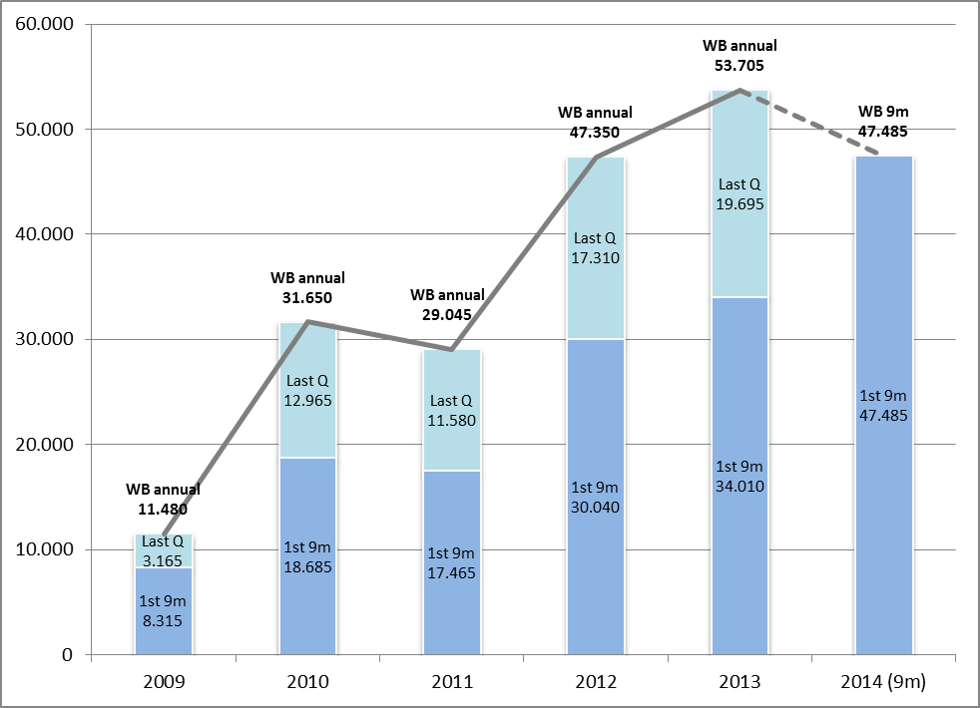
Figure 2: Total asylum applications in the EU and Schengen-associated countries, with the Western Balkan share
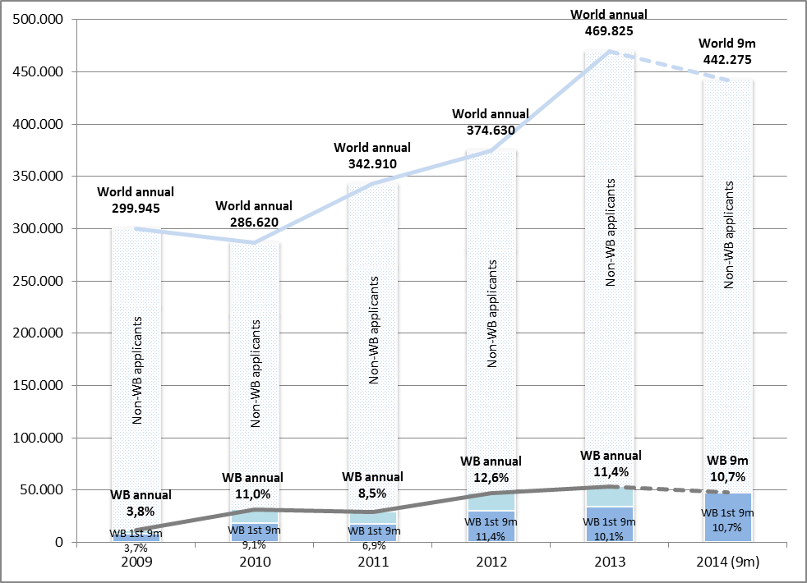
Figure 3: Seasonality of Western Balkan asylum applications since 2009
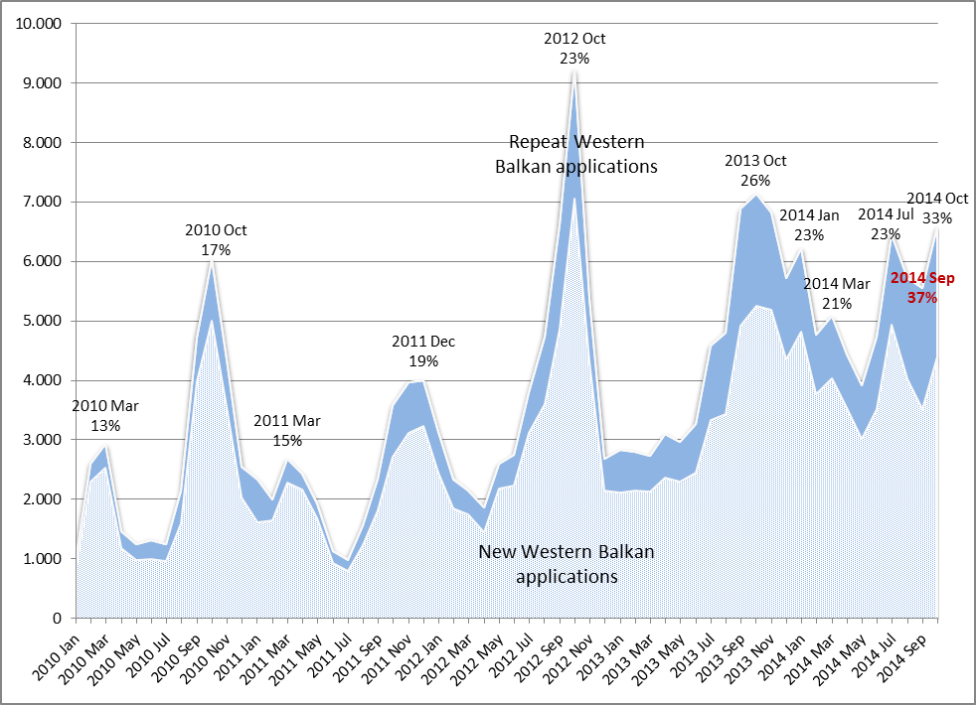
Figure 4: Top EU and Schengen-associated country recipients of Western Balkan asylum applications
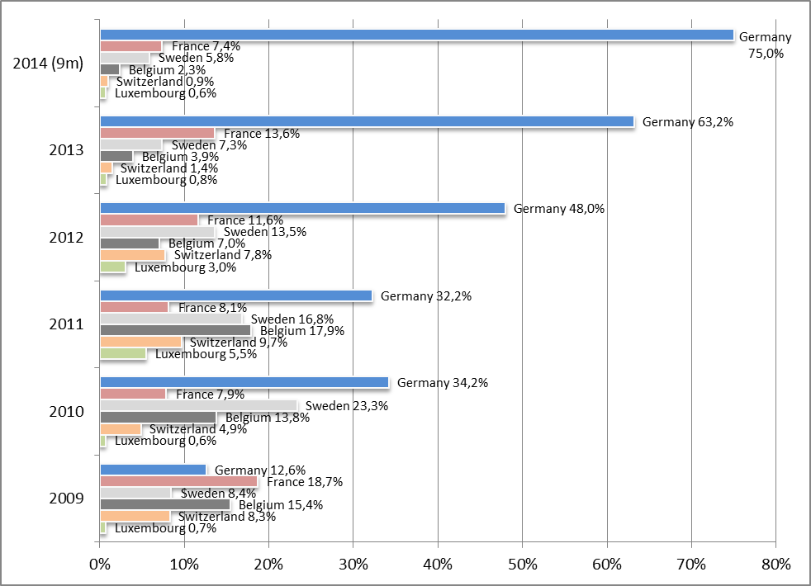
Figure 5: Western Balkan breakdown of asylum seekers in EU and Schengen-associated countries
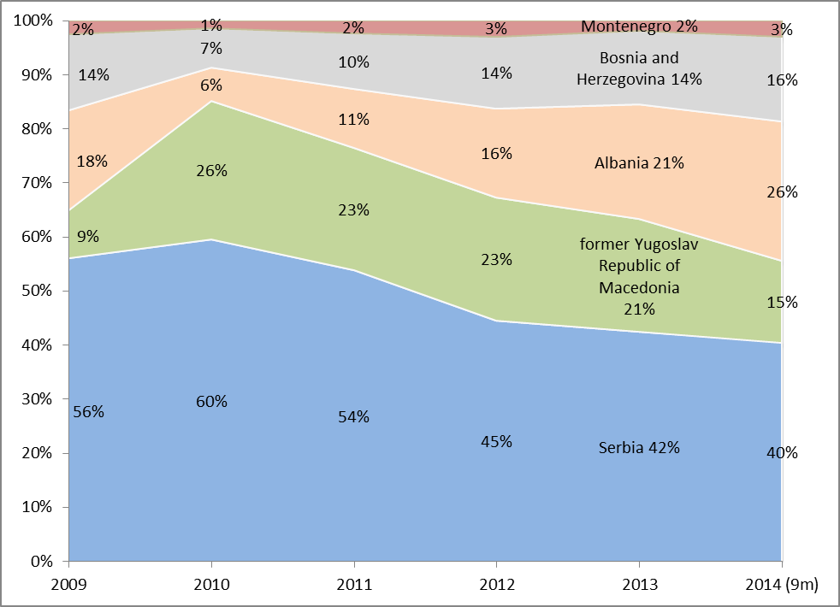
Figure 6: Propensity of Western Balkan citizens to seek asylum in EU and Schengen-associated countries
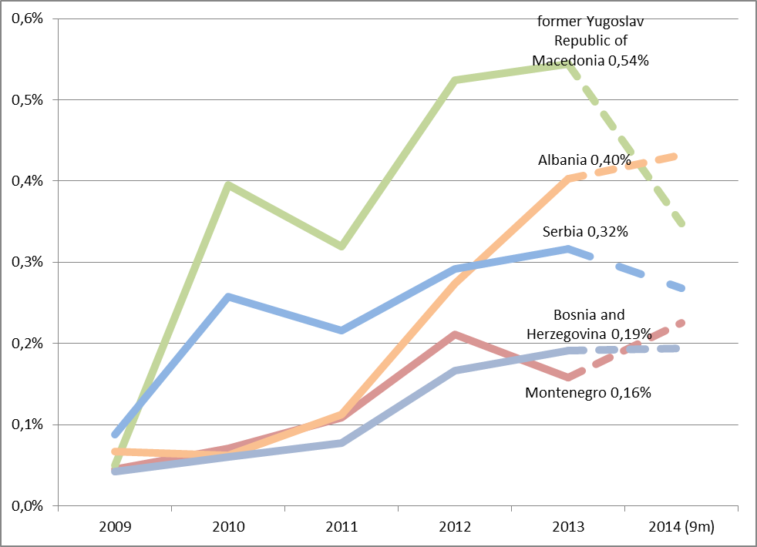
Figure 7: Top EU and Schengen-associated country destinations for Western Balkan asylum applicants
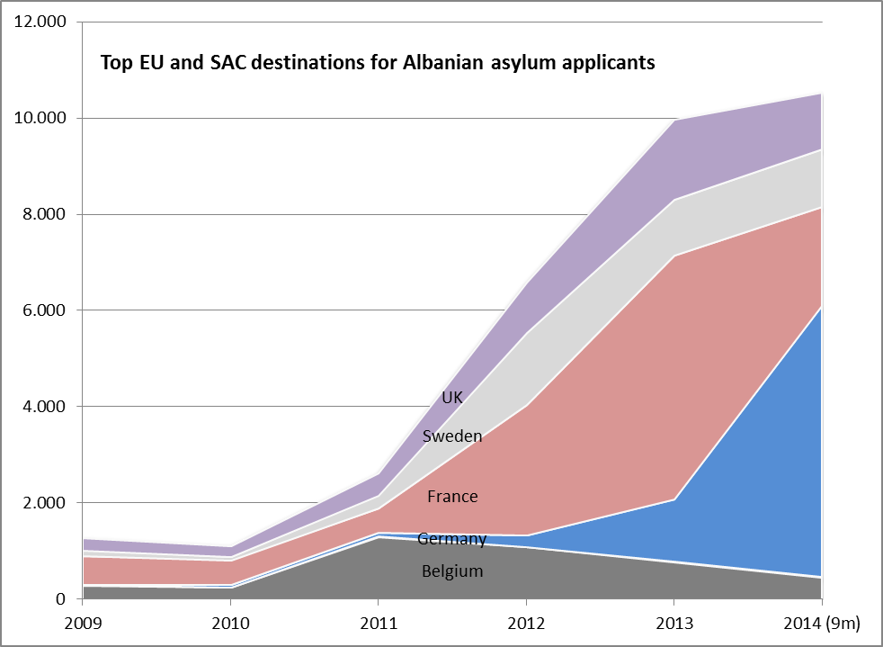
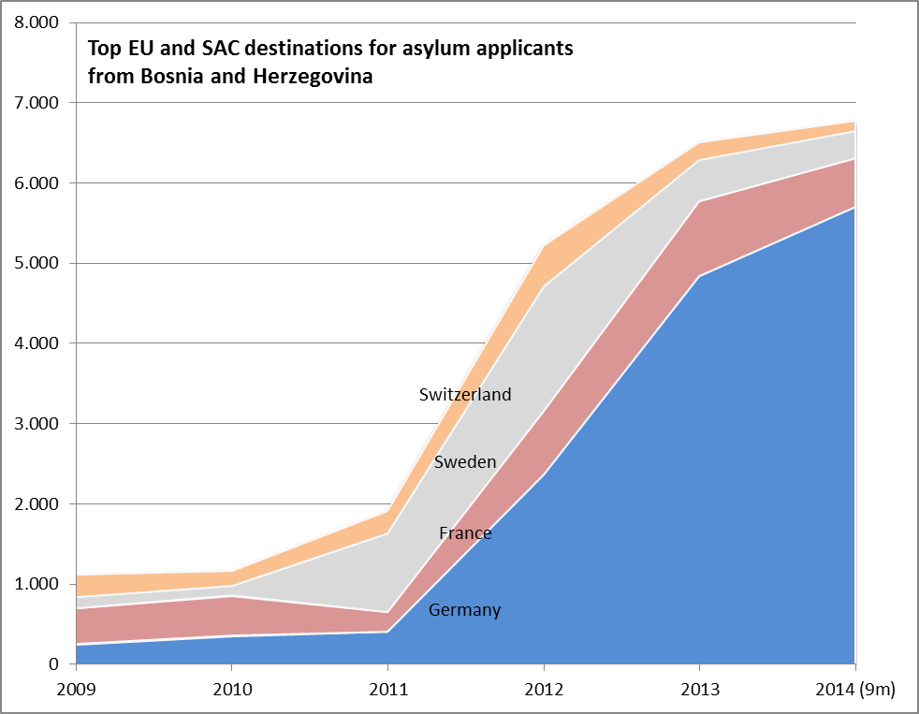
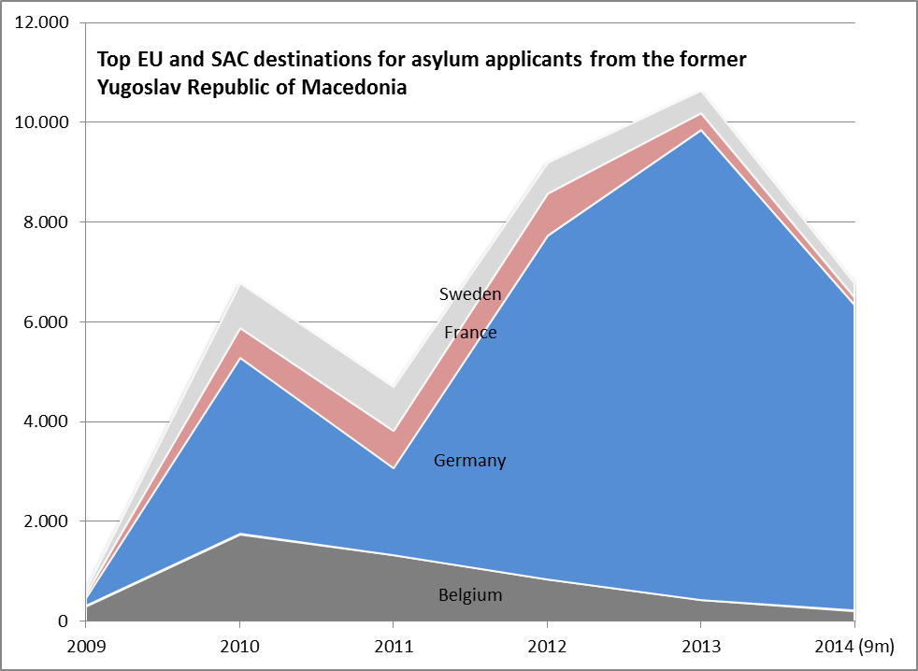
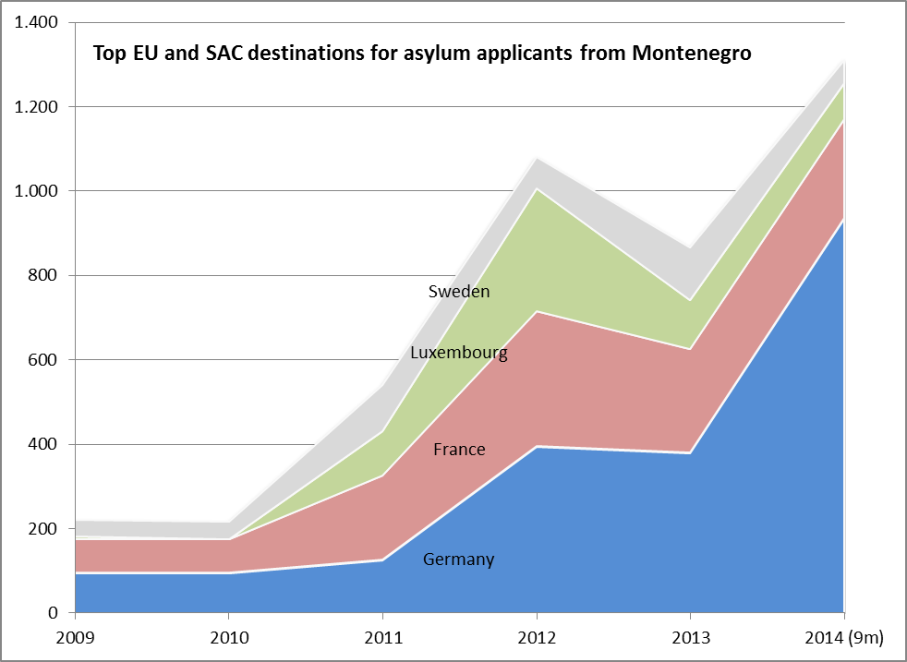
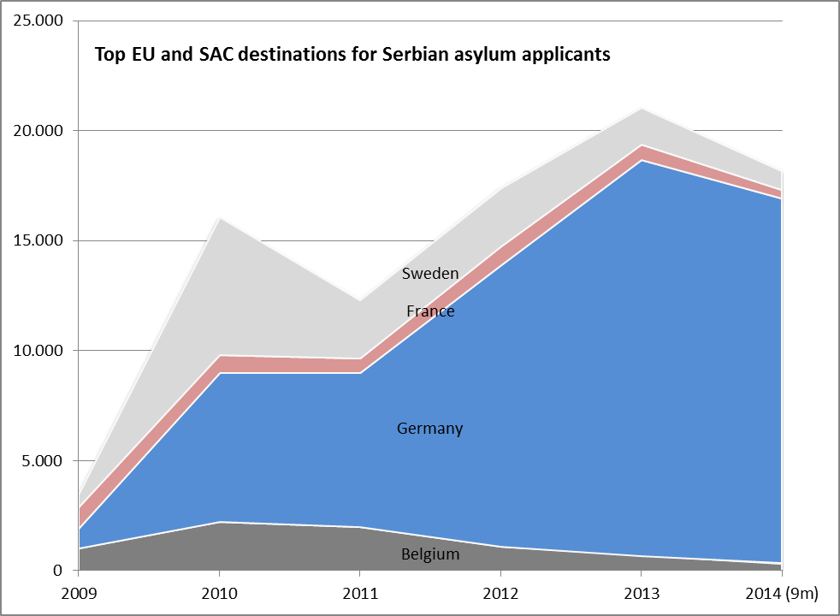
Figure 8: Recognition rate of Western Balkan asylum applications in EU and Schengen-associated countries
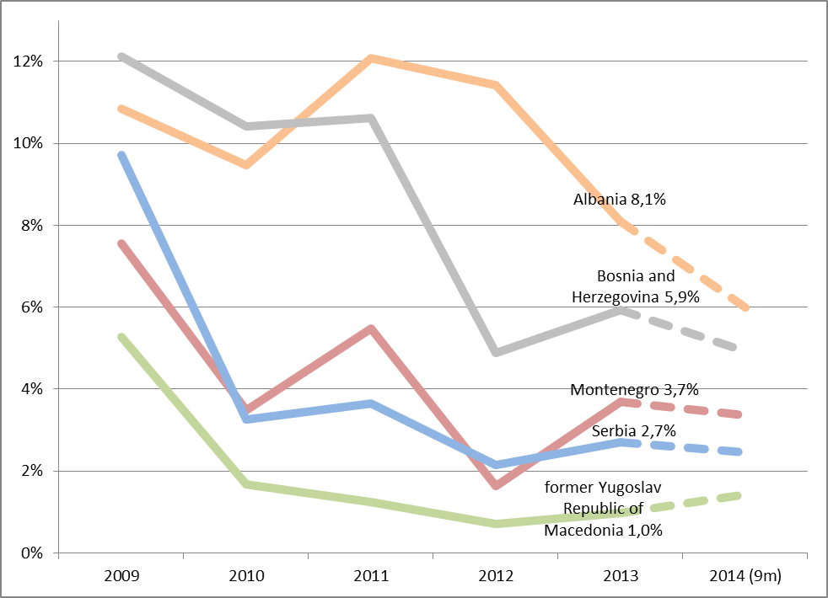

Council Regulation (EC) No 539/2001.
The reference numbers of the previous reports are as follows: SEC(2011) 695, SEC(2011) 1570, COM(2012) 472, and COM(2013) 836.
COM(2014) 700.
Source: Eurostat.
Source: Eurostat.
Source: Eurostat.
Gesetz zur Einstufung weiterer Staaten als sichere Herkunftsstaaten und zur Erleichterung des Arbeitsmarktzugangs für Asylbewerber und geduldete Ausländer, 5 November 2014.
The recognition rate is calculated as the number of positive decisions (on refugee status, subsidiary protection or humanitarian status) as a percentage of the total number of first-instance decisions.
Frontex, Post-Visa Liberalisation Monitoring Mechanism, Report No 46.
Frontex, Western Balkans Annual Risk Analysis 2014.
* This designation is without prejudice to positions on status, and is in line with UNSCR 1244/1999 and the ICJ Opinion on the Kosovo declaration of independence.
These issues are described in detail in EASO’s Asylum Applicants from the Western Balkans, 2013. In Albania, actual instances of blood feud are very rare, yet this phenomenon is still used by some as a pretext to lodge asylum applications.
Frontex, Western Balkans Annual Risk Analysis, 2014.
Frontex, Western Balkans Annual Risk Analysis, 2014.
Frontex, Western Balkans Annual Risk Analysis, 2014.
Frontex, Western Balkans Annual Risk Analysis, 2014.
Calculated as the number of asylum applications in the EU and Schengen-associated countries divided by population size.

