1. INTRODUCTION
The 2015 edition of the EU Justice Scoreboard ('the Scoreboard') is presented in a time where the EU is committed to revitalising growth and to generating a new momentum for change. Effective justice systems play a key role in creating an investment friendly environment, restoring confidence, providing greater regulatory predictability and sustainable growth.
The Scoreboard assists Member States to improve the effectiveness of their justice system. This edition seeks to identify possible trends and contains new indicators and more fine-tuned data.
The important role of justice systems for growth complements their crucial function of upholding the values upon which the EU is founded. Access to an effective justice system is a fundamental right which is at the foundation of European democracies and is recognised by the constitutional traditions common to the Member States. The right to an effective remedy before a tribunal is enshrined in the Charter of Fundamental Rights of the European Union.
The effectiveness of justice systems is also crucial for the implementation of EU law and for the strengthening of mutual trust. Whenever a national court applies EU legislation, it acts as a ‘Union court’ and must provide effective judicial protection to everyone, citizens and businesses, whose rights guaranteed in EU law have been violated. Shortcomings in national justice systems are an obstacle for the functioning of the single market, for the well-functioning of the EU area of justice and the effective implementation of the EU acquis.
For these reasons, since 2011, national judicial reforms have become an integral part of the structural components in Member States subject to the Economic Adjustment Programmes. Since 2012, the improvement of the quality, the independence and the efficiency of judicial systems has also been a priority for the European Semester, the EU annual cycle of economic policy coordination. The 2015 Annual Growth Survey renews the commitment to carrying out structural reforms in the area of justice.
A large process of justice reforms is being undertaken in Member States…
The information collected for this edition of the EU Justice Scoreboard shows that in 2014, all Member States were engaged in reforming their justice systems. The scope, scale and state of play of the reform process vary significantly, as well as the objectives pursued, which could be tackling inefficiencies, enhancing quality and accessibility, managing budgetary constraints, strengthening citizen trust or fostering a business-friendly environment.
Figure 1: Mapping of justice reforms in the EU in 2014 (source: European Commission)
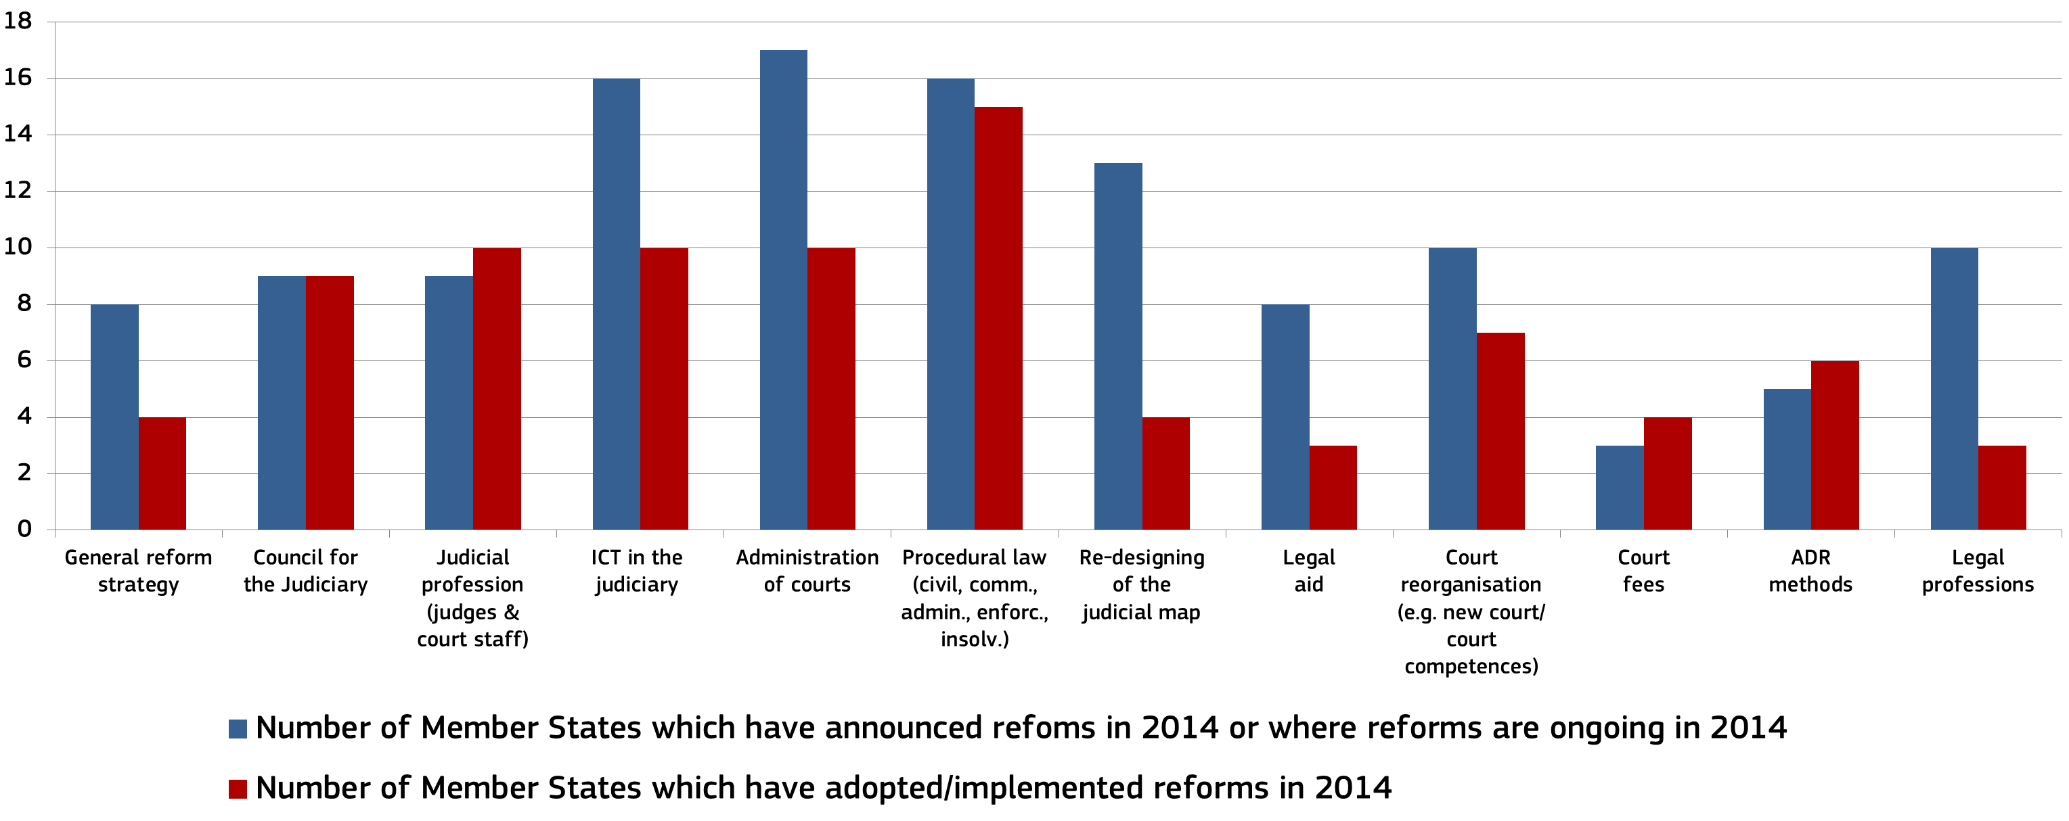
The reforms range from operational measures, such as the modernisation of the management process in court, the use of new information technology, the development of alternative dispute resolution, to more structural measures such as restructuring the organisation of courts, reviewing the judicial map, simplification of procedural rules, reforming judicial and legal professions and reforming legal aid.
…encouraged and supported at EU level.
This reform process is part of the structural reforms encouraged at EU level to put Europe firmly on the path of economic recovery. Together with investment and fiscal responsibility, structural reforms are one of the three pillars of an integrated approach for the EU's economic and social policy in 2015. Structural reforms to ensure the effectiveness of judicial systems pave the way for a more business- and citizen- friendly environment.
The findings of the 2014 Scoreboard, together with a specific country assessment carried out for each of the Member States concerned, helped the EU to define country-specific- recommendations in the area of justice. Following a proposal from the Commission, the Council made recommendations to twelve Member States to improve, depending on the country concerned, the independence, quality and/or efficiency of their justice system. Out of these twelve Member States, ten Member States were already identified in 2013 and six in 2012 as facing challenges relating to the functioning of their justice systems. The Commission closely follows the implementation of these recommendations through a dialogue with national authorities and interested parties in the concerned Member States.
To support these reform efforts, the Commission also intensified the dialogue with Member States through its group of contact persons on national justice systems. The discussions drew on Member States' expertise and triggered exchanges of information on practices to support the quality of justice systems, in particular, quality management methods, courts' communication policies, efforts towards the uniform application of EU law and recent reforms carried out to enhance the efficiency and quality of the judicial system (e.g. in terms of its structure). Pursuing efforts to promote the exchange of best practices is key for supporting the quality of justice reforms in Member States.
The European Structural and Investment Funds (ESI Funds) provide support to Member States' efforts to improve the functioning of their justice systems. At the start of the new programming period 2014-2020, the Commission engaged in an intensive dialogue with Member States on establishing the strategic funding priorities of the ESI Funds in order to encourage a close link between policy and funding. Based on the draft partnership agreements, the total budget allocated to investments in institutional capacity of public administration amounts to almost 5 billion Euros for the next programming period. Out of the twelve Member States that received a country-specific-recommendation in the area of justice in 2014, eleven identified justice as a priority area of support for the ESI Funds. Justice is also a priority in the Economic Adjustment Programmes for Greece and Cyprus which will use ESI Funds in this area. The country-specific-recommendations, the country specific assessment and the data provided in the Scoreboard are key elements for Member States when setting out their funding priorities.
Member States which identified justice systems as a priority area intend to use ESI Funds mostly for improving the efficiency of the judiciary. Although concrete activities will depend on the particular needs of each Member State concerned, some types of activities are emerging as being common to more Member States, such as the introduction of case management systems, the use of ICT in courts, the monitoring and evaluation tools, and training schemes for judges. The extent of this support varies between the Member States: while some Member States intend to support a broad section of their justice systems, others will concentrate on only a few courts which are facing particular challenges or are selected for pilot purposes. The Commission emphasised the importance of robust indicators for monitoring effectiveness of the support and issued guidance documents on monitoring indicators in line with those used in the Scoreboard. They will ensure the regular reporting of the Member States to the Commission on achieved results. These data will help the evaluation of EU support in rendering Member States' justice systems more effective.
What is the EU Justice Scoreboard?
The EU Justice Scoreboard is an information tool aiming to assist the EU and Member States to achieve more effective justice by providing objective, reliable and comparable data on the quality, independence and efficiency of justice systems in all Member States.
The Scoreboard contributes to identifying potential shortcomings, improvements and good practices. It shows trends on the functioning of the national justice systems over time. It does not present an overall single ranking but an overview of the functioning of all justice systems based on various indicators which are of common interest for all Member States.
The Scoreboard does not promote any particular type of justice system and treats all Member States on an equal footing. Whatever the model of the national justice system or the legal tradition in which it is anchored, timeliness, independence, affordability, and user-friendly access are some of the essential parameters of an effective justice system.
The 2015 Scoreboard focuses on litigious civil and commercial cases as well as administrative cases in order to assist Member States in their efforts to pave the way for a more business- and citizen friendly environment, which in turn fosters investment, as well as for a deeper and fairer internal market. The Scoreboard is a tool which evolves in dialogue with Member States and the European Parliament, with the objective of identifying the essential parameters of an effective justice system. The European Parliament has called on the Commission to progressively broaden the scope of the Scoreboard and reflection on how to do this has started.
How does the EU Justice Scoreboard feed the European Semester?
The EU Justice Scoreboard provides information on the functioning of justice systems and helps assess the impact of justice reforms. Poor performance revealed by the Scoreboard indicators always requires a deeper analysis of the reasons behind the result. This country-specific assessment is carried out in the context of the European Semester process through bilateral dialogue with concerned authorities and stakeholders. This assessment takes into account the particularities of the legal system and the context of the concerned Member States. It may eventually lead the Commission to propose Council country-specific-recommendations on the improvement of justice systems.

What is the methodology of the EU Justice Scoreboard?
The Scoreboard uses different sources of information. Most of the quantitative data are currently provided by the Council of Europe Commission for the Evaluation of the Efficiency of Justice (CEPEJ) with which the Commission has concluded a contract in order to carry out a specific annual study. These data are from 2013 and have been provided by Member States according to the CEPEJ methodology. This year the data have been collected by CEPEJ specifically for EU Member States. The study also provides country fiches which give more context and should be read together with the figures.
For the 2015 Scoreboard, the Commission has also drawn upon additional sources of information, namely Eurostat, the World Bank, the World Economic Forum, the European judicial networks (in particular the European Network of Councils for the Judiciary, which provided replies to a questionnaire on judicial independence) and the group of contact persons on national justice systems. Further data have also been obtained through data collection exercises and field studies on the functioning of national courts when they apply EU law in the areas of competition, consumer protection, Community trademarks and public procurement.
How do effective justice systems contribute to growth?
Effective justice systems play a key role in restoring confidence throughout the entire business cycle. Where judicial systems guarantee a good enforcement of rights and contracts, creditors are more likely to lend, firms are dissuaded from opportunistic behaviour, transaction costs are reduced and investments can go more easily to innovative sectors which often rely on intangible assets (e.g. intellectual property rights). More effective courts promote the entry of entrepreneurs into the market and foster competition. Research shows that there is a positive correlation between firm size and effective justice systems, while weaker incentives to invest and to employ are found in the presence of shortcomings in the functioning of justice. The impact of national justice systems on the economy is underlined by the International Monetary Fund, the European Central Bank, the OECD, the World Economic Forum and the World Bank.

2. Indicators of the 2015 EU Justice Scoreboard
The 2015 Scoreboard has evolved: this third edition of the Scoreboard seeks to identify possible trends whilst taking a cautious and nuanced approach as the situation varies significantly, depending on each Member State and indicator. The 2015 Scoreboard also contains new indicators and more fine-tuned data based on new sources of information, for example, on the efficiency of courts in the areas of public procurement and intellectual property rights, the use and the promotion of alternative dispute resolution methods (hereafter ADR), the use of Information and Communication Technology (hereafter ICT) for small claim proceedings, courts' communications policies, composition and powers of Councils for the judiciary. It also contains, for the first time, data on the share of female professional judges, as more gender diversity can contribute to a better quality of justice systems.
Efficiency of justice systems
The 2015 Scoreboard maintains the indicators relating to the efficiency of proceedings: length of proceedings, clearance rate and number of pending cases. In addition, the 2015 Scoreboard shows the outcome of four data collection exercises aimed at providing more fine-tuned data on the length of judicial proceedings in the areas of EU competition law, consumer law, Community trademarks and public procurement. The effectiveness of judicial systems in these areas governed by EU law is particularly important for the economy.
Quality of justice systems
As in previous editions, the 2015 Scoreboard focuses on certain factors that can help to improve the quality of justice, such as training, monitoring and evaluation of court activities, the use of satisfaction surveys, budget, and human resources. The 2015 Scoreboard complements data on the availability of ICT with a more in-depth look into how electronic tools can be used in practice. Moreover, cooperation with the group of contact persons on national justice systems has yielded a useful insight into communication practices of courts and concrete methods used by Member States to promote ADR. In addition, the 2015 Scoreboard provides data on legal aid and gender balance in the judiciary.
Independence of the judiciary
The Scoreboard presents data on the perceived independence of the justice system as provided by the World Economic Forum (WEF) in its annual Global Competitiveness Report. While perceived independence is important, as it can influence investment decisions, what is more important is that judicial independence is effectively protected in a justice system through legal safeguards (structural independence). The 2014 Scoreboard presented a first general overview of how justice systems are organised to protect judicial independence in certain types of situations where it can be at risk. The Commission has continued cooperation on the structural independence of the judiciary with the European judicial networks, particularly the European Network of Councils for the Judiciary. The 2015 Scoreboard provides updated information on the legal safeguards presented last year and expands the comparative overview on structural independence. In particular, it presents a comparison of the composition and main powers of existing Councils for the Judiciary in the EU, information on which branch of government adopts criteria for determining the financial resources for the judiciary and what these criteria are.
Context for the analysis
Efficiency, quality and independence are the main parameters for analysis of the effectiveness of justice systems. The data on the workload of courts in Member States provides important information on the context in which justice systems operate (e.g. tasks of courts, level of litigiousness). Irrespective of disparities among Member States, every judicial system should be in a position to handle its workload within a reasonable time, whilst meeting expectations of quality and independence.
Figure 2: Number of incoming civil, commercial, administrative and other cases per 100 inhabitants* (First instance, 2010, 2012 and 2013) (source: CEPEJ study)
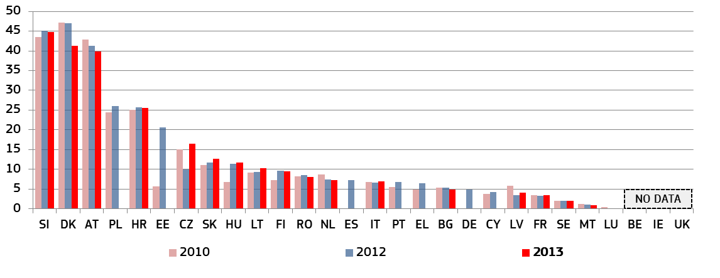* This category includes all civil and commercial litigious and non-litigious cases, enforcement cases, land-registry cases, administrative law cases (litigious or non-litigious) and other non-criminal cases. IT: The possible misinterpretation concerning the comparison between 2010, 2012 and 2013 could be explained by the implementation of a different classification of civil cases.
Figure 3: Number of incoming civil and commercial litigious cases per 100 inhabitants* (First instance, 2010, 2012 and 2013) (source: CEPEJ study)
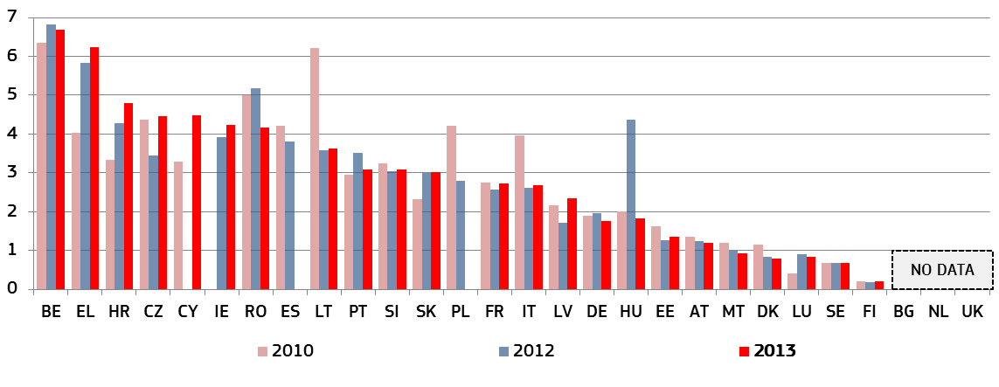* Litigious civil and commercial cases concern disputes between parties, for example disputes regarding contracts, following the CEPEJ methodology. By contrast, non-litigious civil (and commercial) cases concern uncontested proceedings, for example, uncontested payment orders. Commercial cases are addressed by special commercial courts in some countries and handled by ordinary (civil) courts in others. IT: The possible misinterpretation concerning the comparison between 2010, 2012 and 2013 could be explained by the implementation of a different classification of civil cases.

3. Key findings of the 2015 EU Justice Scoreboard

3.1 Efficiency of justice systems
Justice delayed is justice denied. Timely decisions are essential for businesses and investors. In their investment decisions, companies take into account the risk of being involved in commercial disputes, labour or taxation disputes or insolvencies. The efficiency with which a judicial system in a Member State handles litigation is very important. For example, the legal enforcement of a supply or services contract becomes very costly the longer the judicial dispute takes, and even meaningless beyond a certain time, as the probability of retrieving money from payments and penalties diminishes.

3.1.1 Length of proceedings
The length of proceedings expresses the time (in days) needed to resolve a case in court, meaning the time taken by the court to reach a decision at first instance. The 'disposition time' indicator is the number of unresolved cases divided by the number of resolved cases at the end of a year multiplied by 365 days. Apart from Figures 13 to 17, all figures concern proceedings at first instance and compare, where available, data for 2010 with data for 2012 and 2013. Although different appeal procedures can have a major impact on length of proceedings, the efficiency of a judicial system should already be reflected at first instance, as the first instance is an obligatory step for everyone going to court.
Figure 4: Time needed to resolve civil, commercial, administrative and other cases*
(First instance/in days) (source: CEPEJ study)
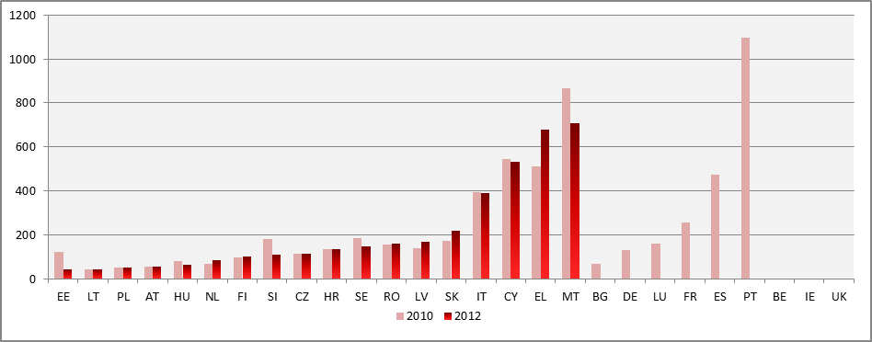
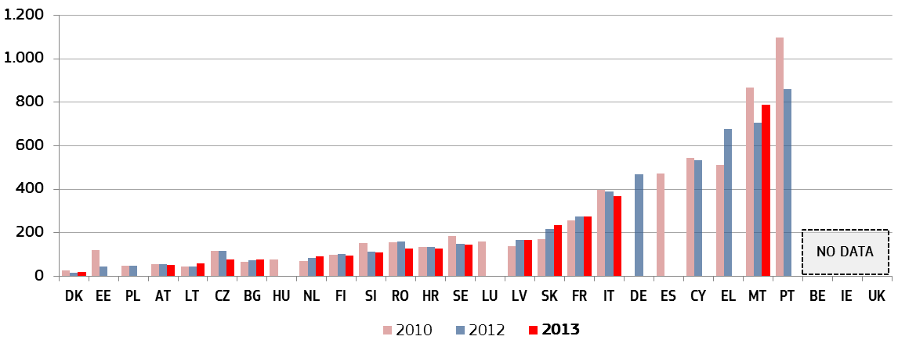* This category includes all civil and commercial litigious and non-litigious cases, enforcement cases, land-registry cases, administrative law cases (litigious or non-litigious) and other non-criminal cases. Comparisons should be undertaken with care as some Member States reported changes in the methodology for data collection or categorisation (CZ, EE, IT, CY, LV, HU, SI) or made caveats on completeness of data that may not cover all Länder or all courts (DE, LU).
Figure 5: Time needed to resolve litigious civil and commercial cases*
(First instance/in days) (source: CEPEJ study)
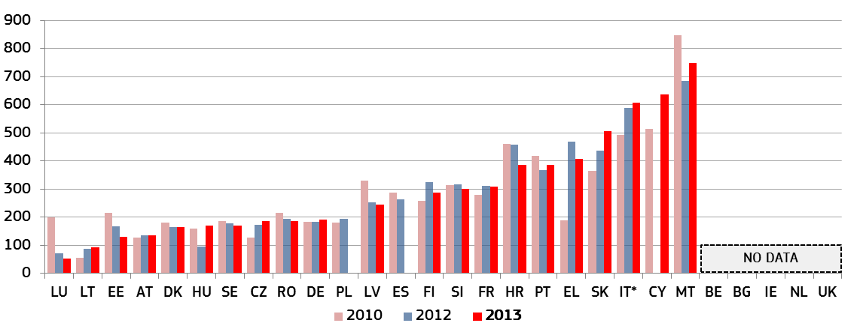* Litigious civil (and commercial) cases concern disputes between parties, for example disputes regarding contracts, following the CEPEJ methodology. By contrast, non-litigious civil (and commercial) cases concern uncontested proceedings, for example, uncontested payment orders. Commercial cases are addressed by special commercial courts in some countries and handled by ordinary (civil) courts in others. Comparisons should be undertaken with care, as some Member States reported changes in the methodology for data collection or categorisation (CZ, EE, IT, CY, LV, HU, SI) or made caveats on completeness of data that may not cover all Länder or all courts (DE, LU). NL provided a measured disposition time, but it is not calculated by CEPEJ.
Figure 6: Time needed to resolve administrative cases* (First instance/in days) (source: CEPEJ study)
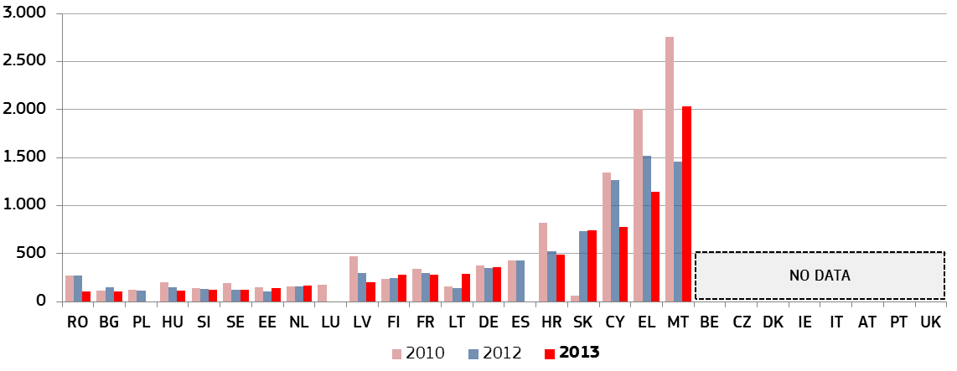* Administrative law cases concern disputes between citizens and local, regional or national authorities, following the CEPEJ methodology. Administrative law cases are addressed by special administrative courts in some countries and handled by ordinary (civil) courts in others. Comparisons should be undertaken with care as some Member States reported changes in the methodology for data collection or categorisation (HU), a reorganisation of the administrative court system (HR) or made caveats on completeness of data that may not cover all Länder or all courts (DE, LU). Changes in incoming cases may allegedly explain variations in LT.

3.1.2 Clearance rate
The clearance rate is the ratio of the number of resolved cases over the number of incoming cases. It measures whether a court is keeping up with its incoming caseload. The length of proceedings is linked to the rate at which the courts can resolve cases, the 'clearance rate', and to the number of cases that are still waiting to be resolved, 'pending cases'. When the clearance rate is about 100% or higher it means the judicial system is able to resolve at least as many cases as come in. When the clearance rate is below 100%, it means that the courts are resolving fewer cases than the number of incoming cases, and as a result, at the end of the year, the number of unresolved cases adds up as pending cases. If this situation persists over several years, this could indicate a more systemic problem, as the build-up of backlogs further aggravates courts' workloads and causes the duration of proceedings to increase further.
Figure 7: Rate of resolving civil, commercial, administrative and other cases*
(First instance/in % - values higher than 100% indicate that more cases are resolved than come in, while values below 100% indicate that fewer cases are resolved than come in) (source: CEPEJ study)
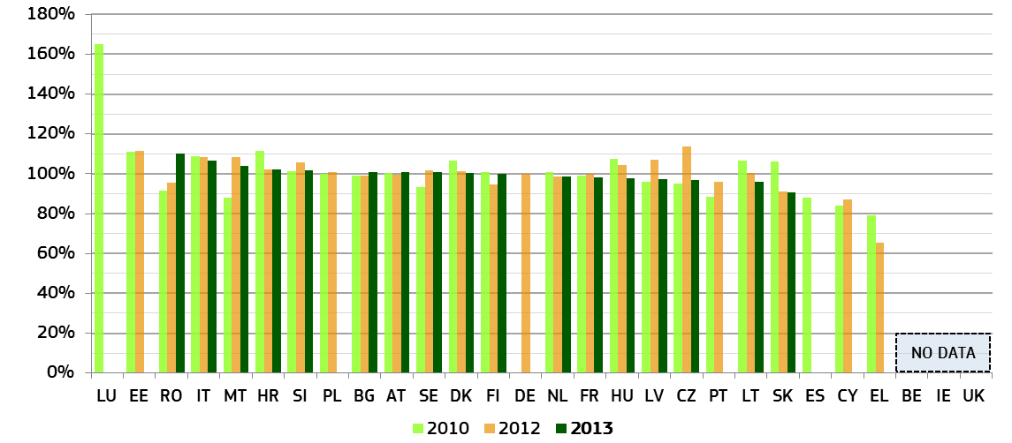* Comparisons should be undertaken with care as some Member States reported changes in the methodology for data collection or categorisation (CZ, EE, IT, CY, LV, HU, SI) or made caveats on completeness of data that may not cover all Länder or all courts (DE, LU). Changes in incoming cases may allegedly explain variations in LT and SK. In LV external and internal factors such as new insolvency proceedings allegedly had an impact in variations.
Figure 8: Rate of resolving litigious civil and commercial cases* (First instance/in %) (source: CEPEJ study)
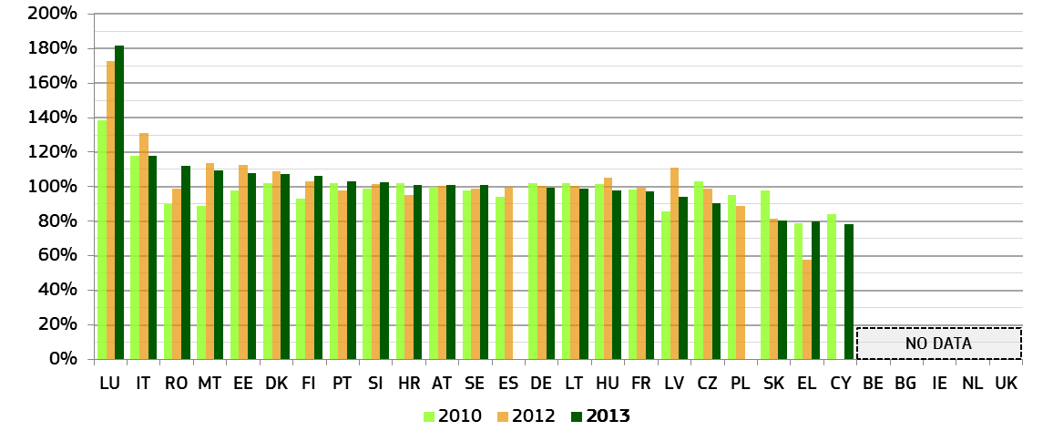* Comparisons must be undertaken with care, as some Member States reported changes in the methodology for data collection or categorisation (CZ, EE, IT, CY, LV, HU, SI) or made caveats on completeness of data that may not cover all Länder or all courts (DE, LU). NL provided a measured disposition time, but it is not calculated by CEPEJ.
Figure 9: Rate of resolving administrative cases* (First instance/in %) (source: CEPEJ study)
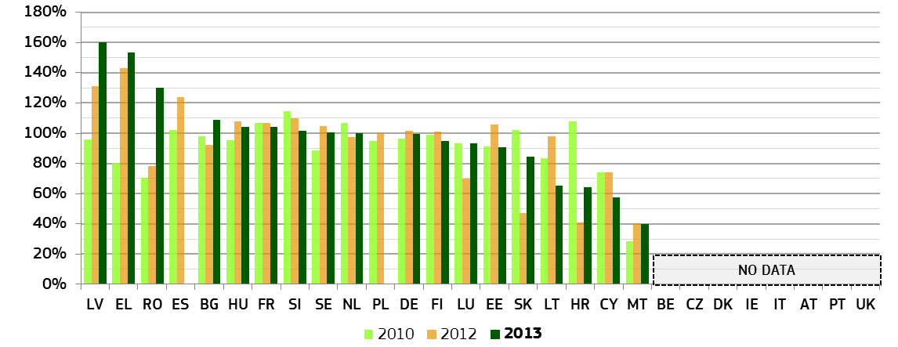* Comparisons should be undertaken with care as some Member States reported changes in the methodology for data collection or categorisation (HU), a reorganisation of the administrative court system (HR) or made caveats on completeness of data that may not cover all Länder or all courts (DE, LU). Changes in incoming cases may allegedly explain variations in LT.

3.1.3 Pending cases
The number of pending cases expresses the number of cases that remains to be dealt with at the end of a period. It also influences the disposition time. Therefore, in order to improve the length of proceedings, measures are required to reduce the number of pending cases.
Figure 10: Number of civil, commercial, administrative and other pending cases* (First instance/per 100 inhabitants) (source: CEPEJ study)
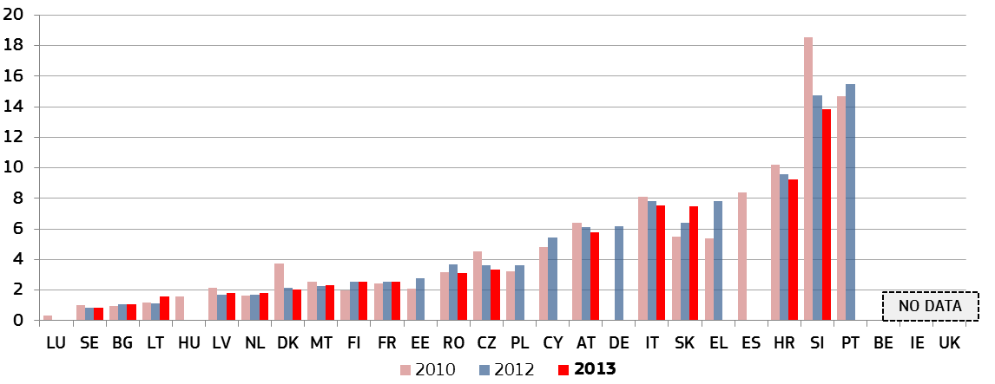* Comparisons should be undertaken with care as some Member States reported changes in the methodology for data collection or categorisation (CZ, EE, IT, CY, LV, HU, SI) or made caveats on completeness of data that may not cover all Länder or all courts (DE, LU). Changes in incoming cases may allegedly explain variations in LT and SK. In DK the digitalization of the land registry may allegedly explain the decrease in pending cases.
Figure 11: Number of litigious civil and commercial pending cases* (First instance/per 100 inhabitants) (source: CEPEJ study)
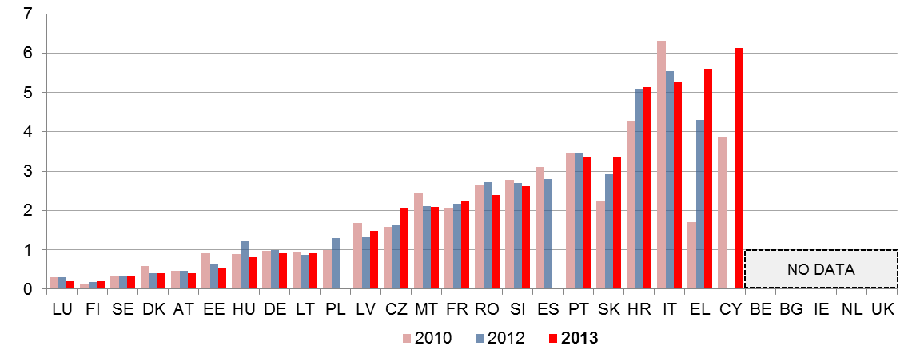* Comparisons should be undertaken with care as some Member States reported changes in the methodology for data collection or categorisation (CZ, EE, IT, CY, LV, HU, SI) or made caveats on completeness of data that may not cover all Länder or all courts (DE, LU). Changes in incoming cases may allegedly explain variations in EL, LT and SK.
Figure 12: Number of administrative pending cases* (First instance/per 100 inhabitants) (source: CEPEJ study)
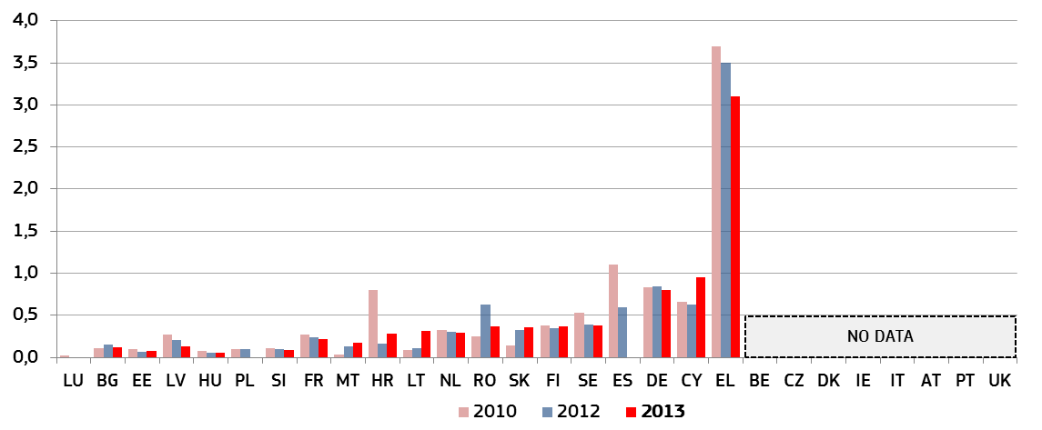* Comparisons should be undertaken with care, as some Member States reported changes in the methodology for data collection or categorisation (HU), a reorganisation of the administrative court system (HR) or made caveats on completeness of data that may not cover all Länder or all courts (DE, LU). Changes in incoming cases may allegedly explain variations in LT and SK.

3.1.4 Efficiency in specific areas
To complement the general data on civil, commercial and administrative cases, the 2015 Scoreboard presents information on the average length of proceedings in certain areas which are relevant for the business environment. Existing data collection systems in Member States do not always provide data for specific fields of law. Since these data grant us a more fine-tuned vision of the effectiveness of justice systems in Member States, this Scoreboard has looked into the areas of insolvency, competition law, consumer law, intellectual property rights and public procurement.
Figure 13: Time needed to resolve insolvency* (in years) (source: World Bank: Doing Business)
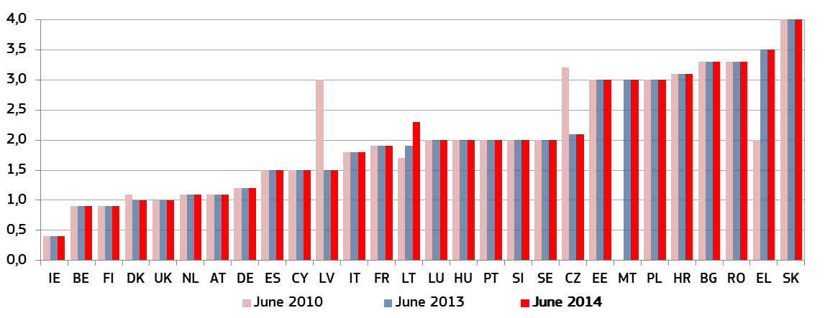* Time for creditors to recover their credit. The period of time is from the company’s default until the payment of some or all of the money owed to the bank. Potential delay tactics by the parties, such as the filing of dilatory appeals or requests for extension, are taken into consideration. The data are collected from questionnaire responses by local insolvency practitioners and verified through a study of laws and regulations, as well as public information on bankruptcy systems.
The data presented below refers to the application of EU law before national courts, notably competition and consumer law rules, Community trade mark and public procurement law. These data throw light onto the effectiveness of the functioning of national courts for the application of EU law in these areas. Information is provided on the average number of days needed to reach a decision before national courts at first and second instance in cases pertaining to these specific fields.
Data have been collected through a variety of sources. The average length of cases pertaining to EU competition law and consumer law has been gathered in cooperation with European networks of national authorities responsible for the enforcement of these areas of EU legislation. Data on Community trade mark has been gathered from the members of the European Observatory on Infringements of Intellectual Property Rights, who have relied upon specific statistics - where available - or on representative samples of cases. Data on public procurement has been collected through a pilot data exercise commissioned by the European Commission. In view of the divergences in the way data are presented for these instances, Member States are ordered alphabetically in their original languages.
Competition law encourages efficiency and innovation and helps to reduce prices. The effective enforcement of these rules is essential for the business environment. The average length for resolving judicial review cases in competition law at first instance corresponds broadly to the average disposition time for administrative cases and appears to be higher than the average length for civil, commercial, administrative and other cases. The length resulting from cases identified in some Member States presents, however, much higher values. This disparity could be due, in some cases, to the complexity involved in this type of specialised litigation. The figure below also shows that in several Member States, significant differences in length can be observed between first and second judicial review instances. In many States, the time it takes for a case to be resolved tends to present higher values at second instance than at first.
Figure 14: Time needed to resolve judicial review cases against decisions of national competition authorities applying Articles 101 and 102 TFEU* (in days) (source: pilot data collection exercise carried out by the European Commission with the European Competition Network)
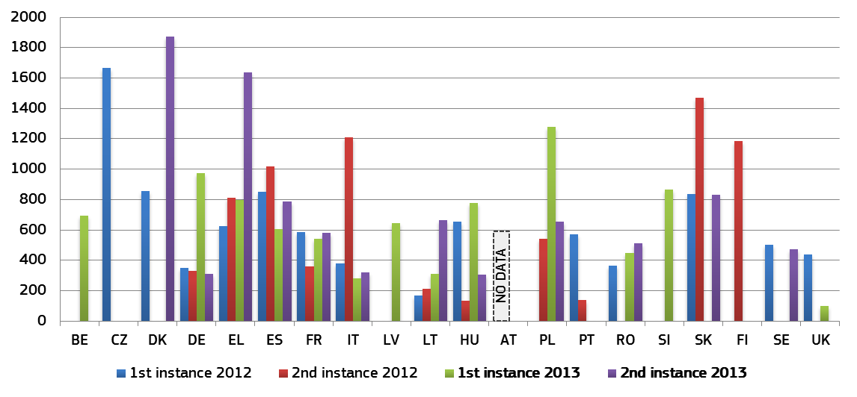
* No cases were identified within this period in BG, EE, IE, HR, CY, LU, MT and NL. The calculation of the average length has been carried out on the basis of a pilot data exercise that identified all cases of appeal of national competition authority decisions applying Articles 101 and 102 of the Treaty on the Functioning of the European Union for which judicial decisions on the substance were issued between 2012 and 2013. The figures are provided for1st and 2nd instance. For this scenario of judicial review there is no second instance in AT and in SI it only applies as of August 2013.
True consumer protection also requires the effective functioning of the courts adjudicating on the application of rules that protect consumers. The 2015 Scoreboard explores the length that it takes to solve an appeal against the decision of consumer protection authorities applying the Unfair Commercial Practices Directive, the Unfair Contract Terms Directive and the Consumer and Sales Guarantees Directive in Member States. Although the average length for resolving judicial review cases in consumer law at first instance appears to be higher than the average length for civil, commercial, administrative and other cases, the divergence is generally smaller than the one observed in competition law cases.
Figure 15: Time needed to resolve appeals to decisions of consumer protection authorities* (in days) (source: pilot data collection exercise carried out by the European Commission with the Consumer Protection Cooperation Network)

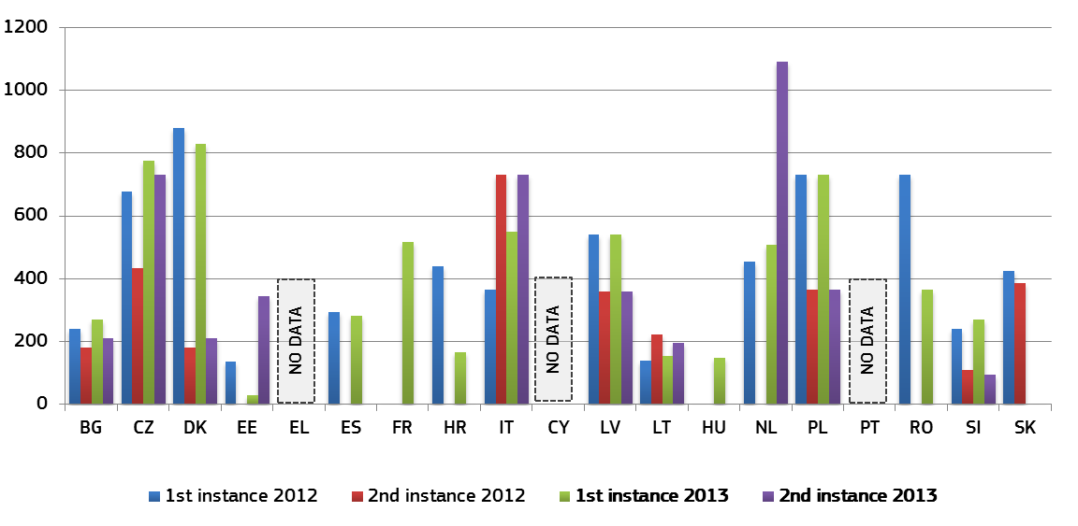* The scenario considered for this figure was not applicable to BE, LU, AT, FI, SE and UK since certain consumer protection authorities are not empowered to adopt decisions declaring an infringement of these rules. There were no relevant cases in DE, IE and MT within this period. In FR cases of appeal are marginal. The calculation of the average length has been carried out on the basis of samples of cases of judicial review of decisions of a consumer protection authority applying the Unfair Contract Terms Directive, Consumer Sales and Guarantee Directive, Unfair Commercial Practices Directive and their national implementing provisions which were solved by courts in 2012 and 2013. The size of samples varies across Member States.
Growth in more innovative sectors, notably including those relying on intangible assets, such as intellectual property rights, is dependent on a well-functioning law enforcement system. For this reason, this year the Scoreboard gathers specific data on the average length of time needed for cases of infringement of a Community trademark dealt with by national courts at first and second instance. With some exceptions, the differences in length in comparison with the average length for civil, commercial, administrative and other cases are smaller than in the two previously considered cases.
Figure 16: Time needed to resolve cases of infringement of Community trademark* (in days) (source: pilot data collection exercise carried out by the European Commission with the European Observatory on infringements of intellectual property rights)
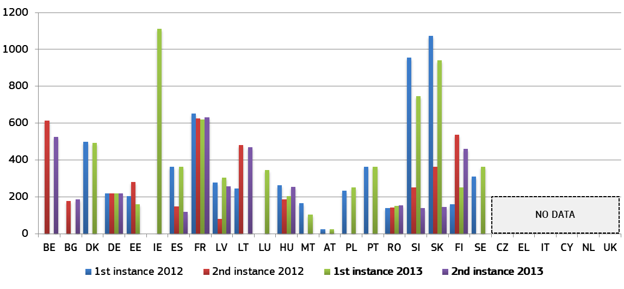
* No cases were identified in HR. The calculation on the length has been carried out on the basis of samples of cases relating to Community trade mark infringements where decisions were issued in 2012 and 2013. The samples of cases have been collected by members of the European Observatory on Infringements of intellectual property rights. Where statistics on length for these cases were available, samples of cases have not been used.
Finally, the Scoreboard also gathers data on the time taken to solve cases related to public procurement. Public procurement rules ensure that public contracts are awarded in an open, fair and transparent manner. The chart below presents data for the first, second and third instances in cases where national courts apply remedies further to actions introduced before the contract is concluded. Data are provided for the years 2009-2012. The graph shows that non-judicial entities resolving at first instance (the Public Procurement Remedies Directive allows for this possibility) tend to have shorter proceedings than judicial bodies. While remedies appear to function smoothly at this first instance, appeals at further stages take more time.
Figure 17: Time needed to resolve cases in which public procurement rules applied* (in days) (source: pilot study)
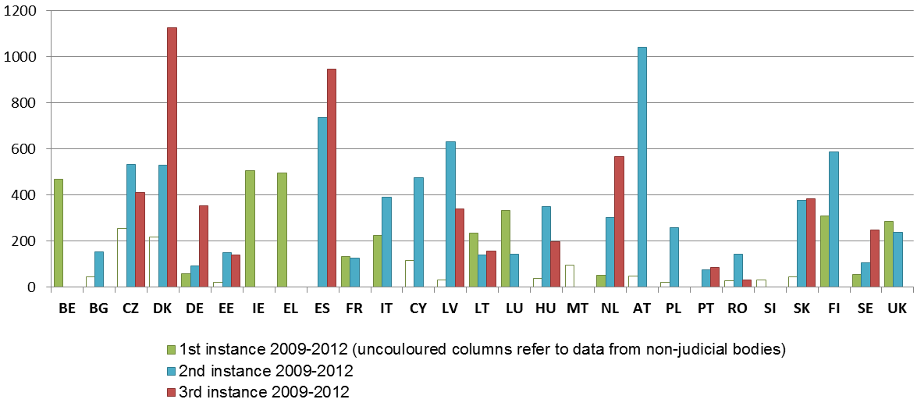
* The calculation of the average length has been carried out on the basis of samples of cases relating to remedies foreseen under the Public Procurement Directive before the contract is concluded where decisions were issued between 2009 and 2012. In those Member States where first instance appeals are solved by a non-judicial body (BG, CZ, DK, EE, ES, CY, LV, HU, MT, AT until 2014, PL, RO, SI and SK) data for this instance appear in white. The study did not cover HR which joined the EU in July 2013. Average length could not be retrieved for first instance in ES and PT and for second instance in IE and MT.

For the 2015 Scoreboard, initial research was carried out to map the enforcement procedure and the time needed to satisfy claims. As very few sources collect comparative data on the length of enforcement, an appropriate methodology was elaborated. This led to an approach which focused on the collection of a representative sample of data on the length of time between the moment a final judicial decision has been made and, respectively, the moment the defendant’s bank account is frozen, as well as the moment the frozen funds are actually recovered. Extensive contact with relevant stakeholders, such as courts or bailiffs in various geographical locations, was made in order to substantiate the appropriateness of the methodology used for the research. Despite the scarcity of data, certain information has been provided on the length of enforcement proceedings. For example, in Italy the research shows that it takes 136 days from the final judicial decision to the recovery of the assets which includes 23 days from the judicial decision until the freezing of the bank account. The data from Finland show that on average, it takes 21 days from the judicial decision until the bank account is frozen.
Conclusions on the efficiency of justice systems
- The third edition of the EU Justice Scoreboard seeks to identify possible trends. A cautious and nuanced approach is required. The situation varies significantly, depending on the respective Member State and indicator. Furthermore, data are not always available for all Member States and for the three years covered. Reaping the rewards of justice reform takes time. As the Scoreboard is a regular exercise, it will keep track of progress.
- In general, for those Member States for which data are available, some improvement in the efficiency of justice systems in Member States can be observed. Over the years covered, it appears that more Member States show a positive rather than a negative trend in terms of disposition time and clearance rate in litigious civil and commercial cases and administrative cases. For pending cases it is not possible to identify a clear common trend in either direction, except for a sustained decrease of pending cases in civil, commercial, administrative and other cases.
- Amongst Member States facing particular challenges, positive trends appear to prevail, with a few exceptions. The positive signs that appear in certain Member States undertaking ambitious reforms should encourage them to continue their efforts with determination and commitment.
- The pilot data collection exercises seem to indicate that the performance of courts varies depending on the area of law concerned. For example, litigation in certain areas where national courts act as Union courts, such as competition law and consumer protection law, can take longer to resolve than in the broader area of civil, commercial and administrative cases. By contrast, in the public procurement area, Member States resolve cases within shorter periods.
- These data on specific areas of law also indicate differences between first and second instance proceedings. However, a common trend in the length of proceedings between these two instances across the EU cannot be identified.

In 2014, Economic Adjustment Programmes in EL, PT (ended in June 2014) and CY included conditionality on justice reform.
Communication from the Commission, Annual Growth Survey 2015, COM (2014) 902 final.
The data have been collected in cooperation with the group of contact persons on national justice systems.
Council Recommendation of 8 July 2014 on the National Reform Programme 2014 of Bulgaria and delivering a Council opinion on the Convergence Programme of Bulgaria, 2014 (2014/C 247/02); Council Recommendation of 8 July 2014 on the National Reform Programme 2014 of Croatia and delivering a Council opinion on the Convergence Programme of Croatia, 2014 (2014/C 247/10); Council Recommendation of 8 July 2014, on the National Reform Programme 2014 of Ireland and delivering a Council opinion on the Stability Programme of Ireland, 2014 (2014/C 247/07); Council Recommendation of 8 July 2014 on the National Reform Programme 2014 of Italy and delivering a Council opinion on the Stability Programme of Italy, 2014 (2014/C 247/11); Council Recommendation of 8 July 2014 on the National Reform Programme 2014 of Latvia and delivering a Council opinion on the Stability Programme of Latvia, 2014 (2014/C 247/12); Council Recommendation of 8 July 2014 on the National Reform Programme 2014 of Malta and delivering a Council opinion on the Stability Programme of Malta, 2014 (2014/C 247/16); Council Recommendation of 8 July 2014 on National Reform Programme 2014 of Poland and delivering a Council opinion on the Convergence Programme of Poland, 2014 (2014/C 247/19); Council Recommendation of 8 July 2014 on the National Reform Programme 2014 of Portugal and delivering a Council opinion on the Stability Programme of Portugal, 2014 (2014/C 247/20); Council Recommendation of 8 July 2014 on the National Reform Programme 2014 of Romania and delivering a Council opinion on the Convergence Programme of Romania, 2014 (2014/C 247/21); Council Recommendation of 8 July 2014 on Slovakia’s 2014 national reform programme and delivering a Council opinion on the Stability Programme of Slovakia, 2014 (2014/C 247/23); Council Recommendation of 8 July 2014 on the National Reform Programme 2014 of Slovenia and delivering a Council opinion on the Stability Programme of Slovenia, 2014 (2014/C 247/22); Council Recommendation of 8 July 2014 on the National Reform Programme 2014 of Spain and delivering a Council opinion on the Stability Programme of Spain, 2014 (2014/C 247/08)
BG, ES, HU, IT, LV, MT, PL, RO, SI, SK.
BG, IT, LV, PL, SI, SK.
In 2013 the Commission set up a group of contact persons on national justice systems in view of the preparation of the EU Justice Scoreboard and to promote the exchange of best practices on the effectiveness of justice systems. To this end Member States have been asked to designate two contact persons, one from the judiciary and one from the ministry of justice, and regular meetings of this informal group have taken place in 2014 and 2015. One Member State has not yet nominated contact persons and four have only nominated one from the ministry of justice but not from the judiciary.
AT, BE, DE, IE, EL, HR, IT, LT, NL, PT, RO have made presentations in this group on certain aspects of their justice system.
Regulation 1303/2013 of the European Parliament and of the Council of 17 December 2013 laying down common provisions on the European Regional Development Fund, the European Social Fund, the Cohesion Fund, the European Agricultural Fund for Rural Development and the European Maritime and Fisheries Fund and laying down general provisions on the European Regional Development Fund, the European Social Fund, the Cohesion Fund and the European Maritime and Fisheries Fund and repealing Council Regulation EC No 1083/2006, OJ L 347, 20.12.2013.
The reasons for country-specific recommendations are presented by the Commission in a Staff Working Documents, available at: http://ec.europa.eu/europe2020/making-it-happen/country-specific-recommendations/index_en.htm
Available at: http://ec.europa.eu/justice/effective-justice/index_en.htm
The regular collection of data by CEPEJ for the 47 Member States of the Council of Europe takes place every two years (the last general CEPEJ report was published in 2014 with 2012 data). All but three Member States have replied to the CEPEJ questionnaire for the Scoreboard.
On the economic impact of effective justice systems, see 2014 EU Justice Scoreboard, section 'The effectiveness of national justice systems as a structural component for growth'; see also "The Economic Impact of Civil Justice Reforms", European Commission, Economic Papers 530, September 2014.
Length of proceedings, clearance rate and number of pending cases are standard indicators defined by CEPEJ. http://www.coe.int/t/dghl/cooperation/cepej/evaluation/default_en.asp
Data includes updates made by CEPEJ after the publication of their 2013 study as transmitted to the Commission.
2015 Study on the functioning of judicial systems in the EU Member States, carried out by the CEPEJ Secretariat for the Commission. Available at: http://ec.europa.eu/justice/effective-justice/index_en.htm
See also study prepared for the for the Directorate-General for Internal Market, Industry, Entrepreneurship and SMEs of the European Commission on Bankruptcy and second chance for honest bankrupt entrepreneurs available at: http://ec.europa.eu/enterprise/newsroom/cf/itemdetail.cfm?item_id=7962&lang=en
The specificity of the situations looked upon explains that it has not always been possible to cover all EU Member States in the graphs as certain type of cases could not be found in some of them.
In the cases of judicial review targeted by the exercise, these authorities are a party to the proceedings.
The number of relevant cases of judicial review varies per Member State. In some instances, the limited number of relevant cases (BE, CZ, DK, IT, PL and SK) makes that one case with a very long duration can considerably affect the average. In ES, the length for second instance refers also to appeals on grounds of breach of a fundamental right which are normally solved within a shorter period.
In general, data does not cover financial services and products. In CZ data have been collected from the authorities responsible for the Unfair Commercial Practices Directive. The number of relevant cases in DK, EE, FR, HR, NL, SI and SK is low, which means that one case with a very long duration can considerably affect the average. For ES, data do not cover all Autonomous Communities. Data from IT, PL and RO are based on an estimation provided by the consumer protection authority.
See for example "What makes civil justice effective?”, OECD Economics Department Policy Notes, No. 18 June 2013 and "The Economics of Civil Justice: New Cross-Country Data and Empirics", OECD Economics Department Working Papers, No. 1060.
The size of samples varies across Member States. For DK, statistical data relates also to cases in which national trade mark law was applied by the Maritime and Commercial Court. DE does not have specific statistics for Community trade mark cases as statistics are collected for all cases related to industrial property. The figures provided are based on estimates by courts. In SK, second instance refers to the Supreme Court in 2012 and to cases heard in second instance by the District Court of Bratislava in 2013. In some Member States (EE, LT, LU, HU, FI and in SI for second instance) the number of relevant cases is limited. In IE there was only one relevant case within this period.
Economic efficiency and legal effectiveness of review and remedies procedures for public contracts, by Europe Economics, study prepared for the Directorate-General for Internal Market, Industry, Entrepreneurship and SMEs of the European Commission, available at: http://ec.europa.eu/growth/single-market/public-procurement/modernising-rules/evaluation/index_en.htm
Data for HR are available at the web page of the Croatian State Commission for supervision of public procurement procedures in their annual reports.
Case study on the functioning of enforcement proceedings relating to judicial decision in Member States, Matrix, study prepared for the European Commission (Directorate-General Justice and Consumers), available at: http://ec.europa.eu/justice/effective-justice/index_en.htm
A trend, as reflected in the three Scoreboards, can reveal very different situations; for example, changes in length of proceedings can range from 10 days (or fewer) to 100 days (or more).
For more detail on the variations see in particular the country fiches in the 2015 Study on the functioning of judicial systems in the EU Member States, carried out by the CEPEJ Secretariat for the Commission.
2010, 2012, 2013.
E.g. EL.

