3.2 Quality of justice systems
High-quality institutions, including national justice systems, are a determinant for economic performance. Effective justice requires quality throughout the whole justice chain. A lack of quality of justice decisions may increase business risks for large companies and SMEs and affect consumer choices.
All Member States are taking measures to support the quality of their justice systems. Although there is no single agreed way of measuring the quality of the justice system, the Scoreboard uses certain parameters, which are generally accepted as relevant and that can help to improve the quality of justice.

3.2.1 Monitoring, evaluation and survey tools to support the quality of justice systems
Monitoring and evaluation of the activities of courts are tools which help improve the predictability and timeliness of justice decisions and court functioning. These tools can consist in monitoring the day-to-day activity of the courts thanks to data collection. They can also consist in a more prospective evaluation of the court system, for example by using quality indicators or even by defining quality standards for the whole justice system. Surveys conducted amongst professionals who work in courts and/or users of the courts can also provide relevant information to enhance the quality of the justice system.
Figure 18: Availability of monitoring of court activities in 2013* (source: CEPEJ study)
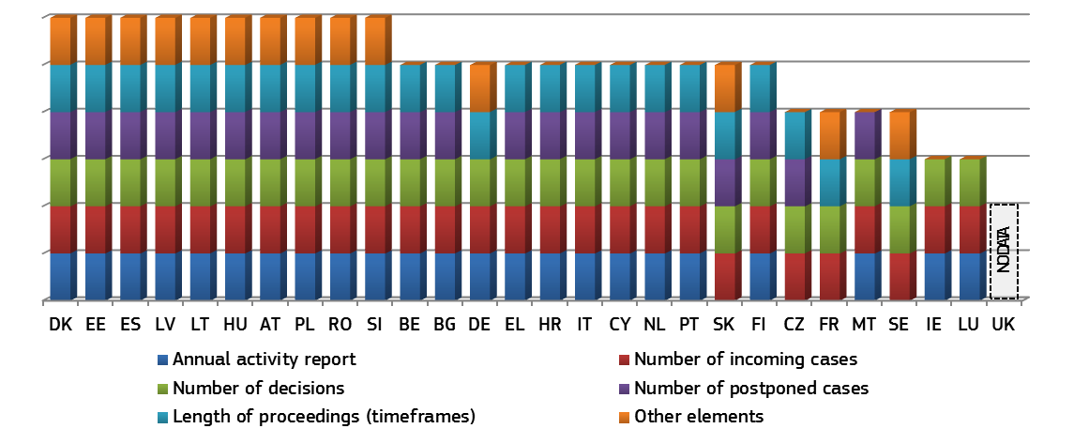* Monitoring systems aim to assess the day-to-day activity of the courts, thanks in particular to data collection and statistical analysis. For FR differences from the previous Scoreboard edition derive from the correction of data which is stable for both years. Data for ES and PL stems from 2012.
Figure 19: Availability of evaluation of court activities in 2013* (source: CEPEJ Study)
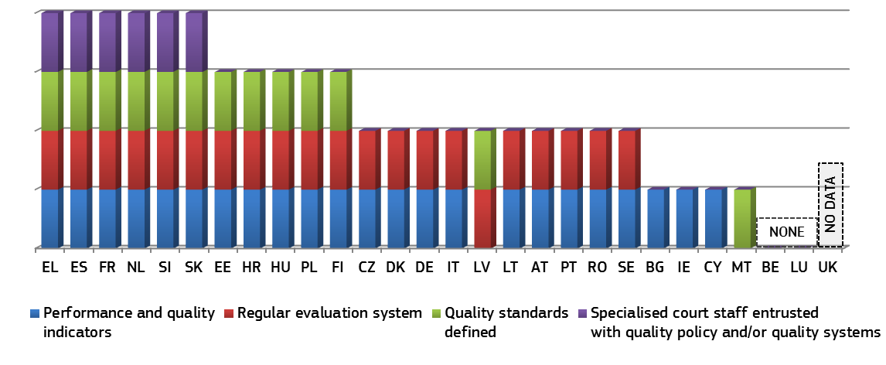* The evaluation system refers to the performance of courts, generally using indicators and targets. In addition some Member States define quality policies and standards for the whole judicial system. In RO, performance indicators on the activity of courts are used regularly. For all the other Member States the results are identical to the data collected for 2012. Data for ES and PL stems from 2012.
Figure 20: Surveys conducted among court users or legal professionals in 2013* (source: CEPEJ Study)
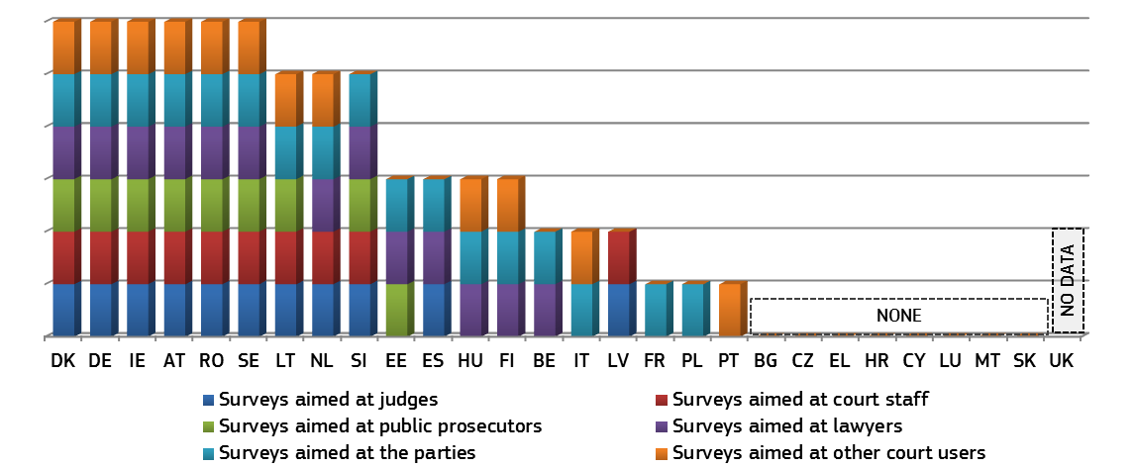* Surveys aimed at public prosecutors have been reported as decreasing in NL, while those aimed at lawyers, parties and other court users have been reported as increasing in HU and LT respectively. For all the other Member States the results are identical to the data collected for 2012. Data for EL, ES and PL stems from 2012.

3.2.2 Information and communication technology systems help to reduce the length of proceedings and to facilitate access to justice
ICT systems for the registration and management of cases are indispensable tools at the disposal of courts for the effective time management of cases, as they help to improve the rate at which the court can handle cases and thereby reduce the overall length of proceedings. ICT systems for communication between courts and parties (e.g. electronic submission of claims) can contribute to reducing delays and costs for citizens and businesses by facilitating the access to justice. ICT systems also play an increasingly important role in cross-border cooperation between judicial authorities and thereby facilitate the implementation of EU legislation.
Figure 21: ICT Systems for the registration and management of cases*
(weighted indicator-min=0, max=4) (source: CEPEJ study)
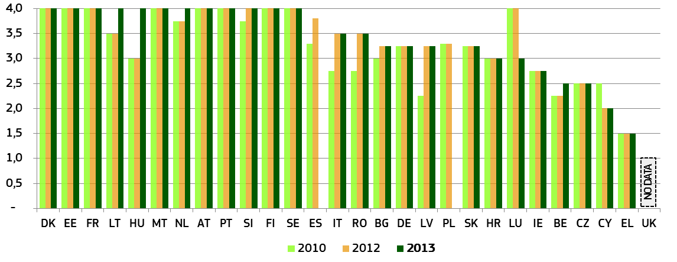
* Composite indicator constructed from several ICT indicators (case registration system, court management information system, financial information system, videoconferencing) that measure availability of these systems from 0 to 4 (0= available in 0% of courts; 4=available in 100% of courts).
Figure 22: Electronic communication between courts and parties*
(weighted indicator-min=0, max=4) (source: CEPEJ study)
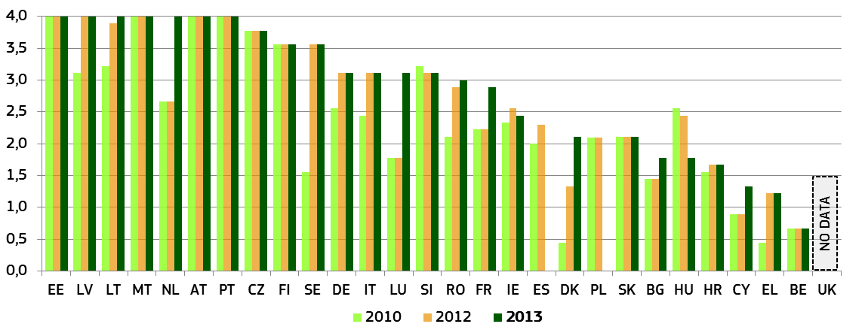* Composite indicator constructed from several ICT indicators (electronic web forms, website, follow-up of cases online, electronic registers, electronic processing of small claims, electronic processing of undisputed debt recovery, electronic submission of claims, videoconferencing, other electronic communication facilities) that measure availability of these systems from 0 to 4 (0= available in 0% of courts; 4=available in 100% of courts).

Figure 23: Electronic processing of undisputed debt recovery
(0 = available in 0% of courts, 4 = available in 100% of courts) (source: CEPEJ study)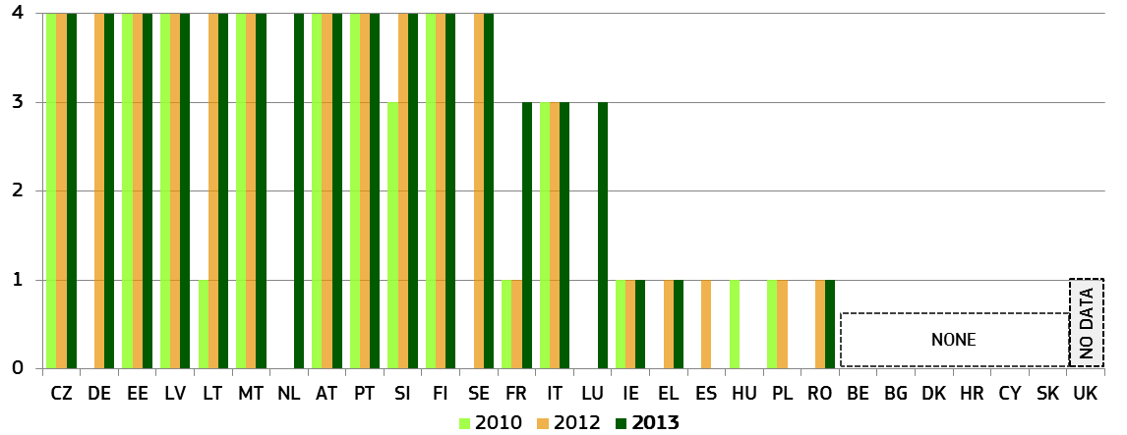
Figure 24: Electronic submission of claims (0 = available in 0% of courts, 4 = available in 100% of courts) (source: CEPEJ study)
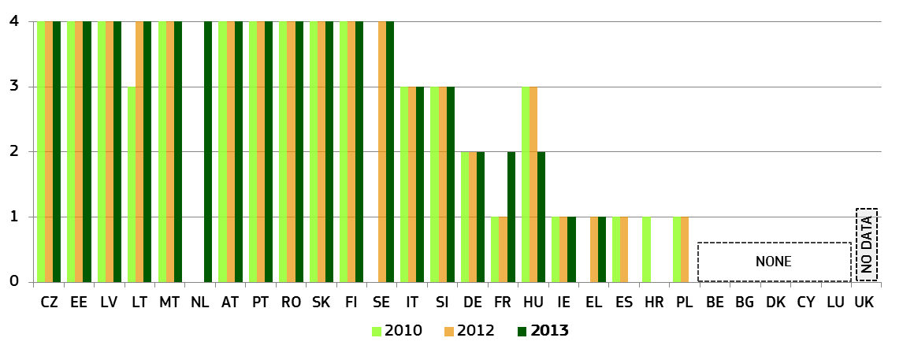An effective small claims procedure, whether at national or at European level, is key for improving citizens’ access to justice and for enabling them to make better use of their consumer rights. The importance of cross-border online small claims procedures is also increasing due to cross-border e-commerce. One of the policy goals of the European Commission is therefore to simplify and speed up small claims procedures by improving the communication between judicial authorities and by making smart use of ICT. The eventual goal is to reduce administrative burden for all user groups: courts, judicial actors and end users.
The 11th e-government benchmarking report commissioned by the European Commission measures for the first time the quality of small claims procedures online in EU Member States. For this study, the assessment of the small claims procedure was carried out by researchers (so-called 'Mystery Shoppers'). The purpose was to detect whether online public service provisions are organised around users' needs. For this purpose each researcher acted as a regular citizen and his/her 'journey' was time-boxed, i.e. each mystery shopper had one day to assess one life event. This implies that when a particular feature could not be found within this time, it was answered negatively. A negative response does therefore not mean per se that the particular feature was not online available – it does, however, suggest that it was not easy to find intuitively, without too many clicks, and that it is very likely that regular citizens or entrepreneurs would not use it / find it either.
Figure 25: Benchmarking of small claims procedures online (for each category maximum 100 points, in total maximum 700 points) (source: Delivering on the European Advantage? ‘How European governments can and should benefit from innovative public services’, study prepared for the European Commission (Directorate-General Communications Networks, Content and Technology)
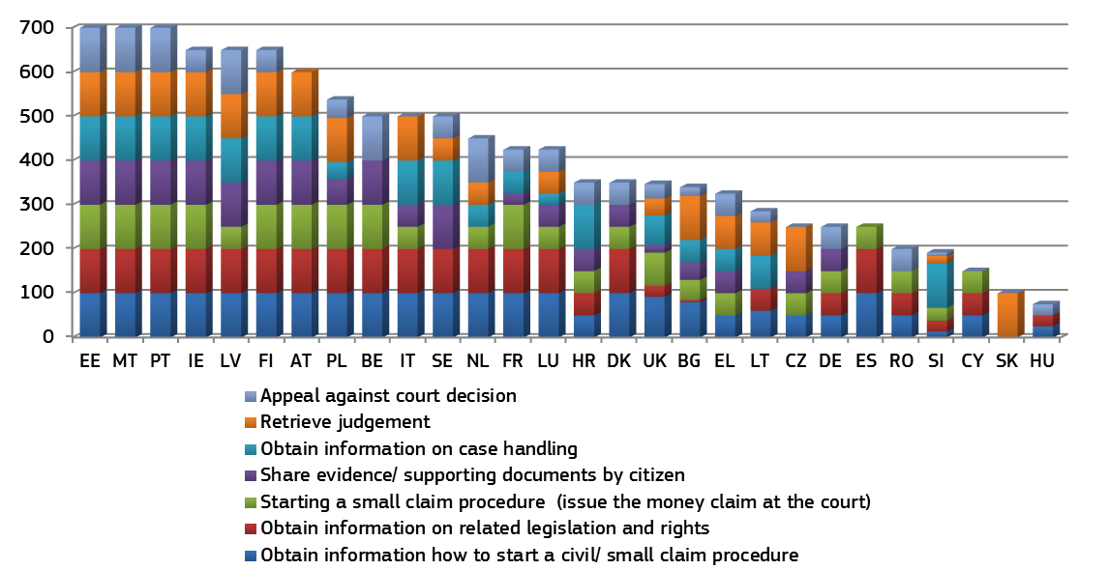

3.2.3 Courts' communication policies
Courts' communication efforts are crucial to help citizens and businesses to make informed decisions about avenues for redress (judicial or non-judicial) and contribute to the necessary trust in the judicial system. The media plays a crucial role in reporting on court cases. By seeking to improve contact between courts and the media, the judiciary can better inform the public of judicial work (scope, limitations and complexities) and contribute to the quality of reporting (e.g. avoiding factual mistakes).
In 2014, the Commission launched an exchange of information between Member States on practices and policies on courts communication. This revealed the need to have a better overview of practices in this field. As a follow-up, the Commission carried out a mapping of current practices in cooperation with Member States, on the important parameters of an effective courts' communication policy. This included the availability of information for the general public; the ways in which courts organise their relations with the press/ media; training for judges on communication with parties and the press; availability and practices regarding the publication of court decisions online (at all levels of the judicial system).
Figure 26: Availability of online information about the judicial system for the general public* (source: European Commission)
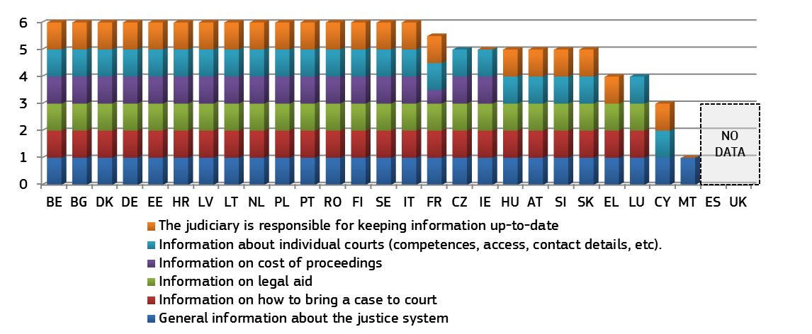* For each of the categories in the figure 1 point can be awarded. As a federal state, DE is characterised by decentralised structures. Therefore the federal states decide by themselves which information to provide online and are thus in charge of keeping the information updated. The same applies at federal level.
Figure 27: Relations between courts and the press/ media* (source: European Commission)
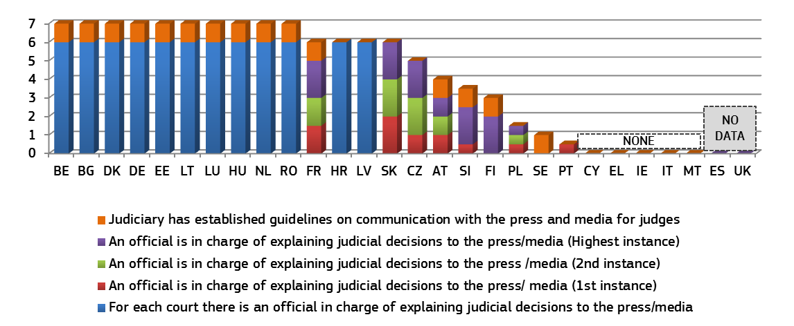* For each instance (1st, 2nd and 3rd) two points can be awarded if there a press officer or 'press judge' that covers both civil/ commercial cases and administrative case. If only one category of cases is covered (e.g. either civil/ commercial or administrative) only one point is awarded. If there is a press officer for some courts 0,5 points are awarded per instance (1st, 2nd and 3rd). In IE the Courts Service does have a Media Relations Advisor who prepares and issues press releases to the media.
Figure 28: Availability of training for judges on communication with parties and the press* (source: European Commission)
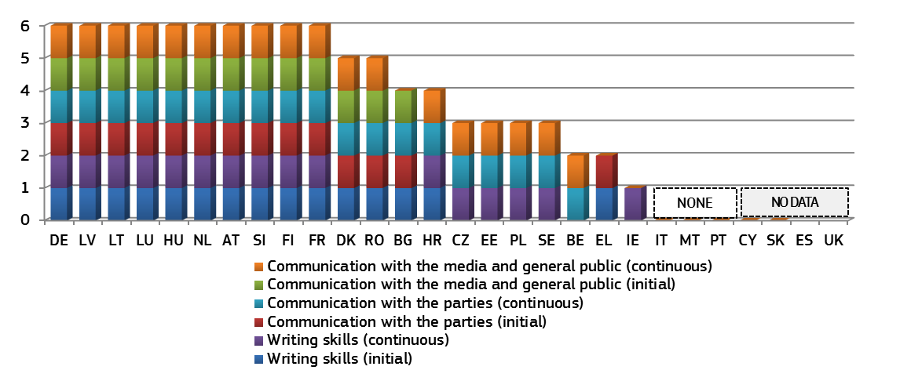
* For each of the categories in the figure 1 point can be awarded.
Figure 29: Access to published judgements online* (civil and commercial cases, all instances) (source: European Commission)
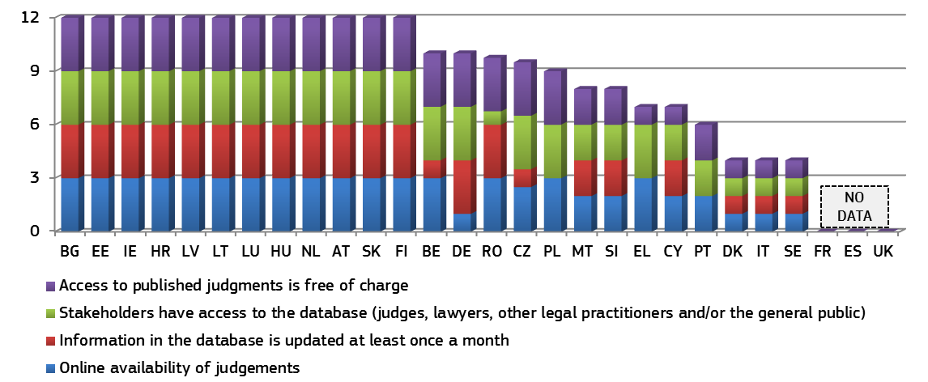* For the categories 'Online availability of judgements', 'Information in the database is updated at least once a month', and 'Access to published judgments is free of charge' 3 points are awarded when this is the case for all instances (1st, 2nd and 3rd). When the service is only available at for certain court instances (1 or 2 points are awarded). When the service is only available for some courts 0,5 points are awarded per instance. For the category 'Stakeholders have access to the database (judges, lawyers, other legal practitioners and/or the general public', 1 point is awarded when all stakeholders are covered. If the general public has no access, 0,25 points are awarded for each stakeholder which has access (e.g. judges = 0,25 points, lawyers = 0,25 points, other legal practitioners = 0,25 points).
Figure 30: Access to published judgements online* (administrative cases, all instances) (source: European Commission)
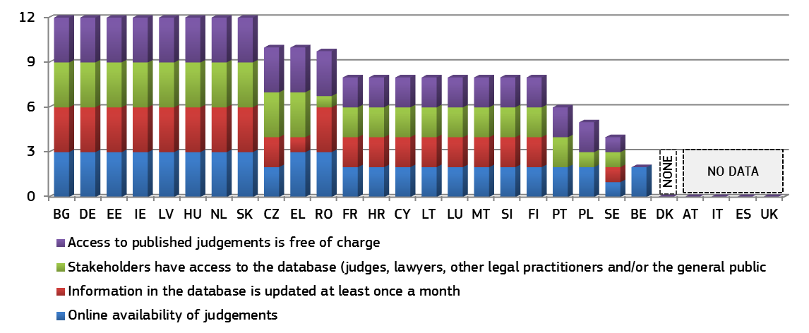* For the categories 'Online availability of judgments', 'Information in the database is updated at least once a month', and 'Access to published judgments is free of charge' 3 points are awarded when this is the case for all instances (1st, 2nd and 3rd). When the service is only available at certain court instances, 1 or 2 points are awarded. When the service is only available for some courts 0.5 points are awarded per instance. For the category 'Stakeholders have access to the database (judges, lawyers, other legal practitioners and/or the general public', 1 point is awarded when all stakeholders are covered. If the general public has no access, 0.25 points are awarded for each stakeholder which has access (e.g. judges = 0.25 points, lawyers = 0.25 points, other legal practitioners = 0.25 points). In IE the Courts Service’s website is the official platform for publication of all judgments of all courts exercising civil and criminal jurisdiction. There is no specific category known as "administrative cases".
Figure 31: Practices regarding the publications of judgments online* (civil and commercial cases, all instances) (source: European Commission)
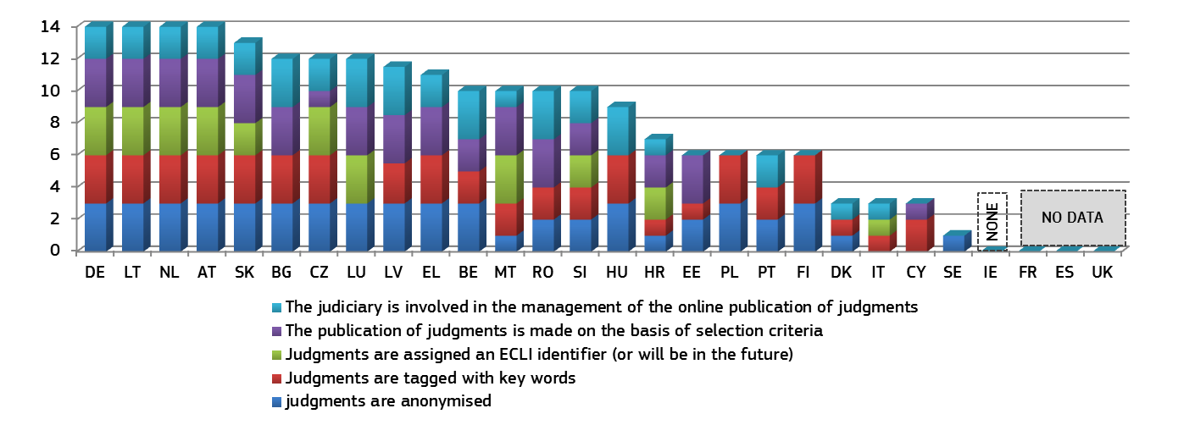* For the categories 'The publication of judgments is made on the basis of selection criteria', 'Judgments are assigned an ECLI identifier (or will be in the future)', 'Judgments are tagged with key words' and 'Judgments are anonymised', 3 points are awarded when this is the case for all instances (1st, 2nd and 3rd). When the service is only available at for certain court instances (1 or 2 points are awarded depending on the number of instance that are covered). In Malta the second instance court is the highest court.
Figure 32: Practices regarding the publications of judgments online (administrative cases, all instances)* (source: European Commission)
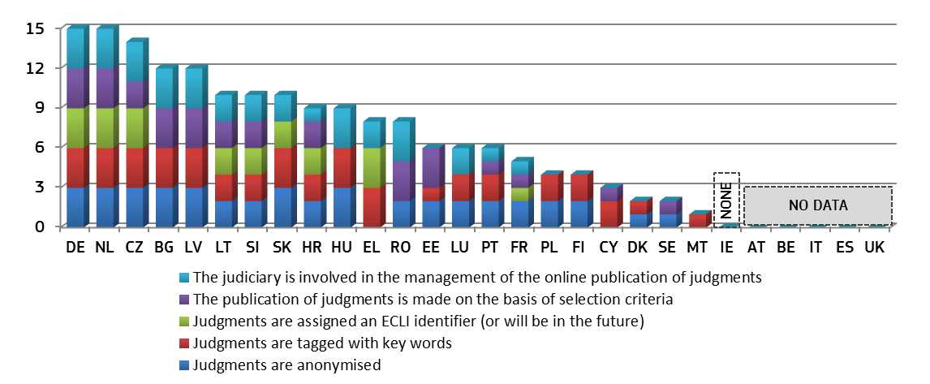* For the categories 'The publication of judgments is made on the basis of selection criteria', 'Judgments are assigned an ECLI identifier (or will be in the future)', 'Judgments are tagged with key words' and 'Judgments are anonymised', 3 points are awarded when this is the case for all instances (1st, 2nd and 3rd). When the service is only available at for certain court instances (1 or 2 points are awarded depending on the number of instance that are covered). In Malta, the second instance court is the highest court. In IE the Courts Service’s website is the official platform for publication of all judgments of all courts exercising civil and criminal jurisdiction. There is no specific category known as "administrative cases".

3.2.4 Alternative Dispute Resolution (ADR) methods help to reduce the workload of courts
The ADR covers any methods of resolving disputes other than by litigation in courts. Mediation, conciliation, and arbitration are the most common forms of ADR. By comparison to average litigation, they can help parties to arrive at a compromise in a shorter period of time and foster a more harmonious culture in which there are no winners or losers. ADR can contribute to effective justice and ultimately to an investment-friendly environment and economic growth. All Member States which provided data reported the availability of at least three ADR methods, with a large majority reporting four methods, i.e. judicial and non-judicial mediation, conciliation and arbitration. In spite of the availability of multiple avenues to settle a dispute outside the courtroom, ADR methods remain generally underused in most Member States, as documented in Figure 35. The Scoreboard provides data on Member States' public sector activities to promote and incentivise the use of these methods. While promotional activities are considered voluntary steps, incentives are codified by law or government decree and are thus a requirement. Figure 33 and 34 are based on replies to a questionnaire sent to the Member States' contact persons. Figure 35 is based on a Eurobarometer survey. It sets out the responses of companies which reported having received consumer complaints through various channels in the past 12 months.
Figure 33: Promotion of the use of ADR by the public sector* (source: European Commission)
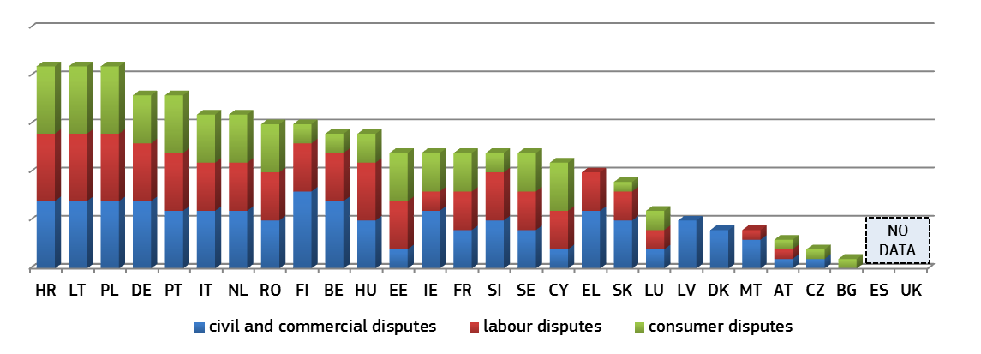
* Aggregated indicator based on the following data: 1) websites providing information on ADR, 2) publicity campaigns in media, 3) brochures to the general public, 4) specific information sessions on ADR are available upon request, 5) specific communication activities organised by courts, 6) publication of evaluations on the use of ADR, 7) publication of statistics on the use of ADR, 8) others. For each promotion tool set out in the questionnaire one point is allocated. For certain Member States additional activities may be undertaken (DE).
Figure 34: Incentives to use ADR* (source: European Commission)
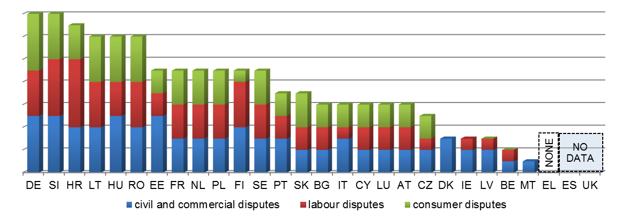
* Aggregated indicator based on the following data: 1) legal aid covers (partly or in full) costs incurred with ADR, 2) full or partial refund of court fees, including stamp duties, if ADR is successful, 3) no lawyer for ADR procedure required, 4) judge can act as mediator, 5) ADR/mediation co-ordinator at courts, 6) others. For each incentive tool set out in the questionnaire one point is allocated. Certain Member States referred to additional method to facilitate the use of ADR (IE). In CZ if the nature of the matter allows, the judge can initiate court settlement and seek a compromise.

Figure 35: Consumer complaints received by companies through various channels* (source: Eurobarometer survey)
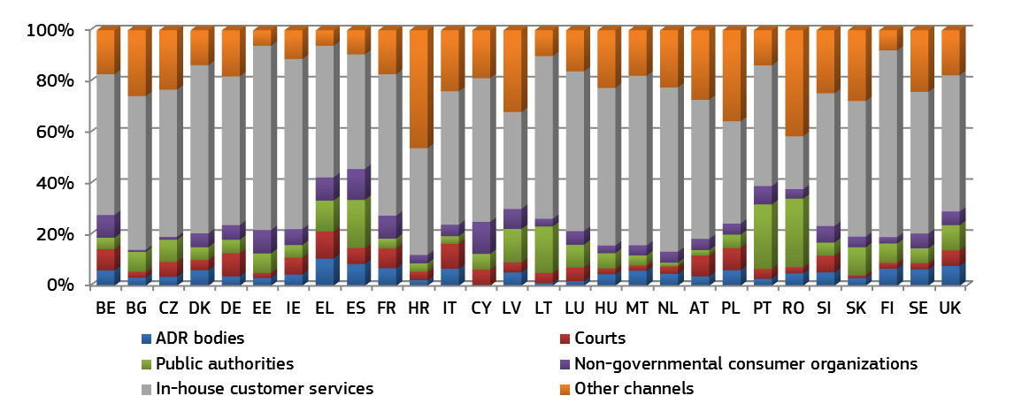* The figure does not take into account those responses where retailers had not received any consumer complaints through any channels at all.

3.2.5 Promoting training of judges can help to improve the effectiveness of justice
The training of judges is an important element for the quality of judicial decisions. Information deriving from the European judicial training 2014 annual report about the current percentage of judges participating in continuous training in EU law, or in the law of another Member State, has also been included.
Figure 36: Compulsory training for judges in 2013* (source: CEPEJ study)
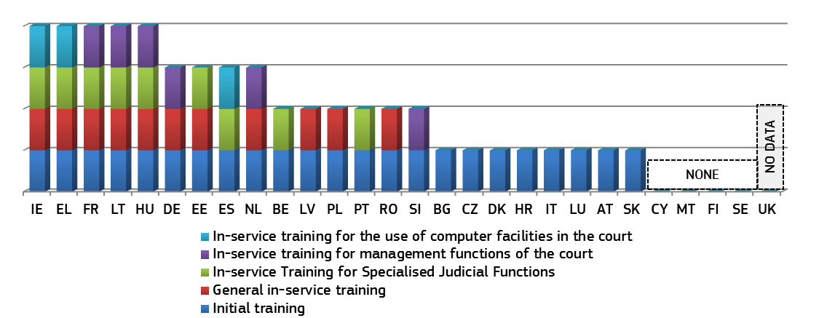* DE and HU have reportedly increased the number of compulsory training categories in comparison to 2012. Data for ES and PL stems from 2012.
Figure 37: Judges participating in continuous training activities in EU Law or in the law of another Member State* (as a % of total number or judges ) (source: European Commission, European Judicial Training, 2014)
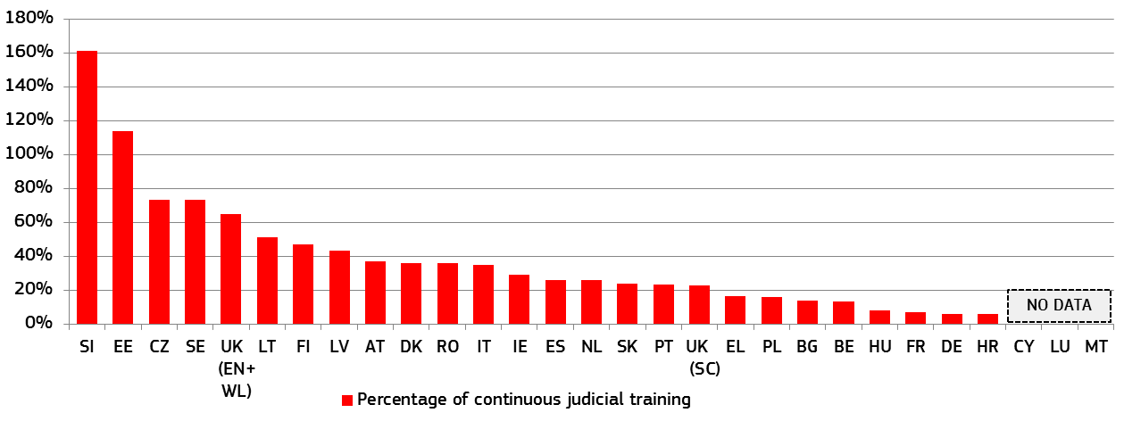* This year, data have been provided for UK (SC). For FR, it includes prosecutors. In a few cases reported by the Member States the ratio of participants to existing members of a legal profession exceeds 100%, meaning that participants took part in more than one training activity on EU law.

3.2.6 Resources
The table below shows the general total approved budget of courts per inhabitant for 2010, 2012 and 2013. The table reflects relative stability in the budget for courts per inhabitant over three years, with a small increase on average.
Figure 38: Budget for courts* (in EUR per inhabitant) (source: CEPEJ study)
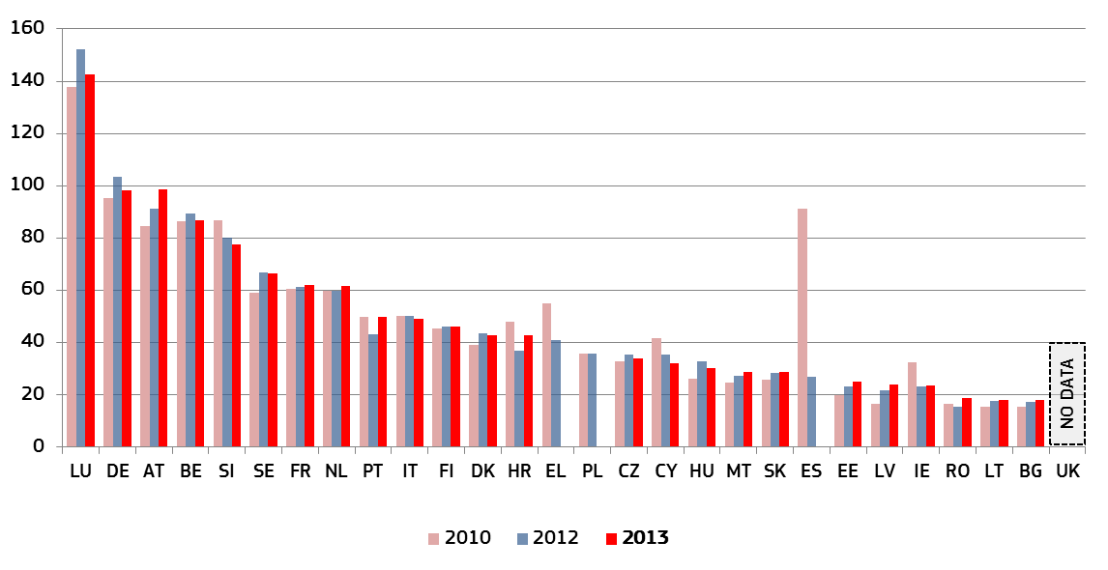* Figure 38 indicates the annual approved budget allocated to the functioning of all courts, whatever the source and level of this budget (national or regional). Comparisons should be undertaken with care as figures for AT, BE, FR, EL and LU correspond to the budget for the whole judicial system and include legal aid and prosecution services, data for DE is not complete as it does not cover all Länder and some Member States receive funding from international and European institutions. The significant decrease for ES between 2010 and 2012 reflects the fact that data from the Autonomous Communities and from the Council for the Judiciary was not included in the 2012 data.
Article 47 of the Charter of Fundamental rights of the European Union requires that legal aid is made available to those who lack sufficient resources, in so far as this aid is necessary to ensure effective access to justice. The 2015 Scoreboard includes information on legal aid expenditure per capita in Member States in 2010, 2012 and 2013. The chart below shows that significant differences in these amounts can be found between groups of countries. There has been relative stability on the amounts spent on legal aid per inhabitant over the years covered in most Member States. The table does not provide information on how the global amounts allocated to legal aid are distributed amongst beneficiaries or cases.
Figure 39: Annual public budget allocated to legal aid per inhabitant in 2010, 2012 and 2013* (source: CEPEJ study)
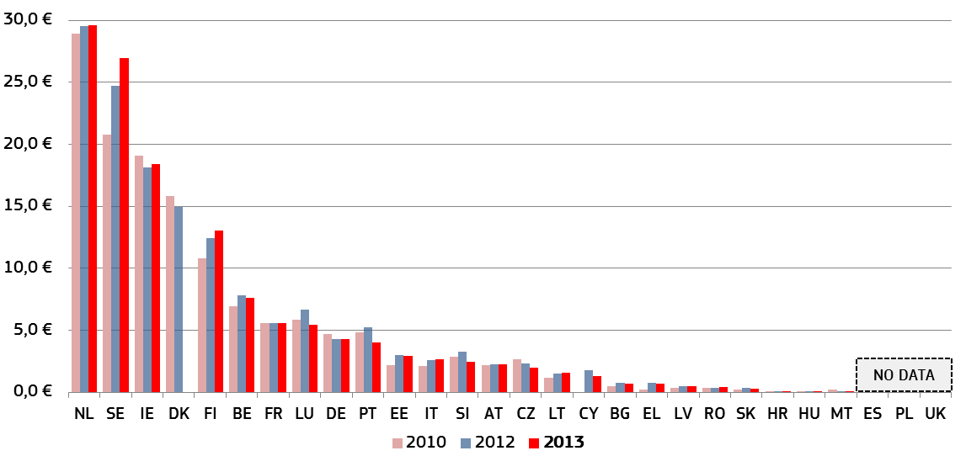* Figure 39 indicates the amount of annual public budget allocated to legal aid in 2010, 2012 and 2013 per inhabitant. The budget for DE is incomplete as it does not cover all Länder. In certain Member States legal professionals may also cover part of the legal aid, which is not reflected in the figures above.
Figure 40: General Government total expenditure on "law courts"*
(in EUR per inhabitant) (source: Eurostat)
This additional indicator on resources draws upon Eurostat’s data on government expenditure. It presents the budget actually spent, which complements the existing indicator on allocated budget for courts. The comparison is made between 2010, 2011 and 2012.
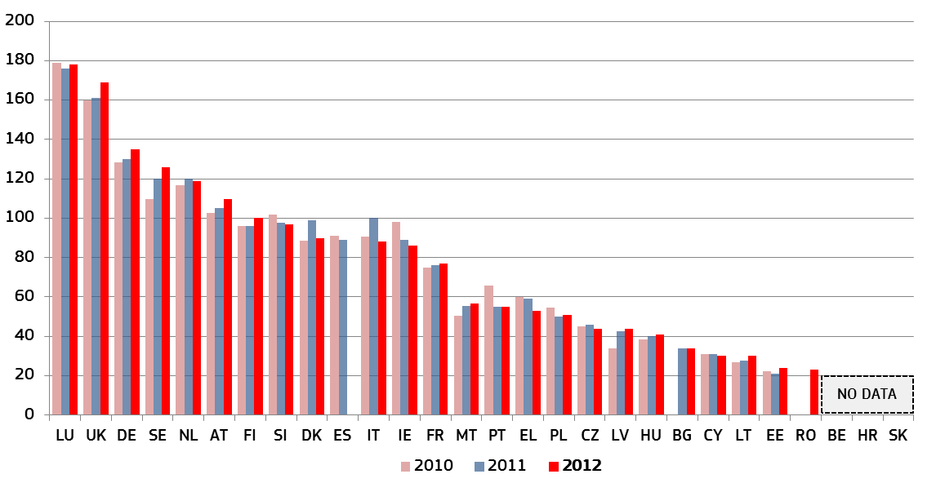
* Whereas Figure 38 indicates the annual approved budget allocated to the functioning of all courts, whatever the source and level of this budget (national or regional), Figure 40 presents general government total (actual) expenditure on courts (National Accounts Data, Classification of the Functions of Government, group 03.3). Figure 40 also includes probation systems and legal aid.
Figure 41: General government expenditure on law courts as a percentage of GDP (source: Eurostat)
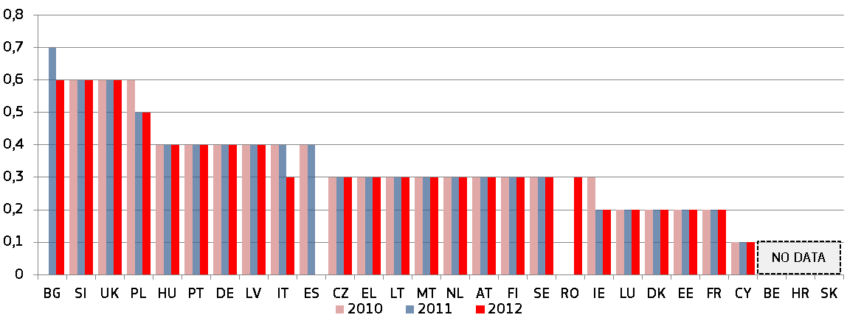
The tables below provide information on human resources in judicial systems for Member States. As regards the number of judges per 100.000 inhabitants, relative stability can be found in most Member States between 2010 and 2013, with a small increase on average. Similarly, an increase in the ratio of lawyers per 100.000 inhabitants can be observed in most Member States. These ratios are very different across countries.
Figure 42: Number of lawyers* (per 100.000 inhabitants) (source: CEPEJ study)
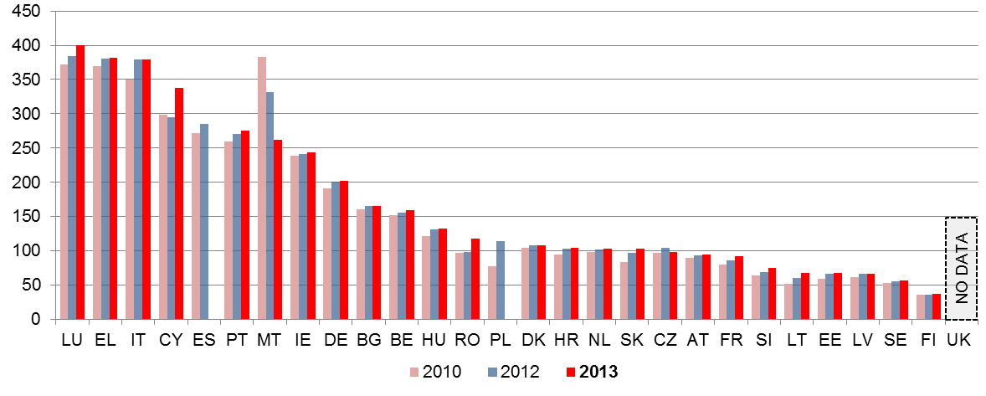* A lawyer is a person qualified and authorised according to national law to plead and act on behalf of his or her clients, to engage in the practice of law, to appear before the courts or advise and represent his or her clients in legal matters (Recommendation Rec (2000)21 of the Committee of Ministers of the Council of Europe on the freedom of exercise of the profession of lawyer).
Figure 43: Number of judges* (per 100.000 inhabitants) (source: CEPEJ study)
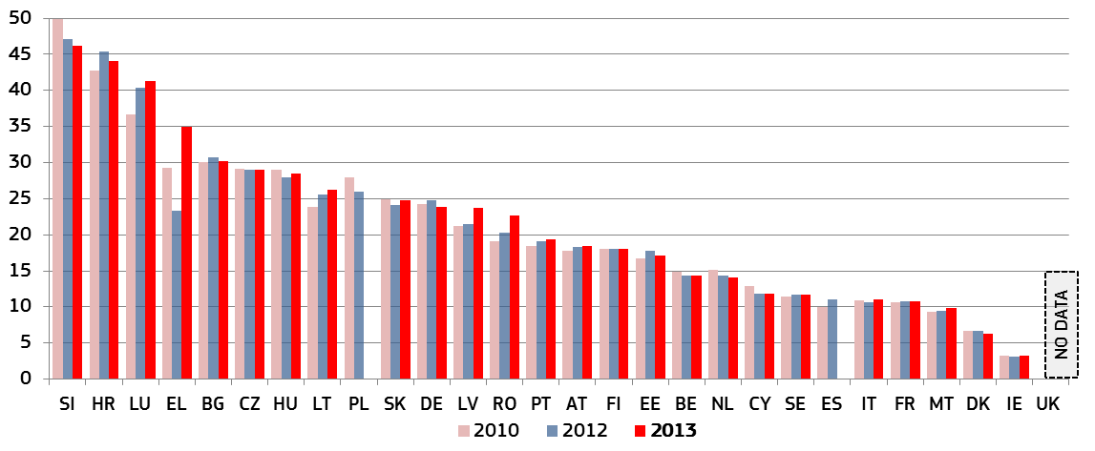* The category consists of judges working full-time, following the CEPEJ methodology. It does not include Rechtspfleger/court clerks who exist in some Member States. The total number of professional judges for EL includes different categories over the years shown above, which partly explains their variation.
Figure 44: Variation of the absolute number of all courts (geographic locations) between 2010-2013* (source: CEPEJ study)
Figure 1 on 'Mapping of justice reforms in the EU in 2014' shows that an important number of Member States have initiated, adopted or implemented a reform of the judicial map and or of the courts' structure. The figure below complements this information as it provides data on the variation of the number of all courts as geographical locations for the period 2010-2013. The variation in the number of courts as legal entities is not represented in this figure.
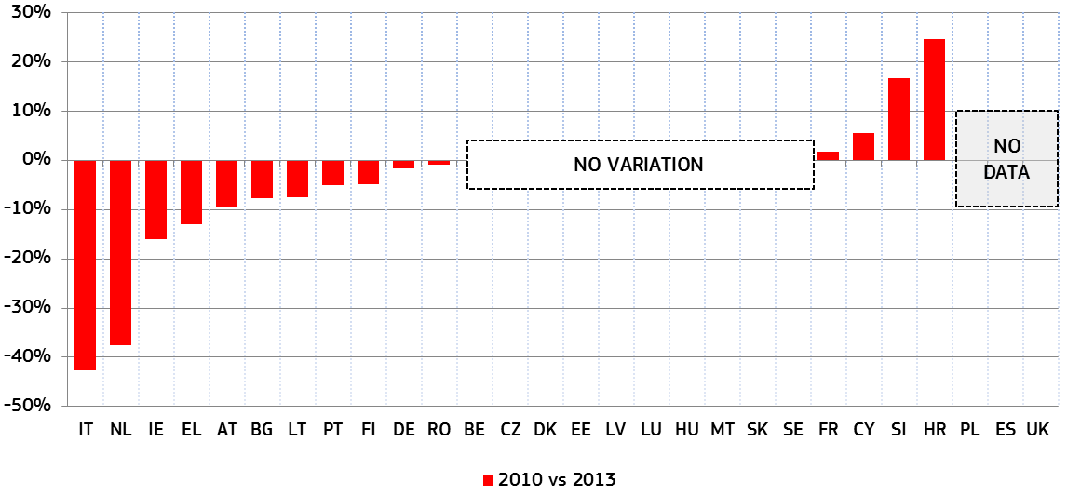* IT implemented the reorganisation of the geographical distribution of courts in September 2013. This included the closing (by merger with other offices) of 30 Tribunals, 30 Prosecution offices, 220 branches of Tribunals and 346 Judges of the peace. LT reduced the number of district courts from 54 to 49, in January 2013. NL reorganised the geographical distribution of courts in 2013(reduction from 64 to 40). This reorganisation resulted in the closure of sub-district courts. For HR and SI the increase is explained by a different interpretation given to CEPEJ’s question in 2013 as compared to 2010.
3.2.7 Share of female professional judges
Diversity among employees adds complementary knowledge, skills and experience and reflects the reality on the ground. This is particularly true for courts. A more gender diverse body of judges can contribute to a better quality of justice system.
The figures below on female judges at first and second instance and in Supreme Courts provide a diverse picture. The data confirm an inverse relationship: the higher the court, the lower the share of female judges. Whilst for most Member States the current share of female judges at first and second instance is relatively high and within the gender balance zone of a share of 40-60%; the situation is very different for female judges in Supreme Courts. Having said that, the trends over the past three years for first and second instance courts, and over the past seven years for Supreme Courts are largely positive. They suggest that most Member States are working towards reaching the gender balance zone.
Figures 45: Share of female professional judges at first and second instance and Supreme Courts (source: European Commission and CEPEJ study)
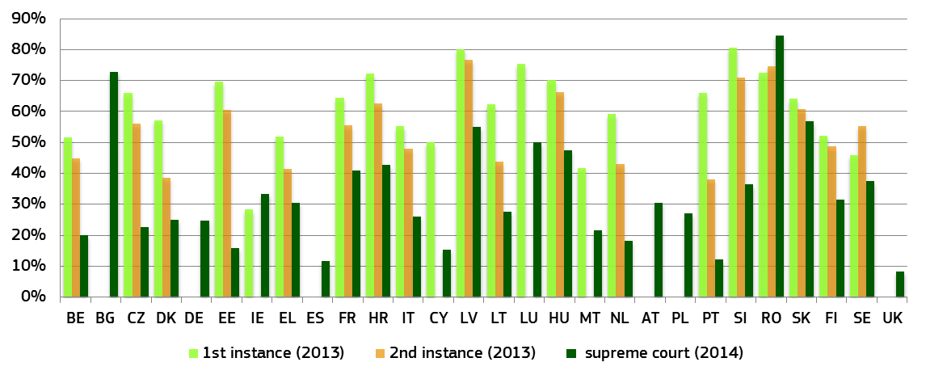
Figure 46: Variation in share of female profession judges at both first and second instance from 2010 to 2013 as well as Supreme Courts from 2007 to 2014* (source: European Commission and CEPEJ study)
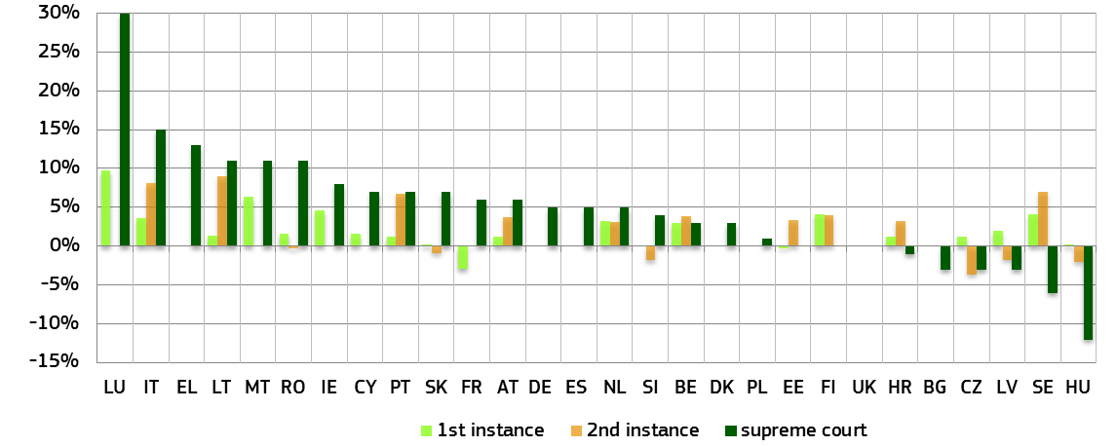
* For first instance courts in SI and the Supreme Courts of EE, FI and the UK, the data showed no variation during the reference period.

Conclusions on the quality of justice systems
- The 2015 EU Justice Scoreboard shows that there is scope to pursue and enhance efforts to support the quality of judicial systems.
- Efforts to enhance ICT tools for the judicial system have continued. However, the indicators reveal gaps in a number of Member States, both for ICT tools available for the administration and management of courts and for electronic communications between courts and parties. Electronic processing of claims and of undisputed debt recovery is not possible in a significant number of Member States. More in-depth comparative data are required to better identify the challenges in the modernisation of ICT tools for judicial systems and best practices. Such an overview would support Member States who have started or are in the process of modernising ICT tools. The Commission will support such efforts, in cooperation with the group of contact persons on national justice systems.
- A large majority of Member States are using evaluation tools to monitor court activities. Annual activity reports on the functioning of the justice system are published widely. However, not all data collection systems provide sufficient information on the functioning of the system or EU-wide comparable data, including those requested by CEPEJ.
- Few Member States follow a comprehensive approach for the evaluation of court activities. A majority of Member States use surveys to collect information on the functioning of their justice systems. However, only a few Member States surveyed all relevant stakeholders (judges, court staff, public prosecutors, lawyers, the parties and other court users).
- Access to justice requires that legal aid is made available to those who lack sufficient resources in so far as the aid is necessary to ensure effective access to justice. There is a wide discrepancy between Member States regarding the budget per inhabitant allocated to legal aid.
- There is significant scope for improving online small claims procedures. The benchmarking exercise carried out in this field reveals scope for improvement of both processing aspects and the quality and accessibility of information. To develop online processing of small claims further steps are needed to integrate key enablers, such as e-ID (or another identifier) and authenticated documents, at different steps of the small claims procedure.
- In the majority of the Member states more than 20% of judges participated in continuous training on EU law or on the law of other Member States. This exceeds the 5% annual target of legal practitioners who need to be trained in order to reach, by 2020, the objective of 50%. In 2013, all Member States that provided data on training for judges reached the annual target.
- All Member States are making efforts to make information available to citizens about their judicial systems, including on individual courts, and on how to proceed when going to court. However, there is a lack of information on the cost of proceedings and on legal aid in a number of Member States. A vast majority of Member States organise training on communication skills for judges.
- The majority of Member States enable free online access to civil and commercial judgments for the general public, with trends indicating the frequent updating of data (at least once a month). Access is provided free of charge in nearly all Member States. Online availability of judgments on administrative cases is slightly less widespread. Online access to decisions handed down by first instance courts is also less widespread for all categories of cases (civil, commercial, administrative). Anonymisation of online published court judgments and tagging of judgments with keywords are common practices. About a third of all Member States are using or are planning to use the European Case Law Identification system. Very few Member States translate rulings of the highest court into a foreign language.
- Data on the use of ADR methods show that in almost half of Member States, ADR is used more often than courts for solving consumer disputes. In more than one third of Member States consumers turned more often to ADR than to non-governmental consumer organisations or to public authorities.
- Virtually all Member States which provided data reported public sector promotional activities and incentives to increase the use of ADR methods. For both promotion and incentives a large group of Member States reported the same number of tools put in place in civil and commercial disputes, labour and consumer disputes.
- Over the past three years there has been on average a small increase in the resources allocated to the judiciary in Europe. Effective justice requires an adequate level of resources. It is for each Member State to ascertain, further to a global and in-depth assessment of the situation of its system, the exact level of resources that it requires. For this purpose, the use of tools allowing Member States to monitor and evaluate courts is essential. The information provided by these tools should be taken into account when determining the allocation of resources.
- While an adequate level of resources is always indispensable, a variety of factors is determinant for the improvement of effectiveness. For example, a better functioning of courts may be linked to measures aimed at improvement the management of cases, to reforms in the procedure or to the integration of well-performing information and communication technologies into the system.
- The higher the court instance, the lower the share of female judges. Even if the share of female professional judges for both first and second instance as well as Supreme Courts shows a positive trend for most Member States for Supreme Courts most Member States still have some way to go to reach the gender balance of 40-60%.

3.3 Independence
Judicial independence is a requirement stemming from the right to an effective remedy enshrined in the Charter of Fundamental Rights of the EU (Article 47). It is also important for an attractive investment environment, as it assures the fairness, predictability, certainty and stability of the legal system in which businesses operate.
In addition to information about perceived judicial independence, which can influence investment decisions, the 2014 Scoreboard presented a first general overview of how justice systems are organised to protect judicial independence in certain types of situations where their independence can be at risk.
In continued cooperation with the European judicial networks, particularly the European Network of Councils for the Judiciary (ENCJ), the Commission expanded the comparative overview on structural independence. The figures presented in the 2015 Scoreboard are based on the replies to an updated questionnaire elaborated by the Commission in close association with the ENCJ and on the ENCJ Guide.

3.3.1 Perceived judicial independence
Figure 47: Perceived judicial independence* (perception – higher value means better perception) (source: World Economic Forum)
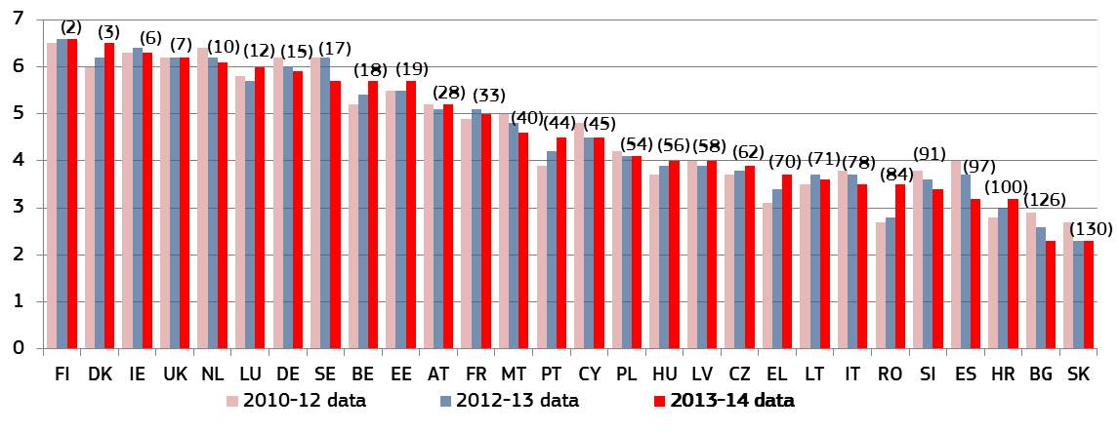* The number in brackets displays the latest rank among 144 countries in the world.

3.3.2 Structural independence
As several Member States are envisaging reforms concerning their Councils for the Judiciary or are reflecting on establishing independent bodies whose primary task is the protection of judicial independence, the figures present a comparison of composition (according to the nomination process) and of the main powers of existing Councils for the Judiciary in the EU (Figures 48 and 49). These comparative overviews could assist Member States in adopting reforms that will ensure the effectiveness of Councils for the Judiciary as independent national institutions with the final responsibility for the support of the judiciary in the independent delivery of justice, while taking into account the traditions and specificities of justice systems.
Determining the financial resources for the judiciary is a sensitive issue that can affect judicial independence. New Figure 50 presents information on which branch of government adopts criteria for determining the financial resources for the judiciary and what these criteria are.
Ensuring structural independence requires legal safeguards that protect it in situations where the independence of justice systems can be at risk. Five indicators are used to show safeguards in such situations: the safeguards regarding the transfer of judges without their consent (Figure 51), the dismissal of judges (Figure 52), the allocation of incoming cases within a court (Figure 53), the withdrawal and recusal of judges (Figure 54) and threat to the independence of a judge (Figure 55). For such situations, the 2010 Council of Europe Recommendation on judges: independence, efficiency and responsibilities ('the Recommendation') presents standards to ensure that the independence of the judiciary is respected.
Figures have been updated in cases where the legal framework or practice in Member States has changed since the publication of the 2014 Scoreboard. In some figures, additional safeguards have been presented, such as the body that decides on the appeal against dismissal of a judge, and a new, quantitative layer has been added, showing the number of times a particular situation occurred in 2013, for example the number of transfers of judges without their consent and the number of dismissals of judges. The figures present an overview of the legal safeguards in certain types of situations without making an assessment or presenting quantitative data on their effectiveness.
This overview aims to assist the European judicial networks and relevant authorities to examine the effectiveness of these safeguards. In 2014, the European Network of Councils for the Judiciary started working on such an assessment.
Figure 48: Composition of the Councils for the Judiciary according to the nomination process*
The figure presents the composition of Councils for the Judiciary, members of the ENCJ, according to the nomination process, depending on whether the members are judges/prosecutors selected by their peers, members nominated by the executive or legislative branch, or members nominated by other bodies and authorities. Not less than half the members of Councils for the Judiciary should be judges chosen by their peers from all levels of the judiciary and with respect for pluralism inside the judiciary.
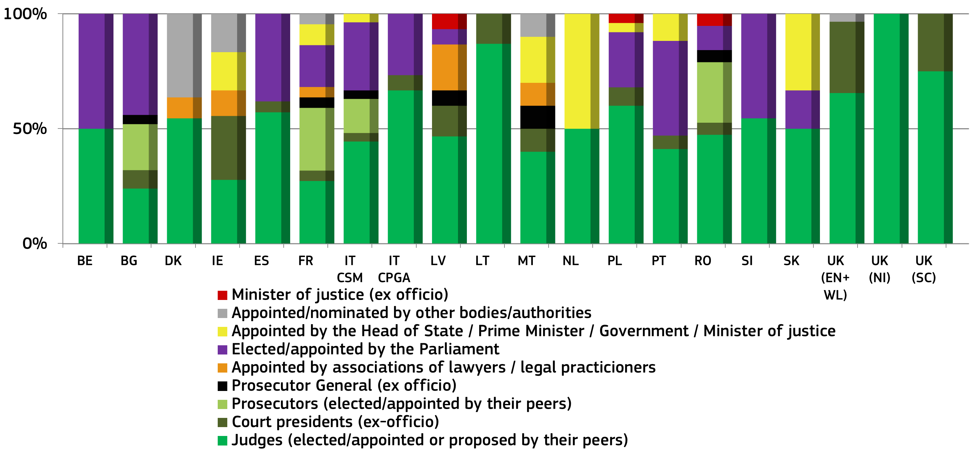
* BE: judicial members are either judges or prosecutors; BG: category prosecutors includes one elected investigative magistrate; DK: all members are formally appointed by the Minister of justice; category Appointed/nominated by other bodies/authorities includes two court representatives (nominated by the union for administrative staff and by the police union); FR: the Council has two formations – one with jurisdiction over sitting judges and one with jurisdiction over prosecutors; the Council includes one member of the Conseil d'Etat elected by the general assembly of the Conseil d'Etat; IT-CSM: Consiglio Superiore della Magistratura (covering civil and criminal judiciary); category judges includes two magistrates (judges and/or prosecutors) elected from the Supreme Court; IT-CPGA: Consiglio di presidenza della giustizia amministrativa (covering administrative judiciary); ES: members of the Council coming from the judiciary are appointed by the Parliament - the Council communicates to the Parliament the list of candidates who have received the support of a judges' association or of twenty five judges; MT: Leader of Opposition appoints one lay member; NL: members formally appointed by Royal Decree on the proposal of the Minister of Security and Justice; RO: elected magistrates validated by the Senate; SI: members elected by the National Assembly on the proposal of the President of the Republic.
Figure 49: Powers of the Councils for the Judiciary *
The figure presents certain main powers of the Councils for the Judiciary, members of the ENCJ, such as those regarding the appointment and dismissal of judges, the transfer of judges without their consent, disciplinary proceedings concerning judges, adoption of ethical standards and promotion of judges.
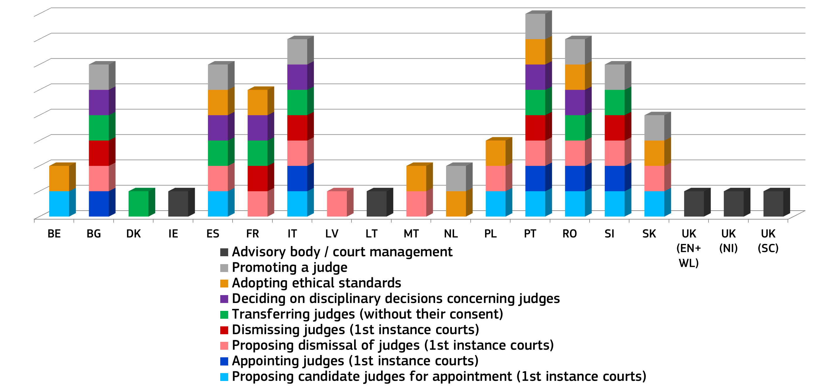
* The chart presents only certain powers and the Councils for the Judiciary have additional competences. IT: both councils for the judiciary (CSM: civil/criminal judiciary, and CPGA: administrative judiciary). In some countries, the executive has an obligation, either by law or practice, to follow a proposal by the Council for the Judiciary to appoint or dismiss a judge (e.g. ES).
Figure 50: Criteria for determining financial resources for the judiciary*
The figure shows which branch of government (judiciary, legislature or executive) defines the criteria for determining financial resources for the judiciary. It also presents, per country, what these criteria are: either amount based on historic/realised costs, which is the most common criterion, or, less frequently, the number of incoming/resolved cases, the anticipated costs or needs/requests by courts.
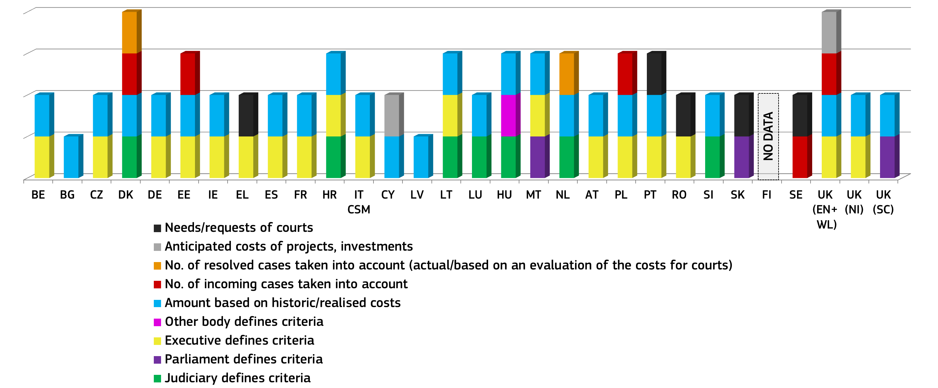

* DK: number of incoming and resolved cases at 1st instance court are taken into account; DE: only for the Supreme Court’s budget - for the 1st and 2nd instance, judiciary systems vary between the federal states; EE: only for 1st and 2nd instance courts; HU: law states that the salaries of judges shall be determined in the act on the central budget in such a way that the amount shall not be lower than it had been in the previous year; NL: number of resolved cases based on an evaluation of the costs for courts is taken into account.
Figure 51: The safeguards regarding the transfer of judges without their consent (irremovability of judges)
The figure examines the scenario of the transfer of judges without their consent and shows whether such a transfer is allowed and, if so, which authorities decide on such matters, the reasons (e.g. organisational, disciplinary) for which such a transfer is allowed and whether an appeal against the decision is possible. For the first time, the figure also shows the number of judges that were transferred without their consent in 2013.
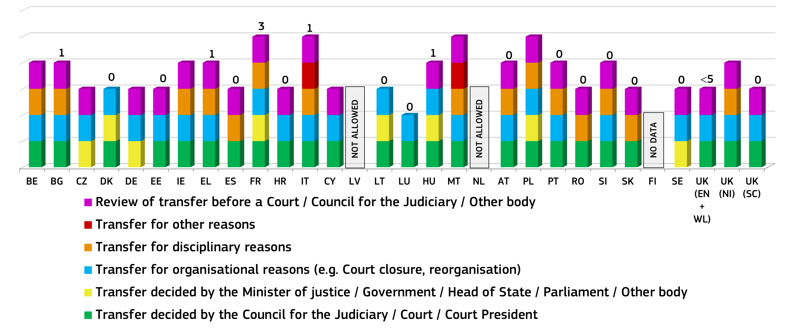
* The number above the column indicates the number of judges transferred without consent in 2013 (no number indicates no data available). BE: transfer for organisational reasons only within a court; CZ: a judge can be transferred only to the court of the same instance, the court one instance higher or lower (all within the same judicial district); DE: transfer for maximum of three months and only in cases of representation; EL: one judge transferred from civil/criminal judiciary; LT: temporary transfer, when there is an urgent need to ensure the proper functioning of the court; FR: Minister of justice can transfer a judge for organisational reasons in the rare event such as the closure of a court or for legal reasons such as fixed-term appointments (for a court’s president or for specialized functions); PL: following court reorganisation, approximately five hundred judges from closed courts were transferred to other courts; RO: only temporary transfer, up to a year, for disciplinary sanctions; UK (EN+WL): fewer than five judges transferred in 2013, if any at all.
Figure 52: The dismissal of first and second instance judges*
This figure presents the authorities that have the power to propose and decide on the dismissal of judges of first and second instance in the different Member States. The upper part of the column indicates who takes the final decision and the lower part shows – where relevant –who proposes dismissal or who must be consulted before a decision is taken. For the first time, the figure also shows the number of judges that were dismissed in 2013 and whether a review of the dismissal before a court, constitutional court or other independent body is possible.

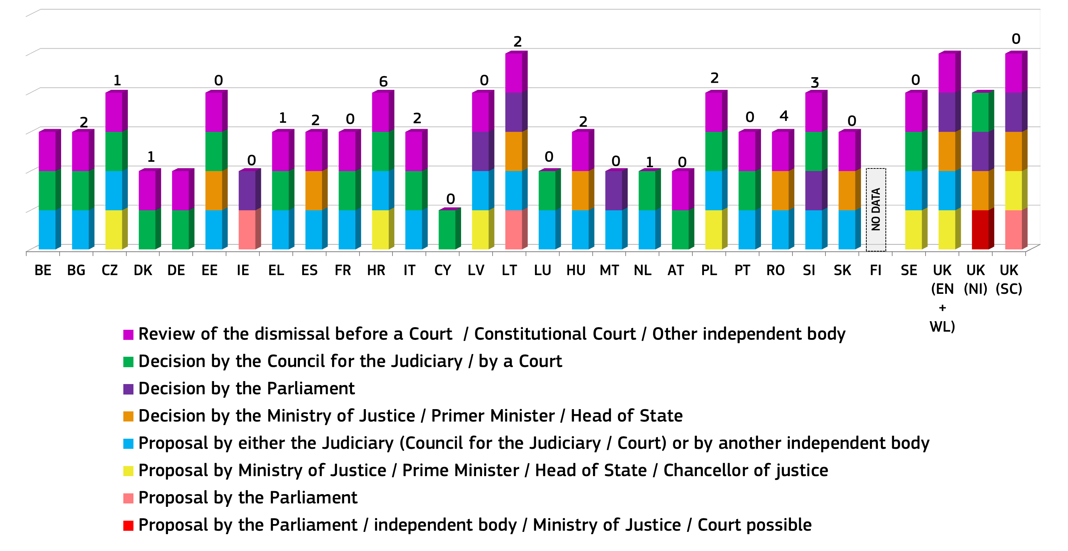

* The number above the column indicates the number of judges dismissed in 2013 (no number indicates no data available). EL: One judge dismissed from the civil/criminal judiciary; UK (EN+WL): no full-time judges were dismissed. Only part-time (fee-paid) judges were dismissed, namely one tribunal judge, four Recorders (usually sitting 15 days or so a year) and eight (lay) magistrates; In some countries, the executive has an obligation, either by law or practice, to follow the proposal of the Council for the Judiciary to dismiss a judge (e.g. ES).
Figure 53: The allocation of cases within a court
The figure presents at what level the criteria for distributing cases within a court are defined (e.g. law, well-established practice), how cases are allocated (e.g. by court president, by court staff, random allocation, pre-defined order) and which authority supervises the allocation.
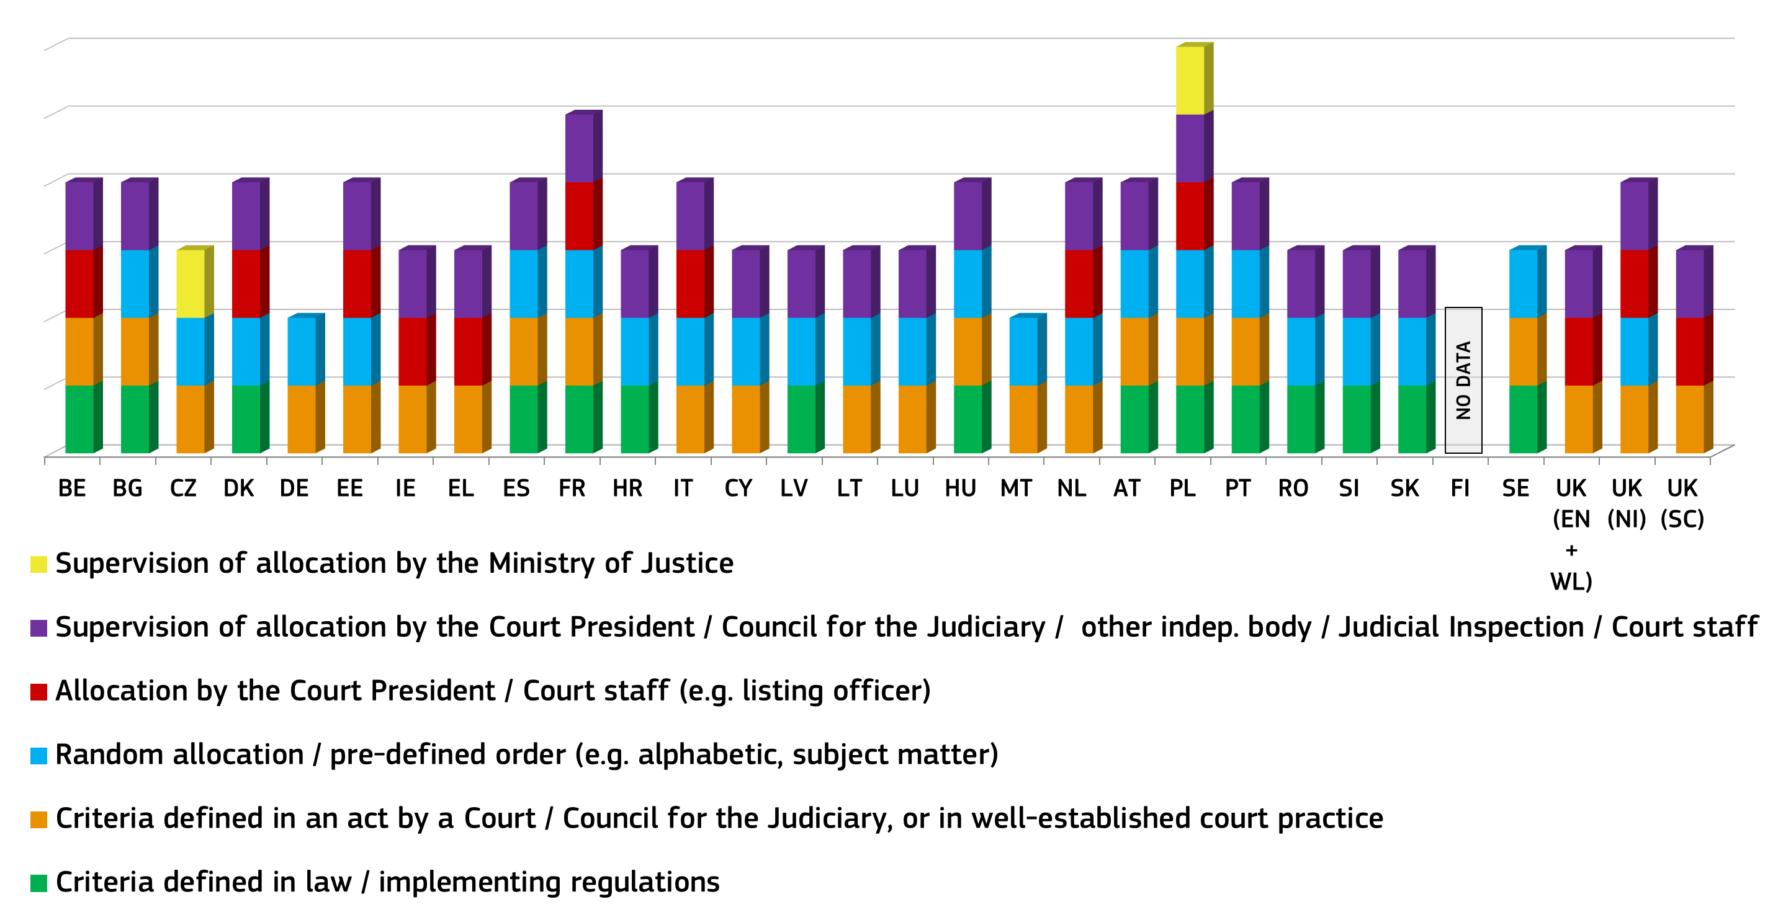

Figure 54: The withdrawal and recusal of a judge
The figure presents whether or not judges can be subject to sanctions if they disrespect the obligation to withdraw from adjudicating a case in which their impartiality is in question, compromised, or where there is a reasonable perception of bias. The figure also presents which authority decides on a recusal request by a party aimed at challenging a judge.
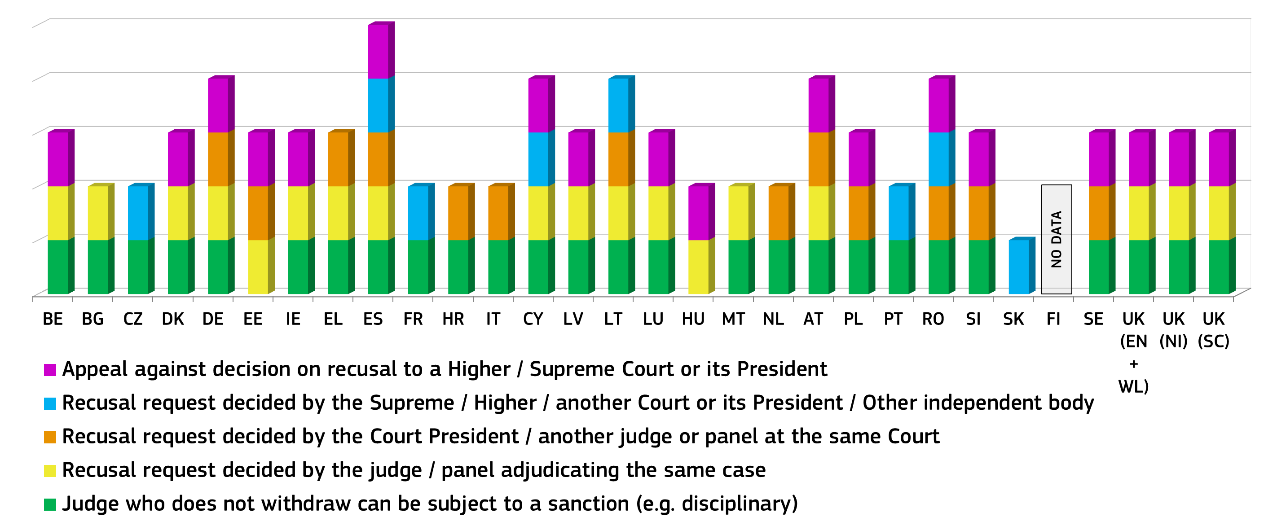
Figure 55: The procedures in case of threat against the independence of a judge
The figure presents which authorities can act in specific procedures for protecting judicial independence when judges consider that their independence is threatened. It also presents the measures these authorities can adopt (e.g. issuing a formal declaration, filing of complaints or sanctions against persons seeking to influence judges in an improper manner). Action taken for the protection of judicial independence comes from a public prosecution service or a court (in case of sanctions), or from the Council for the Judiciary in the case of other measures.
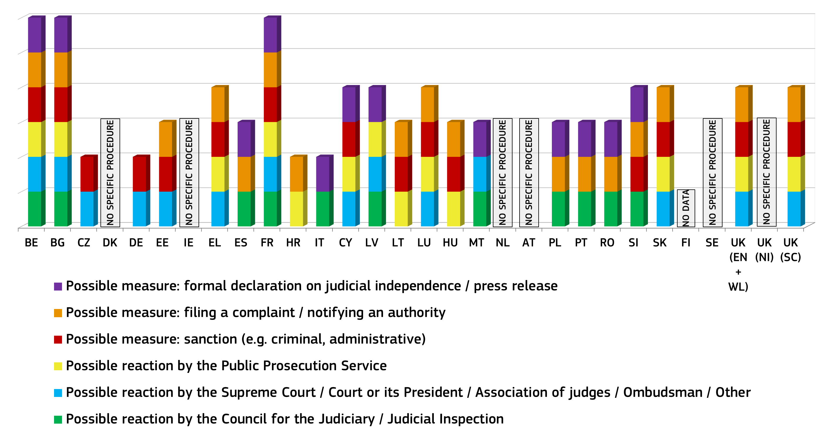

Conclusions on judicial independence
- Over the last three years, in most Member States the perception of independence has improved or remained stable. However, in a few Member States, an already low level of perceived independence has deteriorated further.
- The 2015 Scoreboard expanded the mapping of legal safeguards aimed at protecting judicial independence in certain situations where it may be at risk. It also shows the number of transfers of judges without their consent and the number of dismissals of judges in 2013. In addition, it presents information on the criteria used in Member States for determining financial resources for the judiciary.
- As several Member States are envisaging reforms concerning their councils for the judiciary, or considering establishing such independent bodies, the 2015 Scoreboard provides a comparative overview of the councils' powers and composition. This could assist Member States in ensuring the effectiveness of councils for safeguarding the independence of the judiciary, while taking into account the traditions and specificities of justice systems.
- The Commission will encourage judicial networks to deepen their assessment of the effectiveness of legal safeguards and will reflect how these findings could be presented in future Scoreboards.

4. ADDRESSING THE DATA GAP
Gathering data on the key elements of justice systems covering all Member States remains a challenge. The figure below illustrates the data gap. It presents the percentage of information available per Member States for each of the key components of the Scoreboard (efficiency, quality and independence).
Figure 56: Data gaps and availability of information (efficiency, quality, independence/ percentage by Member State) (source: European Commission)
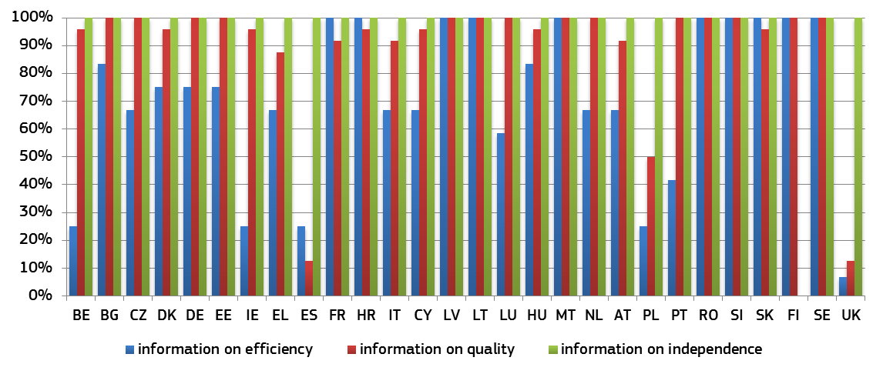
Information on independence was made available by almost all Member States. In the area of quality, the availability of information is generally above 50%. The main difficulties remain in the area of efficiency. Although almost all Member States participated in the collection of data by CEPEJ for the preparation of the 2015 Scoreboard, the level of replies to the specific questions still needs to be improved.
Difficulties in gathering data are due to various reasons, in particular: the lack of relevant data due to insufficient statistical capacity; the fact that the national categories for collecting data do not correspond to the ones used by CEPEJ, or, in a few cases, the unwillingness to participate in the collection of data for the Scoreboard.
To remedy the data gap, the Commission calls on Member States to provide all data relevant to the Scoreboard and intends to reinforce the following activities:
- work with the group of contact persons on national justice systems in gathering data and, as interest for developing new indicators has been expressed within the group, in developing possible new indicators;
- cooperate with EU bodies in specific areas of growth-related EU law, such as competition, consumer rights, intellectual property rights and expand cooperation to other areas;
- cooperate with the European networks in the area of justice, in particular the European Network for the Councils for the Judiciary, the Network of the Presidents of the Supreme Judicial Courts of the EU, the Association of the Councils of State and Supreme Administrative Jurisdiction, the European Judicial Training Network and with the associations of legal practitioners, particularly the lawyers;
- follow the joint data collection exercise between Eurostat/UNODC and the expert groups in the area of Home Affairs; and
- address certain Member States' lack of capacity to collect relevant justice statistics in the framework the European Semester.

5. CONCLUSIONS
The 2015 EU Justice Scoreboard reflects the efforts undertaken by Member States to render their national justice systems more effective. It shows certain improvements but at the same time reveals that reaping the benefit of justice reforms takes time. Commitment and determination are therefore indispensable to achieve more effective justice.
The Commission renews its commitment to support these efforts in cooperation with Member States and all stakeholders. Effective justice deserves such joint efforts given the role it plays for enforcing the Union common values and contributing to economic growth.

See for example CEPEJ “Checklist for promoting the quality of justice and the courts”; Opinion n°6 (2004) Consultative Council of European Judges (CCJE) available at: https://wcd.coe.int/ViewDoc.jsp?Ref=CCJE(2004)OP6&Sector=secDGHL&Language=lanEnglish&Ver=original&BackColorInternet=FEF2E0&BackColorIntranet=FEF2E0&BackColorLogged=c3c3c3
CCJE Opinion n°6 (2004) § 34 (…) the evaluation of "quality" of the justice system, i.e. of the performance of the court system as a whole or of each individual court or local group of courts, should not be confused with the evaluation of the professional ability of every single judge.
Data on “other elements” include for example appealed cases (EE, LV), hearings (SE), or number of cases solved within certain time brackets (DK).
11th e-Government Benchmark report (SMART 2013/0053-3). Available at: http://ec.europa.eu/digital-agenda/en/news/eu-egovernment-report-2014-shows-usability-online-public-services-improving-not-fast
Mystery Shoppers are trained and briefed to observe, experience, and measure a (public service) process by acting as a prospective user. Each mystery shopper has one day to assess a life event.
Available at: http://ec.europa.eu/digital-agenda/en/news/eu-egovernment-report-2014-shows-usability-online-public-services-improving-not-fast
Data have been collected in cooperation with the group of contact persons on national justice systems.
The parameters of the questionnaire built upon the Opinion n°7 (2005) of the Consultative Council of European Judges (CCJE) on "Justice and society", (available at: https://wcd.coe.int/ViewDoc.jsp?Ref=CCJE(2005)OP7&Sector=secDGHL&Language=lanEnglish&Ver=original&BackColorInternet=FEF2E0&BackColorIntranet=FEF2E0&BackColorLogged=c3c3c3, the report of the European Network of Councils for the Judiciary "Justice, society and the media" (available at: http://encj.eu/images/stories/pdf/GA/Dublin/encj_report_justice_society_media_def.pdf) and is complementary to the data collected by the European Commission for the Efficiency of Justice of the Council of Europe (CEPEJ).
Data have been collected in cooperation with the group of contact persons on national justice systems.
Data have been collected in cooperation with the group of contact persons on national justice systems.
Data have been collected in cooperation with the group of contact persons on national justice systems. For each of the categories in the figure 1 point can be awarded.
Data have been collected in cooperation with the group of contact persons on national justice systems.
Data have been collected in cooperation with the group of contact persons on national justice systems.
Data have been collected in cooperation with the group of contact persons on national justice systems.
Data have been collected in cooperation with the group of contact persons on national justice systems.
Data have been collected in cooperation with the group of contact persons on national justice systems.
Data have been collected in cooperation with the group of contact persons on national justice systems.
Flash Eurobarometer 396, “Retailers' attitudes towards cross-border trade and consumer protection”, 2015 (to be published). The survey was conducted amongst retailers’ businesses selling to final consumers in the retail and service sectors employing 10 or more persons (per country) in the 28 Member States of the European Union. It excluded wholesale trade and commission trade (NACE code G 51), except of motor vehicles and motorcycles, activities auxiliary to financial intermediation (J 67), research and development (K 73) as well as other business activities (K 74).
In 2011 the European Commission set the target that half of all legal practitioners in the EU should have attended training in European law or in the law of another Member State by 2020 and to support this training with EU funds for 20 000 practitioners per year by 2020. The 2014 Report on European Judicial Training describes the progress towards the target set and also contains information on EU-funded training.
Available at: http://ec.europa.eu/justice/criminal/files/final_report_2014_en.pdf
CEPEJ defines all courts as geographical locations; these are premises or court buildings where judicial hearings take place. If there are several court buildings in the same city, they must be taken into account. The figures include the locations for first instance courts of general jurisdiction and first instance specialised courts, as well as the locations for High Courts and/or Supreme Courts.
Commission Staff Working Document, Report on Progress on equality between women and men in 2013 Accompanying the document Report from the Commission to the European Parliament, the Council, the European Economic and Social Committee and the Committee of the Regions 2013 Report on the Application of the EU Charter of Fundamental Rights (COM(2014) 224 final).
For those Member States where Councils for the Judiciary do not exist (CZ, DE, EE, EL, CY, LU, AT and FI), the replies to the updated questionnaire have been obtained in cooperation with the Network of the Presidents of the Supreme Courts of the European Union. See Guide to the European Network of Councils for the Judiciary, June 2014, available at: http://www.encj.eu/index.php?option=com_content&view=article&id=9&Itemid=11
The WEF indicator is based on survey answers to the question: "To what extent is the judiciary in your country independent from the influences of members of government, citizens, or firms?" The survey was replied to by a representative sample of firms in all countries representing the main sectors of the economy (agriculture, manufacturing industry, non- manufacturing industry, and services). The administration of the survey took different formats, including face-to-face interviews with business executives, telephone interviews and mailings, with an online survey as an alternative. Available at: http://www.weforum.org/reports/global-competitiveness-report-2013-2014
Recommendation CM/Rec(2010)12 of the Committee of Ministers to member states on judges: independence, efficiency and responsibilities.
This overview contains information on how the justice systems are organised and does not intend to reflect the complexity and details of these systems. The figures present the Member States according to the alphabetical order of their geographical names in the original language. The height of the columns does not necessarily reflect the effectiveness of the safeguards.
Based on the ENCJ Guide (available at: http://www.encj.eu/index.php?option=com_content&view=article&id=9&Itemid=11).
Councils for the judiciary are independent bodies, established by law or under the constitution, that seek to safeguard the independence of the judiciary and of individual judges and thereby to promote the efficient functioning of the judicial system. See Recommendation CM/Rec(2010)12 of the Committee of Ministers to member states on judges: independence, efficiency and responsibilities, paras. 26-27.
Based on the ENCJ Guide (available at: http://www.encj.eu/index.php?option=com_content&view=article&id=9&Itemid=11).
Data collected through an updated questionnaire elaborated by the Commission in close association with the ENCJ. For those Member States where Councils for the Judiciary do not exist, the replies to the updated questionnaire have been obtained in cooperation with the Network of the Presidents of the Supreme Courts of the European Union.
Data collected through an updated questionnaire elaborated by the Commission in close association with the ENCJ. For those Member States where Councils for the Judiciary do not exist, the replies to the updated questionnaire have been obtained in cooperation with the Network of the Presidents of the Supreme Courts of the European Union.
§ 52 of the Recommendation contains guarantees on the irremovability of judges, in particular that a judge should not be moved to another judicial office without consenting to it, except in cases of disciplinary sanctions or reform of the organisation of the judicial system.
Data collected through an updated questionnaire elaborated by the Commission in close association with the ENCJ. For those Member States where Councils for the Judiciary do not exist, the replies to the updated questionnaire have been obtained in cooperation with the Network of the Presidents of the Supreme Courts of the European Union.
§ 46 and 47 of the Recommendation require that national systems provide for safeguards regarding the dismissal of judges.
It can be one or two different bodies depending on the reason for dismissal or the type of judge (e.g. president, etc.).
Data collected through an updated questionnaire elaborated by the Commission in close association with the ENCJ. For those Member States where Councils for the Judiciary do not exist, the replies to the updated questionnaire have been obtained in cooperation with the Network of the Presidents of the Supreme Courts of the European Union.
§ 24 of the Recommendation requires that the systems for the distribution of cases within a court follow objective pre-established criteria in order to safeguard the right to an independent and impartial judge.
Data collected through an updated questionnaire elaborated by the Commission in close association with the ENCJ. For those Member States where Councils for the Judiciary do not exist, the replies to the updated questionnaire have been obtained in cooperation with the Network of the Presidents of the Supreme Courts of the European Union.
Sometimes more than one authority can take this decision, depending on the level of the court where the recused judge sits.
§ 59, 60 and 61 of the Recommendation provide that judges should act independently and impartially in all cases and should withdraw from a case or decline to act where there are valid reasons defined by law, and not otherwise.
Data collected through an updated questionnaire elaborated by the Commission in close association with the ENCJ. For those Member States where Councils for the Judiciary do not exist, the replies to the updated questionnaire have been obtained in cooperation with the Network of the Presidents of the Supreme Courts of the European Union.
§ 8, 13 and 14 of the Recommendation provide that where judges consider that their independence is threatened, they should be able to have recourse to effective means of remedy.
The percentage of available information takes into account: for efficiency the efficiency indicators deriving from the CEPEJ study and on the areas of competition, consumers and community trade mark; for quality, indicators deriving from the CEPEJ study and data collected through the group of contact persons on national justice; for independence, indicators deriving from the Commission questionnaire.

