

1. **Interconnections as vital parts of the Energy Union**

During the last decades, the European Union has worked intensively towards building the most integrated, competitive and sustainable common energy market of the world.

The integration of the EU's energy markets is delivering tangible results: **wholesale electricity** **prices have declined** by one-third[1]; consumers have **more choice** as energy suppliers compete to deliver lower prices and better services; and the legal framework has improved competition in the sector.

Nonetheless, much remains to be done. Import dependency, outdated infrastructure and a lack of investment, a retail market which is not fully functioning, high final energy prices for citizens and for businesses harming the competitiveness of our companies, the need to shift to a low-carbon economy in order to fight climate change as well as challenges to our technological leadership lead to one conclusion: the EU must overcome its fragmentation of national energy markets. The European Union must change its ways to produce, transport and consume energy. Europe's energy policy must be reset in the right direction: that of an Energy Union.

It is for these reasons that the European Commission adopted a framework strategy for a resilient Energy Union with a forward looking climate policy. This Communication on achieving a 10% electricity interconnection target is one concrete step in this direction.

An interconnected European energy grid is vital for Europe's energy security, for more competition on the internal market resulting in more competitive prices as well as for better achieving the decarbonisation and climate policy targets which the European Union has committed to. An interconnected grid will help deliver the ultimate goal of the Energy Union, i.e. to ensure affordable, secure and sustainable energy, and also growth and jobs across the EU.

There are **missing interconnection links between several countries. Building these interconnections will require the mobilisation of all efforts at all levels, as a matter of urgency, to achieve the common objective of a fully functioning and connected internal energy market.**

Energy infrastructure has been high on the European energy agenda. The European Council in October 2014 called for *"speedy implementation of all the measures to meet the target of achieving interconnection of at least 10 % of their installed electricity production capacity for all Member States."* This Communication[2] responds to this call and presents a strategy to ensure the full integration of the internal electricity market through adequate levels of interconnection, which will serve also an integral part of the Energy Union.

1. **The benefits of an Interconnected Energy System**

Interconnecting isolated national electric power systems and building a truly European Electrical System will bring a number of important benefits for the European Union and its Member States.

Electricity interconnections will increase Europe´s **security of supply**. They will improve the reliability of the electricity system, thus increase the quality of service and reduce power interruptions and productivity losses in the commercial and industrial sectors. Ambitious levels of electricity interconnection will help reduce Europe´s dependency, due to the optimisation of the system leading to a reduction of fuel imports, generating more opportunities for Europe in terms of investments, growth and jobs. In addition, interconnections facilitate instantaneous help between Transmission System Operators (TSO) providing greater cooperation and solidarity between them.

An interconnected grid allows for more **affordable prices in the internal market**, through more competition and greater efficiency, in addition to a better and more cost-effective use of available resources. Interconnections imply greater integration of the European Market, provide for a larger market size and higher competition levels, as well as higher market efficiency. The figure below shows that cross-border exchanges have increased markedly since the end of the 1990's, the start of the market opening process.

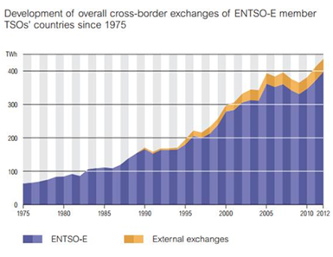

A more integrated market through interconnections also reduces the need for investment in peak generation capacity and storage because the plants that each country has would not be needed at the same time. This would result in substantial economic and political benefits in Member States due to reduced capital investments as well as to the reduction of the environmental impact due to the plants that would not be necessary to be built. Increasing the exchanges of the system balancing services also reduces the system short term operation costs. Lower generation costs and/or lower investments in generation and avoided fuel costs through the interconnection of electricity grids translate into more competitive electricity prices to businesses and households. An adequately interconnected European energy grid brings the benefits of the market closer to European citizens, as consumers could save EUR 12-40 billion annually by 2030[3].

A well interconnected grid is crucial for **sustainable development and decarbonising the energy mix** as it enables the grid to accommodate increasing levels of variable renewables in a more secure and cost-efficient way. Relying on renewable sources for a greater part of the generation mix contributes to meeting the EU climate goals, by reducing CO2 emissions, and moreover increasing security of supply. Higher interconnections are also essential to meet the EU ambition to be world leader in renewable energy, which is not only a matter of a responsible climate change policy but also an industrial policy imperative. Europe's renewable energy and technology firms have emerged as major industrial players employing around 1.2 million people in 2012, creating stable jobs at regional and local level as well as sustainable growth.

In sum, more interconnections will contribute to more affordable electricity prices in the long term due to the higher market efficiency, higher electricity supply security, reliability and quality, which are essential for social and economic activities, while ensuring a high standard of environmental protection. These developments will also help reduce our energy dependency, due to the reduction in the consumption of imported fuels and facilitate new investments in Europe due to the more competitive prices of electricity and the improvement in the competition levels of the European industries. More electricity interconnections will also lower environmental impact due to the non-built power plants and the reduction of CO2 emissions and will increase the capacity of integrating renewable energy, unleashing a higher potential of growth for the European renewable energy industry and ensuring world leadership of the European renewable industry and, therefore, higher job creation capacity of this industry in Europe with a net job creation in Europe.

**For these reasons, the interconnection of the electricity markets must be a political priority for the European Union at all levels in the years to come**.

1. **The EU's energy infrastructure policy thoroughly modernised**

Being aware of the benefits of energy interconnections, Member States have increased their interconnection capacities during the last decades. However, twelve Member States, mainly in the periphery of the EU, remain below the 10% electricity interconnection target and are thus isolated from the internal electricity market.

**Interconnection levels for electricity in 2014**

|  |  |  |  |  |
| --- | --- | --- | --- | --- |
| **Member State** | |  |  | |
| **Member States above 10% interconnection** | | | | |
| AT | |  | 29% | |
| BE | |  | 17% | |
| BG | |  | 11% | |
| CZ | |  | 17% | |
| DE | |  | 10% | |
| DK | |  | 44% | |
| FI | |  | 30% | |
| FR | |  | 10% | |
| GR | |  | 11% | |
| HR | |  | 69% | |
| HU | |  | 29% | |
| LU | |  | 245% | |
| NL | |  | 17% | |
| SI | |  | 65% | |
| SE | |  | 26% | |
| SK | |  | 61% | |
| **Member States below 10% interconnection** | | | | |
| IE | |  | | 9% |
| IT | |  | | 7% |
| RO | |  | | 7% |
| PT | |  | | 7% |
| EE[4] | |  | | 4% |
| LT4 | |  | | 4% |
| LV4 | |  | | 4% |
| UK | |  | | 6% |
| ES | |  | | 3% |
| PL | |  | | 2% |
| CY | |  | | 0% |
| MT | |  | | 0% |
|  | Source: ENTSO-E, Scenario Outlook and Adequacy Forecast 2014 | | |  |

In this context, the European Union has **gradually been equipping itself with the right policy tools** to enable necessary investments in grid infrastructure, investments in interconnection being paramount among those.

In the wake of the economic crisis, the European Commission put forward a European Energy Programme for Recovery (EEPR) which consisted, *inter alia*, in the identification of interconnection projects across the EU and the mobilisation of EU financial resources. This programme helped realising several interconnection projects between Member States, which due to the lack of appropriate funds had previously not been built. The EEPR spent some EUR 650 million on electricity interconnections (Annex 1).

**Map of EEPR-supported interconnections**

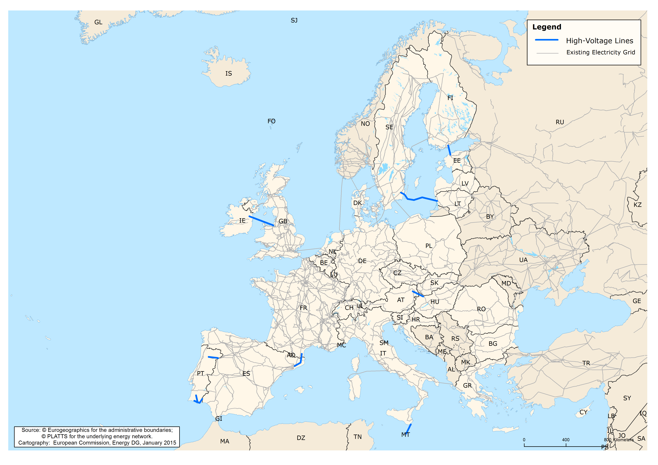

The TEN-E Regulation[5] adopted in 2013, together with the Connecting Europe Facility (CEF)[6], create a stable European instrument designed to identify and ensure the timely implementation of the projects Europe needs along 12 priority corridors and areas. These tools with, *inter alia*, the introduction of Projects of Common Interest (PCI), the improvement of the regulatory treatment and the acceleration of the permit granting represent a major step forward.

**As underlined by the European Council, the interconnection target should mainly be reached through implementation of the Projects of Common Interest**.The first Union list of PCIs was adopted in 2013; it consists of 248 projects, of which 137 are in electricity, including **52 electricity interconnections** and one project with anticipatory investments enabling future interconnections, out of which 37 projects are involving Member States that currently have an interconnection level below 10%.

**Map of first PCI list for electricity interconnectors in Member States below 10%**

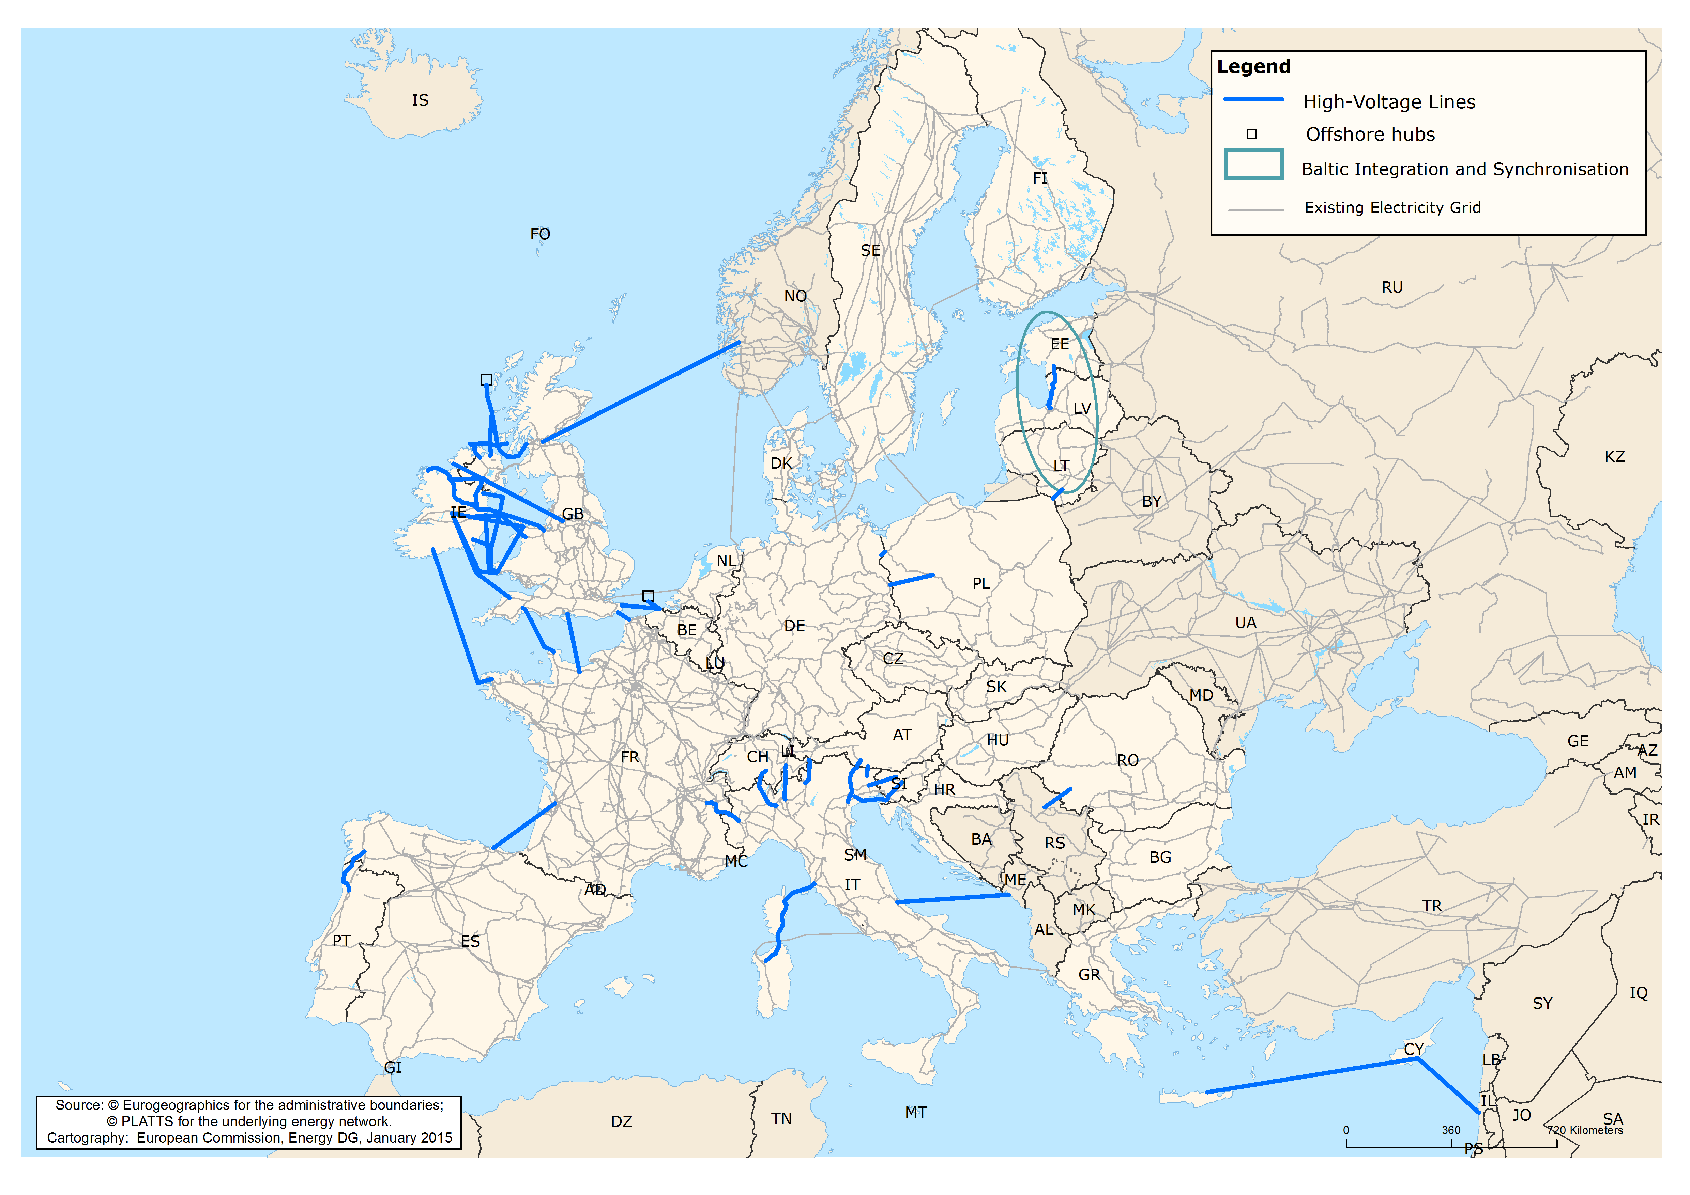

The PCI list is a flexible list that is updated every two years. Work to prepare the second list is currently underway in the regional setting established by the TEN-E Regulation, in view of its adoption by the Commission in autumn 2015. **Special priority will be given to those projects that will significantly increase the current interconnection capacity where it is well below the established 10% objective**, notably where this objective is particularly difficult to achieve.

The Projects of Common Interest are designed and implemented by both transmission system operators (TSO) and private promoters. Current projects are in different stages of development; some are under construction but many are still in the early phases of preparation. Some 75% of all the PCIs from the first Union list are planned to be completed by 2020.

Below are some examples of EEPR projects and PCIs that, if and when completed, would help Member States reach the 10% target, some already in the months to come, others in the medium term:

* The project linking Baixas, *France* to Santa-Llogaia, *Spain* has received support from the EEPR. After its inauguration in February 2015, the electricity interconnection capacity between France and the Iberian Peninsula will double. The PCI between Aquitaine, *France* and the Basque country, *Spain* is currently subject to detailed studies financed by EC grants. This project would again double the interconnection capacity. All efforts shall be mobilised to complete it in 2020, moving the interconnections level closer to reaching the target of 10%.
* Identified in the first PCI list, the new interconnection between *Portugal* (Vila Fria - Vila do Conde – Recarei) and *Spain* (Beariz – Fontefría) will increase the interconnection capacity of currently 7% between Portugal and Spain by 2016 and bring Portugal above the 10% target.
* Whilst *Estonia, Latvia* and *Lithuania* are well interconnected among themselves, the interconnectivity with the EU electricity market amounted in 2011 to just 4% for all three Member States. The situation is however rapidly improving. By 2015 the Baltic States reached 10% interconnectivity with the EU electricity market via Finland, through the EEPR project Estlink2. The interconnection between Sweden (Nybro) and Lithuania (Klaipeda) - known as the project Nordbalt1, funded under the EEPR – would further improve the integration of the future power market between the Baltic Member States and Nord Pool Spot from mid-2016.
* The completion of the construction of the PCI interconnection between Lithuania and *Poland* known as LitPol Link would double the level of interconnection of Poland to 4% by the end of 2015. It would also further the synchronous interconnection of the Baltic networks with the Continental European Networks. Another identified PCI, the interconnection between Vierraden, *Germany* and Krajnik, *Poland*, would bring Poland's interconnectivity to above 10% by 2020.
* Thanks to PCIs in the *United Kingdom*, comprising internal lines and ensuring interconnections with Belgium, France, Ireland and Norway, the United Kingdom would reach the 10% target and its interconnections would be less congested.
* Several *Italian* PCIs in the electricity sector, mainly interconnectors between Italy and France, Switzerland and Austria and the necessary internal reinforcements, would improve its electricity interconnection capacities with the neighbours to around 12%, when completed by 2020. Thus, the reliability of electricity supply would be better ensured in Italy and the risk of congestion would be much lower.
* *Ireland* could also substantially increase its interconnection capacity thanks to the several PCIs included in the first list. Ireland's interconnection level was 3% in 2011; it increased to 7% in 2013 thanks to an EEPR funded project connecting Ireland with the United Kingdom, and its interconnectivity would even exceed 15% in 2020 when the planned PCIs connecting further with the United Kingdom (Northern Ireland and Great Britain) and possibly France would be constructed.
* The interconnection level of *Romania* would increase from the current level of 7% to above 9%, getting therefore closer to the target through the implementation of the interconnection with Serbia by 2017.
* *Cyprus* is an energy island heavily dependent on oil and experiencing high electricity prices. The future interconnection called the Euroasia Interconnector, currently in the pre-feasibility phase, was included in the first Union PCI list. The project will have a capacity of 2,000 MW and would take the interconnection level for Cyprus to over 100% when completed in 2023.
* Thanks to support from the EEPR*, Malta*'s interconnection level will go from 0% now to approx. 35% with the commissioning of the high voltage interconnection with Italy (Sicily) during 2015.

Implementation of the PCIs will bring Europe much closer to the achievement of the 10% electricity interconnection target between **Member States if the foreseen projects are completed**[7]in 2020 (see map below)**. Efforts need to be stepped-up for those below the target to achieve 10% by 2020, mainly Spain and Cyprus, through a more coordinated approach and using all tools available.**

**Map of interconnection levels in 2020 after implementation of current PCIs**

<5%

>5 & <10%

>10 & <15%

>15%

1. **The European regulatory framework must be fully implemented and applied**

A solid regulatory framework is a prerequisite for the necessary infrastructure investments to happen. Since 2013 the European Union has adopted a holistic approach to infrastructure planning and implementation. **The** **trans-European energy networks Regulation (TEN-E) addresses for the first time the specific issue of projects that cross borders or that have an impact on cross-border flows.**

The TEN-E Regulation recognizes that these projects need specific regulatory treatment, and proposes that a cost-benefit analysis clearly demonstrates those supra-national benefits and provides the possibility to allocate costs across borders based on the benefits they generate in the concerned Member States. The TEN-E Regulation also requires national regulatory authorities to provide regulatory incentives commensurate to the risks incurred by such projects. This means that the tariffs set for use of the infrastructure take into account e.g. the appropriate length of time for the investments to be recouped, bearing in mind appropriate depreciation times, need for anticipatory investments, etc.

The large majority of the projects are promoted by transmission system operators, with regulators approving or setting the tariffs. There are also projects, including some PCIs, which are promoted by private parties, so called merchant lines. These tend to recoup their costs from price differences between the two ends of a line. Their risks are therefore of a very different nature. For this reason, while the provisions of the TEN-E Regulation on permit granting apply, these lines often get exemptions from parts of the regulatory framework, such as those on third party access and use of congestion tariffs.

The TEN-E Regulation also addresses for the first time the question of lengthy **permit granting** procedures and public acceptance, which are the main hurdles for infrastructure development, especially for overhead electricity lines. The Regulation introduces a binding overall time limit of 3.5 years for permit granting, which should dramatically bring down the 10-13 year current average. The permit granting powers have to be concentrated in one competent authority ("one-stop-shop"). Following strong enforcement by the Commission, these will finally be in place in all Member States in spring 2015[8]. New rules on enhanced consultation and transparency are also introduced to better involve citizens in the planning process. The objective is to render the process more efficient while safeguarding the EU’s high standards in environmental protection.[9]

**It is of key importance that Member States implement and fully apply the provisions of the TEN-E Regulation so as to avoid any delays in implementation of the necessary projects.** The Commission will ensure full implementation and strict enforcement.

1. **Making full use of all available financial instruments, CEF, ESIF and EFSI**

The Commission estimates that some EUR 200 billion are required up to 2020 to build the necessary infrastructure to adequately interconnect all EU Member States, that will ensure security of supply and enhance sustainability. For electricity projects some EUR 105 billion are needed, out of which some **EUR 35 billion for the interconnections** which acquired a PCI status and are necessary to reach the 10% target across the EU.

The importance of an interconnected grid is well reflected in the multi-annual EU budget for 2014-20. Under the **Connecting Europe Facility (CEF)** which covers three sectors - transport, energy, telecommunications - energy accounts for EUR 5.35 billion out of the total of ca. EUR 30 billion[10]. Whilst the CEF funding represents only around 3% of the investment needed up to 2020, it can leverage other funds through using financial instruments, such as project bonds already tested in the Pilot phase 2012-2013. An important share of the CEF will therefore be implemented through such instruments.

For the CEF grants to make a difference they must be targeted at a few critical projects and must be combined with the efforts of regulators to finance projects through network tariffs other funding sources. Member States may also use the **European Structural and Investment Funds** (ESIF) under certain conditions. Preliminary estimates suggest that around €2 billion from the European Regional Development Fund (ERDF) are expected to be allocated to large electricity and gas infrastructures. For example, the Czech Republic (indicatively about €200 million ) and Lithuania (indicatively € 69.5 million) plan to use this option and foresee funding through ERDF for high-voltage smart electricity grids..

On 13 January 2015, the Commission proposed the creation of a **European Fund for Strategic Investment (EFSI)** to significantly improve EU investment projects' access to long term financing. This instrument could cover **PCIs or other interconnection projects** put forward, therefore accelerating and complementing the current structure of support for PCIs and beyond. New possibilities for commercial financing are offered by **EFSI**, which will be established in close partnership with the European Investment Bank (EIB). The Fund is at the very heart of the Commission's Growth, Jobs and Investment package. The EFSI will mobilise at least EUR 315 billion in private and public investment across the EU, against an EU budget contribution of EUR 16 billion and a contribution by the EIB of EUR 5 billion. The multiplier effect of the EFSI is thus estimated to be at least a factor of 15.

Energy figures prominently among the priorities of the Fund. The Fund's investment operations shall be in line with Union policies and support general objectives such as development of infrastructure, including in the area of energy, in particular energy interconnections.

Next to the Connecting Europe Facility, the EFSI is now likely to emerge as an important tool to help PCIs and promoters in implementing their projects. An Investment Portal is being set up that is designed to boost the transparency of the EU investment project pipeline to make information accessible to potential investors. EFSI brings together project promoters and investors and ensures more support for financial risks. As the great majority of infrastructure projects present a solid business case, the EFSI can play a key role in leveraging the necessary investment together with other investment and commercial banks. In relation to access to EFSI financing, the speedy and timely preparation of a project will be of outmost importance. The Regional Groups involved in the PCI process will have an important role to play in this respect.

Building on existing EIB and Commission advisory services, a European Investment Advisory Hub (EIAH) shall provide advisory support for investment project identification, preparation and development and act as a single technical advisory hub (including on legal issues) for project financing within the EU. This shall include support on the use of technical assistance for project structuring, use of innovative financial instruments, and use of public-private partnerships. The EIAH will not only look at EFSI, but also advice on the use of other funding possibilities already available for infrastructure projects, including from CEF and the European Structural and Investment Funds.

It is equally important to underline the contribution from private investors, either via the EFSI or via other market-based instruments such as the European Long-Term Investment Funds which can channel private financing to long-term investments such as energy infrastructure.

The TEN-E policy is showing first results, but more needs to be done. To speed up the achievement of the interconnection target the Commission intends to intensify the work of the Regional Groups, established under the TEN-E Regulation, to closely monitor progress of each PCI and to propose corrective and targeted early action when necessary, especially in those Member States furthest away from the 10% target. The Commission will also intensify its support for the critical projects through targeted measures. The Commission will assess project by project to look at any obstacles and risks that might delay construction and take action as necessary such as:

- bring together the promoters to find solutions to technical, planning, design and implementation issues and facilitate contacts with the EIB and other banks;

- provide access to technical assistance to better shape the project and make it bankable;

- work together with ACER and the national regulators to find the best incentives;

- ensure compliance with the TEN-E Regulation and launch appropriate procedures, in case provisions are not yet implemented, for instance on permit granting;

- facilitate agreement between Member States to solve political issues.

1. **Regional cooperation must be strengthened**

The critical PCIs and interconnectors in particular are mainly large scale projects which are inherently complex and prone to delays. Project promoters have signalled permit granting procedures and public acceptance as the main risk factors for swift implementation. Hence, the possibilities to speed up their implementation require concerted action by all parties concerned, including Member States, the transmission system operators and promoters, regulators and planning authorities.

All Projects of Common Interest need an approach that transcends the individual project level. Strong regional cooperation, as established under the TEN-E Regional Groups, is key to implementation.

The four Regional Groups for electricity (Northern Seas Offshore Grid, Baltic Energy Market Interconnection Plan (BEMIP), North-South interconnections in West-Europe and North-South interconnections in Central Eastern and South Eastern Europe) adopt a regional list of PCIs in preparation of the EU-wide list. They follow the implementation of the PCIs in their region and report on possible difficulties and may propose corrective measures.

However, the Regional Group setting may not always be sufficient. In particular, **regional cooperation must be further enhanced** and brought to a higher level to tackle broader policy priorities that go beyond project specific issues of planning and implementation. These issues are related e.g. to the need to find innovative technological solutions, to bring the planning of the grid closer together with the planning of generation, to urgently address security of supply risks through synchronised regulatory and infrastructure measures, or to engage more closely in finding sustainable and acceptable solutions in environmentally sensitive regions.

The Commission considers that the work of the TEN-E Regional Groups needs to be enhanced in the following areas:

* In the case of the ***Baltic region***, the current form of enhanced regional cooperation in the BEMIP is bearing fruits and the region will be well interconnected in electricity, and also in gas, by 2020. The Commission is now reviewing the BEMIP structures in close cooperation with the Member States concerned to streamline and to refocus action on the remaining challenges, including in particular the synchronous connection of the Baltic States with the Continental European Network, integration of renewable energy sources and measures to improve energy efficiency. **The review process should culminate in the planned signature of a new Memorandum of Understanding under the Latvian EU Presidency**.
* Another region singled out in the October 2014 Conclusions of the European Council is the ***Iberian Peninsula***. The cooperation on its interconnectivity has recently been stepped up with the signature by the Transmission System Operators of Spain, France and Portugal of a common strategy paper for the development of interconnection in January 2015. The common strategy paper lists common goals and indicates some options for projects. The Commission has actively facilitated this cooperation and is **creating a new High Level Group to render the cooperation concrete**. To support this work, the Commission has launched a study on the benefits, costs and the technical possibilities for further interconnection of the Iberian Peninsula with the rest of the EU. In March 2015 a summit of the Heads of State and Government of the three countries will be held. The Commission is convinced that this summit will bring about new impetus to this process and will accompany any new engagement accordingly.
* The countries surrounding the ***Northern Seas*** are currently insufficiently interconnected to make optimal use of existing and foreseen onshore and offshore generation capacity. The Northern seas offer a unique opportunity to supply a substantial amount of low-carbon, indigenous energy, produced close to some of the most energy intensive regions of Europe. Its power generation potential may amount to 4-12% of the EU's electricity consumption by 2030. The objective in this region is to achieve improved interconnection to facilitate market integration and trade flows, and integration of large amounts of offshore renewables production, notably wind. The area also offers good possibilities for the development of innovative technologies, such as Carbon Capture and Storage Strategy, energy storage or power-to-gas. The Commission actively supports and will further **promote the work of this regional group and the development of an Action Plan**.
* The Commission has initiated reinforced cooperation on infrastructure development priorities in ***Central and South Eastern Europe***. The electricity market needs to be better interconnected and modernised in this region, also to enable tapping on the important renewable potential. This is even more important at a time when the region is confronted with an especially difficult situation in gas after the abandoning of South Stream. Therefore, a **High Level Group was set up in January 2015** and its first meeting took place in Sofia on 9 February.

The Commission will work closely with the Member States concerned for each of these forms of enhanced regional cooperation on a region specific strategy to address the most pressing issues and actions to take. The four regions will establish an **Action Plan** with concrete milestones for implementation, including concrete interconnection proposals to achieve the 10% target agreed at EU level. In the specific case of the achievement of the 10% where this is more difficult to achieve, the Commission is aware of the several proposals that have been put forward (e.g. for the Baltic States a new phase in the LitPol Link or for the Iberian Peninsula with France the interconnections between Navarra-Bordeaux, Sabiñanigo-Marsillon or Monzón-Cazaril). In these cases, the Commission will provide assistance and advice to the concerned parties in order to include new projects in their corresponding action plans.

The Commission will monitor closely the implementation of the Action Plans. To the extent possible, the Commission will promote the alignment between the different regional groups' working practises.

The Commission will also closely work with the European Network of Transmission System Operators for Electricity (ENTSO-E) to make sure that the Ten-Year Network Development Plan (TYNDP), which constitutes the sole instrument for the selection of Projects of Common Interest (PCIs), widens its scope and clearly identifies projects to achieve the 10% interconnection target while proposing concrete action, including the possibility to complement the TYNDP if need be.

The Commission will report annually to the European Council on the implementation of PCIs and on progress to reach 10%, which will be an important element of the comprehensive annual stocktaking foreseen in the Strategic Framework for the Energy Union. The Commission will ensure that the work of the regional groups benefits from the appropriate synergies with the EFSI, once it is constituted. The Commission will also steer the debate within the regional groups on other pressing issues, such as the modernisation of the grids.

In addition, in late 2015 the Commission will convene the first **Energy Infrastructure Forum** to discuss and find solutions to issues that are common to all regions across Europe and, where relevant, with neighbouring countries.

1. **Looking towards 2030**

At the invitation of the March 2014 European Council, the Commission proposed in May 2014 to extend the current 10% electricity interconnection target to 15% by 2030 while taking into account the cost aspects and the potential of commercial exchanges in the relevant regions. The October 2014 European Council mandated the Commission to report *"regularly to the European Council with the objective of arriving at a 15% target by 2030".* This target is aimed to be achieved mainly through the implementation of PCIs.

EU energy policy goals and the 2020 and 2030 energy and climate targets will not be achievable without a fully interconnected European electricity grid with more cross-border interconnections, storage potential and smart grids to manage demand and ensure a secure energy supply in a system with higher shares of variable renewable energy. In this respect the gradual construction of the pan-European electricity highways will also be crucial. The Commission announced in January 2014 its intention to monitor the deployment of smart grids and the level of interconnections between Member States, with particular urgency between those that are furthest away from meeting the agreed objective of 10% of their installed production capacity.

The completion of the internal electricity market, notably ending the isolation of electricity islands, secure energy supplies for all consumers and a greater share of electricity generation based on variable renewable energy sources require more than 10 % interconnection capacity, and efforts by the EU and Member States must be guided by the need for all Member States to reach at least 15 % by 2030. At the same time, differences between Member States in terms of geographic location and structure of energy mix and supply means that a case-by-case approach based on a thorough assessment of the bottlenecks, taking into account the costs, is needed. The regional cooperation structures will be a valuable setting for discussing and agreeing on the way forward. The Commission will use these forms of strengthened regional cooperation also for the achievement of the 15% target.

1. **Conclusion**

The European Union needs to bring its electricity interconnection level to 10% by 2020 on its way to create a resilient Energy Union with a forward looking climate policy. It is clear that Europe needs to redouble its efforts to respond to the energy and climate policy challenges.

The regulatory and financial framework that has recently been put into place is showing first results. What is needed now is political determination by the Member States and all other actors to meet the objectives. This means an intensification of the work in the Regional Groups set up under the TEN-E Regulation, while the Commission will continue to deploy initiatives to deepen regional cooperation.

The European Council agreed that a reliable and transparent governance system without any unnecessary administrative burden will be developed to help ensure that the EU meets its policy goals. This will include streamlining current reporting requirements.

The Commission will issue a report on the basis of the Member States' reports. This report, which will be an important element of the comprehensive annual stocktaking foreseen in the Strategic Framework for the Energy Union, will include a full state of play on all Projects of Common Interest; with recommendations on speeding up projects and increasing the flexibility of the PCI list should the deadline of 2020 for the delivery of the 10% interconnection capacity not be met. If needed, the Commission will propose further measures in order to achieve this target.

As demonstrated by the positive political engagement regarding the Baltic Sea Region and the Iberian Peninsula, support at the highest level is essential to make progress on these large projects.

1. This refers to the period 2008-2012; cfr COM(2014)21/2.
2. In line with the European Council mandate, this Communication focusses on electricity. As regards gas, no interconnection target has been proposed because for security of supply reasons the Member States are already obliged to provide for the situation when their largest single gas infrastructure element fails (so-called N-1 rule). Cfr Regulation EU 994/2010.
3. Study: Benefits of an integrated European energy market, July 2013, Booz & Co.
4. The three Baltic States – Estonia, Latvia and Lithuania – are not yet synchronised with the European grid and need therefore to be taken as one entity. While fully integrated amongst themselves, the value of 4% for the three Baltic States provides their level of interconnection with the European electricity market (i.e.: via Finland). The value is provided for early 2014, before the Estlink2 interconnection was put into operation. With the completion of this project, the Baltic States' interconnection level substantially increased to around 10%.
5. Regulation 347/2013 on guidelines for trans-European energy infrastructure, OJ L 115, 25.4.2013
6. Regulation 1316/2013 establishing the Connecting Europe Facility, OJ L 348, 20.12.2013
7. Annex 2 provides an overview of the projects in the Member States below 10% interconnection capacity
8. The deadline was Autumn 2013 as stipulated in the TEN-E Regulation.
9. Furthermore, the Commission services have developed guidance for the streamlining of environmental impact assessment procedures for energy infrastructure Projects of Common Interest (PCI's).
10. These figures take into account the recent Commission proposal to establish the European Fund for Strategic Investment (EFSI).