TABLE OF CONTENTS
Glossary 4
1. Introduction 6
2. Member States interim reports on progress in implementation of the Programmes of Measures 7
2.1 Contents of reporting 7
2.2 Status of reporting 9
3. Some Key facts from Member States' reports 10
4. The basis for an effective Programme of Measures: reliable data and a sound methodological approach 11
4.1 The need for a reliable data basis for PoMs 11
4.2 Gap analysis: what needs to be done to achieve the objectives? 16
5. Targeting of measures to reduce pressures and impacts to achieve WFD objectives 19
5.1 Introduction 19
5.2 Apportionment of pressures and impacts to sources 20
5.3 Approaches to assigning measures to sectors/sources to reduce pressures 21
5.4 Assigning measures across the polluters and activities/sectors responsible for the impacts 22
5.5 Cost effectiveness 23
5.6 Assessment of disproportionate costs 25
5.7 Effects of uncertainties 25
6. Overview of implementation of Article 11.3.a Basic Measures 27
7. Overview of implementation of Article 11.3.b-l other Basic Measures 29
7.1 State of implementation in 2012 29
7.2 Delays in implementation 30
7.3 Financing of basic measures (Article 11.3 b) to l)) 32
8. Overview of implementation of Article 11.4 Supplementary Measures 34
8.1 State of implementation in 2012 34
8.2 Delays in implementation 36
8.3 Financing of supplementary measures 37
9. Reporting of Key Types of Measures 39
10. Progress with implementation of measures to reduce pressures (nutrients, organic matter) from agriculture 42
10.1 Context 42
10.2 Quantification of the scale of agricultural pressures 43
10.3 Assessment of measures for the achievement of WFD objectives 43
10.4 Key Types of Measure 44
10.4.1 KTM2. Reduce nutrient pollution in agriculture beyond the requirements of the Nitrates Directive 45
10.4.2 KTM12: Advisory services for agriculture 48
11. Progress with implementation of measures to reduce pressures from chemicals 49
11.1 Context 49
11.2 Quantification of the scale of chemical pressures 50
11.3 Assessment of measures for the achievement of WFD objectives 51
11.3.1 Basic and supplementary measures 51
11.3.2 Measures required by the EQS Directive 51
11.4 Key Types of Measure 51
11.4.1 KTM3. Reduce pesticides pollution in agriculture 53
11.4.2 KTM15: Measures for the phasing-out of emissions, discharges and losses of priority hazardous substances or for the reduction of emissions, discharges and losses of priority substances 54
11.4.3 KTM16: Upgrades or improvements of industrial wastewater treatment plants (including farms) beyond the requirements of the Integrated Pollution Prevention and Control (IPPC) Directive 56
12. Progress with implementation of measures to reduce pressures from hydromorphological alterations 57
12.1 Context 57
12.2 Quantification of the scale of pressures from hydromorphological alterations 58
12.3 Assessment of measures for the achievement of WFD objectives 60
12.4 Key Types of Measure 62
12.4.1 KTM5. Improving longitudinal continuity (e.g. establishing fish passes, demolishing old dams) …………………………………………………………………………………………………………………………………………….62
12.4.2 KTM6: Improving hydromorphological conditions of water bodies other than longitudinal continuity ……………………………………………………………………………………………………………………………………………65
13. Progress with implementation of measures to reduce pressures from urban waste water treatment 68
13.1 Context 68
13.2 Quantification of the scale of the pressures 69
13.3 Assessment of measures for the achievement of WFD objectives 70
13.4 Key Types of Measure 70
13.4.1 KTM1. Construction or upgrades of wastewater treatment plants beyond the requirements of the Directive on Urban Waste Water Treatment 71
14. Progress with implementation of measures to reduce pressures from water abstractions 73
14.1 Context 73
14.2 Quantification of the scale of the pressure 74
14.3 Assessment of measures for the achievement of WFD objectives 74
14.4 Key Types of Measure 75
14.4.1 KTM7: Improvements in flow regime and/or establishment of minimum ecological flow 76
14.4.2 KTM8: Water efficiency measures for irrigation (technical measures) 78
15. Obstacles to the implementation of measures 79
15.1 Overview of obstacle reported in 2012 79
15.2 Inspection and enforcement of measures 80
16. Overall progress with implementation of programmes of measures 81
17. Main changes and improvements envisaged for the second planning cycle 83
18. Annex - Recommendations to the Member States 85

Glossary

AA | Annual Average
APSFR | Areas with Potential Significant Flood Risk
AWB | Artificial Water Body
BD | Birds Directive (79/409/EEC)
BWD | Bathing Water Directive (76/160/EEC)
CAP | Common Agricultural Policy
CEA | Cost Effectiveness Analysis
CIS | Common Implementation Strategy
COD | Chemical Oxygen Demand
COM | European Commission
DIS | Data Information Sharing
DWD | Drinking Water Directive (80/778/EEC) as amended by Directive (98/83/EC)
EARDF | European Agricultural Rural Development Fund
EC | European Commission
Eflows | Ecological Flows
EFTA | European Free Trade Association
EIA | Environmental Impact Assessment Directive (85/337/EEC)
EQS | Environmental Quality Standard
EU | European Union
FD | Floods Directive (2007/60/EC)
FHRM | Flood Hazard and Risk Maps
FRMP | Flood Risk Management Plan
GEP | Good Ecological Potential
GES | Good Ecological Status
GIS | Geographical Information System
GWD | Groundwater Directive (2006/118/EC)
HD | Habitats Directive (92/43/EEC)
HMWB | Heavily Modified Water Body
HPP | Hydro Power Plant
IED | Industrial Emissions Directive (2010/75/EU)
IMP_POM | Progress on the implementation of the Programmes of Measures
IPPCD | Integrated Pollution Prevention and Control Directive (96/61/EC)
KTM | Key Type of Measure
MAC | Maximum Allowable Concentration
MS | Member State
MSFD | Marine Strategy Framework Directive (2008/56/EC)
N | Nitrogen
NAP | Nitrates Action Programme
ND | Nitrates Directive (91/676/EEC)
NVZ | Nitrate Vulnerable Zones
OP | Operational Programme
P | Phosphorus
PA | Partnership Agreement
pe | Population equivalent
PFRA | Preliminary Flood Risk Assessment
PoM | Programme of Measures
PPPD | Plant Protection Products Directive (91/414/EEC)
RBD | River Basin District
RBMP | River Basin Management Plan
RBSP | River Basin Specific Pollutant
RDP | Rural Development Programme
SCG | Strategic Coordination Group
Seveso | Major Accidents (Seveso) Directive (96/82/EC)
SIIF | Structured Information and Implementation Framework
SWD | Staff Working Document
UWWT | Urban Waste Water Treatment
UWWTD | Urban Waste Water Treatment Directive (91/271/EEC)
WB | Water Body
WFD | Water Framework Directive (2000/60/EC)
WFS | Web Features Services
WISE | Water Information System for Europe

Introduction
The Water Framework Directive (WFD) establishes a framework for sustainable water management through the development of River Basin Management Plans (RBMPs) and Programmes of Measures (PoMs), with the objective of preventing deterioration of the aquatic environment and of achieving good status of all water bodies by 2015.
According to the WFD, the PoMs are established in order to achieve the environmental objectives of the Directive, and should therefore include the actions that Member States plan to take for that purpose.
The WFD PoMs are made of basic and supplementary measures.
Basic measures are the minimum requirements to be included in the PoMs. They consist of:
- measures associated with the implementation of other Community legislation for the protection of waters (referred to in WFD Article 11(3)a and Annex VI, for example, measures to achieve compliance with the objectives of the Nitrates and Urban Waste Water Treatment Directives) and
- other WFD-specific basic measures (WFD Articles 11(3) paragraphs b to l) that are required to achieve the environmental objectives. These WFD-specific basic measures are largely administrative and regulatory instruments such as permit regimes, general binding rules, etc. These instruments should enable the authorities to exert control over all activities that can have a significant impact on water bodies and therefore potentially hinder the achievement of the environmental objectives.
Basic measures are often not enough to achieve the environmental objectives. In those cases, supplementary measures are required (Article 11(4)). The WFD is not prescriptive on the type of supplementary measures. These can be of very diverse nature and Member States are able to tailor them to the situation in their River Basin Districts (RBDs) as long as the objectives are met.
PoMs were due for the first time in December 2009, as part of the RBMPs, and should have been made operational by December 2012. The RBMPs and PoMs have to be updated every 6 years.
Member States were required to report to the Commission on the progress in implementation of their PoMs by December 2012 (WFD Article 15.3). Details of this reporting are provided in the following section.
In November 2012 the Commission published a Blueprint to Safeguard Europe's Water Resources. The Blueprint set out key actions that need to be taken by water managers and policy makers to address the challenges faced by the aquatic environment. As part of the Blueprint package, the Commission published the 3rd Implementation Report of the WFD, based on the first RBMPs, and containing already some preliminary conclusions on the PoMs. The report included as well specific assessments of implementation and recommendations for each Member State.
As a follow up of the Blueprint the Commission Services held a series of bilateral meetings with Member States during 2013 and 2014 with the aim of reviewing implementation and discuss the way the Member States were to take forward the Commission's recommendations.
The aim of this report is to provide an overview of the progress made by Member States in the development and implementation of PoMs under the WFD. It draws on the conclusions from the abovementioned reports and assessments (Commission assessment of the first River Basin Management Plans; Member States’ interim reports on the progress in implementation of their programmes of measures; information from bilateral meetings with Member States), and an in-depth assessment of five key aspects/pressures (agriculture, chemicals, hydromorphology, urban waste water treatment and water abstraction) undertaken in 2014. It supports the key conclusions and recommendations included in the Commission Communication which it accompanies, as far as WFD PoMs is concerned.
In addition, a number of key recommendations for each Member State are included in Annex.

Member States interim reports on progress in implementation of the Programmes of Measures

Contents of reporting
Interim reporting to the Commission on progress in implementing the PoMs was required by 22 December 2012 based on a reporting template agreed in May 2011 by the Commission and Member States through the Common Implementation Strategy (CIS). The reporting template focused on reporting progress in implementation and, as such, did not request information on the effectiveness the measures implemented so far. Estimates of effectiveness should have been part of the PoMs as reported in 2009 and ultimately the measured impact in terms of improvement in water status will only be available as part of the 2nd RBMP in 2015.
The contents of the 2012 reporting on progress was structured in two main parts:
- for all individual measures as reported in the PoMs adopted in 2009, Member States were required to provide a qualitative indication of progress in terms of whether the implementation of the measure had been completed, it was on-going or had not been started. For measures involving construction or building works, the on-going category was differentiated between "planning on-going" and "construction on-going" (see Box 1 for more details about the definition of these terms).
- for some Key Types of Measures (KTMs), defined as those expected to deliver the bulk of the environmental improvement, the Member States were required to provide an estimate of progress on the basis of quantitative indicators, based as well in the categorisation of measures completed, on-going and not started. Member States were asked to identify the relevant KTMs for each RBD out of a list of the 16 KTMs expected to be the most important across the EU (Annex 1 to the reporting template). Member States could also add other KTMs that were not on the list, if they were considered important in their RBDs. For each KTM a list of possible quantitative indicators was provided, to accommodate differences in data availability between Member States. The Member States were asked to report at least one quantitative indicator, but as many as they wished.
It should be recalled that according to the WFD, the measures need to be made operational at the latest by 22 December 2012. This concept largely corresponds to the category 'measure completed' as described in the reporting template.
Box 1: Guidance on the interpretation of “not started”, “on-going” and “completed” for different types of measures:
Reference date is a best estimate of the situation towards the end of 2012. Therefore, any reference below to "has not started", "planning on-going", "construction on-going", "on-going", "has been completed", etc. is to be understood as referring to the estimated situation towards the end of 2012.
- Measures involving construction or building works (e.g. a waste water treatment plant, a fish pass, a river restoration project, etc):
  - Not started means the technical and/or administrative procedures necessary for starting the construction or building works have not started.
  - Planning on-going means that administrative procedures necessary for starting the construction or building works have started but are not finalised. The simple inclusion in the RBMPs is not considered planning in this context.
  - Construction on-going means the construction or building works have started but are not finalised.
  - Completed means the works have been finalised and the facilities are operational (maybe only in testing period in case e.g. a waste water treatment plant).
- Measures involving advisory services (e.g. training for farmers):
  - Not started means the advisory services are not yet operational and have not provided any advisory session yet
  - On-going means the advisory services are operational and are being used. This is expected to be the situation for all multi-annual long/mid-term advisory services that are expected to be operational during the whole or most of RBMP cycle.
  - Completed means an advisory service that has been implemented and has been finalised, i.e. is no longer operational. This is expected only for advisory services that are relatively short term or one-off, and which duration is time limited in relation to the whole RBMP cycle.
- Measures involving research, investigation or studies:
  - Not started means the research, investigation or study has not started, i.e. contract has not been signed or there has not been any progress.
  - On-going means the research, investigation or study has been contracted or started and is being developed at the moment.
  - Completed means the research, investigation or study has been finalised and has been delivered, i.e. the results ore deliverables are available (report, model, etc.).
- Measures involving administrative acts (e.g. licenses, permits, regulations, instructions, etc.):
  - Not started means the administrative file has not been opened and there has not been any administrative action as regards the measure
  - On-going means an administrative file has been opened and at least a first administrative action has been taken (e.g. requirement to an operator to provide information to renew the licensing, request of a permit by an operator, internal consultation of draft regulations, etc.). If the measure involves more than one file, the opening of one would mean already “on-going”
  - Completed means the administrative act has been concluded (e.g. the license or permit has been issued, the regulation has been adopted, etc). If the measure involves more than one administrative act, “completed” is achieved only when all of them have been concluded.

Status of reporting
Reporting was done electronically through WISE. Most Member States and RBDs reported by the deadline of 22 December 2012 or later but in time for the Commission to include the assessment in this report. A number of RBDs reported only in the last few months and therefore it was not possible to include them in the assessment presented in this report.
Table 1 presents the status of reporting as at the end of 2014. The EU-wide statistics included in this assessment report cover only the submissions in the first two columns.
Table 1. Status of WISE reporting (unless noted in brackets the reporting dates refer to all RBDs in each Member State).
Member State | WISE electronic reports received by the deadline and included in the assessment | WISE electronic reports received after the deadline but included in the assessment | Not included in the assessment
AT | 20/12/2012
BE | 21/12/2012 (Flanders) | 15/01/2014 (Wallonia) | 24/11/2014 (Brussels)  No report (Federal)
BG |  | 21/02/2013 – 1/03/2013
CY | 22/12/2012
CZ |  | 07/01/2013 (Danube)  04/02/2013 (Oder) | Not reported (Elbe)
DE | 12/12/2012
DK |  |  | Not reported to date
EE |  | 28/06/2013
EL |  |  | A paper report was received on 12/12/2014
ES | 19/12/2012 (Ebro, Jucar, Tinto, Odiel and Piedras, Guadalete and Barbate, Guadalquivir, Guadiana, Tajo, Cantabrico Occidental,Cantabrico Oriental, Galicia Costa, Miño-Sil)  20/12/2012 (Andalucia) | 22/02/2013 (Segura, Duero) | 22/10/2014 (Catalonia) 13/11/2014 (Ceuta and Melilla)  Not reported to date (7 RBDs in Canary Islands)
FI | 21/12/2012
FR | 20/12/2012
HR |  |  | Not reported to date
HU |  | 16/06/2013
IE |  | 08/02/2013
IT | 21/12/2012 (except Sicily) |  | Not reported to date (Sicily)
LT |  | 31/12/2012
LU |  | 27/12/2012
LV |  | 28/12/2012
MT |  | 28/02/2013
NL | 14/12/2012
PL | 21/12/2012
PT |  | 11-25/07/2013 (except Madeira and Azores) | Not reported to date (Madeira and Azores)
RO |  | 15/02/2013
SE | 19/12/2012
SI |  | 20/12/2013
SK | 21/12/2012
UK | 17-20/12/2012 (except Gibraltar) |  | Not reported to date (Gibraltar)

The Commission has opened EU pilots to inquire a number of Member States about the missing reports.

Some Key facts from Member States' reports
The following is a summary of some main facts extracted from the Member States' reports. More details are provided in the remainder of the report.
- At EU level, 23% of WFD-specific basic measures (Article 11(3) b to l) were reported as completed, 66% on-going and 11% not started. The figures reported for supplementary measures (Article 11(4)) were 29% completed, 54% on-going and 17% not started.
- The type of WFD measures more commonly reported by Member States (MS) (beyond existing pre-WFD directives) are
  - Construction or upgrade of urban waste water treatment (19 MS).
  - Reduce nutrient pollution in agriculture (16 MS).
  - Improving river continuity and other hydromorphological measures (16 MS).
  - Research, improvement of knowledge base reducing uncertainty (15 MS).
  - Drinking water protection measures (15 MS).
- Two thirds of the RBDs reported that the basic measures (Nitrates Directive plus the WFD basic measures in Article 11(3) b to l) are not sufficient to tackle diffuse pollution from agriculture, indicating a need to take supplementary measures.
- Around three quarters of the RBDs indicated that basic measures are not sufficient to address water flow regulation and morphological alterations, indicating a need to take supplementary measures.
- However, on average around 20% of the WFD basic measures (Articles 11(3) b to l) are reported as completed and only 10% of the hydromorphological and diffuse sources supplementary measures have been completed (75% are on-going, 15% have not yet started)
- The type of basic measures more often reported as significantly delayed are those related to water abstraction (31 RBDs or 23%).
- The majority (75% or more) of supplementary measures have been completed only in 2 Member States. 11 Member States have significant percentages (more than 20%) of supplementary measures not started.
- Funding/financial obstacles is the most common reason indicated for delays in implementing supplementary measures, affecting 7% of the supplementary measures at EU level
- EU funds have been reported as used sparsely in funding supplementary measures. 13 Member States report having financed more than 10% of supplementary measures using the main EU funds (Cohesion, Structural and/or Rural Development) of which only 3 finance more than 20% of measures.
- 8 Member States have quantitatively assessed the pollution loads from agriculture, but only 1 has estimated the reduction needed to achieve WFD good status. Most Member States recognise the contribution of the Nitrates Directive implementation but only in qualitative terms, not assessing how much they will close the gap to good status, and how much additional effort is needed.
- The situation is similar for chemical pollution, with most Member States only programming measures that will reduce pressure but there is no assessment of how much these measures will close the gap. Only 11 Member States consider atmospheric deposition as significant.
- As regards hydromorphological measures, hydropower is the most commonly cited driver responsible for interruption of river continuity, followed by water supply and flood protection. Progress in implementation is slow, with 80% of the measures either not started or still on-going in 8 Member States.
- Measures related to waste water treatment beyond UWWTD have progressed significantly, with 7 Member States showing more than 75% of the measures either completed or under construction, although situation is very diverse. 5 Member States indicated more than 75% of the measures have not started or are on-going.
- As regards water abstraction and establishment of ecological flows, implementation delays are significant, with 8 Member States reporting at least 50% of the measures as not started.
- Reporting of drinking water protection measures shows good progress with 9 Member States above 60% completion.

The basis for an effective Programme of Measures: reliable data and a sound methodological approach

The need for a reliable data basis for PoMs
In designing the PoMs, the WFD article 11(1) requires Member States to take into account the previous planning steps. Indeed, the design of appropriate measures to achieve the objectives can only be done on the basis of adequate knowledge of the pressures, impacts and status affecting the water bodies. The WFD planning process is designed to deliver this knowledge base required to take well informed decisions.
The 3rd implementation report and the bilateral meetings showed that the first PoMs were affected by significant gaps in many Member States as regards the pressures and impacts analysis, development of assessment methods and monitoring of water status (see Table 2). Unless these gaps are filled, it is difficult to design robust PoMs, targeted to the existing significant pressures and based on sound status data.
A number of significant gaps are common to many Member States.
The assessment of hydromorphological pressures needs to be improved substantially. The pressure analysis should be based on an inventory of pressures at the necessary level of detail as to serve the purpose. In some cases the Member States only took into account large modifications, in the context of the identification of heavily modified water bodies. However, this approach does not guarantee that all relevant hydromorphological pressures which may cause water bodies to fail their environmental objectives are recorded and taken into account in the subsequent planning steps. The availability of information on hydromorphological pressures for the first RBMP was scarce in many Member States, as this issue was largely not regulated before the WFD. However, it is expected that Member States will have much better information basis for the update of the pressures and impacts analysis for the 2nd RBMPs. The bilateral meetings show that this is the case in many Member States.
Another significant gap affecting many Member States is the availability of biological assessment methods sufficiently sensitive to hydromorphological pressures. This has been recently highlighted again as a significant gap. If assessment methods are not sufficiently sensitive to hydromorphological pressures, they are not able to detect ecological degradation and therefore will overlook significant impacts which will not be picked up in the design of the PoMs.
Chemical monitoring has also been identified in the 3rd implementation report as needing significant improvement. Due to the gaps in monitoring and assessment, it was not possible at that time to establish the 2009 baseline for chemical status. At EU level, as many as 40% of surface water bodies were reported as unknown chemical status in the first RBMPs. On this weak information basis it is not possible to design adequate PoMs.
As regards the assessment of chemical and quantitative status of groundwater, the first RBMPs in most Member States did not adequately cover the dependent surface water and terrestrial ecosystems. This was mostly due to the lack of knowledge on the interlinkages between groundwater and surface water. Again, this is an area where significant improvements in the knowledge base is expected for the second RBMPs.
Table 2: Identification of main gaps in the pressures and impacts analysis, development of methods for the assessment of status and monitoring networks in the first RBMPs. Note: situation has improved significantly in the meantime as Member States improved their methods in view of the second RBMPs.
Member State | Pressures and impacts analysis | Methods for assessment of status | Monitoring networks | Comments
AT | ☺ | ☺ | ☺ | Largely in place for the first RBMP.
BE | 😐 | 😐 | ☺ | Improvements in the assessment of hydromorphological pressures are needed. Missing assessment methods in coastal waters and in consideration of surface water and terrestrial dependent ecosystems in groundwater status assessment. Improvements to GEP needed in Wallonia.
BG | 😐 | 😐 | 😐 | Significant improvements are needed in the analysis of pressures and impacts (including re-delineation of river water bodies), development of assessment methods and monitoring. GEP needs improvement.
CY | 😐 | 😐 | 😐 | Improvements in the assessment of quantitative pressures are needed, as well as the development of assessment methods for hydromorphology and chemical monitoring. GEP needs improvement.
CZ | 😐 | ☺ | ☺ | Assessment of hydromorphological pressures needs completion. Assessment methods and monitoring was largely in place for the first RBMP. GEP needs improvement.
DE | ☺ | 😐 | 😐 | Some gaps in biological and hydromorphological assessment methods and chemical monitoring.
DK |  |  |  | Not assessed
EE | 😐 | 😐 | 😐 | Harmonisation and improvement in the consistency of the pressures and impacts analysis is needed, in particular for hydromorphology. Some gaps in assessment methods and monitoring for rivers and lakes need to be filled. GEP needs improvement.
EL | 😐 | ☹ | ☹ | Robust criteria for assessing significant pressures need to be developed, in particular for hydromorphology. Significant gaps in assessment methods. First RBMP relied on existing monitoring data, WFD monitoring started only in 2012. GEP needs to be established.
ES | 😐 | 😐 | 😐 | Improvements in pressures and impacts analysis are needed, in particular to overcome inconsistencies as regards hydromorphology. Significant gaps in assessment methods and monitoring (chemical and ecological status). Inconsistencies in the ecological status results. GEP needs improvement.
FI | ☺ | ☺ | ☺ | Largely in place for the first RBMP.
FR | ☺ | 😐 | 😐 | Significant gaps in assessment methods and monitoring of ecological status. GEP needs improvement.
HR | 😐 | ☹ | ☹ | Improvements are needed in the pressures and impacts analysis, in particular for transitional and coastal waters. First RBMP was based on pre-WFD methods. GEP needs improvement.
HU | 😐 | 😐 | 😐 | Improvements are needed on the pressures and impacts analysis, in particular for chemicals and hydromorphology. Significant gaps in assessment methods and monitoring for ecological and chemical status. GEP needs to be established.
IE | 😐 | 😐 | 😐 | The assessment of hydromorphological pressures and impacts needs to be improved. Assessment methods were largely in place for the 1st RBMP but needed consolidation and completion. Some monitoring gaps.
IT | 😐 | ☹ | ☹ | Groundwater assessment methods and monitoring missing in 4 regions for the first RBMP. Significant gaps in methods and monitoring of surface waters. Decree regulating methods and monitoring was adopted in 2010 only. GEP needs to be established.
LT | 😐 | 😐 | 😐 | Improvements are needed in the pressures and impacts analysis to reduce the number of unknown pressures and link thresholds of significance with risks of failure of good status. Significant gaps in assessment methods and monitoring for surface waters. GEP needs improvement.
LU | 😐 | 😐 | 😐 | Improvements are needed in the pressures and impacts analysis and in particular in the definition of reliable thresholds of significance. Gaps in assessment methods, in particular for hydromorphology, and in monitoring networks.
LV | 😐 | 😐 | 😐 | Improvements are needed in the pressures and impacts analysis and in particular for hydromorphology. Gaps in monitoring and assessment methods for surface water. GEP needs to be established.
MT | 😐 | ☹ | ☹ | Pressures and impacts analysis needs improvement, in particular as regards diffuse pollution and hydromorphology. No assessment methods and monitoring for inland surface waters and significant gaps in coastal waters.
NL | ☺ | ☺ | ☺ | Largely in place for the first RBMP.
PL | 😐 | ☹ | ☹ | Improvements needed in the pressures and impacts analysis, in particular in thresholds of significance and their link to the risk of failing good status. Very significant gaps in monitoring and assessment methods. GEP needs to be established.
PT | 😐 | 😐 | 😐 | Improvements needed in the pressures and impacts analysis, in particular in hydromorphology and water abstraction. Significant gaps in assessment methods and monitoring in the first RBMP.
RO | 😐 | 😐 | 😐 | Thresholds of significance need to be linked to risk of failing to achieve good status to improve the pressures and impacts analysis. Significant gaps in assessment methods and monitoring in the first RBMP. GEP needs improvement.
SE | 😐 | 😐 | 😐 | Improvement needed in pressures and impacts analysis, in particular for hydromorphology. Significant gaps in assessment methods and monitoring networks. GEP needs improvement.
SI | ☹ | 😐 | 😐 | Very significant pressures overlooked in the first RBMP, in particular (but not only) hydromorphological pressure assessment incomplete. Significant gaps in assessment methods and monitoring of surface waters.
SK | ☺ | 😐 | 😐 | Significant gaps in assessment methods for ecological status and monitoring of surface waters.
UK | ☺ | 😐 | 😐 | Some gaps in assessment methods and monitoring of surface waters in the first RBMP.
Legend:
☺ | Largely in place in the first RBMPs.
😐 | Significant gaps in the first RBMPs.
☹ | Very significant gaps in the first RBMPs.

Recommendations (as included in the Communication)
Member States need to step up their efforts to base their PoMs on a sound assessment of pressures and impacts on the aquatic ecosystem and on a reliable assessment of water status. Otherwise, if the basis assessment of pressures is flawed, the entire RBMPs will be ill-founded and there is a risk that Member States will not carry out their work where it is most needed and in a cost-effective way.
Monitoring should be maintained and/or improved. In particular, the monitoring of water status should be improved for surface water, especially as concerns priority substances. The remaining shortcomings in the methods to assess the ecological status of water should be urgently addressed in several Member States. The development of methods sensitive to hydrological and physical alterations of water bodies is particularly important, and some Member States have done this already. The resulting increased knowledge base should ensure that measures are better targeted to achieve WFD objectives.

Gap analysis: what needs to be done to achieve the objectives?
The WFD PoMs should be designed to achieve the WFD environmental objectives (WFD Article 11(1)). The default objective in WFD is to achieve good status for all water bodies by 2015. This objective is quantified and linked to a clear timetable. Therefore, in designing the PoMs, Member States are expected to identify which measures are needed to achieve good status.
The starting point is the current situation, as reflected in the pressures and impacts analysis and the status assessment on the basis of monitoring.
In the process of designing the PoMs, it is important first to establish the business as usual (or baseline) scenario, i.e. to understand how far will the existing and already planned measures lead us towards the objective of good status. On the basis of this assessment, the WFD specific basic measures (Article 11(3) paragraphs b to l) and supplementary measures (Article 11(4)) can be designed to fill the remaining gap by reducing the pressures to levels compatible with good status. Figure 1 depicts schematically this process.

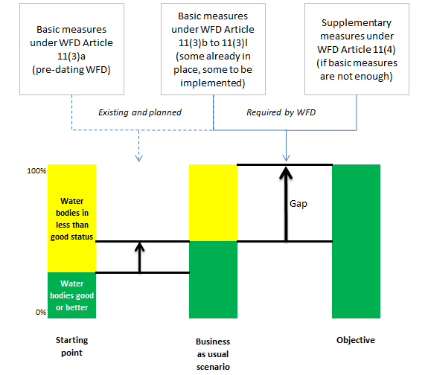
Figure 1. Simplified illustration of a process to identify and fill in the gap between the current status and the 2015 objective of good water status.
If more than one combination of measures can achieve good status, a cost-effective analysis can help identifying the optimum solution able to deliver the desired result at the lowest cost.
Once Member States have established how much would it cost to achieve good status to whom and by when, then it is possible to assess whether exemptions need to be applied due to disproportionate costs, technical unfeasibility or natural conditions.
The Commission’s assessment shows that many Member States have not followed this logic in designing their PoMs. Instead, they have included in the PoMs measures that are largely already in place or in the pipeline and, in some cases, additional measures identified ex-ante as feasible. Then an assessment is done of how far these measures will contribute to the achievement of the WFD’s environmental objectives and, for those water bodies not achieving good status, an exemption is applied without proper justification as required by WFD.
Other Member States designed their PoMs on the basis of a number of scenarios reflecting different combination of measures. The plausible scenarios are often built on the basis of measures identified ex-ante as feasible. Again, this ex-ante assessment is often based on expert judgement and/or inputs from the affected sectors. This approach pre-empts the result and is not adequate to justify the exemptions according to WFD. Judgements on feasibility should be based on a transparent assessment of what is needed to achieve good status.
The WFD’s environmental objectives are quantified and linked to a clear timetable. The approach taken by many Member States – of ‘moving in the right direction’ based (largely) on business-as-usual scenarios – is clearly not sufficient to achieve the environmental objectives for most water bodies.
Another important aspect linked to the approach taken in designing the PoMs is the consequences of the application of exemptions. In most cases, when exemptions are applied and the achievement of ‘good status’ is postponed, it is not clear whether measures are taken to progress towards the objective, as required by the directive (Article 4(4)d).
Further information on the approaches taken by Member States can be found in the following sections of this report, but the overall conclusions is that very few Member States have performed a quantitative gap analysis to underpin the design of the PoMs.

Recommendations (as included in the Communication)
In order to correctly design the PoMs, Member States need to identify the most cost-effective combination of measures that are needed to fill in the gap between water’s current status and ‘good status’. This gap analysis is necessary to understand what needs to be done to achieve the objectives, how much time it will take and how much it will cost to whom. In addition, properly justifying exemptions due to technical unfeasibility or disproportionate costs are possible only based on this analysis. Moreover, even if exemptions are justified, Member States need to ensure that measures progress as far as possible towards the objectives.

Targeting of measures to reduce pressures and impacts to achieve WFD objectives

Introduction
Measures should be targeted in terms of their type and extent to ensure that pressures are addressed and that this will deliver improvements towards achieving good status or potential in the individual water bodies. The measures should be designed based on the assessment of the actual status of the water body, supplemented with the information from the analysis of pressures and impacts affecting the water body.
Each step of the planning process of the WFD is, therefore, necessary to ensure the correct measures are implemented in the appropriate location. The planning process started with the transposition of the Directive into national law and the administrative arrangements, and it was followed by the characterisation of the RBD (including the pressures and impacts analysis, the economic analysis, the delineation of water bodies and the establishment of the typology and reference conditions for surface water bodies: the basis for the ecological status assessment). The status assessment based on sufficient (parameters, frequency, etc.) and updated monitoring results is a fundamental element of the planning process, but is also often the weak part of the chain. Finally, the environmental objectives are set and the PoMs to achieve those objectives are established.
The PoMs should have become operational by December 2012 at the latest. There is a need to monitor the effects and effectiveness of the measures in the improvement of the water status and (as stated in Article 11.5) where monitoring or other data indicate that the objectives set are unlikely to be achieved. The cause of the possible failure should be investigated, relevant permits and authorisations should be reviewed, monitoring programmes reviewed and adjusted and amended or additional measures devised to ensure achievement of objectives.
In terms of the objective of achieving good status by 2015, the aim would be to identify the gap in water body status/potential expected by 2015 and the status required by the Water Framework Directive. How large the gap that must be filled to achieve WFD objectives in any particular RBD and Member State will depend, for example, on how Member States have implemented the requirements under other Directives (e.g. the relative stringency of measures in national Nitrates Action Plans) and policies, as well as differences in the type, extent and magnitude of pressures on water bodies. The gap should be filled with measures that would be implemented under the Water Framework Directive for those water bodies expected to be failing objectives in 2015 without exemptions.
The gap to the achievement of objectives will be caused by significant pressures on water bodies: the sources and sectors responsible will have to be identified to determine where actions on the ground are needed to reduce pressures to levels in/on water bodies compatible with the achievement of objectives. The required reduction of the pressures to fill the gap to the achievement of objectives should then be quantified: this can be expressed in different ways depending on the nature of the pressure. For example: for nutrient pollution it could be in terms of the required reduction in the loads of nitrogen and phosphorus in the receiving water bodies; for pressures arising from the hydromorphological alteration of water bodies it could be expressed as number of barriers that have conditions not compatible with the achievement of Water Framework Directive objectives; and, for water abstractions the volume of water abstracted or diverted that has to be reduced to achieve objectives.
The assessment of the first RBMPs has shown that the measures are often not concrete and the expected achievements not always clear. In general, it should be better reflected that the PoMs should be based on the result of the analysis of pressures and impacts and the status information from the monitoring programmes. Often the definition of the measures is too vague and there is little clarity on the scope of the measures.
Furthermore, the financial commitment, the bodies or organisations responsible for the implementation, the planned timetable and the expected effects on the improvement of the status are not described in the majority of the RBMPs. This lack of detail in defining the measures concretely may lead to insufficient action to tackle the specific problems of the water bodies and hinder the achievement of the WFD at local level.
The aim of using source apportionment is primarily to give a clear picture of the most important sources for a given pressure or impact. In this context a source might be considered as a combination of a pressure type (e.g. diffuse or point source pollution combined with the responsible sector or driver like diffuse – agriculture or diffuse – forestry).

Apportionment of pressures and impacts to sources
Table 1 summarises the information found on how the identified impacts and pressures on water bodies have been apportioned to the responsible sources and sectors. Source apportionment information is required so that measures can be targeted affectively at sources to reduce the pressures to levels compatible with the achievement of WFD objectives.
The information was primarily obtained from an in-depth assessment of the information presented by Member States in their bilateral meetings with the Commission on the implementation of their first RBMPs and PoMs. This was supplemented as necessary by the information reported in 2012 on progress with implementation of the PoMs and the first RBMPs and supporting documents.
Table 1: Apportionment of identified impacts between the sources and sectors responsible for the pressures
Approach adopted | Member States
No information | PL
Impacts and pressures not apportioned between sources and sectors | BE (Brussels region); MT; PT
Qualitative apportionment: sources identified but their relative contribution to impacts and pressures on water bodies not assessed or quantified | CY; DE; ES; FI; IE; HU; IT; LU; LV; RO; UK
Quantitative apportionment for all impacts (e.g. nutrient pollution) and sources (e.g. agriculture and waste water discharges) | -
Quantitative apportionment for some impacts and all their pressures | CZ; SE; LT
Quantitative apportionment for some impacts and just their main pressures | AT; EE; FR; SK; BE (Flanders and Wallonia); FI; NL, RO; UK;
There are differences in approaches between RBDs in the MS, for example because some regions within a MS may have different Competent Authorities. | IT; SE; FR; BE; UK

None of the 23 Member States assessed seems to have undertaken source apportionment for all impacts and pressures though 12 Member States have undertaken source apportionment for some impacts in relation to some if not all sources/sectors. 11 Member States or regions of a Member State have only undertaken a qualitative apportionment where the main sources of pressures have been identified but their relative contributions to the pressures have not been quantified.
Examples of the methodologies used:
- A mathematical model presumably validated by monitoring data was used to assess the impacts of point and diffuse pollution sources on the rivers in Lithuania, as well as to calculate the pollutant concentrations in the main rivers and to identify the input loads of individual pollution sources. The source of hydromorphological alteration pressures were identified as being from hydropower plants and straightened rivers. So other than for some chemicals, the sources of which were unknown, the sources of practically all pressures were identified during the preparation of the first RBMPs.
- A source apportionment has been made for some pressures for example, in the Scheldt RBD in Belgium (Walloon region) it has been determined that the chemical industry and food industry are responsible for 81% of the COD and for 84% of the total phosphorus discharged by the whole industrial sector. However for the other pressures such as from hydromorphological alterations though the main sources are identified their relative impacts have not been apportioned.
- In the Czech Republic and Romania quantitative apportionments have been made mainly for nutrients and organic pollutants from point (discharges) and diffuse sources. The quantitative apportionment was detailed (at facility level (discharges) and quantification of diffuse sources on water body level) both in kg/year of pollutants.
- For most of the RBDs in France an apportionment between domestic / agricultural / industrial sectors for phosphorus, organic matter and nitrogen was done without any differentiation between point sources and diffuse sources.
- In Sweden source apportionment has only been made for nutrients - not for other impacts such as those from hazardous substances.

Approaches to assigning measures to sectors/sources to reduce pressures
Table 2 summarises the results of the assessment of the approaches used by 23 Member States in assigning measures to sectors/sources to reduce pressures.
Table 2: Summary of other approaches to applying measures to reduce pressures
Approach | Member States
Applied to those sectors affected by Article 11.3.a basic measures | CY; IE; LU; LV; RO
Applied to sectors where legal mechanisms and enforcement were available | IE; LV
Applied to sectors where measures were considered as being most cost effective | BE; NL; LV
Focus on sectors where measures are known from past experience to reduce pressures/improve status | SK; LV
Sectors that have traditionally been regulated and subject to improvement measures | IT; IE; SK
Sectors identified as being a source of significant pressures on water bodies | AT; CY; EE, FI, FR; MT; LU; BE; NL; LV; IT; IE; SK ; RO
On sectors where other (than Article 11.3.a) measures were already in place | IT
Other approach | EE; ES; FI; LT; PT; SE; BE; NL
No information found | CZ; IT; ES
Note that more than one approach may apply in a Member State
14 Member States targeted measures at the sectors identified as being a source of significant pressures on water bodies and three MS applied measures to sectors where measures were considered as being most cost effective. No relevant information was found for 3 Member States.
For example the measures in the Irish PoMs focus primarily on basic measures (Article 11.3.a). They have been applied to sectors based on a combination of a source-based apportionment (i.e. point versus diffuse sources of P with some differentiation into agriculture sources and wastewater discharges for example) and expert judgement derived from past experience of water management.

Assigning measures across the polluters and activities/sectors responsible for the impacts
Table 3 summarises the results of the assessment of 23 Member States in terms of how measures were selected across the polluters and sectors responsible for the impacts on water bodies
Table 3: Summary of approaches to assigning measures across the sectors responsible for pressures and impacts on water bodies
Approach | Member State
Focus predominantly on one sector | None
Focus on the sectors contributing most to the pressures and impacts | AT; BE; CY; DE; EE; FR; HU; IE; LT; LU; LV; MT; NL; RO; SE; SK
Focus on the sectors where the measures were considered to be most effective in reducing pressures | FI; PT; UK; EE; LT; NL; SE
Focus on the sectors where measures were considered to be most cost effective | BE; FR; LV; RO; UK
Focus on those sectors where measures were more enforceable | LT
No information found or the approach was not clear | CZ; ES; IT; PL; FR
Note: More than one approach may apply in each Member State
16 Member States indicated that measures were focused on the sectors contributing most to the pressures and impacts on water bodies and 7 to the sectors where the measures were considered to be most effective in reducing pressures. There was no or unclear information for 6 Member States.
Examples of the approaches:
- Harmonised approaches for development of Programmes of Measures were developed at the national level in Germany. Measures have been developed for each respective theme (i.e. agriculture, groundwater, hydromorphology, water pricing etc.). On the one hand, this ensures a common approach in the Länder, especially in RBDs with multiple administrative districts. On the other hand, the information provided in the plans remains very general as only overarching categories of measures are provided.
- The PoMs for the more southerly RBDs in Sweden clearly address the main polluting sectors - waste water from households, industry and agriculture. However, when it comes to the most important pressure in the 2 northern RBDs – from hydromorphological alterations - the approach is more complicated. A substantial part of the costs for physically reducing the impact from hydromorphological pressures is for building fish passes where roads or rail tracks cross over rivers. This source seem relative minor compared to the many hydropower facilities in these areas impacting large lengths of the rivers which seem not be prioritised for measures: the money spent on the minor obstacles in the rivers may be lost if the problems at the large hydropower facilities are not solved.
- Another example for reducing the impacts of hydromorphological pressures and restoration of river continuity are the PoMs in Austria. They are following a prioritisation approach based on ecological effectiveness of the measures. According to this prioritisation river stretches were identified where the restoration of river continuity would be of highest importance and effect for the improvement of the conditions for endangered medium distance migratory fish species. All obstacles in these river stretches have to be made passable for migratory fish regardless whether the obstacle is due to hydropower plants, flood protection works or other sources.

Cost effectiveness
Cost-effectiveness analysis (CEA) is an appraisal technique that provides a ranking of alternative measures on the basis of their costs and effectiveness, where the most cost-effective has the highest ranking.
Uncertainty on costs, effectiveness and time-lagged effects of measures needs to be dealt with throughout the economic analysis process associated with the WFD, and more generally throughout the process of identifying measures and developing the RBMP. Sources of uncertainty are highly diverse according to situations and river basins, but will exist with regards to the assessment of pressures, impacts, baseline, costs or measures effectiveness. It is important that key areas of uncertainty and key assumptions made for the analysis are clearly spelt out and reported alongside the results of the analysis.
Table 4.1 summarises the results of the assessment on the use of cost effectiveness analysis in 23 Member States.
Table 4.1: Summary on Member States use of a cost effectiveness analysis for the development of the programme of measures
The use of cost effectiveness analysis | Member State
For measures for all significant pressures | DE, FR; LT; LU; LV; PT; RO; UK
For measures for some but not all significant pressures | AT; BE; CY; CZ; ES; HU; NL; SE, FI
A cost-effectiveness analysis was not undertaken | EE; IE; MT; PL
No information or not clear | IT; SK

Eight of the 23 Member States assessed have used a cost-effectiveness analysis in the development of their programmes of measures for all significant pressures and a further 8 for some but not all significant pressures. A cost effectiveness analysis appears to have not been undertaken in 4 Member States and no information or unclear information on this was found for 2 Member States.
Efforts have been done in the first implementation cycle to assess the cost-effectiveness of different measures as an instrument to support decision making towards a cost effective implementation/achievement of the WFD objectives. At the same time, various difficulties were faced; therefore additional information on the effectiveness of measures and the expected progress in achieving the WFD objectives as linked to their related costs are desirable for the third implementation cycle/in the second RBMPs.
In most of the RBMPs it is stated that a cost effectiveness analysis (CEA) was conducted during the development of the PoMs that is either for all measures, or for a selection of measures, or for a specific sector. In the majority of cases, it was reported that the CEA influenced the final selection of measures. However there is a great variety regarding the level at which the cost-effectiveness analysis has been performed. In addition, in approximately half of the cases the cost-effectiveness analysis (CEA) was performed for measures related to all significant pressures, while in the remaining ones either the CEA was not performed or only dealing with measures linked to some of the significant pressures.
The CEA often targeted only the supplementary measures, while in general the methodologies used are often unclear or poorly reported. A variety of approaches was taken, e.g. using expert estimations, case study approaches, reference to general procedures implicitly dealing with CEA, using modelling and decision support tools, stakeholder participation etc.
Besides some methodological considerations, various gaps in information availability did limit the use of a CEA (Table 4.2); the main factors here are the lack of information on the environmental effectiveness of some measures in terms of reducing pressures and improving water body status for some pressures, as well as the lack of information on the time-lag between making measures operational, the pressures being reduced and improvements being apparent.
Issues related to the regulatory effectiveness of some measures in terms of reducing pressures and improving water body status for some pressures as well as to the costs information of measures for some pressures also hindered the use of cost-effectiveness analysis on some cases.
Table 4.2: Factors limiting the use of cost-effectiveness analysis in the first programmes of measures
Factor | Member State
Lack of information on the environmental effectiveness of some measures in terms of reducing pressures and improving water body status for some pressures | AT; BE; DE; FI; FR; LT; LU; MT; PT; SE; UK
Lack of information on the regulatory effectiveness of some measures in terms of reducing pressures and improving water body status for some pressures | AT; DE; FI; MT; UK
Lack of information on the time-lag between making measures operational, the pressures being reduced and improvements being apparent | AT; DE; FI; LT; LU; MT; PT; RO
Lack of information on the costs of measures for some pressures | DE; IE; LU; PT; RO; SE; UK
Other | ES; HU; LT; LU; PL; SE
No information | CY; CZ; EE; FR; IT; LV; NL; SK

Assessment of disproportionate costs
The WFD allows for an extended time to the achievement of objectives or the application of less stringent objectives if properly justified on the grounds of disproportionately expensive measures (Articles 4.4 and 4.5). The argument of the measures being disproportionately expensive was used by 17 of the 27 Member States when applying exemptions in their first RBMPs with the proportion of surface waters exempted for this reason up to 55% of exempted surface water bodies depending on the Member State.
However, there was little information found on the details and the process of determining disproportionately expensive measures in the first RBMPs. In addition a review of cost and benefit information used in the first RBMPs published in 2012 showed that limited information on cost and benefit was currently available. This was true in particular with respect to the benefits of WFD implementation: such information was rarely included in the RBMPs and in total, benefit information could only be found for 22 RBDs.
Therefore, in most cases alternatives approaches that vary considerably across the EU (e.g. linked to affordability affordability/financial impact, in some cases linked to distributional effects etc.) have been used to conduct the disproportionality of costs assessment. Also a check of alternative financing mechanisms that could influence the disproportional cost evaluation is lacking in most of the RBMPs.

Effects of uncertainties
Measures should be targeted in terms of their type and extent to ensure that pressures are tackled and reduced, and that this will deliver improvements towards achieving good status or potential in the individual water bodies. The measures should be designed based on the assessment of the actual status of the water body, supplemented with the information from the analysis of pressures and impacts affecting the water body.
Therefore, uncertainty in the robustness and suitability of methods used in the Article 5 analysis of pressures and impacts, and/or in the confidence of the results of monitoring and the subsequent assessment of ecological and chemical status can fundamentally affect how measures are targeted at water bodies at risk of failing objectives or those that are assessed as being at less than good status from all significant pressures in a RBD.
Table 5 summarises the effects of uncertainty had on the programmes of measures developed for the first cycle in the 23 Member States assessed.
Table 5: Effects of uncertainty of the targeting of measures to tackle pressures in the first RBMPs
Effect | Member State
The effects of uncertainty were not considered when targeting measures | BE; CY; ES; FI; HU; IE; IT; LU; LV; MT; PL; PT; RO*; SK
Measures were targeted only on water bodies with well quantified pressures | CZ; HU; IE; LT; NL; SE; SK; UK
Measures were targeted only on water bodies clearly at risk of failing objectives | IE; LT; LU; NL; PL; PT; RO; SE; UK
Only expert judgment has been used in the assessment of pressures and impacts | EE; FI; IE
Measures were targeted at those water bodies failing objectives with a defined level of confidence in their status | AT; FR; LT; UK
Measures were targeted at those water bodies failing objectives whose status was assessed with compliant methods for at least one but not all biological quality elements | HU
Measures were targeted at those water bodies failing objectives with types that had been intercalibrated | LT
Measures were targeted at those water bodies failing objectives that are only monitored for physicochemical quality elements | CZ
Measures were targeted at water bodies that are failing objectives and are not directly monitored but have been assessed using the monitoring results from monitored water bodies in the same group | LT; PT
No information | DE
Note more than one “effect” may apply to a Member State.
* For basic measures only in RO.
The effects of uncertainty appear to have not been considered when targeting measures in 14 of the 23 Member States assessed: in addition in Romania uncertainty was not considered in applying basic measures but was in terms of supplementary measures. In 12 Member States measures were targeted only on water bodies with well quantified pressures and/or were clearly at risk of failing objectives.
As an example of the effect of uncertainties on the design of programmes of measures, in the United Kingdom (England and Wales) for many of the diffuse sources the knowledge of the detail of sources and pathways was too uncertain to know what measures would be feasible and effective, particularly at a detailed site specific level. For this reason, the measures included in the first RBMPs in England and Wales focused on actions planned for other drivers, national measures, and locally targeted actions to control pollution.
A common theme among Member States was the use of measures during the first cycle designed to reduce uncertainties (e.g. LT, PT, SE and UK). Such measures could be related to research, monitoring and assessment. In Lithuania the uncertainties identified in the RBMPs were in relation to a) the status of river water bodies; b) the impacts of certain risk factors on river water bodies; c) the ecological status in lakes and good ecological potential in artificial lakes; and, d) about the reasons for poor status.

Overview of implementation of Article 11.3.a Basic Measures
22 Member States reported in their first RBMPs that all basic measures under Article 11.3.a had been implemented in all their national RBDs and their national parts of international RBDs. For the remaining 6 Member States some of the basic measures had not been implemented in all RBDs.
In 2010 Member States were asked to report whether or not basic measures planned for their first programmes of measures were enough to reduce significant pressures to levels compatible with the achievement of WFD objectives such as the achievement of good status by 2015. Table 6 shows the percentage of RBDs that reported that basic measures (Article 11.3.a to 11.3.l) were enough to achieve WFD objectives. The Table shows that basic measures were enough in the largest proportion of RBDs for pressures arising from transitional and coastal water management and in the smallest proportion of RBDs for diffuse source pressures.
Table 6: Percentage of RBDs where the implementation of Article 11.3.a to 11.3.l basic measures were considered as being enough to achieve WFD objectives
Significant pressure on surface water bodies | Percentage of RBDs
Transitional and coastal water management such as estuarine/coastal dredging and tidal barrages (136) | 66%
Other morphological alterations such as barriers and land sealing(138) | 60%
Water Abstraction for example for agriculture or public water supply (149) | 47%
Other Pressures such as introduced species and recreation (152) | 40%
River management such as the physical alteration of river channels and river dredging (142) | 33%
Water flow regulation and morphological alterations such as flood defence dams and weirs (154) | 14%
Point Sources such as those from urban waste water treatment works and industrial installations (156) | 12%
Diffuse Sources such as those from agriculture and urban areas (156) | 8%
Source WISE 2010 electronic reports. The numbers in parenthesis after the pressure type are the numbers of RBDs that reported on whether or not basic measures were enough. All 28 MS reported.
If Article 11.3 basic measures were considered not to be enough, Member States were asked to provide information on which specific Article 11.3.a basic measures and Article 11.3.b to l basic measures were considered not to be enough to tackle significant pressures.
Table 7: Overview of Article 11.3.a basic measures that were reported as not being enough to tackle significant pressures on surface water bodies in the first RBMPs
Pressure | Article 11.3.a measure
Pressure | BWD | BD | DWD | Seveso | EIA | SSD | UWWTD | PPPD | ND | HD | IPPCD
Point Source (156) | 22% | 8% | 12% | 19% | 10% | 6% | 60% | 8% | 8% | 14% | 38%
Diffuse Source (156) | 18% | 9% | 15% | 8% | 18% | 20% | 10% | 21% | 63% | 19% | 4%
Water Abstraction (149) | 1% | 9% | 11% | 0% | 10% | 0% | 1% | 1% | 0% | 13% | 1%
Water flow regulations and morphological alterations (154) | 1% | 11% | 2% | 0% | 19% | 0% | 1% | 0% | 5% | 18% | 2%
River management (142) | 1% | 14% | 1% | 0% | 18% | 0% | 0% | 0% | 7% | 18% | 1%
Transitional and coastal water management (136) | 1% | 2% | 0% | 0% | 6% | 0% | 0% | 0% | 2% | 3% | 1%
Other morphological alterations (138) | 0% | 9% | 1% | 0% | 12% | 0% | 0% | 0% | 4% | 10% | 1%
Source: WISE 2010 electronic reports. Percentages in table cells are the percentage of RBDs where Article 11.3.a basic measures were not enough to achieve WFD objectives. In brackets next to the pressures is the number of RBDs reporting whether these measures were enough or not to tackle the listed significant pressures on surface water bodies. Note that the percentages in the rows do not add up to 100% as more than one measure may be needed (but insufficient) to address significant pressures on surface waters.
Key to table
BWD | Bathing Water Directive (76/160/EEC)
BD | Birds Directive (79/409/EEC)
DWD | Drinking Water Directive (80/778/EEC) as amended by Directive (98/83/EC)
Seveso | Major Accidents (Seveso) Directive (96/82/EC)
EIA | Environmental Impact Assessment Directive (85/337/EEC)
SSD | Sewage Sludge Directive (86/278/EEC)
UWWTD | Urban Wastewater Treatment Directive (91/271/EEC)
PPPD | Plant Protection Products Directive (91/414/EEC)
ND | Nitrates Directive (91/676/EEC)
HD | Habitats Directive (92/43/EEC)
IPPCD | Integrated Pollution Prevention Control Directive (96/61/EC)

The cells highlighted in red indicate for which significant pressure on surface waters the basic measure that was most considered not to be enough to achieve WFD objectives. For example, for point sources, measures implemented by Member States under the Urban Waste Water Treatment Directive were not enough in 60% of RBDs (within 20 Member States) for which there is reported information and those measures incorporated in Member States Nitrates Action Programmes were not enough to tackle diffuse source pressures in 63% of RBDs (within 22 Member States).

Overview of implementation of Article 11.3.b-l other Basic Measures

State of implementation in 2012
As described in section 3.1, Member States reported on which Article 11.3 basic measures were considered as being enough to reduce significant pressures to levels compatible with achievement of WFD objectives. If they were considered not to be enough, Member States were asked to provide information on which specific Article 11.3.a basic measures and Article 11.3.b to l basic measures were considered as not being enough to tackle significant pressures.
Table 8 presents the Article 11.3.b to l basic measures that were reported in 2010 as not being enough to achieve WFD objectives.
Table 8: Overview of Article 11.3.b to l basic measures that were reported as not being enough to tackle significant pressures on surface water bodies in the first RBMPs
Pressure | Article 11.3
Pressure | b | c | d | e | f | g | h | i | j | k | l
Point Source (156) | 9% | 13% | 5% | 5% | 1% | 72% | 13% | 17% | 6% | 33% | 28%
Diffuse Source (156) | 5% | 12% | 4% | 3% | 1% | 17% | 71% | 17% | 3% | 21% | 15%
Water Abstraction (149) | 7% | 31% | 15% | 48% | 1% | 8% | 9% | 13% | 1% | 1% | 8%
Water flow regulations and morphological alterations (154) | 3% | 16% | 1% | 8% | 1% | 9% | 13% | 76% | 1% | 2% | 9%
River management (142) | 1% | 13% | 1% | 4% | 1% | 1% | 8% | 54% | 1% | 1% | 8%
Transitional and coastal water management (136) | 1% | 2% | 1% | 1% | 1% | 4% | 7% | 18% | 1% | 7% | 1%
Other morphological alterations (138) | 1% | 2% | 1% | 1% | 1% | 4% | 3% | 32% | 1% | 1% | 1%
Source: WISE 2010 electronic reports. Percentages in table cells are the percentage of RBDs where Article 11.3. b to l basic measures were not enough. In brackets next to the pressures is the number of RBDs reporting whether these measures were enough or not to tackle the listed significant pressures on surface water bodies
Key
Article | Short name
11.3.b | Measures for the recovery of cost of water services (Article 9)
11.3.c | Measures to promote efficient and sustainable water use
11.3.d | Measures for the protection of water abstracted for drinking water (Article 7)
11.3.e | Controls over the abstraction of fresh surface water and groundwater and impoundment of fresh surface waters
11.3.f | Controls, including a requirement for prior authorisation of artificial recharge or augmentation of groundwater bodies
11.3.g | Requirement for prior regulation of point source discharges liable to cause pollution
11.3.h | Measures to prevent or control the input of pollutants from diffuse sources liable to cause pollution
11.3.i | Measures to control any other significant adverse impact on the status of water, and in particular hydromorphological impacts
11.3.j | Prohibition of direct discharge of pollutants into groundwater
11.3.k | Measures to eliminate pollution of surface waters by priority substances
11.3.l | Any measures required to prevent significant losses of pollutants from technical installations and to prevent and/or reduce the impact of accidental pollution incidents

The cells highlighted in red indicate for which significant pressure on surface waters the basic measure that was most considered not to be enough to achieve WFD objectives. For example, for pressures arising from hydromorphological alterations, measures implemented by Member States under Article 11.3.i (measures to control any other significant adverse impact on the status of water, and in particular hydromorphological impacts) were not enough in 76% of RBDs (within 23 MS) for which there is reported information, and those measures incorporated in Article 11.3.g measures (requirement for prior regulation of point source discharges liable to cause pollution) were not enough to tackle point source pressures in 72% of RBDs (within 22 MS).
Figure 1: Progress at the EU level on the implementation of basic measures (Article 11.3.b to l) reported in 2012
Key as for Table 4.1. Based on 24 MS, number of RBDs in brackets. DK and EL did not report; HR has only recently published its first RBMPs and is yet to report on their progress. LV did not report on this aspects. BE data covers the RBDs in Flanders and in Wallonia but not the ones in Brussels and in the coastal region.

Delays in implementation
Member States were asked to report if there were substantial delays in the implementation of basic measures required under Article 11.3. b to l. Table 9 summarises at the EU level (24 MS) the proportion of RBDs where basic measures were reported to be delayed in 2012. Substantial delays were reported in all categories in the range of 9-23% of the measures planned.
Table 9: Number of RBDs reporting substantial delays in implementation of Article 11.3.b to l
Article 11.3 | Basic Measure | Number of RBDs reporting substantial delay | % of RBDs reporting
d | Protection Water Abstraction | 31 | 23%
i | Adverse Impact | 25 | 19%
g | Point Source Discharges | 23 | 17%
e | Controls Water Abstraction | 21 | 16%
b | Cost Recovery Water Services | 20 | 15%
c | Efficient Water Use | 18 | 13%
h | Pollutants Diffuse | 16 | 12%
j | Pollutants Direct Groundwater | 14 | 10%
k | Surface Priority Substances | 13 | 10%
l | Accidental Pollution | 12 | 9%
f | Recharge Augmentation Groundwater | 12 | 9%

In terms of Article 11.3.d measures for the protection of water abstraction, substantial delays in implementations were reported in France (12 RBDs), Sweden (10 RBDs), Ireland (7 RBDs) and Spain (2 RBDs). Fifty one (35%) of the 144 RBDs reporting information on the state of implementation of Article 11.3.b to l measures had at least one measure that was substantially delayed. In 29 (20% of RBDs) at least 10% of the measures and in 12 (8% of RBDs) at least 50% of the measures were substantially delayed.
Table 10 summarises at the Member State level the reasons reported for basic measures being delayed or not completed. To do this, the reasons have been categorised into broad “types” of reason or obstacles.
At the EU level (23 MS), 12% of basic measures were delayed or uncompleted because of legislative/regulatory/administrative barriers and, as described above, Ireland and the Czech Republic reported that 30% of their basic measures had been delayed for this reason. Funding or finance issues were also reported to be causing delay or non-completion of 3% of basic measures at the EU level, with the highest proportion in Italy (15%), Portugal (10%) and Spain (7%).
Table 10: Summary of reasons for substantial delays and/or explanation of the state of implementation of basic measures (Article 11.3 (b to l)) in 2012
MS | fund | research | adm | tech | later | general | update | not appl
AT (33) |  |  |  |  |  | 3% (0%)
BE (77)
BG (44) | 5% (5%)
CY (11)
CZ (33) |  |  | 30% (27%)
DE (110)
DK (NR)
EE (33)
EL (NR)
ES (165) | 7%  (7%) | 2% (2%) | 4% (4%) |  | 5% (0%) | 1% (1%) | 1% (1%) | 1% (0%)
FI (88)
FR (143) | 1% (0%) |  | 8% (8%)
HU (11) |  |  | 9% (9%)
IE (77) |  |  | 36% (36%) |  |  |  |  | 9% (0%)
IT (62) | 15% (15%)
LT (44)
LU (22)
LV (NR)
MT (11)
NL (44)
PL (110) | 5% (5%)
PT (88) | 10% (0%) |  | 6% (0%) |  |  | 5% (1%) |  | 2% (0%)
RO (11)
SE (110) | N/A |  | N/A
SI (NR)
SK (16) |  |  | 13% (13%) |  | 13% (13%)
UK (165)
EU (1508) | 3% (2%) | 0.2% (0.2%) | 4% (4%) | 0% (0%) | 1% (0.1%) | 0.5% (0.2%) | 0.1% (0.1%) | 1% (0%)
Note: Bold numbers in cells are the percentages of basic measures with the reason for the substantial delay in implementation. Numbers in brackets in cells are the percentages of measures reported to have a substantial delay. Numbers in brackets next to MS codes are the number of basic measures reported at the RBD level. All measures included in this table were either reported as not started or on-going, some with a substantial delay. All had a textual description of the state of implementation. NR = not reported.
Key to Table
fund | Funding/finance obstacles
research | Research/investigation/developments/further work needed
adm | Legislation/regulation/administration barriers
tech | Technical barriers/difficulties
later | Not yet included/Planned to start later in the cycle/next cycle
general | General description only
update | Waiting for updates of information
not appl | Not needed/applicable

Financing of basic measures (Article 11.3 b) to l))
Member States were asked to report on the source of EU funds for the financing of Article 11.3.b to l basic measures. Figure 2 shows that 81% of these other basic measures were financed from non-EU funds, indicating that potentially there could be better utilisation of EU funds by Member States. The EU funds most commonly reported were structural (9%), rural development (5%) and cohesion fund (3% of measures, however it should be noted that not all Member States and regions are eligible for support from the cohesion fund). A more detailed breakdown per Member States is given in Table 8.
Figure 2: The use of different sources of EU funds for the financing of other basic measures (Article 11.3.b to l) at the EU level in 2012
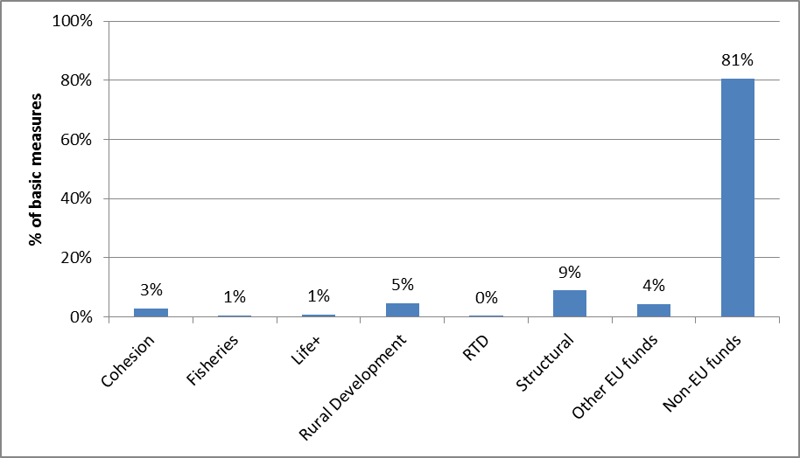
Note: Based on 22 Member States. DK, EL and HR have not reported to WISE. DE, FI and LV did not report on this aspect.
Table 11: Percentages of Article 11.3 (b to l) other basic measures financed from EU funds in 2012
MS | Cohesion | Fisheries | Life+ | Rural Development | RTD | Struc-tural | Other EU funds | Non-EU funds
AT (33) | 0% | 0% | 0% | 0% | 0% | 0% | 0% | 100%
BE (66) | 0% | 0% | 3% | 3% | 0% | 0% | 3% | 92%
BG (44) | 7% | 0% | 0% | 0% | 0% | 11% | 2% | 79%
CY (11) | 0% | 0% | 0% | 0% | 0% | 0% | 0% | 100%
CZ (33) | 0% | 0% | 0% | 0% | 0% | 27% | 0% | 73%
DE (NR)
DK (NR)
EE (33) | 36% | 0% | 0% | 9% | 0% | 27% | 0% | 55%
EL (NR)
ES (165) | 4% | 1% | 1% | 4% | 1% | 17% | 2% | 79%
FI (NR)
FR (143) | 0% | 0% | 0% | 10% | 0% | 2% | 1% | 87%
HR (NR)
HU (11) | 27% | 0% | 0% | 18% | 0% | 18% | 82% | NR
IE (77) | 0% | 0% | 4% | 0% | 0% | 0% | 0% | 96%
IT (62) | 2% | 2% | 2% | 8% | 0% | 13% | 2% | 48%
LT (44) | 9% | 9% | 0% | 9% | 0% | 0% | 0% | 73%
LU (22) | 0% | 0% | 0% | 0% | 0% | 9% | 0% | 91%
LV (NR)
MT (11) | 0% | 0% | 0% | 0% | 0% | 18% | 0% | 82%
NL (44) | 0% | 0% | 0% | 0% | 0% | 0% | 0% | 100%
PL (110) | 0% | 0% | 0% | 0% | 0% | 2% | 0% | 98%
PT (88) | 1% | 0% | 0% | 5% | 0% | 58% | 0% | 39%
RO (11) | 9% | 0% | 0% | 9% | 0% | 0% | 9% | 100%
SE (110) | 0% | 0% | 0% | 9% | 0% | 0% | 36% | 64%
SI (50) | 8% | 0% | 0% | 4% | 0% | 0% | 2% | 86%
SK (16) | 25% | 0% | 0% | 13% | 0% | 0% | 0% | 63%
UK (165) | 0% | 0% | 1% | 4% | 0% | 0% | 0% | 96%
The number in brackets is the number of basic measures (summed from the RBD level) reported by Member State.
In BE in the RBDs in Wallonia region, due to the lack of consolidated data, the information on EU Funds is lacking, even though some of the measures were financed by EU Funding.
Note: a measure may be funded from more than one source and so the percentages for a MS do not necessarily add up to 100%. NR = not reported

Overview of implementation of Article 11.4 Supplementary Measures

State of implementation in 2012
Figure 3 presents the state of implementation of supplementary measures in 2012 at the Member States level. As well as there being a large difference between Member States in the number of supplementary measures reported (given in brackets next to the MS abbreviation), there is also a large difference in the state of implementation:
- In around one-third of Member States over 20% of their supplementary measures had not been not been started in 2012;
- In around 80 % of Member States less than 20% of their supplementary measures had only been completed in 2012.
In their 2010 reports, Member States provided details on which supplementary measures were used to tackle each of the significant pressures on their water bodies. In their 2012 reports on progress with the implementation of programmes of measures, details were provided on the progress being made with implementation of the supplementary measures. Therefore, an indication of the progress being made in tackling significant pressures through the application of supplementary measures could be obtained by linking the two datasets.
Figure 4 shows (aggregated at EU level) the state of implementation of supplementary measures in 2012 being used to tackle point source, diffuse source, water abstraction and hydromorphological pressures on surface water bodies. For all the four pressure categories over 80% of measures were either not-started or on-going indicating that at the mid-way point of the first cycle that there was still a large “gap” to be filled if all measures were to be completed by 2015. There were only small differences between the four pressure types with the supplementary measures for water abstraction pressures having the largest proportion of completed measures (19%) and hydromorphological alteration pressures the smallest (10%).
Figure 3: Percentage of supplementary measures in each Member State that was not-started, on-going and completed in 2012
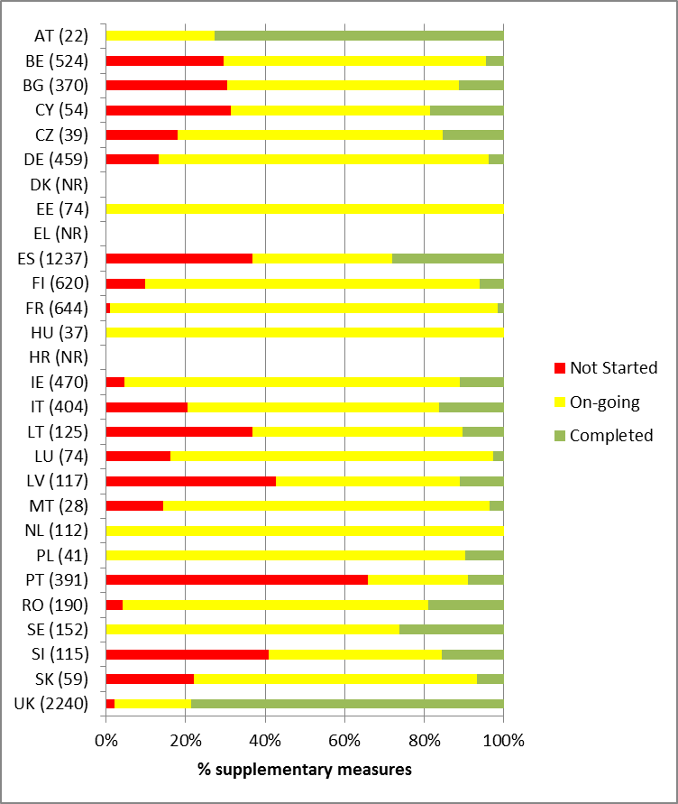
Note: numbers in brackets are the number of measures summed at the RBD level for each MS. NR = not reported. BE data covers the RBDs in Flanders and in Wallonia but not the ones in Brussels and in the coastal region.
Figure 4: State of implementation of supplementary measures being used to tackle significant pressures on surface water bodies
Note: the number of Member States on which the figure is based is shown in brackets next to the pressure type. Hydromorphological alteration pressures are an aggregation of pressures arising from water flow regulations and morphological alterations, river, transitional and coastal water management and other morphological alterations. The following MS are not included in the figure above: DK, EL and HR have not yet reported on progress; the 2010 and 2012 data from CZ, MT, SE and SI could not be linked. BE data only covers the RBDs in Flanders but not the ones in Wallonia, in Brussels and in the coastal region. The data are based on the average state of implementation of measures for each MS so that MS reporting many more measures than others do not unduly bias the overall picture.

Delays in implementation
As with Article 11.3 b to l basic measures, Member States were asked to report whether there was a substantial delay in implementing supplementary measures included in the first RBMPs in 2009, and to explain any such delays. 85% of the 39 measures in the Czech Republic, 53% of the 152 in Sweden and 37% of the 459 in Germany were reported to be delayed. In comparison only 0.4% of the 2240 measures in the United Kingdom were delayed and none in Austria, Estonia, Hungary, Luxembourg, Slovenia and Slovakia.
In 74 (54%) of the 136 RBDs with reported information on the state of implementation of supplementary measures, there was at least one measure reported to be substantially delayed. Fifty RBDs (37%) had substantial delays in implementation of at least 10% and in 15 (11%) RBDs with at least 50% of their supplementary measures.
In addition, Member States could also explain the state of implementation of any measure be they delayed or not. Table 12 summarises the reasons given for delays in implementation and the state of measures. The information reported in national languages has been categorised in a number of broad reasons and/or obstacles. Though this is not a precise categorisation it is sufficient to indicate the main reasons and obstacle for delays in implementation of supplementary measures.
At the EU level (25 MS), around 7% of supplementary measures were delayed or not completed because of financial/lack of funding reasons with over 10% being delayed in 8 Member States. Around 4% of supplementary measures at the EU level were delayed or not completed because further research and/or investigations were needed, and around 3% because there were legislative/regulation/administration barriers.
Table 12: Summary of reasons for substantial delays and/or explanation of the state of implementation of supplementary measures in 2012
MS | fund | research | adm | tech | later | land | general | staff | update | no need | no prior | new | plan | cost
AT (22)
BE (524) | 1.2% | 2.4% | 5.3% | 4.7% | 5.3% |  | 2.4% | 0.6% | 1.8% | 0.6% | 7.6%
BG (370) | 7.0% |  | 0.8% | 0.5% |  |  |  |  |  | 0.5%
CY (54) | 13% | 13% | 2% | 2% | 11% |  |  |  |  |  |  | 2%
CZ (39) | 15% | 23% | 23% | 8% | 8% |  | 8%
DE (459) | 22% |  | 29% | 11% |  | 22% |  | 22% |  | 4% |  | 4%
DK (NR)
EE (74) |  |  |  |  |  |  | 35%
EL (NR)
ES (1237) | 11.2% | 0.1% | 0.5% | 0.2% | 0.1% |  | 2.2% |  | 2.7% |  |  |  | 0.2%
FI (620) | 9.5% | 0.5% | 1.1% | 1.9% | 6.1% | 0.2% | 1.8% | 0.2% |  | 0.3%
FR (644) | 1.1% | 0.2% | 3.6% | 3.1% | 0.3% |  | 0.5% |  |  | 0.2%
HR (NR)
HU (37)
IE (470) | 3.8% | 1.3% | 5.3% | 0.2% |  |  |  |  |  | 1.5% | 1.3% |  | 0.2% | 1.3%
IT (412) | 23% |  | 0.2% |  | 0.2% |  |  | 0.7%
LT (125) | 0.8% |  | 5.6% | 6.4% | 0.8% | 1.6% | 0.8% |  |  |  |  |  | 0.8%
LU (74)
LV (117) | 33% | 3% | 3% | 3% | 24%
MT (28) |  |  | 18% | 4%
NL (112) | 18% |  | 5% |  |  | 4%
PL (41) | 7.3% |  | 9.8% | 4.9% |  | 4.9%
PT (391) | 12.3% |  | 0.8% | 0.5% | 3.1% |  | 1.0% |  | 0.5%
RO (190) | 4.7% |  | 5.8% | 0.5% |  | 0.5% | 0.5% |  |  | 0.5%
SE (152) |  | 6.6% | 6.6% |  | 19.7% |  | 13.2% |  |  |  |  |  | 7.2%
SI (115)
SK (59) | 3.4% | 10.2% |  | 3.4% |  |  | 5.1%
UK (2240) |  | 12.5% | 0.3% | 0.5% |  |  | 0.0% |  |  | 0.1%
EU (8277) | 7.1% | 4.1% | 3.4% | 1.7% | 1.7% | 1.4% | 1.3% | 1.3% | 0.5% | 0.5% | 0.4% | 0.2% | 0.2% | 0.1%
Note: numbers in brackets are the number of supplementary measures reported at the RBD level. All measures included in the Table were either reported as not started or on-going, some with a substantial delay. All had a textual description of the state of implementation. NR = not reported. In BE only Flanders reported on substantial delays. AT and LU did not provide textual descriptions.
Key to table
fund | Funding/finance obstacles
research | Research/investigation/developments/further Work needed
adm | Legislation/regulation/administration barriers
tech | Technical barriers/difficulties
later | Planned to start later in the cycle/next cycle
land | Lack of land/acquisition
general | General description only
staff | Lack of staff
update | Waiting for updates of information
no need | Not needed
no prior | Low priority
new | New/information/findings
plan | Planning/approval barriers
cost | Not cost effective

Financing of supplementary measures
Member States were also asked to report on the source of EU funds for the financing of supplementary measures. Figure 5 shows that 81% of supplementary measures were financed from non-EU funds. The EU funds most commonly reported were structural (8%) and rural development (4%) funds. A more detailed breakdown per Member States is given in Table 13.
Figure 5: The use of different sources of EU funds for the financing of supplementary measures at the EU level in 2012
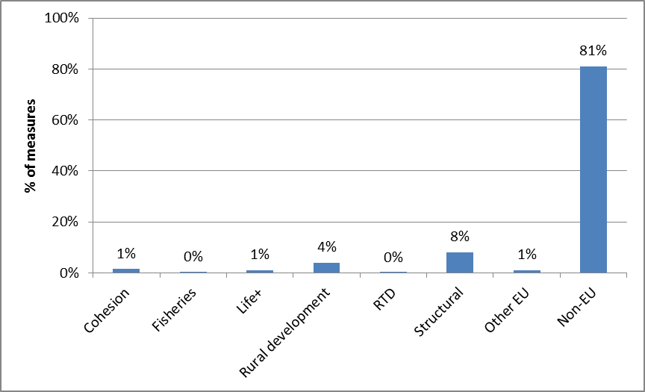
Note: Based on 24 Member States. DK, EL and HR have not reported to WISE. DE did not report on this aspect.
Table 13: Percentages of supplementary measures financed from EU funds in 2012
MS | Cohesion | Fisheries | Life+ | Rural development | RTD | Structural | Other EU | Non-EU
AT(22) | 0% | 0% | 18% | 14% | 0% | 14% | 0% | 68%
BE(524) | 0% | 0% | 0% | 3% | 0% | 1% | 2% | 94%
BG(370) | 7% | 0% | 1% | 6% | 0% | 7% | 0% | 79%
CY(54) | 0% | 0% | 0% | 0% | 0% | 0% | 0% | 100%
CZ(39) | 0% | 0% | 0% | 0% | 0% | 28% | 0% | 72%
DE(NR)
DK(NR)
EE(74) | 18% | 0% | 0% | 7% | 0% | 12% | 0% | 82%
EL(NR)
ES(1237) | 2% | 0% | 2% | 1% | 0% | 17% | 2% | 78%
FI(620) | 0% | 0% | 1% | 10% | 0% | 6% | 1% | 83%
FR(644) | 0% | 0% | 3% | 11% | 0% | 19% | 1% | 70%
HR (NR)
HU(37) | 0% | 0% | 0% | 0% | 0% | 0% | 0% | 100%
IE(470) | 0% | 0% | 5% | 0% | 0% | 0% | 0% | 95%
IT(247) | 0% | 0% | 0% | 4% | 0% | 11% | 2% | 84%
LT(125) | 9% | 2% | 1% | 3% | 0% | 1% | 0% | 85%
LU(74) | 0% | 0% | 0% | 0% | 0% | 0% | 0% | 100%
LV(117) | 5% | 1% | 1% | 4% | 0% | 14% | 1% | 74%
MT(28) | 11% | 0% | 11% | 7% | 0% | 7% | 4% | 71%
NL(112) | 3% | 0% | 2% | 1% | 0% | 2% | 4% | 89%
PL(41) | 12% | 12% | 7% | 22% | 0% | 15% | 5% | 68%
PT(391) | 7% | 0% | 0% | 7% | 0% | 42% | 1% | 45%
RO(190) | 3% | 0% | 0% | 14% | 0% | 1% | 4% | 97%
SE(152) | 0% | 0% | 0% | 13% | 0% | 0% | 13% | 87%
SI(115) |  |  |  |  |  |  |  | 100%
SK(59) | 0% | 0% | 0% | 17% | 0% | 0% | 0% | 83%
UK(8277) | 0% | 0% | 0.2% | 1% | 0% | 2% | 0% | 97%
Note: The number in brackets is the number of supplementary measures (summed from the RBD level) reported by Member State. Note: a measure may be funded from more than one source and so the percentages for a MS do not necessarily add up to 100%. NR = not reported.
In BE in the RBDs in Wallonia region, due to the lack of consolidated data, the information on EU Funds is lacking, even though some of the measures were financed by EU Funding.

Reporting of Key Types of Measures
In 2012, Member States were asked to report on 16 defined Key Types of Measures (KTM). KTMs were expected to incorporate Article 11.3 (b to l) basic measures and supplementary measures. Their implementation and completion were expected to deliver the bulk of the actions required to achieve WFD objectives, i.e. to reduce significant pressures to the extent required to achieve good status or to prevent deterioration of status in high and good status water bodies. A key type of measure was expected to be reported by Member States only if it was related to a significant pressure in that Member State. Member States could identify a limited number of key types of measures for each RBD and provide for those quantitative indicators of progress in implementation. Member States were also given the possibility to report different or additional KTMs according to their specific situations and requirements.
There were large differences in the numbers of KTMs reported by Member States, and also between the RBDs within the Member States (Figure 6). Spain and Italy reported on all 16 KTMs, but not for all of their RBDs, and Lithuania did not report any. KTM 1 (Construction or upgrades of wastewater treatment plants beyond the requirements of the Directive on Urban Waste Water Treatment) was the most frequently reported (19 MS) and KTM 8 (water efficiency measures for irrigation), the least frequently (6 MS) (Figure 7).
Figure 6: Number of Key Types of Measure reported by Member States
Note: DK, EL and HR have not reported to WISE
Figure 7: Number of Member States reporting on the different Key Types of Measure
Note: DK, EL and HR have not reported to WISE
Key to KTMs
KTM | Title
1 | Construction or upgrades of wastewater treatment plants beyond the requirements of the Directive on Urban Waste Water Treatment
2 | Reduce nutrient pollution in agriculture beyond the requirements of the Nitrates Directive
3 | Reduce pesticides pollution in agriculture
4 | Remediation of contaminated sites (historical pollution including sediments, groundwater, soil
5 | Improving longitudinal continuity (e.g. establishing fish passes, demolishing old dams)
6 | Improving hydromorphological conditions of water bodies other than longitudinal continuity
7 | Improvements in flow regime and/or establishment of minimum ecological flow
8 | Water efficiency measures for irrigation (technical measures)
9 | Progress in water pricing policy measures for the implementation of the recovery of cost of water services from households
10 | Progress in water pricing policy measures for the implementation of the recovery of cost of water services from industry
11 | Progress in water pricing policy measures for the implementation of the recovery of cost of water services from agriculture
12 | Advisory services for agriculture
13 | Drinking water protection measures (e.g. establishment of safeguard zones, buffer zones etc.)
14 | Research, improvement of knowledge base reducing uncertainty
15 | Measures for the phasing-out of emissions, discharges and losses of priority hazardous substances or for the reduction of emissions, discharges and losses of priority substances
16 | Upgrades or improvements of industrial wastewater treatment plants (including farms) beyond the requirements of the Integrated Pollution Prevention and Control (IPPC) Directive

Table 14 gives an overview of the KTMs reported by Member States – three Member States (DK, EL and SI) have not reported. It should be noted that it would not necessarily be expected that all KTMs would be reported by Member States as significant pressures types vary across Member States and some may not be required. These differences may reflect differences in the extent and type of pressures between and within Member States but they may in some cases also reflect a lack of a common understanding of what is meant by a “Key Type of Measure” and what should be reported. This is particularly the case where a Member States has reported a pressure as being significant but then not reported the KTM associated with that pressure. For example a further 6 Member States might have been expected to report KTM 5 (improving longitudinal continuity) which is associated with pressures arising from hydromorphological alterations of water bodies.
Member States were not asked to report on any substantial delays in the implementation of KTMs. However, as KTMs are composites of Article 11.3.b to l basic measures and supplementary measures, and substantial delays have been reported on both types of measure (section 4.2 and 5.2, respectively), it is reasonable to assume that there will also be substantial delays in the implementation of some KTMs in some Member States.
The state of implementation of the KTMs associated with the 5 Topic/pressures selected for in-depth assessment is presented in the following sections.
Table 14: Breakdown of the Key Types of Measure reported by Member States in 2012
MS(RBDs) | Key Types of Measure
MS(RBDs) | 1 | 2 | 3 | 4 | 5 | 6 | 7 | 8 | 9 | 10 | 11 | 12 | 13 | 14 | 15 | 16
AT(3) | 3 | 3 |  |  | 3 |  | 2 |  |  |  |  | 3
BE(6) | 6 | 6 | 6 | 6 | 5 | 6 | 6 |  | 6 | 6 | 6 | 6 | 6 | 6 | 6 | 6
BG(4) | 3 | 1 | 1 | 3 | 2 | 2 | 2 | 2 |  |  |  | 3 | 3 | 2 | 1 | 1
CY(1) |  |  |  | 1 |  | 1 |  |  |  |  |  |  | 1 | 1 | 1
CZ(3) | 3 |  |  | 3 | 3 | 3 |  |  |  |  |  |  |  | 3
DE(10) | 9 | 10 |  |  | 10 | 10 |  |  |  |  |  | 9 |  | 9
DK
EE(3) | 3 | 3 | 3 | 3 | 3 | 3 | 2 |  | 3 | 3 | 3 | 3 | 3 | 3 | 2 | 2
EL
ES(15) | 10 | 8 | 2 | 8 | 4 | 13 | 10 | 9 | 7 | 5 | 3 | 3 | 7 | 14 | 6 | 3
FI(8) | 3 | 4 |  |  | 4 | 2 | 1 |  |  |  |  | 1 | 4
FR(13) | 12 | 11 | 12 |  | 13 | 13 | 5 | 7 | 13 | 13 | 13 | 7 | 12 | 11 | 13 | 11
HR
HU(1) | 1
IE(7) | 7 | 7 | 7 | 3 |  |  |  |  | 7 | 7 | 7 |  | 7 | 7 | 7
IT(7) | 6 | 5 | 3 | 4 | 3 | 5 | 6 | 6 | 2 | 1 | 2 | 3 | 5 | 7 | 4 | 4
LT(4)
LU(2) | 1 | 2 | 2 |  | 1 | 2 | 2 |  | 2 | 2 | 2 | 2 | 1 |  | 2
LV(4) | 4 | 4 |  | 4 | 1 | 3 |  |  |  |  |  |  |  | 4 |  | 1
MT(1) |  |  |  |  |  |  |  | 1 |  |  |  | 2 |  | 1
NL(4) |  |  |  |  | 4 | 4
PL(10) | 2 | 2 |  |  |  |  | 9 |  | 10 | 9 | 10 | 2 | 1 | 10
PT(8) | 2 |  |  |  |  |  |  |  |  |  |  |  | 2 | 4
RO(1) | 1 | 1 |  | 1 | 1 | 1 | 1 | 1 | 1 | 1 | 1 | 1 | 1 | 1 | 1 | 1
SE(10) | 3 |  |  | 5 | 5 | 5 |  |  |  |  |  |  | 5
SI (2)
SK(2) |  | 2 |  | 2 |  |  |  |  | 2
UK(15) | 5 | 5 | 5 | 1 | 15 | 15 | 4 |  | 4 | 4 | 4 | 15 | 5 | 3
SUM
Note: the numbers in the brackets are the number of RBDs for which the measure was reported. DK, EL and HR have not reported. LT and SI did not report any KTMs. Also note that Member States were able to report new Key Types of Measure if they were different from the predefined KTMs. BE reported 7 different new KTMs; BG 2, ES 17, FI 5, FR 1, IE 22, IT 1, LV 5, PL 10, RO 6 and SK 3.

Key to KTMs
KTM | Title
1 | Construction or upgrades of wastewater treatment plants beyond the requirements of the Directive on Urban Waste Water Treatment
2 | Reduce nutrient pollution in agriculture beyond the requirements of the Nitrates Directive
3 | Reduce pesticides pollution in agriculture
4 | Remediation of contaminated sites (historical pollution including sediments, groundwater, soil
5 | Improving longitudinal continuity (e.g. establishing fish passes, demolishing old dams)
6 | Improving hydromorphological conditions of water bodies other than longitudinal continuity
7 | Improvements in flow regime and/or establishment of minimum ecological flow
8 | Water efficiency measures for irrigation (technical measures)
9 | Progress in water pricing policy measures for the implementation of the recovery of cost of water services from households
10 | Progress in water pricing policy measures for the implementation of the recovery of cost of water services from industry
11 | Progress in water pricing policy measures for the implementation of the recovery of cost of water services from agriculture
12 | Advisory services for agriculture
13 | Drinking water protection measures (e.g. establishment of safeguard zones, buffer zones etc.)
14 | Research, improvement of knowledge base reducing uncertainty
15 | Measures for the phasing-out of emissions, discharges and losses of priority hazardous substances or for the reduction of emissions, discharges and losses of priority substances
16 | Upgrades or improvements of industrial wastewater treatment plants (including farms) beyond the requirements of the Integrated Pollution Prevention and Control (IPPC) Directive

Progress with implementation of measures to reduce pressures (nutrients, organic matter) from agriculture

Context
Agricultural activities are significant sources of pressures on water bodies in the EU.
The assessment of the first RBMPs showed that agriculture was a significant source in terms of:
- Diffuse nitrate pollution in all 28 Member States, and in 90% (126) of RBDs;
- Diffuse phosphorus pollution in 26 Member States (excluding CZ and LT), and 79% (111) of RBDs;
- Point source nitrate pollution in 12 Member States, and 22% (31) of RBDs;
- Point source phosphorus pollution in 11 Member States, and 21% (29) of RBDs;
- Soil erosion in 10 Member States, and 31% (44) of RBDs.
In addition 18 Member States reported surface water bodies that were subject to diffuse source pressures from agriculture. 5 other Member States reported significant diffuse source pressures but not separated according to sector of origin (5 Member States did not report on pressures at the water body level).
All 21 Member States that reported impacts on surface water bodies indicated that nutrient enrichment was a significant impact and 18 Member States organic enrichment. These two impacts would not solely be a result of agricultural activities and pressures.
11 Member States indicated that Article 11.3.i basic measures were not enough to tackle pressures from diffuse agricultural pressures though 10 other Member States did not report diffuse sources by sector and hence information on pressures relating to agriculture was not available from this source.
In terms of diffuse source pollution to groundwater (not necessarily from agriculture) 3 Member States (DK, LT and LV) out of 26 Member States indicated that basic measures were enough and the other 22 that they were not enough to achieve WFD objectives. The basic measures most frequently reported not to be enough were those relating to the Nitrates Directive and to Article 11.3.i. On this basis supplementary measures would be expected to be required to reduce diffuse source pressures to levels compatible with the achievement of WFD objectives.

Quantification of the scale of agricultural pressures
In only one (Lithuania) of 23 Member States included in the in-depth assessment has quantified the scale of the pressures arising from agriculture in terms of the reductions required to achieve WFD objectives. This was undertaken using a mathematical model to produce a source apportionment of organic matter, ammonium, nitrates and phosphorus.
In 10 Member States (AT, BE, CZ, DE, EE, FR, LU, NL, RO and SK) the RBMPs have quantified the load contribution of N and P coming from the agriculture sector but not in terms of necessary load reductions to achieve WFD objectives. However, according to the information provided during the bilateral meetings with EE, the reduction of agricultural pressures to allow the achievement of good status in coastal water and marine waters has been quantified since the publication of the first plans.
In other Member States (such as IT and MT) information on the scale of agricultural pressures is only expressed in terms of the percentage of water bodies failing good status.

Assessment of measures for the achievement of WFD objectives
A combination of basic measures and supplementary measures would be expected to reduce agricultural pressures in water bodies to level compatible with the achievement of WFD objectives. The Article 11.3.a basic measures most pertinent to nutrient pollution from agriculture would be the ones specified in national Nitrates Actions Programmes.
From the information assessed only two Member States (Lithuania and Latvia) has made a quantitative assessment of the gap that will be filled by the measures taken under the national Nitrates Action Programmes (NAP), though for Latvia it is not clear whether this is solely an assessment of the effectiveness of measures in general or just those with the NAP. In 6 Member States (AT, EE, PL, PT, RO and UK) the measures within the Nitrates Action Programme are expected to help achieve improvements but there is no clear view on how much of the gap will be filled and/or by when. In most Member States (BE, CY, CZ, DE, FI, FR, HU, IE, LU, MT, NL and SK) the measures are planned but there is no assessment or judgement as to how much the measures will contribute to the achievement of WFD objectives. For the remaining 3 Member States (ES, IT, SE) no information was found or the information was not clear.
A similar picture was obtained in terms of the quantification of the effectiveness of other basic (Article 11.3. b to l) and supplementary measures in terms of achieving WFD objectives with most Member States not carrying out a quantitative judgment on how effective the selected measures would be in achieving WFD objectives.

Key Types of Measure
The two most-relevant Key Types of Measures associated with reducing nutrient and organic matter pollution from agriculture are:
- KTM2. Reduce nutrient pollution in agriculture beyond the requirements of the Nitrates Directive;
- KTM12: Advisory services for agriculture (Note: no differentiation is made between to which agriculture pressure the advisory services are applied, for example they may be relevant to pesticide pollution as well as nutrient pollution).
Quantitative indicators for the scale and progress with the implementation of measures were proposed for each of the defined Key Types of Measure. Member States could also report their own indicators if the proposed ones were not appropriate for their specific national situations. The following figures present progress in terms of the pre-defined indicators.

KTM2. Reduce nutrient pollution in agriculture beyond the requirements of the Nitrates Directive
Figure 8: Percentages of measures/indicators associated with KTM2 that were reported as being not started, on-going and completed at the Member State level in 2012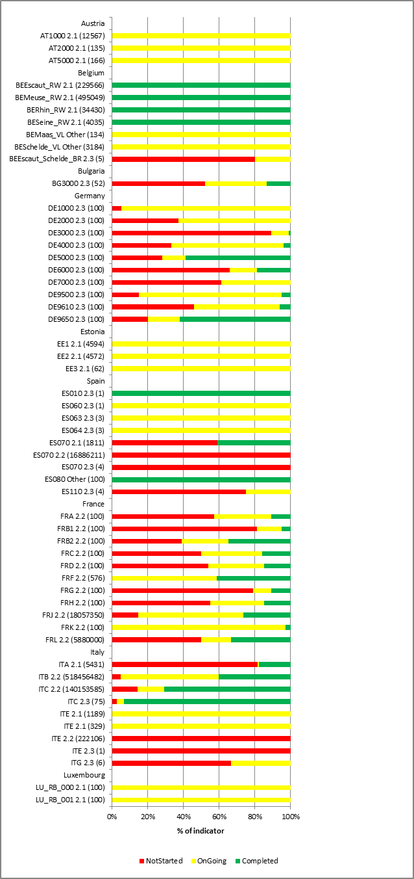 | 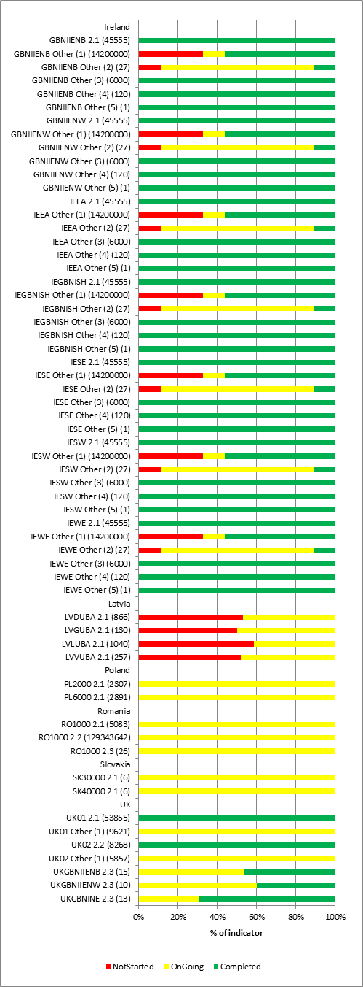

Key to indicators:
The annotations next to each bar in the Figure shows “RBDCode: Indicator number: (value of the indicator when 100% completed)":
2.1 Area of agricultural land covered by measures (km²) beyond the requirements of the Nitrates Directive
2.2 Estimated Total Costs (€) of the measures
2.3 Number of projects/measures
BESchelde_VL; BEMaas_VL | Other | Km of streams with buffer strips
ES080 | Other | Percentage of projects
IE | Other (5) | Implementation of GAP regulations - national value
IE | Other (4) | The number of inspections carried out on authorised derogation farms annually - National values
IE | Other (3) | The approximate number of farm inspections carried out every year - national value
IE | Other (2) | Number of Teagasc Projects - national value
IE | Other (1) | Funding provided per annum for the Agricultural Catchments Programme - national values
UK01; UK02 | Other (1) | Area of agricultural land covered by priority catchments
In Germany the indicators of the KTMs for each RBD are presented as percentages at different states of implementation and are considered as comparable between RBDs. The indicators for some of the KTMs in some French RBDs are also presented as percentages of the measures at different states of implementation.

Figure 8 illustrates the indicators reported by Member States for KTM2. The quantitative value for the indicator, equivalent to when the measures are 100% completed is given in brackets after the RBD abbreviation. There is a wide variation in the degree of implementation of the measures between Member States with for example, with the measures associated with indicator 2.1 being 100% completed in the Irish RBDs and in the United Kingdom (Scotland), 100% on-going in Austria and a large proportion not started in some RBDs in Spain and Italy.

KTM12: Advisory services for agriculture
Figure 9: Percentages of indicator/baseline associated with KTM12 that were reported as being not started, on-going and completed at the Member State level in 2012
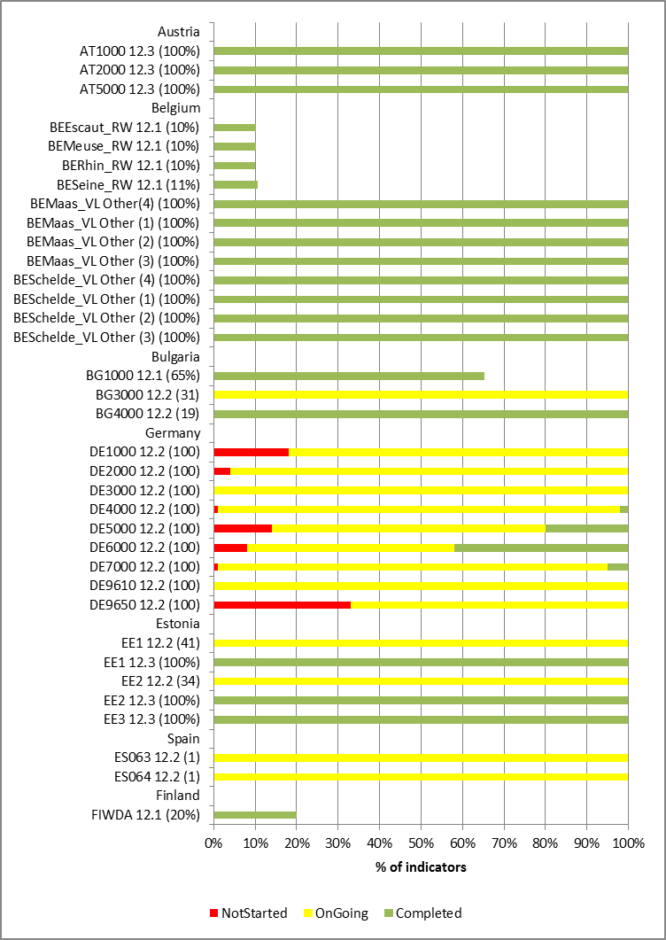 | 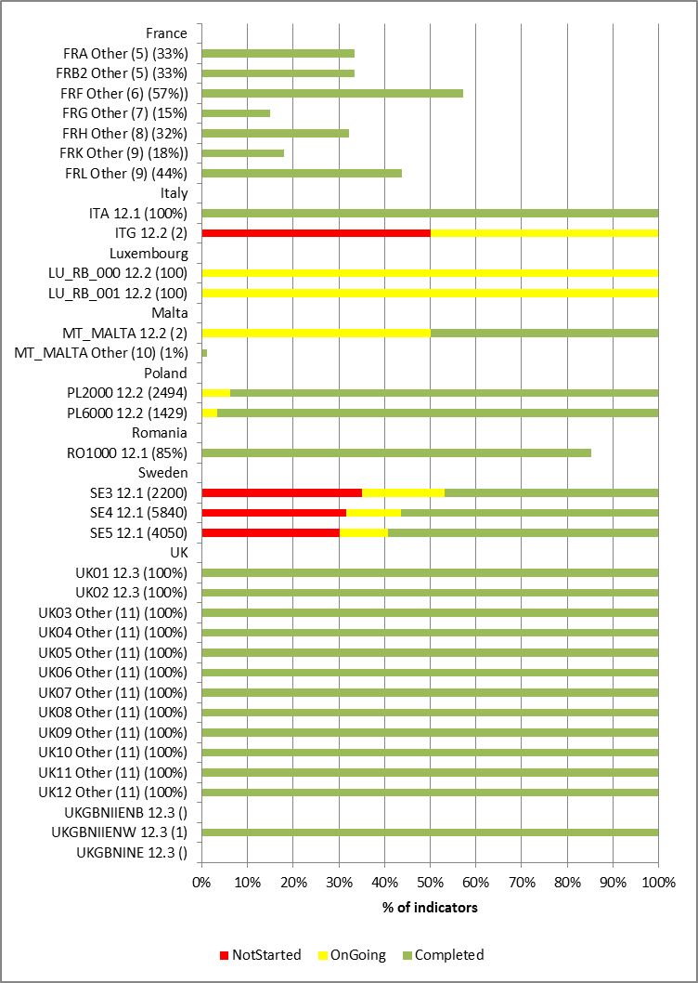

Key to indicators:
The annotations next to each bar in the Figure shows “RBDCode: Indicator number: (value of the indicator when 100% completed).”

12.1 Number of farms
12.2 Number of advisory services
12.3 Area (km²) of agricultural land

BEMaas_VL, BESchelde_VL | Other (1) | number of attendees at educational and training concerning plant protection and spraying
BEMaas_VL, BESchelde_VL | Other (2) | annual number of individual businesses assisted and advised
BEMaas_VL, BESchelde_VL | Other (3) | number of publications regarding good practice and pest spraying
BEMaas_VL, BESchelde_VL | Other(4) | Annual budget for Coordination of Information and Guidance on sustainable Fertilization
FRA, FRB1 | Other (5) | estimated total cost of measures for management training actions for agricultural users of pollutants, awareness, animation.
FRF | Other (6) | Water Agency funded training actions and awareness raising
FRG | Other (7) | estimated cost over 2010-2015
FRH | Other (8) | Cost of advice services
FRK, FRL | Other (9) | cost of actions
MT_MALTA | Other (10) | Farm Advisory Service Consortium established
UK03 to 12 | Other (11) | Total area in each RBD covered by the Catchment Sensitive Farming programme
In Germany the indicators of the KTMs for each RBD are presented as percentages at different states of implementation and are considered as comparable between RBDs. Note that indicators 12.1 and 12.3 were reported in terms of a value in 2012 in relation to the baseline value representing 100% completion of the measure. The bars for these indicators therefore show percentage progress to complete implementation of the measures.
Figure 9 illustrates the indicators reported by Member States for KTM12: 12.1 and 12.3 are presented in terms of % of the quantitative value at the end of 2012 compared to the baseline value indicating completion of the measure. The quantitative value for the indicator equivalent to when the measures are 100% completed is given in brackets after the RBD abbreviation. There is a wide variation in the degree of implementation of the measures between Member States with for example, 12.2 being 95% completed in Poland, 100% on-going in two Spanish RBDs and in Luxembourg, and 50% not started in one Italian RBD.

Progress with implementation of measures to reduce pressures from chemicals

Context
Chemicals arise from a number of activities leading to significant pressures and impacts on water bodies in the EU:
The assessment of the first RBMPs showed that:
- Agriculture was a significant source in terms of:
  - Diffuse source pesticide pollution in all 25 Member States (excluding Lithuania, Luxembourg and Poland), and in 65% (91) of RBDs;
  - Point source pesticide pollution in 9 Member States, and 16% (22) of RBDs;
- The industrial/urban sectors contributing significantly to chemical pollution were:
  - Industrial emissions in 28 Member States, and in 87% (129) of RBDs;
  - Households in 25 Member States, and in 80% (119 RBDs);
  - Waste deposits in 16 Member States, and in 41% (61 RBDs);
  - Atmospheric deposition in 11 Member States, and 29% (43 RBDs).
In addition 15 Member States reported surface water bodies that were subject to point source pressures from facilities under the IPPC Directive and also point source pressures from non-IPPC plants. 7 other Member States reported significant point source pressures but not separated according to sector of origin. 3 Member States did not report on pressures at the water body level. Diffuse source pressures from abandoned industrial sites were reported by 8 Member States. 20 of the 21 Member States that reported impacts on surface water bodies indicated that contamination by priority substances. Other sources that may be of relevance in terms of the chemical pollution of groundwater could include point source pressures from UWWT works (see chapter for more detail on measures relating to UWWT), point source pollution from contaminated sites (13 MS), waste disposal sites (8 MS) and mine waters (7 MS).
Good chemical status was not achieved in surface water bodies in 22 Member States and in 21 Member States non-compliance with EQSs associated with river basin specific pollutants resulted in less than good ecological status in surface water bodies. In 13 of the 22 Member States, 10 or more priority substances were causing failure of chemical status.
8 and 2 Member States indicated that Article 11.3.a basic measures were enough to tackle significant point source pressures from IPPC and non-IPPC plants, respectively, and 4 and 6 Member States said that Article 11.3.b to l basic measures were not enough for point source pressures from IPPC and non-IPPC plants, respectively. 4 Member States reported that Article 11.3.b to l basic measures were not enough to tackle diffuse source pressures from abandoned industrial sites.

Quantification of the scale of chemical pressures
In most of the Member States the scale of the pressure arising from chemicals has been expressed in terms of number of water bodies failing EU Environmental Quality Standards (EQS) for priority substances or national EQSs for River Basin Specific Pollutants.
None of the Member States seem to have quantified the scale of the pressure in terms of the loads of the substances in the affected water bodies that must be reduced by measures to achieve WFD objectives. This is considered as a serious gap as the appropriately targeted and cost-effective measures should be designed based on a precise knowledge of the extent of pollution of waters. Insufficient information on the emissions, discharges and losses is accompanied with incomplete information on chemical status and on the occurrence of the RBSPs. This gap in status assessment disables proper linking of measures to the status which may lead to an ineffective design of measures.
The loads from sources of Priority Substances or River Basin Specific Pollutants have only been collected in the Netherlands and Slovakia. The number of point source discharges containing chemicals that are affecting the achievement of objectives was considered only in Finland, Hungary and Slovakia and the number of contaminated sites was referred to by Estonia.

Assessment of measures for the achievement of WFD objectives

Basic and supplementary measures
No Member State seems to have undertaken a quantitative assessment of the gap that will be filled by the basic measures required by Article 11.3.a (measures required by the IPPC Directive). In eight Member States Article 11.3.a basic measures are expected to help achieving improvements but there is no clear view on how much of the gap will be filled, and there is no assessment or judgement as to how much the measures will contribute to the achievement of WFD objectives in 13 other Member States.
Similarly for no Member State was any information found indicating that there had been a quantitative assessment of the gap that will be filled by the basic measures required by Article 11.3.g, or Article 11.3.k or by supplementary measures relevant to chemical pollution.

Measures required by the EQS Directive
Directive 2008/105/EC (the EQS Directive) established EU Environmental Quality Standards (EQS) for Priority Substance and eight other pollutants that were regulated by the Dangerous Substances Directive (76/464/EEC). Article 5 of the EQSD requires Member States to establish an inventory of emissions, discharges and losses of all priority substances and the eight other pollutants. The EQSD also allows the designation of mixing zones (Article 4) where regulated effluent discharges containing these substances can exceed EQSs without being in non-compliance with WFD objectives providing certain conditions are met.
16 out of the 28 Member States assessed had inventories of priority substances and/or river basin specific pollutants for at least one of their RBDs. Inventories were being developed in a further two Member States. Seven Member States use, or have the option of using mixing zones, in their regulation and control of chemicals and one other Member State is considering their future use. Few Member States reported specific measures for the progressive reduction of pollution from priority substances and for only one (United Kingdom) were specific measures reported for ceasing or phasing out emissions, discharges and losses of priority hazardous substances.
In the United Kingdom (England and Wales), pollution reduction plans have been or are being developed for all priority and priority hazardous substances. These may include for industrial discharges use of alternative chemicals, restriction of chemicals at source, better pollution prevention measures or improved end-of-pipe treatment. The focus of the first plan seems to have been on EU initiatives to restrict chemicals at source: this is expected to be sufficient to achieve WFD objectives where there are few EQS failures.

Key Types of Measure
The most-relevant Key Types of Measures (KTM) associated with reducing the pressures and impacts arising from chemicals are:
- KTM 3. Reduce pesticides pollution in agriculture;
- KTM12: Advisory services for agriculture (Note: no differentiation is made between to which agriculture pressure the advisory services apply);
- KTM 15: Measures for the phasing-out of emissions, discharges and losses of priority hazardous substances or for the reduction of emissions, discharges and losses of priority substances;
- KTM 16: Upgrades or improvements of industrial wastewater treatment plants (including farms) beyond the requirements of the Integrated Pollution Prevention and Control (IPPC) Directive.
Note that chemicals are released from urban waste water treatment works, diffuse run-off from urban areas (e.g. storm overflows) and diffuse sources of urban waste water not connected to sewers. These potential sources are not included in this assessment of chemical measures.
Quantitative indicators for the scale and progress with the implementation of measures were proposed for each of the defined Key Types of Measure. Member States could also report their own indicators if the proposed ones were not appropriate for their specific national situations. The following figures present progress in terms of the pre-defined indicators.

KTM3. Reduce pesticides pollution in agriculture
Figure 10: Percentages of indicator/measures associated with KTM3 that were reported as being not started, planning on-going, construction on-going and completed at the Member State level in 2012
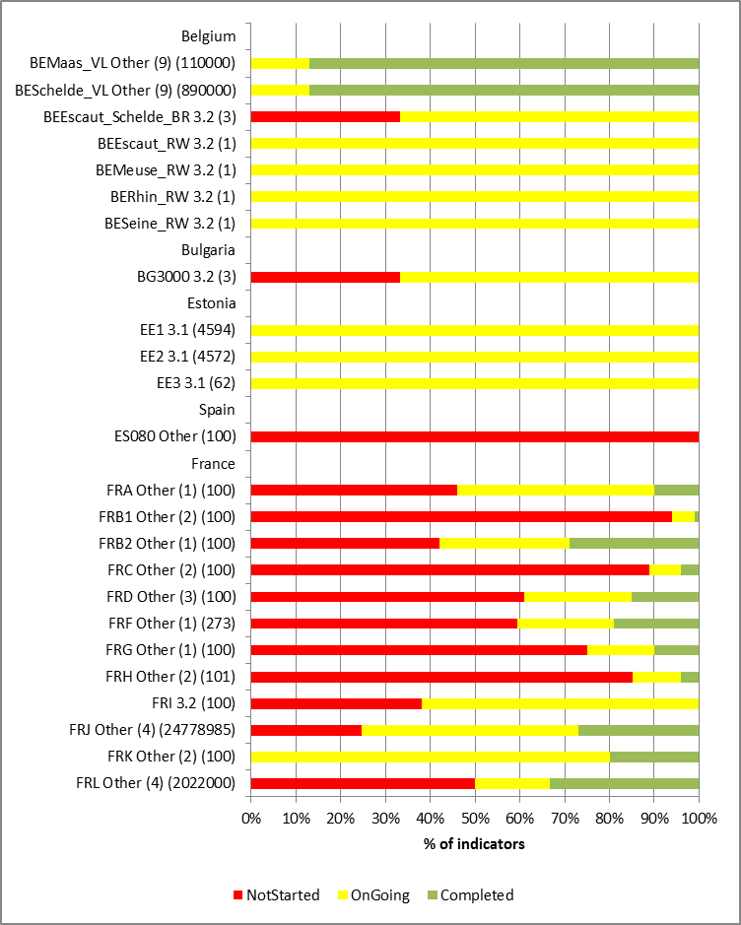 | 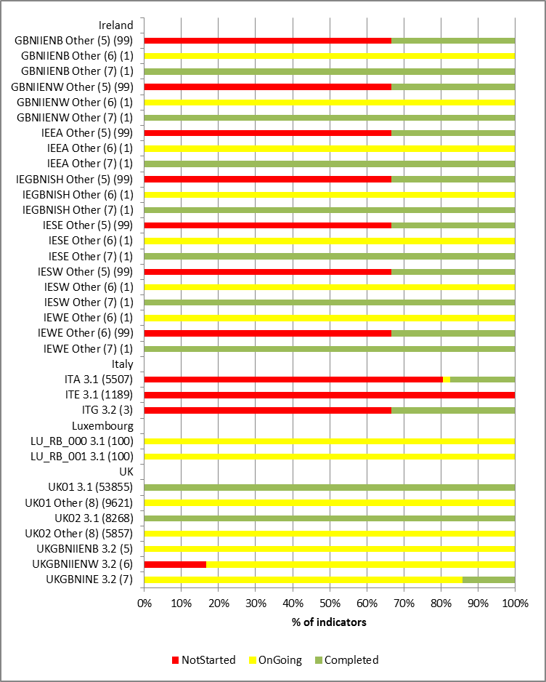

Key to indicators:
The annotations next to each bar in the Figure shows “RBDCode; Indicator number; (value of the indicator when 100% completed)":
3.1 Area of agricultural land covered by measures (km2) to reduce pollution in agriculture
3.2 Number of projects/measures
BESchelde_VL, BEMaas_VL | Other (9) | number of sprayed hectares with new machinery
ES080 | Other | percentage of projects
FRA, FRB1, FRF, FRG | Other (1) | aid paid or contracted out under the rural development program for actions to reduce pollution from pesticides
FRB1, FRC, FRH, FRK | Other (2) | % of cost of measure
FRD | Other (3) | project cost for reduction of pollution caused by nitrates under CAP
FRJ, FRL | Other (4) | estimated cost of measure
All IE RBDs | Other (5) | % of pesticides usage surveys
All IE RBDs | Other (6) | Completion of national action plan
All IE RBDs | Other (7) | Transposition of Pesticide Use Directive
UK01, UK02 | Other (8) | Area of agricultural land in priority catchments

Figure 10 illustrates the indicators reported by Member States for KTM3. Relative few Member States (7) reported this KTM with the predefined indicators. For 5 of these Member States all the measures were either not started or on-going, indicating that a lot of progress would probably be required between 2012 and 2015 if the measures were to be completed within the duration of the first RBMP cycle.

KTM15: Measures for the phasing-out of emissions, discharges and losses of priority hazardous substances or for the reduction of emissions, discharges and losses of priority substances
Figure 11: Percentages of indicator/measures associated with KTM15 that were reported as being not started, planning on-going, construction on-going and completed at the Member State level in 2012
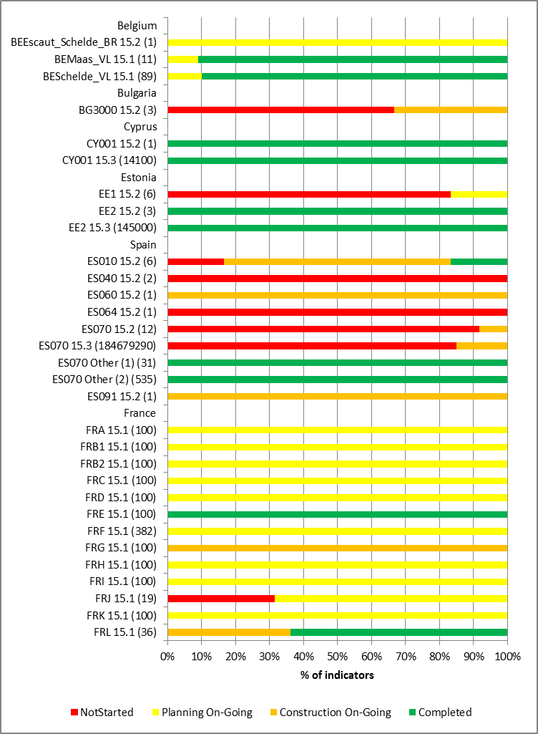 | 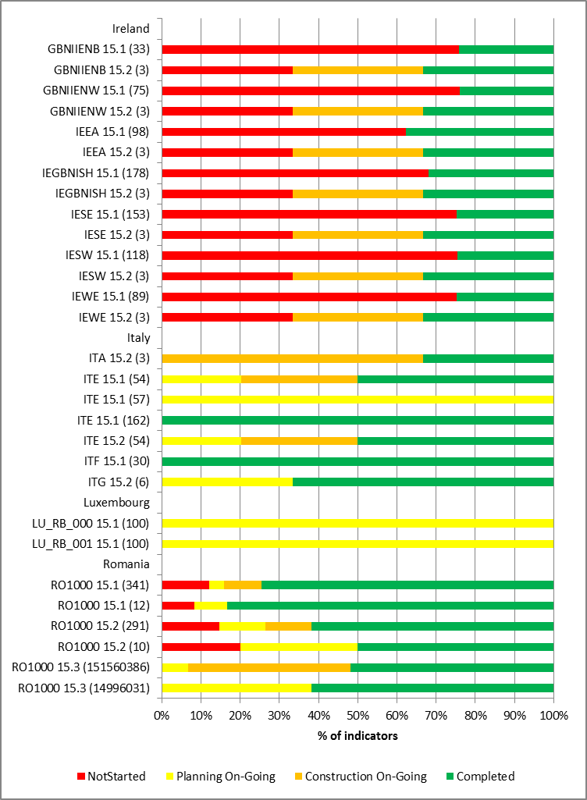

Key to indicators
The annotations next to each bar in the Figure shows “RBDCode: Indicator number: (value of the indicator when 100% completed)":
15.1 Number of permits issued or updated;
15.2 Number of projects/measures;
15.3 Estimated Total Costs (€)
ES070 | Other (1) | number of authorized discharges
ES070 | Other (2) | number of discharges inventoried

Figure 11 illustrates the indicators of progress of measures associated with for KTM15 reported by 10 Member States. In one Member State all measures were reported to be completed whereas in 8 Member States, over 50% of measures and in 4 Member States over 80% of measures were either not-started or on-going.

KTM16: Upgrades or improvements of industrial wastewater treatment plants (including farms) beyond the requirements of the Integrated Pollution Prevention and Control (IPPC) Directive
Figure 12: Percentages of indicator/measures associated with KTM16 that were reported as being not started, planning on-going, construction on-going and completed at the Member State level in 2012
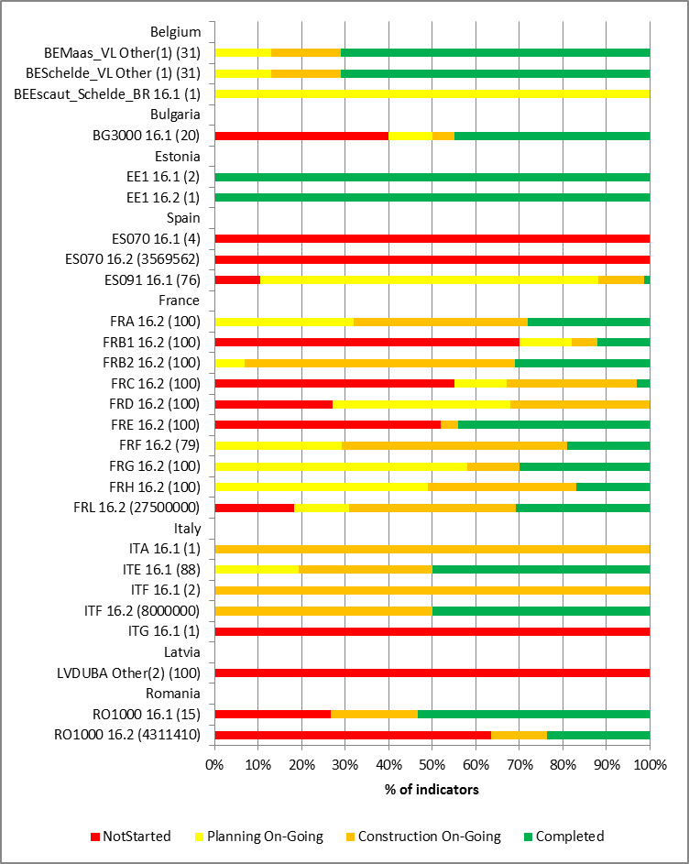
Key to indicators
The annotations next to each bar in the Figure shows “RBDCode: Indicator number: (value of the indicator when 100% completed)":
16.1 Number of projects/measures
16.2 Estimated Total Costs (€)
BEMaas_VL, BESchelde_VL | Other(1) | Number of Flemish BAT studies for non-IPPC companies
LVDUBA | Other (2) | Measure performance per cent

Only 8 Member States reported this KTM, and only 6 of these used the pre-defined indicators (Figure 12). In only one Member State were all the measures reported as completed, and in the remainder around half of the measures were only not-started or on-going.

Progress with implementation of measures to reduce pressures from hydromorphological alterations

Context
The WFD is the first piece of European environmental legislation which addresses hydromorphological modifications and their impacts on water bodies. The Directive explicitly requires Member States to manage the effects on the ecological quality of water which result from changes to physical characteristics of water bodies. It requires action in those cases where the hydromorphological pressures are having an impact on the ecological status, interfering with the ability to achieve the WFD objectives.
The assessment of the first RBMPs (in terms of the sectors/activities responsible for the pressures) showed that the types of hydromorphological alterations that were most frequently reported to be causing significant pressures on surface water bodies were:
- Cross profile construction and interruption of continuity (e.g. dams, weirs, locks, impoundments, reservoirs) in 17 Member States in 57 of the 60 RBDs within those Member States where an apportionment of pressures between sectors/activities had been described;
- Bank reinforcement, bank fixation, embankments (training wall, breakwater, groynes etc.) in 13 Member States (in 40 of the 60 RBDs within those Member States);
- Channelisation/ straightening in 11 Member States (in 34 of the 60RBDs within those Member States); and
- Longitudinal profile construction and interruption of lateral continuity (e.g. dykes) in 11 Member States (in 32 of the 60 RBDs within those Member States).
In the remaining 11 Member States and 88 RBDs no relevant information on the sources of hydromorphological pressures had been found/presented in the RBMPs.
The sectors most frequently identified in the RBMPs as being responsible for the pressures arising from cross profile construction and interruption of continuity were:
- Hydropower in 49 RBDs in 16 Member States;
- Water Supply (including irrigation) in 34 RBDs in 12 Member States Member States; and,
- Flood protection in 29 RBDs and 11 Member States.
The sector most frequently identified (19 RBDs in 10 Member States) as being responsible for pressures arising from bank reinforcement was flood protection.
Member States electronic reports to WISE distinguish between four types of significant pressures that may lead to the hydromorphological alterations of surface water bodies. These are:
- Water flow regulations and morphological alterations of surface water (reported to be significant in 22 of the 23 Member States who reported this information to WISE). 23 Member States also reported that Article 11.3.i basic measures were not enough to reduce these pressures to level compatible with the achievement of WFD objectives;
- River management pressures reported to be significant in 19 Member States. 19 Member States also indicated that basic measures were not enough to achieve WFD objectives; for 17 Member States this was Article 11.3.ij basic measures;
- Transitional and coastal water management pressures reported to be significant in 12 Member States. 11 Member States also indicated that basic measures were not enough to achieve WFD objectives; for 9 Member States this was Article 11.3.i basic measures; and
- Other morphological alterations pressures reported to be significant in 15 Member States. 13 Member States also indicated that basic measures were not enough to achieve WFD objectives in terms of this pressure. All 13 Member States indicated that Article 11.3.i basic measures were not enough;
- 19 of the 21 Member States reporting to WISE on the impacts of pressures on surface water bodies indicated that habitat alteration were significant.
In addition pressures arising from water abstraction can also lead to impacts on the hydrological regime of affected water bodies. Water abstraction pressures are presented in section 14 of this report.
In implementing the WFD, the establishment of Good Ecological Status and Good Ecological Potential (for Heavily Modified Water Bodies/Artificial Water Bodies) is followed by the planning of measures to achieve the relevant environmental objective. The focus of this section is on measures relevant to addressing the adverse effects of hydromorphological alterations typically associated with uses such as: flood protection, hydropower, agriculture, navigation, drinking water; and others.
In most RBDs (96% of RBDs), hydromorphological measures were proposed in the PoMs of the 1st planning cycle, although it is generally not clear how the proposed measures were expected to contribute to the improvement of ecological status or potential.

Quantification of the scale of pressures from hydromorphological alterations
The scale of hydromorphological pressures has been quantified to a certain extent in the majority of Member States assessed (17 out of 22). In a few cases, quantification is reported with regard to all significant pressures but in most cases, the approach is partial, i.e. quantification was undertaken only for some but not all significant pressures or quantified pressure information is provided only in relation to the designation of HMWB. Examples of the way the scale of hydromorphological pressures was quantified include the following:
- Number of cross-sectional obstacles (dams, weirs, barriers, locks) (e.g. HU, SK, AT). In some cases, it is indicated how many barriers are not compatible with the achievement of good status/potential.
- Length of water bodies affected by dams (e.g. EE).
- Number of river regulation engineering structures (narrow flood plain, deepened bed, regulated bed shape, embankment protection) (e.g. HU).
- Number of km of straightened rivers (e.g. LT).
- Number of hydropower plants which exert a significant impact on the downstream river stretches, making thus the planning of measures necessary (e.g. LT).
In certain Member States, quantified figures only referred to the number of water bodies affected by significant hydromorphological pressures (e.g. changes in water level, disrupted continuity, other morphological changes, or simply the standard pressure categories) preventing the achievement of good status/potential.
Despite the (partial) availability of quantified information on the scale of hydromorphological pressures, the reductions required to achieve WFD objectives per se were estimated explicitly only in a few cases.
In addition, the linkage between types of hydromorphological pressures, specific water uses, and specific hydromorphological measures has been made explicit in 39% of RBD, but in 41% of RBDs, no such clear links were reported. For example, an RBMP may indicate the number of fish passes proposed to restore river continuity at specific barriers, but the uses or sectors which these barriers serve are not stated (e.g. navigation, hydropower etc.).
In the majority of RBDs (66%), there is no description or no information found on the effects of planned hydromorphological measures and on whether they will improve the ecological status/potential. The expected improvements due to hydromorphological measures are described only for 34% of RBDs. The information provided in this respect is quite heterogeneous and overall, it remains general. In the majority of RBMPs, the measures are not reported for specific water bodies, thus there is no information on the expected effects of measures at water body level. The in-depth assessment of the PoM verified that, in most cases, there is no quantification of the effects of the hydromorphological measures required to achieve WFD objectives. Occasionally, qualitative statements are given, e.g. for the Netherlands, the RBMPs/PoMs mention that the proposed measures on hydromorphology will contribute largely in achieving the ecological targets. Similarly, for Poland, qualitative statements indicate expectations that measures will improve hydromorphology e.g. biological continuity and increase in the diversity of fish and other aquatic organisms by creating fish passages or partial or complete removal of barriers.
In the 1st cycle, it has often been argued that the biological assessment methods were not (or not sufficiently) sensitive to hydromorphological pressures. This had an effect on the adequateness of the assessment of hydromorphological impacts, the selection of appropriate measures and predictions of specific expected effects on good ecological status or potential.
Indeed, there is pressing need for systematic monitoring of the effects of hydromorphological measures, e.g. of fish passes, ecological flows etc., on biological elements to check their effectiveness.
Austria assessed/proved in pilot projects that migration barriers significantly reduce or even prohibit the positive effects of other hydromorphological restoration measures. Ensuring river continuity in rivers with migratory fish was perceived to be a prerequisite for good ecological status or potential and thus declared to be state of the art and technology in the National Water Act for any construction in the river. As a consequence obstacles already in place as well as new constructions will have to be equipped with fish migration aids unless disproportionate costs or technically infeasibility can be demonstrated to competent authorities. Applying ecological sensitive biological methods Austria has defined also specific flow values, which ensure the achievement of good ecological status.
According to estimations made in the context of the comparative study on pressures and measures in major RBMPs, on average in the EU there will only be an 8%-12% reduction in the number of surface water bodies affected by the key types of significant hydromorphological pressures between 2009 and 2015 assuming that the reported PoMs are successfully implemented.
To deal with uncertainty related to gaps in the classification processes related to morphology in the 1st cycle, some Member States have used a prioritisation approach. In the case of Scotland, it was reported that in the 1st cycle there was limited experience and expertise on which to base the design and delivery of habitat restoration projects of the scale necessary to achieve good status / potential in all surface water bodies. Therefore the number of projects initially tackled was limited focusing on the experience and expertise available at the time. The priority for measures was on catchments where the measures would contribute to the achievement of other objectives (e.g. biodiversity conservation; diffuse pollution reduction; flood management). In terms of some barriers affecting the continuity of rivers for fish migration it was not certain the extent to which the structures are real barriers to fish migration. There were too few suitable experts available to oversee the necessary studies and come up with effective design solutions to address all the barriers to fish migration by 2015. Consequently, work was prioritised so that the most downstream dams were tackled first and, where relevant, work to improve river continuity for fish migration was timetabled in line with the scheduling of improvements to the quality of the fish habitat upstream. It was planned that fish passages would be provided for 82 smaller dams and other barriers by 2015 as this was thought to be the most that could be achieved without incurring disproportionate expense through installing unnecessary, ineffective or premature solutions.

Assessment of measures for the achievement of WFD objectives
In most Member States, the RBMPs and PoMs did not include any information on the way that Article 11.3.a basic measures would contribute to the achievement of good status / potential through the reduction of hydromorphological pressures. The pertinent Article 11.3.a measures were those associated with the Environmental Impact Assessment Directive (85/337/EEC), the Habitats Directive (92/43/EEC) and the Birds Directive (79/409/EEC). A quantitative assessment of the gap to be filled to achieve WFD objectives by basic measures under Article 11.3.a targeted to hydromorphological pressures could not be found in any Member States.
The other most relevant basic measure to the reduction of hydromorphological pressures are measures formulated under Article 11.3.i. on “other significant adverse impacts”, in particular measures to ensure that the hydromorphological conditions of the bodies of water should be consistent with the achievement of the required ecological status or good ecological potential. For example, controls should be defined to ensure that actions in or near rivers do not negatively impact on morphological conditions. These may include controls to protect the river bed and bank structure to ensure good status can be achieved and/or controls (authorisations/permits/general binding rules) in place for land drainage.
In the majority of RBDs (ca. 65%), basic measures under Article 11.3.i to control significant hydromorphological adverse impacts on the status of water were still on-going, concerning their status of implementation in 2012. At the same time, in 19% of RBDs substantial delays in the implementation of these measures were reported.
In the majority of Member States, the PoM make explicit use of hydromorphological measures under Article 11.3.i, but they have not included any concrete information on the way that these measures would contribute to the achievement of good status / potential through the reduction of hydromorphological pressures. A quantitative assessment of the gap to be filled to the achievement of WFD objectives by other basic measures under Article 11.3.i targeted to hydromorphological impacts could not be found in any Member State.
Considering the fact that in a relatively large share of RBDs, other basic measures (under Article 11.3.i) were not enough to tackle significant pressures from water flow regulation and morphological alterations (76% of RBDs), and from river management (54% of RBDs), supplementary measures related to hydromorphological improvements were proposed in most PoM. There were few exceptions e.g. Cyprus considered the measures included under Article 11.3.i sufficient to tackle significant hydromorphological pressures and consequently no corresponding supplementary measures were included in the PoM.
The implementation of the majority of supplementary measures addressing flow morphology and dams, weirs and other morphological barriers is ongoing as of 2012.
Similar to basic measures (Articles 11.3.a and 11.3.i), the PoM do not include any concrete assessment or information on the way that supplementary hydromorphological measures would contribute to the achievement of WFD objectives. In some cases, details are provided on the reasons why extended deadlines for achievement objectives until 2012 or 2027 (exemptions) have been necessary due to issues related to hydromorphological assessments. Lithuania reports that one of the reasons for extended deadlines is that some hydromorphological measures (e.g. for water bodies affected by hydropower plants or the naturalisation of river beds) require pilot activities and further investigations.
The number and extent of supplementary measures taken varies widely across the Member States. In some Member States (e.g. UK, LT), many supplementary measures are associated with the reduction of hydromorphological pressures, while in other Member States (e.g. PL and SK), only a few supplementary hydromorphological measures are reported.
Considering the type of hydromorphological measures included under Article 11.4, these usually entail technical measures, e.g. renaturalisation of river beds, upgrading HPP turbines, fish passes, habitat restoration, floodplain restoration, along with actions for ecological flows. In addition, supplementary hydromorphological measures are often investigations and measures targeted at further data collection, e.g. actions on the morphological characterisation of rivers (e.g. IT), continuation of testing of candidate HMWB (e.g. SK).
In fact, in certain Member States (e.g. LV, SE), measures directly related to improvements in hydro-morphological conditions were relatively few. Most of the supplementary hydromorphological measures were related to the examination of the existing situation and development of further action plans, because knowledge on the possible effects of hydromorphological measures was insufficient in the 1st cycle. Supplementary measures of such investigative nature are not expected to contribute to the achievement of WFD objectives short-term, but provide the necessary decision basis for coming planning cycles.

Key Types of Measure
The most relevant Key Types of Measures (KTM) associated with reducing the pressures and impacts from the hydromorphological alteration of water bodies are:
- KTM5. Improving longitudinal continuity (e.g. establishing fish passes, demolishing old dams);
- KTM6: Improving hydromorphological conditions of water bodies other than longitudinal continuity;
- KTM7: Improvements in flow regime and/or establishment of minimum ecological flow.
Information on KTM7 is provided in chapter 11 on measures to reduce pressures from water abstractions.
Quantitative indicators for the scale and progress with the implementation of measures were proposed for each of the defined Key Types of Measure. Member States could also report their own indicators if the proposed ones were not appropriate for their specific national situations. The following figures present progress in terms of the pre-defined indicators.

KTM5. Improving longitudinal continuity (e.g. establishing fish passes, demolishing old dams)
Figure 13: Percentages of indicator/measures associated with KTM5 that were reported as being not started, planning on-going, construction on-going and completed at the Member State level in 2012
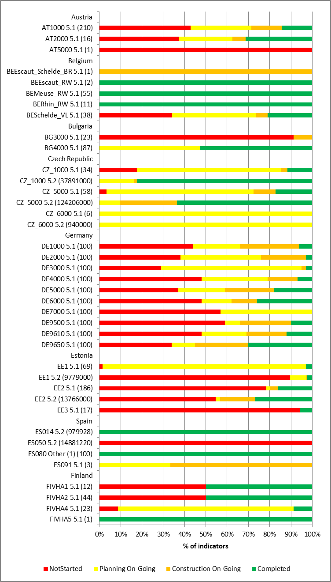 | 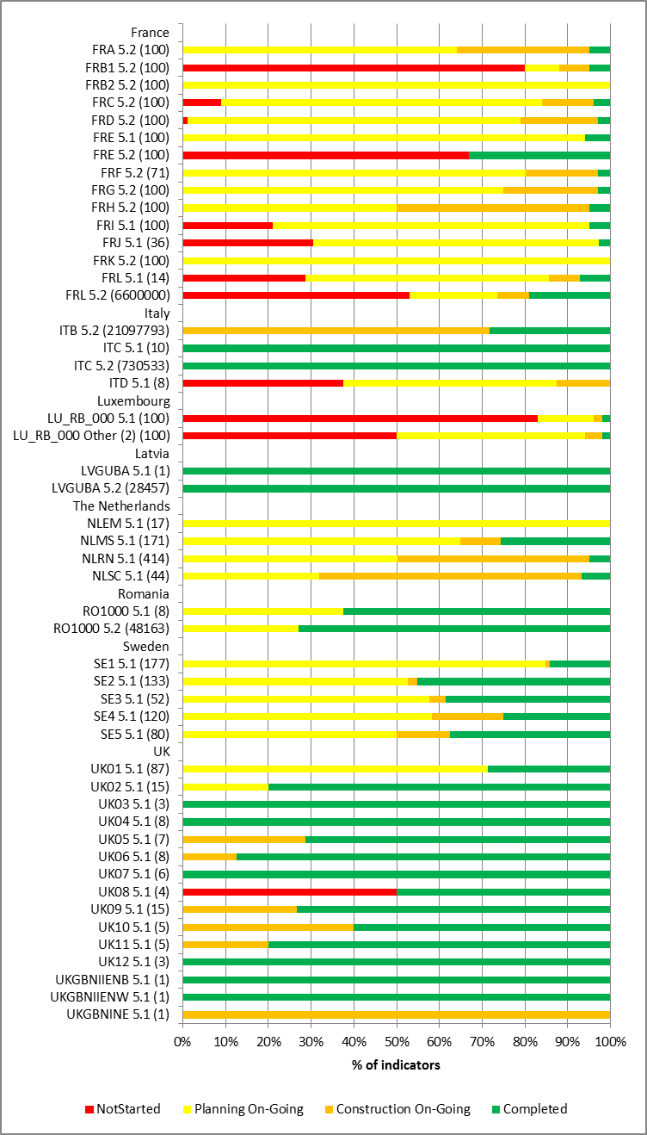

Key to indicators
The annotations next to each bar in the Figure shows “RBDCode; Indicator number; (value of the indicator when 100% completed)":
5.1 Number of projects/measures to improve longitudinal continuity
5.2 Estimated Total Costs ( €) of the measures
ES080 | Other (1) | % of projects
LU_RB_000 | Other (2) | % of number of selected priority dams

In Germany the indicators of the KTMs for each RBD are presented as percentages at different states of implementation and are considered as comparable between RBDs. The indicators for some French RBDs are also presented as percentages of the measures at different states of implementation.

Figure 13 illustrates the indicators reported by 16 Member States for KTM5. There is a wide variation in the degree of implementation of the measures between Member States. Overall in a quarter of the 16 Member States over 40 % of the measures to improve longitudinal continuity were not started, and in half of the Member States, 80% were either not-started or on-going. This indicates that a much increased effort would be required over the next period of the plan to reach full completion by 2015.

KTM6: Improving hydromorphological conditions of water bodies other than longitudinal continuity
Figure 13: Percentages of indicator/measures associated with KTM6 that were reported as being not started, planning on-going, construction on-going and completed at the Member State level in 2012
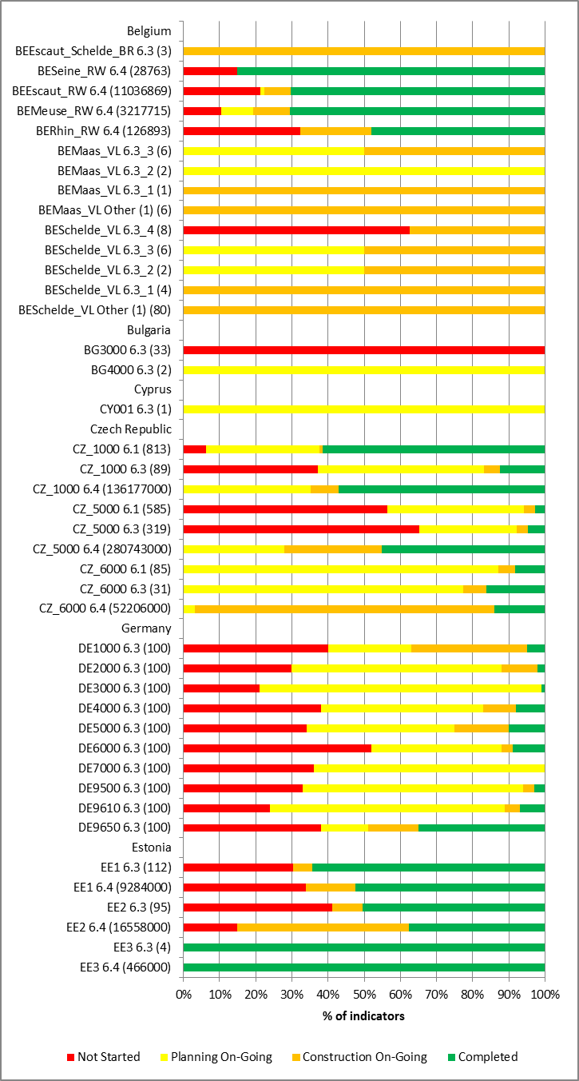 | 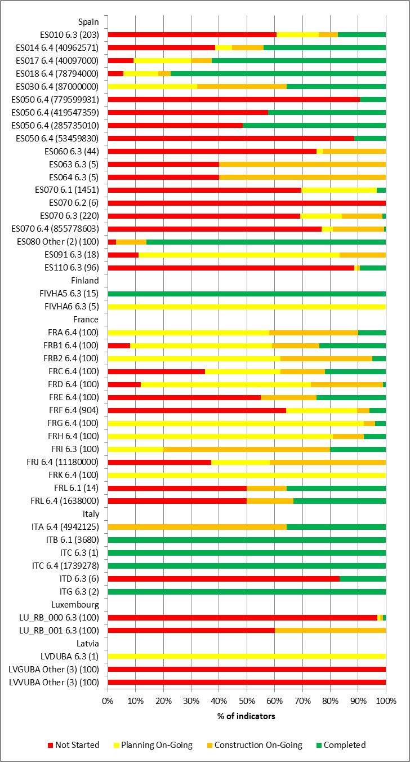

Key to indicators
The annotations next to each bar in the Figure shows “RBDCode; Indicator number; (value of the indicator when 100% completed)":
6.1 Length of rivers (km) affected by measures
6.2 Area of RBD (km²) affected by measures
6.3 Number of projects/measures
6.4 Estimated Total Costs (€) of the measures
BEMaas_VL, BESchelde_VL | 6.3_1 | Number of projects with structural restoration
BEMaas_VL, BESchelde_VL | 6.3_2 | Actions related to hydromorphological recovery within Natura 2000 site
BEMaas_VL, BESchelde_VL | 6.3_3 | Number of protection or recovery programmes
BESchelde_VL | 6.3_4 | Number of projects, analysis of hydromorphological development opportunities within SPAs
BEMaas_VL, BESchelde_VL | Other (1) | km of navigable waterways on which a shoreline management plan is applicable
ES080 | Other (2) | % of projects
LVGUBA, LVVUBA | Other (3) | % actions in progress
UK01, UK02 | Other (4) | Area (km2) of agricultural land covered by requirements for buffer strips
UK03 to UK12 | Other (5) | Other - Measures to ensure Natura 2000 protected areas achieve their objectives
In Germany the indicators of the KTMs for each RBD are presented as percentages at different states of implementation and are considered as comparable between RBDs. The indicators for some French RBDs are also presented as percentages of the measures at different states of implementation.

Figure 13 illustrates the indicators reported by 16 Member States for KTM6. As in other KTMs there was a wide variation of the measures between Member States. Two of the measures are 100% completed in the United Kingdom but one measure had not been started in 1 RBD in Spain. Overall in terms of numbers of measures planned, in 10 of the 14 Member States reporting the number of projects/measures (indicator 6.3) at least 80% of measures were either not-started or planned, again indicating that there appears to be a significant proportion of planned measures that need completing before 2015.

Progress with implementation of measures to reduce pressures from urban waste water treatment

Context
Discharges from urban waste water treatment works are most often associated with loads of nutrients (nitrogen and phosphorus), organic matter, sediment, toxic substances such as ammonia and some priority substances and river basin specific pollutants: the actual loads of each contaminants in treated effluent depends on the level of treatment in the works and the proportion and nature of domestic and industrial facilities discharging into the sewage collection systems.
In the context of pressures arising from urban waste water treatment:
- 16 out of the 23 Member States that reported on pressures at the surface water body level indicated that point source pressures from UWWT works were significant;
- 5 other Member States just reported at the aggregated level (without identification of contributory specific sectors) that point sources were significant;
- 9 Member States reported that pressures from storm overflows were significant; and,
- Releases from facilities not connected to sewerage network were significant in 13 Member States.
All 21 and 18 of the 21 Member States that reported indicated that nutrient enrichment and organic enrichment, respectively, were significant impacts on surface water bodies. Urban waste water treatment is a significant (but not necessarily the sole) source of pollutants that can cause these two impacts.
23 Member States indicated that Article 11.3.a basic measures were not enough to reduce pressures from point source to levels compatible with the achievement of WFD objectives.

Quantification of the scale of the pressures
All Member States for which an assessment was conducted have identified that UWWT plants are a significant pressure. The majority of Member States do not know by how much the loads of pollutants discharged from UWWT plants need to be reduced to achieve the objectives of the WFD.
Four Member States have carried out some form of quantitative analysis for all pollutants: Germany has carried detailed pressure assessment for UWWT plants >2000 pe, and the United Kingdom has used a modelling approach to determine the load reduction required to achieve the required standards in receiving waters when reviewing permits for UWWT plants. Similarly, Lithuania used a modelling approach to identify which water bodies would fail to achieve the WFD objectives after the implementation of the basic measures, and proposed supplementary measures where required. Italy has included an assessment of the load reduction required to achieve WFD objectives in the RBMPs.
Three Member States have calculated the load reductions required for some pollutants, but not all. Austria has calculated the load reductions required for chemical pollution (priority substances and river basin specific pollutants) but has not quantified the load reduction required for nutrients, whilst Sweden and Latvia have carried out a detailed source apportionment for nutrients only. In addition, Portugal has made an assessment of the load reduction required to achieve WFD objectives on a water body basis, where the data exists. However, the data does not exist for many water bodies. Estonia has calculated the reduction in load required to achieve the WFD objectives in coastal and marine waters, but has not done this assessment for surface waters.
Finland has quantified the sources of nitrogen and phosphorus to each water body but has not calculated the total loads of nitrogen and phosphorus in each water body.
Romania has identified the load reduction that will be achieved from the measures applied to UWWT plants, and has separately estimated the number of water bodies that it expects to be in good status by 2015, but no explicit link has been made between the measures and the achievement of good ecological status.
Seven Member States (BE, CZ, FR, HU, LU, NL, SK) have carried out an analysis of the pressure that UWWT plants exert on each water body, but have not specified by how much the load needs to be reduced to achieve the WFD objectives.
Four Member States (CY, ES, IE and MT) have not quantified the scale of the pressures arising from UWWT plants.

Assessment of measures for the achievement of WFD objectives
Implementation and compliance with the UWWT Directive is considered to be important in respect of achieving WFD objectives, but the majority of Member States do not know by how much the loads of pollutants discharged from UWWT plants need to be reduced to achieve the objectives of the WFD in the receiving water bodies. Four exceptions seem to be Belgium (Flanders), Lithuania, Romania and the United Kingdom (England and Wales) where there have been detailed modelling of the effects of point sources (all 4 countries) and diffuse sources (LT and RO only) on the status of water bodies.
Focus instead has been on the load reductions in treated wastewater required by the UWWT Directive.
Nine Member States (EE, ES, FI, LU, LV, PT, RO, SK, UK) have identified that the implementation of the UWWT Directive will help achieve improvements, but there is no clear view on how much of the gap will be filled, or by when. Nine other Member States (CY, CZ, DE, FR, IE, HU, MT, NL, PL) have planned measures but have made no assessment or judgment as to how much the measures will contribute to the achievement of the WFD objectives. For example, Austria and the Netherlands state that they have fully implemented the UWWT Directive and that the minimum reductions in treated effluent for phosphorus and nitrogen have been met, but give no assessment of how that has contributed to the achievement of WFD objectives.
Article 11.3.g and supplementary measures have also been widely applied or planned, but the contribution this will make to achieving WFD objectives have not generally been assessed. In those Member States that have identified that supplementary measures are required, only 1 (LT) has clearly assessed the contribution these will make to closing the gap to compliance.

Key Types of Measure
The most-relevant Key Type of Measure (KTM) associated with reducing the pressures and impacts arising from nutrients and organic pollution from urban wastewater treatment is:
- KTM1. Construction or upgrades of wastewater treatment plants beyond the requirements of the Directive on Urban Waste Water Treatment.
Note that nutrients are also discharged from diffuse run-off from urban areas (e.g. storm overflows) and diffuse sources of urban waste water not connected to sewers. It is not clear whether measures to tackle these potential sources are included in the reporting of KTM1 though some Member States linked supplementary measures tackling these pressures to this KTM.
Quantitative indicators for the scale and progress with the implementation of measures were proposed for each of the defined Key Types of Measure. Member States could also report their own indicators if the proposed ones were not appropriate for their specific national situations. The following figures present progress in terms of the pre-defined indicators.

KTM1. Construction or upgrades of wastewater treatment plants beyond the requirements of the Directive on Urban Waste Water Treatment
Figure 14: Percentages of indicator/measures associated with KTM1 that were reported as being not started, planning on-going, construction on-going and completed at the Member State level in 2012
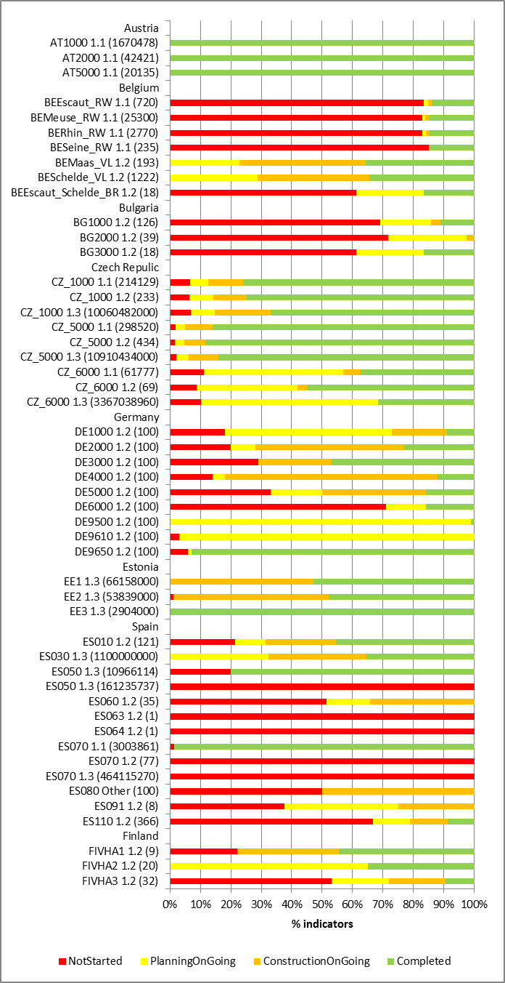

Key to indicators measures
The annotations next to each bar in the Figure shows “RBDCode; Indicator number; (value of the indicator when 100% completed)”
1.1 Number of population equivalent covered by measures beyond the requirements of the UWWTD
1.2 Number of projects/measures
1.3 Estimated Total Costs (€) of the measures
ES080 – Other percentage of projects
SE - Other - The figures indicate the measure of work to achieve wastewater directive's requirements for nitrogen removal.
In Germany the indicators of the KTMs for each RBD are presented as percentages at different states of implementation and are considered as comparable between RBDs. The indicators for some of the KTMs in some French RBDs are also presented as percentages of the measures at different states of implementation.

Figure 14 illustrates the indicators reported by 19 Member States for KTM1. There is a wide variation in the degree of implementation of the measures between Member States with for example, 1.1 being 100% completed in Austria and United Kingdom (Northern Ireland), 80% planning on going in Italy and Luxembourg, and 60% not started in Latvia. Overall in terms of the implementation status of measures (indicator 1.2), for 12 of the 13 Member States reporting this indicator, at least 50% of measures were not started or on-going, and for 3 of these at least 80% were not started or on-going. This seems to indicate that in most of the 13 Member States there is a significant gap to the completion of all measures by 2015.

Progress with implementation of measures to reduce pressures from water abstractions

Context
Pressures from the abstraction of water can arise from a number of sources including:
- Agriculture (9 and 8 Member States, respectively, reported this source was a significant pressure on surface and on ground water bodies);
- Public Drinking Water Supply (9 and 13 Member States, respectively, reported this source was a significant pressure on surface and on ground water bodies);
- Manufacturing (8 and 9 Member States, respectively, reported this source was a significant pressure surface and on ground water bodies);
- Electricity cooling (6 Member States reported this source was a significant pressure);
- Fish farms (8 Member States reported this source was a significant pressure);
- Hydro-energy not cooling (7 Member States reported this source was a significant pressure);
- Quarries (4 Member States reported this source was a significant pressure on both surface and ground water bodies);
- Navigation (2 Member States reported this source was a significant pressure);
- Water transfer (8 Member States reported this source was a significant pressure); and
- In addition, a further 5 Member States only reported water abstraction pressures on surface and groundwater bodies at an aggregated level with no indication of the responsible sectors, making a total of 19 out of the 23 Member States that reported water abstraction pressures at either aggregated or disaggregated level.
Water abstraction pressures can lead to changes in the natural volume and flow regimes of affected water bodies thereby adversely altering aquatic and water dependent habitats. 19 out of 21 Member States that reported information indicated that altered habitats were a significant impact on their surface water bodies: pressures other than those from water abstraction can also cause these impacts as is described in Section 12 of this report. Six out of 22 Member States also reported that altered habitats were a significant impact resulting from pressures on groundwater.
Member States were asked to report whether or not basic measures were enough to meet WFD objectives in terms of water abstraction pressures. 16 Member States (out of 28 Member States that reported on whether basic measures were enough or not) indicated that either or both Article 11.3.e and Article 11.3.c measures were not enough to reduce water abstraction pressures on surface water bodies to levels compatible with the achievement of WFD objectives. In terms of groundwater, 21 out of the 26 Member States that reported this information indicated that either or both Article 11.3.e and Article 11.3.c measures were not enough to reduce water abstraction pressures on groundwater bodies to levels compatible with the achievement of WFD objectives.

Quantification of the scale of the pressure
Only one Member State (of the 23 assessed) has quantified the scale of the abstraction pressures that need to be reduced to achieve WFD objectives. Different studies have been carried out in Spain to identify which ecological flows (in the first planning cycle only focused on minimum flows and hydro-peaking) should be established in order to achieve the WFD environmental objectives (high and good ecological status and good ecological potential) in a large number of WBs and an extrapolation exercise has been developed for other WBs.
In terms of expressing the scale of water abstraction pressures, 9 Member States (AT, EE, FI, HU, IT, NL, PL, RO, UK) report the number of water bodies significantly affected; exploitation indicators have been calculated in 2 Member States (CZ, ES); and the water balances of groundwater bodies in Malta have been calculated. In the United Kingdom (England and Wales) Environmental Flow Indicators have been used to provide the proportion of the flow regime of a water body that can be allowed for abstraction without causing unacceptable impacts on the water environment. They provide an initial base for identifying those impacts of abstraction on surface flows that could limit good ecological status.

Assessment of measures for the achievement of WFD objectives
In terms of Article11.3.a basic measures, those associated with the Environmental Impact Assessment Directive (85/337/EEC) and the Habitats Directive (92/43/EEC) can contribute to reducing the gap. Out of the 23 assessed Member States, one of them (ES) has developed a quantitative assessment of the gap that will be filled by these measures, and by when. 2 Member States (EE, PT) consider that the measures are expected to help achieve improvements but there is no clear view on how much of the gap will be filled and/or by when. In 8 Member States (AT, BE, CY, FI, IE, MT, NL, PL) the measures are planned but there is no assessment or judgement as to how much the measures will contribute to the achievement of WFD objectives. For the remaining 9 Member States (CZ, DE, FR, HU, IT, RO, SE, SK, UK) no information was found. In 3 Member States water abstraction pressures are not relevant.
This result reflects the lack of integration of Nature Protected Areas and their water requirements into the RBMPs, in particular when establishing specific additional objectives and measures, such as analysed in the Background Document to the Workshop on Water, Marine, Nature and Biodiversity (December 2014). Significant steps forward can also be expected when ecological flows are consistently being applied, in strong correlation with the requirements of protected species and habitats.
Basic measures under Articles 11.3.c and 11.3.e (measures to promote an efficient and sustainable water use and controls over the abstraction, respectively) and supplementary measures can contribute to the reduction of the pressures in affected water bodies. As for Article 11.3.a basic measures, the only Member State to quantify the reductions required to achieve WFD objectives was Spain.

Key Types of Measure
The most relevant Key Types of Measures (KTM) associated with reducing the pressures and impacts arising from water abstractions are considered here to be:
- KTM 7: Improvements in flow regime and/or establishment of minimum ecological flow;
- KTM 8: Water efficiency measures for irrigation (technical measures);
Quantitative indicators for the scale and progress with the implementation of measures were proposed for each of the defined Key Types of Measure. Member States could also report their own indicators if the proposed ones were not appropriate for their specific national situations. The following figures present progress in terms of the pre-defined indicators.

KTM7: Improvements in flow regime and/or establishment of minimum ecological flow
Figure 15: Percentages of indicator/measures associated with KTM7 that were reported as being not started, planning on-going, construction on-going and completed at the Member State level in 2012
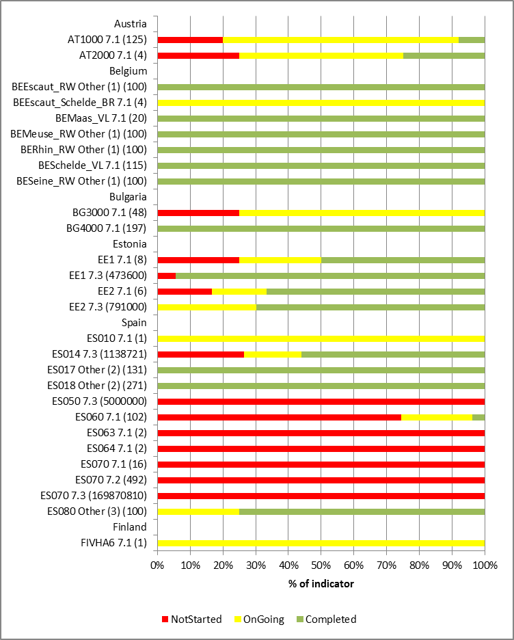 | 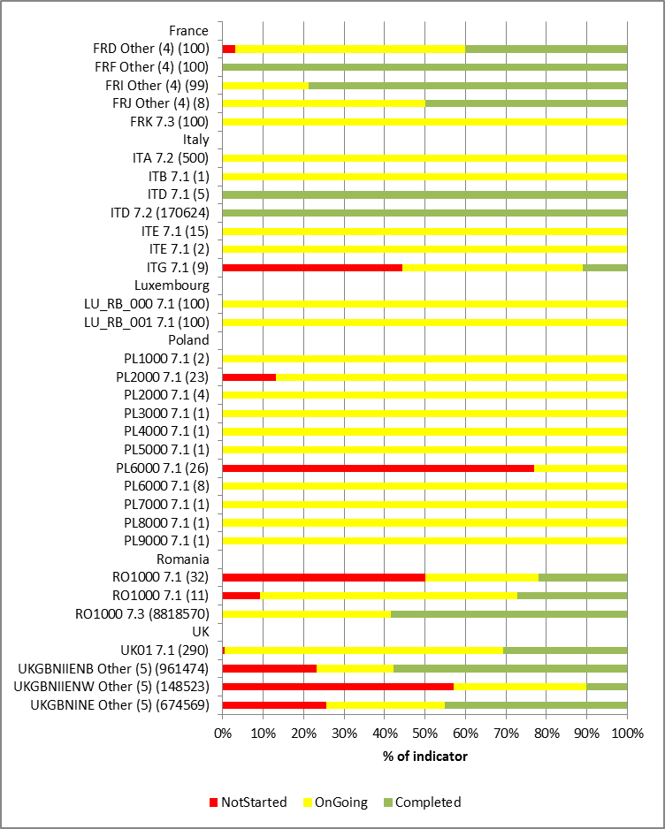

Key to indicators measures
The annotations next to each bar in the Figure shows “RBDCode; Indicator number; (value of the indicator when 100% completed)”
7.1 Number of projects/measures (including permits)
7.2 Length of rivers (km) affected by measures
7.3 Estimated Total Costs (€) of the measures
BEEscaut_RW, BEMeuse_RW, BERhin_RW, BESeine_RW | Other (1) | Characterising low water flow in the Walloon Region
ES017, ES018 | Other (2) | Number of RWB/TWB with minimum flow regime
ES080 | Other (3) | % of projects
FRD, FRF, FRI, FRJ | Other (4) | Number of catchments for which reference flows were defined
UKGBNIIENB, UKGBNIIENW, UKGBNINE | Other (5) | km of water mains replaced

Figure 15 illustrates the indicators reported by 12 Member States for KTM7. As in other KTMs there was a wide variation of the measures between Member States. Measures are largely completed in Belgium but measures had largely not been started in Spain. In 8 of the 11 Member States reporting indicator 7.1 (number of measures), at least 50% of the measures (and in 6 of these Member States, at least 80% of the measures) were not started or on-going.
The ambition, in terms of reported measures, is uneven. Austria, Belgium, Bulgaria, Spain and France report more than 100 projects while United Kingdom have included up to 290 only in Scotland (UK01); in Finland this line of action is incidental (1 project).

KTM8: Water efficiency measures for irrigation (technical measures)
Figure.16: Percentages of indicator/measures associated with KTM8 that were reported as being not started, planning on-going, construction on-going and completed at the Member State level in 2012
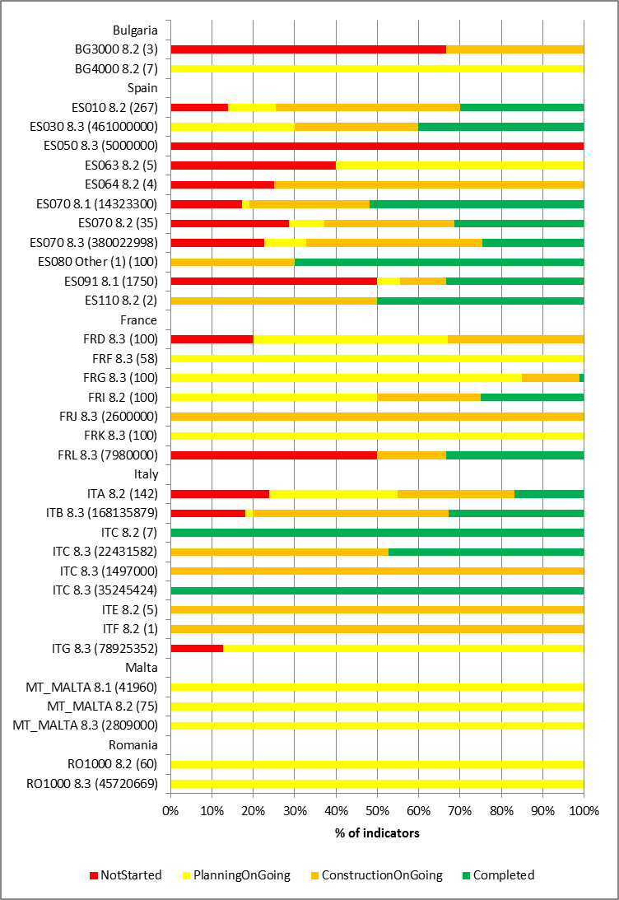
Key to indicators measures
The annotations next to each bar in the Figure shows “RBDCode; Indicator number; (value of the indicator when 100% completed)”
8.1 Area covered by projects;
8.2 Number of projects/measures;
8.3 Estimated Total Costs (€)
ES080 Other (1) % of projects

Only 6 Member States reported this KTM (Figure.16) using one or more of the predefined indicators.
Regarding the status reported in 2012, the majority of the projects were “on-going” in Bulgaria, France, Italy, Romania and Spain. There is a difference though in the completion of the projects: Spain (30%) and Italy (31 projects) reported on a significant number of “completed” projects but no completion has been achieved yet in Bulgaria and Romania. A limited number of projects were reported as “not started” in 2012. Bearing in mind this status of implementation, increased efforts are needed in order to achieve the objectives by 2015 for the Member States that have reported on this KTM.

Obstacles to the implementation of measures

Overview of obstacle reported in 2012
A variety of obstacles to delivery of the Programmes of Measures has been reported by the Member States, the most common of which is a lack of finance (17 Member States). Many Member States (10) report unexpected planning delays and some (7) report governance issues that cause delays or problems in implementing the PoM. Further details are provided in Table 15.
Table 15: Obstacles to delivering the Programme of Measures
Obstacles to delivering the PoM | Number of MS | MS
Governance issues | 7 | AT, BE, FI, IE, MT, NL, SE
(Unexpected) planning delays | 10 | AT, BE, BG, FI, FR, LT, NL, PL, PT, RO
Lack of finance | 17 | BG, CY, CZ, DE, ES, FI, FR, IE, IT, LT, LV, MT, NL, PL, PT, RO, SK
Lack of mechanism for implementing measures | 3 | CY, IE, LT
Planned measure no longer considered as being cost effective (e.g. national regulations not yet adopted) | 3 | BE, LT, UK
Unexpected extreme events (e.g. accidents, droughts, floods) | 1 | BE
Other (some identified below) | 16 | AT, BG, CY, CZ, DE, ES, FI, FR, LT, LU, LV, NL, PL, RO, SK, UK
No specific obstacles identified | 1 | EE
No information | 1 | HU
Note: BE data covers the RBDs in Flanders and in Wallonia but not the ones in Brussels and in the coastal region.

Other obstacles identified by the Member States in implementing the PoMs include the following:
- Lack of acceptance or inertia by stakeholders (sometimes volunteers) tasked with implementing measures or stakeholders who will be affected by measures (CY, DE, FR, PL, UK). This indicates a need for a more considered public participation process that ensures stakeholders actively support the measures that are put in place;
- Trouble acquiring the land or property rights needed to implement the measures (DE, NL, PL, RO, SK);
- Knowledge gaps (AT, ES, LT);
- Complexity of measure (ES, FR, UK);
- Lack of or poor coordination with neighbouring Member States and/or non-EU countries in the preparation of international RBMPs (LT, LV); and,
- Lack of management plans for Natura 2000 protected areas (BG).
Lack of funding and the economic crisis have been reported as a main obstacle in relation to hydromorphological improvements in several countries. For example in France, the implementation of hydromorphological measures is facing delays due to the economic crisis. Project developers and local governments face a reduction of financial means for measures related to hydromorphological restoration.

Inspection and enforcement of measures
Enforcement refers to the broad range of activities undertaken by authorities to ensure that permits are issued and other legal requirements are followed, as well as actions done in the case of possible infringements. Enforcement thus includes control procedures as well as sanctions and legal action via courts. Inspections are on-site visits by authorised government officers to ensure that the conditions in the permits and other legal requirements are respected.
Effective enforcement is of critical importance for reaching the WFD objectives. In its Preamble, the Water Framework Directive underlines the importance of ‘full implementation and enforcement’ of existing environmental legislation (recital 53). The Directive calls on Member States ‘to determine penalties applicable to breaches’; these should be ‘effective, proportionate and dissuasive’ (Art. 10).
Enforcement is an important concern, along with implementation of the WFD: the EU Environment Council, in December 2010, called on the Commission and Member States to ‘enhance and improve’ the implementation and enforcement of EU environmental legislation. In 2012, the European Commission released a Communication on better knowledge and responsiveness for environmental measures. The Communication noted that there is a ‘lack of data on compliance and enforcement work being undertaken at national level by inspectors, prosecutors and courts’.
These aspects were further investigated in the “Comparative Study of Pressures and Measures in the Major River Basin Management Plans” undertaken in 2012. Information was obtained either directly through questionnaires or interviews with Member States’ representatives of the CIS Strategic Coordination Group or through results of previous studies for 24 Member States (EL, FR and MT not included).
It was found that there were many differences across the Member States in terms of their approaches to enforcement in the area of water governance as well as concerning the number of inspections and level of sanctions. At the same time, data on enforcement were incomplete in many Member States, hindering both the attainment of an overview of national work in this area as well as an assessment of the achievement of EU goals to strengthen the implementation and enforcement of environmental legislation.
In most of the smaller Member States, there is one main environment enforcement authority and this body carries out inspections of water-related permits across all the main economic sectors: examples include Cyprus, Lithuania, Portugal and Slovenia. In one larger Member State, the United Kingdom, the three regional environment agencies (for England and Wales, Northern Ireland and Scotland) also enforce permits across all main sectors.
In some other Member States, however, differences for specific economic sectors are seen, which often relate to IPPC installations. In Austria, for example, enforcement for large IPPC installations is carried out at federal level, while all other water-related enforcement occurs at lower levels. In Luxembourg, the Environment Agency leads enforcement for IPPC facilities (and smaller ‘classified installations’), while the Water Management Agency is the lead authority for all other enforcement related to water.
As described in earlier sections of this report, diffuse agricultural pollution is a major problem for water bodies across the EU. In some Member States control permits do not adequately address diffuse pollution . In addition, the the Court of Auditors report highlighted limitations in how Member States define and enforce cross-compliance requirements e.g. the requirements for farmers were not precise enough, the actual volume of water abstracted was not checked. In several Member States, specific sectors were identified where greater enforcement efforts were needed: small facilities and hydropower in Sweden; dams and diffuse sources in Estonia; and agriculture in Ireland.

Overall progress with implementation of programmes of measures
This section examines the overall progress in implementation of the Programmes of Measures, focusing in particular on reported achievements and delays.
Member States were asked to report on the main achievements made in delivering the Programmes of Measures. For the majority of Member States (19), some but not all measures have been started and some but not all measures have been completed. No Member State reported having completed all measures and only one Member State (AT) reports that the status of water bodies is improving. The majority of Member States (17) reported that new legislation or regulations have been adopted as a requirement to fulfilling certain measures. Table 16 summarises the main achievements reported by Member States.
Table 16: Member States’ reported achievements in delivering the PoM
Achievements in delivering the PoM | Number of MS | MS
Required new legislation and/or regulations adopted or in progress | 17 | AT, BE, BG, CY, CZ, ES, FI, FR, IE, IT, LT, LU, MT, PL, RO, SK, UK
All planned measures started | 1 | NL
Some planned measures started | 19 | AT, BE, BG, CY, CZ, DE, ES, FI, FR, IT, LT, LU, LV, MT, PL, PT, RO, SK, UK
All measures completed | 0 | (none)
Some measures completed | 19 | AT, BE, BG, CY, CZ, DE, ES, FI, FR, IT, LT, LU, LV, MT, NL, PT, RO, SK, UK
Finance secured for planned measures | 9 | AT, EE, FR, IT, LU, MT, PL, RO, UK
Status of water bodies improving | 1 | AT
Other achievements (some identified below) | 11 | AT, EE, FR, IE, LT, LU, LV, MT, NL, PL, UK
No achievements described | 1 | SE
No information reported | 1 | HU
Note: BE data covers the RBDs in Flanders and in Wallonia but not the ones in Brussels and in the coastal region.

The types of “other achievements” reported (i.e. achievements other than those described in Table 16) include the following:
- Pollution reduction and hydromorphological improvements (AT);
- Protection of ecologically important areas (AT);
- Research on the effectiveness of measures (AT);
- Research on the assessment of long-term wastewater irrigation (water reuse) impacts on the soil geochemical properties and the bioaccumulation of heavy metals to the agricultural products (CY)
- Improvements in water efficiency/reduction in per capita drinking water consumption (MT, FR);
- Cooperative working between public authorities and stakeholders at international, national and/or local levels (AT, MT, UK);
- Implementation of measures delivering multiple benefits (UK); and,
- Improved monitoring or surveys of catchments to identify pressures and assess status (CY, LT, MT, UK).

Member States also reported on measures that were included in the first RBMPs but which have been significantly delayed. Table 17 provides the percentages of the substantial delays in other basic measures and supplementary measures per Member State.

Table 17: Substantial delays in the implementation of measures (combined Article 11.3 b to l and Article 11.4 measures) reported by Member States in 2012
Member State | % of measures delayed |  | Member State | % of measures delayed
AT | 0% |  | IE | 21%
BE | 3% |  | IT | 19%
BG | 6% |  | LT | 8%
CY | 7% |  | LU | 0%
CZ | 56% |  | LV | 0.4%
DE | 18% |  | MT | 7%
DK | NR |  | NL | 9%
EE | 0% |  | PL | 11%
EL | NR |  | PT | 7%
ES | 10% |  | RO | 6%
FI | 8% |  | SE | 77%
FR | 7% |  | SI | 0%
HR | NR |  | SK | 13%
HU | 5% |  | UK | 0.2%
 |  |  | EU(25) | 12%

Note:
NR = Not reported
The % of measures delayed for each Member State was calculated as the average of the percentage of basic measures (Article 11.3 b to l) and percentage of supplementary measures (Article 11.4) reported to be delayed in 2012
Over 10% of measures were substantially delayed in a third of the 25 Member States reporting information. There were large differences across the EU with Member States such as Austria, Estonia, Luxembourg and Slovenia reporting no substantial delays in the implementation of their measures to the Czech Republic and Sweden where over half of their measures were significantly delayed.
At EU level, 23% of WFD-specific basic measures (Article 11(3) b to l) were reported as completed, 66% on-going and 11% not started. The figures reported for supplementary measures (Article 11(4)) were 29% completed, 54% on-going and 17% not started. All these figures indicate that in spite of the numerous achievements completed by the Member States so far, in some cases there is an urgent need to overcome delays in the implementation of the measures and to speed up the necessary processes in the Member States.

Main changes and improvements envisaged for the second planning cycle
Shortcomings in the implementation of programmes of measures by Member States have been identified in the Commission’s 2012 implementation report and also in the Preliminary Assessment report of progress produced in 2013. The Commission has asked Member States questions in their bilateral meetings on how these shortcomings are planned to be addressed in the second planning cycle.
Member States provided in their bilateral meeting with the Commission much information that indicates that there are planned changes and improvements in the second cycle. Based on the information we can point out several areas where improvements in the second river basin management plans are expected:
- At least 10 Member States intends to establish, finalize or extend its inventory of sources of pollution in relation to Priority Substances and River Basin Specific Pollutants (RBSP) in the second RBMPs.
- A shortcoming identified in the first plans was insufficient monitoring programmes; eight Member States indicated that they would be increased or better monitoring of the biological quality elements, and 7 said there would be better or revised monitoring networks in general for the second plan.
- It also appears that the methods used to assess and classify water status are to be improved in terms of developing or improving the assessment methods for the biological quality elements (8 Member States), and by the inclusion of RBSP in the assessment of ecological status (7 Member States).
- In terms of the analysis of pressures and impacts, at least 7 Member States expect improved methods for the assessment of significant pressures and impacts and/or apportionment to sectors (including 5 Member States that expect to improve the models that can be used for source apportionment purposes), and the improved assessment of hydromorphological significant pressures and linkage to measures in 7 Member States.

Annex - Recommendations to the Member States

Background

As it was mentioned in the introduction, the Commission has collected a significant amount of information on the implementation of the Water Framework Directive (WFD) in the Member States through the assessment of the first river basin management plans (RBMPs), the interim report on the programmes of measures (PoMs) and in bilateral meetings on the implementation of the RBMPs.
This information provides the Commission with a general understanding of what are the strengths and weaknesses in the different Member States of the implementation of the WFD. The recommendations in this annex are based on this information and knowledge.

Aim and nature of the recommendations

The recommendations aim to assist Member States in identifying the areas where improvement in the implementation of the WFD is needed and expected as a matter of priority.
The Commission expects Member States to address the gaps in implementation in their second RBMPs (to be published at the end of 2015) at least in the form of measures included in the PoMs.
The recommendations do not only cover the PoMs but also previous steps of the WFD planning process which are essential for the design of effective PoMs (see Chapter 4).
The recommendations are intentionally kept general and succinct in order to highlight certain areas of particular concern where the need for improvement is expected as a priority. Therefore, the set of recommendations cannot be considered exhaustive.
The number of recommendations does not necessarily indicate the level of performance of the Member State in the implementation of the WFD because the seriousness of the gaps that such recommendations address differs among Member States.

RECOMMENDATIONS TO AUSTRIA
Austria should:

- Make sure that RBMPs are more precise in analysing and linking pressures and impacts (information regarding status and the scale of the pressures is not always clear). Similarly, the gap analysis of the measures required to achieve good status in the light of the pressures should be more strongly elaborated.
- Develop fully the economic analysis of water use, including the calculation of environmental and resource costs, and how the cost effectiveness analysis influenced the selection of measures. The RBMPs should provide more information about the measures, especially the expected impact/effect on the WB status. Other information, such as the location, timing and financing would add an additional level of concretisation to the RBMPs.
- Clarify delineation of small water bodies in 2nd RBMPs.
- Make clearer the approach regarding exemptions in the RBMPs: methodology applied for defining technical feasibility and disproportionate costs; measures under Article 4.5; measures for planned new hydropower development; explanations on implementation of Article 4.7; consideration of uncertainties in the Article 5 pressures and impacts analysis; monitoring and classification of status has influenced the targeting of measures.
- Review the degree to which the existing measures to implement the Nitrates Directive (ND) are sufficient to address agricultural pressures and ensure basic measures as per Article 11.3.h are put in place to control other diffuse pollutants – e.g. phosphate, pesticides, particulate matter. These measures should be specific, have a clear legal basis, and include appropriate advice, monitoring and inspection regimes to ensure their effective implementation. In addition to the basic measures, it should be set out clearly what supplementary measures will be needed to bridge the gap to good status and which of these measures will be included in the 2nd PoMs and what funding sources will be used to deliver these. Clear references to expectations for the Rural Development Programs in this regard (and to other funding sources) are expected.
- Provide more information in 2nd RBMPs about measures taken or being taken to address diffuse sources of pollutants (e.g. existing laws better enforced; action plans or guidance modified in order to specifically support the achievement of WFD objectives).
- Work in the next cycle RBMPs to improve the revision of the designation of Highly Modified Water Bodies and methodologies for establishing Good Environmental Potential (GEP). Water Bodies below storage lakes or dams for hydropower production are automatically classified as heavily modified water bodies (HMWB) according to the Austrian RBMPs provisions. There are a significant number of water bodies with water flow and morphological alterations due to hydropower plants (nearly 56 % of WB).
- Provide a clear commitment in the 2nd RBMPs to properly prioritised hydromorphological measures and to a review of hydropower permits as restoration measures and the establishment of an ecological flow downstream of hydropower plants will be necessary to achieve good surface water status

RECOMMENDATIONS TO BELGIUM
Belgium should:
- Ensure good coordination between the different regions. In the past, plans were developed separately by each of the Regions and by the Federal government for coastal waters. Although the Regions and the Federal government participate in the International River Commissions of the Scheldt and the Meuse, this is not sufficient to enable effectively coordinated implementation of the WFD. In particular, the PoMs need to be clearly linked where they concern pressures and measures that affect several Regions (e.g. pollution from the Regions that affects coastal waters).
- Ensure that consultation processes at various levels (regional, national, international) are coordinated and that key information (pressures, monitoring, status, environmental objectives and exemptions, measures) is made available in a consolidated way for the whole of the RBDs (at least for the Belgian part), avoiding separate products available in different timelines which made impossible having a completed picture of the RBD.
- Establish a quantitative source apportionment and a link between pressures/impacts and their sources. Belgium should use these as a basis for determining the Programmes of Measures.
- Improve the methods for the status assessment of water bodies to reduce the degree of uncertainty in status classification and thus support the gap analysis required to identify measures.
- Ensure that the RBMPs clearly identify the gap to good status for individual pressures and water bodies, and that PoMs are designed and implemented to close that gap since none of the three Regions carried out an assessment/analysis of how far pressures (and their corresponding sources) have to be reduced to achieve the WFD objectives. Exemptions should be adequately justified at water body level.
- Ensure that cost-effectiveness analyses are conducted in the Brussels and Walloon Regions to inform their next RBMPs (only Flanders has carried it out).
- Increase significantly the level of ambition and justify better the exemptions applied based on the assessment of the measures needed to reach good status and a proper assessment of alternative solutions and all necessary mitigation measures for exemptions for new infrastructure.
- Review the degree to which the existing measures to implement the Nitrates Directive (ND) are sufficient to address agricultural pressures to allow the more stringent nutrient conditions for the WFD and MSFD to be met. Additionally, Belgium should ensure basic measures as per Article 11.3.h are put in place to control other diffuse pollutants – e.g. phosphate, pesticides, particulate matter. These measures should be specific, have a clear legal basis, and include appropriate advice, monitoring and inspection regimes to ensure their effective implementation. In addition to the basic measures, it should be set out clearly what supplementary measures will be needed to bridge the gap to good status and which of these measures will be included in the second PoMs and what funding sources will be used to deliver these. Clear references to expectations for the Rural Development Programs in this regard (and to other funding sources) are expected.
- Include in the 2nd RBMPs the necessary hydromorphological measures to achieve good status, including those targeting the good ecological potential for heavily modified water bodies (to broaden the scope, make the designation process clearer and ensure the necessary budget).
- Include in the 2nd RBMPs additional objectives for protected areas and measures to achieve these objectives.
- Integrate environmental and resource costs into cost recovery calculations for the 2nd RBMPs.

RECOMMENDATIONS TO BULGARIA
Bulgaria should:
- Ensure the necessary coordination of approaches and methodologies among its 4 RBDs in the 2nd RBMPs.
- Review all existing permits in all RBDs and where necessary, amend them to ensure that they are compatible with the WFD objectives.
- Include in the 2nd RBMPs results of the international cooperation with neighbouring countries.
- Review the pressures and impacts analysis and status assessment in a consistent manner across all RBDs in the 2nd RBMP and ensure that the measures are based on the updated pressures and impacts analysis and status assessment of water bodies.
- Complete the development of methods for the status assessment of water bodies and determination of reference conditions. An adequate WFD-compliant assessment and monitoring framework is a necessary pre-requisite to design effective PoMs and ultimately to achieve the WFD objectives.
- Ensure that the RBMPs clearly identify the gap to good status, and that the PoMs are designed and implemented to close that gap. Exemptions should be adequately justified at water body level.
- Identify in the 2nd RBMP a solution to address the significant pressure from landfills, and commit to accelerating the implementation of measures to comply with the UWWTD.
- Ensure that significant point and diffuse sources of chemical pollution are proactively identified and measures put in place to control them.
- Review in the 2nd RBMP the environmental quality standards for the river basin specific pollutants and take the updated standards into account when designing measures for those pollutants.
- Set out in the 2nd RBMPs a clear assessment of the pressure agriculture is exerting on the status of water bodies.
- Review the degree to which the existing measures to implement the Nitrates Directive (ND) are sufficient to address agricultural pressures and concentrate efforts on ensuring farmers understand their obligations in this regard and can finance the necessary investments. Additionally Bulgaria should ensure basic measures as per Article 11.3.h of the WFD are put in place to control other diffuse pollutants – e.g. phosphate, pesticides, particulate matter. These measures should be specific, have a clear legal basis, and include appropriate advice, monitoring and inspection regimes to ensure their effective implementation. In addition to the basic measures, it should be set out clearly what supplementary measures will be needed to bridge the gap to good status and which of these measures will be included in the second POM and what funding sources will be used to deliver these. Clear references to expectations for the Rural Development Programs (RDPs) in this regard (and to other funding sources) are expected.
- Ensure coordination between water and agriculture departments to make sure that developments supported by these investments do not undermine the achievement of WFD objectives (Bulgaria is considering significant investment in irrigation and drainage under the RDP 2014-2021).
- Set more stringent objectives for all drinking water protected areas in the 2nd RBMP cycle and complete the establishment of drinking water safeguard zones. These measures should be included in the PoMs.
- Prioritize the agglomerations with more than 2.000 PE in terms of the WFD principles and of financing in the 2nd RBMPs but should also assess the pressures due to waste water from small agglomerations (less than 2.000 PE) in the second RBMP cycle.
- Ensure compliance with Article 5 UWWTD for more stringent treatment, especially in big cities.
- Develop in the 2nd RBMPs an appropriate methodology to establish good ecological potential including the necessary mitigation measures linked to water uses and quality level.
- Develop a proper methodology for establishing ecological flow linked with good ecological status in the 2nd RBMPs and ensure this e-flow is applied through review of permits.
- Implement measures to mitigate the effects of navigation and related activities in the Black sea RBD.
- Establish an improved and harmonised approach to exemptions in the 2nd RBMPs. The methodology should include calculations of disproportionate costs, assessment methods for adverse effects and better environmental options.
- All the planned projects that may deteriorate the status of a water body have to be included in the 2nd RBMPs Should adequately justify and support new modifications (such as dams and navigation projects) by a proper assessment of alternative solutions and include all necessary mitigation measures.
- Consider and prioritise the use of green infrastructure and/or natural water retention measures that provide a range of environmental (improvements in water quality, flood protection, habitat conservation etc.), social and economic benefits which can be in many cases more cost-effective than grey infrastructure.

RECOMMENDATIONS TO CYPRUS
Cyprus should:
- Provide a more detailed analysis of pressures and impacts, as well as an improved risk assessment based on the improvement of the monitoring network. The RBMPs should be explicit about the impacts related to each significant pressure and provide quantitative figures on the scale of the pressures that need to be reduced, to reach WFD objectives. Also, the targeting of the measures should be explicit in terms of their type and extent, to ensure that pressures are addressed adequately.
- Develop fully the economic analysis of water use, including the calculation of environmental and resource costs, and how the cost effectiveness analysis influenced the selection of measures.
- Increase the use of EU funds to finance PoMs.
- Utilise metering (especially for agriculture) to better determine quantitative status of WBs and to secure their long-term protection because abstraction of groundwater is a significant pressure in Cyprus, mainly due to unregulated self-abstractions and permits not set consistent with environmental needs.
- Enforce the Law for groundwater status improvement (the application deadline for non-licensed boreholes was extended until June 2014 for farmers).
- Promote more efficient irrigation networks and maximization of water reuse.
- Consider switching to less water-intensive agricultural products, which can often provide a better economic return.
- Review the degree to which the existing measures to implement the Nitrates Directive (ND) are sufficient to address agricultural pressures and concentrate efforts on ensuring farmers understand their obligations in this regard and can finance the necessary investments. Additionally Cyprus should ensure basic measures as per article 11.3.h of the WFD are put in place to control other diffuse pollutants – e.g. phosphate, pesticides, particulate matter. These measures should be specific, have a clear legal basis, and include appropriate advice, monitoring and inspection regimes to ensure their effective implementation. In addition to the basic measures, it should be set out clearly what supplementary measures will be needed to bridge the gap to good status and which of these measures will be included in the second POM and what funding sources will be used to deliver these. Clear references to expectations for the Rural Development Programs (RDPs) in this regard (and to other funding sources) are expected. Irrigation investments made in the Rural Development Programmes must be carried out to ensure water saved goes back to restore depleted aquifers.
- Develop further the hydromorphological assessment methods so that improved biological monitoring results will allow for better risk assessment and more targeted measures concerning hydromorphological pressures. Cyprus should be more ambitious in 2nd RBMPs in relation to hydromorphological measures.
- Consider and prioritise the use of green infrastructure and/or natural water retention measures that provide a range of environmental (improvements in water quality, increase of water infiltration and thus aquifer recharge, habitat conservation etc.), social and economic benefits which can be in many cases more cost-effective than grey infrastructure.
- Accelerate implementation of the UWWTD measures, availing of EU funds as collecting systems and treatment plants are not fully operational (62,0% of the population equivalent according to 2010 data).
- Present in the 2nd RBMPs improved identification of pressures from chemical pollutants on the basis of the inventory of priority substances emissions (established since June 2013).

RECOMMENDATIONS TO CZECH REPUBLIC
Czech Republic should:
- Ensure good coordination between public administration and other stakeholders to improve the planning and implementation of PoMs and to monitor their effectiveness.
- Ensure in the 2nd RBMPs that measures adopted in the PoMs are based on a reliable status assessment of water bodies (clear setting of the scale of pressures, measures needed to fully address the pressures and proportion of these measures) and are linked to the relevant pressures. The explanation of the links between pressures and status and respective measures should be included in the update of the RBMPs.
- Focus better the operational monitoring of water bodies on verification of results from the pressures and impacts analysis, e.g. the link between impacts on water bodies and hydromorphological pressures should be addressed. Furthermore, Czech Republic should clarify the link between the pollution by hazardous substances and their sources. Czech Republic should consider necessary changes in operational monitoring to pick up potential polluting loads.
- Ensure that the RBMPs clearly identify the gap to good status, and that the PoMs are designed and implemented to close that gap. The identified impacts have to be clearly apportioned between the sources and sectors/drivers responsible for the pressures for all significant water management issues.
- Base the assessment of measures for River Basin Specific Pollutants on appropriate Environmental Quality Standards (EQS) in the 2nd RBMPs cycle.
- Assess what additional objectives/measures are needed for Protected Areas (Species and Habitats, Drinking Water, Bathing Water) and to include these additional objectives/measures in the 2nd RBMPs.
- Indicate clearly in the 2nd RBMP when WFD objectives will be achieved. Exemptions should be adequately justified at water body level and, in particular for new modifications, compliance with Article 4.7 of the WFD has to be ensured in the 2nd RBMPs cycle.
- Present in the 2nd RBMPs a clear assessment of the number of water Bodies failing to reach good status due to agriculturally derived pressures because diffuse sources of pollution from nitrogen and pesticides were identified as the main significant pressures from agriculture in the Czech Republic. Czech Republic should start measures to control diffuse sources of pollution outside of NVZs and Czech Republic should improve controls of hydromorphological pressures from agriculture. Czech Republic should report quality of lakes.
- Review the degree to which the existing measures to implement the Nitrates Directive (ND) are sufficient to address agricultural pressures. Additionally Czech Republic should ensure basic measures as per article 11.3.h of the WFD are put in place to control other diffuse pollutants – e.g. phosphate, pesticides, particulate matter. These measures should be specific, have a clear legal basis, and include appropriate advice, monitoring and inspection regimes to ensure their effective implementation. In addition to the basic measures, it should be set out clearly what supplementary measures will be needed to bridge the gap to good status and which of these measures will be included in the second POMs and what funding sources will be used to deliver these. Clear references to expectations for the Rural Development Programs (RDPs) in this regard (and to other funding sources) are expected. The Czech Republic RDP proposes significant investment in drainage measures, with the potential to lead to deterioration of status. Compliance with Article 4.7 must be ensured.
- Ensure that the Methodology for ecological flows (called Minimum Residual Flow) is consistent with the WFD environmental objectives (good ecological status or potential).
- Provide information on future and current actions to address hydromorphological pressures deriving from water management, hydropower, private users and other related sectors, and to put in place adequate measures in the 2nd RBMPs (in particular to develop a strategy to implement fish passes and ensure connectivity) and by including other restoration measures.
- Justify adequately new hydromorphological modifications (e.g. new hydropower plants, new drainage, etc.), support them by a proper assessment of alternative solutions and include all necessary mitigation measures.
- Consider and prioritise the use of green infrastructure and/or natural water retention measures that provide a range of environmental (improvements in water quality, flood protection, habitat conservation etc.), social and economic benefits which can be in many cases more cost-effective than grey infrastructure.
- Ensure proper assessment of the chemical status of its groundwaters and, if the quality standards in Annex I of the GWD are insufficient to achieve the environmental objectives for groundwater-dependent ecosystems. Czech Republic should establish more stringent nitrates and pesticides threshold values (point 3 of Annex I of Directive 2006/118/EC).
- Identify clearly in the 2nd RBMPs Basic measures to allow for a clear assessment of the need for additional measures, e.g. Czech Republic should provide all information on the level of compliance and timing to reach full compliance with Directive 91/271/EEC (article 15 and following) and what measures beyond this are necessary to reach good status and which of these will be included in the 2nd RBMPs.
- Develop fully the economic analysis of water use, including the calculation of Environmental and Resource Costs. Czech Republic should revise approach to the exemption from water fees during scarcity periods, and CZ should elaborate on this issue in the 2nd RBMP.
- Carry out a cost effectiveness analysis of potential measures (voluntary or obligatory), for achieving the environmental objectives. The effectiveness of the implemented measures will have to be demonstrated by the assessment of the status/potential of water bodies in the second RBMPs. Available funding, in particular the EU funds (e.g. RDP funds, Structural and Investment funds, LIFE Integrated Projects and Horizon 2020) needs to be exploited as much as feasible in order to implement PoMs. Consequently, appropriate priorities shall be set in the programming documents (PA, OPs and RDPs) of the new EU funding policy 2014-2020.
RECOMMENDATIONS GERMANY
Germany should:
- Improve knowledge (in designing and making operational the measures for the 2nd RBMP cycle) on the link between pressures and impacts in order to:
  - Refine the significance of the pressures by quantifying those which are likely to prevent the achievement of environmental objectives;
  - Assess the reduction in pressures required to achieve environmental objectives;
  - Apportion the source and clearly identify the responsible sectors/areas.
- Enhance measures to tackle pollution by nutrients (nitrogen and phosphorus) considering their impact on the ecological status because diffuse pollution from agriculture is the main reason for poor groundwater status, and all coastal and transitional waters are failing due to eutrophication. Full consideration of the basin-wide impact is needed in this respect (local and downstream impacts including up to transitional and coastal waters).
- Check that their nutrient standards are consistent with biological requirements for the achievement of good status and set out a more coherent strategy in the 2nd RBMPs that reflects:
  - for agriculture: what will be achieved through measures to implement the Nitrates Directive, through basic measures under article 11.3. of the WFD, basic measures included in pillar 1 (GAEC, greening) of the CAP and supplementary measures under pillar 2 of the CAP; Germany should put in place a revised nitrates action programme under the Nitrates Directive that can address this issue meaningfully
  - for urban areas: what will be achieved through compliance with the UWWTD and what will be required beyond this (e.g. tightening of standards, addressing storm water overflows).
In particular it is expected that the 2nd RBMPs, based on the necessary reduction in nutrient load, clearly identify the extent to which the measures already taken under the implementation of ND and UWWTD contribute to the achievement of WFD objectives and which additional measures should be taken to actually achieve these objectives. A clear identification of basic (mandatory) measures is expected to be made transparent both to the sectors and the general public. Clarity on timescale of implementation of the measures is also expected.
- Review regulation on the use of pesticides (beyond nutrients) in order to prevent pollution at source and effectively reduce current levels of contamination of both surface and groundwater, making clear linkages with the implementation of the Directive on the sustainable use of pesticides. If the National Action Programme is intended to fulfil the requirement to have controls on pesticide pollution as required by article 11.3 of the WFD, then the detail on these controls (mandatory measures) should be set out in the RBMPs and the PoMs.
- Define measures targeted to agriculture with a much better level of detail to ensure their uptake by farmers, their inspection by relevant agencies and to assist tracking of compliance. Basic measures are mostly presented as legislative acts and in the next RBMPs Germany should present detail on technical measures included in such acts.
- Make a clear distinction in the RBMPs between mandatory measures (the minimum being measures to implement article 11.3.) and voluntary ones that will be funded under the EARDF.
- Make clear to what extent the full range of agriculture measures included in the RBMP will be sufficient to redress agriculture pressures to allow good status objectives to be achieved.
- Consider properly ecological flows wherever existing and planned abstractions may jeopardize the achievement of environmental objectives. This is particularly crucial when considering the review of water allocations and permits.
- Review the legislative base on morphology to ensure that controls exist to adequately prevent new morphological pressures.
- Consider and prioritise the use of green infrastructure and/or natural water retention measures that provide a range of environmental (improvements in water quality, flood protection, habitat conservation etc.), social and economic benefits which can be in many cases more cost-effective than grey infrastructure.
- Provide more information in the RBMPs about the measures, especially the expected impact/effect on the water bodies´ status. Other information, such as the location, timing and financing would add a level of specificity to the 2nd RBMPs that was a weakness in the first RBMP.
- Provide better information on how measures are selected and targeted towards a water body. While uncertainties related to the status and the effects of measures were provided in the 1st RBMPs it is expected that many of these obstacles should have been overcome in the 2nd RBMPs.
- Provide more ambitious programmes of measures for the 2nd RBMPs to increase the number of water bodies at good status by 2021.
- Review the designation of HMWBs, in particular taking into account restoration measures that would make it possible for water bodies to achieve good status, which will in turn provide a legal driver for restoration measures.
- Ensure that the RBMPs clearly identify the gap to good status, and that the PoMs are designed and implemented to close that gap. Should all measures not be put in place in the second RBMP Germany is expected to provide better justification for exemptions to the achievement of environmental objectives (in particular as regards the assessment of affordability and disproportionate costs). Germany should include in the RBMPs a clear timetable for the measures to be implemented.
- Include in the 2nd RBMPs a more consistent approach to substance-specific measures in the different Länder and put in place substance-specific and general measures to address pollutants at source.
- Set out better information on the allocation of financial resources for measure implementation in the 2nd RBMPs.
- Mainstream across Germany good practices from some Länder on consistently addressing hydromorphological pressures through the Rural Development Programmes.
- Explore all opportunities to secure necessary funding to pay for RBMP measures, e.g. wider application of article 9, RDPs, national flood budget (with a priority for natural water retention measures), water company investment and industry measures to reduce chemicals at source.
RECOMMENDATIONS TO ESTONIA
Estonia should:
- Ensure coherent trans-boundary cooperation in PoMs development (with Latvia).
- Finalise the setting of all reference conditions for the purpose of the 2nd RBMP cycle; any gap (i.e. lake diatoms) should be explained in the 2nd RBMPs.
- Complement biological assessment with (improved and harmonised) monitoring of hydromorphology in the 2nd RBMPs.
- Apply fully the one-out–all-out principle in ecological status assessment in the 2nd RBMPs.
- Assess for the 2nd RBMPs all potential HMWB in relation to "other means" that can be a better environmental option and restoration option. In accordance with WFD requirements, take action to restore HMWB if feasible.
- Focus in the 2nd RBMP cycle on better linking pressures to impacts and measures, including by source apportionment, and provide a clear assessment of how many of the pressures (and their sources) have to be reduced to achieve the WFD goals.
- Link clearly in the 2nd RBMPs cycle the overcoming of the gap to good status with the implemention of basic and supplementary measures.
- Make more explicit the links between other supporting programmes and legislation relevant to the WFD, such as urban wastewater treatment and programmes for Nitrate Vulnerable Zones (NVZs). The contribution of these supporting programmes to achieving the objectives of the WFD should be shown in quantitative terms.
- Assess the requirements of Birds and Habitats areas and, if additional water requirements (quality/ quantity) are needed to achieve favourable conservation status, and include them as additional objectives in the 2nd RBMPs.
- Improve transparency in the application of exemptions for the 2nd RBMPs; include the cost effectiveness of measures in the RBMP; and define the criteria for the application of "technical unfeasibility", "disproportionate costs" and "natural conditions".
- Be more concrete in the 2nd RBMPs in terms of measures and the expected achievements and clearly link the measures (both basic and supplementary) to specific pressures and quantify the expected impact of the measures in terms of the WFD objectives.
- Put in place measures in line with article 11.3.h WFD to control diffuse pollution (controls mean binding requirements - not voluntary measures, such as the code of good practice).
- Establish a clear requirement for farmers to protect water to the standard necessary under Nitrates Directive (ND) and WFD.
- Provide information on what binding measures will be placed on agriculture to control diffuse pollution in the second cycle especially outside Nitrate Vulnerable Zones (NVZ) areas.
- Take into consideration what types of measures are needed to help deliver the WFD and then ensure these are targeted to the right farmer/right location in the 2nd cycle RDPs.
- Undertake accurate pressures analysis to precisely define sources of nitrate and phosphate pollution.
- Cover diffuse sources in the inventory of pollution sources elaborated in the 2nd RBMPs to the highest extent possible (e.g. agricultural sources of cadmium, pesticides; storm water run-off, etc.).
- Provide complete information on the level of compliance, and timing to reach compliance, by agglomerations, including information on funding, in accordance with Directive 91/271/EEC (article 15 and following).
- Integrate the action plan for the Ordovician Ida-Viru oil-shale basin in the PoMs of the 2nd RBMPs.
- Ensure that its ecological flow methodology is compatible with Good Ecological Status (GES), and that it takes into account the CIS guidance that has been adopted.
- Improve the assessment of hydromorphological significant pressures taking into account all significant alterations, e.g. drainage, infrastructure, barriers etc.
- Consider and prioritise the use of green infrastructure and/or natural water retention measures that provide a range of environmental (improvements in water quality, flood protection, habitat conservation etc.), social and economic benefits which can be in many cases more cost-effective than grey infrastructure.
- Describe clearly in the 2nd RBMPs how status will be derived for non- monitored water bodies and to restrict and streamline the use of expert judgement.
- Apply fully the one-out–all-out principle in ecological status assessment in the 2nd cycle
- Take into account atmospheric deposition in identifying RB specific pollutants and in deciding where to monitor RBSPs and priority substances (PS).
- Include for the 2nd RBMP priority substances in chemical status assessment and river basin specific pollutants in ecological status assessment.
- Be transparent for the 2nd RBMP in the HMWB designation process and provide rationale for the changes done since the 1st RBMP.

RECOMMENDATIONS TO GREECE
Greece should:
- Urgently adopt and report to the Commission the two outstanding Greek RBMPs.
- Improve transboundary cooperation, building on the progress achieved so far; additional efforts in the context of WFD-implementation are needed, so that the second RBMPs for international RBDs are developed in close cooperation with neighbouring countries.
- Made fully operational the new National Monitoring Programme (NMP). All outstanding assessment methods should be developed and made operational as soon as possible. All water bodies should be classified according to WFD compliant methods. The one-out all-out principle should be used across the board. The data must be collected on a regular basis for all relevant quality elements. The recommendations of the RBMPs regarding the proposed modifications to the NMP need to be carefully considered and actions for their implementation to be pursued. The data of the new NMP must be quality assured, organised and archived. It is recommended that these data are made available to all users and the general public through easily accessible formats.
- Develop publicly available WFD compliant National Guidance Documents, addressing the key implementation steps where significant weaknesses have been identified (characterisation of pressures, typology, reference conditions, monitoring and grouping of water bodies, methods for the status classification, HMWB designation, application of exemptions and in particular regarding Article 4.7, etc.), necessary to ensure WFD compliance and increased comparability and transparency.
- The information obtained regarding chemical pollution needs to be extended by filling gaps in monitoring, including the monitoring of mercury and other relevant pollutants in biota, and trend monitoring in biota and/or sediment.
- Ensure in the updated RBMPs a better understanding and identification of the main risks and pressures in each river basin, based on detailed harmonised methodologies, and underpinned by consolidated and robust data.
- Particularly urgent is the development of sound methodologies to address hydromorphological pressures. The current combination of weak pressure analysis (with not precautionary enough thresholds of significance), lack of ecological status assessment methods sensitive to hydromorphological pressures, unclear process for designation of HMWB and lack of development of GEP makes it very likely that significant hydromorphological pressures are completely overlooked in the implementation process. Potential effects of “smaller” modifications such as dams lower than 15 m, dredging, river straightening, drainage, etc., including impacts to transitional and coastal waters, should be assessed.
- Agriculture is indicated as exerting a significant pressure on the water resource in most Greek RBDs. There needs to be further investigation regarding the hydromorphological pressures from agriculture. In addition, the measures taken as regards agriculture need to be more specific, in order to have more reliable positive results regarding the WFD-objectives.
- Regarding GW quantity issues, very limited information about actual abstractions has been used. The latter are based on estimates. Even if the revised NMP will provide better information the issue of illegal abstractions/boreholes, their potential effects and ways to deal with them needs to be considered most thoroughly.
- Regarding exemptions: overall and even if a large number of water bodies are in “unknown” status, there is a limited number of exemptions, linked to the fact that only a limited number of water bodies “fail” the objectives of the WFD. This needs to be significantly re-considered after monitoring information becomes available - and consequently, most probably, more measures will need to be taken.
- The application of exemptions needs to be more transparent and the reasons for the exemptions should be clearly justified in the plans. This especially holds true for a coherent and complete approach regarding Article 4.7 exemptions. The use of exemptions under Article 4.7 should be based on a thorough assessment of all the steps as requested by the WFD, in particular a proper assessment of whether the project will cause deterioration or prevent the achievement of good status, whether the project is of overriding public interest, whether the benefits to society outweigh the environmental degradation, and regarding the absence of alternatives that would be a better environmental option. Furthermore, these projects may only be carried out when all possible measures are taken to mitigate the adverse impact on the status of the water.
- No clear link between measures and status assessment is made. In order to address this, the gaps in the steps leading to the Programme of Measures, such as pressure and impact assessment, monitoring and status classification, should be addressed. This is important in order to implement measures where they are needed to reach the WFD objectives.
- In relation to chemical pressures, the intention to compile inventories of emissions in accordance with Directive 2008/105/EC needs to be carried out, but does not in itself count as a measure against chemical pollution. More information on relevant measures needs to be included in the 2nd RBMPs.
- In relation to hydromorphological pressures, and based on a sound assessment, measures should be taken to mitigate the impacts (e.g. river restoration, removal of structures, etc.).
- Meaningful information regarding the scope, the timing and the funding of the measures should be included in the PoM so the approach to achieve the objectives is clear and the ambition in the PoM is transparent.
- PoM in RBMPs: the limited level of ambition, and lack of clarity regarding expected effects, need to be rectified. The PoM includes mostly administrative acts that may not make a difference (particularly if implementation is not enforced). Many projects that are in apparent conflict with the WFD (e.g. new dams not properly justified, new irrigation network projects) are included in the PoM (e.g. for improving GW quantitative status since the irrigation water will come from a new reservoir in the future). A thorough check of such projects that are included in the PoM is needed in order to check if they really are WFD-relevant measures (linked also to the Article 4.7 issue above). This inclusion of new dams/irrigation schemes, etc. in most of the PoM also affects the costs indicated: a part of the costs of the PoM-supplementary measures (as defined up to 2015) come for such projects (often financed through the EU). Otherwise, there is very limited financing included for “core” WFD-measures to achieve the environmental objectives (e.g. restoration/mitigation, etc.) without clear commitments for after 2015. There needs to be a clear separation of measures designed to achieve WFD environmental objectives from measures designed to increase water supply and other objectives.
- Develop fully the economic analysis of water use (including the polluter pays principle, including a clear definition of water services, harmonising methodologies and data in all RBMPs) and ensure that the water tariffs/fees lead to adequate recovery of the costs of water services and provide incentives for users to use water resources efficiently. This is particularly important for agriculture. The implementation of measures on cost recovery and water pricing based on a common approach across RBDs is urgent, in order to fulfil the Article 9 requirements and to achieve economic sustainability.
- Up to now, there is no consideration of climate change - no “climate proofing” of the RBMP/PoMs. These issues need to be dealt with urgently.
- The Drought Management Plans (DMP) developed as supplementary to the RBMPs are a valuable addition. However, they need to be taken a step further, be more harmonised, and evolve into an operational level with the “measures proposals” being implemented in areas where relevant.
- Ensure that the authorities responsible for water management are fully in charge of the contents and development of the RBMPs. Support from consultants and researchers is often necessary, but the authorities' ownership of the RBMP should be ensured to embed the WFD principles and obligations into practice and avoid the disconnection of the planning process from the water management reality. Long-term capacity and expertise building should be ensured in the water administration, based on sufficient resources and personnel available at all relevant administrative levels.
- The consultation process needs to be strengthened. More efforts should be done to ensure active participation of all relevant stakeholders and the comments should be taken under consideration in a more transparent way.

RECOMMENDATIONS TO SPAIN
Spain should:
- Adopt as soon as possible the outstanding RBMPs for the Canary Islands
- Ensure the consultation and adoption of the 2nd RBMPs according to the WFD timetable, avoiding delays.
- Fill as soon as possible the gaps in transposition in the intra-community RBDs
- Improve reporting to WISE, ensuring that the information uploaded is the same as in the RBMPs. Report for the 2nd RBMPs complete information as regards significant pressures, including the results of the quantitative analysis, translated into the simple qualitative report required in WISE.
- Consider reviewing the legislation to incorporate explicitly the identification, by way of the pressures and impacts analysis, of water bodies at risk.
- Ensure the completion as soon as possible of the framework for status assessment considering the following:
  - Reference conditions and boundaries for quality elements have to be binding. Revise typology if needed to ensure that it is fit to serve as a basis for classification.
  - Translate the results of the intercalibration exercise to the assessment systems in a transparent way
  - The complete assessment framework, and in particular the intercalibration results of 2013 and the new standards introduced by Directive 2013/39/EU for existing priority substances, should be considered in the status assessments for the second RBMP.
  - Fill the gaps in assessment systems for biological quality and supporting elements, in particular for fish
  - Include the complete assessment systems for coastal and transitional waters.
  - Report transparently the confidence and limitations of the assessments as appropriate.
- Fill urgently the gaps in monitoring of surface waters and ensure consistent monitoring with appropriate coverage (and thereby classify the status of all water bodies). Ensure that monitoring is adequately resourced and maintained to inform adequately the RBMPs and the decisions on the PoMs.
- Extend chemical monitoring beyond water bodies affected by industrial discharges. Consider as well atmospheric deposition and urban waste water discharges as relevant sources of chemical pollution.
- In the context of designation of HMWBs, develop clear criteria/thresholds to define the significant adverse effect of restoration measures on water uses, and a proper (real) assessment of other alternatives that could be better environmental options.
- Ensure that GEP is correctly defined for all HMWBs and AWBs (in terms of biological condition and mitigation measures).
- Ensure that environmental objectives are established for all water bodies in the second cycle, including for HMWBs and AWBs. If no objectives are defined, appropriate measures cannot be established either.
- Ensure that the assessment of groundwater quantitative status considers all aspects of the definition, including local falls in the water table that may lead to a risk in water-dependent ecosystems, and including protected areas.
- Develop a plan to extend and generalise the use of flow meters for all water abstractions and uses, and to require users to report regularly to the river basin authorities the volumes actually abstracted. Use this information to improve quantitative management and planning.
- Ensure that:
  - all abstractions are registered and permits adapted to the available resources.
  - all abstractions are metered and subject to control of the river basin authorities
  - the necessary amendments to the legislation are enacted to require all abstractions to be registered and regulated, no matter under which regime they got their permit (pre- or post-1985 Law).
- Ensure that the e-flows established guarantee good ecological status. If this is not the case, report transparently the deviations and the justifications on the basis of technical feasibility or disproportionate costs. In the relevant water bodies, consider the objectives of water-dependent protected habitats and species in setting e-flows.
- Harmonise the consideration of temporary streams in the Mediterranean area on the basis of sound ecologically-based scientific criteria and methodologies. Ensure distinction between situations of dry rivers due to natural causes (temporary streams) and human activity (due to over-abstraction).
- Provide better justification of exemptions. There is no analysis of the measures needed to achieve good status. Therefore, it is not possible to justify whether measures are disproportionately costly or technically unfeasible. Measures need to be taken as far as possible in water bodies where exemptions are applied, and report them in the RBMPs.
- Ensure in the 2nd RBMPs that the status of all water bodies is assessed in accordance with the WFD before considering any further infrastructure that would be liable to cause deterioration in the status of water bodies or prevent the achievement of good status. These infrastructures can only be authorised if the conditions of article 4(7) are fulfilled. The justification needs to be included in the RBMP. The "declaration of general interest" in the Spanish legislation cannot be automatically equated with the concept of "overriding public interest" in article 4(7)(c). This has to be justified case by case in the 2nd RBMPs.
- Avoid presenting the maintenance of ecological flow in new dams as an ecological benefit of the dam, but consider it as a mitigation measure. Justify the flood protection share on a case by case basis, including the justification that there is no better environmental option.
- Separate very clearly in the 2nd RBMPs the measures designed to achieve the environmental objectives from others. The latter need to be treated as Article 4(7) exemptions whenever appropriate (i.e. modifications to water bodies liable to cause deterioration or prevent the achievement of good status or potential).
- Review the way the modernisation of irrigation is considered in the PoMs. Only those projects which genuinely contribute to the WFD objectives should be labelled as such. Such contribution should be justified and quantified in the RBMPs on a case by case basis. The abstraction permits should be reviewed and set to meet the environmental objectives and then modernisation is the efficiency measure put in place to achieve compliance with the new permit condition.
- Ensure that there is a proper integration of the pressures and impacts analysis, the status assessment and the design of the PoMs. Avoid defining the PoMs on the basis of business as usual and a non-transparent assessment of “what can be done”, but rather on a genuine gap analysis that identifies which measures are needed to achieve good status and can also support the justification of exemptions.
- Ensure that RBMPs apportion impacts to pressures and sources/drivers, to increase the understanding of which activities and sectors are responsible – and in which proportion - for achieving objectives.
- Ensure that RBMPs provide much more information about the measures, such as their location (including the number of water bodies), classification (basic, other basic, supplementary) and character (voluntary or binding), the targeted sector and source, the pressure they address (beyond the current grouping by general topics) and the expected specific effects in terms of status improvement.
- Consider and prioritise the use of green infrastructure and/or natural water retention measures that provide a range of environmental (improvements in water quality, increase of infiltration and thus aquifer recharge, flood protection, habitat conservation etc.), social and economic benefits which can be in many cases more cost-effective than grey infrastructure, as well as other restoration measures, removal of dams and other hydro morphological barriers.
- Ensure that the process of selecting (or not) measures is more sound and transparent, providing in the RBMPs not only statements that a cost-effectiveness analysis has been carried out, but also informing on the measures that have been considered in the analysis, its results and how this assessment has influenced the selection of measures.
- Clarify in the RBMPs what technical measures are behind legislation and how much they contribute to closing the gap to good status as basic measures are mostly presented as legislative acts (e.g. articles of the Water Law and related regulations).
- Ensure that appropriate basic measures are established for control of diffuse pollution. The basic measures for diffuse pollution should go beyond the Nitrates Directive codes of practice, which are voluntary instruments limited to nitrates issues. They do not address other agricultural pressures (phosphates, pesticides, etc.). Mandatory measures that are controllable should be included in the 2nd RBMPs.
- Ensure that monitoring of drinking-water protected areas includes all relevant parameters of the Drinking Water Directive.
- Define the status of protected areas to ensure a harmonised approach across the country.
- Carry out a comprehensive study together with the responsible authorities for nature to derive the quantitative and qualitative needs for protected habitats and species, translated into specific objectives for each protected area which should be inserted in the RBMPs. Appropriate monitoring and measures should also be included in the RBMPs.
- Introduce volumetric abstraction fees for all users (including self-abstraction of groundwater) covering properly calculated environmental and resource costs. Ensure that the cost-recovery instruments are adapted as soon as possible to the WFD to ensure that they provide adequate incentives to use the water efficiently. In addition, the revenues of cost-recovery instruments should be sufficient for the river basin authorities to effectively execute their water management tasks (update and maintenance of register of abstractions, monitoring, etc.).
- Develop a basic harmonisation of the minimum elements to be included in water tariffs for drinking water supply and waste water treatment for the 2nd RBMPs to ensure long-term sustainability of investments in water protection across the country.
- Consider water use for energy production (hydropower and cooling) as a water service, and present relevant information (cost recovery, environmental and resource costs, "discount rates for dams") transparently in the updated RBMPs.
- Present transparently subsidies and cross-subsidies in the 2nd RBMPs (i.e. desalinated water, dam construction, etc.) and justify dam discount calculation on a case by case basis.
- Extend calculation of environmental costs to costs related to energy production (hydropower, cooling) and diffuse pollution from agriculture.
- Reinforce the cooperation with Portugal and France in shared RBDs (covering characterisation, pressures and impacts, monitoring, assessment of status, public consultation, measures, etc.), ensuring that there is a common understanding for transboundary water bodies and catchments for these issues. The outcomes of such cooperation (in particular with Portugal) should be reflected in the RBMPs or ad-hoc background documents.

RECOMMENDATIONS TO FINLAND
Finland should:
- Provide more information about the threshold values/standards that have been set to support good status, not only for surface waters, but also for groundwater and coastal waters.
- Provide a more comprehensive cost-effectiveness and cost-benefit analysis, to clarify the criteria applied for the selection of measures in the RBMPs.
- Clarify the methods used and criteria applied for determining pressures in the RBMPs. Moreover, the links between different pressure-impact-measures should be further explained. Measures should be more concrete and include the final expected achievements and, if possible, quantify the impact in terms of the WFD objectives.
- Address the gaps in basic measures (e.g. tools to control P pollution, especially in terms of monitoring the actual P applications).
- Ensure the link between Nitrates Directive and WFD (e.g. measures used to track and monitor compliance, outcomes of the Nitrates Decree amendment process and the resulting improved linkages, etc.).
- Introduce binding requirements for farmers to address their nutrient inputs, particularly of phosphates, where the voluntary programmes/scheme do not work.
- Adopt measures oriented towards manure handling and recycling, decrease nutrients discharges, etc. in order to improve nutrient balances.
- Include information on the activities that will be undertaken in order to reduce the deficiencies in the requirements for cross-compliance (manure collection, storage, etc.) depending on the outcome of the impact assessment on slurry storage. Finland should ensure that funding for these activities is designated and enforcement ensured via the RBMPs.
- Provide further clarification on how Common Agricultural Policy (CAP) funding will be targeted once the approach is clarified (budget share and implementation schemes – voluntary or mandatory - of measures funded by CAP Pillar II that help to achieve water objectives). Finland should take into account the measures highlighted during the bilateral meeting with COM services held on 17th September 2014.
- Reducing the quantity of nutrients (N and P) from urban waste water is necessary to allow the achievement of WFD objectives. Finland should ensure nitrogen removal from UWWTPs in order to achieve good environmental status, especially in relation to problems in removing nitrogen in low-temperature environments.
- Ensure close linkage of the analysis of pressures and impacts with the determination of measures in the RBMPs in relation to chemical pollution.
- Clarify any reasoning for exemptions and explain the measures that have been put in place for Drinking Water.
- Approve additional more stringent standards in the RBMPs for water bodies that appear eutrophic but need to comply with Bathing and Habitats Directives.
- Provide more detailed information in the RBMPs on activities that may modify the hydromorphological conditions of the water bodies and have a negative impact on the ecological status, including on the mitigation measures included in the Water Act (587/2011). Finland should include in the RBMPs a clear measure to review all existing hydropower permits to ensure the achievement of WFD objectives, in particular in relation to the ecological flow, fish passes and other mitigation measures.
- Consider and prioritise the use of green infrastructure and/or natural water retention measures that provide a range of environmental (improvements in water quality, prevention of diffuse pollution from agriculture, flood protection, habitat conservation etc.), social and economic benefits which can be in many cases more cost-effective than grey infrastructure.
RECOMMENDATIONS TO FRANCE
France should:
- Close the remaining gaps in monitoring networks and assessment methodologies as regards ecological status or surface water, chemical status of surface and groundwaters and quantitative status of groundwaters.
- Improve knowledge about the link between pressures and impacts in designing and making operational the measures for the second cycle, in order to:
  - Refine the significance of the pressures by quantifying those which are likely to prevent the achievement of environmental objectives
  - Assess the reduction in pressures required to achieve the environmental objectives
  - Apportion pressures by their sources and identify the responsible sectors/areas.
- Enhance measures to tackle pollution by nutrients (nitrogen and phosphorus), considering their impact on ecological status. Full consideration of the basin-wide impact is needed in this respect (local and downstream up to transitional and coastal waters). To this extent, France should check that their nutrient standards are consistent with biological requirements for the achievement of good status and provide a more coherent strategy encompassing WFD with:
  - the Nitrates Directive and CAP in agriculture
  - the UWWT Directive in urban areas
In particular, it is expected that RBMPs, based on the necessary reduction in nutrient load, clearly identify the extent to which the measures already taken under the implementation of ND and UWWTD contribute to the achievement of WFD objectives and which additional measures should be taken to actually achieve these objectives. A clear identification of basic (mandatory) measures is expected to be made transparent both to the sectors and the general public.
- Review the regulation of the use of pesticides in order to effectively reduce current levels of contamination of rivers and groundwater, making clear linkages with the implementation of the Directive on the Sustainable Use of Pesticides.
- Define measures targeted to agriculture at an appropriate level of detail to ensure their uptake by farmers and their inspection by relevant agencies. The RBMPs are expected to make a clear distinction between mandatory measures and voluntary ones that will be funded under the EARDF.
- Clearly and transparently identify river basin specific pollutants and set an ambitious approach to combating chemical pollution with adequate measures.
- Ensure that ecological flow is considered wherever existing and planned abstractions may jeopardize the achievement of environmental objectives. This is particularly crucial when considering the review of water allocations and permits and the construction of new dams and reservoirs.
- Ensure that the RBMPs clearly identify the gap to good status, and that the PoMs are designed and implemented to close that gap with transparent and meaningful information regarding the scope, the timing and the funding of the measures. France is expected to provide a more consolidated methodology for justification of exemptions to the achievement of environmental objectives (in particular as regards the assessment of affordability and disproportionate costs).
- Provide a more complete definition of water services and a proper recovery of cost to contribute to the objectives, especially when fully accounting for environmental and resource costs for services creating a pressure on water bodies.
- Consider restoration measures as well as the use of green infrastructure and/or natural water retention measures that provide a range of environmental (improvements in water quality, flood protection, habitat conservation etc.), social and economic benefits which can be in many cases more cost-effective than grey infrastructure.
- Incorporate more extensively the consideration of climate change issues including pressure analysis, monitoring and a climate check of the measures.
RECOMMENDATIONS TO CROATIA
Croatia should:
- Review all existing permits and where necessary, amend them to ensure that they are compatible with the WFD objectives.
- Coordinate the preparation of the next RBMPs with the preparation of the international Danube RBMP and the Sava RBMP and ensure that cooperation with the neighbouring countries extends to all shared catchments. Coordination of measures in internationally shared karstic aquifers should be established.
- Review the pressures and impacts analysis and status assessment in the 2nd RBMPs and ensure that the measures are based on the updated pressures and impacts analysis and status assessment of water bodies. Besides basic measures, supplementary measures that are necessary to achieve the objectives set should also be included in the 2nd RBMPs.
- Ensure that the RBMPs clearly identify the gap to good status, and that the PoMs are designed and implemented to close that gap. Exemptions should be adequately justified at water body level.
- Complete the development of methods for the status assessment of water bodies and determination of reference conditions and apply them through the implementation of robust monitoring programmes (start monitoring hydromorphological parameters in lakes and transitional and coastal waters and fish in lakes). An adequate WFD-compliant assessment and monitoring framework is a necessary pre-requisite to design effective PoMs and ultimately to achieve the WFD objectives.
- Make improvements to groundwater monitoring, investigate and address reasons for saline intrusions.
- Determine effectiveness of basic measures and what needs to be done in addition. Based on this gap analysis Croatia should take measures in addition to the action programme for nitrates and on the use of plant protection products, if necessary. Those measures should be part of the next RBMPs.
- Review existing controls to ensure that agricultural practices do not cause hydromorphological pressure and update controls where necessary for inclusion in the PoM of the 2nd RBMPs.
- Include hydromorphological measures in the PoM of the 2nd RBMPs.
- Ensure that an ecological flow consistent with good status is established and review the existing permits where relevant.
- Ensure the appropriate designation of HMWBs and develop a methodology for establishing good ecological potential. These methodologies should be documented in the RBMPs.
- Justify adequately new hydromorphological modifications, such as navigation projects or new hydropower plants. They should be supported by a proper strategic assessment of cumulative effects, an assessment of alternative options, and include all necessary mitigation measures.
- Consider and prioritise the use of green infrastructure and/or natural water retention measures that provide a range of environmental (improvements in water quality, flood protection, habitat conservation etc.), social and economic benefits which can be in many cases more cost-effective than grey infrastructure.
- Establish an improved and harmonised approach to exemptions in the 2nd RBMPs. The methodology should include calculations of disproportionate costs, assessment methods for adverse effects and better environmental options.
- Review and update the list of river basin specific pollutants.
- Ensure that abstraction controls are in place by the time of the 2nd RBMPs.
- Provide in the 2nd RBMPs all the information on the level compliance and timing to reach compliance of agglomerations, including information on funding, in accordance with Directive 91/271/EEC (article 15 and following).
- Prioritize the agglomerations with more than 2.000 PE in terms of the WFD principles and of financing in the 2nd RBMPs but should also assess the pressures due to waste water from small agglomerations (less than 2.000 PE) in the 2nd RBMPs cycle.
- Ensure the compliance of Article 5 UWWTD for more stringent treatment, especially in big cities.
- Assess the need to take additional measures on point source pollution beyond the requirements of the UWWTD and IED to fulfil the WFD objectives.
- Croatia should set additional objectives for protected areas, monitor them and assess what additional measures are required to achieve those additional objectives (Species and Habitats, Drinking Water, Bathing Water).
- Develop fully the economic analysis of water use, including the calculation of Environmental and Resource Costs and ensure that the water tariff and the water fees lead to adequate recovery of the costs of water services. Measures that foster introduction of individual metering where shared metering is in place should be proposed.
RECOMMENDATIONS TO HUNGARY
Hungary should:
- Carry out a more detailed, quantitative pressures and impacts analysis using source apportionment in the 2nd RBMPs. Applying this more detailed analysis, measures could be assigned to water bodies specifically more focused on agriculture, water abstraction and protected areas. Hungary should also further analyse hydromorphological pressures and impacts in the 2nd RBMPs and reconsider the necessary supplementary measures which should be implemented to reach targets.
- Strengthen monitoring to reduce unknowns and uncertainties by implementing robust monitoring programmes to support the application of methods for the status assessment of water bodies and definition of reference conditions. An adequate WFD-compliant assessment and monitoring framework is a necessary pre-requisite to design effective PoMs and ultimately to achieve the WFD objectives.
- Ensure in the 2nd RBMPs that measures adopted in the PoMs are based on a reliable status assessment of water bodies and are linked to the relevant pressures.
- Ensure that the RBMPs clearly identify the gap to good status, and that the PoMs are designed and implemented to close that gap. Hungary should indicate in the 2nd RBMP when WFD objectives will be achieved. Exemptions should be adequately justified at water body level.
- Ensure that abstraction is addressed through effective permits, metering and controls.
- Ensure in the 2nd RBMP that controls are put in place including mandatory requirements for farmers where necessary at farm level to tackle diffuse pollution from nutrients and pesticides, in order to meet WFD objectives.
- Ensure that the Rural Development Programme adequately contributes to the achievement of WFD objectives.
- Develop an appropriate methodology for the designation of Heavily Modified Water Bodies.
- Consider and prioritise the use of green infrastructure and/or natural water retention measures that provide a range of environmental (improvements in water quality, flood protection, habitat conservation etc.), social and economic benefits which can be in many cases more cost-effective than grey infrastructure.
- Ensure the correct application of Article 4.7 for new infrastructure projects liable to cause deterioration in the status of water bodies, in particular for the assessment of best environmental option, cost-benefit analysis and to ensure that all practicable steps are taken to mitigate adverse effects.
- Develop fully the economic analysis of water use, including the calculation of Environmental and Resource Costs covering those generated by diffuse and point sources, and ensure that the water tariff and the water fees lead to adequate recovery of the costs of water services.
- Consider whether exclusion of water pricing in agriculture is justified. Hungary should elaborate on this issue in the 2nd RBMPs. Prioritize clearly the measures foreseen in terms of cost-effectiveness and define whether measures are voluntary or obligatory.
- Ensure implementation of WFD compliant monitoring and of the PoMs by allocating adequate human and financial resources, exploring the possibility of using EU funds (e.g. RDP funds, Structural and Investment Funds and LIFE Integrated Projects).
RECOMMENDATIONS TO IRELAND
Ireland should:
- Step up recent efforts to better understand the links between impacts and pressures at the water body or catchment scale, and use this information, together with results from enhanced monitoring, to better design and target measures in the 2nd RBMPs.
- Provide an improved assessment of the gap to the achievement of objectives. This should be comprehensive and identify the significant gaps that exist in terms of Ireland's under-implementation of article 11.3.a basic measures (especially for drinking water and urban waste water treatment) and identify all further measures that are necessary beyond this to allow achievement of WFD good status.
- Define clearly the totality of action needed if it may not be possible to deliver all measures in the 2nd RBMP. This will be essential for justifying any exemptions claimed.
- Provide greater certainty on the financing of measures in the 2nd RBMPs cycle. This is expected to include water charges, EU and national funds. Adequate financial resources for effective planning and regulatory functions of the EPA and other authorities are further necessities to underpin cost-effective water management decisions. A wider definition of water services and a fuller recovery of costs are expected to contribute to achieving the objectives in the 2nd RBMPs.
- Set out clearly the remaining gap to be closed to good status. Ireland has put in place quite good basic measures in the first RBMP (whole territory approach to Nitrates directive and controls on phosphate), however, it was not clear in the first RBMPs how the remaining gap can be closed. Agricultural production ambitions associated with Harvest 2020 could pose a risk to achievement of WFD objectives and appropriate safeguard measures should be added into enhanced basic measures (e.g. mandatory soil testing; controls on sediment and pesticides) and supplemented by measures to protect and restore water in the Rural development and forestry programmes 2012-2021. Where the 2nd RBMPs identify additional measures necessary for the agriculture sector, RDPs may need to be reviewed to include these.
- Use the information on impacts from chemical pressures (which is emerging as a result of enhanced monitoring since the first cycle plans with some exceedances of EQSs reported) to underpin a source apportionment to establish the relative contributions from relevant sectors and inform the appropriate measures to ensure compliance with objectives.
- Address existing gaps in the legislative framework (abstraction and morphological controls) for the correct implementation of the WFD to ensure all basic measures are in place with a legal basis in the 2nd RBMPs.
- Characterize better impacts arising from water abstractions. There is not enough information relating hydromorphological measures to pressures and the linkages between the measures and their expected effects are not indicated in the plans.
- Complete the review of the legislative framework to improve the management of abstractions and to address morphological impacts. Ireland should make measures operational in the 2nd RBMPs.
- Ensure that orphan hydromorphological modifications (i.e. no clear user/responsibility) are addressed through a restoration programme which is adequately funded.
- Consider and prioritise the use of green infrastructure and/or natural water retention measures that provide a range of environmental (improvements in water quality, flood protection, habitat conservation etc.), social and economic benefits which can be in many cases more cost-effective than grey infrastructure.
- Ensure effective coordination between the WFD and FD, especially in the identification and prioritization of natural water retention measures that can deliver cost effective outcomes for both. Funding for such measures should be prioritised from EU (e.g. agriculture, forestry) and national funds.
RECOMMENDATIONS TO ITALY
Italy should:
- Ensure that the PoMs are designed on the basis of robust information on pressures and status. Selection of measures should be based on a cost-effective analysis. Transparent information should be reported in the 2nd RBMPs on the expected effectiveness of the measures in terms of status improvements.
- Complete the development of methods for the status assessment of water bodies and apply them through the implementation of robust monitoring programmes.
- Apply exemptions in a more transparent manner and the reasons for the exemptions should be clearly justified in the 2nd RBMPs cycle, in particular in relation to the technical infeasibility and the disproportionate costs.
- Provide in the RBMPS information on the actual application of Article 4(7) (there is no instance of application reported) because a high number of new hydropower projects have been authorised in Italy during the past 5 years and the RBMPs have included some general explanations about how a few regions would apply Article 4(7).
- Ensure proper implementation of the exemption under Article 4(7) for projects liable to cause status deterioration or prevent the achievement of good status. The effects of new hydropower plants on ecological status should be properly assessed and, if relevant, all conditions of Article 4(7) should be met.
- Establish in the 2nd RBMPs cycle an appropriate water pricing policy (article 9 WFD), in particular for agriculture, that provides adequate incentives for users to use water efficiently. Both water provision and self-abstraction should be covered. Cost-recovery instruments should include all financial, environmental and resource costs.
- Enforce in the 2nd RBMPs cycle the implementation of metering to all abstractions. Users should report consumption regularly to river basin authorities. This information should be used for the preparation of future RBMP updates.
- Introduce binding requirements for farmers to improve nutrient balances (measures oriented towards manure handling and recycling, decrease nutrients discharges, etc.).
- Review systematically the abstraction permits and, if necessary, revise them, to ensure they are consistent with the environmental objectives.
- Set out in the 2nd RBMPs cycle which basic and supplementary measures are necessary to achieve good status. This gap analysis can then be used to justify exemptions where necessary.
- Ensure improved information on costs of measures in the 2nd RBMPs cycle.
- Ensure that the PoMs are adequately funded and will be implemented to ensure reaching the objectives of good status. Italy should look into and rely on all available sources of funding, including EU funds.
- Improve coordination between regions and RBD authorities and improve reporting to make it more integrated at RBD level (it is essential to clarify the respective roles of the Regions and RBD authorities and give further detail on the integration and coordination of regions, RBD and the national level for reporting).
- Include substance-specific as well as general measures against chemical pollution in its 2nd RBMPs.
- Identify the extent of the problem from UWWTD in article 5 analysis – pressures from discharge of urban wastewater - for the 2nd RBMPs cycle (this should be clearly and transparently presented, also for small agglomerations).
- Improve substantially the information on hydromorphological pressures for the 2nd RBMPs. Measures should be included in the PoM to tackle hydromorphological pressures.
- Consider and prioritise the use of green infrastructure and/or natural water retention measures that provide a range of environmental (improvements in water quality, increase of water infiltration – aquifer recharge, flood protection, habitat conservation etc.), social and economic benefits which can be in many cases more cost-effective than grey infrastructure.

RECOMMENDATIONS TO LITHUANIA
Lithuania should:
- Ensure coherent trans-boundary cooperation in PoMs development (with Latvia).
- Ensure for the 2nd RBMPs cycle that the maximum scenario set out what it would cost to implement the measures needed to achieve good status (this should be informed by the updated article 5 -pressures and impacts analysis-).
- Assess the gap to Good Environmental Status/Good Environmental Potential as a starting point for the planning of measures and the justification of exemptions in the 2nd RBMPs cycle.
- Use MSFD results for preparing the 2nd RBMPs. MSFD objectives should be taken into account when defining WFD measures.
- Set up the missing reference conditions for the 2nd RBMPs.
- Finalise the assessment methods for quality elements, make full use of the one-out-all-out principle, include RBSPs in the ecological status assessment, assess chemical status in relation to both AA-EQS and MAC-EQS, consider uPBTs and atmospheric deposition when deciding on monitoring sites for the 2nd RBMPs cycle.
- Focus more in the second RBMPs on the source and pressure identification from chemicals, as well as the information regarding the status and scale of the pressures.
- Improve the characterization of pressures in order to significantly reduce the cases of unknown pressures, and to ensure that pressures are linked with appropriate measures, and that funding is made available for them.
- Pay special attention in setting thresholds for significance of pressures considering actual impact on the water status as informed by the monitoring data.
- Improve the analysis of compliance with the requirements related to the basic measures in the 2nd RBMPs cycle. The RBMPs do not include a comprehensive assessment of compliance with the requirements of Article 11.3.b-l on the basic measures. It is not clear how much of the gap to the achievement of the WFD objectives is expected to be achieved by the implementation of Article 11.3.b-l.
- Present the implementation level of basic and mandatory measures the 2nd RBMPs cycle. The farming community should be involved and education strengthened on this issue. Lithuania should take into consideration the opportunities provided by the Rural Development Programme (RDP).
- Ensure a clear strategy that defines the basic/mandatory measures that all farmers should adhere to and the additional supplementary measures that can be financed. Also, Lithuania should ensure a clear baseline so that farmers know the rules and the authorities in charge of Common Agriculture Policy funds can adequately set up Rural Development Programmes and cross compliance water requirements.
- Ensure that RDPs provide for sufficient financing of supplementary measures to help reach good status in the 2nd RBMPs. Where this is not provided – further action through basic measures will be necessary.
- Report transparently in the 2nd RBMPs on what load reduction of nutrients is necessary to reach nutrient conditions consistent with good status and devise measures to implement the reduction.
- Provide a more detailed assessment in the 2nd RBMPs cycle of the percentage of farmers having sufficient slurry/manure storage facilities.
- Collect statistics on the level of farmer compliance with basic measures (an understanding of the level of compliance with basic measures should inform the gap analysis and the preparation of the 2nd RBMP PoMs).
- Assess any new or maintenance work on the drainage of agricultural lands against Art 4.7, and execute only compliant projects.
- Take into account the inventory of sources of pollution (established in accordance with the requirements set out in Article 5 of the EQS Directive) in identifying measures against chemical pollution. Diffuse sources need to be considered.
- Provide complete information on the level of compliance, and timing to reach compliance, by agglomerations, including information on funding, in accordance with Directive 91/271/EEC (article 15 and following UWWTD).
- Ensure compliance with the new Law on Drinking Water Supply and Wastewater Management that was adopted on 12 June 2014 (and came into force on 1 of November 2014) and the Regulation on wastewater management: Order D1-515 of Minister of Environment dated 8 October 2007 (environmental requirements for the IAS), especially in following aspects: effectiveness of IAS reach a level of environmental protection similar to what is requested by the UWWTD, obligation to connect to centralize system by households, implementing projects of collecting systems, etc.
- Develop a more ambitious set of measures for the mitigation of major hydromorphological pressures in the 2nd RBMPs cycle, such as land drainage, hydropower, flood protection, navigation and deepening of river beds.
- Identify and implement no-regret measures. There is no need to have full certainty to take action to restore hydromorphology.
- Include results of the hydropower plants' study into the 2nd RBMPs cycle and include measures based on the results of the study in the 2nd RBMPs cycle including as necessary the review of the permits to incorporate mitigation measures.
- Consider and prioritise the use of green infrastructure and/or natural water retention measures that provide a range of environmental (improvements in water quality, flood protection, habitat conservation etc.), social and economic benefits which can be in many cases more cost-effective than grey infrastructure.
- Identify additional measures as needed and planned in the protected areas and set additional objectives for the areas on drinking water.
- Ensure that the assessment of additional objectives is carried out in particular for Protected Areas designated for the protection of species and habitats for the 2nd RBMPs. These objectives need to be clearly identified and included in the plans and LT should ensure better integration of the 2nd RBMP for Protected Areas (PA) with, in particular Natura 2000 Plans.
- Identify the measures needed for the additional objectives identified in Protected Areas, include them in the 2nd RBMPs cycle and ensure links with the Natura 2000 Management Plans.
- Ensure that the new legislation on water tariffs requires recovery of costs of water services (water supply and sanitation) taking into account social and economic circumstances, and providing incentives for efficient water use.
- Improve significantly the PoMs for the 2nd RBMP cycle in order to ensure that pressures are linked with appropriate measures

RECOMMENDATIONS TO LUXEMBOURG
Luxembourg should:
- Close the remaining gaps in monitoring networks and assessment methodologies as regards ecological status or surface water, chemical status of surface and groundwaters and quantitative status of groundwaters.
- Improve the structure of the RBMPs by clearly distinguishing the information and the measures that are relevant for the Rhine RBD, for the Meuse or for both.
- Improve knowledge about the link between pressures and impacts in designing and making operational the measures for the 2nd RBMPs cycle in order to:
  - Refine the significance of the pressures by quantifying those which are likely to prevent the achievement of environmental objectives
  - Assess the reduction in pressures required to achieve environmental objectives
  - Apportion pressures by their source and identify the responsible sectors/areas
- Enhance measures to tackle pollution by nutrients (nitrogen and phosphorus) considering their impact on ecological status. Full consideration of the basin-wide impact is needed in this respect (local and downstream up to transitional and coastal waters). To this extent Luxembourg should check that their nutrient standards are consistent with biological requirements for the achievement of good status and provide a more coherent strategy encompassing WFD with:
  - the Nitrates Directive and CAP in agriculture
  - the UWWT Directive in urban areas
In particular, it is expected that RBMPs, based on the necessary reduction in nutrient load, clearly identify the extent to which the measures already taken under the implementation of ND and UWWTD contribute to the achievement of WFD objectives and which additional measures should be taken to actually achieve these objectives. A clear identification of basic (mandatory) measures is expected to be made transparent both to the sectors and to the general public.
- Define measures targeted to agriculture with an appropriate level of detail to ensure their uptake by farmers and their inspection by relevant agencies. The RBMPs are expected to make a clear distinction between mandatory measures and voluntary ones that will be funded under the EARDF.
- Review the regulation of the use of pesticides in order to effectively reduce current levels of contamination of both rivers and groundwater, making clear linkages with the implementation of the Directive on the Sustainable Use of Pesticides.
- Complete the inventory of chemical emissions with detailed information on pressures from priority and priority hazardous substances including small emitters and diffuse sources. This improved inventory is expected to support the design of relevant and more detailed measures for the reduction / phasing out of emissions of these substances as appropriate.
- Monitor mercury, hexachlorobenzene and hexachlorobutadiene in biota for comparison with the biota standards in the EQSD, unless water EQS providing an equivalent level of protection are derived.
- Ensure that the RBMPs clearly identify the gap to good status, and that the PoMs are designed and implemented to close that gap with transparent and meaningful information regarding the scope, the timing and the funding of the measures. The high number of exemptions applied in the first RBMPs is expected to be significantly brought down in the second cycle.
- Justify better in the 2nd RBMP the designation of HMWB and water bodies subject to exemptions in particular as regards the consideration of significant adverse effects and affordability. Good ecological potential should be correctly defined for HMWB.
- Provide information on how the polluter pays principle has been taken into account in the RBMPs.
- Provide a more complete definition of water services and a proper recovery of cost disaggregated into the different uses to contribute to the objectives, especially when fully accounting for environmental and resource costs for services creating a pressure on water bodies.
- Improve the reporting into the WISE to reflect the information in the RBMPs.

RECOMMENDATIONS TO LATVIA
Latvia should:
- Ensure that projects having an impact on water bodies (including drainage works) assess possible better environmental alternatives
- Ensure a coherent trans-boundary cooperation in PoM development (with Estonia and Lithuania)
- Consider and prioritise the use of green infrastructure and/or natural water retention measures that provide a range of environmental (improvements in water quality, flood protection, habitat conservation etc.), social and economic benefits which can be in many cases more cost-effective than grey infrastructure.
- Establish a quantitative source apportionment and a link between pressures/impacts and their sources for the 2nd RBMP cycle.
- Consider a revision of delineation of size of water bodies (where justified by different conditions) to ensure a proper assessment of pressures and design of measures by the 2nd RBMPs.
- Develop missing assessment methods for ecological status assessment and reduce unknown chemical status.
- Identify river basin specific pollutants (RBSP) for the 2nd RBMP and include them in the assessment of ecological status.
- Consider the atmospheric deposition and diffuse sources of chemical pollutants in determining where to monitor, to improve knowledge on which to base the identification of measures.
- Comply with article 7 and annex V requirements for the monitoring of Drinking Water Protected Areas for the 2nd RBMP.
- Define clearly gaps for individual pressures and water bodies.
- Include for the next RBMPs not only statements that cost-effectiveness analysis has been carried out and a methodology description, but also inform on its results and how this assessment has influenced the selection of measures. In general Latvia should significantly improve the justification of exemptions in the 2nd RBMP cycle.
- Separate and identify clearly the causes of eutrophication for the 2nd RBMP cycle, in order to know which proportion comes from agriculture. Latvia should take precautionary measures even if agriculture is not identified as the most important pressure.
- Ensure that the eutrophication status of the Baltic Sea is also taken into account in the designation of Nitrate Vulnerable Zones (NVZs). This is necessary under the Nitrates Directive (ND) and will contribute towards achievement of WFD and MSFD objectives.
- Gather data to understand farmer compliance with existing requirements (e.g. slurry storage, nutrient planning, pesticides application). This is essential to understand if existing measures will be sufficient (if fully complied with) or if additional measures will be needed and should be included in the 2nd cycle PoMs.
- Assess any new or maintenance work on the drainage of agricultural lands against Art 4.7, and execute only compliant projects.
- Include as a pressure in the 2nd RBMP the lack of slurry storage on small farms and address the issue either through the Nitrates Directive or through the WFD Programme of Measures. Actions taken should be reported clearly in the 2nd RBMPs.
- Establish additional (supplementary) measures to protect water from agricultural pressures financed through the Rural Development Programmes.
- Use the inventories required by Article 5 of the Environmental Quality Standards Directive to identify measures to tackle sources of pollution.
- Provide complete information on the level of compliance, and timing to reach compliance, by agglomerations (e.g. the 6-8 water bodies in the Daugava which require further action beyond the UWWTD), including information on funding, in accordance with Directive 91/271/EEC (article 15 and following UWWTD).
- Ensure in the 2nd RBMPs cycle the extension and upgrade of wastewater collection networks as well as increased connection rates.
- Strengthen and significantly improve for the 2nd RBMPs cycle the handling of hydromorphological pressures, from assessment of pressures to monitoring, status assessment and definition of measures including fish passes and establishment of ecological flows which guarantee the achievement of good ecological status (e.g. hydro power plants). Latvia should clarify how much of the gap to the achievement of WFD objectives is expected to be covered by implementation of hydromorphological measures.
- Specify for the 2nd RBMPs in more detail the measures related to hydromorphological pressures not only for HMWB designation but also for monitoring, assessment and definition of measures. Most of the hydromorphological measures are non-technical measures and therefore the expected results are not clearly defined. Resulting from this lack of specificity, the measures established for HMWBs are not always related to the mitigation of the specific hydromorphological pressure.
- Ensure that the 2nd RBMPs include fish passes as a measure to restore HMWBs to reach Good Ecological Potential (GEP).
- Identify clearly the water bodies and protected areas needing additional measures and specify the type of measures necessary.
- Put in place for the 2nd RBMPs cycle measures that target the objectives of Protected Areas and integrate them in the RBMPs.
- Integrate in the 2nd RBMPs as additional objectives the water needs of water-dependent protected habitats and species, including the requirements established in the Management Plans for Natura 2000 sites.
- Increase the rate of individual metering and volumetric pricing in households.
- Test typology against biological data and make any required change in typology
- Develop fish monitoring and assessment methods
- Include mercury, hexachlorobenzene and hexachlorobutadiene biota data in the 2nd RBMP
- Report transparently in the 2nd RBMP on the methodology used for the assessment of groundwater status and include GW terrestrial dependant ecosystem
- Provide information on which substances are being monitored in biota and/or sediments for the purpose of trend assessment
- Establish a methodology for assessing trends and trend reversals. There is a need to have transparent reporting in the 2nd RBMP on what has been done on trend assessment, the results, and whether there is a need to establish measures for trend reversals.
- Support for the 2nd RBMPs the designation of HMWB by the development of clear criteria for "significant hydromorphological alteration", "significant impact on the use" and "better environmental options".
- Develop GEP classification for the 2nd RBMP
RECOMMENDATIONS TO MALTA
Malta should:
- Ensure good coordination between public administration and other stakeholders to improve the planning and implementation of PoMs and to monitor their effectiveness.
- Identify clearly basic measures in the 2nd RBMPs to allow for a clear assessment of the need for additional measures. Malta should also ensure they are targeted for proper protection of Protected Areas and all other water bodies.
- Ensure effective coordination between WFD and FD, especially in the elaboration of flood risk and hazard maps.
- Ensure in the 2nd RBMPs that measures adopted in the PoMs are based on a reliable status assessment of water bodies and are linked to the relevant pressures. Malta should also specify the impact of the planned measures.
- Ensure that the RBMPs clearly identify the gap to good status, and that the PoMs are designed and implemented to close that gap. Malta should indicate in the 2nd RBMP when WFD objectives will be achieved. Exemptions should be adequately justified at water body level.
- Ensure in the 2nd RBMPs cycle a fully operational monitoring programme, covering at least the following topics: groundwater chemical status (nitrate levels in the annual recharge), groundwater quantitative status, the inland surface water bodies (considering all WFD quality elements), the identification of river basin-specific pollutants and derivation of EQSs, and protected areas.
- Put in place in the 2nd RBMPs cycle a fully operational monitoring programme that ensures the following crucial steps in the WFD process: clear definition of quality elements, Good Ecological Status (GES) and Good Ecological Potential (GEP), an apportionment of sources with regard to the different pressures/impacts, and a quantification of the gap to achieving objectives for all pressures affecting all water bodies.
- Develop fully the economic analysis of water use, including the calculation of Environmental and Resource Costs.
- Perform the cost-effectiveness analysis as planned. Based on this, a clear prioritisation of measures and an explanation of the process should be developed. The justification for disproportionality of costs of measures should be improved. The effectiveness of the implemented measures will have to be demonstrated by the assessment of the status/potential of water bodies in the second RBMPs. Available funding, in particular the EU funds (e.g. RDP funds, Structural and Investment Funds, LIFE Integrated Projects and Horizon 2020) needs to be exploited as much as feasible in order to implement PoMs. Consequently, appropriate priorities should be set in the programming documents (PA, OPs and RDPs) of the new EU funding policy 2014-2020.
- Delineate inland surface water bodies in the 2nd RBMPs cycle.
- Improve the implementation of the Nitrates Directive (especially to counter illegal disposal of farm manure on fields due to lack of adequate storage facilities). Malta should establish a methodology for addressing the pressure from nitrates and submit information on the enforcement, monitoring and controls.
- Ensure the implementation and enforcement of the new legislation on groundwater abstractions in order to balance water abstraction with recharge. Malta should set as a priority for the 2nd RBMPs cycle the control on abstractions and metering to be in place. The water demand map should be prepared too.
- Use the inventory of emissions to review the monitoring programme and the list of RBSPs for the 2nd RBMPs, and to identify appropriate measures against chemical pollution.
- Prioritise measures and explain in more detail in the 2nd RBMP its approach to identifying them.
- Submit a plan on resolving the discharge of animal husbandry waste in the sewage collecting system because the Maltese WWTPs had a performance problem as regards compliance with the COD standards. This was linked to farm manure discharges in the collecting system
- Include measures in the 2nd RBMPs that target over-abstraction and contamination from nitrates to ensure better protection of Drinking Water protected areas.
- Assess for the 2nd RBMPs whether the measures planned for protected areas can lead to achieving the additional objectives of protected areas and whether they are sufficient.
- Consider and prioritise the use of green infrastructure and/or natural water retention measures that provide a range of environmental (improvements in water quality, increase of water infiltration and thus aquifer recharge, flood protection, habitat conservation etc.), social and economic benefits which can be in many cases more cost-effective than grey infrastructure.

RECOMMENDATIONS TO THE NETHERLANDS
The Netherlands should:
- Provide an inventory of the different sources of pressures in the 2nd RBMPs and define ambitious measures based on the pressures and impacts analysis and status assessment of water bodies. The choice of measures should reflect the significance of the pressure.
- Develop a clear link between the measures identified in the PoMs and their contribution to the achievement of the WFD objectives.
- Ensure that the RBMPs clearly identify the gap to good status, and that the PoMs are designed and implemented to close that gap. It should be assessed, how much of the pressures (and their corresponding sources) have to be reduced to achieve the WFD objectives. The Netherlands should clearly define gaps for individual pressures and water bodies. Exemptions should be adequately justified at water body level.
- Include in its 2nd RBMPs substance-specific measures to reduce chemical pollution.
- Take measures to remove pollution from N and P at a reasonable economic level because the main source of the diffuse pressures in the Netherlands is agriculture.
- Assess the effectiveness of the existing measures and identify which additional measures are needed to close the gap in the implementation of the Nitrates Directive and the WFD.
- Develop a clear strategy in the RBMPs for pollution from agriculture (mainly nutrients but also pesticides) and define the basic/mandatory measures – besides the 5th National Action Programme – that all farmers should adhere to, and the additional supplementary measures that can be financed. This should be developed in cooperation with the farming community to ensure technical feasibility and acceptance.
- Ensure that point and diffuse sources of pollution in the agricultural sector are controlled.
- Include additional measures for protected areas in the 2nd RBMPs.
- Revise the designation of HMWBs in the 2nd RBMPs to ensure that the restoration of water bodies is a strong driver for the improvement of the status of water bodies.
- Consider and prioritise the use of green infrastructure and/or natural water retention measures that provide a range of environmental (improvements in water quality, flood protection, habitat conservation etc.), social and economic benefits which can be in many cases more cost-effective than grey infrastructure.
- Make efforts to reduce the use of exemptions and maintain an ambitious approach to WFD implementation. The Netherlands should adequately justify the exemptions applied in the RBMPs including a proper assessment of alternative solutions and all necessary mitigation measures.
RECOMMENDATIONS TO POLAND
Poland should:
- Make clearer the basis for the selection of the measures and whether a cost-effectiveness analysis of measures (article 5 and Annex III WFD) has been carried out. There is often a lack of information on identification of pressures and their sources, on how measures were selected and on links between pressures/uses and measures. It is not clear whether Poland is planning to include the cost-effectiveness analysis in this RBMP update or how it plans to assess whether pressures were tackled effectively.
- Provide more information concerning the identification of pressures, selection of measures and a commitment to indicating the links between the pressures and measures in the 2nd RBMP cycle.
- Provide in the 2nd RBMP cycle information about monitoring of progress on the implementation of the current PoM, and the assessment of its effectiveness.
- Quantitatively apportion the contribution each pressure is making to the failure of WFD objectives at the RBD, sub-basin and water body level so that cost-effective measures can be developed and implemented.
- Ensure that monitoring and subsequent assessments of the status of water bodies are carried out in compliance with the requirements prescribed by the WFD. In particular Poland should develop a coherent and comprehensive monitoring network under Article 8 WFD which enables the correct classification of all water bodies, monitor water bodies in line with the requirements of Annex V to the WFD and with adequate frequencies, and set reference conditions for all quality elements for all water bodies.
- Designate artificial and HMWBs and justify their designation; develop a system for classifying them and establish a coherent and comprehensive monitoring network to enable their classification; duly justify exemptions at the water-body level.
- Improve methodology and transparency in the application of exemptions for the 2nd RBMP. This should rely on strategic planning including adequate assessment of better environmental options, clear defined criteria for the application of "technical unfeasibility", "disproportionate costs" and "natural conditions".
- Carry out the quantitative assessment to assess the gap for all, not just some measures (e.g. the National Implementation Programme). The extent of measures should be clear from the POMs and how/by when the status of water bodies will be good.
- Designate sufficient number of ZVNP (article 3 ND) in the 2nd RBMPs cycle and adopt measures to effectively combat nitrate pollution in these zones as required by ND and Art 11.3a WFD.
- Adopt measures to improve nutrient balances oriented towards manure handling and recycling on farms, decrease nutrient discharges (fertiliser and pesticide applications), perform more controls and monitoring, etc. This should be followed by identification of financing sources designed to fund these measures.
- Address agriculture's impact with basic measures to ensure the achievement of the established objectives. If basic measures do not suffice to achieve the environmental objectives, the Government should establish supplementary measures (article 11.4 and part B of Annex VI WFD).
- Consider and put in place measures for addressing hydromorphological impacts from agriculture in line with requirement of Art 11.3 WFD. Any new or maintenance work on the drainage of agricultural lands should be assessed against Art 4.7, and only compliant projects should be executed.
- Provide an inventory of sources of pollution, in accordance with Directive 2008/105/EC, and use it to identify substance-specific measures.
- Put in place in the 2nd RBMPs cycle concrete actions to reduce the number of unknowns and to increase the percentage of WB in good chemical status.
- Adopt in the 2nd RBMPs better measures to improve the monitoring programmes, since the RBMPs have not provided a coherent or comprehensive overview of the ecological and chemical water status within each RBD, in breach of the obligations under Articles 8 and 13(4) WFD for the first RBMP.
- Consider and prioritise the use of green infrastructure and/or natural water retention measures that provide a range of environmental (improvements in water quality, flood protection, habitat conservation etc.), social and economic benefits which can be in many cases more cost-effective than grey infrastructure.
- Provide additional objectives for especial protection in the RBMPs for protected areas and report information on the status of drinking water protected areas associated with groundwater bodies. There is a lack of conservation action plans for Natura 2000 areas.
- Clarify in the 2nd RBMPs cycle the objectives and planned measures for protected areas (nitrate vulnerable zones, sensitive areas, protected areas under shellfish and fish water directives, etc.).
- Provide information on drinking water protected areas associated with groundwater bodies and on the number of drinking water protected areas - including whether they are in good status or not.
- Provide complete information on the level of compliance, and timing to reach compliance, by agglomerations, including information on funding, in accordance with Directive 91/271/EEC (article 15 and following).
RECOMMENDATIONS TO PORTUGAL
Portugal should:
- Make basic measures legally binding and identify them clearly in the 2nd RBMPs to allow for a clear assessment of the need for additional measures, e.g. on agriculture or wastewater treatment.
- Promote good coordination between public administration and other stakeholders, in particular involving the existing River Basin Councils, to improve the planning and implementation of PoMs and to monitor their effectiveness.
- Develop the RBMPs for international RBDs in close cooperation with Spain, in particular for as regards the identification of pressures and impacts, design of monitoring networks, methodologies used to assess status and development of PoMs.
- Complete the development of methods for the status assessment of water bodies and determination of reference conditions and apply them through the implementation of robust monitoring programmes. An adequate WFD-compliant assessment and monitoring framework is a necessary pre-requisite to design effective PoMs and ultimately to achieve the WFD objectives.
- Include, in the 2nd RBMPs, estimations of when WFD objectives will be achieved.
- Include, in the RBMPs, justification for the exemptions applied. Portugal should in particular improve the justifications regarding disproportionate costs and technical unfeasibility, as well as the cost-efficiency analysis.
- Ensure that the RBMPs clearly identify the gap to good status, and that the PoMs are designed and implemented to close that gap. Exemptions should be adequately justified at water body level (in particular, natural conditions should not be invoked when measures are not being implemented due to other reasons, such as lack of funding).
- Ensure that diffuse sources of pollution in the agricultural sector are controlled, by including mandatory requirements for farmers where necessary.
- Deal with phosphate pollution and not just nitrates. Portugal should ensure that measures taken will be sufficient to address agriculture nutrient pressures to the level needed to secure nutrient conditions consistent with good status.
- Review all existing permits for abstractions and flow regulations, including dams, and, where necessary, amend them to ensure that they are compatible with the WFD objectives.
- Improve the designation of Heavily Modified Water Bodies and avoid the automatic designation of water bodies downstream of big dams. A methodology to establish Good Ecological Potential should be developed. Its application should be documented in the RBMPs.
- New hydromorphological modifications, such as new hydropower plants, should comply with the requirements for exemptions of Article 4(7) and should be adequately justified, in particular as regards the assessment of alternative options, and include all necessary mitigation measures.
- Consider and prioritise the use of green infrastructure and/or natural water retention measures that provide a range of environmental (improvements in water quality, increase water infiltration and thus aquifer recharge, flood protection, habitat conservation etc.), social and economic benefits which can be in many cases more cost-effective than grey infrastructure.
- Develop fully the economic analysis of water use, including the calculation of Environmental and Resource Costs and ensure that the combination of water tariffs and the Water Resources Tax lead to adequate recovery of the costs of water services.
- Ensure that the measures foreseen are clearly prioritized in terms of cost-effectiveness, whether measures are voluntary or obligatory, and available funding, exploring the possibility of using EU funds (e.g. RDP funds, Structural and Investment Funds and LIFE Integrated Projects) to implement PoMs.
- Ensure that climate change is adequately considered in the assessment of pressures and status of water bodies and that the objectives of the National Strategy for Adaptation to Climate Change are properly taken into account in the design of the PoMs.
RECOMMENDATIONS TO ROMANIA
Romania should:
- Review the pressures and impacts analysis and status assessment in the 2nd RBMP and ensure that the measures are based on the updated pressures and impacts analysis and status assessment of water bodies.
- Complete the development of methods for the status assessment of water bodies and definition of reference conditions and apply them through the implementation of robust monitoring programmes.
- Strengthen monitoring as there are not enough monitoring data related to ecological and chemical elements and this is one of the reasons for low confidence in the status assessment.
- Indicate clearly in the 2nd RBMPs when WFD objectives will be achieved.
- Ensure that the RBMPs clearly identify the gap to good status, and that the PoMs are designed and implemented to close that gap. Exemptions should be adequately justified at water body level.
- Ensure that diffuse sources of pollution in the agricultural sector are controlled, including mandatory requirements for farmers where necessary.
- Ensure in the 2nd RBMPs that relevant links are established with the Common Agricultural Policy mechanisms and with its pesticides national action plan.
- Include in the 2nd RBMPs measures related to nitrates also outside of Nitrate Vulnerable Zones (NVZs).
- Identify in the 2nd RBMPs measures that are more targeted to specific substances.
- Impose stricter measures in the 2nd RBMPs on plants treating waste water and industries discharging to the public sewage system, if needed in order to reach good chemical status.
- Provide in the 2nd RBMPs a detailed overview of new and planned infrastructure projects that could create hydromorphological pressures and an assessment of their impacts, any exemptions required, and any measures to address the pressures.
- Consider and prioritise the use of green infrastructure and/or natural water retention measures that provide a range of environmental (improvements in water quality, increase water infiltration and thus aquifer recharge, flood protection, habitat conservation etc.), social and economic benefits which can be in many cases more cost-effective than grey infrastructure.
- Justify adequately exemptions in general and especially new modifications, such as navigation projects and new hydropower plants, and support them by a proper assessment of alternative solutions and include all necessary mitigation measures.
- Develop further and analyse ecological flow in the 2nd RBMPs using the information on ecological status and the information available under the Common Implementation Strategy (CIS).
- Review the designation of HMWBs and improve the methodology used for establishing good ecological potential (GEP) in the 2nd RBMPs.

- Pay special attention to the implementation of basic measures (UWWTD and IED) that account for a large number of exemptions.
- Put in place the measures and allocate the necessary funds to fulfil the requirements of UWWTD and ensure that the discharges are in line with good ecological status / good ecological potential in the 2nd RBMPs cycle.
- Investigate cases in the 2nd RBMPs where there are non-compliant Drinking Water Protected Areas in relation to the requirements of WFD Articles 7 and 8, and establish respective measures where necessary.
- Set objectives and measures for the management of water-dependent species and habitats in the 2nd RBMPs.
- Put in place measures in the 2nd RBMPs for protecting drinking-water protected areas. Romania should consider establishing safeguard zones for all drinking water abstractions.
- Provide a presentation of the approach and results of cost-effectiveness analysis in the 2nd RBMPs.
- Develop fully the economic analysis of water use, including the calculation of Environmental and Resource Costs covering those generated by diffuse and point sources, and ensure that the water tariff and the water fees lead to adequate recovery of the costs of water services.
RECOMMENDATIONS TO SWEDEN
Sweden should:
- Provide a more comprehensive cost effectiveness analysis of the measures in the RBMPs.
- Establish source apportionment for at least the polluting substances (or groups of substances, e.g. pesticides) most commonly found and/or having the most significant impact in each RBD, and link the impact to specific measures because the connection between source and impact is very vague in the first RBMPs, especially at a single substance level.
- Increase the number of basic measures in place to address agriculture's impact on water quality and quantity.
- Ensure it is clear in the RBMPs what the gap on pressures from agriculture is and to what extent the gap will be filled by basic measures and to what extent by supplementary measures.
- Provide information in RBMPs on what nutrient load reduction is necessary from agriculture to reach nutrient conditions consistent with good status, and to what extent the measures included in Sweden's PoM (nitrates measures, WFD basic measures, WFD supplementary measures) will bridge this gap. Sweden should ensure such an approach and calculations are clearly set out as the basis for consultation on measures.
- Ensure that designation of Nitrate Vulnerable Zones (NVZs) and revision of Action Programmes (Nitrates Directive) take into account action needed to contribute towards meeting WFD obligations.
- Put more in focus the need to reduce the load of phosphorus in coastal areas – according to the gap analysis - and link it directly to measures.
- Ensure proper consideration of WFD in Rural Development Programmes.
- Provide in RBMPs (in relation to exemptions under Article 4.4 - calculation of disproportionate cost and the definition of technical unfeasibility) additional clarification and examples of unclear sources of pollution and diffuse leakages, as well as measures for nutrient pollution, which should be implemented as soon as possible.
- Consider additional measures needed to achieve the WFD objectives in water bodies (in relation to Directive 91/271/CEE).
- Provide clear commitment in the RBMPs to properly prioritised measures and the review of hydropower permits because no specific hydromorphological measures are identified in the PoMs despite the large number of water bodies being affected by this kind of pressure. A clear link for the protection of biological quality elements should be established.
- Consider river restoration and prioritise the use of green infrastructure and/or natural water retention measures that provide a range of environmental (improvements in water quality, increase water infiltration and thus aquifer recharge, flood protection, habitat conservation etc.), social and economic benefits which can be in many cases more cost-effective than grey infrastructure.
- Identify clearly in the RBMPs the protected areas not expected to reach the more stringent objectives according to other directives.
- Ensure the link between the Bathing Water Directive and the WFD in the 2nd RBMP cycle. Also Sweden should ensure better justification and application of exemptions, including linking water and nature legislation.
- Clarify that all water bodies used as drinking water abstraction sources are included in the protected areas, and measures that ensure compliance with Article 7 are included in the PoMs.
RECOMMENDATIONS TO SLOVENIA
Slovenia should:
- Coordinate the preparation of the next RBMPs with the preparation of the international Danube RBMP and the Sava RBMP and ensure that cooperation with the neighbouring countries extends to all shared catchments.
- Determine (as a priority) which stretches between 10 and 100 km² deserve delineation as water bodies (to ensure that significant impacts are not being overlooked).
- Review the pressures and impacts analysis and status assessment in the 2nd RBMPs and ensure that the measures are based on the updated pressures and impacts analysis and status assessment of water bodies.
- Ensure that the RBMPs clearly identify the gap to good status, and that the PoMs are designed and implemented to close that gap. Exemptions should be adequately justified at water body level.
- Complete the development of methods for the status assessment of water bodies and definition of reference conditions and apply them through the implementation of robust monitoring programmes (start monitoring hydromorphological parameters in lakes and transitional and coastal waters and fish in lakes). An adequate WFD-compliant assessment and monitoring framework is a necessary pre-requisite to design effective PoMs and ultimately to achieve the WFD objectives.
- Include the standards related to the repealed freshwater fish directive in the ecological status parameters in the 2nd RBMPs and include the monitoring of fish in the monitoring of ecological status.
- Ensure implementation of measures to address hydromorphological pressures – if necessary by reviewing permits/concessions and allocating the necessary resources.
- Ensure that the study on aligning environmental flows with good ecological status is completed and used to inform future review of concessions/permits in the second RBMP.
- Develop objective criteria for 2nd RBMPs for assessing "significant adverse effects on the water use" and "better environmental option" in the context of the HMWB designation process. Good Ecological Potential should be developed in terms of biology and mitigation measures at water body level and reported in the 2nd RBMPs.
- Make sure that new hydromorphological modifications, such as new hydropower plants, comply with the WFD requirements for these exemptions. They should also be adequately justified and supported by a proper strategic assessment of cumulative effects and alternative solutions and include all necessary mitigation measures.
- Calculate and include transparently in the 2nd RBMPs the contribution that the Nitrate Action Programme will deliver in closing the nutrient gap to WFD good status.
- Develop indicators of farmers' compliance with the measures in the Nitrates Directive (e.g. farmers' awareness of rules, uptake of measures, slurry storage) as this is necessary to track progress on implementation of measures and to understand the gap to be closed through additional measures.
- Include clear targets/expectations in RBMPs for the RDP measures so that it is clear how they should contribute to close the gap to achieve good status.
- Assess what additional measures are required to achieve the additional objectives for protected areas (Species and Habitats, Drinking Water, Bathing Water) and include them in the 2nd RBMPs. Slovenia should close the gap in designating Surface Drinking Water Protected Areas.
- Consider and prioritise the use of green infrastructure and/or natural water retention measures that provide a range of environmental (improvements in water quality, increase water infiltration and thus aquifer recharge, flood protection, habitat conservation etc.), social and economic benefits which can be in many cases more cost-effective than grey infrastructure.
- Provide all the information on the level of compliance, and timing to reach compliance, by agglomerations, including information on funding, in accordance with Directive 91/271/EEC (article 15 and following).
- Prioritize the agglomerations with more than 2.000 PE in terms of the WFD principles and of financing in the 2nd RBMPs, but also assess the pressures due to waste water from small agglomerations (less than 2.000 PE) in the second RBMPs cycle.
- Ensure the compliance of Article 5 UWWTD for more stringent treatment, especially in big cities.
- Develop fully the economic analysis of water use, including the calculation of Environmental and Resource Costs and ensure that the water tariff and the water fees lead to adequate recovery of the costs of water services. Measures that foster introduction of individual metering, where shared metering is in place, should be proposed.
RECOMMENDATIONS TO SLOVAKIA
Slovakia should:
- Ensure good coordination between public administration and other stakeholders to improve the planning and implementation of PoMs and to monitor their effectiveness, i.e. a more detailed implementation plan for the PoMs and information about the control mechanisms should be included in the 2nd RBMPs cycle. Furthermore, Slovakia should ensure effective coordination between WFD and FD.
- Complete the monitoring framework, as an adequate WFD-compliant monitoring and assessment framework is a necessary pre-requisite to design effective PoMs and ultimately to achieve the WFD objectives.
- Ensure in the 2nd RBMPs that measures adopted in the PoMs are based on a reliable status assessment of water bodies and are linked to the relevant pressures. The explanation of the links between pressures and status and respective measures should be included in the update of the RBMPs. In the 2nd RBMP cycle, Slovakia should consider supplementary measures for RBSPs and priority substances that show exceedances.
- Ensure that the quantitative assessment of how much the pressures have to be reduced to achieve the WFD objectives is clearly identified in RBMPs. The gap that needs to be closed for the achievement of WFD objectives by 2015 (or later) has to be clearly quantified in terms of the reductions needed in the pressures causing water bodies to fail, or be at risk of failing, the environmental objectives. The applied Environmental Quality Standards (EQS) should be specified in the 2nd RBMPs. The identified impacts have to be clearly apportioned between the sources and sectors/drivers responsible for the pressures for all significant water management issues.
- Indicate in the 2nd RBMPs when WFD objectives will be achieved. Exemptions should be adequately justified at water body level, and in particular Slovakia needs to ensure compliance with Article 4.7 of the WFD in the 2nd RBMP cycle.
- Provide a coherent strategy to address agriculture's pressure on water in the 2nd RBMPs cycle (how the gaps on basic measures will be closed, what supplementary measures, including under the RDP, will be included in the 2nd RBMP, an assessment of the extent to which the basic and supplementary measures in the second cycle will be sufficient to address agricultural pressures to allow the achievement of good status, etc.). Agriculture is considered as a key source of pollution by nutrients, organic substances and pesticides. The major release of pollutants from agriculture occurs through diffuse sources. Slovakia should implement through national law and include in the 2nd RBMPs basic measures, consistent with article 11.3, to address nutrients, sediment, hydromorphology and pesticides. Slovakia should ensure a better control of abstractions in the 2nd RBMP cycle (e.g. information to be provided on how metering of water consumption in agriculture is ensured).
- Provide information on future and current actions to address hydromorphological pressures deriving from water management, hydropower, private users and other related sectors, and to put in place adequate measures to address these hydromorphological pressures in the 2nd RBMPs.
- Make sure that new hydromorphological modifications (e.g. new hydropower plants, new or reconstructed drainage, etc.) comply with the requirements of the WFD for these exemptions, and are adequately justified and supported by a proper assessment of alternative solutions and include all necessary mitigation measures.
- Consider and prioritise the use of green infrastructure and/or natural water retention measures that provide a range of environmental (improvements in water quality, increase water infiltration and thus aquifer recharge, flood protection, habitat conservation etc.), social and economic benefits which can be in many cases more cost-effective than grey infrastructure.
- Identify clearly basic measures in the 2nd RBMPs to allow for a clear assessment of the need for additional measures, e.g. Slovakia should provide all information on the level of compliance and timing to reach full compliance with Directive 91/271/EEC (article 15 and following).
- Develop fully the economic analysis of water use, including the calculation of Environmental and Resource Costs. Slovakia should ensure water pricing in agriculture. Slovakia should elaborate on this issue in the 2nd RBMPs.
- Carry out a cost-effectiveness analysis of potential measures (voluntary or obligatory), for achieving the environmental objectives. The effectiveness of the implemented measures will have to be demonstrated by the assessment of the status/potential of water bodies in the second RBMPs. Available funding, in particular the EU funds (e.g. RDP funds, Structural and Investment Funds, LIFE Integrated Projects and Horizon 2020) needs to be exploited as much as feasible in order to implement PoMs. Consequently, appropriate priorities should be set in the programming documents (PA, OPs and RDPs) of the new EU funding policy 2014-2020.
- Ensure that climate change is adequately considered in the assessment of pressures and status of water bodies and that the objectives of the Slovakian Strategy for Adaptation to Climate Change are properly taken into account in the design of the PoMs.
RECOMMENDATIONS TO THE UNITED KINGDOM
The United Kingdom should:
- Address the large uncertainties reported in the 1st RBMPs in relation to the assessment of the status, the pressures and the effect of potential measures.
- Improve the monitoring of impacts in the 2nd RBMPs. Further investigations in that regard need to be translated into increased confidence in the impact of pressures and status assessment.
- Increase the focus on verifying the effectiveness in the 2nd RBMPs cycle of current basic measures (checking whether they are properly enforced).
- Be more transparent in the next cycle in the decision process in terms of the point (ratio) where measures become disproportionately expensive and how this relates to the level of confidence required before decisions to take measures are made.
- Ensure that the RBMPs clearly identify the gap to good status, and that the PoMs are designed and implemented to close that gap (this is particularly relevant to assess the effectiveness of the existing measures in relation to significant pressures such as agriculture and hydromorphology and which additional measures are needed to close the gap).
- Ensure that basic (mandatory) measures required under the WFD are implemented. The United Kingdom should also set out clearly the contribution that supplementary measures are expected to make towards the achievement of WFD objectives in the 2nd RBMP. There should be a re-focus to “harder regulation” and more enforceable supplementary measures that might make these measures more effective.
- Provide a more transparent approach where there is a quantitative apportionment of pressures between all the contributory sources with the respective contributions they are expected to make to the achievement of WFD objectives.
- Consider and prioritise the use of green infrastructure and/or natural water retention measures that provide a range of environmental (improvements in water quality, increase water infiltration and thus aquifer recharge, flood protection, habitat conservation etc.), social and economic benefits which can be in many cases more cost-effective than grey infrastructure.
- Provide a clear strategy that defines the basic/mandatory measures that all farmers should adhere to and the additional supplementary measures that can be financed because the United Kingdom is a country where agriculture is indicated as exerting a significant pressure on the water resource in all RBDs. This strategy should aim at solving the problem of pollution from N, P, organic pollution, sediment, and pesticides. It should involve the implementation of WFD basic measures (including the Nitrates Directive) and supplementary measures at a level that will ensure the achievement of WFD good status.
- Take measures on the incentive function of water pricing for all water services, with the aim of ensuring an efficient use of water (for example, in Northern Ireland, there is no metering or volumetric charging of domestic customers). Information on how the polluter pays principle has been taken into account should be provided in the 2nd RBMPs.

COM(2012) 673 final.
See "Report from the Commission to the European Parliament and to the Council on the Implementation of the Water Framework Directive (2000/60/EC) River Basin Management Plans" COM(2012)670 and accompanying Commission Staff Working Document SWD(2012)379, available at http://ec.europa.eu/environment/water/participation/map_mc/map.htm
During 2013-2014 the Commission held bilateral meetings with all Member States except Denmark. The Commission also supported the EFTA Surveillance Authority in a bilateral meeting with Norway.
A separate Commission Staff Working Document covers the Floods Directive.
See https://circabc.europa.eu/w/browse/3d4e17e7-0fdb-4466-b962-229b2284441a
A collaborative platform created by the Commission and Member States in 2001 to support WFD implementation, see http://ec.europa.eu/environment/water/water-framework/objectives/implementation_en.htm.
Extracted from the reporting template agreed by the Commission and Member States, cf. footnote Error: Reference source not found.
Water Information System for Europe, http://water.europa.eu. The raw Member States' reports are available in the Central Data Repository of the European Environment Agency http://cdr.eionet.europa.eu/.
Some unsolved technical problems with the electronic files sent by Slovenia prevented their full use. Therefore, not all EU-wide statistics in this report include Slovenian data.
The importance of the preparatory planning steps in the WFD implementation was already highlighted in the 3rd implementation report COM(2012)670 and accompanying SWD(2012)379.
See CIS guidance Number 31 on ecological flows in the implementation of the WFD, available at https://circabc.europa.eu/w/browse/847bd875-5ccb-46f5-965d-311a99ddc0ac
Based on the information in the Commission 3rd Implementation report (http://ec.europa.eu/environment/water/water-framework/impl_reports.htm#third) and bilateral meetings.
GEP means Good Ecological Potential, the WFD objective for heavily modified and artificial water bodies.
An assessment of the first Danish RBMPs was published by the Commission in 2012 (http://ec.europa.eu/environment/water/water-framework/pdf/CWD-2012-379_EN-Vol3_DK.pdf). However, these plans were later on cancelled by a national Court. The definitive Danish RBMPs for the first cycle were only adopted and reported to the Commission on 30 October 2014. The electronic reporting of the RBMPs is expected in March 2015 according to the indications by the Danish authorities. The Commission services have not yet assessed these plans and no bilateral meeting took place yet. Therefore, this is reported as not assessed in this table.
References to good status in this section should be construed as references to good potential for heavily modified and artificial water bodies.
The development of the classification framework which makes operational the quantification of the objectives of good status is done through a combination of EU wide measures (such as the Commission Decision on Intercalibration 2013/480/EU for ecological status of surface waters, the Directive 2008/105/EC for chemical status of surface waters and the Groundwater Directive 2006/118/EC for EU-wide standards to be considered as part of the assessment of groundwater chemical status) and national measures (setting biological standards for surface waters for those types and pressures not covered by the intercalibration exercise, setting standards for physico-chemical, hydromorphological and river basin specific pollutants for surface water ecological status, setting threshold values for chemicals to be assessed as part of groundwater chemical status and setting standards for groundwater bodies to assess quantitative status).
See CIS guidance number 1: Economics and the environment, the implementation challenge of the WFD and CIS guidance number 11: Planning process, available at https://circabc.europa.eu/w/browse/a3c92123-1013-47ff-b832-16e1caaafc9a
http://ec.europa.eu/environment/archives/water/implrep2007/pdf/EU%20pressures%20and%20measures_Task_4b_Final%20report.pdf
BG, DK, EL, HR, SI not included.
Directive 96/61/EC, re-casted as Directive 2008/1/EC and superseded by the Industrial Emissions Directive (2010/75/EU) on 7 January 2014
COM Staff Working Document 2012.
COM Staff Working Document 2012
Ibid
Ibid
Pressures & Measures study, section on Hydromorphology.
Preliminary assessment report PoM.
Council of the European Union, Improving environmental policy instruments: Council conclusions, 3061st Environment Council meeting, Brussels, 20 December 2010.
COM (2012)95 final, 7 March 2012.
Task 1 – Governance; Final Report 28 November 2012 http://ec.europa.eu/environment/archives/water/implrep2007/background.htm
CIS: Common Implementation Strategy of the Water Framework Directive

