Executive summary 1
1. Scene setter: economic situation and outlook 5
2. Structural issues 13
2.1. Fiscal policy, taxation and long-term sustainability 14
2.2. Education, skills, science and innovation 21
2.3. Social and labour activation policies 25
2.4. Healthcare system 29
2.5. Energy independence, efficiency and transport networks 31
2.6. Public administration reforms 35
A1. Overview table (CSRs, 2020 Targets) 37
AB. Standard tables 41

LIST OF Tables

LIST OF Graphs
1.1 Latvia - Real GDP growth and contributions 3
1.2 Latvia – General government debt and deficit 4
1.3 Latvia – labour market indicators 5
1.4 General government spending on health 6
2.1.1. Tax revenue to GDP, 2012 13
2.1.2. Tax wedge for a single person earning 67% of the average wage, 2013 13
2.1.3. VAT gap, 2011 13
2.1.4. Distributional effect of SSC rate reduction by 1pp 14
2.1.5. Distributional effect of PIT rate reduction by 1pp 14
2.1.6. Tax wedge reduction between 2013 and 2014 15
2.2.1 Share of low achievers in PISA 2012 20
2.2.2 Public expenditure per tertiary student as a share of GDP per capita 20
2.2.3 R&D intensity projections 21
2.3.1 Non-coverage of social benefits 23
2.3.2 Evolution of population and working age population, 2014-2020 24
2.4.1 Public health expenditure as % of total health expenditure 27
2.4.2 Self-reported unmet needs for medical examination 27
2.5.1 Waste treatment methods 30

LIST OF Boxes
1. Economic surveillance process 7

LIST OF Boxes

LIST OF Maps

Following a slowdown in 2014, Latvia’s economic growth is expected to pick up again, reaching 2.9% in 2015 and 3.6% in 2016. Latvia's pattern is highly sensitive to external developments, where the risks are on the downside. Domestic demand is projected to be the key growth driver in 2015-16. Unemployment is estimated to fall from around 11% in 2014 to 9.2% in 2016 amid some rebound in labour demand. Wages grew by an estimated 7% in 2014. General government deficit is projected to remain low at around 1% of GDP in 2015 and 2016. Public debt is projected to decline to 35.5% of GDP in 2016.
3.6% in 2016. Latvia's pattern is highly sensitive to external developments, where the risks are on the downside. Domestic demand is projected to be the key growth driver in 2015-16, as the sharp depreciation of the Russian rouble is adversely affecting exporters. Unemployment is estimated to fall from around 11% in 2014 to 9.2% in 2016 amid some rebound in labour demand. Wages grew by an estimated 7% in 2014. General government deficit is projected to remain low at around 1% of GDP in 2015 and 2016. Public debt is projected to decline to 35.5% of GDP in 2016.
This Country Report assesses Latvia's economy against the background of the Commission's Annual Growth Survey which recommends three main pillars for the EU's economic and social policy in 2015: investment, structural reforms, and fiscal responsibility. In line with the Investment Plan for Europe, it also explores ways to maximise the impact of public resources and unlock private investment. The Report reviews the policy response since mid-2014, notably as regards the country-specific recommendations issued by the Council in July 2014. The main observations and findings of the analysis are:
- On fiscal policy and taxation, a high tax wedge for low-income earners remains a disincentive for the formal employment and reduces demand for low-skilled workers. The tax revenue potential of environmental and property taxes has not been used sufficiently. Measures for improving tax compliance have high prominence in the 2015 budget, but the level of tax avoidance is still high. Further plans for increasing the tax ratio to GDP are not well articulated. Medium-term expenditure plans assume limited resources or even discontinuation of some public services, putting their credibility at risk in the face of mounting spending pressures.
• On social policy, labour activation and healthcare, reforms to social assistance benefits have not advanced, although a significant amount of analytical and planning work has been undertaken. Social expenditure has a limited impact on poverty reduction in Latvia due to overall low levels of spending and the dominance of insurance-based benefits. Labour market outcomes have improved both for young people and the long-term unemployed. However, young people with low levels of education and no work experience remain in a challenging situation. The coverage of active labour market measures remains too low and a career guidance system remains weak. Under-financing of the health care system hinders access to healthcare for vulnerable groups.
• On education, skills, science and innovation, Latvia intends to introduce an internationally-recognised higher education accreditation system, implement a financing model that rewards quality, promote internationalisation, and increase the proportion of university graduates in science, technology, engineering and mathematics. On vocational education and training, quality and offer of apprenticeships is not sufficient. In science and innovation, steps are being taken to target funding to research institutions that are internationally competitive. Latvia’s business R&D intensity is one of the lowest in the EU: together with insufficient policies to foster cooperation between science and businesses, this is hindering the development of knowledge-driven economy.
• On energy independence and efficiency, Latvia has fully opened its electricity retail market. However, electricity connections with Estonia are inadequate and challenges remain to ensure the smooth functioning of the regional electricity market. Latvia's gas market liberalisation and transmission system operator unbundling is to be completed by 2017. Important regulatory and ownership issues need to be dealt with in advance of the deadline. Latvia has delayed implementation of the EU energy efficiency scheme and energy and carbon intensity is significantly higher than the EU average, particularly in the household and transport sectors.
• As for the judiciary and public administration, there has been substantial progress on mediation and arbitration frameworks. However civil, criminal and commercial proceedings in lower courts are still too long, especially in corruption-linked cases, and there are loopholes in the application of insolvency law. The state-owned enterprise management reform has finally been adopted; however, there is uncertainty about the timing and the ambition to adopt the necessary secondary legislation. The quality and capacities of public administration are affected by relatively low remuneration levels, especially for senior staff. Proposed measures to strengthen the institutional and financial independence of the Competition Council have been insufficient.
• Latvia's level of investment is low, particularly in the energy and transport infrastructure sector. Low investment can reduce competitiveness and growth potential, weighing on productivity and capacity to produce jobs.
Overall, Latvia has made some progress in addressing the country-specific recommendations issued by the Council in 2014. The reform process has regained momentum since the parliamentary elections. The parliament has passed into law a number of important bills left over from the previous parliament, most notably on construction, public procurement, insolvency, state-owned enterprise management and the Single Development Institution. The authorities have taken action to improve the judiciary, to intensify the fight against tax avoidance, and to target science funding towards internationally competitive institutions. The electricity market was fully liberalised in January 2015. Limited progress was made on reforming social assistance and tackling inadequate healthcare access. Some progress was made on implementing higher education and science reforms and improving the availability of quality work-based training.
The Country Report reveals the policy challenges stemming from the analysis, namely:
- Labour tax reforms are not sufficiently targeted at reducing the high tax wedge on low-income earners. Property and environment taxes have a potential to support a growth-friendly tax shift away from labour taxation.

- The credibility of the medium-term budgetary plans is hampered as revenue and expenditure measures are not spelled out. Lack of clarity on revenue plans affects timely decision making on spending priorities and progression of structural reforms.

- There is room to improve the supply of skills to increase labour productivity. Higher education suffers from inadequate public funding and a lack of impartial study field accreditation. There is a lack of attractiveness for the vocational education and apprenticeships. Not properly targeted public funding to internationally competitive institutions negatively affects research and innovation system outcomes.

- Important challenges are the capacity of the social safety net, the access to healthcare for vulnerable groups and a sufficient labour supply. The social safety net is not sufficiently strong, pension adequacy is at risk and the financing and coverage of active labour measures is inappropriate. On health, waiting times for diagnostics are high, there is a lack of sickness prevention and health promotion, and the health care workforce strategy is not yet implemented.

- For the full opening of the gas market from April 2017, regulatory and ownership issues would need to be settled over the coming months, in order to ensure predictability and a smooth transition. Implementation of the EU energy efficiency scheme relies on rolling out ambitious energy efficiency projects in buildings, heating systems, and low-carbon transport.

- Time needed to resolve administrative, civil and commercial cases is excessively long. The role of the Judicial Council in implementing judicial reforms is not strong enough. The state-owned enterprise management reform is not complete, a public administration reforms is not planned the capacities of the Competition Council are not sufficiently strong.

Growth outlook
Economic growth weakened to 2.4% in 2014 from 4.2% in 2013. The slowdown reflected the uncertain external environment, in particular the steep depreciation of the Russian rouble and risks from the conflict between Russia and Ukraine. These uncertainties have weakened business sentiments and investment, especially in the export sector, and have offset an initial positive momentum stemming from the euro adoption. In 2015, the
economy is facing both positive and negative external shocks. While the recent steep drop in oil prices is supporting domestic consumption, exporters have been hit by the depreciation of the Russian rouble. Overall, economic growth is expected to improve to 2.9% in 2015, and 3.6% in 2016.
Domestic demand is projected to be the key growth driver in 2015-16. After some slowdown in 2014, the latest data show that private consumption is accelerating again, supported by wage growth and cheaper oil. Fuels account for about 6% of household spending and therefore the recent downward trend in oil prices has given a significant boost to consumers' disposable income and to demand. Investment growth is expected to improve slightly in 2015 and more substantially in 2016, based on the assumption that geopolitical risks will subside.
Graph 1.1: Latvia - real GDP growth and contributions
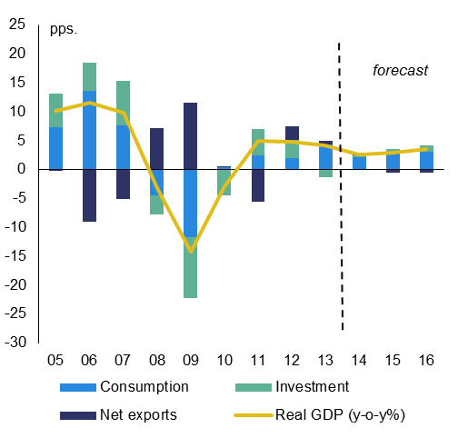
Source: European Commission
The sharp depreciation of the Russian rouble is hurting exporters. About 11% of the country's exports go to Russia. There is also some indirect exposure through other trading partners affected by the depreciation of the rouble. All in all, imports are set to rise faster than exports in volume terms but the current account deficit is likely to remain relatively small due to terms of trade gains.
Employment remained broadly flat in 2014 as the economic slowdown and external demand risks weakened labour demand and a shrinking labour force reduced labour supply. Real wages increased by nearly 15% on a cumulative basis in 2013-14 on the back of solid economic recovery since the crisis and the national minimum wage hikes. Nevertheless, unemployment is expected to keep falling, from around 11% in 2014 to 9.2% in 2016 amid a further contraction in the labour force and some rebound in labour demand. However, the projected increase in unit labour costs may pose a risk to Latvia's competitiveness in the medium term. The national minimum wage increases. While improving work incentives, it may also weaken demand for low-skilled labour in regions with low productivity.
Inflation is expected to remain low at 0.9% in 2015 and 1.9% in 2016, reflecting oil price effects. The disinflationary impact will be mostly through fuel and transport services in 2015, while lagged effects to natural gas and heating prices will affect the 2016 outcome as well. Nevertheless, inflation in 2015 is set to exceed the reported rate of 0.7% in 2014 as service prices are pushed up by the projected strong growth in wages. In addition, the deregulation of household electricity prices from January 2015 triggered a one-off hike after a long price freeze on the market.
Fiscal policies
The authorities demonstrate strong commitment to fiscal targets with the medium-term objective for a structural deficit of 1% of GDP being the main anchor for budgetary planning. The Fiscal Discipline Law entered into force and the Fiscal Discipline Council was created on 1 January 2014. Nevertheless, fiscal performance is still facing challenges. In particular, government revenues are exposed to economic risks stemming from the unstable geopolitical situation and to tax compliance risks linked to the large share of the shadow economy.
Graph 1.2: Latvia – general government debt and deficit
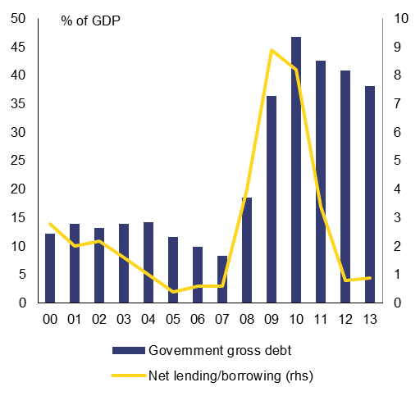
Source: European Commission
Fiscal policy is constrained by limited fiscal space for boosting investments in sectors where private incentives are insufficient. On the one hand, the government is committed to maintaining a low-tax environment to support private investment. On the other hand, large needs for spending on social protection, healthcare and education restrain government resources to invest in infrastructure and R&D, which are lagging behind EU standards. Facing external security risks, the government has recently committed to increasing its defence budget. This further limits its capacity to boost investment in other sectors.
The cost of debt refinancing has dropped substantially, helped also by Latvia's adoption of the euro in 2014. Latvia has favourable access to international bond markets. In January 2015, Latvia repaid EUR 1.2 billion to the European Commission, reaching a total repayment ratio of 75% of funds received under the financial assistance programme in 2009-11. Latvia has successfully completed the post-programme surveillance procedure. Future debt refinancing needs have decreased compared with previous years.
Shadow economy
The authorities recognise the need to tackle tax avoidance and thus unlock tax revenue potential. Compared with the Baltics and other Member States, the shadow economy accounts for a relatively large proportion of Latvia’s economy and there is a large gap between the country’s potential tax revenue under its existing tax laws and actual revenue collected. This is partly due to occasional tax avoidance by individual companies and households, but is also, and to a significant degree, the result of organised criminal activities (tax avoidance schemes, counterfeiting, smuggling, etc.). The situation worsened significantly during the crisis, but has improved since, aided by the authorities’ efforts to improve tax administration and cover gaps in the taxation system. The State Revenue Service is doing more risk analysis, using existing and new registers to limit possibilities to set up and operate fraudulent companies.
The 2015 budget relies on effective implementation of new improvements in the tax administration system. Further measures are planned, most notably changes to the public procurement law to be introduced in 2015, which require the main contractors and sub-contractors to have no tax debts and to have wage levels comparable to the industry average. In response to these improvements, the Latvian authorities report that organised crime groups tend to use more foreign residencies, often changing location and using sophisticated IT solutions. This complicates investigations and requires greater cooperation with international counterparts. In this context, inadequate resourcing and training of the professionals in tax administration and judiciary hampers their capacity to solve complex financial crimes.
Social assistance system
Benefit adequacy and coverage is low and activation and conditionality on benefit recipients is weak. While significant amount of analytical work was undertaken, there has been no progress on the ground. Implementation is planned for 2017 only and the planned changes are not backed by budgetary plans. On a positive note, the new social policy monitoring information system has been launched, making it easier to monitor social assistance benefits and services.
Labour market policies
The labour market situation is continuing to improve. Active labour market measures are being redesigned to reduce the overall share of public works and to increase the role of non-governmental organisations in implementing customised support such as mentoring and counselling for the long-term unemployed. However, tapping the full labour force potential of the pre-pension age unemployed, people with disabilities and social assistance benefit recipient will remain important. On outreach to youth not in employment, education or training, guidelines for mentoring and training are being drawn up and cooperation networks with municipalities are being established. However, visibility of the Youth Guarantee among the target groups remains low and the career guidance system is fragmented.
Graph 1.3: Latvia – labour market indicators
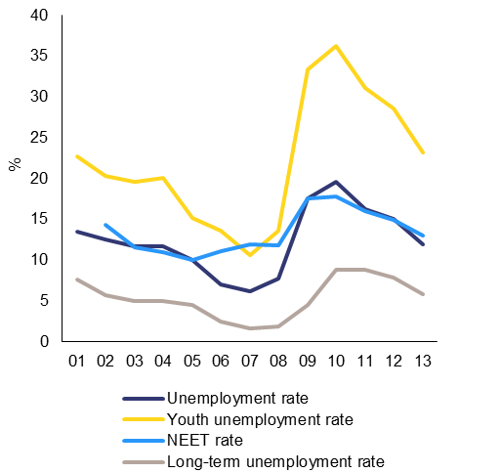
Source: European Commission
Healthcare system
Access to healthcare is hampered by low public healthcare financing and high out-of-pocket payments, leaving a large proportion of the population with unmet healthcare needs. The accessibility in hospital care leaves room for improvement, co-payments for pharmaceuticals are relatively high; there are shortages of healthcare access regionally and for the vulnerable groups, including long waiting times for specialist consultations and oncological diagnostics; sickness prevention and health promotion is insufficient, and performance incentives for general practitioners are lacking, deploy e-health applications are not sufficiently deployed a health care workforce strategy to address ageing, low salaries, and up-skilling is missing. Also, there is some scope for efficiency gains as regards pharmaceutical purchases and hospital transfers: e.g., related to the use of the diagnosis-related-group financing system.
Graph 1.4: Government expenditure on health as % of GDP (EU average and percentiles 25, 75; LV)
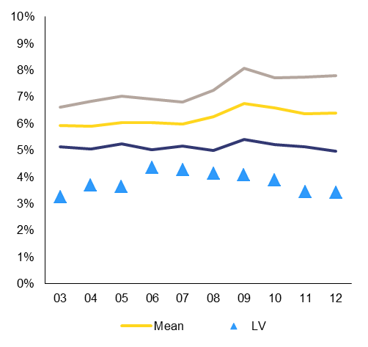
Source: WHO Health for All Database
Education reforms
The authorities are planning to create an independent national accreditation agency in 2015. The agency is to be included in the European Quality Assurance Register for Higher Education no later than 2018, i.e. before the next comprehensive accreditation round, which is scheduled for 2019. Proper control of the quality of the education on offer in public and private institutions has so far been lacking (only 30% of study places are publicly financed). Based on the recommendations from a recent World Bank study, a new higher education financing model supporting quality-criteria is being developed and some performance-oriented funding will be piloted in 2015. Other challenges include the governance of higher education institutions, a restricted use of EU foreign languages in teaching, and the access to the student-loan system.
While the consolidation of the VET network is in its final stages, the curricula reform needs more emphasis. Less than half of the profession standards, planned modular programmes, and contents of the qualification exams have been updated and the reform is stretched out until 2023. The quality of work-based learning and apprenticeship type schemes, especially in technology and engineering remains a challenge. In 2015 Latvia will need to finalise a comprehensive vocational education and training law. It will also need to finalise secondary legislation on work based learning and formalised involvement of sectoral councils. Motivating companies, especially SMEs, to provide quality work-based learning placements remains problematic.
An independent external evaluation of the relevance of Latvia's scientific output has been published by the Nordic Council and seems to be serving as a basis for determining which institutions are to be merged or shut down and which are eligible for more EU and national funding. These are positive developments.
Energy policies
After several delays, full electricity market opening took place on 1 January 2015. Prices on the wholesale market in the Latvian-Lithuanian price zone remain on average higher than in Estonia and less stable. The Estonian-Latvian connection is still heavily congested and no changes are to be expected in 2015. To alleviate the situation, Transmission System Operators will be offering more transmission capacities. By the end of 2015 the situation is likely to improve as Nordbalt, the Swedish-Lithuanian interconnector, will be completed, thus bringing lower Swedish prices to the Latvian-Lithuanian price zone and relieving congestion on the Estonian-Latvian connection.
Latvia's 'emergent gas market' exemption has expired and the respective legislation to address obligations has been partly put in place. Third party access rules for the transmission grid and the Incukalns gas storage facility need to be laid down in secondary legislation. Latvia's exemption as an isolated gas market still stands, so Transmission System Operator unbundling will need to be completed by April 2017, making the monopoly's transmission and distribution infrastructure accessible to new supplies.
Latvia's progress towards the 2020 renewable energy target has slowed. At the same time, a moratorium on granting new permits for the renewable energy support scheme will continue until 2016. There are concerns about high reliance on imported gas in district heating, especially in Riga.
Transportation infrastructure
Some progress has been achieved on the Rail Baltic European-gauge railway infrastructure project, which is subject to funding from the Connecting Europe Facility. In view of political sensitivities, there has been little action to improve Riga and Ventspils ports' operational management, transparency, and regional competitiveness, as supported by 2014 World Bank and State Audit analysis.
In 2014, around half of roads in Latvia were in a poor condition. The 2014-20 road funding programme relies mostly on the EU funding. It is therefore important to develop a viable long-term funding mechanism with additional national financing. The number of road fatalities per million inhabitants remains one of the highest in the EU.
Judiciary
The efficiency and quality of the judicial system has improved during the last year, though challenges remain. The current codes of civil, administrative and criminal procedures hamper a fast progress of cases. The insolvency law is not properly implemented, hampering the accountability of insolvency administrators. A comprehensive human resource policy is lacking and there is room to strengthen the role of the Judicial Council and judges in implementing judicial reform. There has been good progress on reforming arbitration courts and mediation, but room for further steps exists. Significant EU funding will be allocated for the training of investigators, prosecutors and judges in the 2014-20 financing period.
Public administration
In 2014 the Cabinet of Ministers adopted a Public Service Law. However, the law may face significant resistance in parliament and local government will be exempted from it. Centralised selection of senior public officials is due to start in September 2015. Insufficient pay compared to the responsibilities and private sector salaries result in relatively high staff rotation: this has a negative effect on the public administration quality and capacities.
The framework law on the management of state owned enterprises was adopted in October. The actual implementation, including adopting the necessary secondary legislation and putting in place a centralised state owned enterprises manager, is however still due.
There has been no progress on the Competition Council's proposals for amendments to the Competition Law. Under the Competition Council's proposal, it would have greater institutional and financial independence to take effective action against public bodies restricting competition and to prevent experienced staff from leaving.
Box 1: Economic surveillance process

The Commission’s Annual Growth Survey, adopted in November 2014, started the 2015 European Semester, proposing that the EU pursue an integrated approach to economic policy built around three main pillars: boosting investment, accelerating structural reforms and pursuing responsible growth-friendly fiscal consolidation. The Annual Growth Survey also presented the process of streamlining the European Semester to increase the effectiveness of economic policy coordination at the EU level through greater accountability and by encouraging greater ownership by all actors.
This Country Report includes an assessment of progress towards the implementation of the 2014 Country-Specific Recommendations adopted by the Council in July 2014. The Country-Specific Recommendations for Latvia concerned public finances and taxation, social assistance and healthcare, education and research, energy connections and public administration and judiciary.

Table 1.1: Key economic, financial and social indicators - Latvia
1 Domestic banking groups and stand-alone banks.
2 Domestic banking groups and stand-alone banks, foreign-controlled (EU and non-EU) subsidiaries and branches.
3 Real effective exchange rate
(*) Indicates BPM5 and/or ESA95
Source: European Commission; ECB

Table 1.2: Macroeconomic Imbalances Procedure scoreboard indicators
(1) Figures highlighted are those falling outside the threshold established in the European Commission's Alert Mechanism Report. For REER and ULC, the first threshold applies to euro area Member States.
(2) Figures in italics are calculated according to the old standards (ESA95/BPM5).
(3) Export market share data: total world exports are based on the fifth edition of the Balance of Payments Manual (BPM5).
Source: European Commission

Fiscal Policy
The authorities are committed to a prudent level of government borrowing. The 2015 budget targets a nominal deficit of 1% of GDP. The new spending measures of 0.6% of GDP are largely financed from a revenue-effort of 0.5% of GDP. The main thrust of the revenue effort is concentrated on improving tax compliance through better information exchange between government bodies and addressing some rigidities in excise taxation. Moreover, the authorities expect a positive revenue effect from the January 2015 increase in the national minimum wage from EUR 320 to EUR 360 and have decided to maintain the requirement for the state-owned enterprises to pay 90% of their dividends to the government in 2015. The main spending increases are in the health, education, defence and agriculture sectors. The increase in the national minimum wage implies wage increases for low-paid state employees.
The authorities are committed to reducing the fiscal deficit to below 1% of GDP over the coming years. A nominal deficit of 1% of GDP is targeted in 2015, followed by 0.9% in 2016 and 0.7% in 2017. However, the underlying fiscal situation has deteriorated, due the softening of economy activity leading to lower tax revenue. This implies reduced fiscal space for the many public service needs, which are not fully reflected in the medium-term expenditure plans.
Medium-term expenditure plans remain tightly constrained, putting their credibility at risk in the face of mounting spending pressures. After a period of tight budget control and expenditure cuts during the crisis, the authorities have allowed some nominal expenditure increases in priority areas and resumed partial pension indexation in 2014. However, the expenditure plans still assume that a wide range of existing government programmes will be discontinued and that only the minimum level of public services will be maintained. This will mean the compression of the government expenditure relative to GDP, in particular in capital spending, the wage bill and public purchases of goods and services. Moreover, measures aimed at expanding the social safety net, ensuring adequacy of pensions and competitive wage levels in the public sector and facilitating reforms in health and education are not fully accounted for in the medium-term expenditure plans. Decisions are therefore postponed to the time of the annual budget preparation. In several cases this might mean that some reform priorities never obtain financing or are overruled by short-term interests.
Taxation
Latvia has a high tax burden for low-income earners and tax compliance is weak. The overall tax burden of 28% of GDP in 2012 is well below the EU average of 40% (Graph 3.1.1). The tax system is characterised by limited taxation of capital and high reliance on consumption and labour taxes in terms of total revenue. The tax wedge for low-income earners, standing at 43.1% for single persons earning 67% of the average wage, was above the EU average of 36.6% in 2013 (Graph 3.1.2). Within Latvia's flat-rate tax system, the only element of progressivity is the basic personal income tax allowance, which is one of the lowest in the EU, including the Baltic States. The high tax wedge for low-income earners also undermines employment in the formal economy. Undeclared work was estimated to account for 13% of GDP in 2013. () A Eurobarometer () survey shows that the prevalence of envelope (underreported) wages in Latvia is the highest among the Baltic States and in the EU as a whole, while working without contract is less common. Tax avoidance also affects VAT revenue: the estimated gap between potential and actually collected VAT revenue was almost 5% in 2011, which was among the highest rates in the EU (Graph 3.1.3).
Graph 2.1.1: Tax revenue to GDP, 2012
Source: Taxation trends in the European Union, 2014

Graph 2.1.2: Tax wedge for a single person earning 67% of the average wage, 2013
Source: Taxation trends in the European Union, 2014

Graph 2.1.3: VAT gap, 2011 (1)
(1) A difference between the theoretical VAT liability and the actual VAT revenue collected.
Source: Study to quantify and analyse the VAT Gap in the EU-27 Member States, European Commission, 2012
Latvia has made some progress in reducing the tax burden, but not all measures are targeted at low-income earners. In 2014, an increase in the basic personal income tax allowance and the allowance for dependants reduced the tax wedge for households with children significantly. At the same time, all income groups benefitted from a reduction by 1 pp. of the combined social security contribution rate. () Nevertheless, the tax wedge for single earners without children remains high and acts as a disincentive for getting low-wage workers into formal employment. In 2015, the personal income tax rate was reduced from 24% to 23% and the national minimum wage rose from EUR 320 to EUR 360 per month. However, an across-the-board personal income tax reduction implied only a marginal gain for low-wage earners, while being more beneficial to middle and high-income earners (Graph 3.1.4), for whom the tax wedge is already relatively low. The 2014 social security contribution rate reduction had a more equal income distribution (Graph 3.1.5) (), while fiscal costs were similar to the personal income tax reduction ().
Graph 2.1.4: Distributional effect of PIT rate reduction by 1pp
Source: European Commission, Joint Research Centre, based on the EUROMOD model

Graph 2.1.5: Distributional effect of SSC rate reduction by 1pp (1)
(1) Divergences for the second and sixth decile relative to other income groups are related to (i) shifts in composition of the decile (e.g. moving from the first decile to the second and thus lowering the average for it) and (ii) loosing eligibility to means-tested benefits.
Source: European Commission, Joint Research Centre, based on the EUROMOD model
Latvia announced a plan for a progressive personal income tax basic allowance in 2016. The intention is to introduce progressive differentiation of the personal income tax basic allowance for three income thresholds, e.g. increasing the basic allowance for low-income earners, keeping the allowance for middle-income earners unchanged and setting it at zero for high-income earners. This measure would increase the progressivity of labour taxation, but the full extent of the effect on the tax wedge for low-income earners is not yet clear. In general, an increase in the basic personal income tax allowance would decrease the tax wedge for low-income single earners. ()
The increase in the national minimum wage supports low-income earners and could increase incentives to work, but may put at risk the viability of some low-wage jobs, especially in regions with lower productivity. The minimum wage increase is also seen as a revenue-increasing measure because it reduces the prevalence of envelope wages. () However, some low-wage jobs may become non-viable or working time may be underreported thus circumventing the measure. Around 29% of registered employees earn a minimum or below minimum wage (including 6% working without a wage) () and are likely to be affected by the minimum wage increase. The minimum wage increase does not change the tax wedge, but allows low-income earners with dependents to benefit from tax allowances through a higher take-home wage. A single earner on the minimum wage with two children does not pay personal income tax and still has unused allowances. ()
Graph 2.1.6: Tax wedge reduction between 2013 and 2014
Source: Latvian Ministry of Finance
The authorities want to raise the tax-to-GDP ratio to 30% of GDP. However, under the current plans the tax burden is projected to fall from around 28% of GDP in 2015 to around 26% in 2017. To meet the target, the authorities put strong emphasis on improving tax compliance, while leaving open a second option of increasing taxes on consumption, natural resources and property. The tax revenue target of 30% of GDP is important for the sustainable financing of public services, as public spending in several sectors was reduced to a minimum during the fiscal adjustment period.
Improving tax compliance is among the authorities' top priorities. The 2015 budget included a number of measures to improve tax compliance, amounting to some 0.2% of GDP. Moreover, the Latvian tax administration is active in fighting tax fraud and avoidance schemes set up by criminal groups. The tax administration is conducting sectoral examinations, ensuring a balanced improvement in tax compliance in problematic sectors. Although recent indicators on the undeclared economy suggest an improvement as compared with the economic crisis period, the level of tax avoidance is still high relative to that in other Member States. Achieving the planned revenue targets depends on the efficiency of the tax administration and broad public acceptance of culture of paying taxes. Resources and training of the professionals in the tax administration and judiciary seem not fully adequate to strengthen their capacity to solve complex financial crimes. Sanctions applied by the judiciary in tax fraud and evasion cases seem inadequately dissuasive.
Environmental taxes have significant potential to generate revenues and facilitate resource efficiency. Environmental tax revenue accounted for 2.4% of GDP in 2012, with the biggest contribution coming from taxes on transport fuels (1.8% of GDP). Other taxes on pollution, resource use and transport (excluding transport fuels) amounted to 0.58% of GDP in revenue. Changes in excise duties and environmental taxes introduced in 2014 had a modest fiscal effect and limited impact on producer and consumer behaviour. Very small changes in the 2015 budget focus only on reducing rigidities in excise taxation, including a decrease in fuel-related energy subsidies. Taxes relating to waste management appear ineffective in diverting waste from landfill to recycling. Moreover, there is no indexation of excise or environmental taxes, and their real value and impact will fall over time.
Existing tax measures appear to be insufficient to improve energy efficiency in the transport sector. Transport accounts for the largest proportion of Latvia's greenhouse gas emissions (26% in 2012). Even though vehicle registration tax is linked to CO₂ emission, new cars in Latvia had the highest CO₂ emission per km in the EU in 2013. Only around 40 electric vehicles were registered in Latvia in 2014. Corporate passenger cars continue to benefit from VAT deductions on both their purchase price and operating costs ().
A 2015 study () suggests that environmental taxes could generate substantial additional revenue in Latvia. Ensuring an equal treatment of all fuel types based on their energy content and emission levels could generate 0.8% of GDP in revenue by 2025. Increased taxation of the use of resources, water and of waste management and air pollution could generate an additional 0.4% of GDP in revenue in 2017, rising to 0.5% in 2025. The landfill tax for municipal waste is one of the lowest in the EU: increasing it would facilitate recycling and divert waste from landfills.
Property taxes also provide scope for a growth-friendly tax shift. Property taxes accounted for 0.9% of GDP in revenue in 2012, well below the EU average of 2.3% of GDP. Since 2013, local governments have been able to set annual property tax rates from 0.2% to 3% of the value depending on the property type and use ().Local government can also grant tax rebates to vulnerable social groups. Decentralised property taxation at local government level poses difficulties for efficient tax administration: e.g., some local governments engage in tax competition attracting new residents and gaining from their income tax payments. The transparency of tax administration is low and the reports from the State Control have revealed shortcomings in accounting for all properties, the application of tax rates that were lower than mandated, reluctance to deal with tax arrears and insufficient use of public registers to check eligibility for tax rebates. Cadastral values used for property taxation are annually updated based on market values. However, given the steep increase in the updated cadastral values, the authorities are considering capping property tax increases for land and forests in 2016.
Long term sustainability
Latvia does not appear to be facing medium- and long-term sustainability challenges. Government debt (38.2% of GDP in 2013) is below the Treaty () threshold of 60% of GDP and it is projected to stay broadly stable until 2030, assuming no further policy changes are made. In the long-term, age-related public expenditure is projected to fall as the funded pension schemes will increase their share. However, the adequacy of future pensions is estimated to decline (), thus representing a risk of current policies being reviewed, which could have an impact on future sustainability.
The privately managed/funded pension scheme will gradually take over part of the pension obligations from the public pension scheme and reduce risks to future pension sustainability. In order to finance future public expenditure related to population ageing, Latvia increased contributions to the funded pension scheme from 2% to 4% of gross wages in 2013, and to 5% in 2015. In 2016, the rate will rise to 6%. The retirement age went up in 2014 by three months from 62 years and will go up by a further three months each year, reaching 65 years in 2025. However linking the retirement age or benefits with life expectancy is not intended. The minimal contribution period to secure a full pension was increased from 10 to 15 years (expected to reach 20 years by 2025).
Fiscal framework

The implementation of the domestic fiscal framework is well advanced. The fiscal discipline law entered into force in 2013 and the Fiscal Discipline Council was created on 1 January 2014. The Medium-Term Objective is the cornerstone for budgetary planning, including for the 2015 budget ().
The Fiscal Discipline Council has started working. The Council found that the 2015 budget complied with the fiscal rules and was based on a plausible, although slightly optimistic, macroeconomic forecast. The first fiscal monitoring report includes several recommendations to the government, in particular in the area of taxation. The Council supports the government's objective of a tax-to-GDP ratio of 30% of GDP to ensure sustainability of public services, and agrees with the significant revenue potential that could be obtained by containing the shadow economy. The Council has issued one irregularity report and one opinion to the government and the parliament, flagging decisions that appear to breach the fiscal discipline law. The Council puts its reports and the authorities' replies on its website. ()
There is some ambiguity around the requirement in the fiscal discipline law for an independently endorsed macroeconomic forecast. The main macroeconomic developments underpinning the budget are agreed with the Bank of Latvia, which is an independent institution. However, the agreement itself and the underlying justifications are not public. Other experts from the Ministry of Economics, commercial banks and international organisations are also consulted on the forecast. In addition, the Fiscal Discipline Council expresses its view on the macroeconomic projections underlying the budget, providing thus some ambiguity on the respective roles of institutions.

Investment Labour productivity currently stands at 57% of the EU average. in human capital plays Labour productivity currently stands at 57% of the EU average. a crucial role in achieving convergence with the average EU labour productivity level, (Latvia's productivity stands at around 60% of the EU average) (). Latvia has made progress over recent years in improving the supply of skills, as borne out by improving Programme for International Student Assessment scores under the OECD Programme for International Student Assessment (above above International Student Assessment OECD Programme for International Student Assessment Programme for International Student Assessment OECD Programme for International Student Assessment OECD Programme for International Student Assessment OECD Programme for International Student Assessment PISA) OECD Programme for International Student Assessment OECD Programme for International Student Assessment, rising tertiary attainment and a Programme for International Student Assessmentdeclining early school leaving rate. A number of challenges remain, such as the low proportion of employment in knowledge-intensive sectors, low adult participation in lifelong learning and poor provision of in-company training (). Employers report serious difficulties in finding employees with the right skills (). There is also evidence of bottleneck vacancies in sectors such as metal processing, machinery, IT, road hauling, food processing, health care and textiles (). However, the lack of the necessary skills may not be the only factor, as difficulties in filling vacancies may also be linked to poor working conditions (such as salaries and training). Replacement demands may result in future labour shortages emerging in healthcare, science and engineering ().
Latvia’s tertiary education attainment rate has increased to 40.7% in 2013, which is well above the EU average of 36.9%. Women clearly outperform men: 53.1% as compared with 28.3% in 2013. While it has increased significantly in the last five years, the proportion of university graduates in the science, technology, engineering and mathematics is below the EU average (18.8% compared with 22.8% in 2012). Encouragingly, the authorities have continued a gradual reallocation of publicly-funded study places to prioritise science, technology, engineering and mathematics over social sciences. Also, according to the Ministry of Education Strategy for 2014-2020, a diagnostic test in physics and chemistry for the eighth to eleventh grade pupils is to be introduced from 2016 on pilot basis, with mandatory exams for high school graduates to commence in 2017.
School outcomes are rather positive on average but they mask large gender and regional differences. While the overall early school leaving rate has been decreasing since 2008 and reached 9.8% in 2013, there were only 5.8% school-leavers among girls compared with 13.6% among boys. Similarly, the performance of 15-year-olds’ in the 2012 PISA in reading, mathematics and science is above the EU average, although girls significantly outperform boys in reading and science (Graph 3.2.1). PISA 2012 results also show significant regional differences. Schools in the Riga area perform close to the best EU countries, while schools in rural areas lag behind (). Also, there have been some concerns as regards the quality of teaching in bilingual public schools, as teachers there sometimes have limited knowledge of the Latvian language ().
Graph 2.2.1: Share of low achievers* in PISA 2012
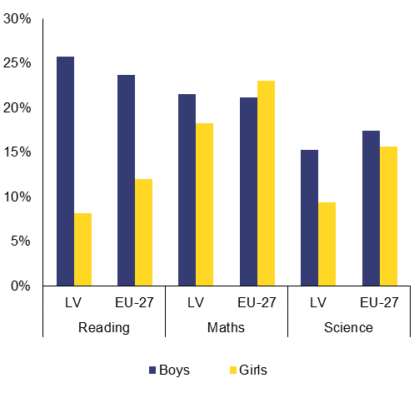
*15 year-olds performing below PISA level 2
Source: OECD
The main challenges in higher education are an inadequate public funding system, low levels of internationalisation and a lack of internationally-approved accreditation. Public expenditure per student is among the lowest in the EU, and the present financing model lacks performance-oriented components (Graph 3.2.2). On a positive note, a new quality-targeting financing model is being developed, based on the recommendations from a recent World Bank study (), and some performance-oriented funding will be piloted in 2015. While the number of international students (including the Erasmus programme) increased by 15% in 2013-14 and represents 5.9% of the total number of students, the present financing model provides no incentive for internationalisation. One of the reasons why foreign teaching staff is not being attracted is that there are specific language requirements for professorships Finally, accreditation procedures are not based on an independent assessment of the quality of higher education. The government plans to designate the Academic Information Centre () as its independent national accreditation agency. It will be included in the European Quality Assurance Register for Higher Education in 2018 at the latest, i.e. before the next big accreditation round, which is scheduled for 2019. Moreover, the quality of academic staff will be improved by amendments being drawn up to improve how professors’ qualifications are assessed. Under the new compulsory criteria, professors will have to have a minimum number of international publications and a sufficient knowledge of foreign language(s).
Graph 2.2.2: Public expenditure per tertiary student as a share of GDP per capita (2011)*
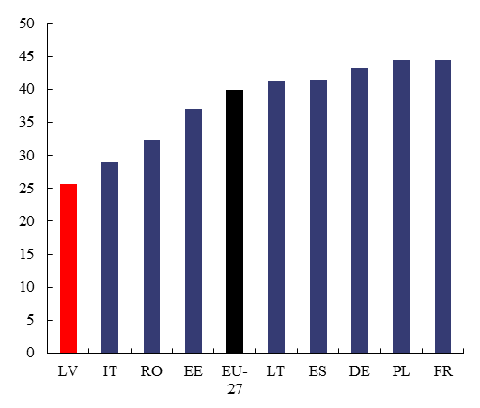
*Measured in purchasing power standards (PPS), Latvia spent PPS EUR 5506 per student in 2011, compared with an EU average of PPS EUR 9947. This was only 25.7% of Latvian GDP per capita, while the EU-average was 40%
Source: Eurostat, UOE database
Overall, higher education reforms are regaining some momentum. The success of reform depends on proper control of the quality of education on offer, both in public and private institutions, and on adequate funding to promote the system's innovation capacity and internationalisation.
The attractiveness of vocational education and training and its apprenticeship component remain a challenge. Enrolment in vocational education and training -oriented upper secondary school programmes is among the lowest in the EU. Eurobarometer surveys () have shown that vocational education and training has a poor image overall. For instance, the proportion of people that agree with the statement that vocational education and training provides high quality learning is well below the EU average. Tthe apprenticeship component is insufficiently expanded. For example, a proper legislative framework regulating relationships between the apprentice and company (e.g. on pay and training requirements) and effective incentives for companies to provide apprenticeships or practical training placements are missing.
While the consolidation of the vocational education and training network is in its final stages, curricula reform needs more work. Less than half of the profession standards, planned modular programmes, and contents of the qualification exams have been updated and the reform is due to continue out until 2023. In August 2014, the government adopted amendments to the Vocational Education Law (to be approved by parliament). In these, the role of sectoral expert councils in developing of curricula, examination content and organising work-based learning is clearly stated. The creation of new structures (convents) is foreseen to strengthen the role of employers and other stakeholders in vocational education and training governance. The amendments will also link vocational education and training qualification levels to the national and European qualification levels. () The scope of work-based learning, piloted in 2013, will be increased in 2015; however, the coverage is expected to remain insufficient.
Inadequate public funding in a fragmented research and innovation system is leading to poor scientific outcomes (). An adequate quality of the science base is a necessary precondition for improving cooperation between businesses and academia, and for leveraging private investment. In that context, the efficiency of public spending leaves clear room for improvement. Latvia invested only around 0.6% of GDP in R&D in 2013 - the third lowest level in the EU. Public R&D intensity reached only 0.43% of GDP in 2013 and remains excessively dependent on EU structural funds. Even though business R&D intensity increased slightly to 0.17% of GDP in 2013, it remains clearly below the EU average of 1.29%. Co-operation between businesses and academia remains very limited.
Graph 3.2.3: R&D intensity projections, 2000-2020*
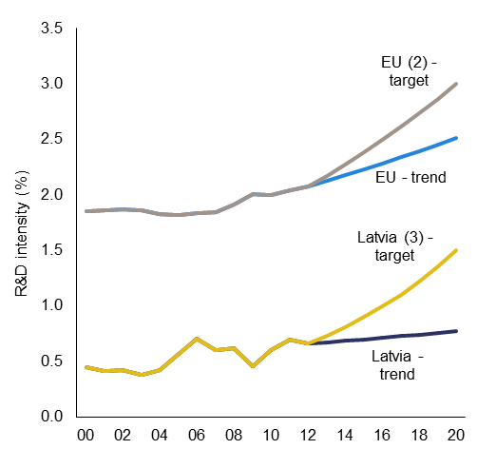
*The R&D intensity projections based on trends are derived from the average annual growth in R&D intensity for 2007-2012. (2) EU: The projection is based on the R&D intensity target of 3.0% for 2020. (3) LV: The projection is based on a tentative R&D intensity target of 1.5% for 2020.
Source: European Commission DG Research and Innovation
The authorities are in the process of reforming the research and innovation system. Incentives have been introduced for research institutions to merge in line with the Smart Specialisation Framework. Following external evaluation of research performance, a new institutional funding system is being introduced to allocate more resources to institutions assessed as excellent at international level. Research institutions have been requested to prepare medium-term strategies as a precondition for public financing. The implementation plan of the Smart Specialisation Framework and a clear monitoring mechanism, part of the ex-ante conditionality for European Structural and Investment Funds, is due by July 2015.
Competitiveness of the private sector is hampered due to a lack of knowledge transfer policies and instruments: e.g. public-private partnerships, support systems such as clusters, innovation vouchers, and technology transfer points. The economy is dominated by small and medium-sized enterprises and Latvia remains specialised in sectors with low and medium-low research intensity, such as metal processing and machinery, wood products and food processing. However, the country is slowly developing a more knowledge-intensive industrial sector. A corporate income tax incentive to promote research and development spending was introduced in July 2014.
Latvia has made some efforts to promote innovation. However, there is room for optimising innovation structures and capacities on the basis of the Smart Specialisation Framework and improve its innovation governance. According to the Innovation Union Scoreboard 2014 (), Latvia ranks 27th among the EU-28 as regards innovation performance. Together with Bulgaria and Romania, Latvia forms the so-called group of ''modest innovators'' (innovation performance level less than 50% of the EU average). Relatively few SMEs are involved in innovative activities (e.g. Latvia ranks 28th among the EU-28 for the sales of new-to-market and new-to-firm innovations as % of turnover and 26th for the contribution of high-tech and medium-tech products to the trade balance as % of total exports plus imports of products) ().
Latvia's key challenges include a weak social security system and a shrinking labour force. Low coverage and adequacy of unemployment and social assistance benefits prevents effective action on reducing poverty, social exclusion risks and the high degree of inequality. Social assistance reforms are still at an early stage. Activation efforts for social assistance beneficiaries remain limited and coverage of active labour market measures is too low. Ensuring sustainable labour market integration of young people, notably those with low levels of education and no work experience, remains a challenge. A comprehensive career guidance system is lacking.
Social protection
Social expenditure has little impact on poverty reduction due to overall low levels of spending () and the dominance of insurance-based benefits. In 2014, around 32.7% of Latvia's population were at risk of poverty or social exclusion and income inequality remains among the highest in the EU (). Single working parents are exposed to a high poverty risk. () Poverty rates for young adolescents and elderly show worrying trends. () The growing proportion of recipients of the low minimum pension () (11% of newly granted pensions in 2011 to 17% in 2013) requires particular attention. The elderly are also the most exposed to the risk of unmet medical care needs. The high level of housing deprivation () (38.3% in 2013; the 2nd highest in the EU) is also a cause for concern. The depth of poverty is also high, thus underlining the need for an effective social assistance. ()
The unemployment () and social assistance () benefits are characterized by poor benefit adequacy and coverage. The recent State Audit report identified serious flaws in the social assistance system and its governance.
Graph 2.3.1: Non-coverage of social benefits*
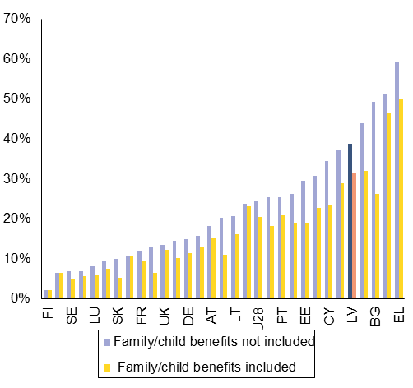
*Proportion of 18-59 years old individuals living in jobless households at risk of poverty, whose total social transfers equal to less than 10% of disposable household income Source: European Commission
The social assistance reforms have not advanced since the country specific recommendation was made in 2011, although a significant amount of analytical and planning work has been undertaken. In 2014, the authorities presented plans to increase the minimum income level and revise its equivalence scales from 2017. () It is also planned to increase minimum unemployment benefits and pensions, increase means-testing for state social benefits and reduce labour taxes for low wage earners. Aside from the lengthy implementation timeline, the planned changes would significantly increase several benefits, but are not backed by budgetary plans. While the 2015 budget provides increases in social protection expenditure (), no additional funding was allocated for social assistance. In September 2014, Latvia launched a new social policy monitoring information system, which will allow for improved monitoring of social benefits and social services. However, it is too early to assess its impact on the quality of policy making.
Labour market participation
The main labour market indicators continue to improve, against the backdrop of a shrinking labour force. At 70.6%, Latvia's employment rate for the people aged 20-64 is slightly above the EU average. The unemployment rate has fallen sharply, but remains above 10% in early 2015. In the last ten years Latvia's population has decreased by 12%, which is the second highest decrease in the EU after Lithuania's, as a result of low birth rates (), high death rates, and strong emigration. () Employment rates have improved across all population groups; however there is scope for increasing employment for elderly, people with disabilities () and people living in disadvantaged areas. Nominal unit labour cost growth was 7.3% in 2013 and a cumulated growth over the past three years reached 10.5%. The high growth rate relative to other Member States reflects some readjustment after a strong decline during the crisis period and is supported by a stronger economic growth than elsewhere.
Graph 2.3.2: Evolution of population and working age population, 2014-2050 (Index 2014=100)
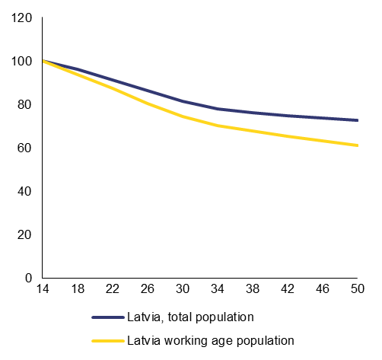
Source: European Commission
Preventing youth unemployment and its negative long-term consequences is critical given the serious demographic challenges. Youth unemployment rate () and number of young people not in employment, education or training have decreased, but are still relatively high. Fewer than half of the young people not in employment, education or training are registered with the public employment services. () The supply of quality apprenticeships is insufficient. Youth Guarantee measures have started slowly in 2014, but it is too early to assess the number of quality offers for young people within a four month period. Overall, awareness of the Youth Guarantee among target groups is low. Latvia is preparing youth outreach measures to reach the young people not in employment, education or training not registered at the Public employment service. This is a new initiative and the fieldwork is expected to start in spring 2015.
The provision of career guidance services is weak () and fragmented. The incentives in the provision of career guidance are not well aligned to ensure that the advice provided is in the best interest of the students. Currently, the general education schools that provide career guidance services have strong incentives to keep the students in their school. There could be some risk that other career options, such as vocational education and training, might not be sufficiently explored.
The financing and coverage of active labour market policies remains low in comparison with other EU countries. In 2012, only 5.6 out of 100 persons wanting to work were covered by active labour market policies (), while only 2 out of 100 persons wanting to work were covered by training programs. The funding for active labour market policies and training of unemployed adults () has been reduced for 2014 and 2015 faster than the decline in number of unemployed, while the cost of most measures has gone up. Thus, the active labour market policy coverage is expected to remain low. () The public works program has made up a large share of the overall active labour market policy package; however, starting from 2015 the program will be reduced.
Bringing social assistance clients into the labour market is a challenge due to inadequate cooperation between social and other services. Many of the long-term unemployed have poor health, addictions, low motivation and caring obligations, which require flexible and innovative support programmes. A new programme for the activation of the long-term unemployed is planned to be implemented in 2015, with an increased role for non-governmental organisations and strengthened cooperation with social, healthcare and other services.

The Latvian health system suffers from low public financing and high out-of-pocket payments, leaving a high proportion of the population with unmet healthcare needs. Both public healthcare expenditure per capita and total healthcare expenditure are among the lowest in the EU (). At the same time, a relatively low proportion of health expenditure is allocated to public health, such as disease prevention programmes.
Graph 2.4.1: Public health expenditure as % total health expenditure (EU average and percentiles 25, 75; LV)
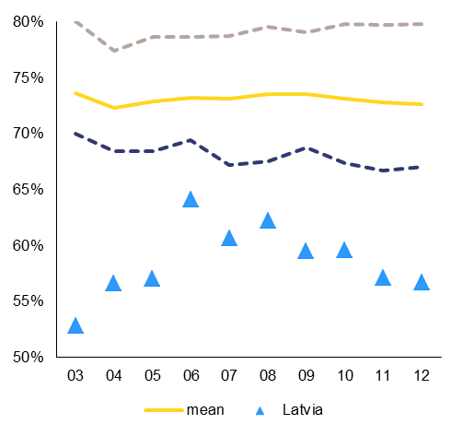
Source: WHO Health for All Database
Unmet needs for medical care for reasons of costs are the highest among EU Member States. Moreover, a relatively high incidence of bribes and informal payments is a cause for concern as costs are already a significant barrier to equitable healthcare access. () Headline population health status indicators, such as life expectancy, are low and high mortality rates among the working-age population aggravate demographic challenges. The death rate at working age (i.e. between 20 and 64 years) is the second highest in the EU, giving rise to an estimated 3.9% reduction in Latvia’s workforce in 2012. ()
Graph 2.4.2: Self-reported unmet needs for medical examination by reason
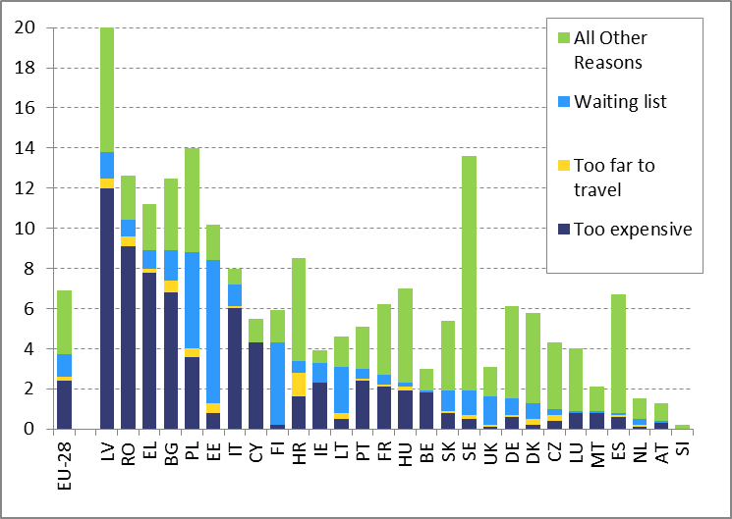
Source: European Commission
Additional funds were made available in 2014 to improve the accessibility of healthcare services, but this is unlikely to translate into significant improvements. The additional financing was used to slightly lower patient co-payments, reduce waiting times for specialist consultation visits, finance additional oncology diagnostics and laboratory examinations, and increase salaries of the lowest paid healthcare personnel (mostly due to an increase in the minimum wage). The Ministry of Health wants to further increase financing for outpatient services; decrease co-payments for medicines and hospital care. It also wants to increase the number of residency places, especially in rural areas; strengthen the gatekeeping role of general practitioners; and implement e-health applications. This would be in line with the Council recommendation. Also, the Public health strategy for 2014-20, adopted in October 2014 is a step in the right direction.
Adequate and stable medium-term financing to address the challenges and speed up reforms in the healthcare system is not guaranteed. Healthcare access for vulnerable groups is restricted. Primary care and referral systems are not sufficiently strong; clinical guidelines are not in place; waiting times for specialist consultations and cancer diagnostics are relatively high; performance incentives for general practitioners are insufficient; there is a lack of sickness prevention and health promotion; a healthcare workforce strategy to address ageing, shortages, low salaries and skills is not in place. At the same time, there is scope for efficiency gains in hospital transfers, e.g. related to a diagnosis-related-group-based financing system in hospitals and deployment of e-health applications. Also the accountability and transparency of the management of hospitals is a matter of concern. The infrastructure mapping exercise, to be elaborated by July 2015, could be the basis for any decision on Structural Funds-financed infrastructure investments.

After several delays, full electricity retail market opening took place on 1 January 2015. Twelve operators are now selling electricity, including four to households, and some 0.5% of households have switched their electricity provider. Vulnerable customers (around 100 000) will continue to profit from a regulated tariff. Prices on the wholesale market in the Latvian-Lithuanian price zone are still on average higher and less stable than in Estonia due to continued transmission congestions on the Estonia-Latvia border and possible capacity reservation on Lithuania's border with Belarus. The Transmission System Operators are starting to offer more annual capacities, thus increasing market flexibility.
The Swedish-Lithuanian interconnector Nordbalt is expected to be completed in late 2015. This could bring lower Swedish prices to the Latvian-Lithuanian price zone and relieve congestion on the Estonian-Latvian connection. A positive price effect may also come from the completion of the link between Lithuania and Poland in 2016. Construction works on Latvia's third electricity interconnection with Estonia and the third stage of Kurzeme Ring electricity network connection are due to commence in 2015. Work towards the synchronisation of the Baltic States electricity flows with the rest of the Continental Europe Network is ongoing and may require major financial resources.
Latvia's 'emergent gas market' exemption has expired and the relevant legislation to address obligations has been partly put in place. As a first step, the Third Party Access rules for the transmission grid and the Incukalns gas storage facility need to be laid down in secondary legislation. Proposals for Third Party Access rules and associated tariffs will need to be endorsed by the national regulator. Third Party Access rules will partly determine to what extent the Klaipeda LNG terminal can play a regional role). Latvia's exemption as an isolated market still stands, so the Transmission System Operators unbundling will need to be completed by April 2017. This will make the current monopoly's transmission and distribution infrastructure accessible to potential new supplies. The authorities will need to complete the legislation opening up the gas market in 2015 so that Latvijas Gaze could start gradual unbundling from 2016. In parallel, Incukalns gas storage infrastructure ownership and future storage management issues will need to be settled.
Latvia has delayed adoption of the Energy Efficiency Law and implementation of the EU energy efficiency obligation scheme. () There is little clarity and significant delay as regards setting-up the proposed National Energy Efficiency Fund to finance renovation of buildings. Also, the energy services market and energy service companies' projects still need to be developed, as required by the Directive 2012/27/EU. As regards renewable energy support, prolonged uncertainty owing to the moratorium on the renewable energy support scheme has a negative effect on investment decisions in this sector and may affect prospects for meeting the national renewable energy support target of 40% by 2020. At the same time, decoupling the renewable energy support support scheme from subsidies to fossil-fuel-based co-generation plants and bringing it in line with the new State Aid rules could both - reduce the cost of scheme considerably and increase security of supply through investments in additional renewable energy support capacity in the heating sector.
An increase in reuse and recycling could improve resource efficiency. However, significant investments in infrastructure, improvements in market instruments (extended producer responsibility, taxation facilitating investment in line with the waste hierarchy) and the regulatory framework are still needed to ensure separate collection of certain waste streams and improve recycling rates, including of biodegradable waste (composting). Even though municipal waste generation in Latvia remained below the EU average (), its main treatment option remains disposal in landfills (). It is unlikely that Latvia will meet the 2020 50% recycling target and the 2020 65% landfill diversion targets for biodegradable waste.
Graph 2.5.1: Waste treatment methods
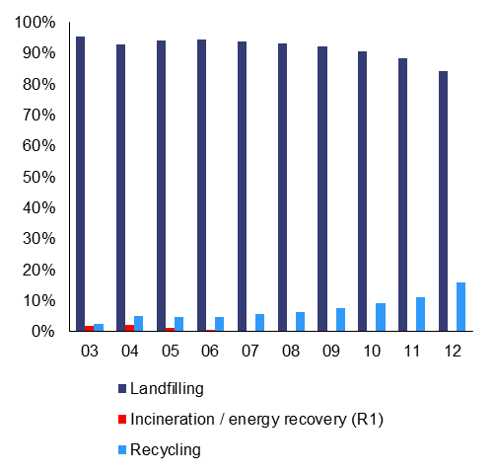
Source: European Commission
Latvia's energy intensity is more than double compared to the EU average, i.e. 328.6 vs. 143.2 kg of oil equivalent per EUR 1000 (2013 data). Greenhouse gas intensity of 0.49 (Gg per million EUR of GDP) was also higher than the EU average of 0.35 and Latvia faces one of the highest deficits in energy trade balance (gas and oil) (), making economy and households dependent on global energy prices. The residential sector accounts for 34% of total energy consumption. Latvia has made some progress in modernising its district heating networks and improving energy efficiency in multi-apartments, as well as public and industrial buildings. However, the scope for further energy savings remains significant; only around 2% of the residential multi-apartment buildings have been heat-insulated (). Latvia is planning to use all Emission Trading Scheme auctioning revenues for domestic climate and energy related purposes.
Transport is the largest emitter of greenhouse gases in Latvia, accounting for 26% of total emissions in 2012. The car fleet is dominated by second-hand cars, while new cars had the highest CO₂ emissions per km in the EU in 2013. Corporate passenger cars continue to benefit from VAT deductibility for both their purchase price and operating costs, including fuel. Overall, the measures in place do not appear sufficient to significantly improve energy efficiency of the transport sector. The Structural Funds financing for 2014-2020 will contribute to development of low carbon transport, in particular public transport, electric vehicles charging system and electrification of railway network that would considerably reduce the CO₂ emissions. ()
Some progress has been achieved on the Rail Baltic European-gauge railway infrastructure project. In 2014, a political agreement was reached between the three Baltic States and a joint venture was established in Riga. The project is subject to funding from the Connecting Europe Facility.
In 2014, around 45% of the road transport infrastructure was in a poor or very poor condition. The number of road fatalities per 1 million inhabitants remains one of the highest in the EU (provisionally, 102 compared to the EU average of 50 in 2014). Since the 2014-2020 road funding programme mostly relies on EU funding, Latvia will need to develop a viable long-term financing mechanism with additional national financing, including public-private partnerships.
According to the 2014 World Bank study on the performance of the three main Latvian ports, the competitive position of the sector could be improved through better cost and revenue management, more efficient land management, improved land connectivity and supply chain functioning. However, the authorities have not taken any significant measures in this regard.
Availability of modern connectivity infrastructure is a key factor for growth. Latvia ranks lowest in the EU for household broadband access in rural areas (41.4% vs. the EU average 89.8%); nevertheless, 92% of households have Next Generation Access (connections with the download speed of above 30Mbps). ()

The efficiency and quality of the judicial system have improved in the past year, though challenges remain. Proposed amendments to civil and administrative procedural laws to further expedite cases are not yet implemented. They would help ensuring proper implementation of the insolvency law (accountability of insolvency administrators). Also a comprehensive human resource policy linked to professional evaluation of judges is not yet implemented, and there is room to strengthen the role of the Judicial Council and court chairpersons in implementing judicial reforms. There has been substantial progress on the reform of arbitration courts () and mediation. ().
The amended insolvency law that will enter into force in March 2015 is expected to reduce the length of insolvency proceedings. The time needed to resolve administrative, civil and commercial cases has shortened () and the rate of resolving administrative cases remains high (). However, the rate of resolving civil and commercial cases in first instance courts has worsened compared to previous year, () creating a backlog. To address the problem, cases are being redistributed more equally among courts. European Social Fund financing will be allocated for raising competencies of court and judicial institutions' staff in the 2014-2020 period.
The state-owned enterprise management reform is key. It was promised to be in force by early 2014 in the Eurogroup commitment letter of June 2013 in the context of Latvia’s euro accession, after many delays during the EU-IMF financial assistance programme 2009-2012. In order to comply with the OECD accession requirements, the framework law was adopted in the final reading on 16 October 2014. The actual implementation, including the adoption of necessary secondary legislation and modalities for establishing a centralised state-owned enterprise manager within the State Chancellery is still due. Despite a new instruction by the Cabinet of Ministers, there are doubts selection of boards of directors of state-owned enterprises can be shielded from political interference.
In 2014 a new Public Service Law was submitted to the Parliament, defining common standards for public sector hiring, career development, assessment, motivation and training. However, local governments will be exempted and the changes may face significant resistance in the Parliament. On the positive side, a centralised selection of senior public officials is due to start from September 2015 and a consistent training strategy for civil servants and law enforcement agencies is to be implemented from late 2015.
Insufficient pay compared to the responsibilities and private sector salaries result in high staff rotation. Remuneration levels appear low for qualified staff in the public sector, especially for senior level positions and thus pose a risk to modernise and improve public administration capacities. In this context, retaining talented and well-trained public servants after the end of the EU Presidency will be a challenge.
The Competition Council has proposed amendments to the competition law to increase its institutional and financial independence. The amendments could strengthen its capacity to intervene effectively against anticompetitive behaviour, including in state-owned enterprises, and to allow independent budgeting of the institution similar to other regulators (financial, utilities regulators). The supervising ministry () has so far rejected the principle of greater institutional independence, but is more open to allowing greater financial independence (for instance, allowing the Council to keep some of the fees it collects, i.e. for mergers). This, however, may not address the concerns raised in the country-specific recommendation on the effectiveness and impartiality of the Competition Council. In particular, the lack of institutional independence may impact the quality and scope of the Council's work, including possible political interference with investigations of anti-competitive actions or biased monitoring of state and municipal owned enterprises.
Internal tensions have destabilised the work of the Corruption Prevention and Combating Bureau. The guidelines for the prevention and combating of corruption expired in 2013 and have not been renewed. The investigations of the Bureau have focused on public procurement in construction and healthcare sectors that are among the most vulnerable to corruption. ()
The conflict-of-interest system for public officials is complex and rigid and prioritises formalistic compliance over assessing the merits of individual cases. () A legislative amendment has been adopted to strengthen the follow-up on findings by the State Audit Office. () In the World Bank’s 2013 governance indicators, Latvia ranks 21st among EU Member States on control of corruption.

2014 commitments | Summary assessment ()
CSR 1: Preserve a sound fiscal position in 2014 and strengthen the budgetary strategy as of 2015, ensuring that the deviation from the medium-term objective remains limited to the impact of the systemic pension reform. Pursue efforts to further reduce the tax burden on low-income earners in the context of a shift towards more growth-friendly property and environmental taxes and by improving tax compliance and collection. | Latvia has made some progress in addressing CSR 1 of the Council recommendation (this overall assessment of CSR 1 excludes an assessment of compliance with the Stability and Growth Pact):  - Some progress in reducing labour taxation, but measures could be better targeted at low-income earners.  - Limited progress in shifting taxation to other tax bases and environmental taxes. Subsidy for fuel used in agriculture was tightened Latvia still has a substantial potential to raise revenues from environmental and property taxation.  - Some progress in improving tax compliance and combating shadow economy.
CSR 2: Step up implementation of the higher education reform, in particular through the establishment of an independent accreditation agency and a financing model that rewards quality.  Provide career guidance at all education levels, improve the quality of vocational education and training, including by strengthening apprenticeship, and make progress in employability of young people including by putting in place outreach measures for non-registered youth not in employment education or training.  Take steps for a more integrated and comprehensive research system also by concentrating financing towards internationally competitive research institutions. | Latvia has made some progress in addressing CSR 2 of the Council recommendation:  - Some progress in addressing higher education reforms: steps are taken to establish internationally-certified accreditation system and introduce new quality-promoting financing model.  - Some progress in improving the quality of vocational education and training and its apprenticeship component. The vocational education and training curricula reform is in progress and some steps were made to strengthen vocational education and training governance, increase the role of employers and expand provision of work-based learning.  - Some progress in improving employability of young people, as most of the Youth Guarantee measures have started. Preparations for the young people not in employment, education or training-outreach project are underway.  - Limited progress in providing career guidance: the plans to improve career guidance are at an early stage.  - Some progress in introducing reforms of the public research organisations and research financing system. The government has launched plans to consolidate the research base and reform the financing of research performing institutions. However, it remains to be seen how this reform will be implemented and it needs adequate resources.
CSR 3: Reform social assistance and its financing further to ensure better coverage, adequacy of benefits, strengthened activation and targeted social services.  Increase coverage of active labour market policies.  Improve the cost-effectiveness, quality and accessibility of the healthcare system. | Latvia has made limited progress in addressing CSR 3 of the Council recommendation:  - Limited progress in social assistance reform. Several studies and policy documents were prepared, but the implementation is uncertain.  - Limited progress in activation and provision of targeted social services. A new programme targeting the long-term unemployed is to be launched.  - Limited progress in increasing the coverage and effectiveness of active labour market policies: e.g., funding and the number of participants involved in active labour market policis will decrease in 2015 compared to 2014.  - Limited progress in improving cost-effectiveness, quality and accessibility of health care system. In general, there is a clear under-financing of the healthcare sector that negatively affects access to healthcare for vulnerable groups.
CSR 4: Accelerate the development of gas and electricity interconnections to neighbouring Member States to diversify energy sources and promote competition through improved integration of the Baltic energy markets.  Pursue efforts to further increase energy efficiency in transport, buildings and heating systems. | Latvia has made some progress in addressing the CSR 4 of the Council recommendation:  - Some progress in improving competition on the electricity and gas market: full opening of the electricity retail market from January 2015 and the first steps towards full gas market opening by 2017 (regulated third party access to infrastructure). With the completion of Klaipeda LNG terminal and two new regional electricity interconnectors in 2015 and 2016, the Baltic regional energy market will be stronger and energy supplies more diversified.  - Some progress with adopting the new Energy Efficiency Law and putting in place energy efficiency obligation scheme to transpose the Directive (2012/27/EU); there is a persisting uncertainty as regards future renewable energy support framework.  - Some progress in addressing energy efficiency in buildings, but limited effort to reduce greenhouse gas emissions in the transport sector (e.g., in 2013 Latvia's average CO2 emissions of new passenger cars were the highest in the EU).
CSR 5: Complete judicial reforms including the pending reforms of insolvency, arbitration and mediation frameworks to ensure a more business- and consumer- friendly legal environment.  Step up public administration reforms, including by implementing state owned enterprise management reform and increasing institutional and financial independence of the Competition Council. | Latvia has made some progress in addressing the CSR 5 of the Council recommendation:  - Substantial progress with improving mediation and arbitration frameworks. However, implementation of judicial reforms is still required, including amendments to civil and administrative code, comprehensive human resource policy.  - Some progress in improving the insolvency regime; however finalisation of secondary legislation and further accountability of insolvency practitioners is warranted.  - Limited progress in implementing public administration reforms, establishing a credible and de-politicised state owned enterprise management system and strengthening institutional and financial independence of the Competition Council.
Europe 2020 (national targets and progress)
Early school leaving target: 13.4% | The early school leaving rate was 9.8% in 2013. Girls perform better than boys: 5.8% against 13.6% in 2013.
Tertiary education target: 34-36% | The tertiary attainment rate was 40.7% in 2013. Women perform better than men: 53.1% against 28.3% in 2013.
R&D target: 1.5% of GDP | Latvia remains a long way from its R&D target and the current level of around 0.60% of GDP has not improved in the last years. Latvia will need to create new incentives and allocate more financing to progress towards Europe 2020 national target.
National Greenhouse gas (GHG) emissions: 17% in 2020 compared to 2005 (in non-ETS sectors) | According to the latest national projections, Latvia is expected to increase its non-ETS emissions by 18% in 2020, thus target may be missed by 1pp in 2020.
2020 Renewable energy target: 40%  Share of renewable energy in all modes of transport: 10% | RES share in the final energy consumption in 2013: 36.5% (estimate).  With a RES share in transport at 3.1% (2012) and limited measures for increasing the RES share, the binding 10% RES target may be unattainable.
Energy efficiency target: absolute level of energy consumption in 2020: Primary energy consumption 5.37 Mtoe; Final energy consumption 4.47 Mtoe | Energy consumption level in 2012: Primary energy consumption 4.4 Mtoe; Final energy consumption 4.0 Mtoe
Employment rate target set in the 2012 NRP: 73% | Employment rate around 70% in 2014. Latvia is on track to reach its EU2020 target.
Reduction of population at risk of poverty and/or living in jobless households: - 121 000 | Reduction of the number of people at-risk-of-poverty and/or living in jobless households per 1 000 was -140 in 2013. Latvia has reached its poverty target; the challenge will be to prevent it from increasing as economy grows.

Table B.1: Macroeconomic indicators

Table B.2: Financial market indicators

Table B.3: Taxation indicators
Table B.4: Labour market and social indicators
Table continued
Table B.5: Product market performance and policy indicators
Table B.6: Green growth

(?) It represents a bulk of the unobserved economy of 16% of GDP in 2012, as estimated by the Central Statistics Bureau. Based on Putnins & Sauka, 2014, Shadow Economy Index for the Baltic countries 2009-2013, non-registered employment is estimated to account for 4.2% of GDP in 2013 and envelope wages for 9.5% out of the estimated shadow economy of 23.8% of GDP.
(?) Special Eurobarometer 402, Undeclared Work in the European Union, 2013
(?) In 2014, the ceilings to SSC were introduced (EUR 48 600 in 2015), which is a regressive element on labour taxation.
(?) The SSC rate reduction was shared between employee and employers with 0.5 pp. reduction for each, therefore a direct gain for household disposable income was lower than for the PIT rate reduction.
(?) The 2014 social security rate reduction cost some 0.3% of GDP and the 2015 personal income tax rate reduction some 0.2% of GDP.
(?) During the crisis, the PIT basic allowance was reduced from around 20% of the average wage in 2009 to around 8% in 2010 and has increased to around 10% in 2014. Compared with other flat tax rate countries the basic allowance in Latvia is low. In 2013, the basic allowance was 26% of the average wage in Lithuania, 15% in Estonia (expected to increase to 16% in 2015) and 12% in Romania.
(?) For tax avoidance, formally employed receive both the minimum wage and an unreported payment, for which no labour taxes are paid. An increase in the minimum wage expands a share of declared income and paid taxes.
(?) According to the State Revenue Service.
(?) Tax wedge for such person is 28%, due to the combined employee and employer SSC rate of 34.1% of gross income.
(?) VAT deductions for cars with GPS route registration equipment amount to 100%, but without the GSP registration deductions are limited to 80% and company car tax is paid.
(?) Eunomia Research & Consulting with Aarhus University, draft Study on Environmental Fiscal Reform Potential in 14 EU member States, 2015.
(?) Standard rate for land and commercial property is 1.5% and for residential property within a range of 0.2%-0.6% depending on the value. The higher rate of 3% is applied to neglected buildings, uncultivated land and from 2015 to unregistered buildings without construction permit.
(?) Treaty on the Functioning of the European Union (TFEU)
(?) Net replacement rate at the average wage is estimated to decline from around 71.9% in 2013 to 51.2% in 2053.
(?) The Medium-Term Objective of a structural deficit of 0.5% of GDP is set for the national budgetary framework, while for the EU fiscal surveillance the MTO is defined as a structural deficit of 1% of GDP.
(?) See http://www.fiscalcouncil.lv/home. There is no provision in the Fiscal Discipline Law that obliges the government to formally respond to the Fiscal Council’s opinions; however the government has done so.
(?) Source: Eurostat, Labour productivity per hour worked.
(?) Source: Eurofound 5th Working Conditions Survey.
(?) According to the European Working Conditions Survey 2013, 63% of the companies in Latvia report such difficulties against the EU average of 39%.
(?) Country fiche: Mapping and Analysing Bottleneck Vacancies in EU Labour Markets - Latvia (2014)
(?) The Ministry of Economics; Informative report on midterm and long term labour market forecasts, June 2014
(?) See OECD (2013), 2012 OECD Programme for International Student Assessment (PISA) and Kangro A. et al. (2014), The Quality of Education in Latvian Schools in International Comparison
(?) The Ombudsman of Latvia: tiesibsargs.lv/files/content/Petijumi/Bilingvala%20izglitiba_2014.pdf
(?) The World Bank (2014), Higher Education Financing in Latvia.
(?) The Academic Information Centre is in charge of recognizing diplomas and professional qualifications and referencing the national framework to the European qualifications framework.
(?) Special Eurobarometer 369, Attitudes towards vocational education and training, Published September 2011; Special Eurobarometer 417, European Area of Skills and Qualifications, Published June 2014.
(?) The 2014 reform that awards separate diplomas for VET and general education could have ambiguous impacts on the student performance in basic skills and calls for careful monitoring of the impact.
(?) Latvia has the lowest share of highly cited scientific publications in EU-28.
(?) In 2007-2013 EUR 452 million were allocated to R&D, while in 2014-2020 it is planned to allocate EUR 467 million from the ERDF financing.
(?) 2014 Innovation Union Scoreboard, ec.europa.eu/enterprise/policies/innovation/files/ius/ius-2014_en.pdf
(?) European Commission (2014), Research and Innovation performance in Latvia 2014, http://ec.europa.eu/research/innovation-union/pdf/state-of-the-union/2014/countries/latvia.pdf
(?) In 2012 Latvia's spending on social protection at 14% of GDP was the lowest in the EU (EU: 29.5% of GDP)
(?) At 0.35, Latvia's Gini coefficient was the 2nd highest in the EU in 2013. The income quintile share ratios (S20/S80) stood at 6.3 in 2013, the 4th highest value in the EU.
(?) More than a quarter of working single parents are exposed to at-risk of poverty, which is the third highest in the EU.
(?) For young adolescents it increased from 38.8% in 2010 to 47.7% in 2013 and for elderly (above 65) – from 33% in 2011 to 39.3% in 2014.
(?) The level of minimum pension depends on the insurance period ranging from EUR 70 to 109.
(?) Housing deprivation refers to households with a leaking roof, damp walls, floor or foundation, rot in the window frames or floor, no bath/shower and no indoor toilet.
(?) The depth of poverty (or poverty gap) provides information on how far off households are from poverty line http://ec.europa.eu/eurostat/statistics-explained/index.php/Glossary:At-risk-of-poverty_gap
(?) In 2013 only 14% of unemployed were entitled for unemployment benefits (the EU average 31%). Adequacy of unemployment benefits measured as net replacement rate in sixth months of unemployment was the 6th lowest in the EU. Source: EC calculations based on EU-SILC data.
(?) Scientific research: Latvia: “Who is Unemployed, Inactive or Needy? Assessing Post‐Crisis Policy Options”, World Bank, 2013.
(?) The minimum income level will be set at 40% of median equalised household income: around EUR 129 per month for a single person, EUR 220 for two adult household and EUR 349 for a household of two adults and two children
(?) For example, to abolish sliding scale ceilings for insurance-based benefits, that will mostly benefit higher income households. There is also funding to increase family state benefits for second and subsequent children and subsidize electricity costs. These measures are more targeted and may contribute to reducing inflow into social assistance.
(?) Total fertility rate in Latvia at 1.44 is below the EU average of 1.58 in 2012. (Source Eurostat)
(?) On Emigration, see Hazans, Mihails (2013), “Emigration from Latvia: Recent trends and economic impact”, in OECD, Coping with Emigration in Baltic and East European Countries, OECD Publishing, pages 96-97.
(?) Employment rates range from above 33% for persons with the least severe disability to 4.5% for people with severe disabilities. (Source: Pamatnostādnes sociālo pakalpojumu attīstībai 2014.- 2020.gadam, page 41)
(?) In 3Q2014, seasonally-adjusted youth unemployment rate was 20.3%.
(?) In the second quarter of 2014 there were around 23000 young people not in employment, education or training, but only 8700 where registered at the public employment services.
(?) In 2013 only 36% of population had received career guidance services while in education (EU average: 61%). (Special Eurobarometer 417, June 2014)
(?) Source: Eurostat labour market policy participants per 100 persons wanting to work (source: DG EMPL).
(?) National data by the Ministry of Welfare in January 2015.
(?) Although national sources show higher ALMP coverage based on the number of registered unemployed, the activation support as defined by labour market policy participants per 100 wanting to work (EUROSTAT) has not changed much.
(?) Health at a Glance: Europe 2014, http://ec.europa.eu/ health/reports/docs/health_glance_2014_en.pdf
(?) Special Eurobarometer 397 on Corruption, February 2014, ec.europa.eu/public_opinion/archives/ebs/ebs_397_en.pdf.
) Commission calculation based on Eurostat life table, 2012
(?) To transpose Directive 2012/27/EU
(?) 301 kg/y/inhabitant compared to around 487 kg on average in 2012, Eurostat data
(?) 84% of municipal waste landfilled against the EU average of 33%; only 12% was recycled and 4% composted (EU average: 27% and 14%), Eurostat data
(?) The trade deficit for energy products in Latvia is 5.2% of GDP (significantly more than the EU average of 3.1%).
(?) In 2014-2020, ERDF financing of EUR 247 million is allocated to promote energy efficiency in public and residential buildings; EUR 31 million for municipal, buildings, EUR 32.6 million for manufacturing sector, EUR 53 million to promote energy efficiency and use of local RES in district heat supply.
(?) In 2014-2020 ESIF investments in environmentally friendly public transport: EUR 108.5 million, in electric vehicles charging systems: EUR 7 million and in TEN-T railway development EUR 454 million.
(?) Digital Agenda Scoreboard 2014, ec.europa.eu/digital-agenda/en/digital-agenda-scoreboard
(?) The Arbitration law came into force in January 2015; it aims to strengthen conditions for establishment of arbitration and the arbitrators' qualification requirements. There were still more than a hundred arbitration courts registered in the Enterprise Register in 2014.
(?) The law on Mediation entered into force in June 2014.
(?) From 302 days in 2012 to 202 days in 2013 for administrative cases. For civil and commercial cases, it slightly shortened to 245 days in 2013. Source: The 2015 EU Justice Scoreboard
(?) The rate of resolving administrative cases in First Instance Courts amounted to 160.1% in 2013. Source: The 2015 EU Justice Scoreboard
(?) In 2012 it amounted to 111.2% while in 2013 it was only 94%. Source: The 2015 EU Justice Scoreboard
(?) The Competition Council is set up as governmental agency under the supervision of the Ministry of Economics and submits quarterly reports of activities and expenditures.
(?) 2014 EU Anti-Corruption Report, http://ec.europa.eu / dgs/home-affairs/what-we-do/policies/organized-crime-and-human-trafficking/corruption/anti-corruption-report/docs/2014_acr_latvia_chapter_en.pdf
(?) Council of Europe Group of States against Corruption (GRECO),http://www.coe.int/t/dghl/monitoring/greco/evaluations/round4/GrecoEval4(2012)3_Latvia_EN.pdf
(?) Amendments of the Law on Prevention of Waste of Financial Means and Property of Public Entities, 13 March 2014, http://likumi.lv/doc.php?id=265303
(?) The following categories are used to assess progress in implementing the 2014 CSRs of the Council Recommendation: No progress: The Member State has neither announced nor adopted any measures to address the CSR. This category also applies if a Member State has commissioned a study group to evaluate possible measures. Limited progress: The Member State has announced some measures to address the CSR, but these measures appear insufficient and/or their adoption/implementation is at risk. Some progress: The Member State has announced or adopted measures to address the CSR. These measures are promising, but not all of them have been implemented yet and implementation is not certain in all cases. Substantial progress: The Member State has adopted measures, most of which have been implemented. These measures go a long way in addressing the CSR. Fully addressed: The Member State has adopted and implemented measures that address the CSR appropriately.

