[1]



Delegations will find attached the opinion of the Portuguese Parliament on the application of the Principles of Subsidiarity and Proportionality regarding the above-mentioned proposal.

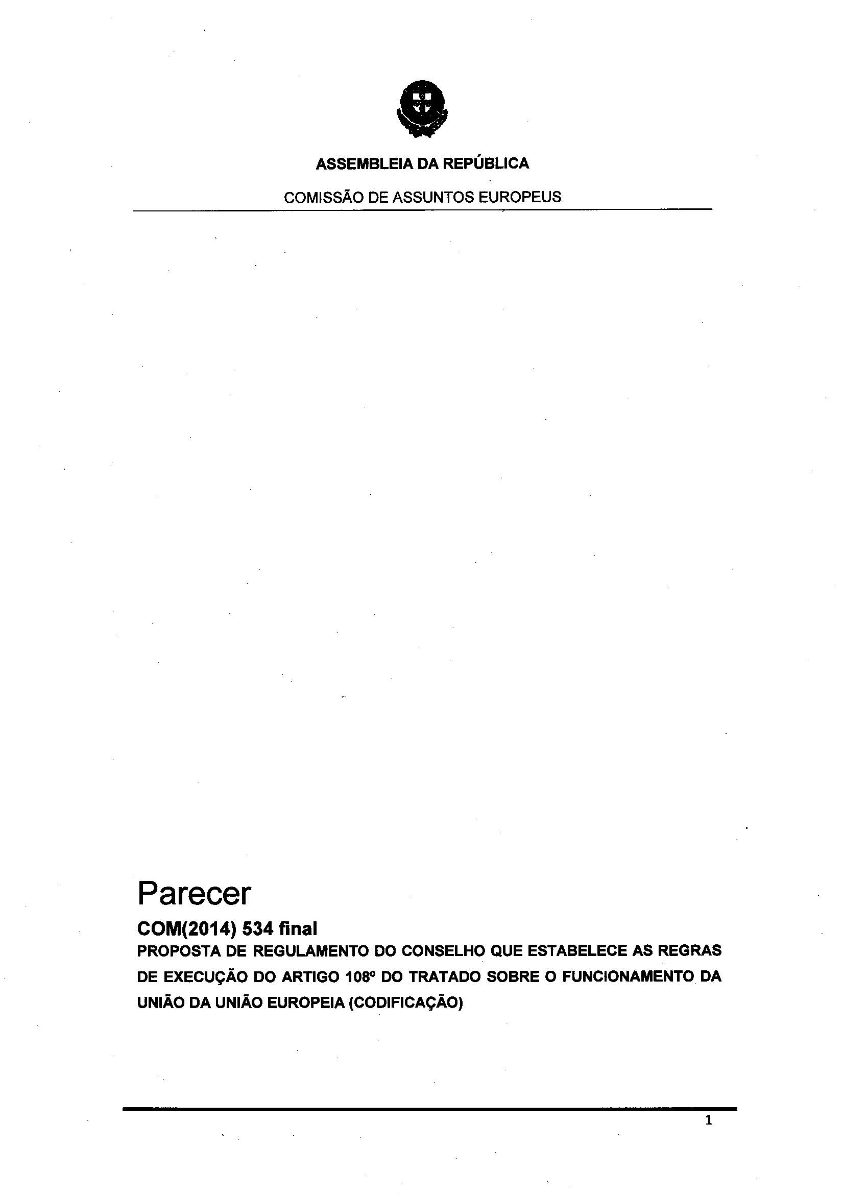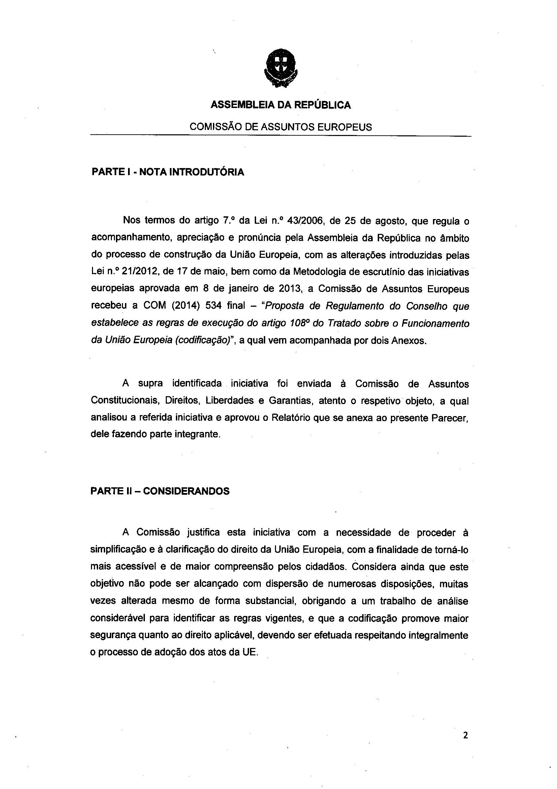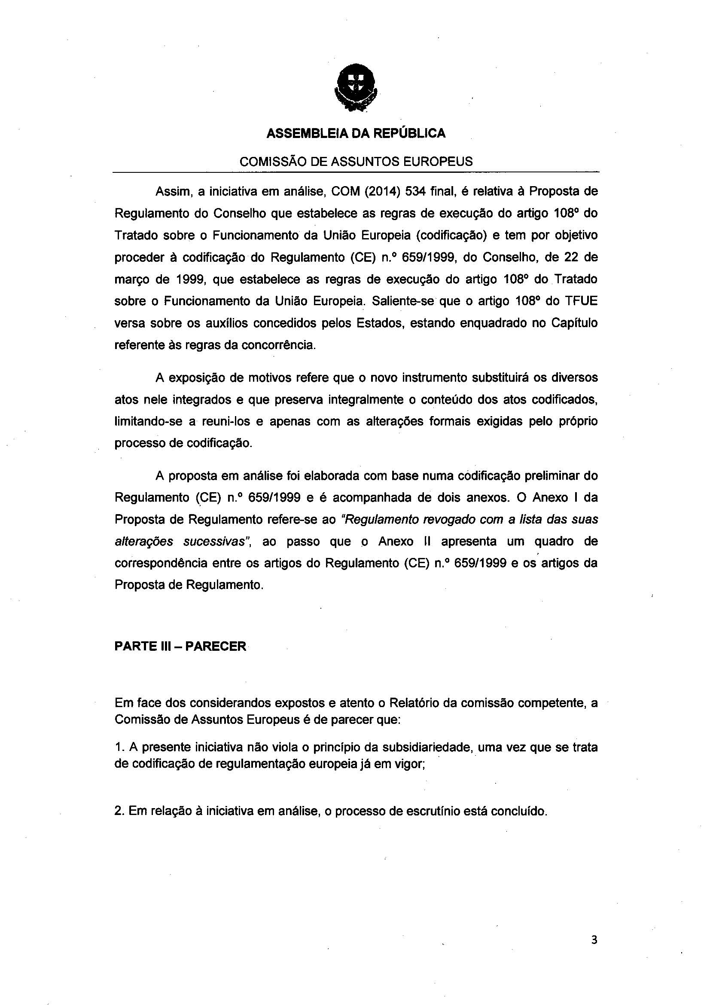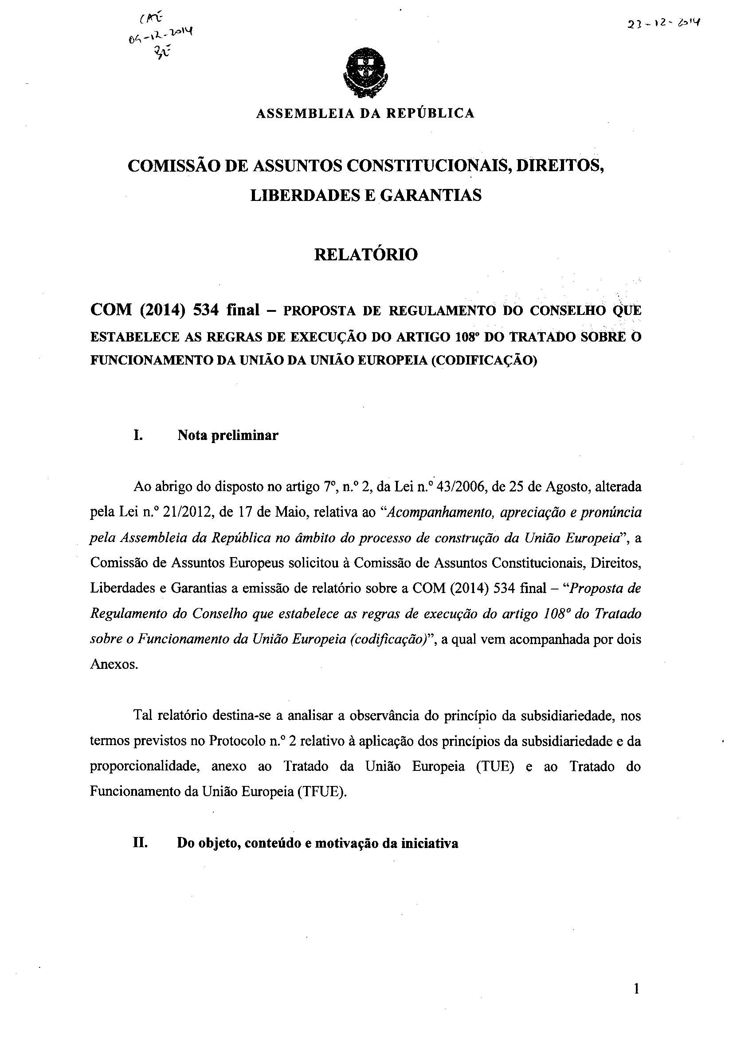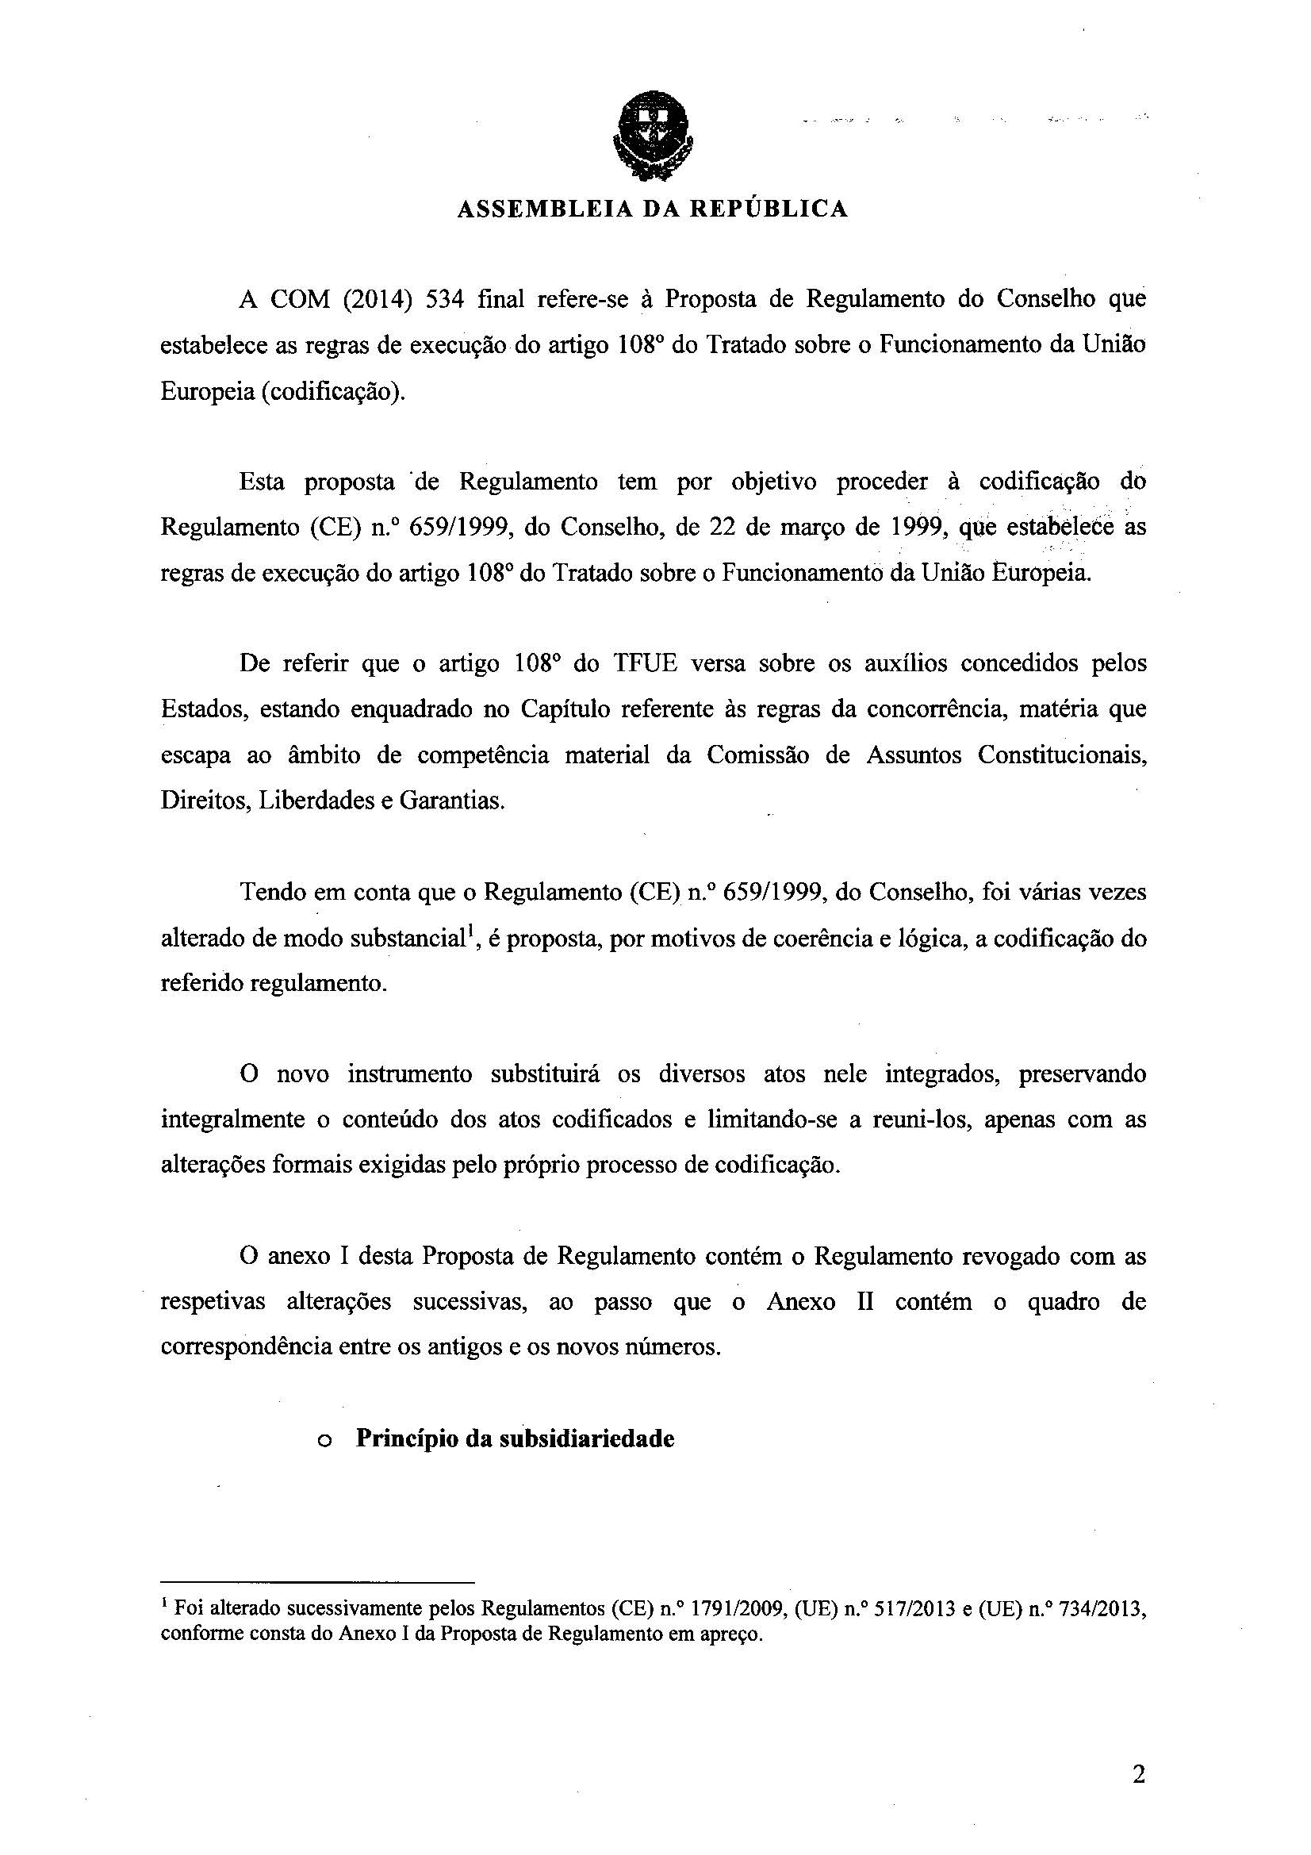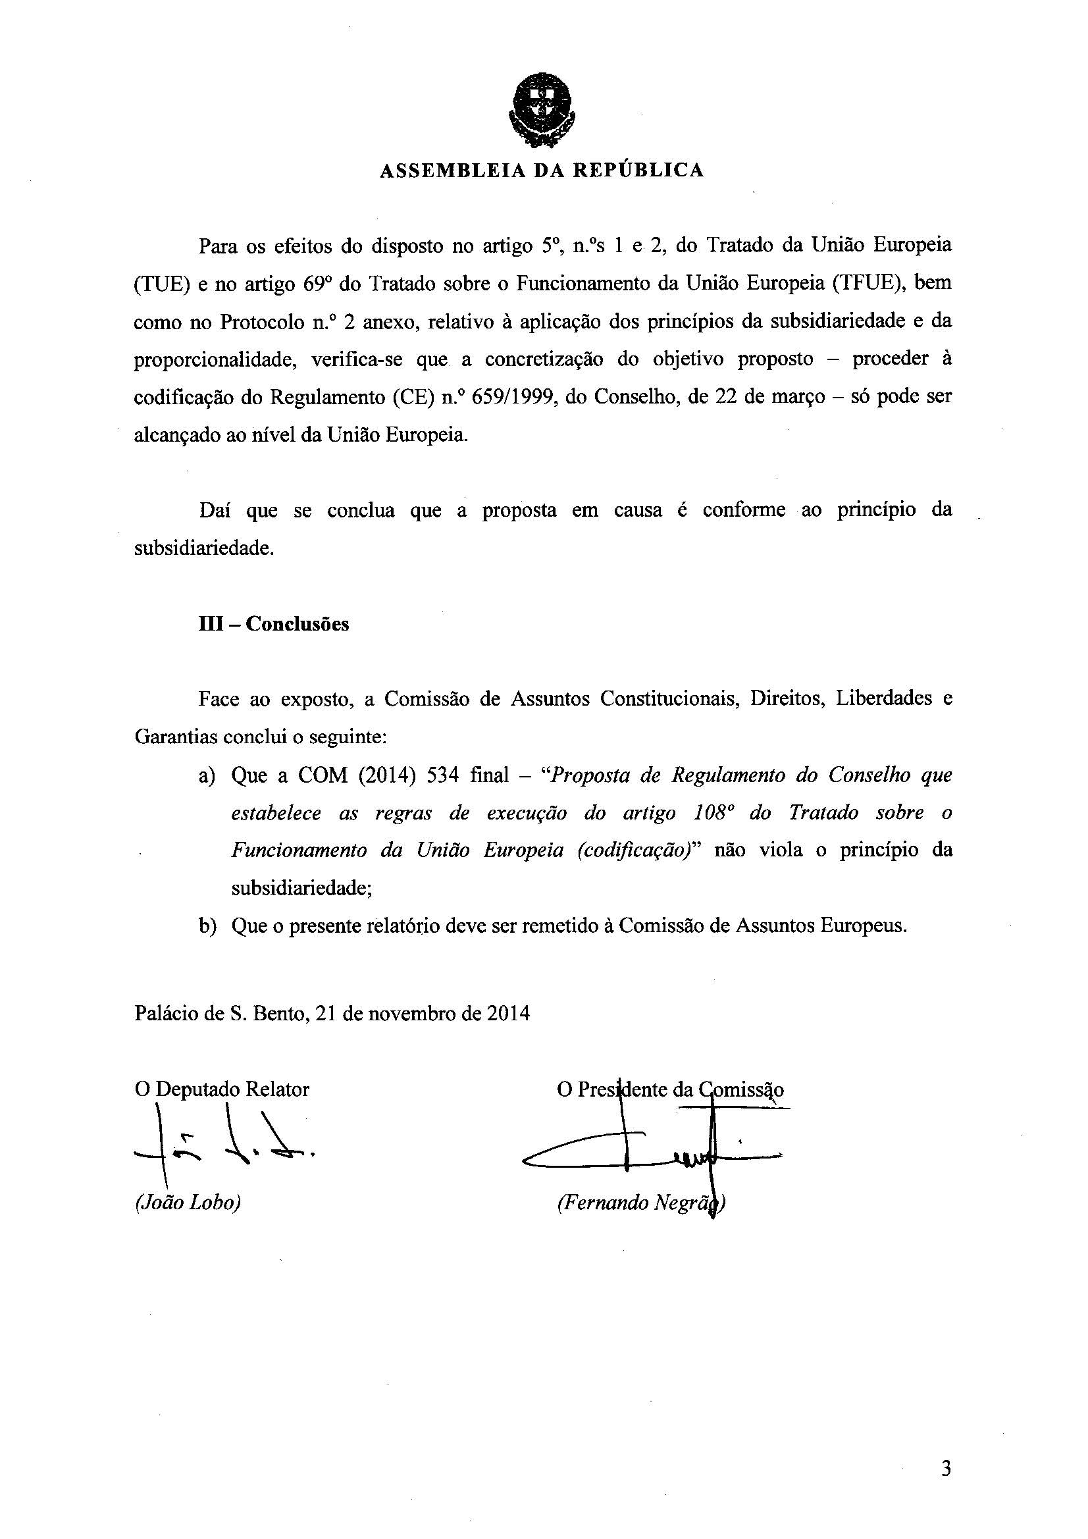

1. Translation(s) of the opinion may be available on the Interparliamentary EU Information Exchange website (IPEX) at the following address: <http://www.ipex.eu/IPEXL-WEB/search.do>