ê 1340/2008
ANNEX I

SA FLAT – ROLLED PRODUCTS

SA1. Coils
7208100000
7208250000
7208260000
7208270000
7208360000
7208370010
7208370090
7208380010
7208380090
7208390010
7208390090
7211140010
7211190010
7219110000
7219121000
7219129000
7219131000
7219139000
7219141000
7219149000
7225301000
7225303010
7225309000
7225401510
7225502010

SA2. Heavy plate
7208400010
7208512000
7208519100
7208519800
7208529100
7208521000
7208529900
7208531000
7211130000

SA3. Other flat-rolled products
7208400090
7208539000
7208540000
7208908010
7209150000
7209161000
7209169000
7209171000
7209179000
7209181000
7209189100
7209189900
7209250000
7209261000
7209269000
7209271000
7209279000
7209281000
7209289000
7209908010
7210110010
7210122010
7210128010
7210200010
7210300010
7210410010
7210490010
7210500010
7210610010
7210690010
7210701010
7210708010
7210903010
7210904010
7210908091
7211140090
7211190090
7211232010
7211233010
7211233091
7211238010
7211238091
7211290010
7211908010
7212101000
7212109011
7212200011
7212300011
7212402010
7212402091
7212408011
7212502011
7212503011
7212504011
7212506111
7212506911
7212509013
7212600011
7212600091
7219211000
7219219000
7219221000
7219229000
7219230000
7219240000
7219310000
7219321000
7219329000
7219331000
7219339000
7219341000
7219349000
7219351000
7219359000
7225401290
7225409000
_____________
ANNEX II
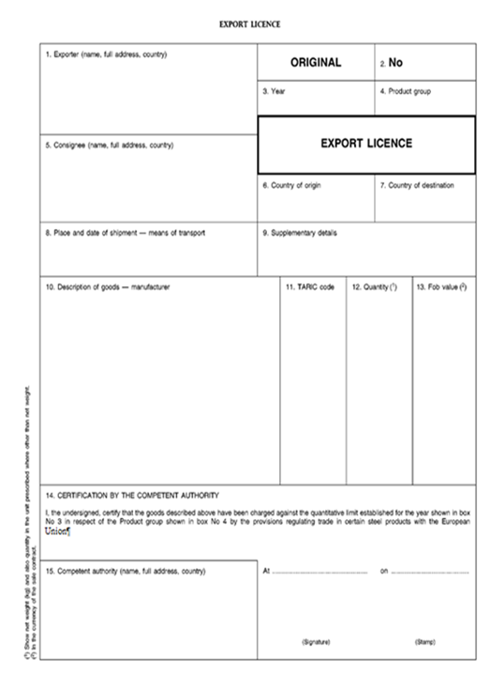
INCLUDEPICTURE \d "C:\\Users\\tuomise\\AppData\\Local\\Temp\\1\\L_2008348EN.01000802.tif" \* MERGEFORMATINET INCLUDEPICTURE \d "C:\\Users\\tuomise\\AppData\\Local\\Temp\\1\\L_2008348EN.01000802.tif" \* MERGEFORMATINET INCLUDEPICTURE \d "C:\\Users\\tuomise\\AppData\\Local\\Temp\\1\\L_2008348EN.01000802.tif" \* MERGEFORMATINET INCLUDEPICTURE \d "C:\\Users\\tuomise\\AppData\\Local\\Temp\\1\\L_2008348EN.01000802.tif" \* MERGEFORMATINET INCLUDEPICTURE \d "C:\\Users\\tuomise\\AppData\\Local\\Temp\\1\\L_2008348EN.01000802.tif" \* MERGEFORMATINET 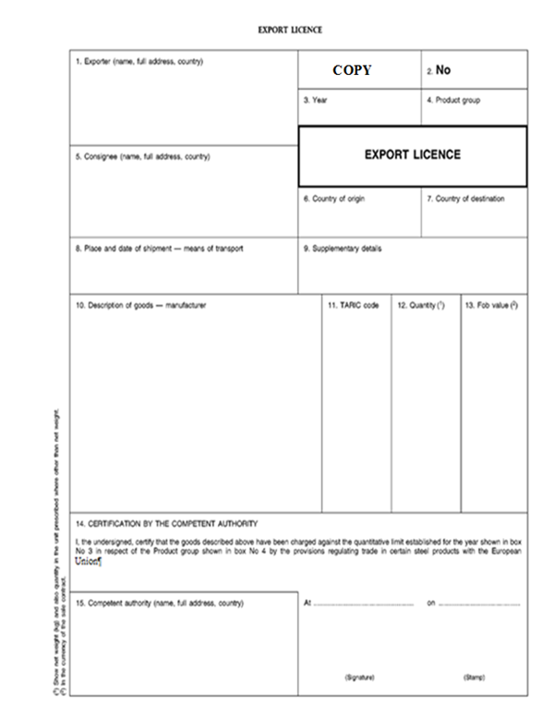
INCLUDEPICTURE \d "C:\\Users\\tuomise\\AppData\\Local\\Temp\\1\\L_2008348EN.01000901.tif" \* MERGEFORMATINET INCLUDEPICTURE \d "C:\\Users\\tuomise\\AppData\\Local\\Temp\\1\\L_2008348EN.01000901.tif" \* MERGEFORMATINET INCLUDEPICTURE \d "C:\\Users\\tuomise\\AppData\\Local\\Temp\\1\\L_2008348EN.01000901.tif" \* MERGEFORMATINET INCLUDEPICTURE \d "C:\\Users\\tuomise\\AppData\\Local\\Temp\\1\\L_2008348EN.01000901.tif" \* MERGEFORMATINET INCLUDEPICTURE \d "C:\\Users\\tuomise\\AppData\\Local\\Temp\\1\\L_2008348EN.01000901.tif" \* MERGEFORMATINET
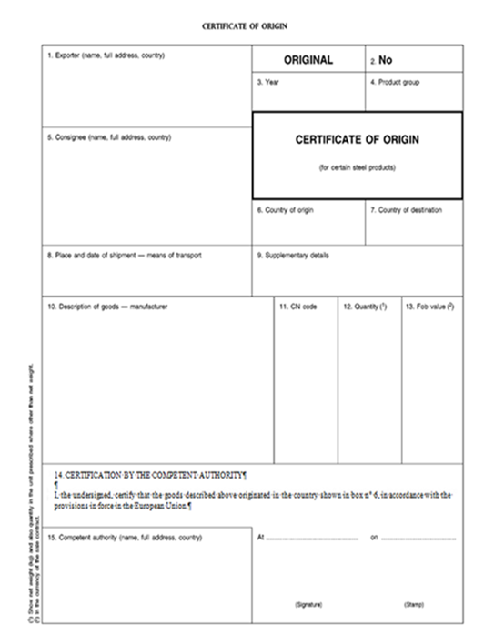
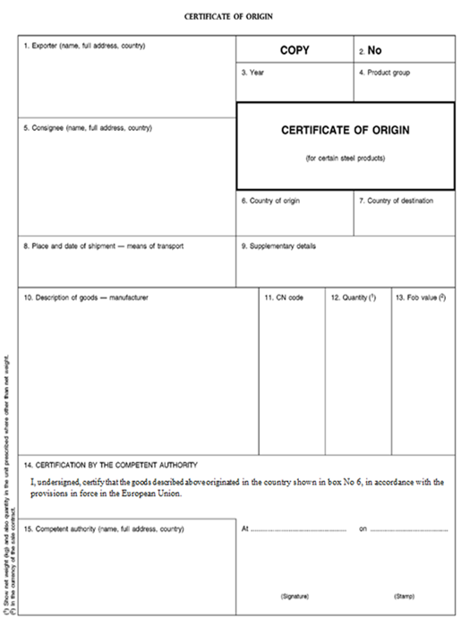
INCLUDEPICTURE \d "C:\\Users\\tuomise\\AppData\\Local\\Temp\\1\\L_2008348EN.01001001.tif" \* MERGEFORMATINET INCLUDEPICTURE \d "C:\\Users\\tuomise\\AppData\\Local\\Temp\\1\\L_2008348EN.01001001.tif" \* MERGEFORMATINET INCLUDEPICTURE \d "C:\\Users\\tuomise\\AppData\\Local\\Temp\\1\\L_2008348EN.01001001.tif" \* MERGEFORMATINET INCLUDEPICTURE \d "C:\\Users\\tuomise\\AppData\\Local\\Temp\\1\\L_2008348EN.01001001.tif" \* MERGEFORMATINET INCLUDEPICTURE \d "C:\\Users\\tuomise\\AppData\\Local\\Temp\\1\\L_2008348EN.01001001.tif" \* MERGEFORMATINET _____________ INCLUDEPICTURE \d "C:\\Users\\tuomise\\AppData\\Local\\Temp\\1\\L_2008348EN.01001101.tif" \* MERGEFORMATINET INCLUDEPICTURE \d "C:\\Users\\tuomise\\AppData\\Local\\Temp\\1\\L_2008348EN.01001101.tif" \* MERGEFORMATINET INCLUDEPICTURE \d "C:\\Users\\tuomise\\AppData\\Local\\Temp\\1\\L_2008348EN.01001101.tif" \* MERGEFORMATINET INCLUDEPICTURE \d "C:\\Users\\tuomise\\AppData\\Local\\Temp\\1\\L_2008348EN.01001101.tif" \* MERGEFORMATINET INCLUDEPICTURE \d "C:\\Users\\tuomise\\AppData\\Local\\Temp\\1\\L_2008348EN.01001101.tif" \* MERGEFORMATINET
ANNEX III
INCLUDEPICTURE \d "C:\\Users\\tuomise\\AppData\\Local\\Temp\\1\\L_2008348EN.01001202.tif" \* MERGEFORMATINET INCLUDEPICTURE \d "C:\\Users\\tuomise\\AppData\\Local\\Temp\\1\\L_2008348EN.01001202.tif" \* MERGEFORMATINET INCLUDEPICTURE \d "C:\\Users\\tuomise\\AppData\\Local\\Temp\\1\\L_2008348EN.01001202.tif" \* MERGEFORMATINET INCLUDEPICTURE \d "C:\\Users\\tuomise\\AppData\\Local\\Temp\\1\\L_2008348EN.01001202.tif" \* MERGEFORMATINET INCLUDEPICTURE \d "C:\\Users\\tuomise\\AppData\\Local\\Temp\\1\\L_2008348EN.01001202.tif" \* MERGEFORMATINET 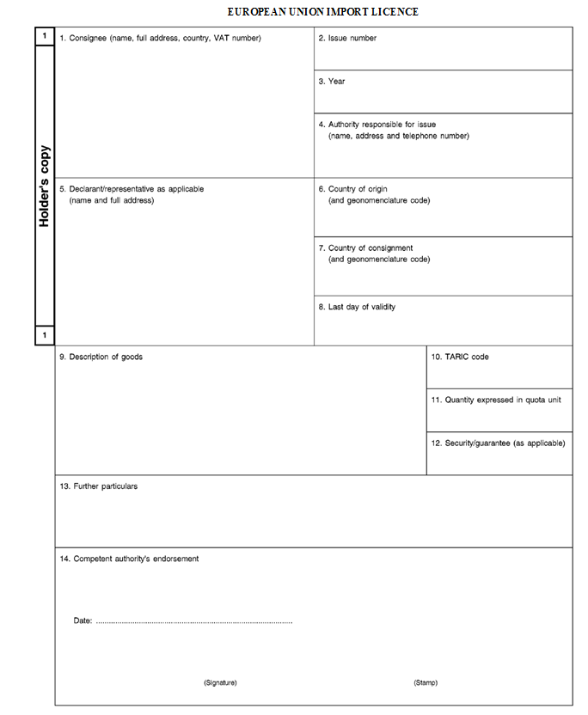
INCLUDEPICTURE \d "C:\\Users\\tuomise\\AppData\\Local\\Temp\\1\\L_2008348EN.01001301.tif" \* MERGEFORMATINET INCLUDEPICTURE \d "C:\\Users\\tuomise\\AppData\\Local\\Temp\\1\\L_2008348EN.01001301.tif" \* MERGEFORMATINET INCLUDEPICTURE \d "C:\\Users\\tuomise\\AppData\\Local\\Temp\\1\\L_2008348EN.01001301.tif" \* MERGEFORMATINET INCLUDEPICTURE \d "C:\\Users\\tuomise\\AppData\\Local\\Temp\\1\\L_2008348EN.01001301.tif" \* MERGEFORMATINET INCLUDEPICTURE \d "C:\\Users\\tuomise\\AppData\\Local\\Temp\\1\\L_2008348EN.01001301.tif" \* MERGEFORMATINET
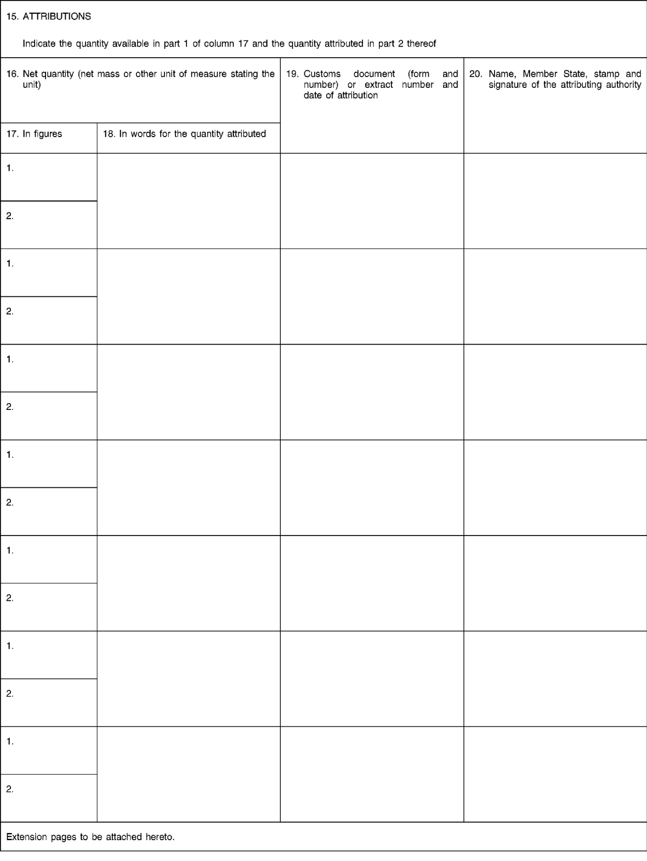
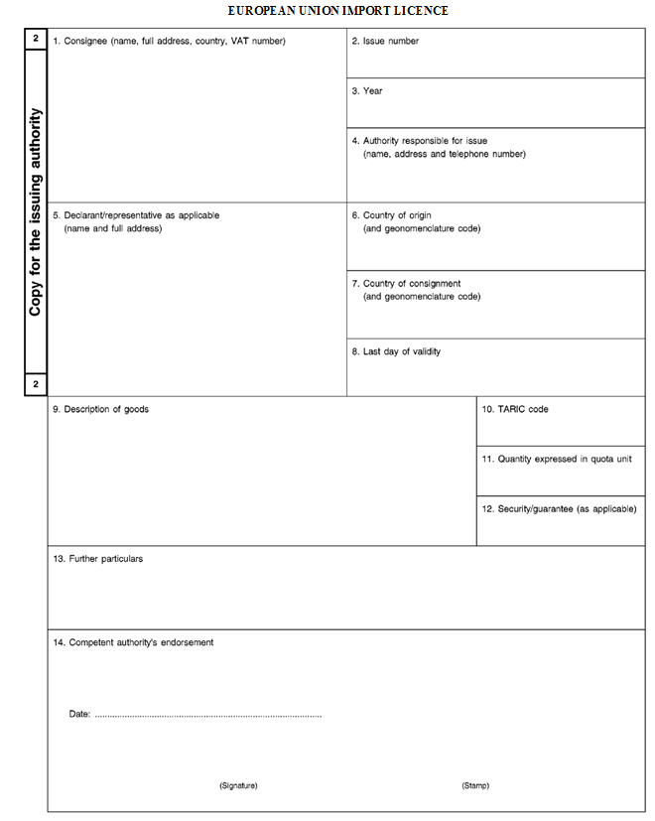
INCLUDEPICTURE \d "C:\\Users\\tuomise\\AppData\\Local\\Temp\\1\\L_2008348EN.01001501.tif" \* MERGEFORMATINET INCLUDEPICTURE \d "C:\\Users\\tuomise\\AppData\\Local\\Temp\\1\\L_2008348EN.01001501.tif" \* MERGEFORMATINET INCLUDEPICTURE \d "C:\\Users\\tuomise\\AppData\\Local\\Temp\\1\\L_2008348EN.01001501.tif" \* MERGEFORMATINET INCLUDEPICTURE \d "C:\\Users\\tuomise\\AppData\\Local\\Temp\\1\\L_2008348EN.01001501.tif" \* MERGEFORMATINET INCLUDEPICTURE \d "C:\\Users\\tuomise\\AppData\\Local\\Temp\\1\\L_2008348EN.01001501.tif" \* MERGEFORMATINET
_____________

ê 1012/2014 Art. 1.2 and Annex (adapted)
ANNEX IV
СПИСЪК НА КОМПЕТЕНТНИТЕ НАЦИОНАЛНИ ОРГАНИ
LISTA DE LAS AUTORIDADES NACIONALES COMPETENTES
SEZNAM PŘÍSLUŠNÝCH VNITROSTÁTNÍCH ORGÁNŮ
LISTE OVER KOMPETENTE NATIONALE MYNDIGHEDER
LISTE DER ZUSTÄNDIGEN BEHÖRDEN DER MITGLIEDSTAATEN
PÄDEVATE RIIKLIKE ASUTUSTE NIMEKIRI
ΔΙΕΥΘΥΝΣΕΙΣ ΤΩΝ ΑΡΧΩΝ ΕΚΔΟΣΗΣ ΑΔΕΙΩΝ ΤΩΝ ΚΡΑΤΩΝ ΜΕΛΩΝ
LIST OF THE COMPETENT NATIONAL AUTHORITIES
LISTE DES AUTORITÉS NATIONALES COMPÉTENTES
POPIS NADLEŽNIH NACIONALNIH TIJELA
ELENCO DELLE COMPETENTI AUTORITÀ NAZIONALI
VALSTU KOMPETENTO IESTĀŽU SARAKSTS
ATSAKINGŲ NACIONALINIŲ INSTITUCIJŲ SĄRAŠAS
AZ ILLETÉKES NEMZETI HATÓSÁGOK LISTÁJA
LISTA TAL-AWTORITAJIET NAZZJONALI KOMPETENTI
LIJST VAN BEVOEGDE NATIONALE INSTANTIES
WYKAZ WŁAŚCIWYCH ORGANÓW KRAJOWYCH
LISTA DAS AUTORIDADES NACIONAIS COMPETENTES
LISTA AUTORITĂȚILOR NAȚIONALE COMPETENTE
ZOZNAM PRÍSLUŠNÝCH ŠTÁTNYCH ORGÁNOV
SEZNAM PRISTOJNIH NACIONALNIH ORGANOV
LUETTELO TOIMIVALTAISISTA KANSALLISISTA VIRANOMAISISTA
FÖRTECKNING ÖVER BEHÖRIGA NATIONELLA MYNDIGHETER

BELGIQUE/BELGIË
Service public fédéral de l'économie, des PME, des classes moyennes et de l'énergie
Direction générale Ö des Analyses économiques et de l'Economie internationale Õ
Service des licences
RueÖ du Progrès 50 Õ
B- Ö 1210 Õ Bruxelles
Fax (32-2) 277 50 63
Federale Overheidsdienst Economie, KMO,
Middenstand & Energie
Algemene Directie Ö Economische Analyses en Internationale Economie Õ
Dienst Vergunningen
Ö Vooruitgangstraat 50 Õ
B- Ö 1210 Õ Brussel
Fax (32-2) 277 50 63

БЪЛГАРИЯ
Министерство на икономиката
дирекция „Регистриране, лицензиране и контрол“
ул. „Славянска“ № 8
1052 София
тел.: (359-2) 940 70 01
факс: (359-2) 987 21 90, (359-2) 981 99 70

ČESKÁ REPUBLIKA
Ministerstvo průmyslu a obchodu
Licenční správa
Na Františku 32
CZ-110 15 Praha 1
Fax (420) 224 21 21 33

DANMARK
Erhvervs- og Byggestyrelsen
Økonomi- og Erhvervsministeriet
Langelinie Allé 17
DK-2100 København Ø
Fax (45) 35 46 60 01

DEUTSCHLAND
Bundesamt für Wirtschaft und Ausfuhrkontrolle,
(BAFA)
Frankfurter Straße 29—35
D-65760 Eschborn 1
Fax (49) 6196 90 88 00

EESTI
Majandus- ja Kommunikatsiooniministeerium
Harju 11
EE-15072 Tallinn
Faks: +372 631 3660

IRELAND
Department of Enterprise, Trade and Employment
Import/Export Licensing, Block C
Earlsfort Centre
Hatch Street
IE-Dublin 2
Fax +353-1-631 25 62

Ö ΕΛΛΑΣ Õ
Υπουργείο Ö Ανάπτυξης και Ανταγωνιστικότητας Õ
Γενική Διεύθυνση Διεθνούς Οικονομικής Ö και Εμπορικής Õ Πολιτικής
Ö Δ/νση Συντονισμού Εμπορίου και Εμπορικών Καθεστώτων Õ
Ö Τμήμα Β΄: Ειδικών Καθεστώτων Εισαγωγών Õ
Ö Οδός Õ Κορνάρου 1
GR-105 63 Αθήνα
Ö Τηλ. (30-210) 328 60 41-43 Õ
Φαξ (30-210) 328 60 94
Ö Email: e3a@mnec.gr Õ

ESPAÑA
Ministerio de Industria, Turismo y Comercio
Secretaría General de Comercio Exterior
Subdirección General de Comercio Exterior de Productos Industriales
Paseo de la Castellana 162
E-28046 Madrid
Fax +34-91 349 38 31

FRANCE
Ministère de l'économie, des finances et de l'industrie
Direction générale des entreprises
Sous-direction des biens de consommation
Bureau textile-importations
Le Bervil
12, rue Villiot
F-75572 Paris Cedex 12
Fax (33) 153 44 91 81

HRVATSKA
Ministarstvo vanjskih i europskih poslova
Trg N. Š. Zrinskog 7-8,
10000 Zagreb
Tel. (385) 1 6444626
Fax (385) 1 6444601

ITALIA
Ministero dello Sviluppo Economico
Direzione Generale per la Politica Commerciale
DIV. III
Viale America, 341
I-00144 Roma
Tel. (39) 06 59 64 24 71/59 64 22 79
Fax (39) 06 59 93 22 35/59 93 26 36
E-mail: polcom3@mincomes.it

ΚΥΠΡΟΣ
Υπουργείο Εμπορίου, Βιομηχανίας και Τουρισμού
Υπηρεσία Εμπορίου
Μονάδα Έκδοσης Αδειών Εισαγωγής/Εξαγωγής
Οδός Ανδρέα Αραούζου Αρ. 6
CY-1421 Λευκωσία
Φαξ (357) 22 37 51 20

LATVIJA
Latvijas Republikas Ekonomikas ministrija
Brīvības iela 55
LV-1519 Rīga
Fakss: +371-728 08 82

LIETUVA
Lietuvos Respublikos ūkio ministerija
Ö Investicijų ir eksporto Õ departamentas
Gedimino pr. 38/2
LT-01104 Vilnius
Faks. +370-5-26 23 974

LUXEMBOURG
Ministère de l'économie et du commerce extérieur
Office des licences
BP 113
L-2011 Luxembourg
Fax (352) 46 61 38

MAGYARORSZÁG
Magyar Kereskedelmi Engedélyezési Hivatal
Margit krt. 85.
HU-1024 Budapest
Fax (36-1) 336 73 02

MALTA
Diviżjoni għall-Kummerċ
Servizzi Kummerċjali
Lascaris
MT-Valletta CMR02
Fax (356) 25 69 02 99

NEDERLAND
Belastingdienst/Douane centrale dienst voor in- en uitvoer
Postbus 30003, Engelse Kamp 2
NL-9700 RD Groningen
Fax (31-50) 523 23 41

ÖSTERREICH
Bundesministerium für Wirtschaft und Arbeit
Außenwirtschaftsadministration
Abteilung C2/2
Stubenring 1
A-1011 Wien
Fax (43-1) 7 11 00/83 86

POLSKA
Ministerstwo Gospodarki
Plac Trzech Krzyży 3/5
00-507 Warszawa
Polska
Fax (48-22) 693 40 21/693 40 22

PORTUGAL
Ministério das Finanças e da Administração Pública
Direcção-Geral das Alfândegas e dos Impostos
Especiais sobre o Consumo
Rua da Alfândega, n.o 5, r/c
P-1149-006 Lisboa
Fax (+ 351) 218 81 39 90

ROMÂNIA
Ministerul pentru Întreprinderi Mici și Mijlocii, Comerț, Turism și Profesii Liberale
Direcția Generală Politici Comerciale
Str. Ion Câmpineanu, nr. 16
București, sector 1
Cod poștal 010036
Tel. (40-21) 315 00 81
Fax (40-21) 315 04 54
e-mail: clc@dce.gov.ro

SLOVENIJA
Ministrstvo za finance
Carinska uprava Republike Slovenije
Carinski urad Jesenice
Spodnji plavž 6C
SI-4270 Jesenice
Faks (386-4) 297 44 72

SLOVENSKO
Odbor obchodnej politiky
Ministerstvo hospodárstva
Mierová 19
827 15 Bratislava 212
Slovenská republika
Fax (421-2) 48 54 31 16

SUOMI/FINLAND
Tulli Ö (Finnish Customs) Õ
PL 512
FI-00101 Helsinki
Ö P. +358 295 52 00 Õ
Ö F. Õ +358-20-492 28 52
Ö Tullen Õ
PB 512
FI-00101 Helsingfors
Ö Tfn +358 295 52 00 Õ
Fax +358-20-492 28 52

SVERIGE
Kommerskollegium
Box 6803
S-113 86 Stockholm
Fax (46-8) 30 67 59

UNITED KINGDOM
Department of Trade and Industry
Import Licensing Branch
Queensway House — West Precinct
Billingham
UK-TS23 2NF
Fax (44-1642) 36 42 69
_____________

ê 1340/2008
ANNEX V
QUANTITATIVE LIMITS
Products | Tonnes per year
SA. Flat products
SA1. Coils | 87125
SA2. Heavy plate | 0
SA3. Other flat products | 117875
_____________

é
ANNEX VI
Repealed Regulation with list of its successive amendments
Council Regulation (EC) No 1340/2008
(OJ L 348, 24.12.2008, p. 1)
 | Regulation (EU) No 38/2014 of the European Parliament and of the Council  (OJ L 18, 21.1.2014, p. 52) |  | Only point 7 of the Annex
Council Regulation (EU) No 1012/2014
(OJ L 283, 27.9.2014, p. 2)
_____________
ANNEX VII

Correlation Table
Regulation (EC) No 1340/2008 | This Regulation
Articles 1 to 16 | Articles 1 to 16
Article 16a | Article 17
Article 16b | Article 18
– | Article 19
Article 17 | Article 20
Annexes I to V | Annexes I to V
– | Annex VI
– | Annex VII
_____________

