

**Executive Summary**

“Sound and imaging equipment", has been identified as a candidate product group for possible Ecodesign measures, comprising game consoles, video players/ recorders and projectors. The Ecodesign Directive 2009/125/EC of the European Parliament and of the Council[1] establishes a framework for the Commission to set ecodesign requirements through regulations, or for industry to make self-regulatory initiatives. The impacts of potential policy measures are assessed in line with the requirements of the Directive, together with possible measures under the Energy Labelling Directive 2010/30/EC[2].

Compared to other Ecodesign Regulations the energy savings potential of this product group is relatively moderate. For sound and imaging equipment energy savings amount to around 2.5 TWh per year; this compares to 215 TWh per year for the Ecodesign Regulation on Space Heaters, and 16 TWh per year for the Ecodesign Regulation on Computers. The analysis presented in the report is considered proportionate to the expected savings.

This impact assessment also assesses whether an industry self-regulatory initiative can be considered an alternative policy measure.

**1. PROBLEM DEFINITION**

The problem is that the environmental performance of sound and imaging equipment could be improved, and that the market penetration of energy-efficient products is lower than it could be. The consequences are that innovation is not sufficiently encouraged, and that energy costs for equipment users are higher than economically necessary.

A check of available market data found that in 2012 roughly about 50 million video players and recorders, 12 million game consoles and 2 million projectors were sold in the EU. Altogether they consume around 8.5TWh electricity per year, and the consumption is forecast to increase to 13 TWh in 2020. The market forecast found that video players/ recorders and projectors will gradually disappear from the market. The sales figures for video players/ recorders and projectors are currently dropping by up to 10% per year, and this decrease will continue as other technologies increasingly replace these products.

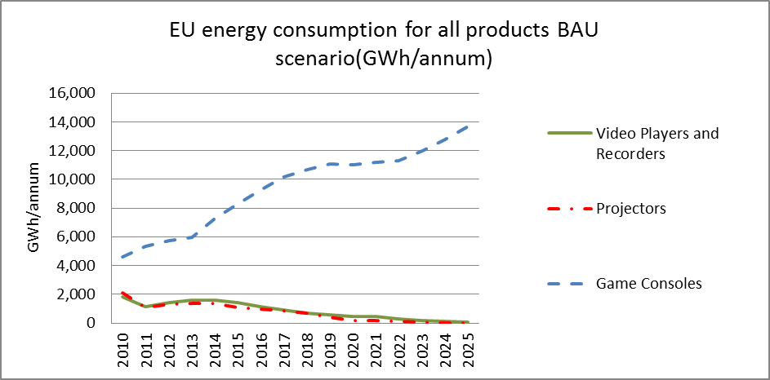

*Figure 1: Business as Usual - EU Energy Consumption for all Products*

The key problem regarding game consoles is their increasing energy consumption, related to their quickly expanding functionalities and gaming performance. Their annual energy saving potential has been estimated at around 1.5 TWh per year, by the year 2020. The key question for this report is whether the current trends of growing energy consumption of game consoles could be significantly reduced by a voluntary agreement, or whether there is a need for introducing mandatory ecodesign or energy labelling measures.

**2. OBJECTIVES**

The preparatory study[3] and the Impact Assessment (IA) study found that there is a cost-effective potential for reducing the energy consumption of sound and imaging equipment, and that the full potential is currently not being exploited. The objective is therefore to analyse whether ecodesign or energy labelling measures, including self-regulation, can contribute to the 20/20/20 energy policy objectives.

In line with recitals 18 and 19 and Article 15(6) of the Ecodesign Directive, it should be explored whether self-regulation could be the preferred option. For sound and imaging equipment products fulfilling the ecodesign criteria, the general objective is to correct market failures and to reduce energy consumption in a proportionate and cost-effective manner, without affecting functionality.

**3. POLICY OPTIONS**

The following legislative and non-legislative measures have been considered:

- Option 1: No EU action (baseline)

- Option 2: Self-Regulation (Voluntary Agreement under the Ecodesign Directive)

- Option 3: Ecodesign Implementing Measures

- Option 4: Energy Labelling Measures

*Game consoles*

Option 1 is included in the analysis not only for comparison purposes, but also as a viable option in its own right. This option implies that barriers will persist for realising the potentials to improve the energy efficiency of game consoles. Although consoles become relatively more efficient, energy consumption will increase, but less rapidly than the gaming performance.

Option 2: In 2012, three game console manufacturers (Microsoft, Nintendo and Sony) presented to the Commission a comprehensive industry proposal for game consoles. With the exception of the required monitoring and reporting parts, it contained all essential elements, and is therefore regarded sufficient to evaluate this initiative as an alternative to a regulatory implementing measure.

The proposal is based on a simplified approach, with requirements on two operational modes: ‘media playback/streaming’ and ‘navigation’. These modes are also simple to test. The electricity consumption requirements in the operational modes are 90 W in 2013, and 70 W in 2017. The industry proposal did not tackle the gaming mode for lack of performance metrics.

Option 3 aims at improving the environmental impact of game consoles by setting mandatory maximum levels for their power consumption. It is based upon the technical concept of the industry proposal, but with more stringent power caps. The requirements in the operational modes are 70 W in 2014 and 50 W in 2017. It proposes further “power supply” and “power management” requirements. The modelling of this option could not consider future possibly extended performance or functionalities of next generations of game consoles, as they are hard to predict.

Option 4: A mandatory EU energy label approach aims at categorising products by efficiency class, applying an A to G categorisation by 2014. However, there are only three main product types/ models, one produced by each manufacturer, and the product architectures and gaming performance vary widely between the three different products. This means that there are considerable differences in functionality and power consumption between the products of each manufacturer, which may render labelling ineffective.

The following table summarises the maximum energy consumption levels of all 4 options for games consoles:

|  |  |  |  |  |  |  |  |  |
| --- | --- | --- | --- | --- | --- | --- | --- | --- |
|  | Policy Options | | | | | | | |
|  | 1 No action | 2 Industry proposal | | 3 Ecodesign | | 4 Energy Labelling | | |
| Requirements in Watt (≤W) |  | Tier 1  2013 | Tier 2  2017 | Tier 1 2014 | Tier 2 2017 | Label Class | Tier 1 2014 | Tier 2 2017 |
| Media Playback mode | 90 | 70 | 70 | 50 | **A** | 30 | 15 |
| **B** | 40 | 25 |
| **C** | 50 | 35 |
| Navigation mode |  | 90 | 70 | 70 | 50 | **D** | 60 | 45 |
| **E** | 70 | 55 |
| **F** | 80 | 60 |
| **G** | 90 | 70 |

Table 1: Summary - Game Consoles Options

*Video Players/ Recorders*

Option 1: The baseline option can be characterised by a clear downward trend in sales. The trend will continue due to technological shifts towards the separation of the hard/optical drive from the product and toward streaming clients, removing the need for these products.

Option 2 has been discarded, as no self-regulatory initiative has been proposed by industry.

Option 3: Policy options with ecodesign requirements were developed in the preparatory study in 2010, and re­assessed in light of new technical information and industry feedback. The revised and more stringent proposal is based on the operational modes like on-play, and has updated timelines starting in 2014.

Option 4 has been discarded, as an energy labelling for video player/recorder has not been found pertinent, due to their relatively low energy consumption, and the limited improvement potential.

*Projectors*

Option 1: With no EU action, the baseline scenario is characterised by a clear downward sales trend, as applications are substituted by widescreen televisions.

Option 2 has been discarded for projectors, as such an initiative has not been proposed by industry.

Option 3 is based on reassessed and updated policy scenarios of the preparatory study. The requirements are based upon an assessment of available technology, and propose light efficiency requirements.

Option 4: A label for projectors would be complex but feasible. The labelling option is based on the requirements and on simplified assumptions suggested in the preparatory study. It would result in improvements in efficiency from 2016 onwards.

The Table below gives an overview of the options retained for in-depth analysis, for all three types of products within the overall group “image and sound equipment”.

|  |  |  |
| --- | --- | --- |
| Game consoles | Video players / recorders | Projectors |
| * Option 1 No EU action * Option 2 Industry Proposal - Self Regulation * Option 3 Mandatory Ecodesign * Option 4 Mandatory energy labelling | * Option 1 No EU action * Option 3 Mandatory Ecodesign | * Option 1 No EU action * Option 3 Mandatory Ecodesign * Option 4 Mandatory energy labelling |

Table 2: Retained options: Game Consoles, Video Players/ Recorders and Projectors

**4. IMPACT ANALYSIS**

The overarching aim of this section is to assess the overall energy and carbon savings against other parameters, such as economic and social impacts. The assessment is implemented in line with the criteria set out in Article 15(5) of the Ecodesign Directive, taking into account the impacts on manufacturers, including SMEs. The aim is to find a balance between achieving the appropriate level of ambition and associated benefits for the environment/ user on the one hand, and the potential burdens for manufacturers on the other.

As almost all mass-market video players/recorders projectors and game consoles are assembled in China, EU manufacturers will not be affected, practically. Costs related to improved technology and production, and re-design, will primarily be borne by non-EU manufacturers.

**Economic impact**

The most important economic impacts of the retained options are summarised below.

*Game consoles*

Option 2 (Industry Proposal: Self-Regulation) would not incur high additional costs, as manufacturers themselves have already introduced the necessary changes in their production plans.

Option 3 (Mandatory Ecodesign requirements) require changes to products, which may represent a significant proportion of manufacturing costs per unit, but the required changes will very likely add little to the final price. On the other hand, consumers may save energy from more efficient components. Due to the strong competition between the three global players, no information regarding future details is available. Therefore it is very difficult to estimate precisely the impacts on the buyers and the affordability of consoles.

Option 4 (Mandatory Energy Labelling) would incur very minor additional costs to display the energy classes on a label, but would not incur extra costs in production. Manufacturers are able to set the pace of any efficiency improvements they wish to implement.

*Video players/ recorders*

With Option 3 being implemented in 2014, the levels suggested for a regulation would not require substantive changes to mass market products, since there is little scope for improvement. Impacts will be minimal, and will be low/ no cost.

*Projectors*

Option 3 could result in an increase in manufacturing costs, reflected in the consumer increase in product price to cover improved efficiency power supplies, and improved light efficiencies. No significant design changes would be necessary to achieve the requirements. The affordability is difficult to forecast, both with regard to how manufacturing costs could be passed through to consumers, and regarding the competition of more expensive projectors with screens.

Option 4 would not be expected to incur significant supply chain costs.

**Environmental Impacts**

The electricity consumption for all product groups was analysed and estimated through a modelling exercise, with model development advised by technical experts within the product groups.

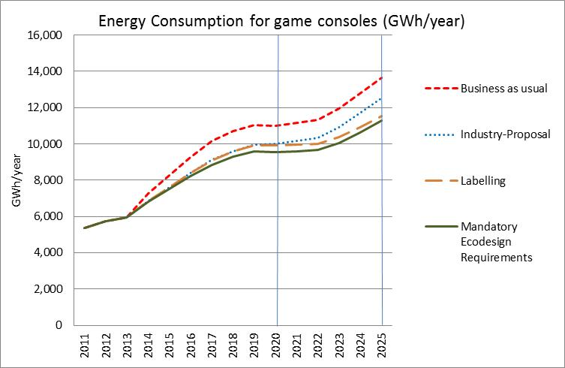

*Figure 2: Evolution of Annual Energy Consumption - Game Consoles*

The annual electricity consumption of game consoles is estimated to have been approximately 4.6 TWh in 2010 in the EU-27, and is estimated to increase to 11 TWh per year in 2020 (BaU). Figure 2 shows that the energy consumption increases uniformly for all options. By 2020, the saving potential of all intervention options is similar, with a very small advantage for the ecodesign option. By 2025, the two mandatory regulation options achieve 16% energy savings, i.e., roughly double the savings of the industry proposal, which achieves energy savings of 8%.

*Video players / recorders*

The electricity consumption of the “business as usual” option for video players and recorders are displayed previously, in Figure 1. The electricity consumption is forecast to drop steadily, and falls towards zero by 2025. A mandatory ecodesign Option 3 would add to the decrease in energy use, and would provide for a stronger decrease already by 2015 and 2016, but would regress towards the baseline curve in the longer term.

*Projectors*

According to modelling predictions, the electricity consumption of projectors decreases similarly to video players/ recorders. Regulatory options would have no significant effects, and would not add to the constant decrease in energy use.

**Social Impacts**

For all policy options assessed, the risk of job losses is expected to be very low. For regulatory measures, the staged approach and timings will allow manufacturers to adapt to Ecodesign requirements in a timely manner.

Within the EU, there are only a small number of SMEs indirectly involved, for example, to develop game software, for some “high end” video players/recorders, or for import and retail, and they will not be noticeably affected.

Prices are not expected to change to such an extent that affordability could be negatively affected, especially in declining markets such as projectors and video players.

**Other impacts**

The full Impact Assessment Report assesses in more detail further economic costs and social impacts. In summary, these impacts are expected to be marginal within the EU.

**5. COMPARISON OF THE POLICY OPTIONS**

The following table summarises the estimated electricity and carbon savings attributable to the preferred policy options compared to the business as usual scenario.

|  |  |  |  |  |
| --- | --- | --- | --- | --- |
| **Table – Annual Electricity and Carbon (Mt CO2) Savings vs. BaU:** | | | | |
|  | **2020** | | **2025** | |
|  | **Electricity Savings (GWh/a)** | **Carbon Savings (Mt CO2 eq/a)**[4] | **Electricity Savings (GWh/a)** | **Carbon Savings (Mt CO2 eq/a)** |
| **Game consoles** | | | | |
| Policy option 2 - Industry Proposal | 1,020 | 0.408 | 1,122 | 0.449 |
| Policy option 3 - Mandatory Ecodesign Requirements (Regulation) | 1,461 | 0.584 | 2,395 | 0.958 |
| Policy option 4 - Mandatory Energy Labelling | 1,115 | 0.446 | 2,124 | 0.849 |
| **Video players/ recorders** | | | | |
| Policy option 3 - Mandatory Eco design Requirements (Regulation) | 360 | 0.145 | 50 | 0.020 |
| **Projectors** | | | | |
| Policy option 2 - Mandatory Eco design Requirements (Regulation) | 6 | 0.002 | 2 | 0.001 |
| Policy option 3 - Mandatory Energy Labelling | 62 | 0.025 | 23 | 0.009 |

Table 3: Summary of quantified annual impacts - 2020 and 2025

Table 3 shows that the saving potential of games consoles is much more significant than for the two other product groups.

**5.1. Game Consoles**

The regulatory option with ecodesign measures (Option 3) leads in the long term - by 2025 - to most savings (2.4 TWh per year), and provides therefore the highest environmental benefits, but has also the highest economic and social impacts. The energy labelling option (Option 4) has similar effects to the ecodesign option, but will be slightly less effective concerning environmental impacts and savings (2.1 TWh per year). The self-regulation option (Option 2) has the lowest economic and social impacts, but leads in the long term to savings of only 1.1 TWh per year, lying in the middle between “no-action” and the regulatory options.

However, Option 2 has the advantage that it is already effective in the short- and medium-terms. The Option 2 annual electricity savings of 1 TWh can be translated into around 200 Million Euros of cost savings on electricity for consumers. The fact that technology developments and market changes for such electronic equipment are very rapid suggests that referring to the medium-term forecast rather than to the long-term forecast might be more reliable.

**5.2. Video Players/ Recorders**

A mandatory ecodesign option would achieve some additional savings in comparison to the “business as usual” option, but the overall saving potential is very low. The preferred option for this product group is therefore Option 1, "No action".

**5.3. Projectors**

The analysis shows that there are little environmental benefits from any of the policy options, which gives little weight to the argument of pursuing anything other than the baseline scenario. The preferred option is therefore Option 1, "No action".

**6. CONCLUSIONS**

For game consoles, the self-regulation Option 2 is the preferred choice. It provides the most advantages, has the best cost-benefit ratio, and provides the best energy efficiency improvements. It contributes to solving the continuity problem with the current positive trend towards energy efficiency. In this dynamic sector, Option 2 generates almost comparable savings to the alternative of mandatory ecodesign or energy labelling requirements, it provides flexibility, and it enables quicker updating of target levels, and has a lower administrative burden. The self-regulation option comprises a contribution of 1 TWh per year energy savings to the 20/20/20 target.

The self-regulatory initiative proposed by the games consoles manufacturers was finally revised in November 2014 to the satisfaction of all Commission services. It is suggested that the proposal, and especially the monitoring system, be reviewed by the end of 2017.

1. OJ L 285, 31.10.2009
2. OJ L 153, 18.06.2010
3. See http://www.ecomultimedia.org/
4. Assumption: 0.4 kg CO2/kWh following MEErP