- Background
This report sets out the main results of the 2007-13 Hercule II Programme adopted in 2007 to promote activities to protect the European Community’s financial interests. It is based on an independent evaluation commissioned by the European Commission’s Anti-Fraud Office (OLAF) and carried out between March and December 2014 by an external contractor, supported and supervised by a steering group of officials from OLAF and the Commission’s Secretariat-General.
The first Hercule Programme, established by Decision No 804/2004/EC, was dedicated to protecting the EU’s financial interests by supporting the fight against irregularities, fraud and corruption affecting the EU budget. In 2007, it was succeeded by Hercule II with the adoption of Decision No 878/2007/EC, which amended Decision No 804/2004/EC. In 2014, the European Parliament and the Council adopted Regulation (EU) No 250/2014 on the Hercule III Programme for 2014-20.
2. The Programme
The general objective of Hercule II was to establish a Community action programme to promote activities designed to strengthen EU action with regard to the prevention and combating of fraud affecting the financial interests of the Union, including the fight against cigarette smuggling and counterfeiting, in particular:
- ‘enhancing transnational and multidisciplinary cooperation between Member States’ authorities, the Commission and OLAF;
- building networks throughout the Member States, acceding countries and candidate countries — in accordance with a memorandum of understanding — facilitating the exchange of information, experience and best practices, while also respecting the distinct traditions of each Member State;
- providing technical and operational support for the law enforcement authorities of the Member States in their fight against illegal cross-border activities, emphasising support for customs authorities;
- without undermining operational effectiveness, striking a geographical balance by including, if possible, all Member States, acceding states and candidate countries — in accordance with a memorandum of understanding — in the activities financed under the Programme; and
- multiplying and intensifying the measures in the areas identified as the most sensitive, particularly in the field of cigarette smuggling and counterfeiting.’

Types of activity
The Programme involved financial support for three types of activity:
- technical assistance for national authorities;
- training, seminars and conferences; and
- IT support.
Technical assistance
Technical assistance was the largest type of activity in terms of budget and number of grant agreements. Activities included financial support for the purchase of equipment used by national and regional administrations in investigations to protect the EU’s financial interests. Technical assistance projects fell into two groups:
- ‘investigation support’ for the fight against fraud and corruption in general; and
- ‘cigarettes’; this was to strengthen beneficiaries’ capacity to combat cigarette smuggling and counterfeiting. The Programme provided funding inter alia for the purchase of X-ray scanners to be used at the Union’s external borders to detect smuggled and counterfeit cigarettes in vehicles or containers and for the purchase and training of sniffer dogs.
In 2010 and 2011, Danish customs received grants for an amount of EUR 335 000 for the purchase of X-ray scanners for use at border crossing points in order to increase the quantity and quality of customs controls in Denmark with the purchase of eight X-ray scanners to uncover illegal shipments of tobacco products and possibly other components to be used in the illegal production of tobacco. In the first nine months, the devices were used for almost 30 000 scans. This led to almost 400 hits and allowed for the detection of 9 000 cartons smuggled cigarettes as well as seizures of drug, alcohol and weapons.
Training, seminars and conferences
This type of activity was divided into two parts:
- conferences, seminars and training activities, e.g. to spread best practice in the area of fighting fraud, cigarette smuggling and counterfeiting, raise awareness and improve prevention. Financial support was also given for specialised digital forensic training for customs officials and policemen; and
- ‘legal training’, including specific comparative law studies needed for preparing policy documents and legislative proposals.
IT support
The Programme funded the purchase by the Commission of (access to) databases for Member State beneficiaries, e.g. customs or police, to use in the course of their investigations. These contain information on companies, company ownership, trade data, ship movements and cargo manifest data. The Programme also supported the development of specific IT tools for the automated analysis of large amounts of trade data, the results of which are used for risk analyses and help customs in the Member States to focus their activities on areas of risk.

Budget
The budget (commitment appropriations) for the 2007-13 Multi-annual Financial Framework (MFF) was EUR 98 525 000, i.e. around EUR 14.3 million a year. Figure 1 shows the breakdown by type of activity.
Figure 1: Budget appropriations by type of activity (2007-13)
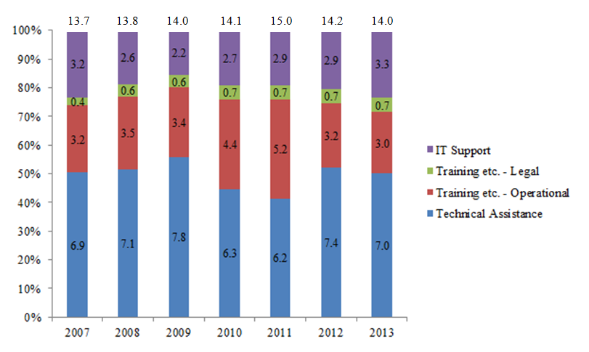
Under the Financial Regulation, funding under the Hercule II Programme could take two forms:
- grants, following calls for proposals; and
- public procurement contracts, following calls for tender.
Grants for technical assistance could cover up to 50 % of eligible costs, training activities up to 80 % and legal training up to 90 %. The beneficiaries were:
- national and regional administrations in Member States or acceding states (technical assistance was restricted to this category);
- research and educational institutes (these were not allowed to apply for technical assistance grants, but could apply for training, seminars, conferences, studies and IT support activities); and
- non-profit-making bodies.
Any legal entity that satisfied the applicable legal requirements could participate in procurement procedures and apply for a contract under the Programme. Public procurement was used for purchasing (access to) databases, specialised training and the development of specific IT tools.
Under certain conditions, the Programme could also cover the costs of representatives from certain non-EU countries participating in training events.
The allocation of the budget and the number of grants and contracts show that 52.8 % of the funds were allocated in grants and 47.1 % for procurement.
Table 1: Overview of number of grants and contracts by type of activity and year
Year | Technical assistance | Training |  |  | Legal training | IT support | Total |  | Grand total
 | Grants | Grants | Proc. | Total | Grants | Proc. | Grants | Proc.
2007 | 29 | 10 | 10 | 20 | 9 | 9 | 48 | 19 | 67
2008 | 31 | 9 | 17 | 26 | 9 | 13 | 49 | 30 | 79
2009 | 27 | 12 | 18 | 30 | 10 | 7 | 49 | 25 | 74
2010 | 27 | 16 | 10 | 26 | 9 | 11 | 52 | 21 | 73
2011 | 28 | 9 | 22 | 31 | 9 | 13 | 46 | 35 | 81
2012 | 42 | 15 | 9 | 24 | 9 | 16 | 66 | 25 | 91
2013 | 32 | 17 | 10 | 27 | 10 | 6 | 59 | 16 | 75
Total | 216 | 88 | 96 | 184 | 65 | 75 | 369 | 171 | 540
When the evaluation started in March 2014, many activities for which grant agreements or contracts had been concluded were still ongoing and it was not possible to collect information on the results achieved. However, the beneficiaries and contractors concerned were asked for their opinions as to the efficiency of programme implementation.
Implementation
The Programme was implemented on the basis of annual Commission financing decisions approving the annual budget and work programme. These set out an indicative overview of the priorities for the activities in the year in question and the budget available for each type of activity. Annual reviews reported on the implementation of the annual work programmes.
3. Evaluation objectives, methodology and data sources
Objectives
The primary objective of the independent evaluation was to assess the effectiveness of the Programme, i.e.: the extent to which the objectives of the Programme have been achieved.
The second objective was to assess the efficiency of implementation on the basis of:
- economy: were the resources for achieving the objectives made available to the beneficiaries in due time, in appropriate quantity and quality?
- utility: to what extent did the action taken address the needs, problems and issues identified when the Programme was adopted? Were there any collaterals or side-effects?
- consistency: to what extent were positive/negative spillovers into related policy areas, such as the Customs and Fiscalis programmes, maximised/minimised?
- acceptability: to what extent did the stakeholders accept the Programme and consider it to be useful?
The third objective was to assess the Programme’s EU added value (‘additionality’) and the sustainability of its results.
The evaluation did not explicitly cover the relevance of the Programme, as it was addressed by an impact assessment accompanying the Commission’s proposal for the Hercule III Programme (2014-2020). The evaluation covered all activities under the Programme over the 2007-13 programming period. It focused on technical assistance, the results of which were considered essential to the overall success of the Programme.
Methodology
The evaluation was carried out on the basis of a method (‘contribution analysis’) developed by the contractor which consists of gathering information on the Programme, its implementation and its achievements in order to generate hypotheses about causal links between activities enabled with financial support from the Programme, on the one hand, and their outputs and outcomes, on the other. The hypotheses were subsequently tested against new data collected through surveys, interviews and case-studies. The results fed into a ‘theory of change’ that describes how the Hercule funded activities eventually contribute to a long-term impact by generating outputs and outcomes. In this way, it was possible to identify and clarify productive mechanisms within the Programme and contextual factors that influenced it. The heterogeneous nature of the activities funded under the Programme as well as the results generated by these activities required a comprehensive approach in the examination of the achievement of the Programme’s objectives. The contractor’s methodology enabled the assessment of the quantitative results (outputs) and longer term outcomes by comparing them with perceptions and opinions from experts and stakeholders that were collected during interviews and surveys. The interviews and surveys contained questions and statements in relation to the results of the Programme (effectiveness) as well as to the quality of its implementation (efficiency). The response rates in the surveys were satisfactory, whereas the respondents were representative for the Programme’s beneficiaries in terms of geographical spread, type of activity and funding instrument. The interviews were held with a sufficient number of stakeholders covering all sectors of activity and the entire period. The results of the interviews and surveys led to a validation of the initial findings and a further fine-tuning of the Programme’s results.
The modest size of the Programme does not justify a full Cost/Benefit analysis to be carried out as its costs would be disproportionate to the Programme’s budget.
The overall impact on the protection of the Union’s financial interests is difficult to assess with the limited size of the Programme, but the contractor’s methodology still provides sufficient grounds to assume that the results of the external evaluation are valid, representative and reliable.
Data sources
The external evaluator was provided with administrative and financial information from the Commission’s databases on the number, amounts and geographical distribution of the grants and contracts, including copies of grant beneficiaries’ final reports. These reports include information on results achieved that contributed to the protection of the Community’s financial interests, such as the number and value of seizures made with X-ray scanners, losses to national and Union budgets that were prevented and participants’ evaluation of the outcomes of conferences and training sessions.
The evaluator was also provided with the report on the 2010 mid-term evaluation of the Programme and the main results and recommendations from the Court of Auditors 2005 and 2010 audits on the Commission’s (OLAF’s) management of financial programmes.
The evaluator gathered data from online surveys of beneficiaries and participants, 38 stakeholder interviews and 20 case-studies. For the survey of beneficiaries, a questionnaire was sent to over 100 organisations, including NGOs, the judiciary, customs, police and education institutes that received a grant or a contract to organise an event (e.g. conference, seminar or training course). The response rate was relatively high (65 %, or 68 respondents), but most of the replies were from organisations that had recently received financial support from the Programme. There were few replies from organisations that benefited from support in the first years of the Programme (2007-10) only and for events in that period it was difficult to find and interview beneficiaries and participants.
The questionnaire for the survey of participants was sent to 1 464 individuals who had attended a conference, seminar or training course supported under the Programme. After three reminders, the response rate was 39 % (574 respondents), with 90 % of the responses relating to events in 2013 or 2014 and 23 % (131) to digital forensic training sessions.
The contractor carried out a specific survey for users of the databases, but the response rate was too low to draw any valid or reliable conclusions. The number of users in the Member States is limited and they had already been asked twice for their views on the usefulness of the databases for their work. The evaluator’s findings regarding database use are based on case-studies only.
4. Key findings of the external evaluation
Effectiveness
The effectiveness of Hercule II was assessed against each of the five objectives set out in the Programme’s legal basis (see above).
The Programme enhanced transnational and multidisciplinary cooperation. The surveys and stakeholder interviews indicate that anti-fraud training and training, seminars and conferences with a legal focus were the main drivers in achieving this. In some instances, technical assistance also contributed (e.g. the cross-border development of automated number-plate recognition systems (ANPRS)), but it was mostly used within a Member State, rather than between actors in two or more Member States. The Programme also effectively increased beneficiaries’ and participants’ understanding of EU and national mechanisms for the protection of the Union’s financial interests; the findings suggest that this contributed to Member States becoming increasingly aware of the benefits of increased cooperation.
The findings show that the Programme was effective in establishing and strengthening networks of actors involved in protecting the Union’s financial interests. Both formal and (predominantly) informal networks were established between Member State authorities, the Commission and OLAF. Among other things, these networks supported faster information exchange between national authorities, greater access to information and improved capacity to respond to fraud. In addition, the Programme contributed to improved cooperation between practitioners and academics in the Member States. Of the different types of activity, anti-fraud training was the most effective in building networks. The effectiveness of the Programme could be enhanced by ensuring more personal contact between administrators, for example through staff exchanges.
The Programme facilitated the exchange of information, experience and best practice. Several respondents and interviewees confirmed that this applied most of all to participants in anti-fraud training, seminars or conferences, in particular during the events, but also after they had returned to their usual working environment.
The evaluation showed that the Programme delivered the intended results by providing support for technical assistance, in particular strengthening beneficiaries’ operational and investigative capacity to counter activities detrimental to the Union’s financial interests. The evidence from the surveys, stakeholder interviews and case-studies suggests that it was generally unlikely that the equipment in question would have been purchased without the EU co-financing. There were many examples of technical assistance providing law enforcement agencies with high-quality equipment that helped improve the collection of evidence of corruption, fraud and smuggling in Member States. In addition, technical assistance increased beneficiaries’ flexibility and investigative capacity.
In general, the findings showed that beneficiaries considered access to the databases to be useful for their work. The Programme was effective in facilitating access to data and databases in some Member States, while in others it contributed to a limited extent only. The Commission managed access to the databases for the national contact points, who distributed it further at national level. The findings suggest that the distribution of access through national contact points only did not ensure that all relevant authorities in the Member States benefited. Overall, the access supported national authorities in their investigations, which would otherwise have been less successful, and led to economies of scale for the beneficiaries.
The Programme supported the development of IT tools for the analysis of large amounts of data. One of these, the ‘Contraffic’ tool provides information for customs on the status and movement of containers by using Container Status Messages from open sources. The Contraffic tool receives more than 15 000 data requests per year from more than 300 customs officers and has improved the ability of customs to detect fraud. Furthermore, this tool enabled an automated analysis of more than 2 million Single Administrative Document (SAD) import declarations from maritime transport operators to detect misdeclarations of the country of origin in a pilot involving 12 Member States. Another IT-support tool, the automatic monitoring tool (AMT) generates automated alerts for outliers in trade data and can be used to monitor trade flows relevant for intelligence analyses and targeted controls by Member State customs. The AMT has improved authorities’ ability to detect the undervaluation of imported goods and made them more efficient, freeing up human resources and time for other investigation work. However, the AMT is only expected to reach its full potential with improvements that aim at reducing the number of “false positive” alerts that have only started under the Hercule III Programme and that will be continued in 2015-2016.
The AMT was used in a joint customs operation by OLAF and the Member States that targeted the undervaluation of imported goods, which leads to huge losses to the EU and Member States’ budgets every year. The operation prevented the loss of EUR 80 million in customs duties. The use of estimated fair prices, which are part of the AMT project output, was essential during the planning and operational phases of the operation. In one month, OLAF and the participating customs authorities detected more than 1 500 containers with goods of which the declared customs value was heavily undervalued. This involved false descriptions of goods, false weights and quantities, and counterfeit goods. In addition, the authorities identified several ‘missing’ traders and non-existent importers, triggering a number of criminal and administrative investigations in several countries.
Technical assistance, training and IT support activities were funded to support the fight against cigarette smuggling and counterfeiting. The Programme’s increased focus on this area (as compared with its predecessor) following the conclusion of agreements with tobacco companies led to such efforts being stepped up. This is shown by the many activities providing funding for the purchase of technical equipment and confirmed by the views of beneficiaries: 75 % of the survey respondents agreed that the Programme had been successful in this regard.
The results achieved through the three types of activity are complementary and it is not possible to assess whether a particular type was more effective than others in contributing to the outcomes and impacts of the Programme. For example, technical assistance was highly effective in providing strengthened technical and operational support for law enforcement and customs authorities, and in improving investigations, monitoring and intelligence work. Its contribution to enhanced transnational and multidisciplinary cooperation between Member State authorities and the Commission was limited, but this was not its main objective. Training, seminars and conferences enhanced transnational cooperation between Member State authorities and strengthened networks and the exchange of information, but were less effective in harmonising levels of skills, equipment and readiness in the Member States to detect smuggled and counterfeit products. IT support for technical assistance improved investigation, monitoring and intelligence work.
The absence of memoranda of understanding on national or regional authorities in non-EU countries participating in the Programme limited the geographical distribution of beneficiaries to the Member States. (However, participants from a large number of non-EU countries did attend events such as the digital forensic training sessions). Activities were generally evenly spread across the Member States, but there were some clear differences: Belgium, France and Germany received most funding and implemented most projects (grants and contracts) for all types of activity, but beneficiaries in all Member States received technical assistance grants, with Spain, Poland and Hungary the biggest beneficiaries in monetary terms, followed by Belgium, Germany, Lithuania, the Netherlands, Portugal, Romania and Finland. These Member States are all characterised either by busy ports of entry into the Union or by external EU land borders to the East. Poland, Hungary and Romania received most grants for training, seminars and conferences. Belgium received substantial funding for conferences, because it hosts one of the contractors that organised conferences and seminars carried out in other Member States and non-EU countries. Universities and NGOs in Italy and Germany were successful in securing funding for smaller conferences and training courses on legal matters. The participants to these events however originated from a wide range of EU Member States and third countries.

Figure 2: Aggregated commitment appropriations (2007-13) for all types of activity (technical assistance, training, legal training and IT support), by Member State

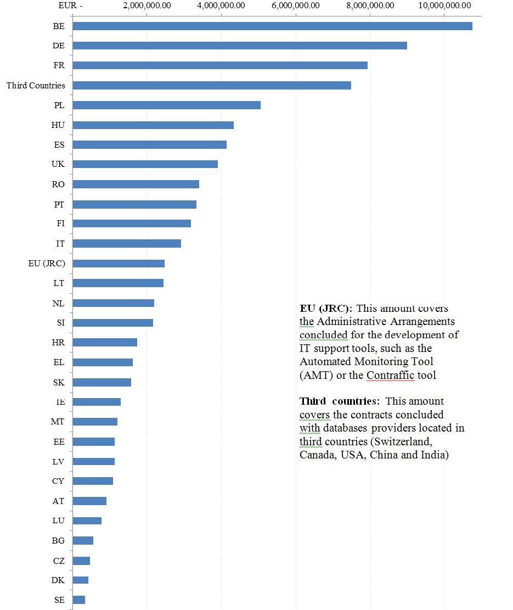

Efficiency
The evaluation assesses the efficiency of programme implementation and concludes, mostly on the basis of interviews and surveys, that there are sufficient grounds to assume that the Programme achieved its intended effects at reasonable cost. Although it is not possible to conclude whether it led to overall efficiency gains in the Member States, it appears from the surveys and stakeholder interviews that its management by the Commission (OLAF) was efficient in terms of making resources available to the beneficiaries in due time, quantity and quality. Nevertheless, further efficiency gains may be possible if Member States shared best practices with respect to purchasing and procuring equipment.
The annual budget of the Programme varied between EUR 13.7 and 15 million, with 67 to 91 activities receiving funding each year. The average amount for a grant or contract was therefore less than EUR 190 000. In each case, the transaction costs for the recipient and for the Commission should be proportionate to the amount awarded. In the beneficiaries’ survey, 90 % of the respondents agreed or strongly agreed with the statement that the desired results were achieved at reasonable cost.
On the basis of information from the three annual reports on the implementation of the Programme, data from the final reports on the technical assistance examined in the case-studies and statements in stakeholder interviews, it was possible to produce a rough estimate of the financial impact of seizures made and losses prevented using technical equipment and services purchased under the Programme. This amounts to over EUR 270 million, or three times the total cost of the Programme (EUR 98 million).
Hence, it can be concluded that there are indications that the Programme achieved its desired effects at reasonable cost. However, it is not possible to conclude whether it led to significant efficiency gains by Member States’ law enforcement agencies in their efforts to strengthen the protection of the Union’s financial interests. The evidence points to efficient project management in terms of resources being made available to beneficiaries in due time, quantity and quality. However, varying experiences still suggest that there may be additional benefit to be gained from Member States comparing notes on the type of equipment used and how it is procured.
The evaluation shows the importance of the additional monitoring requirements put in place following the mid-term evaluation of the Programme in 2010 and an internal audit in 2008, in particular as regards the reporting requirements for technical assistance grants.
The replies in the surveys and stakeholder interviews demonstrated that the technical equipment purchased under the Programme is effective in protecting the Union’s financial interests. Generally, across the different types of activity, stakeholders agree that the results achieved using such equipment could not have been achieved, or could have been achieved to a lesser extent, with the means made available by national or regional authorities or partners. This finding applies to all three types of activity, although training, seminars and conferences are seen as having been particularly instrumental in facilitating international cooperation and establishing networks that would otherwise not have been created. The tools developed and provided through the IT support and technical assistance add more direct value to national customs and law enforcement authorities’ investigations and, as such, contribute to the protection of the Union’s financial interests.
The beneficiaries welcomed the fact that the management of the Programme within OLAF was centralised in one unit in 2012. They are positive overall about the procedures for the calls for proposals (81 % of respondents in favour or strongly in favour). While they consider the reporting requirements to be relatively easy to meet (78 % of respondents agreed or strongly agreed), the evidence showed that more should be done to improve them. The Commission would be better able to monitor the results and impacts of the activities funded if it requested the right types of data from beneficiaries in their final technical report.
The beneficiaries and participants are satisfied with the Programme’s ability to meet their needs at the Member-State level. In the beneficiaries’ survey, the vast majority of the 68 respondents (86 %) either agreed or strongly agreed that the results of the project in which they were involved addressed the needs and problems in their country. In particular, the anti-fraud training projects were assessed as meeting countries’ needs to a very high extent: 94 % agreed or strongly agreed that the projects addressed their needs and problems. The focus of the activities goes beyond the Member States’ needs, as they helped to protect the financial interests of the Union. The Programme achieved its objectives and it is thus assessed that it contributed to the prevention of losses to the Union budget. However, the Programme could not address all the needs of the Member States’ customs for technical equipment to strengthen their operational capacity.
EU added value and sustainability of results
All sources confirm that the Programme delivered added value at Union level. Generally and across the different types of activity, stakeholders agree that their own objectives could not have been achieved, or could have been achieved to a lesser extent, with national or regional means. The nature of the added value varies across the types of activity: training and conferences are particularly instrumental in facilitating international cooperation and establishing networks, while IT tools and technical assistance provide more direct value for national customs and law enforcement authorities’ investigations.
The beneficiaries confirmed the usefulness of the Programme, in particular for customs, and underlined that the benefits far outweighed the costs of participation. Moreover, they clearly stated their intention to continue using the technical equipment.
The Commission ensured this sustainability of the results by allowing grant co-financing to cover maintenance costs. In exchange, beneficiaries undertook to submit a final implementation report one year after the closing date of the project to demonstrate its effectiveness and the sustainability of the outcome. As regards training, seminars and conferences, the participants are generally confident that the lessons learned can be put into practice, so sustainability was achieved in this respect too. This was particularly true of participants in digital forensic training.
Complementarity
Complementarity was ensured sufficiently in the preparation and implementation of the Programme. Stakeholders generally agree that it had a distinctive profile in addressing the protection of the financial interests of the Union which sets it apart from other (DG HOME and DG TAXUD) programmes. In particular, technical assistance was highlighted as a feature not offered by other EU initiatives, even though technical assistance actions could benefit from synergies with other EU initiatives. This applies for example to the use of ANPRS, whose results could be enhanced by making use of information from the existing EU funded systems, such as the European Car and Driving Licence Information System (EUCARIS network), the European Register of Road Transport Undertakings (ERRU) and the Réseau Permis de Conduire (RESPER) systems that have been set up under several Union initiatives.
While efforts have been made to coordinate the planning of the different Union’s programmes in the area of e.g. customs, more could be done to enhance cooperation between the Commission’s services to benefit from synergies between programmes and to prevent overlaps between EU Programmes and initiatives.
5. Contextual factors weighing on the Programme’s performance
The contextual factors that had an impact on the performance of the Programme included a number of issues, though these factors are difficult to quantify:
- for technical assistance grants, national and regional administration had to contribute at least 50 %. Since the outbreak of the financial crisis in 2008, budget constraints had considerably reduced applicants’ and beneficiaries’ financial capacity and this led to some applications, and even some grants that had already been awarded, being withdrawn. This has been addressed in the new Hercule III Regulation, which provides for funding of up to 80 % of eligible costs (up to 90 % in exceptional and duly justified cases);
- a substantial proportion of the budget for action funded under grants consisted of VAT (up to 25 %, depending on the applicable rates), but the Financial Regulations precluded the eligibility of VAT under the Programme. In practice, therefore, grants covered a lower percentage of the costs (less than 40 % in the case of technical assistance) and the shortfall had to be borne by the beneficiary;
- examination of applications in response to calls for proposals showed that applicants often had difficulties complying with administrative and legal requirements due to language barriers or unfamiliarity with the procedures for submitting an application or implementing a grant;
- the shortage of payment appropriations at the end of the Programme led to substantial delays in the final payment of grants concluded in the last two years.

6. Conclusions and way forward
The external evaluation concluded that the Programme ‘reached the objectives which it set out to achieve, and thus […] delivered its intended impact’. It also concluded that the three types of activity delivered complementary and sustainable results and that implementation was efficient and achieved the desired effects at reasonable cost. However, some areas for improvement were identified; these are listed below, together with the action that will be taken to address them:
- The impact of the Programme could be enhanced by ensuring more personal contacts between administrations, e.g. through staff exchanges. Funding for the costs related to staff exchanges are already eligible under the specifications for training and successful exchanges took place, e.g. between Italy and Bulgaria in 2010. The Commission will encourage and promote exchanges of staff at different levels of national and regional administrations in neighbouring Member States to improve cooperation on cross-border operations and investigations. In order to increase the cost-efficiency and quality of training funded under the Programme, the Commission will examine other possibilities for training and staff exchange, such as closer cooperation within existing European networks of national forensic institutes and judicial training organisations;
- Distributing access to databases through national contact points has not ensured that all relevant Member State authorities benefit. The evaluation findings indicate that the same is true across Member States, with some possibly benefiting more from the data than others. The Programme supported access to data by purchasing (access to) databases and managing access rights for staff in Member State law enforcement agencies. As the access rights are limited, the national contact points have to prioritise when awarding access to national and regional administrations. The findings on the use of the databases underline their usefulness, but also the difficulty of demonstrating the contribution they make to protect the Union’s financial interests. The Commission will undertake a careful review of the current users’ information requirements, together with an examination of the information sources available on the market in order to better match the former’s requirements to the available information sources. This should lead to the most cost-efficient use of the databases, in particular for purposes relating to the protection of the Union’s financial interests;
- Varying experiences as regards the efficiency of project management suggest that there may be advantages to be gained from sharing experience between Member States on the type of equipment used and how it is procured. Action under the Programme is managed by grant beneficiaries and the national co-funding should provide them with sufficient incentives to do this as efficiently as possible. The Commission selects applications on the basis of cost-efficiency and on several occasions it invited applicants to review the costs in the light of best practice and prices in other Member States, in particular for expensive equipment such as X-ray scanners or ANPRSs. It will further encourage the exchange of best practice, in particular in the context of cross-border projects combining several Member States’ efforts to protect the Union’s financial interests.
- The Commission’s ability to monitor the results and impacts of the activities funded could be improved by ensuring that beneficiaries are asked to provide the right types of data in their final technical reports and that Member States’ competent authorities improve their dedicated monitoring in relation to better demonstrate the added value of Hercule funded actions in relation to the fight against and prevention of activities detrimental to the Union’s financial interests, in particular cigarettes smuggling and counterfeiting . Since 2013, the Commission has asked beneficiaries to report on results achieved one year after the closing date of the grant agreement so that it has information for a period in which the equipment was fully operational. The requested information relates to the results obtained with equipment or services, purchased with the help of the Programme’s financial support, and used in operations to support investigations to protect the Union’s financial interests. The information could be related to investigations into alleged irregularities or corruption with EU expenditures; the fraud schemes operated by the fraudsters; the number of arrests made (and convictions, if already available) or estimates of the financial impact on the national or Union’s budget. The reporting requirements will eventually enable the Commission to demonstrate the contribution the Programme makes to the protection of the Union’s financial interests and at the same time enable beneficiaries to comply with national reporting requirements.
- While efforts have been made to coordinate the planning of the different Union’s programmes in the area of e.g. customs, more could be done to enhance cooperation between the Commission’s services to benefit from synergies between programmes and to prevent overlaps. The Commission will continue its internal coordination activities to take advantage of synergies between Union Programmes and to prevent overlaps from occurring. Moreover, within the framework of the Commission’s ‘Better Regulation’ strategy, a further simplification and streamlining of activities needed for the implementation of the Programme will be examined to reduce efforts and costs for the Programme’s beneficiaries as well as the Commission’s services.

In this report, the term ‘the Programme’ refers to the Hercule II Programme as adopted by the amendment of Decision 804/2004/EC by Decision 878/2007/EC.
The contractor was Rambøll Management Consulting. The evaluation was undertaken pursuant to Article 7 of Decision No 804/2004/EC as amended by Decision No 878/2007/EC of the European Parliament and of the Council of 23 July 2007 amending and extending Decision No 804/2004/EC establishing a Community action programme to promote activities in the field of the protection of the Community's financial interests (Hercule II programme), OJ L 193, 25.7.2007, under which ‘by 31 December 2014 the Commission (OLAF) shall present to the European Parliament and to the Council a report on the achievement of the objectives of the programme’. The delay in the adoption of the report is due to the restructuring of the services of the European Commission at the end of 2014.
The contractor’s report and its annexes can be retrieved from: https://bookshop.europa.eu/en/home/
Article 1 of Decision No 804/2004/EC as amended.
Article 1(2) of Decision No 804/2004/EC as amended.
Article 1a of Decision No 804/2004/EC as amended.
Article 6(2) of Decision No 804/2004/EC as amended; 2007 prices.
The figures are based on the commitment appropriations made available in the Financing Decisions 2007-2013. In 2007, the ‘Legal Training’ activities were part of the ‘Conferences, seminars and training’ activities that was divided in a ‘Training – Operational part’ and a ‘Training – Legal part’. The budget for the latter amounted to EUR 375 000.
Council Regulation (EC, Euratom) No 1605/2002 of 25 June 2002 (the Financial Regulation) and Commission Regulation (EC, Euratom) No 2342/2002 of 23 December 2002 (the Implementing Rules) for 2007-12, and Regulation (EU, Euratom) No 966/2012 of the European Parliament and of the Council of 25 October 2012 (the New Financial Regulation) and Commission Delegated Regulation (EU) No 1268/2012 of 29 October 2012 (the Rules of Application) for 2013 and beyond. The evaluation did not consider the impact of the New Financial Regulation on the implementation of the Hercule II Programme, but it can be argued that this reduced the administrative burden (e.g. for grant beneficiaries) by simplifying rules for low-value grants and shortening payment deadlines.
See Article 2, in particular paragraph 1, of Decision No 804/2004/EC as amended, which determines the instruments and conditions for funding.
Article 2a of Decision No 804/2004/EC as amended. All grant beneficiaries had to ‘promote the strengthening of Community action to protect the Community’s financial interests’. Article 3 of Decision No 804/2004/EC as amended lists the conditions for bodies in candidate or other non-EU countries to be eligible for grants from the Programme. As these conditions were not met, no grants were awarded to such bodies in third countries.
See Article 2a of Decision No 804/2004/EC as amended. Entities in categories (b), ‘research and educational institutes’, and (c), ‘all non-profit-making bodies’, must also have had legal personality for at least a year and be established and operating in a Member State or a country outside the Community, as defined in Article 3.
The Commission adopted annual reviews pursuant to Article 7 of Decision No 804/2004/EC as amended, which it transmitted to the European Parliament and to the Council. The most recent were for 2011 (SWD(2012) 445 final, 11.12.2012), 2012 (SWD(2013) 287 final, 24.7.2013) and 2013 (SWD(2014) 247 final, 17.7.2014).
Fiscalis was a multiannual Community action programme to improve the operation of taxation systems in the internal market (Decision No 1482/2007/EC, OJ L 330, 15.12.2007). Customs was a multiannual action programme to support and complement action taken by Member States to ensure the effective functioning of the internal market in the customs field (Decision No 624/2007/EC, OJ L 154, 14.6.2007).
SEC(2011) 1610 final and SEC(2011) 1611 of 19 December 2011
(Updated) Intermediate review on the achievement of the objectives of the Hercule II Programme. This was carried out on the basis of the second paragraph of Article 7 of Decision No 804/2004/EC as amended. In 2008, the internal audit capacity carried out a financial audit on the 2004-06 Hercule Programme. It contained a number of recommendations as to how OLAF’s implementation of the Programme could be improved.
Special Report No 1/2005 (OJ C 202, 18.8.2005).
Special Report No 2/2011; http://eur-lex.europa.eu/LexUriServ/LexUriServ.do?uri=SRCA:2011:02:FIN:EN:PDF.
Beneficiaries of the Programme are legal entities with whom the Commission concluded a grant agreement or a contract. Participants are individuals who attended or participated in an event (conference, seminar, and training) funded under the Programme. They do not receive direct Commission support, but their costs are met from the budget for the event.
In theory, the sample of surveyed beneficiaries may not have been representative, as it did not contain organisations that benefited at the very beginning but considered the Programme irrelevant and withdrew. However, the Commission’s attention was never brought to any such cases. Also, replies to questions and statements in relation to events that took place some time ago are in general less reliable; this could also have distorted the results of the survey. The sample contains replies from organisations that benefited throughout the entire period of the Programme.
Decision No 804/2004/EC as amended, Article 1(2), points (a) to (e).
This does not refer to the use of IT tools, but to the fact that staff in national authorities use the networks to contact their counterparts in other Member States in order to exchange information spontaneously.
Eight of 16 Member State stakeholders and one NGO stakeholder confirmed clearly that the Programme had provided national law enforcement (especially customs) authorities with technical and operational support in the fight against illegal cross-border activities, e.g. the new equipment gave authorities more flexibility – previous scanners were huge and processing slow, while the new scanners are faster and smaller.
The EU concluded ‘settlements’ with four tobacco companies to fight cigarette smuggling and counterfeiting. The EU and the Member States received substantial payments from the companies under these settlements.
The grants are awarded to successful applications submitted within the framework of Call for Proposals where the Commission received applications from a limited number of Member States. Following the publication of notices in the Official Journal and an active dissemination of information on the Call amongst professional networks, the number of applications and the number of Member States has increased substantially during the last years of the implementation of the Programme.
This figure should be handled with caution, as it is by no means complete. This estimate is based on an analysis of the annual reports and final reports submitted by beneficiaries of, in particular, technical assistance actions, together with a large number of secondary sources used by the contractor in its analysis. Beneficiaries of technical assistance grants for example report on the number of seizures and the prevented losses to the national and Union’s budget as the result of the actions that were enabled with equipment or information purchased under the Programme. The detection of a container with smuggled or counterfeited cigarettes represents a substantial amount of prevented losses. This estimate does not include the gains from prevention or results that are hard to quantify. The case-studies do not cover all Hercule II activities. The financial impact is likely to be greater.
Beneficiaries of technical assistance grants have to submit a final implementation report one year after the closing date of the grant agreement. This requirement was imposed in the light of the short period of time between the purchase of the equipment and the closing date of the agreement, which makes it difficult for the beneficiary to report any tangible results obtained through using the equipment.
An analysis carried out by DG TAXUD in 2013-2014 to determine the aggregated investment needs of Member States’ customs in 2014-2020 revealed that this represents an amount that is 30 times higher than the budget to made available under the Hercule III Programme.
See: https://joinup.ec.europa.eu/community/eucaris/description .
See for example: http://ec.europa.eu/transport/modes/road/access/erru_en.htm
See: http://ec.europa.eu/idabc/en/document/3989/5926.html
The contractor’s report contains 16 conclusions. The contractor was not asked to make recommendations but it made suggestions in six conclusions (2,5,7,10,11 and 15) for possible further action. The conclusions and way forward in this section are based on the contractor’s finding and complemented by the Commission’s findings and experience with the implementation of the Programme as well as the feed-back the Commission received from applicants for grants, grant beneficiaries and contractors, the Commission’s services and the other institutions following the negotiations on the follow-up of the Programme for the new MFF 2014-2020 during the years 2012-2014.
Based on conclusion 2 of the contractor’s report
Based on conclusion 5
Based on conclusion 10
Based on conclusions 7 and 11
Based on conclusion 15

