

**ANNEX I –Assessment of the state of stocks in the North-East Atlantic and adjacent waters**

The stock sample assessed by STECF under the new methodology is larger[1] than the sample used for the time series 2007-2014 (in earlier Communications). It includes stocks with an estimate of the ratio F/Fmsy of EU relevance for the monitoring of the CFP implementation. This results in a sample of 62 stocks.

The indicators are: a) number of stocks fished at/below Fmsy, b) number of stocks inside/outside safe biological limits, c) number of stocks with unknown status (with respect to safe biological limits). STECF also produced an indicator on the arithmetic mean value of F/Fmsy, and one on changes in advice coverage.

**Table 1. Achievement of MSY and status of stocks: 2015[2]**

|  |  |
| --- | --- |
| Assessment used to provide advice for year: | 2015 |
|  | Number of fish stocks |
| Stocks with MSY estimates | 62 |
| Stocks fished at or below Fmsy | 32 |
| Stocks fished above Fmsy | 30 |
|  |  |
| Stocks inside safe biological limits | 20 |
| Stocks outside safe biological limits | 16 |
|  |  |
| Stocks with advice to stop fishing | 11 |

**Graph 1: Coverage of advice in the north-east Atlantic including North Sea and Baltic Sea[3]**

**Graph 2: Number of stocks with advice to stop fishing[4]**

**Table 3. Status of stocks fished at MSY (as assessed in 2013 for 2015 advice)**

|  |  |
| --- | --- |
| **Fished at or below MSY** | **Fished above MSY** |
| **Baltic Sea:** Herring in Subdivisions 25 - 29 (excluding Gulf of Riga) and 32  Herring in Subdivision 30 (Bothnian Sea)  Herring in Subdivision 28.1 (Gulf of Riga) | Cod in Subdivisions 22-24 (Western Baltic Sea)  Herring in Division IIIa and Subdivisions 22 - 24 (Western Baltic spring spawners)  Sprat in Subdivisions 22 - 32 (Baltic Sea) |
| **North Sea (Including Skagerrak and Eastern Channel):**  Haddock in Subarea IV and Divisions IIIa West and VIa (North Sea. Skagerrak and West of Scotland)  Herring in Subarea IV and Divisions IIIa and VIId (North Sea autumn spawners)  Nephrops in Fladen Ground (FU 7), in Firth of Forth (FU 8) and in Moray Firth (FU 9)  Norway Pout in Subarea IV (North Sea) and Division IIIa (Skagerrak - Kattegat) - Autumn assessment  Northern shrimp (Pandalus borealis) in Divisions IIIa West and IVa East (Skagerrak and Norwegian Deeps)  Plaice Subarea IV (North Sea)  Sole in Division VIIe (Western Channel)  Sprat in Subarea IV (North Sea) | Cod in Subarea IV (North Sea). Divison VIId (Eastern Channel) and IIIa West (Skagerrak)  Nephrops in Farn Deeps (FU 6)  Saithe[5] in Subarea IV (North Sea) Division IIIa West (Skagerrak) and Subarea VI (West of Scotland and Rockall)  Sandeel in the Dogger Bank area (SA 1)  Sandeel in the South Eastern North Sea (SA 2)  Sandeel in the Central Eastern North Sea (SA 3)  Sole in Division VIId (Eastern Channel)  Sole in Subarea IV (North Sea)  Sole in Division IIIa and Subdivisions 22-24 (Skagerrak. Kattegat. and the Belts) |
| **Western European Waters**  Black-bellied anglerfish (Lophius budegassa) in Divisions VIIIc and IXa  White anglerfish (Lophius piscatorius) in Divisions VIIIc and IXa  Herring in Division VIIa South of 52° 30’ N and VIIg.h.j.k (Celtic Sea and South of Ireland  Herring in Division VIIa North of 52° 30’ N (Irish Sea)  Horse mackerel (Trachurus trachurus) in Division IXa (Southern stock)  Megrim (Lepidorhombus whiffiagonis) in Divisions VIIIc and IXa  Nephrops in North Minch (FU 11)  Nephrops in South Minch (FU 12)  Nephrops in the Firth of Clyde (FU 13)  Nephrops in the Sound of Jura (FU 13)  Nephrops in Irish Sea East (FU 14)  Nephrops on Porcupine Bank (FU 16)  Nephrops in the Smalls (FU 22)  Whiting in Division VIIe-k | Cod in Divisions VIIe-k (Celtic Sea cod)  Cod in Division VIIa (Irish Sea)  Cod in Division VIa (West of Scotland)  Haddock in Divisions VIIb.c.e-k  Haddock in Division VIb (Rockall)  Herring in Division VIa (North)  Hake in Division VIIIc and IXa (Southern stock)  Megrim (Lepidorhombus spp.) in Divisions IVa and VIa  Four-spot megrim (Lepidorhombus boscii) in Divisions VIIIc and IXa  Nephrops in Irish Sea West (FU 15)  Nephrops on the Aran Grounds (FU 17)  Plaice in Division VIIe (Western Channel)  Sole in Divisions VIIIa.b (Bay of Biscay)  Sole in Divisions VIIf. g (Celtic Sea)  Sole in Division VIIa (Irish Sea)  Nephrops off the southeastern and southwestern coasts of Ireland (FU 19) |
| **Widely distributed stocks**  Blue ling (Molva dypterygia) in Division Vb. and Subareas VI and VII  Herring in Subareas I. II. V and Divisions IVa and XIVa (Norwegian spring-spawning herring)  Mackerel in the Northeast Atlantic (combined Southern. Western and North Sea spawning components)  Roundnose grenadier (Coryphaenoides rupenstris) in Subareas VI and VII. and Divisons Vb and XIIb  Blue whiting in Subareas I-IX. XII and XIV (combined stock) | Hake in Division IIIa. Subareas IV. VI and VII and Divisions VIIIa.b.d (Northern stock)  Horse mackerel (Trachurus trachurus) in Divisions IIa. IVa. Vb. VIa. VIIa-c. e-k. VIII (Western stock) |

**Annex II Mediterranean**

**Table 1.** Number of known stocks and proportion of stocks assessed as overfished in the Mediterranean and Black Sea, per region, 2010 - 2013 (**Source**: STECF and GFCM-SAC).[6],[7]

|  |  |  |  |  |  |  |
| --- | --- | --- | --- | --- | --- | --- |
| **Area** | | | **2010** | **2011** | **2012** | **2013** |
| **MEDITERRANEAN SEA** | | |  |  |  |  |
| Number of known stocks | | | 78 | 88 | 90 | 83 |
| Proportion of stocks assessed as overfished | | | 87% | 95% | 93% | 93% |
|  | Western Mediterranean | |  |  |  |  |
|  | | Number of known stocks | 41 | 60 | 57 | 52 |
|  | | Proportion of stocks assessed as overfished | 95% | 97% | 95% | 92% |
|  | Central Mediterranean | |  |  |  |  |
|  | | Number of known stocks | 20 | 24 | 27 | 27 |
|  | | Proportion of stocks assessed as overfished | 80% | 92% | 93% | 93% |
|  | Eastern Mediterranean | |  |  |  |  |
|  | | Number of known stocks | 17 | 4 | 6 | 4 |
|  | | Proportion of stocks assessed as overfished | 82% | 75% | 83% | 75% |
| **BLACK SEA** | | |  |  |  |  |
| Number of known stocks | | | 4 | 5 | 6 | 7 |
| Proportion of stocks assessed as overfished | | | 75% | 100% | 83% | 86% |
| **TOTAL Number of known stocks** | | | **82** | **93** | **96** | **90** |

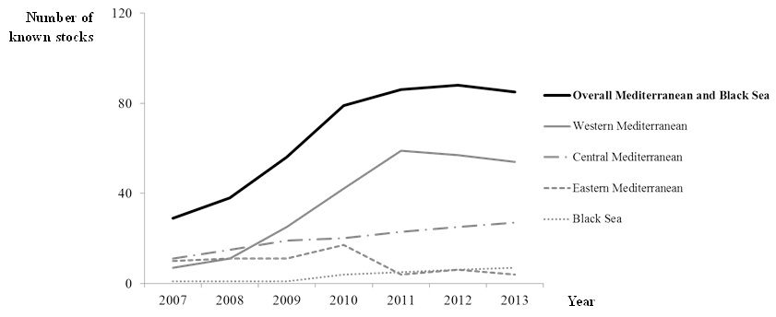

**Figure 1**. Number of known stocks 2007-2013 by Mediterranean sub-region and Black Sea.

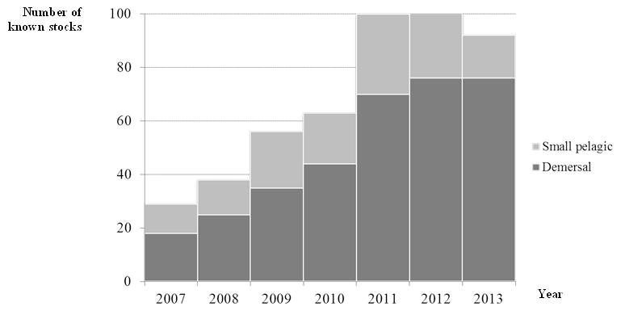

**Figure 2.** Number of known stocks from 2007-2013 by fishery in the Mediterranean and Black Sea.

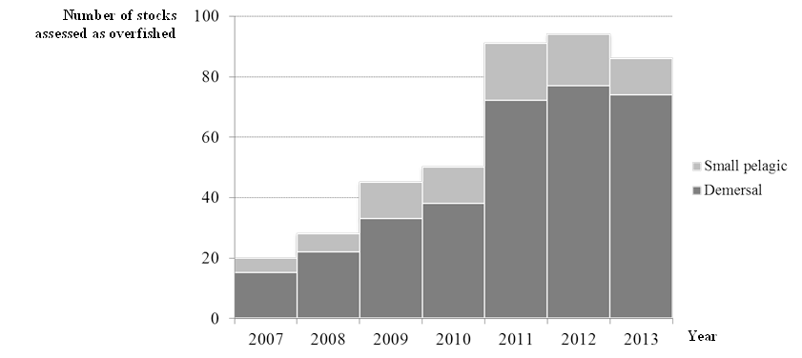

**Figure 3.** Number of overfished stocks from 2007-2013 by fishery in the Mediterranean and Black Sea

**Annex III. Economic performance in haddock fisheries in the Atlantic**

Graph 1 Net profits demersal trawlers UK (vessel length 24-40)



Graph 2 Average wage and GVA per vessel demersal trawlers UK (vessel length 24-40)



1. This evaluation includes small stocks of Nephrops
2. This evaluation applies the STECF methodology and is based on the latest data and assessments on stocks including small stocks of Nephrops and short-lived species managed within a biomass escapement MSY target.
3. From data compiled by European Commission, using the same method as in previous editions of this Communication.
4. Advice to stop fishing, for a zero catch, for the lowest possible level of catch or similar wording
5. Only very slightly overfished
6. The respective catches, in live weight, of the known stocks correspond to a limited part of the total catches in the Mediterranean and Black Seas (*i.e*. approx. 495 Kt out of 1.4.Mt total estimated, **Source**: STECF, GFCM-SAC, and FAO Capture Production). The total number of known stocks may therefore be still very limited compared to the total compared to the total number of stocks.
7. "TOTAL number of known stocks" means the overall number of advices provided per sub-region and per year. The total number of advices can include the same stock in several years