

**1. Statistical annex**

Chart 1: Croatian citizens (all ages) residing in other EU Member States in 2013, in thousands, by country of residence

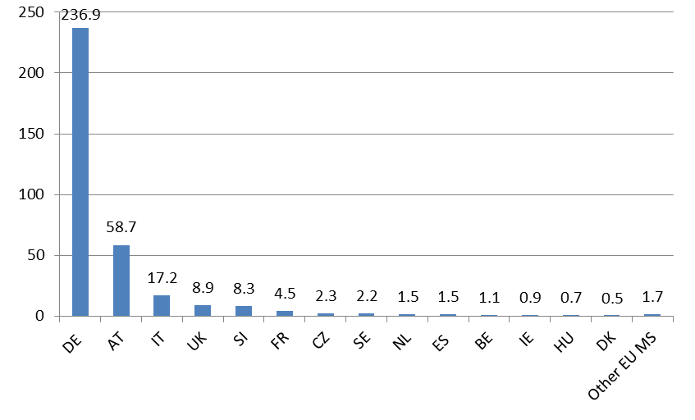

*Source*: Eurostat Population statistics (1st January 2013 values, table migr_pop1ctz), except for UK: UN Population Division <http://www.un.org/en/development/desa/population/migration/data/estimates2/estimatesorigin.shtml>; and FR: estimations based on OECD International Migration Database <http://stats.oecd.org/Index.aspx?DataSetCode=MIG>, see Vidovic and Mara (2015).

Chart 2: Distribution of working-age (15-64) Croatian citizens residing in other EU countries, by duration and country of residence, in 2014 (in % of total)

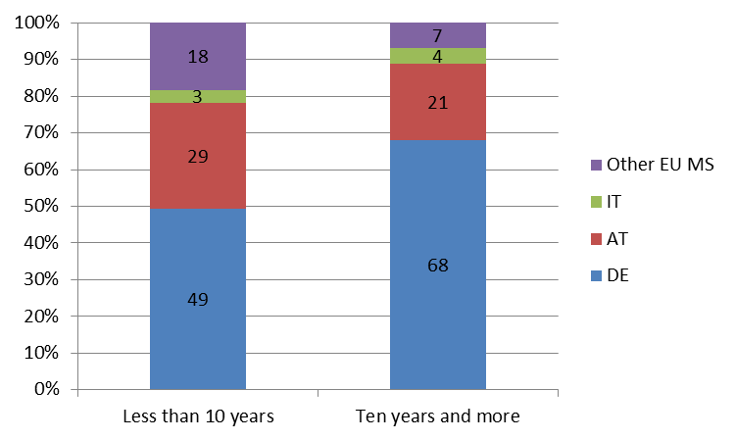

*Source*: DG EMPL calculations based on Eurostat EU-LFS.

*Notes*: The category 'Ten years and more' does not include those born in their current country of residence; i.e. it includes only Croatian nationals that in 2014 have lived for at least ten in their current country of residence but were born in another country. Data for IT and other EU MS is of limited reliability.

Chart 3: Mobility rate by country: working-age citizens living in another EU country, by years of residence (age group 15-64, 2014, as a percentage of the working-age population of the country of citizenship)

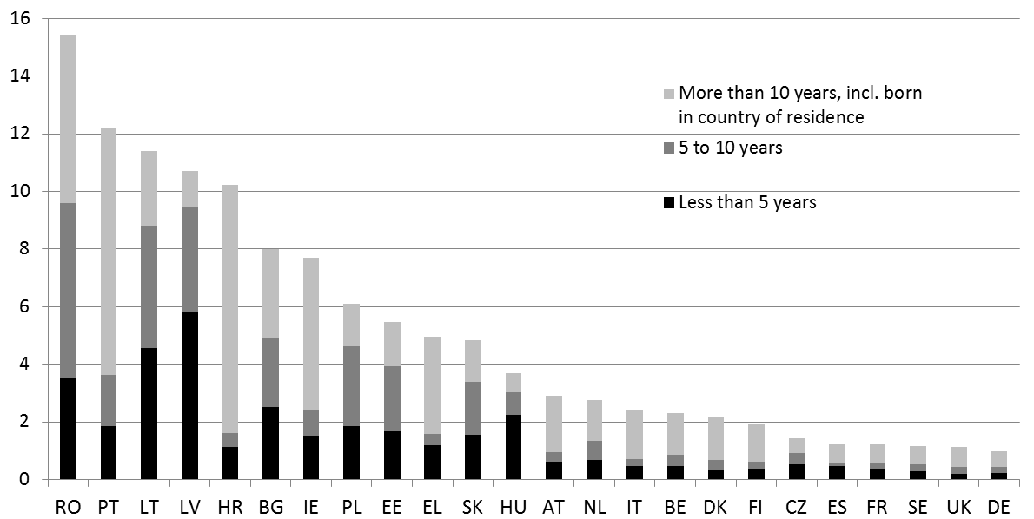

*Source*: DG EMPL calculations based on Eurostat EU-LFS.

*Notes*: The mobility rate is the number of working-age citizens living in another Member State in 2014, as a percentage of the working-age population of the country of citizenship. Figures for CY, LU, MT and SI are too small to be reliable. Figures for DK, EE, FI and HR are of limited reliability due to the small size of the sample.

Chart 4: Portable documents A1 issued for posting to other countries, breakdown by sending country (2013), in thousands

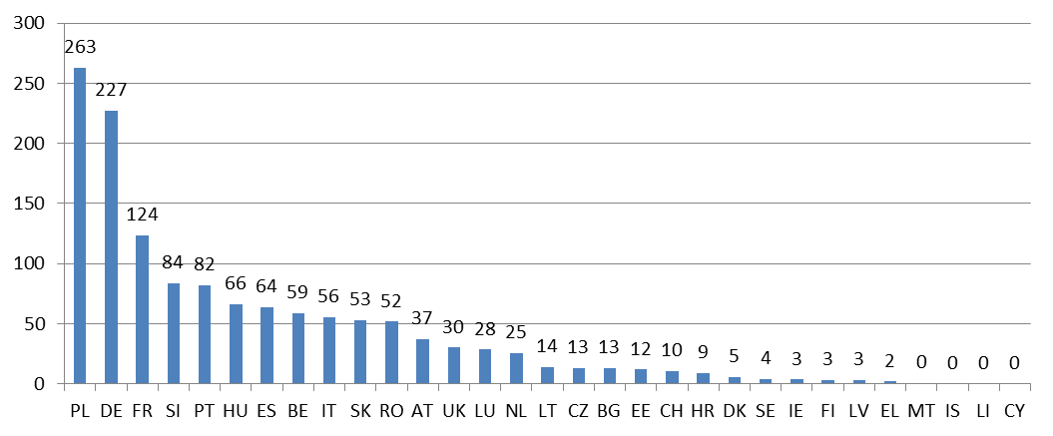

*Source*: European Commission, Report on A1 portable documents issued in 2012 and 2013, December 2014. *Note*: as Croatia acceded to the EU on 1st July 2013, data on portable documents issued by this country only relate to the period 1st July 2013 to 31st December 2013. This has to be taken into account when comparing to other Member States.

Chart 5: Portable documents A1 issued for posting from Croatia, breakdown by destination country (2013)

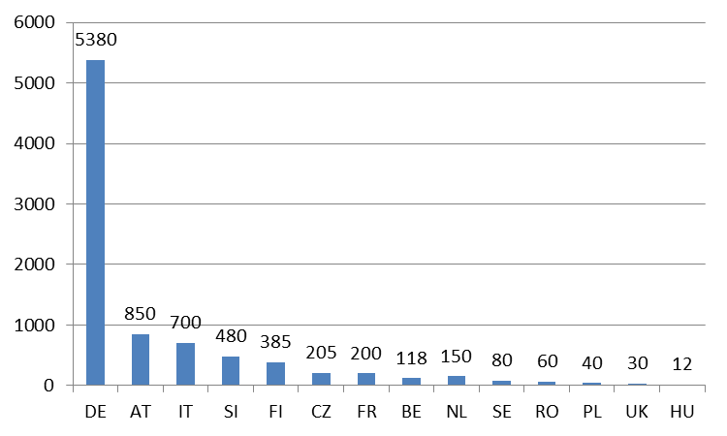

*Source*: European Commission, Report on A1 portable documents issued in 2012 and 2013, December 2014. *Note*: (1) Only countries with value higher than 10 are reported. (2) As Croatia acceded to the EU on 1st July 2013, data on portable documents issued by this country only relate to the period 1st July 2013 to 31st December 2013. This has to be taken into account when comparing to other Member States.

Chart 6: Portable documents A1 issued for posting to Croatia, breakdown by origin country (2013)

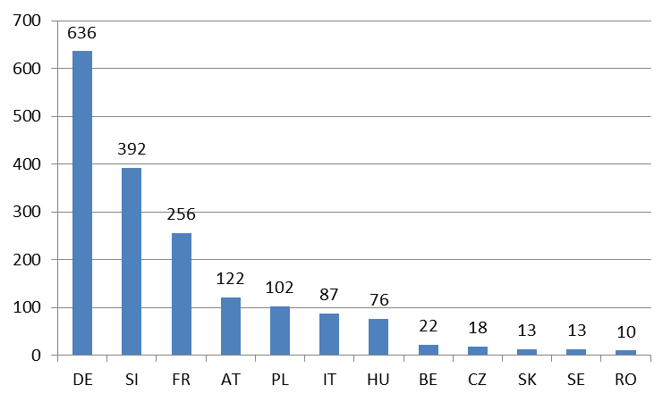

*Source*: European Commission, Report on A1 portable documents issued in 2012 and 2013, December 2014. *Note*: (1) Only countries with value equal or higher than 10 are reported. (2) As Croatia acceded to the EU on 1st July 2013, data on portable documents issued to this country only relate to the period 1st July 2013 to 31st December 2013.

Chart 7: Migration flows in and out of Croatia from and towards EU countries

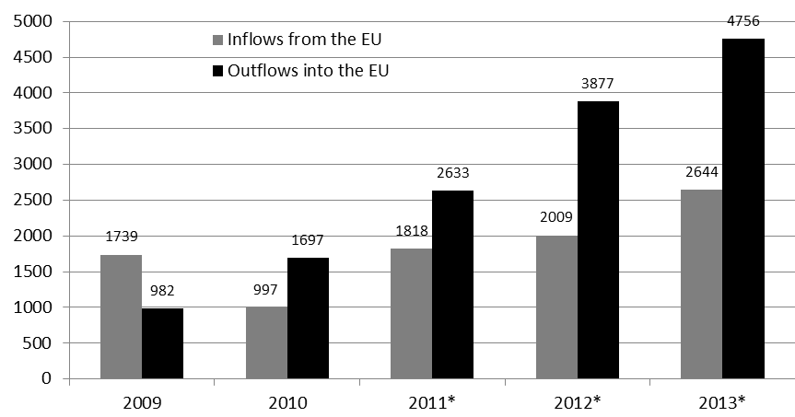

*Source*: Croatian Bureau of Statistics (2014), Migration of population of Republic of Croatia 2013, 2012, 2011, 2010, 2009. *Note*: According to Bozic (2007), data presented by the Statistical Office of Croatia may not fully reflect the actual size of emigration, since the reporting is limited to those who reported their departure. *New methodology of counting in place from 2011 onwards.

Table 1: Outflows of Croatian nationals from Croatia by destination countries

|  |  |  |
| --- | --- | --- |
| Destination countries | 2012 | 2013 |
| Total | 10836 | 13394 |
| Europe | 10130 | 12232 |
| **EU-27** | **3216** | **4058** |
| *Among which:* |  |  |
| Germany | 1765 | 2069 |
| Austria | 476 | 716 |
| Italy | 293 | 496 |
| Slovenia | 258 | 229 |
| Netherlands | 164 | 98 |
| Sweden | 63 | 79 |
| Belgium | 12 | 63 |
| UK | 53 | 61 |
| France | 42 | 54 |
| Hungary | 2 | 44 |
| **Other European countries** | **6914** | **8174** |
| *Among which:* |  |  |
| Serbia | 3735 | 3805 |
| Bosnia and Herzegovina | 2641 | 3580 |
| Montenegro | 165 | 52 |
| Switzerland | 283 | 613 |

*Source*: Croatian Bureau of Statistics (2014), Migration of population of Republic of Croatia 2013 and Croatian Bureau of Statistics (2013), Migration of population of Republic of Croatia 2012. *Note*: According to Bozic (2007), data presented by the Statistical Office of Croatia may not fully reflect the actual size of emigration, since the reporting is limited to those who reported their departure.

Table 2: Stock of Croatian nationals residing in selected EU Member States, according to national data of the residence countries.



*Source:* Germany: Central Register of Foreigners (Ausländerzentralregister), published by Statistical Office (Statistisches Bundesamt), Fachserie 1 Reihe 2, 2014; Austria: Statistik Austria, Statistik des Bevölkerungsstandes; Italy: Istat, "Popolazione residente al 1 gennaio, cittadinanza", <http://dati.istat.it/> ; Slovenia: Statistical Office of the Republic of Slovenia, available at:<http://pxweb.stat.si/pxweb/Database/Demographics/05_population/15_Population_structure/05_05E10_Citizenship/05_05E10_Citizenship.asp>; Sweden: Statistics Sweden, available at: <http://www.statistikdatabasen.scb.se/pxweb/en/ssd/START__BE__BE0101__BE0101F/UtlmedbR/?rxid=49c124a7-1c61-4e4a-bacb-2807c526a5f0> .

*Notes*: (1) Periods covered are 1st January of reference year except for: Germany and Sweden: 31st December of preceding year. (2) Due to differences in methods and data sources, the numbers above are not comparable across countries.

Table 3: Inflows of Croatian nationals in selected EU Member States, according to national data of the destination countries



*Source:* Germany: German Statistics Office (Statistisches Bundesamt); Austria: Statistik Austria, available at: <http://www.statistik.at/web_de/statistiken/bevoelkerung/wanderungen/index.html> ; Slovenia: Statistical Office of the Republic of Slovenia, available at: <http://pxweb.stat.si/pxweb/Dialog/varval.asp?ma=05N1008E&ti=&path=../Database/Demographics/05_population/40_Migration/05_05N10_International/&lang=1> ; Ireland, Department of Social Protection, <http://www.welfare.ie/en/Pages/Personal-Public-Service-Number-Statistics-on-Numbers-Issued.aspx> ; Sweden: Statistics Sweden, <http://www.statistikdatabasen.scb.se/pxweb/en/ssd/START__BE__BE0101__BE0101J/ImmiEmiMedb/?rxid=49c124a7-1c61-4e4a-bacb-2807c526a5f0>; UK: DWP, <https://www.gov.uk/government/statistics/national-insurance-number-allocations-to-adult-overseas-nationals-entering-the-uk-to-september-2014> , the data refers to the number of Croatian adults (over 16) who successfully applied for a National Insurance Number.

*Notes*: (1) Periods covered are the whole reference year except for: *Germany, 2014: January to May and figure for this year represents inflows from Croatia of all non-German citizens (the data on previous years is inflows of Croatian citizens only).. (2) **Changes over the last year available are comparisons 2013 over 2012 for all countries, except for Ireland and the UK where 2014 is compared to 2013. (3) Due to differences in methods and data sources, the numbers above are not comparable across countries. For instance, Germany applies for its national migration flow data a different definition of migration (resident at least 3 months) than the international one used by most countries (resident at least twelve months) which tends to lead to higher numbers.

Table 4: Net flows (inflows minus outflows) of Croatian nationals in selected EU Member States, according to national data of the destination countries



*Source:* Same a preceding table.

*Notes*: (1) Periods covered are the whole reference year except for: *Germany, 2014: January to May; (2) **Changes over the last year available are comparisons 2013 over 2012 for all countries. (3) Due to differences in methods and data sources, the numbers above are not comparable across countries.

Table 5: Employment among Croatian nationals in selected EU Member States, according to national data of the country of employment (social security data or Ministry of employment)



*Source:* Germany: Labour Agency (Bundesagentur für Arbeit), [www.statistik.arbeitsagentur.de](http://www.statistik.arbeitsagentur.de), *Beschäftigung von Staatsangehörigen der EU-Mitgliedsstaaten in Deutschland*, 30.Juni 2014; Austria: Bundesministerium für Arbeit, Soziales und Konsumentenschutz; Slovenia: Employment Service of Slovenia, available at: <http://www.ess.gov.si/trg_dela/trg_dela_v_stevilkah/zaposlovanje_tujcev> ; Italy: INPS: 'Osservatorio sugli Extracomunitari e sui Comunitari nei paesi dell'Europa dellest'; Sweden: Labour Statistics Based on Administrative Sources (RAMS), provided by Statistics Sweden; Czech Republic: Labour Office of the Czech Republic, data for 2013 and 2014 are estimations.

*Notes*: (1) Periods covered are the whole reference year except for: *Germany: June of each reference year; **Czech Republic: Stock as of 31 December of the reference year. (2) ***: Changes over the last year available are comparisons 2014 over 2013 for all countries, except for Italy and Sweden: 2013 compared to 2012. (3) Due to differences in methods and data sources, the numbers above are not comparable across countries.

Table 6: Number of working age (15-64) Croatian citizens residing in other EU Member States (mid-2011 to mid-2014), by labour market status, in thousands



*Source*: DG EMPL calculations based on Eurostat EU-LFS (average over Q2 and Q3 for each year). *Notes*: The values in terms of changes between 2013 and 2014 (highlighted in grey) are not statistically significant (lower than the reliability limits).

Table 7: Distribution of Croatian workers residing in the EU-27 by economic sector, compared to overall employment (in %), 2014



*Source*: DG EMPL calculations based on Eurostat EU-LFS. *Notes*: The values in brackets are of limtied reliability due to small sample size. Croatian workers in the EU-27 include all ages and all categories of duration of residence (less and more than ten years), except those who were born in their current country of residence or who did not answer that question, which are excluded from the analysis.

Table 8: Distribution of Croatian workers residing in the EU-27 by occupation, compared to overall employment (in %), 2014



*Source*: DG EMPL calculations based on Eurostat EU-LFS. *Notes*: The values in brackets are of limited reliability due to small sample size. Armed forces are not included. Croatian workers in the EU-27 include all ages and all categories of duration of residence (less and more than ten years), except those who were born in their current country of residence who are excluded from the analysis.

Chart 8: Convergence of GDP per capita in PPS compared to the EU-28 average, 2000–13

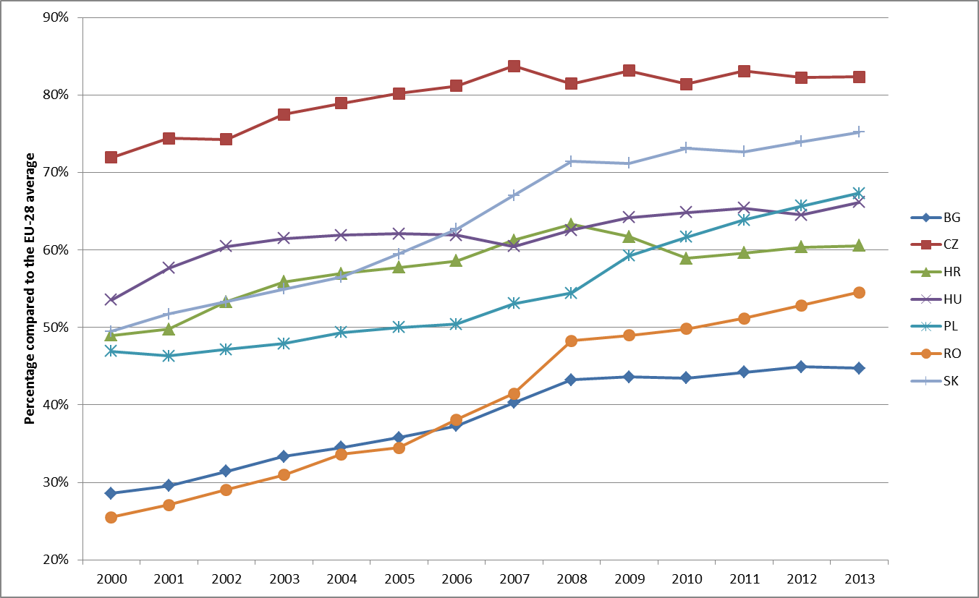

*Source*: DG EMPL calculations based on Eurostat Annual National Accounts data [prc_ppp_ind].

Chart 9: GDP per capita in PPS compared to the EU-28 average, 2013

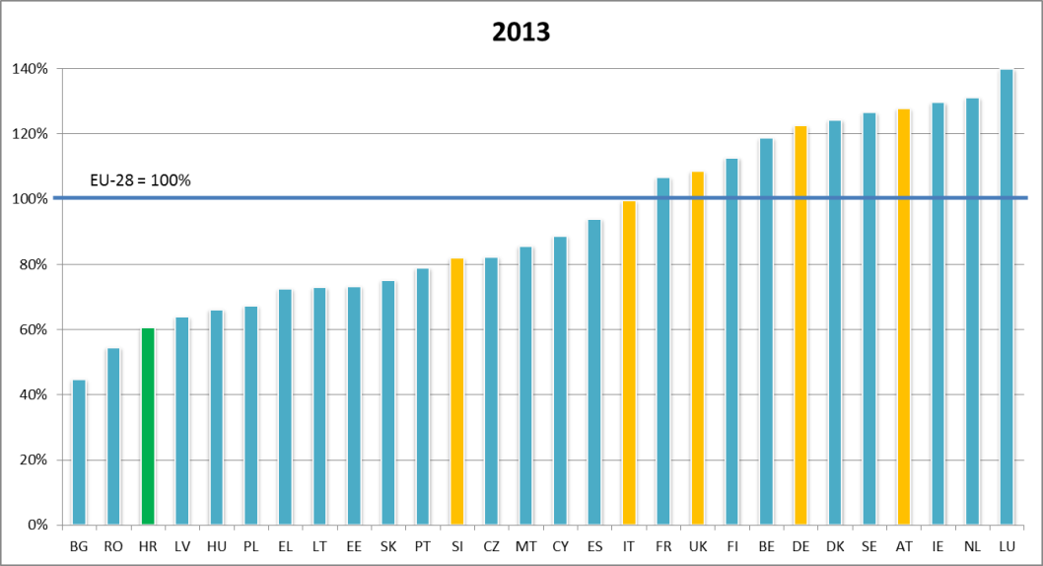

*Source*: DG EMPL calculations based on Eurostat Annual National Accounts data [prc_ppp_ind]. *Note*: bars in orange denote countries that are the main destination countries for mobile Croatian citizens.

Chart 10: Employment, unemployment and youth unemployment rate trends, 2004-14

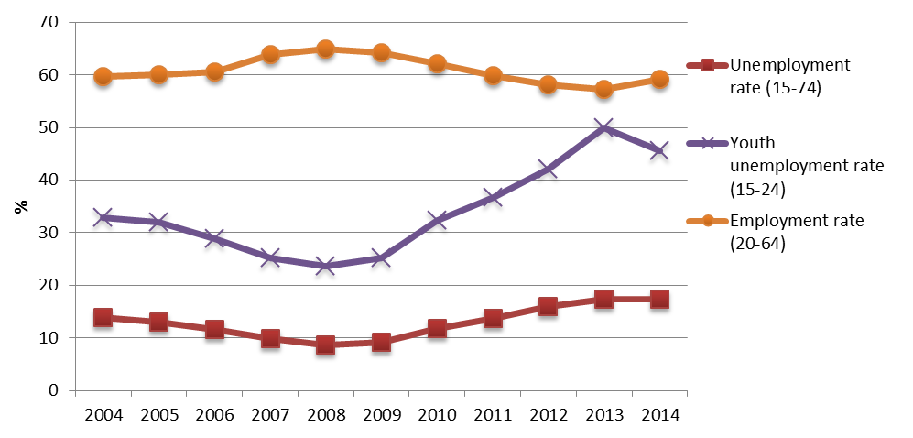

*Source*: Eurostat, EU-LFS, harmonized unemployment [une_rt_a], employment [lfsi_emp_a] and youth unemployment rates [une_rt_a], yearly averages.

Chart 11: Main labour market indicators, comparison of Croatia (2013 and 2014) with EU-28 average (2014)

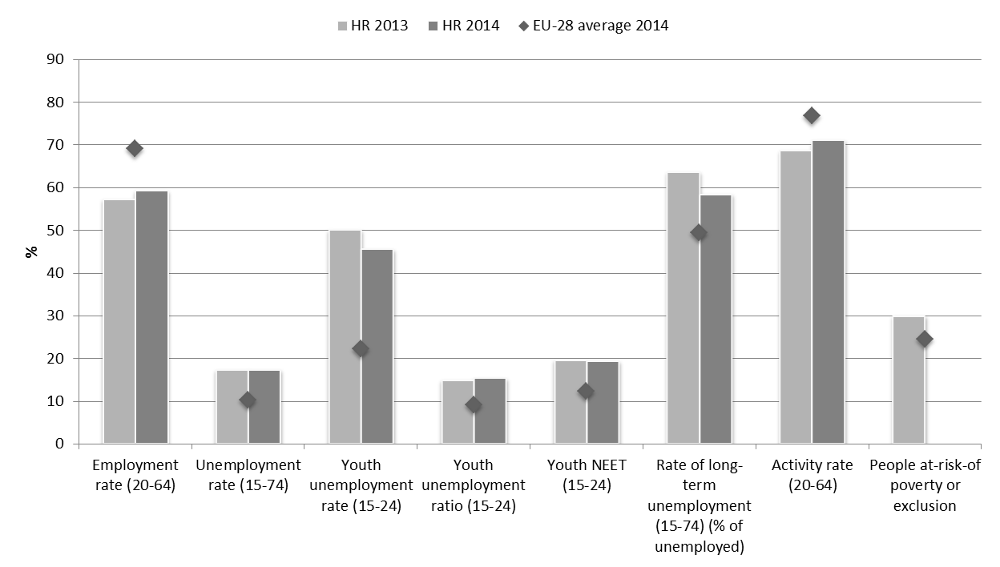

*Source*: Eurostat, EU-LFS and EU SILC. EU-28 figure for People at risk of poverty or exclusion refers to 2013 data.

**Chart 12: Socio-economic breakdown of recent movers from Croatia to other EU Member States, compared to average in EU-27 and Croatia, 2014, in % of total working-age (15-64)**

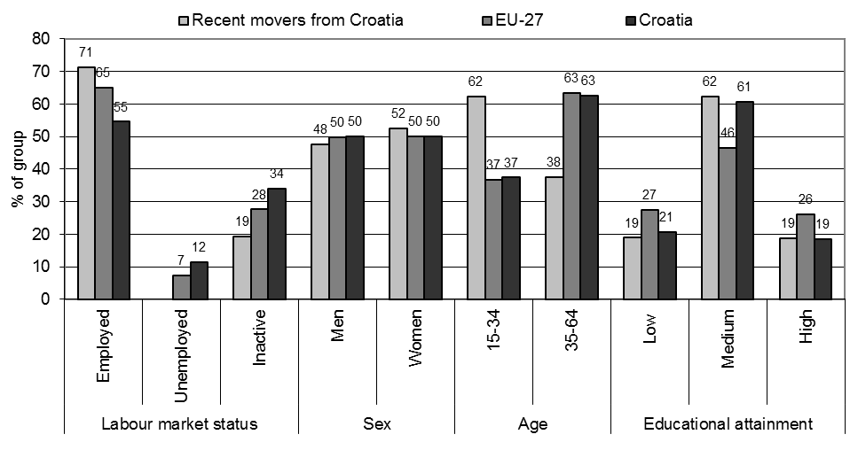

Source: Eurostat, EU-LFS. Recent movers defined as Croatian citizens residing for less than 10 years in another EU country. Value for recent movers from Croatia being unemployed too small to be statistically reliable.

**2. References**

Bozic (2007), *Strengthening cross border cooperation in the Western Balkans regarding migration management, Croatia, in: Migration Flows in Southeast Europe*, a compendium of National Perspectives, Belgrade, April.

CMR (2015), *Free movement of workers and transitional arrangements: lessons from the 2004 and 2007 enlargements* (*forthcoming*).

Croatian Bureau of Statistics (2013), *Migration of population of Republic of Croatia 2012*, released on 15 July 2014, available at: <http://www.dzs.hr/Hrv_Eng/publication/2013/07-01-02_01_2013.htm>.

Croatian Bureau of Statistics (2014), *Migration of population of Republic of Croatia 2013*, released on 15 July 2014, available at: <http://www.dzs.hr/Hrv_Eng/publication/2014/07-01-02_01_2014.htm>.

ECAS (2014), *Fiscal Impact of EU Migrants in Austria, Germany, the Netherlands and the UK*, available at <http://www.epim.info/wp-content/uploads/2014/11/2BC_EU-migrants-final-2.pdf>.

Eurofound (2012), *Labour mobility within the EU: The impact of return migration*, available at: <http://eurofound.europa.eu/sites/default/files/ef_publication/field_ef_document/ef1243en.pdf>.

Eurofound (2014), *Labour migration in the EU: recent trends and policies*, available at: <http://eurofound.europa.eu/sites/default/files/ef_publication/field_ef_document/ef1456en.pdf>.

European Commission (2011), *Employment and Social Developments in Europe Review*. Chapter 6 – Intra-EU mobility and the impact of enlargement.

European Commission (2013), Eurobarometer 'Internal Market', Special Eurobarometer 398, available at: <http://ec.europa.eu/public_opinion/archives/ebs/ebs_398_en.pdf>.

European Commission (2014), *Mapping and analysing Bottleneck Vacancies on the EU Labour Market*, available at <http://ec.europa.eu/social/BlobServlet?docId=12625&langId=en>.

European Integration Consortium (2009), *Labour mobility within the EU in the context of enlargement and the functioning of the transitional arrangements*, available at: <http://ec.europa.eu/social/main.jsp?langId=en&catId=89&newsId=497>.

European Policy Centre (2013), *Making progress towards the completion of the Single European Labour market*: available at: <http://www.epc.eu/documents/uploads/pub_3529_single_european_labour_market.pdf>.

Eurostat (2014) News release 5/2015 – Personal transfers in the EU28 – January 2015, available at: <http://ec.europa.eu/eurostat/documents/2995521/6457244/2-09012015-AP-EN.pdf/18f662ac-8b70-4254-a45b-10b78613a5a4>.

Galgóczi B..and Leschke J. (2012). *Intra-EU labour migration after Eastern enlargement and during the crisis*. ETUI Working Paper 2012.13

GHK-ICF (2013), *A fact finding analysis on the impact on the Member States' social security systems of the entitlements of non-active intra-EU migrants to special non-contributory cash benefits and healthcare grantedon the basis of residence*, available at: <http://ec.europa.eu/social/main.jsp?langId=en&catId=89&newsId=1980&furtherNews=yes>

Martins, P., Piracha, M. and Varejao, J. (2012), *Do Immigrants Displace Native Workers? Evidence from Matched Panel Data*, IZA Discussion Paper No. 6644. Available at SSRN: <http://ssrn.com/abstract=2089673>

NIESR (2011), *Labour mobility within the EU - The impact of enlargement and the functioning of the transitional arrangements*, available at: <http://ec.europa.eu/social/main.jsp?langId=en&catId=89&newsId=1108&furtherNews=yes>

OECD (2013), *International Migration Outlook 2013*, OECD Publishing, available at <http://www.oecd-ilibrary.org/social-issues-migration-health/international-migration-outlook-2013_migr_outlook-2013-en>.

Pilar(2014), *Pilar's Barometer of Croatian society* Institute of Social Sciences Ivo Pilar, Zagreb; available at <http://barometar.pilar.hr>.

Social Situation Monitor (2013), *Access of mobile EU citizens to social protection*, Research note No 10/2013, available at <http://ec.europa.eu/social/BlobServlet?docId=11568&langId=en>.

Vidovic and Mara (2015), *Free movement of workers, transitional arrangements and potential mobility from Croatia*. Report for the European Commission, *forthcoming*.

Wadsworth, J. (2015), *Immigration in the UK Labour Market – CEP Election Analysis*, LSE – Centre for Economic Performance