

**ANNEX I:**

**Overview table summarising the monthly reports of the Turkish Cypriot Chamber of Commerce according to Article 8 of Commission Regulation (EC) No 1480/2004 in EUR**

|  |  |  |  |  |  |  |  |  |  |  |  |  |  |
| --- | --- | --- | --- | --- | --- | --- | --- | --- | --- | --- | --- | --- | --- |
| Traded Products | January | February | March | April | May | June | July | August | September | October | November | December | **Total** |
| Aluminium/ PVC Products | 4,600 | 22,120 | 5,400 | 2,040 | 3,600 | 5,600 | 6,400 | 6,000 | 4,800 | 6,000 | 20,280 | 4,800 | **91,640** |
| Live Animals/Animal products (fresh fish) | 72,102 | 85,505 | 81,640 | 67,802 | 68,367 | 74,127 | 89,666 | 67,968 | 72,151 | 75,434 | 52,987 | 42,368 | 850,115 |
| Building/ Articles of Stone | 17,956 | 11,424 | 31,162 | 24,970 | 17,584 | 54,865 | 16,735 | 1,330 | 34,188 | 19,445 | 24,124 | 40,804 | 294,586 |
| Ceramic products/refractory goods | 19,229 | 15,589 | 6,342 | 8,457 | 6,273 | 4,249 | 6,614 | 11,377 | 11,102 | 7,772 | 10,411 | 13,922 | 121,336 |
| Chemical Products | 0 | 0 | 0 | 0 | 0 | 0 | 0 | 0 | 0 | 0 | 0 | 0 | 0 |
| Electricity | 1,200 | 1,600 | 0 | 0 | 0 | 1,000 | 0 | 0 | 0 | 0 | 0 | 0 | 3,800 |
| Earth and stone | 0 | 55 | 235 | 0 | 0 | 0 | 0 | 0 | 0 | 0 | 2,011 | 0 | 2,301 |
| Electronic Equipment | 1,600 | 1,200 | 18,350 | 0 | 4,266 | 300 | 2,033 | 1,000 | 1,000 | 1,000 | 1,000 | 1,000 | 32,749 |
| Glass and glassware | 800 | 0 | 0 | 0 | 0 | 0 | 0 | 0 | 150 | 0 | 0 | 0 | 950 |
| Handicraft products | 868 | 313 | 0 | 0 | 423 | 504 | 502 | 330 | 1,010 | 709 | 58 | 218 | 4,935 |
| Iron/Steel | 24,050 | 12,470 | 31,990 | 15,340 | 22,272 | 14,000 | 16,150 | 26,262 | 16,422 | 26,474 | 37,296 | 23,225 | 265,951 |
| Miscallenous/Manufactured articles | 21,014 | 12,879 | 19,609 | 37,314 | 29,181 | 26,214 | 27,405 | 22,584 | 21,883 | 26,489 | 25,468 | 23,487 | 293,527 |
| Paintings | 0 | 0 | 0 | 0 | 0 | 0 | 0 | 0 | 0 | 0 | 0 | 0 | 0 |
| Paper Products | 3,000 | 7,000 | 5,200 | 2,760 | 8,600 | 9,900 | 8,200 | 4,920 | 4,920 | 0 | 4,100 | 4,100 | 62,700 |
| Pastrycooks' products | 0 | 0 | 5,500 | 0 | 0 | 0 | 0 | 0 | 0 | 0 | 0 | 0 | 5,500 |
| Plastic Products | 146,654 | 110,503 | 120,706 | 124,262 | 125,197 | 126,990 | 131,278 | 87,952 | 121,354 | 102,218 | 135,193 | 97,753 | 1,430,060 |
| Pre-fabricated buildings | 150 | 0 | 0 | 120 | 70 | 50 | 0 | 0 | 40 | 200 | 85 | 150 | 865 |
| Prepared Foodstuffs | 0 | 0 | 0 | 0 | 0 | 0 | 0 | 0 | 0 | 0 | 0 | 0 | 0 |
| Printed Books, newspapers etc. | 4,000 | 0 | 3,000 | 3,300 | 1,000 | 0 | 0 | 4,900 | 4,100 | 10,710 | 4,100 | 4,980 | 40,090 |
| Raw metal | 13,070 | 16,335 | 10,060 | 1,380 | 24,350 | 6,850 | 7,575 | 10,210 | 6,750 | 6,550 | 6,750 | 7,750 | 117,630 |
| Saddlery and Harness | 0 | 0 | 0 | 0 | 0 | 0 | 0 | 0 | 0 | 0 | 0 | 0 | 0 |
| Textile articles | 0 | 0 | 0 | 0 | 0 | 0 | 0 | 0 | 0 | 0 | 0 | 0 | 0 |
| Vegetable residues and by-products | 1,600 | 0 | 1,600 | 1,600 | 0 | 0 | 1,400 | 0 | 1,500 | 0 | 1,200 | 2,000 | 10,900 |
| Vegetables | 83,390 | 80,418 | 45,200 | 23,200 | 1,000 | 4,200 | 12,000 | 5,500 | 0 | 2,500 | 0 | 0 | 257,408 |
| Water Storage/heating | 0 | 0 | 0 | 0 | 0 | 0 | 0 | 0 | 0 | 0 | 0 | 0 | 0 |
| Wood | 0 | 0 | 0 | 0 | 0 | 0 | 0 | 0 | 0 | 0 | 0 | 0 | 0 |
| Wooden products/ furniture | 1,324 | 2,600 | 1,798 | 1,735 | 2,506 | 599 | 2,457 | 2,120 | 2,353 | 2,080 | 3,146 | 1,428 | 24,146 |
| **Total** | **416,606** | **380,010** | **387,792** | **314,280** | **314,689** | **329,449** | **328,414** | **252,453** | **303,723** | **287,579** | **328,209** | **267,984** | **3,911,189** |

**Source:** Turkish Cypriot Chamber of Commerce

**ANNEX II:**

**Value of goods crossing the Green Line reported by the authorities of the Republic of Cyprus for 2014**

|  |  |
| --- | --- |
|  | Total |
| January | 337,708.46 |
| February | 323,545.17 |
| March | 319,324.28 |
| April | 310,983.28 |
| May | 306,734.03 |
| June | 276,871.29 |
| July | 305,747.53 |
| August | 245,626.19 |
| September | 256,183.95 |
| October | 263,391.20 |
| November | 327,495.96 |
| December | 246,434.00 |
| **TOTAL** | **3,520,045.34** |

**Source**: table based on data received from the Cyprus Chamber of Commerce and Industry

**ANNEX III:**

**Value of goods which crossed the Green Line and value of goods for which accompanying documents were issued by the Turkish Cypriot Chamber of Commerce**

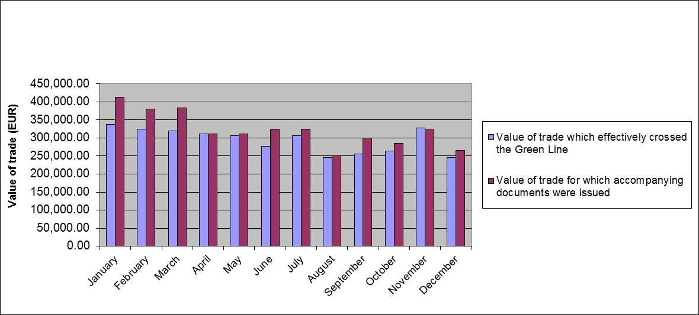

**Source**

- For the value of goods for which accompanying documents were issued: Turkish Cypriot Chamber of

Commerce

- For the value of goods which crossed the Green Line: Cyprus Chamber of Commerce and Industry

**ANNEX IV:**

**Most traded products**



|  |  |  |
| --- | --- | --- |
| Fresh fish | 836,231 | 24% |
| Vegetables | 215,124 | 6% |
| Raw metal scrap | 289,923 | 8% |
| Wooden products/furniture | 249,312 | 7% |
| Building materials/article of stone | 418,076 | 12% |
| Plastic products | 1,321,958 | 38% |
| Aluminium/PVC products | 75,545 | 2% |
| Other | 113,877 | 3% |
| **TOTAL** | **3,520,045** | **100%** |

**Source**: table based on data received from the Cyprus Permanent Representation to the EU

**ANNEX V:**

**Development of most traded goods in 2014 (highest value)**

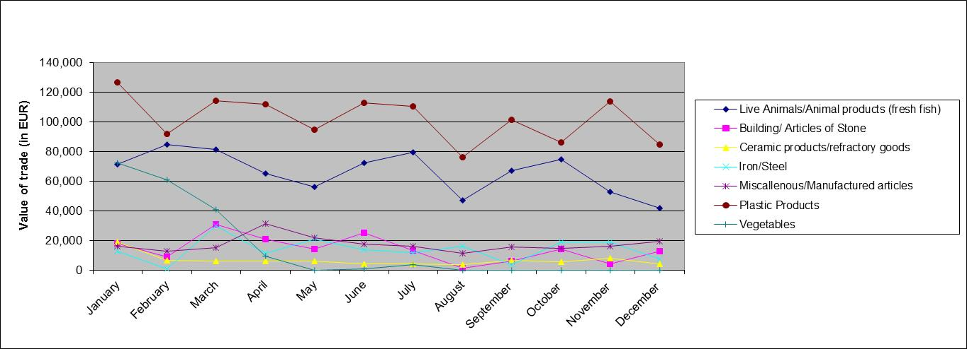

**Source**: Graph based on data received from the Turkish Cypriot Chamber of Commerce

**ANNEX VI**

|  |  |  |  |  |  |  |
| --- | --- | --- | --- | --- | --- | --- |
| **Movement of G/C and T/C persons and vehicles across the crossing points as per Council Regulation (EC) No 866/04**  **(01/01/2014 – 31/12/2014)** | | | | | | |
| **MONTH** | **MOVEMENTS OF PERSONS** | | | **MOVEMENTS OF VEHICLES** | | |
| GREEK -CYPRIOTS | TURKISH-CYPRIOTS | **TOTAL** | VEHICLES  GCs | VEHICLES TCs | **TOTAL** |
| 01 / 2014 | 46198 | *71470* | **117668** | 14988 | *27336* | **42324** |
| 02 / 2014 | 39004 | *67249* | **106253** | 13416 | *25156* | **38572** |
| 03 / 2014 | 46436 | *64997* | **111433** | 1508 | *24881* | **40689** |
| 04 / 2014 | 50748 | 63816 | **114564** | 18007 | 24707 | **42714** |
| 05 / 2014 | 52934 | 78356 | **131290** | 17936 | 28417 | **46353** |
| 06 / 2014 | 48588 | 74949 | **123537** | 17559 | 29992 | **47551** |
| 07 / 2014 | 51769 | 83954 | **135723** | 18587 | 31263 | **49850** |
| 08 / 2014 | 57091 | 77471 | **134562** | 20232 | 29663 | **49895** |
| 09 / 2014 | 50259 | 85679 | **135938** | 16904 | 32492 | **49396** |
| 10 / 2014 | 49768 | 89818 | **139586** | 16307 | 31945 | **48252** |
| 11 / 2014 | 47082 | *78676* | **125758** | 14821 | *29028* | **43849** |
| 12 / 2014 | 50029 | *90706* | **140735** | 15997 | *31615* | **47612** |
| **TOTAL** | 589906 | *927141* | **1517047** | 20562 | *346495* | **547057** |

**Source**: Republic of Cyprus Police Headquarters, Operations Branch, 15/01/2015

**ANNEX VII**

|  |  |
| --- | --- |
| **Nationality** | **Number of irregular migrants apprehended  after crossing the Green Line[1]  (01/01/2014 – 31/12/2014)** |
| Syria | 621 |
| Pakistan | 60 |
| Iran | 44 |
| Georgia | 34 |
| India | 28 |
| Egypt | 16 |
| Somalia | 15 |
| Armenia | 14 |
| Nigeria | 13 |
| Bangladesh | 12 |
| Ukraine | 12 |
| Iraq | 11 |
| Turkey | 11 |
| Vietnam | 10 |
| China | 9 |
| Jordan | 9 |
| Republic of Moldova | 9 |
| Lebanon | 7 |
| Cameroon | 6 |
| Sri Lanka | 6 |
| Belarus | 4 |
| Congo | 4 |
| Algeria | 3 |
| Palestine[2] | 3 |
| Russia | 3 |
| Serbia | 2 |
| Sierra Leone | 2 |
| Tunisia | 2 |
| Afghanistan | 1 |
| Gambia | 1 |
| Ivory Cost | 1 |
| Kyrgyzstan | 1 |
| Libya | 1 |
| Mali | 1 |
| Morocco | 1 |
| Nepal | 1 |
| Sudan | 1 |
| **TOTAL** | **979** |

**Source**: CYPOL and SBAs

1. These figures include both the 970 irregular migrants apprehended in the government-controlled areas and the 9 irregular migrants apprehended in the SBA.
2. This designation shall not be construed as recognition of a State of Palestine and is without prejudice to the individual positions of the Member States on this issue.