introduction
The achievement of the Energy Union requires a fundamental transformation of Europe's energy system. Renewable energy is essential for this transformation to take place as it contributes to all of the Energy Union objectives: the delivery of security of supply, a transition to a sustainable energy system with reduced greenhouse gas emissions, industrial development leading to growth and jobs and lower energy costs for the EU economy.
A comprehensive European policy framework to support the development and integration of renewables based on quantified targets, regulatory clarity and market based investment incentives compatible with State aid rules is in place since 2009. The Renewable Energy Directive with the legally binding 20% EU target, 10% target for renewable energy use in transport and the binding national targets for 2020 forms an integral part of the EU energy policy. It became the key driver for European led global investment in renewable technologies and supportive renewable energy policies far beyond Europes' frontiers helping renewables emerge as cost-competitive energy source in the last decade in Europe and on global scale. The European renewable energy industry today employs 1.15 million people. By promoting also development and innovation aspects of renewable energy technologies, the Directive and its targets for renewable energy represent an integrated element of a European strategy for growth, industrial innovation, technological leadership and competitiveness as well as for reducing emissions.
In accordance with the requirements set out in the Renewable Energy Directive, this report provides a mid-term assessment of the progress of the EU and its Member States towards the 2020 renewable energy targets, and includes an assessment of the feasibility of 10% renewable energy target for transport, the sustainability of biofuels and bioliquids consumed in the EU and the impacts of this consumption in accordance with the requirements of the Directive,. Furthermore, on the basis of a comprehensive REFIT evaluation of the Renewable Energy Directive launched in 2014, this report also provides a preliminary assessment of the efficiency and effectiveness of the Renewable Energy Directive in line with the requirements of Communication on Regulatory fitness and performance,.
EU and Member State progress and recent developments are assessed on the basis of 2013 Eurostat data on renewable energy, Member States renewable energy progress reports submitted to the Commission in 2013, the Commission's own research and the research carried out for the Commission,. 2014 and 2020 projections are based on Green-X modelling carried out for the Commission in 2014.
With a projected share of 15.3% in 2014 in the gross final energy consumption, the EU and an overwhelming majority of Member States are advancing well towards 2020 targets. However, as the trajectory becomes steeper over the coming years some Member States may need to intensify their efforts to keep on track, and where necessary by making use of the cooperation mechanisms with other Member States. There is now a clear interest from several Member States to use the cooperation mechanisms for achieving 2020 targets, and negotiations are ongoing.
46% of final energy consumption in the EU is used for heating and cooling. Renewable energy share in the heating and cooling sector was estimated to be 16.6% in 2014. Renewable heating is increasingly being used as a cost-efficient and secure alternative to fossil fuels in Member States in district heating and at local level.

Already today, 26% of the EU's power is generated from renewables. About 10% of the total EU electricity is sourced from variable renewable electricity (such as wind and solar).

In the transport sector, the target for 2020 is to achieve 10% share of renewable energy, the bulk of which is still expected to come from biofuels. However, the progress in the past five years towards this target has been slow – with a projection of only 5.7% renewable energy in transport in 2014. The main reason for this was uncertainty caused by delay in finalisation of the policy to limit the risks of indirect land-use change, and insufficient progress in deployment of alternative, second generation biofuels. A political agreement on limiting the impact from indirect land use change has meanwhile been reached.

The mid-term evaluation of the regulatory fitness of Renewable Energy Directive carried out in 2014 indicates that all articles of the Directive are relevant for its objective (increasing sustainably the share of renewable energy in the final energy consumption of the EU and its Member States) and the Directive has been successful in meeting these objectives. Nevertheless, the level of effectiveness and efficiency of the measures laid down by the Directive varies, depending on a number of factors, notably their implementation at Member State level.
Figure 1. Final energy consumption in Europe: by sector with renewable share in 2014 against 2020 target

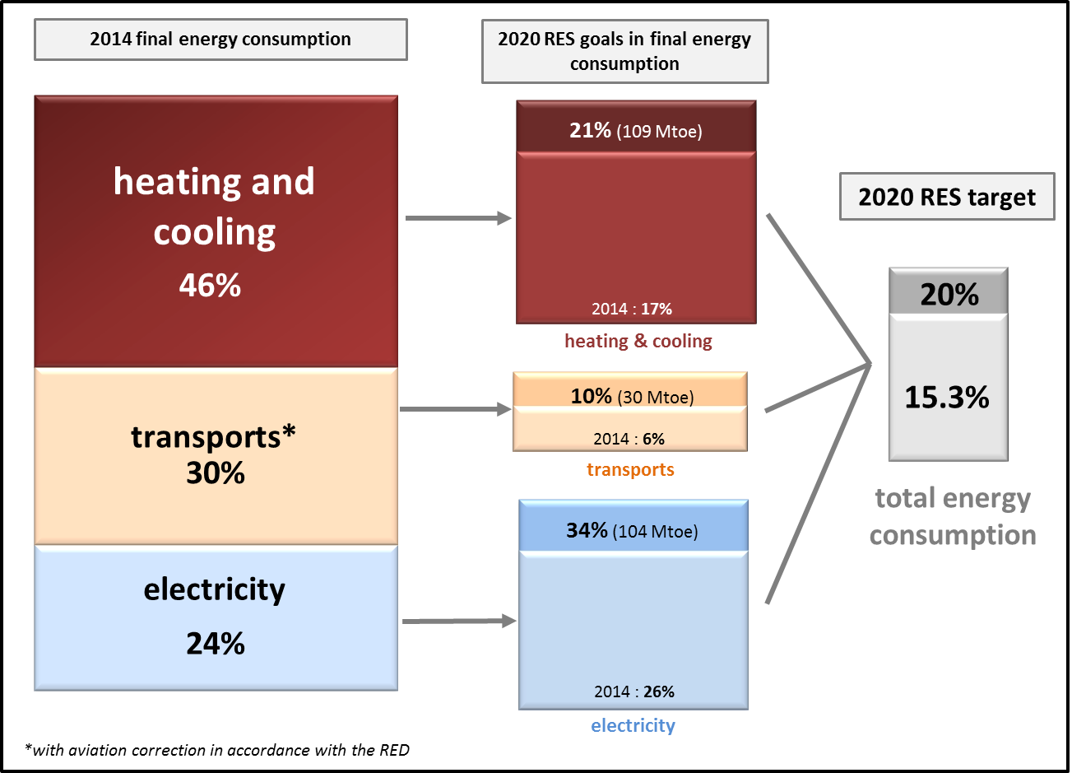
Source: European Commission, based on Eurostat calculation. 2014 data are model based estimates.

1. progress in deploying renewable energy
In 2013, the combined EU share of renewable energy reached 15% and the estimate for 2014 indicates a 15.3% share, which is above the trajectory for the EU as a whole. 26 Member States met their first 2011/2012 interim target and 25 Member States are expected to meet their 2013/2014 target. Some have already reached their 2020 targets. Decrease in the overall energy consumption in recent years has helped several Member States to advance in their RES share. The good overall result is not surprising, given that the interim targets are less ambitious in the early years however the trajectory for later years becomes much steeper.
Only France and the Netherlands failed to meet their 2011/2012 interim target, though only slightly - by a margin of less than 1 percentage point. This can be explained by the presence of non-economic barriers, long procedures for permit granting (especially in the wind sector) coupled with technical barriers for wind and biomass in France. The uncertainty concerning investment incentives resulting from reforms of the support schemes was the main reason why the Netherlands' renewable energy development was lagging behind.
In many countries, a strong development of the renewable heating sector was a key driver for reaching and exceeding these Member States' interim targets. This is the case for example in Bulgaria, Finland and Sweden, where development has mainly been driven by low-cost biomass options. In Estonia, Italy and Portugal, the electricity sector contributed most to the fact that these countries exceeded their overall targets foreseen in their National Renewable Energy Action Plans (NREAPs).
Renewable energy use in transport has generally been lagging in most countries, except in Sweden, Finland, Austria, France and Germany.
Reaching the 2020 renewable energy targets remains fully possible for the EU as a whole and the majority of the EU Member States (Figure 2). However, as the trajectory in the Renewable Energy Directive becomes steeper closer to 2020, especially for those Member States that are already progressing slowly, and regulatory uncertainty and administrative barriers continue to impact private investments in the sector, additional measures might be needed for a number of Member States. The majority of Member States are nevertheless expected to meet or exceed their 2020 renewable energy targets based on an assessment of current and planned policies.
Figure 2. Expected RES deployment in Member States and 2020 RES targets
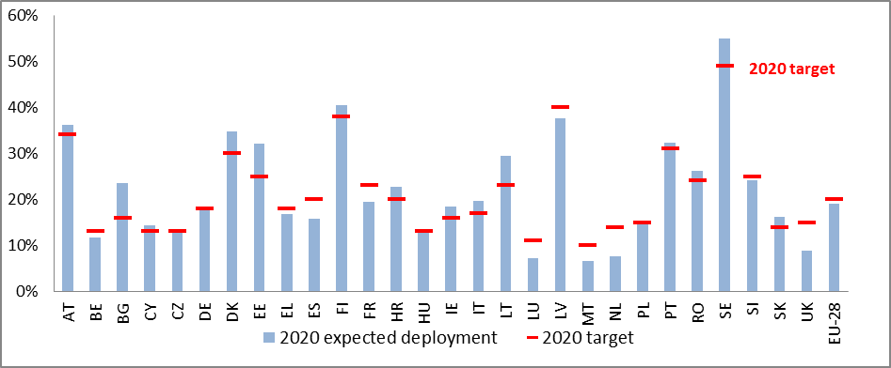
Source: European Commission, based on TU Wien (Green-X) projections (2014)
Nineteen Member States, including for example Austria, Estonia, Denmark, Germany, Italy, Lithuania, Romania or Sweden, may exceed, some even considerably, their 2020 renewable energy targets with implemented and planned renewable energy policies.
However, some Member States, including France, Luxembourg, Malta, the Netherlands and the United Kingdom, and to a lesser extent Belgium and Spain need to assess whether their policies and tools are sufficient and effective in meeting their renewable energy objectives. Achievement of the 2020 renewable energy targets is also not certain in the case of Hungary and Poland: it is only under optimistic assumptions related to the future development of energy demand and country-specific financing conditions that the 2020 renewable energy targets appear achievable.
It must be noted that this assessment is based on modelling and only includes policy measures implemented until the end of 2013. Some Member States have meanwhile taken important decisions on public support or policy reforms, that could, if implemented in a timely manner, deliver the necessary growth in renewable energy deployment by 2020. Member States have also been engaged in discussions on the possible signing of cooperation agreements. The Commission expects new information from Member States by the end of 2015, the due date for next round of national renewable energy reports.
As evident from the overview table in Annex I, there are good prospects for cooperation and re-distribution of renewable energy target achievement between the Member States. Therefore, 2015 and 2016 will be crucial years for signing cooperation agreements between Member States.
Heating and cooling sector
In the heating and cooling sector, 22 Member States were on track and only 6 (Denmark, Ireland, France, the Netherlands, Portugal, Slovakia) did not meet their planned 2013 renewable energy deployment level in the heating and cooling sector.
Solid biomass was still the largest contributor to renewable heat production in 2013 with 73 Mtoe of renewable heat produced, well above the NREAP trajectory. Heat production from solid biomass was above the trajectory in 21 Member States. In 2014, the European Commission published a report on the sustainability of solid and gaseous biomass for heat and electricity generation. The report includes information on current and planned EU actions to maximise the benefits of using biomass while avoiding negative impacts on the environment.
Roughly one sixth of the biomass heat generation is based on grid connected applications, while the majority is still based on decentralised units. In absolute terms, decentralised heat generation from biomass also grows faster than biomass heat generation from grid connected systems. The largest biomass heat consumers were France with 10.2 Mtoe and Germany with 8 Mtoe.
Heat pumps contributed 7.4 Mtoe to renewable energy heat and cooling production in 2013 which is far above the planned levels indicated in the NREAPs. In absolute figures, Italy stands out as a leader in heat pump use with 2.5 Mtoe, followed by France with 1.6 Mtoe and Sweden with 1.2 Mtoe production.
Biogas plays a significantly smaller role among heating and cooling technologies. In 2013, 2.6 Mtoe of heat was produced from biogas. Germany was the biggest producer of biogas heat, with 1.3 Mtoe produced in 2013.
Solar thermal heat production, with 1.9 Mtoe in 2013, still contributes relatively little to the renewable energy use in the heating and cooling sector and the current production remains below the NREAP trajectory. This has to be viewed from the perspective of low economic growth and moribund construction market. Germany, Austria and Greece are the EU's top three producers of solar thermal heat.
Electricity sector
In the electricity sector, technology deployment and production rates in 2013 were generally in line with the trajectory foreseen in the National Renewable Energy Action Plans (NREAPs).
15 Member States (Belgium, Bulgaria, Germany, Estonia, Spain, Croatia, Italy, Cyprus, Latvia, Lithuania, the Netherlands, Romania, Finland, Sweden and United Kingdom) were above their indicative trajectory shares for renewable electricity use in 2013.
In 2013, gross electricity generation from renewables reached 823 TWh in 2013 and increased by 11 % compared with 2012, with electricity generation from solar power experiencing the most significant growth against previous year (20%). In 2013, renewable electricity generation accounted for almost 26% of total EU gross electricity generation.
Hydropower plants generate by far the largest share of electricity from renewable energy sources, while their share of total renewable electricity generation shrank from 94% to 43% over the 1990-2013. This is due to the more rapid expansion of wind and photovoltaic.
Wind power generation more than tripled over the period 2005-2014 and it has become the second largest contributor to renewable electricity, taking over biomass. Preliminary 2014 data indicate that power production from wind reached 247 TWh compared to 234 TWh in 2013. Germany, Spain and UK are the EU's top 3 producers of wind power.
Solar electricity generation has also increased rapidly and in 2013 accounted for 10% of all renewable electricity. Also, in 2013 the electricity generated from photovoltaic energy surpassed solid biomass and is now the third most important contributor to the electricity production from renewable sources.
Solid renewables (wood and other solid biomass, excluding renewable wastes) are also used in conventional thermal generation power plants: their share in electricity from renewable sources grew from 3.5% in 1990 to 9.5% in 2013. Bioliquids and biogas, which were negligible in 1990, reached 6.7% in 2013 (Figure 3).

Figure 3. EU renewable electricity generation in 1990-2013
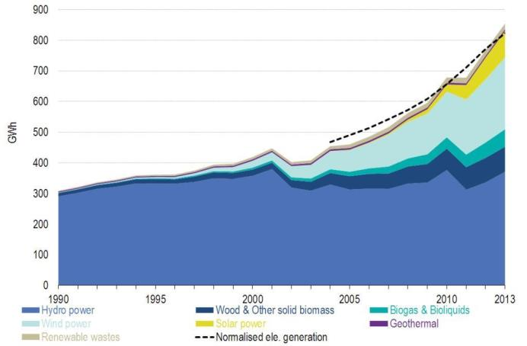
Source: Eurostat
Total installed capacity of renewable electricity generation has increased significantly over the last 20 years, in particular through rapid growth of installed wind and PV capacity. To put into perspective, while electricity generation capacity from renewable sources in 2013 reached around 380 GW, the existing electricity generation capacity of fossil fuel plants in the EU was around 450 GW in 2013. Preliminary data indicate that the EU managed to set a new wind energy capacity installation record in 2014 with 12.4 GW newly installed capacity. By the end of 2014, the EU wind energy fleet had passed the 130 GW mark and it is not long to go before the EU has 10 GW installed offshore (the total capacity of installed offshore wind power reached 9.2 GW at the end of 2014, compared to 7 GW at the end of 2013). Offshore wind development remains below NREAP trajectories.
Transport sector
Renewable energy deployment in the transport sector has seen less progress than in the electricity and heating and cooling sectors. The EU share of renewable energy in transport reached 5.4% in 2013. Sweden is the only Member State that has already reached its renewable energy target for transport with the 2013 share reaching 16.7%, well above the binding 10% target for 2020.
Biodiesel remains the most widely used form of renewable energy in transport with 10.3 Mtoe in 2013, followed by bioethanol with 2.7 Mtoe.
France, Germany and Italy are the top 3 biodiesel markets in the EU with 2.3 Mtoe, 1.9 Mtoe and 1.2 Mtoe consumption in 2013. Also for bioethanol the largest consumption was reported by Germany with 758 ktoe, followed by France with 392 ktoe and Denmark with 387 ktoe.
A consumption of 1484 ktoe of renewable electricity in transport was reported for 2013, the vast majority of it being consumed in non-road transport modes. In absolute terms, France was the biggest consumer with 239 ktoe, followed by Italy with 218 ktoe and Germany with 215 ktoe.
Overview of expected future developments
Considering Member States' current and planned policy initiatives, their current implementation rates and the various barriers to renewable energy development, a positive trend can be observed with respect to expected renewable energy deployment in the EU for 2014 and for 2020. However, the need for improvements in individual sectors and technologies is also becoming apparent.
The following table gives a more detailed comparison of the estimated and planned (based on NREAPs) deployment levels for each renewable energy technology at EU level in 2014 and by 2020. It also aggregates (by sector and for renewable energy in total) model projected deviations from the NREAP target levels - comparing expected and planned deployment.
Table 1. Projected deployment and deviation from planned EU technology deployment 2014 and 2020
 | Projected deployment 2014 | NREAP  target  2014 | Projected 2020 deployment |  | 2020  target | Deviations
 | Projected deployment 2014 | NREAP  target  2014 | Min. | Max. | 2020  target | 2012 | 2014 | 2020 Min. | 2020  Max.
Technology category | Mtoe | Mtoe | Mtoe | Mtoe | Mtoe | % | % | % | %
RES electricity | 72.5 | 73.3 | 91.9 | 94.9 | 103.7 | 2.1 | -1.1 | -13.0 | -8.5
Biomass (solid and liquid) | 9.1 | 10.3 | 12.2 | 12.6 | 14.7 | -8.2 | -11.2 | -19.3 | -14.3
Biogas | 4.3 | 3.5 | 5.1 | 5.1 | 5.4 | 35.2 | 22.1 | -7.9 | -6.2
Geothermal | 0.5 | 0.6 | 0.9 | 0.9 | 0.9 | -9.5 | -13.0 | -21.8 | -0.9
Hydro large-scale | 26.1 | 26.5 | 27.7 | 27.8 | 27.4 | -1.0 | -1.4 | 0.9 | 1.5
Hydro small-scale | 4.2 | 4.0 | 4.8 | 4.9 | 4.5 | -1.0 | 4.0 | 6.9 | 9.6
Photovoltaics | 7.7 | 3.9 | 10.1 | 10.4 | 7 | 94.2 | 96.8 | 38.8 | 47.6
Concentrated solar power | 0.3 | 0.7 | 0.3 | 0.4 | 1.6 | -21.2 | -52.6 | -78.3 | -76.5
Wind onshore | 18.9 | 20.3 | 28.2 | 30.1 | 30.3 | -4.4 | -7.0 | -8.7 | -0.7
Wind offshore | 1.3 | 3.4 | 2.4 | 2.6 | 11.5 | -38.1 | -62.7 | -80.3 | -77.0
Marine/Ocean | 0.1 | 0.1 | 0.2 | 0.2 | 0.5 | -19.2 | -38.9 | -56.2 | -54.3
RES heating & cooling | 87.6 | 80.5 | 105.6 | 107.5 | 108.9 | 10.6 | 8.8 | -4.2 | -1.3
Biomass (solid and liquid) | 73.7 | 68.1 | 84.9 | 86.5 | 85.3 | 9.6 | 8.3 | -1.6 | 1.4
Biogas | 2.5 | 2.5 | 3 | 3 | 4.5 | 16.5 | 0.4 | -33.7 | -32.5
Geothermal | 0.7 | 1.2 | 1.3 | 1.3 | 2.6 | -34.4 | -41.6 | -50.9 | -50.4
Heat pumps | 8.5 | 6.2 | 12.8 | 12.9 | 10 | 33.4 | 37.7 | 25.5 | 29.3
Solar Thermal | 2.2 | 2.6 | 3.7 | 3.7 | 6.4 | -1.7 | -15.3 | -45.6 | -41.8
RES transport (biofuels only) | 16.6 | 18.4 | 18.5 | 19.1 | 29.5 | -2.5 | -9.7 | -37.2 | -35.0
1st generation biofuels | 14.6 | 17.6 | 16.2 | 16.9 | 27.1 | -11.2 | -16.9 | -40.0 | -37.7
2nd generation biofuels | 2.0 | 0.8 | 2.3 | 2.3 | 2.4 | 211.0 | 143.7 | -5.5 | -4.9
RES total | 176.7 | 172.3 | 216.0 | 221.5 | 242.1 | 5.7 | 2.6 | -12.0 | -8.5
Source: TU Wien (Green-X) modelling (2014)
Although, the heat sector appears to be most advanced among all renewable energy sectors with 88 Mtoe current (2013) deployment well above the planned one (77 Mtoe as reported by Member States in their NREAPs), scenarios of future deployment indicate a decline in the surplus, which will turn into a small deficit by 2020. In particular, the development of biomass heat and heat pumps has been remarkably strong in several Member States. A higher than planned contribution from these technologies is also expected in 2020. In contrast, one can identify a need for improvement with regard to technologies such as biogas, solar thermal collectors and mid- to large-scale geothermal heating systems. These technology options may most urgently require additional initiatives in order to let them play their role in meeting the 2020 renewable energy obligations and considering their potential for adding increasingly needed flexibility to the electricity systems.
The renewable electricity sector shows a comparatively larger gap by 2020. Thanks to the strong deployment of photovoltaics in several Member States, renewable electricity in 2013 was nearly at the level of the NREAP trajectory. Due to a slowdown in progress in several Member States, a small deficit can be noted in 2014 based on modelling, and this trend is assumed to continue in the forthcoming years until 2020. At technology level, photovoltaic has already reached the initially planned 2020 deployment levels as early as in 2013, while hydro and onshore wind are expected to reach the levels planned in the NREAPs in the coming years, offshore wind is lagging behind.
As evident from Table 1, the gap between planned and actually expected deployment rates is the highest for concentrated solar power and marine technologies, as these technologies are still struggling to get on the market and the actual technology deployment rates lag behind the declared intentions in NREAPs. Overall, and considering the planned contribution towards total renewable energy production by 2020, substantial efforts are needed to continue the deployment of the most cost effective technologies, and improved framework conditions in particular for offshore wind, are the most important measures for achieving the renewable energy targets.
In transport, the use of conventional and advanced biofuels is currently lagging behind NREAP deployment trajectory.

2. Creating an enabling environment through removal of non-economic barriers
As the analysis in the previous section indicates, despite steady progress until now, the achievement of the 2020 targets is still largely dependent on continuity of current policies in Member States and additional measures enabling deployment of renewable energy. For certain Member States this will require cooperation with other Member States. Other Member States will need to address non-cost barriers in order to boost development and deployment of renewables and allow their full integration in the energy market.
Spatial planning, administrative and authorisation procedures for project developers are important factors affecting investment decisions for large energy infrastructure projects as well as decentralised renewable energy projects. In order to facilitate market access for new entrants, in particular SMEs, the Renewable Energy Directive obliges Member States to simplify procedures, increase transparency and ensure coordination among involved authorities in charge of authorisation procedures for new renewable energy producers. The Commission has already in the past identified the slow progress in simplification of administrative procedures for renewable energy producers in Member States as an important challenge to the renewable energy growth in Europe.
The most recent assessments however point to some progress in this area, with a large number of simplification measures reported in the Member States' progress reports.
Some Member States have introduced a one-stop-shop system for renewable energy producers seeking approval of their projects. Such a system has for example been put in place in the Netherlands, and has led to significant decreases in the lead times of projects. In Belgium, Flanders and the Walloon region are now merging environmental and building permits, thus effectively creating a single permit procedure, which still involves different authorities but can be applied for in one step. In Austria, the one-stop-shop is only partial, as only some permits (e.g. environmental and building permits) can be obtained together.
On-line information platforms and applications are so far only used in only a few Member States (e.g. Portugal, Hungary, Italy and Sweden). Several Member States have however introduced facilitated notification procedures for small renewable energy installations such as roof-top photovoltaic installations. In this type of procedure the explicit approval of the authorities is not necessary, but approval is considered granted upon notification as long as the project follows the criteria for the procedure. The UK has introduced a twelve months’ time-limit for planning permits, which includes the necessary time for appeals.
Improvements in coordination and cooperation among involved authorities are reported by most Member States. For the identification of appropriate sites for renewable energy projects, many Member States seem to be working in close cooperation with the different authorities involved. Other Member States have explicitly tried to coordinate procedures, or merged different permits.
However, a majority of Member States recognise the need for further improvements in their administrative procedures applicable to renewable energy producers. This conclusion is also supported by renewable energy project developers and economic operators, and the in-depth analysis on efficiency of the legal provisions on administrative and permit procedures included in the Renewable Energy Directive, as provided in the following section.

3. Renewable Energy Directive is fit for its purpose: preliminary findings of the REFIT evaluation
Following the requirements of the Communication on “Regulatory Fitness and performance: results and next steps" (REFIT), a REFIT evaluation of the Renewable Energy Directive was carried out in 2014. The results of this evaluation indicate that the objective of increasing sustainably the share of renewable energy in the EU final energy consumption has been successful, with the binding national targets, the NREAPs and biennial monitoring being particularly effective for transparency for investors and other economic operators, and the quality of information on renewable energy markets and policies in the Member States.
These legal provisions have contributed to the overall achievement of EU’s energy and climate policy goals, security of energy supply, employment, public acceptance and regional development. They have proved their relevance for the overall EU energy and climate change objectives, by determining a large deployment of RES which resulted in around 388 Mt of gross avoided CO₂ emissions in 2013 and a reduction in the EU demand of fossil fuels of 116 Mtoe. More importantly for the EU security of supply, the RES substitution of natural gas made up 30% of all avoided fossil fuel use in 2013; almost half of Member States reduced their gross inland consumption of natural gas by at least 7%. Avoided imported fuel costs due to increasing use of renewable energy amount to at least some EUR 30 billion a year. From the perspective of renewable energy deployment costs, when assessing the added value of the Directive, the evaluation concluded that binding targets have incentivised Member States to improve their allocation of resources instead of simply lowering their renewable energy deployment ambitions. Moreover, an EU-wide biofuel sustainability criteria covering the 3rd largest world biofuel market with biofuel consumption of 0.7 mboe/d would not have been in place in the absence of the Directive.
Preliminary results of the evaluation indicate that renewable energy capacity would probably have increased in some Member States at the same rate without a mandatory target set at EU level, whereas in other Member States this would not necessarily be the case, therefore a binding target has been the key driver for renewable energy capacity development in those Member States that were previously less striving to develop their renewable energy potential.
Member States have developed a range of national policy measures aimed at stimulating renewable energy deployment, the design and implementation of which is at the discretion of the Member States. Nevertheless, the level of effectiveness and efficiency of the measures laid down by the Directive varies, depending on a number of factors such as their implementation at Member State level, clarity of the tasks that need to be fulfilled by Member States, uncertainty about costs, benefits or legal barriers or lack of incentives.
When assessing effectiveness and efficiency of the Directive’s provisions, the evaluation indicated that it is important to distinguish between long term and short term objectives. Typically, benefits increase over time. A number of provisions were identified where administrative costs were relatively high in the beginning, but reduced significantly over time. This is the case if processes and procedures need to be developed to fully implement the provisions of the Directive (e.g. Art. 17-19 on biofuel sustainability and the various procedures that are required for achieving the implementation of Articles 13 and 14 of the Directive).
Regarding the impact of the Directive's requirements on the administrative burden for administrations and businesses at Member State level, it was concluded that additional measures had to be taken at national and local level, but that these measures nevertheless had a limited impact on the overall burden, visible particularly in the first years of implementation. Certain provisions of the Directive were found to have contributed to reducing the administrative burden on Member States, such as the use of templates for planning and reporting requirements provided by the Directive.
The REFIT evaluation identified a number of positive examples in relation to the provisions of the Renewable Energy Directive within the 2020 framework:
- provisions are most effective and efficient if they are both mandatory and well defined, as it has been the case with national renewable energy targets and the NREAPs;
- provisions addressed to Member States that require targets and regulations to be achieved at national level, are likely to be more effective and efficient than those provisions that require specific actions at local or regional level. This is apparent in the case of streamlining administrative procedures;
- provisions are most effective and efficient if the relevant rules are set from the beginning (or soon after) and remain stable during the duration of the legislation (credibility and transparency);
- EU level involvement in sustainability certification of specific commodities (such as biofuels) has proven to be an effective means of achieving the sustainability objectives laid down in the Directive.

The REFIT evaluation also indicate that the effectiveness and efficiency of almost all the provisions of the Directive could be further enhanced by putting a stable post-2020 policy framework in place. A stable longer term outlook would enhance investor certainty as well as increase the incentives for stakeholders and government authorities (incl. the many local and regional governments involved in, for example, Articles 13 and 14) to invest the effort needed.
Considering the results of this evaluation and Member States’ performance in implementing Articles 13 and 14 of the Renewable Energy Directive and the limited progress achieved in administrative simplification and removal of non-economic barriers, the Commission will launch a comprehensive study on the practical implementation of administrative procedures for renewable energy projects in Member States.
On the basis of that and results of the REFIT evaluation study on the Renewable Energy Directive and main findings included in this report, the Commission intends to issue a dedicated REFIT evaluation staff working document by the end of 2015.

4. Feasibility of 10% Renewable energy target in transport and Assessment of the sustainability of EU biofuels
The Renewable Energy Directive set a target for 2020 to achieve at least 10% of renewable energy consumption in transport, the bulk of which would come from biofuels. However, the progress in the past five years towards this target has been slow – a 5.4% share was achieved in 2013 and 2014 projection indicates a share of 5.7%. The main reason for this was political uncertainty and increasing awareness that certain biofuel production pathways may increase overall greenhouse gas emissions when emissions from indirect land use change are taken into account, as well as the lack of commercial availability of alternative, second generation biofuels.
The use of renewable energy in 2013 resulted in 388 Mt of gross avoided CO₂ emissions at EU level,. By far the highest levels were attained in the electricity sector (75%), while due to the low deployment rate of renewable energy, the lowest emission savings were achieved in transport sector (9%) or around 35 MtCO₂eq. Most of these savings came from the use of biofuels, while only a portion stemmed from the use of renewable electricity in transport, especially in the rail sector,. The current methodology contained in Annex V of the Renewable Energy Directive provides options to improve the greenhouse gas (GHG) performance of first generation biofuels, while the forthcoming amendments in the Renewable Energy Directive and Fuel Quality Directive for mitigation of indirect-land change should increase the use of advanced biofuels with higher GHG saving potential.
Overall, about 75% of all biofuels consumed in the EU were produced within the Union. Domestic biodiesel production accounted for 79% of the total consumption in the EU, while imports came primarily from Argentina or Indonesia. EU Member States produced 71% of the ethanol consumed, with the remaining imported primarily from either the United States or Brazil. While food security in Africa has been raised as a concern in the context of biofuel consumption, with the exception of marginal bioethanol imports from Sudan, hardly any EU consumed biofuels were imported from Africa until 2013 and biofuel exports from Africa are only expected to show moderate growth in the future.
In addition to the importation of biofuels as a final product, some biofuel production is also carried out using imported feedstock. More than 60% of the biodiesel consumed in the EU is produced using domestic feedstock, primarily rapeseed. Indonesian palm oil and Argentine soybeans account for the majority of imported feedstock used in biodiesel production in Europe, each accounting for around 12% of the total EU biodiesel volume.
As for bioethanol, about 79% of the bioethanol consumed in the EU market came from EU-produced feedstock, primarily wheat, maize, and sugar beet. Feedstock imported to produce ethanol included maize from the United States and Ukraine as well as sugar cane from Guatemala.
Within the EU, the sustainability of biofuels is implemented through the sustainability requirements contained in the Renewable Energy Directive. Third country feedstock producers can demonstrate compliance with the Renewable Energy Directive's sustainability criteria through use of bilateral agreements, Member State national systems, or voluntary schemes recognized by the European Commission. Of the three options, voluntary schemes are increasingly the most important compliance mechanism as they give feedstock producers certainty their crops will comply with all Member States' requirements regardless of where the feedstock was produced. By the end of 2014 the number of Commission recognized voluntary schemes increased to 19.
Full account of the analysis of feasibility of 10% renewable energy target in transport, and assessment of EU biofuel sustainability is provided in the technical annex to this report (accompanying Staff Working Document).

Conclusions
Renewable energy is becoming a widely accepted, mainstream source of energy. The Renewable Energy Directive with the legally binding European and national targets and 10% target for renewable energy use in transport became the key driver for European led global investment in renewable technologies and supportive renewable energy policies far beyond Europes' frontiers.
This momentum needs to continue. The transition towards a decarbonised EU energy mix will not be possible without significantly higher shares of renewable energy. Higher shares of renewable energy, especially in the heating and transport sectors, will also help the EU tackle its long-standing energy security challenges, by reducing, in particular, its import dependency on fossil fuels.
With less than six years to go to the end of 2020, majority of the Member States are well on track to meeting the renewable energy targets laid down in the Renewable Energy Directive. For the EU as a whole, there are good prospects that the 2020 target will be reached. However, for a number of Member States, reaching the targets may appear difficult not least due to the steeper slope of the trajectory and persistent market barriers. Making best use of the opportunities offered by the cooperation mechanisms foreseen in the Renewable Energy Directive, are necessary. Achieving 10% renewable energy target for transport by 2020 is challenging, but remains feasible, and progress achieved in some Member States testify to this. A breakthrough in advanced biofuels, and a comprehensive approach towards decarbonisation of the transport sector, including decisive steps towards increasing the share of renewable electricity in transport, remains key.
The evaluation of the Renewable Energy Directive carried out in 2014 in the context of the REFIT programme, indicates that the Directive is effective and achieves its objectives, but its implementation could be improved at Member States' level.
The Commission will continue to engage with the Member States and all stakeholders to ensure the deployment and integration of increasing shares of renewable energy in line with the EU 2020 renewable energy targets, and the view towards future 2030 energy and climate framework target achievement.

Directive 2009/28/EC on the promotion of the use of energy from renewable sources
Reporting obligations set out in Articles 17 and 23 of Directive 2009/28/EC require the Commission to report biennially to the European Parliament and the Council on the progress achieved in Renewable Energy development in the EU and Member States, and on the EU biofuel sustainability. The current Renewable Energy progress report covers these requirements and also the specific 2014 review elements required under Article 23 (8) of the Directive Directive 2009/28/EC.
Specifically, Articles 17 (7) and 23 (1-6) and 23 (8) of Directive 2009/28/EC
Previous Renewable energy progress report adopted in 2013 and 2011, are available on: http://ec.europa.eu/energy/en/topics/renewable-energy/progress-reports
In accordance with REFIT programme as listed in Annex to the REFIT Communication "Regulatory fitness and performance: results and next steps" (REFIT), COM (2013) 685
Mid-term Evaluation of the Renewable Energy Directive: a study in the context of REFIT programme, CE DELFT et al, 2015 available on: http://ec.europa.eu/energy/en/studies
Member State biennial renewable energy progress reports (2013), http://ec.europa.eu/energy/renewables/reports/2013_en.htm
Renewable energy progress and biofuel sustainability, ECOFYS et al, 2014, available on: http://ec.europa.eu/energy/en/studies
The State of Renewable Energies in Europe 2014 report (Eurobserv'ER, 2015)
In the framework of Renewable energy progress and biofuel sustainability, ECOFYS et al, 2014
Renewable energy progress and biofuel sustainability, ECOFYS et al, 2014
European Commission calculation on the basis of Eurostat and 2014 modelling estimates.
ECOFYS, 2014
Wind, PV, CSP without storage and tidal/wave/ocean as % of total final electricity demand
2012/0288 (COD)
REFIT evaluation of the Renewable Energy Directive, CE Delft (2014)
2013 data EUROSTAT, 2014 and 2020 estimates are based on Green-X (TU Wien) modelling carried out for the Commission in the framework of Renewable energy progress report and biofuel sustainability study (Ecofys et al, 2014).
Based on 2013 EUROSTAT data.
Assessed policies include measures described in the National Renewable Energy Action Plans and 2013 Member State progress reports.
The figure projects 2020 with current and planned policies (on the basis of NREAP and 2013 Member State progress reports) in place, and does not take into account the policies implemented after 2013 or the necessary additional efforts by Member States in order for them to comply with the legally binding targets.
Data sources: 2013 Eurostat data are used to assess Member State and sectorial performance, while renewable energy technology assessments are based on provisional 2013 data from Eurostat (where available) or Eurobserv'ER 2014.
Eurobserv'ER 2014
State of play on the sustainability of solid and gaseous biomass used for electricity, heating and cooling in the EU (SWD(2014) 259 final.
Eurobserv'ER 2014
2013 EUROSTAT.
Eurobserv'ER 2014
2013 Eurostat
Eurobserv'ER 2014
Data sources: 2013 Eurostat data are used to assess Member State and sectorial performance, while renewable energy technology assessments are based on provisional 2013 data from Eurobserv'ER 2014.
Eurostat statistics explained (March, 2015)
Eurostat statistics explained (March, 2015)
Eurostat statistics explained (March, 2015)
2014 Wind Energy Barometer, Eurobserv'ER (2015)
Eurostat statistics explained (March, 2015)
Idem.
Idem
Wind Energy Barometer, Eurobserv'ER (2015)
This includes only biofuels complying with the EU sustainability criteria of the Renewable Energy Directive. According to Art. 17 (1) of the RES Directive, non-certified biofuels cannot be counted towards national and EU renewable energy targets.
Eurostat
Eurostat
Eurostat.
Eurostat
RES progress and biofuels sustainability, Ecofys et al (2014)
COM (2013) 175 and COM (2011) 31
Renewable energy progress and biofuels sustainability, ECOFYs et al (2014) and REFIT evaluation of the Renewable Energy Directive, CE Delft (2014)
2013 national renewable energy progress reports: http://ec.europa.eu/energy/renewables/reports/2013_en.htm
Study on the competitiveness of the EU Renewable Energy Industry, ICF International (2014), Geothermal District Heating potential study, (2014)
REFIT evaluation of the Renewable Energy Directive, CE Delft (2014)
National Renewable Energy Action plans and biennial national renewable energy progress reports are legal requirements set out in Art. 4 and Art.22 of the Renewable Energy Directive
Renewable Energy in Europe – approximated recent growth and knock-on effects, European Environment Agency (2015)
European Energy Security Strategy, COM (2014)
WEO (2014)
Even quite abruptly at some point in time, as may be the case with the cooperation mechanisms, closer to 2020.
REFIT evaluation of the Renewable Energy Directive, CE Delft (2014)
Renewable energy in Europe – approximated recent growth and knock-on effects, European Environment Agency, 2015
Direct emission savings, therefore not including emissions from indirect land use change.
European Environment Agency, 2015
Renewable energy progress and sustainability of biofuels, ECOFYS, 2014
Commission's proposal on indirect land use change COM (2012) 595, 2012/0288 (COD)
ECOFYS, 2014
ECOFYS, 2014
ECOFYS, 2014
ECOFYS, 2014

