[1]



Delegations will find attached the above-mentioned document.

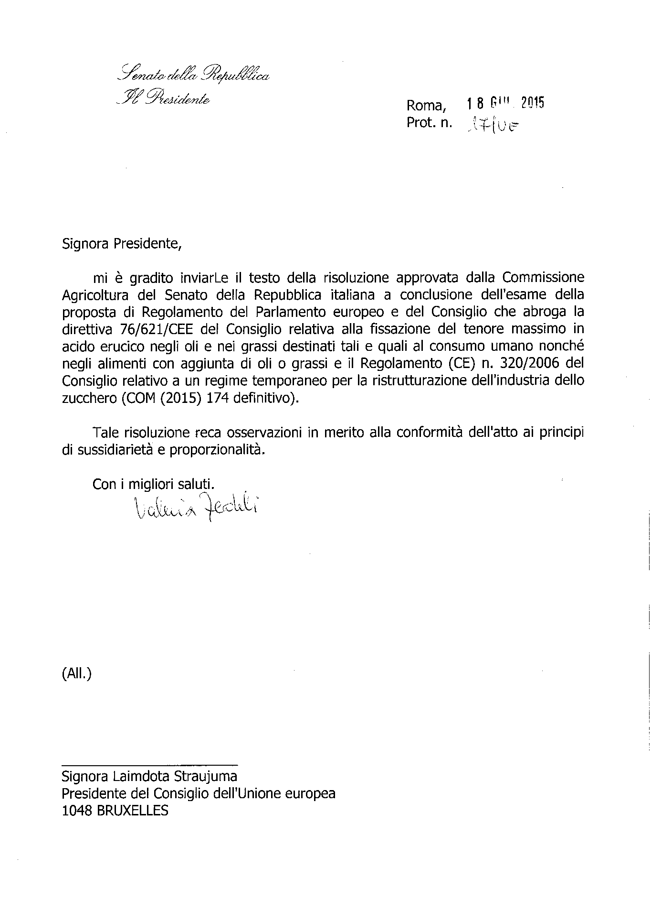

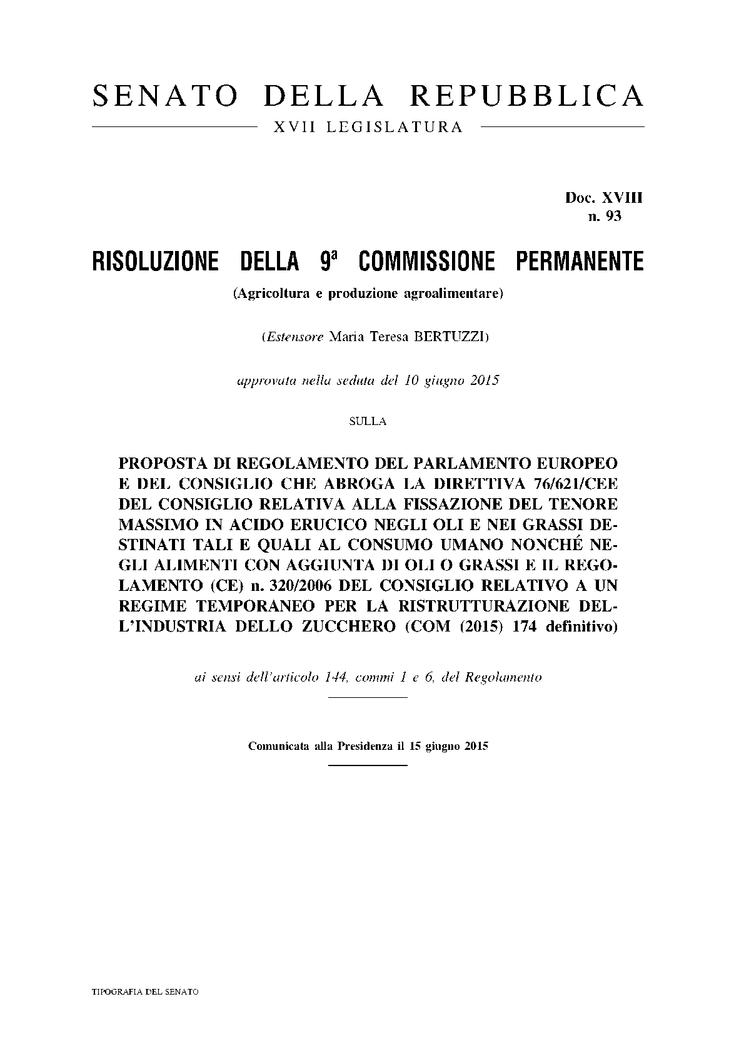

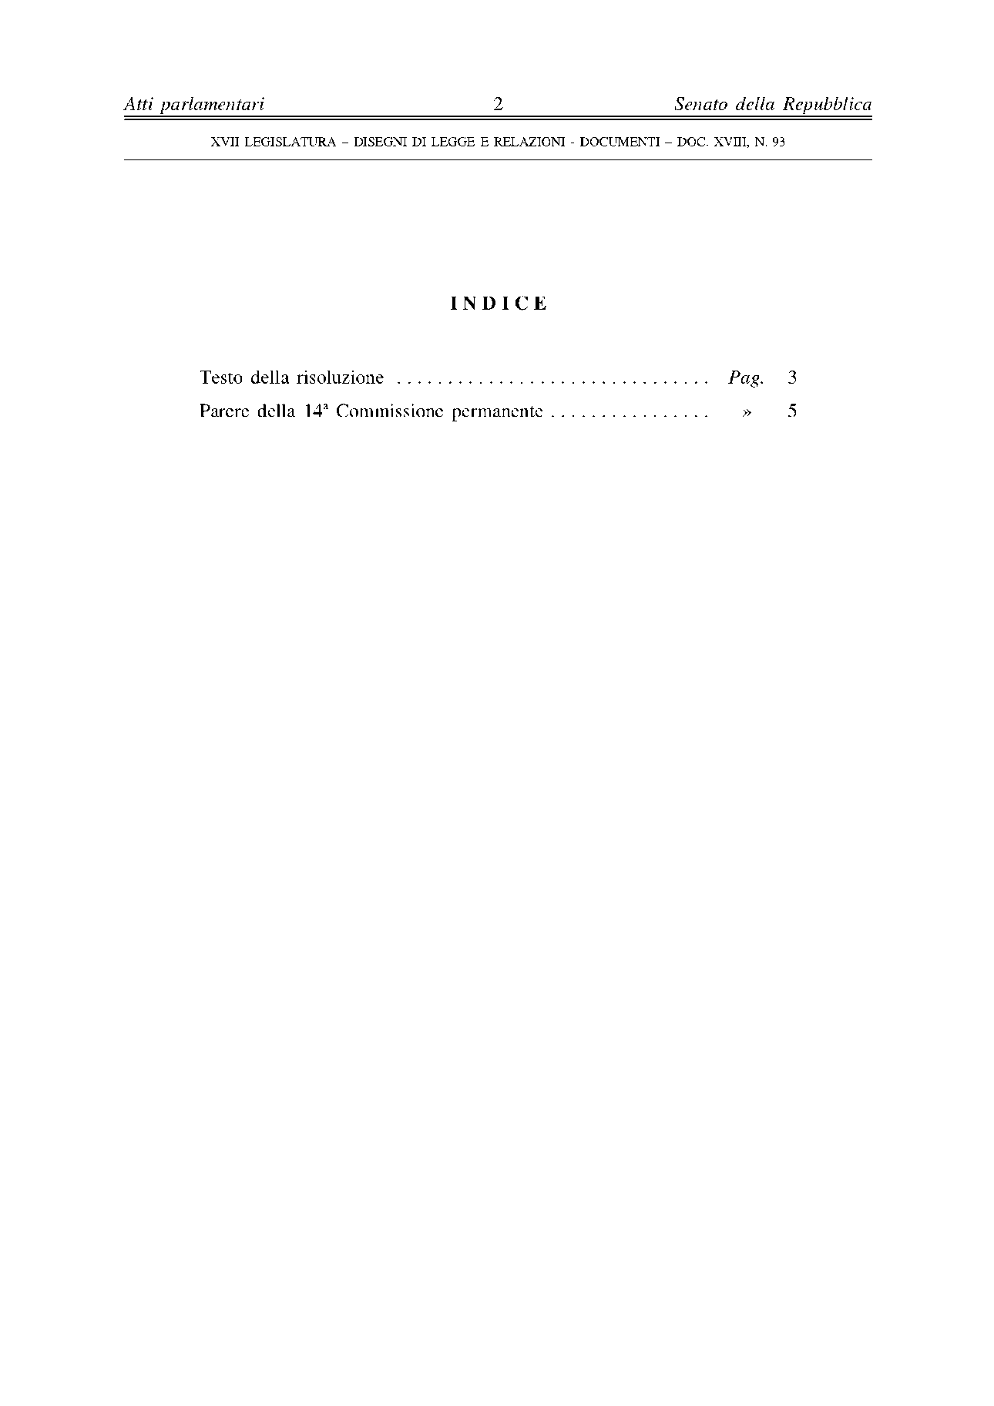

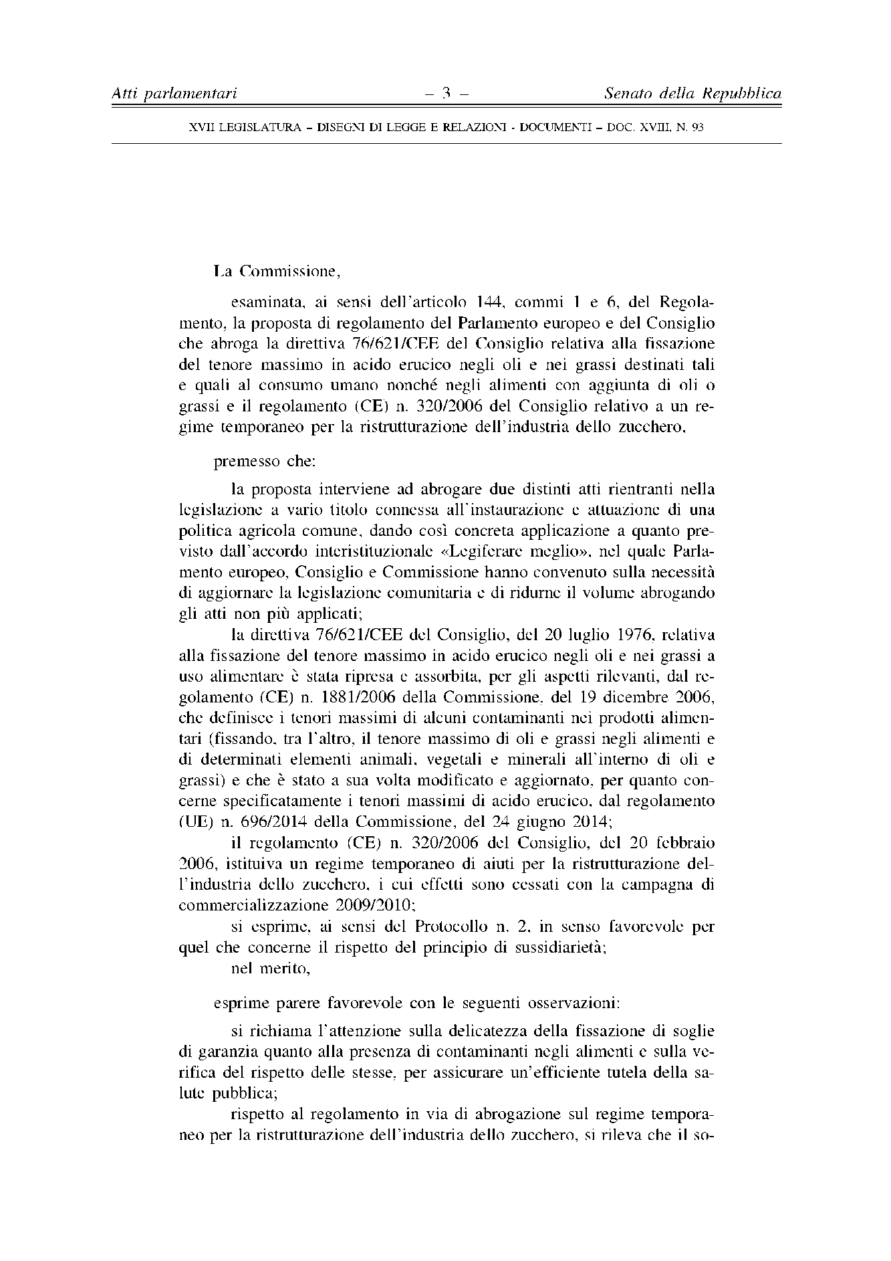

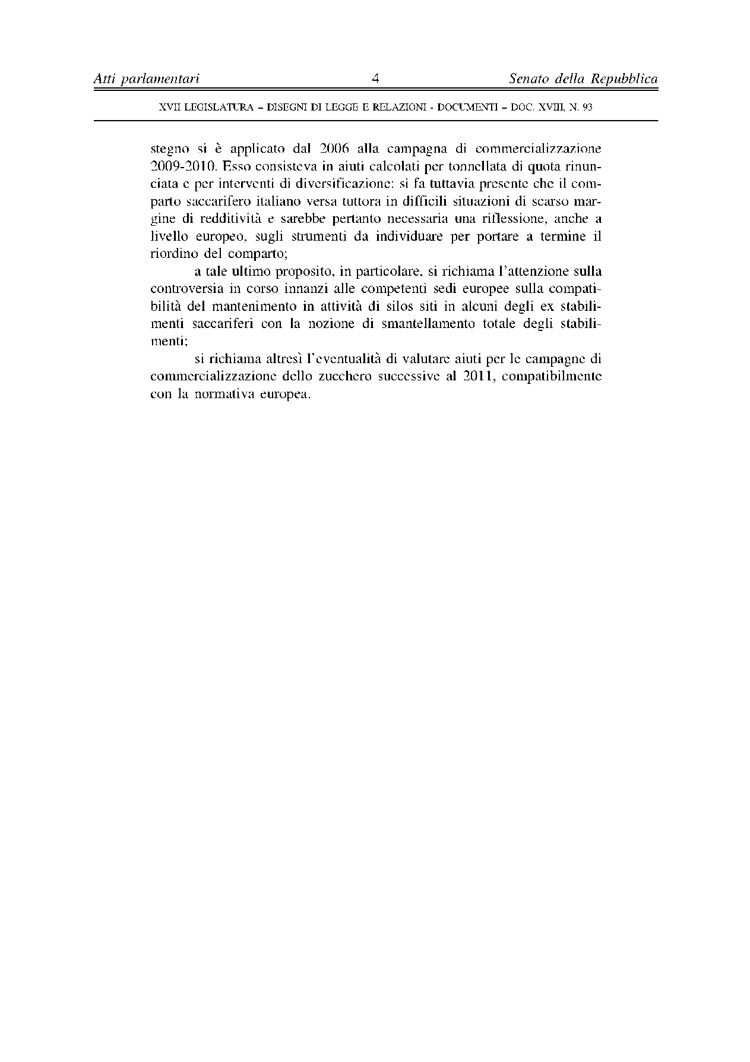

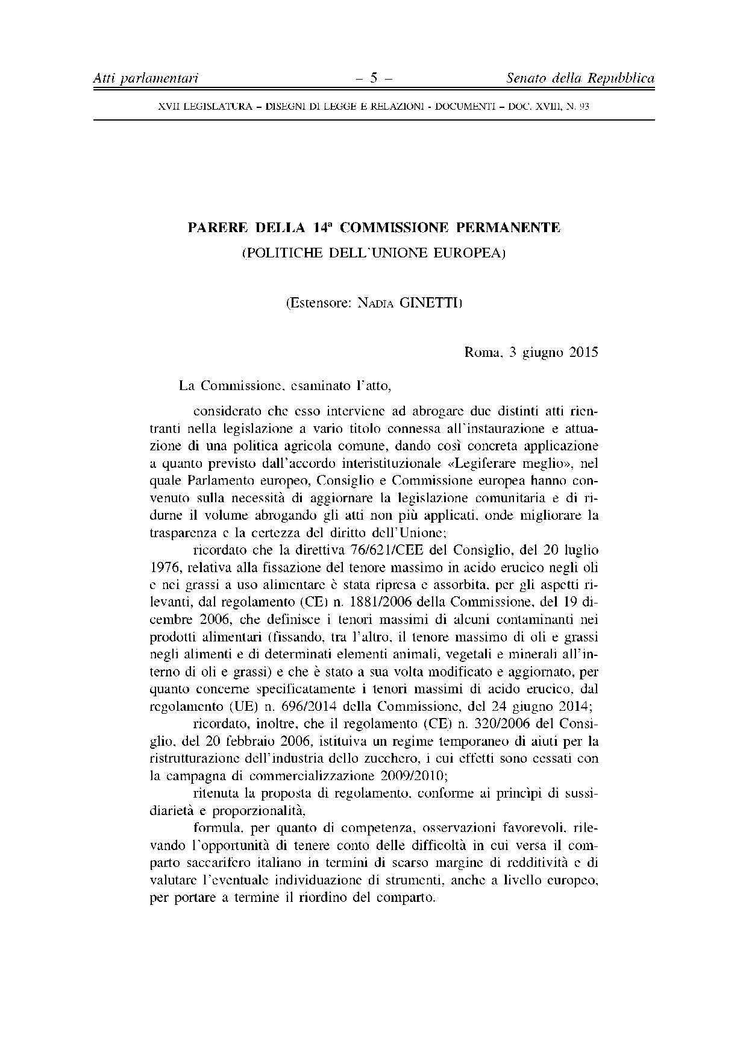

1. translation(s) of the opinion may be available on the Interparliamentary EU Information Exchange site IPEX at the following address: http://www.ipex.eu/IPEXL-WEB/search.do