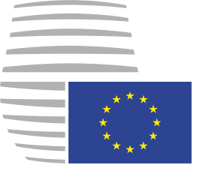 | Council of the European Union  General Secretariat
 |  |  | Brussels, 23 June 2015
 |  |  | CM 3130/15
 |  |  | PARLNAT
COMMUNICATION
INFORMATION
Contact: | dri.parlnat@consilium.europa.eu
Tel./Fax.: | +32.2-281.6678/+32.2-281.7393
Subject: | Draft amending budget No 5/2015 to the general budget for 2015 - Transmission to Member States parliaments

National parliaments' attention is drawn to the fact that, due to the urgency of the matter, draft amending budget No 5/2015, submitted by the Commission on 13 May 2015, needs to be adopted without delay.

In this perspective, the Council wishes to inform national parliaments that, in accordance with Article 3(3) of its Rules of Procedure, it has to shorten the eight-week period laid down in Article 4 of Protocol No 1 on the role of national parliaments in the European Union, in order to be able to adopt a position on draft amending budget No 5/2015 in a timely manner.

The Council trusts that the urgency of the matter will be widely understood and shared by national parliaments.

_____________________

