[1]



Delegations will find attached the above-mentioned document.

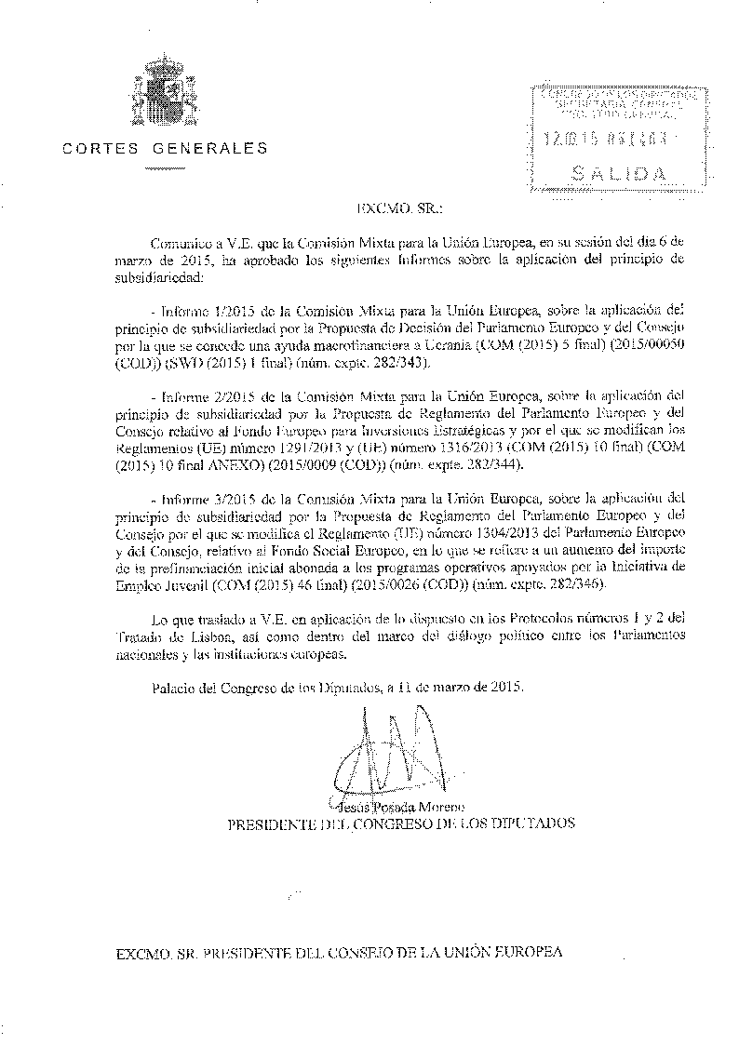ANNEX

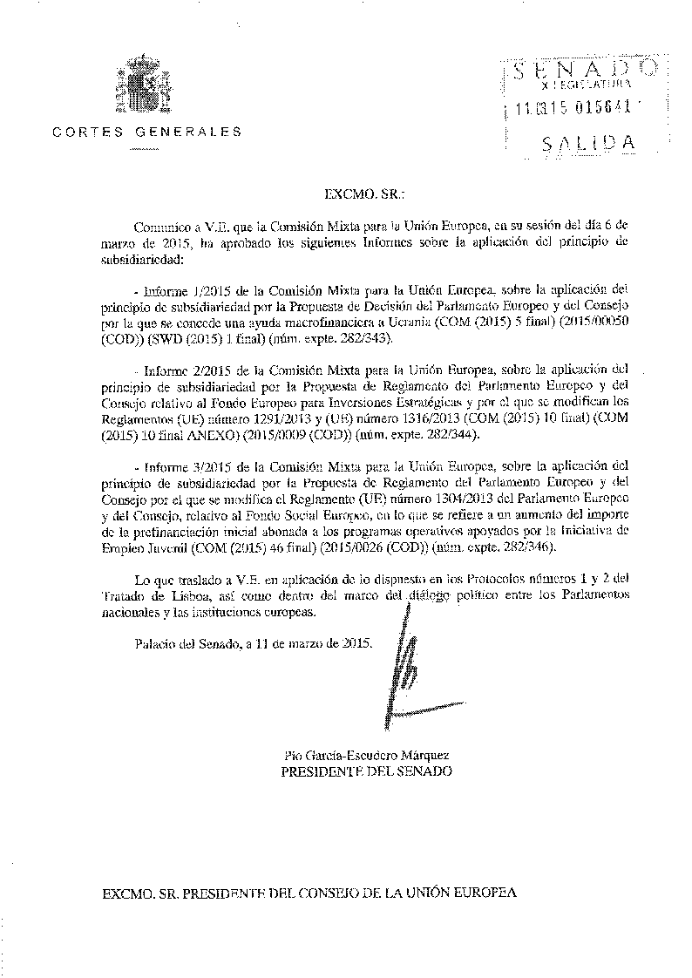

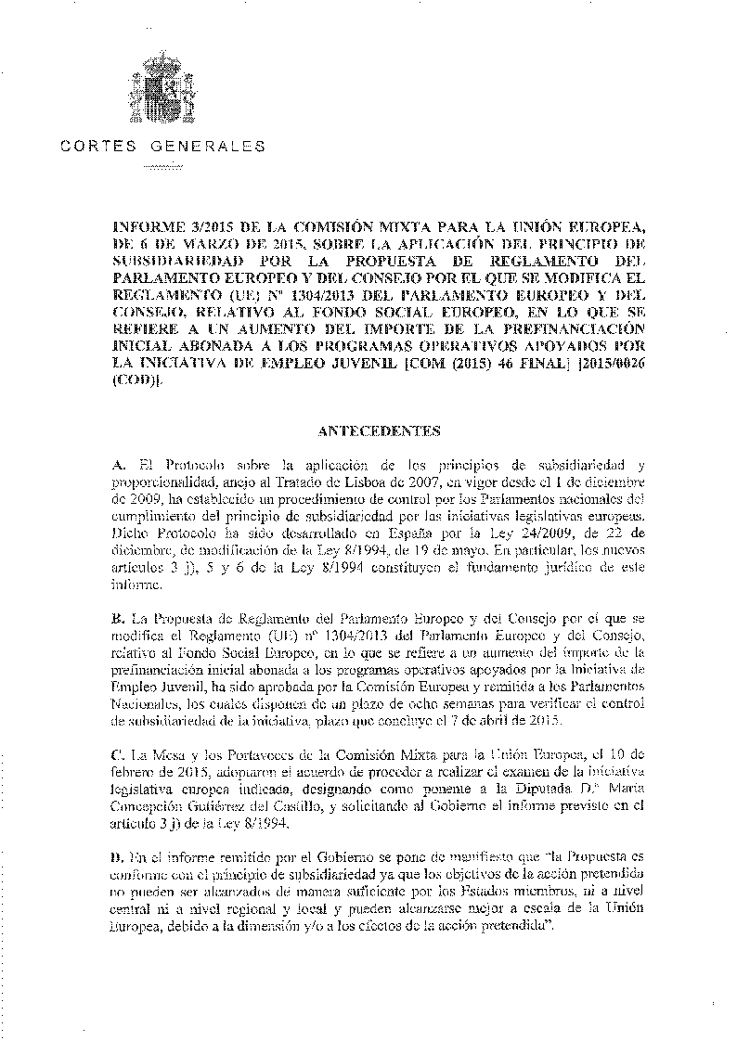

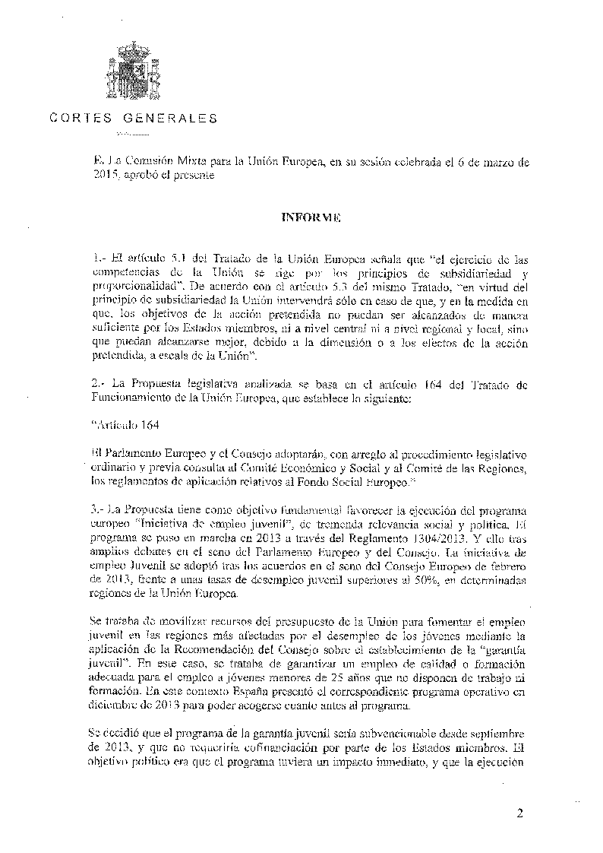

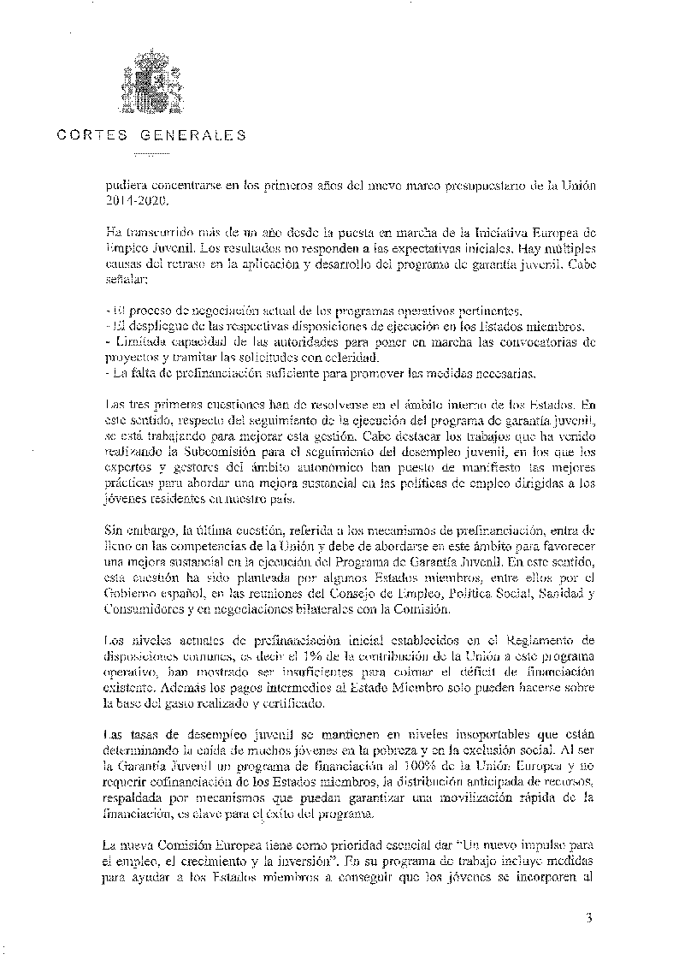

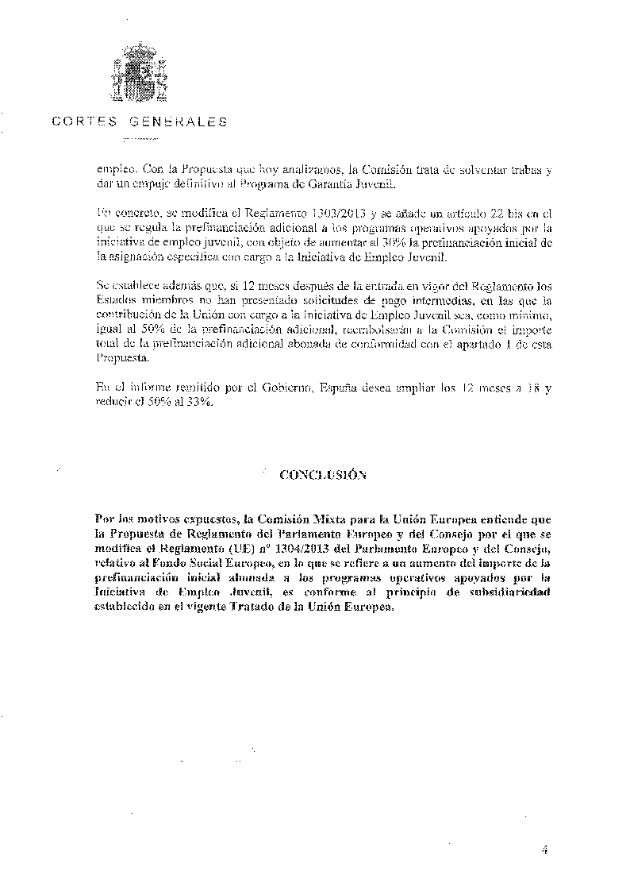

1. This opinion is available in English on the interparliamentary EU information exchange site (IPEX) at the following address: http://www.ipex.eu/IPEXL-WEB/search.do