[1]



Delegations will find attached the abovementioned Opinion.

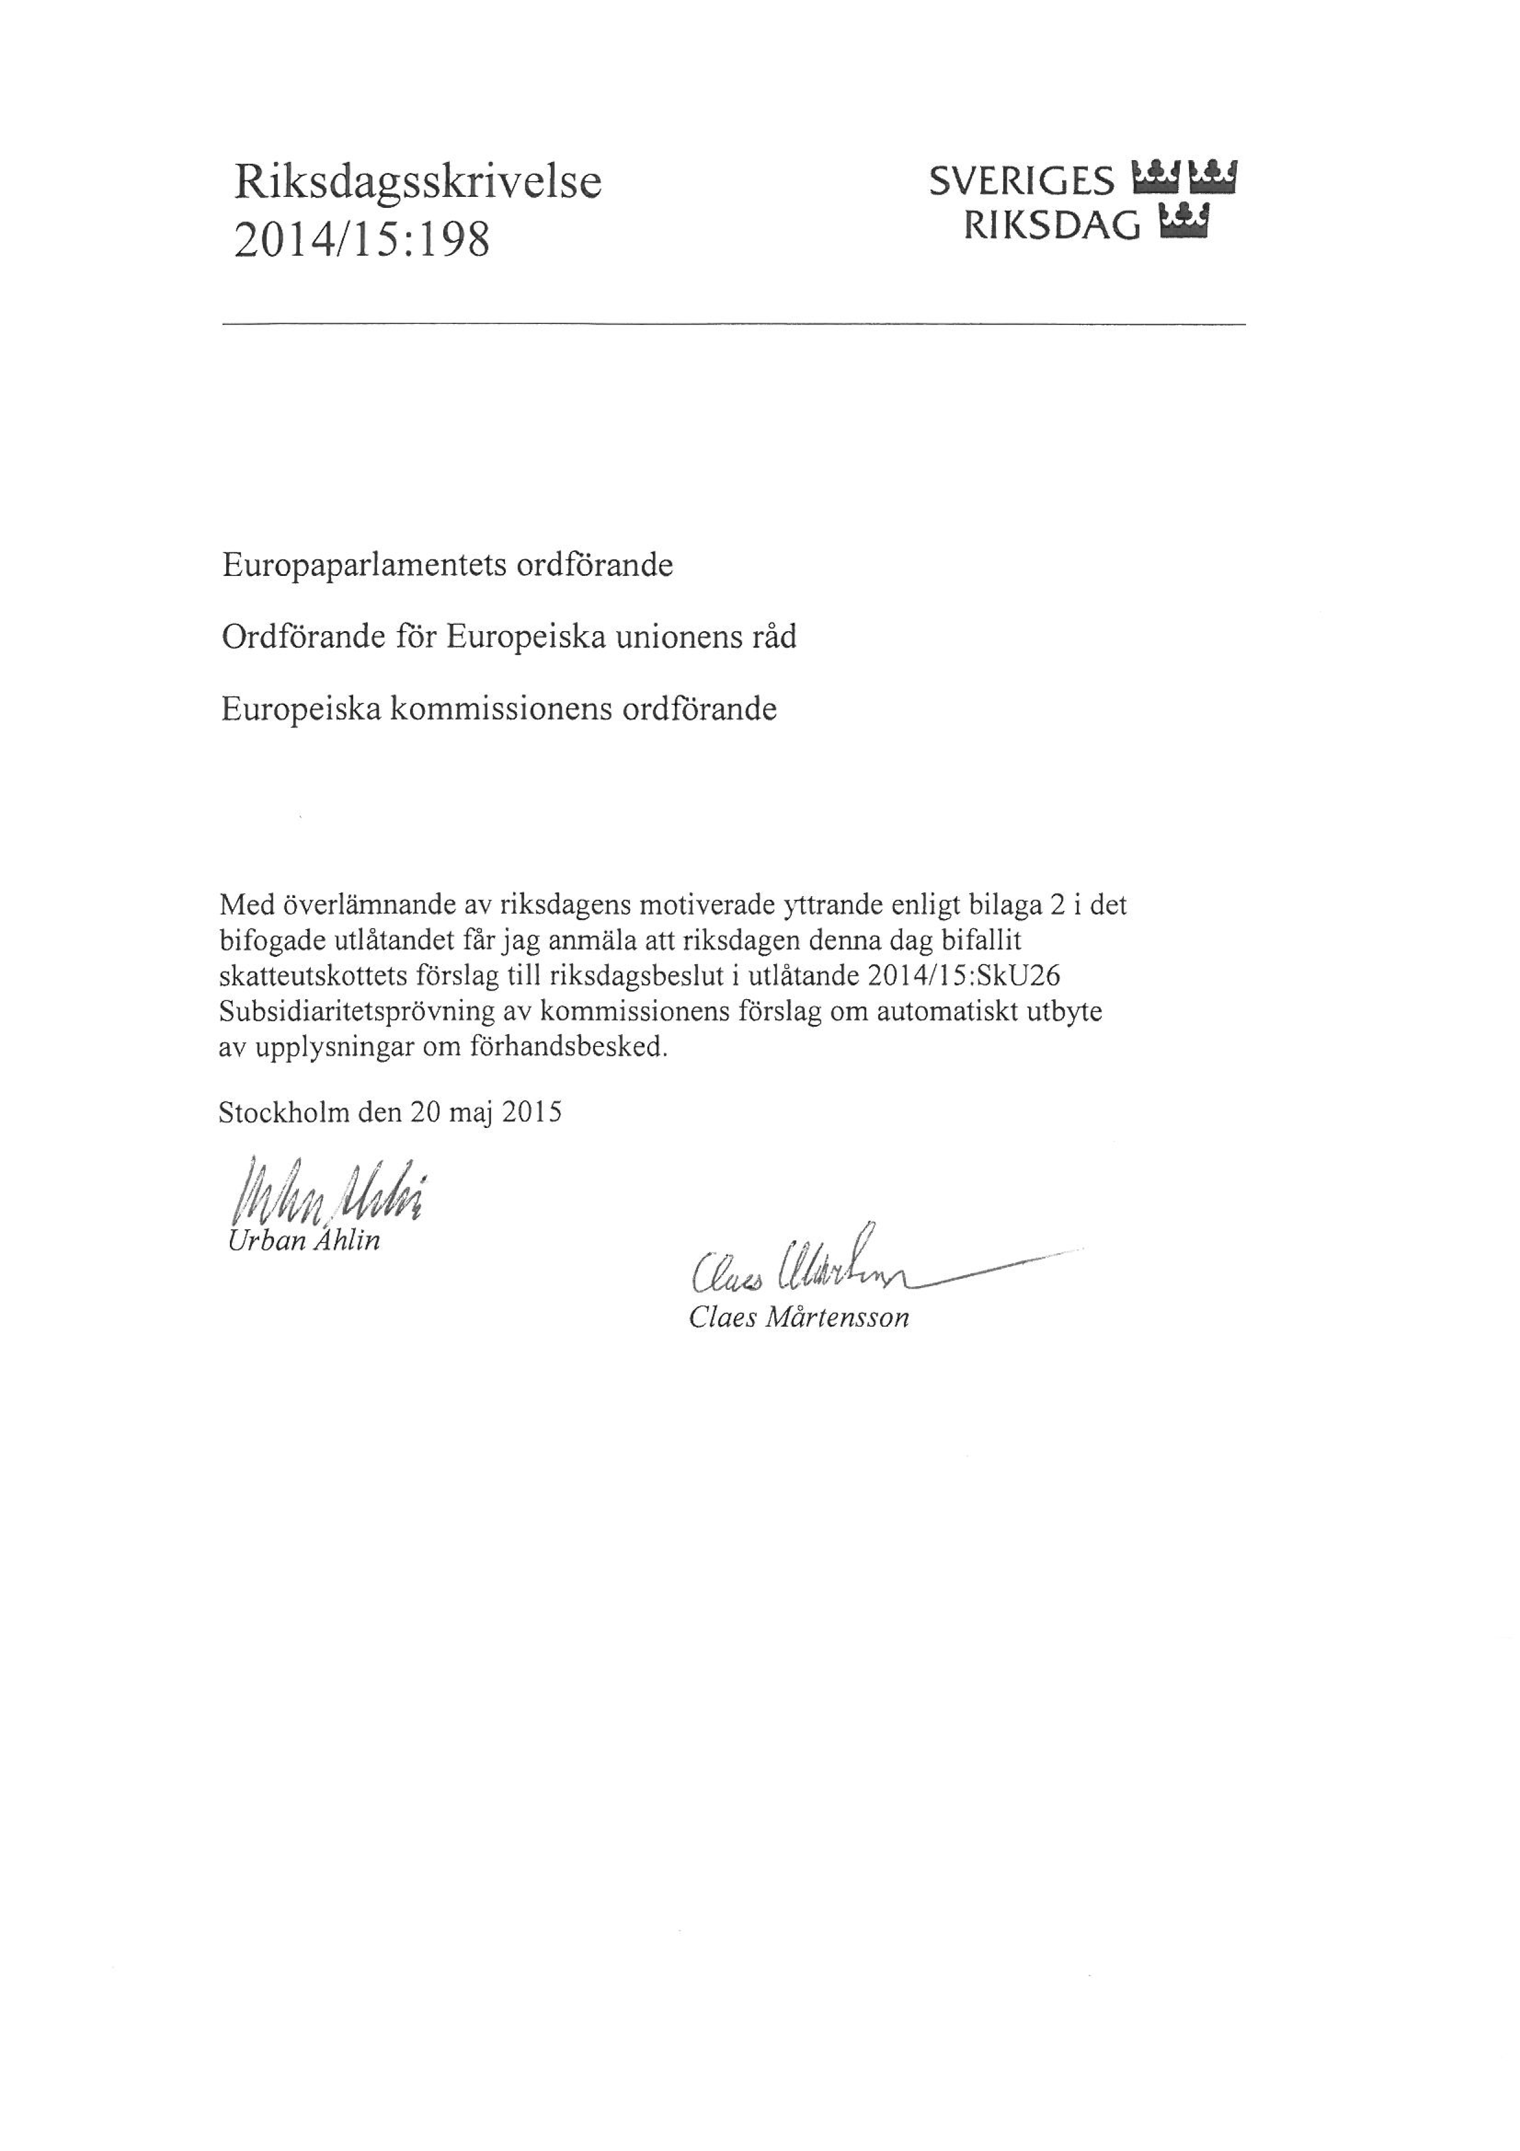

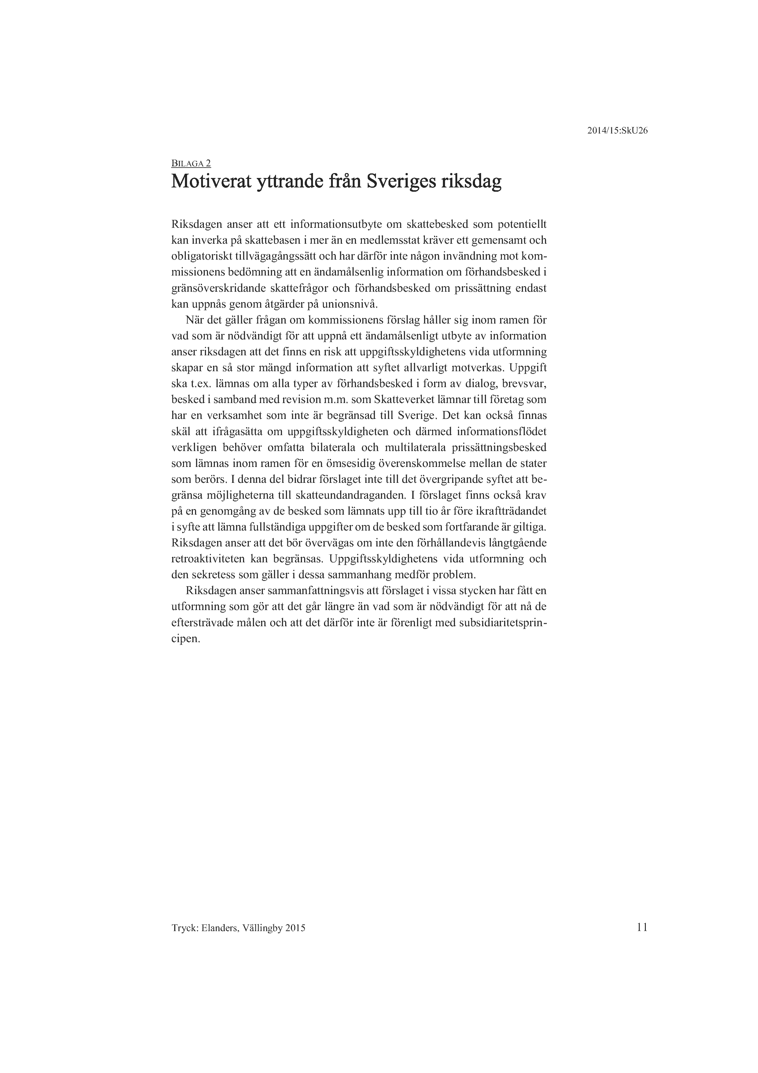

1. Translation(s) of the opinion may be available on the Interparliamentary EU Information Exchange website (IPEX) at the following address: http://www.ipex.eu/IPEXL-WEB/search.do