

Delegations will find attached the Opinion of the Italian Parliament[1].

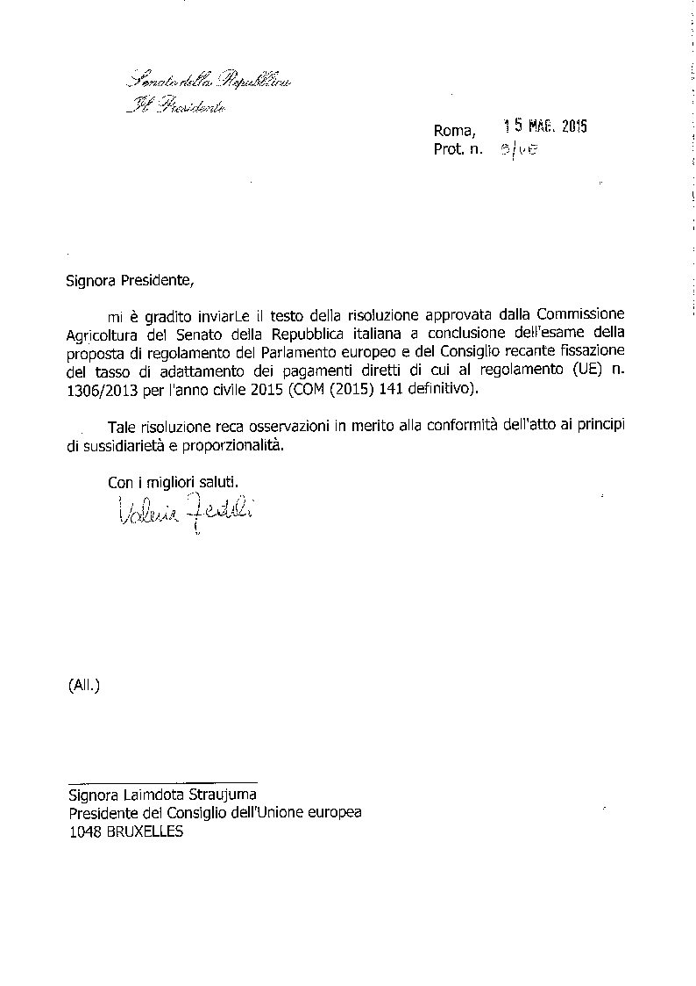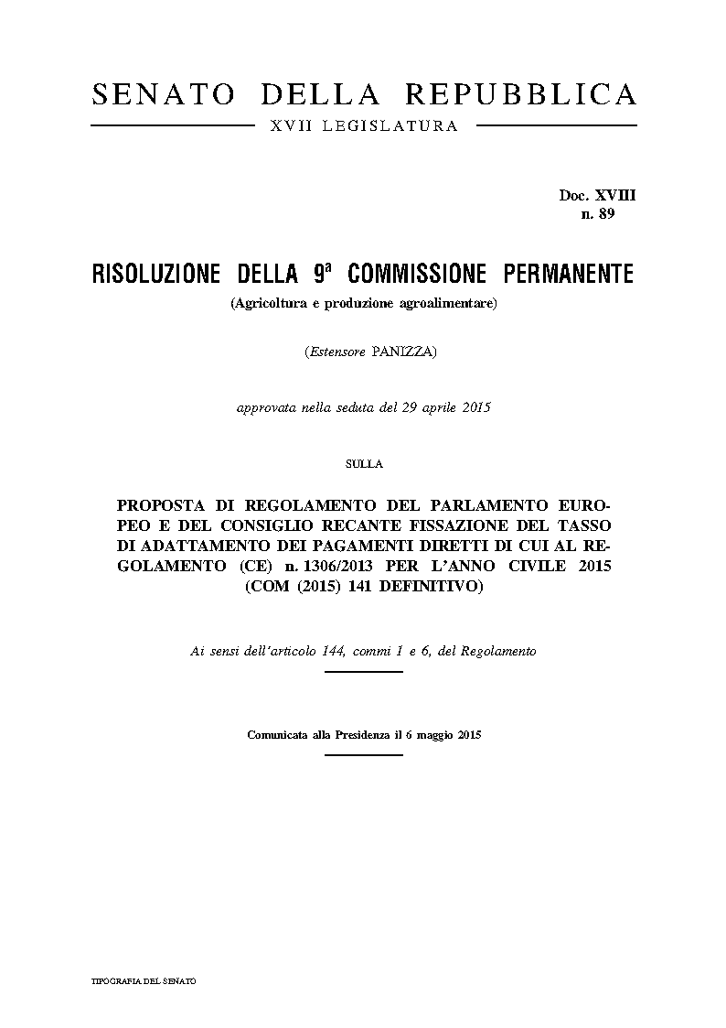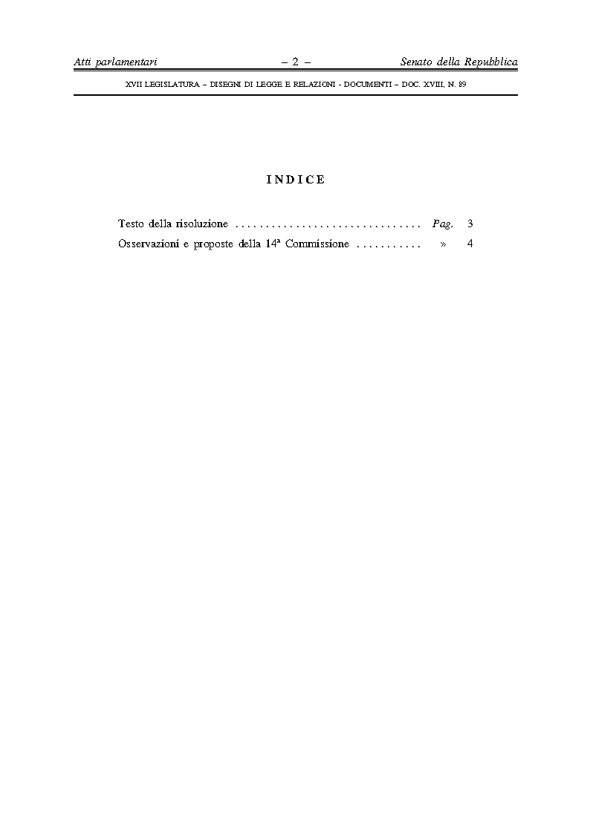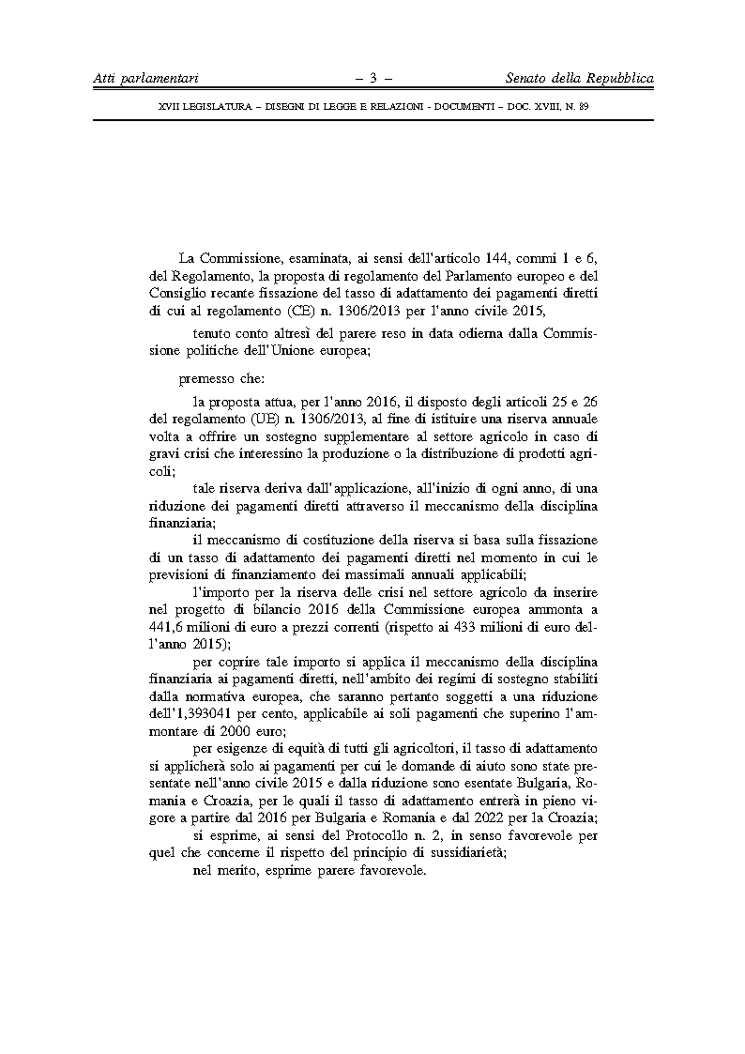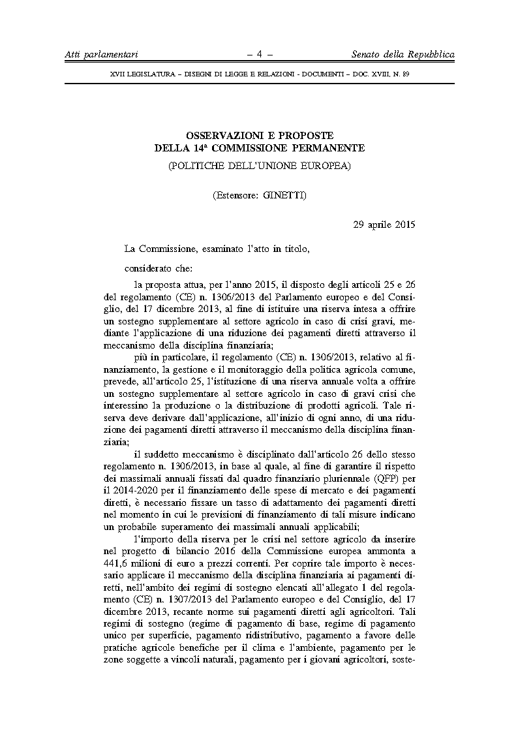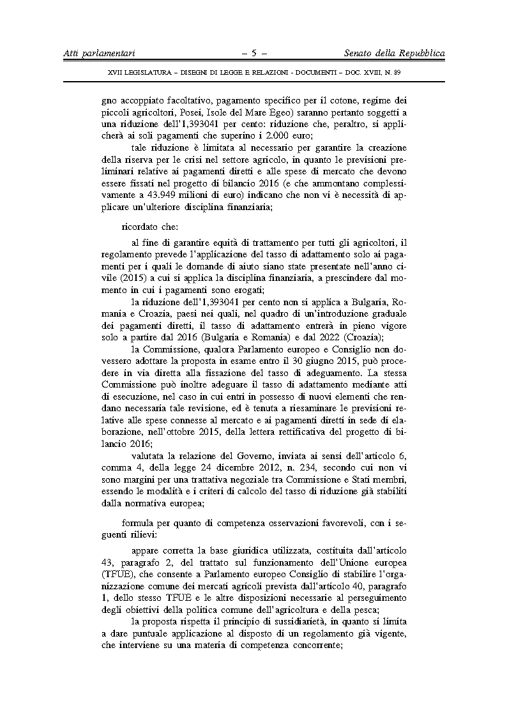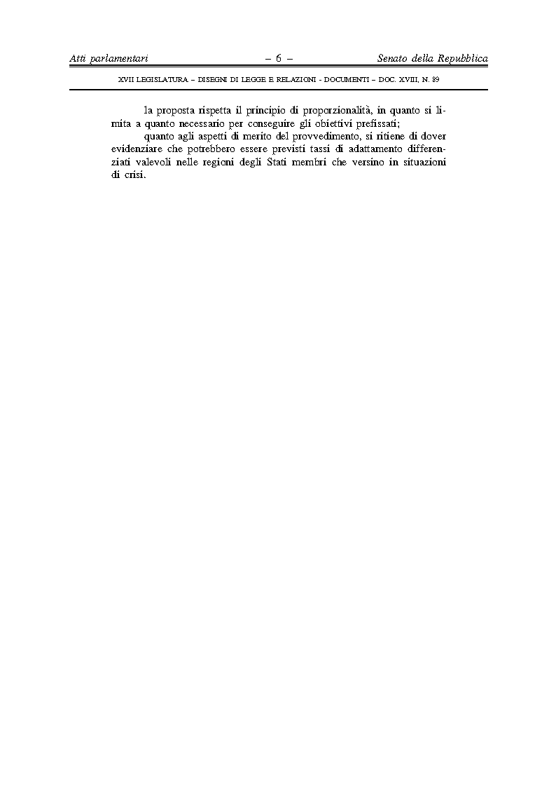

____________________

1. The translation(s) of the opinion may be available on  the Interparliamentary EU Information Exchange site IPEX at the following address: <http://www.ipex.eu/IPEXL-WEB/search.do>