|  |  |  |  |  |
| --- | --- | --- | --- | --- |
|  | Council of the  European Union | |  |  |
|  | |  | | Brussels, 3 July 2015 |
|  | |  | |  |
| Interinstitutional File:  2015/0125 (NLE) | |  | | 10475/15 |
| **ASIM 46**  **MIGR 34**  **COMIX 308**  **INST 229**  PARLNAT 77 |

COVER NOTE

|  |  |
| --- | --- |
| from: | Slovak Parliament |
| date of receipt: | 29 June 2015 |
| to: | President of the Council of the European Union |
| Subject: | Proposal for a COUNCIL DECISION establishing provisional measures in the area of international protection for the benefit of Italy and Greece  doc. 9355/15 ASIM 30 MIGR 30 COMIX 247 - COM(2015) 286 final  - Opinion on the application of the Principles of Subsidiarity and Proportionality[1] |

Delegations will find attached the above mentioned document.

________________________

**ANNEX**

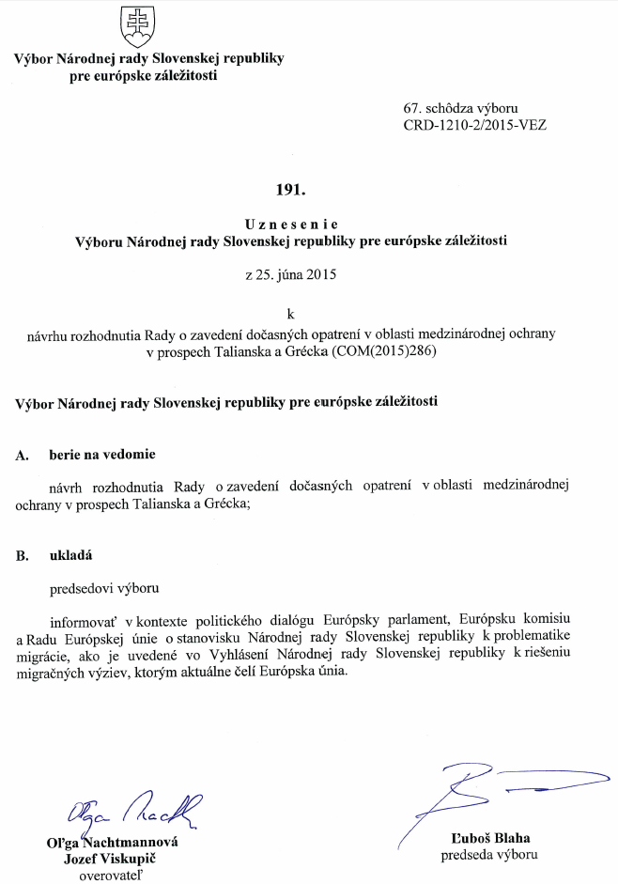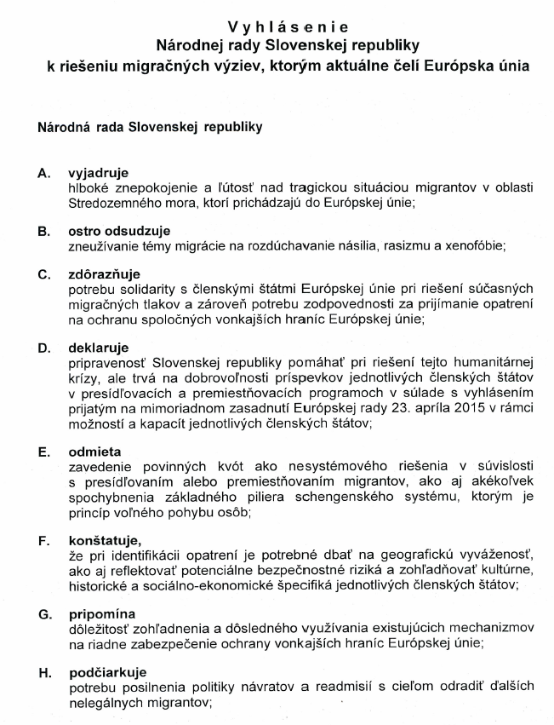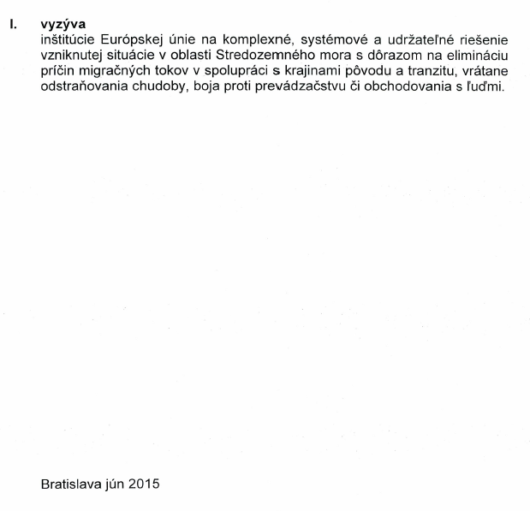

1. Translation(s) of the opinion may be available on the Interparliamentary EU Information Exchange site IPEX at the following address: http://www.ipex.eu/IPEXL-WEB/search.do