[1]



Delegations will find attached the revised version of the above mentioned Opinion.



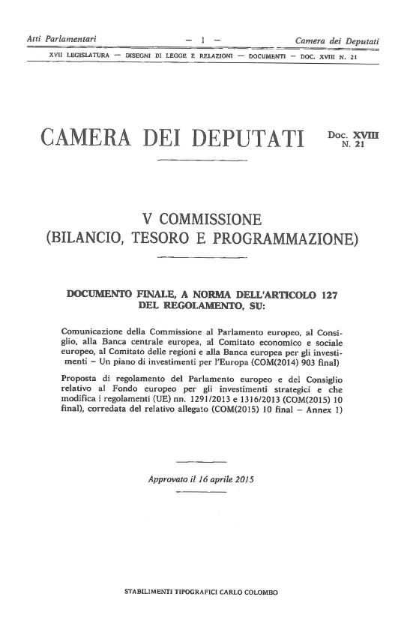

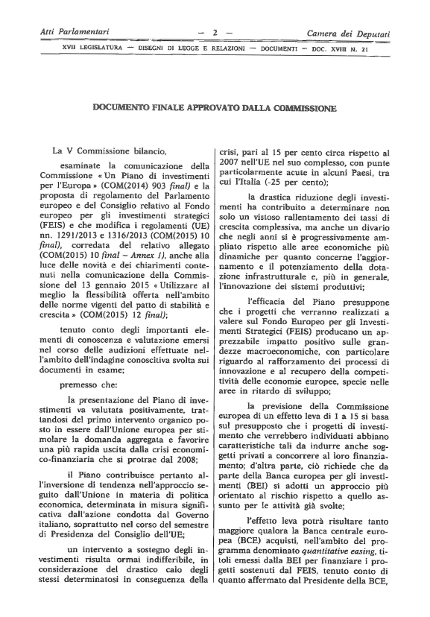

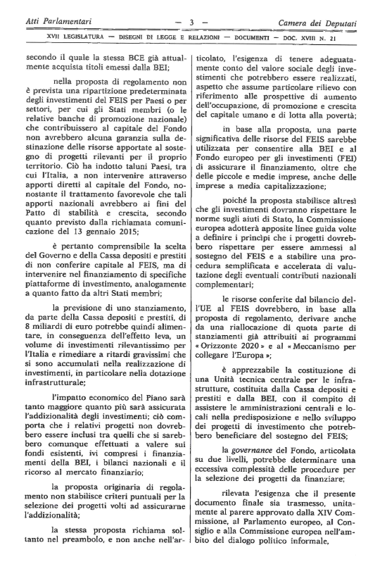

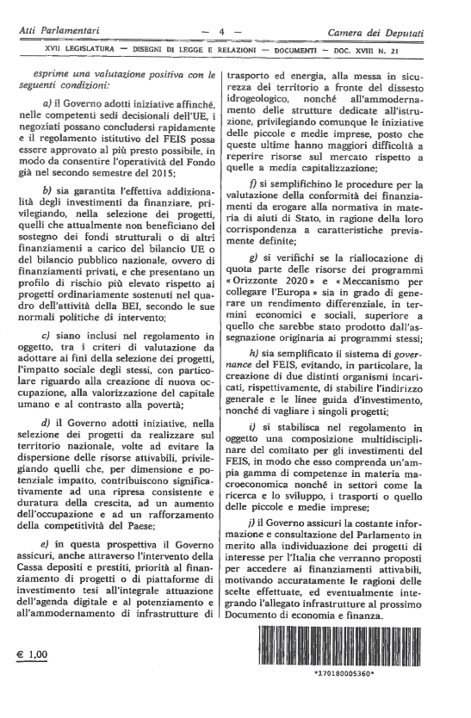

1. Translation(s) of the opinion may be available on the Interparliamentary EU Information Exchange website (IPEX) at the following address: http://www.ipex.eu/IPEXL-WEB/search.do