

ANNEX

to the

Draft Regulation

amending Regulation (EC) No 1683/1995 of 29 May 1995 laying down a uniform format for visas

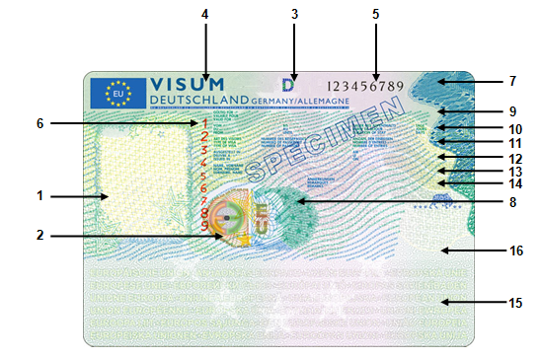

**Security features**

1. An integrated colour portrait of the holder produced to high security standards.

2. An optically variable device (‘Kinegram’ or equivalent) shall appear in this space. Depending on the angle of view, the letters ‘E’, ‘EU’ and kinematic guilloche lines become visible in various sizes and colours.

3. This box shall contain the three-letter country code as set out in ICAO Document 9303 on machine-readable travel documents of the issuing Member State in optically variable colouring. Depending on the angle of view, it shall appear in different colours.

4. The word ‘‘visa’’ and the issuing Member State in capital letters shall appear in this space.

5. This box shall contain the 9-digit national number of the visa sticker in horizontal orientation, which shall be pre-printed in black. A special font type shall be used.

6. This box shall contain the 9-digit national number of the visa sticker in vertical orientation, which shall be pre-printed in red. A special font type shall be used, different from the one used for box 5. The ‘number of the visa sticker’ is the three-letter country code as set out in box 3 and the national number as referred to in box 5 and box 6.

7. This box shall contain the letters ‘EU’ with a latent image effect. These letters shall appear light when held flat and dark when turned by 90°.

8. This box shall contain the codes according to box 3 with a latent image effect. This code shall appear light when held flat and dark when turned by 90°.

**Sections to be completed**

The words designating the boxes shall appear in English and French. The issuing State may add a third official Union language. However, the word ‘‘visa’’ in the top line may appear in any one official language of the Union.

9. This box shall begin with the words ‘valid for’. The issuing authority indicates the territory in which the visa holder is entitled to travel.

10. This box shall begin with the word ‘from’ and the word ‘until’ shall appear further along the line. The issuing authority shall indicate the period of the visa holder’s stay as authorised by the visa. Further along the line the words ‘duration of stay’ (i.e. duration of applicant’s intended stay) and again ‘days’ shall appear.

11. This box shall begin with the words ‘type of visa’. The issuing authority shall indicate the category of visa in conformity with Articles 5 and 7 of this Regulation. Further along the line the words ‘number of passport’ (after which the holder’s passport number shall appear) and ‘number of entries’ shall appear.

12. This box shall begin with the words ‘issued in’ and shall be used to indicate the place of issue. Further along the line the word ‘on’ (after which the date of issue shall be filled in by the issuing authority) shall appear.

13. This box shall begin with the words ‘Surname, Name’.

14. This box shall begin with the word ‘remarks’. It shall be used by the issuing authority to indicate any further information which is considered necessary, provided that it complies with Article 4 of this Regulation. The following two and a half lines shall be left empty for such remarks. In addition, part of this box could be used for a future 2D barcode if included in the common technical specifications.

15. This box shall contain the relevant machine-readable information to facilitate e.g. external border controls. The machine-readable zone shall contain a printed text in the background printing, indicating the codes according to box 3 and ‘European Union’ in different languages. This text shall not affect the technical features of the machine readable zone or its ability to be read.

16. This box is reserved for the possible addition of a common 2D barcode.