REPORT FROM THE COMMISSION TO THE EUROPEAN PARLIAMENT AND THE COUNCIL
on the implementation of Regulation (EC) No 428/2009 setting up a Community regime for the control of exports, transfer, brokering and transit of dual-use items

1. Introduction
Article 23(3) of Regulation (EC) No 428/2009 calls for the Commission to submit an annual report to the European Parliament on the activities, examinations and consultations of the Dual-Use Coordination Group (DUCG). Furthermore, the Commission Communication (COM(2014)244) recognises that the publication of reports and non-sensitive control information could be critical steps to enhance transparency and improve operators' compliance and their capacity to implement controls. This report, prepared by the Commission and the DUCG with inputs from Member States, provides information on the implementation of the Regulation in 2014, and includes aggregated export control data for 2013.

2. Evolution of the policy & regulatory framework

2.1. Export control policy review
2014 marked an important stage in the export control policy review with the adoption of Communication (COM(2014)244) of 24 April 2014, which aims at mapping the direction for EU export controls, and identifies concrete policy options for their modernisation and their adaptation to rapidly changing technological, economic and political circumstances. Furhter to the adoption of the Communication, the Commission launched an impact assessment with a view to evaluating the costs and benefits associated with the various review options and identifying the most suitable regulatory and non-regulatory actions (http://ec.europa.eu/smart-regulation/impact/planned_ia/docs/2013_trade_015_duxc_en.pdf).
Upon publication of Regulation (EU) No 599/2014, on 12 June 2014, a Joint Statement by the European Parliament, the Council and the Commission on the review of the dual-use export control system was published, recognising that modernisation and further convergence of the system is needed in order to keep up with new threats and rapid technological changes, to reduce distortions and promote a uniform level playing field for exporters.
Furthermore, the Council adopted, on 21 November 2014, Conclusions on the review of export control policy (http://www.consilium.europa.eu/uedocs/cms_data/docs/pressdata/EN/foraff/145903.pdf), while the European Parliament put an Oral Question on the topic (http://www.europarl.europa.eu/sides/getDoc.do?pubRef=-//EP//TEXT+OQ+O-2014-000081+0+DOC+XML+V0//EN).

2.2. Amendments to Regulation (EC) No 428/2009
Council Regulation (EC) No 428/2009 was amended twice over the reporting period:
- Regulation (EU) No 599/2014 of the European Parliament and the Council of 16 April 2014, introduced a delegation of competence to the Commission to update the EU Control List in Annex I (“delegated acts”) and to remove destinations from the scope of EUGEAs in Annex II in relation to arms embargoes;
- Commission Delegated Regulation (EU) No 1382/2014 of 22 October 2014 updated the EU Control List in Annex I to the Regulation, and incorporated modifications agreed at the multilateral export control regimes in 2011, 2012 and 2013. The modifications include de-control of certain items and amendments to goods description and definitions, as well as some new controls e.g. on internet surveillance and intrusion software. The new updated and consolidated EU Control List became applicable on 31 December 2014, thereby allowing the EU to adhere to its international commitments with regard to export controls and helping EU exporters where control parameters were relaxed.
Further evolution of the regulatory framework remains open for examination as part of the export control policy review.

2.3. National implementing measures
The Regulation is binding in its entirety and directly applicable in all Member States, but, nevertheless, foresees that Member States should take measures in implementation of certain provisions, and that information on those measures should be published in the Official Journal of the European Union. In 2014, the DUCG collected inputs from Member States to update the notice published on 6 March 2012 providing an overview of measures taken by Member States regarding e.g. the extension of brokering and transit controls, the extension of controls to non-listed items for reasons of public security and human rights consideration, the introduction of national general export authorisations, the application of intra-EU transfer controls for non-listed items, as well as information relating to national export control authorities.

3. Activities of the Dual-Use Coordination Group
Article 23 of the Regulation sets up a Dual-Use Coordination Group (DUCG) bringing together experts from the Commission and Member States to examine any issue concerning the application of export controls with a view to practically improving their consistency and effectiveness throughout the EU.

3.1. Consultations on implementation issues
Over the reporting period, the DUCG provided a forum for consultations on a number of topical issues concerning the implementation of the Regulation. The DUCG held 7 meetings, and discussed specific control issues e.g. application of the cryptography note exemption, the CBRN lists of high-risk substances and explosive precursors, Euratom agreements, and the control of graphite.
The DUCG conducted a technical exchange of information regarding implementing national measures, and prepared an update of the Official Journal publication on national measures (OJ C67 of 6 March 2012).
The DUCG reviewed the methodology and approach for data exchange, and conducted a comprehensive licensing data collection exercise (on 2013 data) in order to increase information exchange between MS and public transparency about EU dual-use export controls.
The DUCG set up, jointly with customs administrations, a technical sub-group to examine the potential convergence of customs' "Authorised Economic Operators" programmes with export control "internal compliance programmes". The technical sub-group focused, in an initial stage, on the preparation of an AEO-ICP comparison table.
The DUCG conducted a technical exchange of information regarding the control of Information and Communication Technology (ICT) monitoring and interception items. The DUCG set up a "Surveillance technology expert group" to examine this issue in depth. Another technical expert group on nuclear-grade graphite was also set up.

3.2. Technical support to the preparation of updates to the EU control list
The DUCG was consulted and supported the preparation of a Commission Delegated Regulation updating the EU Control List. Special national experts shared technical expertise and training with competent authorities highlighting the most important changes to the control list on the occasion of a special session of the DUCG.

3.3. EU Guidelines on Dual-Use Export Controls
The DUCG prepared an addition to EU Guidelines supporting exchange of information and consultations between Member States with respect to global licences. The revised Guidelines were endorsed, as a non-binding instrument, by the Dual-Use Working Party of 24 November 2014.

3.4. Exchange of information between competent authorities
The DUCG continuously works on further development of the Dual-use e-System (DUeS), a secure and encrypted electronic system hosted by the Commission, to enable effective exchange of information between export control authorities and the Commission. The DUCG introduced new functionalities and improvements into DUeS, providing for exchange of information concerning denials on brokering and transit of dual-use items, as well as on exporters prohibited from using EU General Export Authoritisations.
The DUCG has also finalised preparations for the extension of the DUeS to exports denials under Regulation (EC) No 1236/2005 concerning trade in certain goods which could be used for capital punishment, torture or other cruel, inhuman or degrading treatment or punishment. The new functionality is expected to enter into operation in the 1st quarter of 2015. Technical information regarding the DUeS was also transmitted to the European External Action Service, to support the electronic exchange of information on arms export denials.

3.5. Transparency and dialogue with industry and academia
In light of Article 23(2), the Commission held regular meetings with industry stakeholders. In particular, the DUCG held a "DUCG-Industry Forum" on 23 October 2014 in Brussels with industry associations and civil society organisations to discuss review options identified in the Commission Communication "The review of export control policy: ensuring security and competitiveness in a changing world" (http://trade.ec.europa.eu/doclib/docs/2014/october/tradoc_152858.pdf).
The DUCG also prepared documentation to support exporters' implementation of the regulations. In particular, a "Comprehensive Change Note" summarises, for information purposes, the control text changes to the EU control list introduced under Commission Delegated Regulation (EU) No 1382/2014 (http://trade.ec.europa.eu/doclib/docs/2014/october/tradoc_152854.pdf).

3.6. Export control monitoring and enforcement
The Commission promotes effective monitoring and enforcement of export controls within the EU through various support actions. In 2014, the Commission released a new version of the 'correlation table' linking customs codes with dual-use classifications and continued inclusion of export control parameters into the EU's online customs tariff database (TARIC).
National authorities are primarily responsible for the enforcement of export controls. Over the reporting period, a few enforcement actions were reported and resulted in the imposition of administrative penalties.
3.7. Pool of Experts
In 2014 the Pool of Experts operated by Commission’s JRC and experts made available by some Member States continued to provide support to EU export control authorities requesting advice in relation to concrete licensing cases. In total, 9 advices were provided to 6 Member States competent authorities.
3.8. Capacity building
The Commission’s Joint Research Centre continued the series of technical seminars for licensing authorities in collaboration with the US Department of Energy, started in 2007. The 7th seminar was held on May 6-7, 2014 in Ispra, Italy. In total the events were attended by over 80 EU licensing officers and technical experts coming from Member States.
The DUCG also contributed to the preparation by Commission services (JRC, TAXUD, TRADE) of a simulation exercise for export control licensing officers and customs officers, to be conducted in the 1st quarter of 2015.

4. EU export controls – Key Data
It is difficult to get reliable information on dual-use exports as there is no correspondingly defined economic sector. However the Commission and Member States do collect data that allow for approximate estimates of exports of dual-use goods based, on the one hand, on customs commodities identified by the correlation table which include dual-use goods and, on the other hand, on specific licensing data collected by competent authorities. To be noted, estimates of exports presented hereafter do not cover services and intangible technology transfers associated with the trade in dual-use goods. Estimates presented below derive from 2013 export data.

4.1. EU dual-use trade: items and destinations
The Regulation primarily applies to the export of about 1825 dual-use items listed in Annex I (the "EU Control List") and classified in 10 categories (Figure 1). These dual-use items relate to circa 1000 customs commodities, including chemicals, metals and non-metallic mineral products, computers, electronic and optical products, electrical equipment, machinery, vehicles and transport equipment etc. and typically fall at the high–tech end of this large, mixed commodity area.
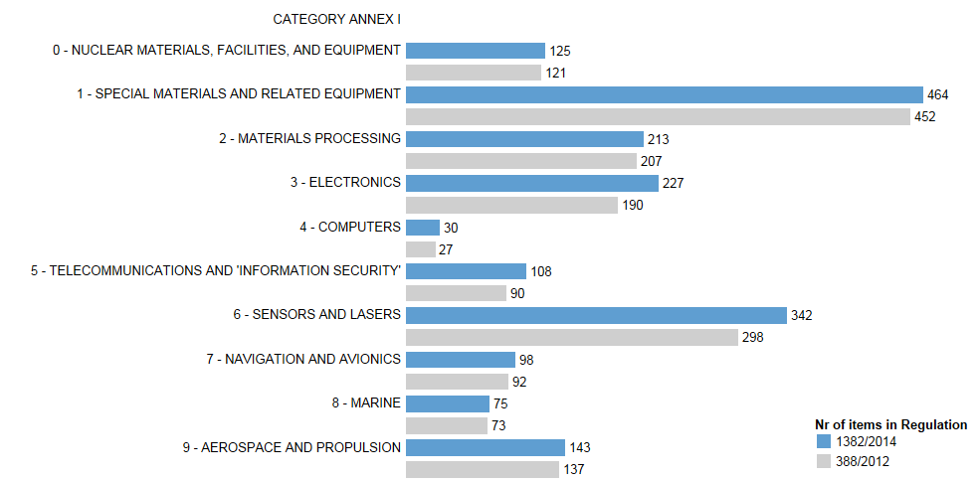
Figure 1: Number of dual-use items listed in Categories of Annex I further to the adoption of Regulation (EU) No 1382/2014.
Using the correlation between customs codes and dual-use classifications, it is estimated that controls apply to items included in an 'export domain' representing approximately 20% of EU total exports (Figure 2).
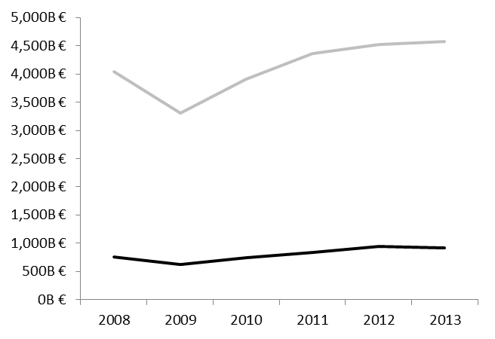
EU TOTAL EXPORT
DUAL-USE EXPORT DOMAIN
100%
20%

Figure 2: Estimated value of the 'dual-use export domain' and total exports
A large part of the dual-use export domain concerns intra-EU trade or exports towards 'E001 countries' benefiting from general export authorisations. This reflects the EU export market structure in the relevant commodities as well as trade facilitation under EUGEAs (Figure 3)
Figure 3: Destination countries and sub-regions for EU dual-use export domain in 2013.
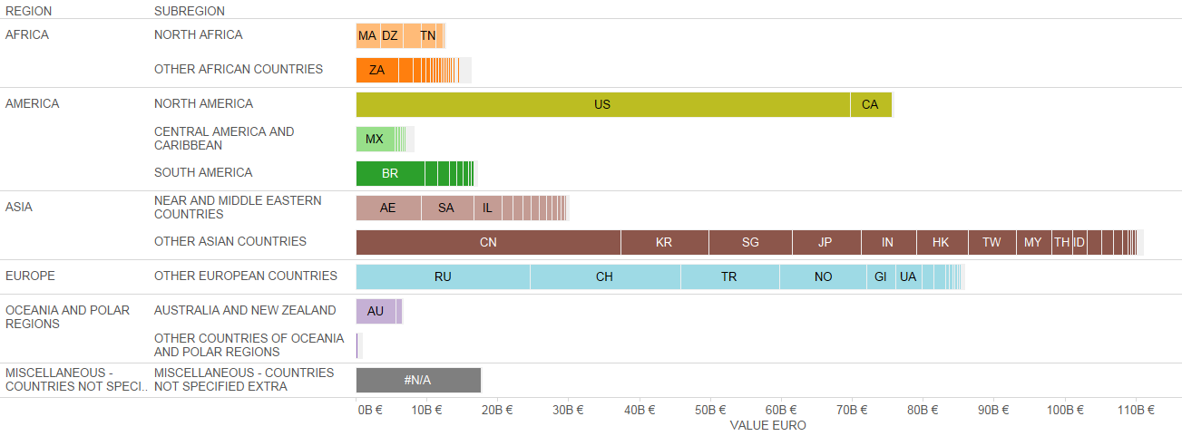 Figure 4: Destination countries by world regions and subregions, 2013

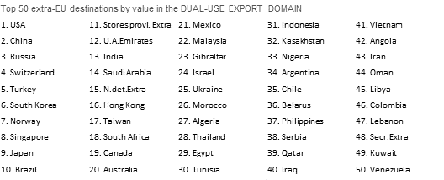
Figure 5: Top 50 extra-EU destinations by value in the dual-use export domain 2013.

4.2. Applications, licences, denials
The DUCG has exchanged information and collected licensing data, in order to improve the understanding of export controls and their economic effect. Some data collected for the reporting period is reported below; it should be noted however that not all Member States collect all data. The information provided below thus represents approximate estimates of aggregate quantities and value within the limits of the data made available by the time this report was being drawn up.
Figure 6: Number of authorisations and denials (2010-2013)
Figure 7: Value of authorisations and denials for (2010-2013) (mln EUR)
Figure 8: Comparative number of authorisations per category (2013 data)

Figure 9: Comparative value of authorisations per category (2013 data)
In total, data estimates point to a marked increase of controlled trade over the last year, with applications value' reaching EUR 85 bn and controlled dual-use exports thus representing over 4.9 % of total extra-EU exports. Authorised trade amounted to EUR 48 bn, representing 3.1% of total extra-EU exports, with a majority of transactions authorised under individual licenses (approx. 25.000 single licenses issued in 2013). By contrast, only a small portion of exports were actually denied: approx. 260 denials were issued in 2013, representing about 0,06% of the value of controlled dual-use exports in that year, and a negligible portion of total EU exports.

Some competent authorities also publicly report on trade in dual-use items.
Joint Statement by the European Parliament, the Council and the Commission attached to Regulation (EU) No 599/2014.
OJ L173, 12.06.2014, p; 79.
OJ L 371, 30.12.2014, p. 1
OJ C 67, 6.3.2012, p. 1.
COM (2014)244 final of 24 April 2014.
The notion of dual-use export domain refers to this large, mixed commodity area which includes dual-use items. The trade of dual-use items takes place within this commodity area, but is not identical to it, since by far, not all of the commodities within the dual-use export domain are export-controlled. Measurements by the Commission's Joint Research Centre, based on Eurostat’s COMEXT database, result in a stable estimate of a 'dual-use export domain' representing about 20% of EU total exports (including intra-EU trade).
"Stores and provisions extra" are defined as delivery of ships' and aircraft's stores.
"N.det.Extra" includes countries and territories not specified within the framework of trade with third countries. (These codes are usually used for goods delivered for offshore installations). "Secr. Extra" includes countries and territories not specified for commercial or military reasons.
In Figure 6 and Figure 7, "Applications" data include all applications for licenses, including notifications under general authorisations, thus providing an indication of "controlled trade". The charts makes use of authorisation data as estimate for application data, in cases where no application data is available. "Authorisations" data refers to dual-use exports authorised under individual and global licences. It should be noted that applications do not necessarily correspond to the sum of authorisations and denials, as a number of applications may be cancelled and some applications may not be finalised within the same year. "Denial" refers to the volume and value of denied exports.
This figure includes value for applications and notifications under General Export Authorisations.
In 2013, denied exports amounted to 0.003% of total extra-EU exports.

