CYPRUS

In 2014 the number of new complaints made against Cyprus fell to its lowest level in recent years. New EU Pilot files opened also dropped, to below the 2012 total. The overall number of pending infringement cases against Cyprus has not changed much over the last three years. The number of new cases registered in 2014 is the lowest of the last five years. New infringement cases for late transposition rose slightly for the second year running but remained well below the 2010 and 2011 levels.
- COMPLAINTS
- New complaints made against Cyprus by members of the public (2011-14)
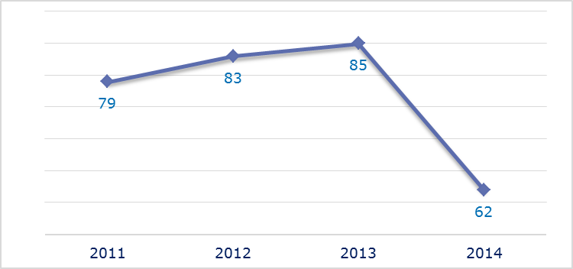
- Evolution of complaints against Cyprus
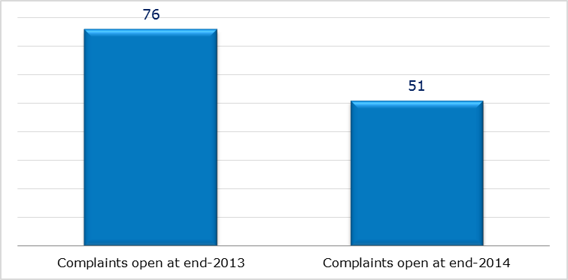
- New complaints registered in 2014: main policy areas
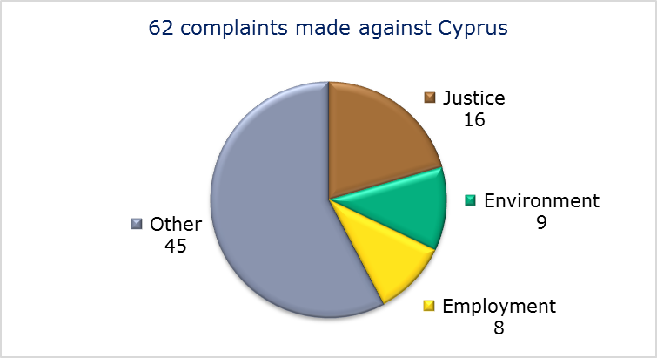
- EU PILOT
- New EU Pilot files opened against Cyprus (2011-14)
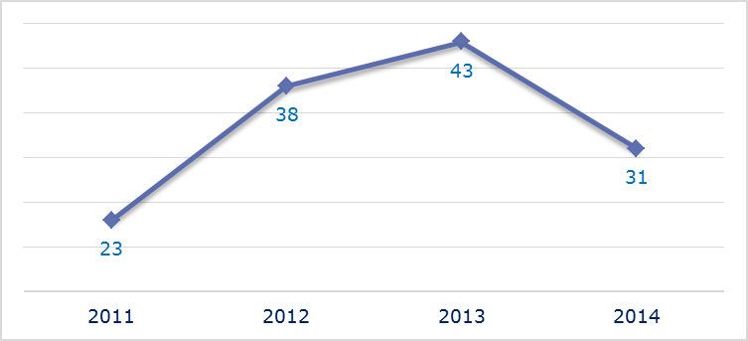
- Evolution of files relating to Cyprus open in EU Pilot
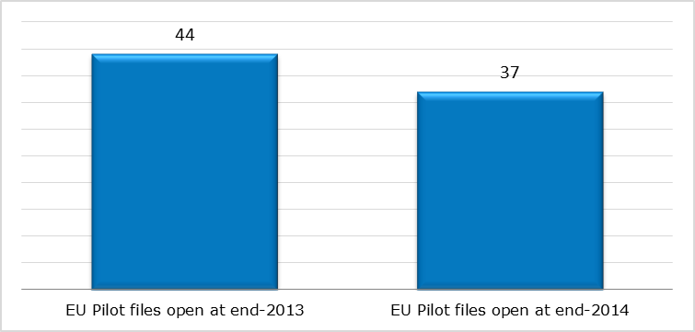
- New EU Pilot files opened in 2014: main policy areas
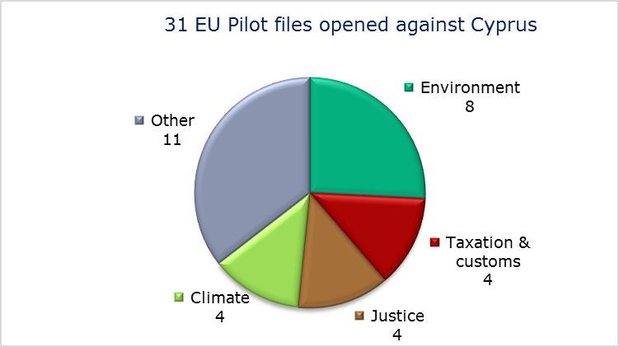
- EU Pilot files: average response time in days (2011-14)
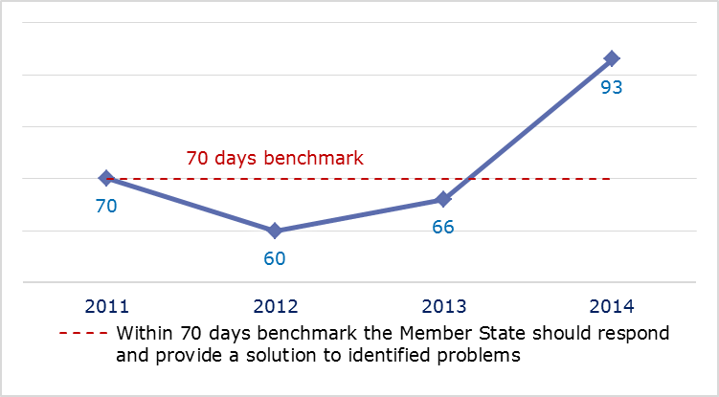
- EU Pilot files: evolution of the resolution rate by Cyprus (2011-14)
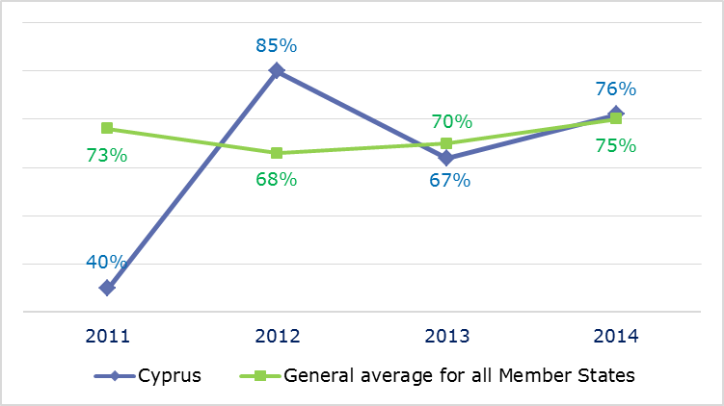
- INFRINGEMENT CASES
- Infringement cases against Cyprus open on 31 December (2010-14)
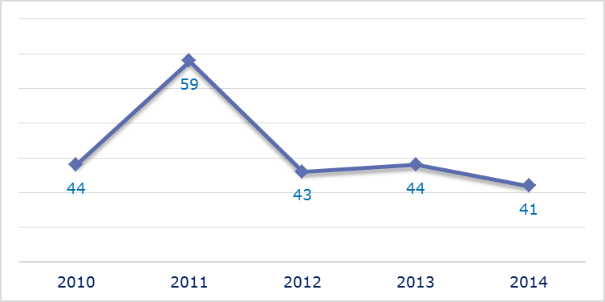
- New infringement cases opened in 2014: main policy areas
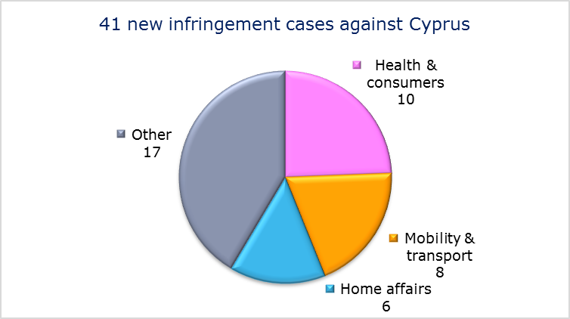
- Key infringement cases and referrals to the Court
- The Commission opened 41 new infringement cases against Cyprus in 2014. These, and other major ongoing infringement cases, concern:
- obstacles to the registration of vehicles;
- non-communication of measures transposing the directive on aerosol dispensers;
- incorrect application of the Unfair Commercial Practices Directive and the Directive on unfair terms in relation to the purchase of immovable property;
- non-communication of measures transposing the Capital Requirements Directive;
- significant impact from a development project in the area of Limni and the lack of strict protection of the Caretta Caretta species of turtle;
- the alleged systematic detention of certain categories of asylum applicants without properly assessing the need for detention, and the lack of an effective remedy against detention orders;
- the late transposition of the Directive on the Single Permit for non-EU nationals, of the directive on standards for the qualification of non-EU nationals or stateless persons as beneficiaries of international protection and of the directive on combating the sexual abuse and sexual exploitation of children and child pornography;
- failure to efficiently implement functional airspace blocks. Under the Single European Sky legislation, national air traffic control organisations should work together in regional airspace blocks to gain efficiency, cut costs and reduce emissions. The set-up of these common airspace blocks is arranged around traffic flows rather than state boundaries, which leads to performance improvements;
- discrimination against non-Cypriot EU nationals in bus transport;
- lack of connection to the EU driving licence network (RESPER);
- incorrect implementation of the directive laying down minimum standards for the protection of pigs, which requires that sows are kept in groups during part of their pregnancy.
- The Commission referred one case to the Court under Article 258 TFEU. It concerns:
- the incompatibility with EU law of Cyprus’ pensions rights for Cypriot nationals under 45 years old working in the EU institutions;
- The Commission did not refer any cases to the Court under Article 260(2) TFEU.
- TRANSPOSITION OF DIRECTIVES
- New late transposition infringement cases against Cyprus (2010-14)
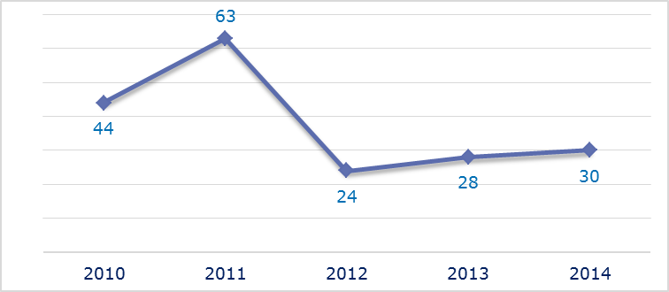
- New late transposition infringement cases opened in 2014: main policy areas
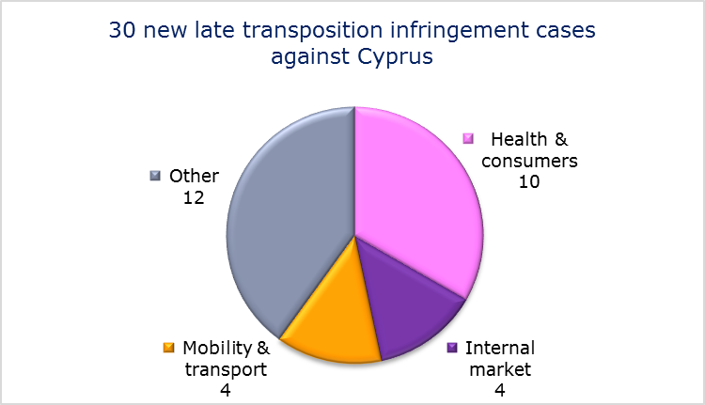
- Referrals to the Court
The Commission did not refer any cases to the Court under Articles 258 and 260(3) TFEU.
- EARLY RESOLUTION OF INFRINGEMENT CASES

Major cases closed without a Court judgment in 2014
These concerned:
- failure to fully transpose the Oil Stocks Directive and the Renewable Energy Directive;
- non-communication of measures transposing the Industrial Emissions Directive;
- failure to fully transpose the directive on the geological storage of carbon dioxide;
- late transposition of the directive on preventing and combating trafficking in human beings and protecting its victims;
- late transposition of the 'Sharp injuries' Directive.
- IMPORTANT JUDGMENTS
- Court rulings
There were no major Court rulings in 2014.

- Preliminary rulings
No major preliminary rulings were addressed to the Cypriot judiciary in 2014.

CZECH REPUBLIC

After a significant fall in 2012, the number of new complaints made against the Czech Republic has remained stable. New EU Pilot files opened against the Czech Republic fell from 2013’s peak. The overall number of pending infringement cases has remained fairly steady since the big drop in 2012. New infringement cases for late transposition have fallen considerably since 2011.
- COMPLAINTS
- New complaints made against the Czech Republic by member of the public (2011-14)
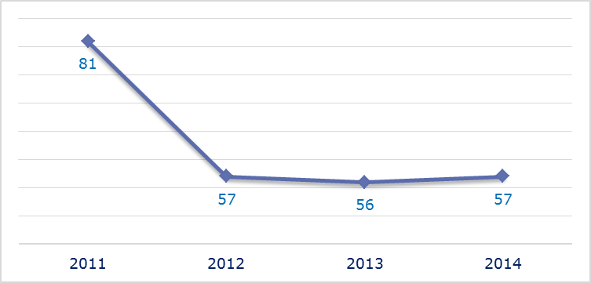
- Evolution of complaints against the Czech Republic
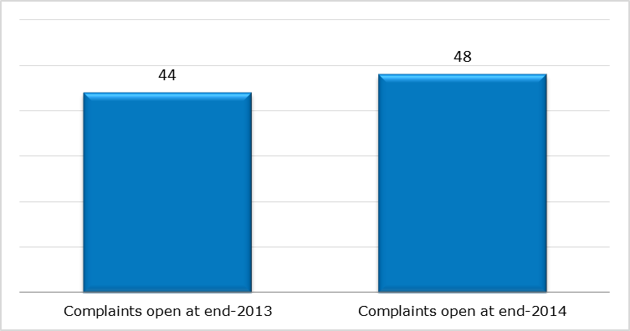
- New complaints registered in 2014: main policy areas
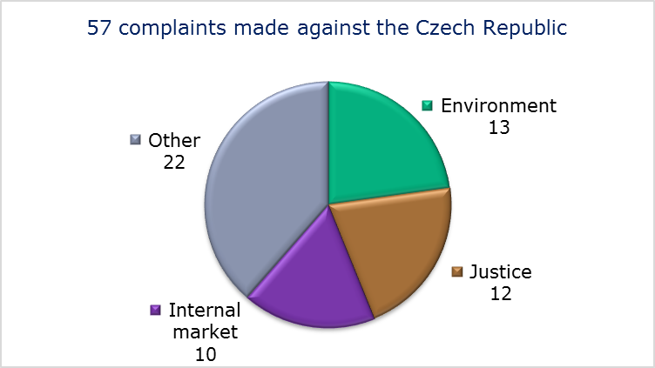
- EU PILOT
- New EU Pilot files opened against the Czech Republic (2011-14)
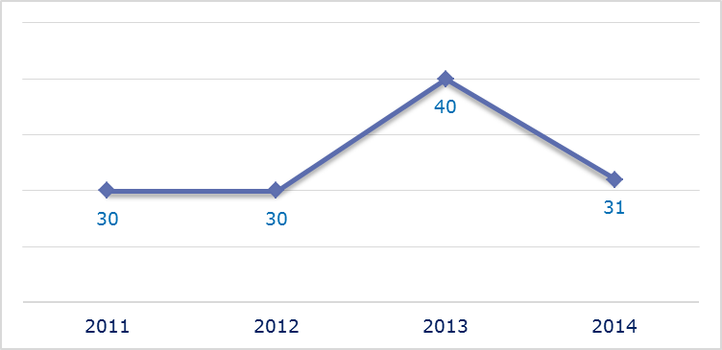
- Evolution of files relating to the Czech Republic open in EU Pilot
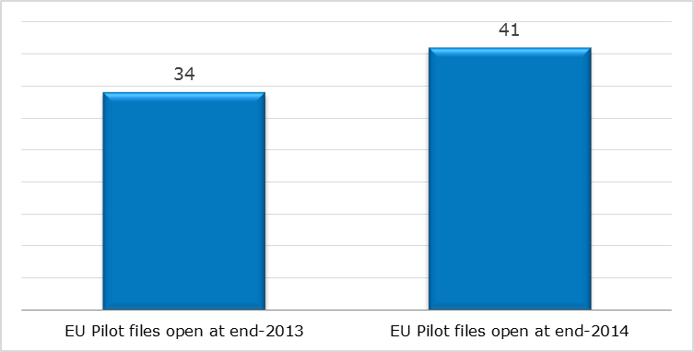
- New EU Pilot files opened in 2014: main policy areas
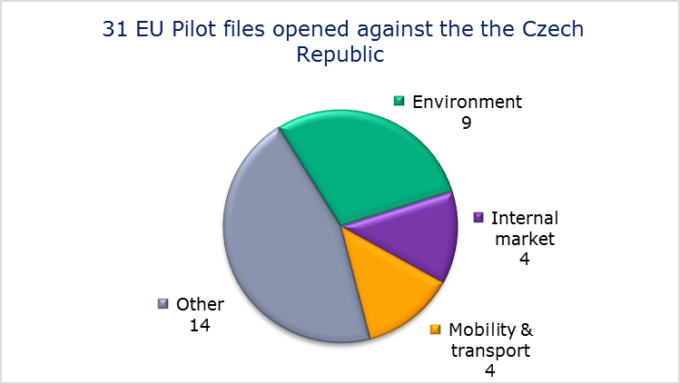
- EU Pilot files: average response time in days (2011-14)
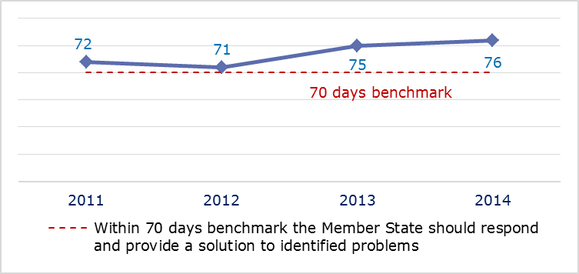
- EU Pilot files: evolution of the resolution rate by the Czech Republic (2011-14)
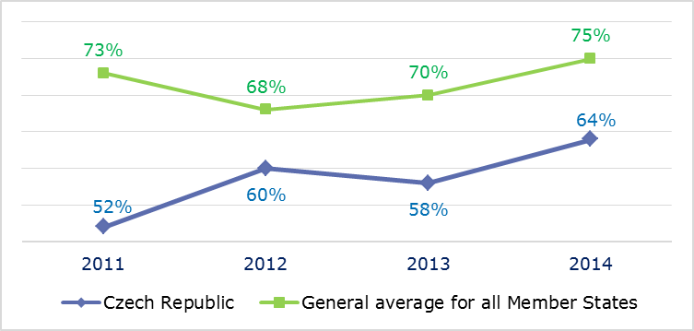
- INFRINGEMENT CASE
- Infringement cases against the Czech Republic open on 31 December (2010-14)
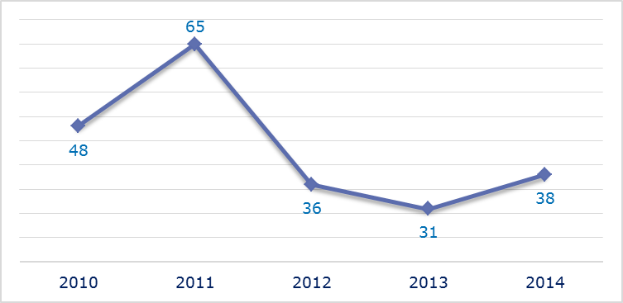
- New infringement cases opened in 2014: main policy areas
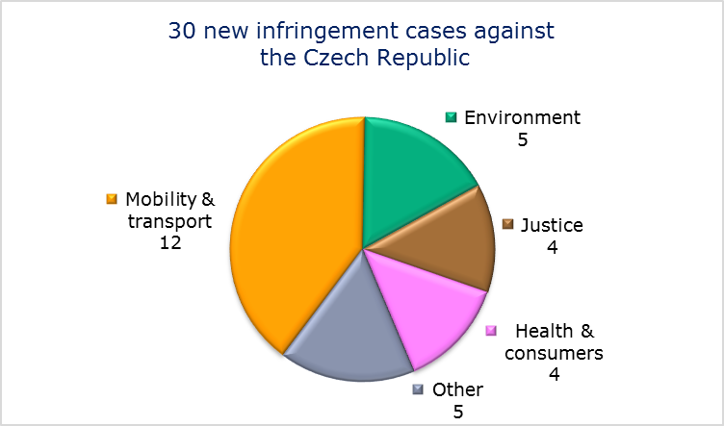
- Key infringement cases and referrals to the Court
- The Commission opened 30 new infringement cases against the Czech Republic in 2014. These, and other major ongoing infringement cases, concern:
- nonconformity with the Waste Directive;
- nonconformity with the Racial Equality Directive due to discrimination against Roma children by disproportionately and systematically placing them in special schools meant for children with disabilities;
- implementation of the right to appeal against a visa refusal;
- the right of EU nationals to become members of a political party or to found one in the Member State of residence;
- transposition of the Free Movement Directive;
- requirement to have Czech nationality to work as notary;
- late notification of measures transposing the Capital Requirements Directive;
- failure to efficiently implement functional airspace blocks. Under the Single European Sky legislation, national air traffic control organisations should work together in regional airspace blocks to gain efficiency, cut costs and reduce emissions. The set-up of these common airspace blocks is arranged around traffic flows rather than state boundaries, which leads to performance improvements;
- lack of a register of road transport undertakings and of a connection to the European system, and failure to fulfil preconditions necessary for the European Electronic Toll Service to function;
- incomplete notification of measures transposing the Cross-border Healthcare Directive;
- The Commission referred one case to the Court under Article 258 TFEU. It concerns:
- rules on the hallmarking of jewellery. The Czech Assay Office requires certain articles of jewellery imported from another EU country to be stamped with an additional national hallmark even when they have already been lawfully hallmarked and marketed in the EU.
- The Commission did not refer any cases to the Court under Article 260(2) TFEU.
- TRANSPOSITION OF DIRECTIVES
- New late transposition infringement cases against the Czech Republic (2010-14)
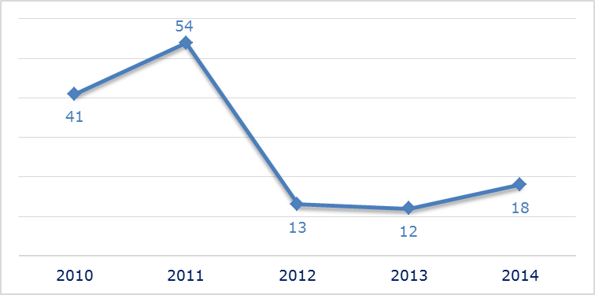
- New late transposition infringement cases opened in 2014: main policy areas
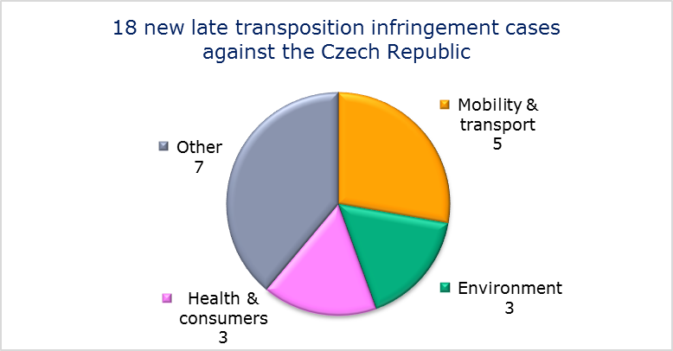
- Referrals to the Court
The Commission did not refer any cases to the Court under Articles 258 and 260(3) TFEU.
- EARLY RESOLUTION OF INFRINGEMENT CASES

Major cases closed without a Court judgment in 2014
These concerned:
- incorrect implementation of the First Railway Package;
- designation of national bodies and sanctions in relation to the protection of passenger rights;
- inspection of carriers in the area of aviation security.
- IMPORTANT JUDGMENTS
- Court rulings
There were no major Court rulings in 2014.
- Preliminary rulings
In preliminary rulings addressed to the Czech judiciary, the Court ruled that:
- the EU Copyright Directive does not allow health establishments to be exempted from the payment of copyright fees. The monopoly granted to the Czech copyright collecting society to collect fees for the use of composers' musical works is compatible with the freedom to provide services; Moreover, the grant of this territorial monopoly over the management of copyright is not, as such, contrary to competition rules either (Article 106 in conjunction with Article 102 TFEU);
- the operation of a camera system installed by an individual in his family home to protect the property and the health and life of the home owned, but which also monitors a public space, is not considered as processing for a purely personal or household activity and therefore falls within the scope of the Data Protection Directive.

DENMARK

The number of new complaints made against Denmark has remained relatively stable over the last four years. After reaching a peak in 2013, new EU Pilot files opened against Denmark fell considerably in 2014. The overall number of pending infringement cases has not changed much over the last five years. However, infringement cases against Denmark for late transposition increased in 2014 for the first time since 2011.
- COMPLAINTS
- New complaints made against Denmark by members of the public (2011-14)
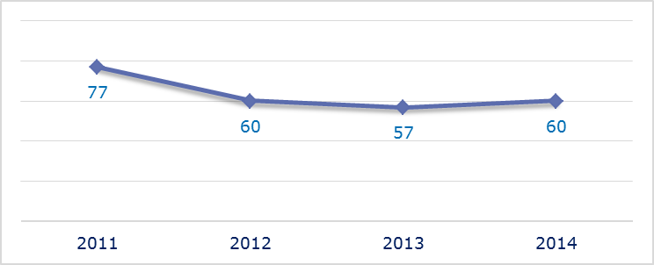
- Evolution of complaints against Denmark
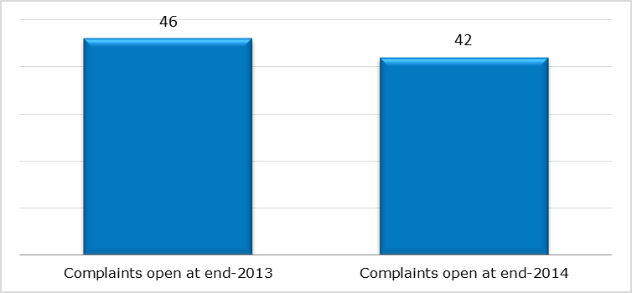
- New complaints registered in 2014: main policy areas
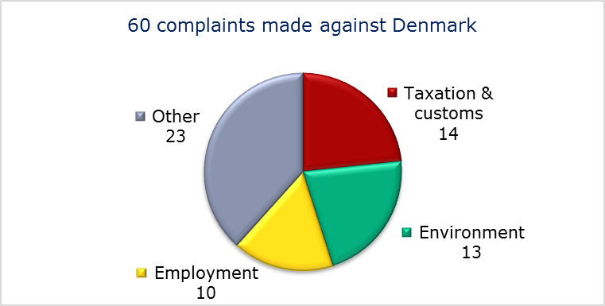
- EU PILOT
- New EU Pilot files opened against Denmark (2011-14)
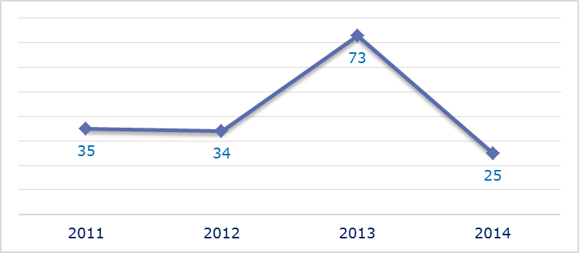
- Evolution of files relating to Denmark open in EU Pilot
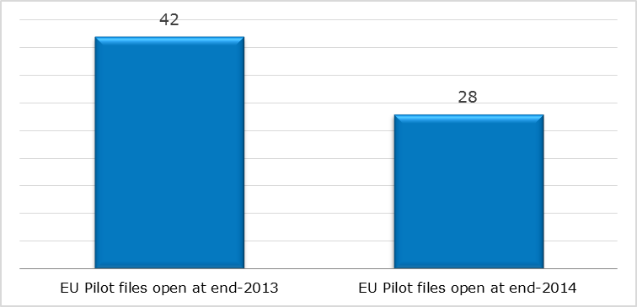
- New EU Pilot files opened in 2014: main policy areas
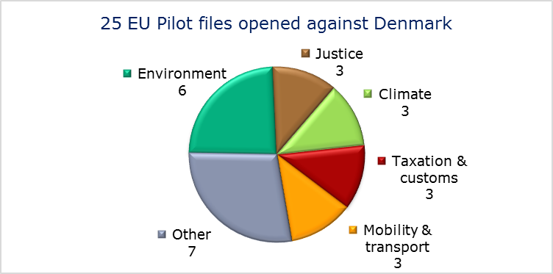
- EU Pilot files: average response time in days (2011-14)
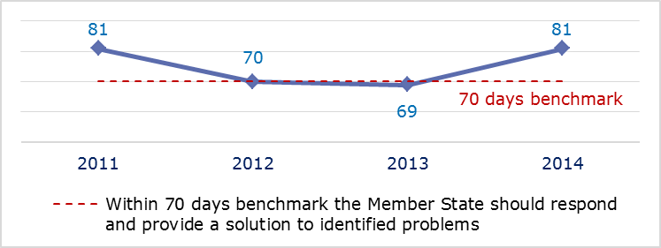
- EU Pilot files: evolution of the resolution rate by Denmark (2011-14)
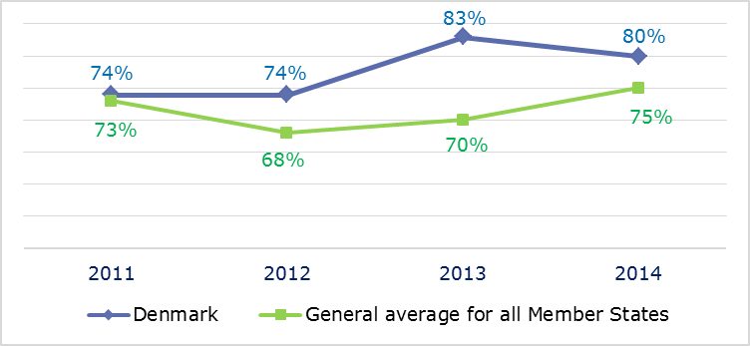
- INFRINGEMENT CASES
- Infringement cases against Denmark open on 31 December (2010-14)
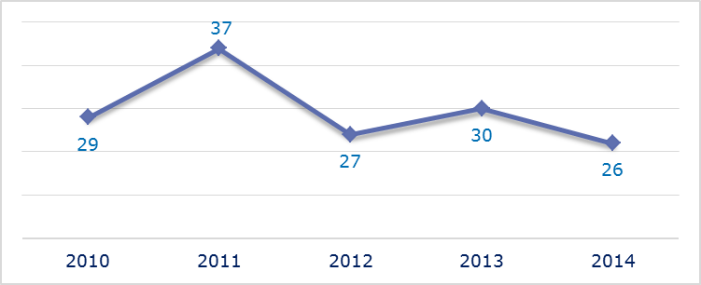
- New infringement cases opened in 2014: main policy areas
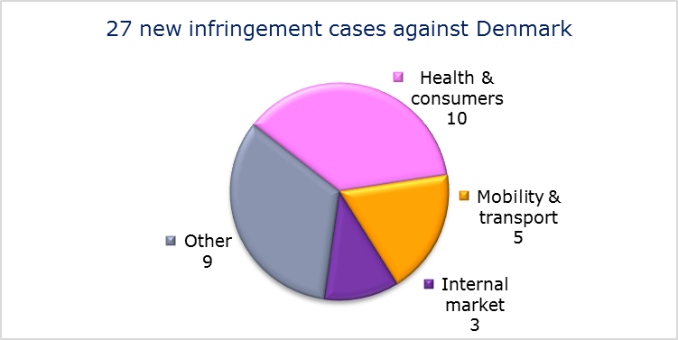
- Key infringement cases and referrals to the Court
- The Commission opened 27 new infringement cases against Denmark in 2014. These, and other major ongoing infringement cases, concern:
- nonconformity of the National Holiday Act with Article 7 of the Working Time Directive by imposing a one-year delay between the accrual and exercise of annual leave rights;
- difference of treatment between permanent staff and part-time staff employed in the municipal education sector. Various collective agreements exclude part-time staff from a number of benefits that full-time employees receive. The directive on part-time work requires the equal treatment of part-time staff and permanent staff doing similar work;
- nonconformity of the national transposition measures with the Marine Strategy Framework Directive;
- non-communication of national measures transposing the Capital Requirements Directive;
- restrictions on non-resident hauliers’ access to the Danish road transport market;
- incorrect application of the regulation on the rights of bus and coach passengers due to a lack of designated bus terminals for disabled passengers;
- nonconformity of the national transposition measures with the directive on railway safety;
- discriminatory taxation of foreign investment funds.
- The Commission referred two cases to the Court under Article 258 TFEU. They concern:
- Denmark’s lack of river basin management plans, which are required under the Water Framework Directive;
- Denmark’s failure to amend its national legislation to ban all forms of snus, an oral tobacco product sold both loose and in small sachets. All forms of snus are banned from sale in the EU, with the exception of Sweden.
- The Commission did not refer any cases to the Court under Article 260(2) TFEU.
- TRANSPOSITION OF DIRECTIVES
- New late transposition infringement cases against Denmark (2010-14)
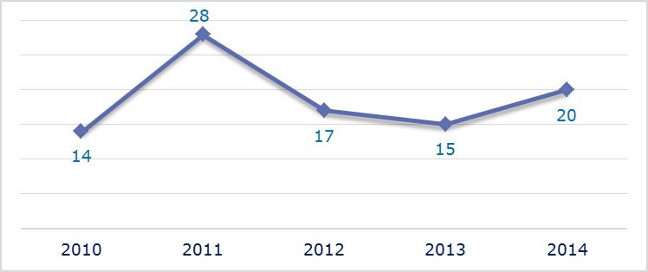
- New late transposition infringement cases opened in 2014: main policy areas
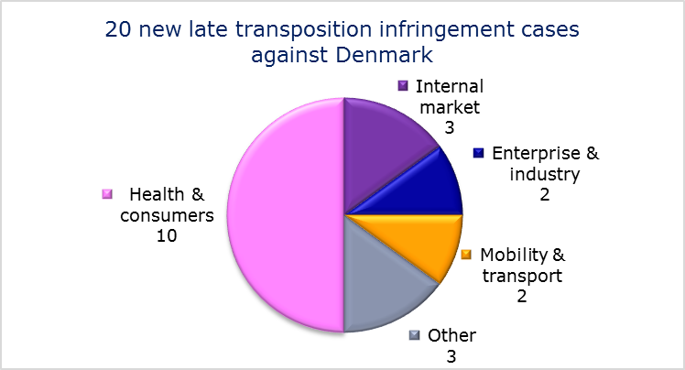
- Referrals to the Court
The Commission did not refer any cases to the Court under Articles 258 and 260(3) TFEU.
- EARLY RESOLUTION OF INFRINGEMENT CASES

Major cases closed without a Court judgment in 2014
These concerned:
- failure to comply with the Competition Directive by obliging property owners to become paying members of a particular local cable TV association;
- authorisations for mussel fishing in Natura 2000 sites;
- unjustified restrictions on non-resident hauliers transporting empty pallets and containers into and within Denmark;
- incorrect application of the directive laying down minimum standards for the protection of pigs, which requires that sows are kept in groups during a part of their pregnancy.
- IMPORTANT JUDGMENTS
- Court rulings
The Court ruled that:
- Denmark failed to comply with Water Framework Directive by failing to adopt and notify the river basin management plans the directive requires.
- Preliminary rulings
In preliminary rulings addressed to the Danish judiciary, the Court ruled that:
- at the reasonable request of competing operators aiming to access and use specific network elements and facilities, the Danish national regulatory authority may oblige an electronic communications operator with significant power in a given market to install specific cables provided that this obligation is based on the nature of the problem identified, is proportionate and is justified under the Framework Directive. The fulfilment of these criteria is for the national court to verify. The Court has also taken into account the initial investment of the operator concerned and the price control mechanism that allows the recovery of installation costs;
- the obesity of a worker can be a disability covered by the directive on employment equality if it hinders a person’s full and effective participation in personal and professional life on an equal basis with other workers.

ESTONIA

The number of new complaints made against Estonia has not varied greatly over the last four years, and new EU Pilot files opened against it have held relatively stable over the same period. The downward trend in the number of pending infringement cases continued in 2014. New infringement cases for late transposition also fell slightly.
- COMPLAINTS
- New complaints made against Estonia by members of the public (2011-14)
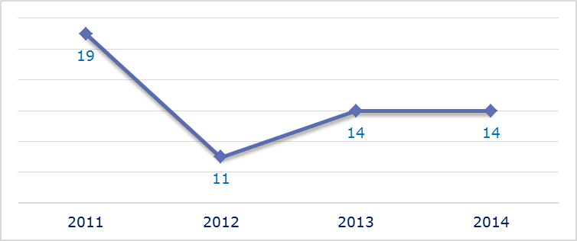
- Evolution of complaints against Estonia
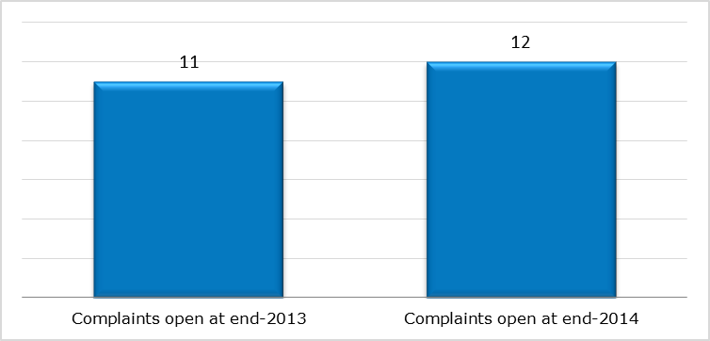
- New complaints registered in 2014: main policy areas
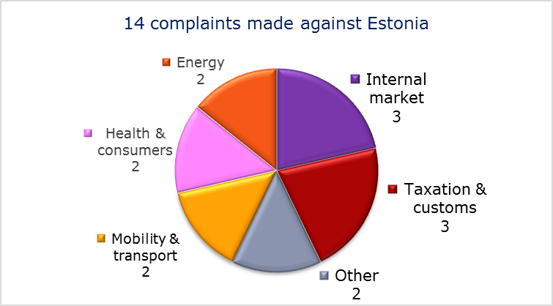
- EU PILOT
- New EU Pilot files opened against Estonia (2011-14)
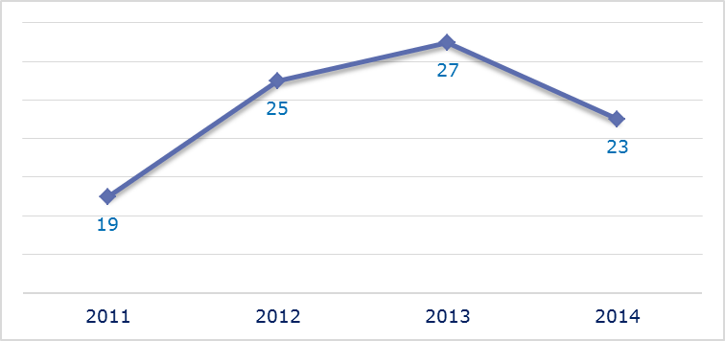
- Evolution of files relating to Estonia open in EU Pilot
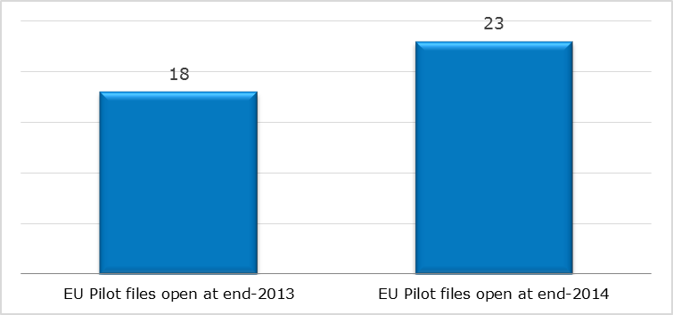
- New EU Pilot files opened in 2014: main policy areas
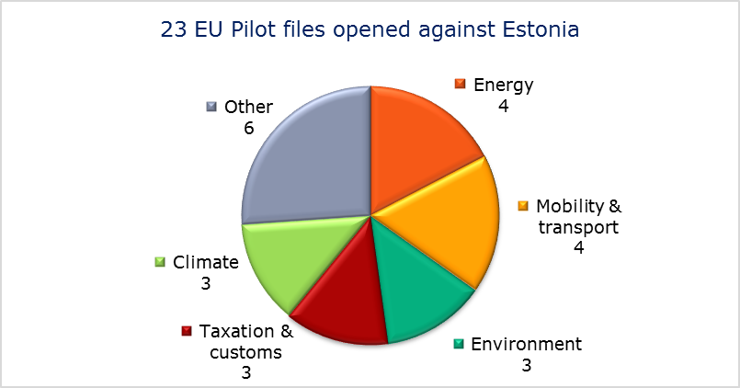
- EU Pilot files: average response time in days (2011-14)
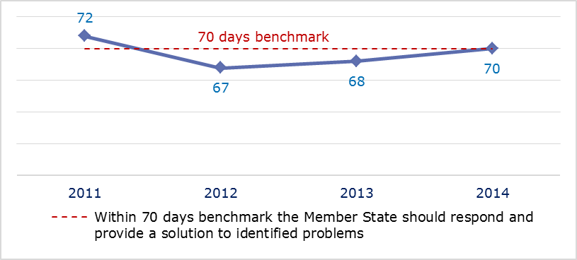
- EU Pilot files: evolution of the resolution rate by Estonia (2011-14)
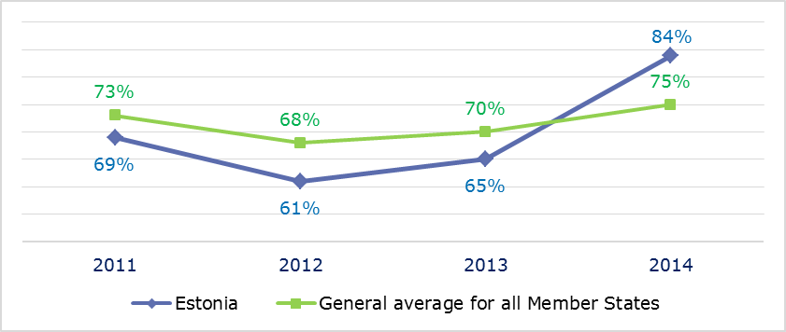
- INFRINGEMENT CASES
- Infringement cases against Estonia open on 31 December (2010-14)
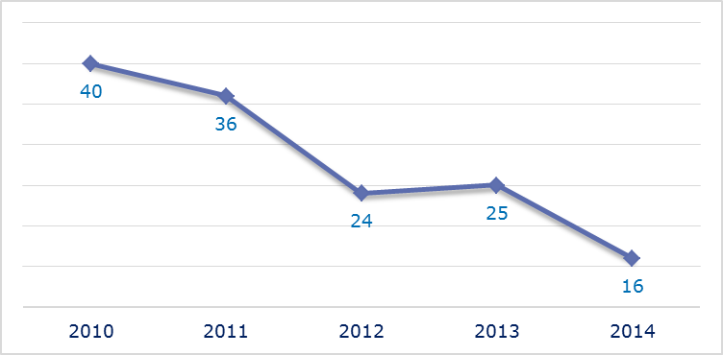
- New infringement cases opened in 2014: main policy areas
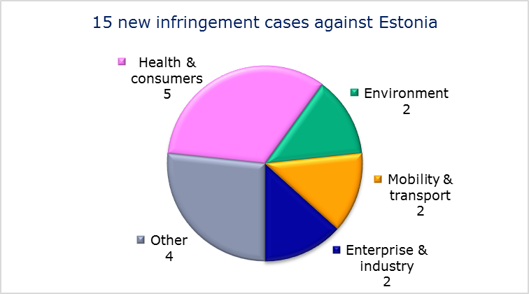
- Key infringement cases and referrals to the Court
- The Commission opened 15 new infringement cases against Estonia in 2014. These, and other major ongoing infringement cases, concern:
- obstacles to the parallel imports of pharmaceuticals;
- restrictions on the marketing of cigarettes. In Estonia, a time limit for the sale of cigarettes is linked to the fiscal stamp on the packaging. Three months after a new tax marking design enters into force, cigarettes bearing the old marking are no longer allowed to be sold;
- incomplete transposition of the Marine Strategy Framework Directive;
- lack of effective judicial remedy against the refusal, annulment or revocation of a visa, in breach of the provisions of the Visa Code;
- non-communication of national measures transposing the Capital Requirements Directive;
- failure to connect to and use the EU driving licence network (RESPER) under the directive on driving licences;
- incorrect transposition of the directive on railway safety;
- failure to notify full transposition of the Cross-border Healthcare Directive.
- The Commission referred one case to the Court under Article 258 TFEU. It concerns:
- incorrect transposition of the directive on public access to environmental information.
- The Commission did not refer any cases to the Court under Article 260(2) TFEU.
- TRANSPOSITION OF DIRECTIVES
- New late transposition infringement cases against Estonia (2010-14)
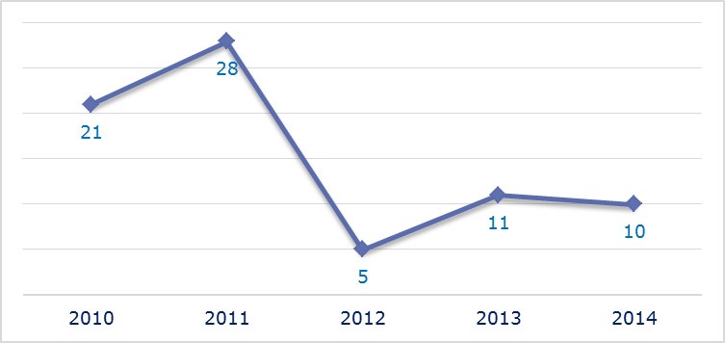
- New late transposition infringement cases opened in 2014: main policy areas
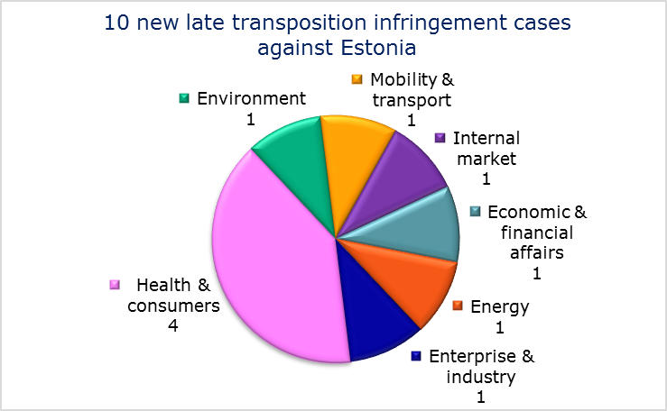
- Referrals to the Court
The Commission did not refer any cases to the Court under Articles 258 and 260(3) TFEU.
- EARLY RESOLUTION OF INFRINGEMENT CASES

Major cases closed without a Court judgment in 2014
These concerned:
- under national law, the Ministry of Economic Affairs and Communications carried out certain regulatory tasks, including managing radio frequency allocations and granting frequency authorisations. At the same time it controlled the largest TV and radio broadcast network operator in Estonia (the state-owned company Levira Ltd). These control tasks have been transferred to the Ministry of Finance, ensuring compliance with the Framework Directive for electronic communications networks and services;
- failure to fully transpose the Electricity and Gas Directives;
- discriminatory taxation of foreign investment funds regarding income from real estate. While resident funds are entitled to a tax exemption for their real estate income, comparable funds established in other EU Member States and EEA countries are subject to tax.
- IMPORTANT JUDGMENTS
- Court rulings
There were no major Court rulings in 2014.
- Preliminary rulings
In preliminary rulings addressed to the Estonian judiciary, the Court ruled that:
- a programme manual adopted by a monitoring committee in the context of an operational programme established by two Member States and intended to promote European territorial cooperation, cannot prevent a decision of the monitoring committee rejecting an application for aid from being subject to appeal before a court of a Member State, as this would constitute a breach of Regulation (EC) No 1083/2006, read in conjunction with Article 47 of the Charter of Fundamental Rights of the European Union.

The number of files open at the end of 2013 given in the 2013 annual report is different from the current figure. This is because some files were registered late and others have been closed.
Directive 2013/10/EU.
Directive 2005/29/EC.
Directive 93/13/EEC.
Directive 2013/36/EU, MEMO/14/589.
In breach of Council Directives 2003/9/EC, 2005/85/EC and Article 47 of the EU Charter of Fundamental Rights.
Directive 2011/98/EU.
Directive 2011/95/EU.
Directive 2011/92/EU.
Regulation (EC) No 550/2004.
IP/14/818.
Directive 2008/120/EC.
MEMO/14/36.
The Commission decided on 26 September 2013 to refer the case to the Court; the application was filed on 14 November 2014, Commission v Cyprus C-515/14, IP/13/869.
IP/14/156 and IP/13/259.
Directive 2010/75/EU.
Directive 2009/31/EC.
Directive 2011/36/EU.
Directive 2010/32/EU.
The number of files open at the end of 2013 given in the 2013 annual report is different from the current figure. This is because some files were registered late and others have been closed.
Directive 2008/98/EC.
Directive 2000/43/EC.
MEMO/14/589.
MEMO/14/293.
Directive 2004/38/EC.
Directive 2013/36/EU.
Regulation (EC) No 550/2004.
IP/14/818.
Directive 2011/24/EU and MEMO/14/537.
Commission v Czech Republic, C-525/14, IP/14/785.
Directive 2001/29/EC.
OSA, C-351/12 Court press release No 23/14.
Rynes, C-212/13 and Court press release No 175/14.
The number of files open at the end of 2013 given in the 2013 annual report is different from the current figure. This is because some files were registered late and others have been closed.
Directive 2003/88/EC.
Directive 97/81/EC and MEMO/13/583.
Directive 2008/56/EC.
Directive 2013/36/EU.
Regulation (EC) No 1072/2009.
Regulation (EU) No 181/2011.
MEMO/14/36.
MEMO/13/375.
Commission v Denmark,C-323/11 and C-190/14, IP/14/157.
Commission v Denmark,C-468/14, IP/14/812.
Directive 2002/77/EC.
Directive 2008/120/EC.
Commission v Denmark, C-190/14.
Directive 2002/21/EC.
TDC A/S v Teleklagenævnet, C-556/12.
Directive 2000/78/EC.
FOA, C-354/13.
The number of files open at the end of 2013 given in the 2013 annual report is different from the current figure. This is because some files were registered late and others have been closed.
MEMO/14/537.
Directive 2008/56/EC.
MEMO/14/589.
Directive 2013/36/EU.
Directive 2006/126/EC.
MEMO/14/537.
MEMO/14/470.
Directive 2003/4/EC, Commission v Estonia, C-206/14, IP/14/158. Estonia subsequently adopted the necessary legislative amendments and the Commission withdrew the Court application.
Directive 2002/21/EC.
Directives 2009/72/EC and 2009/73/EC.
IP/11/718.
Liivimaa Lihaveis MTÜ v Eesti-Läti programmi 2007-2013 Seirekomitee, C-562/12.

