Part II: Member States
Staff Working Document
2014 Annual Report

AUSTRIA 4
BELGIUM 10
BULGARIA 18
CROATIA 25
CYPRUS Error! Bookmark not defined.
CZECH REPUBLIC Error! Bookmark not defined.
DENMARK Error! Bookmark not defined.
ESTONIA Error! Bookmark not defined.
FINLAND Error! Bookmark not defined.
FRANCE Error! Bookmark not defined.
GERMANY Error! Bookmark not defined.
GREECE Error! Bookmark not defined.
HUNGARY Error! Bookmark not defined.
IRELAND Error! Bookmark not defined.
ITALY Error! Bookmark not defined.
LATVIA Error! Bookmark not defined.
LITHUANIA Error! Bookmark not defined.
LUXEMBOURG Error! Bookmark not defined.
MALTA Error! Bookmark not defined.
NETHERLANDS Error! Bookmark not defined.
POLAND Error! Bookmark not defined.
PORTUGAL Error! Bookmark not defined.
ROMANIA Error! Bookmark not defined.
SLOVAKIA Error! Bookmark not defined.
SLOVENIA Error! Bookmark not defined.
SPAIN Error! Bookmark not defined.
SWEDEN Error! Bookmark not defined.
UNITED KINGDOM Error! Bookmark not defined.

AUSTRIA

The number of new complaints made against Austria has steadily fallen since it peaked in 2012. New EU Pilot files opened against Austria have been on a downward trend since 2011, despite a peak in 2013. The number of open infringement cases has been relatively stable since 2011. New infringement cases for late transposition rose in 2014 but the number was still below the 2011 level.
- COMPLAINTS
- New complaints made against Austria by members of the public (2011-14)
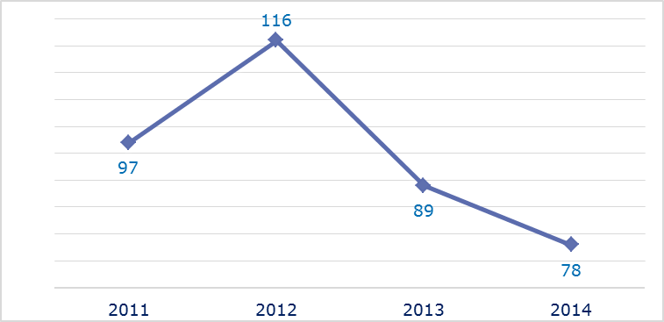
- Evolution of complaints against Austria
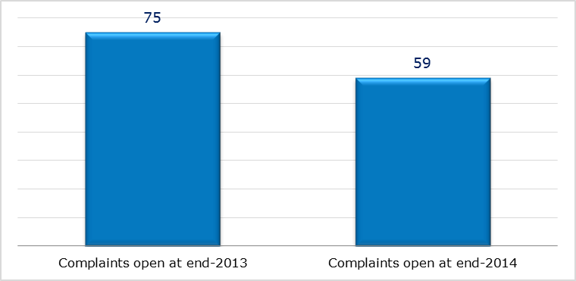
- New complaints registered in 2014: main policy areas
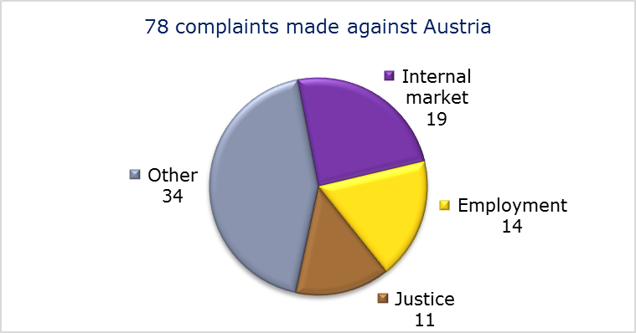
- EU PILOT
- New EU Pilot files opened against Austria (2011-14)
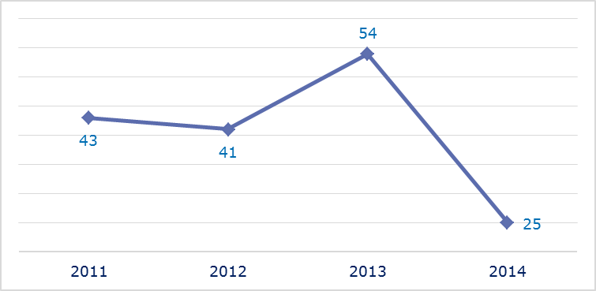
- Evolution of files relating to Austria open in EU Pilot
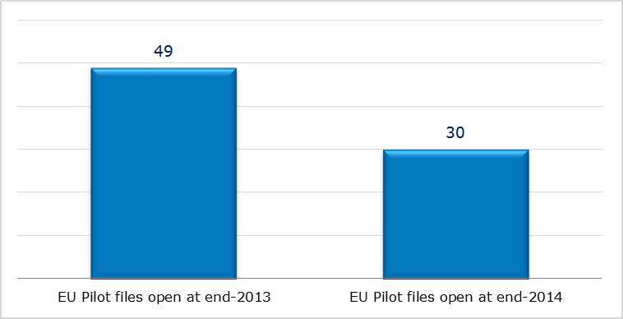
- New EU Pilot files opened in 2014: main policy areas
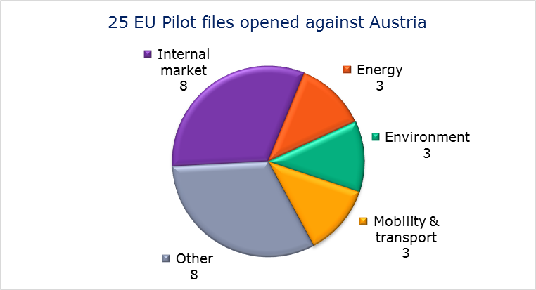
- EU Pilot files: average response time in days (2011-14)
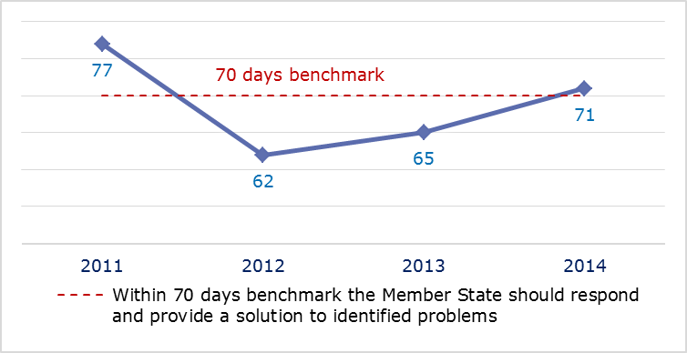
- EU Pilot files: evolution of the resolution rate by Austria (2011-14)
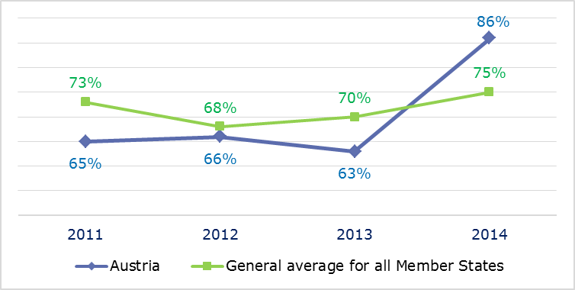
- INFRINGEMENT CASES
- Infringement cases against Austria open on 31 December (2010-14)
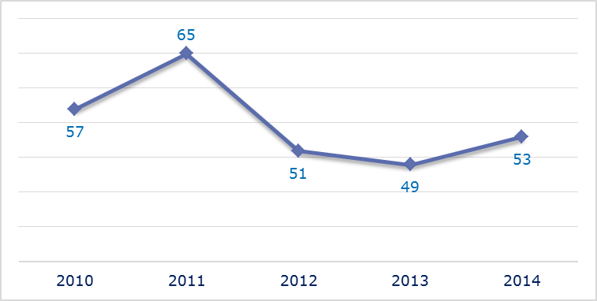
- New infringement cases opened in 2014: main policy areas
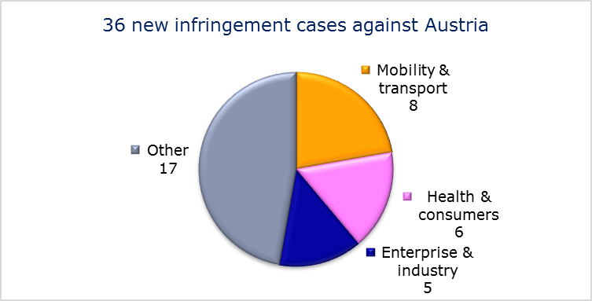
- Key infringement cases and referrals to the Court
- The Commission opened 36 new infringement cases against Austria in 2014. These, and other major ongoing infringement cases, concern:
- the incompatibility of Austrian legislation with EU law regarding questions related to who is responsible for the health and safety at work of school teachers in certain provinces;
- Austria’s reservation of 75 % of its study places for medical and dentistry studies for Austrian nationals;
- partial transposition of the Energy Performance of Buildings Directive;
- obstacles to distance sales of certain tobacco products within the EU;
- non-communication of measures transposing three directives in the automotive sector;
- non-compliance with the EU–Turkey association agreement (problems linked to the Austrian establishment and residence law and its compliance with the rights of Turkish nationals and their families under the EU–Turkey association law and its standstill clauses);
- non-transposition of the directive on free movement of EU nationals and their family members;
- obstacles to the free provision of services of ski instructors in Austria;
- non-communication of measures transposing the Capital Requirements Directive;
- failure to efficiently implement functional airspace blocks. Under the Single European Sky legislation, national air traffic control organisations should work together in regional airspace blocks to gain efficiency, cut costs and reduce emissions. The set-up of these common airspace blocks is arranged around traffic flows rather than state boundaries, which leads to performance improvements;
- incorrect application of the regulation on the rights of bus and coach passengers;
- toll rates at Felbertauern crossing (non-discrimination);
- separation of rail accounts;
- failure to notify full implementation of the Cross-border Healthcare Directive.
- The Commission referred two cases to the Court under Article 258 TFEU. They concern:
- a proposed hydro power plant which would cause serious deterioration in the quality of the Schwarze Sulm river in Styria;
- failure to bring national rules into line with Directive 2004/49/EC on rail safety.
- The Commission did not refer any cases to the Court under Article 260(2) TFEU.
- TRANSPOSITION OF DIRECTIVES
- New late transposition infringement cases against Austria (2010-14)
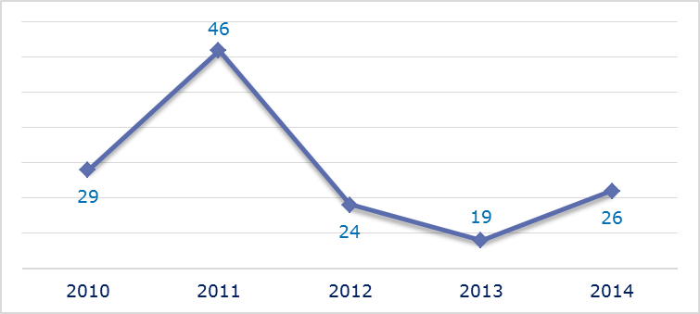
- New late transposition infringement cases opened in 2014: main policy areas
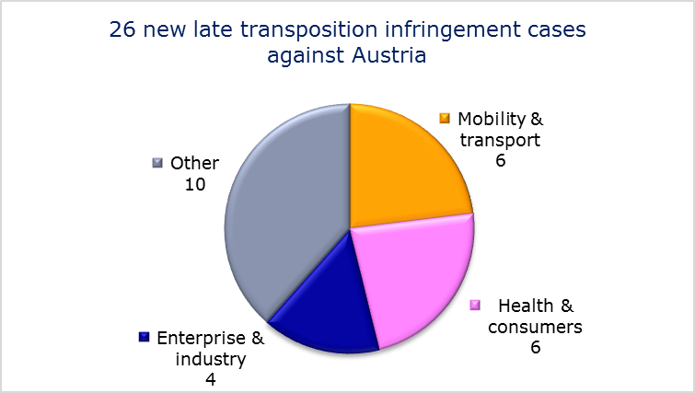
- Referrals to the Court
The Commission did not refer any cases to the Court under Articles 258 and 260(3) TFEU.
- EARLY RESOLUTION OF INFRINGEMENT CASES

Major cases closed without a Court judgment in 2014
These concerned:
- incomplete transposition of the Strategic Environmental Assessment Directive;
- taxation of charities.
- IMPORTANT JUDGMENTS
- Court rulings
There were no major Court rulings in 2014.
- Preliminary rulings
In preliminary rulings addressed to the Austrian judiciary, the Court ruled that:
- Member States may impose the requirement that both the applicant and the spouse have reached the age of 21 by the time of their application for a residence permit for the purpose of family reunification, a measure to prevent forced marriages;
- the demographic criteria applied in Austria for determining whether a need to establish a new pharmacy exists are contrary to the freedom of establishment.

BELGIUM

The number of new complaints made against Belgium increased considerably in 2014. After peaking in 2013, new EU Pilot files opened against Belgium fell slightly. Total pending infringement cases increased for the first time since 2010. New infringement cases involving late transposition significantly increased in 2014 for the first time since 2011.
- COMPLAINTS
- New complaints made against Belgium by members of the public (2011-14)
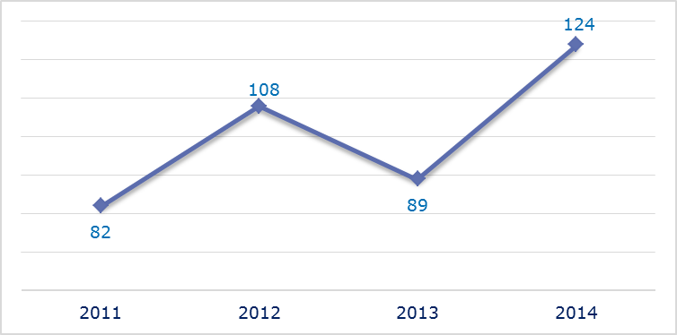
- Evolution of complaints against Belgium
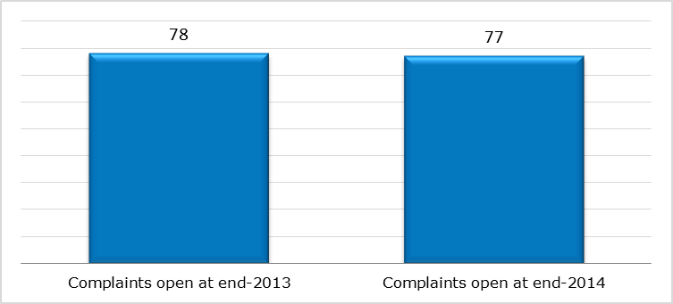
- New complaints registered in 2014: main policy areas
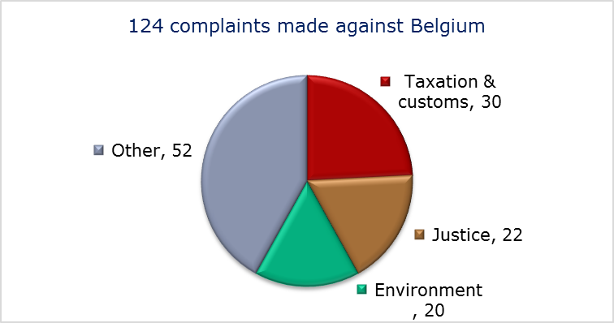
- EU PILOT
- New EU Pilot files opened against Belgium (2011-14)
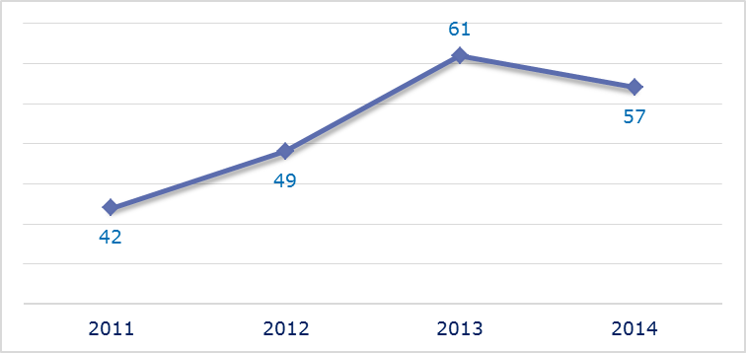
- Evolution of files relating to Belgium open in EU Pilot
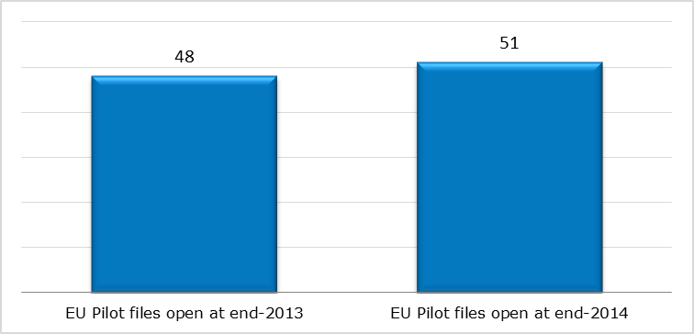
- New EU Pilot files opened in 2014: main policy areas
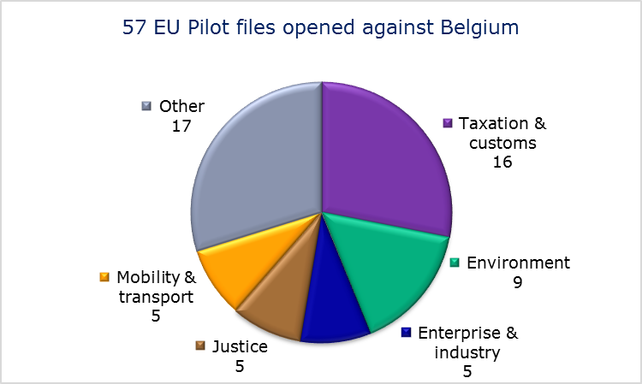
- EU Pilot files: average response time in days (2011-14)
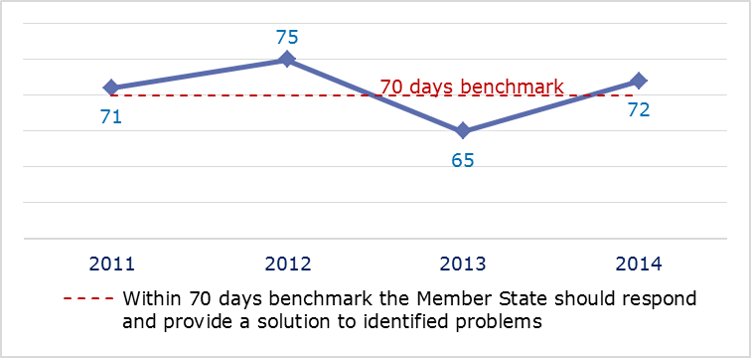
- EU Pilot files: evolution of the resolution rate by Belgium (2011-14)
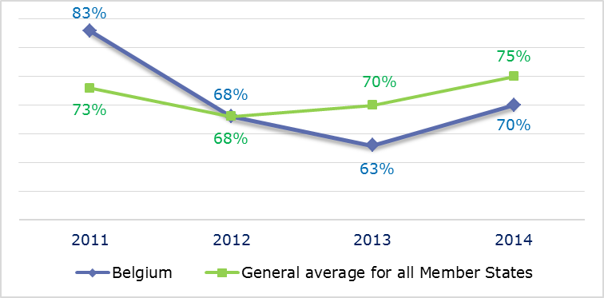
- INFRINGEMENT CASES
- Infringement cases against Belgium open on 31 December (2010-14)
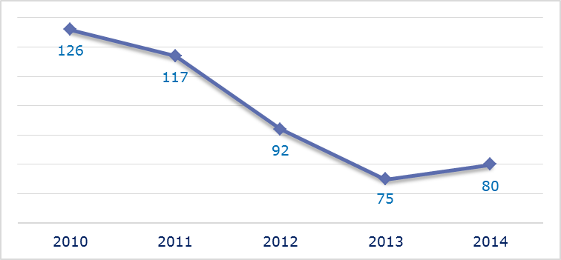
- New infringement cases opened in 2014: main policy areas
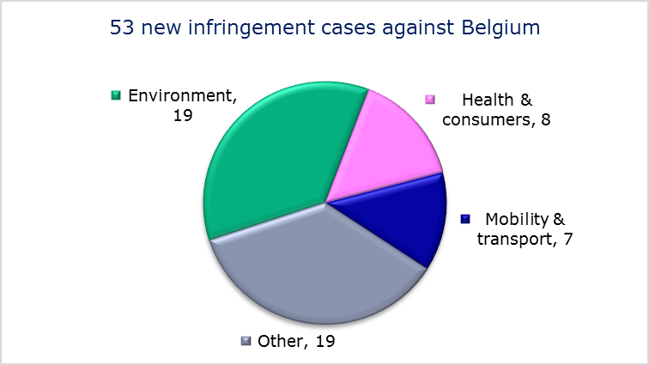
- Key infringement cases and referrals to the Court
- The Commission opened 53 new infringement cases against Belgium in 2014. These, and other major ongoing infringement cases, concern:
- limited access for non-Belgian residents to certain higher education courses in medicine; the procedure has been suspended until the end of 2016 to allow Belgium to prove that the restrictive measures are necessary and proportionate to protect the Belgian healthcare system;
- incorrect application of the regulations on the coordination of social security systems; these allow the Belgian authorities to subject someone to Belgian social security legislation even if he or she has a certificate issued by an institution of another Member State attesting that the legislation of the latter applies to that person;
- incorrect transposition of the Electricity and Gas Directives;
- failure to provide strict protection for the harbour porpoise as required under the Habitats Directive;
- non-respect of EU air quality standards (PM₁₀ limit values) in several zones and agglomerations;
- the issue of visas and residence cards for non-EU family members of EU nationals and safeguards against the expulsion of EU nationals;
- restrictions on the principle of freedom of establishment as regards organisation of port labour;
- failure to efficiently implement functional airspace blocks. Under the Single European Sky legislation, national air traffic control organisations should work together in regional airspace blocks to gain efficiency, cut costs and reduce emissions. The set-up of these common airspace blocks is arranged around traffic flows rather than state boundaries, which leads to performance improvements;
- failure to connect to RESPER, the EU driving licence network;
- incorrect implementation of the directive laying down minimum standards for the protection of pigs, which requires that sows are kept in groups during part of their pregnancy;
- six requests by the national authorities to waive the collection of traditional own resources; the Commission is concerned that the authorities have not demonstrated that the entitlements were irrecoverable for reasons not attributable to them;
- collection of interest due on the late payment of own resources in a procedure where the requested securities turned out to be insufficient to cover a customs debt;
- late transposition of the Capital Requirements Directive, the Cross-border Healthcare Directive.
- The Commission referred three cases to the Court under Article 258 TFEU. They concern:
- the requirement under Belgian legislation to prove language knowledge exclusively through a certificate issued by the Belgian authorities for posts in the local administrations of the French-, Flemish- and German-speaking regions; discriminatory treatment of foreign undertakings for collective investment in transferable securities. They have to pay a higher yearly tax rate (0.8 %) than Belgian undertakings (0.01 %);
- refusal to apply tax exemptions for electricity and gas consumption granted to European Union institutions, in breach of the Union’s Protocol on Privileges and Immunities.
- The Commission did not refer any cases to the Court under Article 260(2) TFEU.
- TRANSPOSITION OF DIRECTIVES
- New late transposition infringement cases against Belgium (2010-14)
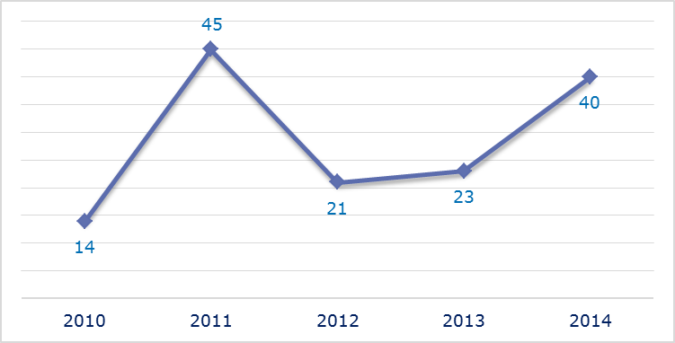
- New late transposition infringement cases opened in 2014: main policy areas
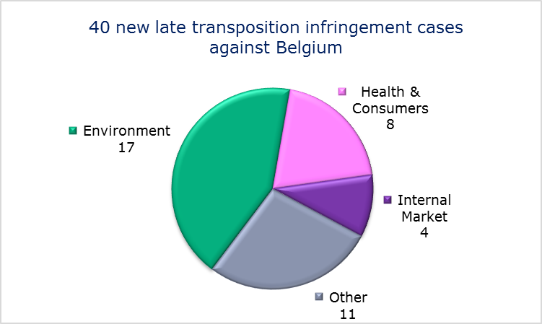
- Referrals to the Court
The Commission referred one case to the Court under Articles 258 and 260(3) TFEU. It concerns:
- failure to fully transpose the Energy Performance of Buildings Directive. The Commission proposed a daily penalty of 42 178.50 EUR.
- EARLY RESOLUTION OF INFRINGEMENT CASES

Major cases closed without a Court judgment in 2014
These concerned:
- incompatibility of the working time of professional fire-fighters with the Working Time Directive;
- non-communication of national measures transposing the Late Payment Directive;
- failure to fully transpose the directive improving and extending the EU greenhouse gas emission allowance trading scheme;
- incorrect application of the directive on the development of EU railways by not keeping separate business accounts for provision of transport services and management of railway infrastructure;
- incorrect application of the regulation concerning the rights of bus and coach passengers by not designating the enforcement body in the Brussels-Capital Region and by not setting up a penalty system for infringements of the regulation;
- non-ratification by Belgium of the Euro-Mediterranean Aviation Agreement with Morocco;
- discriminatory inheritance tax provisions in Walloon law which discourage Belgian residents from investing in foreign shares because their inheritance might be more heavily taxed;
- customs fees and opening hours of customs offices.
- IMPORTANT JUDGMENTS
- Court rulings
The Court ruled that:
- Belgium infringed EU law by excluding members of a profession (dentists and physiotherapists) from the scope of the law which transposes the Unfair Commercial Practices Directive, by imposing restrictive rules on the announcement of price reductions, and; by banning door-to-door sales for products above EUR 250;
- Belgium failed to ensure adequate collection and treatment of urban wastewater.
- Preliminary rulings
In preliminary rulings addressed to the Belgian judiciary, the Court ruled that:
- Member States can impose a general tax on operators providing electronic communications networks or services on account of the presence on public and private property of cellular telephone communication masts, pylons or antennae which are necessary for their activity;
- Member States are not allowed to apply tax rules that provide for a different evaluation of methods of assessing the income from immovable property, if this results in higher taxation only because the comparable foreign income is evaluated at a higher value.
- under EU asylum law, the interpretation to be given to the concept of ‘internal armed conflict’ must be independent of the definition used in international humanitarian law. An internal armed conflict exists where a State’s armed forces confront one or more armed groups or where two or more armed groups confront each other, regardless of the intensity of the confrontations, the level of organisation of the armed forces involved or the duration of the conflict;
- protection for medical reasons is a form of humanitarian protection granted on a discretionary basis by Member States, and as such is excluded from the scope of the EU asylum acquis. Therefore, the rights and benefits available to beneficiaries of such a form of protection are to be decided exclusively under national legislation;
- Member States are obliged to cover the basic subsistence needs of non-EU nationals who are irregularly staying on their territory only in so far as this is necessary to ensure that emergency health care and essential treatment of illness are made available during the period in which their return cannot be carried out. For an appeal to be effective against a return decision whose enforcement may expose the non-EU national concerned to a serious risk of grave and irreversible deterioration in their state of health, that person must be able to avail himself, in such circumstances, of a remedy with suspensive effect.

BULGARIA

The number of new complaints made against Bulgaria has remained stable in recent years. After a peak in 2012, new EU Pilot files opened against Bulgaria fell in 2013 and remained at the same level in 2014. The overall number of pending infringement cases has not fluctuated much over the last five years. New infringement cases for late transposition increased significantly in 2014, taking the total to its highest level of the past five years.
- COMPLAINTS
- New complaints made against Bulgaria by members of the public (2011-14)
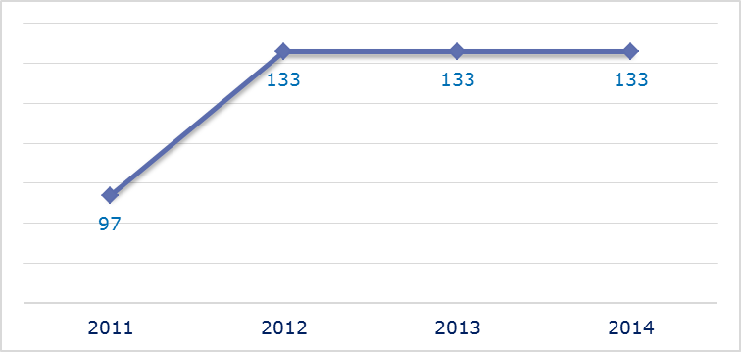
- Evolution of complaints against Bulgaria
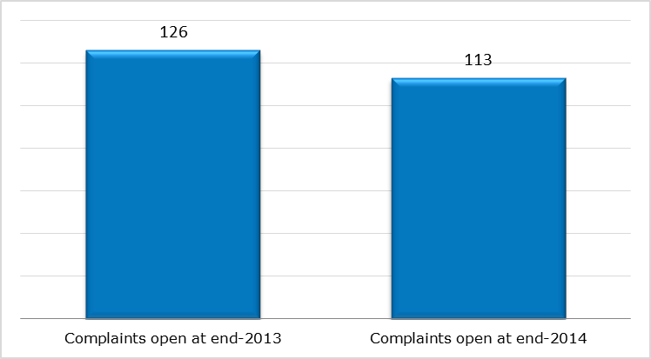
- New complaints registered in 2014: main policy areas
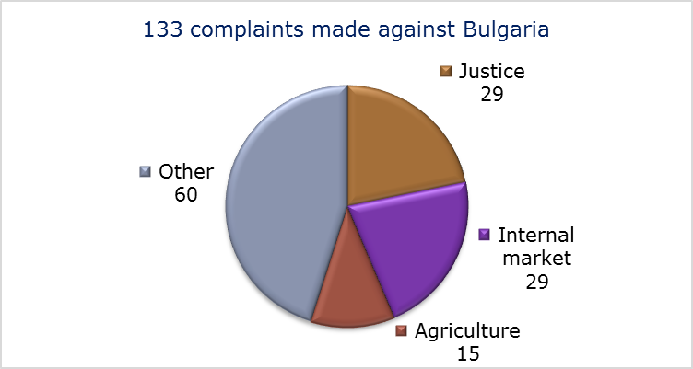
- EU PILOT
- New EU Pilot files opened against Bulgaria (2011-14)
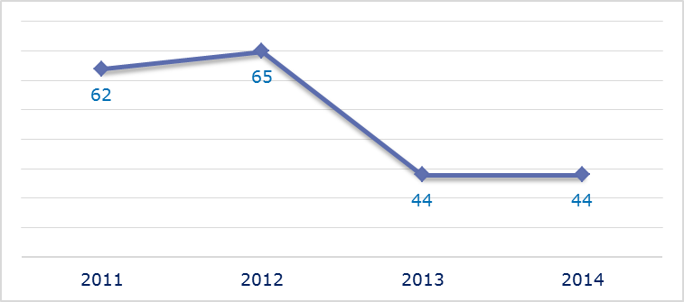
- Evolution of files relating to Bulgaria open in EU Pilot
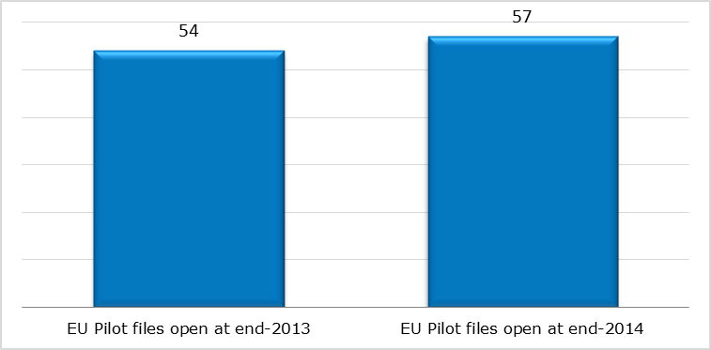
- New EU Pilot files opened in 2014: main policy areas
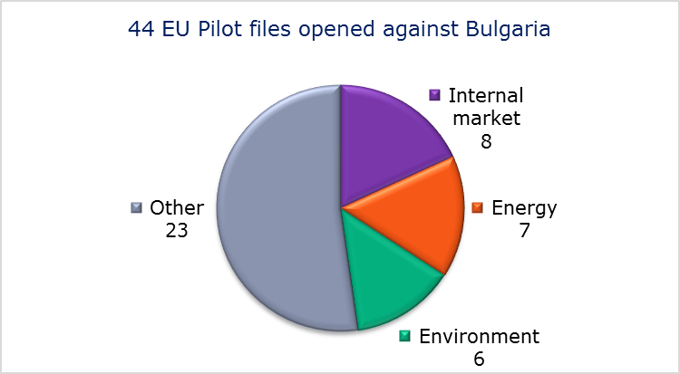
- EU Pilot files: average response time in days (2011-14)
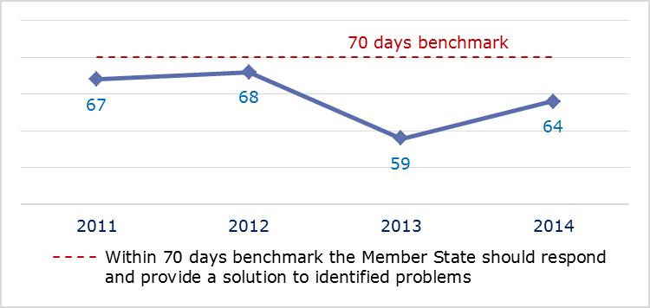
- EU Pilot files: evolution of the resolution rate by Bulgaria (2011-14)
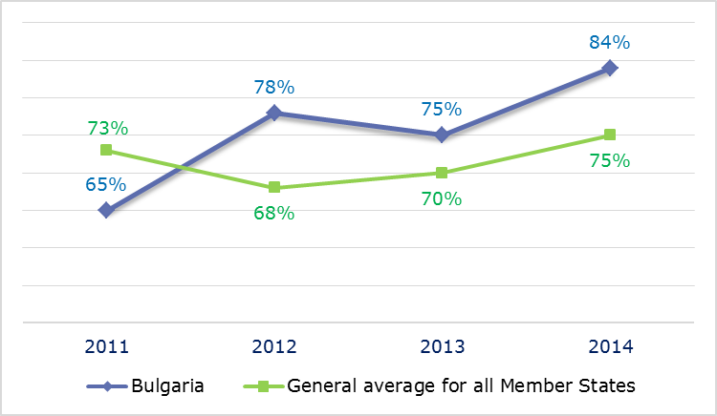
- INFRINGEMENT CASES
- Infringement cases against Bulgaria open on 31 December (2010-14)
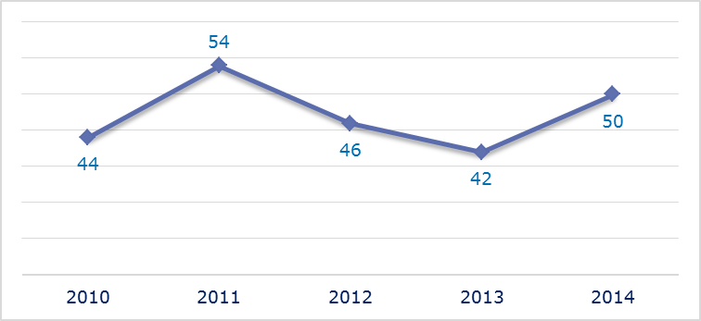
- New infringement cases opened in 2014: main policy areas
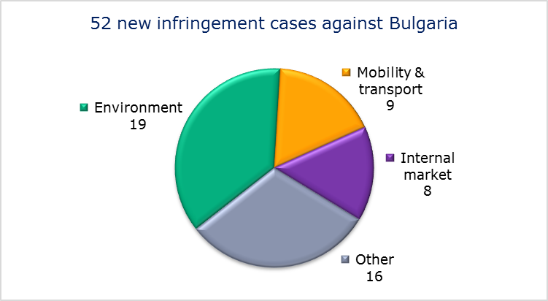
- Key infringement cases and referrals to the Court
- The Commission opened 52 new infringement cases against Bulgaria in 2014. These, and other major ongoing infringement cases, concern:
- incompatibility of the working conditions of Ministry of the Interior staff with the Working Time Directive;
- obstacles to the production and sale of cigarette tubes with filters;
- non-respect of EU air quality standards (PM₁₀ limit values) in all air quality zones;
- non-respect of EU air quality standards (sulphur dioxide limit values) in one zone;
- incorrect transposition of the directive on deposit-guarantee schemes and disproportionate restriction of the free movement of capital. Two banks have been put into receivership with a complete suspension of payments and bank activities and depositors have not had access to their funds for three months;
- non-communication of measures transposing the Capital Requirements Directive;
- failure to efficiently implement functional airspace blocks. Under the Single European Sky legislation, national air traffic control organisations should work together in regional airspace blocks to gain efficiency, cut costs and reduce emissions. The set-up of these common airspace blocks is arranged around traffic flows rather than state boundaries, which leads to performance improvements;
- failure to connect to the EU driving licence network (RESPER);
- failure to notify full transposition of the Cross-border Healthcare Directive.
- The Commission referred two cases to the Court under Article 258 TFEU. They concern:
- breach of the Landfill Directive by continuing to operate numerous non-compliant landfill sites;
- failure to protect unique habitats and endangered species.
- The Commission did not refer any cases to the Court under Article 260(2) TFEU.
- TRANSPOSITION OF DIRECTIVES
- New late transposition infringement cases against Bulgaria (2010-14)
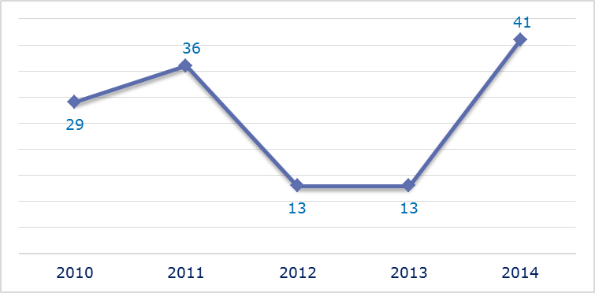
- New late transposition infringement cases opened in 2014: main policy areas
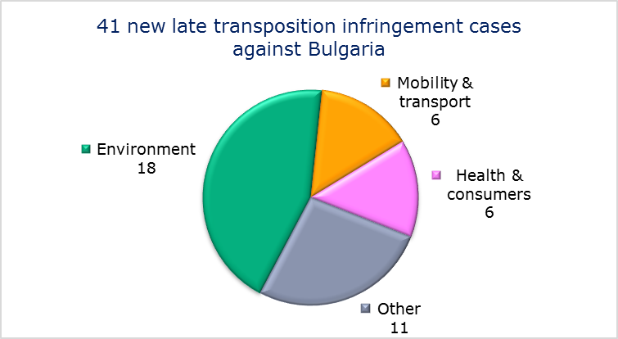
- Referrals to the Court
The Commission did not refer any cases to the Court under Articles 258 and 260(3) TFEU.
- EARLY RESOLUTION OF INFRINGEMENT CASES

Major cases closed without a Court judgment in 2014
These concerned:
- failure to fully transpose the directive improving and extending the EU greenhouse gas emission allowance trading scheme;
- illegal construction of ski resorts in the Rila Mountain;
- non-communication of national measures transposing the Industrial Emissions Directive and Laboratory Animals Directive;
- right to deduct and refund of VAT.
- IMPORTANT JUDGMENTS
- Court rulings
The Court ruled that:
- Bulgaria failed to comply with the provisions of the First Railway Package. It included staff remuneration and social security contributions in the calculation of charges incurred for all of the minimum services and for access by the network to service infrastructure costs. However, staff remuneration and social security contributions cannot be considered to be directly incurred as a result of operating the train service.
- Preliminary rulings
In preliminary rulings addressed to the Bulgarian judiciary, the Court ruled that:
- the Return Directive for illegally staying non-EU nationals:
- precludes, among other things, national measures that allow the extension of an initial six-month period of detention solely because the non-EU national concerned has no identity documents; instead, the referring court should carry out an evaluation of all the facts and circumstances on a case-by-case basis;
- does not consider per se a non-EU national as showing ‘lack of cooperation’, if he failed to obtain an identity document making it possible for him to be removed from the Member State concerned;
- does not require a Member State to issue an autonomous residence permit (or a similar document) to a non-EU national without identity documents; however, if a national court releases such a person concerned because there is no longer a reasonable prospect of his removal, the Member State must confirm the situation of this person in writing.

CROATIA

The number of new complaints made against Croatia increased significantly in 2014 from 2013, when Croatia joined the EU half way through the year. New EU Pilot files opened evolved in a similar manner. Ten infringement cases against Croatia were open on 31 December 2014. During the year the Commission launched 13 infringement cases against Croatia for late transposition.
- COMPLAINTS
- New complaints made against Croatia by members of the public (2013-14)
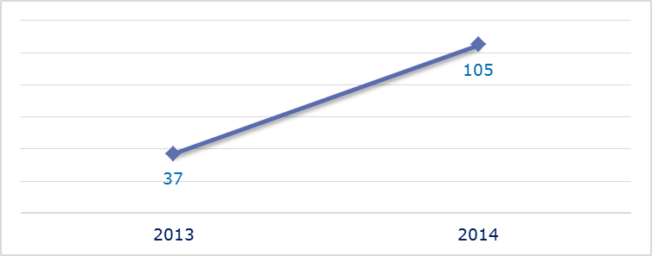
- Evolution of complaints against Croatia
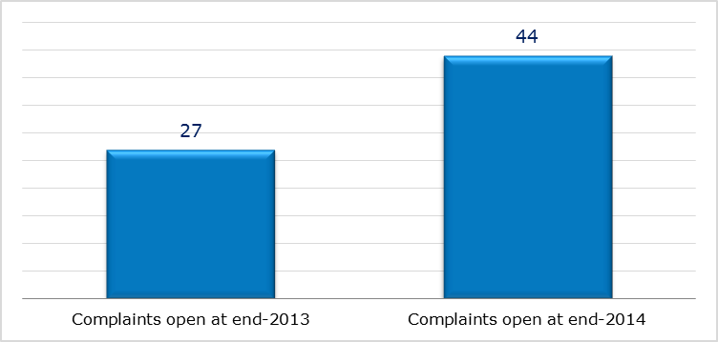
- New complaints registered in 2014: main policy areas
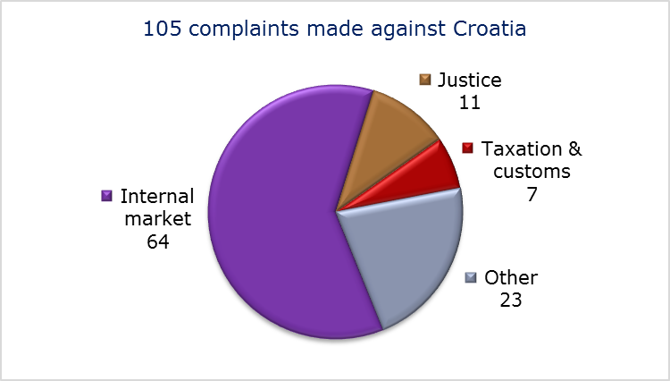
- EU PILOT
- New EU Pilot files opened against Croatia (2013-14)
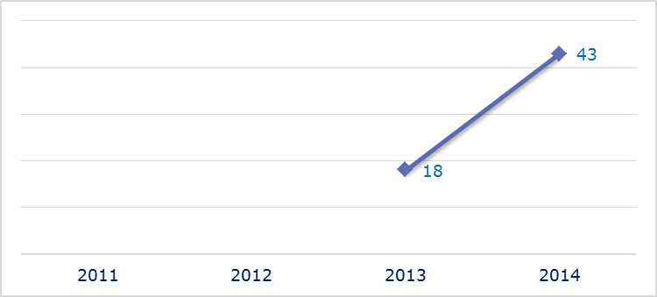
- Evolution of files relating to Croatia open in EU Pilot
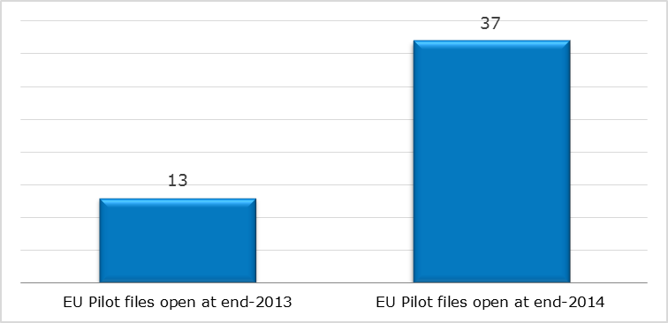
- New EU Pilot files opened in 2014: main policy areas
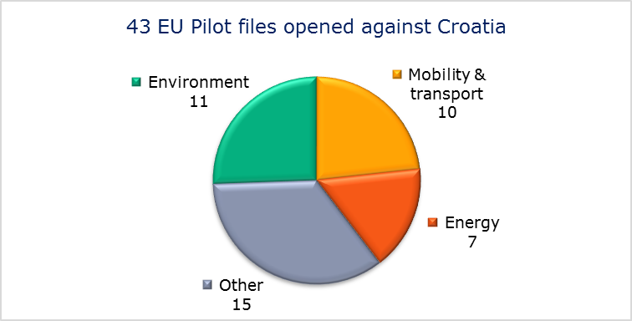
- EU Pilot files: average response time in days (2011-14)
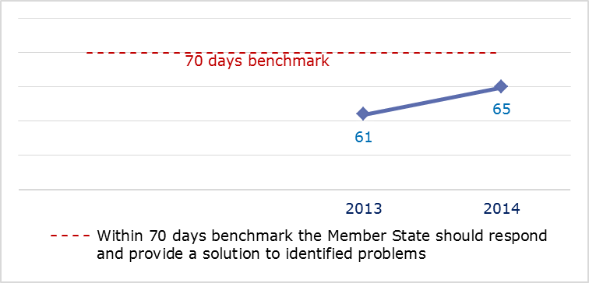
- EU Pilot files: evolution of the resolution rate by Croatia (2011-14)
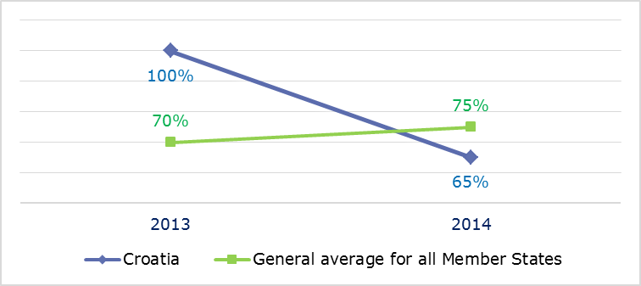
- INFRINGEMENT CASES
- Infringement cases against Croatia open on 31 December (2010-14)
There were 10 infringement cases open against Croatia on 31 December 2014.
- New infringement cases opened in 2014: main policy areas
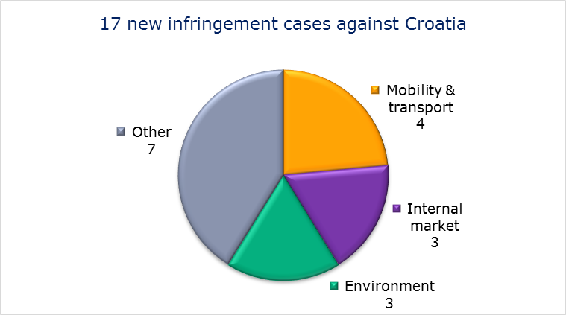
- Key infringement cases and referrals to the Court
- The Commission opened 17 new infringement cases against Croatia in 2014. These, and other major ongoing infringement cases, concern:
- the law on the privatisation of the Industrija Nafte d.d. (INA) energy company. This law grants the Croatian State significant special powers over INA that seem to be unjustified restrictions on the free movement of capital;
- non-communication of measures transposing the Capital Requirements Directive;
- failure to efficiently implement functional airspace blocks. Under the Single European Sky legislation, national air traffic control organisations should work together in regional airspace blocks to gain efficiency, cut costs and reduce emissions. The set-up of these common airspace blocks is arranged around traffic flows rather than state boundaries, which leads to performance improvements;
- the discriminatory legal regime governing port charges in Croatia.
- The Commission did not refer any cases to the Court under Article 258 TFEU.
- The Commission did not refer any cases to the Court under Article 260(2) TFEU.
- TRANSPOSITION OF DIRECTIVES
- New late transposition infringement cases against Croatia (2010-14)
There were 13 late transposition infringement cases open against Croatia on 31 December 2014.
- New late transposition infringement cases opened in 2014: main policy areas
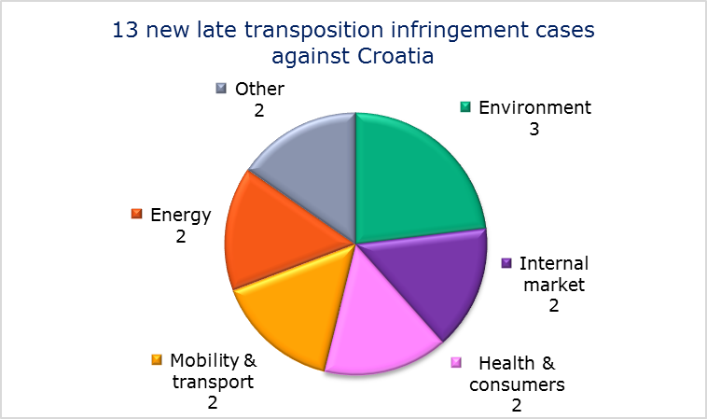
- Referrals to the Court
The Commission did not refer any cases to the Court under Articles 258 and 260(3) TFEU.
- EARLY RESOLUTION OF INFRINGEMENT CASES

Major cases closed without a Court judgment in 2014
The case concerned:
- non-communication of measures transposing the Directive on Waste Electrical and Electronic Equipment.
- IMPORTANT JUDGMENTS
- Court rulings
There were no major Court rulings in 2014.
- Preliminary rulings
No major preliminary rulings were addressed to the Croatian judiciary in 2014.

The number of files open at the end of 2013 given in the 2013 annual report is different from the current figure. This is because some files were registered late and others have been closed.
Directive 89/391/EEC.
The infringement procedures have been suspended until the end of 2016 to allow Austria to provide evidence on whether the restrictive measures are necessary and proportionate to protect the Austrian health system. See IP-12-1388.
Directive 2010/31/EU.
Directives 2012/46/EU, 2013/8/EU and 2013/60/EU.
MEMO/14/589.
Directive 2004/38.
Directive 2013/36/EU.
Regulation (EC) No 550/2004.
IP/14/818.
Regulation (EU) No 181/2011, MEMO/14/241.
MEMO/14/537.
IP-14-2132.
Directive 2011/24/EU, MEMO/14/470.
Commission v Austria, C-346/14, IP/14/448.
Commission v Austria, C-244/14, IP/14/323.
Directive 2001/42/EC.
MEMO/12/708.
Noorzia, C-338/13 and Court press release No 108/14.
Sokoll-Seebacher, C-367/12 and Court press release No 19/14.
The number of files open at the end of 2013 given in the 2013 annual report is different from the current figure. This is because some files were registered late and others have been closed.
IP/12/1388.
Regulation (EC) No 883/2004 and Regulation (EC) No 987/2009.
Directives 2009/72/EC and 2009/73/EC.
Council Directive 92/43/EEC.
PM₁₀ is an air pollutant consisting of small particles with an aerodynamic diameter less than or equal to a nominal 10 micrometers. The particles’ small size allows them to penetrate deep into the lungs where they may be deposited and cause adverse health effects. (Source: European Environment Agency).
MEMO/14/470.
MEMO/13/122.
Regulation (EC) No 550/2004.
IP/14/446.
Directive 2006/126/EC.
Directive 2008/120/EC.
IP/13/135.
Directives 2013/36/EU, 2011/24/EU and 2010/31/EU.
The Commission decided on 26 September 2013 to refer the case to the Court; the application was filed on 2 July 2014, Commission v Belgium C-317/14.
Commission v Belgium C-130/14, IP/14/1144.
The Commission decided on 17 October 2013 to refer the case to the Court; the application was filed on 4 April 2014, Commission v Belgium C-163/14.
Directive 2010/31/EU. Commission v Belgium, C-302/14, IP/14/447.
Directive 2003/88/EC.
Directive 2011/7/EU.
Directive 2009/29/EC.
Directive 91/440/EC.
Regulation (EU) No 181/2011.
IP/13/871.
Directive 2005/29/EC.
Commission v Belgium, C-421/12.
Directive 91/271/EEC, Commission v Belgium, C-395/13.
Belgacom and Mobistar, joined cases C-256/13 and C-264/13.
Verest and Gerards, C-489/13.
Council Directive 2004/83/EC.
Diakite, C-285/12 and Court press release No 12/14.
Directive 2004/83/EC in the meantime repealed by Directive 2011/95.
Mbod’j, C-542/13.
Abdida, C-562/13.
The number of files open at the end of 2013 given in the 2013 annual report is different from the current figure. This is because some files were registered late and others have been closed.
Directive 2003/88/EC.
PM₁₀ is an air pollutant consisting of small particles with an aerodynamic diameter less than or equal to a nominal 10 micrometers. The particles’ small size allows them to penetrate deep into the lungs where they may be deposited and cause adverse health effects. (Source: European Environment Agency).
MEMO/14/470.
MEMO/14/2130.
Directive 94/19/EC.
IP/14/1041.
Directive 2013/36/EU.
Regulation (EC) No 550/2004.
IP/14/818.
Directive 2006/126/EC.
Directive 2011/24/EU, MEMO/14/470.
Directive 1999/31/EC, Commission v Bulgaria, C-145/14, IP/14/47.
The Commission decided on 17 October 2013 to refer the case to the Court; the application was filed on 24 March 2014, C-141/14, IP/13/966.
Directive 2009/29/EC.
Directives 2010/75/EU and 2010/63/EU.
Directive 2001/14/EC.
Commission v Bulgaria, C-152/12.
Directive 2008/115/EC.
Mahdi, C-146/14 PPU and Court press release No 80/14.
Croatia joined the EU on 1 July 2013.
Croatia joined the EU Pilot system in July 2013.
The number of files open at the end of 2013 given in the 2013 annual report is different from the current figure. This is because some files were registered late and others have been closed.
Croatia joined the EU Pilot system in July 2013.
Croatia joined the EU Pilot system in July 2013.
Directive 2013/36/EU.
Regulation (EC) No 550/2004.
IP/14/818.
Directive 2012/19/EU.

