HUNGARY

The number of new complaints made against Hungary rose slightly in 2014 after two years of decline. New EU Pilot files opened against Hungary fell for the second year running from their 2012 peak. The overall number of pending infringement cases has fluctuated to some extent over the last five years. New infringement cases for late transposition rose back to their 2012 level but were still considerably lower than in 2010 and 2011.
- COMPLAINTS
- New complaints made against Hungary by members of the public (2011-14)
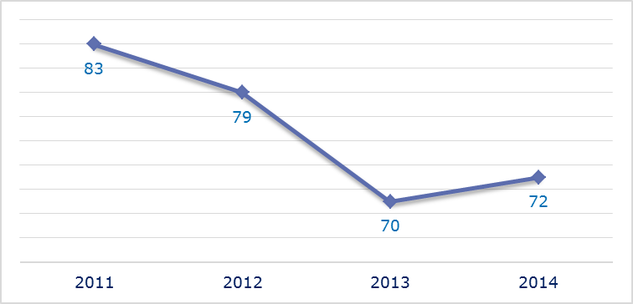
- Evolution of complaints against Hungary
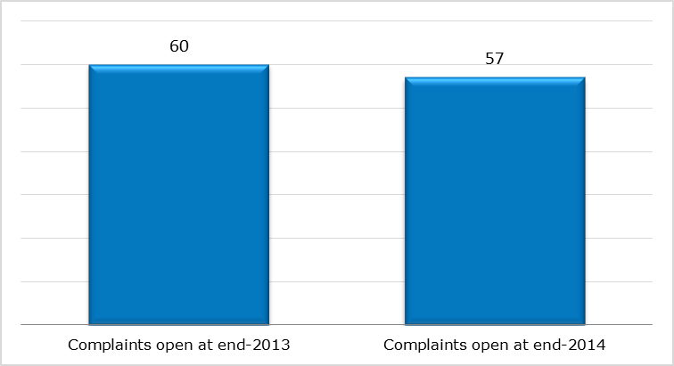
- New complaints registered in 2014: main policy areas
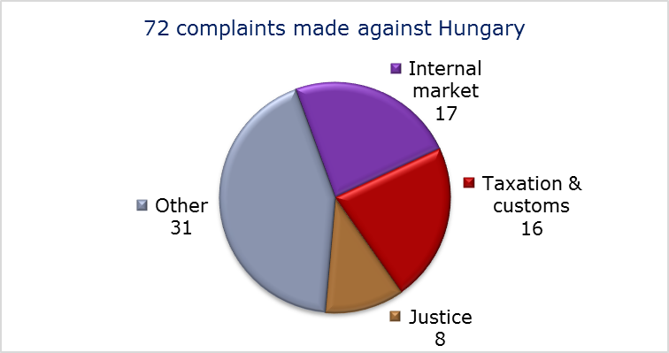
- EU PILOT
- New EU Pilot files opened against Hungary (2011-14)
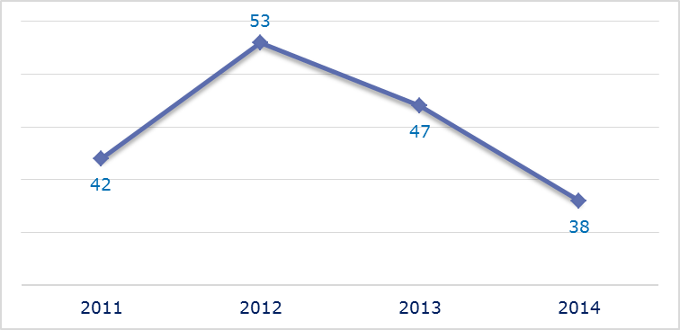
- Evolution of files relating to Hungary open in EU Pilot
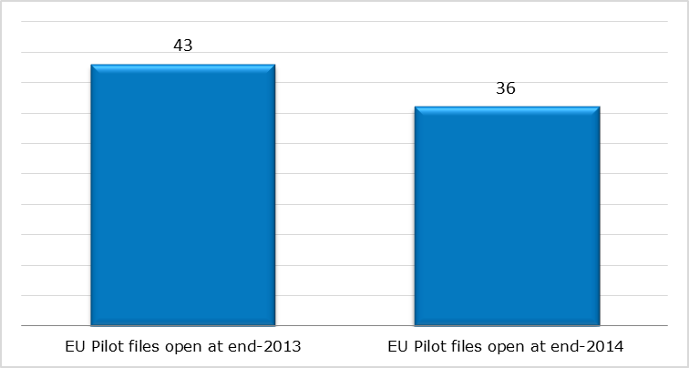
- New EU Pilot files opened in 2014: main policy areas
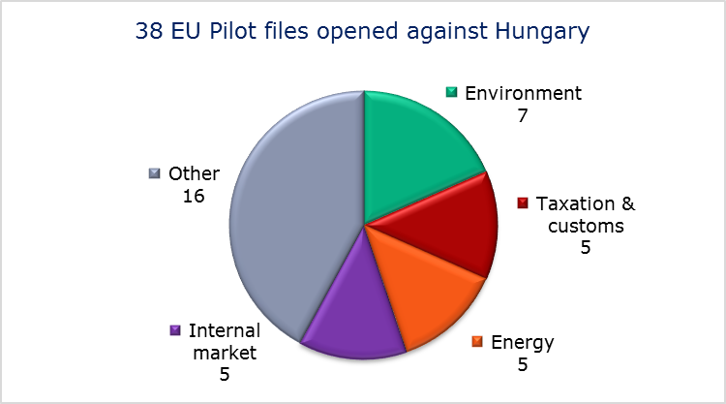
- EU Pilot files: average response time in days (2011-14)
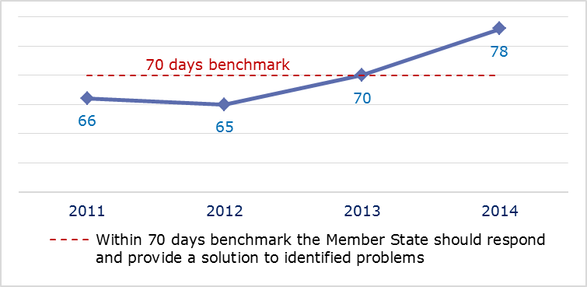
- EU Pilot files: evolution of the resolution rate by Hungary (2011-14)
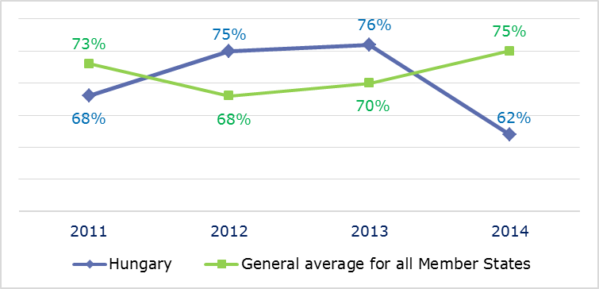
- INFRINGEMENT CASES
- Infringement cases against Hungary open on 31 December (2010-14)
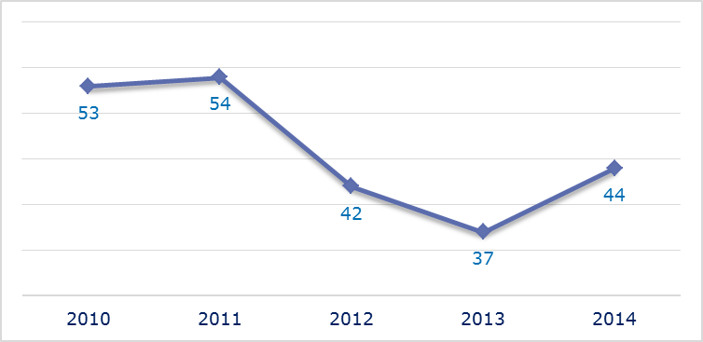
- New infringement cases opened in 2014: main policy areas
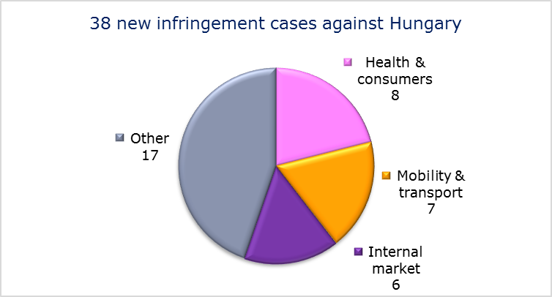
- Key infringement cases and referrals to the Court
- The Commission opened 38 new infringement cases against Hungary in 2014. These, and other major ongoing infringement cases, concern:
- a procedure in the National Media Act allows the assignment of ‘temporary’ licences to use radio spectrum for up to three years in certain cases. This might be disproportionate to the general objectives of the Authorisation Directive;
- a possible infringement of the general EU law principle of effectiveness and the regulation on the implementation of the competition rules through an amendment of the Act on Inter-branch Organisations concerning agricultural products, which restricts the power of the National Competition Authority;
- absence of measures transposing the directive on aerosol dispensers;
- non-respect of EU air quality standards (PM₁₀ limit values) in several zones;
- the award of a contract for the development and operation of an e-tolling system on the Hungarian motorways without a prior competitive procedure;
- the so-called ‘Plaza Stop Law’, which banned the construction and expansion of retail outlets larger than 300 m² from January 2012 until December 2014. A government decree introduced the possibility of requesting an exemption from this ban, but the criteria for granting an exemption were unclear and included a potential ‘economic needs’ test;
- national legislation adopted in December 2013 that on 1 May 2014 terminated all existing usufruct (the right to use land and profit from it) and use rights which had been granted for agricultural land by a contract between parties other than close relatives. This radically shortened the 20-year transitional period adopted in 2012 to four and a half months. The measure has affected people and businesses from other EU Member States that had acquired such rights for an unlimited period of time or that bought lifelong usufruct on small plots of land before 2002;
- requirement to have Hungarian nationality to work as notary;
- late notification of measures transposing the Capital Requirements Directive;
- failure to efficiently implement functional airspace blocks. Under the Single European Sky legislation, national air traffic control organisations should work together in regional airspace blocks to gain efficiency, cut costs and reduce emissions. The set-up of these common airspace blocks is arranged around traffic flows rather than state boundaries, which leads to performance improvements;
- incompatibility of working conditions of urban bus drivers with the Working Time Directive;
- implementation of an earlier Court ruling on the First Railway Package;
- failure to establish the preconditions needed for the European Electronic Toll Service to function;
- in the area of taxation, discriminatory municipal taxation of non-residents, the application of two excise duty rates on ethyl alcohol and the sales restriction on tobacco products already released for consumption.
- The Commission referred one case to the Court under Article 258 TFEU. It concerns:
- the restrictive issuing conditions of meal and holiday vouchers under the new national legal framework.
- The Commission did not refer any cases to the Court under Article 260(2) TFEU.
- TRANSPOSITION OF DIRECTIVES
- New late transposition infringement cases against Hungary (2010-14)
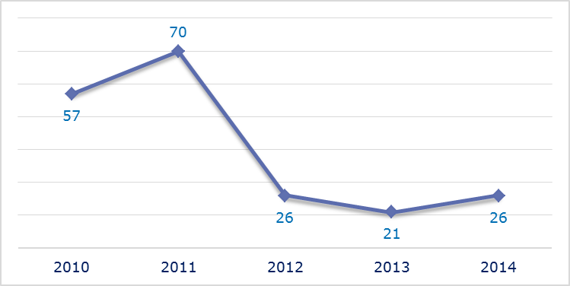
- New late transposition infringement cases opened in 2014: main policy areas
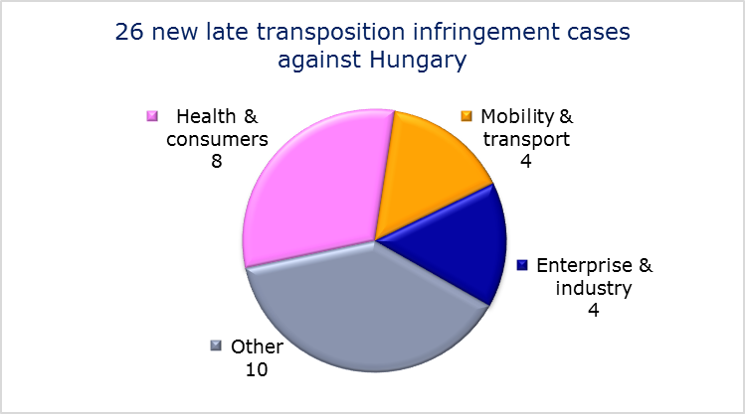
- Referrals to the Court
The Commission did not refer any cases to the Court under Articles 258 and 260(3) TFEU.
- EARLY RESOLUTION OF INFRINGEMENT CASES

Major cases closed without a Court judgment in 2014
These concerned:
- failure to fully transpose the directive improving and extending the EU greenhouse gas emission allowance trading scheme and the directive on the geological storage of carbon dioxide;
- completing the notification of national transposing measures under the Waste Electronic and Electrical Equipment Directive;
- incorrect transposition of the right to appeal against decisions refusing, annulling or revoking visas;
- corrected nonconformities in the area of railway safety;
- access to the ground-handling market at Budapest airport.
- IMPORTANT JUDGMENTS
- Court rulings
The Court ruled that:
- Hungary infringed Union law by ending the term served by its data protection supervisor before the expiry of the term of office. The independence of the authorities responsible for data protection, as laid down in the Data Protection Directive, requires Member States to allow them to serve their full term of office;
- EU law precludes exempting from excise duties fruit distillates (pálinka) produced under both contract and private distillation.
- Preliminary rulings
In preliminary rulings addressed to the Hungarian judiciary, the Court ruled that:
- an import permit that does not comply with the conditions laid down in the regulation on the protection of species of wild fauna and flora by regulating trade in them is void only in respect of those animals that are actually affected by its invalidity. These animals are the only ones that may be seized and possibly confiscated by the competent authority of the Member State where they are situated. The national proceedings concerned Hungary’s decision to invalidate the permits issued by Bulgaria on the import of animals and to confiscate the animals;
- excluding the participation in a tendering procedure of an economic operator who has committed an infringement of competition law established by a judicial decision is allowed under Directive 2004/18/EC; as a consequence such exclusion is also allowed under Articles 49 and 56 TFEU regarding public contracts which fall below the EU thresholds;
- the different tax treatment of a company belonging to a group can constitute indirect discrimination contrary to EU law if the companies affected by the highest band of the special retail tax are linked in the majority of cases to companies which have their registered office in another EU Member State.

IRELAND

The number of new complaints made against Ireland has been constantly increasing and in 2014 approached double the 2011 level. However, new EU Pilot files opened against Ireland nearly halved from their 2013 peak. The overall number of pending infringement cases has not varied much over the last four years, with 2014 seeing a slight rise back to 2011 levels. New infringement cases for late transposition remained very low for the third year running, at less than one third of their levels in 2010 and 2011.
- COMPLAINTS
- New complaints made against Ireland by members of the public (2011-14)
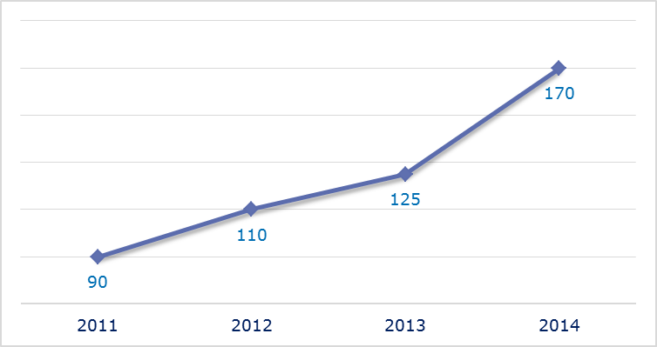
- Evolution of complaints against Ireland
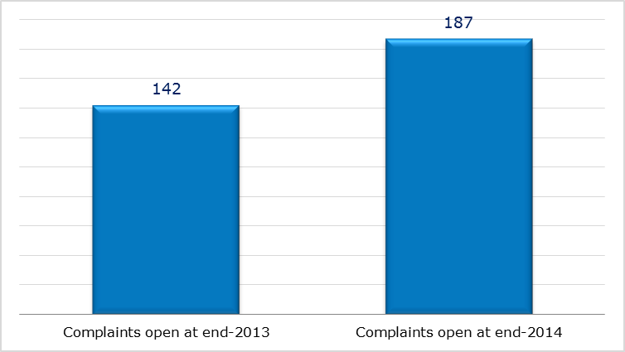
- New complaints registered in 2014: main policy areas
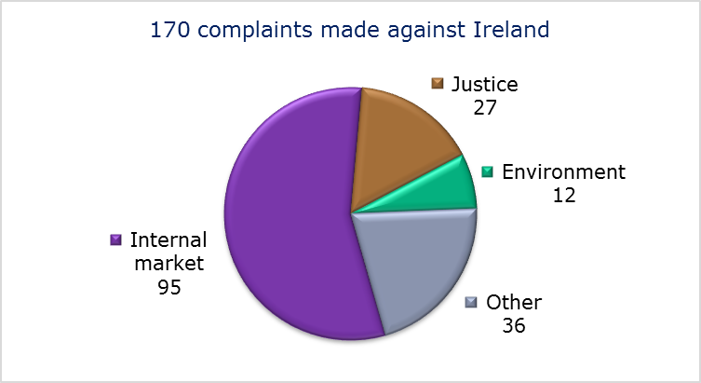
- EU PILOT
- New EU Pilot files opened against Ireland (2011-14)
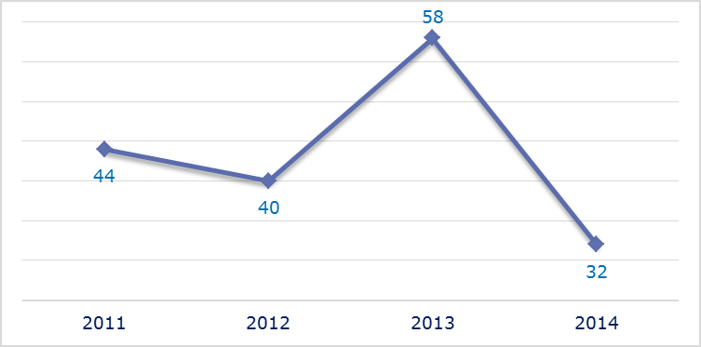
- Evolution of files relating to Ireland open in EU Pilot
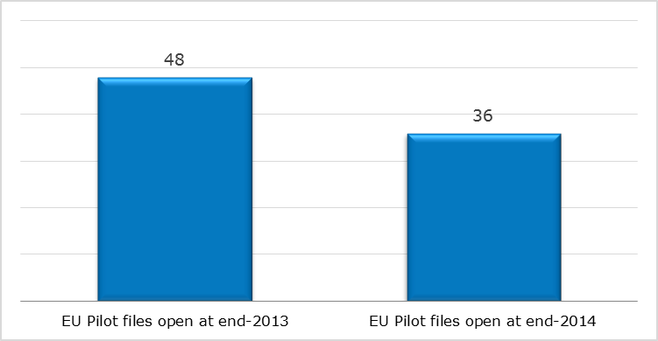
- New EU Pilot files opened in 2014: main policy areas
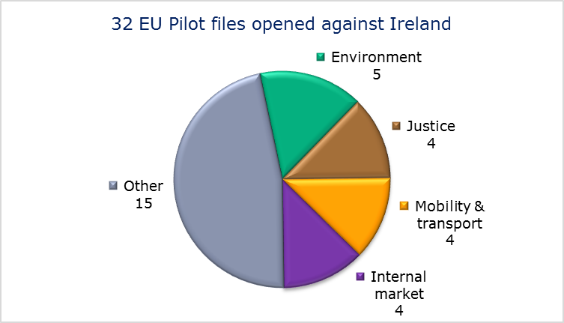
- EU Pilot files: average response time in days (2011-14)
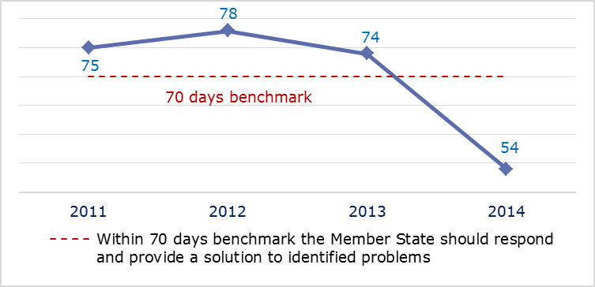
- EU Pilot files: evolution of the resolution rate by Ireland (2011-14)
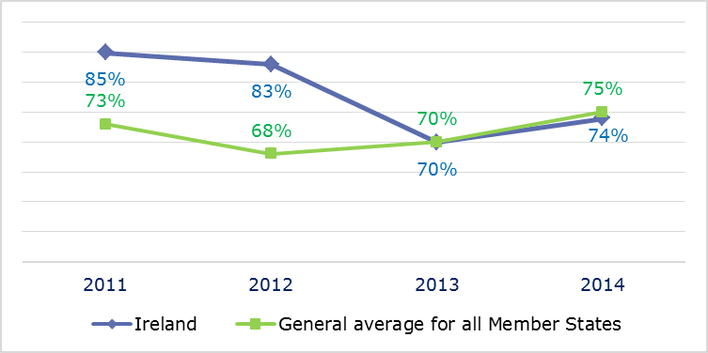
- INFRINGEMENT CASES
- Infringement cases against Ireland open on 31 December (2010-14)
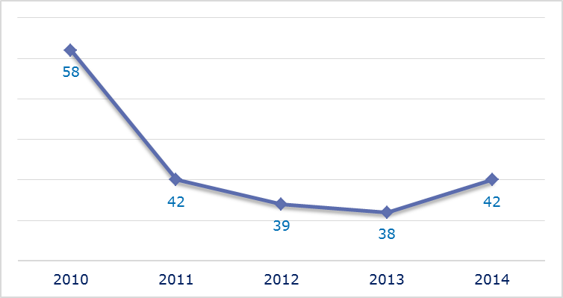
- New infringement cases opened in 2014: main policy areas
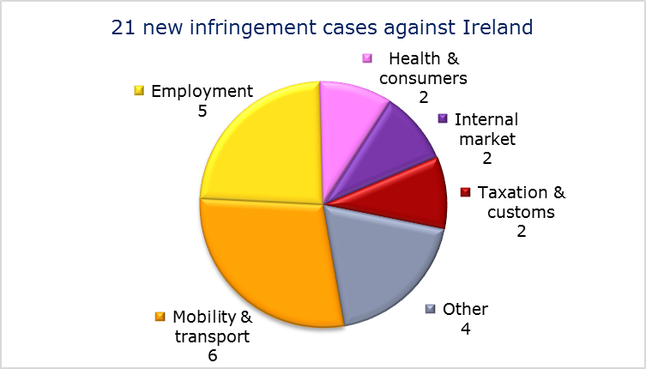
- Key infringement cases and referrals to the Court
- The Commission opened 21 new infringement cases against Ireland in 2014. These, and other major ongoing infringement cases, concern:
- the incompatibility of national provisions on annual leave with Working Time Directive as regards the carry-over period for leave not taken due to illness;
- incorrect application of the Working Time Directive by not counting the ‘sleepover’ hours of social care workers as working time and not granting them minimum daily and/or weekly rest periods or equivalent compensatory rest;
- incorrect application of the Working Time Directive by applying the practice of ‘rolled-up’ holiday pay for part-time and fixed-term teachers;
- late transposition of:
  - the directive implementing the Framework Agreement on prevention from sharp injuries in the hospital and healthcare sector concluded by the European Hospital and Healthcare Employers’ association (HOSPEEM) and the European Federation of Public Service Unions (EPSU),
  - the Cross-border Healthcare Directive,
  - the Capital Requirements Directive.
- failure to protect peat land sites in breach of the Habitats Directive, the Environmental Impact Assessment Directive and Article 4(3) of the TFEU;
- failure to accept applications for a residence card lodged by family members during their first three months of residence, in breach of the directive on the right of EU citizens and their family members to move and reside freely within the territory of the Member States;
- exempting the Voluntary Health Insurance Board from the application of the Non-life Insurance Directives, although the criteria for exemption are no longer met;
- failure to efficiently implement functional airspace blocks. Under the Single European Sky legislation, national air traffic control organisations should work together in regional airspace blocks to gain efficiency, cut costs and reduce emissions. The set-up of these common airspace blocks is arranged around traffic flows rather than state boundaries, which leads to performance improvements;
- failure to connect to RESPER, the EU driving licence network;
- non-ratification of the Convention concerning Internal Carriage by Rail as amended by the Vilnius Protocol of 3 June 1999, in breach of Article 4(3) of the TFEU.
- The Commission referred two cases to the Court under Article 258 TFEU. They concern:
- failure to apply the rules of the Working Time Directive to doctors in training and other non-consultant hospital doctors;
- incorrect application of the rules on fiscal marking of gas oils and kerosene by allowing the use of marked fuel for the purposes of private pleasure craft.
- The Commission did not refer any cases to the Court under Article 260(2) TFEU.
- TRANSPOSITION OF DIRECTIVES
- New late transposition infringement cases against Ireland (2010-14)
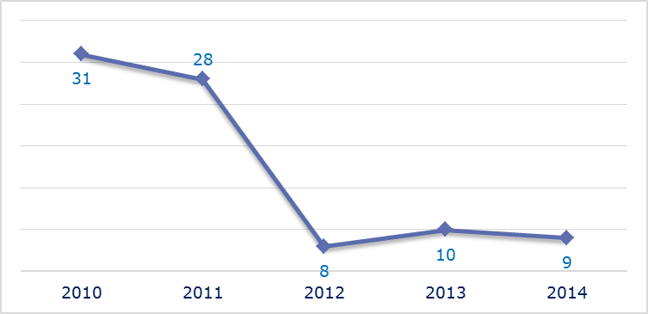
- New late transposition infringement cases opened in 2014: main policy areas
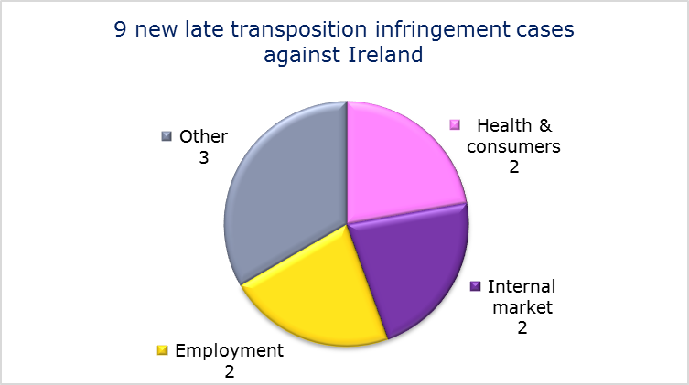
- Referrals to the Court
The Commission referred two cases to the Court under Articles 258 and 260(3) TFEU. They concern:
- failure to fully transpose the Renewable Energy Directive. The Commission proposed a daily penalty of EUR 25 447.5;
- partial transposition of the Electricity Directive. The Commission proposed a daily penalty of EUR 20 358.

- EARLY RESOLUTION OF INFRINGEMENT CASES

Major cases closed without a Court judgment in 2014
These concerned:
- late transposition of the directive implementing the Framework Agreement on prevention from sharp injuries in the hospital and healthcare sector concluded by the European Hospital and Healthcare Employers’ association (HOSPEEM) and the European Federation of Public Service Unions (EPSU);
- incorrect transposition of the Late Payment Directive;
- failure to fully transpose the directive on the geological storage of carbon dioxide;
- absence of transposition of the directive on preventing and combating trafficking in human beings and protecting its victims;
- lack of sanctions for misuse of air slots in breach of the Slot Regulation;
- exit taxation of companies;
- discriminatory treatment of taxpayers receiving termination payments for their employment with group companies when they started their employment in another Member State in comparison with taxpayers who started their employment in Ireland;
- late transposition of the Renewable Energy Directive;
- application of minimum and maximum prices on tobacco, which is in breach of the directive on taxes other than turnover taxes which affect the consumption of manufactured tobacco.
- IMPORTANT JUDGMENTS
- Court rulings
There were no major Court rulings in 2014.
- Preliminary rulings
In preliminary rulings addressed to the Irish judiciary, the Court ruled that:
- Member States are not required to grant maternity leave or adoption leave to a female worker who as a commissioning mother had a baby through a surrogacy arrangement;
- the definitions of ‘residence’ and ‘stay’ for the purposes of applying Regulation (EC) No 883/2004 on the coordination of social security systems apply when someone is suddenly taken seriously ill while on holiday in another Member State and is compelled to remain in that Member State as a result of the illness;
- the Data Retention Directive is invalid. The retention of data required by the directive might be considered appropriate to meet the objective of fighting organised crime and terrorism, and therefore of improving public security. However, the directive’s wide-ranging and serious interference with the fundamental rights to respect of private life and to protection of personal data is not sufficiently limited to what is strictly necessary;
- the principles of effectiveness and the right to good administration under EU asylum law allow Member States to apply national procedures under which an application for subsidiary protection is examined only after an application for refugee status has been refused, provided that it is possible to submit both applications at the same time and that the national rules do not make the procedure unreasonably long.

ITALY

The number of new complaints made against Italy has stabilised over the past two years at a rather high level. After a clear decline in 2012, new EU Pilot files increased again in 2014 to above the 2011 level. By contrast, the overall number of pending infringement cases reached a five-year low in 2014. New infringement cases for late transposition also fell further in 2014, to their lowest level in five years.
- COMPLAINTS
- New complaints made against Italy by members of the public (2011-14)
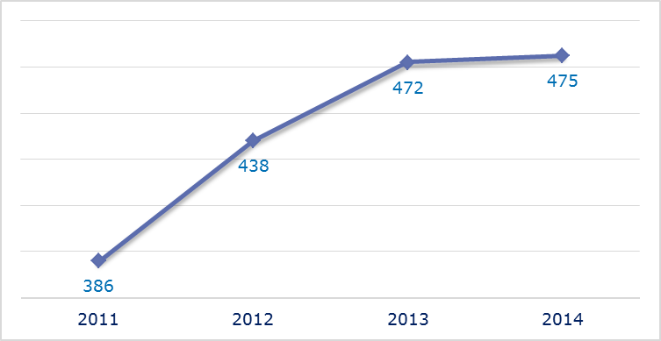
- Evolution of complaints against Italy
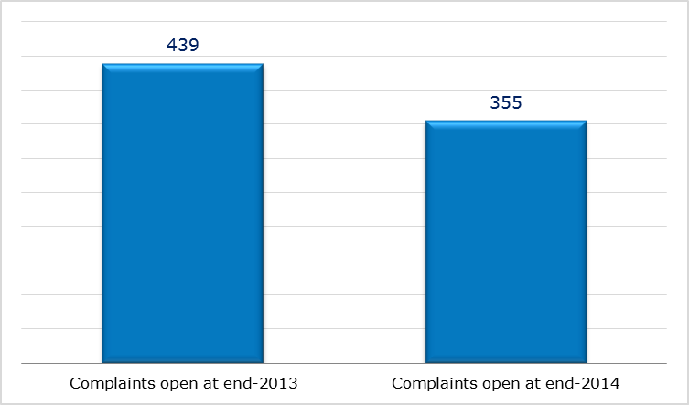
- New complaints registered in 2014: main policy areas
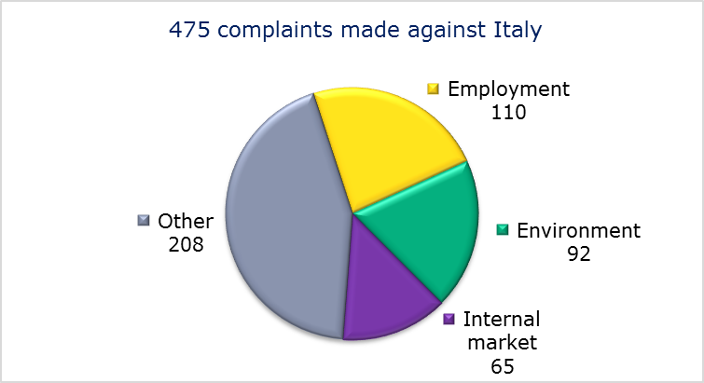
- EU PILOT
- New EU Pilot files opened against Italy (2011-14)
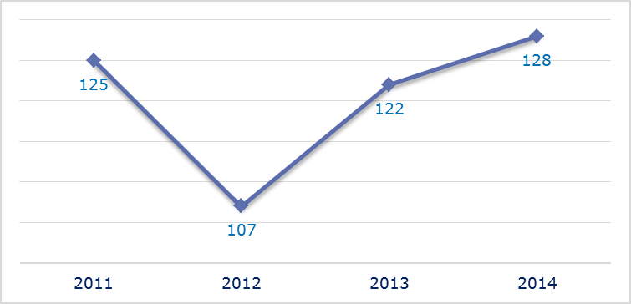
- Evolution of files relating to Italy open in EU Pilot
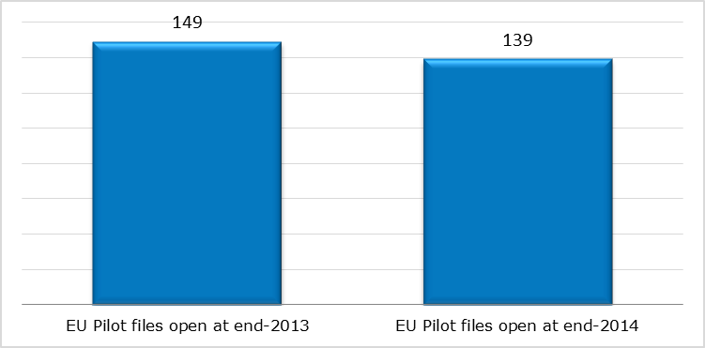
- New EU Pilot files opened in 2014: main policy areas
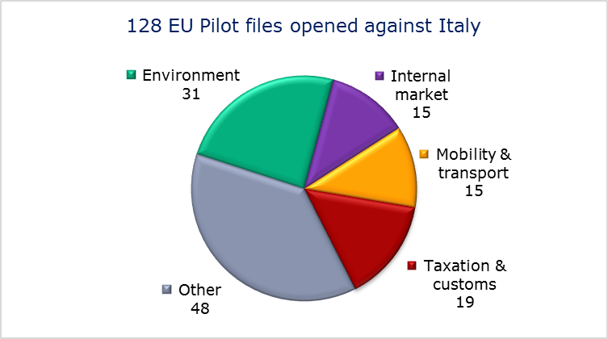
- EU Pilot files: average response time in days (2011-14)
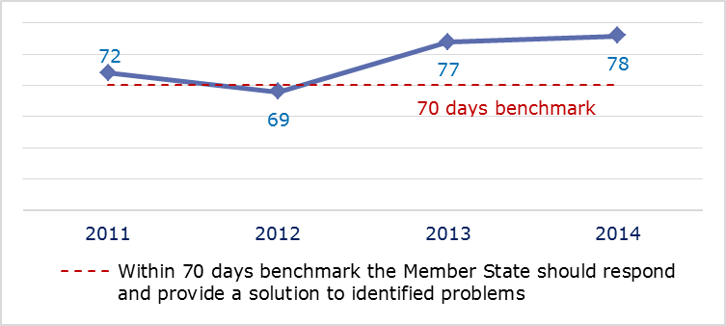
- EU Pilot files: evolution of the resolution rate by Italy (2011-14)
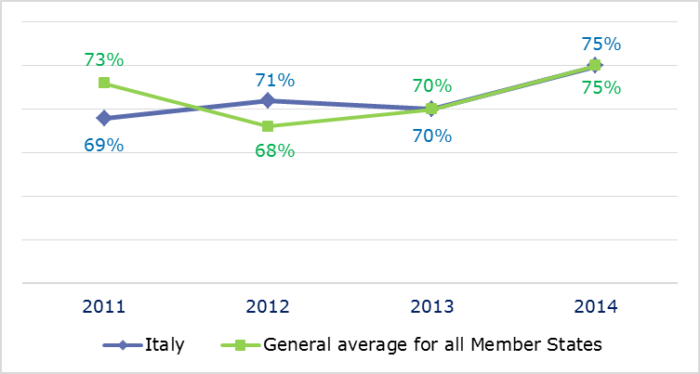
- INFRINGEMENT CASES
- Infringement cases against Italy open on 31 December (2010-14)
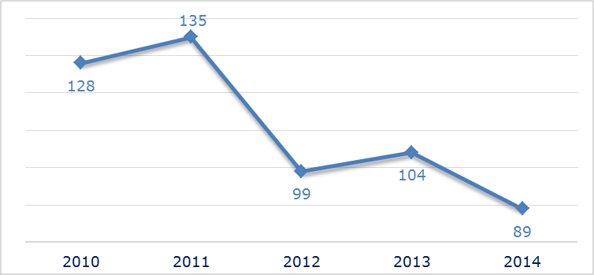
- New infringement cases opened in 2014: main policy areas
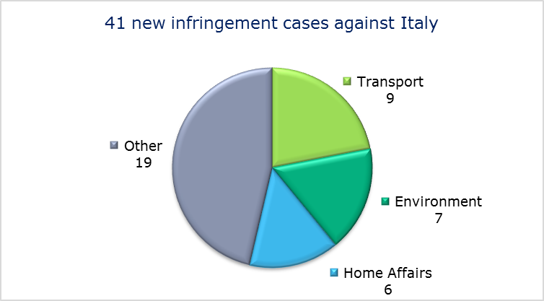
- Key infringement cases and referrals to the Court
- The Commission opened 41 new infringement cases against Italy in 2014. These, and other major ongoing infringement cases, concern:
- failure to comply with the regulation establishing a common organisation of agricultural markets by not imposing the necessary measures to effectively and efficiently recover levies owed by milk producers that exceeded their quota;
- the incorrect application of the Authorisation Directive by not respecting the obligation to make administrative charges and costs for electronic communications providers transparent. In addition, some of the charges on smaller operators are discriminatory and disproportionate;
- failure to comply with a Commission Decision and the subsequent judgment of the Court of Justice under Article 108(2) on investment aid to the hotel industry in Sardinia;
- incompatibility of the working conditions of some public sector staff with the Fixed-Term Directive; it appears that the salaries, paid leave linked to seniority and other entitlements of these staff are less generous than for permanent staff;
- incorrect application of the Late Payment Directive;
- the trapping of birds with nets for use as live decoys;
- failure to comply with the Urban Waste Water Treatment Directive in 900 agglomerations across Italy;
- incorrect application of the Drinking Water Directive (arsenic and fluoride in drinking water);
- nonconformity of the national legislation with the Return Directive on aspects such as an effective forced-return monitoring system, criminalisation of irregular stay, detention and detention conditions;
- alleged denial of access to the asylum procedure for migrants arriving from Greece and possibly in need of international protection (under the Dublin Regulation);
- late transposition of the Capital Requirements Directive;
- failure to efficiently implement functional airspace blocks. Under the Single European Sky legislation, national air traffic control organisations should work together in regional airspace blocks to gain efficiency, cut costs and reduce emissions. The set-up of these common airspace blocks is arranged around traffic flows rather than state boundaries, which leads to performance improvements.
- The Commission referred two cases to the Court under Article 258 TFEU. They concern:
- the exclusion of National Health Service staff from certain rights under the Working Time Directive;
- nonconformity with the directive on compensation to crime victims; Italian legislation provides for compensation to victims of certain violent intentional crimes, such as terrorism and organised crime, but not for all of them.
- The Commission referred one case to the Court under Article 260(2) TFEU. This concerns:
- failure to recover illegal and incompatible State aid to companies in Venice and Chioggia. The Commission proposes a daily fine of EUR 24 578.40 for the period between the previous Court judgment (on 6 October 2011) and the judgment in this case; the Commission also proposes a higher daily fine if Italy does not comply with the judgment in this case within six months.

- TRANSPOSITION OF DIRECTIVES
- New late transposition infringement cases against Italy (2010-14)
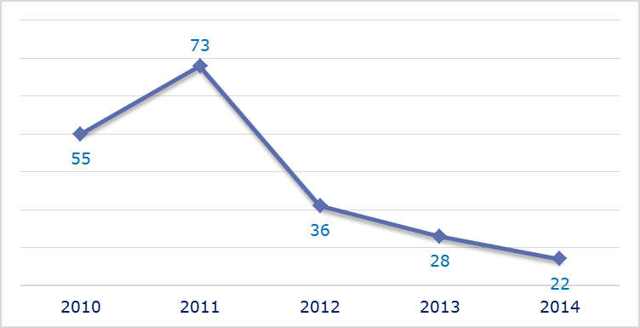
- New late transposition infringement cases opened in 2014: main policy areas
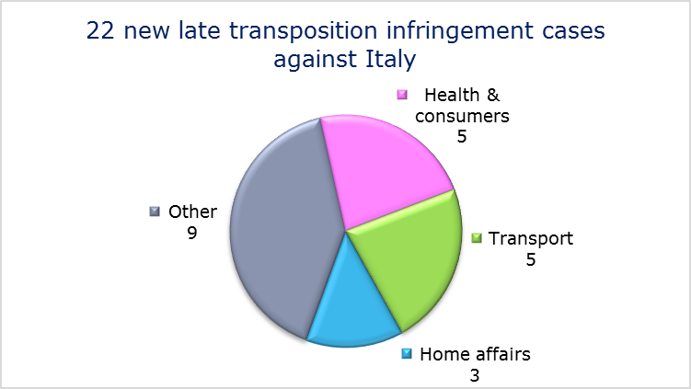
- Referrals to the Court
The Commission did not refer any cases to the Court under Articles 258 and 260(3) TFEU.
- EARLY RESOLUTION OF INFRINGEMENT CASES

Major cases closed without a Court judgment in 2014
These concerned:
- late transposition of the directive implementing the Framework Agreement on prevention from sharp injuries in the hospital and healthcare sector concluded by the European Hospital and Healthcare Employers’ association (HOSPEEM) and the European Federation of Public Service Unions (EPSU);
- late transposition of the Industrial Emissions Directive;
- incorrect transposition of the Environmental Liability Directive;
- lack of controls on the illegal use of driftnets. Following a Court judgment in October 2009, and in the context of an action plan, Italy agreed to give top priority to implementing additional measures to eradicate illegal driftnet activities. The Commission monitored Italy’s implementation of the remedial actions included in the action plan over the first half of 2014;
- incorrect application of the Long-Term Residents Directive by limiting some core social benefits to its nationals and totally or partially excluding non-EU nationals who are long-term residents;
- several fishing agreements concluded by Italy with third countries in breach of the EU’s exclusive competence in the field of fisheries; the Italian authorities subsequently provided evidence that the agreements have been terminated;
- the authorities’ refusal to recognise that holders of Italy’s Maturita magistrale diploma were fully qualified to exercise the profession of primary school teacher in Italy. As a result, holders of this diploma could not work in any other Member State;
- incorrect application of the directive on the minimum level of training of seafarers due to several shortcomings in Italy’s system for training and certifying them;
- incorrect application of the regulation on rail passengers’ rights and obligations;
- discriminatory airport charges for non-EU carriers.
- IMPORTANT JUDGMENTS
- Court rulings
The Court ruled that Italy:
- did not implement the 2007 judgment of the Court of Justice establishing its failure to fulfil obligations under the waste directives. The Court ordered Italy to pay a lump sum EUR 40 million and a penalty of 42.8 million for each six-month period of delay in implementing the measures necessary for compliance;
- failed to ensure adequate treatment of waste landfilled in Malagrotta and in other Lazio landfills;
- failed to ensure adequate collection and treatment of urban wastewaters;
- failed to comply with the directive on the protection of laying hens by not ensuring that they are no longer reared in unenriched cages;
- Italy’s appeals against two Commission decisions under the European Regional Development Fund are unfounded. One, involving a 10 % flat-rate reduction in financial assistance, concerned the Apulia region and the other, involving the non-admission of interim payment applications, concerned the Campania region.

- Preliminary rulings
In preliminary rulings addressed to the Italian judiciary, the Court ruled that:
- the Fixed-Term Work Directive precludes national rules that authorise the renewal of fixed-term contracts to fill vacant posts, pending the recruitment of tenured school staff, without stating a definite deadline for the completion of these recruitment processes and without providing compensation for damage suffered due to such unlimited renewals;
- the Part-Time Work Directive does not always require an employer to obtain a worker’s consent before changing his part-time contract into a full-time one;
- if a site of EU importance has lost its ecological value due to natural causes and not because a Member State has failed to protect it, the Member State is required to propose to the Commission that the site be declassified;
- the conclusion of international agreements about the recognition by Member States of guarantees of origin issued by non-EU countries is liable to affect the correct functioning of the harmonised certification mechanism established by the Renewable Energy Directive and the objectives it pursues. This is therefore an exclusive EU external competence;
- to be able to acquire the long-term resident status provided for under EU law, non-EU nationals must personally be legally and continuously resident in the host Member State for five years before submitting their application. Family members of a long-term resident may not be exempted from this condition;
- a national of a Member State who qualifies as a lawyer in another Member State has the right to work as a lawyer in his own Member State;
- the notion of "final judgment" under the "ne bis in idem" principle (Article 54 of the Convention implementing the Schengen Agreement (CISA)) includes an order making a finding that there is no ground to refer a case to a trial court which precludes, in the State in which that order was made, to bring new criminal proceedings in respect of the same acts against the person to whom that finding applies, unless new facts and/or evidence against that person come to light; such an order precludes new proceedings against the same person in respect of the same acts in another State;
- Member States are not allowed to reserve the position of President of a Port Authority for its nationals;
- national laws that levy income tax on winnings gained in casinos in other Member States are not compatible with Treaty rules on the freedom to provide services (Articles 52 and 56 TFEU) if those winnings would be exempt from tax if gained in casinos within the national territory.

LATVIA
The number of new complaints made against Latvia fell markedly in 2014 from 2013’s peak. New EU Pilot files opened against Latvia also continued the decline recorded in 2013. However, the number of pending infringements increased for the first time since 2010 after falling for two years. New infringement cases for late transposition have shown little change over the last three years.
- COMPLAINTS
- New complaints made against Latvia by the members of the public (2011-14)
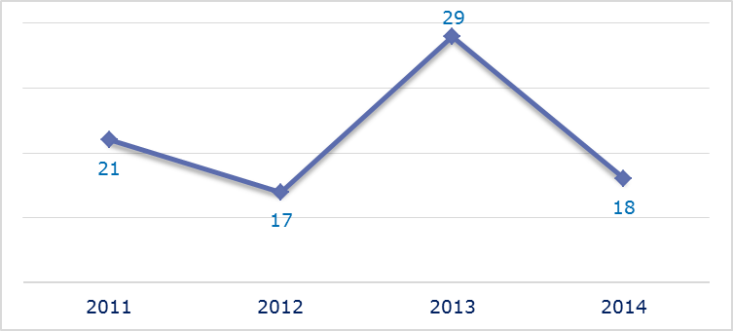
- Evolution of complaints against Latvia
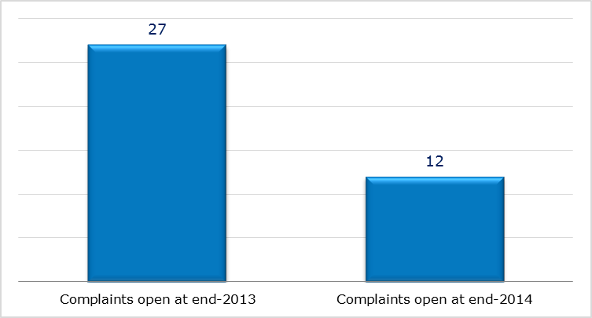
- New complaints registered in 2014: main policy areas
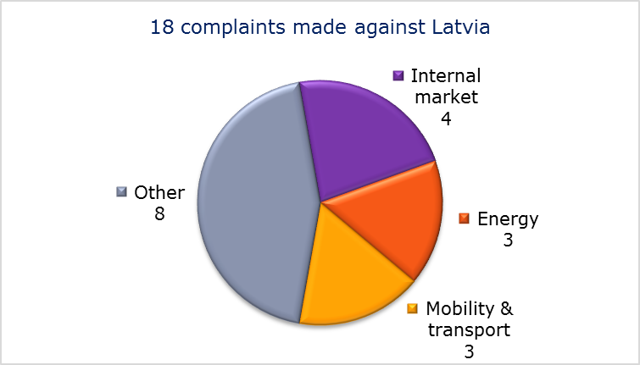
- EU PILOT
- New EU Pilot files opened against Latvia (2011-14)
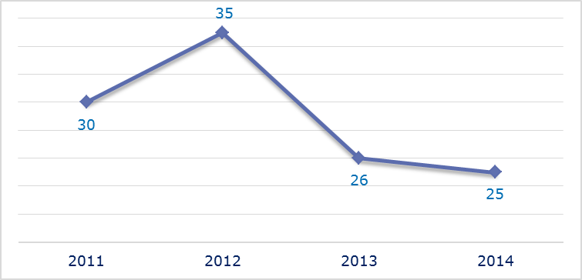
- Evolution of files relating to Latvia open in EU Pilot
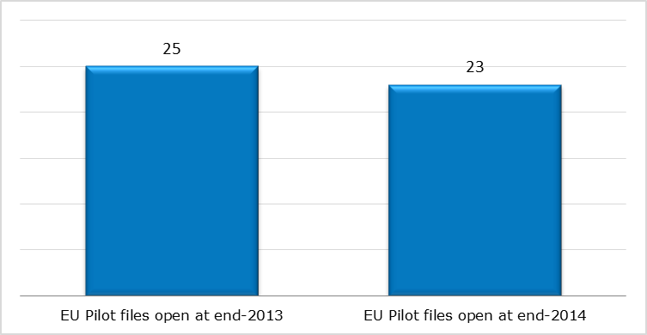
- New EU Pilot files opened in 2014: main policy areas
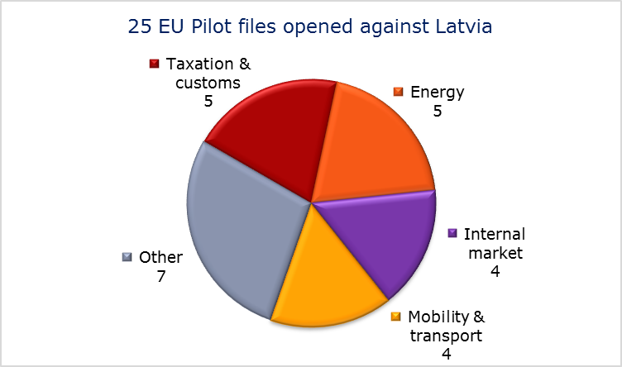
- EU Pilot files: average response time in days (2011-14)
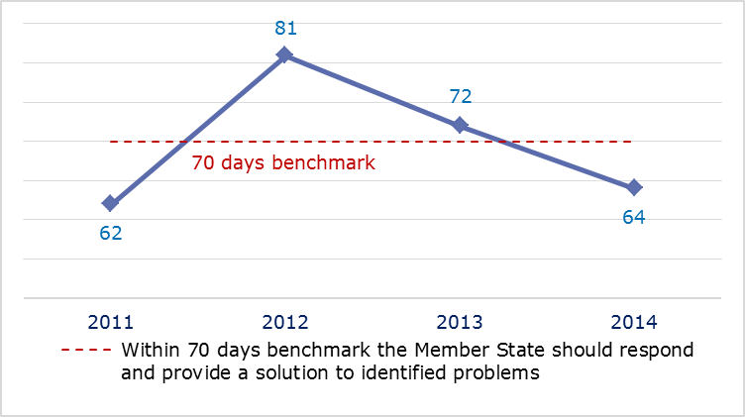
- EU Pilot files: evolution of the resolution rate by Latvia (2011-14)
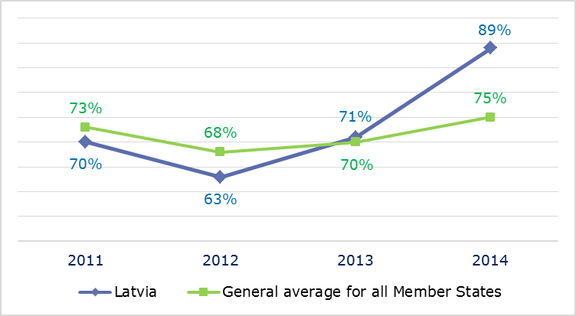
- INFRINGEMENT CASES
- Infringement cases against Latvia open on 31 December (2010-14)
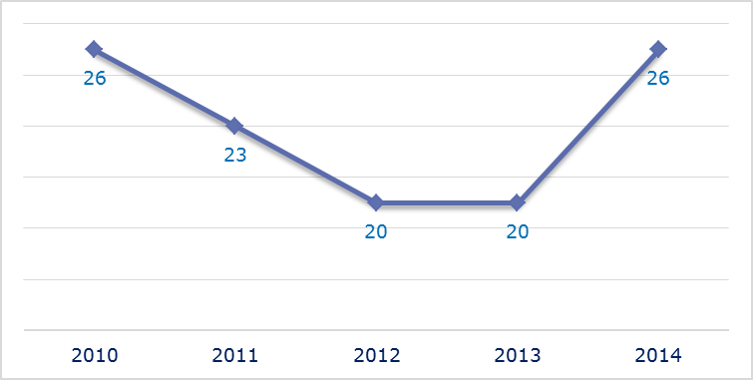
- New infringement cases opened in 2014: main policy areas
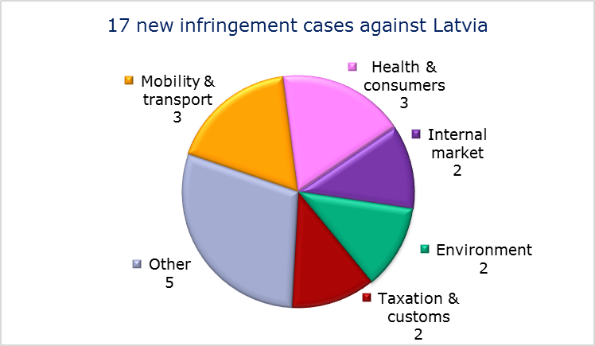
- Key infringement cases and referrals to the Court
- The Commission opened 17 new infringement cases against Latvia in 2014. These, and other major ongoing infringement cases, concern:
- nonconformity of the national legislation with the Audiovisual Media Services Directive. Under Latvian law, any sign of disrespect to Latvia’s national values in audiovisual commercial communications is prohibited. This prohibition goes beyond the provisions of the directive, in particular in light of the freedom of expression enshrined in the Charter of Fundamental Rights of the European Union;
- non-respect of EU air quality standards (maximum PM₁₀ limit values) in one agglomeration;
- restrictions on the right of EU nationals to become members of a political party or to found one in the Member State of residence;
- non-communication of national measures transposing the Capital Requirements Directive and one directive concerning the automotive sector;
- incorrect transposition of the European Electronic Toll Service Directive.
- The Commission referred one case to the Court under Article 258 TFEU. This concerns:
- the requirement to have Latvian nationality to work as a notary.
- The Commission did not refer any cases to the Court under Article 260(2) TFEU.
- TRANSPOSITION OF DIRECTIVES
- New late transposition infringement cases against Latvia (2010-14)
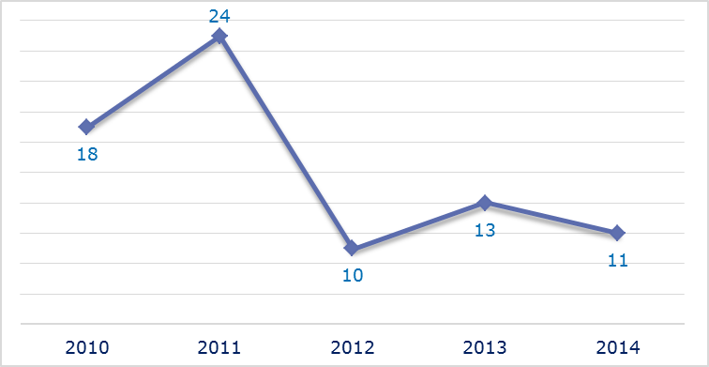
- New late transposition infringement cases opened in 2014: main policy areas
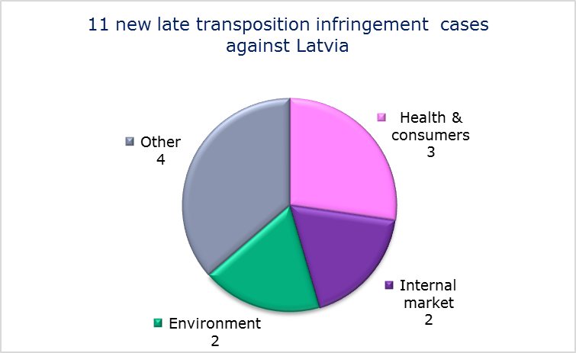
- Referrals to the Court
The Commission did not refer any cases to the Court under Articles 258 and 260(3) TFEU.
- EARLY RESOLUTION OF INFRINGEMENT CASES

Major cases closed without a Court judgment in 2014
These concerned:
- incorrect transposition of the Mining Waste Directive;
- nonconformity of the national transposition measures with the Railway Safety Directive and the directive on separation of accounts in rail.
- IMPORTANT JUDGMENTS
- Court rulings
There were no major Court rulings in 2014.
- Preliminary rulings
In preliminary rulings, the Court ruled that:
- a programme manual adopted by a monitoring committee in the context of an operational programme established by two Member States and intended to promote European territorial cooperation, cannot prevent a decision of the monitoring committee rejecting an application for aid from being subject to appeal before a court of a Member State, as this would constitute a breach of Regulation (EC) No 1083/2006, read in conjunction with Article 47 of the Charter of Fundamental Rights of the European Union.

The number of files open at the end of 2013 given in the 2013 annual report is different from the current figure. This is because some files were registered late and others have been closed.
Directive 2002/20/EC.
Article 4(3) TEU.
Regulation (EC) No 1/2003.
Directive 2013/10/EU.
PM₁₀ is an air pollutant consisting of small particles with an aerodynamic diameter less than or equal to a nominal 10 micrometers. The particles’ small size allows them to penetrate deep into the lungs where they may be deposited and cause adverse health effects. (Source: European Environment Agency).
MEMO/14/241.
For procedural reasons — complete execution of the contract in question — the Commission has decided to close the infringement case.
IP/14/1152.
Directive 2013/36/EU.
Regulation (EC) No 550/2004.
IP/14/818.
Directive 2003/88/EC.
MEMO/14/293.
MEMO/14/293.
The Commission decided on 20 June 2013 to refer the case to the Court; the application was filed on 10 April 2014, Commission v Hungary, C-179/14, IP/13/578.
Directives 2009/29/EC and 2009/31/EC.
Directive 2012/19/EU.
Directive 95/46/EC.
Commission v Hungary, C-288/12 and Court press release No 53/14.
Regulation (EC) No 338/97.
Sofia Zoo, C-532/13.
Generali-Providencia Biztosító, C-470/13.
Hervis Sport, C-385/12.
The number of files open at the end of 2013 given in the 2013 annual report is different from the current figure. This is because some files were registered late and others have been closed.
Directive 2003/88/EC.
Council Directive 2010/32/EU.
Directive 2011/24/EU.
Directive 2013/36/EU.
Directive 92/43/EEC.
Directive 85/337/EEC.
Directive 2004/38/EC.
Council Directive 73/239/EEC and Council Directive 92/49/EEC.
Regulation (EC) No 550/2004.
IP/14/818.
Directive 2006/126/EC.
The Commission decided on 20 November 2013 to refer the case to the Court; the application was filed on 18 February 2014, Commission v Ireland, C-87/14.
Council Directive 95/60/EC.
Directive 2009/28/EC, Commission v Ireland, C-236/14, IP/14/44. Ireland subsequently adopted the necessary legislative amendments and the Commission withdrew the case from the Court.
Directive 2009/72/EC, Commission v Ireland, C-217/14, IP/14/155.
Council Directive 2010/32/EU.
Directive 2011/7/EU.
Directive 2009/31/EC.
Directive 2011/36/EU.
Regulation (EEC) No 95/93.
IP/11/78 on the earlier reasoned opinion.
Directive 2009/28/EC.
Council Directive 95/59/EC.
D., C-167/12 and Court press release No 36/14.
‘I’, C-255/13.
Directive 2006/24/EC.
Digital Rights Ireland and Seitlinger and Others, C-293/12 and C-594/12 and Court press release No 54/14.
Directive 2004/83/CE in the meantime replaced by Directive 2011/95.
H. N., C-604/12.
The number of files open at the end of 2013 given in the 2013 annual report is different from the current figure. This is because some files were registered late and others have been closed.
Council Regulation (EC) No 1234/2007.
MEMO/14/470.
Directive 2002/20/EC.
Commission Decision 2008/854/EC.
Commission v Italy, C-243/10.
Directive 1999/70/EC.
Directive 2011/7/EU, IP/14/689.
MEMO/14/2130.
Directive 91/271/EEC.
Directive 98/83/EC , IP/14/816.
Directive 2008/115/EC.
In breach of Council Directive 2005/85/EC.
Council Regulation (EC) No 343/2003.
Directive 2013/36/EU.
Regulation (EC) No 550/2004.
IP/14/818.
Directive 2003/88/EC, C-124/14, IP/14/159.
Council Directive 2004/80/EC.
Commission v Italy, C-601/14, IP/14/1146.
The Commission decided on 20 November 2013 to refer the case to the Court; the application was filed on 29 July 2014, Commission v Italy, C-367/14.
Council Directive 2010/32/EU.
Directive 2010/75/EU.
Directive 2004/35/EC.
Commission of the European Communities v Italian Republic, C-249/08.
Council Directive 2003/109/EC.
Directive 2008/106/EC.
Regulation (EC) No 1371/2007, IP/14/325. Italy subsequently adopted the necessary legislative amendments and the Commission withdrew the Court application.
Commission v Italy, C-196/13 and Court press release No 163/14.
Commission v Italy, C-323/13.
Directive 91/271/EEC, Commission v Italy, C-85/13 and Commission v Belgium, C-395/13.
Directive 1999/74/EC, and Commission v Italy, C-339/13 and Commission v Greece, C-351/13.
Italy v Commission, T-117/10.
Italy v Commission, C-385/13 P.
Mascolo C-22/13 and Court press release No 161/14.
Mascellani C-221/13.
Cascina Tre Pini, C-301/12.
Green Network SpA/Autorità per l’energia elettrica e il gas, C-66/13.
Tahir, C-469/13 and Court press release No 106/14.
Torresi, C-58/13 and Court press release No 59/14.
M., C-398/12.
Haralambidis, C-270/13.
Blanco and Fabretti, joined cases C-344/13 and C-367/13 and Court press release No 139/14.
The number of files open at the end of 2013 given in the 2013 annual report is different from the current figure. This is because some files were registered late and others have been closed.
Directive 2007/65/EC.
PM₁₀ is an air pollutant consisting of small particles with an aerodynamic diameter less than or equal to a nominal 10 micrometers. The particles’ small size allows them to penetrate deep into the lungs where they may be deposited and cause adverse health effects. (Source: European Environment Agency).
IP/13/47.
MEMO/14/293.
Directive 2013/36/EU; MEMO/14/589.
Directive 2012/46/EU.
Directive 2004/52/EC.
Commission v Latvia, C-151/14, IP/14/48.
Directive 2006/21/EC.
Directive 2004/49/EC and Directive 91/440/EEC.
Liivimaa Lihaveis MTÜ v Eesti-Läti programmi 2007-2013 Seirekomitee, C-562/12.

