FINLAND

After falling in 2011 and 2012, the number of new complaints made against Finland increased in 2013 and 2014. However, new EU Pilot files opened against Finland showed a clear decline in 2014 after rising for three consecutive years. The number of pending infringement cases has fallen each year since 2011, while new infringement cases for late transposition held steady at less than one third of their 2011 peak.
- COMPLAINTS
- New complaints made against Finland by members of the public (2011-14)
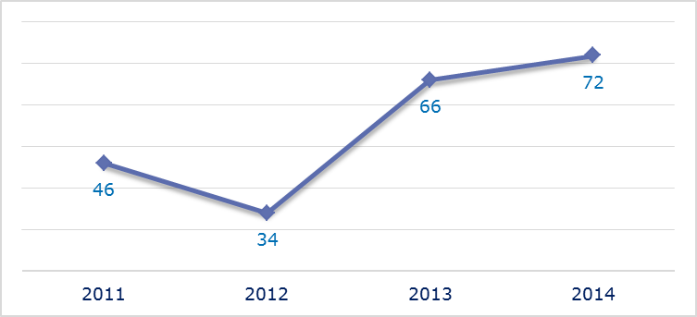
- Evolution of complaints against Finland
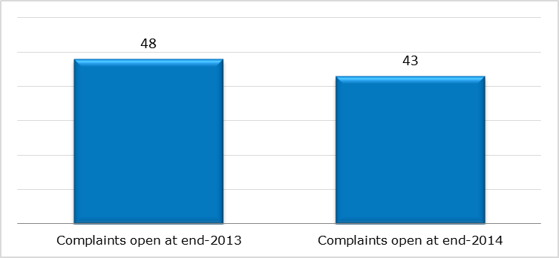
- New complaints registered in 2014: main policy areas
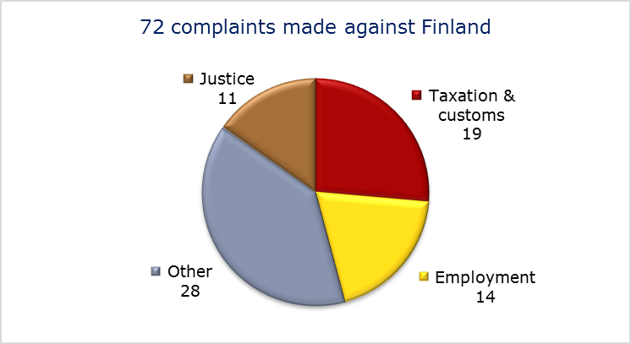
- EU PILOT
- New EU Pilot files opened against Finland (2011-14)
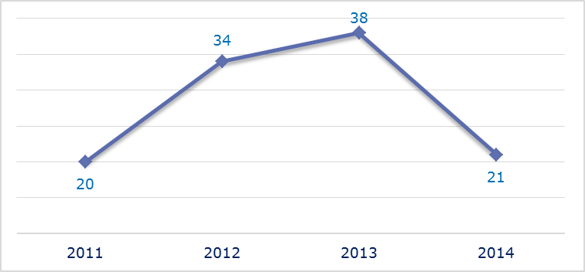
- Evolution of files relating to Finland open in EU Pilot
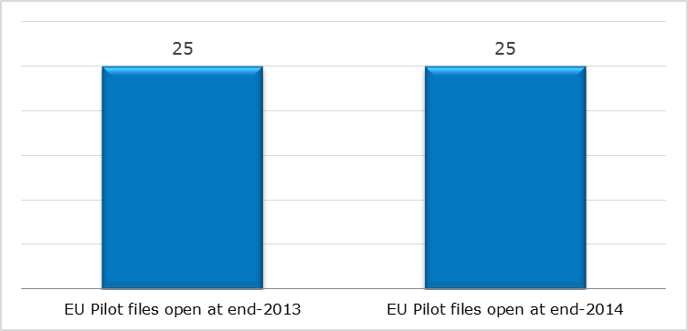
- New EU Pilot files opened in 2014: main policy areas
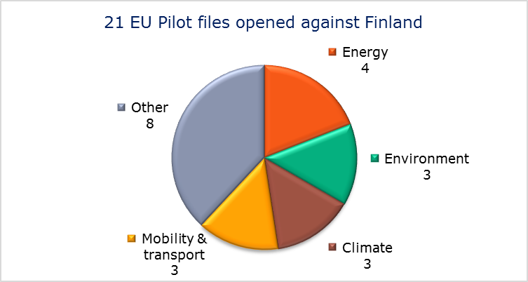
- EU Pilot files: average response time in days (2011-14)
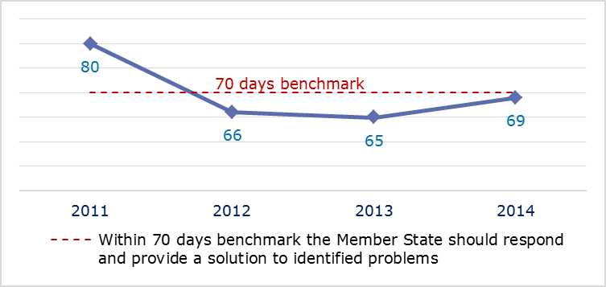
- EU Pilot files: evolution of the resolution rate by Finland (2011-14)
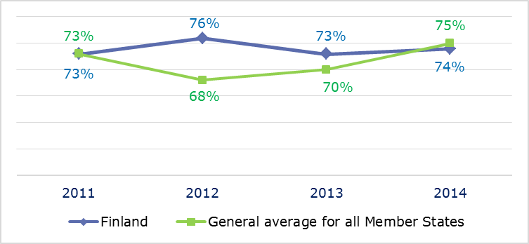
- INFRINGEMENT CASES
- Infringement cases against Finland open on 31 December (2010-14)
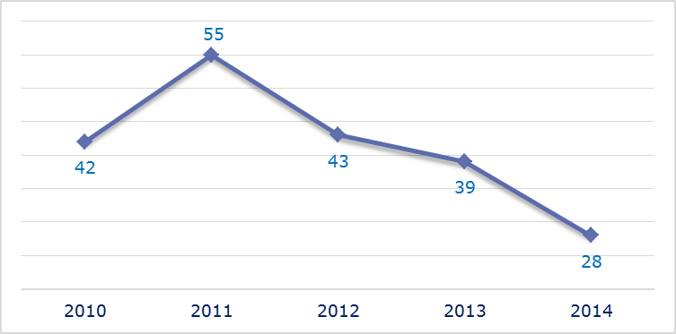
- New infringement cases opened in 2014: main policy areas
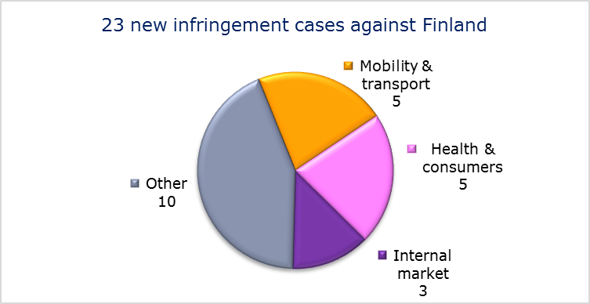
- Key infringement cases and referrals to the Court
- The Commission opened 23 new infringement cases against Finland in 2014. These, and other major ongoing infringement cases, concern:
- implementation of the right to appeal against the refusal, annulment or revocation of a visa;
- non-communication of measures transposing the Capital Requirements Directive;
- maritime cabotage restrictions and discrimination against foreign companies;
- nonconformity of road driving licences;
- failure to notify full transposition of the Cross-border Healthcare Directive;
- incorrect transposition of the directive laying down minimum standards for the protection of pigs, which requires that sows are kept in groups during part of their pregnancy.

- The Commission referred one case to the Court under Article 258 TFEU. It concerns:
- nonconformity with the Racial Equality Directive, due to shortcomings in the competences of the national equality body which provides assistance to victims of discrimination.
- The Commission did not refer any cases to the Court under Article 260(2) TFEU.
- TRANSPOSITION OF DIRECTIVES
- New late transposition infringement cases against Finland (2010-14)
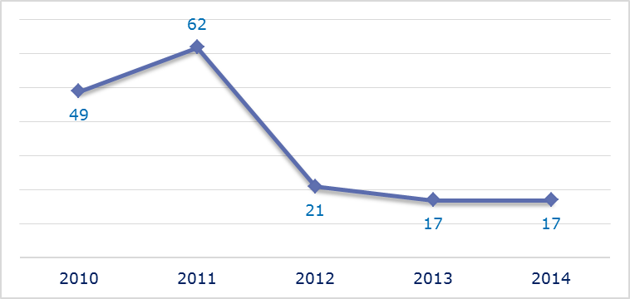
- New late transposition infringement cases opened in 2014: main policy areas
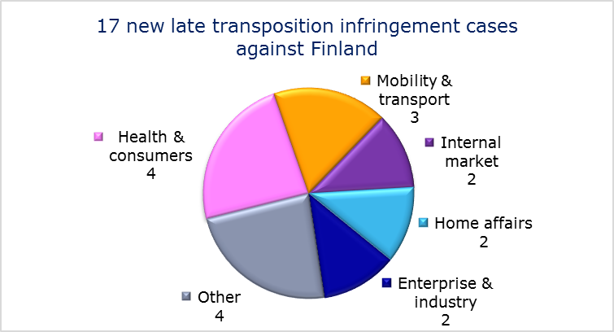
- Referrals to the Court
The Commission referred one case to the Court under Articles 258 and 260(3) TFEU. This concerns:
- failure to fully transpose the Energy Performance of Buildings Directive. The Commission proposed a daily fine of EUR 19 178.25.
- EARLY RESOLUTION OF INFRINGEMENT CASES

Major cases closed without a Court judgment in 2014
These concerned:
- failure to ensure adequate protection of the Saimaa ringed seal;
- incorrect transposition of the Mining Waste Directive;
- discrimination in public transport in the Helsinki region;
- discriminatory taxation of legacies paid to non-resident non-profit organisations.
- IMPORTANT JUDGMENTS
- Court rulings
There were no major Court rulings in 2014.
- Preliminary rulings
In preliminary rulings addressed to the Finnish judiciary, the Court ruled that:
- Member States are not allowed to take into account the different life expectancies of men and women when calculating the statutory benefit payable due to an accident at work.

FRANCE

The number of new complaints made against France has remained relatively stable over the last four years. After a peak in 2013, the number of new cases opened declined in 2014. New EU Pilot files opened against France showed a clear fall from the two previous years. The number of pending infringement cases has been stable since 2013. There was a slight increase in the number of new infringement cases for late transposition, but the levels remains well below those of 2010 and 2011.
- COMPLAINTS
- New complaints made against France by members of the public (2011-14)
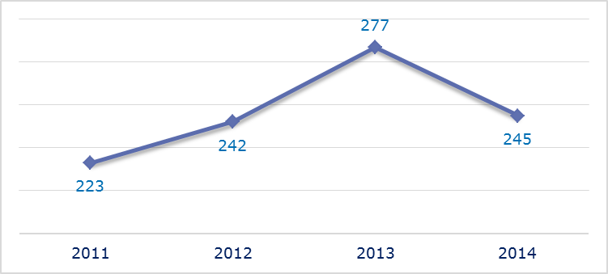
- Evolution of complaints against France
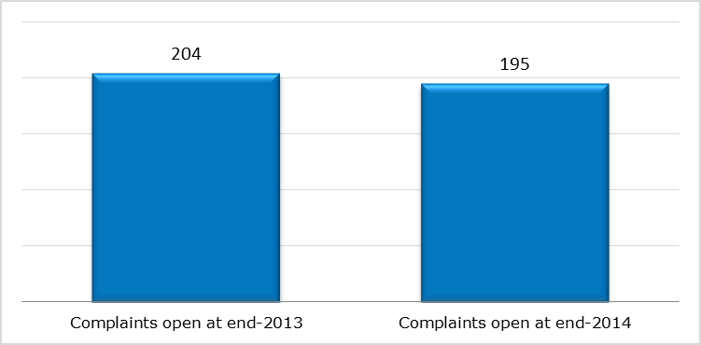
- New complaints registered in 2014: main policy areas
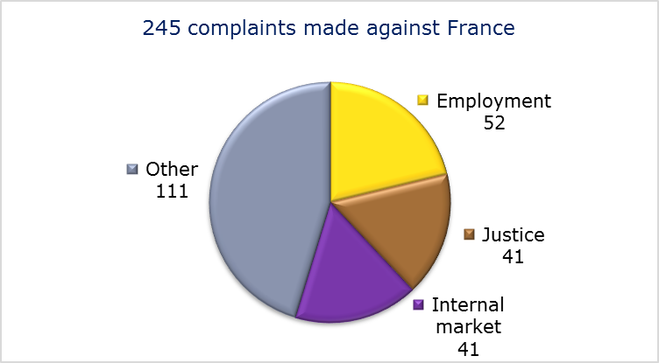
- EU PILOT
- New EU Pilot files opened against France (2011-14)
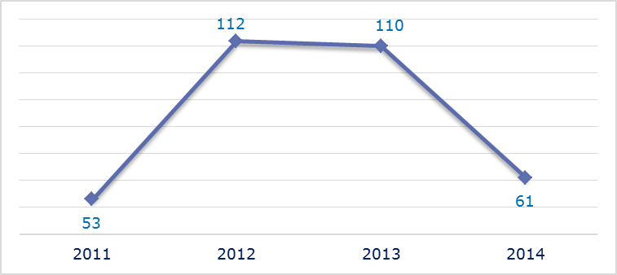
- Evolution of files relating to France open in EU Pilot
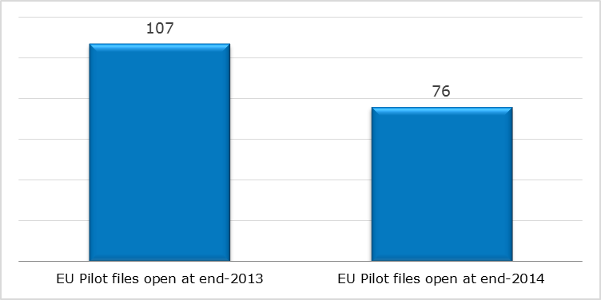
- New EU Pilot files opened in 2014: main policy areas
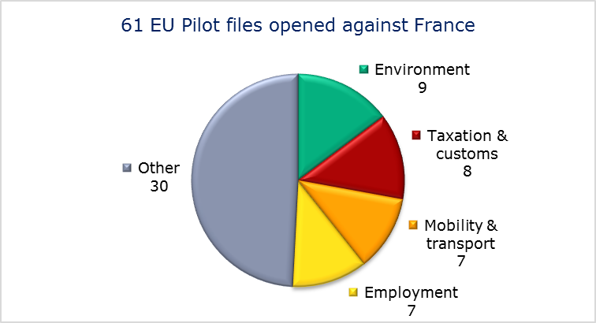
- EU Pilot files: average response time in days (2011-14)
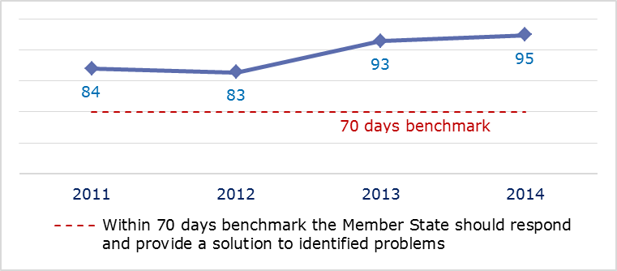
- EU Pilot files: evolution of the resolution rate by France (2011-14)
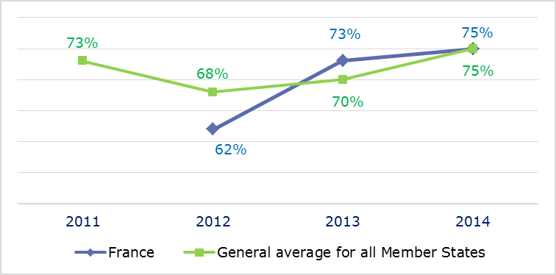
- INFRINGEMENT CASES
- Infringement cases against France open on 31 December (2010-14)
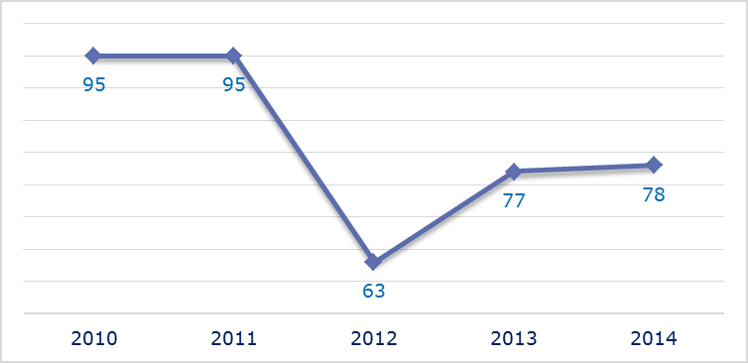
- New infringement cases opened in 2014: main policy areas
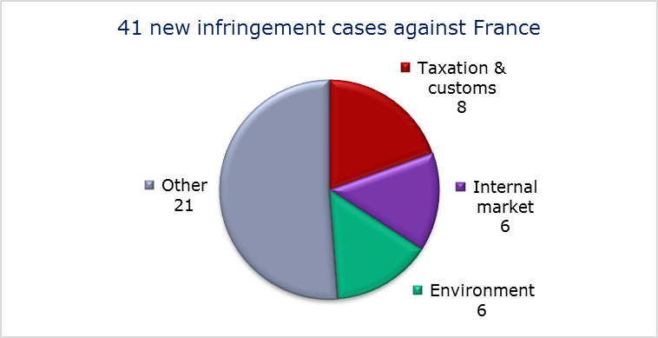
- Key infringement cases and referrals to the Court
- The Commission opened 41 new infringement cases against France in 2014. These, and other major ongoing infringement cases, concern:
- restricting the sale of alcohol test kits to those certified in France;
- restrictions to the importation of certified ambulances;
- incorrect application of the directives on environmental impact assessment and strategic environmental assessment in relation to the Notre-Dame des Landes airport project;
- incorrect application of the Water Framework Directive in relation to the Sivens dam project;
- failure to efficiently implement functional airspace blocks. Under the Single European Sky legislation, national air traffic control organisations should work together in regional airspace blocks to gain efficiency, cut costs and reduce emissions. The set-up of these common airspace blocks is arranged around traffic flows rather than state boundaries, which leads to performance improvements;
- lack of freedom to provide maritime cabotage services to Corsica;
- incorrect transposition of the First Railway package in the Channel Tunnel;
- failure to notify full transposition of the Cross-border Healthcare Directive;
- incorrect transposition of the directive laying down minimum standards for the protection of pigs, which requires that sows are kept in groups during part of their pregnancy;
- incorrect transposition of the directive on unfair business-to-consumer commercial practices in the single market;
- deficiencies in follow-up of the French Supreme Court decision after the CJEU case C-310/09 Accor;
- reduced VAT rate on digital publications;
- non-communication of national measures transposing the Capital Requirements Directive.

- The Commission referred three cases to the Court under Article 258 TFEU. All three concern:
- discriminatory taxation of charities not established in France.
- The Commission did not refer any cases to the Court under Article 260(2) TFEU.
- TRANSPOSITION OF DIRECTIVES
- New late transposition infringement cases against France (2010-14)
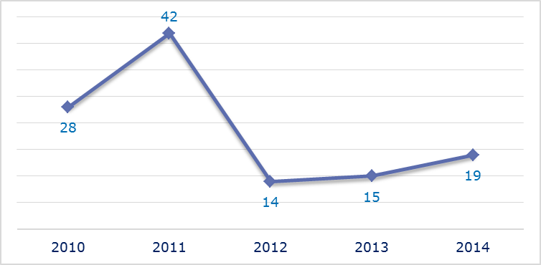
- New late transposition infringement cases opened in 2014: main policy areas
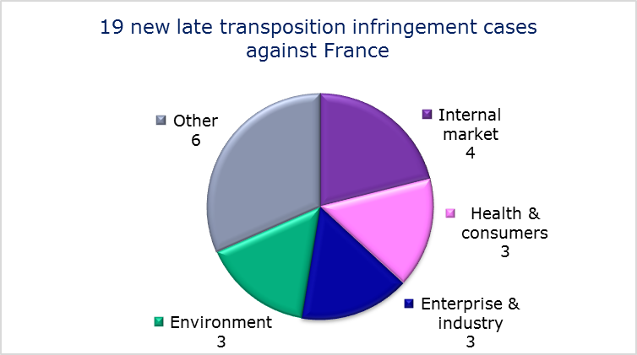
- Referrals to the Court
The Commission did not refer any cases to the Court under Articles 258 and 260(3) TFEU.
- EARLY RESOLUTION OF INFRINGEMENT CASES

Major cases closed without a Court judgment in 2014
These concerned:
- incorrect application of the Competition Directive, Framework Directive and Authorisation Directive concerning electronic communications networks: incumbent national analogue broadcasters were granted ‘bonus’ frequencies while no procedure was in place for any other broadcasters to obtain similar frequencies;
- the existence of regulated gas prices for non-household customers, in breach of the Gas Directive;
- the additional requirement for ‘battery tests’ on cars imported from another Member State where they had already been subject to a roadworthiness check;
- non-recognition of roadworthiness tests from another Member State;
- the freeze of military pensions provided to widows of former Moroccan soldiers who served in the French army. The complainant initiating the case finally withdrew the complaint following a settlement with the French authorities;
- non-communication of national measures transposing the Industrial Emissions Directive;
- tax discrimination against railway services providers;
- incorrect transposition of the First Railway Package;
- passenger rights and designation of national bodies and sanctions when travelling by bus, coach and train;
- tobacco limitation (circulation and detention);
- reduced VAT rate for racehorses;
- VAT exemption for the hiring of sea-going vessels.
- IMPORTANT JUDGMENTS
- Court rulings
The Court ruled that:
- France failed to adequately implement the Nitrates Directive.
- Preliminary rulings
In preliminary rulings addressed to the French judiciary, the Court ruled that:
- Treaty provisions on the free movement of goods preclude national legislation which allows parallel import authorisation to be refused for a plant protection product which does not have a marketing authorisation in the exporting Member State granted in accordance with Directive 91/414/EEC even though that product has a parallel import authorisation and may be regarded as identical to a product covered by a marketing authorisation granted in accordance with that directive in the importing Member State;
- non-EU nationals who have been duly heard on the illegality of their stay need not necessarily be heard again before the adoption of a return decision;
- the extent of the right of illegally staying non-EU nationals to be heard.

GERMANY

In 2014 the number of new complaints made against Germany fell from 2013’s peak but was still above the 2011 and 2012 levels. New EU Pilot files opened against Germany rose very slightly, the fourth consecutive annual increase. The number of pending infringement cases and of new infringement cases for late transposition rose for the second year running but remained below their 2011 levels.
- COMPLAINTS
- New complaints made against Germany by members of the public (2011-14)
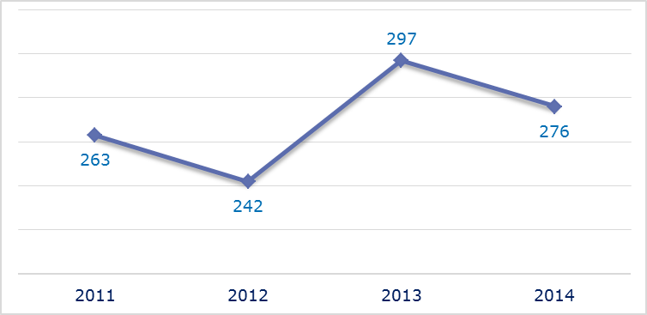
- Evolution of complaints against Germany
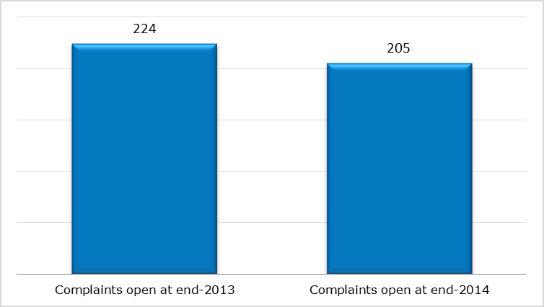
- New complaints registered in 2014: main policy areas
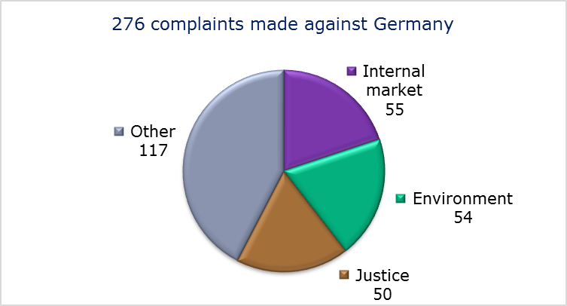
- EU PILOT
- New EU Pilot files opened against Germany (2011-14)
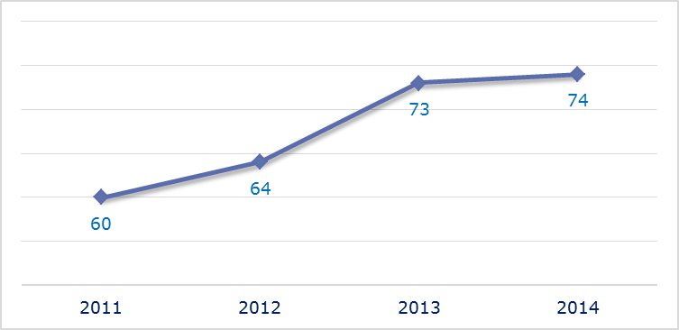
- Evolution of files relating to Germany open in EU Pilot
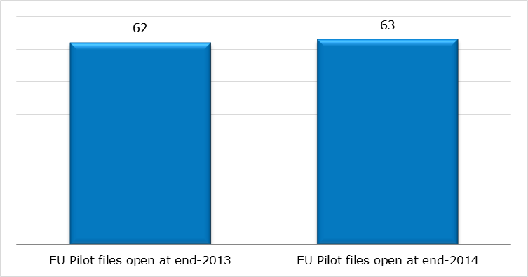
- New EU Pilot files opened in 2014: main policy areas
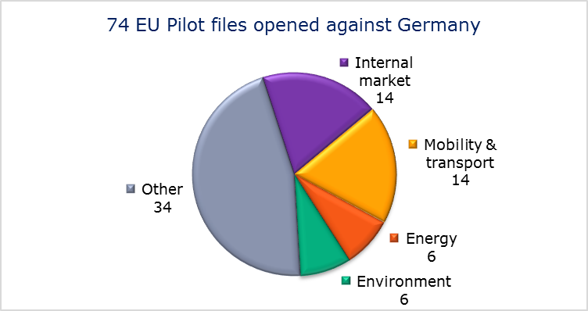
- EU Pilot files: average response time in days (2011-14)
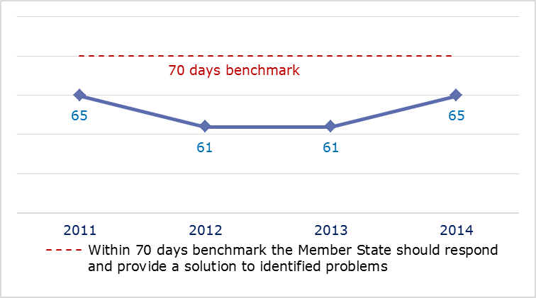
- EU Pilot files: evolution of the resolution rate by Germany (2011-14)
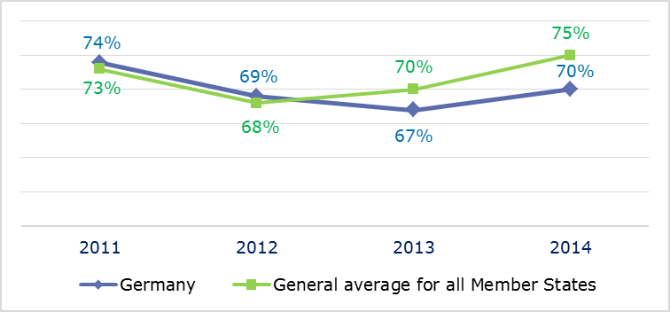
- INFRINGEMENT CASES
- Infringement cases against Germany open on 31 December (2010-14)
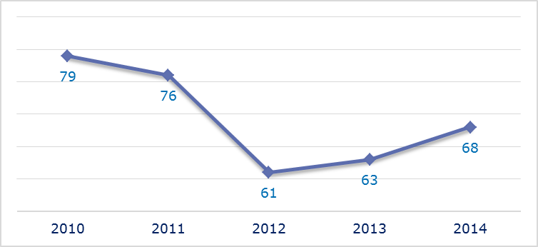
- New infringement cases opened in 2014: main policy areas
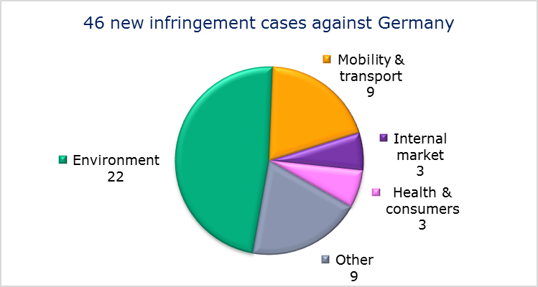
- Key infringement cases and referrals to the Court
- The Commission opened 46 new infringement cases against Germany in 2014. These, and other major ongoing infringement cases, concern:
- nonconformity with the directive on mobile air conditioning: German authorities allowed a German manufacturer to market vehicles in the EU in the first half of 2013 that did not comply with the directive, and decided not to impose any remedial measures on the manufacturer;
- incomplete transposition of the Toy Safety Directive;
- obstacles to the marketing of pyrotechnic goods;
- untimely vehicle inspections;
- restrictions on the establishment of commercial facilities;
- the sale of building plots by municipalities to residents at lower prices than those paid by non-residents (Einheimischenmodell);
- nonconformity of the national legislation with the Return Directive on aspects such as an effective forced-return monitoring system, criminalisation of irregular stay and detention and detention conditions;
- rules on integration requirements (language tests) for granting family reunification;
- nonconformity of German legislation on checks on persons at internal borders with the abolition of internal border controls (Articles 20 and 21 of the Schengen border code);
- ban on online sales of UK veterinary products to customers located in Germany;
- incomplete transposition of the directive on free movement of EU nationals and their family members and violation of Article 21(1) TFEU;
- failure to efficiently implement functional airspace blocks. Under the Single European Sky legislation, national air traffic control organisations should work together in regional airspace blocks to gain efficiency, cut costs and reduce emissions. The set-up of these common airspace blocks is arranged around traffic flows rather than state boundaries, which leads to performance improvements;
- inadequate aviation security;
- failure to notify full transposition of the Cross-border Healthcare Directive.

- The Commission referred two cases to the Court under Article 258 TFEU. They concern:
- nonconformity with EU law of the German legislation on access to justice in environmental matters;
- failure to separate financial flows between train operators and rail track managers in breach of Directive 91/440/EEC on the separation of accounts in the rail sector.

- The Commission did not refer any cases to the Court under Article 260(2) TFEU.
- TRANSPOSITION OF DIRECTIVES
- New late transposition infringement cases against Germany (2010-14)
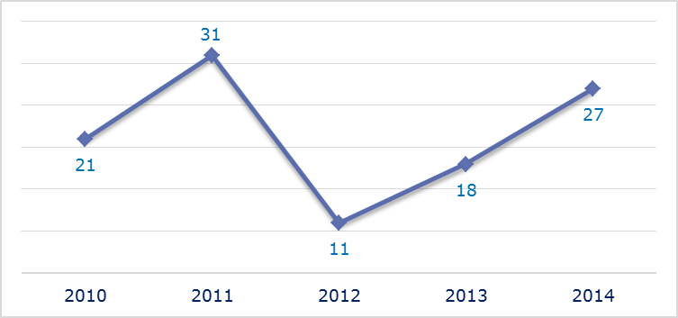
- New late transposition infringement cases opened in 2014: main policy areas
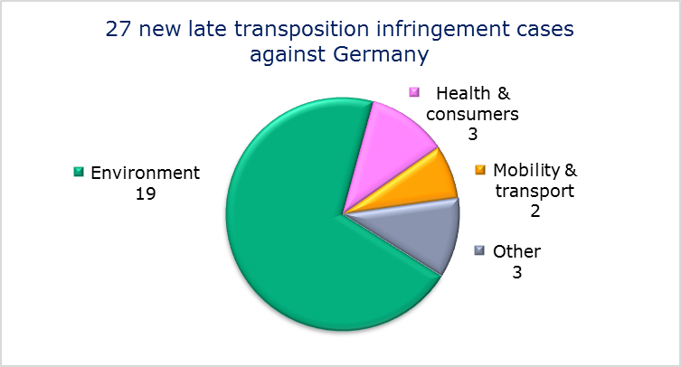
- Referrals to the Court
The Commission did not refer any cases to the Court under Articles 258 and 260(3) TFEU.
- EARLY RESOLUTION OF INFRINGEMENT CASES

Major cases closed without a Court judgment in 2014
These concerned:
- the legislation concerning door-to-door sales. Germany modified its legislation so that consumers are now guaranteed effective protection in all cases covered by the directive to protect the consumer in respect of contracts negotiated away from business premises;
- non-communication of national measures transposing the Late Payment Directive;
- inadequate urban waste water treatment in small agglomerations;
- reduced VAT rate on works of art.
- IMPORTANT JUDGMENTS
- Court rulings
The Court ruled that:
- the German action for annulment under Article 263 TFEU challenging the Council Decision of 18 June 2012 ‘establishing the position to be adopted on behalf of the European Union with regard to certain resolutions to be voted in the framework of the International Organisation for Vine and Wine (OIV)’ is dismissed;
- the German obligation for CE-marked construction products to meet supplementary national requirements for construction products (Bauregellisten) violates the EU rules on the free movement of goods;
- Germany has not failed to fulfil its obligations under Directive 2000/60/EC of the European Parliament and of the Council of 23 October 2000 establishing a framework for Community action in the field of water policy, particularly Articles 2(38) and 9, by excluding certain services from the concept of ‘water services’;
- Germany has to grant non-residents the same inheritance and gift tax allowances as if at least one of the people concerned were resident.

- Preliminary rulings
In preliminary rulings addressed to the German judiciary, the Court ruled that:
- the German monetary allowance for annual leave not taken when an employment relationship is terminated cannot be lost when termination comes about by a workers’ death, on the basis of Article 7 of the Working Time Directive;
- the pre-existing German ‘special liability system’ for pharmaceutical products can still be extended after the notification of Directive 85/374 without infringing the directive;
- consumers supplied with electricity and gas within the framework of a universal supply obligation must be informed, in good time before any price increase comes into effect, of the reasons and preconditions for the increase and its scope. By not providing for such information, the German legislation at issue does not comply with the Electricity and Gas Directives;
- Member States are not obliged to grant social assistance benefits to people who do not meet the conditions for legal residence set out in the directive on the right of EU nationals and their family members to move and reside freely within the territory of the Member States;
- the requirement that the spouse of a Turkish national residing in a Member State should prove the acquisition of basic knowledge of the official language of that State as a condition for issuing a visa for family reunification is incompatible with the standstill clause of the additional protocol to the EC-Turkey association agreement ;
- Member States are obliged to admit to their territory non-EU nationals who wish to stay for more than three months for study purposes if they meet the conditions for admission listed in EU law and if none of the grounds expressly listed by EU law as justification for refusing a residence permit are invoked;
- a Member State is required to detain non-EU nationals staying illegally for the purpose of removing them to a specialised detention facility of that State even if the Member State has a federal structure and the federated state competent to decide upon and carry out such detention under national law does not have such a detention facility;
- the Court does not have jurisdiction to interpret directly the 1951 Refugee Convention, although several pieces of EU legislation have been adopted in the field to which it applies as part of the implementation of EU asylum legislation;
- the Court upheld the validity of the enforcement condition in the "ne bis in idem" principle (Article 54 CISA) requiring that, upon conviction and sentencing, the penalty imposed ‘has been enforced’ or is ‘actually in the process of being enforced’;
- the immediate taxation of the underlying capital gains involved in a corporate restructuring operation, if the capital gains of the shares issued in exchange for the contribution and attributed to non-residents were not subject to German taxation, is justified for preserving the balanced allocation of the power to impose tax;
- it is compatible with the Treaty to reimburse the underlying corporation tax on dividends distributed by German subsidiaries to a German loss-making parent company, where these dividends represent taxable income, but to refuse reimbursement of the underlying corporation tax on dividends distributed by subsidiaries established in non-EU countries.

GREECE

The number of new complaints made against Greece rose in 2014 after falling for two years. New EU Pilot files opened against Greece declined in both 2013 and 2014 from their peak in 2012. The number of pending infringement cases has remained relatively stable since 2012 at a level well below the previous years. New infringement cases for late transposition rose in 2014 but stayed below the 2011 level.
- COMPLAINTS
- New complaints made against Greece by members of the public (2011-14)
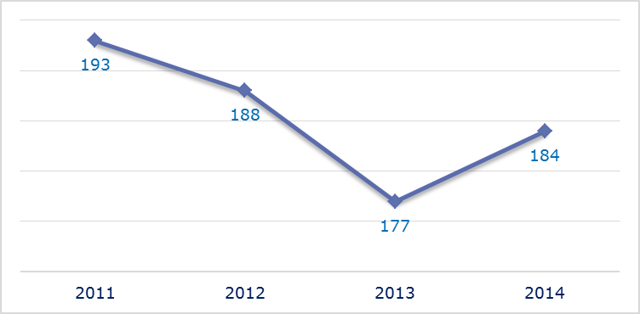
- Evolution of complaints against Greece
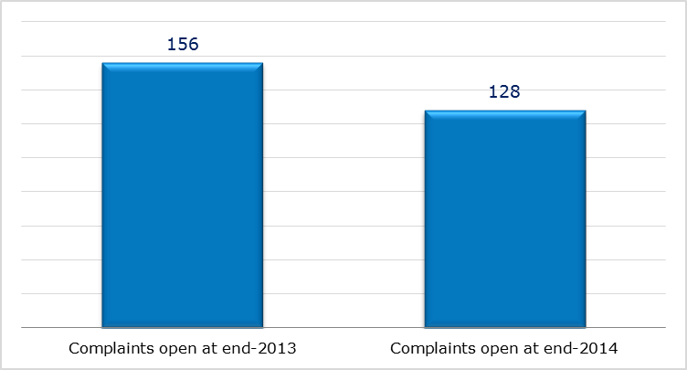
- New complaints registered in 2014: main policy areas
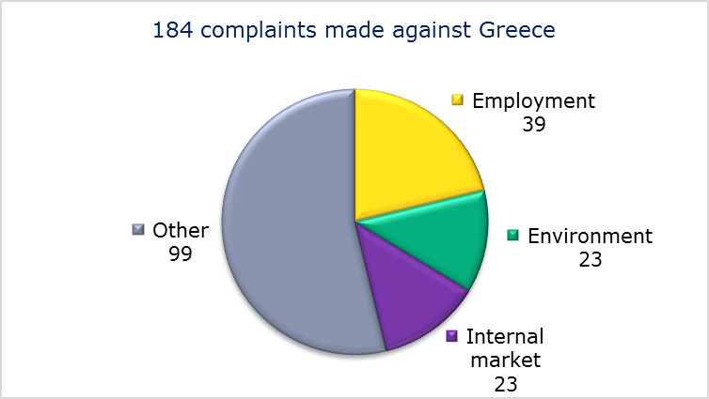
- EU PILOT
- New EU Pilot files opened against Greece (2011-14)
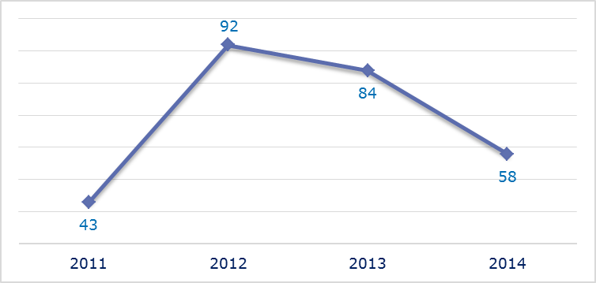
- Evolution of files relating to Greece open in EU Pilot
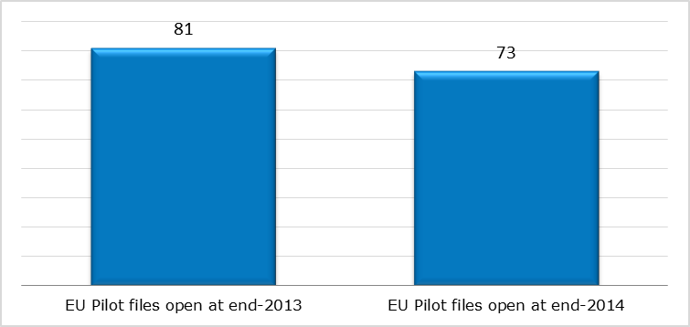
- New EU Pilot files opened in 2014: main policy areas
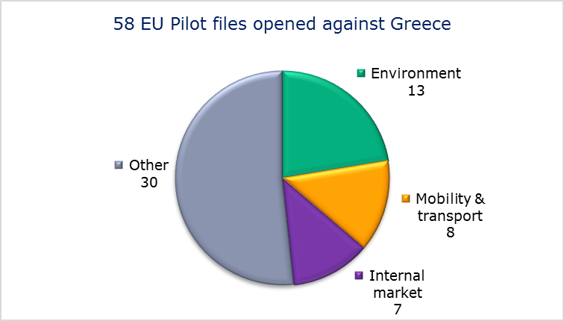
- EU Pilot files: average response time in days (2011-14)
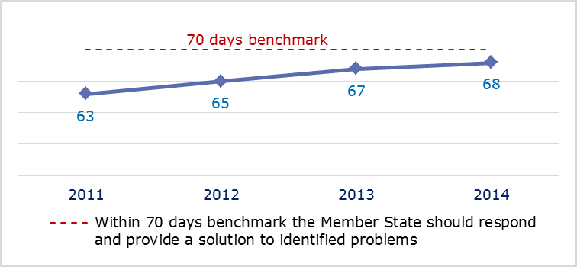
- EU Pilot files: evolution of the resolution rate by Greece (2011-14)
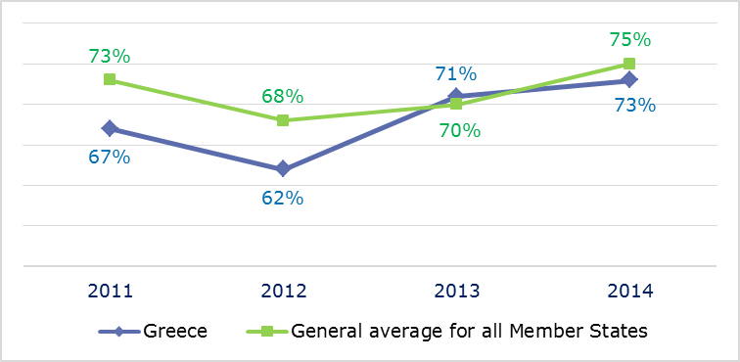
- INFRINGEMENT CASES
- Infringement cases against Greece open on 31 December (2010-14)
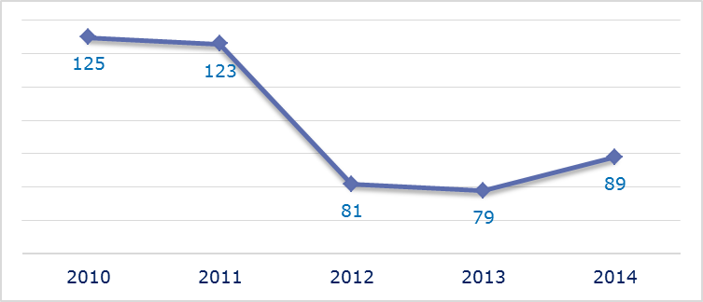
- New infringement cases opened in 2014: main policy areas
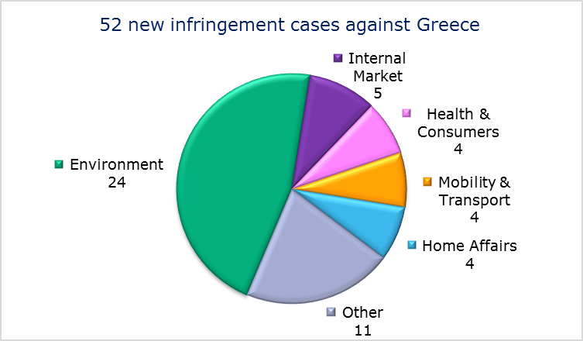
- Key infringement cases and referrals to the Court
- The Commission opened 52 new infringement cases against Greece in 2014. These, and other major ongoing infringement cases, concern:
- nonconformity of a national law from 1934 forcing all wine producers in Samos to be members of the local cooperative and deliver their entire production to it;
- failure to comply with a Commission Decision and the subsequent judgment of the Court of Justice under Article 108(2) TFEU on several aid measures in favour of Hellenic Shipyards SA that constitute incompatible aid and several aid measures approved by the Commission in the past that have been misused;
- failure to comply with reporting obligations under the Energy Performance of Buildings Directive;
- failure to communicate to the Commission a long-term strategy for mobilising investment in renovating the national stock of residential and commercial buildings and its national energy efficiency action plan as required under the Energy Efficiency Directive;
- nonconformity of national legislation with the Return Directive on aspects such as an effective forced-return monitoring system, criminalisation of irregular stay and detention and detention conditions;
- late transposition of the directive on the single permit for non-EU nationals and the directive on combating sexual abuse and sexual exploitation of children and child pornography;
- non-communication of measures transposing the Capital Requirements Directive;
- the shareholder agreement concluded in the framework of the sale of OTE shares to Deutsche Telekom and ratified by law, which provides for special rights of the Greek State that are considered to be incompatible with the free movement of capital and the freedom of establishment;
- failure to efficiently implement functional airspace blocks. Under the Single European Sky legislation, national air traffic control organisations should work together in regional airspace blocks to gain efficiency, cut costs and reduce emissions. The set-up of these common airspace blocks is arranged around traffic flows rather than state boundaries, which leads to performance improvements;
- incorrect transposition of the Court decision on the First Railway package;
- incorrect application of the regulation on the rights of bus and coach passengers;
- discriminatory airport charges;
- failure to notify full transposition of the Cross-border Healthcare Directive;
- incorrect transposition of the directive laying down minimum standards for the protection of pigs, which requires that sows are kept in groups during part of their pregnancy;
- excise duty and reduced taxation of spirit drinks;
- discriminatory taxation of vessels with foreign flags;
- violation of statistical principles.
- The Commission referred three cases to the Court under Article 258 TFEU. They concern:
- incorrect application of the Working Time Directive as interpreted by the Court of Justice, particularly regarding the on-call time of doctors in rural public health services;
- failure to designate a number of zones vulnerable to nitrate pollution and to adopt measures to effectively combat nitrate pollution in these zones;
- failure to provide adequate protection for endangered sea turtles.

- The Commission referred one case to the Court under Article 260(2) TFEU. This concerns:
- failure to implement a judgment of the Court of Justice finding that Greece was failing in its obligation to treat and dispose of urban waste water adequately, with 23 agglomerations across the country lacking the necessary collection and treatment systems. The Commission proposed a lump sum penalty payment of EUR 11 514 081 and a daily penalty of EUR 47 462 until the obligations are fulfilled.
- TRANSPOSITION OF DIRECTIVES
- New late transposition infringement cases against Greece (2010-14)
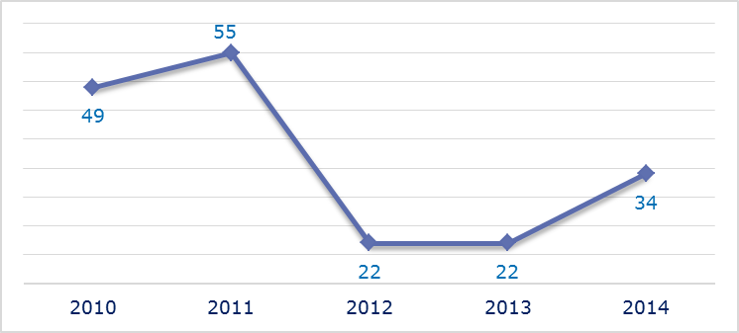
- New late transposition infringement cases opened in 2014: main policy areas
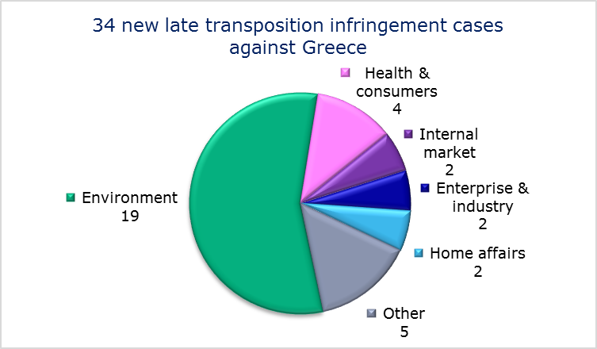
- Referrals to the Court
The Commission did not refer any cases to the Court under Articles 258 and 260(3) TFEU.
- EARLY RESOLUTION OF INFRINGEMENT CASES

Major cases closed without a Court judgment in 2014
These concerned:
- award of a contract for the provision of information technology services to the Social Insurance Foundation (IKA);
- public procurement restrictions on consultants based in Greece and domestic construction companies;
- obstacles to the importation of ice cream packs;
- restrictions on the marketing of plant propagating material;
- deficiencies in the system for training and certifying seafarers;
- lack of port security plans;
- ratification of the Convention on International Carriage by Rail;
- national income taxation of individuals and discrimination against non-residents with disabilities when applying car registration tax;
- notional income taxation of individuals;
- taxable value of second-hand vehicles;
- non-deductibility of payments to low-tax jurisdictions.
- IMPORTANT JUDGMENTS
- Court rulings
The Court ruled that:
- the rearing of laying hens in cages does not comply with the requirements of the directive on the protection of laying hens;
- a General Court judgment annulling the Commission's 2008 decision, finding that Greece had infringed Article 106 TFEU in combination with Article 102 TFEU, should be overturned. The Commission's 2008 decision concerned lignite-exploitation rights giving the State-owned energy company privileged access to lignite, the cheapest source of electricity in Greece. The Commission decision has been referred back to the General Court to rule on outstanding arguments. However, the Court's judgment is a useful clarification as to the scope of application of Article 106 in combination with Article 102;
- Greece failed to fully comply with the 2005 judgment of the Court of Justice finding that it breached the Waste Directive by continuing to operate illegal landfill sites. In addition to a lump sum of EUR 10 million, the Court ordered Greece to pay a fine until the 2005 judgment is fully complied with. The amount of the fine will depend on the progress Greece makes, but in the absence of any progress it will be more than EUR 14 million for each six months of delay.
- Preliminary rulings
No major preliminary rulings were addressed to the Greek judiciary in 2014.

The number of files open at the end of 2013 given in the 2013 annual report is different from the current figure. This is because some files were registered late and others have been closed.
MEMO/14/2130.
Directive 2013/36/EU.
Directive 2011/24/EU, MEMO/14/470.
Directive 2008/120/EC and MEMO/14/36.
Directive 2000/43/EC.
The Commission decided on 14 July 2014 to refer the case to the Court; the application was filed on 26 November 2014, Commission v Finland, C-538/14, IP/14/811.
Directive 2010/31/EU, Commission v Finland, C-329/14, IP/14/447.
Directive 2006/21/EC.
X., C-318/13.
The number of files open at the end of 2013 given in the 2013 annual report is different from the current figure. This is because some files were registered late and others have been closed.
No data on the resolution rate for 2011 are available since France joined the EU Pilot system only in September 2011.
MEMO/14/36.
Directives 2001/42/EC and 2011/92/EU.
Directive 2000/60/EC.
Regulation (EC) No 550/2004.
IP/14/446.
MEMO/13/583, IP-13-357.
Directive 2011/24/EU, MEMO/14/470.
Directive 2008/120/EC.
MEMO/14/36.
Directive 2005/29/EC.
Directive 2013/36/EU.
Commission v France, C-485/14, IP/14/808 (the three infringement cases will be dealt with in a single Court procedure).
Commission Directive 2002/77/EC.
Directive 2002/21/EC.
Directive 2002/19/EC.
Directive 2009/73/EC.
Directive 2010/75/EU.
Directive 91/676/EEC, Commission v France, C-237/12 and Commission v Poland, C-356/13.
MAC GmbH v Ministère de l’Agriculture, de l’Agroalimentaire et de la Forêt, C-108/13.
Mukarugeba v Préfet de police et Préfet de la Seine-Saint-Denis, C-166/13.
Boudljida v Préfet des Pyrénées-Atlantiques, C-249/13.
MEMO/14/537.
Directive 2009/48/EC, MEMO/14/589.
Directive 2011/12/EU, MEMO/14/36.
Directive 2008/115/EC.
Regulation (EC) No 562/2006.
Directive 2004/38.
Regulation (EC) No 550/2004.
IP/14/446.
MEMO/14/2130.
MEMO/14/470.
Directive 2003/35/EC. The Commission decided on 17 October 2013 to refer the case to the Court; the application was filed on 21 March 2014, Commission v Germany, C-137/14, IP/13/967.
Commission v Germany, C-482/14.
Council Directive 85/577/EC.
Directive 2011/7/EU.
Germany v Council, C-399/12.
Commission v Germany, C-100/13.
Commission v Germany, C-525/12.
Commission v Germany, C-211/13 and IP/12/1018 on the earlier referral decision.
Directive 2003/88/EC, Bollacke, C-118/13.
Novo Nordisk Pharma GmbH v S., C-310/13.
Schulz & Egbringhoff, Joined cases C-359/11 and C-400/11 and Court press release No 140/14.
Directive 2004/38/EC, Dano, C-333/13.
That requirement is not compatible with the ‘standstill clause’ of the Association Agreement with Turkey.
Dogan, C-138/13 and Court press release No 96/14.
Council Directive 2004/114/EC.
Ben Alaya, C-491/13 and Court press release No 120/14.
Adala Bero v Regierungspräsidium Kassel, Ettayebi Bouzalmate v Kreisverwaltung Kleve, Thi Ly Pham v Stadt Schweinfurt, Amt für Meldewesen und Statistik, joint cases C-473/13, C-514/13 and C-474/13.
Qurbani, C-481/13.
Zoran Spasic, C-129/14 PPU.
DMC Beteiligungsgesellschaft mbH v Finanzamt Hamburg-Mitte, C-164/12.
Kronos International Inc. v Finanzamt Leverkusen, C-47/2014.
The number of files open at the end of 2013 given in the 2013 annual report is different from the current figure. This is because some files were registered late and others have been closed.
Commission Decision 2009/610/EC.
Commission v Greece, C-485/10.
Directive 2010/31/EU.
Directive 2012/27/EU.
Directive 2008/115/EC.
Directive 2011/98/EU.
Directive 2011/92/EU.
Directive 2013/36/EU.
IP-12-420.
Regulation (EC) No 550/2004.
IP/14/818.
IP-10-807.
Regulation (EU) No 181/2011, MEMO/14/537.
MEMO/14/470.
Directive 2008/120/EC.
MEMO/14/36.
MEMO/14/537.
Directive 2003/88/EC.
The Commission decided on 20 November 2013 to refer the case to the Court; the application was filed on 11 April 2014, Commission v Greece, C-180/14, IP/13/1108.
Directive 91/676/EEC. The Commission decided on 20 June 2013 to refer the case to the Court; the application was filed on 31 March 2014, Commission v Greece, C-149/14, IP/13/576.
Commission v Greece, C-504/14, IP/14/324.
The Commission decided on 20 November 2013 to refer the case to the Court; the application was filed on 9 April 2014, Commission v Greece, C-167/14, IP/13/1102.
Directive 1999/74/EC Commission v Hellenic Republic, C-351/13.
Commission v Greece, C-378/13 and Court press release No 164/14.

