LITHUANIA

The number of new complaints made against Lithuania has hardly changed over the last four years. However, new EU Pilot files opened against Lithuania fell visibly in 2014 from their 2013 peak. The number of pending infringement cases rose slightly but remained far below the 2011 level. New infringement cases for late transposition fell marginally and were well below half the total in 2011.
- COMPLAINTS
- New complaints made against Lithuania by members of the public (2011-14)
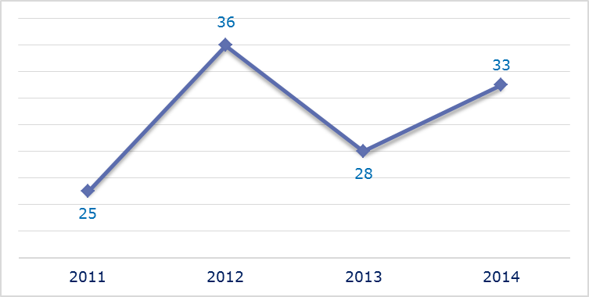
- Evolution of complaints against Lithuania
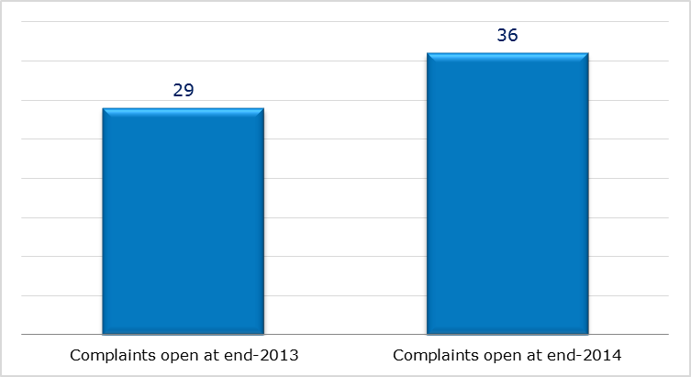
- New complaints registered in 2014: main policy areas
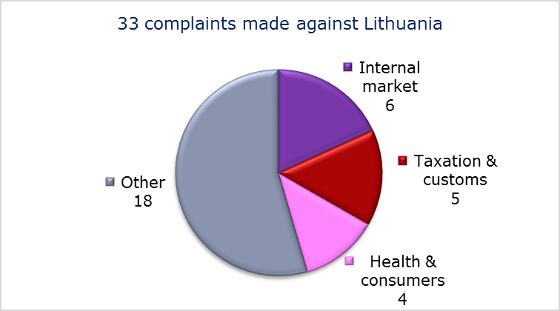
- EU PILOT
- New EU Pilot files opened against Lithuania (2011-14)
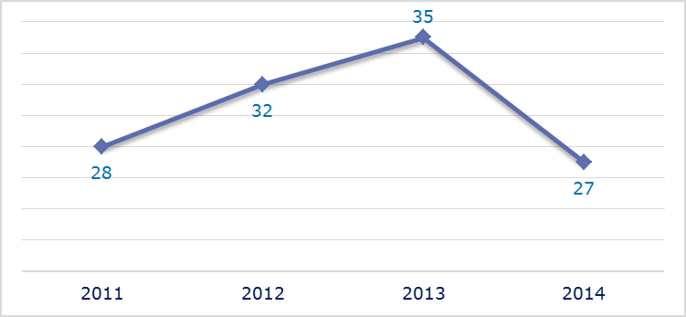
- Evolution of files relating to Lithuania open in EU Pilot
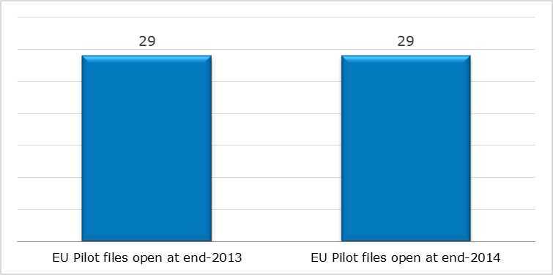
- New EU Pilot files opened in 2014: main policy areas
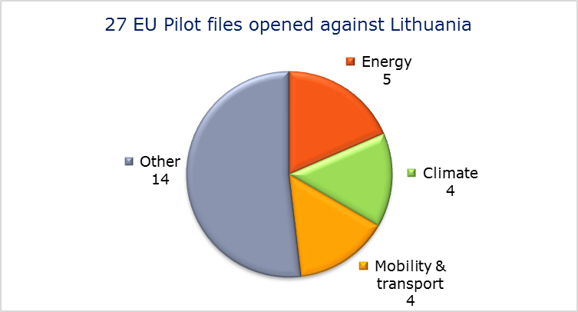
- EU Pilot files: average response time in days (2011-14)
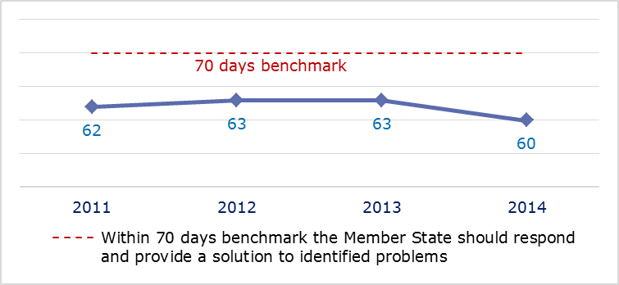
- EU Pilot files: evolution of the resolution rate by Lithuania (2011-14)
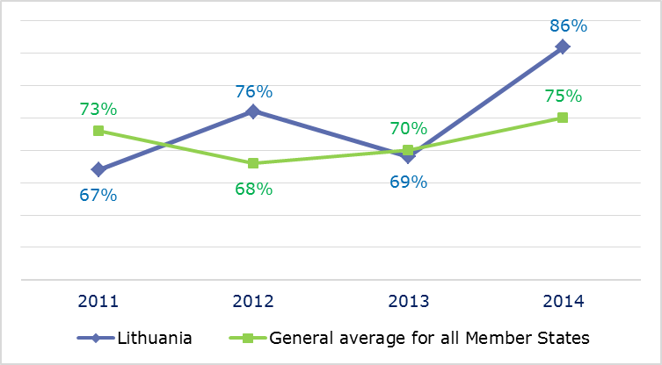
- INFRINGEMENT CASES
- Infringement cases against Lithuania open on 31 December (2010-14)
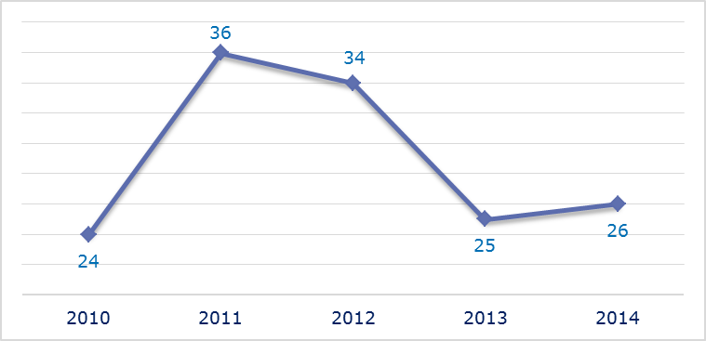
- New infringement cases opened in 2014: main policy areas
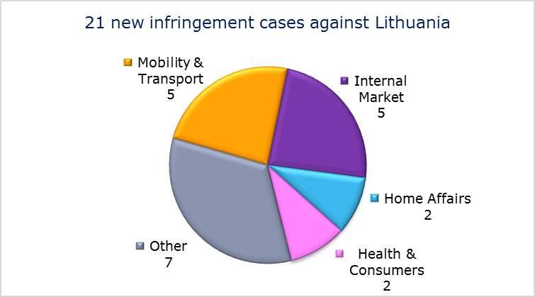
- Key infringement cases and referrals to the Court
- The Commission opened 21 new infringement cases against Lithuania in 2014. These, and other major ongoing infringement cases, concern:
- nonconformity of the national legislation with the Audiovisual Media Services Directive. Under Lithuanian law, television broadcasts from another Member State may be suspended if they contain information on gay marriage or homosexual couples starting families. This restriction could go beyond the scope of the derogations contained in the directive regarding the protection of minors;
- incorrect application of the rule in the Fuel Quality Directive requiring Member States to ensure that the ethanol content of petrol placed on the market within their territory is below 10 %;
- non-communication of national measures transposing the Capital Requirements Directive, the Industrial Emissions Directive and one directive concerning the automotive sector;
- violation of the principle of free movement of goods by requiring articles of precious metal imported from another EU country to be stamped with an additional national hallmark even when they have already been lawfully hallmarked and marketed in the EU;
- restrictions on the right of EU nationals to become members of a political party or to found one in the Member State of residence;
- nonconformity of national legislation with the directive on free movement and residence rights of EU citizens and their family members;
- violation of the principle of freedom to provide services in the port of Klaipeda;
- failure to efficiently implement functional airspace blocks. Under the Single European Sky legislation, national air traffic control organisations should work together in regional airspace blocks to gain efficiency, cut costs and reduce emissions. The set-up of these common airspace blocks is arranged around traffic flows rather than state boundaries, which leads to performance improvements;
- nonconformity of national legislation with the Railway Safety Directive.
- The Commission did not refer any cases to the Court under Article 258 TFEU.
- The Commission did not refer any cases to the Court under Article 260(2) TFEU.
- TRANSPOSITION OF DIRECTIVES
- New late transposition infringement cases against Lithuania (2010-14)
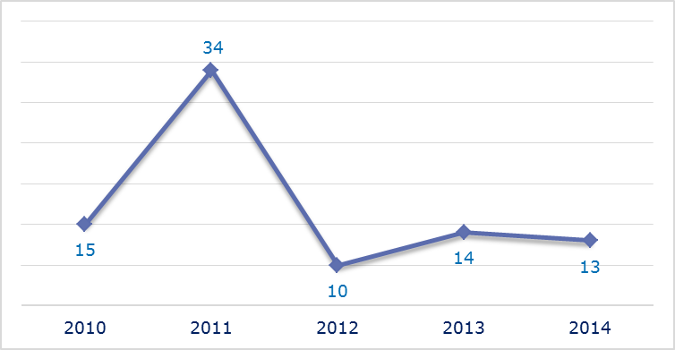
- New late transposition infringement cases opened in 2014: main policy areas
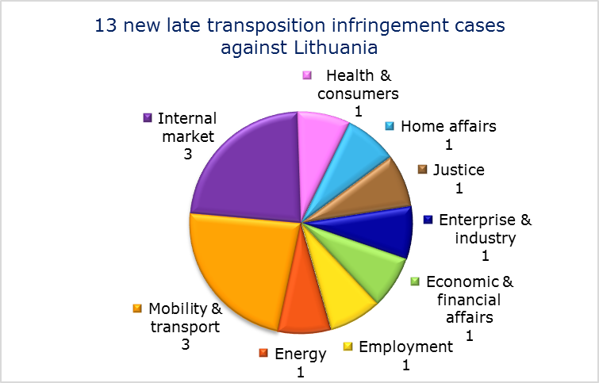
- Referrals to the Court
The Commission did not refer any cases to the Court under Articles 258 and 260(3) TFEU.
- EARLY RESOLUTION OF INFRINGEMENT CASES

Major cases closed without a Court judgment in 2014
These concerned:
- non-communication of national transposition measures concerning the End-of-Life Vehicles Directive;
- incorrect application of the Wild Birds Directive due to the insufficient designation of Special Protection Areas;
- nonconformity of national measures with the directive on separation of accounts in the rail sector.
- IMPORTANT JUDGMENTS
- Court rulings
The Court ruled that:
- the obligation imposed by Lithuanian law to move the steering wheel of right-hand drive vehicles to the left-hand side for road safety reasons infringes EU law.
- Preliminary rulings
In preliminary rulings addressed to the Lithuanian judiciary, the Court ruled that:
- the free movement of goods principle does not permit national legislation that requires precious metal articles to be controlled and stamped again when they have been imported from another Member State where they have already been authorised to be put on the market and stamped with a hallmark in accordance with that Member State’s legislation;
- the national legislation stipulating that a hot water meter that satisfies all the requirements of the directive on measuring instruments and is connected to a remote data-transmission device cannot be used for its intended purpose if it has not undergone a metrological verification as a measuring system infringes the free movement of goods principle.

LUXEMBOURG

The number of new complaints made against Luxembourg increased considerably in 2014 but new EU Pilot files opened against it fell from 2013’s peak. The overall number of pending infringement cases has not fluctuated greatly over the last five years. New infringement cases for late transposition fell, holding well below the 2010 and 2011 levels.
- COMPLAINTS
- New complaints made against Luxembourg by members of the public (2011-14)
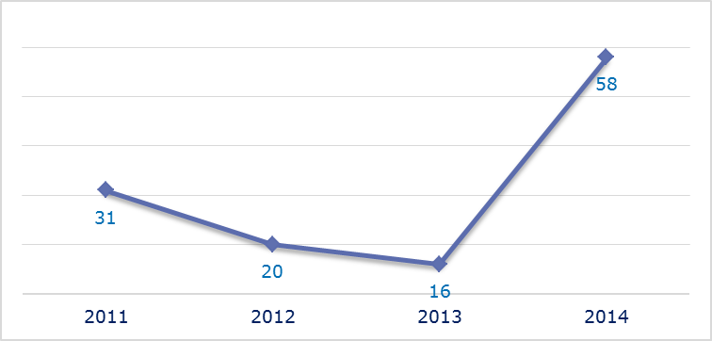
- Evolution of complaints against Luxembourg
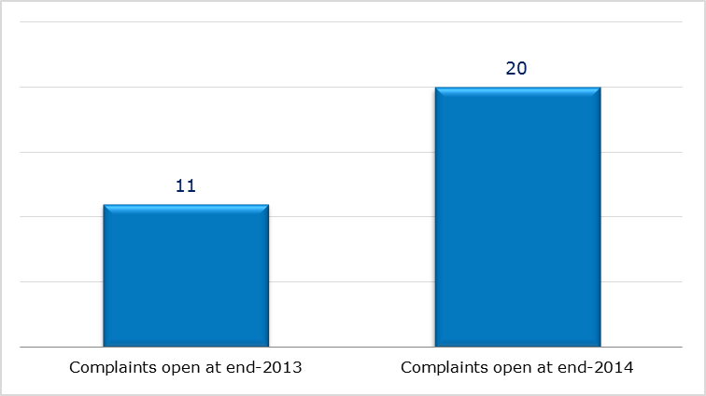
- New complaints registered in 2014: main policy areas
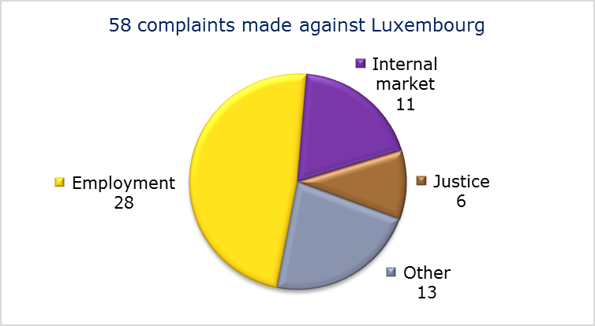
- EU PILOT
- New EU Pilot files opened against Luxembourg (2011-14)
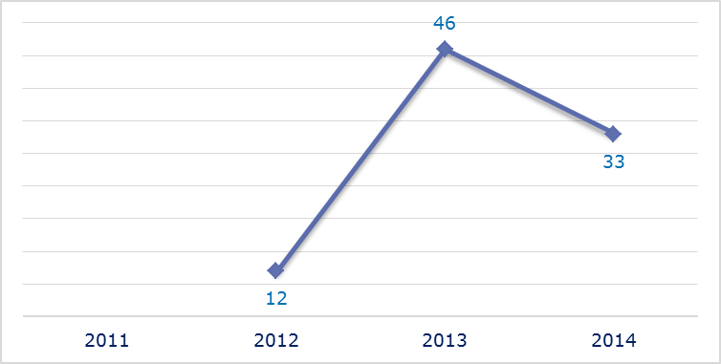
- Evolution of files relating to Luxembourg open in EU Pilot
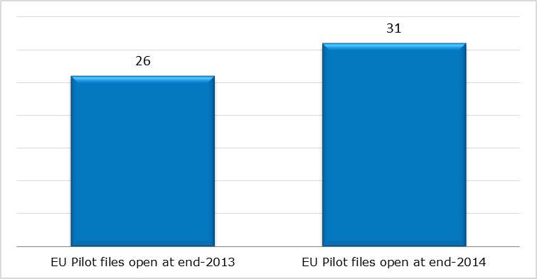
- New EU Pilot files opened in 2014: main policy areas
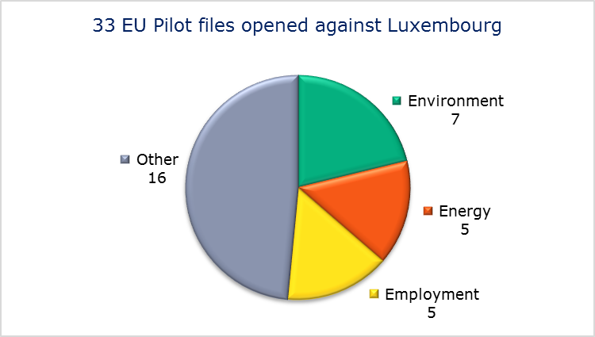
- EU Pilot files: average response time in days (2011-14)
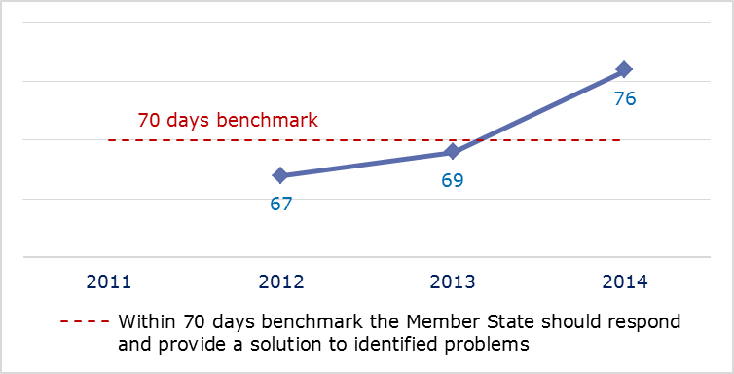
- EU Pilot files: evolution of the resolution rate by Luxembourg (2011-14)
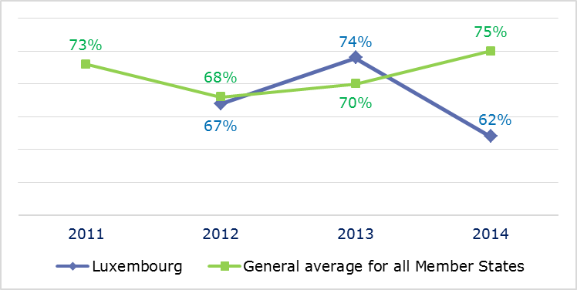
- INFRINGEMENT CASES
- Infringement cases against Luxembourg open on 31 December (2010-14)
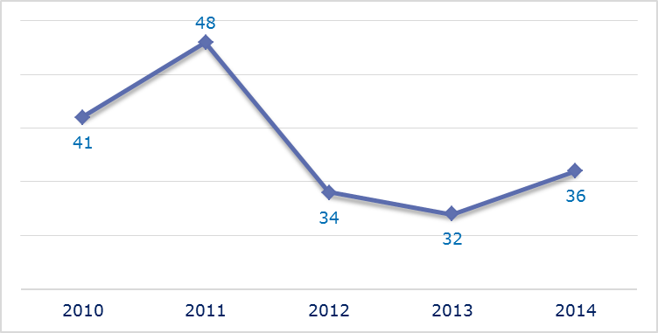
- New infringement cases opened in 2014: main policy areas
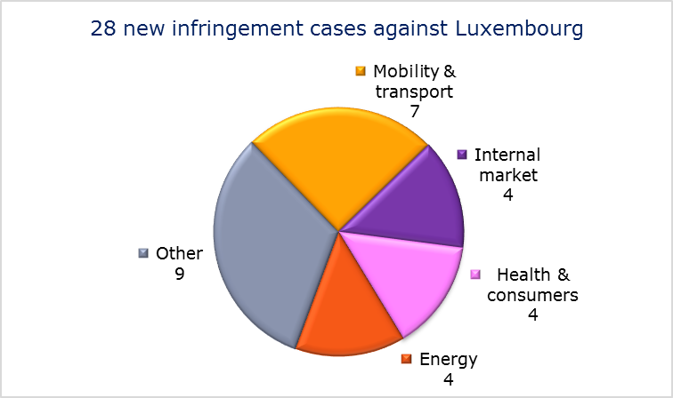
- Key infringement cases and referrals to the Court
- The Commission opened 28 new infringement cases against Luxembourg in 2014. These, and other major ongoing infringement cases, concern:
- non-compliance with the information injunctions in the context of tax ruling and patent box enquiries based on the State aid Procedural Regulation;
- incorrect transposition of the Working Time Directive as regards the annual leave of civil servants;
- incorrect transposition of the Electricity and Gas Directives;
- failure to communicate to the Commission its long-term strategy for mobilising investment in renovating the national stock of residential and commercial buildings and its national energy efficiency action plan, as required under Energy Efficiency Directive;
- inadequate treatment of urban waste water;
- the incorrect application of the regulation on the rights of bus and coach passengers by not setting up a penalty system for infringements of the regulation;
- incorrect transposition of the Railway Interoperability Directive due to shortcomings in safety management, the validity of safety certificates, the independence, tasks and decision-making of the safety authority and the independence of the investigating body;
- failure to efficiently implement functional airspace blocks. Under the Single European Sky legislation, national air traffic control organisations should work together in regional airspace blocks to gain efficiency, cut costs and reduce emissions. The set-up of these common airspace blocks is arranged around traffic flows rather than state boundaries, which leads to performance improvements;
- incomplete transposition of the Capital Requirements Directive and of the Cross-border Healthcare Directive.
- The Commission referred three cases to the Court under Article 258 TFEU. They concern the following:
- the national regulatory authority (the Institut Luxembourgeois de Régulation) had failed to carry out a timely analysis of the relevant markets for fixed access to the public telephone network and for leased lines, in breach of EU telecoms rules;
- the Labour code’s incompatibility with the Fixed-Term Work Directive regarding the advertising of vacancies and workers in casual employment in show business;
- the VAT system applied to independent groups of people: the services provided by an independent group to its members are free of VAT provided that the members’ taxed activities do not exceed 30 % (or 45 % under certain conditions) of their annual turnover. This is not compatible with the EU’s VAT rules.
- The Commission did not refer any cases to the Court under Article 260(2) TFEU.
- TRANSPOSITION OF DIRECTIVES
- New late transposition infringement cases against Luxembourg (2010-14)
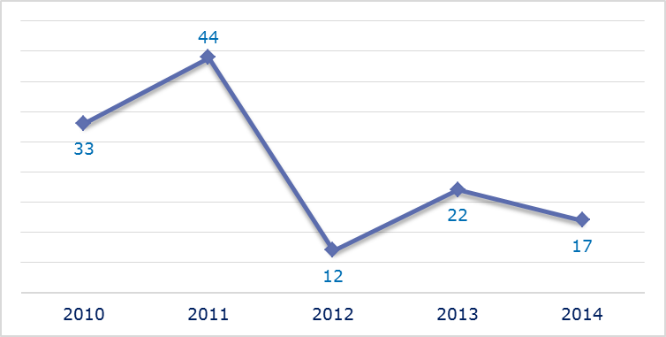
- New late transposition infringement cases opened in 2014: main policy areas
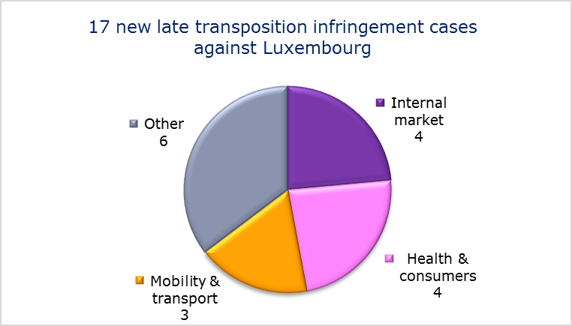
- Referrals to the Court
The Commission did not refer any cases to the Court under Articles 258 and 260(3) TFEU.
- EARLY RESOLUTION OF INFRINGEMENT CASES

Major cases closed without a Court judgment in 2014
These concerned:
- late transposition of the Industrial Emissions Directive;
- various aspects of exit taxation affecting individuals and companies.
- IMPORTANT JUDGMENTS
- Court rulings
There were no major Court rulings in 2014.
- Preliminary rulings
In preliminary rulings addressed to the Luxembourgish judiciary, the Court ruled that:
- to calculate the supplementary family benefits to which a migrant worker is entitled in his/her Member State of employment, the latter should take into account only the same family benefits the worker received in their Member State of residence.

MALTA

The number of new complaints made against Malta increased in 2014 after two years of decline but remained well below the 2011 and 2012 totals. New EU Pilot files opened against Malta fell considerably from 2013’s peak to a level almost identical with 2012. The downward trend in the overall number of pending infringements continued in 2014, taking open cases against Malta on 31 December 2014 to the lowest level of the last five years. New infringement cases for late transposition held unchanged at their lowest level since 2010.
- COMPLAINTS
- New complaints made against Malta by members of the public (2011-14)
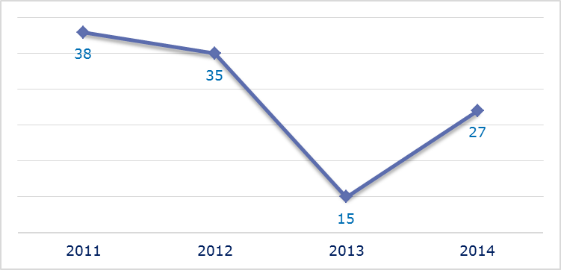
- Evolution of complaints against Malta
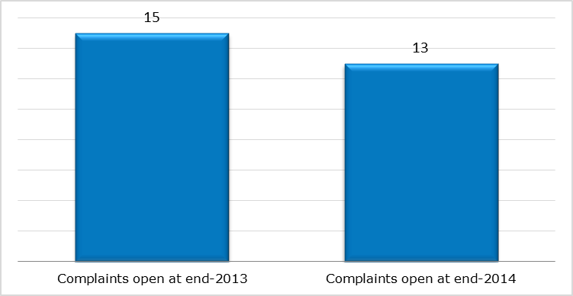
- New complaints registered in 2014: main policy areas
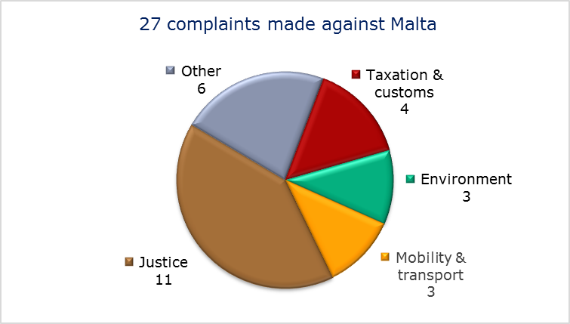
- EU PILOT
- New EU Pilot files opened against Malta (2011-14)
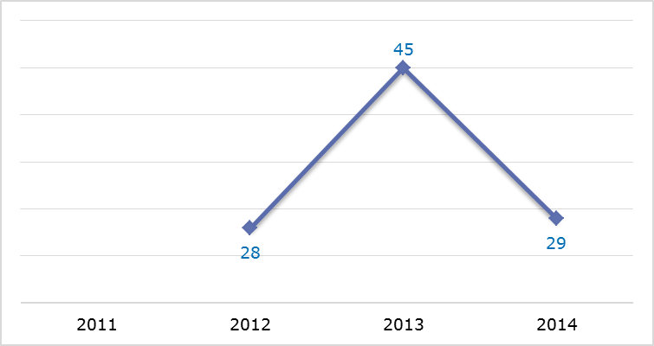
- Evolution of files relating to Malta open in EU Pilot
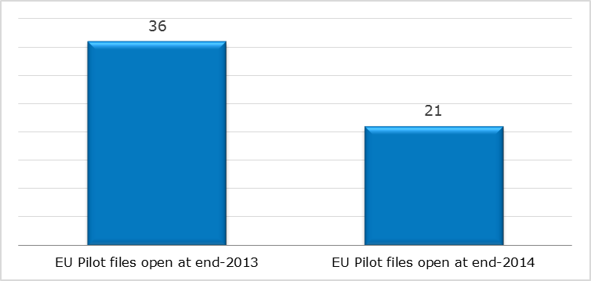
- New EU Pilot files opened in 2014: main policy areas
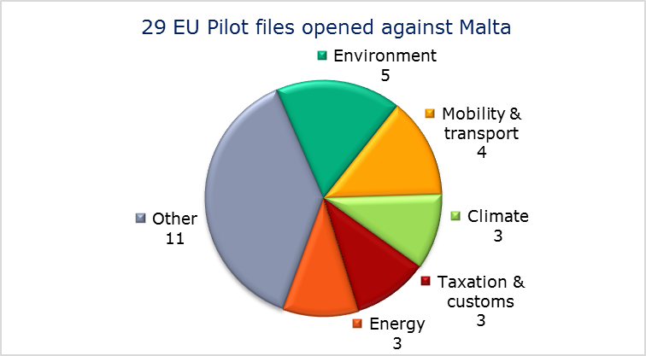
- EU Pilot files: average response time in days (2011-14)
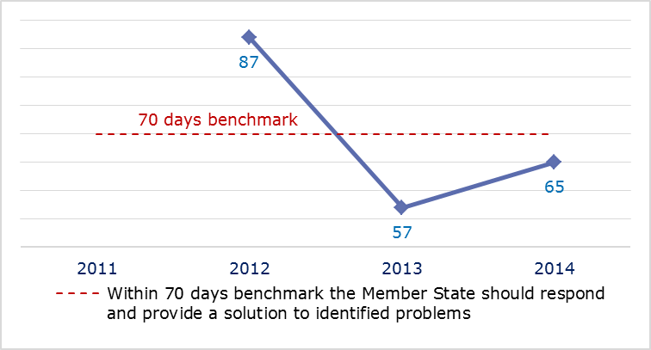
- EU Pilot files: evolution of the resolution rate by Malta (2011-14)
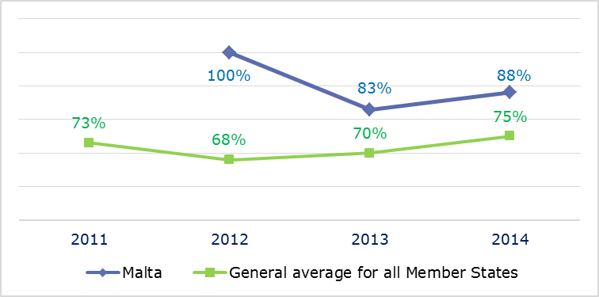
- INFRINGEMENT CASES
- Infringement cases against Malta open on 31 December (2010-14)
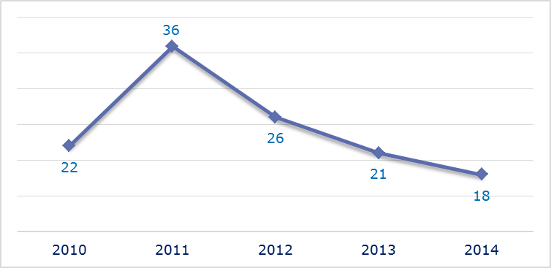
- New infringement cases opened in 2014: main policy areas
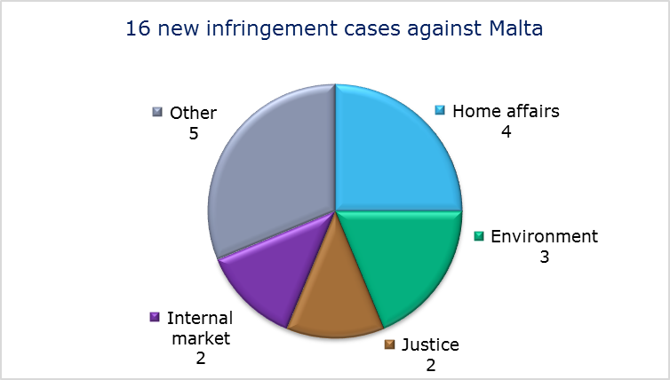
- Key infringement cases and referrals to the Court
- The Commission opened 16 new infringement cases against Malta in 2014. These, and other major ongoing infringement cases, concern:
- finch-trapping, which is prohibited under EU legislation on the conservation of wild birds;
- non-communication of measures transposing the Capital Requirements Directive;
- failure to efficiently implement functional airspace blocks. Under the Single European Sky legislation, national air traffic control organisations should work together in regional airspace blocks to gain efficiency, cut costs and reduce emissions. The set-up of these common airspace blocks is arranged around traffic flows rather than state boundaries, which leads to performance improvements.
- The Commission referred one case to the Court under Article 258 TFEU. This concerns:
- the situation of some Maltese nationals who previously worked under the UK civil servant scheme and whose UK pensions are deducted from their Maltese retirement pensions.
- The Commission did not refer any cases to the Court under Article 260(2) TFEU.
- TRANSPOSITION OF DIRECTIVES
- New late transposition infringement cases against Malta (2010-14)
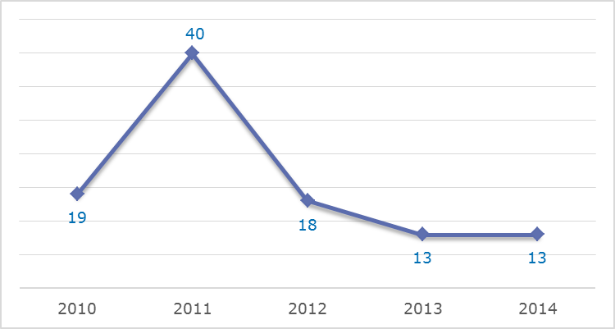
- New late transposition infringement cases opened in 2014: main policy areas
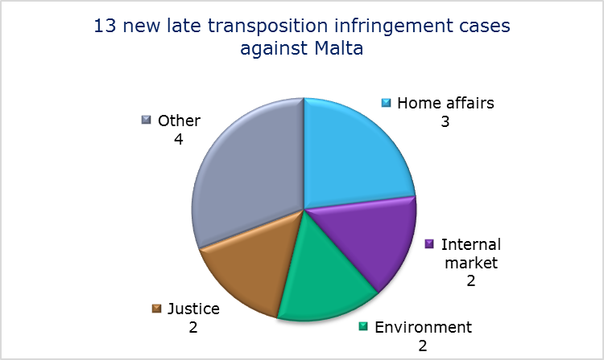
- Referrals to the Court
The Commission did not refer any cases to the Court under Articles 258 and 260(3) TFEU.
- EARLY RESOLUTION OF INFRINGEMENT CASES

Major cases closed without a Court judgment in 2014
These concerned:
- nonconformity with EU law of the Maltese legislation on access to justice in environmental matters;
- incomplete transposition of the directive on preventing and combating trafficking in human beings and protecting its victims;
- discriminatory bus fares for non-residents compared to those for residents.
- IMPORTANT JUDGMENTS
- Court rulings
There were no major Court rulings in 2014.
- Preliminary rulings
No major preliminary rulings were addressed to the Maltese judiciary in 2014.

NETHERLANDS

In 2014 the number of new complaints made against the Netherlands continued falling from its 2012 peak and new EU Pilot files opened against it declined considerably. The overall number of pending infringement cases in 2014 was the lowest for five years. New infringement cases for late transposition remained stable after the big drop seen in 2012.
- COMPLAINTS
- New complaints made against the Netherlands by members of the public (2011-14)
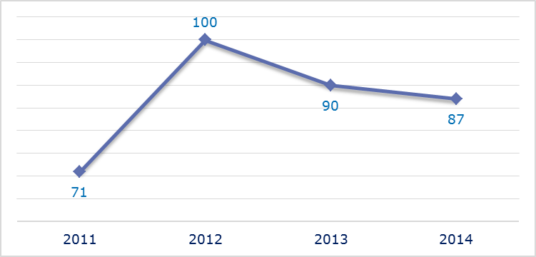
- Evolution of complaints against the Netherlands
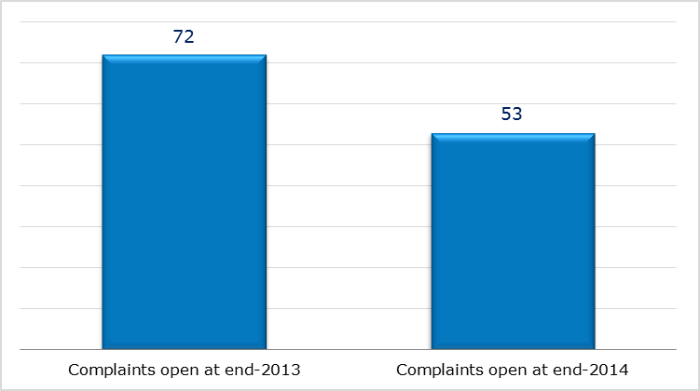
- New complaints registered in 2014: main policy areas
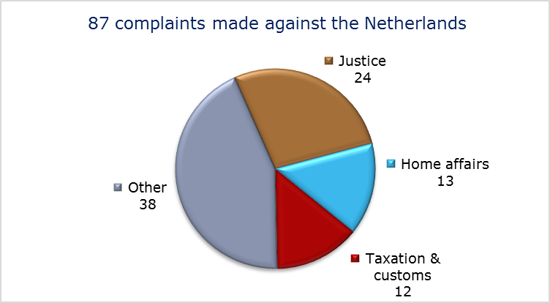
- EU PILOT
- New EU Pilot files opened against the Netherlands (2011-14)
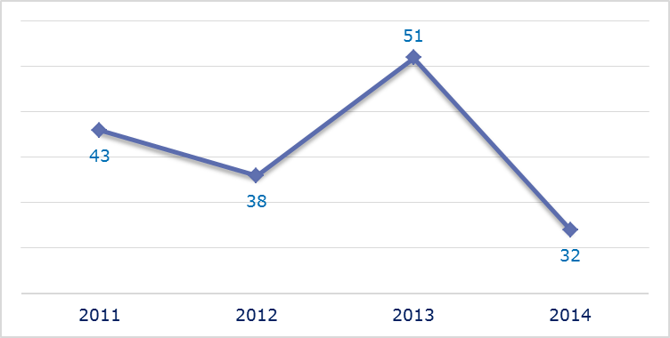
- Evolution of files relating to the Netherlands open in EU Pilot
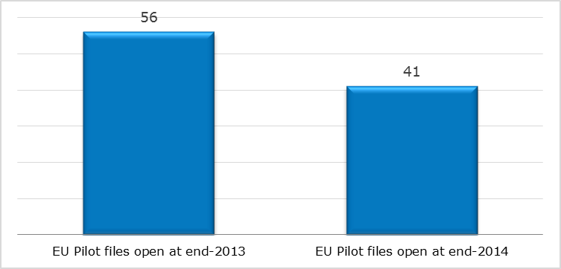
- New EU Pilot files opened in 2014: main policy areas
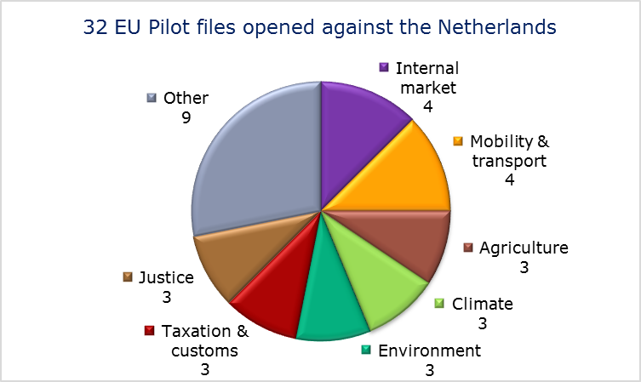
- EU Pilot files: average response time in days (2011-14)
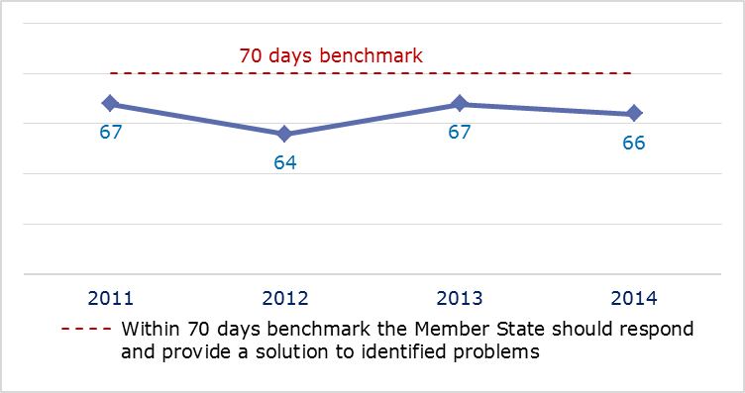
- EU Pilot files: evolution of the resolution rate by the Netherlands (2011-14)
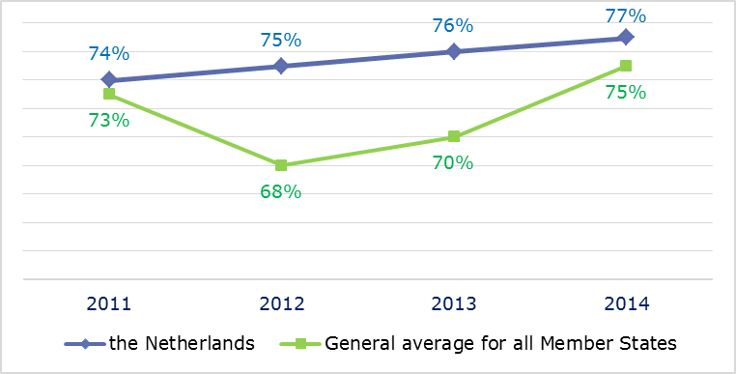
- INFRINGEMENT CASES
- Infringement cases against the Netherlands open on 31 December (2010-14)
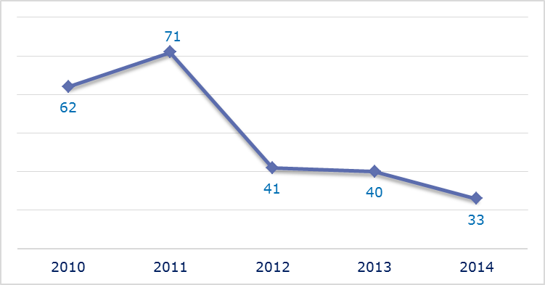
- New infringement cases opened in 2014: main policy areas
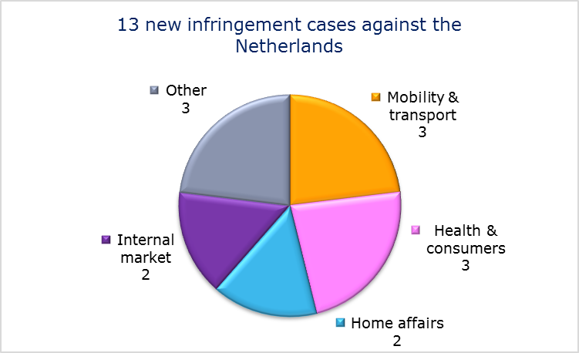
- Key infringement cases and referrals to the Court
- The Commission opened 13 new infringement cases against the Netherlands in 2014. These, and other major ongoing infringement cases, concern:
- the amount of a survivor’s benefits, work incapacity benefits and supplementary allowances will be reduced when exported to a recipient residing outside the EU/EEA area and Switzerland, if the cost of living is lower in this country than in the Netherlands. This is in breach of the EU-Turkey Association Council Decision No 3/80;
- failure to halt ongoing deterioration of the Westerschelde ‘Natura 2000’ site as required by the Habitats Directive;
- failure to efficiently implement functional airspace blocks. Under the Single European Sky legislation, national air traffic control organisations should work together in regional airspace blocks to gain efficiency, cut costs and reduce emissions. The set-up of these common airspace blocks is arranged around traffic flows rather than state boundaries, which leads to performance improvements;
- incorrect transposition of the directive on the initial qualification and periodic training of drivers of certain road vehicles for the carriage of goods or passengers. Drivers born before 1 July 1955 are wrongly exempted from the periodic training requirements stipulated in the directive;
- incorrect application of the Railway Safety Directive;
- incomplete transposition of the Capital Requirements Directive and the Cross-border Healthcare Directive;
- discriminatory taxation of outbound dividends received by insurance companies. Only dividends paid on shares held by Dutch insurance companies are actually tax exempt;
- incorrect application of the directive on cross-border mergers of limited liability companies. Dutch law does not require the set-up of a Special Negotiating Body whose task is to discuss employee participation rights.
- The Commission referred two cases to the Court under Article 258 TFEU. They concern:
- the refusal to allow Erasmus students and students from other Member States who are not economically active in the Netherlands or have not obtained a permanent right of residence to benefit from the reduced transport fares granted to Dutch students;
- failure to fully comply with EU rules on VAT exemptions for water sport activities. The Netherlands grants a VAT exemption if the water sport organisations only employ volunteers to supply sport or physical education services and an exemption on the letting of berths and moorings for vessels provided by water sport organisations, even when they are not linked to sport activities.
- The Commission did not refer any cases to the Court under Article 260(2) TFEU.
- TRANSPOSITION OF DIRECTIVES
- New late transposition infringement cases against the Netherlands (2010-14)
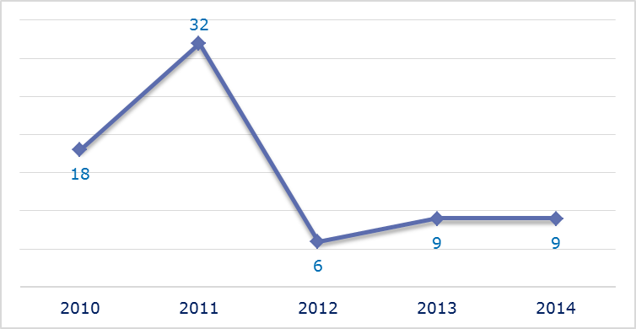
- New late transposition infringement cases opened in 2014: main policy areas
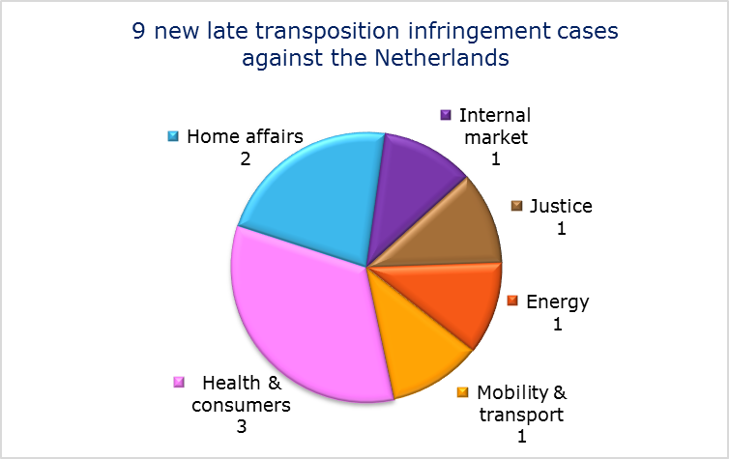
- Referrals to the Court
The Commission did not refer any case to the Court under Articles 258 and 260(3) TFEU.
- EARLY RESOLUTION OF INFRINGEMENT CASES

Major cases closed without a Court judgment in 2014
These concerned:
- restrictions on importing and possessing airsoft devices;
- non-communication of national measures transposing the directive on preventing and combating trafficking in human beings and protecting its victims;
- incorrect application of the Long-Term Residents Directive by requiring disproportionate fees for processing applications for long-term residence status;
- incorrect application of the regulation on the rights of bus and coach passengers by not designating bus terminals where disabled people are entitled to receive assistance, not designating a national enforcement body and not setting up a penalty system for infringements of the regulation.
- IMPORTANT JUDGMENTS
- Court rulings
There were no major Court rulings in 2014.
- Preliminary rulings
In preliminary rulings addressed to the Dutch judiciary, the Court ruled that:
- a Member State is required to recalculate a farmer’s payment entitlements under the regulation laying down detailed rules for the implementation of cross-compliance, modulation and the integrated administration and control system;
- the directive on approximating national legislation on protecting employees in the event of their employer’s insolvency must be interpreted as prohibiting national legislation which treats a non-EU national who is not legally resident in the Member State concerned as not being an employee with the right to an insolvency benefit even if recognised under Member State law as having the status of an ‘employee’;
- a plan or project that has negative implications for a natural habitat present on a ‘Natura 2000’ site and that provides for the creation of an area of equal or greater size of the same natural habitat type within the same site has an effect on the integrity of that site. Protective measures that are provided for in a project and are aimed at compensating for its negative effects on a Natura 2000 site cannot be taken into account in the assessment of the project’s implications. Such measures can be categorised as ‘compensatory measures’ within the meaning of the Habitats Directive if the conditions it sets out are met;
- national authorities must ensure the respect of fundamental rights when assessing the credibility of the declared sexual orientation of applicants for asylum. This excludes intrusive and humiliating medical or pseudo-medical tests, intrusive questioning and requiring photographic or video evidence of sexual practices. The assessment cannot be based on stereotyped notions and should always take full account of the individual situation and personal circumstances of the applicant;
- data about an applicant for a residence permit that are contained in an administrative document (including the data in the document’s legal analysis) are personal data within the meaning of the Data Protection Directive. The person whose data have been processed can request a full summary of the data in an intelligible form;
- the provisions of the Free Movement of Citizens Directive apply to a EU national who has created or strengthened a family life with a non-EU national during genuine residence in another Member State and when he returns with that family member to his Member State of origin;
- a resident parent company should be allowed to form a single tax entity with a resident sub-subsidiary even when the latter is not permanently established in that Member State. Sister companies resident in one Member State with a parent company resident in another Member State should also be allowed to form a fiscal unit;
- a person’s right to be heard before Member State authorities adopt any decision under the Community Customs Code may be relied on directly by individuals before national courts.

The number of files open at the end of 2013 given in the 2013 annual report is different from the current figure. This is because some files were registered late and others have been closed.
Directive 2010/13/EU.
Directive 2009/30/EC.
Directive 2013/36/EU; MEMO/14/589.
Directive 2010/75/EU.
Directive 2013/60/EU.
Directive 2004/38/EC.
MEMO/14/2130.
Regulation (EC) No 550/2004.
IP/14/818.
Directive 2004/49/EC; MEMO/14/470.
Directive 2013/28/EU.
Directive 2009/147/EC.
Directive 91/440/EEC.
Commission v Lithuania, C-61/12 and Court press release No 37/14.
UAB ‘Juvelta’ v VĮ ‘Lietuvos prabavimo rūmai’, C-481/12.
Directive 2004/22/EC.
UAB Vilniaus energija, C-423/13.
No data for 2011 are available as Luxembourg joined the EU Pilot system only in June 2012.
No data for 2011 are available as Luxembourg joined the EU Pilot system only in June 2012.
No data for 2011 are available as Luxembourg joined the EU Pilot system only in June 2012.
IP/14/309.
Council Regulation (EC) No 659/1999.
Directive 2003/88/EC.
IP/14/160.
Directives 2009/72/EC and 2009/73/EC.
Directive 2012/27/EU.
Commission v Luxembourg, C-576/11.
Regulation (EU) No 181/2011.
MEMO/14/537.
Directive 2004/49/EC.
MEMO/14/470.
Regulation (EC) No 550/2004.
IP/14/446.
Directive 2013/36/EU.
Directive 2011/24/EU.
Commission v Luxembourg, C-536/14, IP/14/1147.
Directive 1999/7/EC.
Commission v Luxembourg, C-238/14, IP/160/14.
Directive 2006/112/EC, IP/14/161.
Directive 2010/75/EU.
Wiering, C-347/12.
No data are available for 2011 as Malta joined the EU Pilot system only in June 2012.
No data are available for 2011 as Malta joined the EU Pilot system only in June 2012.
No data are available for 2011 as Malta joined the EU Pilot system only in June 2012.
IP/14/1154.
Directive 2013/36/EU.
Regulation (EC) No 550/2004.
IP/14/818.
The Commission decided on 21 March 2013 to refer the case to the Court; the application was filed on 14 January 2014, Commission v Malta C-12/14, IP/13/249.
Directive 2003/35/EC.
Directive 2011/36/EU.
The number of files open at the end of 2013 given in the 2013 annual report is different from the current figure. This is because some files were registered late and others have been closed.
Directive 92/43/EEC.
Regulation (EC) No 550/2004.
IP/14/446.
Directive 2003/59/EC.
Directive 2004/49/EC.
Directive 2013/36/EU.
Directive 2011/24/EU.
Directive 2005/56/EC.
The Commission decided on 20 June 2013 to refer the case to the Court; the application was filed on 13 May 2014, Commission v Netherlands, C-233/14, IP/13/574.
Directive 2006/112/EC, IP/14/1040.
Directive 2011/36/EU.
Council Directive 2003/109/EC.
Regulation (EU) No 181/2011.
Regulation 796/2004, Vonk Noordegraaf, C/105/13.
Directive 80/987 , Tumer C-311/13.
Directive 92/43/EEC, Briels and Others, C-521/12.
Joined cases A, B, C, C-148/13 to C-150/13 and Court press release No 162/14.
Directive 95/46/EC.
YS and others, joined cases C-141/12 and C-372/12.
Directive 2004/38/EC.
O., C-456/12 and Court press release No 32/14.
SCA Group Holding and Others, joined cases C-39/13, C-40/13 and C-41/13.
Kamino International Logistics BV and Datema Hellmann Worldwide Logistics BV, Joined Cases C-129/13 and C-130/13.

